**FORMULASI *PAPER SOAP* EKSTRAK ETANOL DEDAK PADI (*Oryza sativa* L.) DAN UJI AKTIVITAS ANTIBAKTERI**

**TERHADAP BAKTERI *Escherichia coli* DAN *Staphylococcus aureus***

**MUTHIA RAWDHAH NURUL ZANNAH NPM. 222114147**

**ABSTRAK**

*Paper soap* adalah sabun yang berbentuk lembaran tipis menyerupai kertas. Dedak padi limbah penggilingan padi yang mengandung senyawa antibakteri. Tujuan penelitian ini adalah untuk memformulasikan *paper soap* ekstrak etanol dedak padi dan untuk mengetahui aktivitas antibakterinya.

Penelitian ini merupakan jenis penelitian eksperimental yang dilaksanakan di dalam laboratorium. Mencakup langkah-langkah seperti pengambilan dan identifikasi sampel, persiapan serta pembuatan ekstrak etanol dedak padi ( *Oryza sativa* L.), dan uji aktivitas antibakteri terhadap E*scherichia coli* dengan metode *Cakram Disk*, di mana zona hambat dari ekstrak etanol dedak padi dan sediaan *paper soap* yang mengandung ekstrak dedak padi (*Oryza sativa* L.) diamati dan diukur sebagai hasil dari uji aktivitas antibakteri tersebut.

Hasil penelitian ini menunjukkan bahwa ekstrak etanol dedak padi mengandung senyawa kimia yaitu alkaloid, flavonoid, saponin, tanin, triterpenoid/steroid dan glikosida. Ektrak etanol dedak padi memiliki karakteristik sesuai persyaratan MMI tahun 1989. Hasil penentuan aktivitas antibakteri ekstrak etanol dedak padi menghasilkan zona hambat terhadap bakteri *Escherechia coli* berkisar 5mm - 12,5mm dan *Staphylococcus aureus* berkisar 5,5mm – 16,67mm. Hasil uji evaluasi *paper soap* pemeriksaan organoleptik, pemeriksaan ketebalan, uji keseragaman bobot, uji stabilitas, uji daya busamemenuhi persyaratan dan pada uji iritasi F0, F1, F2, dan F3 tidak mengiritasi kulit, pada uji hedonik formula yang paling disukai adalah F1. Hasil penentuan aktivitas antibakteri *paper soap* menghasilkan zona hambat terhadap bakteri *Escherechia coli* berkisar 8,16mm - 12,5mm dan *Staphylococcus aureus* berkisar 15mm – 14,83mm. dari hasil penelitian dapat disimpulkan bahwa ekstrak etanol dedak padi dapat diformulasikan menjadi sediaan *paper soap* dan memiliki aktivitas antibakteri.

**Kata kunci**: Antibakteri, Dedak padi, *Paper soap,* Sabun

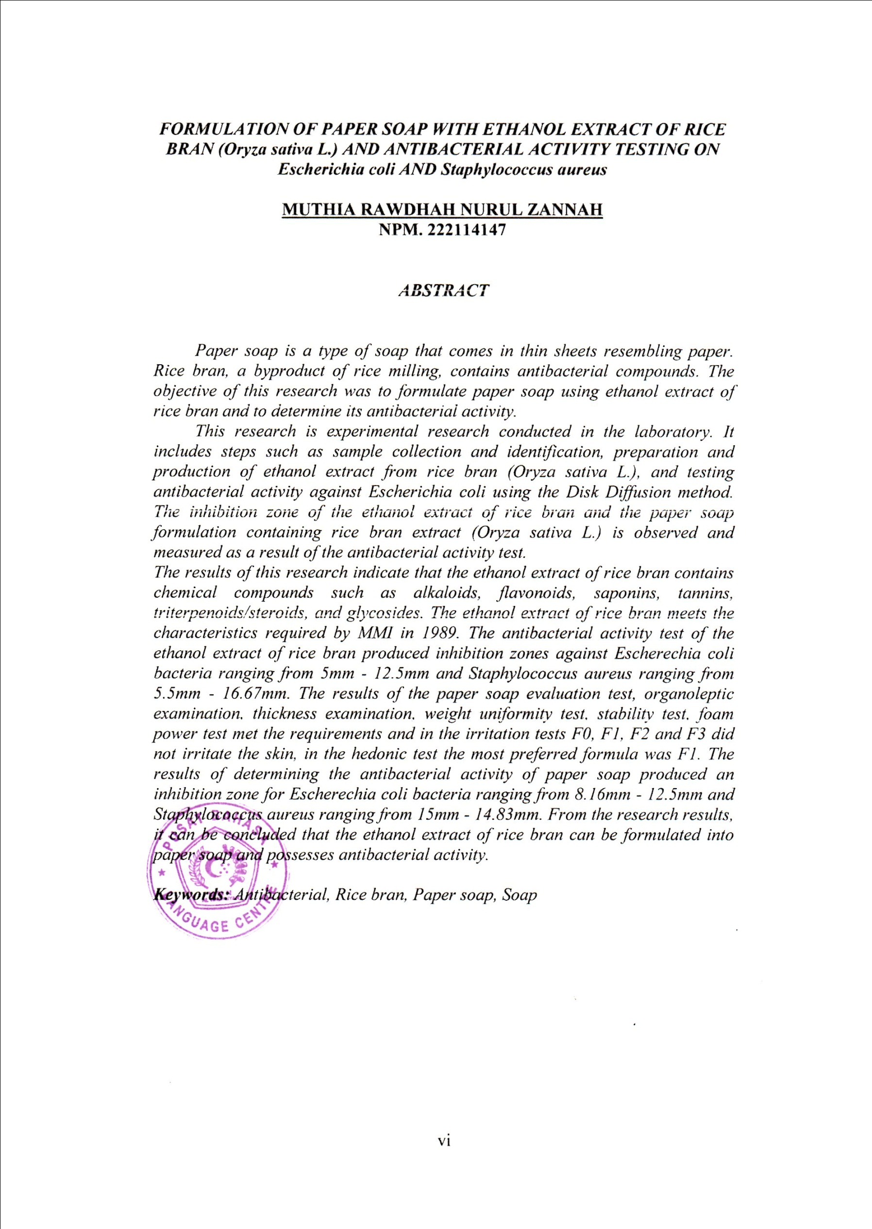**PAPER SOAP FORMULATION OF RICE BRAN (*Oryza sativa* L.) ETHANOL EXTRACT AND TESTING FOR ANTIBACTERIAL ACTIVITY AGAINST THE BACTERIA**

***Escherichia coli* AND *Staphylococcus aureus***

**MUTHIA RAWDHAH NURUL ZANNAH NPM. 222114147**

**ABSTRACT**

Paper soap is soap in the form of thin sheets resembling paper. Rice bran from rice milling waste contains antibacterial compounds. The aim of this research was to formulate paper soap from rice bran ethanol extract and to determine its antibacterial activity.

This research is a type of experimental research carried out in a laboratory. Includes steps such as taking and identifying samples, preparing and making ethanol extract of rice bran (Oryza sativa L.), and testing antibacterial activity against Escherichia coli using the Disc Disc method, where the inhibition zone of the ethanol extract of rice bran and the paper soap preparation is containing rice bran extract (Oryza sativa L.) was observed and measured as a result of the antibacterial activity test.

The results of this research show that the ethanol extract of rice bran contains chemical compounds, namely alkaloids, flavonoids, saponins, tannins, triterpenoids/steroids and glycosides. Rice bran ethanol extract has characteristics in accordance with the 1989 MMI requirements. The results of determining the antibacterial activity of rice bran ethanol extract produce an inhibition zone against Escherechia coli bacteria ranging from 5mm - 12.5mm and Staphylococcus aureus ranging from 5.5mm - 16.67mm. The results of the paper soap evaluation test, organoleptic examination, thickness examination, weight uniformity test, stability test, foam power test met the requirements and in the irritation tests F0, F1, F2 and F3 did not irritate the skin, in the hedonic test the most preferred formula was F1. The results of determining the antibacterial activity of paper soap produced an inhibition zone for Escherechia coli bacteria ranging from 8.16mm - 12.5mm and Staphylococcus aureus ranging from 15mm -

14.83mm. From the research results it can be concluded that rice bran ethanol extract can be formulated into paper soap and has antibacterial activity.

**Key words:** Antibacterial, Rice bran, Paper soap