**ISOLASI DAN UJI AKTIVITAS ANTIBAKTERI BAKTERI ASAM LAKTAT PADA MINUMAN *CLASSIC ENZYME* BERBAGAI MACAM BUAH TERHADAP PERTUMBUHAN**

**BAKTERI *Staphylococcus aureus***

**SITI SALIMAH HARAHAP**

**NPM. 222114146**

# ABSTRAK

*Classic Enzyme* adalah cairan yang dihasilkan dari buah-buahan melalui proses fermentasi dengan waktu panen 1 tahun. Bakteri Asam Laktat dapat di isolasi dari minuman *Classic Enzyme*. Tujuan Penelitian ini adalah untuk mengisolasi dan mendapatkan daya hambat antibakteri dari isolat BAL yang terdapat pada minuman *classic enzyme*.

Penelitian ini merupakan jenis penelitian deskriptif kualitatif dan kuantitatif dengan uji organoleptik, pengukuran pH dan % kadar asam laktat. Isolat yang telah diisolasi dikarakterisasi secara makroskopis (warna, bentuk, ukuran koloni) dan mikroskopis (pewarnaan Gram dan pewarnaan endospora). Uji biokimia (uji katalase dan tipe fermentasi). Uji aktivitas antibakteri terhadap bakteri patogen dengan metode difusi cakram.

Hasil Penelitian organoleptik minuman c*lassic enzyme* memiliki aroma bau khas fermentasi, rasa asam, warna kuning muda keruh dan tekstur cair dengan pH 4,70 dan kadar asam laktat rata-rata 1,0717%. Dari isolasi 6 isolat yaitu BAL 1, BAL 2, BAL 3, BAL 4, BAL 5 dan BAL 6. Karakteristik makroskopis semua BAL berwarna putih susu, BAL 1, BAL 2, BAL 3 dan BAL 6 berbentuk batang sedangkan BAL 4 dan BAL 5 berbentuk bulat. Ukuran koloni berkisar 2,0-2,3 mm. pH sampel 4,70. Karakteristik mikroskopis semua isolat mempunyai pewarnaan gram positif dan endospora negatif. Karakteristik uji biokimia semua isolat katalase negatif dan tipe fermentasi homofermentatif. Semua isolat BAL dapat menghambat pertumbuhan bakteri *Staphylococcus aureus* dengan diameter zona hambat berkisar 8,8 mm hingga 10,6 mm. Dari hasil tersebut disimpulkan bahwa isolat yang diisolasi dari minuman *classic enzyme* adalah bakteri asam laktat yang memiliki aktivitas antibakteri yang berpotensi sebagai minuman probiotik.

**Kata kunci**: Aktivitas antibakteri, Bakteri Asam Laktat, *Classic Enzim, S.aureus*

*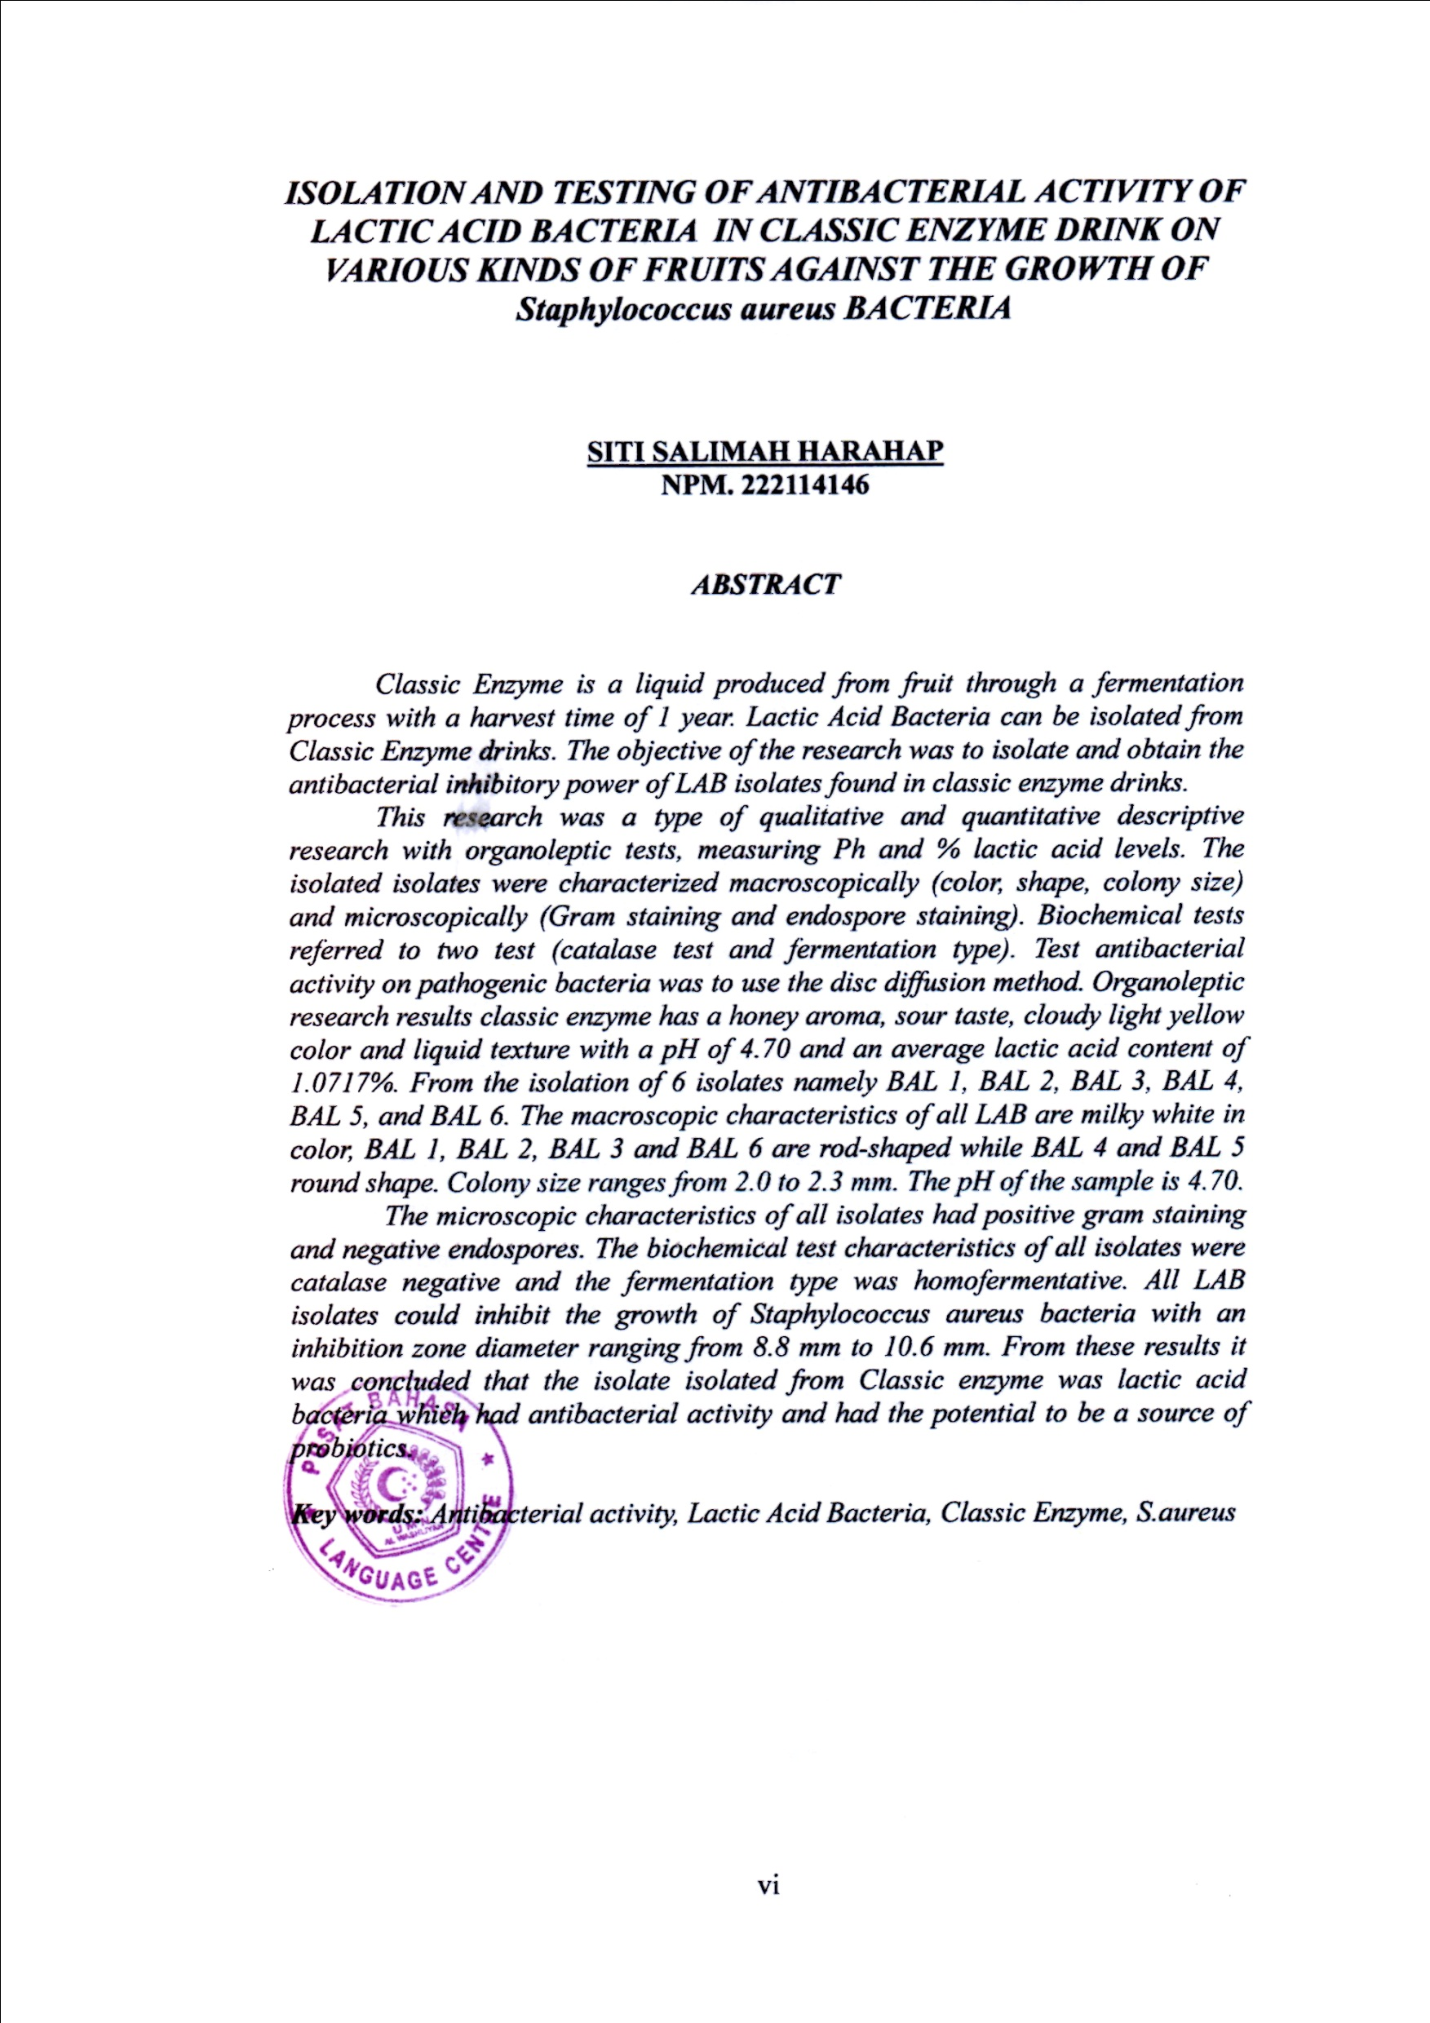****ISOLATION AND TESTING OF ANTIBACTERIAL ACTIVITY OF LACTIC ACID BACTERIA IN CLASSIC ENZYME DRINK ON VARIOUS KINDS OF FRUITS AGAINST THE GROWTH OF Staphylococcus aureus BACTERIA***

**SITI SALIMAH HARAHAP**

**NPM. 222114146**

# *ABSTRACT*

*Classic Enzyme is a liquid produced from fruit through a fermentation process with a harvest time of 1 year. Lactic Acid Bacteria can be isolated from Classic Enzyme drinks. The objective of the research was to isolate and obtain the antibacterial inhibitory power of LAB isolates found in classic enzyme drinks.*

*This research was a type of qualitative and quantitative descriptive research with organoleptic tests, measuring Ph and % lactic acid levels. The isolated isolates were characterized macroscopically (color, shape, colony size) and microscopically (Gram staining and endospore staining). Biochemical tests referred to two test (catalase test and fermentation type). Test antibacterial activity on pathogenic bacteria was to use the disc diffusion method. Organoleptic research results classic enzyme has a honey aroma, sour taste, cloudy light yellow color and liquid texture with a pH of 4.70 and an average lactic acid content of 1.0717%. From the isolation of 6 isolates namely BAL 1, BAL 2, BAL 3, BAL 4, BAL 5, and BAL 6. The macroscopic characteristics of all LAB are milky white in color, BAL 1, BAL 2, BAL 3 and BAL 6 are rod-shaped while BAL 4 and BAL 5 round shape. Colony size ranges from 2.0 to 2.3 mm. The pH of the sample is 4.70.*

*The microscopic characteristics of all isolates had positive gram staining and negative endospores. The biochemical test characteristics of all isolates were catalase negative and the fermentation type was homofermentative. All LAB isolates could inhibit the growth of Staphylococcus aureus bacteria with an inhibition zone diameter ranging from 8.8 mm to 10.6 mm. From these results it was concluded that the isolate isolated from Classic enzyme was lactic acid bacteria which had antibacterial activity and had the potential to be a source of probiotics.*

***Key words:*** *Antibacterial activity, Lactic Acid Bacteria, Classic Enzyme, S.aureus*