**PENGEMBANGAN MEDIA PERMAINAN ULAR TANGGA PADA BIMBINGAN KARIR BAGI SISWA SMP AKP GALANG**

**LENI YUNITA NPM. 201414011**

**ABSTRAK**

Penelitian ini bertujuan untuk mengembangkan media ular tangga yang digunakan dalam pelaksanaan bimbingan karir pada siswa SMP AKP Galang. Penelitian ini adalah penelitian pengembangan *(Research and Development)* dengan model ADDIE yang dibatasi sampai tiga tahap, yaitu (1) tahap *analisis* yaitu kebutuhan dan permasalahan yang dialami siswa, (2) tahap *design* yaitu merancang produk yang akan digunakan sesuai dengan kebutuhan, (3) tahap *development* yaitu mengembangkan produk. Hasil uji ahli materi 90%, ahli media 90%, respon guru 97%, sehingga media ular tangga layak digunakan pada bimbingan karir bagi siswa dalam kategori sangat baik.

Kata kunci: pengembangan, media permainan ular tangga, bimbingan karir bagi

***DEVELOPMENT OF SNAKES AND LADDER GAME MEDIA IN CAREER GUIDANCE FOR STUDENTS OF SMP AKP GALANG***

**LENI YUNITA NPM. 201414011**

***ABSTRACT***

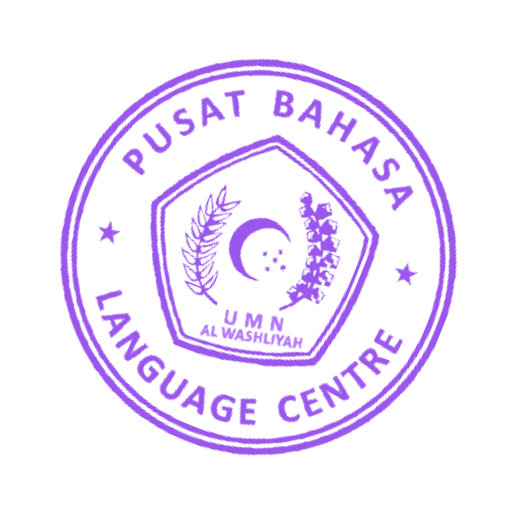The objective of the research was to develop a snake and ladder media used in the implementation of career guidance for students of SMP AKP Galang. This research was a development research (Research and Development) with the ADDIE model which was limited to three stages, namely (1) the analysis stage, namely the needs and problems experienced by students, (2) the design stage, namely designing products that would be used according to needs, (3) the development stage, namely developing products. The results of the material expert test were 90%, media experts 90%, teacher responses 97%, so that the snake and ladder media was suitable for use in career guidance for students in the very good category.

Keywords: development, snake and ladder game media, career guidance