*Lampiran 1: Angket Penelitian*

**Pengaruh *E-Learning* Menggunakan *Google Classroom***

**Terhadap Hasil Belajar Ekonomi Siswa Kelas XI-IPS**

**SMA Swasta Istiqlal Delitua**

Petunjuk Pengisian:

1. Beri tanda check (√) pada kolom jawaban sesuai dengan pilihan anda.
2. Jawaban merentang mulai 1 sampai 5 dengan ketentuan jawaban sebagai berikut:

1 = Sangat Tidak Setuju

2 = Tidak Setuju

3 = Ragu-ragu

4 = Setuju

5 = Sangat Setuju

1. Pastikan semua pertanyaan tidak ada yang terlewat.

**Nama :**

**Kelas :**

Kuisioner mengenai *E-learning* menggunakan *Google Classroom*

|  |  |  |  |  |  |  |
| --- | --- | --- | --- | --- | --- | --- |
| **No** | **Pertanyaan** | **Pilihan Jawaban** | | | | |
| **1** | **2** | **3** | **4** | **5** |
| 1 | Saya menggunakan internet sebagai sumber belajar |  |  |  |  |  |
| 2 | Saya berkomunikasi dengan guru dan teman-teman terkait pelajaran menggunakan koneksi internet |  |  |  |  |  |
| 3 | Saya dapat menggunakan bahan ajar atau petunjuk belajar yang terstruktur dan terjadwal melalui *e-learning* |  |  |  |  |  |
| 4 | Saya dapat me-*review* materi pelajaran setiap saat dan dimana saja melalui koneksi internet |  |  |  |  |  |

|  |  |  |  |  |  |  |
| --- | --- | --- | --- | --- | --- | --- |
| 5 | Saya dapat memperoleh tambahan informasi yang berkaitan dengan materi pelajaran setiap saat dan dimana saja melalui koneksi internet secara lebih mudah |  |  |  |  |  |
| 6 | Saya dapat mengerjakan tugas yang diberikan guru dengan mudah dengan menggunakan *e-learning* |  |  |  |  |  |
| 7 | Saya menjadi lebih mandiri karena *e-learning* |  |  |  |  |  |
| 8 | Saya kurang dekat/akrab dengan guru dan teman-teman selama *e-learning* berlangsung |  |  |  |  |  |
| 9 | Saya mengetahui aplikasi *google classroom* |  |  |  |  |  |
| 10 | Dengan media *google classroom*, memudahkan saya dalam melaksanakan proses pembelajaran *online* |  |  |  |  |  |
| 11 | Dengan diterapkannya *google classroom*, saya dapat belajar dan mengerjakan tugas kapan pun |  |  |  |  |  |
| 12 | Dengan diterapkannya *google classroom*, saya dapat belajar dan mengerjakan tugas dimana pun saya berada ketika saya terhubung dengan internet |  |  |  |  |  |
| 13 | Aplikasi *google classroom* sangat *fleksibel* bagi saya dalam memanfaatkan media pembelajaran digital |  |  |  |  |  |
| 14 | Aplikasi *google classroom* lebih ramah lingkungan karena tidak menguras kuota saat pembelajaran *online* |  |  |  |  |  |
| 15 | Sejak menggunakan *google classroom* saya tidak perlu menggunakan banyak kertas untuk mengerjakan tugas |  |  |  |  |  |
| 16 | Aplikasi *google classroom* memberikan saya manfaat dalam pembelajaran *online* |  |  |  |  |  |
| 17 | Aplikasi *google classroom* memudahakan saya untuk tetap terhubung dengan guru dalam kelas maya |  |  |  |  |  |
| 18 | Kondisi kelas sangat kondusif dalam proses pembelajarn *online* |  |  |  |  |  |
| 19 | Saya memiliki pengalaman yang menyenangkan selama menggunakan *google classroom* |  |  |  |  |  |
| 20 | Saya sangat bangga menggunakan media *google classroom* |  |  |  |  |  |

*Lampiran 2: Wawancara*

**Transkip Wawancara**

**Narasumber : Guru Mata Pelajaran Ekonomi**

**Nama : Drs. Hj Usna Denijar**

Pertanyaan : Apa yang Ibu ketahui tentang media pembelajaran?

Jawaban : Media pembelajaran adalah sarana yang digunakan untuk memperlancar dalam penyampaian materi kepada siswa agar siswa mampu memahami materi, media ini bias berbentuk teknologi dan ada pula yang berbentuk media sederhana. Yang jelas media yang digunakan ini membantu menyampaikan materi agar siswa bias lebih mengerti.

Pertanyaan : Media pembelajaran seperti apa yang diterapkan disekolah untuk pembelajaran *online*?

Jawaban : Media yang digunakan bervariasi, diantaranya menggunakan *whatsapp, quipper school, google classroom.*

Pertanyaan : Apa yang Ibu ketahui tentang *google Classroom*?

Jawaban : *Google Classroom* adalah salah satu media pembelajaran *online* yang sangat efisien digunakan sekarang ini. Dapat membuat guru dan siswa tetap terhubung dalam kelas maya, tidak menguras banyak kuota internet dan mudah untuk diakses kapan saja dan dimana saja.

Pertanyaan : Bagaimana tanggapan ibu tentang pembelajaran menggunakan *google classroom*?

Jawaban : Menurut saya, pembelajaran menggunakan *google classroom* sangat bagus, membantu pembelajaran *online*. Siswa tetap bisa mengakses bahan ajar meskipun dengan jarak jauh. Apalagi penggunaan *google classroom* bias diakses melalui *handphone* sehingga menjadi fleksibel.

Pertanyaan : Apakah *google classroom* memberikan kemudahan dalam memberikan tugas dalam proses pembelajaran *online*?

Jawaban : Ya, *google classroom* sangat membantu guru dalam membuat, membagikan dan menggolongkan setiap penugasan tanpa kertas.

Pertanyaan : Apakah menurut ibu penggunaan *google classroom* merupakan media yang tepat untuk pelajaran ekonomi secara *online*?

Jawaban : Menurut saya, selama pembelajaran *online* pada mata pelajaran ekonomi, penggunaan *google classroom* saya rasa sudah tepat. Tetapi *google classroom* tidak bisa digunakan secara menyeluruh dalam semua materi, ada beberapa materi yang memerlukan referensi lain seperti *blog, youtube,* dsb.

Pertanyaan : Menurut ibu, apa kelemahan dan kelebihan *google classroom*?

Jawaban : Menurut pengamatan dan pengalaman saya, *google classroom* ini kelebihannya banyak bisa mempermudah dalam penugasan, tidak perlu menggunakan banyak kertas, memudahkan siswa dalam melihat materi belajar, siswa mengetahui kriteria penilaian dan jadwal pengumpulan tugas sehingga membuat mereka lebih disiplin. Sedangkan untuk kekurangannya sendiri, aplikasi ini membutuhkan jaringan internet yang stabil. Kadang ada siswa yang sudah mengirim tugas tetapi belum masuk di kelas maya karna terkendala jaringan internet.

Pertanyaan : Berikan saran ibu untuk penggunaan *google classroom*!

Jawaban : Sebisa mungkin untuk penggunaan *google classroom* ini bisa membantu siswa untuk lebih memahami materi, serta diberikan fitur untuk membuat materi dan video menjadi lebih menarik, serta adanya fitur untuk mengecek kesamaan isi dari tugas yang dikerjakan siswa.

*Lampiran 3: Data Mentah Instrumen Angket E-Learning*

**HASIL ANGKET *E-LEARNING* MENGGUNAKAN *GOOGLE CLASSROOM***

|  |  |  |  |  |  |  |  |  |  |  |  |  |  |  |  |  |  |  |  |  |  |  |
| --- | --- | --- | --- | --- | --- | --- | --- | --- | --- | --- | --- | --- | --- | --- | --- | --- | --- | --- | --- | --- | --- | --- |
| **No** | **Nama** | **Butir Pernyataan** | | | | | | | | | | | | | | | | | | | | **Jmlh** |
| **1** | **2** | **3** | **4** | **5** | **6** | **7** | **8** | **9** | **10** | **11** | **12** | **13** | **14** | **15** | **16** | **17** | **18** | **19** | **20** |
| 1 | Abdul Fachri Harahap | 5 | 5 | 4 | 4 | 5 | 3 | 4 | 4 | 4 | 5 | 3 | 4 | 4 | 5 | 5 | 5 | 5 | 4 | 4 | 5 | 87 |
| 2 | Agus Wahyudi | 4 | 4 | 4 | 4 | 4 | 4 | 4 | 5 | 5 | 4 | 4 | 5 | 4 | 4 | 4 | 4 | 4 | 4 | 4 | 5 | 84 |
| 3 | Ahmad Fauzi | 4 | 4 | 4 | 4 | 4 | 4 | 4 | 4 | 4 | 4 | 4 | 5 | 5 | 3 | 4 | 5 | 5 | 5 | 4 | 5 | 85 |
| 4 | Alfannur Habibi | 5 | 4 | 4 | 3 | 4 | 3 | 4 | 5 | 5 | 4 | 4 | 4 | 4 | 4 | 4 | 3 | 4 | 4 | 4 | 4 | 80 |
| 5 | Andre Ananda | 5 | 4 | 4 | 4 | 4 | 3 | 3 | 5 | 5 | 5 | 5 | 4 | 4 | 4 | 5 | 4 | 5 | 4 | 4 | 5 | 86 |
| 6 | Aulia Citra Handini | 5 | 4 | 4 | 5 | 5 | 5 | 4 | 5 | 5 | 5 | 4 | 5 | 5 | 5 | 5 | 5 | 5 | 3 | 4 | 5 | 93 |
| 7 | Azhar Sulaiman | 5 | 4 | 4 | 4 | 4 | 4 | 5 | 5 | 4 | 4 | 4 | 4 | 4 | 4 | 4 | 4 | 5 | 4 | 4 | 5 | 85 |
| 8 | Bima Habib Pratama | 5 | 4 | 4 | 4 | 4 | 4 | 4 | 5 | 5 | 4 | 4 | 4 | 4 | 3 | 4 | 5 | 5 | 4 | 4 | 5 | 85 |
| 9 | Cut Nova Maulidza | 5 | 4 | 4 | 4 | 5 | 5 | 5 | 5 | 5 | 5 | 4 | 5 | 4 | 4 | 5 | 5 | 5 | 4 | 4 | 5 | 92 |
| 10 | Dalilah Hilmi | 5 | 4 | 4 | 5 | 5 | 4 | 5 | 5 | 5 | 4 | 4 | 5 | 4 | 4 | 5 | 4 | 5 | 4 | 4 | 5 | 90 |
| 11 | Dery Permana Sembiring | 5 | 4 | 5 | 4 | 5 | 4 | 4 | 5 | 5 | 5 | 4 | 5 | 5 | 5 | 4 | 5 | 5 | 4 | 5 | 5 | 93 |
| 12 | Devi Ananda | 5 | 4 | 4 | 4 | 4 | 4 | 4 | 4 | 5 | 4 | 5 | 5 | 5 | 4 | 5 | 5 | 5 | 4 | 4 | 5 | 89 |
| 13 | Dinda Oktaviani | 5 | 5 | 4 | 4 | 4 | 4 | 4 | 5 | 5 | 4 | 4 | 5 | 4 | 4 | 5 | 4 | 4 | 4 | 4 | 5 | 87 |
| 14 | Faisal Aprianto | 4 | 4 | 2 | 2 | 4 | 2 | 2 | 3 | 3 | 2 | 3 | 4 | 4 | 2 | 4 | 4 | 4 | 4 | 3 | 3 | 63 |
| 15 | Febby Faradila | 5 | 4 | 4 | 4 | 4 | 4 | 4 | 4 | 4 | 4 | 4 | 5 | 5 | 4 | 5 | 4 | 5 | 4 | 4 | 5 | 86 |
| 16 | Fitri Yani Aurina Lubis | 5 | 4 | 4 | 4 | 5 | 4 | 4 | 5 | 5 | 5 | 5 | 5 | 4 | 4 | 5 | 4 | 5 | 5 | 4 | 5 | 91 |
| 17 | Imsanina Berutu | 5 | 5 | 5 | 5 | 5 | 4 | 4 | 4 | 5 | 5 | 4 | 4 | 4 | 3 | 4 | 4 | 4 | 4 | 4 | 4 | 86 |
| 18 | Indah Rizkyani | 5 | 2 | 3 | 3 | 4 | 2 | 2 | 4 | 5 | 4 | 2 | 3 | 3 | 2 | 3 | 4 | 4 | 3 | 3 | 3 | 64 |
| 19 | Iqbal Hanafi | 5 | 4 | 4 | 4 | 5 | 4 | 4 | 5 | 5 | 4 | 5 | 4 | 4 | 3 | 4 | 5 | 4 | 4 | 4 | 4 | 85 |
| 20 | Laila Muti | 5 | 4 | 4 | 4 | 4 | 4 | 4 | 4 | 4 | 4 | 4 | 4 | 4 | 5 | 5 | 5 | 5 | 5 | 5 | 5 | 88 |
| 21 | Muhammad Fikri | 4 | 4 | 4 | 4 | 5 | 4 | 4 | 5 | 5 | 4 | 4 | 5 | 5 | 4 | 5 | 5 | 5 | 4 | 4 | 5 | 89 |
| 22 | Muhammad Rasyid Siddix | 5 | 5 | 3 | 3 | 4 | 3 | 3 | 5 | 5 | 5 | 3 | 5 | 5 | 3 | 5 | 4 | 5 | 4 | 3 | 5 | 83 |
| 23 | Nanda Susilo | 5 | 5 | 4 | 5 | 5 | 4 | 4 | 5 | 5 | 5 | 4 | 4 | 3 | 3 | 5 | 5 | 4 | 4 | 3 | 4 | 86 |
| 24 | Nayla Irpadia Situmbang | 5 | 4 | 5 | 4 | 5 | 4 | 4 | 5 | 5 | 4 | 4 | 4 | 4 | 4 | 4 | 4 | 5 | 4 | 4 | 5 | 87 |
| 25 | Nur Ardiansyah | 5 | 5 | 5 | 5 | 5 | 3 | 3 | 4 | 4 | 3 | 3 | 5 | 5 | 5 | 4 | 4 | 5 | 3 | 3 | 4 | 83 |
| 26 | Nur Fadillah Pasaribu | 5 | 5 | 4 | 4 | 5 | 4 | 4 | 5 | 5 | 4 | 4 | 5 | 5 | 4 | 5 | 5 | 5 | 4 | 4 | 4 | 90 |
| 27 | Qorry Avrillia | 5 | 4 | 4 | 4 | 5 | 4 | 4 | 5 | 5 | 5 | 4 | 5 | 5 | 4 | 5 | 5 | 5 | 4 | 4 | 5 | 91 |
| 28 | Ricky Syahputra | 5 | 5 | 4 | 5 | 5 | 3 | 3 | 5 | 5 | 5 | 5 | 4 | 3 | 3 | 4 | 4 | 5 | 3 | 3 | 4 | 83 |
| 29 | Ririn Aswinda | 5 | 4 | 3 | 3 | 5 | 4 | 3 | 4 | 5 | 5 | 4 | 4 | 5 | 5 | 5 | 4 | 5 | 3 | 4 | 5 | 85 |
| 30 | Salman Al-Farizi | 4 | 4 | 4 | 4 | 4 | 4 | 4 | 4 | 4 | 4 | 4 | 4 | 4 | 5 | 4 | 4 | 5 | 4 | 4 | 5 | 83 |
| 31 | Salyna Widya Hasanah | 5 | 5 | 4 | 4 | 4 | 4 | 3 | 3 | 5 | 4 | 3 | 3 | 4 | 4 | 4 | 5 | 4 | 5 | 4 | 4 | 81 |
| 32 | Yani Maharani | 4 | 4 | 4 | 4 | 5 | 4 | 4 | 5 | 4 | 4 | 4 | 5 | 5 | 4 | 5 | 4 | 5 | 4 | 4 | 4 | 86 |
| 33 | Agustia Putri | 5 | 4 | 4 | 4 | 5 | 4 | 4 | 5 | 5 | 4 | 4 | 5 | 5 | 5 | 5 | 5 | 5 | 4 | 4 | 5 | 91 |
| 34 | Alvito Ramadhan | 4 | 4 | 3 | 4 | 3 | 3 | 4 | 3 | 4 | 4 | 3 | 3 | 4 | 3 | 4 | 3 | 4 | 3 | 3 | 4 | 70 |
| 35 | Amanda Devina | 5 | 5 | 4 | 4 | 5 | 4 | 4 | 4 | 5 | 5 | 4 | 4 | 5 | 5 | 5 | 5 | 5 | 4 | 4 | 4 | 90 |
| 36 | Andre Putra Dwifa | 5 | 5 | 5 | 4 | 4 | 3 | 3 | 5 | 5 | 5 | 3 | 3 | 4 | 4 | 5 | 5 | 5 | 4 | 4 | 4 | 85 |
| 37 | Arlita Damayanti | 5 | 4 | 4 | 4 | 5 | 4 | 4 | 5 | 4 | 4 | 4 | 5 | 5 | 3 | 5 | 4 | 5 | 4 | 4 | 4 | 86 |
| 38 | Bagus Laksono | 4 | 4 | 4 | 4 | 5 | 4 | 4 | 5 | 5 | 4 | 4 | 5 | 5 | 4 | 4 | 4 | 5 | 4 | 4 | 4 | 86 |
| 39 | Bagus Widodo | 5 | 4 | 4 | 4 | 4 | 4 | 4 | 4 | 4 | 4 | 4 | 4 | 4 | 4 | 3 | 4 | 5 | 4 | 4 | 4 | 81 |
| 40 | Bima Bintang Aditia | 4 | 4 | 3 | 3 | 4 | 4 | 4 | 5 | 5 | 4 | 4 | 4 | 4 | 5 | 5 | 4 | 4 | 4 | 4 | 5 | 83 |
| 41 | Citra Dewi | 5 | 5 | 4 | 5 | 4 | 5 | 4 | 4 | 5 | 5 | 5 | 5 | 5 | 4 | 5 | 5 | 5 | 5 | 5 | 5 | 95 |
| 42 | Fachri Zahrin | 5 | 5 | 3 | 3 | 5 | 4 | 4 | 4 | 5 | 5 | 4 | 4 | 4 | 5 | 5 | 5 | 4 | 4 | 4 | 4 | 86 |
| 43 | Fadhillah Farhan | 5 | 5 | 4 | 4 | 4 | 5 | 5 | 4 | 4 | 3 | 3 | 5 | 5 | 5 | 3 | 3 | 5 | 5 | 4 | 4 | 85 |
| 44 | Gilang Ramadhan | 4 | 4 | 4 | 4 | 4 | 3 | 3 | 5 | 4 | 4 | 3 | 4 | 4 | 3 | 3 | 3 | 5 | 4 | 3 | 4 | 75 |
| 45 | Hikmal Akbar | 5 | 4 | 4 | 4 | 5 | 4 | 4 | 5 | 4 | 4 | 5 | 5 | 4 | 5 | 4 | 4 | 5 | 4 | 4 | 5 | 88 |
| 46 | Intan Ayu Rahmawati | 5 | 5 | 4 | 5 | 4 | 4 | 5 | 5 | 4 | 4 | 5 | 5 | 4 | 5 | 5 | 4 | 5 | 4 | 4 | 5 | 91 |
| 47 | Kevin Armanda Pratama | 5 | 4 | 4 | 4 | 5 | 4 | 4 | 5 | 4 | 4 | 4 | 5 | 4 | 2 | 4 | 4 | 4 | 4 | 4 | 5 | 83 |
| 48 | Mahrofa Zagia Natasya | 4 | 4 | 4 | 5 | 5 | 4 | 4 | 3 | 5 | 5 | 5 | 5 | 5 | 5 | 5 | 5 | 5 | 3 | 5 | 5 | 91 |
| 49 | Marfin Arya Wardanu | 5 | 4 | 5 | 4 | 5 | 4 | 4 | 5 | 4 | 5 | 4 | 5 | 4 | 5 | 5 | 4 | 5 | 4 | 4 | 5 | 90 |
| 50 | Mario Kurniawan | 5 | 4 | 4 | 4 | 5 | 3 | 3 | 4 | 5 | 5 | 3 | 4 | 4 | 3 | 4 | 4 | 5 | 4 | 3 | 4 | 80 |
| 51 | Muhammad Abdur Razak | 4 | 4 | 4 | 4 | 4 | 4 | 4 | 4 | 4 | 4 | 4 | 5 | 4 | 5 | 5 | 5 | 5 | 4 | 4 | 5 | 86 |
| 52 | Muhammad Haikhal Putra | 5 | 4 | 2 | 2 | 5 | 2 | 2 | 4 | 4 | 3 | 3 | 4 | 4 | 2 | 2 | 4 | 4 | 3 | 3 | 3 | 65 |
| 53 | Nadya Herlina | 5 | 5 | 4 | 4 | 5 | 4 | 4 | 3 | 5 | 5 | 5 | 5 | 4 | 1 | 4 | 5 | 4 | 4 | 4 | 5 | 85 |
| 54 | Nadya Wulandari | 5 | 4 | 4 | 4 | 4 | 4 | 5 | 3 | 5 | 4 | 4 | 5 | 5 | 4 | 4 | 3 | 4 | 4 | 4 | 4 | 83 |
| 55 | Nurma Wardah | 5 | 4 | 4 | 4 | 5 | 4 | 4 | 5 | 4 | 4 | 4 | 5 | 5 | 5 | 5 | 5 | 5 | 4 | 4 | 5 | 90 |
| 56 | Pitria Nurul Saputri | 5 | 5 | 5 | 5 | 5 | 5 | 5 | 5 | 5 | 4 | 4 | 4 | 4 | 4 | 4 | 4 | 5 | 4 | 4 | 4 | 90 |
| 57 | Purnomo Hadi Yudha | 5 | 4 | 4 | 4 | 4 | 4 | 4 | 5 | 5 | 4 | 4 | 4 | 4 | 4 | 5 | 4 | 4 | 4 | 4 | 5 | 85 |
| 58 | Putri Damayanti | 5 | 4 | 4 | 4 | 4 | 4 | 4 | 5 | 4 | 5 | 4 | 5 | 5 | 5 | 5 | 5 | 5 | 4 | 4 | 5 | 90 |
| 59 | Putri Laila Sari Marbun | 5 | 5 | 3 | 3 | 5 | 5 | 5 | 5 | 5 | 4 | 5 | 5 | 5 | 4 | 4 | 5 | 5 | 4 | 4 | 4 | 90 |
| 60 | Ridho Maulana Lubis | 5 | 4 | 4 | 4 | 5 | 4 | 4 | 5 | 5 | 4 | 4 | 5 | 4 | 5 | 4 | 4 | 5 | 4 | 2 | 5 | 86 |
| 61 | Rizky Fadhillah Anindya | 5 | 4 | 5 | 4 | 5 | 4 | 4 | 5 | 4 | 4 | 4 | 5 | 5 | 4 | 4 | 5 | 4 | 4 | 4 | 5 | 88 |
| 62 | Silvi Savira | 5 | 4 | 5 | 4 | 5 | 4 | 4 | 5 | 4 | 5 | 4 | 5 | 4 | 3 | 4 | 4 | 4 | 4 | 4 | 5 | 86 |
| 63 | Surya Tegar Jaya | 4 | 4 | 4 | 3 | 4 | 3 | 3 | 5 | 5 | 4 | 3 | 4 | 5 | 4 | 4 | 4 | 4 | 4 | 4 | 4 | 79 |
| 64 | Riko Malino | 5 | 4 | 4 | 4 | 5 | 4 | 4 | 5 | 4 | 5 | 4 | 5 | 4 | 5 | 5 | 4 | 5 | 4 | 4 | 4 | 88 |
| 65 | Hendra Gunawan | 4 | 4 | 4 | 4 | 4 | 4 | 4 | 4 | 4 | 4 | 4 | 4 | 4 | 4 | 4 | 4 | 4 | 4 | 4 | 4 | 80 |

*Lampiran 4: Uji Validitas dan Reliabilitas Variabel E-Learning*

|  |  |  |
| --- | --- | --- |
| **Correlations** | | |
|  | | **Total** |
| X01 | Pearson Correlation | .308* |
| Sig. (2-tailed) | .013 |
| N | 65 |
| X02 | Pearson Correlation | .339** |
| Sig. (2-tailed) | .006 |
| N | 65 |
| X03 | Pearson Correlation | .570** |
| Sig. (2-tailed) | .000 |
| N | 65 |
| X04 | Pearson Correlation | .590** |
| Sig. (2-tailed) | .000 |
| N | 65 |
| X05 | Pearson Correlation | .401** |
| Sig. (2-tailed) | .001 |
| N | 65 |
| X06 | Pearson Correlation | .782** |
| Sig. (2-tailed) | .000 |
| N | 65 |
| X07 | Pearson Correlation | .670** |
| Sig. (2-tailed) | .000 |
| N | 65 |
| X08 | Pearson Correlation | .404** |
| Sig. (2-tailed) | .001 |
| N | 65 |
| X09 | Pearson Correlation | .315* |
| Sig. (2-tailed) | .011 |
| N | 65 |
| X10 | Pearson Correlation | .516** |
| Sig. (2-tailed) | .000 |
| N | 65 |
| X11 | Pearson Correlation | .630** |
| Sig. (2-tailed) | .000 |
| N | 65 |
| X12 | Pearson Correlation | .585** |
| Sig. (2-tailed) | .000 |
| N | 65 |
| X13 | Pearson Correlation | .397** |
| Sig. (2-tailed) | .001 |
| N | 65 |
| X14 | Pearson Correlation | .576** |
| Sig. (2-tailed) | .000 |
| N | 65 |
| X15 | Pearson Correlation | .645** |
| Sig. (2-tailed) | .000 |
| N | 65 |
| X16 | Pearson Correlation | .483** |
| Sig. (2-tailed) | .000 |
| N | 65 |
| X17 | Pearson Correlation | .516** |
| Sig. (2-tailed) | .000 |
| N | 65 |
| X18 | Pearson Correlation | .324** |
| Sig. (2-tailed) | .009 |
| N | 65 |
| X19 | Pearson Correlation | .593** |
| Sig. (2-tailed) | .000 |
| N | 65 |
| X20 | Pearson Correlation | .673** |
| Sig. (2-tailed) | .000 |
| N | 65 |
| Total | Pearson Correlation | 1 |
| Sig. (2-tailed) |  |
| N | 65 |

|  |  |  |  |
| --- | --- | --- | --- |
| **Case Processing Summary** | | | |
|  | | N | % |
| Cases | Valid | 65 | 100.0 |
| Excludeda | 0 | .0 |
| Total | 65 | 100.0 |
| a. Listwise deletion based on all variables in the procedure. | | | |

|  |  |
| --- | --- |
| **Reliability Statistics** | |
| Cronbach's Alpha | N of Items |
| .858 | 20 |

*Lampiran 5: Uji Prasyarat Analisis*

**Uji Normalitas**

|  |  |  |
| --- | --- | --- |
| **One-Sample Kolmogorov-Smirnov Test** | | |
|  | | Unstandardized Residual |
| N | | 65 |
| Normal Parametersa,b | Mean | .0000000 |
| Std. Deviation | 2.68924261 |
| Most Extreme Differences | Absolute | .084 |
| Positive | .051 |
| Negative | -.084 |
| Test Statistic | | .084 |
| Asymp. Sig. (2-tailed) | | .200c,d |
| a. Test distribution is Normal. | | |
| b. Calculated from data. | | |
| c. Lilliefors Significance Correction. | | |
| d. This is a lower bound of the true significance. | | |

**Uji Homogenitas**

|  |  |  |  |  |  |
| --- | --- | --- | --- | --- | --- |
| **Test of Homogeneity of Variances** | | | | | |
|  | | Levene Statistic | df1 | df2 | Sig. |
| Hasil Belajar Ekonomi | Based on Mean | .074 | 1 | 63 | .786 |
| Based on Median | .282 | 1 | 63 | .597 |
| Based on Median and with adjusted df | .282 | 1 | 62.995 | .597 |
| Based on trimmed mean | .100 | 1 | 63 | .753 |

**Uji Linearitas**

|  |  |  |  |  |  |  |  |
| --- | --- | --- | --- | --- | --- | --- | --- |
| **ANOVA Table** | | | | | | | |
|  | | | Sum of Squares | df | Mean Square | F | Sig. |
| Hasil Belajar Ekonomi * E-Learning menggunakan Google Classroom | Between Groups | (Combined) | 1977.232 | 19 | 104.065 | 16.026 | .000 |
| Linearity | 1806.597 | 1 | 1806.597 | 278.210 | .000 |
| Deviation from Linearity | 170.636 | 18 | 9.480 | 1.460 | .151 |
| Within Groups | | 292.214 | 45 | 6.494 |  |  |
| Total | | 2269.446 | 64 |  |  |  |

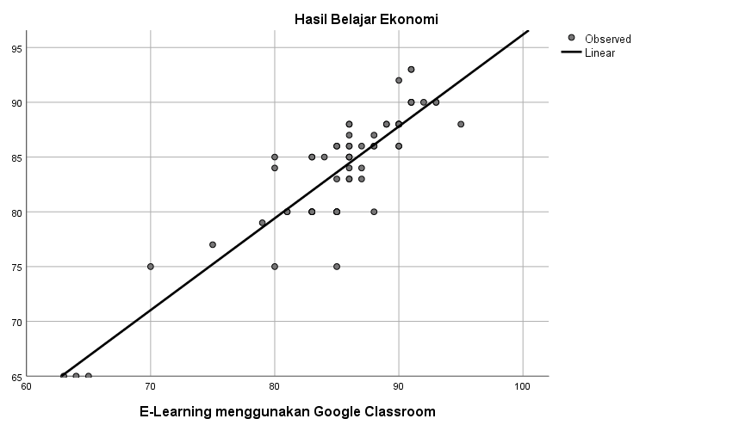

*Lampiran 6: Uji Analisis Regresi Linear Sederhana*

|  |  |  |  |  |  |
| --- | --- | --- | --- | --- | --- |
| **Descriptive Statistics** | | | | | |
|  | N | Minimum | Maximum | Mean | Std. Deviation |
| E-Learning menggunakan Google Classroom | 65 | 63 | 95 | 85.12 | 6.336 |
| Hasil Belajar Ekonomi | 65 | 65 | 93 | 83.71 | 5.955 |
| Valid N (listwise) | 65 |  |  |  |  |

|  |  |  |  |
| --- | --- | --- | --- |
| **Correlations** | | | |
|  | | E-Learning menggunakan Google Classroom | Hasil Belajar Ekonomi |
| E-Learning menggunakan Google Classroom | Pearson Correlation | 1 | .892** |
| Sig. (2-tailed) |  | .000 |
| N | 65 | 65 |
| Hasil Belajar Ekonomi | Pearson Correlation | .892** | 1 |
| Sig. (2-tailed) | .000 |  |
| N | 65 | 65 |
| **. Correlation is significant at the 0.01 level (2-tailed). | | | |

|  |  |  |  |
| --- | --- | --- | --- |
| **Variables Entered/Removeda** | | | |
| Model | Variables Entered | Variables Removed | Method |
| 1 | E-Learning menggunakan Google Classroomb | . | Enter |
| a. Dependent Variable: Hasil Belajar Ekonomi | | | |
| b. All requested variables entered. | | | |

|  |  |  |  |  |
| --- | --- | --- | --- | --- |
| **Model Summary** | | | | |
| Model | R | R Square | Adjusted R Square | Std. Error of the Estimate |
| 1 | .892a | .796 | .793 | 2.711 |
| a. Predictors: (Constant), E-Learning menggunakan Google Classroom | | | | |

|  |  |  |  |  |  |  |
| --- | --- | --- | --- | --- | --- | --- |
| **ANOVAa** | | | | | | |
| Model | | Sum of Squares | df | Mean Square | F | Sig. |
| 1 | Regression | 1806.597 | 1 | 1806.597 | 245.902 | .000b |
| Residual | 462.850 | 63 | 7.347 |  |  |
| Total | 2269.446 | 64 |  |  |  |
| a. Dependent Variable: Hasil Belajar Ekonomi | | | | | | |
| b. Predictors: (Constant), E-Learning menggunakan Google Classroom | | | | | | |

|  |  |  |  |  |  |  |
| --- | --- | --- | --- | --- | --- | --- |
| **Coefficientsa** | | | | | | |
| Model | | Unstandardized Coefficients | | Standardized Coefficients | t | Sig. |
| B | Std. Error | Beta |
| 1 | (Constant) | 12.325 | 4.565 |  | 2.700 | .009 |
| E-Learning menggunakan Google Classroom | .839 | .053 | .892 | 15.681 | .000 |
| a. Dependent Variable: Hasil Belajar Ekonomi | | | | | | |

*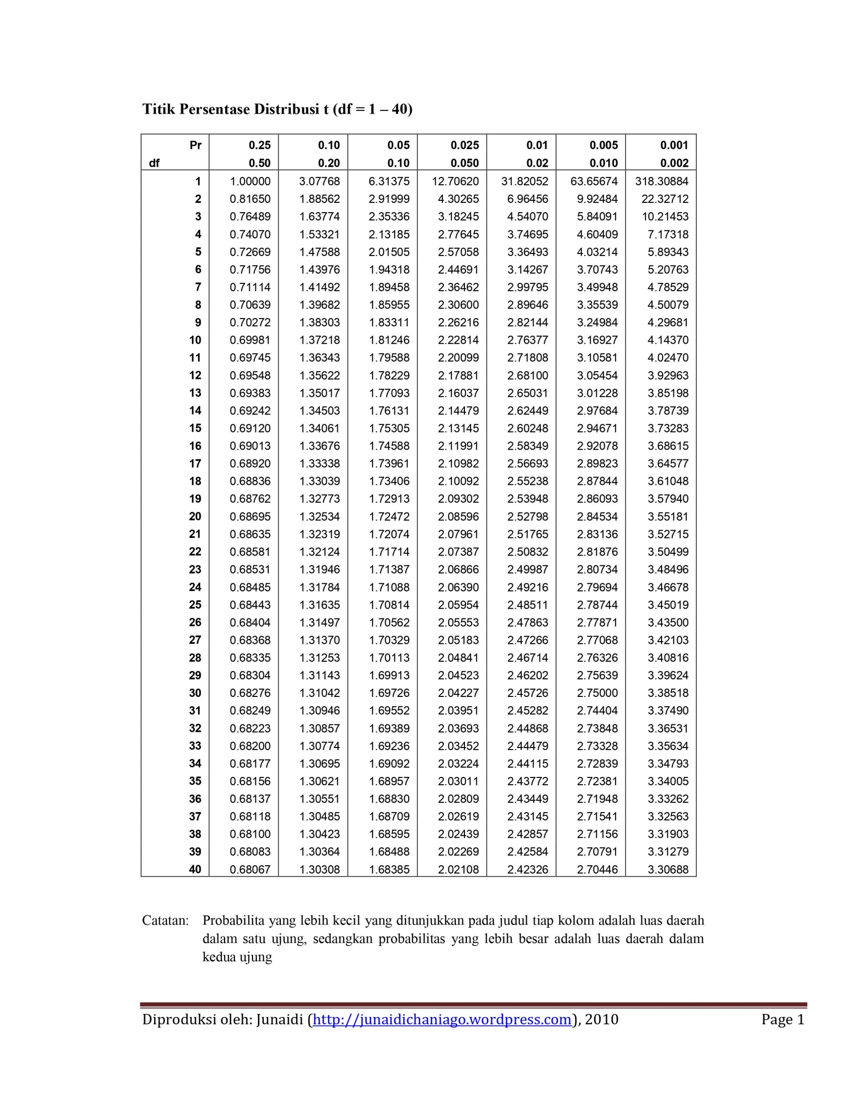Lampiran 7: Tabel Uji T*

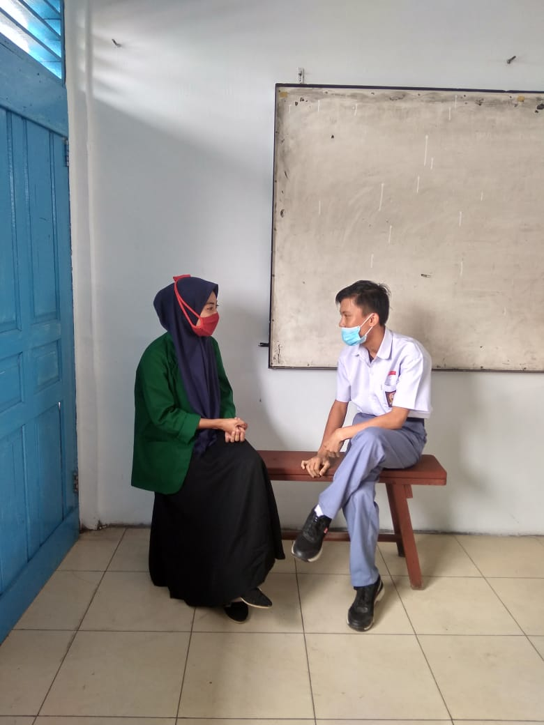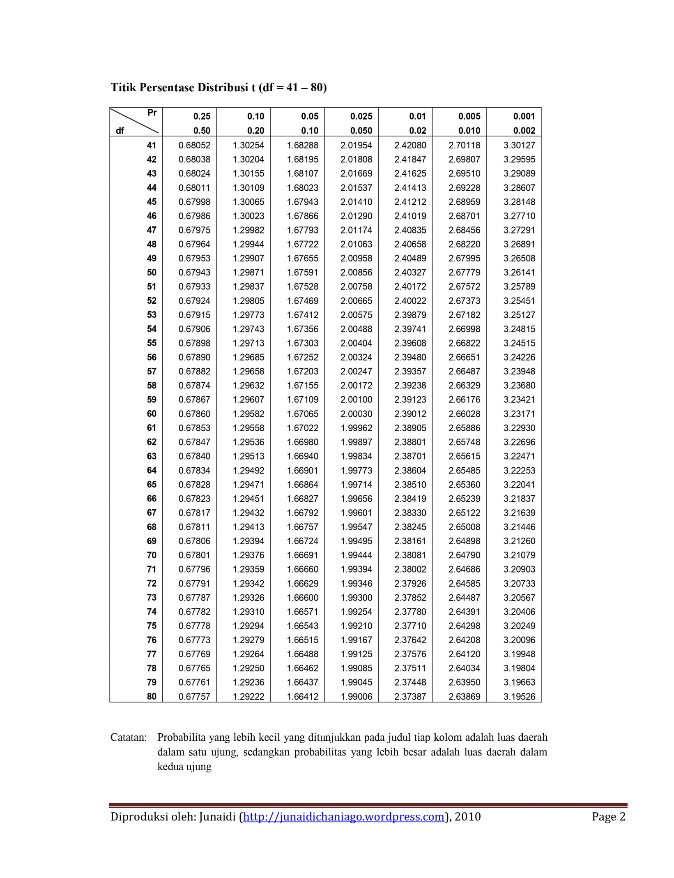

**DOKUMENTASI PENELITIAN**



