LAMPIRAN 1

ANGKET/ KUESIONER
PENGARUH AKTIVITAS BELAJAR TERHADAP PRESTASI BELAJAR SISWA KELAS X SMA SWASTA PRIMA TEMBUNG T.A
2020 / 2021

Dengan Hormat,
Dalam rangka untuk menyelesaikan skripsi pada program studi pendidikan ekonomi, Fakultas Ekonomi Universitas Muslim Nusantara, maka saya memerlukan bantuan adik-adik siswa kelas X SMA Swasta Prima Tembung untuk mengisi kuesioner atau angket yang berjudul "Pengaruh Aktivitas Belajar Terhadap Prestasi Belajar Siswa Kelas X Sma Swasta Prima Tembung T.A 2020 / 2021" dalam rangka mengumpulkan data untuk penelitian tersebut. Oleh karena itu, sebagai alat pengumpulan data yang diperlukan untuk kepentingan ilmiah, kesediaan adik-adik untuk memberikan jawaban yang sesuai dengan kondisi keinginan yang diminati akan sangat saya hargai. Semua identitas dan jawaban yang kami peroleh melalui kuesioner ini tidak akan terbuka untuk umum kecuali untuk alasan ilmiah sehingga kerahasiannya akan sangat terjamin. Saya mengucapkan banyak terima kasih atas bantuan dan kerjasama yang telah adik-adik berikan
Peneliti,

Nirmayanti Boang Manalu

PETUNJUK PENGISIAN
- Mohon terlebih dahulu anda membaca pernyataan dengan cermat, sebelum mengisinya.
- Jawablah dengan sebenarnya.
- Jawaban dengan cek tanda√

IDENTITAS RESPONDEN

Nama :…………………………………....

Nomor Responden :……………..

Jenis Kelamin : a. Laki – laki

b. Perempuan

4. Usia Responden : ……………..Tahun

Pernyataan Atas Variabel X

(Aktivitas belajar)

No | Pernyataan | SS | S | R | TS | STS
1. | Apakah kalian senang membaca buku ?
2. | Apakah kalian sering bertanya kepada guru ?
3. | Apakah kalian pernah memberikan pendapat dalam diskusi baik langsung maupun tidak langsung ?
4. | Apakah kalian pernah menanggapi pendapat orang lain ?
5. | Apakah kalian mendengarkan guru menjelaskan ?
6. | Apakah kalian mencatat materi ?
7. | Apakah kalian berdiskusi dengan baik dengan teman kelompok baik langsung maupun tidak langsung ?
8. | Apakah kalian mengerjakan tugas yang diberikan oleh guru ?
9. | Apakah kalian dapat mengerjakan soal yang diberikan oleh guru ?
10. | Apakah kalian pernah memberi penjelasan kepada teman yang kurang mengerti ?
11. | Apakah kalian berkomunikasi baik dengan teman dan guru ?
12. | Apakah kalian memahami guru yang menjelaskan ?
13. | Apakah kalian memperoleh tambahan materi dari membaca buku,internet dan media lainnya ?
14. | Apakah kalian disiplin dalam kehadiran sekolah ?
15. | Apakah kalian aktif dalam setiap mata pelajaran ?
16. | Apakah kalian kurang memiliki komunikasi yang baik dengan teman dan guru saya ?
17 | Apakah kalian malas dalam mengerjakan tugas rumah (PR) ?
18 | Apakah kalian melawan guru ?
19 | Apakah kalain suka meminta jawaban PR dari teman ?
20 | Apakah kalian suka terlambat masuk jam pelajaran pada proses pembelajaran sudah berlangsung ?

Keterangan

SS : Sangat Setuju : Nilai 5

S : Setuju : Nilai 4

R : Ragu-Ragu : Nilai 3

TS : Tidak Setuju : Nilai 2

STS : Sangat Tidak Setuju : Nilai 1

LAMPIRAN 2

Soal Tes Variabel Y Prestasi Belajar

Nama :

Kelas :

  - Tempat bertemunya penjual dan pembeli adalah pengertian dari
- Taman
- Pasar
- SPBU
- Rumah sakit
- Salon
  - Sebutkan jenis-jenis pasar
    - permintaan bertambah
    - penawaran berkurang
    - permintaan dan penawaran berkurang
    - penawaran berkurang permintaan bertambah
    - penawaran bertambah permintaan berkurang
  - Dari pernyataan-pernyataan dibawah ini yang merupakan bunyi hukum permintaan adalah
    - harga naik permintaan naik.
    - harga turun permintaan turun.
    - harga naik permintaan turun.
    - perubahan harga berbanding dengan perubahan permintaan.
    - perubahan harga sejalan dengan perubahan permintaan.
  - Jika kurva permintaan dan kurva penawaran berpotongan pada suatu titik, perpotongan tersebut adalah....
a. titik temu
b. titik optimum
c. titik keseimbangan
d. titik belok
e. titik persinggungan
  - Harga keseimbangan akan terbentuk apabila....
a. supply = 0
b. suppy = 1
c. demand < supply
d. demand = supply
e. demand > supply
  - Perubahan harga suatu barang tidak memengaruhi permintaan terhadap barang tersebut, ini artinya koefisien permintaan barang tersebut adalah....
a. elastis
b. inelastis
c. unitary
d. elastis sempurna
e. inelastis sempurna
  - Apabial persentase perubahan jumlah barang yang ditawarkan lebih besar dari presentase perubahan harga (E_{s}>1) disebut koefisien penawaran....
a. elastis
b. inelastis
c. unitary
d. elastis sempurna
e. inelastis sempurna
  - Penggolongan pasar berdasarkan wujudnya adalah....
a. pasar konkret dan pasar abstrak
b. pasar harian, pasar mingguan, pasar bulanan, dan pasar tahunan
c. pasar lokal, pasar regional, pasar nasional, dan pasar internasional
d. pasar barang produksi dan pasar barang konsumsi
e. pasar persaingan sempurna dan pasar persaingan tidak sempurna
  - Ketika ada salah satu pihak, yaitu penjual atau pembeli yang lebih dominan di dalam pasar berarti pasar tersebut adalah pasar....
a. sempurna
b. abstrak
c. persaingan sempurna
d. oligopoli
e. konkret
  - Pasar di mana seorang penjual bisa menjual berapa pun produk yang dihasilkannya tanpa memengaruhi kuantitas pasar secara keseluruhan termasuk pada pasar....
a. abstrak
b. monopolistik
c. oligopoli
d. doupoli
e. monopoli
  - Berdasarkan waktu terjadinya, Pekan Raya Jakarta adalah pasar....
a. harian
b. mingguan
c. bulanan
d. tahunan
e. bebas
  - Bentuk campur tangan pemerintah dalam pasar persaingan sempurna dapat berwujud pemberian subsidi kepada....
a. perusahaan kecil
b. perusahaan besar
c. perusahaan besar dan kecil
d. konsumen kecil
e. konsumen potensial
  - Berikut ini ciri-ciri bentuk pasar barang :
- Terdapat banyak penjual dan pembeli
- Jenis barang yang dipasarkan homogen
- Harga terbentuk oleh mekanisme pasar
- Ada hambatan untuk memasuki pasar
- Produknya tidak mempunyai substitusi
Yang merupakan ciri-ciri pasar persaingan sempurna adalah nomor ….
    - 1, 2 dan 3
    - 1, 4 dan 5
    - 2, 3 dan 4
    - 2, 4 dan 4
    - 3, 4 dan 5
  - Jumlah penjual dan pembeli banyak, sehingga harga ditentukan oleh kekuatan permintaan dan penawaran, pembentukan harga semacam ini terjadi dalam pasar...
    - monopoli
    - monopolistik
    - oligopoli
    - nomopsoni
    - persaingan sempurna
  - efektif adalah…..
    - permintaan yang benar-benar dapat dilaksanakan.
    - permintaan yang sangat terpengaruh perubahan harga
    - permintaan yang kurang terpengaruh perubahan harga
    - permintaan yang tidak disertai kemampuan membayar.
    - permintaan yang tidak dipengaruhi oleh perubahan harga.
  - Tabel permintaan menunjukkan hubungan antara jumlah suatu barang atau jasa yang di minta dalam jangka tertentu dan..
- Selera konsumen
- Pendapatan konsumen
- Barang subtitusi
- Harga barang
- Biaya produksi
  - Harga barang dapat mempengaruhi permintaan dan penawaraan. Akibat jika harga naik adalah.....
- permintaan bertambah
- penawaran berkurang
- permintaan dan penawaran berkurang
- penawaran berkurang permintaan bertambah
- penawaran bertambah permintaan berkurang
  - Dari pernyataan-pernyataan dibawah ini yang merupakan bunyi hukum permintaan adalah
- harga naik permintaan naik.
- harga turun permintaan turun.
- harga naik permintaan turun.
- perubahan harga berbanding dengan perubahan permintaan.
- perubahan harga sejalan dengan perubahan permintaan.
  - Berikut ini merupakan faktor-faktor yang mempengaruhi permintaan dan penawaran
  - Harga barang
  - Tingkat pendapatan
  - Selera konsumen
  - Biaya produksi
  - Teknologi
Faktor-faktor yang mempengaruhi permintaan adalah….
- 1,2 dan 3
- 1,3 dan 4
- 2,3 dan 4
- 2,4 dan 5
- 3,4 dan 5
  - Yang mendapat premi produsen adalah……..
- Pembeli submarginal
- Pembelian marginal
- Pembeli supermarginal
- Penjual supermarginal
- Penjual marginal

KUNCI JAWABAN TES SOAL

- D 6. E 11.B 16.D
- E 7.A 12.A 17.E
- C 8.A 13.A 18.C
- C 9.D 14.E 19.A
- D 10.E 15.A 20.D

LAMPIRAN 3
Tabulasi Jawaban X

Statistics
 |  | x1 | x2 | x3 | x4 | x5 | x6 | x7
N | Valid | 60 | 60 | 60 | 60 | 60 | 60 | 60
 | Missing | 0 | 0 | 0 | 0 | 0 | 0 | 0

Statistics
 |  | x8 | x9 | x10 | x11 | x12 | x13 | x14
N | Valid | 60 | 60 | 60 | 60 | 60 | 60 | 60
 | Missing | 0 | 0 | 0 | 0 | 0 | 0 | 0

Statistics
 |  | x15 | x16 | x17 | x18 | x19 | x20
N | Valid | 60 | 60 | 60 | 60 | 60 | 60
 | Missing | 0 | 0 | 0 | 0 | 0 | 0

Frequency Table
x1
 |  | Frequency | Percent | Valid Percent | Cumulative Percent
Valid | Tidak Setuju | 1 | 1.7 | 1.7 | 1.7
 | Ragu-ragu | 1 | 1.7 | 1.7 | 3.3
 | Setuju | 23 | 38.3 | 38.3 | 41.7
 | Sangat Setuju | 35 | 58.3 | 58.3 | 100.0
 | Total | 60 | 100.0 | 100.0

x2
 |  | Frequency | Percent | Valid Percent | Cumulative Percent
Valid | Tidak Setuju | 1 | 1.7 | 1.7 | 1.7
 | Ragu-ragu | 3 | 5.0 | 5.0 | 6.7
 | Setuju | 17 | 28.3 | 28.3 | 35.0
 | Sangat Setuju | 39 | 65.0 | 65.0 | 100.0
 | Total | 60 | 100.0 | 100.0

x3
 |  | Frequency | Percent | Valid Percent | Cumulative Percent
Valid | Ragu-ragu | 4 | 6.7 | 6.7 | 6.7
 | Setuju | 16 | 26.7 | 26.7 | 33.3
 | Sangat Setuju | 40 | 66.7 | 66.7 | 100.0
 | Total | 60 | 100.0 | 100.0

x4
 |  | Frequency | Percent | Valid Percent | Cumulative Percent
Valid | Tidak Setuju | 1 | 1.7 | 1.7 | 1.7
 | Ragu-ragu | 5 | 8.3 | 8.3 | 10.0
 | Setuju | 16 | 26.7 | 26.7 | 36.7
 | Sangat Setuju | 38 | 63.3 | 63.3 | 100.0
 | Total | 60 | 100.0 | 100.0

x5
 |  | Frequency | Percent | Valid Percent | Cumulative Percent
Valid | Tidak Setuju | 1 | 1.7 | 1.7 | 1.7
 | Ragu-ragu | 2 | 3.3 | 3.3 | 5.0
 | Setuju | 19 | 31.7 | 31.7 | 36.7
 | Sangat Setuju | 38 | 63.3 | 63.3 | 100.0
 | Total | 60 | 100.0 | 100.0

x6
 |  | Frequency | Percent | Valid Percent | Cumulative Percent
Valid | Ragu-ragu | 2 | 3.3 | 3.3 | 3.3
 | Setuju | 17 | 28.3 | 28.3 | 31.7
 | Sangat Setuju | 41 | 68.3 | 68.3 | 100.0
 | Total | 60 | 100.0 | 100.0
x7
 |  | Frequency | Percent | Valid Percent | Cumulative Percent
Valid | Tidak Setuju | 1 | 1.7 | 1.7 | 1.7
 | Ragu-ragu | 3 | 5.0 | 5.0 | 6.7
 | Setuju | 14 | 23.3 | 23.3 | 30.0
 | Sangat Setuju | 42 | 70.0 | 70.0 | 100.0
 | Total | 60 | 100.0 | 100.0

x8
 |  | Frequency | Percent | Valid Percent | Cumulative Percent
Valid | Ragu-ragu | 1 | 1.7 | 1.7 | 1.7
 | Setuju | 14 | 23.3 | 23.3 | 25.0
 | Sangat Setuju | 45 | 75.0 | 75.0 | 100.0
 | Total | 60 | 100.0 | 100.0

x9
 |  | Frequency | Percent | Valid Percent | Cumulative Percent
Valid | Ragu-ragu | 1 | 1.7 | 1.7 | 1.7
 | Setuju | 9 | 15.0 | 15.0 | 16.7
 | Sangat Setuju | 50 | 83.3 | 83.3 | 100.0
 | Total | 60 | 100.0 | 100.0

x10
 |  | Frequency | Percent | Valid Percent | Cumulative Percent
Valid | Tidak Setuju | 1 | 1.7 | 1.7 | 1.7
 | Ragu-ragu | 1 | 1.7 | 1.7 | 3.3
 | Setuju | 13 | 21.7 | 21.7 | 25.0
 | Sangat Setuju | 45 | 75.0 | 75.0 | 100.0
 | Total | 60 | 100.0 | 100.0

x11
 |  | Frequency | Percent | Valid Percent | Cumulative Percent
Valid | Ragu-ragu | 2 | 3.3 | 3.3 | 3.3
 | Setuju | 11 | 18.3 | 18.3 | 21.7
 | Sangat Setuju | 47 | 78.3 | 78.3 | 100.0
 | Total | 60 | 100.0 | 100.0

x12
 |  | Frequency | Percent | Valid Percent | Cumulative Percent
Valid | Ragu-ragu | 2 | 3.3 | 3.3 | 3.3
 | Setuju | 8 | 13.3 | 13.3 | 16.7
 | Sangat Setuju | 50 | 83.3 | 83.3 | 100.0
 | Total | 60 | 100.0 | 100.0

x13
 |  | Frequency | Percent | Valid Percent | Cumulative Percent
Valid | Ragu-ragu | 2 | 3.3 | 3.3 | 3.3
 | Setuju | 6 | 10.0 | 10.0 | 13.3
 | Sangat Setuju | 52 | 86.7 | 86.7 | 100.0
 | Total | 60 | 100.0 | 100.0

x14
 |  | Frequency | Percent | Valid Percent | Cumulative Percent
Valid | Setuju | 14 | 23.3 | 23.3 | 23.3
 | Sangat Setuju | 46 | 76.7 | 76.7 | 100.0
 | Total | 60 | 100.0 | 100.0
x15
 |  | Frequency | Percent | Valid Percent | Cumulative Percent
Valid | Ragu-ragu | 2 | 3.3 | 3.3 | 3.3
 | Setuju | 11 | 18.3 | 18.3 | 21.7
 | Sangat Setuju | 47 | 78.3 | 78.3 | 100.0
 | Total | 60 | 100.0 | 100.0

x16
 |  | Frequency | Percent | Valid Percent | Cumulative Percent
Valid | Ragu-ragu | 1 | 1.7 | 1.7 | 1.7
 | Setuju | 13 | 21.7 | 21.7 | 23.3
 | Sangat Setuju | 46 | 76.7 | 76.7 | 100.0
 | Total | 60 | 100.0 | 100.0

x17
 |  | Frequency | Percent | Valid Percent | Cumulative Percent
Valid | Ragu-ragu | 2 | 3.3 | 3.3 | 3.3
 | Setuju | 8 | 13.3 | 13.3 | 16.7
 | Sangat Setuju | 50 | 83.3 | 83.3 | 100.0
 | Total | 60 | 100.0 | 100.0

x18
 |  | Frequency | Percent | Valid Percent | Cumulative Percent
Valid | Ragu-ragu | 2 | 3.3 | 3.3 | 3.3
 | Setuju | 6 | 10.0 | 10.0 | 13.3
 | Sangat Setuju | 52 | 86.7 | 86.7 | 100.0
 | Total | 60 | 100.0 | 100.0

x19
 |  | Frequency | Percent | Valid Percent | Cumulative Percent
Valid | Ragu-ragu | 4 | 6.7 | 6.7 | 6.7
 | Setuju | 9 | 15.0 | 15.0 | 21.7
 | Sangat Setuju | 47 | 78.3 | 78.3 | 100.0
 | Total | 60 | 100.0 | 100.0

x20
 |  | Frequency | Percent | Valid Percent | Cumulative Percent
Valid | Setuju | 10 | 16.7 | 16.7 | 16.7
 | Sangat Setuju | 50 | 83.3 | 83.3 | 100.0
 | Total | 60 | 100.0 | 100.0

LAMPIRAN 4

Tabulasi Jawaban Y

Statistics
 |  | y1 | y2 | y3 | y4 | y5 | y6 | y7
N | Valid | 60 | 60 | 60 | 60 | 60 | 60 | 60
 | Missing | 0 | 0 | 0 | 0 | 0 | 0 | 0

Statistics
 |  | y8 | y9 | y10 | y11 | y12 | y13 | y14
N | Valid | 60 | 60 | 60 | 60 | 60 | 60 | 60
 | Missing | 0 | 0 | 0 | 0 | 0 | 0 | 0

Statistics
 |  | y15 | y16 | y17 | y18 | y19 | y20
N | Valid | 60 | 60 | 60 | 60 | 60 | 60
 | Missing | 0 | 0 | 0 | 0 | 0 | 0

Frequency Table
y1
 |  | Frequency | Percent | Valid Percent | Cumulative Percent
Valid | Salah | 35 | 58.3 | 58.3 | 58.3
 | Benar | 25 | 41.7 | 41.7 | 100.0
 | Total | 60 | 100.0 | 100.0

y2
 |  | Frequency | Percent | Valid Percent | Cumulative Percent
Valid | Salah | 23 | 38.3 | 38.3 | 38.3
 | Benar | 37 | 61.7 | 61.7 | 100.0
 | Total | 60 | 100.0 | 100.0

y3
 |  | Frequency | Percent | Valid Percent | Cumulative Percent
Valid | Salah | 25 | 41.7 | 41.7 | 41.7
 | Benar | 35 | 58.3 | 58.3 | 100.0
 | Total | 60 | 100.0 | 100.0

y4
 |  | Frequency | Percent | Valid Percent | Cumulative Percent
Valid | Salah | 17 | 28.3 | 28.3 | 28.3
 | Benar | 43 | 71.7 | 71.7 | 100.0
 | Total | 60 | 100.0 | 100.0

y5
 |  | Frequency | Percent | Valid Percent | Cumulative Percent
Valid | Salah | 14 | 23.3 | 23.3 | 23.3
 | Benar | 46 | 76.7 | 76.7 | 100.0
 | Total | 60 | 100.0 | 100.0

y6
 |  | Frequency | Percent | Valid Percent | Cumulative Percent
Valid | Salah | 8 | 13.3 | 13.3 | 13.3
 | Benar | 52 | 86.7 | 86.7 | 100.0
 | Total | 60 | 100.0 | 100.0

y7
 |  | Frequency | Percent | Valid Percent | Cumulative Percent
Valid | Salah | 9 | 15.0 | 15.0 | 15.0
 | Benar | 51 | 85.0 | 85.0 | 100.0
 | Total | 60 | 100.0 | 100.0

y8
 |  | Frequency | Percent | Valid Percent | Cumulative Percent
Valid | Salah | 7 | 11.7 | 11.7 | 11.7
 | Benar | 53 | 88.3 | 88.3 | 100.0
 | Total | 60 | 100.0 | 100.0

y9
 |  | Frequency | Percent | Valid Percent | Cumulative Percent
Valid | Salah | 5 | 8.3 | 8.3 | 8.3
 | Benar | 55 | 91.7 | 91.7 | 100.0
 | Total | 60 | 100.0 | 100.0

y10
 |  | Frequency | Percent | Valid Percent | Cumulative Percent
Valid | Salah | 9 | 15.0 | 15.0 | 15.0
 | Benar | 51 | 85.0 | 85.0 | 100.0
 | Total | 60 | 100.0 | 100.0

y11
 |  | Frequency | Percent | Valid Percent | Cumulative Percent
Valid | Salah | 12 | 20.0 | 20.0 | 20.0
 | Benar | 48 | 80.0 | 80.0 | 100.0
 | Total | 60 | 100.0 | 100.0

y12
 |  | Frequency | Percent | Valid Percent | Cumulative Percent
Valid | Salah | 11 | 18.3 | 18.3 | 18.3
 | Benar | 49 | 81.7 | 81.7 | 100.0
 | Total | 60 | 100.0 | 100.0

y13
 |  | Frequency | Percent | Valid Percent | Cumulative Percent
Valid | Salah | 11 | 18.3 | 18.3 | 18.3
 | Benar | 49 | 81.7 | 81.7 | 100.0
 | Total | 60 | 100.0 | 100.0

y14
 |  | Frequency | Percent | Valid Percent | Cumulative Percent
Valid | Salah | 10 | 16.7 | 16.7 | 16.7
 | Benar | 50 | 83.3 | 83.3 | 100.0
 | Total | 60 | 100.0 | 100.0

y15
 |  | Frequency | Percent | Valid Percent | Cumulative Percent
Valid | Salah | 14 | 23.3 | 23.3 | 23.3
 | Benar | 46 | 76.7 | 76.7 | 100.0
 | Total | 60 | 100.0 | 100.0

y16
 |  | Frequency | Percent | Valid Percent | Cumulative Percent
Valid | Salah | 6 | 10.0 | 10.0 | 10.0
 | Benar | 54 | 90.0 | 90.0 | 100.0
 | Total | 60 | 100.0 | 100.0

y17
 |  | Frequency | Percent | Valid Percent | Cumulative Percent
Valid | Salah | 8 | 13.3 | 13.3 | 13.3
 | Benar | 52 | 86.7 | 86.7 | 100.0
 | Total | 60 | 100.0 | 100.0

y18
 |  | Frequency | Percent | Valid Percent | Cumulative Percent
Valid | Salah | 11 | 18.3 | 18.3 | 18.3
 | Benar | 49 | 81.7 | 81.7 | 100.0
 | Total | 60 | 100.0 | 100.0

y19
 |  | Frequency | Percent | Valid Percent | Cumulative Percent
Valid | Salah | 7 | 11.7 | 11.7 | 11.7
 | Benar | 53 | 88.3 | 88.3 | 100.0
 | Total | 60 | 100.0 | 100.0

y20
 |  | Frequency | Percent | Valid Percent | Cumulative Percent
Valid | Salah | 7 | 11.7 | 11.7 | 11.7
 | Benar | 53 | 88.3 | 88.3 | 100.0
 | Total | 60 | 100.0 | 100.0

LAMPIRAN 5

UJI VALIDITAS X
Correlations
 |  | x1 | x2 |  | x3 |  | x4 |  | x5 |  | x6 |  | x7 |  | x8 |  | x9 |  | x10 |  | x11 |  | x12 |  | x13 |  | x14 |  | x15 |  | x16 |  | x17 |  | x18 |  | x19 |  | x20 |  | Aktivitas Belajar
x1 | Pearson Correlation | 1 |  | .156 |  | .124 |  | .130 |  | -.048 |  | .209 |  | .052 |  | -.139 |  | -.134 |  | .120 |  | .160 |  | .306* |  | .079 |  | -.098 |  | -.160 |  | .115 |  | -.147 |  | -.159 |  | -.183 |  | .024 |  | .311*
 | Sig. (2-tailed) |  |  | .233 |  | .347 |  | .322 |  | .718 |  | .109 |  | .695 |  | .290 |  | .306 |  | .363 |  | .221 |  | .018 |  | .547 |  | .458 |  | .221 |  | .383 |  | .262 |  | .226 |  | .162 |  | .855 |  | .000
 | N | 60 |  | 60 |  | 60 |  | 60 |  | 60 |  | 60 |  | 60 |  | 60 |  | 60 |  | 60 |  | 60 |  | 60 |  | 60 |  | 60 |  | 60 |  | 60 |  | 60 |  | 60 |  | 60 |  | 60 |  | 60
x2 | Pearson Correlation | .156 |  | 1 |  | .025 |  | -.228 |  | .067 |  | -.143 |  | -.037 |  | -.049 |  | -.045 |  | .009 |  | .124 |  | -.010 |  | -.018 |  | .291* |  | -.124 |  | -.186 |  | -.010 |  | -.018 |  | -.102 |  | .045 |  | .253
 | Sig. (2-tailed) | .233 |  |  |  | .852 |  | .080 |  | .609 |  | .277 |  | .782 |  | .712 |  | .734 |  | .948 |  | .346 |  | .937 |  | .889 |  | .024 |  | .346 |  | .155 |  | .937 |  | .889 |  | .439 |  | .735 |  | .000
 | N | 60 |  | 60 |  | 60 |  | 60 |  | 60 |  | 60 |  | 60 |  | 60 |  | 60 |  | 60 |  | 60 |  | 60 |  | 60 |  | 60 |  | 60 |  | 60 |  | 60 |  | 60 |  | 60 |  | 60 |  | 60
x3 | Pearson Correlation | .124 |  | .025 |  | 1 |  | .129 |  | .238 |  | -.070 |  | .033 |  | .034 |  | .038 |  | .130 |  | .000 |  | .241 |  | -.120 |  | .026 |  | -.162 |  | .000 |  | -.046 |  | -.060 |  | -.226 |  | .220 |  | .221*
 | Sig. (2-tailed) | .347 |  | .852 |  |  |  | .326 |  | .067 |  | .593 |  | .802 |  | .795 |  | .772 |  | .321 |  | 1.000 |  | .064 |  | .360 |  | .845 |  | .215 |  | 1.000 |  | .728 |  | .648 |  | .083 |  | .092 |  | .000
 | N | 60 |  | 60 |  | 60 |  | 60 |  | 60 |  | 60 |  | 60 |  | 60 |  | 60 |  | 60 |  | 60 |  | 60 |  | 60 |  | 60 |  | 60 |  | 60 |  | 60 |  | 60 |  | 60 |  | 60 |  | 60
x4 | Pearson Correlation | .130 |  | -.228 |  | .129 |  | 1 |  | -.129 |  | .378** |  | -.074 |  | -.036 |  | .037 |  | .012 |  | -.012 |  | -.039 |  | .162 |  | -.207 |  | -.058 |  | -.012 |  | .010 |  | .060 |  | .031 |  | .197 |  | .275*
 | Sig. (2-tailed) | .322 |  | .080 |  | .326 |  |  |  | .327 |  | .003 |  | .573 |  | .787 |  | .779 |  | .928 |  | .930 |  | .768 |  | .216 |  | .113 |  | .663 |  | .925 |  | .941 |  | .651 |  | .812 |  | .131 |  | . .000
 | N | 60 |  | 60 |  | 60 |  | 60 |  | 60 |  | 60 |  | 60 |  | 60 |  | 60 |  | 60 |  | 60 |  | 60 |  | 60 |  | 60 |  | 60 |  | 60 |  | 60 |  | 60 |  | 60 |  | 60 |  | 60
x5 | Pearson Correlation | -.048 |  | .067 |  | .238 |  | -.129 |  | 1 |  | -.196 |  | .041 |  | .275* |  | -.047 |  | .142 |  | .386** |  | -.120 |  | -.076 |  | -.004 |  | .077 |  | .138 |  | .098 |  | .153 |  | -.195 |  | .186 |  | .277**
 | Sig. (2-tailed) | .718 |  | .609 |  | .067 |  | .327 |  |  |  | .133 |  | .758 |  | .034 |  | .724 |  | .280 |  | .002 |  | .361 |  | .562 |  | .975 |  | .558 |  | .293 |  | .456 |  | .244 |  | .135 |  | .155 |  | .003
 | N | 60 |  | 60 |  | 60 |  | 60 |  | 60 |  | 60 |  | 60 |  | 60 |  | 60 |  | 60 |  | 60 |  | 60 |  | 60 |  | 60 |  | 60 |  | 60 |  | 60 |  | 60 |  | 60 |  | 60 |  | 60
x6 | Pearson Correlation | .209 |  | -.143 |  | -.070 |  | .378** |  | -.196 |  | 1 |  | -.235 |  | -.039 |  | .011 |  | .142 |  | .168 |  | .181 |  | .373** |  | .153 |  | -.198 |  | .049 |  | -.077 |  | -.034 |  | .215 |  | .124 |  | .270**
 | Sig. (2-tailed) | .109 |  | .277 |  | .593 |  | .003 |  | .133 |  |  |  | .071 |  | .770 |  | .935 |  | .281 |  | .200 |  | .167 |  | .003 |  | .245 |  | .129 |  | .710 |  | .556 |  | .797 |  | .100 |  | .346 |  | .005
 | N | 60 |  | 60 |  | 60 |  | 60 |  | 60 |  | 60 |  | 60 |  | 60 |  | 60 |  | 60 |  | 60 |  | 60 |  | 60 |  | 60 |  | 60 |  | 60 |  | 60 |  | 60 |  | 60 |  | 60 |  | 60
x7 | Pearson Correlation | .052 |  | -.037 |  | .033 |  | -.074 |  | .041 |  | -.235 |  | 1 |  | .098 |  | .046 |  | -.039 |  | -.138 |  | -.032 |  | -.213 |  | -.022 |  | .063 |  | .497** |  | .339** |  | .065 |  | -.153 |  | .214 |  | .277*
 | Sig. (2-tailed) | .695 |  | .782 |  | .802 |  | .573 |  | .758 |  | .071 |  |  |  | .454 |  | .726 |  | .769 |  | .294 |  | .809 |  | .102 |  | .868 |  | .635 |  | .000 |  | .008 |  | .622 |  | .243 |  | .100 |  | .000
 | N | 60 |  | 60 |  | 60 |  | 60 |  | 60 |  | 60 |  | 60 |  | 60 |  | 60 |  | 60 |  | 60 |  | 60 |  | 60 |  | 60 |  | 60 |  | 60 |  | 60 |  | 60 |  | 60 |  | 60 |  | 60
x8 | Pearson Correlation | -.139 |  | -.049 |  | .034 |  | -.036 |  | .275* |  | -.039 |  | .098 |  | 1 |  | -.239 |  | -.048 |  | .138 |  | -.161 |  | -.051 |  | .022 |  | .069 |  | .148 |  | .205 |  | .026 |  | -.032 |  | .218 |  | .261
 | Sig. (2-tailed) | .290 |  | .712 |  | .795 |  | .787 |  | .034 |  | .770 |  | .454 |  |  |  | .066 |  | .718 |  | .292 |  | .219 |  | .698 |  | .868 |  | .600 |  | .258 |  | .116 |  | .846 |  | .808 |  | .094 |  | .000
 | N | 60 |  | 60 |  | 60 |  | 60 |  | 60 |  | 60 |  | 60 |  | 60 |  | 60 |  | 60 |  | 60 |  | 60 |  | 60 |  | 60 |  | 60 |  | 60 |  | 60 |  | 60 |  | 60 |  | 60 |  | 60
x9 | Pearson Correlation | -.134 |  | -.045 |  | .038 |  | .037 |  | -.047 |  | .011 |  | .046 |  | -.239 |  | 1 |  | .179 |  | -.058 |  | -.016 |  | .186 |  | .132 |  | -.212 |  | -.145 |  | -.180 |  | -.158 |  | -.008 |  | .017 |  | .227
 | Sig. (2-tailed) | .306 |  | .734 |  | .772 |  | .779 |  | .724 |  | .935 |  | .726 |  | .066 |  |  |  | .170 |  | .660 |  | .901 |  | .154 |  | .315 |  | .103 |  | .269 |  | .169 |  | .229 |  | .953 |  | .895 |  | . .000
 | N | 60 |  | 60 |  | 60 |  | 60 |  | 60 |  | 60 |  | 60 |  | 60 |  | 60 |  | 60 |  | 60 |  | 60 |  | 60 |  | 60 |  | 60 |  | 60 |  | 60 |  | 60 |  | 60 |  | 60 |  | 60
x10 | Pearson Correlation | .120 |  | .009 |  | .130 |  | .012 |  | .142 |  | .142 |  | -.039 |  | -.048 |  | .179 |  | 1 |  | .141 |  | .263* |  | .188 |  | .256* |  | .028 |  | -.091 |  | -.096 |  | .000 |  | .240 |  | .000 |  | .398**
 | Sig. (2-tailed) | .363 |  | .948 |  | .321 |  | .928 |  | .280 |  | .281 |  | .769 |  | .718 |  | .170 |  |  |  | .282 |  | .042 |  | .150 |  | .049 |  | .831 |  | .490 |  | .468 |  | 1.000 |  | .064 |  | 1.000 |  | .000
 | N | 60 |  | 60 |  | 60 |  | 60 |  | 60 |  | 60 |  | 60 |  | 60 |  | 60 |  | 60 |  | 60 |  | 60 |  | 60 |  | 60 |  | 60 |  | 60 |  | 60 |  | 60 |  | 60 |  | 60 |  | 60
x11 | Pearson Correlation | .160 |  | .124 |  | .000 |  | -.012 |  | .386** |  | .168 |  | -.138 |  | .138 |  | -.058 |  | .141 |  | 1 |  | .000 |  | .255* |  | -.039 |  | .016 |  | .158 |  | .000 |  | .036 |  | -.071 |  | .044 |  | .343**
 | Sig. (2-tailed) | .221 |  | .346 |  | 1.000 |  | .930 |  | .002 |  | .200 |  | .294 |  | .292 |  | .660 |  | .282 |  |  |  | 1.000 |  | .049 |  | .767 |  | .901 |  | .227 |  | 1.000 |  | .782 |  | .589 |  | .736 |  | .001
 | N | 60 |  | 60 |  | 60 |  | 60 |  | 60 |  | 60 |  | 60 |  | 60 |  | 60 |  | 60 |  | 60 |  | 60 |  | 60 |  | 60 |  | 60 |  | 60 |  | 60 |  | 60 |  | 60 |  | 60 |  | 60
x12 | Pearson Correlation | .306* |  | -.010 |  | .241 |  | -.039 |  | -.120 |  | .181 |  | -.032 |  | -.161 |  | -.016 |  | .263* |  | .000 |  | 1 |  | -.077 |  | -.149 |  | -.208 |  | -.074 |  | -.103 |  | -.154 |  | -.024 |  | -.094 |  | .370
 | Sig. (2-tailed) | .018 |  | .937 |  | .064 |  | .768 |  | .361 |  | .167 |  | .809 |  | .219 |  | .901 |  | .042 |  | 1.000 |  |  |  | .558 |  | .256 |  | .110 |  | .572 |  | .434 |  | .239 |  | .855 |  | .475 |  | . .000
 | N | 60 |  | 60 |  | 60 |  | 60 |  | 60 |  | 60 |  | 60 |  | 60 |  | 60 |  | 60 |  | 60 |  | 60 |  | 60 |  | 60 |  | 60 |  | 60 |  | 60 |  | 60 |  | 60 |  | 60 |  | 60
x13 | Pearson Correlation | .079 |  | -.018 |  | -.120 |  | .162 |  | -.076 |  | .373** |  | -.213 |  | -.051 |  | .186 |  | .188 |  | .255* |  | -.077 |  | 1 |  | .232 |  | .036 |  | .117 |  | -.154 |  | .027 |  | .074 |  | .033 |  | .259*
 | Sig. (2-tailed) | .547 |  | .889 |  | .360 |  | .216 |  | .562 |  | .003 |  | .102 |  | .698 |  | .154 |  | .150 |  | .049 |  | .558 |  |  |  | .075 |  | .782 |  | .372 |  | .239 |  | .838 |  | .574 |  | .803 |  | .000
 | N | 60 |  | 60 |  | 60 |  | 60 |  | 60 |  | 60 |  | 60 |  | 60 |  | 60 |  | 60 |  | 60 |  | 60 |  | 60 |  | 60 |  | 60 |  | 60 |  | 60 |  | 60 |  | 60 |  | 60 |  | 60
x14 | Pearson Correlation | -.098 |  | .291* |  | .026 |  | -.207 |  | -.004 |  | .153 |  | -.022 |  | .022 |  | .132 |  | .256* |  | -.039 |  | -.149 |  | .232 |  | 1 |  | -.039 |  | -.126 |  | -.149 |  | .145 |  | .342** |  | .070 |  | .352*
 | Sig. (2-tailed) | .458 |  | .024 |  | .845 |  | .113 |  | .975 |  | .245 |  | .868 |  | .868 |  | .315 |  | .049 |  | .767 |  | .256 |  | .075 |  |  |  | .767 |  | .338 |  | .256 |  | .269 |  | .007 |  | .593 |  | . .000
 | N | 60 |  | 60 |  | 60 |  | 60 |  | 60 |  | 60 |  | 60 |  | 60 |  | 60 |  | 60 |  | 60 |  | 60 |  | 60 |  | 60 |  | 60 |  | 60 |  | 60 |  | 60 |  | 60 |  | 60 |  | 60
x15 | Pearson Correlation | -.160 |  | -.124 |  | -.162 |  | -.058 |  | .077 |  | -.198 |  | .063 |  | .069 |  | -.212 |  | .028 |  | .016 |  | -.208 |  | .036 |  | -.039 |  | 1 |  | .018 |  | .069 |  | .109 |  | -.014 |  | -.044 |  | .330
 | Sig. (2-tailed) | .221 |  | .346 |  | .215 |  | .663 |  | .558 |  | .129 |  | .635 |  | .600 |  | .103 |  | .831 |  | .901 |  | .110 |  | .782 |  | .767 |  |  |  | .894 |  | .598 |  | .405 |  | .914 |  | .736 |  | . .000
 | N | 60 |  | 60 |  | 60 |  | 60 |  | 60 |  | 60 |  | 60 |  | 60 |  | 60 |  | 60 |  | 60 |  | 60 |  | 60 |  | 60 |  | 60 |  | 60 |  | 60 |  | 60 |  | 60 |  | 60 |  | 60
x16 | Pearson Correlation | .115 |  | -.186 |  | .000 |  | -.012 |  | .138 |  | .049 |  | .497** |  | .148 |  | -.145 |  | -.091 |  | .158 |  | -.074 |  | .117 |  | -.126 |  | .018 |  | 1 |  | .298* |  | .274* |  | -.015 |  | .143 |  | .307*
 | Sig. (2-tailed) | .383 |  | .155 |  | 1.000 |  | .925 |  | .293 |  | .710 |  | .000 |  | .258 |  | .269 |  | .490 |  | .227 |  | .572 |  | .372 |  | .338 |  | .894 |  |  |  | .021 |  | .034 |  | .908 |  | .277 |  | .002
 | N | 60 |  | 60 |  | 60 |  | 60 |  | 60 |  | 60 |  | 60 |  | 60 |  | 60 |  | 60 |  | 60 |  | 60 |  | 60 |  | 60 |  | 60 |  | 60 |  | 60 |  | 60 |  | 60 |  | 60 |  | 60
x17 | Pearson Correlation | -.147 |  | -.010 |  | -.046 |  | .010 |  | .098 |  | -.077 |  | .339** |  | .205 |  | -.180 |  | -.096 |  | .000 |  | -.103 |  | -.154 |  | -.149 |  | .069 |  | .298* |  | 1 |  | -.154 |  | .036 |  | .094 |  | .242
 | Sig. (2-tailed) | .262 |  | .937 |  | .728 |  | .941 |  | .456 |  | .556 |  | .008 |  | .116 |  | .169 |  | .468 |  | 1.000 |  | .434 |  | .239 |  | .256 |  | .598 |  | .021 |  |  |  | .239 |  | .784 |  | .475 |  | . .000
 | N | 60 |  | 60 |  | 60 |  | 60 |  | 60 |  | 60 |  | 60 |  | 60 |  | 60 |  | 60 |  | 60 |  | 60 |  | 60 |  | 60 |  | 60 |  | 60 |  | 60 |  | 60 |  | 60 |  | 60 |  | 60
x18 | Pearson Correlation | -.159 |  | -.018 |  | -.060 |  | .060 |  | .153 |  | -.034 |  | .065 |  | .026 |  | -.158 |  | .000 |  | .036 |  | -.154 |  | .027 |  | .145 |  | .109 |  | .274* |  | -.154 |  | 1 |  | .137 |  | .033 |  | .241
 | Sig. (2-tailed) | .226 |  | .889 |  | .648 |  | .651 |  | .244 |  | .797 |  | .622 |  | .846 |  | .229 |  | 1.000 |  | .782 |  | .239 |  | .838 |  | .269 |  | .405 |  | .034 |  | .239 |  |  |  | .295 |  | .803 |  | . .000
 | N | 60 |  | 60 |  | 60 |  | 60 |  | 60 |  | 60 |  | 60 |  | 60 |  | 60 |  | 60 |  | 60 |  | 60 |  | 60 |  | 60 |  | 60 |  | 60 |  | 60 |  | 60 |  | 60 |  | 60 |  | 60
x19 | Pearson Correlation | -.183 |  | -.102 |  | -.226 |  | .031 |  | -.195 |  | .215 |  | -.153 |  | -.032 |  | -.008 |  | .240 |  | -.071 |  | -.024 |  | .074 |  | .342** |  | -.014 |  | -.015 |  | .036 |  | .137 |  | 1 |  | -.218 |  | .331
 | Sig. (2-tailed) | .162 |  | .439 |  | .083 |  | .812 |  | .135 |  | .100 |  | .243 |  | .808 |  | .953 |  | .064 |  | .589 |  | .855 |  | .574 |  | .007 |  | .914 |  | .908 |  | .784 |  | .295 |  |  |  | .094 |  | . .000
 | N | 60 |  | 60 |  | 60 |  | 60 |  | 60 |  | 60 |  | 60 |  | 60 |  | 60 |  | 60 |  | 60 |  | 60 |  | 60 |  | 60 |  | 60 |  | 60 |  | 60 |  | 60 |  | 60 |  | 60 |  | 60
x20 | Pearson Correlation | .024 |  | .045 |  | .220 |  | .197 |  | .186 |  | .124 |  | .214 |  | .218 |  | .017 |  | .000 |  | .044 |  | -.094 |  | .033 |  | .070 |  | -.044 |  | .143 |  | .094 |  | .033 |  | -.218 |  | 1 |  | .331*
 | Sig. (2-tailed) | .855 |  | .735 |  | .092 |  | .131 |  | .155 |  | .346 |  | .100 |  | .094 |  | .895 |  | 1.000 |  | .736 |  | .475 |  | .803 |  | .593 |  | .736 |  | .277 |  | .475 |  | .803 |  | .094 |  |  |  | .002
 | N | 60 |  | 60 |  | 60 |  | 60 |  | 60 |  | 60 |  | 60 |  | 60 |  | 60 |  | 60 |  | 60 |  | 60 |  | 60 |  | 60 |  | 60 |  | 60 |  | 60 |  | 60 |  | 60 |  | 60 |  | 60
Aktivitas Belajar | Pearson Correlation | .311 |  | .253 |  | .211 |  | .275 |  | .277 |  | .270 |  | .277 |  | .261 |  | .227 |  | .298 |  | .343 |  | .370 |  | .259 |  | .227 |  | .352 |  | .330 |  | .307 |  | .242 |  | .241 |  | .331 |  | 1
 | Sig. (2-tailed) | .000 |  | .000 |  | .000 |  | .000 |  | .003 |  | .005 |  | .000 |  | .000 |  | .000 |  | .000 |  | .001 |  | .000 |  | .000 |  | .000 |  | .000 |  | .002 |  | .000 |  | .000 |  | .000 |  | .002
 | N | 60 |  | 60 |  | 60 |  | 60 |  | 60 |  | 60 |  | 60 |  | 60 |  | 60 |  | 60 |  | 60 |  | 60 |  | 60 |  | 60 |  | 60 |  | 60 |  | 60 |  | 60 |  | 60 |  | 60 |  | 60

LAMPIRAN 6

VALIDITAS VARIABEL Y

Correlations
 |  | y1 | y2 | y3 | y4 | y5 | y6 | y7 | y8 | y9 | y10 | y11 | y12 | y13 | y14 | y15 | y16 | y17 | y18 | y19 | y20 | Prestasi Belajar
y1 | Pearson Correlation | 1 | .041 | -.177 | -.069 | -.253 | -.265* | .071 | -.114 | .010 | -.024 | -.169 | .138 | -.124 | -.076 | -.013 | -.056 | -.066 | -.036 | -.219 | -.325* | -.080
 | Sig. (2-tailed) |  | .758 | .176 | .602 | .051 | .041 | .590 | .385 | .938 | .858 | .197 | .292 | .346 | .566 | .920 | .669 | .615 | .782 | .092 | .011 | .546
 | N | 60 | 60 | 60 | 60 | 60 | 60 | 60 | 60 | 60 | 60 | 60 | 60 | 60 | 60 | 60 | 60 | 60 | 60 | 60 | 60 | 60
y2 | Pearson Correlation | .041 | 1 | -.041 | .113 | -.111 | -.208 | -.139 | -.073 | .134 | .149 | -.051 | -.108 | .158 | .107 | -.192 | -.034 | -.208 | -.019 | -.073 | .034 | .162
 | Sig. (2-tailed) | .758 |  | .758 | .391 | .399 | .110 | .289 | .580 | .306 | .256 | .696 | .412 | .228 | .414 | .142 | .795 | .110 | .884 | .580 | .798 | .215
 | N | 60 | 60 | 60 | 60 | 60 | 60 | 60 | 60 | 60 | 60 | 60 | 60 | 60 | 60 | 60 | 60 | 60 | 60 | 60 | 60 | 60
y3 | Pearson Correlation | -.177 | -.041 | 1 | -.081 | .333** | .265* | -.166 | -.097 | -.010 | .024 | .000 | -.226 | .386** | -.015 | -.226 | .169 | -.033 | .036 | .114 | .325* | .360**
 | Sig. (2-tailed) | .176 | .758 |  | .537 | .009 | .041 | .206 | .463 | .938 | .858 | 1.000 | .083 | .002 | .909 | .082 | .197 | .801 | .782 | .385 | .011 | .005
 | N | 60 | 60 | 60 | 60 | 60 | 60 | 60 | 60 | 60 | 60 | 60 | 60 | 60 | 60 | 60 | 60 | 60 | 60 | 60 | 60 | 60
y4 | Pearson Correlation | -.069 | .113 | -.081 | 1 | -.085 | -.029 | -.057 | .002 | .078 | -.161 | -.129 | -.107 | .276* | .017 | -.259* | .037 | -.029 | .180 | -.113 | .348** | .214
 | Sig. (2-tailed) | .602 | .391 | .537 |  | .521 | .826 | .665 | .988 | .553 | .220 | .324 | .417 | .033 | .900 | .045 | .779 | .826 | .169 | .389 | .007 | .101
 | N | 60 | 60 | 60 | 60 | 60 | 60 | 60 | 60 | 60 | 60 | 60 | 60 | 60 | 60 | 60 | 60 | 60 | 60 | 60 | 60 | 60
y5 | Pearson Correlation | -.253 | -.111 | .333** | -.085 | 1 | -.100 | -.011 | -.200 | -.166 | -.011 | -.177 | -.261* | .044 | -.035 | -.118 | -.184 | -.100 | -.058 | .168 | .045 | -.024
 | Sig. (2-tailed) | .051 | .399 | .009 | .521 |  | .445 | .933 | .125 | .204 | .933 | .175 | .044 | .738 | .789 | .369 | .160 | .445 | .661 | .200 | .733 | .856
 | N | 60 | 60 | 60 | 60 | 60 | 60 | 60 | 60 | 60 | 60 | 60 | 60 | 60 | 60 | 60 | 60 | 60 | 60 | 60 | 60 | 60
y6 | Pearson Correlation | -.265* | -.208 | .265* | -.029 | -.100 | 1 | -.027 | .316* | .237 | -.027 | .049 | -.059 | .194 | -.044 | .131 | .196 | -.010 | .321* | .163 | .316* | .429**
 | Sig. (2-tailed) | .041 | .110 | .041 | .826 | .445 |  | .835 | .014 | .069 | .835 | .710 | .654 | .137 | .739 | .317 | .133 | .942 | .012 | .214 | .014 | .001
 | N | 60 | 60 | 60 | 60 | 60 | 60 | 60 | 60 | 60 | 60 | 60 | 60 | 60 | 60 | 60 | 60 | 60 | 60 | 60 | 60 | 60
y7 | Pearson Correlation | .071 | -.139 | -.166 | -.057 | -.011 | -.027 | 1 | -.007 | .042 | .085 | .023 | -.199 | -.078 | .188 | .099 | .016 | .110 | -.078 | -.153 | -.007 | .120
 | Sig. (2-tailed) | .590 | .289 | .206 | .665 | .933 | .835 |  | .956 | .749 | .519 | .860 | .127 | .552 | .151 | .450 | .906 | .403 | .552 | .244 | .956 | .360
 | N | 60 | 60 | 60 | 60 | 60 | 60 | 60 | 60 | 60 | 60 | 60 | 60 | 60 | 60 | 60 | 60 | 60 | 60 | 60 | 60 | 60
y8 | Pearson Correlation | -.114 | -.073 | -.097 | .002 | -.200 | .316* | -.007 | 1 | .078 | .138 | .078 | .365** | -.038 | .116 | .168 | .052 | .010 | .230 | .030 | .191 | .401**
 | Sig. (2-tailed) | .385 | .580 | .463 | .988 | .125 | .014 | .956 |  | .552 | .293 | .554 | .004 | .773 | .377 | .200 | .694 | .938 | .077 | .822 | .143 | .001
 | N | 60 | 60 | 60 | 60 | 60 | 60 | 60 | 60 | 60 | 60 | 60 | 60 | 60 | 60 | 60 | 60 | 60 | 60 | 60 | 60 | 60
y9 | Pearson Correlation | .010 | .134 | -.010 | .078 | -.166 | .237 | .042 | .078 | 1 | .042 | .000 | -.143 | .325* | .027 | -.166 | .101 | -.118 | .013 | .078 | .266* | .309*
 | Sig. (2-tailed) | .938 | .306 | .938 | .553 | .204 | .069 | .749 | .552 |  | .749 | 1.000 | .276 | .011 | .838 | .204 | .445 | .368 | .922 | .552 | .040 | .016
 | N | 60 | 60 | 60 | 60 | 60 | 60 | 60 | 60 | 60 | 60 | 60 | 60 | 60 | 60 | 60 | 60 | 60 | 60 | 60 | 60 | 60
y10 | Pearson Correlation | -.024 | .149 | .024 | -.161 | -.011 | -.027 | .085 | .138 | .042 | 1 | -.093 | .042 | .042 | .438** | -.121 | .016 | .110 | -.078 | -.153 | -.007 | .275*
 | Sig. (2-tailed) | .858 | .256 | .858 | .220 | .933 | .835 | .519 | .293 | .749 |  | .478 | .749 | .749 | .000 | .356 | .906 | .403 | .552 | .244 | .956 | .033
 | N | 60 | 60 | 60 | 60 | 60 | 60 | 60 | 60 | 60 | 60 | 60 | 60 | 60 | 60 | 60 | 60 | 60 | 60 | 60 | 60 | 60
y11 | Pearson Correlation | -.169 | -.051 | .000 | -.129 | -.177 | .049 | .023 | .078 | .000 | -.093 | 1 | .194 | -.022 | .000 | .217 | -.028 | .049 | -.022 | -.182 | .078 | .166
 | Sig. (2-tailed) | .197 | .696 | 1.000 | .324 | .175 | .710 | .860 | .554 | 1.000 | .478 |  | .138 | .870 | 1.000 | .096 | .833 | .710 | .870 | .165 | .554 | .205
 | N | 60 | 60 | 60 | 60 | 60 | 60 | 60 | 60 | 60 | 60 | 60 | 60 | 60 | 60 | 60 | 60 | 60 | 60 | 60 | 60 | 60
y12 | Pearson Correlation | .138 | -.108 | -.226 | -.107 | -.261* | -.059 | -.199 | .365** | -.143 | .042 | .194 | 1 | -.002 | .019 | .248 | -.158 | .068 | .109 | -.038 | -.172 | .151
 | Sig. (2-tailed) | .292 | .412 | .083 | .417 | .044 | .654 | .127 | .004 | .276 | .749 | .138 |  | .989 | .884 | .056 | .228 | .608 | .405 | .773 | .188 | .248
 | N | 60 | 60 | 60 | 60 | 60 | 60 | 60 | 60 | 60 | 60 | 60 | 60 | 60 | 60 | 60 | 60 | 60 | 60 | 60 | 60 | 60
y13 | Pearson Correlation | -.124 | .158 | .386** | .276* | .044 | .194 | -.078 | -.038 | .325* | .042 | -.022 | -.002 | 1 | -.096 | -.261* | .129 | .068 | .221 | .230 | .365** | .581**
 | Sig. (2-tailed) | .346 | .228 | .002 | .033 | .738 | .137 | .552 | .773 | .011 | .749 | .870 | .989 |  | .464 | .044 | .325 | .608 | .090 | .077 | .004 | .000
 | N | 60 | 60 | 60 | 60 | 60 | 60 | 60 | 60 | 60 | 60 | 60 | 60 | 60 | 60 | 60 | 60 | 60 | 60 | 60 | 60 | 60
y14 | Pearson Correlation | -.076 | .107 | -.015 | .017 | -.035 | -.044 | .188 | .116 | .027 | .438** | .000 | .019 | -.096 | 1 | -.141 | .298* | .088 | .135 | -.163 | -.023 | .359**
 | Sig. (2-tailed) | .566 | .414 | .909 | .900 | .789 | .739 | .151 | .377 | .838 | .000 | 1.000 | .884 | .464 |  | .283 | .021 | .505 | .304 | .215 | .860 | .005
 | N | 60 | 60 | 60 | 60 | 60 | 60 | 60 | 60 | 60 | 60 | 60 | 60 | 60 | 60 | 60 | 60 | 60 | 60 | 60 | 60 | 60
y15 | Pearson Correlation | -.013 | -.192 | -.226 | -.259* | -.118 | .131 | .099 | .168 | -.166 | -.121 | .217 | .248 | -.261* | -.141 | 1 | -.053 | -.100 | .350** | .045 | -.200 | .085
 | Sig. (2-tailed) | .920 | .142 | .082 | .045 | .369 | .317 | .450 | .200 | .204 | .356 | .096 | .056 | .044 | .283 |  | .690 | .445 | .006 | .733 | .125 | .518
 | N | 60 | 60 | 60 | 60 | 60 | 60 | 60 | 60 | 60 | 60 | 60 | 60 | 60 | 60 | 60 | 60 | 60 | 60 | 60 | 60 | 60
y16 | Pearson Correlation | -.056 | -.034 | .169 | .037 | -.184 | .196 | .016 | .052 | .101 | .016 | -.028 | -.158 | .129 | .298* | -.053 | 1 | -.131 | .129 | .052 | .225 | .311*
 | Sig. (2-tailed) | .669 | .795 | .197 | .779 | .160 | .133 | .906 | .694 | .445 | .906 | .833 | .228 | .325 | .021 | .690 |  | .319 | .325 | .694 | .084 | .016
 | N | 60 | 60 | 60 | 60 | 60 | 60 | 60 | 60 | 60 | 60 | 60 | 60 | 60 | 60 | 60 | 60 | 60 | 60 | 60 | 60 | 60
y17 | Pearson Correlation | -.066 | -.208 | -.033 | -.029 | -.100 | -.010 | .110 | .010 | -.118 | .110 | .049 | .068 | .068 | .088 | -.100 | -.131 | 1 | -.186 | .010 | .010 | .076
 | Sig. (2-tailed) | .615 | .110 | .801 | .826 | .445 | .942 | .403 | .938 | .368 | .403 | .710 | .608 | .608 | .505 | .445 | .319 |  | .155 | .938 | .938 | .564
 | N | 60 | 60 | 60 | 60 | 60 | 60 | 60 | 60 | 60 | 60 | 60 | 60 | 60 | 60 | 60 | 60 | 60 | 60 | 60 | 60 | 60
y18 | Pearson Correlation | -.036 | -.019 | .036 | .180 | -.058 | .321* | -.078 | .230 | .013 | -.078 | -.022 | .109 | .221 | .135 | .350** | .129 | -.186 | 1 | .096 | -.038 | .485**
 | Sig. (2-tailed) | .782 | .884 | .782 | .169 | .661 | .012 | .552 | .077 | .922 | .552 | .870 | .405 | .090 | .304 | .006 | .325 | .155 |  | .465 | .773 | .000
 | N | 60 | 60 | 60 | 60 | 60 | 60 | 60 | 60 | 60 | 60 | 60 | 60 | 60 | 60 | 60 | 60 | 60 | 60 | 60 | 60 | 60
y19 | Pearson Correlation | -.219 | -.073 | .114 | -.113 | .168 | .163 | -.153 | .030 | .078 | -.153 | -.182 | -.038 | .230 | -.163 | .045 | .052 | .010 | .096 | 1 | -.132 | .114
 | Sig. (2-tailed) | .092 | .580 | .385 | .389 | .200 | .214 | .244 | .822 | .552 | .244 | .165 | .773 | .077 | .215 | .733 | .694 | .938 | .465 |  | .314 | .388
 | N | 60 | 60 | 60 | 60 | 60 | 60 | 60 | 60 | 60 | 60 | 60 | 60 | 60 | 60 | 60 | 60 | 60 | 60 | 60 | 60 | 60
y20 | Pearson Correlation | -.325* | .034 | .325* | .348** | .045 | .316* | -.007 | .191 | .266* | -.007 | .078 | -.172 | .365** | -.023 | -.200 | .225 | .010 | -.038 | -.132 | 1 | .430**
 | Sig. (2-tailed) | .011 | .798 | .011 | .007 | .733 | .014 | .956 | .143 | .040 | .956 | .554 | .188 | .004 | .860 | .125 | .084 | .938 | .773 | .314 |  | .001
 | N | 60 | 60 | 60 | 60 | 60 | 60 | 60 | 60 | 60 | 60 | 60 | 60 | 60 | 60 | 60 | 60 | 60 | 60 | 60 | 60 | 60
Prestasi Belajar | Pearson Correlation | -.080 | .162 | .360** | .214 | -.024 | .429** | .120 | .401** | .309* | .275* | .166 | .151 | .581** | .359** | .085 | .311* | .076 | .485** | .114 | .430** | 1
 | Sig. (2-tailed) | .546 | .215 | .005 | .101 | .856 | .001 | .360 | .001 | .016 | .033 | .205 | .248 | .000 | .005 | .518 | .016 | .564 | .000 | .388 | .001
 | N | 60 | 60 | 60 | 60 | 60 | 60 | 60 | 60 | 60 | 60 | 60 | 60 | 60 | 60 | 60 | 60 | 60 | 60 | 60 | 60 | 60

LAMPIRAN 7

Regresi Linear Sederhana

Descriptive Statistics
 | Mean | Std. Deviation | N
Prestasi Belajar | 79.2500 | 9.10508 | 60
Aktivitas Belajar | 94.1333 | 2.94852 | 60

Correlations
 |  | Prestasi Belajar | Aktivitas Belajar
Pearson Correlation | Prestasi Belajar | 1.000 | -.135
 | Aktivitas Belajar | -.135 | 1.000
Sig. (1-tailed) | Prestasi Belajar | . | .152
 | Aktivitas Belajar | .152 | .
N | Prestasi Belajar | 60 | 60
 | Aktivitas Belajar | 60 | 60

Variables Entered/Removedª
Model | Variables Entered | Variables Removed | Method
1 | Aktivitas Belajar^{b} | . | Enter

a. Dependent Variable: Prestasi Belajar
b. All requested variables entered.

Model Summary^{b}
Model | R | R Square | Adjusted R Square | Std. Error of the Estimate | Change Statistics
 |  |  |  |  | R Square Change | F Change | df1
1 | .135ª | .118 | .091 | 9.09904 | .018 | 1.078 | 1
9
Model Summary^{b}
Model | Change Statistics |  | Durbin-Watson
 | df2 | Sig. F Change
1 | 58ª | .303 | 1.681

a. Predictors: (Constant), Aktivitas Belajar
b. Dependent Variable: Prestasi Belajar

ANOVAª
Model |  | Sum of Squares | df | Mean Square | F | Sig.
1 | Regression | 89.283 | 1 | 89.283 | 1.078 | .303^{b}
 | Residual | 4801.967 | 58 | 82.793
 | Total | 4891.250 | 59

a. Dependent Variable: Prestasi Belajar
b. Predictors: (Constant), Aktivitas Belajar

Coefficientsª
Model |  | Unstandardized Coefficients |  | Standardized Coefficients | t | Sig.
 |  | B | Std. Error | Beta
1 | (Constant) | 118.523 | 37.837 |  | 3.132 | .003
 | Aktivitas Belajar | -.417 | .402 | -.135 | 3.038 | .000

Coefficientsª
Model |  | Correlations
 |  | Zero-order | Partial | Part
1 | (Constant)
 | Aktivitas Belajar | -.135 | -.135 | -.135

a. Dependent Variable: Prestasi Belajar

Residuals Statisticsª
 | Minimum | Maximum | Mean | Std. Deviation | N
Predicted Value | 77.2196 | 82.2261 | 79.2500 | 1.23015 | 60
Std. Predicted Value | -1.651 | 2.419 | .000 | 1.000 | 60
Standard Error of Predicted Value | 1.176 | 3.097 | 1.608 | .419 | 60
Adjusted Predicted Value | 76.3626 | 83.3185 | 79.2519 | 1.33726 | 60
Residual | -26.39167 | 15.27716 | .00000 | 9.02160 | 60
Std. Residual | -2.900 | 1.679 | .000 | .991 | 60
Stud. Residual | -3.005 | 1.695 | .000 | 1.011 | 60
Deleted Residual | -28.31846 | 15.57576 | -.00194 | 9.37604 | 60
Stud. Deleted Residual | -3.241 | 1.724 | -.005 | 1.031 | 60
Mahal. Distance | .002 | 5.853 | .983 | 1.116 | 60
Cook's Distance | .000 | .330 | .020 | .045 | 60
Centered Leverage Value | .000 | .099 | .017 | .019 | 60

a. Dependent Variable: Prestasi Belajar

LAMPIRAN 8

Titik Persentase Distribusi t= (Df=1-40)

Pr | 0.25 | 0.10 | 0.05 | 0.025 | 0.01 | 0.005 | 0.001
Df | 0.50 | 0.20 | 0.10 | 0.050 | 0.02 | 0.010 | 0.002
1 | 1.00000 | 3.07768 | 6.31375 | 12.70620 | 31.82052 | 63.65674 | 318.30884
2 | 0.81650 | 1.88562 | 2.91999 | 4.30265 | 6.96456 | 9.92484 | 22.32712
3 | 0.76489 | 1.63774 | 2.35336 | 3.18245 | 4.54070 | 5.84091 | 10.21453
4 | 0.74070 | 1.53321 | 2.13185 | 2.77645 | 3.74695 | 4.60409 | 7.17318
5 | 0.72669 | 1.47588 | 2.01505 | 2.57058 | 3.36493 | 4.03214 | 5.89343
6 | 0.71756 | 1.43976 | 1.94318 | 2.44691 | 3.14267 | 3.70743 | 5.20763
7 | 0.71114 | 1.41492 | 1.89458 | 2.36462 | 2.99795 | 3.49948 | 4.78529
8 | 0.70639 | 1.39682 | 1.85955 | 2.30600 | 2.89646 | 3.35539 | 4.50079
9 | 0.70272 | 1.38303 | 1.83311 | 2.26216 | 2.82144 | 3.24984 | 4.29681
10 | 0.69981 | 1.37218 | 1.81246 | 2.22814 | 2.76377 | 3.16927 | 4.14370
11 | 0.69745 | 1.36343 | 1.79588 | 2.20099 | 2.71808 | 3.10581 | 4.02470
12 | 0.69548 | 1.35622 | 1.78229 | 2.17881 | 2.68100 | 3.05454 | 3.92963
13 | 0.69383 | 1.35017 | 1.77093 | 2.16037 | 2.65031 | 3.01228 | 3.85198
14 | 0.69242 | 1.34503 | 1.76131 | 2.14479 | 2.62449 | 2.97684 | 3.78739
15 | 0.69120 | 1.34061 | 1.75305 | 2.13145 | 2.60248 | 2.94671 | 3.73283
16 | 0.69013 | 1.33676 | 1.74588 | 2.11991 | 2.58349 | 2.92078 | 3.68615
17 | 0.68920 | 1.33338 | 1.73961 | 2.10982 | 2.56693 | 2.89823 | 3.64577
18 | 0.68836 | 1.33039 | 1.73406 | 2.10092 | 2.55238 | 2.87844 | 3.61048
19 | 0.68762 | 1.32773 | 1.72913 | 2.09302 | 2.53948 | 2.86093 | 3.57940
20 | 0.68695 | 1.32534 | 1.72472 | 2.08596 | 2.52798 | 2.84534 | 3.55181
21 | 0.68635 | 1.32319 | 1.72074 | 2.07961 | 2.51765 | 2.83136 | 3.52715
22 | 0.68581 | 1.32124 | 1.71714 | 2.07387 | 2.50832 | 2.81876 | 3.50499
23 | 0.68531 | 1.31946 | 1.71387 | 2.06866 | 2.49987 | 2.80734 | 3.48496
24 | 0.68485 | 1.31784 | 1.71088 | 2.06390 | 2.49216 | 2.79694 | 3.46678
25 | 0.68443 | 1.31635 | 1.70814 | 2.05954 | 2.48511 | 2.78744 | 3.45019
26 | 0.68404 | 1.31497 | 1.70562 | 2.05553 | 2.47863 | 2.77871 | 3.43500
27 | 0.68368 | 1.31370 | 1.70329 | 2.05183 | 2.47266 | 2.77068 | 3.42103
28 | 0.68335 | 1.31253 | 1.70113 | 2.04841 | 2.46714 | 2.76326 | 3.40816
29 | 0.68304 | 1.31143 | 1.69913 | 2.04523 | 2.46202 | 2.75639 | 3.39624
30 | 0.68276 | 1.31042 | 1.69726 | 2.04227 | 2.45726 | 2.75000 | 3.38518
31 | 0.68249 | 1.30946 | 1.69552 | 2.03951 | 2.45282 | 2.74404 | 3.37490
32 | 0.68223 | 1.30857 | 1.69389 | 2.03693 | 2.44868 | 2.73848 | 3.36531
33 | 0.68200 | 1.30774 | 1.69236 | 2.03452 | 2.44479 | 2.73328 | 3.35634
34 | 0.68177 | 1.30695 | 1.69092 | 2.03224 | 2.44115 | 2.72839 | 3.34793
35 | 0.68156 | 1.30621 | 1.68957 | 2.03011 | 2.43772 | 2.72381 | 3.34005
36 | 0.68137 | 1.30551 | 1.68830 | 2.02809 | 2.43449 | 2.71948 | 3.33262
37 | 0.68118 | 1.30485 | 1.68709 | 2.02619 | 2.43145 | 2.71541 | 3.32563
38 | 0.68100 | 1.30423 | 1.68595 | 2.02439 | 2.42857 | 2.71156 | 3.31903
39 | 0.68083 | 1.30364 | 1.68488 | 2.02269 | 2.42584 | 2.70791 | 3.31279
40 | 0.68067 | 1.30308 | 1.68385 | 2.02108 | 2.42326 | 2.70446 | 3.30688
Catatan: Probabilita yang lebih kecil yang ditunjukkan pada judul tiap kolom adalah luas daerah dalam satu ujung, sedangkan probabilitas yang lebih besar adalah luas daerah dalam kedua ujung

Titik Persentase Distribusi t= (Df=41-80)

Pr | 0.25 | 0.10 | 0.05 | 0.025 | 0.01 | 0.005 | 0.001
Df | 0.50 | 0.20 | 0.10 | 0.050 | 0.02 | 0.010 | 0.002
41 | 0.68052 | 1.30254 | 1.68288 | 2.01954 | 2.42080 | 2.70118 | 3.30127
42 | 0.68038 | 1.30204 | 1.68195 | 2.01808 | 2.41847 | 2.69807 | 3.29595
43 | 0.68024 | 1.30155 | 1.68107 | 2.01669 | 2.41625 | 2.69510 | 3.29089
44 | 0.68011 | 1.30109 | 1.68023 | 2.01537 | 2.41413 | 2.69228 | 3.28607
45 | 0.67998 | 1.30065 | 1.67943 | 2.01410 | 2.41212 | 2.68959 | 3.28148
46 | 0.67986 | 1.30023 | 1.67866 | 2.01290 | 2.41019 | 2.68701 | 3.27710
47 | 0.67975 | 1.29982 | 1.67793 | 2.01174 | 2.40835 | 2.68456 | 3.27291
48 | 0.67964 | 1.29944 | 1.67722 | 2.01063 | 2.40658 | 2.68220 | 3.26891
49 | 0.67953 | 1.29907 | 1.67655 | 2.00958 | 2.40489 | 2.67995 | 3.26508
50 | 0.67943 | 1.29871 | 1.67591 | 2.00856 | 2.40327 | 2.67779 | 3.26141
51 | 0.67933 | 1.29837 | 1.67528 | 2.00758 | 2.40172 | 2.67572 | 3.25789
52 | 0.67924 | 1.29805 | 1.67469 | 2.00665 | 2.40022 | 2.67373 | 3.25451
53 | 0.67915 | 1.29773 | 1.67412 | 2.00575 | 2.39879 | 2.67182 | 3.25127
54 | 0.67906 | 1.29743 | 1.67356 | 2.00488 | 2.39741 | 2.66998 | 3.24815
55 | 0.67898 | 1.29713 | 1.67303 | 2.00404 | 2.39608 | 2.66822 | 3.24515
56 | 0.67890 | 1.29685 | 1.67252 | 2.00324 | 2.39480 | 2.66651 | 3.24226
57 | 0.67882 | 1.29658 | 1.67203 | 2.00247 | 2.39357 | 2.66487 | 3.23948
58 | 0.67874 | 1.29632 | 1.67155 | 2.00172 | 2.39238 | 2.66329 | 3.23680
59 | 0.67867 | 1.29607 | 1.67109 | 2.00100 | 2.39123 | 2.66176 | 3.23421
60 | 0.67860 | 1.29582 | 1.67065 | 2.00030 | 2.39012 | 2.66028 | 3.23171
61 | 0.67853 | 1.29558 | 1.67022 | 1.99962 | 2.38905 | 2.65886 | 3.22930
62 | 0.67847 | 1.29536 | 1.66980 | 1.99897 | 2.38801 | 2.65748 | 3.22696
63 | 0.67840 | 1.29513 | 1.66940 | 1.99834 | 2.38701 | 2.65615 | 3.22471
64 | 0.67834 | 1.29492 | 1.66901 | 1.99773 | 2.38604 | 2.65485 | 3.22253
65 | 0.67828 | 1.29471 | 1.66864 | 1.99714 | 2.38510 | 2.65360 | 3.22041
66 | 0.67823 | 1.29451 | 1.66827 | 1.99656 | 2.38419 | 2.65239 | 3.21837
67 | 0.67817 | 1.29432 | 1.66792 | 1.99601 | 2.38330 | 2.65122 | 3.21639
68 | 0.67811 | 1.29413 | 1.66757 | 1.99547 | 2.38245 | 2.65008 | 3.21446
69 | 0.67806 | 1.29394 | 1.66724 | 1.99495 | 2.38161 | 2.64898 | 3.21260
70 | 0.67801 | 1.29376 | 1.66691 | 1.99444 | 2.38081 | 2.64790 | 3.21079
71 | 0.67796 | 1.29359 | 1.66660 | 1.99394 | 2.38002 | 2.64686 | 3.20903
72 | 0.67791 | 1.29342 | 1.66629 | 1.99346 | 2.37926 | 2.64585 | 3.20733
73 | 0.67787 | 1.29326 | 1.66600 | 1.99300 | 2.37852 | 2.64487 | 3.20567
74 | 0.67782 | 1.29310 | 1.66571 | 1.99254 | 2.37780 | 2.64391 | 3.20406
75 | 0.67778 | 1.29294 | 1.66543 | 1.99210 | 2.37710 | 2.64298 | 3.20249
76 | 0.67773 | 1.29279 | 1.66515 | 1.99167 | 2.37642 | 2.64208 | 3.20096
77 | 0.67769 | 1.29264 | 1.66488 | 1.99125 | 2.37576 | 2.64120 | 3.19948
78 | 0.67765 | 1.29250 | 1.66462 | 1.99085 | 2.37511 | 2.64034 | 3.19804
79 | 0.67761 | 1.29236 | 1.66437 | 1.99045 | 2.37448 | 2.63950 | 3.19663
80 | 0.67757 | 1.29222 | 1.66412 | 1.99006 | 2.37387 | 2.63869 | 3.19526

Catatan: Probabilita yang lebih kecil yang ditunjukkan pada judul tiap kolom adalah luas daerah dalam satu ujung, sedangkan probabilitas yang lebih besar adalah luas daerah dalam kedua ujung

Titik Persentase Distribusi t= (Df=81-120)

Pr | 0.25 | 0.10 | 0.05 | 0.025 | 0.01 | 0.005 | 0.001
Df | 0.50 | 0.20 | 0.10 | 0.050 | 0.02 | 0.010 | 0.002
81 | 0.67753 | 1.29209 | 1.66388 | 1.98969 | 2.37327 | 2.63790 | 3.19392
82 | 0.67749 | 1.29196 | 1.66365 | 1.98932 | 2.37269 | 2.63712 | 3.19262
83 | 0.67746 | 1.29183 | 1.66342 | 1.98896 | 2.37212 | 2.63637 | 3.19135
84 | 0.67742 | 1.29171 | 1.66320 | 1.98861 | 2.37156 | 2.63563 | 3.19011
85 | 0.67739 | 1.29159 | 1.66298 | 1.98827 | 2.37102 | 2.63491 | 3.18890
86 | 0.67735 | 1.29147 | 1.66277 | 1.98793 | 2.37049 | 2.63421 | 3.18772
87 | 0.67732 | 1.29136 | 1.66256 | 1.98761 | 2.36998 | 2.63353 | 3.18657
88 | 0.67729 | 1.29125 | 1.66235 | 1.98729 | 2.36947 | 2.63286 | 3.18544
89 | 0.67726 | 1.29114 | 1.66216 | 1.98698 | 2.36898 | 2.63220 | 3.18434
90 | 0.67723 | 1.29103 | 1.66196 | 1.98667 | 2.36850 | 2.63157 | 3.18327
91 | 0.67720 | 1.29092 | 1.66177 | 1.98638 | 2.36803 | 2.63094 | 3.18222
92 | 0.67717 | 1.29082 | 1.66159 | 1.98609 | 2.36757 | 2.63033 | 3.18119
93 | 0.67714 | 1.29072 | 1.66140 | 1.98580 | 2.36712 | 2.62973 | 3.18019
94 | 0.67711 | 1.29062 | 1.66123 | 1.98552 | 2.36667 | 2.62915 | 3.17921
95 | 0.67708 | 1.29053 | 1.66105 | 1.98525 | 2.36624 | 2.62858 | 3.17825
96 | 0.67705 | 1.29043 | 1.66088 | 1.98498 | 2.36582 | 2.62802 | 3.17731
97 | 0.67703 | 1.29034 | 1.66071 | 1.98472 | 2.36541 | 2.62747 | 3.17639
98 | 0.67700 | 1.29025 | 1.66055 | 1.98447 | 2.36500 | 2.62693 | 3.17549
99 | 0.67698 | 1.29016 | 1.66039 | 1.98422 | 2.36461 | 2.62641 | 3.17460
100 | 0.67695 | 1.29007 | 1.66023 | 1.98397 | 2.36422 | 2.62589 | 3.17374
101 | 0.67693 | 1.28999 | 1.66008 | 1.98373 | 2.36384 | 2.62539 | 3.17289
102 | 0.67690 | 1.28991 | 1.65993 | 1.98350 | 2.36346 | 2.62489 | 3.17206
103 | 0.67688 | 1.28982 | 1.65978 | 1.98326 | 2.36310 | 2.62441 | 3.17125
104 | 0.67686 | 1.28974 | 1.65964 | 1.98304 | 2.36274 | 2.62393 | 3.17045
105 | 0.67683 | 1.28967 | 1.65950 | 1.98282 | 2.36239 | 2.62347 | 3.16967
106 | 0.67681 | 1.28959 | 1.65936 | 1.98260 | 2.36204 | 2.62301 | 3.16890
107 | 0.67679 | 1.28951 | 1.65922 | 1.98238 | 2.36170 | 2.62256 | 3.16815
108 | 0.67677 | 1.28944 | 1.65909 | 1.98217 | 2.36137 | 2.62212 | 3.16741
109 | 0.67675 | 1.28937 | 1.65895 | 1.98197 | 2.36105 | 2.62169 | 3.16669
110 | 0.67673 | 1.28930 | 1.65882 | 1.98177 | 2.36073 | 2.62126 | 3.16598
111 | 0.67671 | 1.28922 | 1.65870 | 1.98157 | 2.36041 | 2.62085 | 3.16528
112 | 0.67669 | 1.28916 | 1.65857 | 1. 98137 | 2.36010 | 2.62044 | 3.16460
113 | 0.67667 | 1.28909 | 1.65845 | 1.98118 | 2.35980 | 2.62004 | 3.16392
114 | 0.67665 | 1.28902 | 1.65833 | 1.98099 | 2.35950 | 2.61964 | 3.16326
115 | 0.67663 | 1.28896 | 1.65821 | 1.98081 | 2.35921 | 2.61926 | 3.16262
116 | 0.67661 | 1.28889 | 1.65810 | 1.98063 | 2.35892 | 2.61888 | 3.16198
117 | 0.67659 | 1.28883 | 1.65798 | 1.98045 | 2.35864 | 2.61850 | 3.16135
118 | 0.67657 | 1.28877 | 1.65787 | 1.98027 | 2.35837 | 2.61814 | 3.16074
119 | 0.67656 | 1.28871 | 1.65776 | 1.98010 | 2.35809 | 2.61778 | 3.16013
120 | 0.67654 | 1.28865 | 1.65765 | 1.97993 | 2.35782 | 2.61742 | 3.15954

Catatan: Probabilita yang lebih kecil yang ditunjukkan pada judul tiap kolom adalah luas daerah dalam satu ujung, sedangkan probabilitas yang lebih besar adalah luas daerah dalam kedua ujung

Titik Persentase Distribusi t= (Df=121-160)

Pr | 0.25 | 0.10 | 0.05 | 0.025 | 0.01 | 0.005 | 0.001
Df | 0.50 | 0.20 | 0.10 | 0.050 | 0.02 | 0.010 | 0.002
121 | 0.67652 | 1.28859 | 1.65754 | 1.97976 | 2.35756 | 2.61707 | 3.15895
122 | 0.67651 | 1.28853 | 1.65744 | 1.97960 | 2.35730 | 2.61673 | 3.15838
123 | 0.67649 | 1.28847 | 1.65734 | 1.97944 | 2.35705 | 2.61639 | 3.15781
124 | 0.67647 | 1.28842 | 1.65723 | 1.97928 | 2.35680 | 2.61606 | 3.15726
125 | 0.67646 | 1.28836 | 1.65714 | 1.97912 | 2.35655 | 2.61573 | 3.15671
126 | 0.67644 | 1.28831 | 1.65704 | 1.97897 | 2.35631 | 2.61541 | 3.15617
127 | 0.67643 | 1.28825 | 1.65694 | 1.97882 | 2.35607 | 2.61510 | 3.15565
128 | 0.67641 | 1.28820 | 1.65685 | 1.97867 | 2.35583 | 2.61478 | 3.15512
129 | 0.67640 | 1.28815 | 1.65675 | 1.97852 | 2.35560 | 2.61448 | 3.15461
130 | 0.67638 | 1.28810 | 1.65666 | 1.97838 | 2.35537 | 2.61418 | 3.15411
131 | 0.67637 | 1.28805 | 1.65657 | 1.97824 | 2.35515 | 2.61388 | 3.15361
132 | 0.67635 | 1.28800 | 1.65648 | 1.97810 | 2.35493 | 2.61359 | 3.15312
133 | 0.67634 | 1.28795 | 1.65639 | 1.97796 | 2.35471 | 2.61330 | 3.15264
134 | 0.67633 | 1.28790 | 1.65630 | 1.97783 | 2.35450 | 2.61302 | 3.15217
135 | 0.67631 | 1.28785 | 1.65622 | 1.97769 | 2.35429 | 2.61274 | 3.15170
136 | 0.67630 | 1.28781 | 1.65613 | 1.97756 | 2.35408 | 2.61246 | 3.15124
137 | 0.67628 | 1.28776 | 1.65605 | 1.97743 | 2.35387 | 2.61219 | 3.15079
138 | 0.67627 | 1.28772 | 1.65597 | 1.97730 | 2.35367 | 2.61193 | 3.15034
139 | 0.67626 | 1.28767 | 1.65589 | 1.97718 | 2.35347 | 2.61166 | 3.14990
140 | 0.67625 | 1.28763 | 1.65581 | 1.97705 | 2.35328 | 2.61140 | 3.14947
141 | 0.67623 | 1.28758 | 1.65573 | 1.97693 | 2.35309 | 2.61115 | 3.14904
142 | 0.67622 | 1.28754 | 1.65566 | 1.97681 | 2.35289 | 2.61090 | 3.14862
143 | 0.67621 | 1.28750 | 1.65558 | 1.97669 | 2.35271 | 2.61065 | 3.14820
144 | 0.67620 | 1.28746 | 1.65550 | 1.97658 | 2.35252 | 2.61040 | 3.14779
145 | 0.67619 | 1.28742 | 1.65543 | 1.97646 | 2.35234 | 2.61016 | 3.14739
146 | 0.67617 | 1.28738 | 1.65536 | 1.97635 | 2.35216 | 2.60992 | 3.14699
147 | 0.67616 | 1.28734 | 1.65529 | 1.97623 | 2.35198 | 2.60969 | 3.14660
148 | 0.67615 | 1.28730 | 1.65521 | 1.97612 | 2.35181 | 2.60946 | 3.14621
149 | 0.67614 | 1.28726 | 1.65514 | 1.97601 | 2.35163 | 2.60923 | 3.14583
150 | 0.67613 | 1.28722 | 1.65508 | 1.97591 | 2.35146 | 2.60900 | 3.14545
151 | 0.67612 | 1.28718 | 1.65501 | 1.97580 | 2.35130 | 2.60878 | 3.14508
152 | 0.67611 | 1.28715 | 1.65494 | 1.97569 | 2.35113 | 2.60856 | 3.14471
153 | 0.67610 | 1.28711 | 1.65487 | 1.97559 | 2.35097 | 2.60834 | 3.14435
154 | 0.67609 | 1.28707 | 1.65481 | 1.97549 | 2.35081 | 2.60813 | 3.14400
155 | 0.67608 | 1.28704 | 1.65474 | 1.97539 | 2.35065 | 2.60792 | 3.14364
156 | 0.67607 | 1.28700 | 1.65468 | 1.97529 | 2.35049 | 2.60771 | 3.14330
157 | 0.67606 | 1.28697 | 1.65462 | 1.97519 | 2.35033 | 2.60751 | 3.14295
158 | 0.67605 | 1.28693 | 1.65455 | 1.97509 | 2.35018 | 2.60730 | 3.14261
159 | 0.67604 | 1.28690 | 1.65449 | 1.97500 | 2.35003 | 2.60710 | 3.14228
160 | 0.67603 | 1.28687 | 1.65443 | 1.97490 | 2.34988 | 2.60691 | 3.14195

Catatan: Probabilita yang lebih kecil yang ditunjukkan pada judul tiap kolom adalah luas daerah dalam satu ujung, sedangkan probabilitas yang lebih besar adalah luas daerah dalam kedua ujung

Titik Persentase Distribusi t= (Df=121-160)

Pr | 0.25 | 0.10 | 0.05 | 0.025 | 0.01 | 0.005 | 0.001

Pr | 0.25 | 0.10 | 0.05 | 0.025 | 0.01 | 0.005 | 0.001
Df | 0.50 | 0.20 | 0.10 | 0.050 | 0.02 | 0.010 | 0.002
161 | 0.67602 | 1.28683 | 1.65437 | 1.97481 | 2.34973 | 2.60671 | 3.14162
162 | 0.67601 | 1.28680 | 1.65431 | 1.97472 | 2.34959 | 2.60652 | 3.14130
163 | 0.67600 | 1.28677 | 1.65426 | 1.97462 | 2.34944 | 2.60633 | 3.14098
164 | 0.67599 | 1.28673 | 1.65420 | 1.97453 | 2.34930 | 2.60614 | 3.14067
165 | 0.67598 | 1.28670 | 1.65414 | 1.97445 | 2.34916 | 2.60595 | 3.14036
166 | 0.67597 | 1.28667 | 1.65408 | 1.97436 | 2.34902 | 2.60577 | 3.14005
167 | 0.67596 | 1.28664 | 1.65403 | 1.97427 | 2.34888 | 2.60559 | 3.13975
168 | 0.67595 | 1.28661 | 1.65397 | 1.97419 | 2.34875 | 2.60541 | 3.13945
169 | 0.67594 | 1.28658 | 1.65392 | 1.97410 | 2.34862 | 2.60523 | 3.13915
170 | 0.67594 | 1.28655 | 1.65387 | 1.97402 | 2.34848 | 2.60506 | 3.13886
171 | 0.67593 | 1.28652 | 1.65381 | 1.97393 | 2.34835 | 2.60489 | 3.13857
172 | 0.67592 | 1.28649 | 1.65376 | 1.97385 | 2.34822 | 2.60471 | 3.13829
173 | 0.67591 | 1.28646 | 1.65371 | 1.97377 | 2.34810 | 2.60455 | 3.13801
174 | 0.67590 | 1.28644 | 1.65366 | 1.97369 | 2.34797 | 2.60438 | 3.13773
175 | 0.67589 | 1.28641 | 1.65361 | 1.97361 | 2.34784 | 2.60421 | 3.13745
176 | 0.67589 | 1.28638 | 1.65356 | 1.97353 | 2.34772 | 2.60405 | 3.13718
177 | 0.67588 | 1.28635 | 1.65351 | 1.97346 | 2.34760 | 2.60389 | 3.13691
178 | 0.67587 | 1.28633 | 1.65346 | 1.97338 | 2.34748 | 2.60373 | 3.13665
179 | 0.67586 | 1.28630 | 1.65341 | 1.97331 | 2.34736 | 2.60357 | 3.13638
180 | 0.67586 | 1.28627 | 1.65336 | 1.97323 | 2.34724 | 2.60342 | 3.13612
181 | 0.67585 | 1.28625 | 1.65332 | 1.97316 | 2.34713 | 2.60326 | 3.13587
182 | 0.67584 | 1.28622 | 1.65327 | 1.97308 | 2.34701 | 2.60311 | 3.13561
183 | 0.67583 | 1.28619 | 1.65322 | 1.97301 | 2.34690 | 2.60296 | 3.13536
184 | 0.67583 | 1.28617 | 1.65318 | 1.97294 | 2.34678 | 2.60281 | 3.13511
185 | 0.67582 | 1.28614 | 1.65313 | 1.97287 | 2.34667 | 2.60267 | 3.13487
186 | 0.67581 | 1.28612 | 1.65309 | 1.97280 | 2.34656 | 2.60252 | 3.13463
187 | 0.67580 | 1.28610 | 1.65304 | 1.97273 | 2.34645 | 2.60238 | 3.13438
188 | 0.67580 | 1.28607 | 1.65300 | 1.97266 | 2.34635 | 2.60223 | 3.13415
189 | 0.67579 | 1.28605 | 1.65296 | 1.97260 | 2.34624 | 2.60209 | 3.13391
190 | 0.67578 | 1.28602 | 1.65291 | 1.97253 | 2.34613 | 2.60195 | 3.13368
191 | 0.67578 | 1.28600 | 1.65287 | 1.97246 | 2.34603 | 2.60181 | 3.13345
192 | 0.67577 | 1.28598 | 1.65283 | 1.97240 | 2.34593 | 2.60168 | 3.13322
193 | 0.67576 | 1.28595 | 1.65279 | 1.97233 | 2.34582 | 2.60154 | 3.13299
194 | 0.67576 | 1.28593 | 1.65275 | 1.97227 | 2.34572 | 2.60141 | 3.13277
195 | 0.67575 | 1.28591 | 1.65271 | 1.97220 | 2.34562 | 2.60128 | 3.13255
196 | 0.67574 | 1.28589 | 1.65267 | 1.97214 | 2.34552 | 2.60115 | 3.13233
197 | 0.67574 | 1.28586 | 1.65263 | 1.97208 | 2.34543 | 2.60102 | 3.13212
198 | 0.67573 | 1.28584 | 1.65259 | 1.97202 | 2.34533 | 2.60089 | 3.13190
199 | 0.67572 | 1.28582 | 1.65255 | 1.97196 | 2.34523 | 2.60076 | 3.13169
200 | 0.67572 | 1.28580 | 1.65251 | 1.97190 | 2.34514 | 2.60063 | 3.13148
Catatan: Probabilita yang lebih kecil yang ditunjukkan pada judul tiap kolom adalah luas daerah dalam satu ujung, sedangkan probabilitas yang lebih besar adalah luas daerah dalam kedua ujung

LAMPIRAN 9

Tabel r Untuk DF 1-50
df = (N-2) | Tingkat signifikansi untuk uji satu arah
 | 0.05 | 0.025 | 0.01 | 0.005 | 0.0005
 | Tingkat signifikansi untuk uji dua arah
 | 0.1 | 0.05 | 0.02 | 0.01 | 0.001
1 | 0.9877 | 0.9969 | 0.9995 | 0.9999 | 1.0000
2 | 0.9000 | 0.9500 | 0.9800 | 0.9900 | 0.9990
3 | 0.8054 | 0.8783 | 0.9343 | 0.9587 | 0.9911
4 | 0.7293 | 0.8114 | 0.8822 | 0.9172 | 0.9741
5 | 0.6694 | 0.7545 | 0.8329 | 0.8745 | 0.9509
6 | 0.6215 | 0.7067 | 0.7887 | 0.8343 | 0.9249
7 | 0.5822 | 0.6664 | 0.7498 | 0.7977 | 0.8983
8 | 0.5494 | 0.6319 | 0.7155 | 0.7646 | 0.8721
9 | 0.5214 | 0.6021 | 0.6851 | 0.7348 | 0.8470
10 | 0.4973 | 0.5760 | 0.6581 | 0.7079 | 0.8233
11 | 0.4762 | 0.5529 | 0.6339 | 0.6835 | 0.8010
12 | 0.4575 | 0.5324 | 0.6120 | 0.6614 | 0.7800
13 | 0.4409 | 0.5140 | 0.5923 | 0.6411 | 0.7604
14 | 0.4259 | 0.4973 | 0.5742 | 0.6226 | 0.7419
15 | 0.4124 | 0.4821 | 0.5577 | 0.6055 | 0.7247
16 | 0.4000 | 0.4683 | 0.5425 | 0.5897 | 0.7084
17 | 0.3887 | 0.4555 | 0.5285 | 0.5751 | 0.6932
18 | 0.3783 | 0.4438 | 0.5155 | 0.5614 | 0.6788
19 | 0.3687 | 0.4329 | 0.5034 | 0.5487 | 0.6652
20 | 0.3598 | 0.4227 | 0.4921 | 0.5368 | 0.6524
21 | 0.3515 | 0.4132 | 0.4815 | 0.5256 | 0.6402
22 | 0.3438 | 0.4044 | 0.4716 | 0.5151 | 0.6287
23 | 0.3365 | 0.3961 | 0.4622 | 0.5052 | 0.6178
24 | 0.3297 | 0.3882 | 0.4534 | 0.4958 | 0.6074
25 | 0.3233 | 0.3809 | 0.4451 | 0.4869 | 0.5974
26 | 0.3172 | 0.3739 | 0.4372 | 0.4785 | 0.5880
27 | 0.3115 | 0.3673 | 0.4297 | 0.4705 | 0.5790
28 | 0.3061 | 0.3610 | 0.4226 | 0.4629 | 0.5703
29 | 0.3009 | 0.3550 | 0.4158 | 0.4556 | 0.5620
30 | 0.2960 | 0.3494 | 0.4093 | 0.4487 | 0.5541
31 | 0.2913 | 0.3440 | 0.4032 | 0.4421 | 0.5465
32 | 0.2869 | 0.3388 | 0.3972 | 0.4357 | 0.5392
33 | 0.2826 | 0.3338 | 0.3916 | 0.4296 | 0.5322
34 | 0.2785 | 0.3291 | 0.3862 | 0.4238 | 0.5254
35 | 0.2746 | 0.3246 | 0.3810 | 0.4182 | 0.5189
36 | 0.2709 | 0.3202 | 0.3760 | 0.4128 | 0.5126
37 | 0.2673 | 0.3160 | 0.3712 | 0.4076 | 0.5066
38 | 0.2638 | 0.3120 | 0.3665 | 0.4026 | 0.5007
39 | 0.2605 | 0.3081 | 0.3621 | 0.3978 | 0.4950
40 | 0.2573 | 0.3044 | 0.3578 | 0.3932 | 0.4896
41 | 0.2542 | 0.3008 | 0.3536 | 0.3887 | 0.4843
42 | 0.2512 | 0.2973 | 0.3496 | 0.3843 | 0.4791
43 | 0.2483 | 0.2940 | 0.3457 | 0.3801 | 0.4742
44 | 0.2455 | 0.2907 | 0.3420 | 0.3761 | 0.4694
45 | 0.2429 | 0.2876 | 0.3384 | 0.3721 | 0.4647
46 | 0.2403 | 0.2845 | 0.3348 | 0.3683 | 0.4601
47 | 0.2377 | 0.2816 | 0.3314 | 0.3646 | 0.4557
48 | 0.2353 | 0.2787 | 0.3281 | 0.3610 | 0.4514
49 | 0.2329 | 0.2759 | 0.3249 | 0.3575 | 0.4473
50 | 0.2306 | 0.2732 | 0.3218 | 0.3542 | 0.4432

Tabel r Untuk df = 51-100
df = (N-2) | Tingkat signifikansi untuk uji satu arah
 | 0.05 | 0.025 | 0.01 | 0.005 | 0.0005
 | Tingkat signifikansi untuk uji dua arah
 | 0.1 | 0.05 | 0.02 | 0.01 | 0.001
51 | 0.2284 | 0.2706 | 0.3188 | 0.3509 | 0.4393
52 | 0.2262 | 0.2681 | 0.3158 | 0.3477 | 0.4354
53 | 0.2241 | 0.2656 | 0.3129 | 0.3445 | 0.4317
54 | 0.2221 | 0.2632 | 0.3102 | 0.3415 | 0.4280
55 | 0.2201 | 0.2609 | 0.3074 | 0.3385 | 0.4244
56 | 0.2181 | 0.2586 | 0.3048 | 0.3357 | 0.4210
57 | 0.2162 | 0.2564 | 0.3022 | 0.3328 | 0.4176
58 | 0.2144 | 0.2542 | 0.2997 | 0.3301 | 0.4143
59 | 0.2126 | 0.2521 | 0.2972 | 0.3274 | 0.4110
60 | 0.2108 | 0.2500 | 0.2948 | 0.3248 | 0.4079
61 | 0.2091 | 0.2480 | 0.2925 | 0.3223 | 0.4048
62 | 0.2075 | 0.2461 | 0.2902 | 0.3198 | 0.4018
63 | 0.2058 | 0.2441 | 0.2880 | 0.3173 | 0.3988
64 | 0.2042 | 0.2423 | 0.2858 | 0.3150 | 0.3959
65 | 0.2027 | 0.2404 | 0.2837 | 0.3126 | 0.3931
66 | 0.2012 | 0.2387 | 0.2816 | 0.3104 | 0.3903
67 | 0.1997 | 0.2369 | 0.2796 | 0.3081 | 0.3876
68 | 0.1982 | 0.2352 | 0.2776 | 0.3060 | 0.3850
69 | 0.1968 | 0.2335 | 0.2756 | 0.3038 | 0.3823
70 | 0.1954 | 0.2319 | 0.2737 | 0.3017 | 0.3798
71 | 0.1940 | 0.2303 | 0.2718 | 0.2997 | 0.3773
72 | 0.1927 | 0.2287 | 0.2700 | 0.2977 | 0.3748
73 | 0.1914 | 0.2272 | 0.2682 | 0.2957 | 0.3724
74 | 0.1901 | 0.2257 | 0.2664 | 0.2938 | 0.3701
75 | 0.1888 | 0.2242 | 0.2647 | 0.2919 | 0.3678
76 | 0.1876 | 0.2227 | 0.2630 | 0.2900 | 0.3655
77 | 0.1864 | 0.2213 | 0.2613 | 0.2882 | 0.3633
78 | 0.1852 | 0.2199 | 0.2597 | 0.2864 | 0.3611
79 | 0.1841 | 0.2185 | 0.2581 | 0.2847 | 0.3589
80 | 0.1829 | 0.2172 | 0.2565 | 0.2830 | 0.3568
81 | 0.1818 | 0.2159 | 0.2550 | 0.2813 | 0.3547
82 | 0.1807 | 0.2146 | 0.2535 | 0.2796 | 0.3527
83 | 0.1796 | 0.2133 | 0.2520 | 0.2780 | 0.3507
84 | 0.1786 | 0.2120 | 0.2505 | 0.2764 | 0.3487
85 | 0.1775 | 0.2108 | 0.2491 | 0.2748 | 0.3468
86 | 0.1765 | 0.2096 | 0.2477 | 0.2732 | 0.3449
87 | 0.1755 | 0.2084 | 0.2463 | 0.2717 | 0.3430
88 | 0.1745 | 0.2072 | 0.2449 | 0.2702 | 0.3412
89 | 0.1735 | 0.2061 | 0.2435 | 0.2687 | 0.3393
90 | 0.1726 | 0.2050 | 0.2422 | 0.2673 | 0.3375
91 | 0.1716 | 0.2039 | 0.2409 | 0.2659 | 0.3358
92 | 0.1707 | 0.2028 | 0.2396 | 0.2645 | 0.3341
93 | 0.1698 | 0.2017 | 0.2384 | 0.2631 | 0.3323
94 | 0.1689 | 0.2006 | 0.2371 | 0.2617 | 0.3307
95 | 0.1680 | 0.1996 | 0.2359 | 0.2604 | 0.3290
96 | 0.1671 | 0.1986 | 0.2347 | 0.2591 | 0.3274
97 | 0.1663 | 0.1975 | 0.2335 | 0.2578 | 0.3258
98 | 0.1654 | 0.1966 | 0.2324 | 0.2565 | 0.3242
99 | 0.1646 | 0.1956 | 0.2312 | 0.2552 | 0.3226
100 | 0.1638 | 0.1946 | 0.2301 | 0.2540 | 0.3211

Tabel r Untuk df = 101-150
df = (N-2) | Tingkat signifikansi untuk uji satu arah
 | 0.05 | 0.025 | 0.01 | 0.005 | 0.0005
 | Tingkat signifikansi untuk uji dua arah
 | 0.1 | 0.05 | 0.02 | 0.01 | 0.001
101 | 0.1630 | 0.1937 | 0.2290 | 0.2528 | 0.3196
102 | 0.1622 | 0.1927 | 0.2279 | 0.2515 | 0.3181
103 | 0.1614 | 0.1918 | 0.2268 | 0.2504 | 0.3166
104 | 0.1606 | 0.1909 | 0.2257 | 0.2492 | 0.3152
105 | 0.1599 | 0.1900 | 0.2247 | 0.2480 | 0.3137
106 | 0.1591 | 0.1891 | 0.2236 | 0.2469 | 0.3123
107 | 0.1584 | 0.1882 | 0.2226 | 0.2458 | 0.3109
108 | 0.1576 | 0.1874 | 0.2216 | 0.2446 | 0.3095
109 | 0.1569 | 0.1865 | 0.2206 | 0.2436 | 0.3082
110 | 0.1562 | 0.1857 | 0.2196 | 0.2425 | 0.3068
111 | 0.1555 | 0.1848 | 0.2186 | 0.2414 | 0.3055
112 | 0.1548 | 0.1840 | 0.2177 | 0.2403 | 0.3042
113 | 0.1541 | 0.1832 | 0.2167 | 0.2393 | 0.3029
114 | 0.1535 | 0.1824 | 0.2158 | 0.2383 | 0.3016
115 | 0.1528 | 0.1816 | 0.2149 | 0.2373 | 0.3004
116 | 0.1522 | 0.1809 | 0.2139 | 0.2363 | 0.2991
117 | 0.1515 | 0.1801 | 0.2131 | 0.2353 | 0.2979
118 | 0.1509 | 0.1793 | 0.2122 | 0.2343 | 0.2967
119 | 0.1502 | 0.1786 | 0.2113 | 0.2333 | 0.2955
120 | 0.1496 | 0.1779 | 0.2104 | 0.2324 | 0.2943
121 | 0.1490 | 0.1771 | 0.2096 | 0.2315 | 0.2931
122 | 0.1484 | 0.1764 | 0.2087 | 0.2305 | 0.2920
123 | 0.1478 | 0.1757 | 0.2079 | 0.2296 | 0.2908
124 | 0.1472 | 0.1750 | 0.2071 | 0.2287 | 0.2897
125 | 0.1466 | 0.1743 | 0.2062 | 0.2278 | 0.2886
126 | 0.1460 | 0.1736 | 0.2054 | 0.2269 | 0.2875
127 | 0.1455 | 0.1729 | 0.2046 | 0.2260 | 0.2864
128 | 0.1449 | 0.1723 | 0.2039 | 0.2252 | 0.2853
129 | 0.1443 | 0.1716 | 0.2031 | 0.2243 | 0.2843
130 | 0.1438 | 0.1710 | 0.2023 | 0.2235 | 0.2832
131 | 0.1432 | 0.1703 | 0.2015 | 0.2226 | 0.2822
132 | 0.1427 | 0.1697 | 0.2008 | 0.2218 | 0.2811
133 | 0.1422 | 0.1690 | 0.2001 | 0.2210 | 0.2801
134 | 0.1416 | 0.1684 | 0.1993 | 0.2202 | 0.2791
135 | 0.1411 | 0.1678 | 0.1986 | 0.2194 | 0.2781
136 | 0.1406 | 0.1672 | 0.1979 | 0.2186 | 0.2771
137 | 0.1401 | 0.1666 | 0.1972 | 0.2178 | 0.2761
138 | 0.1396 | 0.1660 | 0.1965 | 0.2170 | 0.2752
139 | 0.1391 | 0.1654 | 0.1958 | 0.2163 | 0.2742
140 | 0.1386 | 0.1648 | 0.1951 | 0.2155 | 0.2733
141 | 0.1381 | 0.1642 | 0.1944 | 0.2148 | 0.2723
142 | 0.1376 | 0.1637 | 0.1937 | 0.2140 | 0.2714
143 | 0.1371 | 0.1631 | 0.1930 | 0.2133 | 0.2705
144 | 0.1367 | 0.1625 | 0.1924 | 0.2126 | 0.2696
145 | 0.1362 | 0.1620 | 0.1917 | 0.2118 | 0.2687
146 | 0.1357 | 0.1614 | 0.1911 | 0.2111 | 0.2678
147 | 0.1353 | 0.1609 | 0.1904 | 0.2104 | 0.2669
148 | 0.1348 | 0.1603 | 0.1898 | 0.2097 | 0.2660
149 | 0.1344 | 0.1598 | 0.1892 | 0.2090 | 0.2652
150 | 0.1339 | 0.1593 | 0.1886 | 0.2083 | 0.2643

Tabel r Untuk df = 151-200
df = (N-2) | Tingkat signifikansi untuk uji satu arah
 | 0.05 | 0.025 | 0.01 | 0.005 | 0.0005
 | Tingkat signifikansi untuk uji dua arah
 | 0.1 | 0.05 | 0.02 | 0.01 | 0.001
151 | 0.1335 | 0.1587 | 0.1879 | 0.2077 | 0.2635
152 | 0.1330 | 0.1582 | 0.1873 | 0.2070 | 0.2626
153 | 0.1326 | 0.1577 | 0.1867 | 0.2063 | 0.2618
154 | 0.1322 | 0.1572 | 0.1861 | 0.2057 | 0.2610
155 | 0.1318 | 0.1567 | 0.1855 | 0.2050 | 0.2602
156 | 0.1313 | 0.1562 | 0.1849 | 0.2044 | 0.2593
157 | 0.1309 | 0.1557 | 0.1844 | 0.2037 | 0.2585
158 | 0.1305 | 0.1552 | 0.1838 | 0.2031 | 0.2578
159 | 0.1301 | 0.1547 | 0.1832 | 0.2025 | 0.2570
160 | 0.1297 | 0.1543 | 0.1826 | 0.2019 | 0.2562
161 | 0.1293 | 0.1538 | 0.1821 | 0.2012 | 0.2554
162 | 0.1289 | 0.1533 | 0.1815 | 0.2006 | 0.2546
163 | 0.1285 | 0.1528 | 0.1810 | 0.2000 | 0.2539
164 | 0.1281 | 0.1524 | 0.1804 | 0.1994 | 0.2531
165 | 0.1277 | 0.1519 | 0.1799 | 0.1988 | 0.2524
166 | 0.1273 | 0.1515 | 0.1794 | 0.1982 | 0.2517
167 | 0.1270 | 0.1510 | 0.1788 | 0.1976 | 0.2509
168 | 0.1266 | 0.1506 | 0.1783 | 0.1971 | 0.2502
169 | 0.1262 | 0.1501 | 0.1778 | 0.1965 | 0.2495
170 | 0.1258 | 0.1497 | 0.1773 | 0.1959 | 0.2488
171 | 0.1255 | 0.1493 | 0.1768 | 0.1954 | 0.2481
172 | 0.1251 | 0.1488 | 0.1762 | 0.1948 | 0.2473
173 | 0.1247 | 0.1484 | 0.1757 | 0.1942 | 0.2467
174 | 0.1244 | 0.1480 | 0.1752 | 0.1937 | 0.2460
175 | 0.1240 | 0.1476 | 0.1747 | 0.1932 | 0.2453
176 | 0.1237 | 0.1471 | 0.1743 | 0.1926 | 0.2446
177 | 0.1233 | 0.1467 | 0.1738 | 0.1921 | 0.2439
178 | 0.1230 | 0.1463 | 0.1733 | 0.1915 | 0.2433
179 | 0.1226 | 0.1459 | 0.1728 | 0.1910 | 0.2426
180 | 0.1223 | 0.1455 | 0.1723 | 0.1905 | 0.2419
181 | 0.1220 | 0.1451 | 0.1719 | 0.1900 | 0.2413
182 | 0.1216 | 0.1447 | 0.1714 | 0.1895 | 0.2406
183 | 0.1213 | 0.1443 | 0.1709 | 0.1890 | 0.2400
184 | 0.1210 | 0.1439 | 0.1705 | 0.1884 | 0.2394
185 | 0.1207 | 0.1435 | 0.1700 | 0.1879 | 0.2387
186 | 0.1203 | 0.1432 | 0.1696 | 0.1874 | 0.2381
187 | 0.1200 | 0.1428 | 0.1691 | 0.1869 | 0.2375
188 | 0.1197 | 0.1424 | 0.1687 | 0.1865 | 0.2369
189 | 0.1194 | 0.1420 | 0.1682 | 0.1860 | 0.2363
190 | 0.1191 | 0.1417 | 0.1678 | 0.1855 | 0.2357
191 | 0.1188 | 0.1413 | 0.1674 | 0.1850 | 0.2351
192 | 0.1184 | 0.1409 | 0.1669 | 0.1845 | 0.2345
193 | 0.1181 | 0.1406 | 0.1665 | 0.1841 | 0.2339
194 | 0.1178 | 0.1402 | 0.1661 | 0.1836 | 0.2333
195 | 0.1175 | 0.1398 | 0.1657 | 0.1831 | 0.2327
196 | 0.1172 | 0.1395 | 0.1652 | 0.1827 | 0.2321
197 | 0.1169 | 0.1391 | 0.1648 | 0.1822 | 0.2315
198 | 0.1166 | 0.1388 | 0.1644 | 0.1818 | 0.2310
199 | 0.1164 | 0.1384 | 0.1640 | 0.1813 | 0.2304
200 | 0.1161 | 0.1381 | 0.1636 | 0.1809 | 0.2298

LAMPIRAN 10
SURAT IJIN PENELITIAN

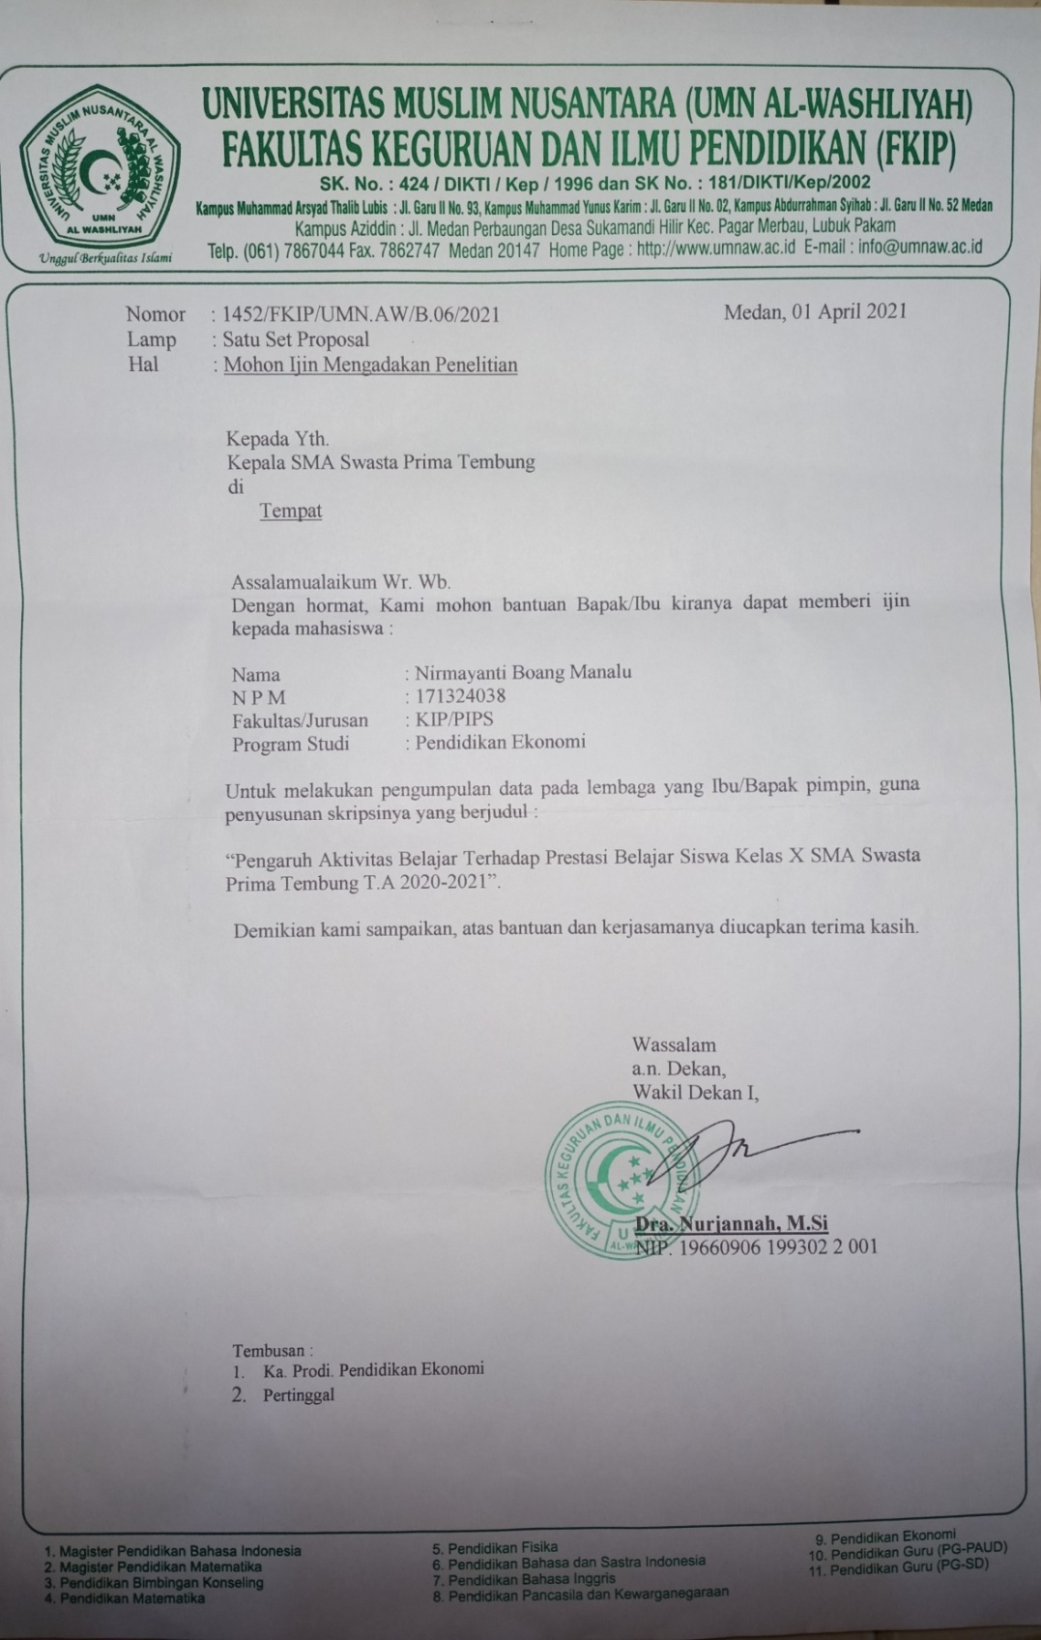

LAMPIRAN 11
SURAT BALASAN PENELITIAN
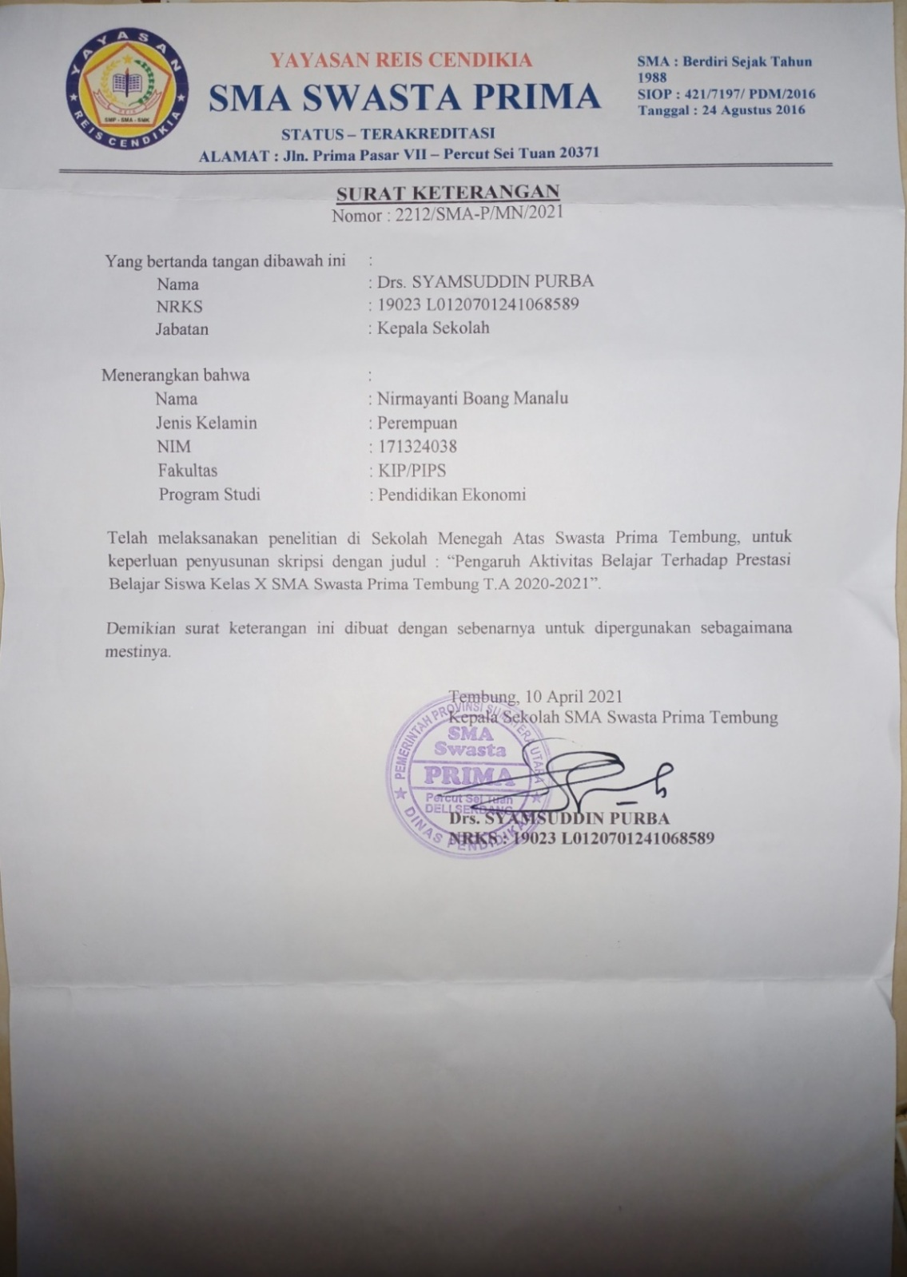

LAMPIRAN 12

DOKUMENTASI SAAT PENELITIAN

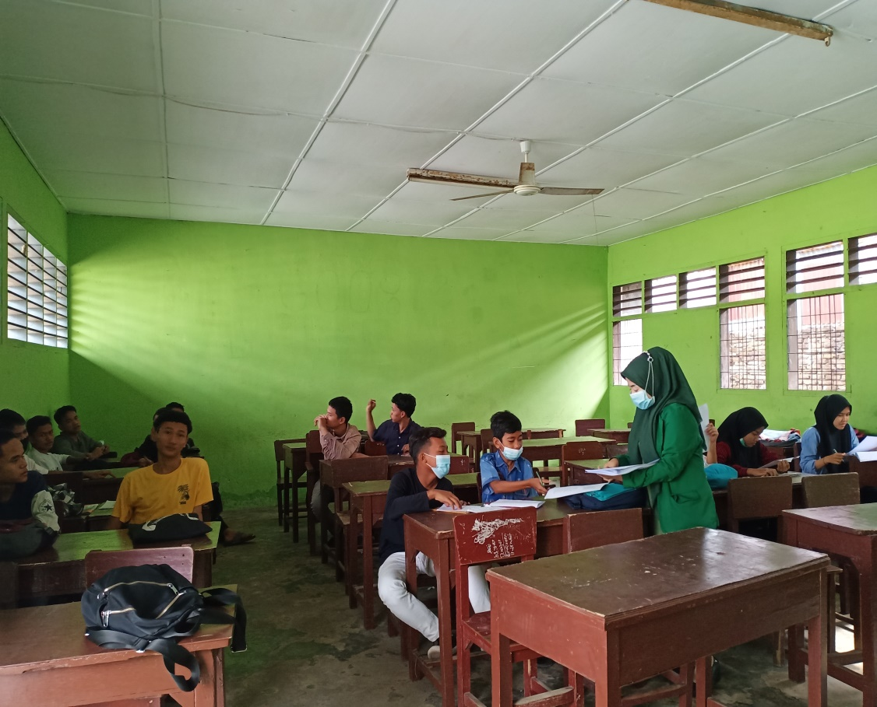
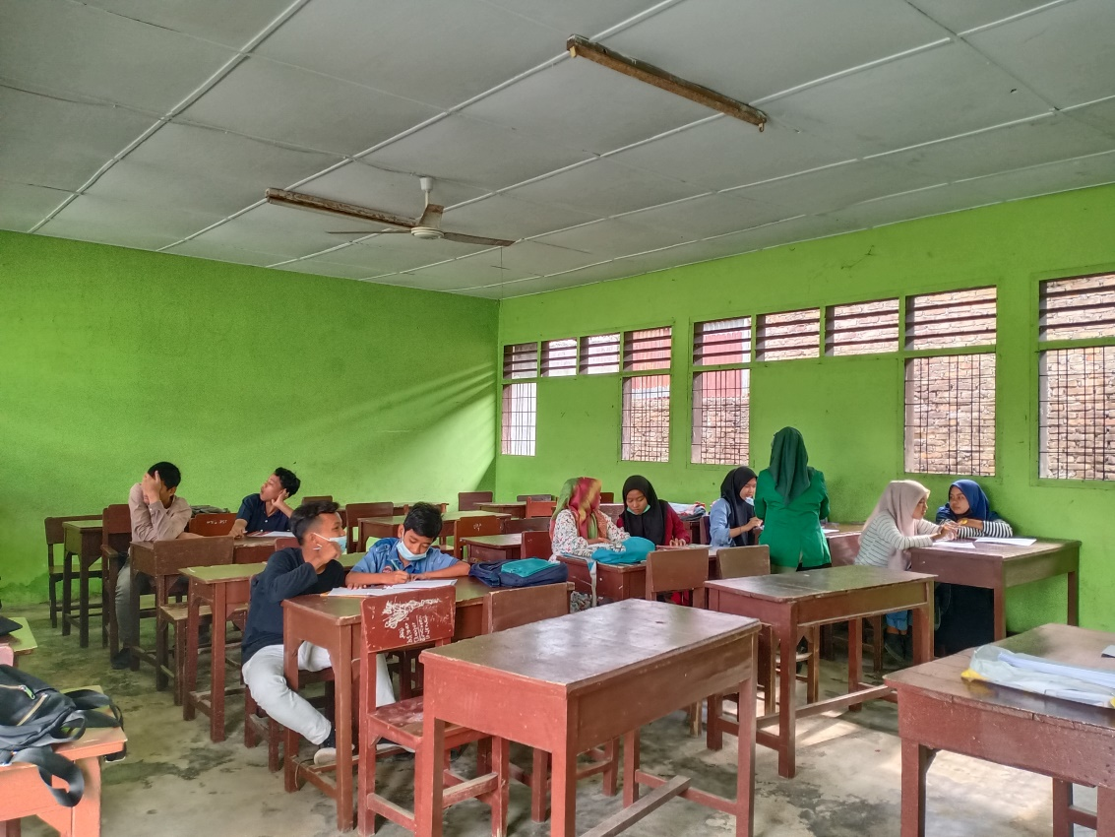

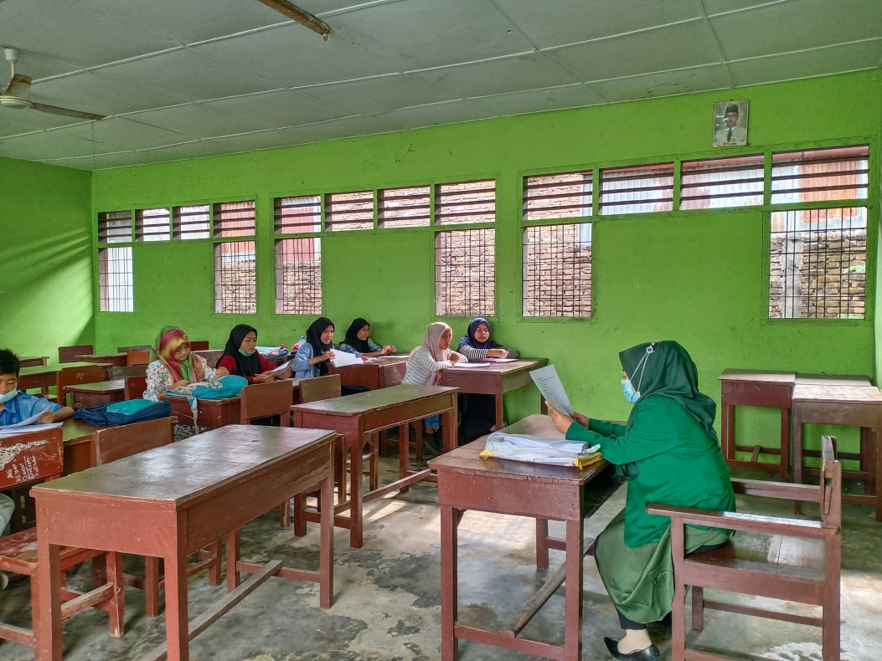

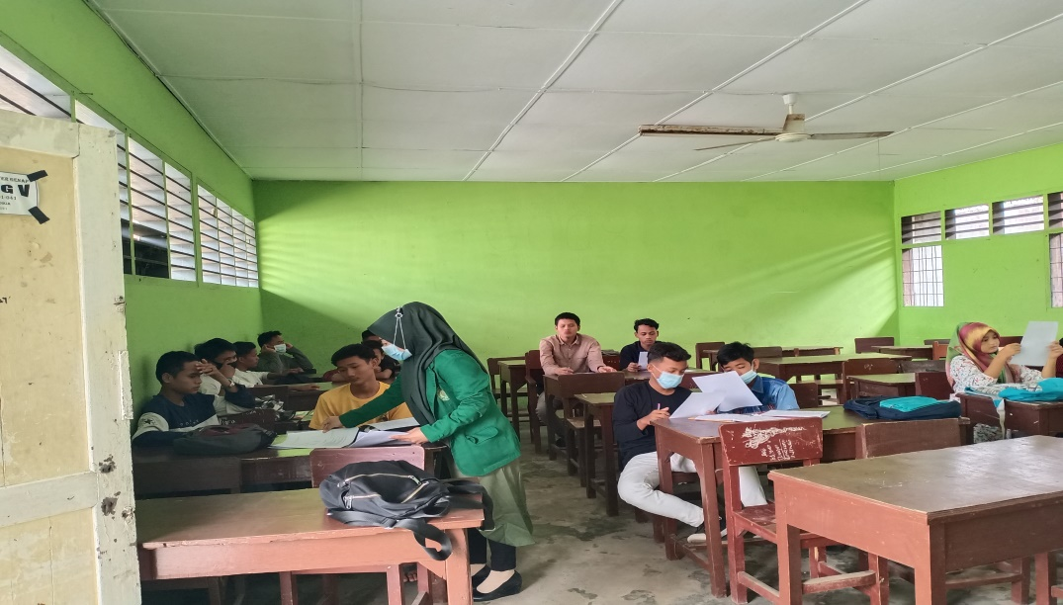

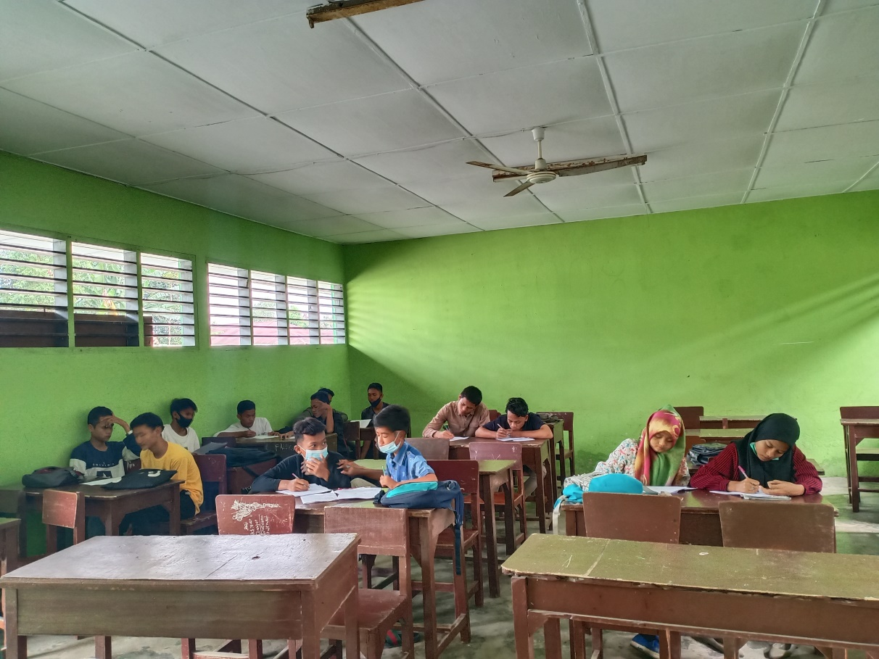

LAMPIRAN 13

BIODATA MAHASISWA
1. Identitas Diri
Nama : Nirmayanti Boang Manalu
Npm : 171324038
Tempat/Tanggal lahir : Rikitbur, 29 Agustus 1999
Agama : Islam
Anak Ke- : 4 (Empat)
Alamat : jl. Bunga sedap malam 1, kec. Medan Johor

II. Pendidikan
SD : SDN Inpres 037158
SMP : SMPN 4 Tanah Pinem
SLTA : SMAN 1 Kutacane
Judul Skripsi : Pengaruh Aktivitas Belajar Terhadap Prestasi Belajar Siswa Kelas X Sma Swasta Prima Tembung T.A 2020/2021
Dosen Pembimbing : Cita Ayni Putri silalahi, S.E.I., M.E.I

III. Orang Tua
Nama Ayah : Alm. Rahman Boang Manalu
Nama Ibu : Almh. Murniati Manik
Alamat : Launjuhar 1, kec. Tanah pinem. kab. dairi

