## ACKNOWLEDGMENT

يَـٰٓأَيُّهَا ٱلَّذِينَ ءَامَنُوا۟ هَلْ أَدُلُّكُمْ عَلَىٰ تِجَـٰرَةٍۢ تُنجِيكُم مِّنْ عَذَابٍ أَلِيمٍۢ ١٠

تُؤْمِنُونَ بِٱللَّهِ وَرَسُولِهِۦ وَتُجَـٰهِدُونَ فِى سَبِيلِ ٱللَّهِ بِأَمْوَٰلِكُمْ وَأَنفُسِكُمْ ۚ ذَٰلِكُمْ خَيْرٌۭ لَّكُمْ إِن كُنتُمْ تَعْلَمُونَ ١١

Meaning : (O you who believe ! Shall I show you a commerce that will save you from a painful doom? . you should believe in Allah and His messenger, and should strive for the cause of Allah with your wealth and your lives. That is better for you, if you did but know. (Surah Ash Shaff Verse10-11)

Alhamdulillah, all praises be to ﷲ , the single power, the Lord of the universe, master of the Day of Judgment, the most merciful and the most gracious one, for all blessings and mercies so the researcher was able to finish this thesis entitled *“*Politeness In And Refusing In Students' Conversation At Smp Al-Washliyah 24 Medan*"*Peace be upon Prophet Muhammad ﷺ , the great leader and good inspiration of world revolution.

The researcher is sure that this thesis would not be completed without the helps, supports, and suggestions from several sides. Thus, the researcher would like to express her deepest thanks to all of those who had helped, supported, and suggested her during the process of writing this thesis. This goes to:

1. **Dr. KRT. Hardi Mulyono K. Surbakti,** as Rector of UMN Al Washliyah, who has given facilities to her during her study at the

University.

1. **Dr. Samsul Bahri, M.Si,** as Dean of FKIP UMN Al Washliyah Medan and his staffs for guidance during the study.
2. **Zulfitri, S.S., M.A,** as the head of English Department who has given a lot of valuable suggestions, comments, and criticism for completing this research.
3. **Nurlaili, S.Pd.I., M. Hum**, as the adviser, who has given her a lot of valuable suggestions, comments and criticism for completing this research.
4. My family, who always give motivation and support**.**

The researcher realizes that this thesis is still far from being perfect. The researcher hopes that this thesis is useful for the researcher in particular and readers in general.

Medan,26 Mei 2025

The researcher

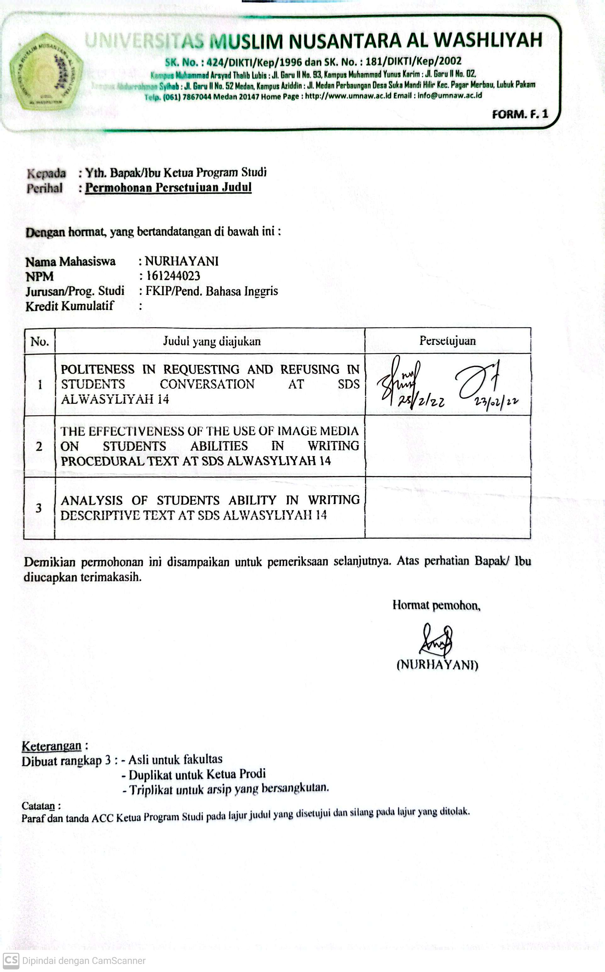

(Nurhayani)

## TABLE OF CONTENTS

ACKNOWLEDGE i

TABLE OF CONTENTS iii

LIST OF TABLE v

LIST OF FIGURE vi

LIST OF APPENDIX vii

ABSTRACT viii

CHAPTER I INTRODUCTION 1

1.1. The Background of Problem 1

1.2. The Identification of Problem 3

1.3. The Limitation of Problem 3

1.4. The Formulation of Problem 4

1.5. The Purpose of Research 4

1.6. Benefits of Research 4

1.7. Basic Assumption 5

CHAPTER II REVIEW OF LITERATURE 6

2.1.Politeness 6

2.1.1.The Definition of Politeness 6

2.1.2.The Indicators of Politeness 7

2.1.3.The Goal of Politeness 8

2.1.4.Politeness in Requesting 9

2.1.5.Politeness in Refusing 11

2.2.Conversation 12

* + 1. Definition of Conversation 12
    2. Type of Conversation 13
  1. Relevan Research 14
  2. Framework of Thinking 20

CHAPTER III METHODOLOGY 22

* 1. Research Design 22
  2. Participants and Place of Research 22
  3. Instrument of Research 22
  4. Data Collection 24
  5. Data analysis 24
  6. Ethical issues 26

CHAPTER IV THE RESULT OF THE RESEARCH AND DISCUSSION 27

* 1. The Result of the Research 27
  2. Discussion 34
  3. **Data Analysis According to Theories** ………………………….... ...38

CHAPTER V CONCLUSION AND SUGGESTION 41

* 1. Conclusion 41
  2. Suggestion 41

REFERENCES 43

**LIST TABLE**

Table 4.1. Observations on Learning at SMP SWASTA 24

AL-WASHLIYAH MEDAN 32

**LIST OF FIGURE**

FRAMEWORK OF THINKING 21

**LIST OF APPENDIX**

Appendix 1 ………………………………………………………… 46

Appendix 2………………………………………………………………. 49