## DEVELOPING READING COMPREHENSION MATERIALS BASED ON OUTCOME BASED EDUCATION (OBE) FOR ELEVENTH GRADE STUDENTSIN THE SMK AL WASHLIYAH 12 SEI RAMPAH

## ACADEMIC YEAR 2023-2024

**THESIS**

**BY:**

**FEBRI RISMA DARA**

**Registration Number:** **227215004**

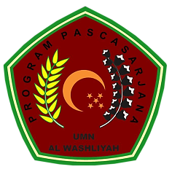

**ENGLISH EDUCATION DEPARTMENT**

**POST GRADUATE STUDY PROGRAM**

**MUSLIM NUSANTARA AL-WASHLIYAH UNIVERSITY**

**MEDAN**

**2024**

## DEVELOPING READING COMPREHENSION MATERIALS BASED ON OUTCOME BASED EDUCATION (OBE) FOR ELEVENTH GRADE STUDENTSIN THE SMK AL WASHLIYAH 12 SEI RAMPAH

## ACADEMIC YEAR 2023-2024

**THESIS**

***Submitted to Fulfil the Requirements to Obtain a Master of Education Degree (M.Pd) in the Postgraduate Program of English Language Education Study Program, Al Washliyah Muslim Nusantara University***

**BY:**

**FEBRI RISMA DARA**

**Registration Number:** **227215004**



**ENGLISH EDUCATION DEPARTMENT**

**POST GRADUATE STUDY PROGRAM**

**MUSLIM NUSANTARA AL-WASHLIYAH UNIVERSITY**

**MEDAN**

**2024**

