**ACKNOWLEDGEMENTS**

*Assalamu’alaikum Wr.Wb*

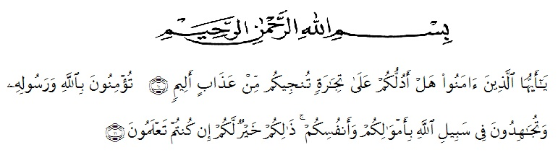

Artinya:  
*“O believers! Shall I guide you to an exchange that will save you from a painful punishment?10. It is to have faith in Allah and His Messenger, and strive in the cause of Allah with your wealth and your lives. That is best for you, if only you knew*.*11.*QS (As-Shaff 10 : 11)

First and foremost, she would praise and thanks to Almighty God, because of His blessings she can complete this research. She got suggestions, criticism and guidance from many people. Therefore, she would like to extend her sincere and special thanks to

1. Assoc. Prof. Dr. Firmansyah, M.Si, the Rector of UMN Al-Washliyah Medan,
2. Sutikno, S.Pd.,M.Pd.,Ph.D.,CIQaR, the Postgraduate Director of UMN Al-Washliyah Medan,
3. Asnawi, S.Pd., M.Hum, the leader of English Department of UMN Al-Washliyah Medan,
4. Dr. Yulia Arfanti, M.Hum, the first consultant, who has given correction, suggestion, comments, criticism for completing her research,
5. The lectures of the English Department of FKIP UMN Al Washliyah Medan who have taught her,
6. She’s beloved parents, Riswan and Armaya who always support her financially, morally and for their love and praying in finishing her study at FKIP UMN Al Washliyah Medan,

Finally, She does all of suggestions and criticism which can be useful and meaningful for the writer. God Bless Us.

Medan, May 2024

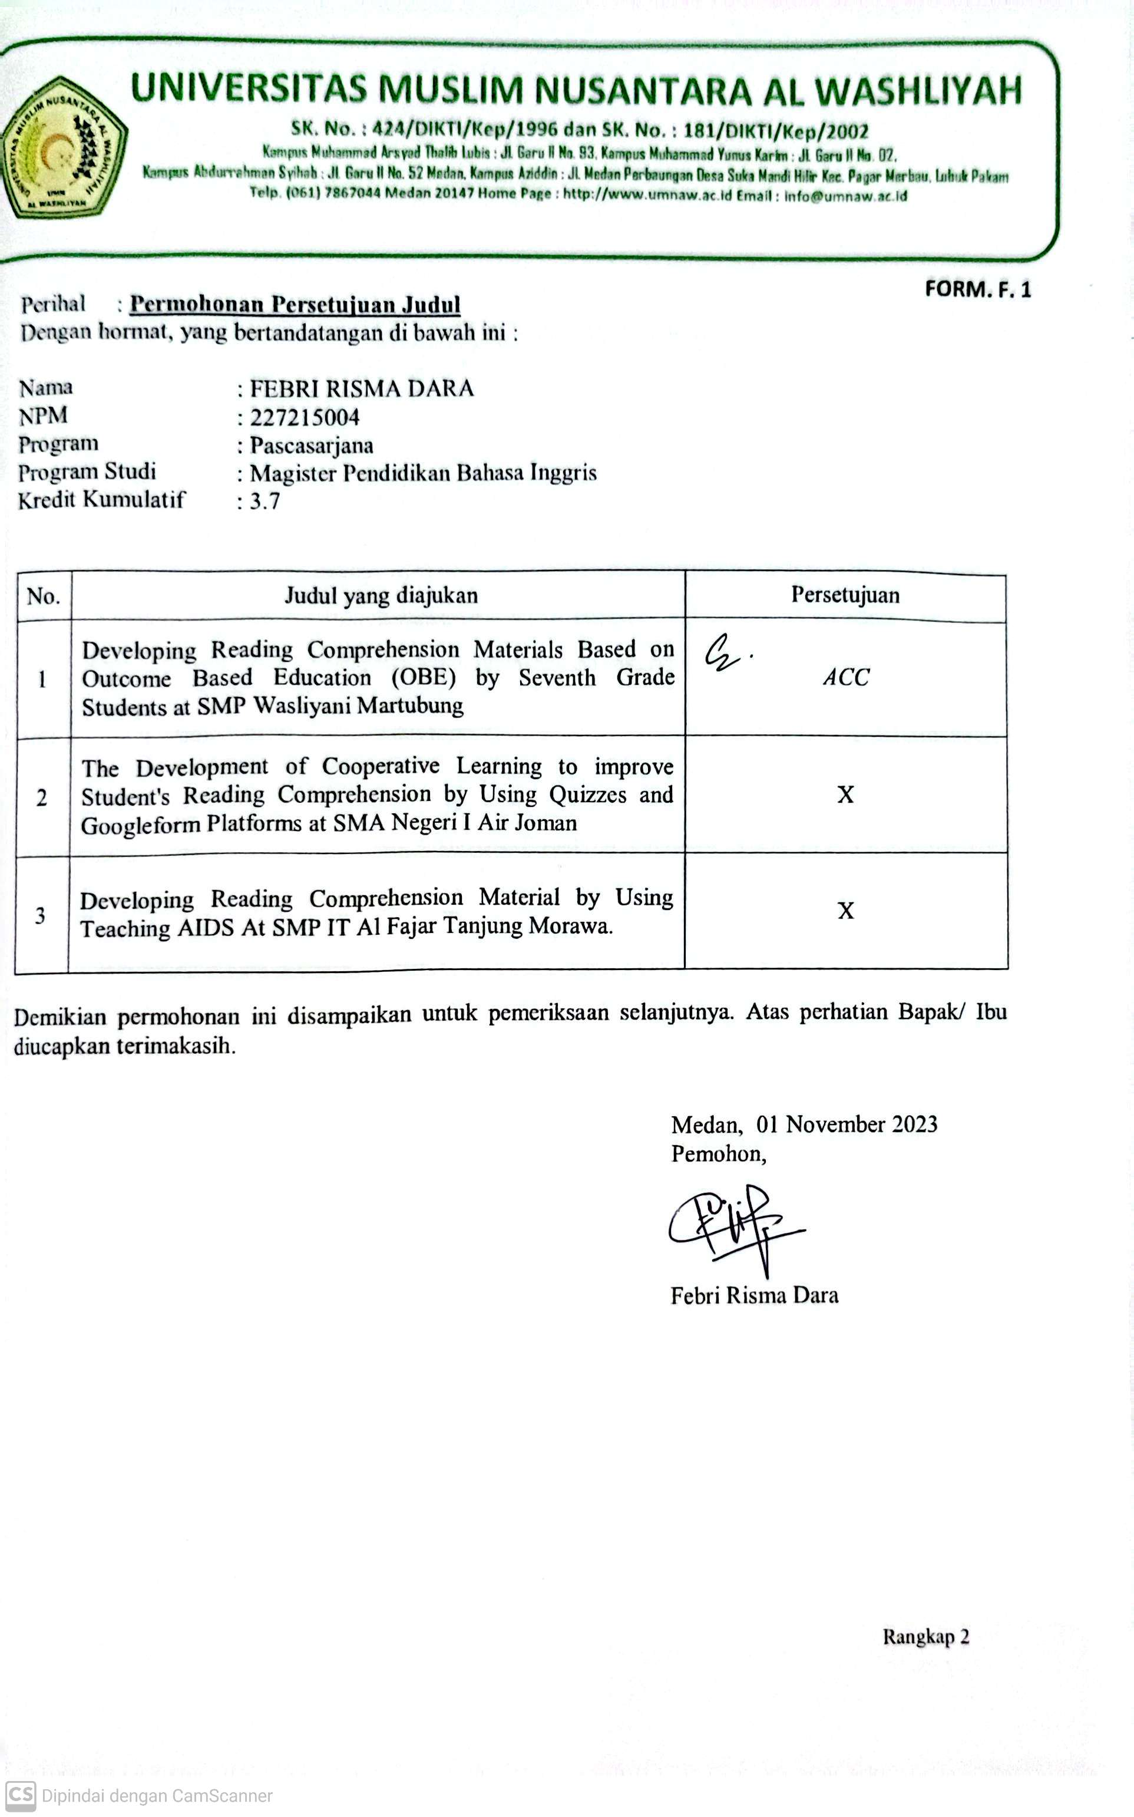The writer

Febri RiSMK Dara

**TABLE OF CONTENTS**

**ABSTRAK ii**

**ABSTRACT iii**

**ACKNOWLEDGEMENTS iv**

**TABLE OF CONTENTS vi**

**LIST OF TABLE ix**

**LIST OF PICTURES x**

**CHAPTER I INTRODUCTION 1**

* 1. Background of the Research 1
  2. Identification of the Research 4
  3. Limitation of the Research 4
  4. Problems of the Research 5
  5. Objectives of the Research 5
  6. Significances of the Research 6

**CHAPTER II REVIEW OF RELATED LITERATURE 7**

* 1. **Theory Study** 7
     1. Reading 7
     2. Definition of Reading 7
     3. Purpose Reading 7
     4. The Reason of Reading 9
     5. Definition of Reading Comprehension 9
     6. Reading Indicators 10
     7. Effective Strategies for Reading Comprehension 12
     8. Outcome Based Education (OBE) 15
     9. Definition of Outcome Based Education (OBE) 15
     10. Main Concepts and Principles of OBE 16
     11. Basic Implementation of OBE 16
  2. **Previous Related Research Findings 17**
  3. **Conceptual Framework 19**
  4. **Hyphothesis 20**

**CHAPTER III RESEARCH METHOD 20**

* 1. Research Design 21
  2. Research Setting and Subjects 23
  3. Population and Sample 24
  4. Population 24
  5. Sample 24
  6. Research Instrument 24
  7. Procedure of Data Collection 25
  8. Technique of Analyzing Data 27

**CHAPTER IV RESULT AND DISCUSSION OF RESEARCH 30**

* 1. Data 30
  2. Data Analyses 30
     1. Student Perception 30
     2. Teacher Perception 36
     3. Principle Perception 37
  3. Result and Discussion 38
     1. Research and Information gathering 38
     2. Planning 39
     3. Developing The Initial Product 40
     4. Preliminary Field Trials 40
     5. Revision of The Main and Operational Product 41
     6. Main and Operational Field Trials 42
     7. Revision of Final Product 44
     8. Dissemination and Implementation 45
  4. Discussion 47
     1. The Development of Reading Comprehension Material by using OBE 47
     2. The Validation of Development of Reading Comprehension Materia 50
     3. The Effectiveness of Developent of Reading Comprehension Material by OBE Method 51

**CHAPTER V CONCLUSION AND SUGGESTION 54**

5.1 CONCLUSION 54

5.2 SUGGESTION 55

**REFERENCES 56**

**APPENDIX 60**

**LIST OF TABLE**

Table 1: Status Category Of Ngain 29

Table 2: Student Interview 32

Table 3: Teacher Perception 36

Table 4: Principle Perception 37

Table 5: Observation of Class XI (Pre-Test) 29 38

Table 6: Observation of Class XI (Preliminary Field Trials) 40

Table 7: Method Assessment 1 41

Table 8: Observation of Class XI (Main and Operational test) 43

Table 9: Method Assessment 2 44

Table 10: Observation of Class XI (Final test) 45

Table 11: Student’s Reading Comprehension Improvement 47

Table 12: Ngain Score 51

Table 13: Status Category of N-Gain Effectivity` 52

**LIST OF PICTURES**

Chart 2.1 Learning Process 20

Chart 3.1 R & D cycle from Borge & Gall 22

Chart 4.1 Student Improvement 49