**DEVELOPMENT OF TEACHING MATERIAL**

**OF NARRATIVE TEXT BASED ON SPARKOL VEDIOSCRIBE IN GRADE X STUDENTS OF MADRASAH ALIYAH SWASTA PP RAUDHATUL HASANAH, MEDAN**

**A Thesis**

**By**

**ARI NINGSIH**

**NPM 207215002**

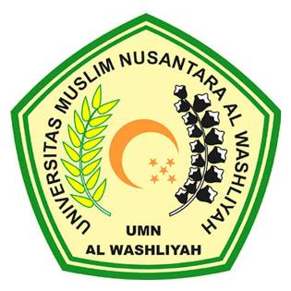

**ENGLISH EDUCATION DEPARTMENT**

**FACULTY OF TEACHER TRAINING AND EDUCATION**

**MUSLIM NUSANTARA AL WASHLIYAH UNIVERSITY**

**MEDAN**

**2021**

**DEVELOPMENT OF TEACHING MATERIAL**

**OF NARRATIVE TEXTBASED ON SPARKOL VEDIOSCRIBE IN GRADE X STUDENTS OF MADRASAH ALIYAH SWASTA PP RAUDHATUL HASANAH, MEDAN**

*Submitted to the Department of English Language Education in Partial*

*Fulfillment of the Requirements for the Degree of*

*Magister Pendidikan*

**By**

**ARI NINGSIH**

**NPM 207215002**



**ENGLISH EDUCATION DEPARTMENT**

**FACULTY OF TEACHER TRAINING AND EDUCATION**

**MUSLIM NUSANTARA AL WASHLIYAH UNIVERSITY**

**MEDAN**

**2021**

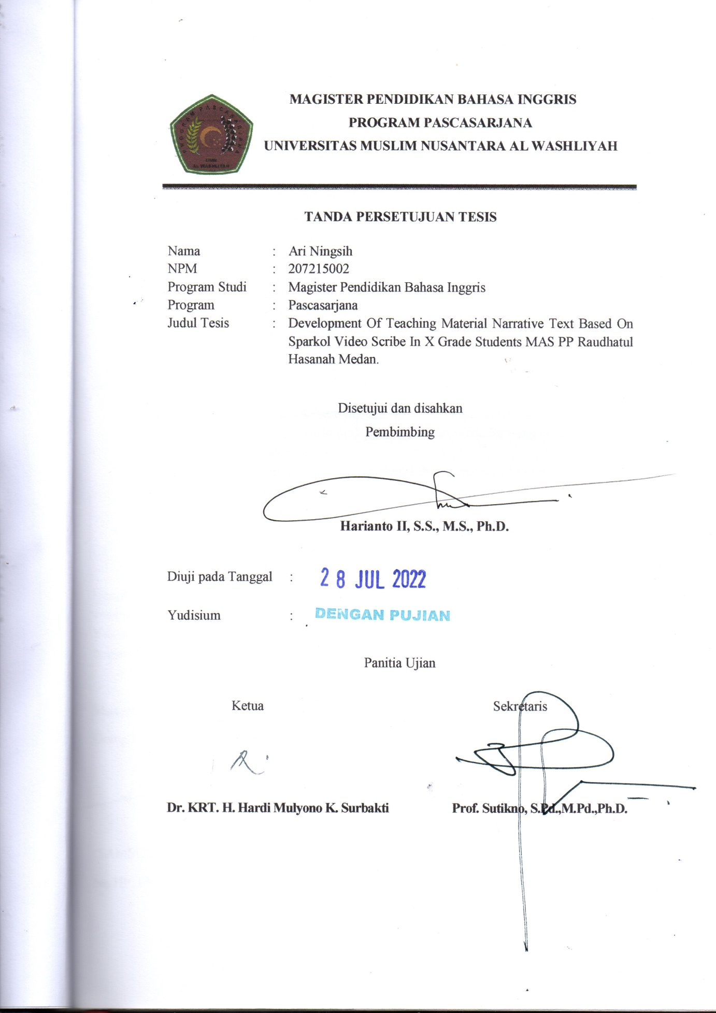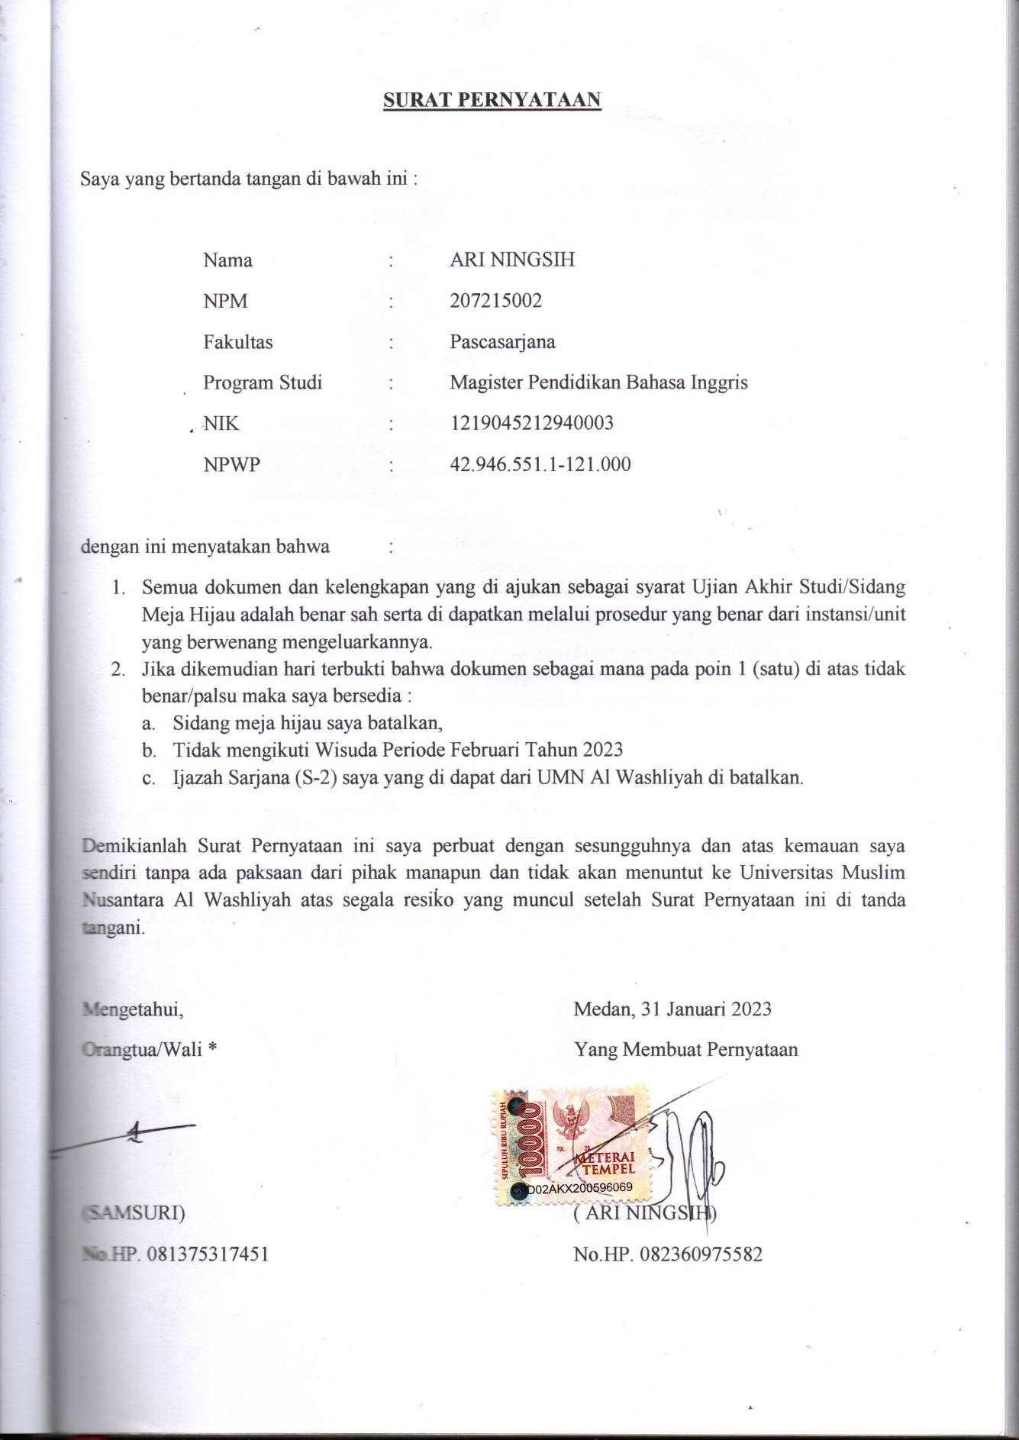

**POSTGRADUATE PROGRAM**

**UNIVERSITAS MUSLIM NUSANTARA AL-WASHLIYAH MEDAN**