# **CHAPTER II**

# **REVIEW OF LITERATURE**

## **Development**

According to the Law of the Republic of Indonesia 18 of 2002, development is a scientific and technological activity aimed at utilizing proven scientific principles and theories to improve the functions, benefits, and applications of existing science and technology, or to produce new technology.

Development is an educational effort both formal and non-formal which is carried out consciously, planned, directed, regularly and responsibly in order to introduce, grow, guide, develop a personality basis that is balanced, intact, in harmony, knowledge, skills in accordance with talents, desires and ability as a provision on one's own initiative to add, improve, develop oneself in the direction of achieving optimal human dignity, quality and ability as well as an independent personality (Iskandar Wiryokusumo, 2011).

According to Seels & Richey (Alim Sumarno, 2012) development means the process of translating or elaborating design specifications into the form of physical features. Development specifically means the process of producing learning materials. Meanwhile, according to Tessmer and Richey (Alim Sumarno, 2012) development focuses not only on needs analysis, but also on broad issues of early-late analysis, such as contextual analysis. Development aims to produce products based on the findings of field tests.

From the opinion of the experts above, it can be concluded that Development is a conscious, planned, directed effort to make or improve, so that it becomes a product that is increasingly useful for improving quality as an effort to create better quality.

1. **Teaching Material**
   1. **Definition of Teaching Material**

All kinds of tools that are used to assist educators in implementing the teaching and learning activities in the classroom and something related to classroom learning and provide an acceleration in understanding the material being taught by educators to students called teaching material (Abadi,Puji, Asaat, 2017).

The teaching materials is the tools that are used by teachers and instructors within schools to facilitate learning and understanding of concepts among students. Also regarded as one of the major aspects that would promote student learning and help in the achievement of academic goals and objectives. The educators need to focus upon bringing about developments in the teaching-learning materials. They need to conduct research and promote modern and innovative methods to enrich the system of education (Radhika Kapur, 2019).

Materials become a determining factor for learners to participate in the learning and create interest in the material to be taught. As expressed by Supriyono, Setiawan & Trapsilasiwi (2014) states that to produce active learning, easy to understand, and fun for students requires a learning model that makes students actively participate in the learning process. (Widodo, 2017).

Based on the opinion of experts, the researcher concluded that teaching material is somethings or tools used in learning process to produce active learning, easy to understand, fun for the students and interest in material that to be taught by the teachers.

Teaching material is being the facility of learning that prepare by the teachers and they need to conduct research and promote modern and innovative methods to enrich the system of education.

* 1. **Types of Teaching Material**

Teaching-learning the materials are of various types and are classified in various ways: Audio and video, Textbook, Maps, Charts, Posters, Models, Overhead Projector, Power Points Slides, Computer, Other reading Materials. (Teaching Learning Materials. (n.d.))

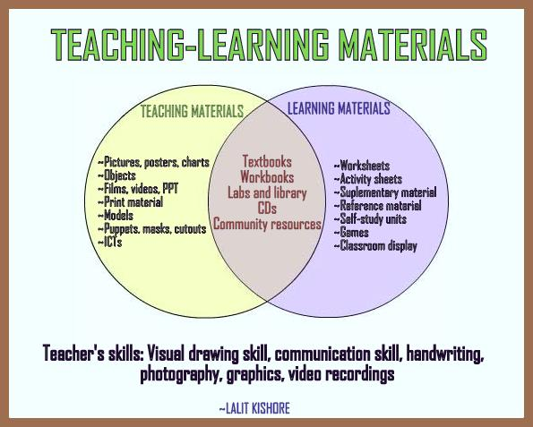

Picture 2.1 the types Teaching Material

* Visual Audio

Djamara (2006: 124), audiovisual media are media that are able to stimulate the senses of sight and hearing together, because this media has elements of sound and elements of images. Audio-visual media has four functions including attention function, affective function, cognitive function, and compensatory function. The function of attention is the core, which is to attract and direct students to concentrate on the content of the lesson.

* Audio Aids

According to the Webster dictionary, audio-visual aids is defined as "training or educational materials directed at both the senses of hearing and the sense of sight, films, recordings, photographs, etc. used in classroom instructions, library collections or the likes". Using audio aids in teaching can improve student performance by engaging them on a different level. These aids in the classroom can have many advantages including engaging auditory learners, adding novelty to activities and using music or mnemonics as memorization techniques.

* Audio-Visual Aids

Audio-Visual Aids are the instructional method of education that uses audio and visual as a mode of learning. The literal meaning of audio is hearing and visual means that is seen by eyes.

Audio-Visual aids are devices that are used in the classroom to make learning engaging and easy. These can also help teachers to communicate messages or information in places where regular teaching fails. Audio-Visual aids motivate them towards the subjects they don’t find interesting.

Examples of audiovisual aids include videos, music clips, flip charts, slideshow presentations, and overhead transparencies.

* Computer Assisted Learning

Computer Assisted Learning (CAL) provides students with two important opportunities: remedial academic support and exposure to computers. Studies have shown that access to computers with educational software can significantly improve student performance in disadvantaged schools. Example of typical CAI sequences are drill and practice, gaming, simulation, Socratic questioning, testing and tutorial instruction. In CAI emphasis is placed upon having students learn new concepts or in reinforcing previously learned concepts.

The features of CAL:

* Interactive and can illustrate a concept through attractive animation, sound, and demonstration.
* Allow students to progress at their own pace and work individually or problem solve in a group.
* Provide immediate feedback, letting students know whether their answer is correct.
  1. **Designing of Teaching Material**

There are three aspects in designing the teaching material: (Teaching Learning Materials. (n.d.))

* Collection

The collection step is the first and foremost step in the preparation of any teaching-learning materials or any project. For example, when researchers are engaged in research projects, they are required to collect data from the sample population.

When the data is collected, only then, it can be analyzed to obtain the results. Before a collection method is put into practice, it is essential for the individuals to generate awareness in terms of what they are preparing. In other words, they need to be aware of their goals and objectives. The participation of students in collection is meaningful and useful in the achievement of desired goals and objectives.

* Preparation

After the collection of materials, the next step is the preparation of teaching-learning materials. When the preparation of teaching-learning materials takes place, then various aspects need to be taken into account. These are the grade levels of the students, subjects and concepts, learning abilities and academic goals.

* Maintenance

Maintenance is an important activity. When the individuals are vested with the responsibility of maintenance of TLMs, they develop among them the significance of sustainability. When one feels that TLMs are required to be used in future as well, then the educators even instruct their students to maintain them. When they are making use of them, they need to be careful that they do not get damaged.

Based on the explanation above, teaching material must be design based on the three aspects of designing. It is important element for the students as a tool in learning process.

* 1. **Function of Teaching Material**

Teaching materials used do not always have to be conventional but as educators, at least take action to repair paradigm, perspective, thinking, attitudes, habits, professionalism, and behavior in teaching. Thus educators deliver innovation in making teaching materials because it will have an impact on the smooth operation of student learning that is not likely to feel bored (Widodo: 2017).

Based on the opinion above, the function of teaching material is not usual material in teaching-learning but as the teachers, the must deliver innovative teaching material because it will give the effect to the students’ characteristics and students’ personality.

* 1. **Benefit of Teaching Material**

The significance of teaching materials is usually recognized in terms of five aspects. These are, student motivation, developing creativity, evoking prior knowledge, encouraging the processes of interpreting, understanding, organizing and amalgamating the educational content, logical thinking, reasoning, and communication and contributing to the development of different skills, values and attitudes among students, and enabling them to acquire an efficient understanding of the academic concepts (Radhika Kapur: 2019).

Learning of new ideas becomes simpler if the student is given recognizable materials linked with the subject matter. The typically little children are drawn to objects of various tones and measures and show their interest in controlling these in different manners which when fed cautiously assists with fostering a propensity for playing with an assortment of articles. This aids in upgrading their creativity. TLMs are required for compelling self-learning. With the utilization of proper materials, one can learn on their own with absolute power over their speed of learning.

1. **Narrative Text**
   1. **Definition of Narrative Text**

Narrative text is a story with complication or problematic events and it tries to find the resolutions to solve the problems. An important part of narrative text is the narrative mode, the set of methods used to communicate the narrative through a process narration. (http.guruberbagirasa.blogspot.com 2013).

Narrative text is a text compiled in a sequence which contains a story that entertains the reader. Narrative text is arranged as attractive as possible to the reader, contain stories that interesting. The main purpose of the narrative text is to convey a story that entertains the reader (Devi, 2015).

Narrative text is not a real story, text that does not describe the true story. The main purpose of the text to make the reader entertained. Narrative text is a story containing many events, it is arranged in sequence. The purpose of this story is entertaining the reader. Kinds of narrative text it can be fiction or non-fiction story. The preparation of the story begins with the introduction, the peak of the problem and solution at the end of the story (Mislaini, 2015).

Based on the definitions above narrative text is a text contained the past story and unreal story to entertain the reader or listeners, it gave the moral massage for the entertaining people. The fiction or non-fiction story of it can make the readers interest because the readers will feel amaze and fun feeling when they read the text.

* 1. **Generic Structure of Narrative Text**

1. Orientation

The orientation section contains the opening of the story that contains the introduction of characters, introduction to the background time and place of the story. Anyway, this section contains a general part of the story that includes what, who, when, and where the story is told.

1. Complications

In this section, the main character starts experiencing conflicts in his life and the main character must resolve the conflicts.

1. Resolutions

The resolution section is the ending story section. In this section all the problems must be resolved by the main character. In the resolution section there is also usually a moral message or moral value or advice that we can take from the story. The moral value in the ending of a narrative text is called Coda.

* 1. **Kind of Narrative Text**

1. Folktale

Folklore / folktale or in Indonesia often referred to as fairy tales are traditional customs and folklore that are passed down from generation to generation, but not recorded.

1. Personal Experience

Personal Experience is a story that tells a personal experience and is usually told from the first person point of view.

1. Fairy Tales

Fairy Tale is a simple story about magical creatures, such as fairies, dragons, witches and princesses, giants and others.

1. Fable

Fable is a story that tells the life of animals that behave like humans. Fables are fiction or fantasy stories (fantasy). Sometimes fables include minority characters in the form of humans. Fable stories are also often called moral stories because they contain messages related to morals.

1. Legend

Legends or legends are ancient folk tales related to events and the origin of a place. For example, Sangkuriang, Batu Menggis and the Legend of Giliraja Island.

Based on the lists above there many kinds again of the narrative text can entertain i.e. Myth, Romance, Mystery, Science Fiction, Horror, Adventure, Historical, Slice of life etc.

* 1. **Purpose of Narrative Text**

There are several purposes of narrative text such as entertaining, educating, informing, conveying the author's experience or as a medium to develop the imagination of the reader.

The important purpose of narrative text is the reader can take the moral massage of the story and the readers can combine the text story to the real life of everyone. Example the story of Malin Kundang, we can take the lesson of that story i.e. everyone must obey to the parents.

* 1. **Language Features of Narrative Text**

According to Haris (2010), there are some features the students should comprehend in narrative text; (1) Plot: What is going to happen? (2) Setting: Where will the story take place? When will the story take place? (3) Characterization: Who are the main characters? What do they look like? (4) Structure: How will the story begin? What will be the problem? How is the problem going to be resolved? (5) Theme: What is the theme/message the writer is attempting to communicate?

In narrative text, it usually uses the past or past forms, because this story is a fiction. Tenses can use past perfect, past continuous, past perfect continuous, or it can be past perfect future continuous. All these rules do not have to be used as references because tenses refer to the conditions and situations of the sentence.

The Language Features of Narrative Text:

* Most often use past tense, it can be simple past tense, past continuous, or other past tense forms.
* Action verbs. It is a verb that shows an action. Example:  Climbed, Turned, Brought, etc.
* Specific noun as pronoun of person. Such as "malin kundang, cinderella".
* Direct and indirect speech, sometimes using dialogue to invite readers to imagine so that the story looks clearer and more real.
* Time Connectives and Conjunctions, it makes the story looks coherent or sequential.  Such as "when, then, suddenly, before, after, soon, etc"
* Adverbs of time (adverbs). Example: One time, once upon a time, one day
  1. **Grammatical Feature of Narrative Text**

There are some grammatical features of narrative text:

1. Use specific nouns such as the name of person, place and building
2. Use adjectives which form noun phrases
3. Use time connectives and conjunctions such as then, before that, soon
4. Use adverbs and Adverbial Phrases
5. Use action Verbs
6. Use saying words such as said, told, promised.
   1. **Example of Narrative Text**

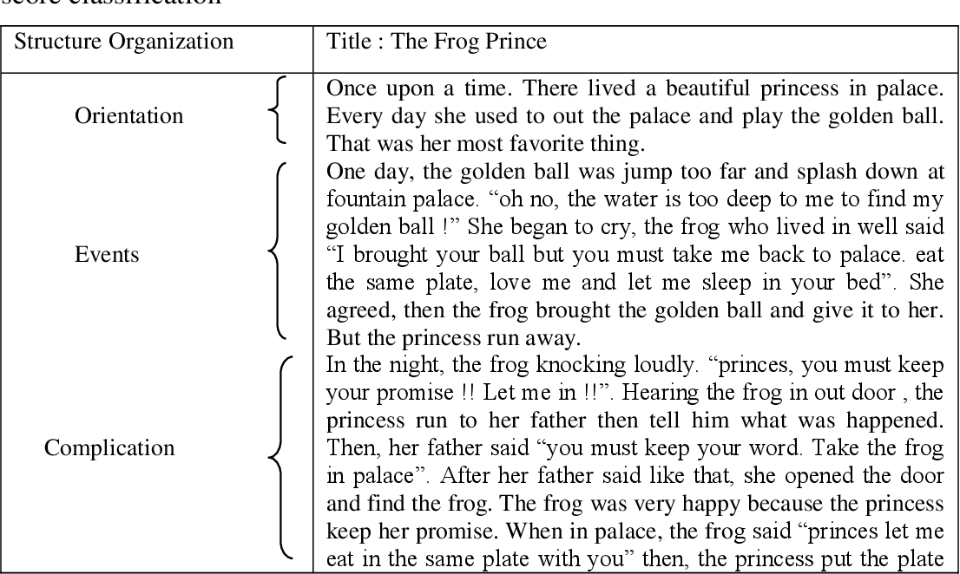

* 1. **Reading Comprehension of Narrative Text**

1. **Definition of Reading Comprehension**

Reading comprehension is a complex process involving a combination of text and readers. It is widely reasonable that the three key types of reading are as accuracy (involves phonological and orthographic processing), fluency (includes time), and comprehension (Ahmadi, Hairul, & Pourhossein, 2012; NICHHD, 2000).

Reading comprehension can be one of the most important parts for a language learner to master and one of the least favorite topics for teachers to address in the classroom. But most of the students have difficulty with constructing meaning from the written texts (Mohammad Reza Ahmadi, Hairul Nizam Ismail & Muhammad Kamarul Kabilan Abdullah: 2013).

1. **Types of Reading Comprehension**

There are two different kinds of reading. They are:

* Extensive reading

Skimming and scanning activities while Hafiz and Tudor (1989 as cited in Alyousef 2005) expressed that exposing learners to large quantities of meaningful and fascinating materials and activities will have a significant impact on the learners’ knowledge of L2.

* Intensive reading

In this type of reading, learners read a page to find the meaning and to be familiar with the strategies of writing. Through this reading, students can get fundamental practice in performing these strategies based on a series of materials. These strategies can be either text-related or learner-related. Yang, Dai, and Gao (2012) expressed that intensive reading is useful to develop reading comprehension. Pollar, Durodo, Gonzalez, Simmons, Kwok, Taylor, Davis, and Simmons (2011) said that intensive reading is considered as a significant instrument for improving reading comprehension.

Example: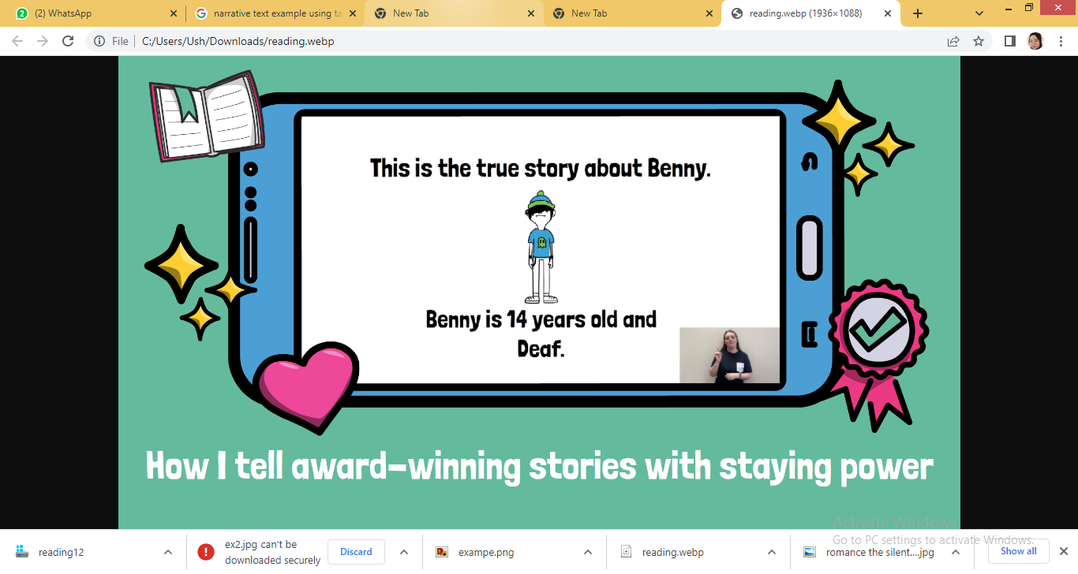

1. **Sparkol VideoSribe**
   1. **Definition of Sparkol VideoScribe**

VideoScribe is the software that we can use in making design of animation set in white with a very easy. This software was developed in the year 2012 by sparkol (one of the companies that are in the United Kingdom). Exactly a year after it was released and publicized, this software already have the users of 100 hundred people more (Jon Air, 2014).

VideoScribe has two types and two versions. The first type of online and the next type of offline. Whereas the first version is a trial version IE users can use this software free or charge for a period of 30 days. After that users are required to switch to pro version. In the pro version, users have to pay or buy software (Obilearning.blogspot.com, 2017).

* 1. **The history of Sparkol VideoScribe**

VideoScribe was first launched in the UK in 2012 by application company Sparkol. In 2013 the Sparkol VideoScribe application has generated more than 100,000 users. And continues to grow every year. VideoScribe is made with Adobe Flash which produces Videos with Quicktime. Video files on Sparkol Videoscribe can be uploaded via Flash video, Quicktime Video or images (JPEG or PNG).

In April 2013, American schoolchildren using VideoScribe created messages for Barack Obama. British Chancellor George Osborne narrated a scribe explaining the Spending Round on the UK Government website in June 2013.

The following month, VideoScribe was recommended on the BBC News website. The VideoScribe iPad app won Best B2B Mobile/Tablet App at the 2013 MOMA Awards after being nominated in three categories. Mashable has used VideoScribe to create some whiteboard videos for their website.

Based on the history above the researcher choose this application because the students in this era have used many modern technology. They will interest of the animation material based on Sparkol VideoScribe. It recommended way to apply the material serving.

* 1. **The Purpose of Sparkol VideoScribe**

The goal of Sparkol VideoScribe is to make presentations in the form of animated videos by presenting a hand that moves while writing or drawing and explaining like someone explaining on a whiteboard.

VideoScribe attracts a lot of student interest so that learning achievement increases up to 88%. And explanations with VideoScribe are more preferred than someone who explains directly.

* 1. **The Advantages of Sparkol VideoScribe**

The main benefits of Sparkol VideoScribe are:

* It helps you create animated videos with little or no experience.
* Whiteboard styles are increasingly popular and relevant.
* A library of sound and image supplies means you don't have to create your own content from scratch.
* We can export in several different formats to different platforms.
  1. **The Technique of Saprkol VideoScribe**
* Sparkol VideoScribe has an amazingly simple editor for a tool as powerful as it turns out. As you can see in the image, the editor is broken up into the main canvas area with the timeline at the bottom and the toolbar at the top.
* We can use the toolbar to add text, images, or chart content to your videos. You'll want to wait until you're done, to add audio clips and voiceovers.
* Once you're done creating, you can export it as a video file or upload it to Youtube, Facebook, or Powerpoint. Videos exported during the trial period will be watermarked and cannot be exported as a file
  1. **Using SVS in Narrative Text**

Sparkol VideoScribe is effective delivering teaching material to the students especially in reading comprehension. Sparkol VideoScribe is not free software. We can try this program for 7 days free of charge and without giving a credit card, but your export options will be limited to Youtube, Facebook, and Powerpoint, and each video will have a watermark. If we decide to purchase Sparkol VideoScribe software, you can pay $168 for one year of access, or pay $35 a month and terminate or resume your contract at any time. That the example of using Sparkol VideoCribe in delivering material.

Opening video

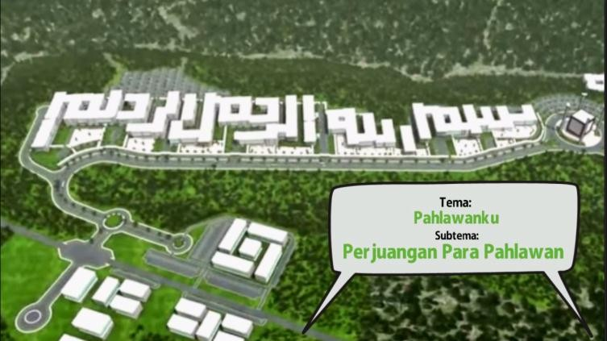

Video KI/KD

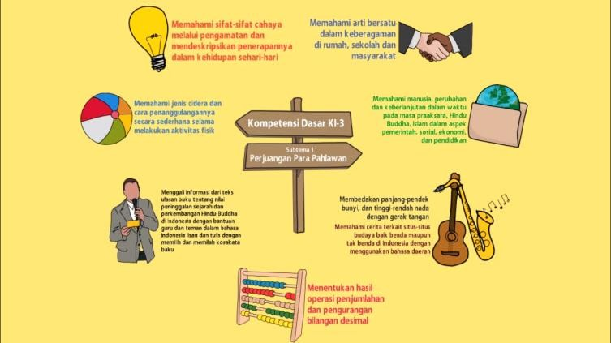

Video Material

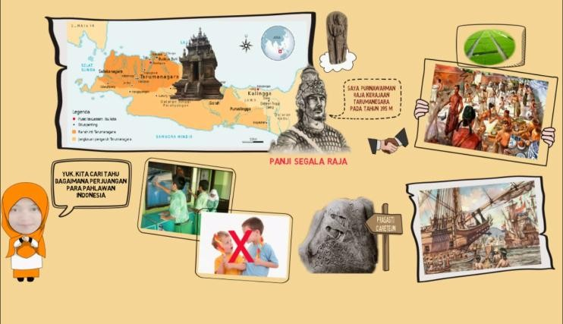

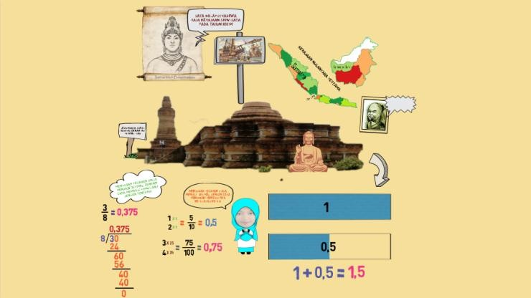

## **Previous Research**

The development of technology affects the way teenagers view using the Internet as a primary goal. This development is also changing the paradigm of learning in education. On its Web site, UNESCO has said that information and communication technology (ICT) can contribute to the freedom of access to education, equality in education, delivery of quality learning and teaching, professional development of teachers and education management that is more efficient in its governance and administration (UNESCO.ICT in Education : 2016). Sparkol videoScribe one of the technology can be used in developing teaching material in reading of narrative text.

Based on the results of a survey conducted by UNICEF, the Ministry of Communications and Information Technology of Indonesia and Harvard University, the US report Security Using Digital Media in Children and Adolescents in Indonesia noted that the number of Internet users in Indonesia (including children and teenagers) is predicted to reach 30 million or about 40% of the population of Indonesia. This study explored the on-line activity of a sample of children and teenagers, involving 400 respondents aged 10 to 19 years from all over Indonesia and representing both urban and rural areas. As many as 98% of children and teenagers claimed to know about the Internet and 79.5% reported being Internet users. (Panji, A : 2014)

Sirozi (2013) indicated that according to UNESCO, educational institutions are not only required to encourage learners to learn, but also claimed to be able to encourage learners to learn, to acquire knowledge, to promote learning to act, to learn to live together and to learn for life (the life-long learning paradigm).

The research of Roudatus Sarifah, Siti Maria Ulfa English Department, STKIP PGRI Bangkalan, Indonesia titled “The effectiveness of videoscribe as innovative media to increase students reading comprehension”.

The research of Siti Munawaroh Universitas Lancang Kuning, Pekanbaru, Indonesia titled “Teaching the Narrative Texts Using Animation Video: Raising Students’ Skills on Reading Comprehension “.

## **Hypothesis**

Ho : There is no difference in the learning achievements of students before and after using the teaching material based on Sparkol VideoScribe subtheme the smartest animal.

Ha : There is a difference in student learning achievements before and after using the teaching material based on Sparkol VideoScribe subtheme the smartest animal.