# **CHAPTER III**

# **METHOD OF RESEARCH**

## **Research and Development Approach**

In this research the researcher uses the research and development (R n D) approach. In research education there are many objects can be developed by Research and Development (R n D), it includes instructional device, instructional media and instructional model etc. the writer used this research approach because the writer will research the development of teaching the material narrative text used sparkol videoScribe as the media in developing teaching the material.

## **Research Design**

Research and Development (R n D) aims to procedure a product in the form of instructional teaching the material used Sparkol VideoScribe as a media and testing the effectiveness of this product in teaching the material narrative text in reading comprehension. Research and Development (R n D) can improve product quality and assess the changes that accrued after holding of development.Sparkol VideoScribe as the media in teaching material narrative text, so Sparkol VideoScribe based on ADDIE Model of development (Analysis-Design-Development-Implementation-Evaluation).

### **ADDIE Model**

ADDIE is one of the method Research and Development (R n D). ADDIE Model of development appeared in 1990, which developed by Reiser and Mollenda. The used ADDIE has work procedures based on the Research and Development (R n D) more systematics and simples.

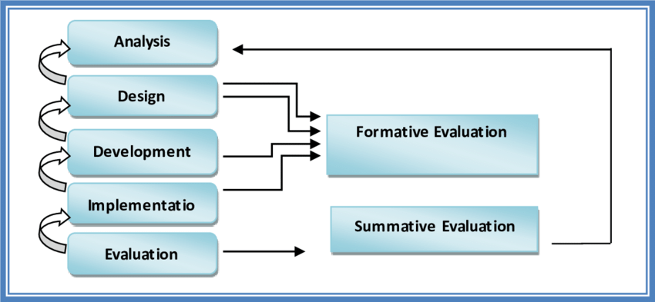

Picture 3.1 ADDIE Model of Development

## **Subject, Object and Time of the Research**

### **Subject of the Research**

The subject of the research are two Subjects: first is a material and second is design expert or the maker of needs Sparkol VideoScribe as well as the teacher at MAS PP Raudhatul Hasanah Medan.

* + 1. The validation lectures material
    2. The validation design lecturer of media-based learning Sparkol
    3. Teacher teaching the material validation

### **Object of the Research**

The object the research in development teaching the material narrative text is X grade at MAS PP Raudhatul Hasanah Medan, consist of expert material, members of teaching the material master of X grade and students of X grade at MAS PP Raudhatul Hasanah Medan.

### **Time of the Research**

The time of the research is second semester of academic year 2021-2022 at Pondok Pesantren Ar-Raudlatul Hasanah Medan.

## **Procedure of Research and Development**

### **The Stage of ADDIE Model**

1. Analysis is the process of identifying in which samples of research.
2. Design is the phase of designing the look of the media that will be developed.
3. Development is part of the learning media in accordance with the design of the media in the design phase.
4. Implementation is the stage to apply the learning media has been created to be developed and prepared in accordance with roles and functions.
5. Evaluation is to evaluate the stage of products that have been developed.

### **Audio-Visual Aids**

### Audio-visual aids are those devices which are used in classrooms to encourage teaching learning process and make it easier and interesting. Audio-visual aids are the best tool for making teaching effective and the best dissemination of knowledge.

### Four Types of Teaching Material are:

* Visuals Aids: Blackboard, Posters, Flashcards, Presentations, Printed textbooks, Graphs and Infographics.
* Audio Aids: Radio, Tape-recorder and CDs
* Audio-visual aids: Videos, Video recordings, Films and Documentaries, Virtual Classrooms and Language Laboratory.
* Computer-Assisted Learning: Pre-recorded DVDs, CDs, online quizzes, e-books, podcasts and blogs.

Audio-visual aids will be applied in this research because, it is suitable with the application of Sparkol VideoScribe. Sparkol VideoScribe will be designed by the teacher based on the animation of the text, in order to improve students’ ability and students’ effectiveness in reading comprehension.

### **Validation of Product**

Validation of the product aims to get accurate data for revision (repair), in order to achieve eligibility products. This validation also includes validation of design, it contents validation and product design is aiming to obtain data in the form assessment and advice validators, so the known valid whether or not the product will then be carried out revision.

Before try the product tasted will be consulted with several experts includes expert content and teaching material narrative text expert, after consulting the product will be addressed and assessed by the teacher of class eight.

### **Trial of Product**

Trial of the product aims to gather data that can be used as a basis to set degree of effectiveness efficiency and the charm of the resulting product. Trials conducted before-after compare the circumstances before and after wearing the system. The design trials of the product made after the design of finished product.

The Formula is:

O1 X O2

Description:

X : teaching the material using Sparkol

O1 : the preliminary test/pre-test

O2 : the final test/post-test

## **Instrument and Technique of Collecting Data**

### **Instrument Validation of Product**

The instrument uses in data collection is in the form of a question form consists of two parts.

1. The form of Likert Scale question form with 5 alternatives answer

* Score 1, if it isn’t very precise, not very obscure, not very easy, not very interesting.
* Score 2, if less precise, less obvious, less convenient, less attractive
* Score 3, if appropriately enough, clear enough, easy enough, quite interesting
* Score 4, if appropriate, clear, easy, interesting
* Score 5, if very precise, very clear, very easy, very interesting

1. The form of commands and suggestions filling sheets validator.

**The Steps are:**

1. Design the Instrument
2. Validate the Instrument to the Expert
3. Asking Opinion about the Instrument

### **Instrument of Trial**

Instrument is the test, it requires a pretest and posttest in this research. This test aims to find out whether there is an increase in students’ achievement of implementation teaching the material narrative text based on Sparkol Videoscribe.

**The Steps are:**

1. Validate the Questions
2. Conducting Pre-test
3. Giving the Treatment used the Instrument
4. Performing Post-test

### **Technique of Collecting Data**

The data of validation product are retrieving or taking from the result of validation against the media developed. First is quantitative data obtained from the scoring results in the form of percentage to know eligibility and valid media the second is qualitative obtained from the options and suggestion of the validation.

The data of trial are obtaining the quantitative data taken from tests of teaching material narrative text in reading comprehension based on pretest and posttest.

## **Technique of Data Analysis**

### **Validation Product**

Data analysis techniques use for analyzing quantitative data validation result is with the technique of calculation of the average value of a function to know the ranking of the trial value for the item in question.

The formula is:

$$Ρ= \frac{ΣΧ}{ΣΧi} × 100$$

Description:

P : the percentages are searchable (feasibility)

∑X : the amount of assessment answers

∑Xi : the highest number of answer

100 : integer constants

Table 3.1 the Eligibility Criteria

|  |  |  |
| --- | --- | --- |
| The Percentages of (%) | The Level of Validity | Eligibility Criteria |
| 90-100 | Very Valid | Very decent, not need for revision |
| 75-89 | Valid | Worthy, no need for revision |
| 65-74 | Quite valid | Pretty decent, need to be revision |
| 55-64 | Less Valid | Less worthy, need a revision |
| 0-54 | It is not Valid | The revision is not feasible the total |

### **Trial**

This data is collecting by using t-test in order to find out the result of students’ learning target or the result before and after developing teaching the material narrative text based on Sparkol VideoScribe.

The Formula is:

$$t= \frac{Md}{\sqrt{\frac{{∑d}^{2}-{\frac{(∑d)}{n}}^{2}}{n(n-1)}}}$$

Description:

t : test-T

md : the average of the difference between the pretest and posttest

d : posttest score difference against the pretest each sample

n : the number of sample

T-test is using for testing hypothesis:

Ho : There is no difference in the learning achievements of students before and after using the teaching material based on Sparkol VideoScribe subtheme the smartest animal.

Ha : There is a difference in student learning achievements before and after using the teaching material based on Sparkol VideoScribe subtheme the smartest animal.

The t-test will compare to t-table