ABSTRAK
PENGARUH KAPABILITAS KERJA, PERILAKU KERJA INOVATIF DAN LINGKUNGAN KERJA INTERNAL TERHADAP KINERJA KARYAWAN PTPN IV REGIONAL II KEBUN LIMAU MUNGKUR
Oleh:
RIZKA KHAIRUNNISYA BR SINAGA
213114093

Tujuanpenelitianiniadalahuntukmengetahuidanmenganalisispengaruhkapabilitaskerja, perilakukerjainovatifdanlingkungankerja internal terhadapkinerjakaryawan PTPN IV Regional II KebunLimauMungkur.Populasidalampenelitianiniadalahseluruhkaryawan PTPN IV Regional II KebunLimauMungkursebanyak 125 responden.PengambilansampelpadapenelitianinidenganmenghitungmenggunakanrumusSlovinyang menjadi 95 respondenkaryawanKebunLimauMungkur.Teknikpengumpulan data dalampenelitianinidenganmelakukanobservasi, dokumentasi, wawancaradanpenyebarankuesionersecaralangsungdenganpengukuran data skalalikert.Teknikanalisis data denganmenggunakanujivaliditas, reliabilitasdanasumsiklasik.Metodeanalisis data menggunakanregresi linear bergandayang hasilnyayaitu: Y = 16,300 + 0,102 X₁ + 0,116 X₂ + 0,272 X₃ + e denganbantuan program SPSS.Hasilpenelitianinisecaraparsial(ujit) membuktikanbahwakapabilitaskerjaberpengaruhpositifdansignifikanterhadapkinerjakaryawanpadakaryawan PTPN IV Regional II KebunLimauMungkur.Perilakukerjainovatifberpengaruhpositifdansignifikanterhadapkinerjakaryawanpadakaryawan PTPN IV Regional II KebunLimauMungkur.Lingkungankerja internal berpengaruhpositifdansignifikanterhadapkinerjakaryawanpadakaryawan PTPN IV Regional II KebunLimauMungkur.Selainitu, Kapabilitaskerja, perilakukerjainovatifdanlingkungankerja internal secaraserentakberpengaruhpositifdansignifikanterhadapkinerjakaryawanpadakaryawan PTPN IV Regional II KebunLimauMungkurdenganilaiF_{hitung} (14,283) > F_{tabel} (2,70), dan nilai signifikansi sebesar 0,000 < 0,05.

Kata kunci:KapabilitasKerja, PerilakuKerjaInovatif, LingkunganKerja
Internal,KinerjaKaryawan

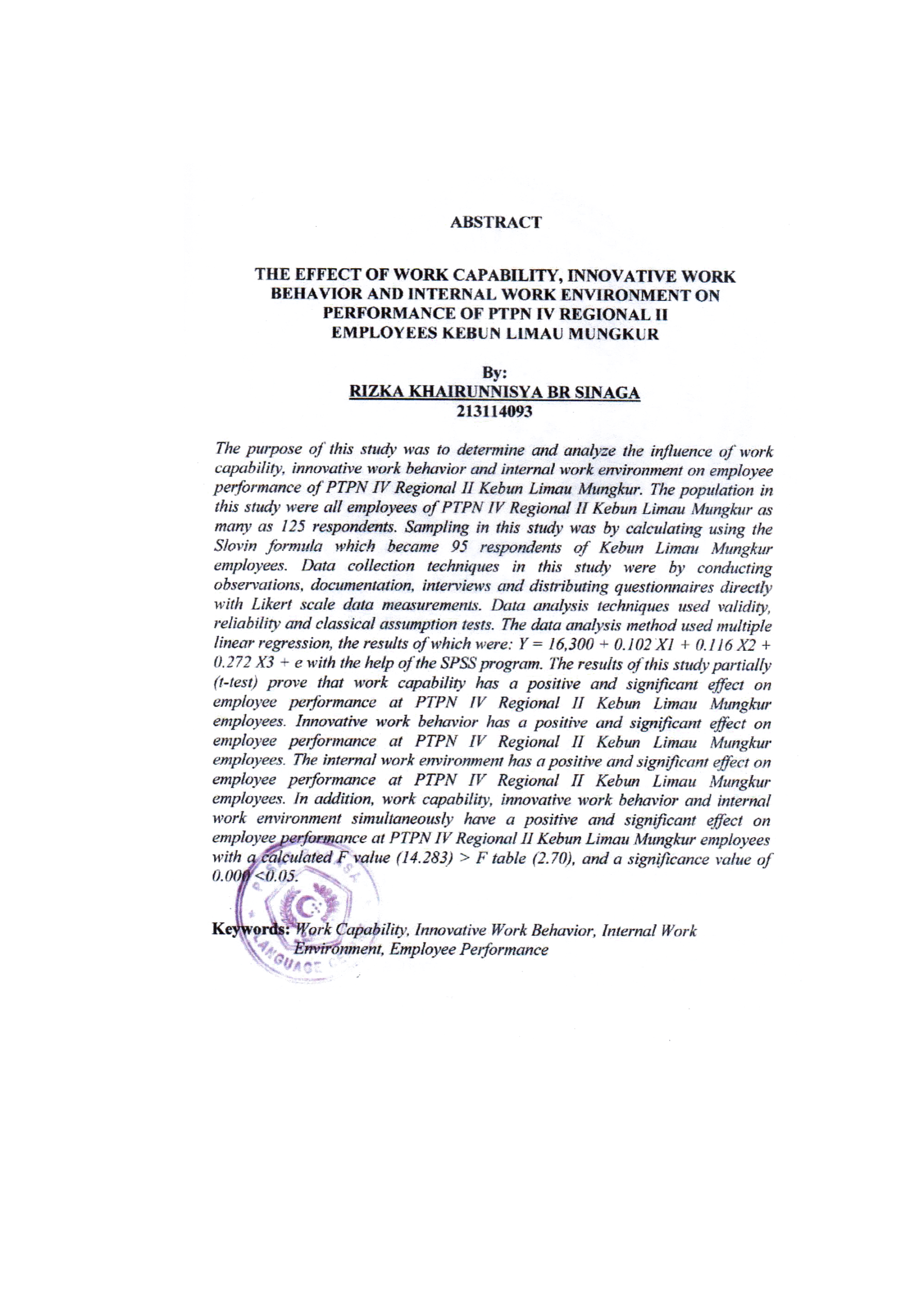
ABSTRACT
THE EFFECT OF WORK CAPABILITY, INNOVATIVE WORK BEHAVIOR AND INTERNAL WORK ENVIRONMENT ON PERFORMANCE OF PTPN IV REGIONAL II
EMPLOYEES KEBUN LIMAU MUNGKUR

By:
RIZKA KHAIRUNNISYA BR SINAGA
213114093

The purpose of this study was to determine and analyze the influence of work capability, innovative work behavior and internal work environment on employee performance of PTPN IV Regional II Kebun Limau Mungkur. The population in this study were all employees of PTPN IV Regional II Kebun Limau Mungkur as many as 125 respondents. Sampling in this study was by calculating using the Slovin formula which became 95 respondents of Kebun Limau Mungkur employees. Data collection techniques in this study were by conducting observations, documentation, interviews and distributing questionnaires directly with Likert scale data measurements. Data analysis techniques used validity, reliability and classical assumption tests. The data analysis method used multiple linear regression, the results of which were: Y = 16,300 + 0.102 X1 + 0.116 X2 + 0.272 X3 + e with the help of the SPSS program.The results of this study partially (t-test) prove that work capability has a positive and significant effect on employee performance at PTPN IV Regional II Kebun Limau Mungkur employees. Innovative work behavior has a positive and significant effect on employee performance at PTPN IV Regional II Kebun Limau Mungkur employees. The internal work environment has a positive and significant effect on employee performance at PTPN IV Regional II Kebun Limau Mungkur employees. In addition, work capability, innovative work behavior and internal work environment simultaneously have a positive and significant effect on employee performance at PTPN IV Regional II Kebun Limau Mungkur employees with a calculated F value (14.283) > F table (2.70), and a significance value of 0.000 <0.05.

Keywords:Work Capability, Innovative Work Behavior, Internal Work
Environment, Employee Performance

