ANALYSIS OF CODE MIXING ON THE INDAH G SHOW’S YOUTUBE PODCAST

A Thesis

By :
DHARMADIAH
NPM : 216114013



FACULTY OF LITERATURE
UNIVERSITAS MUSLIM NUSANTARA AL WASLIYAH
MEDAN
2024
AN ANALYSIS OF CODE MIXING ON THE INDAH G SHOW’S YOUTUBE PODCAST

A Thesis
Submitted as a Partial Fullfillment of the Ruquirement for S1-Degree

By :
DHARMADIAH
NPM : 216114013

FACULTY OF LITERATURE
UNIVERSITAS MUSLIM NUSANTARA AL WASLIYAH
MEDAN
2024

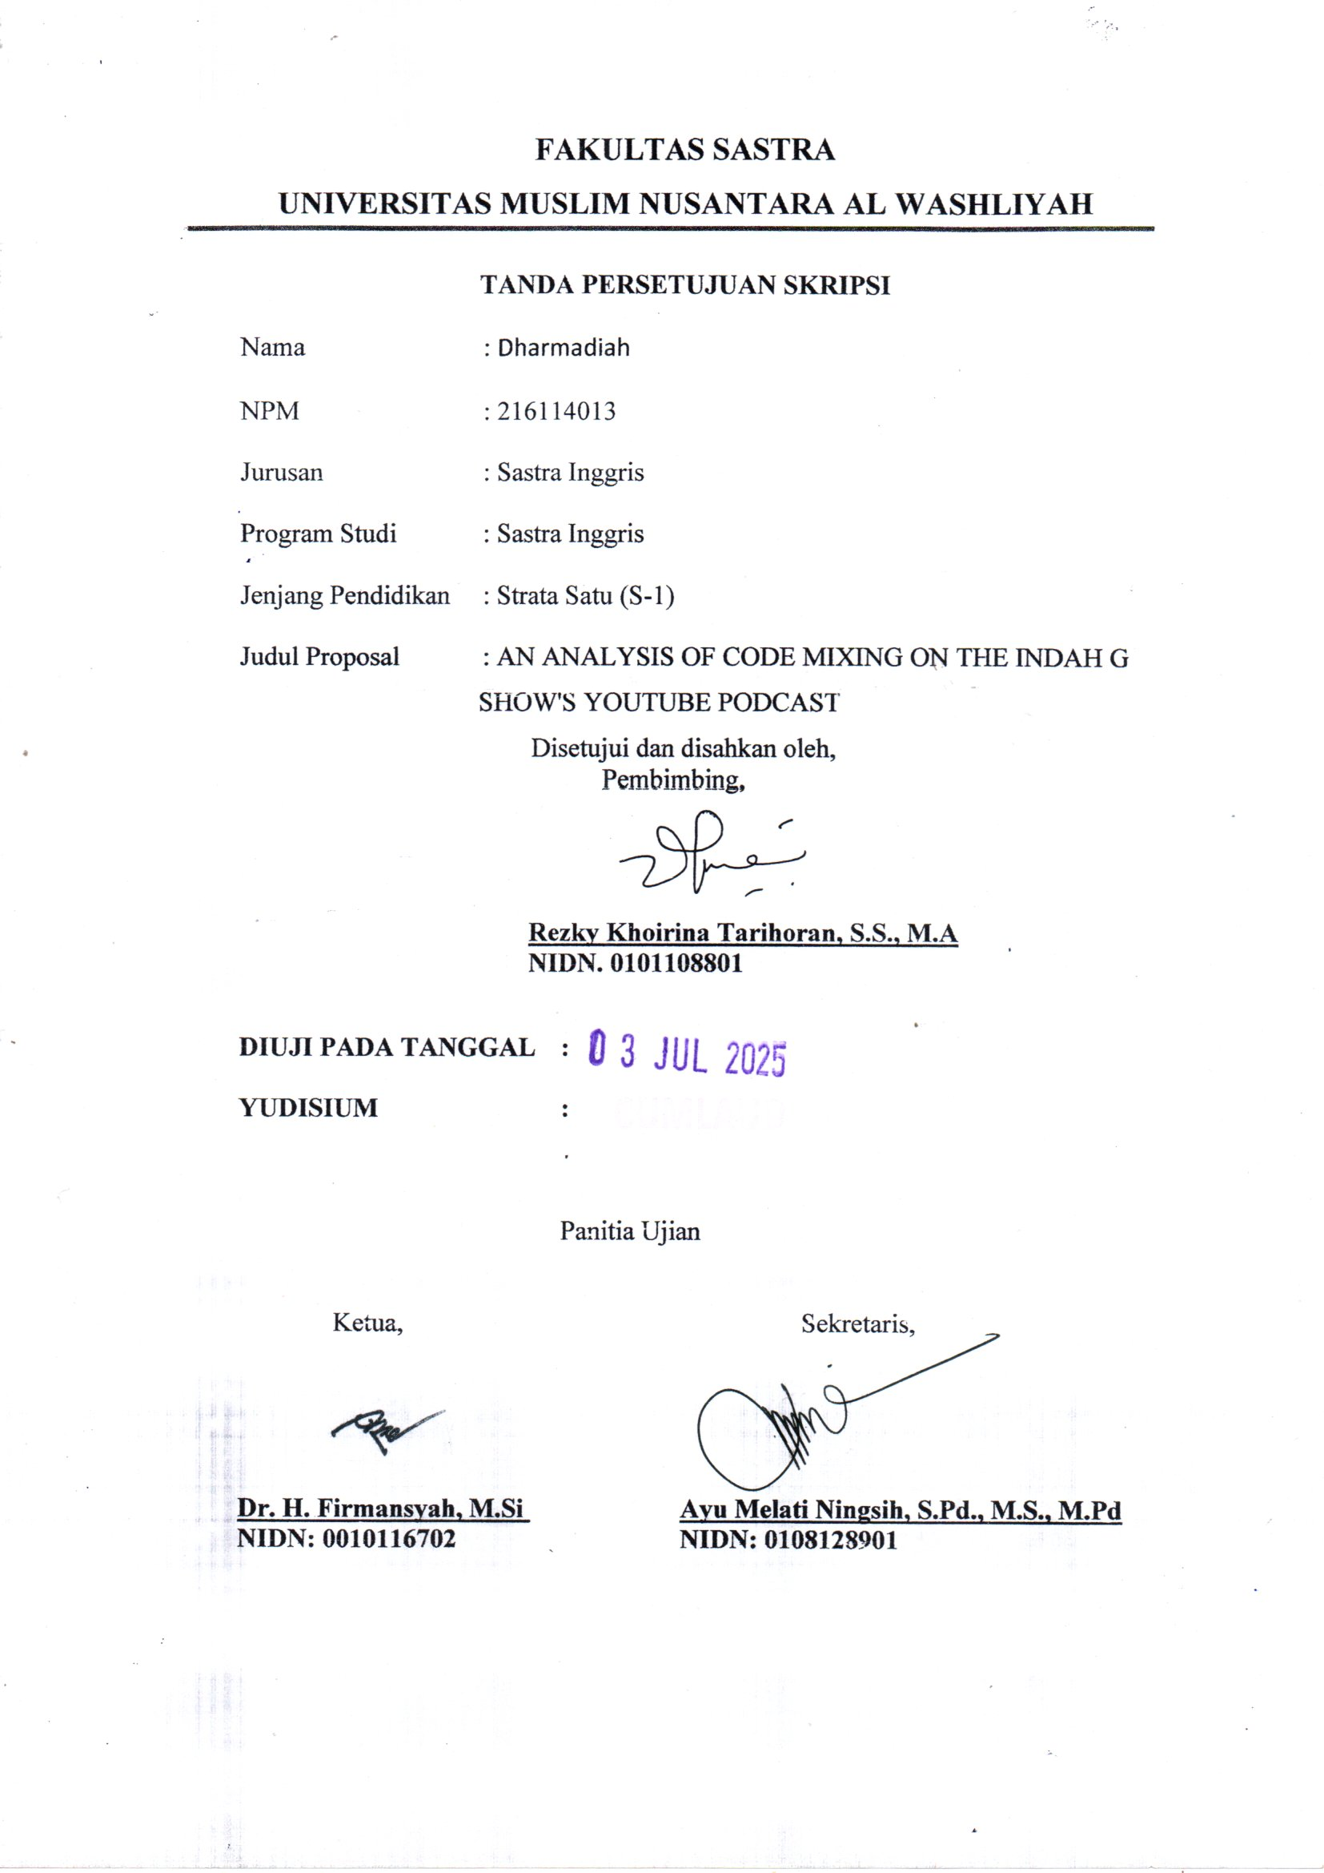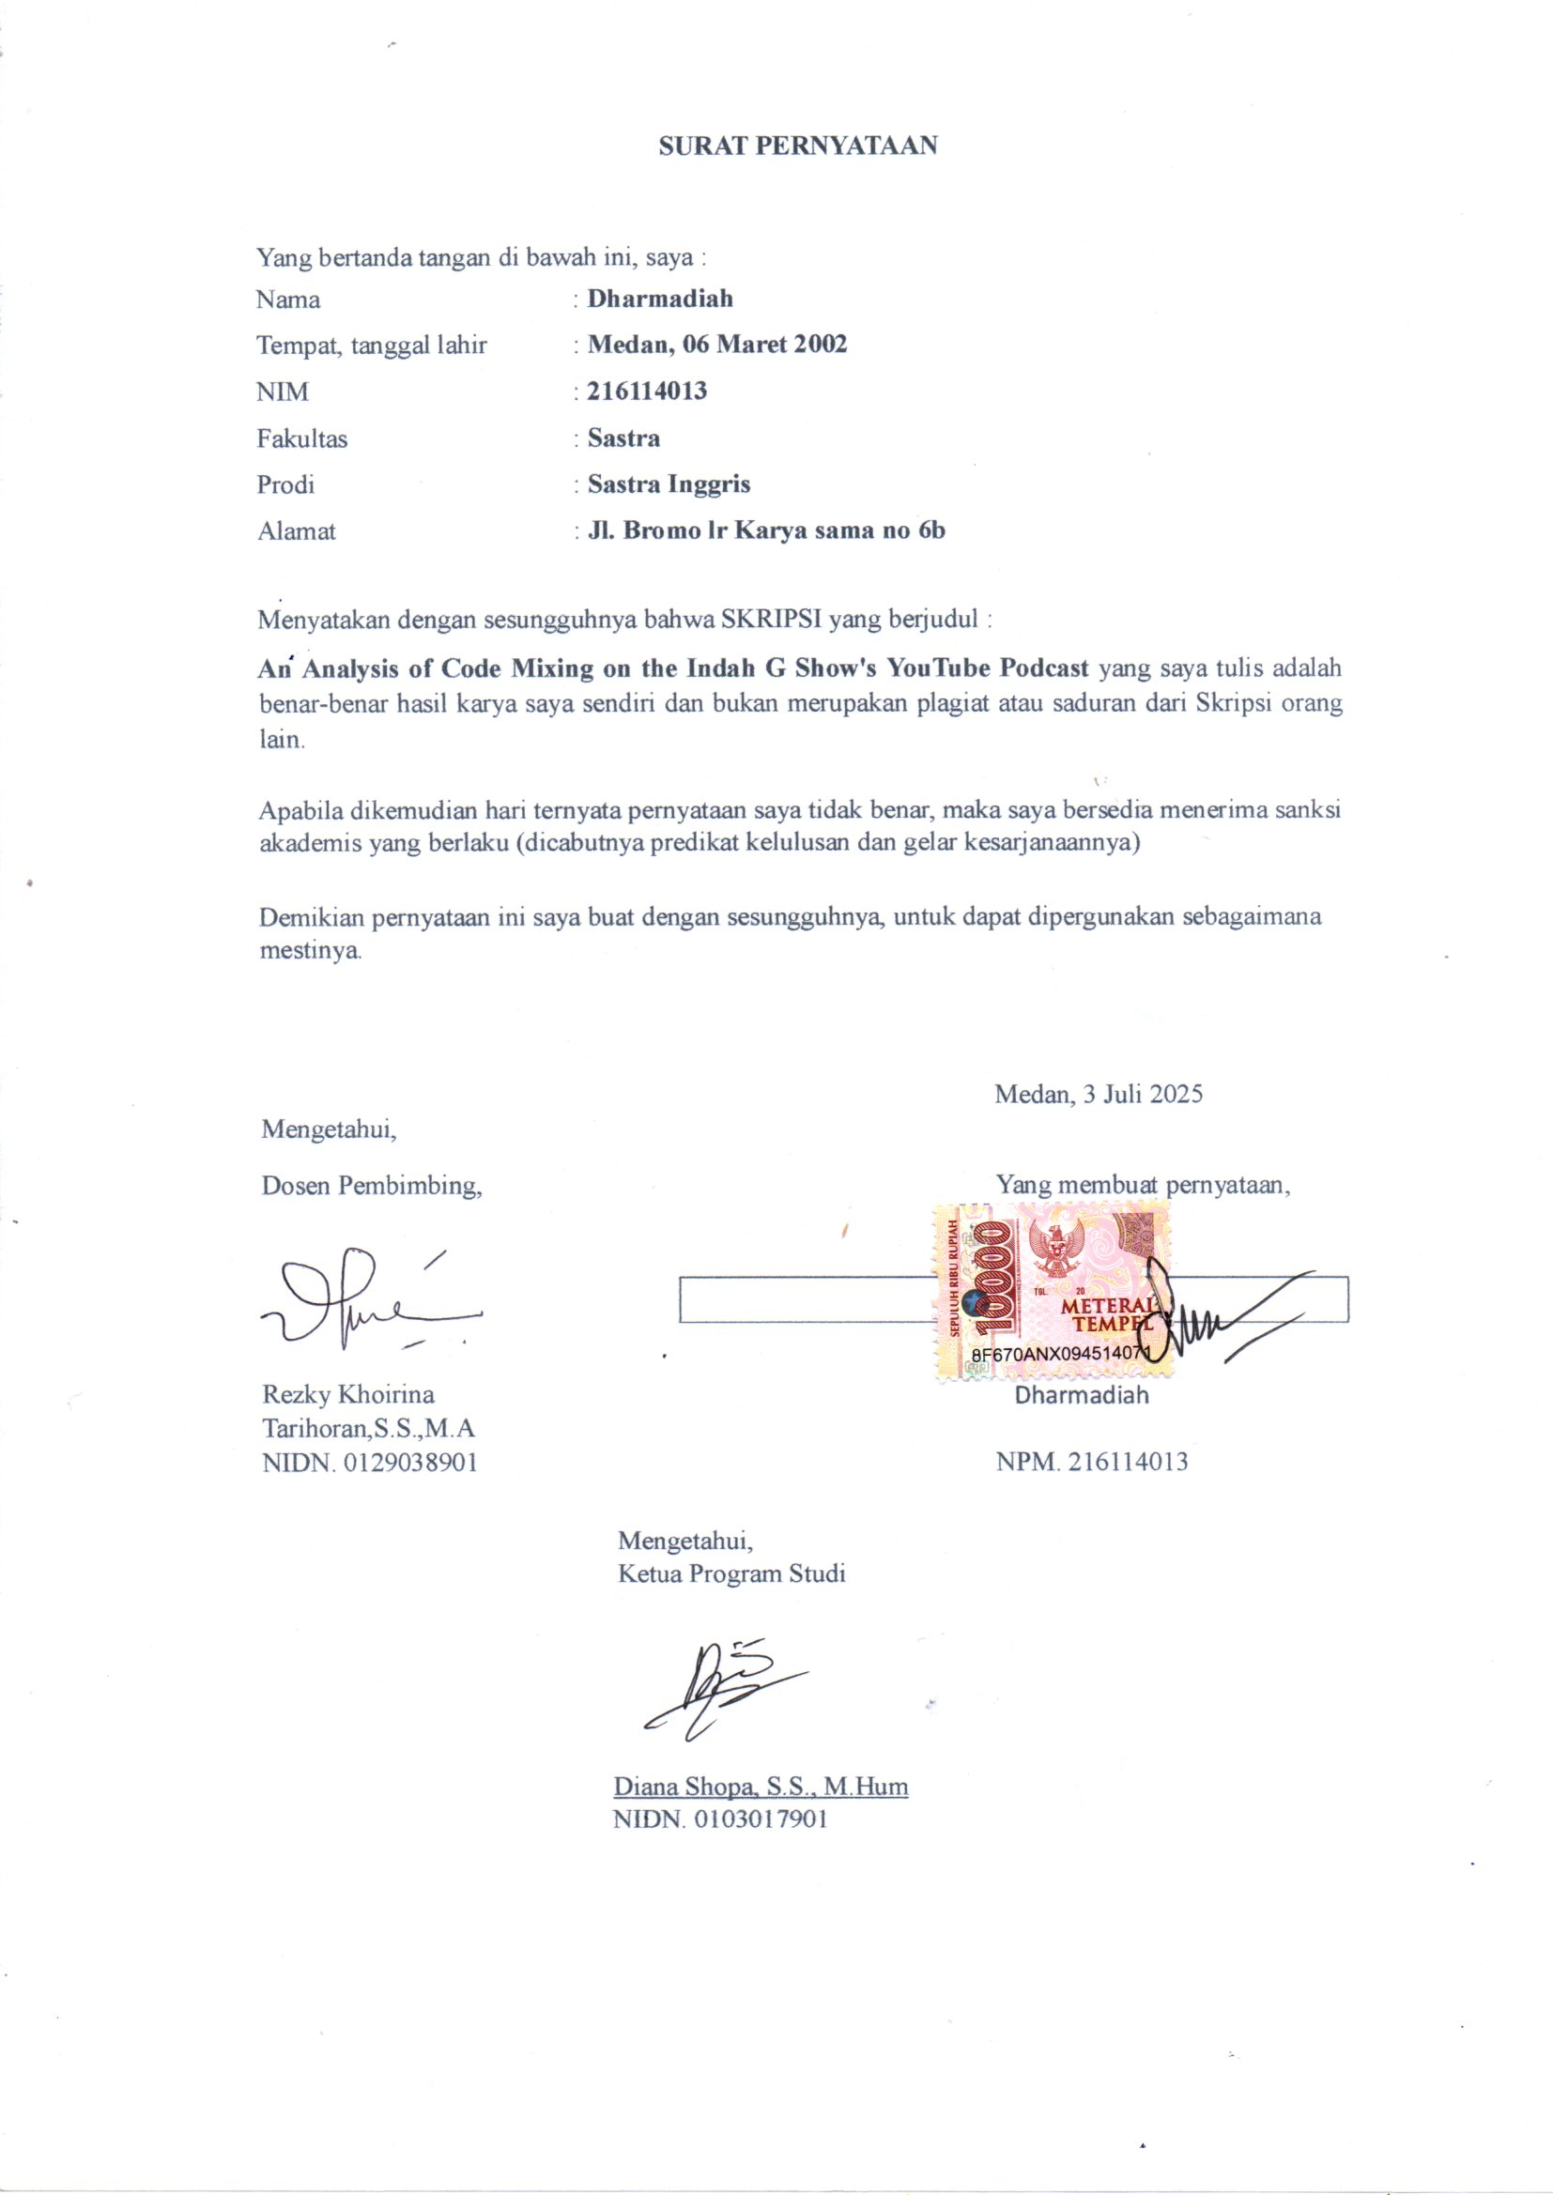
ACKNOWLEDGEMENT
Assalamu’alaikumWarahmatullahiWabarakatuh
In the name of Allah Subhanahuwata‟ala, the greatest lord, the most merciful and beneficent. Alhamdulillahirabbil „alamin, all praises to Allah which by His affection the researcher can design this mini thesis entitled “An Analysis of Code Mixing on The Indah G Show's YouTube Podcast”. Peace be upon the prophet Muhammad Sallallahu„alaihi wassalam which we hope for his blessing in the judgement day. Special thanks to her dearest parents Suhardi and Rosjanah for their prayers, advices, courage, moral, material and supports.
Therefore, the researcher would like to thank :
1. Dr. H. Firmansyah, M.Si as the head of The UniversityofMuslim Nusantara Al-WashliyahMedan.
2. Ayu Melati Ningsih,S.Pd., M.S., M.Pd as the DeanoftheFacultyofLetters.
3. DianaSopha,S.S.,M.Hum.,as the DeputyDeanofthe FacultyofLetters.
4. Vera Kristiana,S.Pd.,M.Pd as the Head of English Literature Study Program.
5. RezkyKhoirinaTarihoran,S.S.,M.A.,asthethesis supervisorwhohashelped providesolutionstoeveryobstacleandhassacrificedhervaluabletimetoguide me in completingthisthesis.
6. Dr. Azhari Tambusai, M.Pd and Diana Sopha, S.S., M.Hum., as the examining lecturer who has provided many constructive suggestions and inputs to the researcher.
7. All lecturers intheFaculty ofLetters whohavetaught andinspiredmeduring the study.
8. My beloved family asspecialy for my mother who always give full support for the completion of this thesis.
9. Myclosestfriends Nurfia Maliza and Raudah aswell asfriendsin the2021 English Literature class who alwaysaccompanyandencouragemetocompletethisthesis.
10. My boyfriend Ahmad Syafi'i who patiently and faithfully waited, encouraged and accompanied the author until completed this college journey.
11. And the last but not last, I wanna thank me, I wanna thank myself for doing all this hard work. I wanna thank me for never give up, I wanna thank me for always being myself.
However, the Researcher realizes that this thesis has limitation in certain way and this thesis is far from being perfect. Thus, critique, comment, and suggestion, are expected to arrange paper better in the forthcoming. Hopefully, this thesis can be useful and can give the beneficial for the readers who want to get information about code mixing.

Medan,30th June 2025
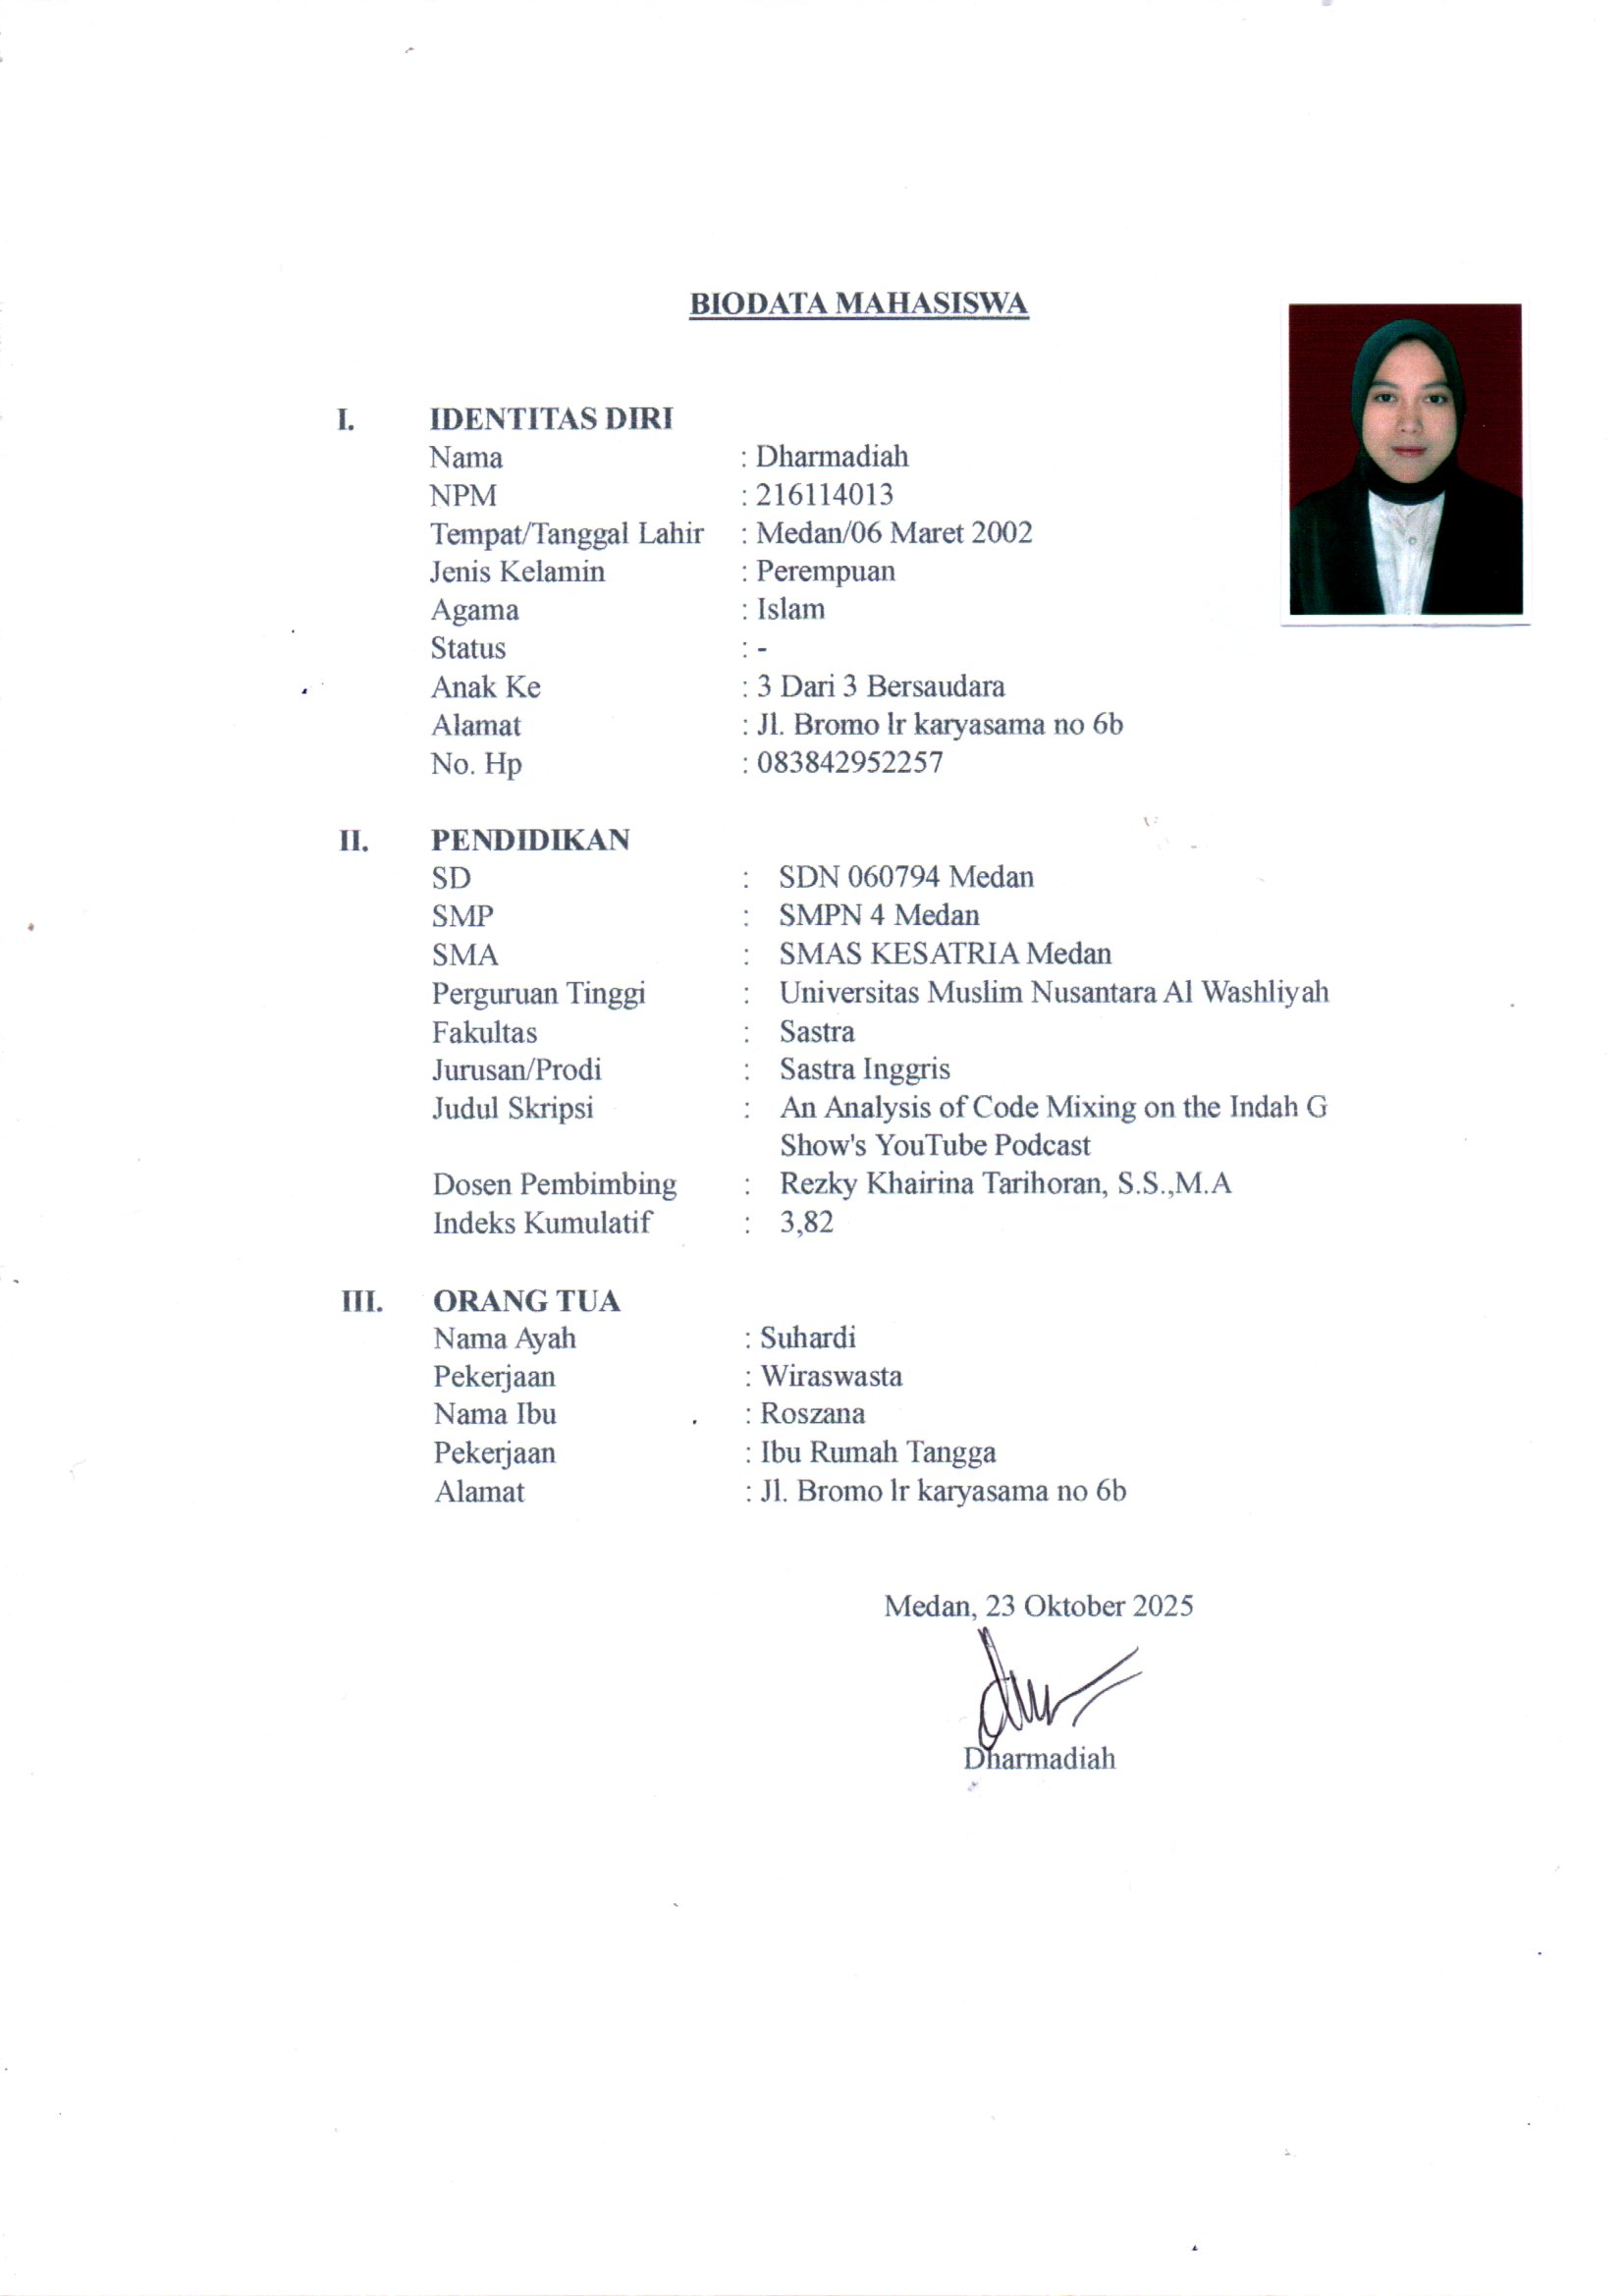
The Researcher

TABLE OF CONTENTS

ACKNOWLEDGEMENT i
TABLE OF CONTENTS iii
LIST OF TABLE v
ABSTRACT vi
ABSTRAK vii
CHAPTER I INTRODUCTION 1
1.1 Background of Research 1
1.2 Identification of the Problem 4
1.3 Limitation of the Problem 5
1.4 Problem of the Research 5
1.5 Objective of the Research 5
1.6 Significance of Research 6
CHAPTER II REVIEW OF LITERATURE 7
2.1 Sociolinguistics 7
2.2 Bilingualism 8
2.3 Code Mixing 9
2.4 Factors of Code Mixing 12
2.5 Youtube 15
2.6 Podcast 16
2.7 Biography of Indah G 16
2.8 Previous Research 17
CHAPTER III METHODOLOGY 20
3.1 Method of Research 20
3.2 Data and source of data 21
3.3 Technique of Collecting Data 21
3.4 Technique of Analysing Data 22
CHAPTER IV FINDING AND DISCUSSION 23
4.1 Findings 23
4.2 Discussion 32
CHAPTER V CONCLUSION AND SUGGGESTION 50
5.1 Conclusion 50
5.2 Suggestions 51
REFERENCES.................................................................................................... 52

ANALISIS CAMPUR KODE DALAM PODCAST YOUTUBE
INDAH G SHOW

DHARMADIAH
216114013

ABSTRAK

Sociolinguistic adalah ilmu yang mempelajari hubungan antara bahasa dan masyarakat. Setiap komunitas memiliki gaya bahasa yang berbeda saat berinteraksi satu sama lain. Karena adanya variasi tersebut, memungkinkan terjadinya pencampuran bahasa dalam percakapan. Pencampuran bahasa tersebut dikenal dalam bidang sosiolinguistik sebagai campur kode. Penggunaan campur kode dalam masyarakat sudah menjadi hal yang umum. Fenomena ini juga terlihat pada salah satu YouTuber yang sering menggunakan campur kode dalam podcast nya , dia adalah Indah Gunawan pemilik The Indah G Show's Youtube Podcast. Oleh karena itu, penelitian ini difokuskan pada campur kode yang muncul dalam video di saluran YouTube The Indah G Show. Tujuan dari penelitian ini adalah untuk mengetahui jenis dan faktor campur kode yang muncul dalam video tersebut. Jenis penelitian ini adalah kualitatif, dengan instrumen utama berupa penelitian manusia. Penelitian ini menggunakan analisis yang fokus pada jenis campur kode menurut Mussyken dan faktor campur kode menurut Hoffman. Setelah menganalisis video tersebut, ditemukan sebanyak 29 data yang berkaitan dengan jenis campur kode. Sedangkan hasil penyebab munculnya campur kode ditemukan sebanyak 8 jenis penyebab dari 10 jenis menurut teori Hoffman.

Kata Kunci: Sosiolinguistik, Campur Kode, Podcast Youtube The Indah G Show

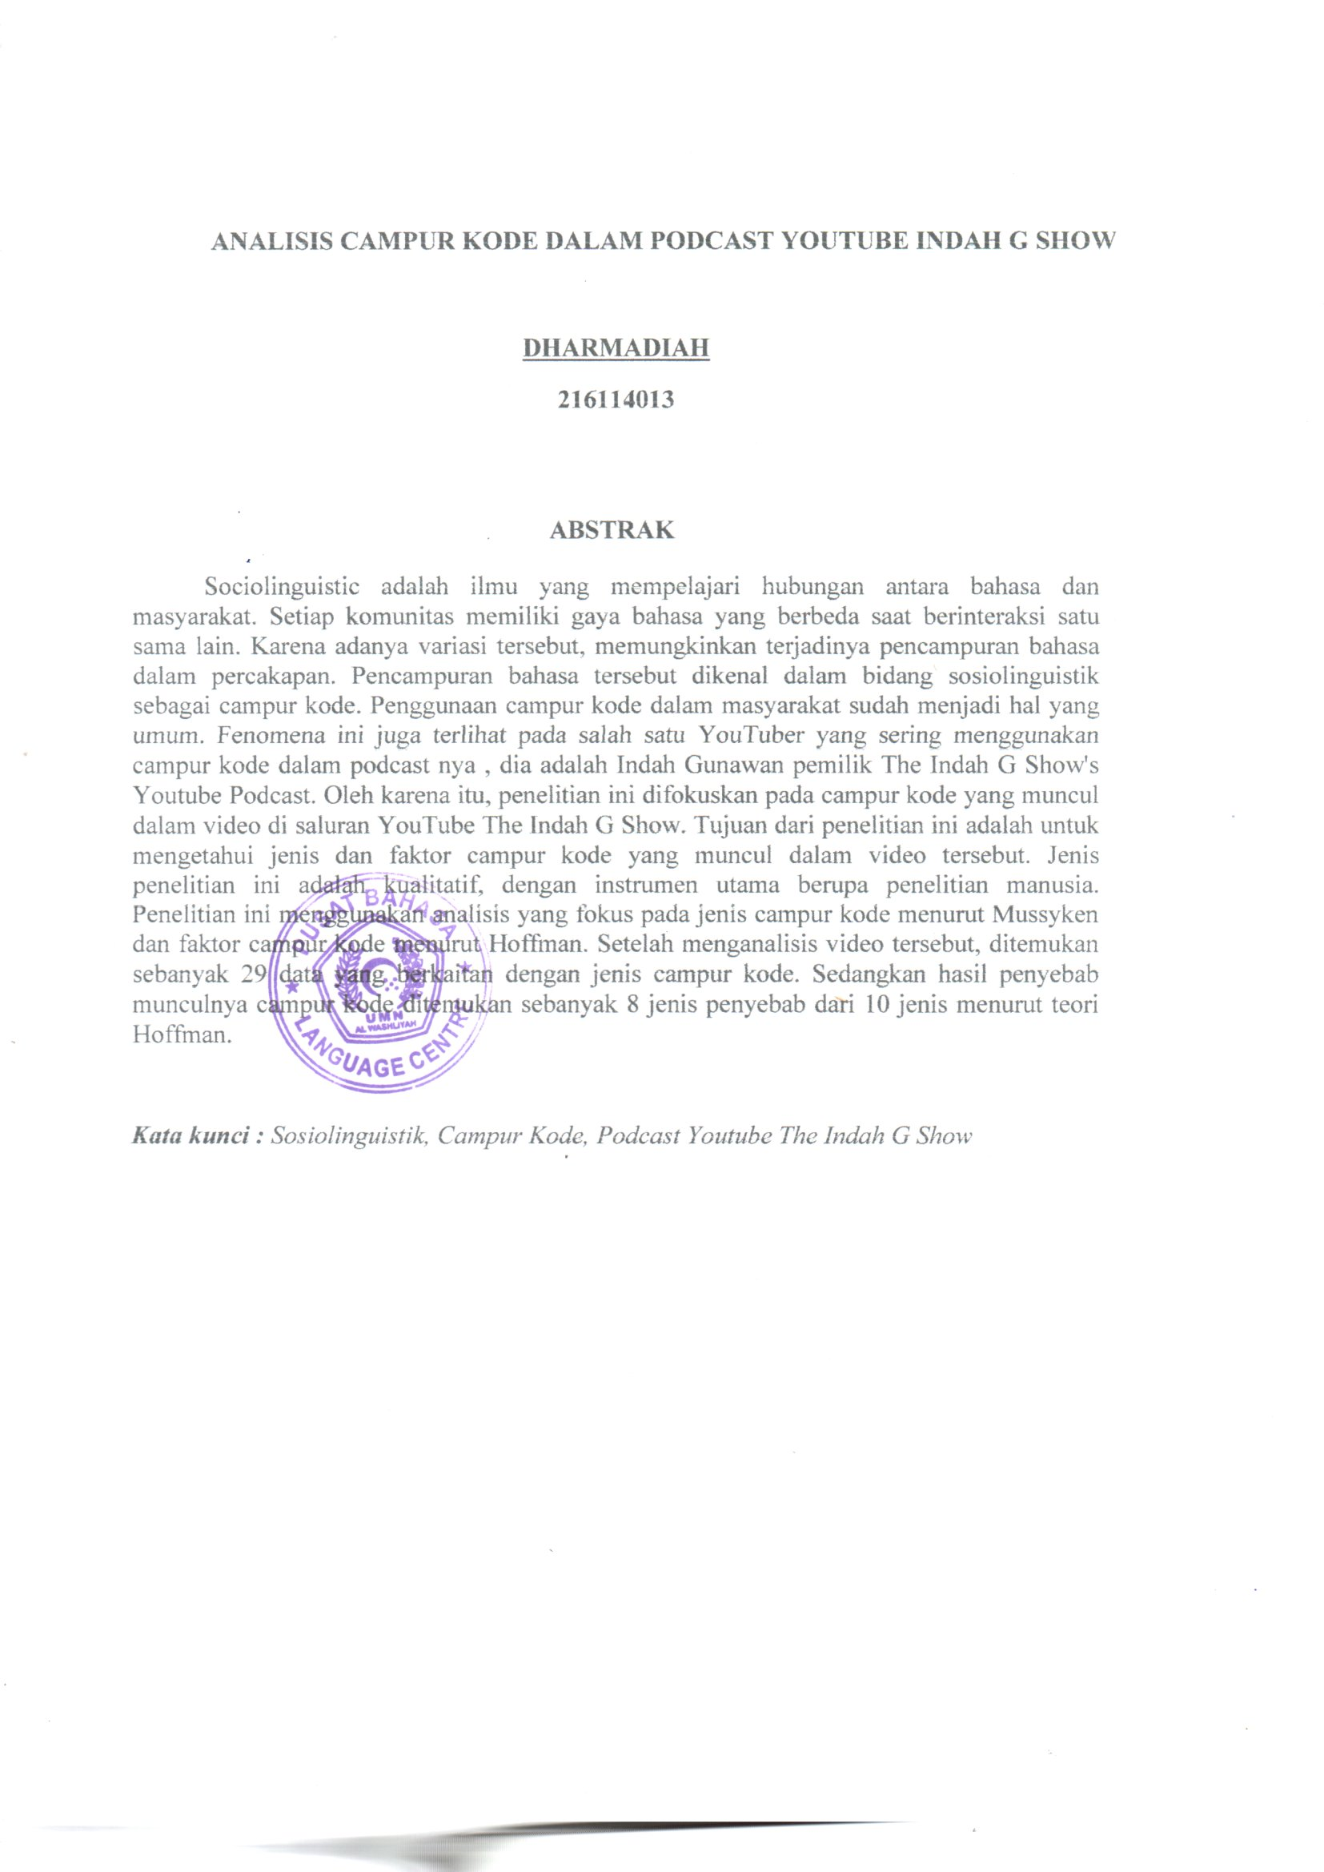

CHAPTER I

INTRODUCTION

1.1 Background of Research
Communication serves a bridge for socializing and interacting whether on a personal or personal or grouplevel, fostering a sense of togetherness. In this modern era where communication trends dominate, individual explore each other potentials, often facilitated through various information technology platforms. These media not only help connect people across distance but also serves as alternative methods for sharing and engaging without physical contact. In addition to being recognized as a communication tool, Media is increasingly used by individuals for entertainment purpose. Nowadays people often communicate in more than one language. The language most often found is english. English as a foreign language is the language most widely used to communicate with other people in Indonesia. English is the common language for communicating with anyone, ilustrating the significance of language in human interactions.
Language is the tool of communication that has the essential part in making communication. Language is also the most important aspect in the life of all being because it can be uses to communicate to each other. A human can not communicate in any real sense without language. As a communication, language has sound, gesture or marks having understood the meaning. However, not everybody has same language and dialect. The human can not be separated of language. Because the language is as a system to communicate between human to other human (Hutajulu&Herman,2019).
1
Sociolinguistics discussed about language and society. It means that is learned about relationship between language and society. Developing communicative competence in two or more language give an individual oppurtinity to express their feelings, thoughts and shape their indentities. It also help them statisfy their individual and social media in the field of sociolinguistics in bilingual or multilingiual societies is code mixing. The phenomenon code mixing of language interested scholars who have examined what triggers such occurences (Musyken,2022).
Code in sociolinguistics simply refers to a language or a language variety. According to Hymes (in Fitrah 2017:31) defines code mixing as the term refers to use of one or more language for consistent transfer of linguistics units from one language into another and by such a language mixture developing a new restricted or not so restricted code of linguistic interaction. A similar definition is stated by Dewi & Torihoran (2021 : 302 ) Code mixing is a sociolinguistic study that occurs when there is a mixing of two languages in a multilingual society in the same sentence which occurs according to the current event. In sociolinguistic phenomena related to society’s use of language. There are situations where many people can understand two or more languages. In sociolinguistics it is called bilingual and multilingual. Bilingual is someone who can speak two languages and multilingual is someone who can speak more than two languages.
This phenomenon can also be found in the media, especially on youtube channel. Youtube is a form of video based social media that began to gain popularity 5 years ago and has more than one billion users if seen from the site’s own (Harilama,2017). However it can not be denied that youtube also contains a lot of code mixing in its broadcasts. Among them is a youtube podcast channel which shows two people having a conversation and discussing a topic.
Kargozari&Zarinkamar (in Robi 2016:83) state that podcasts are a audio or video files that can be downloaded from the internnet. Podcasts are usually played on electronic devices such as mobile phones, laptops, tablets, or mp3 players. Podcasts have long been used in Indonesia because of the importance of the information obtained on podcasts.
One of the youtube podcast that often uses code mixing is The Indah G Show youtube podcast. Indah G is the owner and host of The Indah G Show. She is a youtuber and instagram celebrity. Through her podcast “The Indah G Show” she often discusses various topics ranging from lifestyle, social and viral content. Indah G always uses english in her podcast, but there are times when she uses several Indonesia language to her guest stars. This is because Indah G is more fluent in english.
The researchers chose to analyze Indah G’s podcast for several reason is that Indah G uses english when speaking to its guest stars, so it is vey suitable for this research which analyze code mixing in English to Indonesian. The second reason is that the podcast often discusses social, cultural and political issues which tend to be sensitive when discussed and give rise to pros and cons for listeners.
This research analyze one of The Indah G Show youtube podcast entitled Chindo Jakarta vs Chindo Surabaya. The podcast is divided into 2 parts. Part I was released on April 7, 2022 with almost 27 thousand viewers. Part II was released on April 12, 2022 with almost 16 thousand viewers. The researcher chose this episode because the title is interesting to discuss because it discusses the differences in character and life between Chindo Jakarta and Chindo Surabaya. Apart from that, among the video podcasts on The Indah G Show Youtube Channel, this episode is the most suitable for analysis because this podcast uses aa mixture of english and indonesia, where Indah G invited a chinese ifluencer from jakarta as a guest star, she is Ellaine Ivanka.
Currently, most podcast channels in Indonesia sometimes use english to provide and share the information. In the Indah G show podcast, Indah often invites fuest stars who tend to use english as communication. Indah G as the host and owner sometimes changes language from english to indonesia. He mixes languages to interpret the meaning of the words. By mixing words that are more suitable to use and easier to understand.
Furthermore, the researcher are interested to analyzing this topic because there are many Indonesian people who are used to this phenomenon in everyday communication, whether they realize it or not. The researchers conducted research entitled “An Analysis of Code Mixing on The Indah G ShowYoutube Podcast”.

1.2 Identification of the Problem
The problem of code mixing are identified as :
- There are code mixing on The Indah G ShowYoutube Podcast
- There are 3 types of code mixing that appear on The Indah G ShowYoutube Podcast based on Musyken’s theory
- There are 10factors that cause code mixing on The Indah G Show’s Youtube Podcast based on Hoffman’s theory

1.3Limitation of the Problem
In this research, the researcher focuses on analyzing the types of code mixing on The Indah G Show Youtube Podcast. In this research, the researcher took one of the videos with the title “Chindo Jakarta vs C hindo Surabaya”. In analyzing the video the researcher looked for the code mixing from english to indonesia language. Data collected only from The Indah G ShowYoutube Podcast.

1.4 Problem of the Research
Several statement that need to be discussed in this research are :
- What are the types of code mixing that appears on The Indah G Show’s Youtube Podcast ?
- What are the factors causing code mixing on The Indah G Show Yotube Podcast ?

1.5 Objective of the Research
The objective of this research are :
- To find out thetypes of code mixing that appears on The Indah G Show Yotube Podcast based on Musyken’s theory
- To describes the factors causing code mixing on The Indah G ShowYotube Podcast based on Hoffman’s theory

1.6 Significance of Research
The significances of this research include several points :
- Theoretical
This research aims to increase understanding of sociolinguistics, especially related to the phenomenon of code mixing.
- Practical
- For English Teachers
The teachers can use this research as a guide to deepen learning about code mixing. Apart from that, teachers can also use youtube as a means students because youtube is a platform that students can enjoy during the teaching and learning process.
- For Students
Students can gain a deep understanding of code mixing and can immediately apply it in everyday life
- For other Researchers
The results of this research can be used as a reference for other researcher who are interested in conducting similiar research in different fields.

CHAPTER II

REVIEW OF LITERATURE

2.1 Sociolinguistics
There are several definitions of sociolinguistics given by linguists. According to Wardhaugh(2006:13) sociolinguistics is the study of language in relation to society, while the sociology of language is the study of people in relation to language. In other words, in sociolinguistics we learn the language and the community to find out as much as we can about what kinds of languages and the sociology of language we reverse our direction. A similar definition is stated by Trudgill (2012: 10)sociolinguistics is part of linguistics which is concerned with language as a social and cultural phenomenon. It investigates the field of language and society and has close connections with the social sciences, especially social psychology, anthropology, human geography and sociology.
In sociolinguistics, we study the relationship between language, culture, and society. This is very important because understanding language in a cultural context allows us to communicate and create deeper meaning. Here, cultural understanding becomes crucial. Without this competence, we will have difficulty understanding the meaning of the conversation. This process can be carried out through mass media or electronic media, where sociolinguistics provides in-depth understanding.
Based on various definitions from experts, sociolinguistics can be concluded as a branch of linguistics that focuses on the study of the relationship between language and society, including variations, functions and language users. Each community group has a unique language identity to communicate between them.
7

2.2 Bilingualism
Bilingualism in general is about the use of two languages. Bilingualism refers to a situation where two languages are used in a speech community. Sometimes the term bilingual refers to a person who only uses two or more languages at the same level of performance. But in general, a more moderate view suggested bilingual for a person who does not need to use two or more languages at the same level (Jendra, 2012). To refer to people who can use more than two languages can be called multilingual/multilingual people. However, it is becoming common to use the term bilinguals to refer to people who are more properly identified as multilingual (Jendra, 2012).
Suhardi (2009) stated that the term bilingualism is generally used to refer to the use or mastery of two languages by one or a part of the language community, the term is sometimes also used to refer to situations of using three languages or trilingualism (tri-lingualism) or usage more than three languages are called multilingualism or pluralingualism (multilingualism; plurylingualism). In line of Suhardi‟s statement (2009), Mu'in (2008) states that there are a number of language scientists who argue that the use of more than one such language is referred to by just one term, namely bilingualism.From the definition above, bilingualism can be defined as an individual's ability to speak and understand more than one language. The phenomenon of bilingualism is influenced by various factors, one of which is educational background. A person's level of education can contribute to their ability to master more than one language.

2.3 Code Mixing
Wardhaugh (2006: 103) states that code mixing occurs when conversation use both languages together to the extent that they change from one language to the other in the course of a single utterance it means that the conversation just change some of the elements in their utterance. Code mixing takes place without a change of topic and can involve various levels of language, e.g., morphology and lexical items.
While according to Nababan (1984) code mixing happens when people mix two languages (or more) languages in such speech act or discourse without any force to do mixing codes. It is as the process whereby speakers indulge in code switching between languages of such rapidity and density, even within sentences and phrases that are not possible to say at any given time which language they are speaking. Based on the theory above, it can concluded that code mixing is the of a language from Indonesia to English or it can be a variety of languages, and is usually called the mixing of two languages.
According to Muysken(2000:1) there are three types of code mixing, which are insertion, alternation, and congruent lexicalization. Here is the explanation:

2.3.1 Insertion
Muysken (2000:1) states that the process of code mixing understood as something similarly with borrowing, it means that insertion of a lexical item or phrasal item inserted into the specific structure of language. In the insertion pattern, the lexical borrowing is limited to one lexical unit. In some languages, insertion mostly consists of adverbial phrases, single noun and determiner + noun combinations. Insertion results constituent from one language into a structure of another language.
It is code mixing which occurs in the level of words (Muysken, 2000) as cited (Yuliana, et al 2015: 47-48). Insertion code mixing can be form of single word or group of words but they are not sentence (it is called as a phrases. Outer code mixing is a form of mixing code acured from origi language.
For example :
“Jangan suka nge-claim orang lain lah“
On The Indah G Show’s Youtube Podcast(episode 13)
2:29 – “I was dipaksa guys”
33:43 – “And beneran kayak I see a lot of my friends getting married or at least getting engaged”
The code mixing above is called insertion types because it can be in the form of wods, phrases or clauses. In this case the words that are usually inserted are noun, adjectives or verbs.
2.3.2 Alternation
It is a type of code mixing occurring in the level of clause (Muysken, 2000) as cited in (Yuliana, et al 2015: 47-54). Clause is a group of words which consist of subject and predicate. In Alternation types, a clause can also a group of words which has subject and predicate, but sometimes the subject is embedded. Generally, people also called a clause as a sentence. Here, there are many types of sentences.
For example :
“Or Should I say kehidupan suram kami”
On The Indah G Show’s Youtube Podcast(episode 13)
10:16 – “Pokoknya they more multicultural “
11:18 – “Beneran kayak I see a lot of my friends getting married or at least engaged “
2.3.3 Congruent Lexicalization
Congruent lexicalization is the type of code mixing which occurs in the level of dialect or lexical level (Muysken, 2000) as cited (in Yuliana, et al 2015 : 47-54). It can also mean that it is the mixing of code through changing the pronunciation. In addition, it is the code mixing occurs in the level of phonology. Usually, Indonesian people say something using English word, but actually it is English word which is modified to Indonesian phonological structure.
For example :
“Software gua buat convert file wav jadi mp3 gua udah expired”
On The Indah G Show’s Youtube Podcast(episode 13)
11:18 – “Kayak introduce their friends , kayak gitu tuh orang Jakarta selalu lebih open sih "
11:24 – “And kayak bisa let's say kayak one grup to another grup itu bisa digabung gitu”

2.4Factors of Code Mixing
When code mixing occurs in society, the speaker's reason is an important consideration in the process. According to Hoffman (1991:116) there are a number of reasons for bilingual or multilingual people to mix from their language, as seen below:
2.4.1Talking about certain topics
Sometimes people prefer to talk about certain topics in one language. Sometimes speakers feel free and more comfortable expressing their emotional feelings in their everyday language.

2.4.2Quoting others
A bilingual person quotes famous phrases, proverbs, or sayings from several famous figures mostly from several source language countries. Then, quoting the sentence and expressions and sayings are then quoted in their entirety in their target language.
For example : “Serasa di surga guys”
2.4.3Being assertive about something (expressing solidarity)
When someone speaks using a language that is not their native language suddenly wants to be assertive about something, either intentionally or unintentionally they will switch from their second or first language. Because he feels more comfortable and assertive in his second or first language.
For example : “Okey fix minggu depan cuss ke makassar”
2.4.4 Interjections (inserting sentence fillers or sentence connectors)
Interjections are inserted into sentences to convey surprise, strong emotion, or to get attention. For example: Hey! Look! They have no grammatical value, those who hear them quite often, usually occur in speech rather than in writing. This may occur accidentally or as a sentence connector.
2.4.5 Repetition is used for clarification
When a bilingual wants to clarify his conversation so that it is understood by the listener, he sometimes uses two languages. Often, the message in one code is repeated in the literal code. A repetition not only serves to clarify what is said, but also to strengthen or emphasize the message.
For example : “Sebelum pesan/keep tanya model dan warna yang ready”
2.4.6 Intention to clarify the content of the conversation
A bilingual person makes his conversation run smoothly and can be understood by the listener. A message in one code is repeated in another code in a slightly modified form.
For example : “Info bantu share waspada semakin maraknya penjualan voucher hotel, tiket pesawat, bioskop dll dengan harga miring”
2.4.7Expressing group identity
The way academics communicate in their disciplinary grouping is clearly different from other groups to express group identity.
For example : “Latihan band rohanis remaja perak sorong”
2.4.8Soften or strengthen requests or commands
For Indonesians, mixing Indonesian into English can also function as a request because English is not their mother tongue, so it does not sound as direct as Indonesian. However, code mixing can also strengthen commands since the speaker can feel more powerful than the listener because he can use a language that not everyone can.
For example : kadang hidup yang kita keluhkan adalah hidup yang sangat diinginkan orang lain, so bersyukurlah dengan apa yang ada saat ini”
2.4.9 Due to real lexical needs
When an English-Indonesian bilingual has a word that is lacking in English, he will find it easier to say it in Indonesian. And vice versa, when he has a word that is lacking in Indonesian, he will use the English term.
For example : “Kick off babak kedua”
2.4.10To exclude others
When comments are intended for a limited audience only. Sometimes people want to communicate only to certain people or communities that they belong to. To avoid communication breakdowns, they may try to exclude people by using language that not everyone knows.
For example : “Kukis import dari Manado, thanks oleh oleh nya my dear cuz”

2.5 Youtube
Youtube has become a very popular video platform, functioning as a media sharing site that allows anyone to upload short videos for both public and private audiences. As part of Google, YouTube also provides access to watch videos from other users and share them. Based on research by Frege et al. (2014), YouTube is very popular globally, providing the opportunity for any video to be seen by many people. The groups that trade unions should reach include workers in critical condition, women, the younger generation, ethnic minorities and migrant workers.
Youtube channels serve as home pages for personal accounts, and to upload videos, make comments, or create playlists, having a channel is a must (Karch, 2017). There are various types of videos on YouTube, including entertainment, advertising, educational, and others. YouTube is a very interesting social media platform and plays an important role in global education (Bonk, in Alhamami Munassir 2013).
From the above statement, it can be concluded that on YouTube channels, people can share their opinions, feelings, hobbies, activities, knowledge and other aspects in video format, where users can usually also add a little caption to the videos they upload.

2.6 Podcast
Podcasts first appeared in early 2005. This platform is of course easy to reach, interesting, and can motivate students in the learning process. Podcasts, which are audio or video files uploaded to the internet, have emerged as a valuable resource in the academic world, offering a variety of material for learning.
Kavaliauskine (2008) revealed that podcasts have provided a lot of teaching material for language teachers. In addition, Rosell Aguilar & Fernando (2015:38) stated that podcasts function like public libraries that provide the required material or resources directly to the user’s device. Users can download it for free wuthout the need for registration or fees. They can also choose the discussion topics they want to know about. There are various types of podcasts that can be found on the internet. Currently, there are three categories of podcasts produced and widely used, based on their content format : 1) audio podcasts, 2) enchanced podcasts and 3) video podcasts (Boliger,2010). Audio podcast are the most popular and easy to use type, consisting only of audio and requiring little storage space.

2.7 Biography of Indah G
Indah Gunawan or more known as Indah G was born in Jakarta on April 17, 1997. Quoted from the page https://www.inews.id Indah G is recorded as having a prestigious educational background and even abroad. Indah studied high school at the Jakarta Intercultural School from 2012 to 2016. Then, Indah continued studying at Loyola Marymount University, Los Angeles, USA, in 2016 and graduated in 2020. She managed to get a B.B.A. degree in entrepreneurship. After graduating from college, Indah G did not immediately return to Indonesia because she was trying out a career in Uncle Sam's country. In June 2020, Indah Gunawan continued her career as a writer at New Degree Press in the United States for a year. While there, Indah wrote many manuscripts and published publications. After a year as a writer, Indah G returned to Indonesia and founded a YouTube channel called The Indah G Show in September 2021 until now. Currently, his YouTube channel has more than 38.1 thousand subscribers. Indah often uploads content that discusses political, social, women and gender issues. Apart from that, the content that Indah shares also often discusses controversial issues. Looking at the content, Indah invites many public figures to get insight or views from them.

2.8Previous Research
In this research, researchers are interested in conducting research to find the use of code mixing. There are several researchers who have conducted research on code mixing. Facing this research, the researcher took several relevant studies that had been investigated.
The first previous research, "An Analysis of Code-Mixing Used By the Seventh Semester Students English Department in Muhammadiyah University of Makassar"written by Arniati Arfan (2019). The results of this research show that there are thirty-three sentences that are classified as insertion types, twenty-three sentences are included in the substitution category, and five sentences are classified as congruent lexicalization . Therefore, insertion becomes the most dominant type in student conversations during class discussions. In addition, regarding the code-mixing factor, there were three sentences related to participant roles and relationships, six conversations that included situational factors, twelve conversations that fell into the message-intrinsic factor category, and only one conversation that was identified as a security factor. Thus, message-intrinsic factors proved to be the main motivator for students to mix up their conversations when discussing in class. The second previous research analyzed the seventh semester students english department in Muhammadiyah University of Makassar, while this research uses podcast as the research object.
The second research was previously written by Agung Sukrisna (2019) entitled “Students Perception of the Use of English Podcast in Listening Skills”. The results of this research show that podcasts provide support for students in the learning process in schools that implement two languages. From the interview conducted, the material taught in class is very relevant to the podcasts listened to, which helps students understand the main ideas of the audio. Most students gave positive responses regarding the use of podcasts in learning. From the analysis writen by Agung Sukrisna, the difference withy research conducted by researchers lies in the type of research.
The lastresearcher is Nurfitriani (2020) from the UMSU entitled "An Analysis on Code Mixing and Code Switching on Podcast of Millennial Power Channel.” In her research, she found three categories of code mixing and code switching. For code mixing, there are 31 data related to insertion, 8 data regarding substitutions, and 1 data regarding lexicalization congruence. Meanwhile, in code switching there are 5 data regarding tag transitions, 43 data regarding intra-sentence transitions, and 22 data regarding inter-sentence transitions. It is hoped that this research can provide everyone with an understanding of bilingualism and the phenomena of code mixing and code switching. Nutrifiani’s ressearch analyze two concept namely code mixing and code switching, whereas this research only focuses on analyzing the concept of code mixing. The second difference lies in the Nutrifiani’s podcast which uses indonesian, while this research analyze english language podcast.

CHAPTER III

METHODOLOGY

3.1 Method of Research
In this research, the researcher used qualitative research. According to Creswell (2017), qualitative research requires significant effort including formulating questions, collecting data from specific participants, analyzing data inductively from more specific themes to more general themes, and interpreting the meaning contained in the data. Qualitative methods aim to understand beliefs, experiences, attitudes, behavior and interactions in society.
Creswell in his book entitled "Qualitative Inquiry And Research Design" reveals five research traditions, namely content analysis, phenomenology, grounded theory studies, case studies and ethnography. Content analysis, which is qualitative research methods to analyze the content or meaning of texts, interviews or other media. For example in narrative research, content analysis can be used to analyze themes that emerge in the stories collected.
Based on the explanation above, this research uses Creswell’s qualitative approach that identifies five research traditions. This research is a type of content analysis used to understand the meaning and interpretation behind content, text or media. This approach allows researchers to explore, describe and interpret qualitative data in depth.

20

3.2 Data and source of data
According to Creswell (2015) Sampling techniques can basically be grouped into two main categories, namely Probability sampling and nonprobability sampling. Probability sampling includes Simple Random Sampling, Stratified Random Sampling, Cluster Sampling and Systematic Sampling. While Non-Probability Sampling includes Convenience Sampling, Purposive Sampling, Quota Sampling, Snowball Sampling and Accidental Sampling. This research is included in the category of probability sampling with a type of purposive sampling.
Creswell (2014) stated that researcher choose the sample participants who are seen as most informative to answer the research questions, meaning that researchers deliberately choose choose participants who have characteristics or experiences that are relevant to the research topic. In this research, the researcher chose one theme of The Indah G Show’s Youtube Podcast that is in accordance with the main problem of this research.

3.3 Technique of Collecting Data
The data collection process is carried out through the following steps:
1) Downloading the episode to be analyzed
2) Listening to the speech of the host and source in the podcast
3) Compiling a transcript of Indah G and Ellain Ivanka's speech
4) Classifying the types of code mixing in the existing speech in the podcast
5) Identifying the factors causing code mixing in the Podcast

3.4 Technique of Analysing Data
Researchers have collected data carefully and systematically to ensure that the data makes a meaningful contribution to the research. After that, the researcher will analyze the data based on information that is relevant to the research objectives. The data analysis process is carried out systematically through the following steps:
1) Finding the data related to the code mixing theory.
2) Identifying various types of code mixing from transcription between host and source.
3) Classifying and understand forms of code mixing.
4) Analyzing the factors of using code mixing.
4) Drawing the conclusions by stating the most dominant code mixing found.

CHAPTER IV

FINDING AND DISCUSSION
In this chapter, the researcher classifies the data based on the code mixing category. The data used were taken from two videos in The Indah G Show’s Youtube Podcast. The fesearcher identified various types of code mixing contained in the videos.
Title : Chindo Jakarta vs Chindo Surabaya
Host : Indah G
Guest : Ellaine Ivanka
Episode : 13
Duration : Part II (54:37 seconds) & Part II (45:52 seconds)

4.1 Findings
After conducting the data reduction process, the researcher found 29 English-Indonesian code mixing data that would be classified.
Table 4.1
The Form of Code Mixing Found on The Indah G Show’s Youtube Podcast Part I
No | Time | Finding | Types of Code Mixing
No | Time | Finding | Insertion |  | Alternation |  | Congruent Lexicalization
1 | 2:29 | I was dipaksa guys
2 | 3:13 | what is narasumber ?
3 | 3:14 | narasumber is like source  23
4 | 4:103 | I feel like when I first moved here it felt more like kayak liburan gitu ya
5 | 4:39 | bro , it's because di Surabaya itu gakada apa apa nya beneran
6 | 5:20 | yes for those so many people obsessed with like bahasa Jawa medok like this is the og learn right here
7 | 5:27 | and you guys are saying that indah is medok kan ?
8 | 6:43 | the number two a lot of them are not even from like jakarta , they're from Surabaya or like I got one friend from Makassar and so like my mom started realizing and my mom was like 'kayaknya kamu salah berteman
9 | 7:55 | A lot of my friends in Surabaya like waroeng food like I see them go into like all the small food steals kayak tepi jalan di Surabaya
10 | 8:21 | There's no waroeng in PIK kayak jarang gitu
11 | 8:43 | I feel like bersih
12 | 8:44 | lumayan, its not super dirty
13 | 9:06 | you know like mbak mbak bikin mie goreng
14 | 10:16 | Pokoknya they more multicultural
15 | 10:49 | kayak a layer of jaim gitu
16 | 10:54 | and kayak oh hai , kenalan
17 | 11:00 | kayak meanwhile my experience so far in jakarta , we are always down
18 | 11:18 | kayak introduce their friends , kayak gitu tuh orang Jakarta selalu lebih open
19 | 11:24 | and kayak bisa let's say kayak one grup to another grup itu bisa digabung gitu
20 | 18:00 | Jaksel for those of you watching not from jakarta , Jaksel itu jakarta selatan yah
21 | 27:17 | Dia itu orang Surabaya but apparently his kayak crazy rich Surabaya gitu lah
22 | 29:50 | The dress code is black or red for the guest merah atau itam gitu
23 | 33:48 | And beneran kayak I see a lot of my friends getting married or at least getting engaged
Part II
24 | 7:04 | Definitely in Jakarta itu jauh lebih banyak yang kayak gitu sih
25 | 9:06 | Bantu mami papi with the administration
26 | 13:07 | And like mereka mau gakmau mereka ikhlasin and like they really go hard at like helping their parents
27 | 15:03 | Oh no no no actually cowok cowok Jakarta rata rata start up
28 | 29:40 | you gak mau medoknya tapi you bilang you sukak karna you like their face
29 | 32:48 | sering , itu kayak classic story

Table 4.3
The total number and percentage of code mixing
No. | Types of Code Mixing | Frequency | Percentages
1. | Insertion | 9 | 31%
2. | Alternation | 18 | 62%
3. | Congruent Lexicalization | 2 | 7%
Total |  | 29 | 100%

Table 4.1
The Form of Factors that Cause Code Mixing Found on The Indah G Show’s Youtube Podcast
No | Factor of Code Mixing | Data
No | Factor of Code Mixing | 1 | 2 | 3 | 4 | 5 | 6 | 7 | 8 | 9 | 10 | 11 | 12 | 13 | 14 | 15 | 16 | 17 | 18 | 19 | 20 | 21 | 22 | 23 | 24 | 25 | 26 | 27 | 28 | 29
1 | Talking about certains topic |  |  |  |  |  |  |  |  | √ | √ |  |  |  |  |  |  |  |  |  |  |  |  |  |  |  |  | √
2 | Quoting others |  |  |  |  |  |  |  | √
3 | Being assertive |  |  |  |  |  |  |  |  |  |  |  |  |  |  |  |  |  |  |  |  |  |  |  |  |  |  |  | √
4 | Interjection |  |  |  |  |  |  |  |  |  |  |  |  |  |  |  | √ | √ |  |  |  |  |  |  |  |  |  |  |  | √
5 | Repetition |  |  |  |  |  |  |  |  |  |  |  | √
6 | Intention |  |  |  |  |  |  | √ |  |  |  |  |  |  |  |  |  |  |  | √ |  |  |  | √
7 | Expressing group identity |  |  |  |  |  |  |  |  |  |  |  |  |  | √ | √ |  |  | √ |  |  | √ | √ |  | √ |  | √
8 | To soften or strengthen
9 | Due to real lexical needs | √ | √ | √ | √ | √ | √ |  |  |  |  | √ |  | √ |  |  |  |  |  |  | √ |  |  |  |  | √
10 | To exclude others

Table 4.3
The total number and percentage factors of code mixing
No. | Types of Code Mixing | Frequency | Percentages
1. | Talking about certains topic | 3 | 11%
2. | Quoting others | 1 | 3%
3. | Being assertive | 1 | 3%
4. | Interjection | 3 | 11%
5. | Repetition | 1 | 3%
6. | Intention | 3 | 10%
7. | Expressing group identity | 7 | 24%
8. | To soften or strengthen | 0 | 0%
9. | Due to real lexical needs | 10 | 35%
10. | To exclude others | 0 | 0%
Total |  | 29 | 100%

4.2 Discussion
In this section, the researcher presents data on the types of code mixing that appear in the Indah G YouTube Podcast. Muysken (2009: 69) mentions three types of code mixing. Namely insertion, alternation, and congruent-lexicalization. The following will explain further each type of code mixing that appears in 2 parts of the video with the same title. Each type will be explained one by one.
4.2.1 Types of Code Mixing
a. Insertion
Insertion is a form of insertion of a language into another grammatical structure in an utterance. The insertion can be a word, phrase or clause, in this case the words that are usually inserted are nouns, adjectives, verbs, and action verbs. This can be described as follows :

Insertion means when one constituent B as a foreign language is inserted or used between constituent A as the parent language.

- Data 01 : “I was dipaksa guys”
The utteracce above is included code mixing , because the speaker mixes the word "dipaksa" in his speech in one sentence. This is a type of insertion code mixing.
- Data 02 : “yes for those so many people obsessed with like bahasa Jawa medok like this is the og learn right here”
The above utterance is considered as a type of insertion code mixing because the speaker mixes in a sentence with an A-B-A pattern where there are English phrases or words then continued with Indonesian and ended with English.
- Data 03 : “kayak a layer of jaim gitu”
Code mixing insertion occurs when there is an insertion of words or phrases with an A-B-A pattern with the intention of starting with the parent language then continuing with the inserted language and ending with the parent language again. In the sentence above there is the Indonesian word "kayak" then the English phrase "a layer of" and ending with the word "jaim". The following statement reflects the phenomenon of code mixing insertion.
- Data 04 : “And benerankayak I see a lot of my friends getting married or at least getting engaged”
This statement is considered an insertion type of code mixing because it uses the A-B-A pattern where the word "And" as the parent language is followed by the insertion of the word "beneran" and ends with the sentence "I see a lot of my friends getting married or at least getting engaged" as the parent language too.
- Data 05 : “And like mereka mau gakmau mereka ikhlasin and like they really go hard at like helping their parents”
The statement above is counted as a type of insertion because the Indonesian sentence "they want to or not they forgive" is inserted into the English sentence with the pattern A-B-A
- Data 06 : “Dia itu orang Surabaya but apparently his kayak crazy rich Surabaya gitu lah”
The sentence above more precisely contains code mixing of the insertion type, where Indonesian language elements are inserted into English sentences.
- Data 07: “you gak maumedoknyatapiyou bilang you sukak karna you like their face”
The statement above is considered an insertion type code mixing because it uses the A-B-A pattern.
- Data 08 : “sering, itu kayak classic story”
The statement above is considered an insertion type code mixing because it uses the A-B-A pattern.
- Data 09 : “Oh no no no actually cowok cowok jakarta rata rata start up”
From the statement above, there is an English phrase “Oh no no actually” then inserted the Indonesian sentence “cowok cowok jakarta rata rata” and ends with the English “start up” which shows that the two language are inserted in one sentence. This is a common example in everyday conversation, especially among the younger generation in environments like Jakarta.

b. Alternation
Alternation is a form of Constituent from language A (with words from the parent language or first language) followed by constituent from language B (with words from a foreign language or second language). In this type, the dominance of the constituent in an utterance between A and B is not determined.

In the picture above, A and B illustrate the structure of two different languages ​​and are used by speakers in their utterances.
- Data 01 : “What is narasumber?”
The statement above is considered code mixing with the alternation type because there are two languages, namely English and Indonesian, where the phrase "what is" as the parent language is then continued with the word "narasumber?" as the inserted language.
- Data 02 : “Narasumber is like source”
The sentence "narasumber is like source" is included in the type of code mixing alternation because it combines two languages, namely Indonesian and English, while maintaining the structure and separation between the two languages. In this sentence, "narasumber" is an Indonesian word, while "is like source" uses English.
- Data 03 : “I feel like when I first moved here it felt more like kayak liburan gitu ya”
According to Muysken Alternation code mixing is a mixing strategy where two languages ​​are separated. In this speech, Indah uses alternation code mixing. She mixes two languages, namely English and Indonesian by saying "I feel like when I first moved here it felt more like" then continued with an Indonesian sentence.
- Data 04 : “Bro , it's because di Surabaya itu gakada apa apa nya beneran”
In the sentence "bro, it's because in Surabaya it's not really anything," there are two different languages English and Indonesian used separately in one utterance. The phrase "bro, it's because" uses English, while "di Surabaya itu gak ada apa-apanya beneran" uses Indonesian. Both are separated in the same context, indicating that this is an example of alternation code mixing.
- Data 05 : “And you guys are saying that indah is medok kan?”
The sentence above is considered as an insertion type code mixing because it uses the A-B sentence pattern as a characteristic of the Alternation type.
- Data 06: “The number two a lot of them are not even from like jakarta , they're from Surabaya or like I got one friend from Makassar and so like my mom started realizing and my mom was like kayaknya kamu salah berteman”
This transition shows that the speaker takes a phrase from English and then smoothly switches to Indonesian without mixing the two languages ​​in one sentence. Each part remains recognizable and understandable in the context of each language, thus reflecting the characteristics of alternation code mixing.
- Data 07 : “A lot of my friends in Surabaya like waroeng food like I see them go into like all the small the small food steals kayak tepi jalan di Surabaya”
The sentence above uses two languages ​​with the A - B pattern, where the phrase "A lot of my friends in Surabaya like waroeng food like I see them go into like all the small the small food steals" as pattern A is then continued with the phrase "kayak tepi jalan di Surabaya " as pattern B.
- Data 08 : “I feel like bersih“
The statement above is included in the alternation type of code mixing, where one part of the sentence uses the English word "I feel like," and is followed by the Indonesian word "clean."
- Data 09: “Lumayan , lumayan its not super dirty”
In this sentence, there is the use of two languages—Indonesian "lumayan” and English “it's not super dirty” which remain separated in the context of the speech. The use of these two languages ​​is done sequentially without unifying the sentence structures of the two languages, which characterizes alternation code mixing.
- Data 10 : “There's no waroeng in PIK kayak jarang gitu”
The sentence above uses two languages ​​with the A - B pattern, where the phrase "there's no waroeng in PIK" as pattern A is then continued with the phrase "kayak jarak begitu" as pattern B.
- Data 11 : “you know like mbak mbak bikin mie goreng”
From the sentence above, there are several words in English "you know like" which are then followed by phrases in Indonesian "mbak mbak bikin mie goreng". There is a transition between English and Indonesian in one sentence, so it can be interpreted as a form of alternation.
- Data 12 : “kayak meanwhile my experience so far in jakarta , we are always down”
The statement above is considered an alternation type of coe mixing because the sentence uses the A-B pattern.
- Data 13 : “Jaksel for those of you watching not from jakarta , Jaksel itu jakarta selatan yah”
Code mixing alternation type occurs when there is a transition of words or phrases with an A-B pattern which begins with the parent language then continues with the language being transitioned. The statement above reflects the phenomenon of code mixing alternation.
- Data 14 : “The dress code is black or red for the guest merah atau itam gitu”
From the sentence above, there is the use of English ("The dress code is black or red for the guest") which is combined with Indonesian ("merah atau itam sih"). The use of the words "merah", "atau", "itam", and "gitu" which are in Indonesian shows that there is a transition between the two languages.
- Data 15 : “and kayakoh haikenalan”
The statement above is considered a type of alternation because it uses an A-B pattern where the word "and" as the parent language is followed by the second language sentence "like oh hai, I'm acquainted".
- Data 16 : “And you guys are saying that indah is medok kan?”
The above utterance is an example of code mixing with the congruent alternation type. In the sentence, two different languages namely English and Indonesian are used separately. The beginning of the sentence is in English, while the phrase "medok kan?" is in Indonesian, indicating a shift from one language to another in the same utterance.
- Data 17 : “Definitely in jakarta itu jauh lebih banyak yang kayak gitu sih”
In this type, two languages ​​are used interchangeably in a sentence or phrase, where one language can take a fairly dominant position. In the example, the Indonesian sentence "Jakarta itu jauh lebih banyak yang kaya sih" is mixed with an English phrase. This mixed use shows how the speaker switches between two languages ​​in one expression.
- Data 18 : “Bantu mamipapi with the administration”
In this sentence, the use of Indonesian ("Bantu mami papi") and then switching to English ("with the administration"), which is a characteristic of alternation type code mixing because it uses an A-B pattern.

c. Congruent of Lexicalization
In the congruent lexicalization type, language A and language B which have two different grammatical systems can combine in one utterance because of the lexical elements A and lexical elements B which appear alternately and consistently.
- Data 01 : “and kayak bisa let's say kayak one grup to another group itu bisa digabung gitu”
There are the words "kayak" and the sentence "itu bisa digabung sih" which are Indonesian words that are used interchangeably with each other consistently
- Data 02 : “Kayak introduce their friends , kayak gitu tuh orang Jakarta selalu lebih open”
The sentence above is considered as an insertion type code mixing because it uses the A-B-A-B sentence pattern as a characteristic of the Congruent of Lexicalization type.
  - .2 Factors Causing Code Mixing
According to Hoffman (1991:116) there are 10 reasons for bilingual or multilingual people to switch from their language. In this section, the researcher explains that based on the findings above. There are 3 data talking about certains topic, 1 data quoting others, 1 data Being assertive about something, 3 data interjection, 1 data Repetition is used for clarification, 3 data Intention to clarify the content of the conversation, 7 data expressing group identity, 0 data to soften or strengthen requests or commands, 10 data Due to real lexical needsand 0 data to exclude others as seen below :
a. Talking about certain topics
- Data 01 : "There's no waroeng in PIK kayak jarang gitu “
The data above is includeTalking about a certain topic, The reason is because the phrase is used to express an assessment or description of the condition of the waroeng in PIK, which is related to the topic of discussion about the existence of the waroeng and its frequency at that location.
- Data 02 : " Oh no no no actually cowok cowok jakarta rata rata start up "
The sentence "Oh no no no actually cowok cowok jakarta rata rata start up " is included in the category of Talking about a specific topic. Because this sentence shows that the speaker is discussing a specific topic regarding the characteristics of guys in Jakarta who tend to be involved in the start-up world. The use of code mixing "Jakarta guys" here serves to emphasize the topic being discussed and make it more specific.
- Data 03 : " A lot of my friends in Surabaya like waroeng food like I see them go into like all the small the small food steals kayak tepi jalan di Surabaya”
The data above is included in the category of talking about a specific topic because in this context the phrase is used to clarify or provide an overview of the type of food in question.
b. Quoting others
- Data 01 : "The number two a lot of them are not even from like jakarta , they're from Surabaya or like I got one friend from Makassar and so like my mom started realizing and my mom was like 'kayaknya kamu salah berteman"
The data above is considered to be the occurrence of code mixing of the type of quoting others because there is a phrase that is quoted directly, namely "kayaknya kamu salah berteman"
c. Being assertive about something (expressing solidarity)
- Data 01 : "You gak mau medoknya tapi you bilang you sukak karna you like their face"
The sentence “gak mau medoknya” is included in the point “Being firm about something (expressing solidarity), because this point is more related to the use of language to show firmness, solidarity, or certain emotions.
d. Interjections (inserting sentence fillers or sentence connectors)
- Data 01 : "And kayakoh hai! Kenalan"
The sentence "and kayak oh hai! Kenalan" contains code mixing which is included in the category of Interjections (inserting sentence fillers or sentence connectors) Because the phrase "kayak oh hai! Kenalan" functions as an informal expression, sentence filler, or expression that expresses a relaxed atmosphere when introducing oneself or greeting, which is usually used to add emotional nuances or strengthen communication in conversation.
- Data 02 : "Kayak meanwhile my experience so far in jakarta , we are always down"
The word "kayak" in this sentence falls into the category of an exclamation or sentence filler that is used to express emotions or as a connector in conversation.
- Data 03 : "sering , itu kayak classic story"
The sentence "often, it's like a classic story" which contains the word "sering" is included in the type of Exclamation (inserting sentence fillers or sentence connectors). The use of the word "sering" here functions as a sentence filler that helps convey that something happens with a certain frequency, and can also act as a connector to strengthen the statement. In addition, the use of the word can also function as a frequency marker that strengthens the message, so it falls into this category.
e. Repetition is used for clarification
- Data 01 : "lumayan, lumayan its not super dirty"
Kalimat "lumayan, lumayan its not super dirty" yang mengawali dengan kata "lumayan, lumayan" termasuk dalam jenis penyebab campur kode yang berkaitan dengan Pengulangan digunakan untuk klarifikasi
f. Intention to clarify the content of the conversation
- Data 01 : "And you guys are saying that indah is medok kan?"
The sentence "and you guys are saying that indah is medok kan?" is included in the type of code mixing cause of the intention to clarify the contents of the conversation, because the sentence functions to ensure or clarify what is being discussed, namely regarding the word "medok kan?"
- Data 02 : "Jaksel for those of you watching not from jakarta , Jaksel itu jakarta selatan yah "
The data above is included in the type of code mixing causes related to conversation clarification because this is due to the use of the term "Jaksel" which is a lexical need to mention certain terms that may not have a direct or clearer equivalent in formal Indonesian, so the speaker chooses to use this term to facilitate communication and clarify his/her meaning.
- Data 03 : "And beneran kayak I see a lot of my friends getting married or at least getting engaged *
The sentence "And beneran kayak I see a lot of my friends getting married or at least getting engaged" is an example of code mixing which is included in the cause of the intention to clarify the contents of the conversation. The reason is, the use of the word "beneran kayak" and the mixture of English is intended to clarify or emphasize the speaker's intention so that the listener understands better, so it is included in the effort to clarify the contents of the conversation.
g. Expressing group identity
- Data 01 : "Dia itu orang Surabaya but apparently his kayak crazy rich Surabaya gitu lah"
The sentence "Dia itu orang Surabaya but apparently his kayak crazy rich Surabaya gitu lah" is included in the type of code mixing causes of the Expressing group identity. The reason is because in the sentence, the use of the phrase "dia itu orang" and "gitu lah" shows an attempt to express the identity or characteristics of a group of people from Surabaya, as well as to affirm their social or cultural identity through the use of code mixing.
- Data 02 : "kayak gitu tuh orang Jakarta selalu lebih open "
Data above is included in the category of causes of code mixing that Expresses group identity. The use of the word "kayak" and phrases such as "orang Jakarta" shows an attempt to express the identity of a particular group or community, in this case Jakarta people, and strengthen that identity through the language used.
- Data 03 : "Pokoknya they more multicultural”
The above data is included in the type of causes of code mixing that expresses group identity, because it shows that the speaker wants to emphasize the identity of a multicultural group. The use of English in this context functions to express the identity, diversity, and characteristics of a particular group, so it is included in the category of expressing group identity through code mixing.
- Data 04 : "Kayak a layer of jaim gitu"
The sentence "kayak a layer of jaim sih" is included in the type of causes of code mixing related to Expressing group identity, because the use of the word "kayak" and the phrase "jaim gitu" shows the identity or communication style that is typical of a particular group, in this case it may indicate the social, cultural, or language style identity of the speaker. This is often done to emphasize membership or closeness to a particular group.
- Data 05 : "You know like mbak mbak bikin mie goreng “
The phrase "mbak mbak bikin mie goreng" is included in the type of code mixing causes Expressing group identity, The reason is because the use of this phrase shows the identity of a certain group (such as a group of people who are familiar or have a certain relationship), and shows the characteristics of the group's communication.
- Data 06 : "Definitely in jakarta itu jauh lebih banyak yang kayak gitu sih"
In Jakarta, there must be more like that. The data above shows the types of code mixing causes that describe group identity because they specifically express the group identity of Jakarta.
- Data 07 :”And like mereka mau gakmau mereka ikhlasin and like they really go hard at like helping their parents”
The data above is included in the type of code mixing causes that express group identity, because there is the phrase "mereka mau gak mau mereka ikhlasin" which shows that the speaker wants to emphasize their identity.
h. To soften or strengthen requests or commands
There’s no data factors of code mixing in this type.
i. Due to real lexical needs
- Data 01 : "I was dipaksa guys"
The sentence "I was dipaksa guys" is included in the cause of code mixing "lexical needs" The reason is, in the sentence there is the word "forced" which is the equivalent word in Indonesian which is used because the speaker feels more comfortable using the word to convey a certain meaning.
- Data 02 : "What is narasumber?"
The sentence "what is narasumber?" is included in the cause of real lexical needs, because it contains the word "narasumber" which is a term in Indonesian used to refer to a source of information so that it uses terms from the source language (Indonesian) to fulfill its lexical needs.
- Data 03 : “Narasumber is like source”
The data above is included in this category because the word "narasumber" is used because it is the right word to use, so the speaker uses the word to fulfill his lexical needs.
- Data 04 : "Bro, it's because di Surabaya itu gak ada apa-apa nya beneran"
The phrase "di Surabaya itu gak ada apa-apa nya" indicates the need to use a particular word or expression in Indonesian because there is no suitable equivalent in English, so code mixing is used to convey the meaning accurately.
- Data 05 : "Yes for those so many people obsessed with like bahasa Jawa medok like this is the og learn right here"
The data above is indicates the need to use a particular word or expression in Indonesian because there is no suitable equivalent in English, so code mixing is used to convey the meaning accurately.
- Data 06 : "I feel like bersih"
The speaker chooses to use the word "bersih" in Indonesian because it is easier or more appropriate to express the meaning than the English equivalent.
- Data 07 : "Bantu mami papi with the administration"
The data above is considered a type of real lexical need because there is the phrase "help mom and dad" in Indonesian which is used because the phrase is more familiar or easier to understand in that context.
-Data 08 : “I feel like when I first moved here it felt more like kayak liburan gitu ya”
This sentence is included in the type of cause of code mixing, the type of real lexical need, because there is the phrase "kaya liburan" where the speaker feels more comfortable and appropriate in using this word to express the meaning.
- Data 09 : “The dress code is black or red for the guest merah atau hitam sih”
The sentence above is included in the type of code mixing cause of the real lexical need type. The use of the words "merah" and "hitam" in the sentence occurs because the speaker feels that the Indonesian word is easier or more appropriate to convey the meaning.
-Data 10 : “Bantu mami papi with the administration”
The sentence "Bantu mami papi with the administration" is included in the type of cause of code mixing of real lexical needs, because the use of the phrase "mami papi" shows that the speaker uses words from Indonesian to make them easier to understand in that context.
j) To exclude others
There’s no data factors of code mixing in this type.

CHAPTER V

CONCLUSION AND SUGGGESTION

5.1 Conclusion
After conducting the analysis and obtaining the results, the researcher found several code-mixing in the video The Indah G Show's Youtube Podcast. The data is in the form of types and factors that cause code-mixing. In the type of code-mixing, the researcher analyzed The Indah G Show’s YouTube Podcast using Musyken's theory and the types of code-mixing are categorized into three types, namely Insertion, Alternation and Congruent Lexicalization code-mixing. As a result, in the type of code-mixing in the video, there were 29 data found by the researcher. The type of insertion code-mixing was 9 data, the type of Alternation was 18 data and the type of Congruent lexicalization was 2 data.
Next, there are 8 out of10 factors causing code mixing according to Hoffman's theory,namely 3 data talking about certain topics, 1 data quoting others, 1 data Being assertive about something, 3 data interjection, 1 data Repetition is used for clarification, 3 data Intention to clarify the content of the conversation, 7 data expressing group identity, 0 data to soften or strengthen requests or commands, 10 data Due to real lexical needs and 0 data to exclude others. Thus, the video podcast is proven to have data on code mixing events, as well as factors causing code mixing events. Therefore, this video is worthy of being used as material if you want to learn about code mixingg.
50

5.2 Suggestions
Based on the results of the research that has been discussed, the following suggestions can be submitted.
5.2.1.For Readers
For readers who are looking for information or looking for similar data, they can use this research for sources or comparisons. If the reader wants to research the same event, they can use this research to support their research. This research has a drawback because there is no interview stage as a complement to the research. The author hopes that if you want to research something similar to this research, you must choose an object that can be researched using the interview method in order to determine the factors of code-mixing events in a speech more accurately and have a basis.
5.2.2 For Researchers
For researchers, it is hoped that they can do more research on various linguistic events so that they can gain a lot of knowledge and be useful.

REFERENCES
Agustina, P., Jumadi, J., & Luthfiyanti, L. (2022). CAMPUR KODE DALAM PODCAST KANAL YOUTUBE DEDDY CORBUZIER: MIX CODE IN PODCAST DEDDY CORBUZIER YOUTUBE CHANNEL. LOCANA, 5(2), 97-115.
Alhamami, M. (2014). Attitudes and Self-Efficacy of Language Students on YouTube. Teach. English Technol., 13(3), 3-17.
Arfan, A. (2019). An Analysis of Code-Mixing Used by The Seventh Semester Students of English Department of Muhammadiyah University of Makassar (Doctoral dissertation, Thesis. English Education Department of Muhammadiyah University of Makassar. Makassar).
Ary, Donald, Et. al. 2010. Introduction to Research in Education. Eight Edition. Canada: Nelson Education.
Asrifan, A., Abdullah, H., Yunus, M., & Patil, A. (2021). An Analysis of Code Mixing in the MOVIE “From London to Bali”. ENGLISH FRANCA: Academic Journal of English Language and Education, 5(2), 317-338.
Babu, A. S., Shah, P., & Maiya, A. G. (2013). Clinical trial registration in physiotherapy research. Perspectives in Clinical Research, 4(3), 191-192.
Balqis, R., Simanjuntak, T. A., & Sari, Y. (2024). Alih Kode Dan Campur Kode Dalam Berkomunikasi Antar Siswa di SMP Negeri 1 Sijamapolang. Innovative: Journal Of Social Science Research, 4(6), 2125-2138.
Bolliger, D. U., Supanakorn, S., & Boggs, C. (2010). Impact of podcasting on student motivation in the online learning environment. Computers and Education, 55.
Chaer, A., & Agustina, L. (2010). Sosiolinguistik: perkenalan awal (edisi revisi). Jakarta: Rineka Cipta, 198.
Creswell, J. D. C. and J. W. (2017). Research design: Qualitative, quantitative, and mixed methods approaches. Notes and Queries, s4-I(25), 577.
Creswell, J. W., & Poth, C. N. (2016). Qualitative inquiry and research design: Choosing among five approaches. Sage publications.
Dewi, R. S., Hutasuhut, J., & Tarihoran, R. K. (2021, June). Campur kode pada komik edukasi sebagai upaya pencegahan covid 19. In Prosiding Seminar Nasional Hasil Penelitian (Vol. 4, No. 1, pp. 301-308).
Halim, N. M., Warsidi, W., Efika, S. N., & Halim, A. (2023). Code Mixing Analysis in the Movie Bulan Terbelah di Langit Amerika 2. Vivid: Journal of Language and Literature, 12(1), 63-71.
Harahap, S. D. (2020). Podcast Impacts On Students ’Listening Skill: A Case Study Based On Students’Perceptions. Jurnal Inovasi Penelitian, 1(4), 891-900.
Harilama, S. (2017). Content In Youtube Vlog Influence On Student Attitudes Astablishment Of Communication Sciences Faculty Of Social and Political Science University Of Sam Ratulangi. E_Journal Acta Diurna, 6(1).
Hoffman, J. T. (1991). Negotiating reality after physical loss: hope, depression, and disability. Journal of personality and social psychology, 61(4), 608.
Hurroh, A. R. L., & Dianita Indrawati, S. S. ALIH KODE DAN CAMPUR KODE DALAM PERCAKAPAN SEHARI-HARI SISWA KURSUS DI GLOBAL ENGLISH KAMPUNG INGGRIS PARE-KEDIRI.
Hutajulu, L. S., & Herman. (2019). Analysis of Illocutionary Act in the Movie "You Are My Home" English Subtitle. English Educational Study, 2(1), 29-36.
Kargozari, H. R., & Zarinkamar, N. (2014). Lexical development through podcasts. Procedia-Social and Behavioral Sciences, 98, 839-843.
Kavaliauskiene, G. (2008). Podcasting: A tool for improving listening skills. The Journal of Teaching English with Technology (TEwT), 8(4).
Khoirurrohman, T., & Anjany, A. (2020). Alih Kode Dan Campur Kode Dalam Proses Pembelajaran Di SD Negeri Ketug (Kajian Sosiolinguistik): Array. DIALEKTIKA Jurnal Pemikiran Dan Penelitian Pendidikan Dasar, 10(1), 362-370.
Lumenta, N. J. (2015). Campur Kode Dari Pembawa Acara Musik Indonesia Dalam Program Acara Mtv (Music Television). Jurnal Elektronik Fakultas Sastra Universitas Sam Ratulangi, 4(1).
MAILIYA, A. (2023). An Analysis of Code Mixing and Code Switching in the Podcast Video of Guruku Mr. D Youtube Channel (Doctoral dissertation, UIN Raden Intan Lampung).
Marni, I., Harliyana, I., & Rahayu, R. (2020). Alih Kode dan Campur Kode dalam Bertutur Mahasiswa Fakultas Keguruan dan Ilmu Pendidikan Universitas Malikussaleh. KANDE: Jurnal Ilmiah Pendidikan Bahasa Dan Sastra Indonesia, 1(1), 9-20.
Meigasuri, Z., & Soethama, P. L. (2020). Indonesian–English code-mixing in novel Touché by Windhy Puspitadewi. Journal of Arts and Humanities, 24(2), 135-142.
Moleong, J, Lexy. 2006. Metodologi Penelitian Kualitatif. Bandung: PT Remaja Rosdakarya.
Mu’in, F. (2008). Language in social context. AN INTRODUCTION TO, 9.
Muysken.P . 2000. Billingual speech. : A Typologi of Code mixing. Cambrige : university press.Frege et al. (2014 ) Trade Unions on YouTube: Online Revitalization in Sweden: Jenny Jansson, Katrin Uba p.34.
Nababan, P. W. J. (1984). Sociolinguistics: an introduction. Jakarta: PT Gramedia.
Ningsih, E. A. (2022). An Analysis Of Indonesian-english Code Mixing Used On Deddy Corbuzier Podcast (Doctoral dissertation, Universitas Islam Riau).
Rossel-Aguilar, F. (2013). Podcasting for language learning through iTunes U: The learners' view. Language Learning & Technology, 17(173), 74–93.
Salsabila, I. S., Siregar, I., & Sosrohadi, S. (2021). Analysis of code mixing in jerome polin youtube content “nihongo mantappu”. International Journal of Linguistics, Literature, and Translation, 4(12), 1-8.
Sugiantari, N. P. A. Y. (2018). Code Switching and Code Mixing by The Government of Bali. RETORIKA: Jurnal Ilmu Bahasa, 4(2), 107-112.
Suhardi, B. (2009). Internal structures of migratory cloud systems with diurnal cycle over Sumatera Island during CPEA-I campaign. Journal of the Meteorological Society of Japan. Ser. II, 87(1), 157-170.
Suratiningsih, M., & Cania, P. Y. (2022). Kajian Sosiolinguistik: Alih Kode dan Campur Kode dalam Video Podcast Dedy Corbuzier dan Cinta Laura. Bahtera Indonesia; Jurnal Penelitian Bahasa dan Sastra Indonesia, 7(1), 244-251.
Tampubolon, S., Manalu, H. M., Sipayung, K. T., & Nainggolan, J. (2023). An Analysis Of Code Mixing In Qania Fanani Youtube Channel. Jurnal Pendidikan dan Konseling (JPDK), 5(2), 3204-3207.
Wahyuni, R. D. (2023). PENYEBAB ALIH KODE DAN CAMPUR KODE ANTARA MAHASISWA KAMPUS MENGAJAR DAN SISWA SDN 2 JENAWI. Lingua Franca: Jurnal Bahasa, Sastra, dan Pengajarannya, 7(2), 183-192.
Wardaugh, Ronald. 2006. An Introduction to Sociolinguistic. Oxford: Basil Black Well.

