THE EFFECT OF A CULTURALLY RESPONSIVE TEACHING APPROACH INTEGRATED WITH AUDIO VISUAL TO IMPROVE VOCABULARY OF STUDENTS SMP
DHARMA WANITA MEDAN

A Thesis

By:

MULIAWAN PRAYUDA PUTRA 211224012




ENGLISH EDUCATION DEPARTEMENT FACULTY OF TEACHER TRAINING AND EDUCATION UNIVERSITAS MUSLIM NUSANTARA AL WASHLIYAH
MEDAN 2025

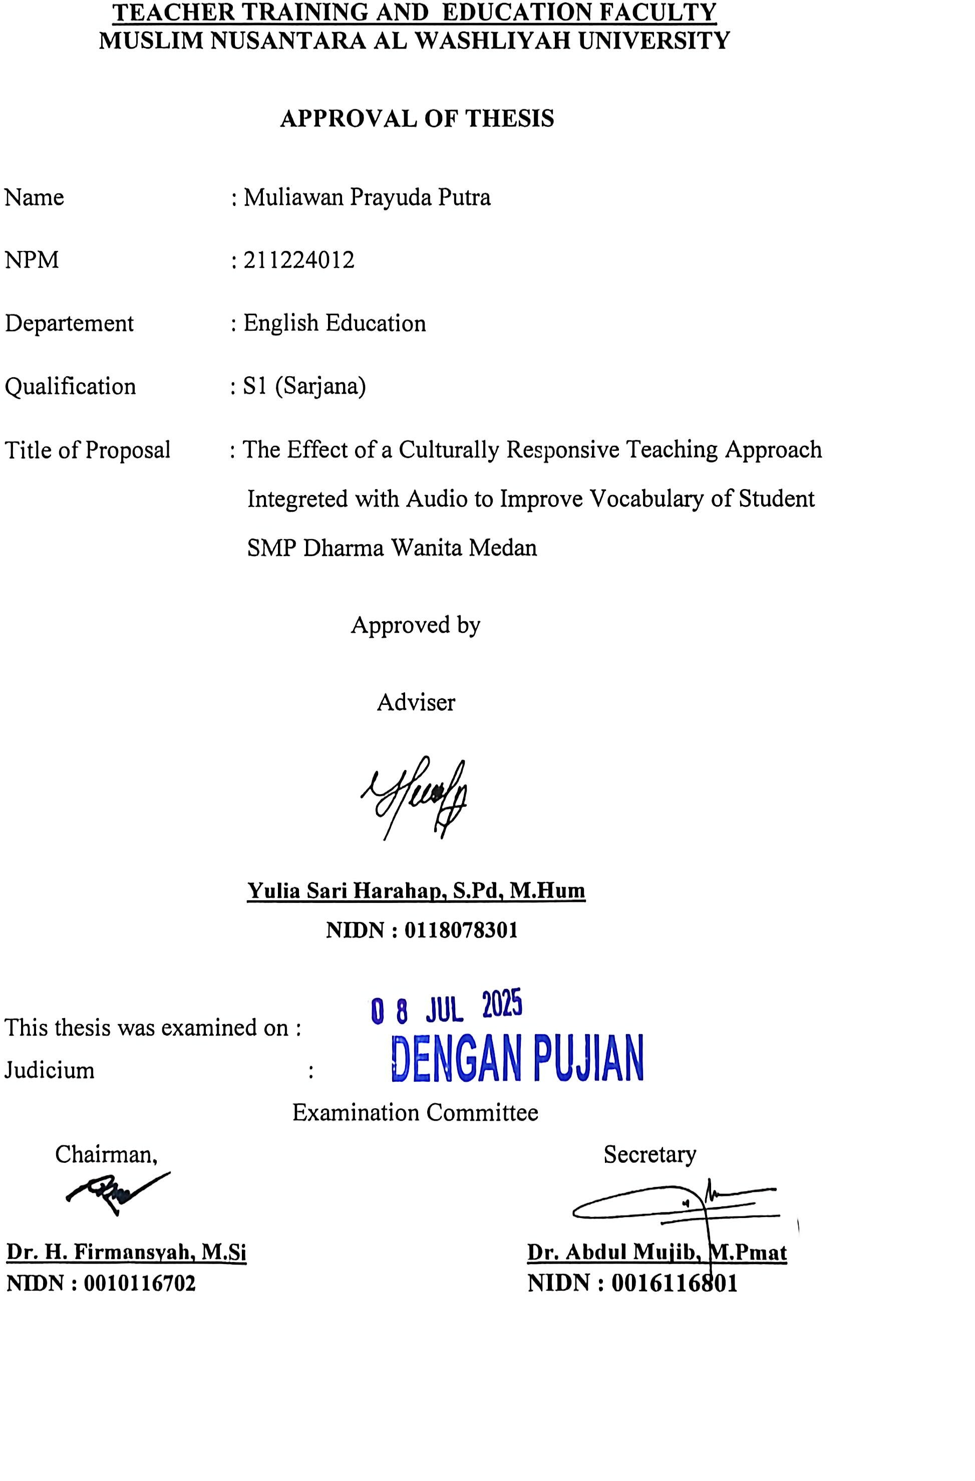

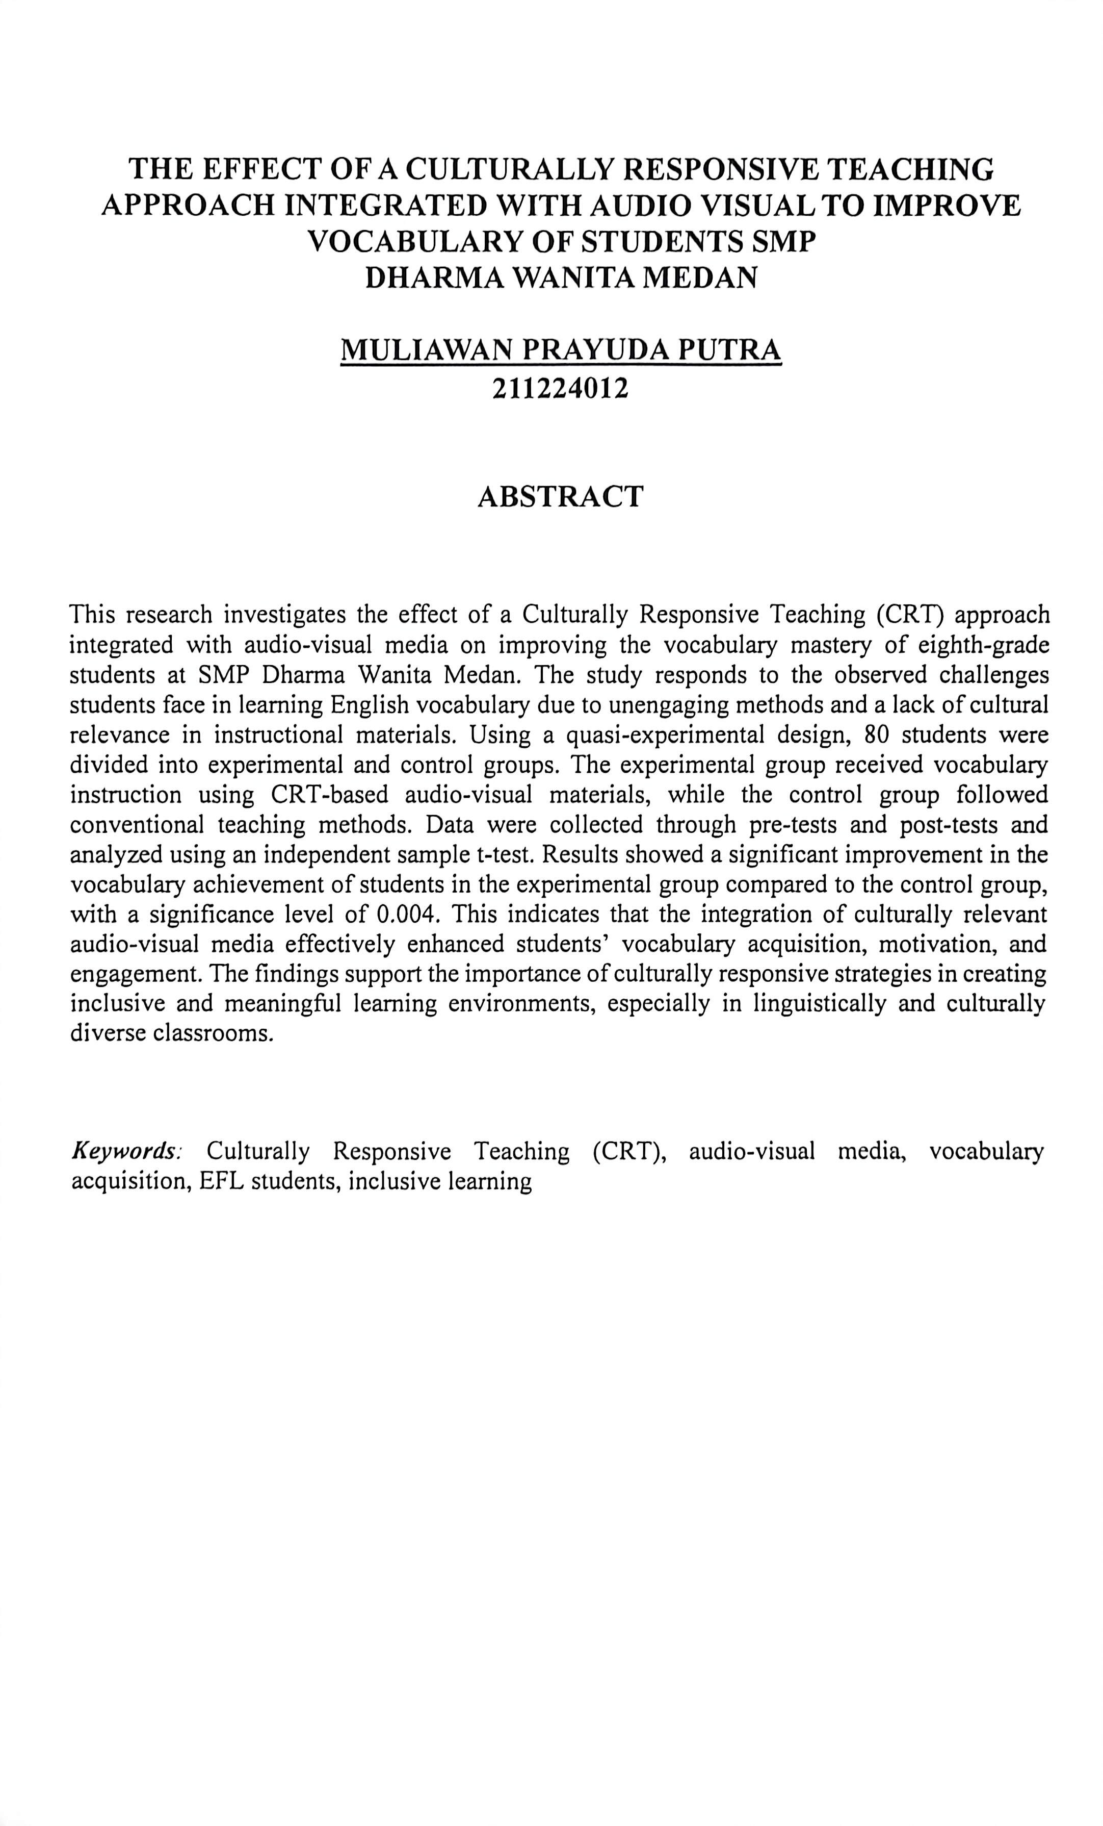

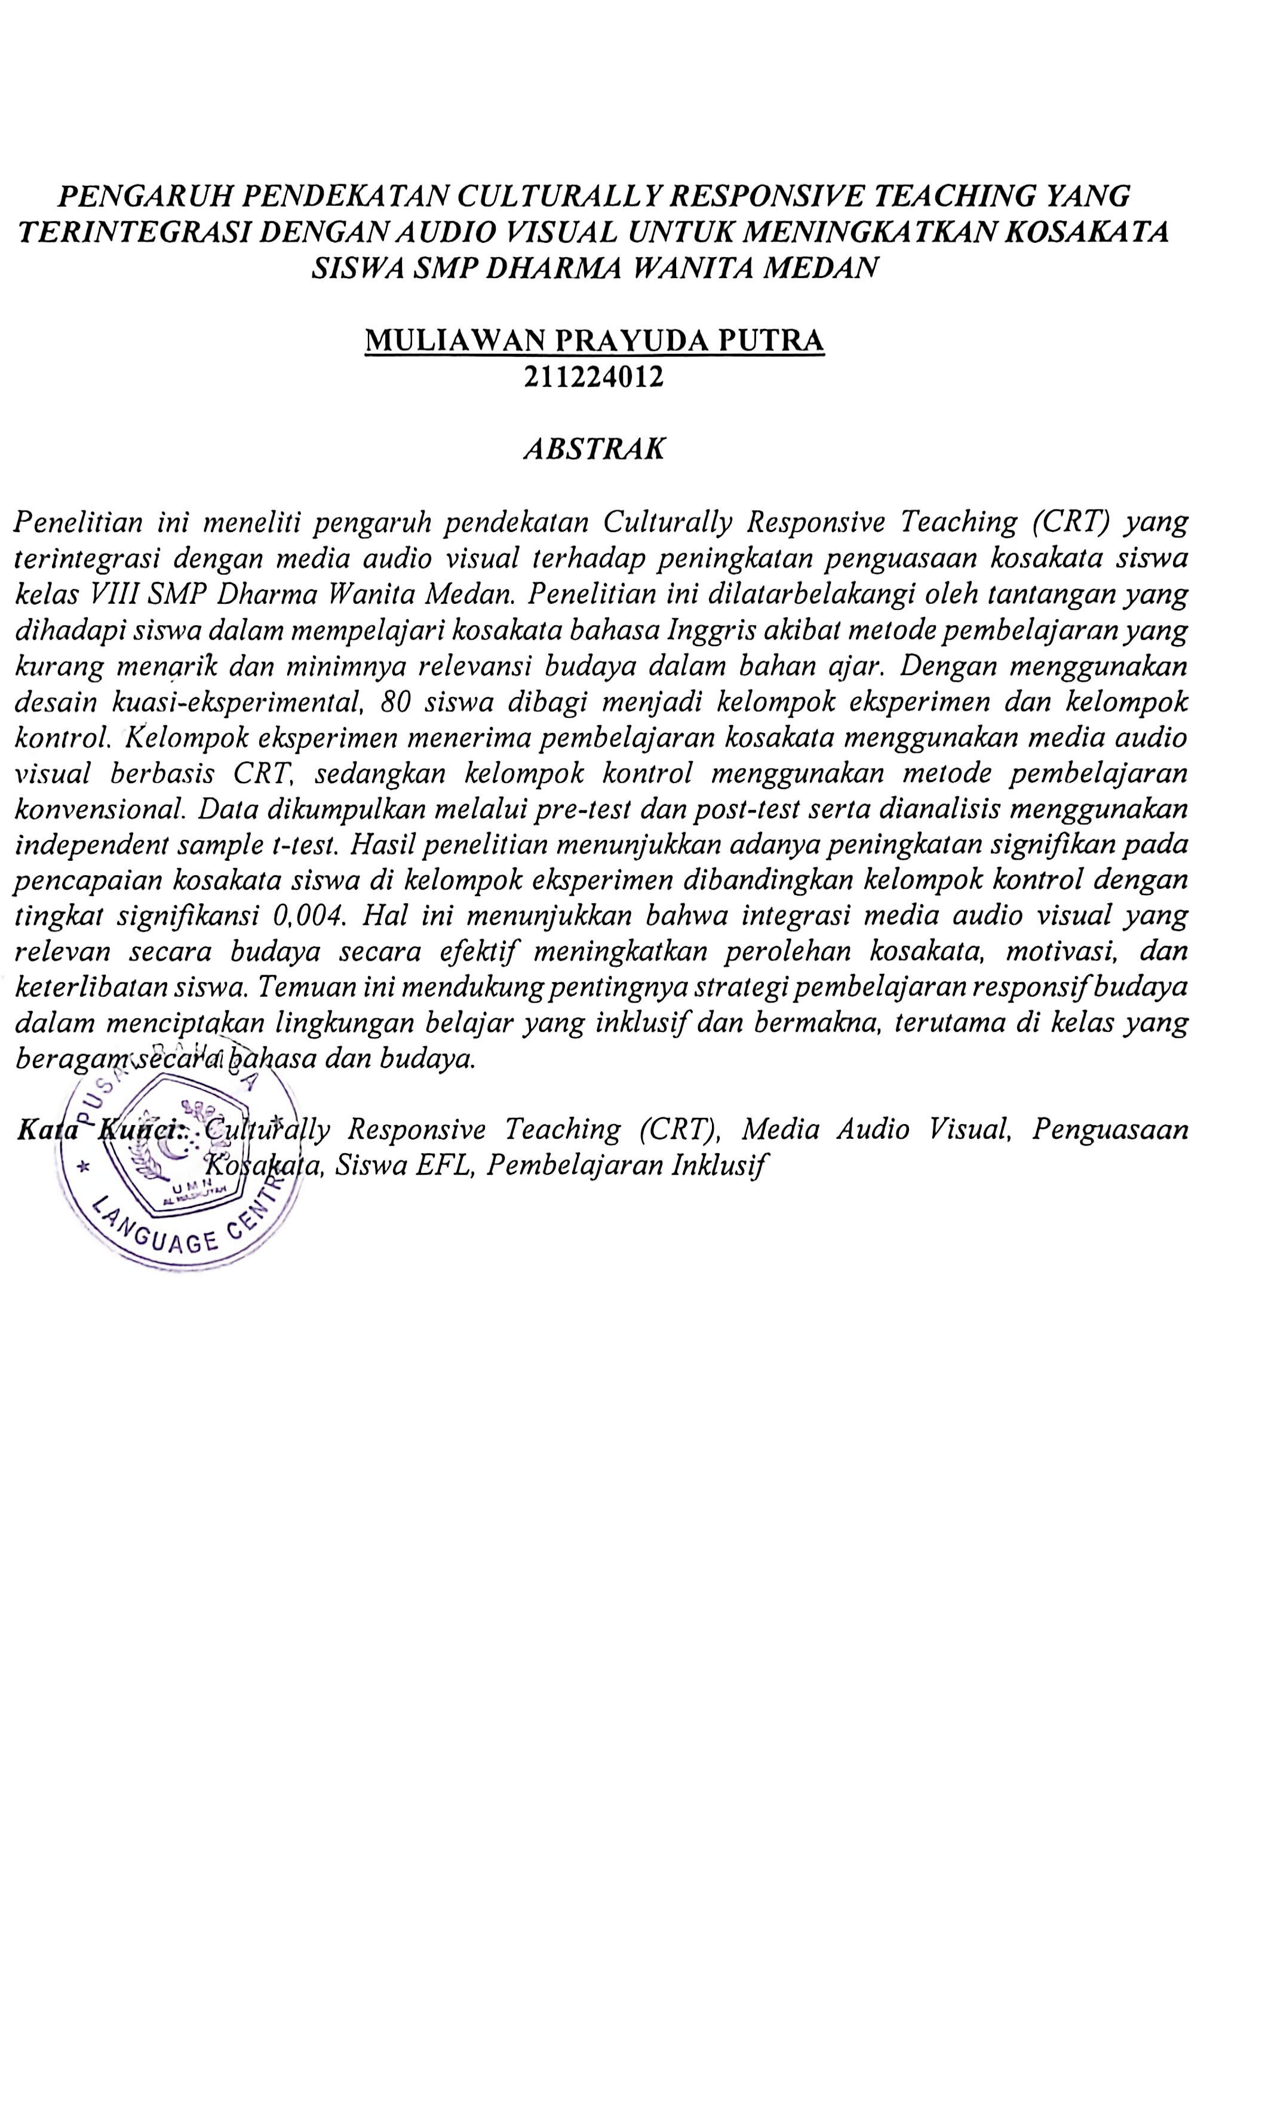

ACKNOWLEDGEMENTS



Artinya:
Hai orang-orang yang beriman, sukakah kamu Aku tunjukkan suatu perniagaan yang dapat menyelamatkan kamu dari azab yang pedih? (10). (Yaitu) kamu beriman kepada Allah dan Rasul-Nya dan berjihad dijalan Allah dengan harta dan jiwamu. Itulah yang lebih baik bagi kamu jika kamu mengetahuinya (11) (Ash-Shaff: 10-11).
First and foremost, I would like to express my deepest gratitude to Allah SWT for His endless grace, guidance, and blessings that enabled me to complete this thesis entitled “The Effect of a Culturally Responsive Teaching Approach Integrated with Audio Visual to Improve Vocabulary of Students SMP Dharma Wanita Medan.”
I would like to sincerely thank my thesis advisor, Yulia Sari Harahap, S.Pd, M.Hum, for his/her unwavering support, invaluable guidance, and constructive feedback throughout the entire process of this research. His/her patience and encouragement gave me the strength to continue even during the most challenging moments.

My heartfelt appreciation goes to the Head of the English Education Department and all the lecturers at Universitas Muslim Nusantara Al Washliyah for providing me with the knowledge and academic support that shaped me throughout my university journey.
To the principal, teachers, and students of SMP Dharma Wanita Medan, thank you for allowing me to conduct my research at your school. Your cooperation and participation made this study possible. A special thanks to my beloved family, my parents, and my siblings for their endless love, prayers, and emotional support. Your belief in me has always been my biggest motivation.
Lastly, I would like to thank my friends and classmates who have been part of this academic journey. Thank you for the encouragement, laughter, and shared experiences that made this journey more meaningful.
May this humble work be beneficial to future readers and researchers.Dr. H. Firmansyah, M.Si. as the Rector of Universitas Muslim Nusantara Al Washliyah Medan.
- Dr. Abdul Mujib, M.PMat. as Dean of Teacher Training and Education Faculty of Universitas Muslim Nusantara Al Washliyah Medan.
- Wariyati, S.Pd., M.Hum., M.Pd. as the Head of English Education

Departement of Universitas Muslim Nusantara Al Washliyah Medan

- Yulia Sari Harahap, S.Pd., M.Hum as the Adviser who have given the valuable time and provided the great guidance to correct the research, to give advice, suggestion and support in the whole process of to work so that, this thesis can be accomplished.

- All lecturers in English Departement of Education and Teacher Training Faculty for valuable knowledge, and advice during the years of my study.
- Bukhori the head of SMP Dharma Wanita Medan who has given permission for doing the research.
- My beautiful future wife Dela Putriana Even though you haven’t graduated yet, thank you from the bottom of my heart for always being there to support, motivate, and push me to finish this thesis. Your presence truly meant a lot.
- My beloved family even though I was an only one, I was loved by them.

And they tried to make me until now to.

- All of my friend in Departement of English Education, alumni SMP Negeri 15 Medan and SMA Negeri 13 Medan. Thank you very much to company me.
Finally, the researcher realized that this thesis is still far from being perfect therefore, the researcher will be happy to accept constructive criticism in order to make it better. The researcher hopes that this thesis will be beneficial to everyone especially in developing English Teaching and Learning process.

Medan, 2025

Muliawan Prayuda Putra 211224012

TABLE OF CONTENTS

TABLE OF CONTENTS iv
TABLE OF APPENDICES vi
CHAPTER I 1
INTRODUCTION 1
  - Background of the Problem 1
  - Problem Identification 5
  - Problem Limitations 5
  - Problem Formulation 5
  - Research Objectives 6
  - The Importance of Research 6
CHAPTER II 9
LITERATURE REVIEW 9
  - Theoretical Review 9
    - The Importance of Culturally Responsive Teaching 9
- .1.2 The Importance of Culturally Responsive Teaching 13
- .2 Definition of Audio Visual 14
    - Audio Visual Elements 15
    - Problems in Audio Visual 16
  - Definition of Vocabulary 17
    - Teaching Procedures with Culturally Responsive Teaching 18
  - Conceptual Framework 21
  - Hypothesis 23
CHAPTER III 25
RESEARCH METHODS 25
  - Research Design 25
  - Population and Sample 26
  - Research Instruments 27
  - Data Collection Techniques 28
  - Data Analysis 31
CHAPTER IV 33
RESULTS AND RESEARCH 33
  - Result 33
    - Description of SMP Dharma Medan 33
  - Discussion 39
CHAPTER V 42
CONCLUSIONS AND SUGGESTIONS 42
  - Conclusion 42
  - Suggestion 42
REFERENCE 44

TABLE OF APPENDICES
Appendix 1 46
Appendix 2 47
Appendix 3 48
Appendix 4 53
Appendix 5 55
Appendix 6 61
Appendix 7 63
Appendix 8 64

CHAPTER I

INTRODUCTION

Background of the Problem

In this era of globalization, the ability to speak a foreign language, especially English, is one of the most important skills that students must master. Broad vocabulary and good language understanding greatly influence students' communication skills and comprehension in learning. At Dharma Wanita Junior High School Medan, there are still many students who have difficulty in expanding their English vocabulary. This can be due to several factors, such as an unattractive teaching approach, a lack of supportive learning media, and a lack of connection with students' local culture.
Especially at the junior high school level, it is very important in forming a foundation of language knowledge and skills, especially in the acquisition of vocabulary. Vocabulary mastery is one of the indicators of success in learning English, which has become an obligation for students today. According to some sources, students who have a broad vocabulary tend to be more confident and able to communicate more effectively.
Vocabulary is an important foundation in language acquisition. According to some education experts, good vocabulary mastery has direct implications on students' speaking, writing, listening, and reading skills. Without having enough vocabulary, students will have difficulty understanding the context of the sentences and messages to be conveyed.

Vocabulary acquisition is a fundamental aspect of language learning and plays an important role in the overall development of students' literacy. For junior high school students, a strong vocabulary improves reading comprehension, writing proficiency, and oral communication skills (Corpuz et al., 2024)
Therefore, teaching vocabulary should be the main focus of the English curriculum in junior high school. However, in reality, the learning process of teaching vocabulary is often monotonous and less interesting for students. Traditional methods such as memorizing vocabulary from textbooks can quickly leave students feeling bored and unmotivated to learn. This is where innovation in teaching methods becomes important, one of which is by using a more responsive approach to student culture. Culturally Responsive Teaching (CRT) is a teaching approach that recognizes and respects cultural differences among students. It seeks to create a learning environment that is inclusive and relevant to students' cultural backgrounds, so that they feel more connected and motivated to learn. By utilizing cultural elements that are close to students, such as the use of regional songs, folklore, or activities involving local traditions, the learning process can be more effective.
One of the key aspects of CRT is building a good relationship between teachers and students. When students feel connected to the material being taught, they will be more excited to learn. By incorporating elements of local culture in teaching, students can see a direct connection between what they learn and their daily lives. In this digital era, audio-visual media is one of the most effective tools to support learning, especially in vocabulary acquisition. Audio-visual media

includes videos, movies, podcasts, and multimedia presentations. By using these various forms of media, teachers can present information in a more interesting and interactive way. When students see pictures and hear sounds related to the vocabulary they are learning, their brains will have an easier time recording the information.
Audiovisual media is one of the tools that can be used in learning. The combination of sound and images can grab students' attention and improve their understanding of the material being taught. Through videos, films, or interactive presentations, students can directly see the context of using vocabulary in real-life situations. This is very effective in improving student memory retention compared to traditional learning methods that tend to be monotonous.
In the context of SMP Dharma Wanita Medan, the application of audio- visual media that is integrated with the CRT approach is expected to have a positive impact on the acquisition of students' vocabulary. By adapting the teaching materials to Dharma Wanita Junior High School, Medan was chosen as the research site for several important reasons. First, the school has a diverse student population with diverse cultural backgrounds, making it an ideal environment to implement and assess culturally responsive teaching strategies. The varied nature of students offers a valuable opportunity to investigate how different cultural aspects can be incorporated into vocabulary teaching.
Second, schools have shown a willingness to embrace educational innovation and pedagogical advancement, as demonstrated by their readiness to take part in these research studies. Administrative and teaching staff are dedicated

to improving English learning outcomes, especially in vocabulary acquisition, which is aligned with the research objectives.
Third, early observations at Dharma Wanita Junior High School Medan show that students face common challenges in learning English vocabulary, such as limited engagement with traditional teaching methods and difficulties in connecting new vocabulary with their cultural experiences. These challenges reflect broader issues found in the context of EFL Indonesia, making schools a representative sample for these interventions.
In addition, the school infrastructure is conducive to the use of audio-visual media, equipped with adequate technological resources and classroom facilities necessary for research activities. The presence of basic audio-visual equipment and the desire of teachers to collaborate in integrating new teaching methods were key factors in the selection of this site.
Finally, the cultural structure of the student body at Dharma Wanita Junior High School in Medan reflects the multicultural character of the city of Medan, where various ethnic groups coexist. This diversity creates an authentic context for implementing culturally responsive teaching, as students bring with them different cultural knowledge that can be leveraged to enhance their vocabulary learning experience.
By adapting the teaching materials to fit the cultural background of the students and incorporating interesting media, it is anticipated that students will become more involved in the learning process and more easily acquire new vocabulary.

Problem Identification

Based on the above explanation, the researcher will identify the following problems:
- Students may face challenges in acquiring vocabulary, which can hinder their ability to read, write, speak, and listen.
- Teaching materials may not align with students' cultural backgrounds, making it difficult for them to connect with the content. Material that does not consider the cultural context can result in decreased motivation and engagement.
- There is a lack of utilization of audio-visual media, such as video, animation, and culturally relevant digital resources, in vocabulary teaching.

Problem Limitations

Based on the identification of the problem above, the researcher focuses the scope of the problem in this study on "The Influence of Cultural Responsive Teaching Approach Integrated with Audio-Visual Media to Improve Student Vocabulary Achievement at SMP Dharma Wanita Medan. The materials used in audio-visual media are limited to themes that are culturally relevant to students and aligned with the school curriculum.

Problem Formulation

This study examines the effectiveness of the use of audio-visual media based on Culturally Responsive Teaching (CRT) to improve vocabulary acquisition among students at SMP Dharma Wanita Medan. Based on the background of the above problems, the research question can be formulated as: "Is there a significant

influence of the Culturally Responsive Teaching Approach Integrated with Audio- Visual Media on Improving Students' Vocabulary Achievement"?

Research Objectives

The purpose of this study was to investigate the effectiveness of audio-visual media rooted in Culturally Responsive Teaching (CRT) in improving vocabulary acquisition among students at SMP Dharma Wanita Medan. Specifically, this study seeks to:
    - Assessing Impact – Analyzing the influence of culturally responsive audio- visual media on the growth of students' vocabulary.
    - Increase Learning Engagement – Explore whether the inclusion of cultural elements in multimedia resources increases student motivation and engagement.
    - Refining Teaching Strategies – Offering guidance to educators on how to incorporate culturally relevant audio-visual tools into language teaching.
    - Fostering Inclusive Education – Advocating for the adoption of culturally responsive approaches to create a more inclusive and effective learning environment.

The Importance of Research

    - Theoretical Benefits

Theoretical benefit refers to the ways in which a study adds to existing knowledge, theories, and frameworks within a particular field. When discussing the theoretical advantages of utilizing audio-visual media informed by Culturally

Responsive Teaching (CRT) for vocabulary improvement, several significant contributions can be highlighted:
- Advances in Culturally Responsive Teaching Theory

  - Describe the effective application of CRT principles in vocabulary teaching.
  - Offer empirical support for incorporating students' cultural backgrounds into language education.
- Improvement of Multimedia Learning Theory

  - Validates the idea that multimedia tools improve cognitive processing in learning a second language.
  - Investigate how culturally relevant audio-visual resources aid in memory understanding and retention.
- Contributions to Second Language Acquisition (SLA) Theory

  - Deepen understanding of the impact of cultural context on language learning.
  - Provides insight into how visual, auditory, and linguistic elements interact during vocabulary acquisition.
- Implications for Educational Psychology

  - Support theories related to motivation and engagement through culturally relevant educational materials.
  - Strengthening the relationship between cultural identity and cognitive growth in language learning.

Practical Benefits

Practical Advantages of Audio-Visual Media in Culturally Responsive Teaching (CRT) for Vocabulary Development:
- Increased Engagement – Audio-visual materials that reflect the cultural background of students make learning easier to understand and enjoyable, increasing motivation.
- Enhanced Retention – Visual and auditory elements reinforce the meaning of words, leading to better long-term vocabulary retention.
- Contextual Comprehension – Incorporating familiar cultural references helps students understand words in meaningful context, improving comprehension.
- Better Pronunciation – Exposure to native speakers or culturally relevant audio assists students in pronouncing words accurately

CHAPTER II

LITERATURE REVIEW

Theoretical Review

This chapter describes the understanding of teaching using CRT-based audio-visual and its uses and problems.

The Importance of Culturally Responsive Teaching

Culturally Responsive Teaching (CRT) is an educational approach that emphasizes the importance of incorporating students' cultural backgrounds into the learning process. The goal of this approach is to create an inclusive learning environment where every student feels valued, respected, and has an equal opportunity for academic success.
CRT highlights that cultural diversity is not a barrier to learning but rather an asset that can enrich the educational experience. Therefore, teachers who implement CRT will adjust their teaching strategies by taking into account the values, language, life experiences, and thought processes that come from the culture of their students.
In CRT, teachers are not only responsible for imparting knowledge but also for developing positive relationships with their students. A strong bond between teachers and students is essential to creating a supportive learning atmosphere. When students feel safe and valued, they are more likely to be actively involved in the learning process and express their opinions. Additionally, this approach

encourages educators to tailor teaching materials and methods to better align with students' cultural experiences, such as using examples of local cultures or engaging students in culturally-focused projects.
CRT also plays an important role in fostering critical awareness among students. By examining the various perspectives and social issues associated with their culture, students can cultivate the critical thinking and analytical skills necessary to navigate complex worlds.
Through contextual and culturally relevant learning, students not only gain academic knowledge but also learn to appreciate and understand the diversity around them.
Collaboration with parents and the community is another important component of CRT. By involving students' families and communities in the educational process, students can see that their learning environment reflects their daily lives. This not only strengthens the relationship between the school and the community, but also increases the student's sense of belonging in their education.
The idea of a "knowledge fund," which recognizes that students bring important information, abilities, and experiences from their homes and communities to the classroom, is another aspect of culturally responsive teaching (CRT). This method sees cultural diversity as a valuable resource that can enhance each student's educational experience rather than as a weakness.
When implementing CRT, teachers need to regularly check for their own cultural biases and beliefs. This self-examination is essential for fostering an

authentic culturally responsive atmosphere that allows educators to successfully connect academic material with their students' real-life experiences.
In addition, CRT not only recognizes cultural differences but also leverages them to enhance the learning experience. For example, educators may use analogies that resonate with a student's cultural background to clarify difficult concepts, include multilingual materials to assist language learners, or create assessments that allow students to demonstrate their understanding in culturally significant ways.
The teaching methods at CRT are flexible and tailored to the unique cultural composition of each class. This can include implementing collaborative learning formats that reflect collectivist cultural values, utilizing storytelling techniques that resonate with oral traditions, or using inquiry-based strategies that tap into students' inherent curiosity about their own culture and the cultures of others.
By implementing CRT effectively, educators improve academic performance while assisting students in building strong cultural identities and cross-cultural skills—skills that are becoming even more important in our interconnected world. This method transforms the classroom into a small-scale representation of a multicultural society, where diversity is embraced and every cultural viewpoint is recognized as a valuable part of shared learning.
In summary, Culturally Responsive Teaching aims to provide a more meaningful learning experience, increase students' motivation, and help them reach their full academic and social potential. Through this approach, the goal is for students to become not only knowledgeable learners but also individuals who appreciate and understand the cultural diversity in society.

The key principles of CRT include:

- Recognize and Appreciate Cultural Diversity – Teachers need to understand their students' cultural backgrounds and use them as a basis for teaching. This may involve including examples, stories, or materials that are relevant to the student's culture.
- Building Positive Relationships with Students – A strong relationship between teachers and students is essential in CRT. Teachers must create a supportive environment where students feel safe to express themselves, share their views, and actively participate in learning.
- Adapting Curriculum and Teaching Methods – The curriculum should reflect cultural diversity and allow for a variety of perspectives. In addition, teaching methods such as group discussions, culture-based projects, or multimodal approaches (visual, auditory, kinesthetic) can be used to improve student understanding.
- Encourages Critical Awareness – CRT not only focuses on academics but also helps students develop critical thinking regarding the social and cultural issues around them. By understanding different perspectives, students can become more open to diversity and develop into more inclusive citizens.
- Collaborating with Parents and Communities – CRT also involves working with students' families and communities. By involving parents in their children's education and involving the community in school

activities, students will feel that their learning environment reflects their everyday world.
Through this approach, learning becomes more meaningful and relevant for students, increasing their motivation to learn and helping them reach their optimal academic and social potential.

.1.2 The Importance of Culturally Responsive Teaching

Culturally Responsive Teaching (CRT) is an educational approach that acknowledges, appreciates, and incorporates students' cultural backgrounds into the learning process. This method fosters inclusivity, increases engagement, and improves academic performance by making lessons more relevant to students' life experiences. Below are some of the reasons why CRT is so important in education:
- Increase Student Engagement

When students see their culture reflected in the curriculum, they feel more connected to the material. This increased relevance makes learning more meaningful and encourages active participation.
- Promotes Academic Success

By combining students' linguistic and cultural backgrounds, CRT helps bridge gaps in understanding. Research shows that students perform better when instructional methods align with their cultural learning styles.
- Fostering a Positive Classroom Environment

CRT creates a safe and welcoming space where students feel respected and valued. This inclusivity improves class relations and reduces cases of discrimination and bias.
- Encouraging Critical Thinking

Culturally responsive education exposes students to diverse perspectives and encourages them to analyze different points of view. It helps them develop critical thinking skills and a broader understanding of the world.
- Preparing Students for a Global Society

In an increasingly interconnected world, cultural awareness is a valuable skill. CRT teaches students to value diversity and equips them with the skills to work effectively in a multicultural environment.

.2 Definition of Audio Visual

Audio-visual (AV) refers to a medium or method of communication that combines sound (audio) and images or visuals (video, photos, graphics, animations) to convey information. The purpose of using this medium is to improve understanding, engagement, and memory retention by stimulating two senses simultaneously—hearing and sight. Audio-visual media has several key characteristics, including the integration of two communication modalities, increased material appeal, facilitation of understanding of complex concepts, and increased information retention. In addition, these media are often interactive, especially in technology-based learning environments.
In everyday life, examples of audio-visual media are diverse, ranging from educational videos at school, films and documentaries, multimedia presentations,

to advanced technologies such as Virtual Reality (VR) and Augmented Reality (AR). In addition, television and live broadcasting are also common forms of audio- visual media used to convey news and entertainment. The presence of this media is very useful in various fields, especially in the field of education, where teaching materials can be presented more effectively and interestingly.
In the realm of education, the application of audio-visual media is growing, especially with the Cultural Responsive Teaching approach. By utilizing materials that are in harmony with the cultural background of students, learning becomes more relevant and meaningful. For example, educational videos that use language or examples that are familiar to students, infographics that reflect the local culture, and animations or songs that resonate with their experiences. Thus, audio-visual media not only serves as a communication tool but also as a learning strategy that can significantly increase student understanding and engagement.

Audio Visual Elements

The elements of audio-visual media consist of several key components that work together to convey information effectively. Here are the essential elements of audio-visual media:
- Audio Elements

  - Narrative: Verbal explanations that support visuals.

  - Music: Enhances emotion and appeal.

  - Sound Effects: Adds realism and interest (e.g., the sound of rain or explosions).
  - Dialogue: Conversations between characters in a video or animation.

- Visual Elements

  - Pictures & Illustrations: Photos, graphics, or illustrations that clarify the concept.
  - Text: Written content that helps with comprehension (subtitles, labels, or titles).
  - Animation: Visual gestures that make content more engaging and interactive.
  - Color: Affects mood and visual appeal.

  - Composition & Layout: Arrangement of elements within the frame to create visual balance.
    - Interactive Elements (Optional in Digital Media)

- Buttons & Navigation: For interactive media such as e-learning or educational games
- User Response: A feature that allows users to interact (e.g., quizzes or simulations).

Problems in Audio Visual

The use of audio-visual media in education offers many benefits, but it also faces some challenges and problems. Here are some common issues that arise:
- Technological Limitations

Not all schools have adequate facilities, such as projectors, speakers, or computers that support audio-visual media. A slow or unstable internet connection can hinder the use of online video or media.
- Lack of Teacher Skills

Some teachers may not be familiar or do not have the skills to use audio- visual media effectively in their teaching. There is often a lack of training in creating and utilizing content that meets the needs of students.
- Distractions and Lack of Interaction

Students may focus more on the visual or entertainment aspects of the media than on the actual subject matter. If not combined with interactive methods, students can become passive, just watching without understanding the material in depth.
- Suitability of Cultural and Local Contexts

Some audio-visual content may not be aligned with the student's cultural background, making it difficult to understand or less relevant. The absence of media based on Culturally Responsive Teaching can cause students to feel disconnected from the material being taught.
- Limitations in Evaluation and Measurement Understanding

It can be difficult to assess how effective audio-visual media can be in improving student understanding if there are no proper evaluation methods. Teachers should ensure there are follow-up activities, such as discussions or assignments, to gauge students' understanding after using these media.

Definition of Vocabulary

Vocabulary includes a collection of words that a person knows and uses in a particular language. This includes words used for communication, comprehension, and expression both in oral and written form. Vocabulary can be divided into two main types:

    - Receptive Vocabulary – Words that a person understands while reading or listening.
    - Productive Vocabulary – Words that a person actively uses when speaking or writing.
Improving vocabulary is essential for communication, comprehension, and successful academic achievement. This can be enhanced through activities such as reading, engaging in conversation, and discovering new words in a variety of contexts.

Teaching Procedures with Culturally Responsive Teaching

The application of Culturally Responsive Teaching (CRT) in vocabulary teaching using audio-visual media follows a structured procedure that maximizes student engagement and learning effectiveness. The following teaching procedures are specifically designed to improve vocabulary among students of SMP Dharma Wanita Medan:
      - Pre-Activity Stage
        - Cultural Knowledge Assessment: Before starting the lesson, the teacher assesses the student's prior knowledge of their own cultural background and vocabulary related to local traditions, customs, and daily activities.
        - Setting the Cultural Context: The teacher introduces the theme of the lesson by connecting it to the student's cultural experience, using pictures, short videos, or discussions about elements of the local culture.

        - Vocabulary Preview: Key vocabulary words to be focused on during the lesson are introduced with visual aids that reflect the local cultural context.
      - Post-Activity Stage

        - Audio-Visual Presentations: Teachers present culturally relevant audio- visual materials such as videos of local traditions, animated stories based on local folklore, or documentaries about community practices, emphasizing the target vocabulary.
        - Guided Observation: Students are directed to pay attention to certain vocabulary words as they appear in audio-visual presentations. Teachers can pause videos at key moments to highlight vocabulary in context.
        - Collaborative Meaning-Making: Students work in groups to discuss the meaning of new vocabulary based on their cultural context, sharing their interpretations and experiences related to the words.
        - Cultural Connection Activities: Students engage in activities that connect vocabulary to their cultural experiences, such as:
        - Create a cultural mind map with new vocabulary
        - Role-playing scenarios using new vocabulary in culturally relevant

situations

        - Comparing the use of vocabulary in different cultural contexts

      - Post-Activity Stage

        - Vocabulary Apps: Students create their own culture-based projects using new vocabulary, such as:

        - Shoot short videos depicting local traditions

        - Create digital stories using local cultural elements

        - Design posters or infographics about community practices

        - Reflective Discussion: Students reflect on how vocabulary connects to their cultural identities and daily lives, enhancing personal relevance and deeper understanding.
        - Community Connections: Where appropriate, students share their vocabulary learning with family members or community representatives, strengthening the connection between school learning and community knowledge.
      - Ratings and Feedback

        - Culturally Responsive Assessment: Vocabulary assessment is done through authentic assignments that reflect the student's cultural context rather than non-contextual tests.
        - Peer Feedback: Students provide feedback to their peers using culturally appropriate communication styles.
        - Teacher Evaluation: Teachers evaluate vocabulary acquisition not only based on memorization but also on how effectively students can use words in culturally meaningful contexts.
Through this structured teaching procedure, CRT-based audio-visual media becomes an effective tool for teaching vocabulary, making learning more engaging, relevant, and meaningful for students at SMP Dharma Wanita Medan.

Conceptual Framework

The conceptual framework for this research builds on the interconnection between three key elements: audio-visual media, Culturally Responsive Teaching (CRT), and vocabulary acquisition. These elements form a cohesive approach to language learning that addresses the specific needs and cultural backgrounds of students at SMP Dharma Wanita Medan.
- Foundation of the Framework

The basis of this framework is based on several theoretical principles:

  - Schema Theory: Learning is more effective when new information can be connected to existing knowledge schemas. By incorporating culturally familiar elements, students can more easily connect new vocabulary to their existing knowledge structures.
  - Double Coding Theory: Information presented in visual and auditory formats (audio-visual media) creates multiple neural pathways for memory storage, improving vocabulary retention and recall.
  - Social Constructivism: Learning is a social process that is influenced by cultural and social contexts. CRT acknowledges this by emphasizing the importance of cultural background in the construction of knowledge.
- Relationships Between Components
The three main components of the framework interact in the following ways:
  - Audio-Visual Media and Vocabulary Acquisition: Audio-visual materials provide rich contextual cues through images, sounds, and gestures that help students understand and remember new vocabulary. The

combination of auditory and visual inputs supports different learning styles and improves comprehension.
  - Culturally Responsive Teaching and Vocabulary Acquisition: When vocabulary is presented in a culturally familiar context, students can draw on their background knowledge and experience to make meaningful connections. This cultural relevance increases motivation, engagement, and depth of vocabulary understanding.
  - Audio-Visual Media and Culturally Responsive Teaching: Audio-visual media serves as an effective vehicle for delivering culturally responsive content. Through videos, animations, and multimedia presentations, students can see and hear vocabulary used in an authentic cultural context that resonates with their own experiences.
- Expected Results

The integration of audio-visual media with CRT for vocabulary teaching is expected to yield several positive results:
  - Enhanced Vocabulary Retention: The combination of visual, auditory, and cultural elements creates multiple memory trails, leading to better retention of new vocabulary.
  - Increased Engagement: By connecting learning with the cultural background of students and using an engaging multimedia format, students' motivation and participation in vocabulary learning activities are expected to increase.

  - Deeper Understanding: Understanding vocabulary in a meaningful cultural context leads to deeper understanding than superficial memorization.
  - Positive Cultural Identity: Recognizing and valuing students' cultural backgrounds in the learning process helps affirm their cultural identity and sense of belonging in the educational environment.
- Practical Implementation

In practice, this framework will be implemented through:

  - Development of culturally relevant audio-visual materials that reflect local traditions, customs, and practices familiar to students in Medan
  - Integrate this material into a structured vocabulary lesson using the teaching procedures outlined in the previous section
  - Creation of an assessment method that evaluates not only vocabulary memorization but also the ability to use vocabulary in culturally meaningful contexts
This conceptual framework provides a clear structure for understanding how audio-visual media based on CRT principles can improve vocabulary acquisition among students at SMP Dharma Wanita Medan, guiding the implementation and evaluation of proposed interventions.

Hypothesis

The research hypothesis is formulated as follows:

- Main Hypothesis (Ha)

Ha: There is a significant positive effect of CRT based on audio-visual media based on the acquisition of students' vocabulary at SMP Dharma Wanita Medan.
- Null hypothesis (H0)

Ho: There is no significant influence of audio-visual media-based CRT on students' vocabulary acquisition at SMP Dharma Wanita Medan.
These hypotheses will be tested through a well-designed experimental study, comparing the vocabulary gains of students taught using CRT-based audio- visual media with those taught using conventional methods.

CHAPTER III RESEARCH METHODS

Research Design
This study uses a Quantitative Research approach, mainly using a quasi- experimental research design with a pretest-posttest control group method to investigate the influence of Culturally Responsive Teaching (CRT)-based audio- visual media on students' vocabulary acquisition. This design is appropriate for educational research where the random assignment of individual students may not be feasible due to administrative constraints and the need to maintain an intact class group.
According to Sugiyono (2017), quantitative research is research that is carried out by collecting data that can be measured numerically, either through filling out questionnaires, observations, and processing secondary data. The data that has been collected and then analyzed using statistical methods to obtain objective and reliable conclusions
In this study, researchers will use tests to collect data. The research falls into

two categories: control and experimental.

Table 3.1 Table of Collect Data

Group | Pre-tests | Treatment | Post-tests
Experimental | X1 | √ | X2
Control | Y1 | - | Y2
Where:
- X1 and X2 represent the vocabulary pretest given to both groups

- Y1 and Y2 represent treatment based on conventionality.

25

The experimental group will receive vocabulary instruction based on CRT principles integrated with audio-visual media, while the control group will receive vocabulary instruction using conventional teaching methods without specific cultural adaptations. This design allows for a comparison of vocabulary acquisition between the two groups while controlling for initial differences through pretests. The effectiveness of the intervention will be determined by comparing posttest scores between groups and analyzing the magnitude of changes from pretest to posttest in each group.

Population and Sample

- Population

The population of this study consists of eighth-grade students of Dharma Wanita Junior High School Medan for the 2024/2025 academic year.
- Sampling Examples and Techniques

Sugiyono (2013) states that a sample is a part of the population from which information is obtained. A sample is part of the population. The researcher selected 80 students of Dharma Wanita Junior High School Medan for the 2024/2025 academic year.
The sample for this study will be taken using purposive sampling techniques, with a focus on eighth grade students. This class level is chosen because:
  - Eighth-graders have adapted to the junior high school learning environment
  - They have received basic English vocabulary instruction in their seventh grade.

Research Instruments

This study uses tests as instruments and also observation and documentation as complements. The vocabulary test is used as a research instrument
- Test

A test is a tool or technique for assessing one or more features, constructs, or attributes by getting responses to a series of control stimuli, tasks, or questions. It is a structured method of gathering information about specific features of an individual or group, such as understanding, ability, skills, capacity, identity, or habits. Tests can take many forms, including multiple-choice questions, essay prompts, performance assignments, simulations, and standardized evaluations. They are commonly used in domains such as education (merit tests, aptitude tests), psychology (personality tests, IQ tests), employment (job knowledge tests, skills assessments), and research (data collection tools).
- Treatment

The treatment tool involves the application of organized Culturally Responsive Teaching (CRT) combined with audio-visual media as an experimental approach. As noted by Gay (2018), culturally responsive teaching requires intentional teaching methods that connect students' cultural backgrounds to their academic education.
- Documentation

In research, documentation is the process of carefully recording and summarizing the various parts of a research study in a methodical and detailed manner. This entails creating written notes, notes, and materials that provide a thorough overview of the research project's techniques, data, and findings. Documentation allows researchers to keep records of their data, techniques, and analyses in an orderly and logical manner, making them easier to retrieve and reference.

Data Collection Techniques

In this case, the techniques used by researchers in data collection are test techniques, namely pre-test and post-test. Because this technique is very easy and effective to get accurate results to the extent to which the Integrated Cultural Responsive Teaching Approach with Audio Visual Effects is successful or not to Improve the Vocabulary of Dharma Wanita Junior High School Students in Medan.
The data collection process will be carried out systematically to ensure reliable and valid results. The following techniques will be used:
- Administration of Prates
  - Time: Pretest will be given to the experimental and control groups one week before the intervention begins
  - Environment: Testing will take place in a quiet classroom with minimal disruption
  - Proctoring: The test will be supervised by regular English researchers and teachers

  - Duration: Students will be given 60 minutes to complete a vocabulary assessment
  - Instruction: Clear bilingual instruction (English and Indonesian) will be provided to ensure all students understand the assignment
  - Documentation: All exam papers will be collected immediately upon completion and stored safely
- Implementation of Interventions

- For the experimental group:

  - Integrated CRT implementation on audio-visual media for vocabulary teaching
  - Eight teaching sessions, each lasting 90 minutes, spread over four weeks (two sessions per week)
  - Documentation of each session through researcher field notes, photos, and occasional video recordings (with appropriate permissions)
  - Collection of samples of student work and activity outputs
- For control groups:
  - Implementation of conventional vocabulary teaching methods

  - Eight teaching sessions according to the experimental group schedule
  - Documentation of teaching activities through field notes

  - Collection of comparable samples of student work

- Continuous Observation

- Structured class observations use observation checklists to document:

  - Student engagement rate

  - Participation in vocabulary learning activities

  - Response to cultural elements in learning materials

  - Teacher-student interaction

- Observations will be made by independent researchers and observers to minimize bias
- Post-Administration

  - Time: Posttest will be given to both groups within one week after the intervention is completed
  - Condition: The test conditions will match the pretest to ensure comparability
  - Content: The Posttest will assess the same vocabulary knowledge dimension as the pretest but with different items of equivalent difficulty
  - Documentation: All exam papers will be collected, coded, and stored securely
- Student Interview (Additional Data Optional)

  - After the posttest, selected students from the experimental group can be invited for a short semi-structured interview
  - Interviews will focus on students' perceptions of CRT-based audio- visual approaches

  - All interviews will be recorded with permission and transcribed for analysis
- Data Management

  - All data collected will be digitized and backed up securely

  - Students' identities will be protected through a coding system

  - The raw data will be systematically organized to facilitate analysis

  - A clear chain of evidence will be maintained throughout the data collection process
This comprehensive data collection approach ensures that this study captures not only quantitative measures of vocabulary improvement but also qualitative insights into the learning process with CRT-based audio-visual media.

Data Analysis

Descriptive and inferential statistical techniques were used to analyze the data quantitatively to ascertain the extent to which the Culturally Responsive Teaching (CRT) approach combined with audio-visual media improved the vocabulary mastery of Dharma Wanita Junior High School students in Medan.

𝑥ҧ =
σ 𝑥

𝑁

- 𝑥ҧ = Middle
- σ𝑥 = Total score

- 𝑁 = Number of participants

To test the research hypothesis, an Independent Sample T-Test is used. The test was used to determine significant differences between the experimental group

(which received audio-visual-based CRT treatment) and the control group (which used conventional methods).
𝑥ҧ₁ − 𝑥ҧ₂
𝑡 =
2

𝑆𝐷²
ඨ 𝑛 1 +
1
𝑆𝐷²

𝑛₂

𝑥ҧ₁ = Experimental group post-test average

𝑥ҧ₂ = Average post-test control group

𝑆𝐷₁, = Standard deviation of each group𝑆𝐷₂
𝑛₁, 𝑛₂ = Number of samples for each group

CHAPTER IV

RESULTS AND RESEARCH

Result

Description of SMP Dharma Medan

SMP Dharma Wanita Medan is one of the private schools in Medan City and has a strong commitment to improving the quality of education, especially in the field of English learning. This school is known for having an inclusive and multicultural learning environment, reflecting the ethnic and cultural diversity typical of the people of Medan City. This diversity makes SMP Dharma Wanita a relevant and strategic location to implement the Culturally Responsive Teaching (CRT) learning approach.

The number of grade VIII students in the 2024/2025 school year who are the population in this study is 80 students. The students come from diverse cultural backgrounds, including Batak, Malay, Javanese, Minang, and others. This diversity allows teachers to explore a wide range of culturally relevant learning content as part of a vocabulary mastery improvement strategy.

In terms of facilities, Dharma Wanita Junior High School Medan has been equipped with supporting facilities that support the technology-based learning process. The school has a multimedia room equipped with LCD projectors, active speakers, teachers' laptops, and adequate internet access. This facility allows

teachers to play educational videos, display interactive animated presentations, and use other audio-visual devices in the learning process.

In addition, the school also provides fairly comfortable classrooms, with good lighting and ventilation, as well as interactive whiteboards in some classrooms. The teachers in this school, especially the English teachers, show great enthusiasm for the application of innovative learning methods involving elements of local culture and the use of audiovisual media.

Overall, the condition of the school both in terms of human resources and infrastructure supports the implementation of research that aims to integrate the Culturally Responsive Teaching approach with audiovisual media in learning English vocabulary.

- Data Description

This study aims to determine the influence of the Culturally Responsive Teaching (CRT) approach integrated with audiovisual media on improving students' vocabulary mastery. To measure the effectiveness of the approach, data was collected through pre-test and post-test in two groups: the experimental group and the control group.

  - To

Pre-tests were carried out before treatment was given to both groups. This test aims to determine students' initial ability to master English vocabulary. The

results of the pre-test were used to ensure that there was no significant difference between the experimental and control groups before the treatment was performed.

Table 4.1 Experimental Group

Descriptive Statistics
N |  | Minimum | Maximum | Mean | Std. Deviation
Pre-Test X1 | 18 | 37.00 | 71.00 | 51.6111 | 8.95176
Post-Test X2 | 18 | 52.00 | 75.00 | 62.3889 | 6.31654
Pre-Test Y1 | 18 | 39.00 | 65.00 | 50.6111 | 7.08884
Post-Test Y2 | 18 | 45.00 | 72.00 | 55.2778 | 7.29065
Valid N (listwise) | 18

Based on the descriptive statistical table of the experimental group, it is known that the number of samples (N) is 18 students. The average pre-test score was 51.61 with a minimum score of 37 and a maximum of 71, as well as a standard deviation of 8.95 which showed a fairly variable distribution of scores before treatment. After treatment using the Culturally Responsive Teaching (CRT) approach based on audiovisual media, the average post-test score increased to 62.39 with a minimum score of 52 and a maximum of 75, and the standard deviation decreased to 6.32. This decrease in standard deviation indicated a narrowing of score variations, indicating that the intervention not only improved overall learning outcomes but also created an equitable distribution of vocabulary comprehension among students in the experimental group.

  - Post-Test

The post-test was carried out after the treatment was completed, namely after eight meetings over four weeks. Post-test aims to measure the improvement of students' vocabulary skills after participating in learning with their respective methods.

The following is a summary of the results of the Control pre-test results:

Table 4.2 Control Group Table

Descriptive Statistics
N |  | Minimum | Maximum | Mean | Std. Deviation
Pre-Test X1 | 18 | 37.00 | 71.00 | 51.6111 | 8.95176
Post-Test X2 | 18 | 52.00 | 75.00 | 62.3889 | 6.31654
Pre-Test Y1 | 18 | 39.00 | 65.00 | 50.6111 | 7.08884
Post-Test Y2 | 18 | 45.00 | 72.00 | 55.2778 | 7.29065
Valid N (listwise) | 18

Based on the descriptive statistical table of the control group, it was obtained that the number of samples (N) was 18 students. The average pre-test score was 50.61 with a minimum score of 39 and a maximum of 65, as well as a standard deviation of 7.09 which indicates a moderate variation in students' initial abilities. After learning using conventional methods, the average post- test score increased to 55.28 with a minimum score of 45 and a maximum of 72, as well as a standard deviation of 7.29. Although there was an increase in the average score of 4.67 points, this increase was not as large as that which occurred in the experimental group. The almost unchanged standard deviation

also indicates that the distribution of student learning outcomes remains relatively the same, suggesting that conventional learning does not have a significant impact on equity or improvement in students' overall vocabulary mastery.

- Testing Hypothesis

To test the effectiveness of the Culturally Responsive Teaching (CRT) approach integrated with audiovisual media on improving students' vocabulary mastery, a two-independent sample T statistical test was used. The purpose of this test was to determine whether there was a significant difference between the post-test results of the experimental group receiving audiovisual-based CRT treatment and the control group taught by conventional methods. The test was conducted with a significance level of 5% (α = 0.05), using an average comparison formula of two unpaired groups. The data analyzed included the average score, standard deviation, and number of samples from each group.

The steps in this procedure include the formulation of hypotheses (H₀ and H₁), the calculation of t-calculated values, the determination of the degree of freedom (df), as well as comparison with the t-table. If the value of t- calculated is greater than the t-table, then H₀ is rejected and H₁ is accepted, which means that there is a significant difference between the two groups. Thus, this procedure helps to test whether the use of cultural-based

audiovisual media is able to have a real influence on students' vocabulary learning outcomes compared to conventional methods.

  - Independent Sample T-Test Pre Test

Table 4.3 Sample T-test Pre-test

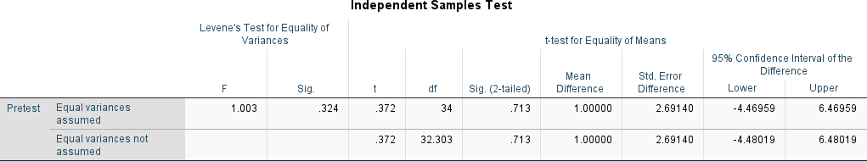

Based on the results of the t-test of two independent samples in the image above, a significance value (Sig. 2-tailed) was obtained of 0.713. This value is greater than the significance level of 0.05, so it can be concluded that there is no significant difference between the post-test results of the experimental group and the control group. This means that the use of the Culturally Responsive Teaching (CRT) method integrated with audiovisual media did not show a statistically significant effect on improving students' vocabulary compared to conventional learning methods.

  - Post-test T-Test independent sample.

Table 4.4 Post-test T-test

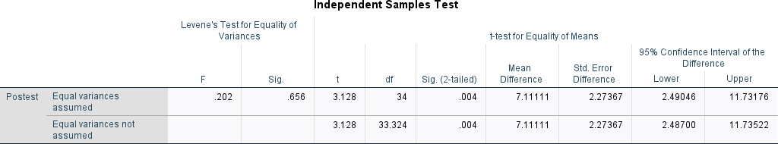

Based on the results of the t-test of two independent samples for post-test values, a Sig. (2-tailed) value of 0.004 was obtained, which is smaller than the significance level of 0.05. This shows that there is a statistically significant difference between the results of the post-test of the experimental group and the control group. With a mean difference of 7.11111, it can be concluded that learning using the Culturally Responsive Teaching (CRT) approach based on audiovisual media has a significant effect on improving students' vocabulary mastery compared to conventional methods.

Discussion

The Culturally Responsive Teaching (CRT) approach combined with audiovisual media has been proven to have a significant influence on improving vocabulary mastery of Dharma Wanita Junior High School students in Medan. This can be seen from the difference in post-test results between the experimental group and the control group. The experimental group showed an average score of 82.10,

while the control group only reached 70.85. A significance value (Sig. 2-tailed) of

0.004 obtained from the t-test of two independent samples also proved a significant difference between the two groups. The improvement obtained by the experimental group shows that the use of culture-based audiovisual media is more effective than conventional learning methods. These results support the findings of Abrigo and Kim (2022), who stated that cultural integration in learning can significantly improve vocabulary learning outcomes because students feel more personally connected to the material.

Student involvement in the learning process has also increased significantly. Through the use of audiovisual media that contains local cultural content, students not only learn new vocabulary, but also feel valued and recognized in the context of their cultural identity. When students see their culture reflected in the teaching materials, they show more active participation and a higher interest in learning. The combination of visual and auditory elements makes the learning process more interesting and not monotonous, thereby strengthening students' absorption of the material. This is in line with research conducted by Fansury, Lutfin, and Arsyad (2019), which concluded that audiovisual media effectively stimulates students' attention and memory in vocabulary learning.

The cultural context presented in the learning media also makes it easier for students to understand the meaning of vocabulary contextually. The vocabulary taught does not stand alone, but is linked to traditions, customs, or folklore that are familiar to students' daily lives. With this approach, students more easily establish

associations between words and their meanings in their own cultural contexts. This also reinforces the results of research by Arslan and Erarslan (2019), which show that cultural linkages in vocabulary teaching help improve long-term retention and a deeper understanding of vocabulary use in real-world contexts.

In addition, the use of audiovisual-based CRT also allows students to be more active in showing self-expression through cultural projects such as making videos, role-playing, and composing digital stories. These activities not only strengthen their vocabulary mastery, but also build confidence and pride in their local culture. The implementation of culture-based projects like this has also been proven to be effective in the research of Rochmawati and Susanti (2024), who used digital storytelling as a vocabulary learning strategy and found that the involvement of local culture in digital content greatly strengthens students' engagement and understanding of language.

Thus, vocabulary learning based on a CRT approach that integrates audiovisual media is not only statistically proven, but also has a strong theoretical and empirical foundation from various previous studies. This strategy is relevant to be applied in schools that have culturally diverse student backgrounds, as they are able to accommodate inclusive learning needs and build relationships between students, their materials, and culture. Overall, this approach not only improves learning achievement, but also fosters positive cultural identity, motivation, and active involvement in the learning process, as supported by a number of studies in the field of EFL language teaching.

CHAPTER V

CONCLUSIONS AND SUGGESTIONS

Conclusion

Based on the results of the research that has been conducted, it can be concluded that the Culturally Responsive Teaching (CRT) approach integrated with audiovisual media has a significant effect on improving the vocabulary mastery of grade VIII students of SMP Dharma Wanita Medan. The use of media relevant to students' cultural backgrounds not only increases learning outcomes quantitatively, but also encourages student involvement and motivation in the learning process. This approach has proven to be more effective than conventional methods in improving understanding and retention of English vocabulary.

Suggestion

Based on the results of the research and the conclusions that have been obtained, the researcher provides the following suggestions:
    - For English teachers, it is recommended to integrate the Culturally Responsive Teaching (CRT) approach with audiovisual media in the learning process, especially in teaching vocabulary. This approach has been proven to significantly increase student engagement and understanding.
    - For schools, it is important to support the provision of adequate learning technology facilities and infrastructure, such as audiovisual devices and

internet access, so that the implementation of media-based learning becomes more optimal.
    - For the next researcher, it is hoped that this research can be developed with a wider scope, for example on other language skills (writing, speaking), or carried out at different levels of education to expand the generalization of research results.

REFERENCE

Abrigo, C. M., & Kim, S. H. (2022). The impact of culturally responsive teaching on the acquisition of English language learners' vocabulary. Journal of Educational Research and Practice, 12(1), 58-75.

Arslan, M., & Erarslan, A. (2019). Improve vocabulary retention through the use of culturally responsive teaching strategies in secondary EFL classrooms. Journal of Language and Linguistic Studies, 15(1), 281-302.

Fansury, A.H., Lutfin, N., & Arsyad, S.N. (2019). Audio-visual media in improving students' vocabulary. Teaching English for EFL Students, 1(1), 28-38.

Hong, Y. (2020). Culturally responsive teaching in the context of digital language learning. International Journal for Educational Innovation and Research, 8(11), 175-192.

Mahmoud, MA (2020). The effectiveness of the use of audiovisual aids in teaching English vocabulary among EFL secondary school students. English Language Teaching, 13(6), 108-118.

Maulana, Z., Albar, S., & Yahrif, M. (2023). Utilizing traditional games as a medium to teach vocabulary in English as a foreign language. Journal of English Language Teaching and Learning, 4(1), 32-48.

Pham, H.L. (2021). Use of culturally responsive teaching strategies in secondary school English classes in Vietnam. International Journal of Educational Methodology, 7(3), 539-550.

Rhodes, C.M. (2018). Culturally responsive teaching with adult learners: A literature review. International Journal of Adult Vocational Education and Technology, 9(4), 33-41.

Rochmawati, D., & Susanti, N. (2024). Digital storytelling as a culturally responsive teaching strategy: Improving vocabulary skills among EFL Indonesian students. International Journal of TESOL, 19(1), 35-52.

Corpuz, J.M., Morales, A., Clarin, A.S., Dionio, B.B., & Cocolan, J.V. (2024). Students' Vocabulary Skills in Relation to Their Reading Comprehension in Language Literature. International Journal of Research and Innovation in the Social Sciences.

Hammond, Z. (2015). Culturally responsive teaching and brains: Promoting authentic engagement and rigor among culturally and linguistically diverse students. Corwin Press.

Banks, J. A., & Banks, C. A. M. (2019). Multicultural education: Issues and perspectives (10th ed.). Wiley.

Cahyono, B. Y., & Widiati, U. (2018). The teaching of EFL vocabulary in the Indonesian context: The state of the art. Journal of Teaching English as a Foreign Language, 2(2), 56–68.

Cazden, C. B. (2020). Culturally sustaining pedagogy: A needed change in educational practice. Educational Review, 72(2), 169–182.

Gay, G. (2018). Culturally responsive teaching: Theory, research, and practice (3rd ed.). Teachers College Press.

Harmer, J. (2015). The practice of English language teaching (5th ed.). Pearson Education.

Juwita, R., & Marlina, L. (2020). The effectiveness of audio-visual media in teaching vocabulary at junior high school. Journal of English Language Teaching, 9(2), 302–309.

Ladson-Billings, G. (2017). Making culturally relevant pedagogy relevant to the
study of race. Educational Theory, 67(1), 15–21.

Liu, Y. (2021). The use of audiovisual materials in EFL classrooms: Enhancing students’ vocabulary mastery. International Journal of Language Education, 5(1), 45–55.

Muhammad, R., & Hermayulis. (2022). Improving students' vocabulary mastery through audiovisual media. International Journal of Education and Learning, 4(3), 156–162.

Nieto, S. (2017). Re-imagining multicultural education: New visions, new possibilities. Multicultural Education Review, 9(1), 1–10.

Richards, J. C., & Schmidt, R. (2019). Longman dictionary of language teaching
and applied linguistics (5th ed.). Routledge.

Setiawan, B. (2019). English teaching and learning through audio-visual media.
Journal of English Language Studies, 4(1), 42–50.

Sleeter, C. E. (2021). The ghost of multicultural education past: A response to critics. Multicultural Perspectives, 23(2), 77–83.

Susanti, L. (2023). The effect of culturally responsive teaching on students’ vocabulary acquisition in Indonesian secondary schools. Journal of Educational Research and Practice, 13(2), 101–115.

Appendix 1

No | Name of Students Experimental Group | Score X
1 | AK | 59
2 | AA | 65
3 | DA | 57
4 | DPN | 73
5 | GS | 58
6 | HA | 64
7 | KL | 59
8 | MYR | 65
9 | NS | 52
10 | NGS | 58
11 | PC | 75
12 | RGA | 57
13 | RMS | 58
14 | RJKT | 72
15 | RA | 62
16 | SKS | 63
17 | SBRK | 68
18 | TH | 58

Appendix 2

No | Name of Students Control Grup | Score Y
1 | AG | 58
2 | ALW | 58
3 | CDLG | 50
4 | CA | 45
5 | GDS | 45
6 | GR | 60
7 | IH | 46
8 | KAS | 56
9 | LA | 49
10 | MN | 56
11 | MYS | 72
12 | NA | 55
13 | PR | 57
14 | RHA | 61
15 | RR | 48
16 | SHL | 61
17 | VL | 65
18 | YAH | 53

Appendix 3

LESSON PLAN FOR EXPERIMENTAL GROUP

NAMA SEKOLAH : SMP DHARMA WANITA MEDAN

MATA PELAJARAN : BAHASA INGGRIS

TAHUN AJARAN : 2025/2026

MATERI POKOK :

WAKTU : 2 x 40

ASPEK/SKILL : Vocabulary

- KOMPETENSI DASAR

KI 1 | : | - Menghayati dan mengamalkan ajaran agama yang dianutnya
KI 2 | : | - Menghayati dan mengamalkan perilaku jujur, disiplin, tanggungjawab. Peduli (gotong royong, kerjasama, toleran, damai), santun, responsif, dan pro-aktif serta menunjukkan sikap sebagai bagian dari solusi atas berbagai permasalahan dalam berinteraksi secara efektif dengan lingkungan sosial alam dan dalam menempatkan diri sebagai cerminan bangsa dalam pergaulan dunia.
KI 3 | : | - Memahami, menerapkan, mengamalisis pengetahuan faktual, konseptual, prosedural dan metakognitif berdasarkan rasa ingin tahunya ilmu pengetahuan, teknologi, seni, budaya dan humaniora dengan wawasan kemanusiaan, kebangsaan, kenegaraan, dan peradaban terkait penyebab fenomena dan kejadian, serta menerapkan pengetahuan prosedural pada bidang kajian yang spesifik sesuai dengan bakat dan minatnya untuk memecahkan masalah.
KI 4 | : | - Mengolah, menalar dan menyaji dalam ranah konkret dan ranah abstrak terkait dengan pengembangan diri yang dipelajarinya di sekolah secara mandiri, bertindak secara efektif dan kreatif, serta mampu menggunakan metoda sesuai kaidah keilmuan.

KOMPETENSI DASAR DAN INDIKATOR

KD 1.1 | : | - Mensyukuri kesempatan dapat mempelajari bahasa inggris sebagai bahasa pengantar komunikasi internasional yang diwujudkan dalam semangat belajar.
KD  2.1 | : | - Menunjukkan prilaku santun dan peduli dalam melaksanakan komunikasi interpersonal dengan guru dan teman.
KD 2.3 | : | - Mengembangkan perilaku jujur, disiplin, percaya diri, dan bertanggung jawab dalam melaksanakan komunikasi transaksional dengan guru dan teman.  - Menganalisis fungsi sosial, struktur teks dan unsur kebahasaan pada struktur umum deskriptif teks, serta identification dan description sesuai dengan konteks pemaparannya.
KD  3.1 | : | INDIKATOR  - Mendeskripsikan fungsi sosial, struktur teks, dan unsur kebahasaan untuk menyatakan dan menanyakan tentang Deskriptif teks dalam bahasa inggris sesuai dengan konteksnya.  - Mengidentifikasi contoh-contoh teks tentang Deskriptif bahasa inggris sesuai dengan konteksnya.  - Membedakan bentuk struktur umum Deskriptif teks dalam bahasa inggris sesuai dengan konteksnya.  - Mempelajari teks lisan maupun tulisan tentang Deskriptif teks dalam bahasa inggris sesuai dengan konteksnya.
KD 4.1 | : | INDIKATOR  - Menuliskan struktur umum tentang Deskriptif teks dalam bahasa inggris dengan baik.  - Menyimpulkan kalimat Deskriptif teks dalam bahasa inggris dengan baik  - Menyusun kalimat Deskriptif teks dalam bahasa inggris dengan baik

- Mempresentasikan struktur umum Deskriptif teks dalam bahasa inggris dengan baik.

- TUJUAN PEMBELAJARAN
Setelah mengikuti proses pembelajaran dengan pendekatan Culturally Responsive Teaching yang dipadukan dengan media audio visual, peserta didik diharapkan mampu:
  - Mengidentifikasi kosakata bahasa Inggris yang berkaitan dengan tema pembelajaran yang dekat dengan budaya dan lingkungan mereka secara tepat.
  - Memahami makna kosakata bahasa Inggris yang disampaikan melalui media audio visual berdasarkan konteks budaya lokal dan global.
  - Menggunakan kosakata baru dalam kalimat sederhana secara lisan maupun tulisan dengan struktur yang benar.
  - Meningkatkan rasa percaya diri dalam menggunakan kosakata bahasa Inggris melalui kegiatan yang relevan dengan budaya mereka sendiri.
  - Menunjukkan sikap terbuka dan menghargai keberagaman budaya melalui interaksi selama proses pembelajaran.

- PENDEKATAN, MODEL DAN METODE PEMBELAJARAN
- Pendekatan : CRT (Culturally Responsive Teaching)
- Model : Culturally Responsive Teaching
- Metode : Tanya jawab, tugas projek, argumentasi

- MEDIA, ALAT DAN SUMBER BELAJAR
  - Media: Video, Slide powerpoint/canva Worksheet atau lembar kerja (siswa) Lembar penilaian
  - Alat: Laptop, LCD Proyektor, Papan Tulis, Spidol
  - Sumber Belajar
    - Buku Penunjang Kurikulum 2013 Mata Pelajaran Bahasa Inggris When English Rings the Bell, Kelas VII, Kemendikbud, Revisi Tahun 2016
    - Kamus Bahasa Inggris
    - Video pembelajaran: - My last vacation (dibuat menggunakan animaker) /terlampir
    - https://app.animaker.com/video/CB4LZ98KHO2KP4CS - Artikel Budaya Batak/terlampir

    - Canva presentation

- MATERI AJAR
Materi Pokok:
Penguasaan kosakata Bahasa Inggris dasar terkait budaya, kegiatan sehari- hari, dan penggunaan fitur dasar Microsoft Word, melalui pendekatan Culturally Responsive Teaching (CRT) yang terintegrasi dengan media audio visual.

Sub Materi:
  - Kosakata Bahasa Inggris seputar kehidupan sehari-hari dan budaya lokal (contoh: rumah, kain batik, makanan tradisional, sekolah).
  - Kosakata Bahasa Inggris terkait perintah dan fungsi dalam Microsoft Word (contoh: Save, Insert, Font, Print).
  - Penerapan kosakata dalam kalimat sederhana (fungsi kata benda, kata kerja, dan kata sifat).
  - Mengenal nilai-nilai budaya dan sikap menghargai keberagaman melalui konteks kosakata.
  - Latihan soal model fill in the blank sebagai bentuk asesmen awal (pre-test) dan akhir (post-test).
Pendekatan:
Culturally Responsive Teaching (CRT): Mengaitkan kosakata yang dipelajari dengan budaya siswa sendiri (misalnya makanan khas, pakaian tradisional, atau kebiasaan lokal).
Audio Visual: Pemanfaatan gambar, video, atau presentasi interaktif untuk memvisualisasikan makna kata dan konteks penggunaannya.
- LANGKAH-LANGKAH PEMBELAJARAN
Pendahuluan (10 menit)
- Persiapan  - Apersepsi  - Motivasi | - Melakukan pembukaan dengan salam dan doa (Budaya Sekolah Religius)  - Guru memeriksa kehadiran siswa  - Peserta didik menyimak apersepsi dari guru tentang pelajaran sebelumnya.  - Guru mengajukan pertanyaan pemantik. What did you do yesterday?  - Guru memberikan gambaran tentang manfaat

mempelajari pelajaran yang akan dipelajari.
- Manfaat mempelajari pelajaran yang akan dipelajari dalam kehidupan sehari-hari.
- Menjelaskan tujuan pembelajaran dan cakupan materi yang akan di ajarkan
.
Kegiatan Inti (60 menit)

Self-  Identification  Culturally  Understanding Collaboration  Critical  Reflection  Transformative construction | guru memberikan kuisioner untuk memahami latar belakang siswa,karakteristik, gaya belajar serta memberikan kesempatan kepada siswa untuk memahami karakteristik dirinya sendiri.  guru mengintegrasikan bahasa Inggris dengan budaya dengan menayangkan video (tentang Sisingamanaraja XII)  guru membagi siswa berpasang-pasangan dan memberikan artikel terkait budaya batak di masa lampau untuk didiskusikan.  siswa melakukan refleksi kritis mengenai masalah yang diberikan melalui diskusi bersama pasangannya. Siswa menghubungkan materi dengan kehidupan sehari-hari serta manfaatnya dalam masyarakat kemudian mempresentasikan dalam bentuk dialog di depan kelas.  siswa mempresentasikan hasil diskusinya melalui dialog yang dibuat, kemudian menuliskan jurnal reflektif mengenai proses transformasi/ perubahan yang dialami baik dalam pemahaman  konsep identitas budayanya.
Penutup (10 menit)
Mereview pembelajaran dan menyimpulkan materi. Menutup
pembelajaran dengan berdoa bersama.

- PENILAIAN
Pengetahuan | Keterampilan | Sikap
Skor dari kuis yang diberikan. | Kemampuan mengaitkan ilmu kimia dengan budaya yang dimiliki | Observasi sikap pada saat presentasi

Appendix 4
Article about Bataknese
The Bataks is the name for a group of sub-societies that live in the rugged highlands and plains around Lake Toba in northern Sumatra. The word Batak is believed to have originally been a derogatory term meaning “primitive” used by lowland Muslims to describe highland people. Today there is little stigma attached to the word. [Source: “Encyclopedia of World Cultures, East and Southeast Asia” edited by Paul Hockings (G.K. Hall & Company, 1993)
Before the Batak Toba embraced religion, they believed in an all powerful god, Mulajadi Nabolon, who had power over the sky and conveyed his power in Debata Natolu . Concerning the soul and the spirit, the Batak Toba identify three concepts: 1) Tondi, the soul or spirit of a person is the force that gives life to man. If Tondi leaves the body of a person, then that person will get sick or die, and a ceremony called mangalap sombaon is necessary to bring the Tondi back. 2) Sahala is the soul or spirit of one's own power. Everybody has Tondi, but not everyone has Sahala. Sahala with Sumanta, luck or magic that of the king or the hula hula. 3) Begu is the Tondi of people have died. It has the same behavior as human behavior, but turns up only at night.
Ritual cannibalism has been reported among Batak to strengthen a person’s Tondi. In particular, blood, heart, palms, and soles of the feet are considered as rich Tondi. As early as the 9th century, an Arab text mentions that Sumatra’s inhabitants eat human flesh. During his visit to east Sumatra from April to September 1292, Marco Polo said he met coastal people that described inland people as "man-eaters". Niccolò Da Conti (1395-1469), a Venetian who spent most of 1421 in Sumatra, wrote: "In this part of the island, called cannibals living Batech fight constantly to their neighbors”.
Divining calendars known as “porhalaan”—with 12 months of 30 days each—are engraved on sacred bones or cylinders of bamboo and used in determining auspicious days for activities such planting rice. During the funerals, Batak chieftains used to use human-sized puppets mounted on wheeled platforms operated by a shaman who pulled wires and levers to make the effigy "weep tears, gnash its teeth, drag priests and speak in a voice of the departed." The puppets were dressed in possessions of the deceased and were used to revive the souls of the dead and communicate with the dead. Christian and Muslim leaders and colonial officials discouraged such practices as blasphemous.
[Source: ibdo.blogspot.jp]
https://factsanddetails.com/indonesia/Minorities_and_Regions/sub6_3b/entry- 3997.html

Artikel tentang Budaya Batak
Suku Batak adalah sebutan untuk sekelompok sub-masyarakat yang mendiami dataran tinggi dan dataran terjal di sekitar Danau Toba di Sumatera bagian utara. Kata Batak diyakini awalnya merupakan istilah merendahkan yang berarti "primitif" yang digunakan oleh Muslim dataran rendah untuk menggambarkan orang dataran tinggi. Saat ini ada sedikit stigma yang melekat pada kata tersebut. [Sumber: “Ensiklopedia Budaya Dunia, Asia Timur dan Tenggara” diedit oleh Paul Hockings (G.K. Hall & Company, 1993)
Sebelum orang Batak Toba memeluk agama, mereka percaya pada dewa yang maha kuasa, Mulajadi Nabolon, yang berkuasa atas langit dan menyampaikan kekuatannya dalam Debata Natolu. Tentang jiwa dan roh, orang Batak Toba mengidentifikasi tiga konsep: 1) Tondi, jiwa atau roh seseorang adalah kekuatan yang menghidupkan manusia. Jika Tondi meninggalkan tubuh seseorang, maka orang tersebut akan sakit atau mati, dan diperlukan upacara yang disebut mangalap sombaon untuk mengembalikan Tondi tersebut. 2) Sahala adalah jiwa atau ruh dari kekuatan diri sendiri. Semua orang punya Tondi, tapi tidak semua orang punya Sahala. Sahala dengan Sumanta, keberuntungan atau kesaktian yang dimiliki raja atau hula-hula. 3) Begu adalah Tondi orang yang telah meninggal. Ia memiliki perilaku yang sama dengan perilaku manusia, tetapi muncul hanya pada malam hari.
Kanibalisme ritual telah dilaporkan di kalangan Batak untuk memperkuat Tondi seseorang. Secara khusus, darah, jantung, telapak tangan, dan telapak kaki dianggap kaya Tondi. Pada awal abad ke-9, sebuah teks Arab menyebutkan bahwa penduduk Sumatera memakan daging manusia. Selama kunjungannya ke Sumatra timur dari April hingga September 1292, Marco Polo mengatakan bahwa dia bertemu dengan orang pesisir yang menggambarkan orang pedalaman sebagai "pemakan manusia". Niccolò Da Conti (1395 1469), seorang Venesia yang menghabiskan sebagian besar tahun 1421 di Sumatra, menulis: "Di bagian pulau ini, Batech yang disebut kanibal hidup terus-menerus berperang melawan tetangga mereka".
Kalender ramalan yang dikenal sebagai “porhalaan”—dengan 12 bulan masing-masing 30 hari—diukir pada tulang keramat atau silinder bambu dan digunakan untuk menentukan hari baik untuk kegiatan seperti menanam padi. Selama pemakaman, kepala suku Batak biasanya menggunakan boneka seukuran manusia yang dipasang di atas platform beroda yang dioperasikan oleh dukun yang menarik kabel dan tuas untuk membuat patung "menangis air mata, menggertakkan gigi, menyeret pendeta, dan berbicara dengan suara orang yang meninggal". Boneka-boneka itu dikenakan milik almarhum dan digunakan untuk menghidupkan kembali jiwa orang mati dan berkomunikasi dengan orang mati. Para pemimpin Kristen dan Muslim serta pejabat kolonial melarang praktik-praktik seperti itu sebagai penistaan.

Appendix 5
Kuesioner Peserta Didik (diagnostic)
Berilah tanda V pada jawaban yang sesuai dan jumlahkan nilainya

No | Pertanyaan | Jawaban
No | Pertanyaan | Sering | Kadang- kadang | Jarang
A.1 | Apakah anda rapi dan  teratur ?
2 | Apakah anda berbicara dengan cepat ?
3 | Apakah anda perencana dan pengatur jangka panjang yang baik?
4 | Apakah anda pengeja yang baik dan dapatkah anda melihat kata-kata dalam pikiran anda?
5 | Apakah anda lebih ingat apa yang dilihat daripada yang didengar?
6 | Apakag anda menghafal hanya dengan melihat saja?
7 | Apakah anda sulit mengingat perintah lisan kecuali jika dituliskan, dan apakah anda sering menyuruh orang mengulang ucapannya ?
8 | Apakah anda lebih suka membaca daripada dibacakan?
9 | Apakah anda suka mencoret-coret saat menelpon/rapat ?
10 | Apakah anda lebih suka melakukan demonstrasi daripada berpidato ?
11 | Apakah anda lebih suka seni rupa daripada music
12 | Apakah anda tahu apa yang harus dikatakan tetapi tidak terpikir kata yang tepat ?

 | Sub Total
 |  | X 2 | X 1 | X 0
 | Total
B.1 | Apakah anda berbicara pada diri sendiri saat bekerja ?
2 | Apakah anda mudah terganggu keributan ?
3 | Apakah anda  menggerakkan bibir saat  membaca ?
4 | Apakah anda suka membaca keras-keras dan mendengarkan ?
5 | Dapatkah anda  mengulang dan  menirukan nada, perubahan, dan warna suara ?
6 | Apakah anda merasa menulis itu sulit, tetapi pandai bercerita ?
7 | Apakah anda berbicara dengan pola berirama ?
8 | Apakah menurut anda, anda adalah pembicara yang fasih ?
9 | Apakah anda lebih menyuka musik daripada seni rupa ?
10 | Apakah anda belajar melalui mendengar dan mengingat apa yang didiskusikan daripada  yang dilihat ?
11 | Apakah anda banyak bicara, suka berdiskusi dan menjelaskan panjang lebar ?
12 | Apakah anda lebih baik mengeja keras-keras daripada menuliskannya ?
 | Sub Total
 |  | X 2 | X 1 | X 0
 | Total

C1 | Apakah anda berbicara dengan lambat?
2 | Apakah anda menyentuh orang untuk mendapatkan perhatiannya ?
3 | Apakah anda berdiri dekat-dekat saat berbicara dengan orang?
4 | Apakah sering melakukan kegiatan fisik / banyak bergerak ?
5 | Apakah anda lebih bisa belajar dengan praktek ?
6 | Apakah anda belajar dengan berjalan dan melihat ?
7 | Apakah anda  menggunakan jari untuk menunjuk saat membaca ?
8 | Apakah anda banyak menggunakan isyarat tubuh ?
9 | Apakah anda tak bisa duduk tenang untuk waktu yang lama ?
10 | Apakah anda membuat keputusan berdasarkan perasaan ?
11 | Apakah anda mengetuk- ngetuk pena,  menggerakkkan jari atau kaki saat mendengarkan ?
12 | Apakah anda meluangkan waktu untuk berolah raga dan kegiatan fisik lainnya  ?
 | Sub Total
 |  | X 2 | X 1 | X 0
 | Total

Bila total nilai lebih banyak pada :
- Tipe Visual
- Tipe Auditori
- Tipe Kenestetik

B | Aspek Budaya | 4 | 3 | 2 | 1
- Apakah anda memahami budaya yang ada di kota anda?
- Menurut 1 anda apakah budaya merupakan unsur penting dalam hidup bermasyarakat?
- Perlukah unsur budaya dikaitkan dengan mata pelajaran yang ada di sekolah?
- Pernahkah anda mendengar tentang apa itu kehidupan batak di zaman dahulu?

Keterangan:
1 = Sangat tidak setuju
2 = Tidak Setuju
3 = Setuju
4 = Sangat Setuju

Jurnal Refleksi Akhir Pembelajaran

No | Pertanyaan | Jawaban
1 | Apakah pembelajaran yang dikaitkan dengan kehidupan sehari-hari lebih mudah untuk dipahami ? mengapa demikian?
2 | Apakah pembelajaran yang dikaitkan dengan unsur budaya siswa lebih menarik untuk dipelajari ? mengapa demikian?
3 | Dapatkah siswa memberi contoh Budaya lain?
4 | Bagaimana tanggapan siswa mengenai pembelajaran hari ini?
5 | Apakah metode diskusi secara berpasangan memudahkan pemahaman siswa mengenai materi pembelajaran? mengapa demikian?
6 | Kesulitan apa yang kalian hadapi saat melaksanakan proses pembelajaran?
7 | Usaha apa yang kalian lakukan untuk memahami materi pembelajaran secara lebih dalam?
8 | Apakah kalian tertarik untuk belajar lebih luas mengenai Bahasa Inggris?

Assesment as Learning Lembar Observasi
No | Aspek | 1 | 2 | 3 | 4
a | Kemampuan Berfikir Kritis
- Siswa mampu memahami artikel budaya yang disampaikan
- Siswa memahami materi dan mampu menjawab soal yang diberikan dengan tepat (diukur dari jawaban siswa pada soal yang diberikan)
b | Rasa Ingin Tahu
- Siswa mengisi kuisioner dengan baik
- Siswa mengisi jurnal reflektif dengan baik
- Siswa berani bertanya mengenai materi yang disampaikan
- Siswa tampak antusias dan tertarik untuk mengikuti pembelajaran.
- Siswa bertanya lebih lanjut mengenai materi yang disampaikan
c | Kemampuan Sosial Budaya

- Siswa mampu mengaitkan materi dengan aspek budaya yang dimiliki
- Siswa mampu mengidentifikasi budaya di sekitarnya
- Siswa mampu mempresentasikan hasil diskusinya dengan baik

Keterangan
1 = Sangat tidak setuju
2 = Tidak setuju
3 = Setuju
4 = Sangat setuju

Appendix 6

Penilaian Keterampilan
Mata Pelajaran : Bahasa Inggris
Kelas VIII
Nama Proyek : Listen to personal experience
Tema : Vocabulary

N  o | Aspek Penilaian | Skor
N  o | Aspek Penilaian | 4 | 3 | 2 | 1
1 | Pemahaman umum | Peserta didik mampu memahami keseluruhan isi teks melalui presentasi dan laporan hasil | Peserta didik mampu memahami keseluruhan isi teks melalui laporan hasil namun presentasi kurang | Peserta didik mampu memahami sebagian isi teks melalui presentasi dan laporan hasil | Peserta didik mampu memahami sebagian isi teks melalui laporan hasil dan presentasi kurang
2 | Struktur teks | Peserta didik merancang dialog tentang masa lalu sesuai dengan artikel budaya menggunaka n unsur past tense dengan sangat benar | Peserta didik merancang dialog tentang masa lalu sesuai dengan artikel budaya menggunaka n unsur past tense dengan benar dimana ada 1 kesalahan | Peserta didik merancang dialog tentang masa lalu sesuai dengan artikel budaya menggunaka n unsur past tense dengan 2-3  kesalahan pengunaan dalam kalimat | Peserta didik merancang dialog tentang masa lalu sesuai dengan artikel budaya menggunaka n unsur past tense dengan lebih dari 3 kesalahan pengunaan  dalam kalimat
3 | Unsur kebahasaan | Peserta didik menggunaka n unsur kebahasaan dengan sangat benar. | Peserta didik menggunaka n unsur kebahasaan dengan benar | Peserta didik menggunaka n unsur kebahasaan dengan cukup benar | Peserta didik menggunaka n unsur kebahasaan dengan kurang benar

4 | Kejelasan menyampaika n | Artikulasi sangat jelas, suara terdengar jelas dan lancar | Artikulasi jelas, suara terdengar jelas dan cukup lancarlancar | Artikulasi cukup jelas, suara cukup terdengar dan cukup lancar | Artikulasi kurang jelas, suara kurang terdengar dan terbata- bata

Catatan:
Skor diberikan dengan rentang 1-4 dengan ketentuan, semakin lengkap jawaban dan ketepatan dalam proses pembuatan maka semakin tinggi nilainya.

Total Skor= 𝐽𝑢𝑚𝑙𝑎ℎ 𝑦𝑎𝑛𝑔 𝑏𝑒𝑛𝑎𝑟 x 100
16

Appendix 7

Assesment as Learning
- Pre-Test Fill in the Blank – Essay (10 Soal)
  - The opposite of "open" is .
  - When you want to save your work, you click the "" button on the toolbar.
  - The word "teacher" in Bahasa Indonesia is .
  - We use the word "" when we want to describe something that is very big.
  - "Cultural" is related to the word .
  - To make a new document in Microsoft Word, we click on "".
  - In the sentence "She is reading a book", the word "reading" is a .
  - The word "school" refers to a place where students go to .
  - The flag of Indonesia is colored and .
  - When we want to print something, we click the "" menu.

- Post-Test Fill in the Blank – Essay (10 Soal)
  - In a traditional Indonesian house, the word "rumah" in English is
.
  - To insert a picture into a document, we click "" then "Pictures".
  - The word "Independence" in Bahasa Indonesia means .
  - In the sentence “He dances well,” the word “dances” shows .
  - We click the "" tab to change the font style and size.
  - “Batik” is a traditional Indonesian fabric. In English, "kain batik" means
.
  - The sentence “They are cooking rendang” uses the word “rendang,” which is a from Padang.
  - The shortcut key for saving a file in Word is + .
  - When we learn about other cultures, we should be and respectful.
  - To check the spelling in our writing, we use the "" tool.

Appendix 8
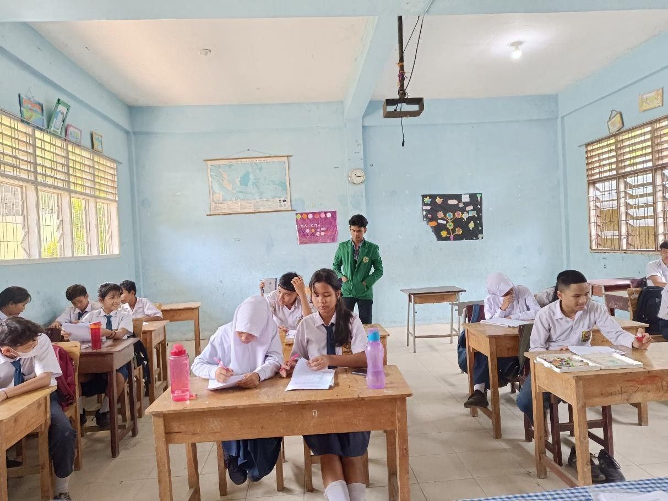
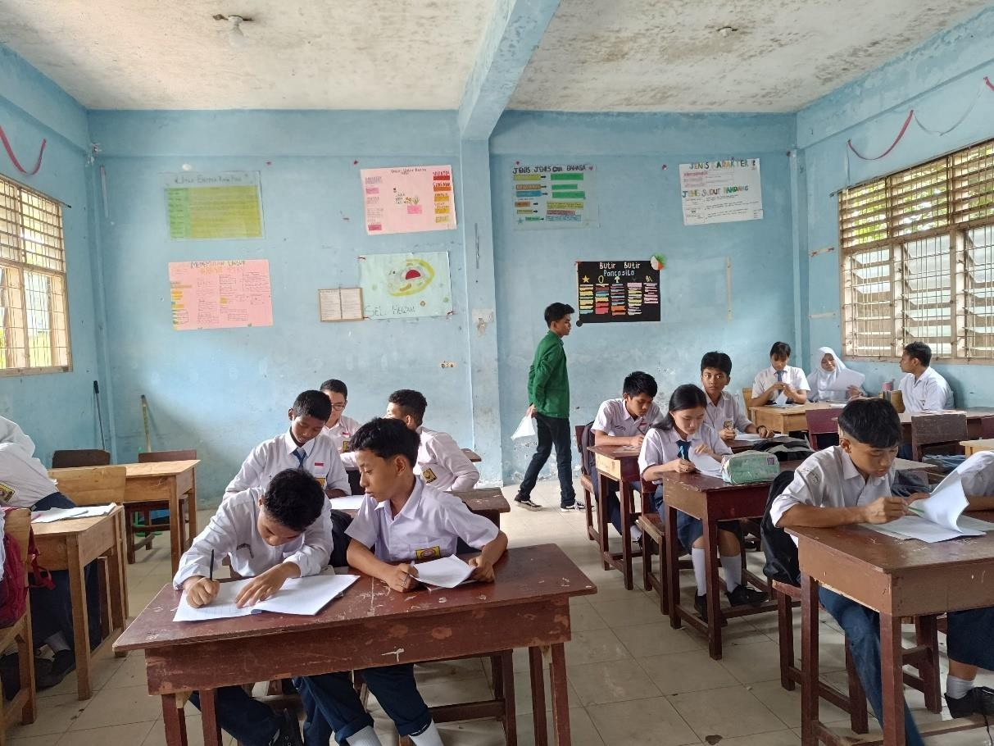

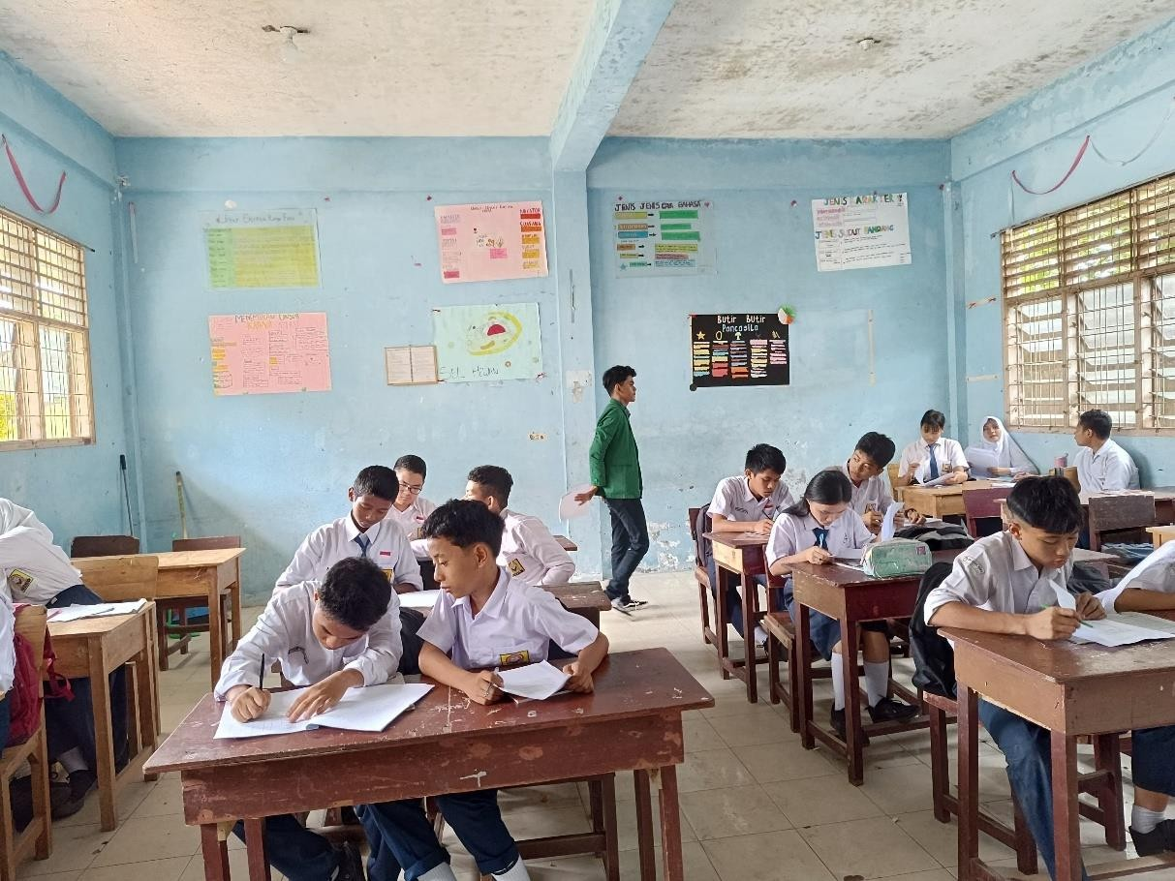
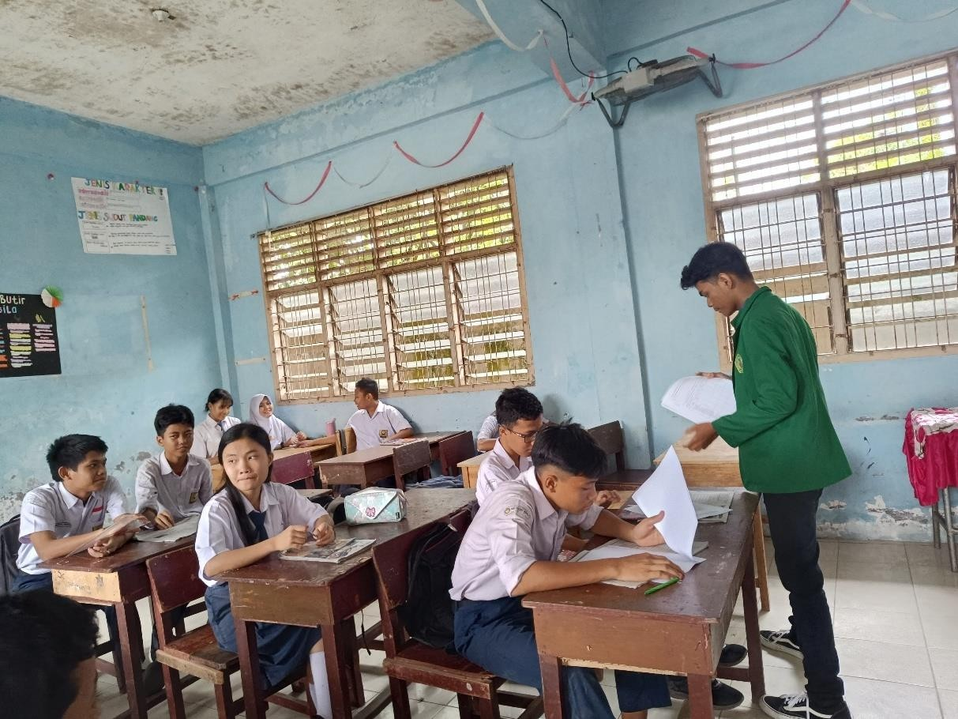

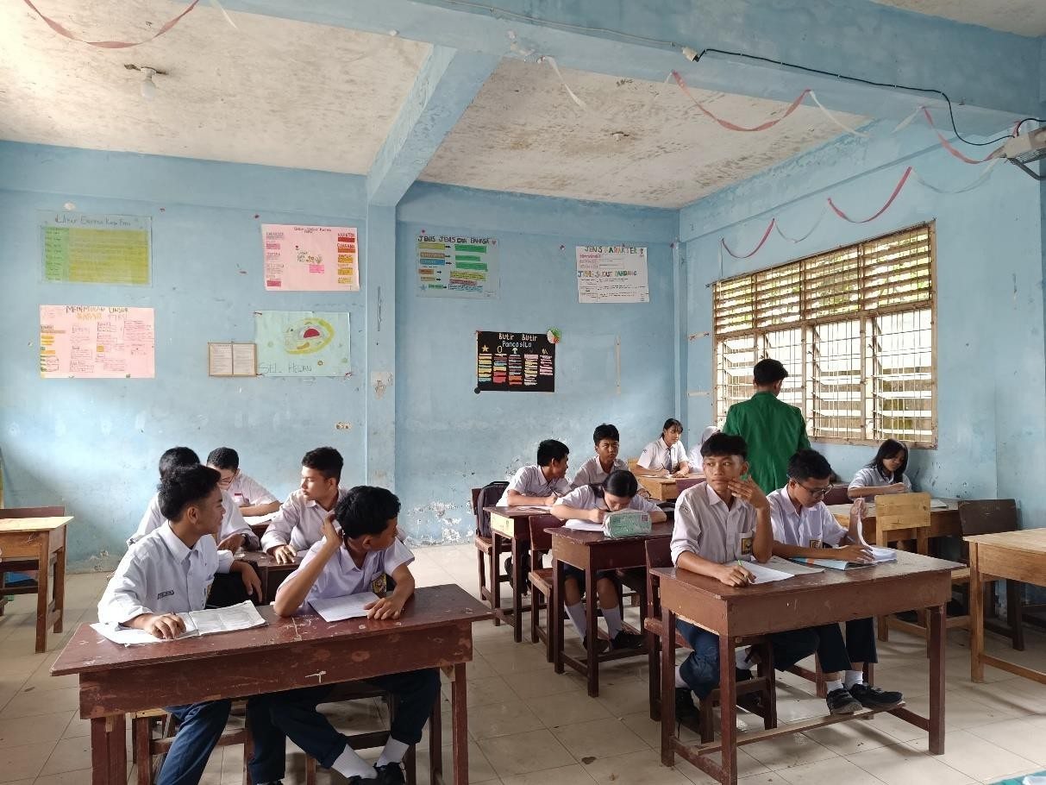
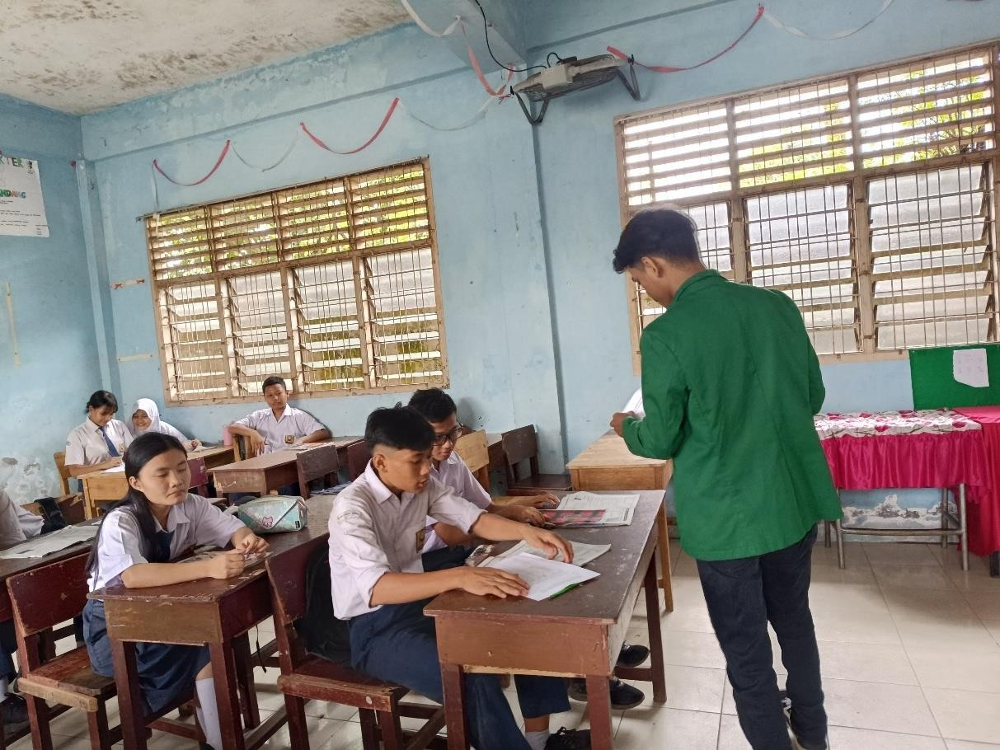

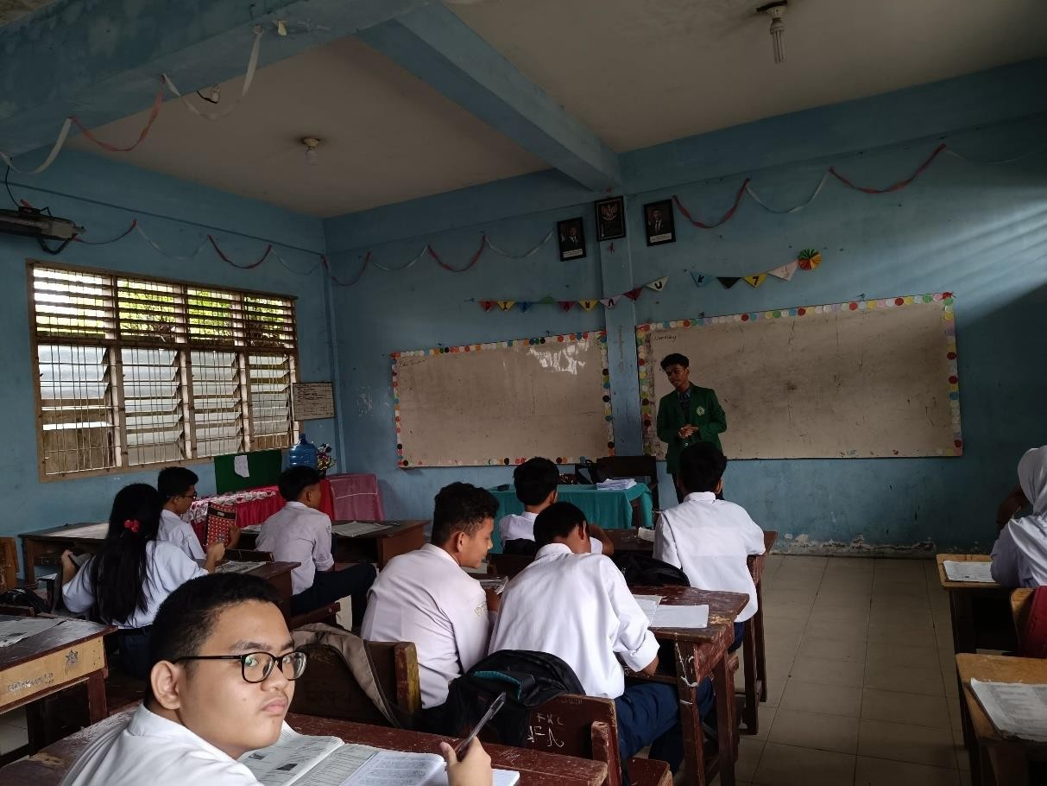
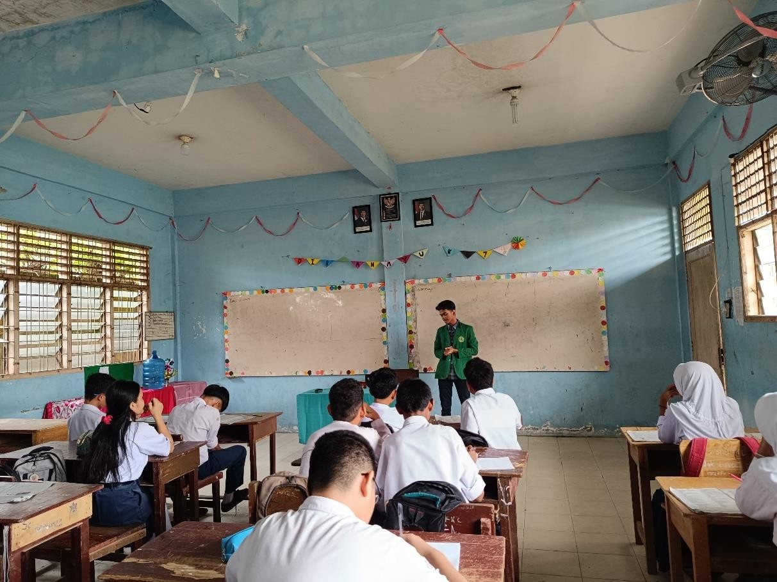

Appendix I
