ENGLISH LITERACY ERRORS OF STUDENTS’ ABILITY IN READING COMPREHENSION AT SMPN 34 MEDAN IN 2025

A Thesis

by

RENY MADHANI NPM: 211224010



ENGLISH EDUCATION DEPARTEMENT FACULTY OF TEACHERS TRAINING AND EDUCATION UNIVERSITAS MUSLIM NUSANTARA AL WASHLIYAH
MEDAN 2025

ENGLISH LITERACY ERRORS OF STUDENTS’ ABILITY IN READING COMPREHENSION AT SMPN 34 MEDAN IN 2025

A Thesis

Submitted to the Department of English Education in Partial Fulfillment of the Requirements for the Degree of
Bachelor of Education

by

RENY MADHANI NPM: 211224010

ENGLISH EDUCATION DEPARTEMENT FACULTY OF TEACHERS TRAINING AND EDUCATION UNIVERSITAS MUSLIM NUSANTARA AL WASHLIYAH
MEDAN 2025

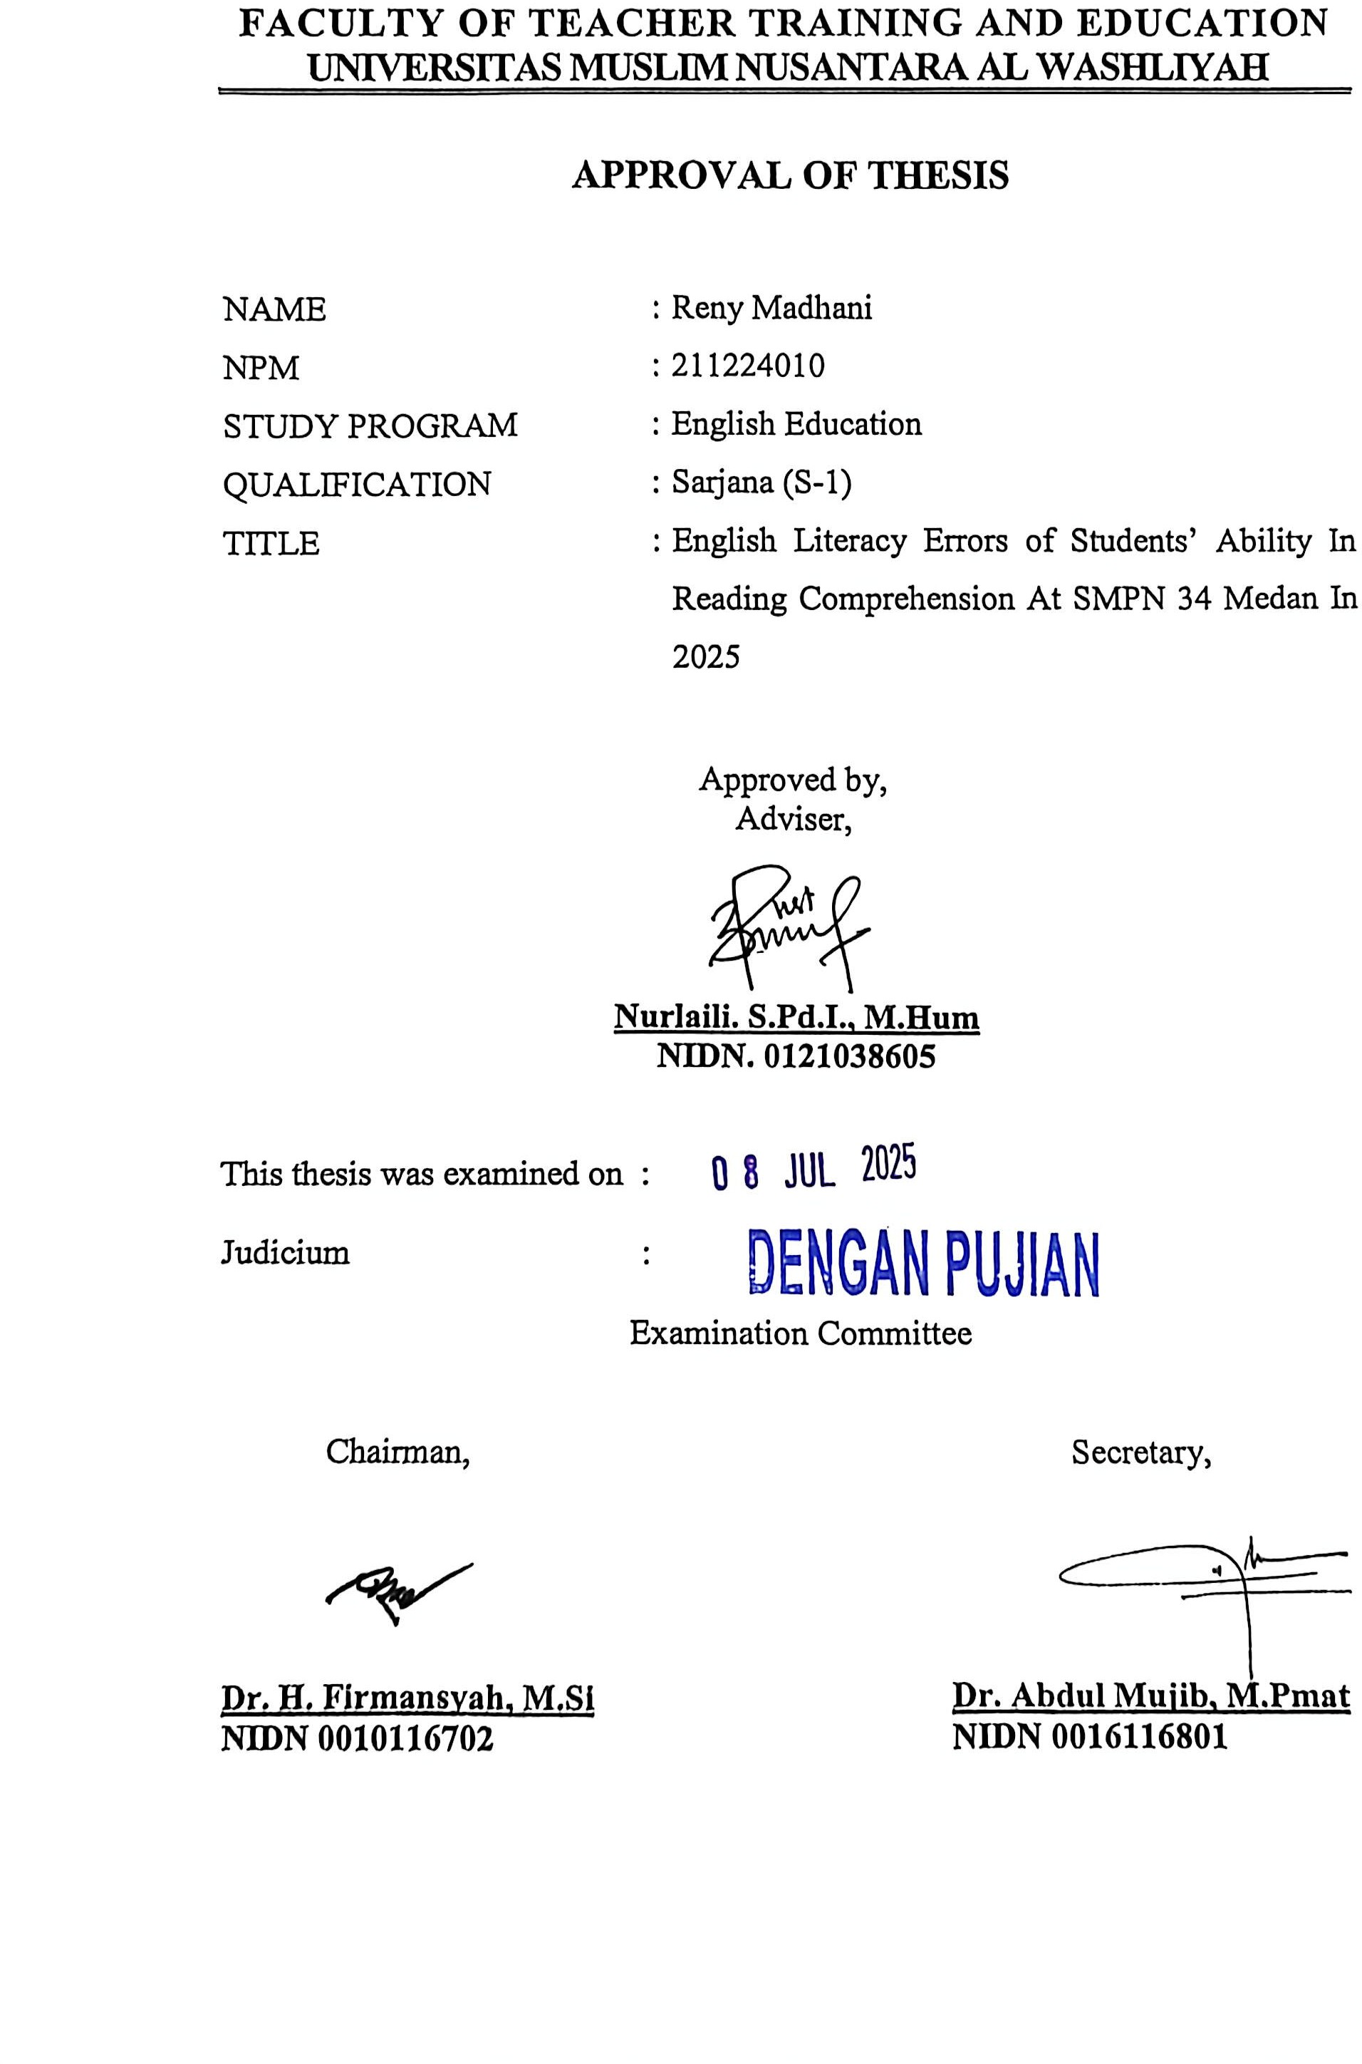

ENGLISH LITERACY ERRORS OF STUDENTS’ ABILITY IN READING COMPREHENSION AT SMPN 34 MEDAN IN 2025

RENY MADHANI NPM: 211224010

ABSTRACT

This study investigated the English literacy errors made by eighth-grade students at SMPN 34 Medan in understanding narrative texts, highlighting their difficulties in reading comprehension. Using a descriptive qualitative method, students' written responses to a narrative text titled “The Little One and the Rain” were analyzed. Ten students answered five open-ended questions designed to assess literal, inferential, and interpretive comprehension. The findings revealed three main types of errors: referencing errors (40%), inference errors (30%), and vocabulary errors (30%). These results suggested that students struggled with interpreting implicit information, vocabulary use, and cohesive referencing. The study concluded that English instruction should have strengthened students’ inference-making skills, vocabulary development, and understanding of textual cohesion to improve reading comprehension.

Keywords: literacy errors, reading comprehension, narrative text, inference, vocabulary, referencing

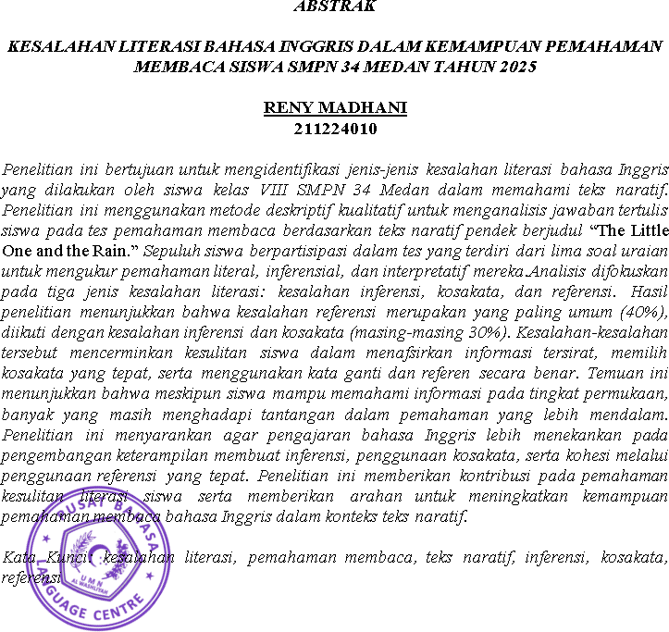

ACKNOWLEDGEMENTS



Artinya:

“Hai orang-orang yang beriman sukakah kamu aku tunjukkan suatu perniagaan yang dapat menyelamatkanmu dari azab yang pedih ?!. (Yaitu) kamu beriman kepada Allah dan Rasul-Nya dan berjihad di jalan Allah dengan harta dan jiwamu. Itulah yang lebih baik bagimu, jika kamu mengetahuinya.” (QS.Ash Shaff: 10-11).

First of all, the greatest gratitude to Allah SWT, the Almighty God for the blesing which has been given to the writer so that she finally completed this thesis in partial fulfillment of the rewuirements for the degree of Bachelor at the English Education, the Faculty of Teachers’ Training and Education, the University of Muslim Nusantara Al Washliyah Medan. This Thesis could not have been accomplished without the guidances, suggetions, and comments from several people so the resercher would like to express her deep gratitude to the following people:

- Dr. H. Firmansyah, M.Si., as the Rector of Universitas Muslim Nusantara Al Washliyah Medan.

- Dr. Abdul Mujib, S.Pd., M.PMat., as the Dean of FKIP of Universitas Muslim Nusantara Al Washliyah Medan.
- Wariyati, S.Pd., M.Hum., M.Pd., as the Head of the English Education Department of Universitas Muslim Nusantara Al Washliyah Medan.
- Nurlaili, S.Pd.I., M.Hum., as the adviser who has donated time, knowledge, guidance, advice, and support to the researcher in guiding the preparation of this thesis.
- Dr. Azhary Tambusai, M.A., as the first examiner who gives the sugestion.
- Wariyati, S.Pd., M.Hum., M.Pd., as the seconde examiner who gives the suggestion.
- All of the lecturers of the English Education Department of Universitas Muslim Nusantara Al Washliyah Medan.
- All of the Academic Administration Stafs of Universitas Muslim Nusantara Al Washliyah Medan.
- All of the Librarians Staffs of Universitas Muslim Nusantara Al Washliyah Medan.
- The researcher would like to express my deepest gratitude and heartfelt appreciation to my parents for their unwavering support, love, and endless sacrifices throughout my academic journey. Thank you, Mom and Dad, for every prayer you have offered, for your patience in listening to my stories and concerns, and for the moral and material support you provided from the very beginning until the completion of this thesis. You have been my foundation when my spirit waned and my greatest source of strength in every challenge I faced. Without your love, faith, and sacrifices, this achievement would not have been possible. Every page of this work reflects your extraordinary dedication to my growth and education. This expression of gratitude is not merely words — it is my sincere tribute to parents who have always believed in and supported me unconditionally. Thank you for everything you have done for me, in ways both seen and unseen.

- Special thanks are also addressed to the researcher’s brother, Rendy Hermawan, for his consistent support, guidance, and words of encouragement, which have been a source of strength throughout the research process.
- The researcher would also like to extend her appreciation to all fellow students of the English Education Class of 2021 at UMN Al Washliyah for their companionship, cooperation, and shared experiences during the academic years. SWT, may Allah SWT bless them all in here after. Aamiin Ya Rabbal ‘aalamiin.
- Last but not least, the researcher would also like to express my gratitude to myself for the perseverance, determination, and resilience I have demonstrated throughout the process of writing this thesis. Thank you to myself for remaining persistent and not giving up despite facing challenging days, pressure, and doubt. Thank you for devoting your time, energy, and thought to continuous learning, striving, and developing until this work was completed.

Medan, 22 June 2025 The Researcher,

Reny Madhani

TABLE OF CONTENTS

ACKNOWLEDGEMENTS I
TABLE OF CONTENTS IV
CHAPTER I 1
INTRODUCTION 1
  - Background of the Problem 1
  - Identification of the Problem 2
  - Limitation of the Problem 2
  - Formulation of the Problem 3
  - Objective of the Research 3
  - Significances of the Research 3
CHAPTER II 4
RIVIEW OF LITERATURE 4
  - Concept of English Literacy 4
    - Definition of English Literacy 4
    - The Importance of Literacy in Education 6
    - Literacy Components: Reading, Writing, Speaking and Listening 8
  - Reading Comprehension 9
    - Literacy Function of Reading Comprehension 9
    - Reading Comprehension Process 9
    - Factors Affecting Literacy Reading Comprehension 11
  - Mistakes in Literacy 12
    - Literacy Errors in Reading Comprehension 12
    - Causes of Literacy Errors Students in Reading Comprehension 13
  - Reading Instruction Methods 15
    - Kinds of Errors 15
    - The Difference Between Errors and Mistakes in Reading Comprehension 16
    - Effective Teaching Methods to Improve Reading Comprehension
. 17
    - The Teacher's Role in Teaching Reading 17
    - Applicable Learning Strategies 18
  - Framework of Thought 19
    - Related Research 19
    - Model Used in this Research 21
CHAPTER III 22
RESEARCH METHOD 22
  - Research Design 22
  - Participants and Research Place 23
  - Research Instruments 23
  - Data Analysis 25
CHAPTER IV 27
RESEARCH RESULT AND DISCUSSION 27
  - Research Findings 27
    - The Data 27
    - Data Analysis 30
  - Discussion 33
CHAPTER V 36
CONCLUSION AND SUGGESTIONS 36
  - Conclusion 36
  - Suggestion 36
REFERENCES 38
APPENDIX 41

CHAPTER I INTRODUCTION

Background of the Problem
Literacy is the ability to read, write and understand information in various forms. In an educational context, literacy includes not only basic reading and writing skills but also the ability to analyze, evaluate and use information effectively. Good literacy is essential for learners as it supports the learning process and the development of critical skills needed in everyday life. Benefits of literacy for learners is, improving reading and comprehension skills, critical skills development, preparation for professional life, supports lifelong learning, increases self-confidence
Although many studies have been conducted to identify errors in English reading comprehension, there is still a lack of in-depth analysis of the specific types of literacy errors made by students at SMPN 34 Medan. Previous studies often only provide an overview of the errors that occur, without categorizing them in detail. Some types of errors that may occur, such as errors in vocabulary comprehension, sentence structure, and context understanding, have not been fully explored in the local context. Therefore, this study aims to identify and analyze the types of literacy errors that students make.
Students at SMPN 34 Medan generally engage in reading literacy activities, including comprehension of vocabulary, sentence structure, and the context of English texts. They are also exposed to information literacy, which involves locating and evaluating information from various sources. However, despite this

exposure, many students still struggle to comprehend narrative texts deeply. They often face difficulties in making inferences, understanding vocabulary in context, and using referents correctly. These recurring issues indicate that there is a gap between what students are expected to understand and their actual comprehension performance. Therefore, it is necessary to investigate the specific types of English literacy errors students make in reading comprehension.

Identification of the Problem

    - Errors in Understanding Text: Many students have difficulty in comprehending the text they read, which can be due to a lack of basic literacy skills, such as limited vocabulary or understanding of sentence structure.
    - Limited Vocabulary: Many students may have inadequate vocabulary, which hinders their ability to understand more complex texts. This limitation can lead to difficulties in capturing the meaning and context of the reading.
    - Inconsistent Curriculum Implementation: Curriculum changes often require time and training for teachers to implement effectively. If teachers do not fully understand the new curriculum, this can result in inconsistent and less effective teaching.

Limitation of the Problem

This research focuses on the types of literacy errors made by errors in understanding word meanings.

Formulation of the Problem

Based on the background of the research and the identification of the study, the problem is formulated as follows: “What types of literacy errors do students make in understanding narrative texts in English at SMPN 34 Medan?”

Objective of the Research

According to the statement, aim of this research is identify types of literacy errors in reading comprehension of English texts

Significances of the Research

From the research result, it is expected to provide several benefits:

    - Identification of Students' Needs: By identifying the types of errors that students often make, this study can help in determining the specific needs of students in English learning, so that appropriate interventions can be implemented.
    - Reading comprehension is an important skill that affects students' academic success. By analyzing literacy errors, this study can provide insights into how to improve students' reading comprehension ability, which in turn can improve their academic performance

CHAPTER II

RIVIEW OF LITERATURE

Concept of English Literacy

Definition of English Literacy

Henry Aditia Rigianti & Fenita Situmorang (2024) states English literacy refers to an individual's ability to read, understand, write and communicate in English effectively. In an educational context, literacy includes not only the ability to read texts, but also the ability to analyze, evaluate and use information gained from reading in various situations. English literacy is essential for students, especially in understanding subject matter taught in English and participating in wider social interactions.
Baker and Brown (2016) define English literacy as an ability that involves more than just reading and writing. They emphasize that literacy is a complex cognitive process that includes understanding, analyzing and using information obtained from texts. In this context, English literacy focuses not only on decoding or word recognition, but also on the ability to understand the deeper meaning of the text read.
The ideas of Baker and Brown, literacy involves several important components:
          - Reading Ability: This includes the ability to recognize words, understand sentence structure, and interpret meaning from texts. Literate readers are able to connect new information with existing knowledge, so as to draw conclusions and make relevant inferences.

          - Metacognitive Strategies: Baker and Brown emphasize the importance of metacognitive strategies in the reading process. Literate students not only read the text, but also monitor their own comprehension, plan how they will approach the reading, and evaluate how well they understand the information presented. This shows that literacy involves self-awareness and reflection in the learning process.
          - Analytical Skills: Literacy also includes the ability to analyze and evaluate information from different sources. Literate readers can distinguish between fact and opinion, and understand the social and cultural contexts that influence the meaning of texts. This is important for developing critical thinking and the ability to argue effectively.
          - Use of Texts in Various Contexts: Baker and Brown also note that English literacy should be understood in a broader context, including language use in social, academic and professional situations. Students need to be able to apply their literacy skills in a variety of contexts to function effectively in an increasingly complex society.
In their study, McKeown and Beck (2016) suggested that literacy errors can be categorized as errors related to vocabulary comprehension, where students are unable to capture the meaning of words used in a particular context. They asserted that vocabulary comprehension is a crucial foundation in the reading process, as without adequate understanding of vocabulary, students will struggle to capture the overall meaning of the text. They also point out that these errors

can be systematic, where certain patterns of errors emerge among students who have similar educational and linguistic backgrounds.

The Importance of Literacy in Education

Rupley, Blair & Nichols (2017) Literacy is a basic skill that is very important in education, especially in the context of English language learning. The importance of literacy in education can be seen from various aspects, which include students' cognitive, social and emotional development. Here are some points that explain the importance of literacy in education:
          - Foundation for Academic Learning: Literacy is the foundation for all forms of learning. The ability to read and comprehend text is essential for accessing information across various disciplines. Students who have good literacy skills can follow lessons more effectively and understand the material taught in class.
Development of Critical Thinking Skills: Literacy involves not only the ability to read, but also the ability to analyze and evaluate information. Literate students are able to think critically, make inferences and draw conclusions from the texts they read. This is crucial in a world full of information and diverse opinions.
          - Preparation for Daily Life: Literacy is also important for everyday life.

The ability to read and understand information, such as instructions, forms and official documents, is indispensable in a variety of situations. Literate students are better prepared to face challenges in society and can participate actively in social and economic life.

          - Increases self-confidence and motivation: Students who have good literacy skills tend to be more confident in their ability to learn and communicate. This confidence can increase students' motivation to learn more and explore different sources of information.
          - Support for Lifelong Learning: Literacy is a necessary skill for lifelong learning. In an ever-changing world, the ability to continuously learn and adapt to new information is essential. Students who are skilled in literacy will be better able to develop new skills and keep up with developments in academic and professional fields.
          - Social and Emotional Development: Literacy also contributes to students' social and emotional development. Through reading, students can understand different perspectives and experiences, which can improve their empathy and social skills. This is important for building healthy relationships and contributing to an inclusive society
Afflerbach (2016) Afflerbach highlights that literacy also plays an important role in the development of critical thinking skills. He argues that good literacy enables students to analyze information, evaluate arguments and make evidence-based decisions. In an educational context, this means that students not only learn to read and write, but also to think critically about the information they receive. These skills are essential to prepare students for challenges in a complex and rapidly changing world.
Baker and Brown (2016) They emphasize that literacy is a skill that should be taught explicitly in an educational context. They argue that students need to

be trained in metacognitive strategies that help them understand and recall information from texts. By developing these skills, students will not only be better at reading, but will also be better equipped to deal with academic and everyday life challenges. Baker and Brown point out that strong literacy can increase students' confidence and motivation to learn.

Literacy Components: Reading, Writing, Speaking and Listening

Harmer, J. (2015) states reading, writing, speaking, and listening are complementary skills in language acquisition. Understanding how these skills are integrated can help individuals improve their overall language ability. Holistic and integrated learning will be more effective in developing language skills.
According to Nation and Newton (2009) these four skills do not stand alone they support each other in the context of communication. For example, reading can help one write better, and listening can improve speaking. In learning situations, practicing all four skills together, such as in group discussions or presentations, can strengthen language comprehension and use. For example, students who listen and read about a particular topic will be better able to speak and write about it. Listening to feedback from others after speaking or writing can help individuals improve their skills.
Thornbury (2017) recommends that activities such as reading a text before writing or listening to a discussion before speaking on the same topic

can strengthen language skills. These strategies allow students to understand the content first before producing language.

Reading Comprehension

Literacy Function of Reading Comprehension

Reading comprehension in literacy has several important aspects that can be described as follows:
          - Building Understanding

Kintsch, W. (2013) states reading serves as the primary tool for building understanding of texts. Students who are able to read well can understand the information conveyed, draw conclusions, and interpret the author's intent. Good comprehension is necessary to answer questions and complete academic assignments.
          - Developing Vocabulary:

Stahl, S. A., & Nagy, W. E. (2020) states the process of frequent reading helps students enrich their vocabulary. By being exposed to a variety of texts, students learn new word meanings and the context in which they are used. A broad vocabulary is essential for improving reading comprehension skills.

Reading Comprehension Process

According to Grabe, W., & Stoller, F. L. (2019) the reading comprehension process is the cognitive steps that readers take to interpret and understand the text they read. In the context of English language learning, this process is crucial to developing students' literacy skills. Here are the main stages in the reading comprehension process:

          - Decoding: The initial stage where the reader recognizes the words in the text. Good decoding skills enable students to read fluently and understand the basic meaning of words.
          - Sentence Comprehension: At this stage, the reader begins to understand the sentence structure and the relationship between words. This understanding is important to get the meaning of the sentence as a whole.
          - Text Comprehension: Readers analyze and understand the content of the text, including the main idea and supporting information. In this stage, students should be able to identify main themes and important details.
          - Inference: Readers draw conclusions and make inferences based on information that is not explicitly stated in the text. This ability is essential for understanding context and deeper meaning.
          - Analysis and Evaluation: Readers examine and evaluate arguments or information in the text, identify biases, and consider the accuracy and relevance of information.
          - Reflection and Metacognition: Students reflect on their understanding of the text and the strategies used while reading. Metacognition helps students to realize their strengths and weaknesses in reading comprehension.

Factors Affecting Literacy Reading Comprehension

Cunningham, A. E., & Stanovich, K. E. (2020) Reading comprehension is a complex skill and is influenced by various factors. In the context of the research on students' literacy errors at SMPN 34 Medan, some of the factors that can affect students' reading comprehension include:
- Cognitive Ability

Students' cognitive abilities, including memory, attention, and critical thinking skills, greatly influence reading comprehension. Students who have good cognitive abilities tend to be able to comprehend and analyze texts more effectively.
- Vocabulary Mastery

A broad vocabulary allows students to understand the meaning of words in different contexts. Students who have limited vocabulary often have difficulty in understanding more complex texts.
- Previous Reading Experience

Rich reading experiences can improve reading comprehension skills. Students who frequently read different types of texts tend to be more skilled at comprehending new texts because they have developed effective reading strategies.
- Motivation and Interest

Intrinsic motivation and interest in the reading material also play an important role. Students who are interested in a particular topic are more likely to make an effort to understand the text and engage in the reading process.

- Reading Strategies

Appropriate use of reading strategies, such as making predictions, note- taking, and summarizing, can help students in comprehending texts. Students who do not use these strategies may have difficulty in remembering and understanding the information read.
- Environmental Factors

A supportive learning environment, including support from teachers and peers, can improve reading comprehension. A positive and conducive environment for learning can motivate students to be more active in reading.
- Metacognitive Skills

Students' ability to realize and control their own thought processes (metacognition) also affects reading comprehension. Students who can evaluate their comprehension and adjust their reading strategies tend to be more successful in understanding texts.

Mistakes in Literacy

Literacy Errors in Reading Comprehension
          - Students Can't Read Reading Comprehension Text
Sarika, S. (2021) states any students have limited English vocabulary, which hinders their ability to understand texts. The inability to recognize and understand key words in the text can lead to difficulties in capturing the overall meaning. Students learning English as a second language are often affected by the structure and vocabulary of their first language. This can lead to errors in comprehension and interpretation of English texts.

          - Main Idea

Koda, K. (2016) states Literacy Error Analysis: This study aims to analyze the types of literacy errors made by students in reading comprehension of English texts. The main focus is to identify frequent errors, such as errors in understanding word meanings, errors in interpreting information, and errors in answering text-related questions.
Factors Causing Errors: The research will also explore the factors that cause literacy errors, including limited vocabulary, lack of understanding of text structure, and lack of use of effective reading strategies.
Impact of Literacy Errors: The study will assess the impact of literacy errors on students' overall reading ability and how this affects their academic performance in English subjects.
Recommendations for Learning Improvement: Based on the results of the analysis, this study will provide recommendations for the development of teaching methods and learning strategies that can help students overcome literacy errors and improve their reading skills.

Causes of Literacy Errors Students in Reading Comprehension

Literacy errors in students, especially in the context of reading comprehension, can be caused by various factors. Here are some of the main causes that can affect students' literacy skills at SMPN 34 Medan

Student Factors: Reardon, S. F., & Galindo, C. (2021) states Low Reading Interest: Students who do not have a high interest in reading are less likely to practice reading, which impacts their reading comprehension skills.
Inadequate Basic Skills: Basic skills in reading, such as decoding and vocabulary acquisition, are essential. Students who do not have a strong foundation in these skills will have difficulty in understanding more complex texts.

Huang, J., & Lee, C. (2018) states Family Socio-Economic Conditions: A less supportive family environment, such as lack of access to books or learning resources, can affect students' literacy skills.
          - School Factors

Baumann, C. C., & Duffy-Hester, A. M. (2018) states Limited Facilities and Learning Resources: Schools that do not have adequate facilities, such as a well- stocked library or varied reading materials, can hinder students' literacy development.
Guthrie, J. T., & Wigfield, A. (2019) states Ineffective Teaching Methods: The use of teaching methods that are uninteresting or inappropriate to students' needs can reduce their motivation and understanding of the material being taught.
          - Influence of Technology

Rosen, L. D. (2019) states use of Gadgets and social media: Excessive use of gadgets and social media can distract students from more productive reading activities, thus reducing the time spent reading books or useful texts.
          - Environmental Factors

Alvord, M., & Brown, L. (2020) states Support from the Learning Environment: An unsupportive environment, both at home and at school, can affect students' motivation and ability to learn to read. Support from teachers and peers is essential for improving literacy skills

Reading Instruction Methods

Kinds of Errors

- Inference Errors

Errors in inferring information that is not explicitly stated. Example:
Inferring that the character in the story is happy, when the context shows that he is disappointed.
- Vocabulary Errors

Errors in understanding vocabulary or phrases in the context of the text. Example:
Misinterpreting the meaning of a key word that changes the meaning of the sentence as a whole.
- Referencing Errors
Errors in interpreting pronouns or references in sentences. Example:
Not knowing who is meant by “he,” “they,” or “this.”

The Difference Between Errors and Mistakes in Reading Comprehension
- Errors

Errors are systematic deviations that occur due to a lack of knowledge or

incomplete understanding of a language rule or concept. In reading comprehension, errors suggest that the student has not yet acquired the correct strategy, structure, or vocabulary to understand the text properly. Errors tend to be consistent and repeatable over time, indicating a deeper issue in language competence.
For example, if a student repeatedly misidentifies the main idea of a paragraph or misunderstands inferential questions, it shows that the student has not yet developed the necessary comprehension skills. Such errors are not caused by carelessness but by a gap in knowledge or literacy ability.

Mistakes
On the other hand, mistakes are unsystematic and often occur due to momentary lapses such as fatigue, lack of concentration, or pressure during testing situations. A mistake does not reflect a lack of understanding, but rather a temporary failure in the performance of an otherwise known skill.
For instance, a student who normally comprehends texts well might misread a question or choose the wrong answer due to distraction or nervousness. If the same test were taken again in a more relaxed situation, the student might perform correctly. Thus, mistakes are performance-related rather than competence-related.

Effective Teaching Methods to Improve Reading Comprehension

Improving students' reading comprehension requires a structured and diverse approach. Here are some effective teaching methods that can be implemented at SMPN 34 Medan to improve students' reading comprehension skills
      - Reading Strategy-Based Teaching

Meliza, M., Suryani, S., & Suryadi, D. (2023) states teaching students various reading strategies, such as making predictions, summarizing, and note-taking, can help them understand texts better. These strategies allow students to actively engage in the reading process and improve their analytical skills.
      - Cooperative Learning Model

Rahmah, A., & Kusumawardani, S. (2018) states cooperative learning, where students work in groups to discuss and analyze texts, can improve reading comprehension. Group discussions allow students to share their understanding and perspectives, which can deepen their understanding of the material.
      - Use of Relevant and Interesting Texts
Iriani, S. (2017) states choosing texts that match students' interests and ability levels can increase their motivation to read. Relevant and interesting texts will make students more engaged and more likely to understand the content.

The Teacher's Role in Teaching Reading

Safitri and Dafit (2021) emphasize that teachers play a role as mentors in helping students find appropriate reading books, facilitators who provide services to facilitate the learning process, and motivators who encourage students to learn. At SMPN 34 Medan, teachers can contribute in various ways to help students

overcome literacy errors. Here are some of the main roles of teachers in reading instruction
      - Providing a Good Reading Model

Teachers should model good reading. By demonstrating how to read correctly and expressively, teachers can motivate students to follow the example and develop their interest in reading.
      - Teaching Reading Strategies

Teachers are responsible for teaching various reading strategies, such as predicting, summarizing, and making inferences. By providing training in these strategies, teachers help students become more active and critical readers.
      - Creating a Supportive Learning Environment

A positive and supportive learning environment is essential for literacy development. Teachers can create a safe and comfortable atmosphere where students feel free to discuss and ask questions about the texts they read.

Applicable Learning Strategies
According to Pressley (2017) to improve students' reading comprehension skills at SMPN 34 Medan, some learning strategies that can be implemented include:
      - Interesting Text-Based Reading Practice

Choosing texts that are relevant and interesting to students can increase their motivation to read. Texts that match students' interests will keep them more engaged and more likely to understand the content.
      - Use of Reading Comprehension Strategies

Teaching students various reading comprehension strategies, such as summarizing, questioning, and drawing conclusions, can help them become more active and critical readers.
      - Evaluation and Constructive Feedback

Providing constructive feedback after evaluating students' reading comprehension is very important. This feedback can help students understand their mistakes and provide direction for future improvement.

Framework of Thought

Related Research

Previous research was conducted as an effort to compare and find new inspiration for further research. The following are some of the findings of previous research related and relevant to the research that the researcher will conduct.
The first research was conducted by Aulia Shefa Salsa, et al (2024) with the title “Analysis of Reading Comprehension Ability of Third Grade Students through Problem Based Learning (PBL) Model”. This study aims to analyze the reading comprehension skills of third grade students of SDN Gayamsari 01 Semarang through the Problem Based Learning (PBL) model and what factors support and hinder students' reading comprehension skills. This type of research is qualitative research. The subjects in this study were third grade students and third grade teachers of SDN Gayamsari 01 Semarang. Data collection techniques were conducted using observation, interview and documentation. The results showed that most of the third grade students of SDN Gayamsari 01 Semarang had good reading comprehension skills, reading comprehension through the Problem Based Learning

(PBL) model was able to support students to build their own knowledge through direct experience with the group in understanding the content of reading. The author makes this research as a reference because in this research there are similarities in writing the author's thesis such as methods and methods of data collection.
The second research was conducted by Sahmal J.A., et al (2022) with the title “Students' Reading Comprehension in Reading English Textbooks”. This study used qualitative methods with descriptive statistical analysis. The research sample consisted of 30 students. The results showed that the reading comprehension score in reading English textbooks fell into the poor category with an average of (24.63). The highest score of students' reading comprehension is poor (53) and the lowest score is also poor (7). The author makes this research as a reference because in this research it is the same to find out students' reading comprehension in reading English textbooks.
The third study was conducted by Fahira Zahra, Ashari P Swondo (2023) with the title "An Error Analysis of Student's Reading Ability on News Item Text". This study was conducted at SMA Swasta Imelda Medan on grade XII students in the 2023/2024 academic year. This study was conducted using a qualitative method that used transcript instruments from students' reading results on news texts. Then from the results of the transcripts read by the students, the researcher examined them to find out what errors often appear in students' reading, especially in news texts. The results of this study indicate that errors in students' reading include substitutions, additions, omissions, repetitions, reversals and unknown words. The author uses this study as a reference because this journal is closely related to the

title of my thesis because they both discuss the analysis of errors in students' reading abilities.

Model Used in this Research

In this study, there are several models that can be used to analyze students' literacy errors and reading comprehension skills including:
- Cooperative Learning Model

This model emphasizes cooperation between students in groups to discuss and analyze texts. In this way, students can help each other understand the text and identify possible errors.
- Reading Strategy-Based Learning Model

This model focuses on teaching various reading strategies, such as summarizing, questioning, and drawing conclusions. By teaching these strategies, students are expected to improve their reading comprehension skills and reduce literacy errors.
- Formative Evaluation Model
This model involves continuous assessment of students' understanding throughout the learning process. By providing constructive feedback, teachers can help students understand their mistakes and provide directions for improvement.

CHAPTER III RESEARCH METHOD

Research Design

Bogdan and Taylor (Andi Prastowo, 2011: 22) state that qualitative methods are research procedures that produce qualitative descriptive data in the form of written or spoken words from people and observable behavior. In essence, qualitative research is a systematic activity used to find theories in the field, not to test theories/hypotheses. This qualitative research aims to gain an understanding of how to observe, describe, analyze existing conditions related to English literacy errors in students' ability to understand reading at SMPN 34 Medan. That is, this qualitative method is used to find out how to measure a person's ability, knowledge, or performance in a particular field.
This research employed a descriptive qualitative research design. The purpose of this research was to identify and describe the types of English literacy errors made by students in understanding narrative texts. The descriptive qualitative approach was chosen because the focus of the study was not to measure students’ scores statistically, but rather to analyze their reading comprehension responses in order to uncover the kinds of literacy difficulties they experience.
This design allowed the researcher to explore and classify the students’ errors into specific categories, such as inference errors, vocabulary errors, referencing errors, and literal comprehension errors. The analysis was conducted through interpretation and explanation of the students’ written answers to reading comprehension questions.

Participants and Research Place
The students in SMPN 34 Medan grade VIII, 10 students in total, were the participants in this research. They were asked to take a reading comprehension test designed to identify literacy errors in reading English texts.
The research was conducted at SMPN 34 Medan because it is one of the public junior high schools where students are actively engaged in English learning, yet often face difficulties in reading comprehension. The participants were selected from Grade VIII students, considering that at this level, students are expected to have developed basic literacy skills in English. A total of ten students from this grade were chosen purposively based on their availability and ability to represent common literacy challenges. These students were given a narrative text to read and asked to answer comprehension questions related to the story. Their written responses served as the primary data source for identifying the types of English literacy errors made in reading comprehension.

Research Instruments

In qualitative research, the researcher serves as the primary instrument for data collection. However, to support the research process, several instruments were also utilized, namely observation, interview (open-ended questionnaire), and documentation. These instruments were applied to gather comprehensive data about students' literacy errors in reading comprehension.
- Observation

Observation was conducted during the reading comprehension activity in the classroom. The researcher observed how students responded to reading tasks, including their behavior, difficulties, and reactions while reading

and answering questions. This helped in understanding students' attitudes and real-time challenges during the reading process.
- Interview / Open-ended Questionnaire

After completing the test, students were asked to answer several open- ended interview questions related to their understanding of the narrative text. These questions aimed to reveal students’ thought processes, how they interpreted the text, and the reasons behind their answers. The interview also helped the researcher confirm and clarify the types of errors identified in their written responses.
- Documentation

Documentation was used to collect and analyze students’ written answers to the reading comprehension test. The test was based on a short narrative titled “The Little One and the Rain”, which was chosen for its clear structure, moral lesson, and potential for inferential and literal interpretation. The test consisted of five open-ended comprehension questions designed to assess:
a.Literal comprehension (e.g., identifying facts or explicit information), b.Inferential comprehension (e.g., drawing conclusions from implied meanings),
c.Interpretative comprehension (e.g., analyzing symbolic meaning or themes).
These written responses became the primary data source for identifying the types of English literacy errors made by the students.

Data Analysis

The data analysis technique used in this research followed the interactive model of Miles and Huberman (2014), which includes three main components: data reduction, data display, and conclusion drawing/verification. This analysis aimed to identify types of English literacy errors found in students' reading comprehension of a narrative text.
- Data Reduction

Data reduction was the process of selecting, simplifying, and focusing on meaningful information from students’ written responses. The researcher examined each student's answer to identify parts that contained literacy errors, particularly in the categories of:
  - Inference Errors

  - Vocabulary Errors

  - Referencing Errors

Only relevant segments indicating comprehension problems were retained.
Irrelevant or repetitive responses were excluded from analysis.
- Data Display
After the data were reduced, they were displayed using tables and descriptive summaries. These displays helped to clearly show which types of errors occurred in each student’s response, making it easier to identify error patterns and their frequency. This step supported an organized understanding of the findings.

- Conclusion Drawing and Verification

In this stage, the researcher interpreted the data by identifying the dominant error types and understanding their implications. The findings were related back to the research question and verified against the raw data to ensure consistency and accuracy. The researcher concluded that most students struggled with referencing, followed by inference and vocabulary, reflecting deeper challenges in reading comprehension beyond literal understanding.

CHAPTER IV

RESEARCH RESULT AND DISCUSSION

Research Findings
This section presented research findings based on students' written responses to a reading comprehension test. The test used a narrative text titled "The Little One and the Rain," which consisted of five open-ended questions that tested literal, inferential, and interpretive comprehension skills. The main objective of this test was to identify three types of English literacy errors: inference errors, vocabulary errors, and reference errors.

The Data

- Inference Errors

Inference errors occurred when students failed to interpret implied meanings or draw logical conclusions from the text.
  - Student AN answered question 2 with: "Rudi was angry because his friend leave him."
This response demonstrates an incorrect inference. The text indicates Rudi was disappointed due to the rain, not because his friends left him. This supports Kintsch’s theory (2013) on inference skills, which states that weak inferencing stems from failure to integrate textual information with prior knowledge.
  - Student LA responded to question 5 with: "Rain mean the story about playing outside."
The student failed to interpret the symbolic meaning of rain. The text intended rain as a metaphor for life's obstacles, not just about outdoor play.

This supports Baker and Brown (2016) who highlight that lack of metacognitive reading strategies often results in poor inferential comprehension.
  - Student OAN wrote: "Rudi feels sad because rain never make good thing." This contradicts the narrative, where rain is described as beneficial. The student did not grasp the moral message implied by the story.

Conclusion: Inference errors were found in 3 students (OAN, AN, LA), indicating a limited ability to connect textual clues with broader meanings or abstract reasoning.
- Vocabulary Errors

Vocabulary errors emerged when students used imprecise or inappropriate words that distorted the intended meaning.
- Student LA wrote in question 3: "Rudi is glory after rain gone."

The word "glory" is semantically inappropriate. The student likely meant "happy" or "relieved", showing limited vocabulary mastery. According to Stahl & Nagy (2020), vocabulary breadth directly influences reading comprehension accuracy.
- Student AN answered: "He was emotion because the water go."

The word "emotion" is vague and does not communicate a specific feeling. This suggests a lack of precise vocabulary.
- Student SHP used the phrase: "He see the sky run."

This phrase indicates confusion over verb-object relationships and

vocabulary usage. It is likely a misinterpretation of a sentence about the rain falling or sky becoming cloudy.
- Student MRF wrote: "Rudi is dry and rain talk to him."

This anthropomorphization of rain reflects misunderstanding of text meaning and inappropriate vocabulary selection.
Conclusion: Vocabulary-related errors were detected in 3 students (LA, AN, MRF) and partially in SHP, indicating that limited word knowledge constrained their ability to express comprehension clearly and accurately.
- Referencing Errors

Referencing errors involved misuse or ambiguity in the use of pronouns and referents, causing confusion about the subject being discussed.

- Student OAN wrote: "Rudi’s mother tell Rudi to wait Rudi can play after
Rudi see Rudi friend."

This overuse of the name "Rudi" instead of using pronouns like "he"

shows a lack of cohesion and understanding of referencing conventions.

- Student AN wrote: "She tell he that the sky is good."

The pronouns "she" and "he" are unclear. It is not explicit who is being referred to, leading to confusion.
- Student LA wrote: "This make him know that this is not bad and this also

good for this.”

The repeated use of "this" without a clear referent caused semantic ambiguity, violating the cohesion principle described

- Student SSS wrote: "Rain is big and him not go because rain."

The misuse of "him" instead of "he" and incorrect syntax contribute to referencing issues.
- Student WGS wrote: "Mother told to boy to wait boy can play."

Similar to OAN, the student avoids using pronouns, affecting cohesion.

Conclusion: Referencing errors were identified in 4 students (OAN, AN, LA, WGS), with partial ambiguity in SSS, indicating that many students struggle with using pronouns effectively to maintain clarity and cohesion in their answers.

Data Analysis
The data analysis in this research was based on the Miles and Huberman (2014) model, which consists of data reduction, data display, and conclusion drawing/verification. After analyzing students' responses to five open-ended questions in the reading comprehension test, three main types of literacy errors were identified: inference errors, vocabulary errors, and referencing errors. The data are presented as follows:

Type of Error | Number of Students | Percentage
Inference Errors | 3 students | 30%
Vocabulary Errors | 3 students | 30%
Referencing Errors | 4 students | 40%

- Inference Errors – 30%

Inference errors occurred when students failed to draw conclusions from implicit information or failed to understand the deeper meaning of the text. A total of 3 students out of 10 (30%) made this type of error.
For example:

  - Student LA interpreted the moral of the story by stating: "Rain means the story is about playing outside."
This indicates a failure to understand the symbolic use of rain in the story,

which was intended to reflect patience and accepting life’s obstacles.

  - Student AN wrote: "Rudi was angry because his friend leave him." This response ignores the context in the text, where Rudi was disappointed because the rain interrupted his game, not because of his friends.
According to Kintsch (2013), inference-making is a high-level comprehension skill that requires readers to go beyond surface-level content. These errors suggest a gap in the students' ability to make connections between text and meaning.
- Vocabulary Errors – 30%
Vocabulary errors were made by 3 students (30%) and occurred when students used words that were inappropriate or vague in the context, which affected the clarity of their understanding.
Examples include:

  - Student LA wrote: "Rudi is glory after rain gone."

The word "glory" is a misused term for "happy" or "relieved," showing limited word choice understanding.

  - Student MRF stated: "Rudi is dry and rain talk to him."

The anthropomorphic expression "rain talk to him" demonstrates vocabulary confusion and conceptual misunderstanding.
According to Stahl & Nagy (2020), a limited vocabulary leads to difficulty in constructing meaning from the text. These errors reflect students’ limited exposure to English vocabulary in context.
- Referencing Errors – 40%

Referencing errors were the most common, occurring in 4 students (40%) and partly in 1 student. These errors appeared when students failed to use pronouns correctly or repeated names unnecessarily, which disrupted cohesion and clarity in their responses.
For instance:

  - Student OAN wrote: "Rudi’s mother tell Rudi to wait so Rudi can play after Rudi see Rudi friend." This repetition shows a lack of ability to apply pronouns such as "he" or "him" effectively.
  - Student LA wrote: "This make him know that this is not bad and this also good for this." This vague use of "this" multiple times without clear reference confuses the reader.

Summary and Interpretation:

The analysis shows that the dominant error was referencing (40%), followed by inference and vocabulary (each at 30%). This suggests that while some students could understand literal content, they still encountered difficulties in:

  - making logical inferences from the text,

  - choosing the appropriate vocabulary,

  - and using grammatical cohesion through proper referencing.

This confirms the view of Baker & Brown (2016), who argue that poor literacy performance is often caused by weak metacognitive strategies, such as self- monitoring and awareness of meaning construction. These findings indicate that future instruction must emphasize reading strategies, vocabulary development, and cohesion awareness to enhance literacy among students.

Discussion
This section discusses the research findings by connecting the identified literacy errors with relevant theories and the actual conditions observed among eighth-grade students at SMPN 34 Medan.

Inference Errors

The inference errors found in 3 students (30%) showed that many learners had difficulty drawing conclusions from implicit information in the text. For instance, when Student AN wrote "Rudi was angry because his friend leave him," it indicated a misinterpretation of the story's implied message. According to Kintsch (2013), inference-making requires readers to integrate background knowledge with textual clues. The failure to make accurate inferences suggests students may lack experience in reflective reading or were not trained to recognize implied meanings. At SMPN 34 Medan, this may reflect a lack of exposure to texts that require inferential thinking. Teaching that focuses only on literal comprehension may not

adequately develop students’ higher-order thinking skills. Therefore, more emphasis should be placed on inferencing practice during reading lesson

Vocabulary Errors

Vocabulary errors occurred in 3 students (30%), where imprecise or awkward word choices distorted meaning. For example, Student LA wrote "Rudi is glory after rain gone," where the word "glory" was semantically inaccurate. This aligns with Stahl and Nagy (2020) who state that vocabulary depth is essential for effective reading comprehension. A limited vocabulary restricts students’ ability to express what they understand accurately.
In the context of SMPN 34 Medan, this might be due to students' limited reading habits or insufficient vocabulary enrichment activities. Vocabulary instruction should be integrated into reading sessions, not taught in isolation. Students also need frequent practice with contextual vocabulary to improve expression and comprehension accuracy.

Referencing Errors
The findings of this study aligned with several previous research studies that investigated students’ reading comprehension difficulties. For example, Aulia Shefa Salsa et al. (2024) found that students benefited from the Problem-Based Learning (PBL) model in improving reading comprehension, while Sahmal J.A. et al. (2022) revealed that students’ comprehension levels were generally poor in English textbooks. Similarly, Zahra and Swondo (2023) identified various types of errors in students’ reading of news item texts, such as omissions, substitutions, and repetitions.

However, the present study provided a more detailed categorization of errors specifically in narrative texts, identifying three main types of English literacy errors: inference errors, vocabulary errors, and referencing errors. The novelty of this research lay in its focus on the qualitative analysis of students’ written responses to assess not only literal comprehension, but also inferential and interpretive understanding. Additionally, the study highlighted referencing errors— an area often overlooked in prior research—as the most dominant issue, thereby offering new insight into how cohesion and pronoun use affected students' reading comprehension in the Indonesian EFL context.

CHAPTER V

CONCLUSION AND SUGGESTIONS

Conclusion
This research was conducted to explore the English literacy errors encountered by eighth-grade students at SMPN 34 Medan in comprehending a narrative text. The research employed a descriptive qualitative approach to analyze students’ written responses to a reading comprehension test based on the narrative “The Little One and the Rain.” The objective was to identify the types of literacy errors that hindered students' understanding. The findings revealed three main categories of English literacy errors: inference errors, vocabulary errors, and referencing errors. Referencing errors emerged as the most dominant, found in 40% of the students’ responses, indicating difficulties in using pronouns and maintaining textual cohesion. Inference and vocabulary errors each accounted for 30% of the total responses, suggesting that students also struggled to interpret implied meanings and to select appropriate vocabulary within context.

These results indicated that while students generally demonstrated basic literal comprehension, they faced substantial challenges in higher-order reading skills, such as drawing inferences, choosing contextually appropriate words, and using cohesive devices effectively. These difficulties reflected a gap between what students were expected to achieve in reading comprehension and their actual performance. The research concluded that more emphasis needed to be placed on teaching strategies that developed students’ inferential thinking, expanded their vocabulary knowledge, and reinforced their understanding of cohesion through the

correct use of referencing. Strengthening these areas was essential to improving students’ overall literacy and reading comprehension in English.

Suggestion
Based on the findings of this study, the following suggestions are offered:

- For English Teachers: Teachers should provide explicit instruction and practice in making inferences, using appropriate vocabulary, and applying cohesive devices correctly. Activities such as guided reading, text-based discussions, and vocabulary reinforcement exercises can help students build stronger literacy skills.
- For Students: Students are encouraged to actively engage in reading various English texts and reflect on the meaning beyond the literal level. They should also make efforts to expand their vocabulary and pay attention to clarity when writing answers, especially regarding pronoun use and sentence cohesion.
- For Future Researchers: Further studies may explore literacy errors in different types of texts (e.g., expository, descriptive) or involve larger and more diverse student populations. In addition, researchers could consider investigating the effectiveness of specific teaching strategies in reducing literacy errors.
By addressing these areas, it is hoped that students’ reading comprehension and overall English literacy skills will improve, especially in understanding and interpreting narrative texts.

REFERENCES

Afflerbach, P. (2016). "Understanding and using reading assessment, K-12."
International Reading Association.

Al Aziz, E. N., & Yusanti, G. (2020). “Increasing Students’reading Comprehension Skill By Using Written Text Book”. English Education: Journal of English Teaching and Research, 5(2), 179-186.

Alvord, M., & Brown, L. (2020). "Creating a Supportive Learning Environment for Literacy." Literacy Research and Instruction, 59(3), 238-253.

Aulia, S. S., & Untari, M. F. A. (2024). Analysis of Reading Comprehension Skills of Grade III Students through Problem based Learning (PBL) Model. Interdisciplinary Journal of Social Science and Education (IJSSE), 223-234

Baker, L., & Brown, A. L. (2016). "Metacognitive skills and reading comprehension." Educational Psychology Review, 28(1), 45-72.

Baumann, C. C., & Duffy-Hester, A. M. (2018). "Improving Classroom Literacy Practices." The Reading Teacher, 71(3), 289-297.

Cunningham, A. E., & Stanovich, K. E. (2020). The Effects of Experience on Reading Comprehension.

Gambrell, L. B., & Morrow, L. M. (2015). "Best practices in literacy instruction." Guilford Press.
Grabe, W., & Stoller, F. L. (2019). Teaching and Researching Reading (3rd Edition). Routledge.

Guthrie, J. T., & Wigfield, A. (2019). "Teaching for Engagement and Motivation in Reading." Educational Psychology Review, 31(1), 63-75.

Harmer, J. (2015). The Practice of English Language Teaching (5th Edition).
Pearson Education Limited.
Henry Aditia Rigianti & Fenita Situmorang (2024) - Pengaruh Program Literasi Bahasa Inggris Terhadap Keterampilan Berbahasa Inggris Pada Siswa Sekolah Dasar

Huang, J., & Lee, C. (2018). "Socioeconomic Status and Literacy Development." Journal of Educational Psychology, 110(5), 785-799.

Iriani, S. (2017). Strategi Guru dalam Meningkatkan Keterampilan Membaca Pemahaman pada Peserta Didik di Kelas IV Sekolah Dasar. Jurnal Pendidikan Dasar, 8(2), 91-98.

Kintsch, W. (2013). The Construction-Integration Model of Text Comprehension.
Cambridge University Press.

Koda, K. (2016). "Factors Contributing to Errors in Reading Comprehension Among ESL Students." Reading Research Quarterly, 51(2), 201-214

Lai, K. W., & Hwang, G. J. (2016). "Exploring the effectiveness of mobile technology for learning." Computers & Education, 94, 1-12.

McGee, L. M., & Richgels, D. J. (2016). "Literacy's Beginnings: Supporting Young Readers and Writers." Pearson.

Meliza, M., Suryani, S., & Suryadi, D. (2023). Strategi Guru dalam Meningkatkan Keterampilan Membaca Pemahaman pada Peserta Didik di Kelas IV Sekolah Dasar. Jurnal Didaktika, 23(1), 1-10

Nation, I. S. P., & Newton, J. (2009). Teaching ESL/EFL listening and speaking.
Routledge.

Oczkus, L. J. (2017). "Guided Reading: A Teacher's Guide." Teacher Created Materials.

Paris, S. G., & Paris, A. H. (2016). "Classroom assessment and the development of student self-regulation." Educational Psychologist, 51(4), 251-267.

Pressley, T. (2017). Public libraries, serious mental illness, and homelessness: A survey of public librarians. Public Library Quarterly, 36(1), 61-76.
Rahmah, A., & Kusumawardani, S. (2018). Penerapan Model Pembelajaran Kooperatif Terpadu (Membaca dan Menulis) dalam Meningkatkan Kemampuan Membaca Siswa. Jurnal Holistika, 10(2), 123-130.

Reardon, S. F., & Galindo, C. (2021). "The Relationship Between Early Reading Skills and Reading Comprehension in Elementary School." Reading and Writing Quarterly, 37(1), 59-77.

Rosen, L. D. (2019). The Impact of Technology on Reading Comprehension.
Educational Psychology Review, 31(2), 253-268.

Rupley, Blair & Nichols (2017) - Effective Reading Instruction and Literacy Development

Safitri, V., & Dafit, F. (2021). Peran guru dalam pembelajaran membaca dan menulis melalui gerakan literasi di sekolah dasar. Jurnal basicedu, 5(3), 1356-1364.

Sahmal, J. A., Sutaryo, S., Jusnita, N., & Dahlan, S. (2022). Studentsã¢ Â ‚¬ Â „¢ Reading Comprehension in Reading English Textbook. Jurnal Bilingual, 12(1), 57-62.

Saracho, O. N., & Spodek, B. (2013). "Handbook of research on the education of young children." Routledge.

Sarika, S. (2021). Pentingnya Memahami Sikap terhadap Membaca pada Siswa dalam Pembelajaran Bahasa. Jurnal Pendidikan dan Pembelajaran, 8(1), 1-10

Stahl, S. A., & Nagy, W. E. (2020). Teaching Word Meanings. Routledge.

Strickland, D. S., & Morrow, L. M. (2015). "Beginning Reading and Writing." International Reading Association.

Thornbury, S. (2017). Scott Thornbury's 30 language teaching methods Google EBook: Cambridge handbooks for language teachers. Cambridge University Press.

APPENDIX

Appendix 1 sample test

Story: The Little One and the Rain

One sunny day, little Rudi was playing in the yard. He was very happy because that day he could play ball with his friends. However, suddenly the sky turned dark, and it started to rain heavily. Rudi and his friends immediately ran into the house, seeking shelter from the increasingly heavy rain.
However, Rudi felt disappointed. He really wanted to continue his game. Seeing Rudi looking sad, his mother came over and said, "Rudi, you must learn to be patient. Sometimes, rain brings good things, like fertilizing plants and making the air fresh. After the rain stops, you can play again."
Rudi listened carefully to his mother's words. After the rain stopped, he went out again to play. He realized that although the rain interfered with his play, it brought many benefits to the surrounding nature. From then on, Rudi began to learn to accept situations that didn't always go his way and learned to be patient.

Test Questions:

- Why does Rudi feel disappointed when it rains?

- What did Rudi learn about rain after listening to his mother's explanation?

- Describe how Rudi felt when he went out to play after the rain stopped.

Further Comprehension Questions (Text Analysis):

- How did Rudi's mother teach him about patience through the rain? Explain from this story!

- Why do you think the author chose rain as a symbol in the story? What meaning does the rain convey in the context of this story?

Appendix 2 Students Worksheet
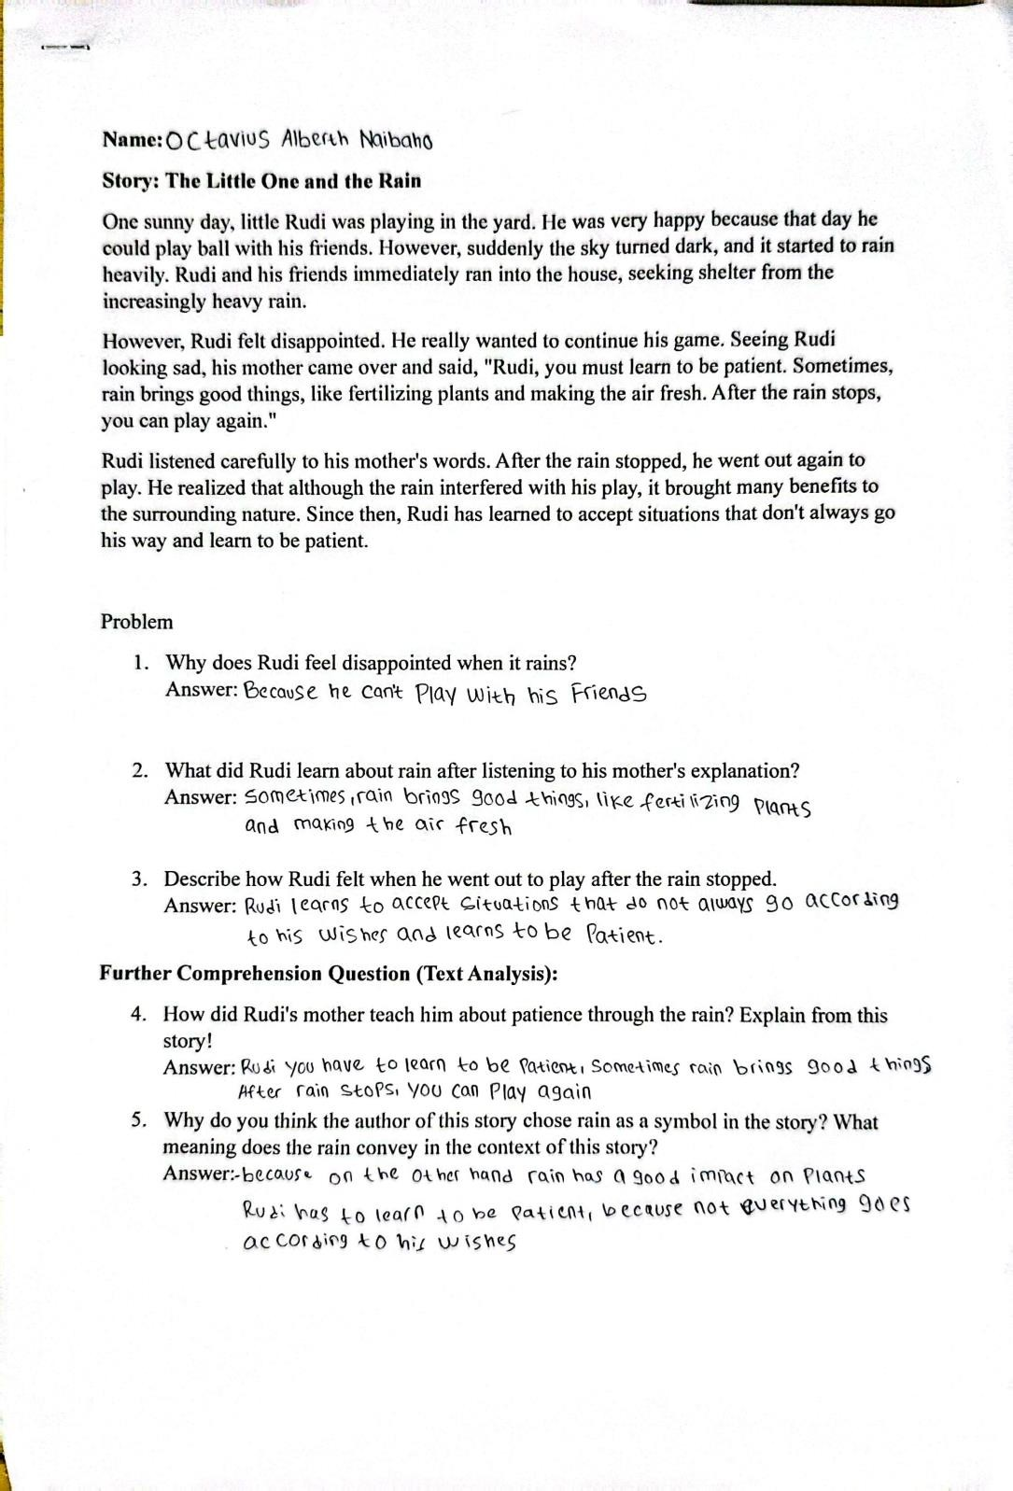

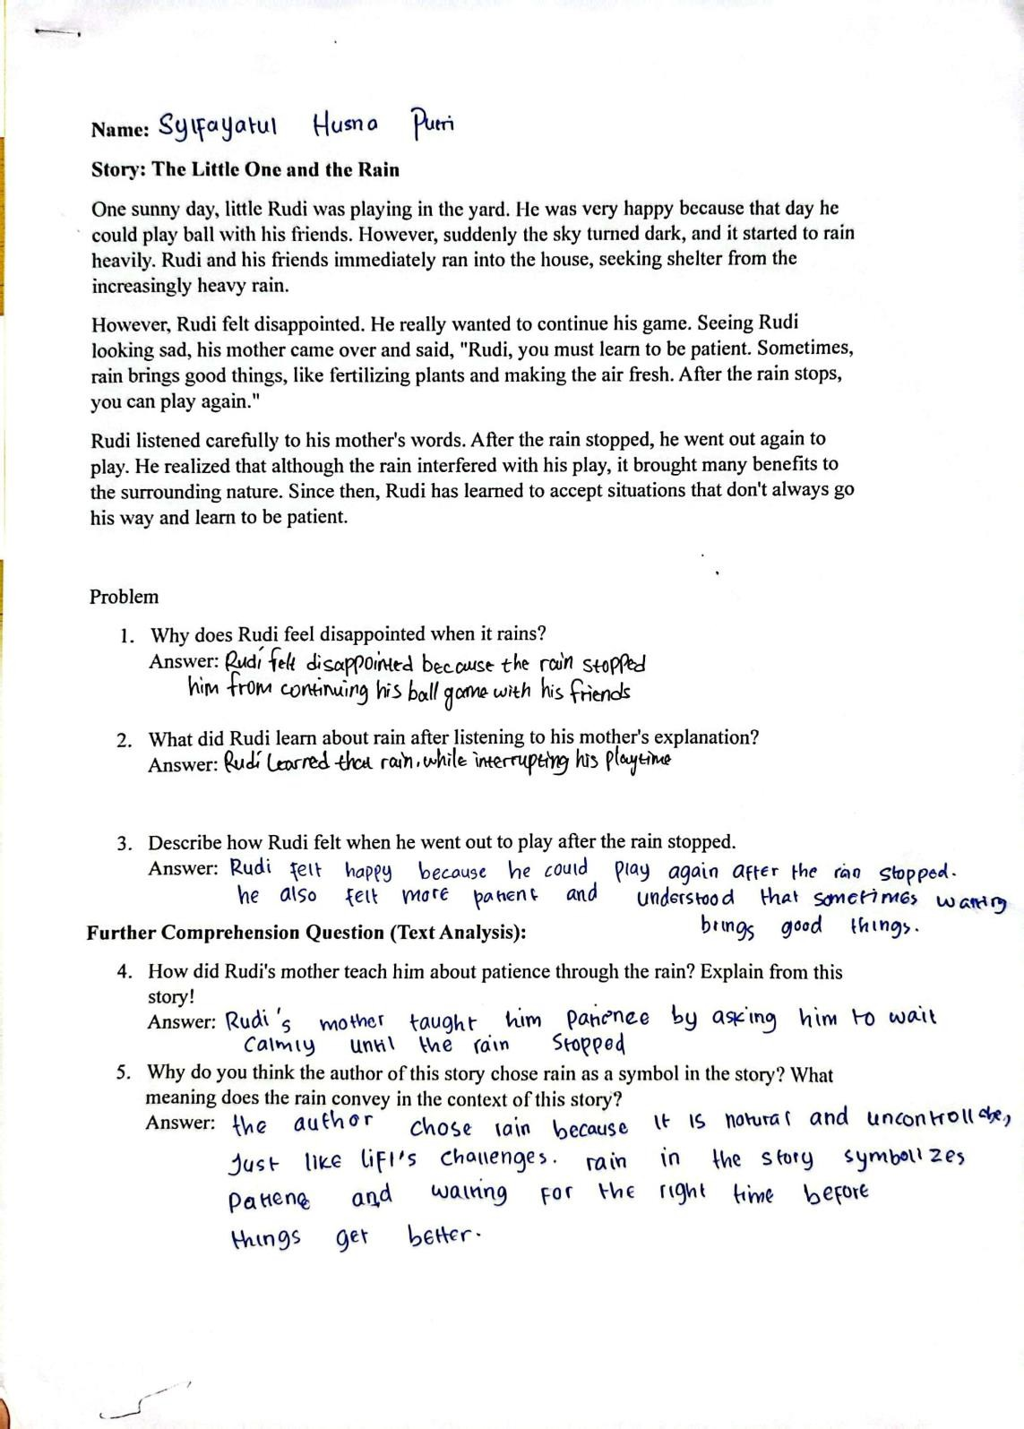

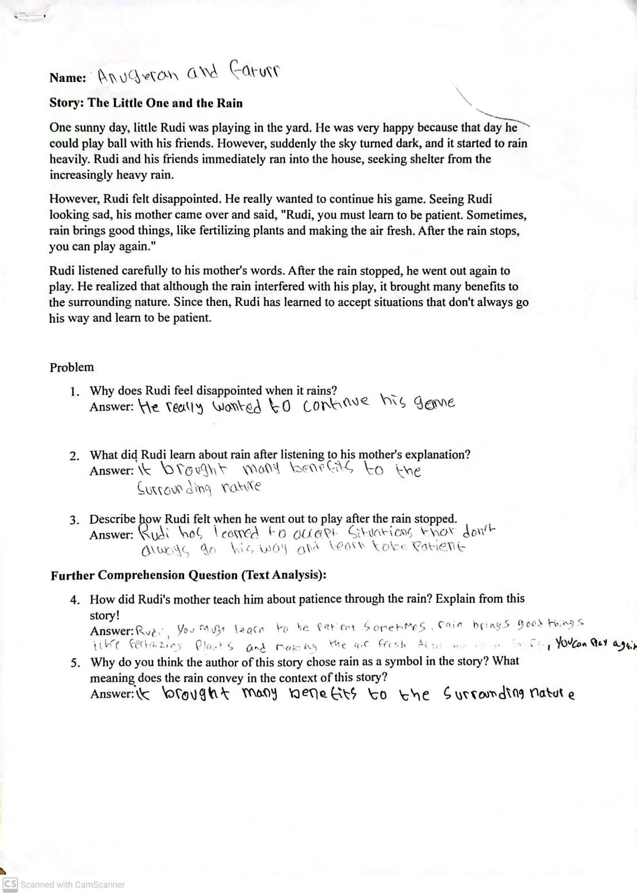

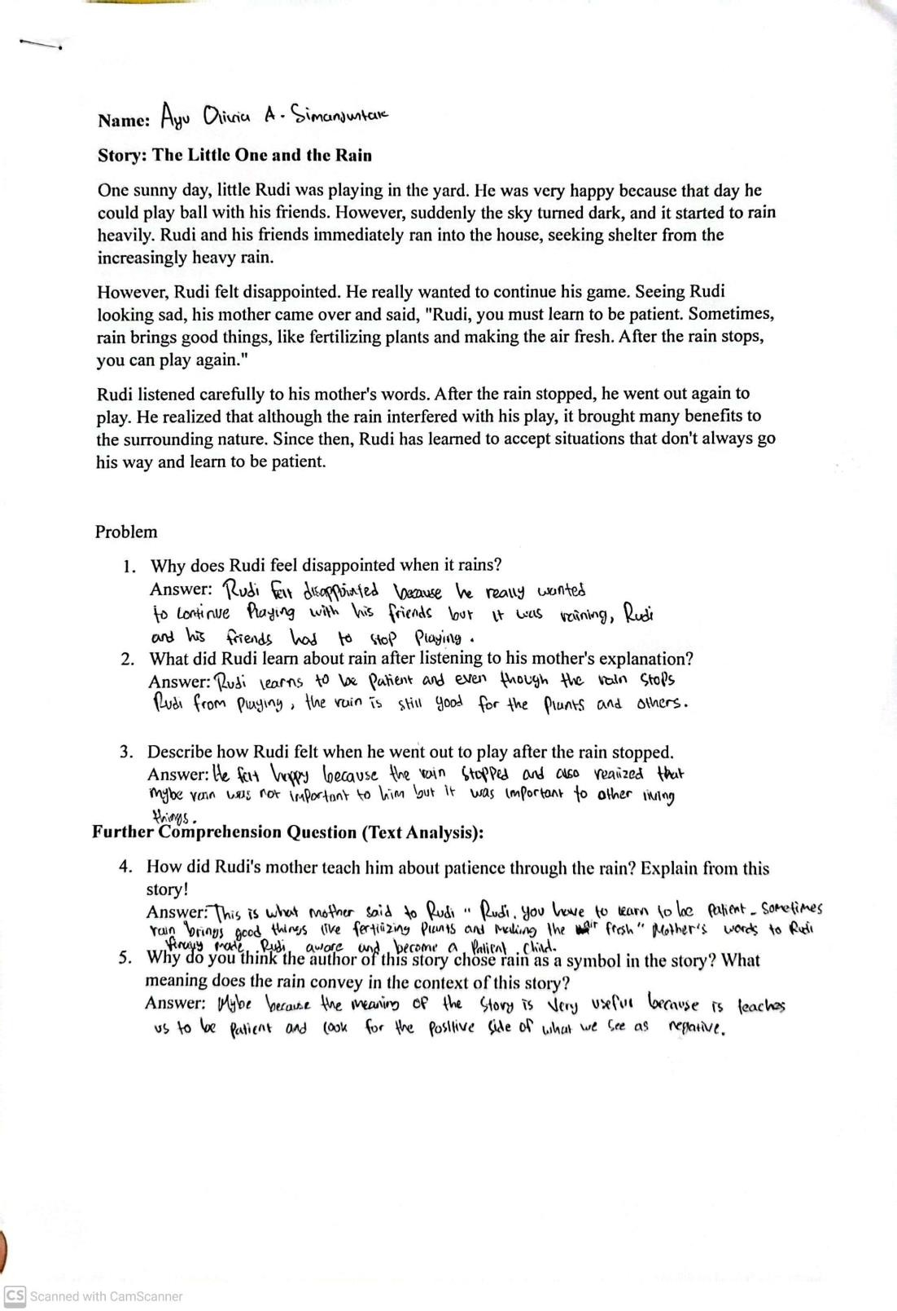

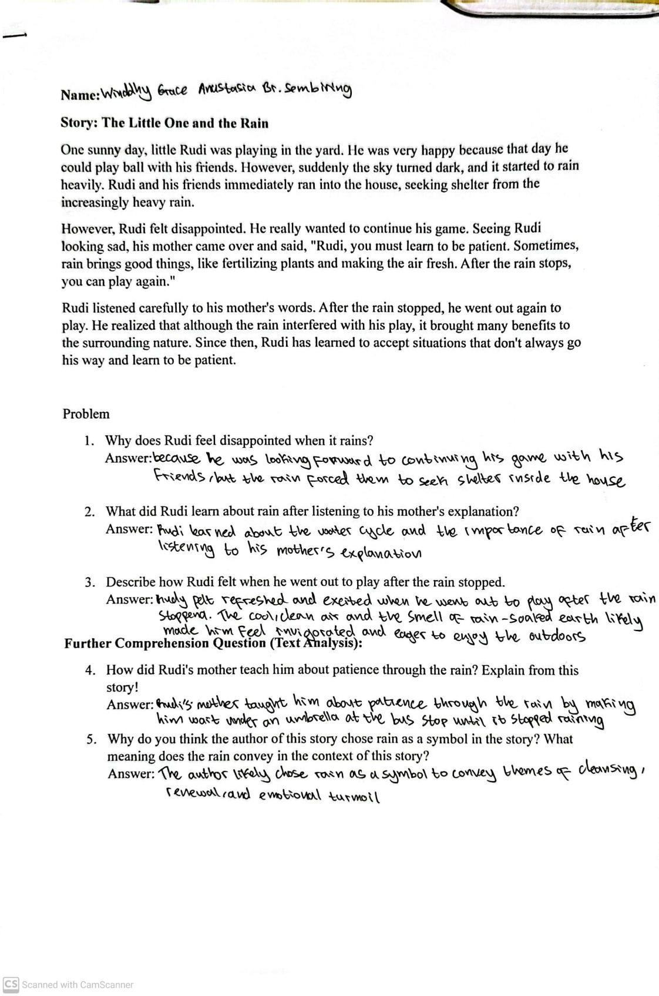

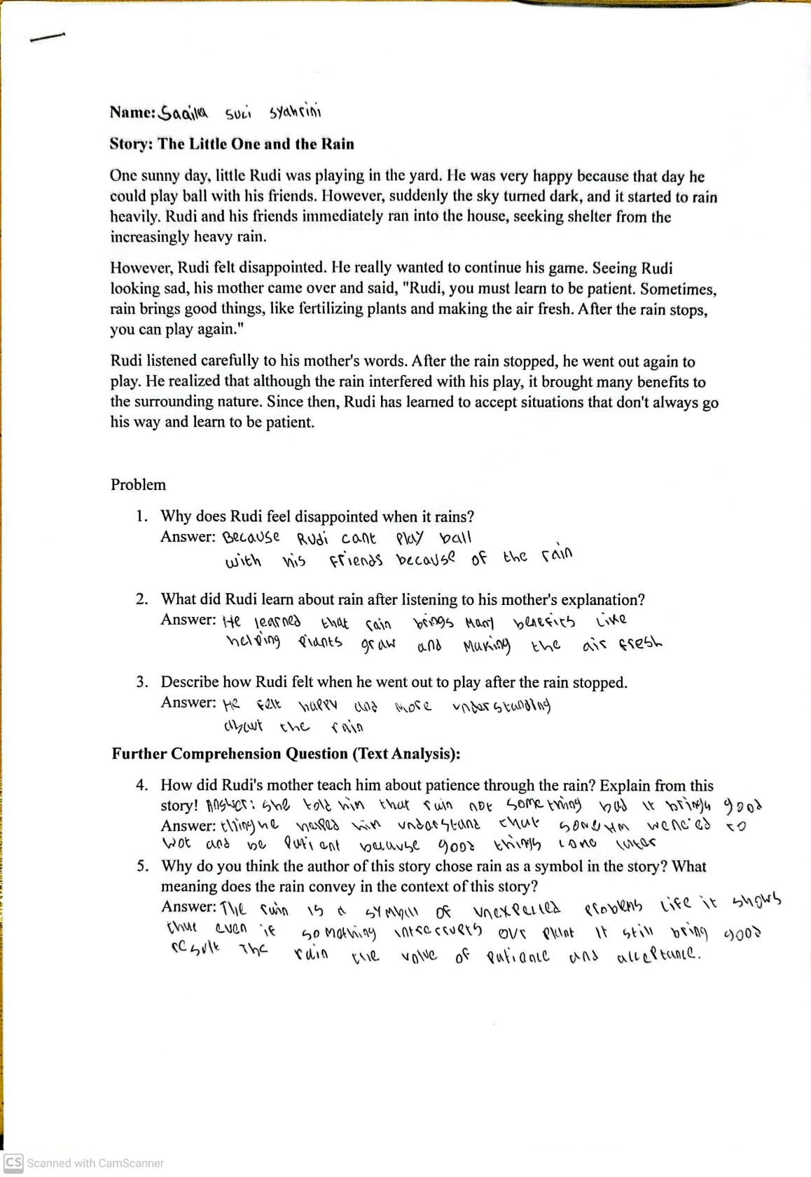

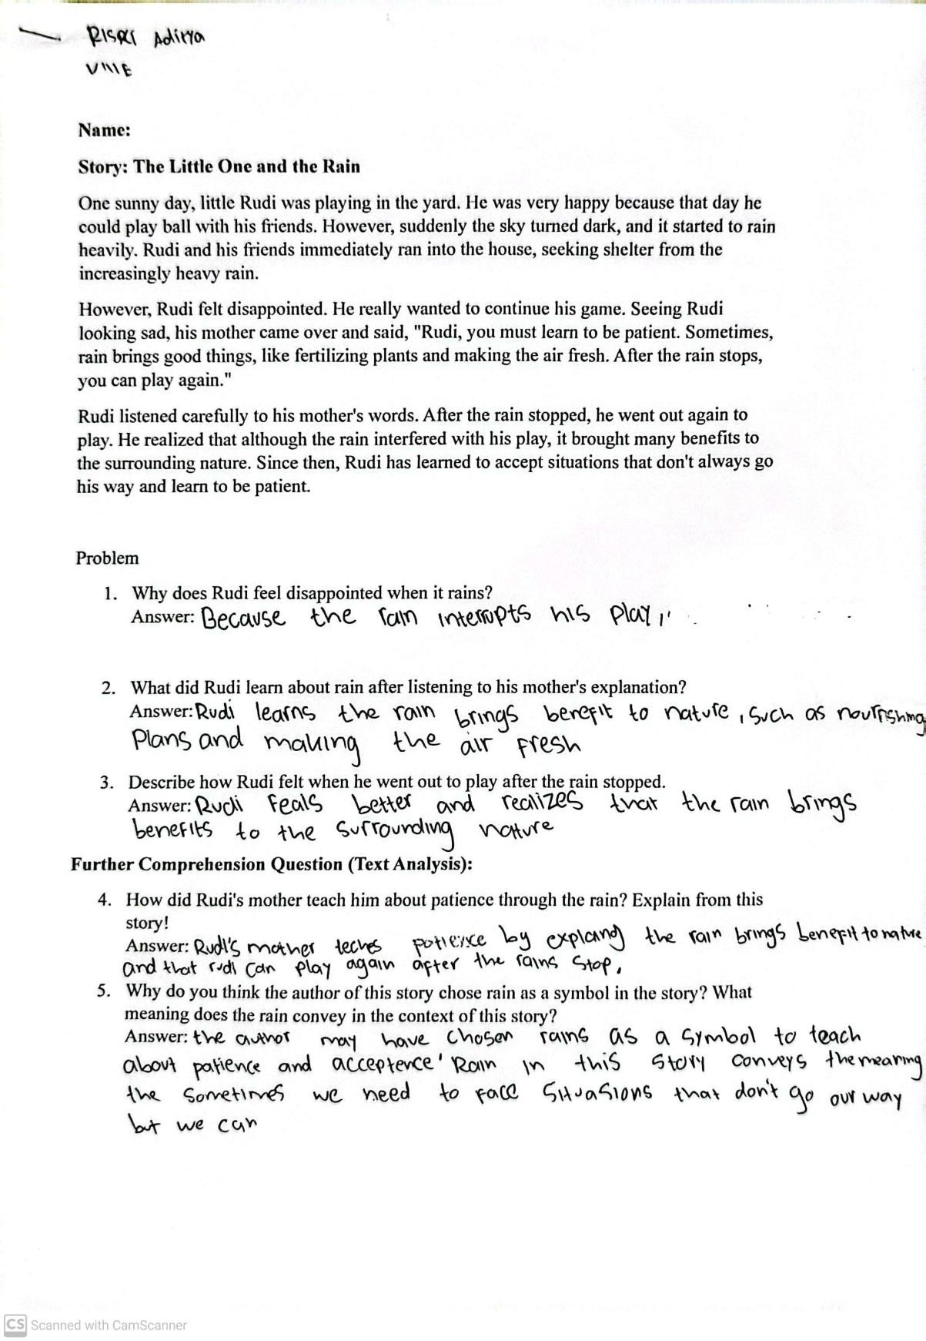

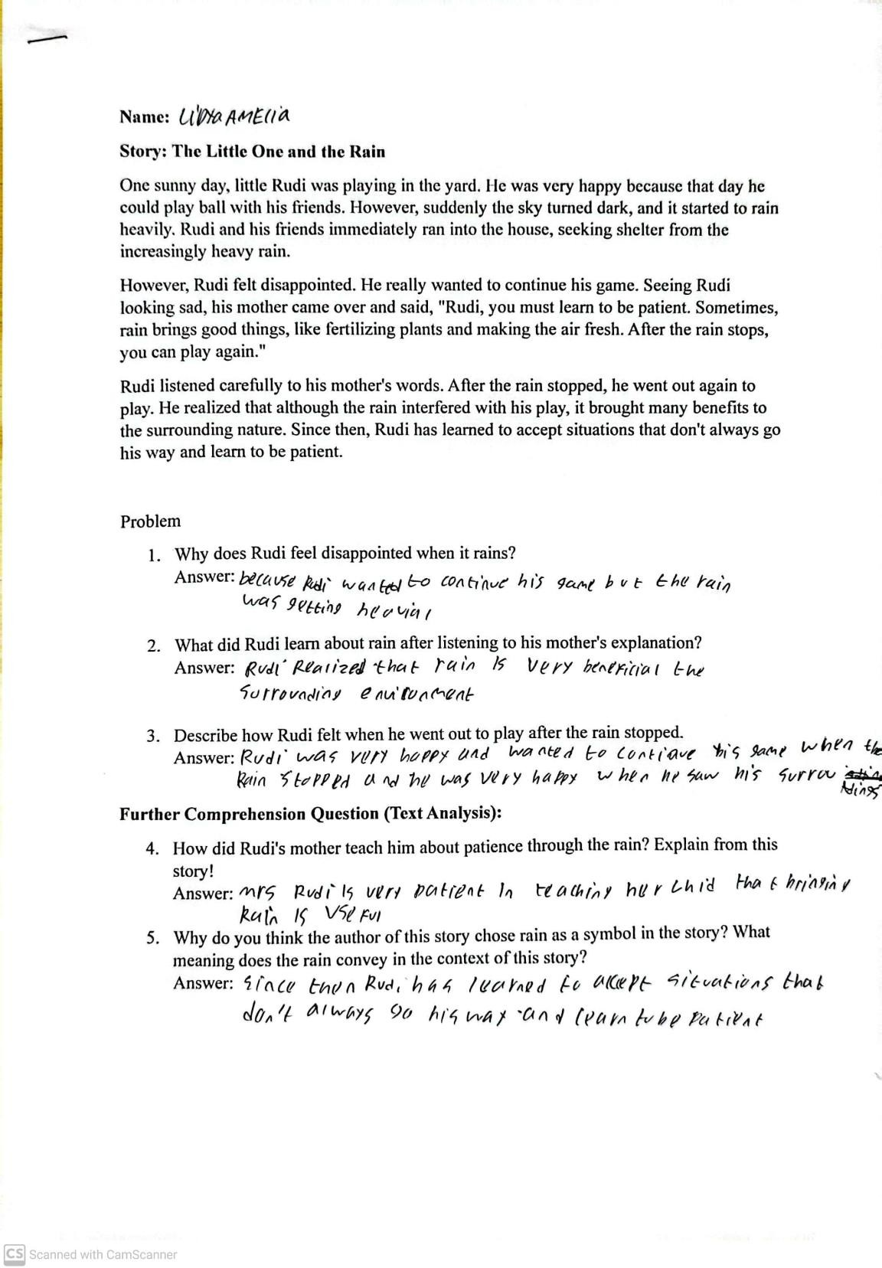

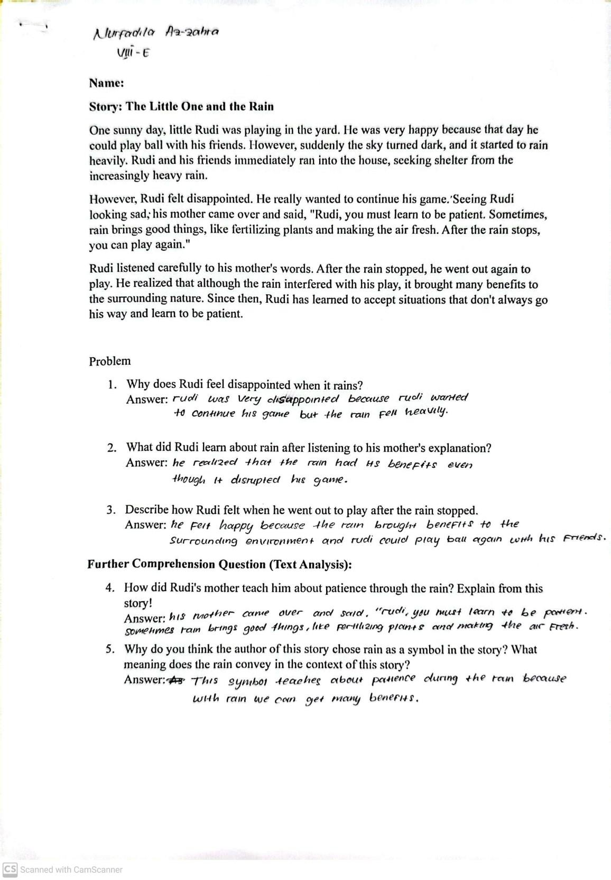

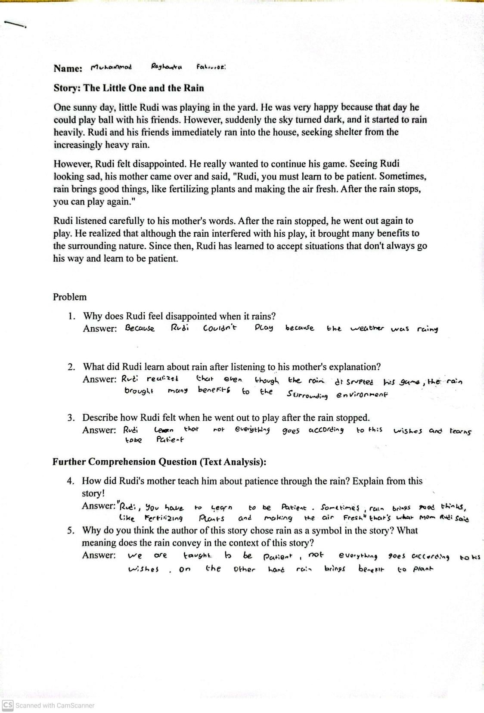

Appendix 3 Documentation
