REFERENCES

Afflerbach, P. (2016). "Understanding and using reading assessment, K-12."
International Reading Association.

Al Aziz, E. N., & Yusanti, G. (2020). “Increasing Students’reading Comprehension Skill By Using Written Text Book”. English Education: Journal of English Teaching and Research, 5(2), 179-186.

Alvord, M., & Brown, L. (2020). "Creating a Supportive Learning Environment for Literacy." Literacy Research and Instruction, 59(3), 238-253.

Aulia, S. S., & Untari, M. F. A. (2024). Analysis of Reading Comprehension Skills of Grade III Students through Problem based Learning (PBL) Model. Interdisciplinary Journal of Social Science and Education (IJSSE), 223-234

Baker, L., & Brown, A. L. (2016). "Metacognitive skills and reading comprehension." Educational Psychology Review, 28(1), 45-72.

Baumann, C. C., & Duffy-Hester, A. M. (2018). "Improving Classroom Literacy Practices." The Reading Teacher, 71(3), 289-297.

Cunningham, A. E., & Stanovich, K. E. (2020). The Effects of Experience on Reading Comprehension.

Gambrell, L. B., & Morrow, L. M. (2015). "Best practices in literacy instruction." Guilford Press.
Grabe, W., & Stoller, F. L. (2019). Teaching and Researching Reading (3rd Edition). Routledge.

Guthrie, J. T., & Wigfield, A. (2019). "Teaching for Engagement and Motivation in Reading." Educational Psychology Review, 31(1), 63-75.

Harmer, J. (2015). The Practice of English Language Teaching (5th Edition).
Pearson Education Limited.
Henry Aditia Rigianti & Fenita Situmorang (2024) - Pengaruh Program Literasi Bahasa Inggris Terhadap Keterampilan Berbahasa Inggris Pada Siswa Sekolah Dasar

Huang, J., & Lee, C. (2018). "Socioeconomic Status and Literacy Development." Journal of Educational Psychology, 110(5), 785-799.

Iriani, S. (2017). Strategi Guru dalam Meningkatkan Keterampilan Membaca Pemahaman pada Peserta Didik di Kelas IV Sekolah Dasar. Jurnal Pendidikan Dasar, 8(2), 91-98.

Kintsch, W. (2013). The Construction-Integration Model of Text Comprehension.
Cambridge University Press.

Koda, K. (2016). "Factors Contributing to Errors in Reading Comprehension Among ESL Students." Reading Research Quarterly, 51(2), 201-214

Lai, K. W., & Hwang, G. J. (2016). "Exploring the effectiveness of mobile technology for learning." Computers & Education, 94, 1-12.

McGee, L. M., & Richgels, D. J. (2016). "Literacy's Beginnings: Supporting Young Readers and Writers." Pearson.

Meliza, M., Suryani, S., & Suryadi, D. (2023). Strategi Guru dalam Meningkatkan Keterampilan Membaca Pemahaman pada Peserta Didik di Kelas IV Sekolah Dasar. Jurnal Didaktika, 23(1), 1-10

Nation, I. S. P., & Newton, J. (2009). Teaching ESL/EFL listening and speaking.
Routledge.

Oczkus, L. J. (2017). "Guided Reading: A Teacher's Guide." Teacher Created Materials.

Paris, S. G., & Paris, A. H. (2016). "Classroom assessment and the development of student self-regulation." Educational Psychologist, 51(4), 251-267.

Pressley, T. (2017). Public libraries, serious mental illness, and homelessness: A survey of public librarians. Public Library Quarterly, 36(1), 61-76.
Rahmah, A., & Kusumawardani, S. (2018). Penerapan Model Pembelajaran Kooperatif Terpadu (Membaca dan Menulis) dalam Meningkatkan Kemampuan Membaca Siswa. Jurnal Holistika, 10(2), 123-130.

Reardon, S. F., & Galindo, C. (2021). "The Relationship Between Early Reading Skills and Reading Comprehension in Elementary School." Reading and Writing Quarterly, 37(1), 59-77.

Rosen, L. D. (2019). The Impact of Technology on Reading Comprehension.
Educational Psychology Review, 31(2), 253-268.

Rupley, Blair & Nichols (2017) - Effective Reading Instruction and Literacy Development

Safitri, V., & Dafit, F. (2021). Peran guru dalam pembelajaran membaca dan menulis melalui gerakan literasi di sekolah dasar. Jurnal basicedu, 5(3), 1356-1364.

Sahmal, J. A., Sutaryo, S., Jusnita, N., & Dahlan, S. (2022). Studentsã¢ Â ‚¬ Â „¢ Reading Comprehension in Reading English Textbook. Jurnal Bilingual, 12(1), 57-62.

Saracho, O. N., & Spodek, B. (2013). "Handbook of research on the education of young children." Routledge.

Sarika, S. (2021). Pentingnya Memahami Sikap terhadap Membaca pada Siswa dalam Pembelajaran Bahasa. Jurnal Pendidikan dan Pembelajaran, 8(1), 1-10

Stahl, S. A., & Nagy, W. E. (2020). Teaching Word Meanings. Routledge.

Strickland, D. S., & Morrow, L. M. (2015). "Beginning Reading and Writing." International Reading Association.

Thornbury, S. (2017). Scott Thornbury's 30 language teaching methods Google EBook: Cambridge handbooks for language teachers. Cambridge University Press.

APPENDIX

Appendix 1 sample test

Story: The Little One and the Rain

One sunny day, little Rudi was playing in the yard. He was very happy because that day he could play ball with his friends. However, suddenly the sky turned dark, and it started to rain heavily. Rudi and his friends immediately ran into the house, seeking shelter from the increasingly heavy rain.
However, Rudi felt disappointed. He really wanted to continue his game. Seeing Rudi looking sad, his mother came over and said, "Rudi, you must learn to be patient. Sometimes, rain brings good things, like fertilizing plants and making the air fresh. After the rain stops, you can play again."
Rudi listened carefully to his mother's words. After the rain stopped, he went out again to play. He realized that although the rain interfered with his play, it brought many benefits to the surrounding nature. From then on, Rudi began to learn to accept situations that didn't always go his way and learned to be patient.

Test Questions:

- Why does Rudi feel disappointed when it rains?

- What did Rudi learn about rain after listening to his mother's explanation?

- Describe how Rudi felt when he went out to play after the rain stopped.

Further Comprehension Questions (Text Analysis):

- How did Rudi's mother teach him about patience through the rain? Explain from this story!

- Why do you think the author chose rain as a symbol in the story? What meaning does the rain convey in the context of this story?

Appendix 2 Students Worksheet
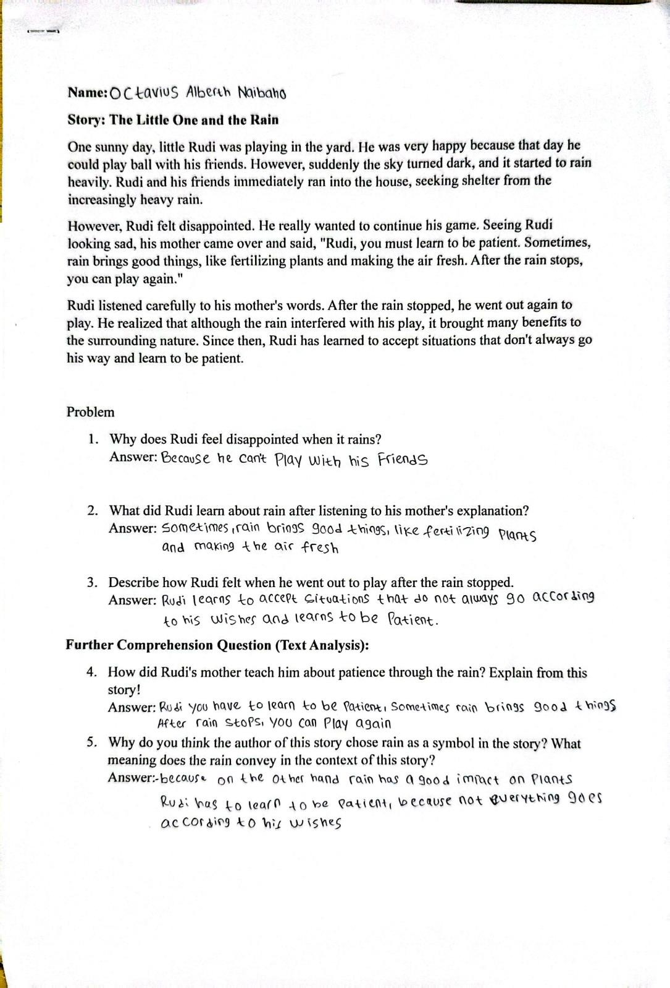

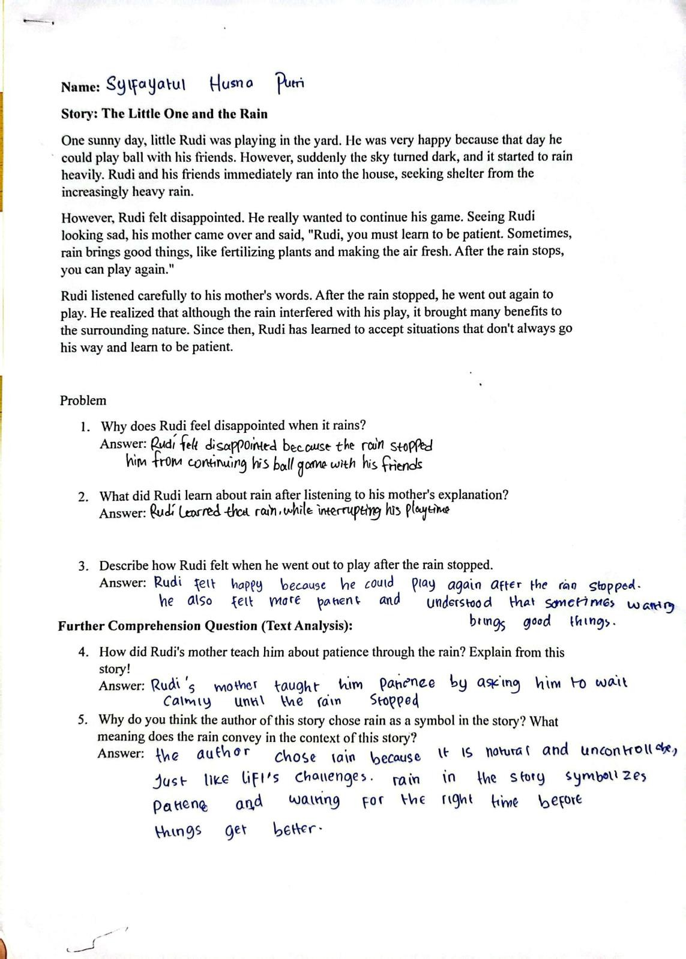

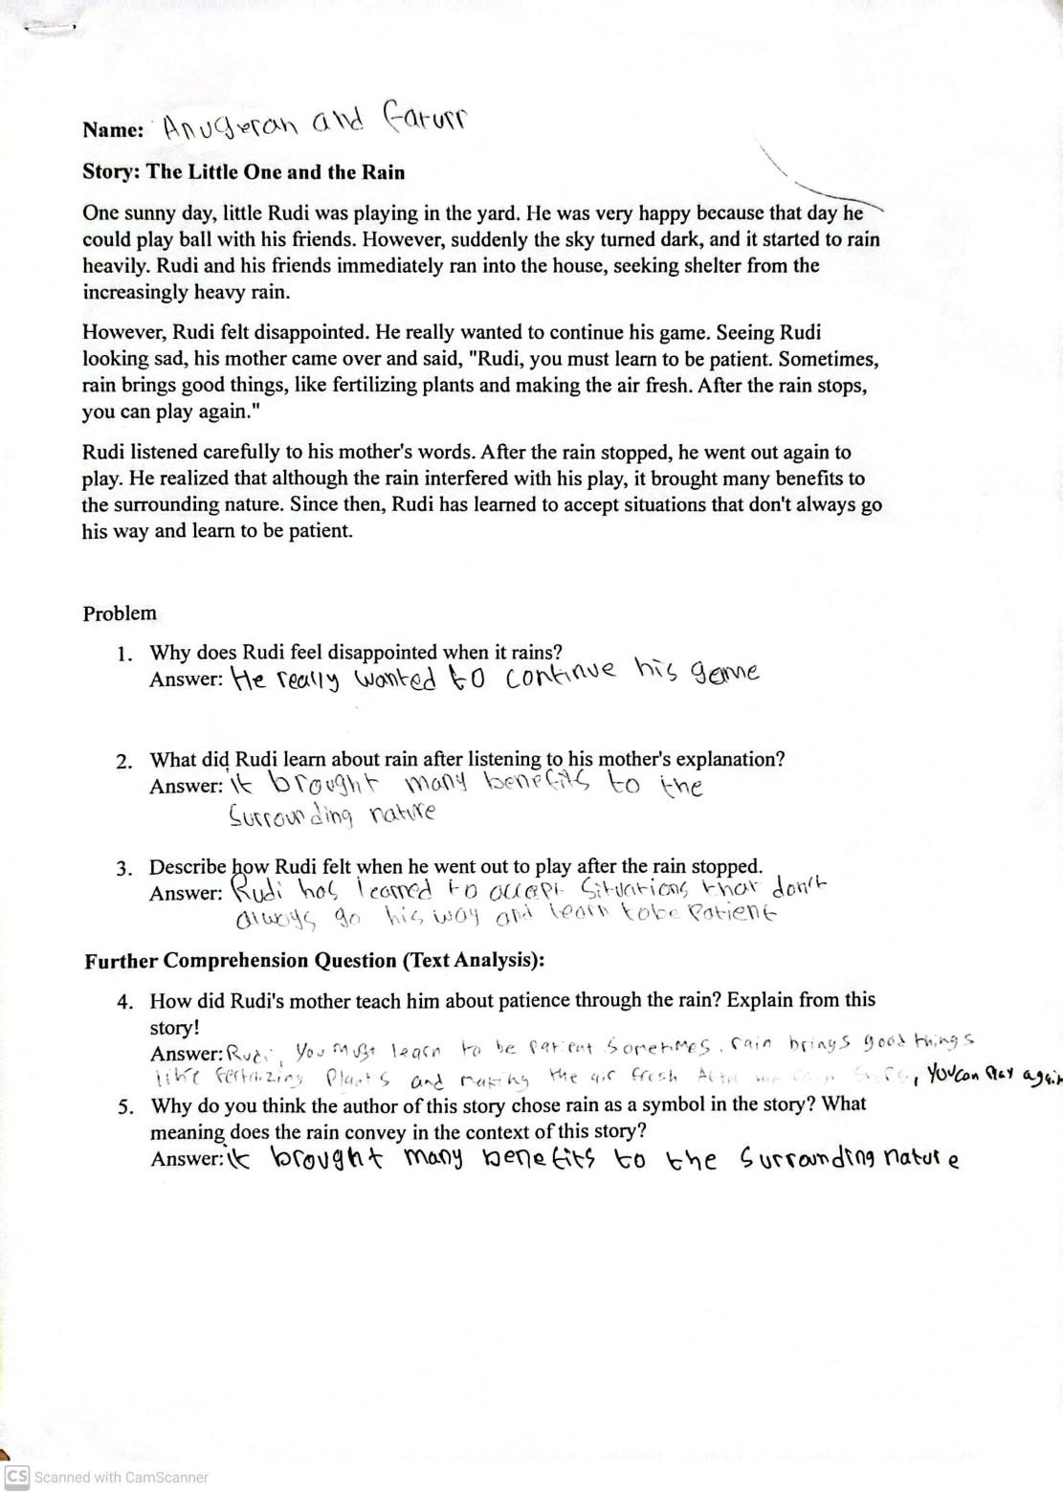

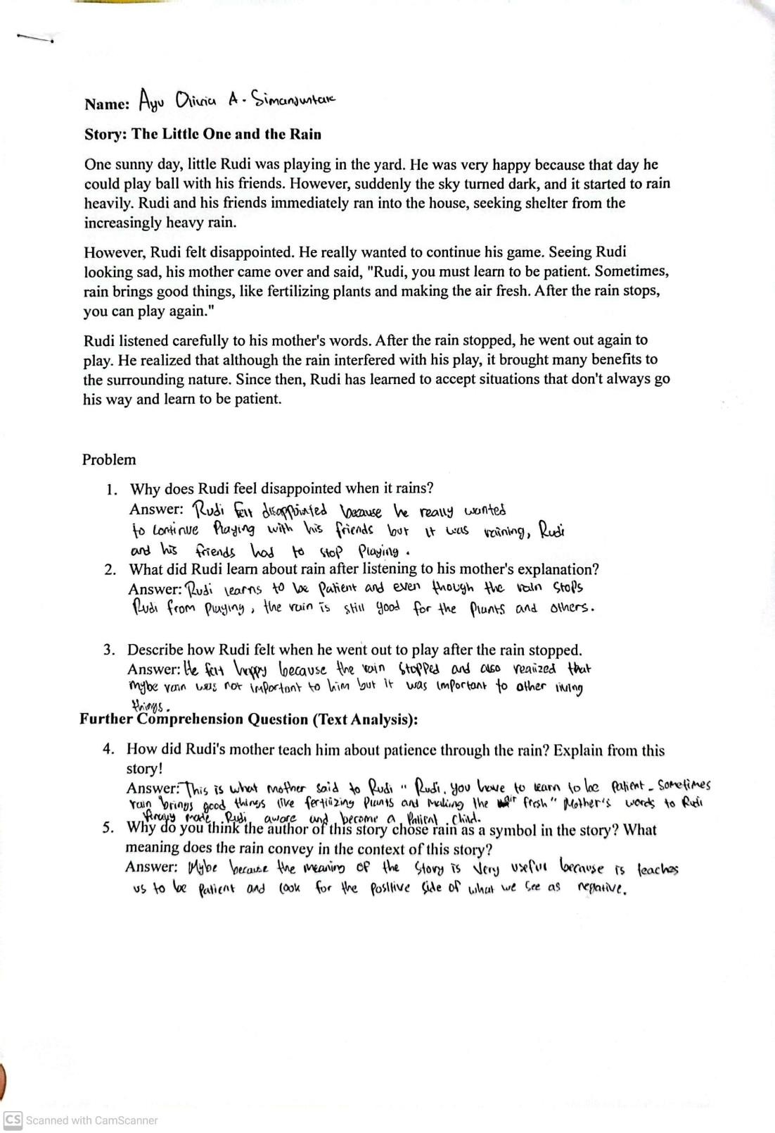

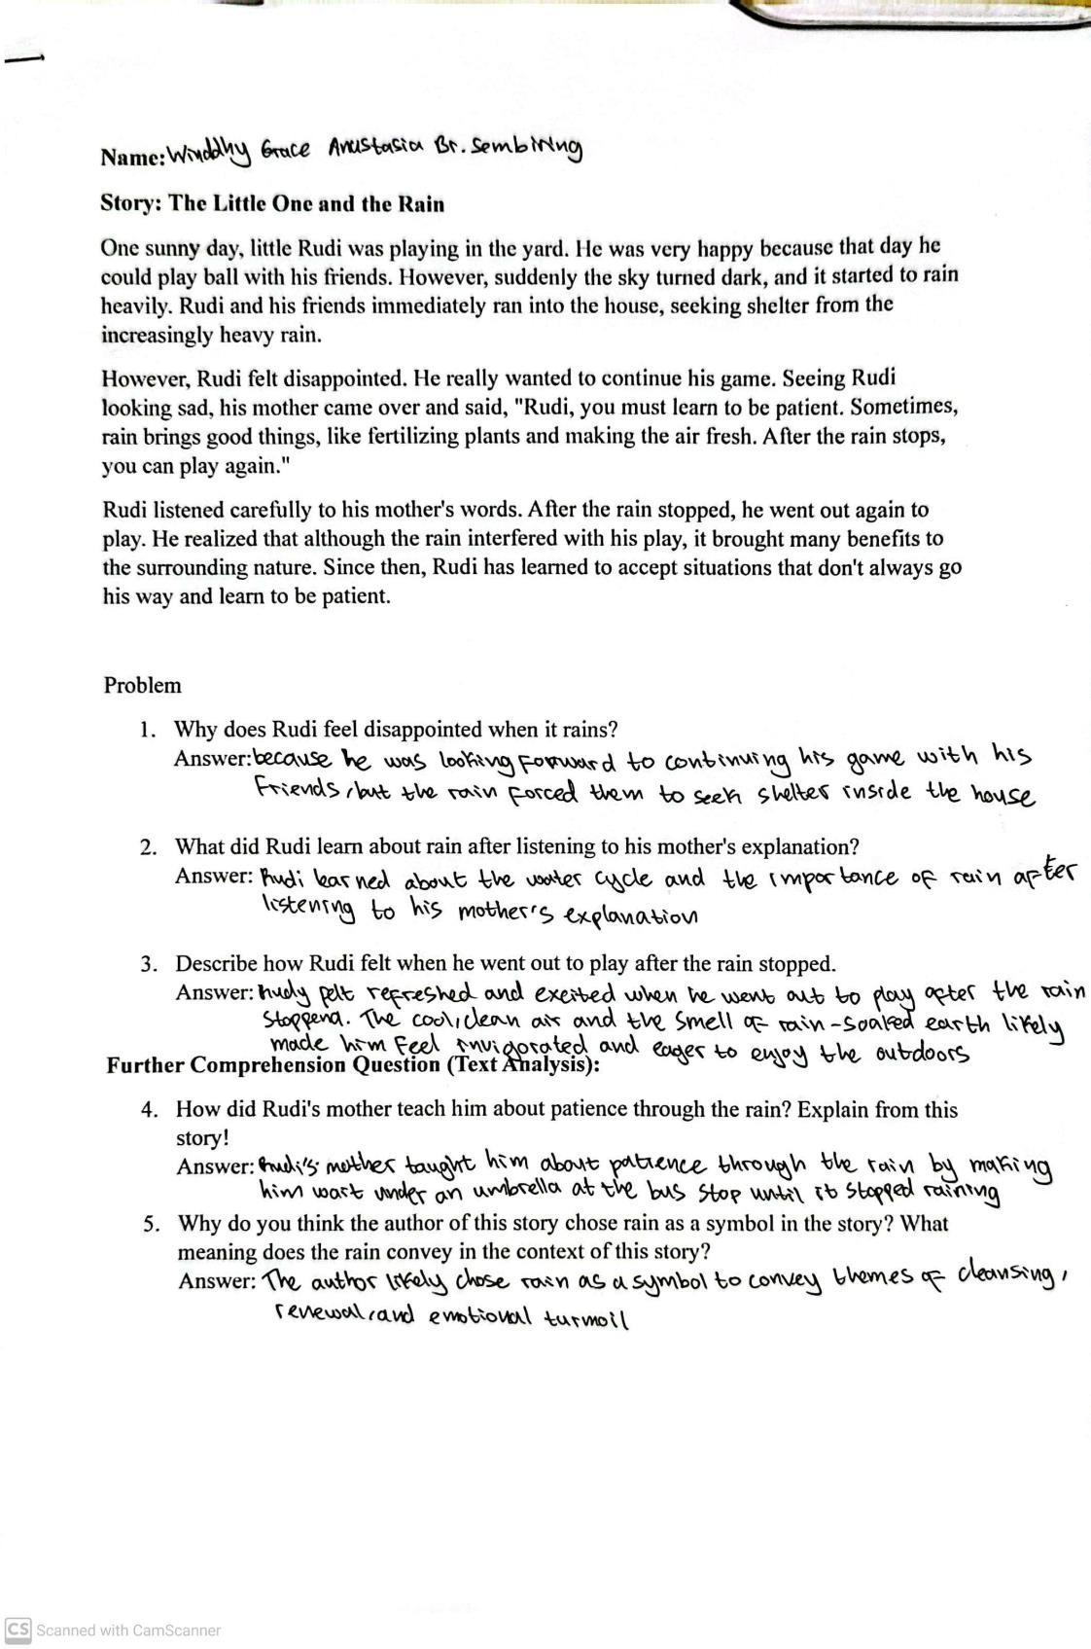

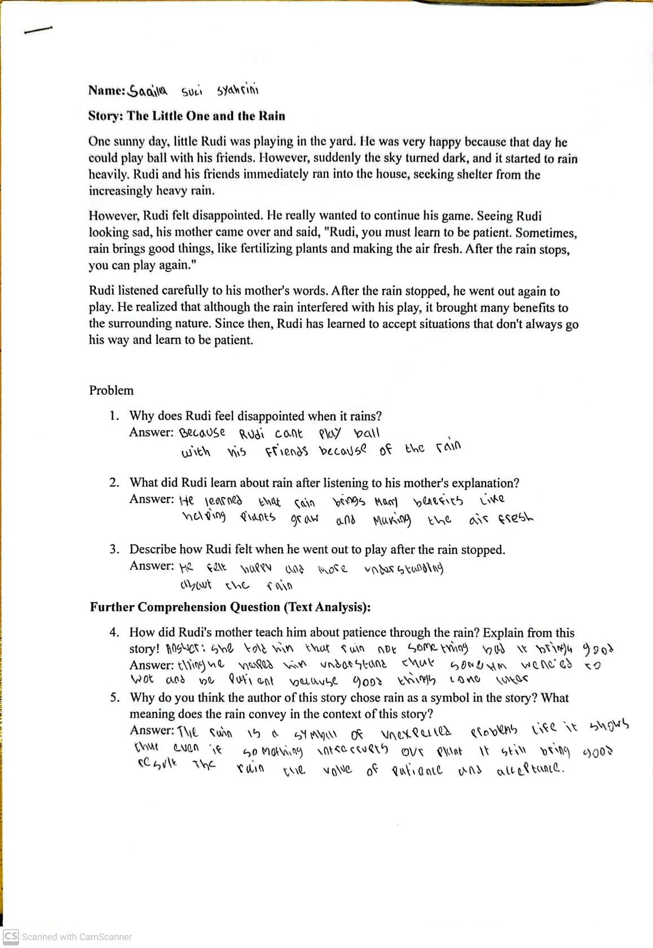

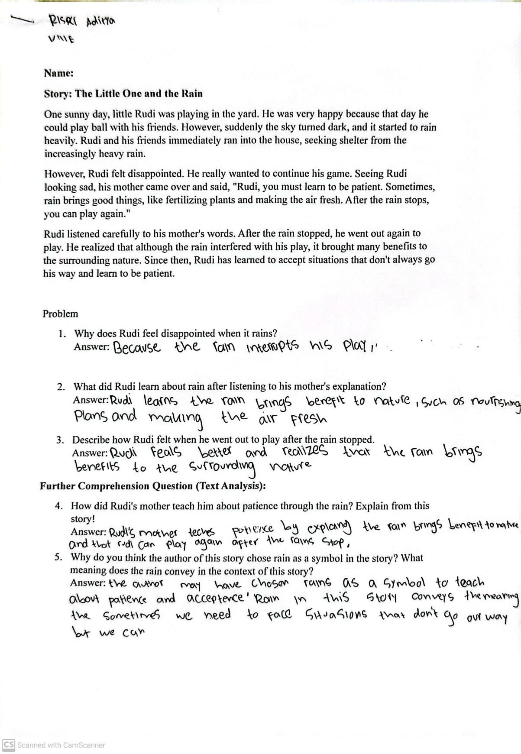

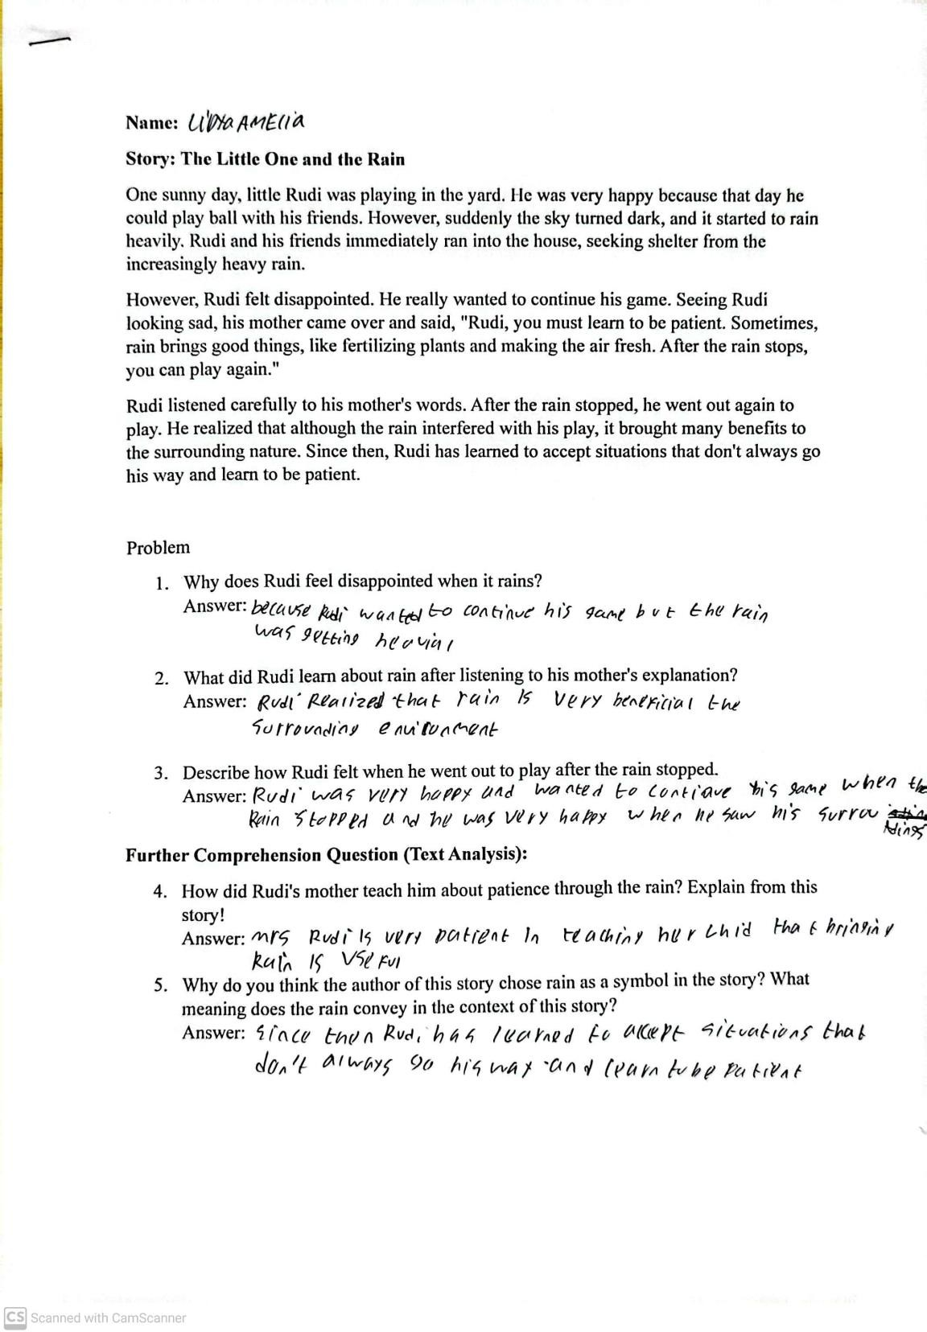

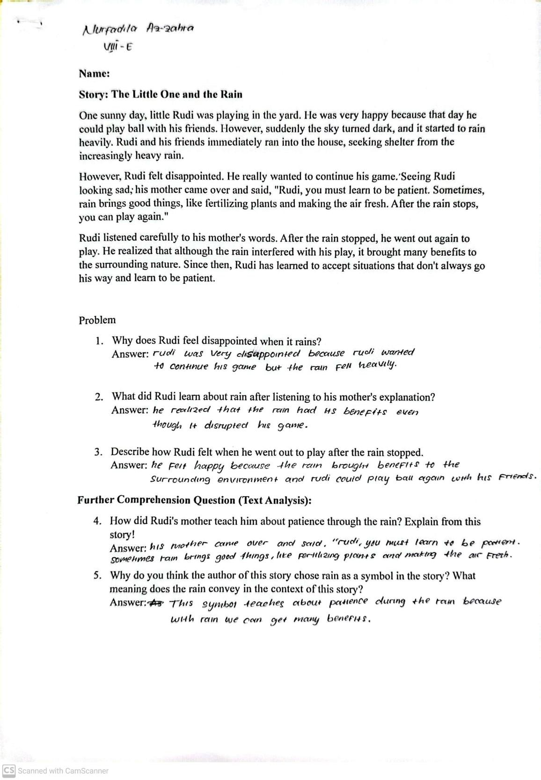

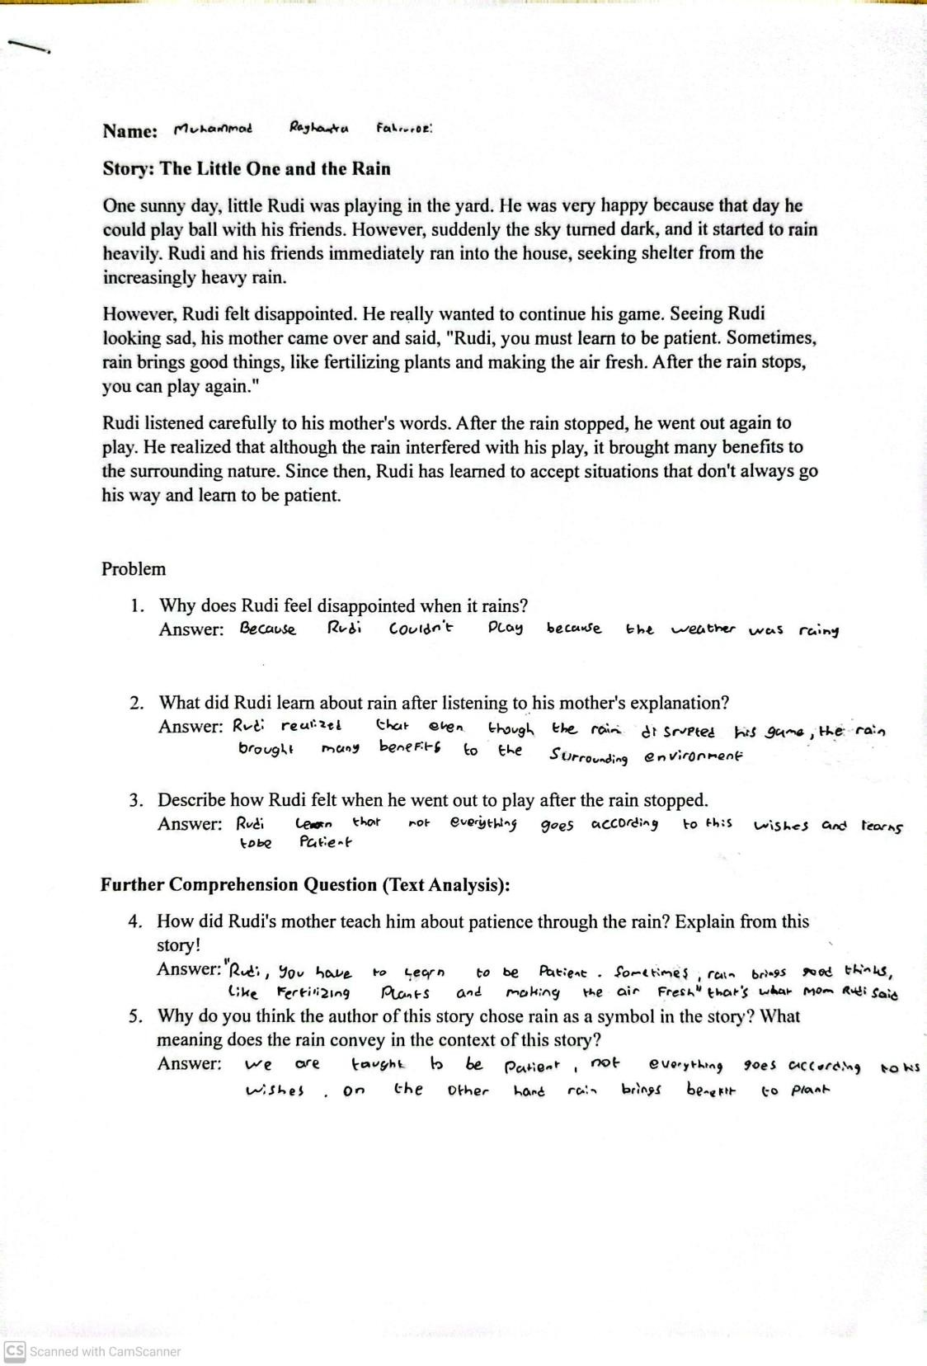

Appendix 3 Documentation
