CHAPTER II
REVIEW OF RELATED LITERATURE
  - General Concept of Writing
    - Definition of Writing
Writing is the most difficult skill for the English learner as the foreign language to master. The difficulties are the structure, Grammar, idea and many more. The skill in writing includes the copetence of punctuation and capitalization. From that, we know that wrting is one of important complex communication form.
Academic writing, as the name implies, is the kind of writing that you are required to do in college or university. It differs from other kinds of writing (personal, literary, journalistic, business, etc) in several ways. The difference can be explained in the part and the purpose Oshima (1991;2).
Oshima, Alice and Ann Hogue (1997;2) stated that it is a progressive activity. This means that when you first write something down, you have already been thinking about what you are going to say and how are you going to say it. Then after you have finished writing, you read over what you have written and make change and corrections. From the statement above, we know that writing is never a one-step action. Writing is a process that has several steps.
It is frequently useful as preparation for some other activities, in particular when students write sentences as a preamble to discussion activities. It also can be uses an integral part of a larger activity where the focus is on language practice, acting out, or speaking. Once again writing is used to help students perform a different kind of activity (in his case speaking and listening. Students need to be able to write to do these activities, but the activities do not teach students. Teaching writing is more than just deadling with matters of handwriting, orthography (the spelling system), and punction, it is about helping students to communicate real message in appropriate mannar. Harmer (2004;34).
Elbow in Brown (2001;336) staed that writing is two- step process in which the writer figures out the meaning firstly, then he put it into language. Writing is consisting of two steps processing and producing. It is processing idea, information into graphic symbols which have to be arranged according to certain conversation to for, meaningful words, sentence, ect.

    - Process of Writing
The process of writing is virtually the same for all writers. Writer gets their ideas from many different sources. Outeykhuon (2006:12) says writing is not easy since it needs a long process to produce a good result in writing. Harmer (2004:4), states that there are four main elements in the writing process, namely planning, drafting, editing, and final revision.
      - Planning
Planning means what the writers are going to write. When planning there are three main issues that should be considered, namely the purpose, the audience, and the content. In case of writing report, the students’ firstly should be able to determine the title, general classification, and description.
      - Drafting
Draft is a first version of piece of writing. This first “go” a text is often done on the assumption that it will be revised later. Here, the students’ begin to construct several paragraphs which contain the title, general statement, and description.
      - Editing
After producing a draft, the students’ read what they have written to see whether it works and where it does not. In this process, the students’ can check the using of verbs, pronouns, and conjuctions in their writing. They can also delete or add some information to complete their writing.
- Final revision
Once the students’ have edited their draft and made changes they consider to be necessary, they produce the final revision.

    - The Purpose of Writing
The specific explanation about the purpose of writing is proposed by McMahan et al (1996;8) stated that written language is used for these following purposes:
- To express the writer’s feeling.
- To entertain the readers through aesthetical materials.
- To persuade the readers about the writer’s opinions, concept, and idea.
There are some writing goals defined by Hampton(1989; 98)
- Writers are independent when they are able to write without much assistance.
- Writers gain comprehensibility when they can write, so that it can be read and understood by themselves and other.
- Writers are fluent when they are able to write smoothly and easily as well as understandably.
- Writers gain creativity when they can write their own ideas, not copying what has already been written.

2.1.4 Benefits of Writing
Scott and Yteberg (1990: 69) mentioned some benefits of writing. Firstly, they state that writing helps to consolidate learning in the other skill areas. For instance, reading helps students to see the ‘rules‘ of writing, and helps build up their language choices. Secondly, they also adds that writing is essentially valuable in itself. There is an extraordinary feeling about seeing one‘s own work in print, and great satisfaction in having written something which he/she want to say. Thirdly, writing is one of the most active ways that we can engage in and with the world. Scott and Yteberg further state, “Writing is an exciting and rewarding activity and is the most visible of the skills”. It is ultimately responsible for nearly all of the man-created aspects of our rapidly changing world. Lastly, writing can improve understanding of an event, also ‘involvement‘ and ‘engagement‘ with the event. It provides the most opportunity for ‘affecting‘ the event. In other words, as compared to other skills, only writing provides ‘all at the same time’ : understanding, involvement and the power to affect experience and events. Based on the benefits of writing elaborated previously, it can be concluded that writing mainly improves one‘s own learning because it records his/her development which at a later stage can be useful for an evaluation of the learning. It can also gain the learners‘ understanding both of themselves or events that happen around them. At last, writing can improve the learners‘ communication, particularly in the written form.

2.1.5 Teaching Writing.
a) The Role of the Teacher
Teachers have significant roles in the process of teaching and learning. It isalso needed in the process of writing. According to Harmer (2007: 330), there arethree roles of English teachers in teaching writing.
1) Motivator
As a motivator, an English teacher has to be able to motivate the students inwriting tasks by creating the right situation for generating the ideas,persuading them of the usefulness of the activity, and encouraging them tomake as much as effort as possible for maximum benefit.

2) Resource
The teacher needs to be ready to provide information and language wherenecessary to the students. He or she must be available and well prepared tolook at the students’ progresses, offer advice and suggestions in aconstructive and tactful way.
3) Feedback provider
As a feedback provider, an English teacher should give positive andencouraging responses to the students’ writing. When offering correction, theteacher should choose what and how much to focus on based on what thestudents need at this particular stage of their studies, and on the tasks theyhave undertaken.It can be inferred that helping students become self-sufficient, competent, andconfident writers is not an easy task, but it is easier to accomplish by recognizingthe key roles as a teacher in the teaching and learning process. The three importantroles are the key point of the teachers to succeed the teaching process especially inteaching writing. The success of teaching writing then depends on how theteachers can play their three functions effectively. Therefore, it is very worthconsidering for the teachers to combine these significances when they areteaching.
b) Types of Classroom Writing Performance
There are many types of writing performances in the classroom. Brown(2001:343) divides a written performance into five kinds. The writingperformances are as follows.
1) Imitative or writing down
Students can attain fundamental skills in writing process through a simple, task. This basic task of writing letters, words, punctuation, and briefsentences can be done when they are producing a text. The activity that maybe involved in this type of writing performances is that the students simplywrite down a written product on their own. They imitate the written productas a form of task to go over their basic skills in writing.
2) Intensive or controlled
It is a kind of performances in which students must produce propervocabulary in a certain context, collocations and idioms, and correctgrammatical features in the sentences. Although their creativity is not allowedmuch, the students working on this type of performance can do anothers simulating creative activity by rewriting the paragraph of their recollection ofreading.
3) Self-writing
This category gets the students to write the things on their own mind. Kindsof activities of this category are note-taking, diary, and journal writing.
4) Display writing
Display writing is very useful for academic purposes. Written exercises, shortanswer essays and other forms of writing in test situations are instances ofdisplay writing. They are kinds of activities when students are asked to writefor the sake of their teacher's assignment or fulfilling their duty in the class.
5) Real writing
Real writing is one of writing performances in which the reader does notknow the answer and genuinely wants the information from the writer. Forexample, writing letters, filling a form and writing a simple message allbelong to real writing.Every beginner writer starts to write from the basic activity such as theimitative writing. This kind of activity gets the students to make letters, words,and simple sentences. The next level of writing is intensive or controlled writing.This activity focuses on grammar, vocabulary, or sentence formation, and notnecessarily to convey meaning. The activity in the next stages is more complexbecause it allows students to produce their written products in the form ofparagraphs or texts of several pages which require better skills than the previousones.
c) Feedback
According to Nation (2009: 115) feedback is an important way oftenstudents to keep their goals in mind. It means that it is important toprovide them with feedback about the eﬀectiveness of their writing so that the students can carry on the idea of their writing. Feedback is widely seen as crucialfor encouraging and consolidating learning and it is also regarded as an essential factor in the writing context. Therefore, it is used as a way to respond to students’writing to help them enhance their writing skills.

1) Feedback on written work
Harmer (2007: 148) states that there are techniques used in giving feedbackon students’ writing.- Respondingresponding to students’ works can be considered as one of giving feedbackon their writing. The response on the students’ works can be used as means offeedback which motivates them when it is done constructively. The feedbackgiven can be seen as responding to students work rather than assessing orevaluating what they have done. It can further stabilize their confidence andmotivation. Feedback on written work does not only come from teachers. The teachers can also encourage students to give feedback to each other. It has positive effect on group cohesion. Muncie, as it is cited by Harmer (2007: 150) states that students are much more likely to be provoked into thinking about what they are writing if the feedback comes from one of their peers. Thus, whenresponding to students work in the drafting stage, peer feedback is potentiallyextremely valuable.The techniques above are required togive students reflection on the progress of their writings. Responding students writing, as the first form of feedback, maycause a positive attitude of students toward their works. It is done constructivelyto create students’ motivation in which it can arouse their interest to keepimproving their writing skills. The next is coding. It shows the students all errorsthey have done, so the correction given can be used by the students to make abetter result on the next writing activity. The last one is involving students. Thistechnique can be very valuable because it gives positive effects among theirworks. Students who accept feedback from peers tend to have a bigger chance tomake self-correction. Therefore, the more the teachers encourage students to beinvolved in giving feedback to each other, or to evaluate their works, the betterthey are be able to develop as successful writers.
2) Source of feedback.
Students can be encouraged to edit their works through the feedback that they get from their classmates, teacher and other readers.
- Teacher feedback
Teacher written feedback is regarded as the most practical and commonestform of response to student writing. In the EFL writing class, teacherfeedback is often employed. As it is stated earlier, one of teachers’ roles inteaching writing is as a feedback provider. Here teachers’ job is to givecomments and responses toward students’ writing.Peer feedback, also referred to as peer response, peer editing and peer review,is another type of feedback. It can force students to develop their thinking andhelp them enhance their skills in responding and commenting on others’works. Through peer review, students can get valuable opportunities toimprove their reading and writing ability as they discuss some aspects such aswriting contents, organizational patterns, grammatical structures and
b) appropriate word choices.
Self-feedback encourages students to look critically and analytically at theirwritings and helps improve their learning autonomy. It means that thestudents write marginal annotations about problems in their evolvingcompositions, to which the teacher responds. Here, students are asked tomake notes on their text with any uncertainties they have during the writing
c) process.
In conclusion, feedback of students’ writing comes from different sources. Itcan be from the teachers, peers, and the students themselves. Feedback given bythe teachers is a common one because teachers have a role in commenting andresponding to their works. The next feedback comes from their peer. It generallyoccurs when they are doing collaborative writing which requires students’involvement in a writing process. The last one comes from the studentsthemselves. They create their autonomy to make self-correction of their writings.These feedback sources may generate the students’ positive attitude toward theirworks and help them to improve their skills on writing.
d) Approaches to teaching writing
There are numbers of different approach to the practice of writing skills.According to Harmer (2007: 325), teachers need to choose what aspect that thestudents have to focus on. It means that the teachers must decide whether theywant the students to be creative on their writings either individually or
e) cooperatively.
1) Creative writing
The term creative writing suggests imaginative tasks such as writing poetry,stories, and play. In the line with this, Gaffield-Vile in Harmer (2007: 328)defines creative writing as a journey of self-discovery that promotes effectivelearning. The activities include students write a simple poem about someone theycare about, they try to construct a narrative, tell stories of their childhood, forexample, they are tapping into their own experiences. This provides motivation tofind out the right words to express such experiences.
2) Collaborative writing
Collaborative writing is a technique which involves students to workcooperatively with their peer. Through sharing information with their peers,writing turns into a social activity and real communication. When students havebeen provided a peer rather than a task by their teacher, writing can becomeenjoyable and practical. Meanwhile, getting immediate feedback from the peersgives a good reason to go on students’ writing. There are many advantages tohaving students write cooperatively. At the drafting stage, multiple perspectiveshelp students explore the topic more extensively. Students working together withpeers often create higher quality drafts with a tighter focus on the topic. Theimmediate response provided by their partner during the composing stage helpsstudents develop their ideas in a coherent way. The further explanation aboutcollaborative writing will be discussed in the next part.
2.1.6 Teaching Writing in Junior High School
Teaching writing for students of junior high school is one of the importantthings that has to be done well. It is because English is one of the compulsorysubjects that has to be taught for students of junior high school level. Englishlearning in Junior High school is aimed at making the students gain the functionallevel that is to communicate written and orally in solving daily problems. Onescope of English learning at junior high school is that students can understand andproduce a short functional text and short essay in the form of procedure,descriptive, narrative and greeting card. These three genres are taughtin the second year of junior high schools. Especially for recount texts, it isincluded in the standard of competences of writing skills both in the first andsecond semester. It means that recount texts have more weight of attention to betaught in junior high schools.
1) Collaborative Writing
a) Definition
Collaborative writing goes beyond the theory of social development byVgotsky (1978: 108). The theory helps to explain the potential of collaborativewriting when it is applied in the teaching learning process. Learning process is asocial activity and is thus enhanced through social interactions. Through theirsocial contacts, students learn new ideas and processes that stimulate their.
- development.
According to Graham and Perin (2007: 4) collaborative writing is a techniquewhere students work together to plan, draft, reflect, and revise their compositions.It needs students’ involvement when they are working as a team. It also allowsstudents to learn from each other. It values the social nature of the writing process.It is in line with Harmer (2004: 12) who says that collaborative writing is a way planning, drafting, reflection, and revision by having students involved together in writing.
- process of writing.
Writing is generallyregarded as an independent project, it is, in fact, a social endeavour. It is becausethe activities involved in the writing process are done by more than one authorand require effective communication between members of the writing group.Dale (1997: 11) also suggests that collaborative writing involves meaningfulinteraction and shared decision between group members in the writing of a shareddocument. It seems that collaborative writing can ease students’ writing processby providing suitable environment while they are working together with theirpartners. From definitions above it can be concluded that collaborative writing is asocial process that encourages students because it involves students’ socialinteraction when they work together in a group.
- Organizing Collaborative Writing
When teachers try to put collaborative writing as a technique in teachingwriting to students, it is better to consider how to organize the students intogroups and the writing activities. The students need some more direction to gowith the activities and the teachers as a facilitator will provide it. According toDale (1997: 46) there are five points to be taken into consideration when teachers

e) organize collaborative writing in a classroom.
1) Forming groups
Forming groups is done when teachers put students in a diverse group. It is ateachers’ task to arrange them into different groups because if students formtheir own groups, they tend to make homogeneous ones. One consideration toform diverse groups is that it creates a positive group that enhances eachmember to interact with partners and assert their individual view.
2) Providing time
Since collaborative writing a bit takes time, that time must be provided forstudents. Students will have chance to assign their works and make their owndiscussion.
3) Primary-writer system
This activity is when teachers need to set certain tasks which make studentscontribute to their works.
4) Assignments
There is not one kind of assignment that works best for a collaborativewriting. A set of assignment for an entire class is no longer the mainimportance because it may be different among the groups of students. Eachgroup could write different works within the same or different genres. Forthat reason, having each group decide on its own topic is certainlyappropriate.

5) Focus on process
Since attention to writing process is a weakness to students who are earlywriters, collaborative writing with its emphasis on process, can be aneffective means of teaching writing process. It offers the students to learnstrategies from each other. The above important points transform the needs of the teachers to effectively organize collaborative writing in a classroom. It can be inferred that through the activities in collaborative writing, the teachers help students to keep a writing process moving forward. Therefore, to support the students to make connection between the process and the product of writing, it is necessary for the teachers to apply those activities in the classroom.
- Advantages of Collaborative Writing
The advantage of collaborative writing is that it increases the amount of combined knowledge of the students when they are working together. In areas of intelligence where one person is weak and others are strong, the collective intelligence of a group of students can be a powerful resource. Students who have better knowledge can help others to do the work. Another advantage of the collaborative process is having more students to read the writing. Having different perspective is important in commenting the result, so the more people looking at the writing, the higher the likelihood that mistakes will be identified and improvements will be made. It can be concluded that collaborative writing is a highly effective way for students to learn not only effective writing skills, but also social skills. It incorporates students’ knowledge, and problem solving abilities into the process of writing. Through the use of specific strategies, guidelines and facilitative activities, students are able to improve upon the steps of the writing process: planning, drafting, editing and final drafting in a collaborative manner that encourages interpersonal communication, cooperation and management. Furthermore, the suggested evaluation of collaborative writing is not just the end product, but also the collaboration itself which permits the students to engage in a higher level thinking if they are involved in the evaluation process. Finally, related to explanations above the researcher believes that collaborative writing can improve students’ writing skills.

2.1.7 Genres of Writing
Gerot and Wignell (1994:190-219), there are fourteen types of genre: spoof, recount, report, analytical exposition, news item, anecdote, narrative, procedure, descriptive, hortatory exposition, explanation, discussion, and reviews.
- Spoof : a text which functions to retell an event with a humorous twist.
- Recount : a text which functions to retell events for the purpose of informing or entertaining.
- Report : a text which functions todescribe the way things are, with reference to a range of natural, manmade and socialphenomena in our environment.
- Analytical Exposition : a text which functions to persuade the reader to listener that something is the case.
- News Item : a text which functions to inform readers, listeners and viewers about events of the day which are considered newsworthy or important.
- Anecdote : a text which functions to share with others an account of an unusual or amusing incident.
- Narrative : a text which functions to amuse, entertain, and to deal with actual or vicarious experience in different ways: narrative deal with problematic events which lead to a crisis or turning point of some kind, which in turn finds a resolution.
- Procedure : a text which functions to describe something is accomplished through a sequence of sections or steps.
- Descriptive : a text which functions to decribe a particular person, place or thing.
- Hortatory Exposition : a text which functions to persuade the readers or listeners that something should or should not be the case.
- Explanation : a text which functions to explain the processes in the formation or workings of natural of sociocultural phenomena.
- Discussion : a text which functions to present (at least) two points of view about an issue.
- Reviews : a text which functions to critique an art work or event for a public audience.
- Greeting card: a text which functions to congratulate and saying happy birthday, happy mother’s day and ect to special person in someone’s life.

2.2. Definition of greeting card
Greeting Card is an illustrated piece of card or high quality paper featuring an expression of friendship or other sentiment. Although greeting cards are usually given on special occasions such us birthdays, christmes or other holiday, such us Halloween, they are also sent to convey thanks or express other feeling (such as to get well from illness). Greeting cards, usually packaged with an envelope, come in a variety of styles. There are both mass- produced as well as handmade versions large and small. While typically inexpensive, more elaborate cards with diecuts or glued-on decorations may be more expensive.
John Beeder (1996;43), former president of greeting card association, says greeting cards are effective tools to communicate important feelings to people you care about: “anyone feels great when they receive an unexpected card in the mail. For me, there is nothing like greeting card to send a special message.

2.2.1 Purpose of greeting card
The perpose of greeting card is to congratulate, to wish or to show sympathy for someone’s achievment. Greeting Card is anillustrated message that expresses, either seriously or humorously, effection, good will, gratitude, sympathy, or other sentiments. Greeting card are usually sent by paper in observance of a special day or event and can be divided into two general classifications: seasonal and everyday. Seasonal cards include those for mother’s day, happy birthday, valentine’s daygraduation. Everyday cards include those commemorating birthday, anniversaries, or birth; cards of condolence, congratulations, or friendship; as well as get-well cards, gif cards, bon voyage cards, and thank you card.
2.2.2 Value of greeting card for students
Many people may argue that the paper greeting card will be obsolete in this information era. We can obtain electronic greeting cards that go faster and farther than the paper ones. Some people even claim that gift may almost replace greeting card sooner or later, as gifts tend to be kept longer than their counterparts. However, greeting cards have a lot of function that other ways of renewing relationship cannot replace
There are a lot of functions of greeting cards such as saying thank you, requesting appointment, ect. The cards are great follow-up for individual on students search or even as a communication with their friends.
Novelties (2005;102) says there are a lot of function of greeting cards such as saying thank you, requesting appointment etc. (the cards are graet follow-up for individuals on a students or even as a communication with their friends. Anyone who needs to make their friends who get the card get happy can produce a variety of greeting card. Rubel (1995;14) interestingly, Rosler sent greeting cards rather than business cards to his friends.
2.2.3 Image on the greeting card
Our world is composed of countless images. “if there is one property that most clearly distinguishes pictures from language and from the other modes of human communication, that property is iconicity. Messaries (1997;3) says that images are combined with lines, shapes, colors, ect, and carry a certain visual effects to our eyes. That is what the real world looks like.
Image is actually complicated, and needs explanation. Different student will have different impressions and understanding to words the same picture due to the personality, gender, ect. Sometimes on the greeting cards also have text to explain further. It is reprted that 24% of the image on the greeting card needs the accompanying text in order to be understood. Messaries (1997;221). Dua to the lack of the explicitness of the visual syntax, words are usually supporting the argumeents that image are supposed to show that a large number of image still need verbal explanation.
2.2.4. Holiday is greeting cards’ busy day
Greeting card can be sent at the Christmas, valentine’s day, mother’s day, happy birthday, congratulation, ect. One of the statistics show that of the total greeting cards sales in Canadian market 45% are seasonal. Greeting cards is a famous paper that use to congratulate someone and giving special words in a special paper (greeting card). Tutunjian (2002;41) says that Finnish and chinese market are two special company of the greeting cards company.
Laura Xiou from Maersk line says that:
Our company is a multinational company. We have both Chinese and foreigner customers. And our employers are foreigners, so we take Christmas as our main greeting season, not on Chinese New year… we only send greeting cards once a year.

2.2.5. Generic structure of greeting card
The generic structure of greeting card is to actually dependedof desig form of the card, however the important thing of the card is at least itcontent of some element as below:
- Receiver
To whom the reeting is sent for. Write down the name of receiver if it is needed
- Body
The body of greeting card usually consists of interesting words added by substance as the following
Quote : these word related to the activity.
Picture : the greeting is inserted with interesting picture
Example : using congratulation expression or sympathy expression.
- Sender
It is better to write dow the sender of the greeting card. Because it’s a name of a person who sends the greeting.
Expession of greeting card
There are some expression can be used in greeting card, such as:


- Congratulation

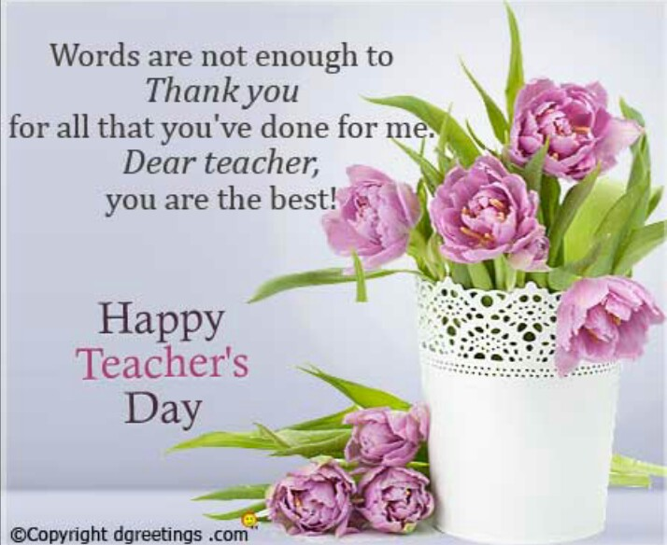
- Happy teachers’ day

- Happy anniversary


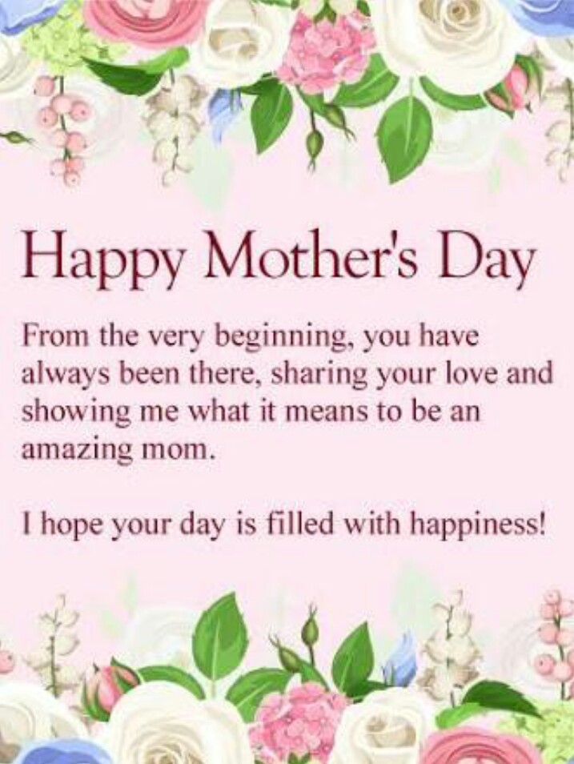
- Happy mothers’ day

In writing test, the students will write a paragraph that contains five components of writing and their paragraph at least of 150 words. The students write about “ send greeting card for someone to give congratulation or happy birthday. The students evaluate by using ESL composition profile.
For ESL students particularly, whose individual needs and goals is highly variable, writing is an efficient tool to facilitate and reinforce other language skill. Reading, vocabulary, and grammar skills are employed in the act of writing. As ESL students become actively engaged in writing process, they read for additional information perhaps to clarify positions concerning particular topic. Writer gathers information by reading, observing, talking with others, synthesizing and evaluating data.

