DAFTAR PUSTAKA

Abdullah, M. (2021). Manajemen dan Evaluasi Kinerja Karyawan. Yogyakarta: Aswaja Pressindo.
Astrinasari, S. (2020). Pengaruh Lingkungan Kerja dan Kompetensi Pegawai Terhadap Kinerja Pegawai Badan Perencanaan dan Pembangunan Daerah (BAPPEDA) Kabupaten Lampung Tengah. Universitas Muhammadiyah Metro, 1(1).
Bateman, T. S., & Snell, S.A. (2020). Management: Leading & Collaborating in a Competitive World. New York: McGraw-Hill Education.
Cascio, W. F. (2006). Managing Human Resources: Productivity, Quality of Life, Profits. New York: McGraw-Hill Irwin.
Daft,R.L.(2018). Management.Boston:Cengage Learning.
Dessler, G. (2018). Human Resource Management. USA: Prentice Hall. Dubrin,A.J.(2017).Essentialsof Management. Boston: Cengage Learning.
Fuadi, N., Razak, M., & Said, Muh. (2022). Pengaruh Lingkungan Kerja, Kompetensi, dan Motivasi Kerja Terhadap KinerjaAnggota Kepolisian di Polres Toraja Utara, 1(1).
Judge,T.A., & Robbins, S. P. (2017). Organizational Behavior. Jakarta: Salemba Empat.
Locke, E. A. (2019). The Job Satisfaction-Job Performance Relationship: A Qualitative and Quantitative Review. New York: Routledge.
Luthans, F. (2019). Organizational Behavior: An Evidence-Based Approach. New York: McGraw-Hill Education.
Mangkat, R. S.,Tewal, B., &Taroreh, R. N. (2019). Pengaruh Pengalaman Kerja, Pelatihan, Nilai Pribadi dan Etos Kerja Terhadap Kinerja Anggota Polisi Pada Kantor Pusat Kepolisian Daerah Sulawesi Utara. Jurnal EMBA, 7(7).
Mathis, R. L., & Jackson, J. H. (2016). Human Resource Management. USA: Cengage Learning, Inc.
Nursangadah, N., & Tjahjaningsih, E. (2017). Pengaruh Kompetensi dan Kepribadian Terhadap Kinerja Dengan Mediasi Komitmen Organisasional (Studi Pada Balai Diklat Keagamaan Semarang). Prosiding Seminar Nasional Multi Disiplin Ilmu & Call for Papers UNISBANK, 3(3).
Porter, L.W., & Lawler, E.E. (2010). Managerial Attitudes and Performance.
Homewood: Irwin.

83

84

Pradana. (2021). Pengaruh Kompetensi dan Lingkungan Kerja Terhadap Kinerja Karyawan pada PT. Lambang Jaya Lampung Selatan. E-Journal, 1(1).
Purnomo, R. A. (2019). Analisis Statistik Ekonomi dan Bisnis dengan SPSS. Ponorogo: WADE Group.
Putri, K. A., Rialmi, Z., & Suciati, R. (2022). Pengaruh Lingkungan Kerja,disiplin Kerja, dan Motivasi Kerja Terhadap Kinerja Personil Polri di Kantor Kepolisian Resor Sawahlunto. Jurnal Ikraith-Ekonomika, 5(2).
Sugiyono. (2022). Metode Penelitian Kuantitatif, Kualitatif dan, R&D. Bandung: Alfabeta.
Tempo.co. (2022, Agustus 11). Divisi Propam, Apa Tugas dan Kewajiban? Diambil 25 Juli 2024, dari https://nasional.tempo.co/read/1621562/divisi- propam-apa-tugas-dan-kewajiban
Wahyuni, A., & Budiono, B. (2022). Pengaruh Lingkungan Kerja dan Kompetensi Terhadap Kinerja Karyawan Melalui Motivasi Kerja. Jurnal Ilmu Manajemen, 10(3).

KUESIONER PENELITIAN

PENGARUH LINGKUNGAN KERJA, KOMPETENSI, DAN NILAI PRIBADI TERHADAP KINERJA PEGAWAI PADA
BIRO PENGAWAS PROFESI DAN PENGAMANAN POLDA
SUMUT

Peneliti memahami waktu saudara/i sangatlah terbatas dan berharga, namun peneliti juga berharap kesediaan saudara/i untuk membantu penelitian ini dengan mengisi secara lengkap kuesioner yang terlampir. Dalam rangka melengkapi data yang diperlukan untuk memenuhi tugas akhir, bersama ini peneliti:

NAMA PENELITI : ENI
NPM : 203114074 PROGRAM STUDI : MANAJEMEN
FAKULTAS : EKONOMI DAN BISNIS
UNIVERSITAS : UNIVERSITAS MUSLIM NUSANTARA
ALWASHLIYAH

Berharap saudara/i dapat memberikan jawaban yang sebenar-benarnya demi membantu penelitian ini dan atas waktu juga kesediaannya peneliti ucapkan terima kasih.

Identitas Responden
Isilah pertanyaan berikut dengan baik dan benar sesuai dengan kondisi sebenarnya. Berilah tanda (√) pada salah satu jawaban yang menurut anda benar.

Nama :
Jenis kelamin : [1] Laki-laki [2] Perempuan Usia : [1] 20-25 Tahun [2] 26-30 Tahun
[3] 31-35 Tahun [4] >40 Tahun
Masa kerja : [1] 3-6 Tahun [2] >6 Tahun

Pernyataan
Isilah pertanyaan berikut dengan baik dan benar sesuai dengan kondisi sebenarnya. Berilah tanda (√) pada salah satu jawaban yang menurut anda benar.

Keterangan:
  - STS =Sangat Tidak Setuju
  - TS =Tidak Setuju
  - KS =Kurang Setuju
  - S =Setuju
  - SS =Sangat Setuju

Lingkungan Kerja (X₁)
No. | Pernyataan | Pernyataan
No. | Pernyataan | SS (5) | S (4) | KS (3) | TS (2) | STS (1)
1 | Fasilitas fisik yang tersedia di tempat kerja saya sangat mendukung produktivitas kerja.
2 | Hubungan sosial antar pegawai di tempat kerja saya sangat harmonis dan mendukung kolaborasi.
3 | Kebijakan yang diterapkan oleh organisasi saya jelas dan adil, serta mendukung perkembangan karir pegawai.
4 | Tempat kerja saya memastikan keselamatan dan kesehatan pegawai melalui berbagai program dan fasilitas yang memadai.
5 | Pimpinan ditempat kerja saya memiliki kualitas kepemimpinan yang baik dan mampu memotivasi serta mengarahkan pegawai dengan efektif.

Kompetensi (X₂)
No. | Pernyataan | Pernyataan
No. | Pernyataan | SS (5) | S (4) | KS (3) | TS (2) | STS (1)
1 | Saya memiliki pengetahuan yang mendalam tentang bidang pekerjaan saya.
2 | Saya memiliki keterampilan teknis yang diperlukan untuk menjalankan tugas-tugas saya dengan efektif.
3 | Saya mampu beradaptasi dengan cepat terhadap perubahan dan situasi baru di tempat kerja.
4 | Saya mampu berkomunikasi dengan jelas dan efektif dengan rekan kerja dan atasan.
5 | Saya memiliki kemampuan kepemimpinan yang baik dan mampu memotivasi serta mengarahkan tim saya.
6 | Saya selalu fokus untuk mencapai hasil yang optimal dalam setiap tugas yang saya kerjakan.

Nilai Pribadi (X₃)
No. | Pernyataan | Pernyataan
No. | Pernyataan | SS (5) | S (4) | KS (3) | TS (2) | STS (1)
1 | Saya selalu menunjukkan konsistensi dalam  menjalankan nilai-nilai pribadi saya di tempat kerja.
2 | Saya memiliki kemampuan untuk memprioritaskan nilai- nilai yang penting dalam setiap keputusan yang saya buat di tempat kerja.

Nilai Pribadi (X₃)
No. | Pernyataan | Pernyataan
No. | Pernyataan | SS (5) | S (4) | KS (3) | TS (2) | STS (1)
3 | Nilai-nilai pribadi saya sangat sesuai dengan nilai-nilai yang dianut oleh organisasi saya.
4 | Saya berkomitmen untuk menjalankan nilai-nilai pribadi saya dalam setiap aspek pekerjaan saya.
5 | Saya secara konsisten menampilkan nilai-nilai pribadi saya dalam perilaku dan tindakan sehari-hari di tempat kerja.

Kinerja Pegawai (Y)
No. | Pernyataan | Pernyataan
No. | Pernyataan | SS (5) | S (4) | KS (3) | TS (2) | STS (1)
1 | Saya selalu mencapai target kuantitas pekerjaan yang ditetapkan oleh organisasi.
2 | Hasil kerja saya selalu memenuhi standar kualitas yang tinggi.
3 | Saya selalu menyelesaikan tugas-tugas saya tepat waktu.
4 | Kehadiran saya di tempat kerja selalu terjaga dengan baik dan sesuai jadwal.
5 | Saya mampu bekerja sama dengan baik dengan rekan kerja dalam tim untuk mencapai tujuan bersama.

Data Uji Instrumen

No. | Identitas Responden
No. | Jenis Kelamin | Usia | Masa Kerja
1 | 2 | 3 | 1
2 | 1 | 4 | 1
3 | 2 | 2 | 1
4 | 2 | 3 | 1
5 | 1 | 2 | 2
6 | 1 | 1 | 1
7 | 2 | 2 | 2
8 | 2 | 3 | 2
9 | 1 | 4 | 2
10 | 1 | 2 | 2
11 | 2 | 3 | 2
12 | 1 | 1 | 1
13 | 2 | 4 | 1
14 | 2 | 3 | 2
15 | 2 | 1 | 2
16 | 2 | 2 | 2
17 | 1 | 4 | 1
18 | 2 | 1 | 2
19 | 2 | 2 | 2
20 | 2 | 2 | 2
21 | 1 | 2 | 1
22 | 1 | 4 | 2
23 | 1 | 3 | 2
24 | 2 | 3 | 1
25 | 1 | 3 | 2
26 | 2 | 2 | 2
27 | 2 | 1 | 2
28 | 2 | 4 | 1
29 | 1 | 3 | 1
30 | 1 | 1 | 1

No. | Lingkungan Kerja (X1)
No. | 1 | 2 | 3 | 4 | 5 | Total
1 | 3 | 3 | 3 | 3 | 3 | 15
2 | 4 | 5 | 4 | 4 | 4 | 21
3 | 2 | 2 | 3 | 2 | 2 | 11
4 | 3 | 3 | 3 | 4 | 3 | 16
5 | 3 | 3 | 3 | 3 | 4 | 16
6 | 4 | 4 | 4 | 4 | 4 | 20
7 | 2 | 2 | 2 | 2 | 2 | 10
8 | 2 | 2 | 2 | 2 | 2 | 10
9 | 4 | 4 | 4 | 4 | 4 | 20
10 | 2 | 2 | 2 | 2 | 2 | 10
11 | 3 | 3 | 3 | 3 | 3 | 15
12 | 2 | 2 | 2 | 2 | 2 | 10
13 | 3 | 3 | 3 | 3 | 3 | 15
14 | 2 | 2 | 2 | 2 | 2 | 10
15 | 2 | 2 | 2 | 2 | 2 | 10
16 | 3 | 3 | 3 | 3 | 3 | 15
17 | 4 | 4 | 4 | 4 | 4 | 20
18 | 4 | 4 | 4 | 4 | 4 | 20
19 | 3 | 3 | 3 | 3 | 3 | 15
20 | 2 | 2 | 2 | 2 | 2 | 10
21 | 4 | 4 | 4 | 4 | 4 | 20
22 | 4 | 4 | 4 | 4 | 4 | 20
23 | 2 | 2 | 2 | 2 | 2 | 10
24 | 3 | 3 | 3 | 3 | 3 | 15
25 | 4 | 4 | 4 | 4 | 4 | 20
26 | 4 | 4 | 4 | 4 | 5 | 21
27 | 3 | 3 | 3 | 4 | 3 | 16
28 | 2 | 2 | 3 | 2 | 2 | 11
29 | 4 | 5 | 4 | 4 | 4 | 21
30 | 3 | 3 | 3 | 3 | 3 | 15

No. | Kompetensi (X2)
No. | 1 | 2 | 3 | 4 | 5 | 6 | Total
1 | 5 | 5 | 5 | 5 | 5 | 5 | 30
2 | 4 | 4 | 4 | 4 | 5 | 4 | 25
3 | 3 | 3 | 3 | 4 | 3 | 3 | 19
4 | 4 | 4 | 5 | 4 | 4 | 4 | 25
5 | 4 | 5 | 4 | 4 | 4 | 4 | 25
6 | 4 | 3 | 3 | 3 | 3 | 3 | 19
7 | 3 | 3 | 3 | 3 | 3 | 3 | 18
8 | 5 | 5 | 5 | 5 | 5 | 5 | 30
9 | 3 | 3 | 3 | 3 | 3 | 3 | 18
10 | 4 | 4 | 4 | 4 | 4 | 4 | 24
11 | 5 | 5 | 5 | 5 | 5 | 5 | 30
12 | 5 | 5 | 5 | 5 | 5 | 5 | 30
13 | 4 | 4 | 4 | 4 | 4 | 4 | 24
14 | 4 | 4 | 4 | 4 | 4 | 4 | 24
15 | 5 | 5 | 5 | 5 | 5 | 5 | 30
16 | 5 | 5 | 5 | 5 | 5 | 5 | 30
17 | 4 | 4 | 4 | 4 | 4 | 4 | 24
18 | 5 | 5 | 5 | 5 | 5 | 5 | 30
19 | 3 | 3 | 3 | 3 | 3 | 3 | 18
20 | 3 | 3 | 3 | 3 | 3 | 3 | 18
21 | 4 | 4 | 4 | 4 | 4 | 4 | 24
22 | 5 | 5 | 5 | 5 | 5 | 5 | 30
23 | 4 | 4 | 4 | 4 | 4 | 4 | 24
24 | 4 | 4 | 4 | 4 | 4 | 4 | 24
25 | 3 | 5 | 5 | 5 | 5 | 5 | 28
26 | 3 | 4 | 3 | 3 | 3 | 3 | 19
27 | 4 | 4 | 5 | 4 | 4 | 4 | 25
28 | 4 | 4 | 4 | 5 | 4 | 4 | 25
29 | 3 | 3 | 3 | 3 | 4 | 3 | 19
30 | 3 | 3 | 3 | 3 | 3 | 3 | 18

No. | Nilai Pribadi (X3)
No. | 1 | 2 | 3 | 4 | 5 | Total
1 | 4 | 4 | 4 | 4 | 4 | 20
2 | 4 | 5 | 4 | 4 | 4 | 21
3 | 3 | 3 | 4 | 3 | 3 | 16
4 | 3 | 3 | 3 | 4 | 3 | 16
5 | 3 | 3 | 3 | 3 | 4 | 16
6 | 5 | 5 | 5 | 5 | 5 | 25
7 | 4 | 4 | 4 | 4 | 4 | 20
8 | 4 | 4 | 4 | 4 | 4 | 20
9 | 3 | 3 | 3 | 3 | 3 | 15
10 | 5 | 5 | 5 | 5 | 5 | 25
11 | 3 | 3 | 3 | 3 | 3 | 15
12 | 4 | 4 | 4 | 4 | 4 | 20
13 | 5 | 5 | 5 | 5 | 5 | 25
14 | 5 | 5 | 5 | 5 | 5 | 25
15 | 3 | 3 | 3 | 3 | 3 | 15
16 | 5 | 5 | 5 | 5 | 5 | 25
17 | 3 | 3 | 3 | 3 | 3 | 15
18 | 5 | 5 | 5 | 5 | 5 | 25
19 | 5 | 5 | 5 | 5 | 5 | 25
20 | 4 | 4 | 4 | 4 | 4 | 20
21 | 3 | 3 | 3 | 3 | 3 | 15
22 | 4 | 4 | 4 | 4 | 4 | 20
23 | 5 | 5 | 5 | 5 | 5 | 25
24 | 3 | 3 | 3 | 3 | 3 | 15
25 | 5 | 5 | 5 | 5 | 5 | 25
26 | 3 | 3 | 3 | 3 | 4 | 16
27 | 4 | 4 | 4 | 5 | 4 | 21
28 | 5 | 5 | 3 | 5 | 5 | 23
29 | 4 | 5 | 4 | 4 | 4 | 21
30 | 3 | 3 | 3 | 3 | 3 | 15

No. | Kinerja Pegawai (Y)
No. | 1 | 2 | 3 | 4 | 5 | Total
1 | 3 | 3 | 3 | 3 | 3 | 15
2 | 4 | 5 | 4 | 4 | 4 | 21
3 | 2 | 2 | 3 | 2 | 2 | 11
4 | 3 | 3 | 3 | 4 | 3 | 16
5 | 3 | 3 | 3 | 3 | 4 | 16
6 | 4 | 4 | 4 | 4 | 4 | 20
7 | 3 | 3 | 3 | 3 | 3 | 15
8 | 3 | 3 | 3 | 3 | 3 | 15
9 | 3 | 3 | 3 | 3 | 3 | 15
10 | 3 | 3 | 3 | 3 | 3 | 15
11 | 4 | 4 | 4 | 4 | 4 | 20
12 | 3 | 3 | 3 | 3 | 3 | 15
13 | 3 | 3 | 3 | 3 | 3 | 15
14 | 3 | 3 | 3 | 3 | 3 | 15
15 | 3 | 3 | 3 | 3 | 3 | 15
16 | 3 | 3 | 3 | 3 | 3 | 15
17 | 4 | 4 | 4 | 4 | 4 | 20
18 | 3 | 3 | 3 | 3 | 3 | 15
19 | 3 | 3 | 3 | 3 | 3 | 15
20 | 3 | 3 | 3 | 3 | 3 | 15
21 | 3 | 3 | 3 | 3 | 3 | 15
22 | 3 | 3 | 3 | 3 | 3 | 15
23 | 3 | 3 | 3 | 3 | 3 | 15
24 | 2 | 2 | 2 | 2 | 2 | 10
25 | 3 | 3 | 3 | 3 | 3 | 15
26 | 3 | 3 | 3 | 3 | 4 | 16
27 | 4 | 4 | 4 | 5 | 4 | 21
28 | 3 | 3 | 4 | 3 | 3 | 16
29 | 3 | 4 | 3 | 3 | 3 | 16
30 | 3 | 3 | 3 | 3 | 3 | 15

Data Hasil Kuesioner

No. | Identitas Responden
No. | Jenis Kelamin | Usia | Masa Kerja
1 | 2 | 3 | 1
2 | 1 | 4 | 1
3 | 2 | 2 | 1
4 | 2 | 3 | 1
5 | 1 | 2 | 2
6 | 1 | 1 | 1
7 | 2 | 2 | 2
8 | 2 | 3 | 2
9 | 1 | 4 | 2
10 | 1 | 2 | 2
11 | 2 | 3 | 2
12 | 1 | 1 | 1
13 | 2 | 4 | 1
14 | 2 | 3 | 2
15 | 2 | 1 | 2
16 | 2 | 2 | 2
17 | 1 | 4 | 1
18 | 2 | 1 | 2
19 | 2 | 2 | 2
20 | 2 | 2 | 2
21 | 1 | 2 | 1
22 | 1 | 4 | 2
23 | 1 | 3 | 2
24 | 2 | 3 | 1
25 | 1 | 3 | 2
26 | 2 | 2 | 2
27 | 2 | 1 | 2
28 | 2 | 4 | 1
29 | 1 | 3 | 1
30 | 1 | 1 | 1
31 | 2 | 3 | 1
32 | 2 | 1 | 2
33 | 2 | 2 | 1
34 | 2 | 3 | 2
35 | 2 | 1 | 2
36 | 2 | 2 | 1
37 | 2 | 1 | 2
38 | 2 | 1 | 1
39 | 2 | 3 | 2
40 | 2 | 2 | 2
41 | 2 | 4 | 1
42 | 1 | 3 | 1
43 | 2 | 2 | 1
44 | 2 | 2 | 1
45 | 1 | 4 | 1
46 | 1 | 1 | 2
47 | 1 | 2 | 1
48 | 2 | 3 | 1
49 | 2 | 3 | 1
50 | 2 | 2 | 1
51 | 1 | 4 | 2
52 | 1 | 3 | 2
53 | 2 | 1 | 1
54 | 1 | 4 | 2

55 | 2 | 3 | 1
56 | 1 | 4 | 1
57 | 2 | 3 | 1
58 | 2 | 2 | 1
59 | 2 | 1 | 1
60 | 1 | 4 | 1
61 | 1 | 3 | 2
62 | 1 | 4 | 2
63 | 2 | 1 | 2
64 | 1 | 1 | 2
65 | 1 | 3 | 2
66 | 1 | 4 | 2
67 | 1 | 4 | 2
68 | 2 | 2 | 1
69 | 1 | 2 | 1
70 | 2 | 4 | 1
71 | 2 | 4 | 1
72 | 2 | 4 | 2
73 | 1 | 2 | 1
74 | 2 | 2 | 2
75 | 2 | 1 | 1
76 | 2 | 2 | 2
77 | 1 | 3 | 2
78 | 2 | 2 | 2
79 | 2 | 4 | 1
80 | 1 | 4 | 2
81 | 2 | 3 | 1
82 | 1 | 1 | 2
83 | 2 | 3 | 1
84 | 2 | 2 | 1
85 | 2 | 4 | 1
86 | 2 | 4 | 2
87 | 2 | 4 | 2
88 | 2 | 2 | 1
89 | 2 | 1 | 2
90 | 1 | 1 | 2
91 | 1 | 3 | 2
92 | 2 | 4 | 2
93 | 1 | 1 | 1
94 | 2 | 4 | 2
95 | 2 | 2 | 1
96 | 2 | 1 | 1
97 | 2 | 2 | 2
98 | 1 | 3 | 2
99 | 2 | 2 | 2
100 | 1 | 2 | 1
101 | 1 | 3 | 2
102 | 2 | 1 | 1
103 | 2 | 1 | 2
104 | 2 | 3 | 2
105 | 2 | 4 | 1
106 | 2 | 2 | 2
107 | 1 | 1 | 1
108 | 2 | 1 | 2
109 | 2 | 1 | 1

No. | Lingkungan Kerja (X1)
No. | 1 | 2 | 3 | 4 | 5 | Total
1 | 3 | 4 | 3 | 2 | 3 | 15
2 | 4 | 4 | 4 | 4 | 2 | 18
3 | 2 | 2 | 3 | 2 | 2 | 11
4 | 3 | 2 | 3 | 3 | 4 | 15
5 | 3 | 3 | 4 | 3 | 2 | 15
6 | 4 | 3 | 4 | 3 | 4 | 18
7 | 2 | 3 | 3 | 4 | 4 | 16
8 | 2 | 2 | 4 | 2 | 3 | 13
9 | 4 | 2 | 3 | 4 | 3 | 16
10 | 2 | 3 | 4 | 3 | 2 | 14
11 | 3 | 4 | 4 | 4 | 3 | 18
12 | 2 | 3 | 3 | 2 | 4 | 14
13 | 3 | 4 | 4 | 2 | 2 | 15
14 | 2 | 3 | 2 | 2 | 4 | 13
15 | 2 | 4 | 2 | 4 | 2 | 14
16 | 3 | 2 | 4 | 2 | 4 | 15
17 | 4 | 4 | 4 | 4 | 3 | 19
18 | 4 | 3 | 3 | 2 | 2 | 14
19 | 3 | 3 | 4 | 2 | 3 | 15
20 | 2 | 2 | 2 | 3 | 4 | 13
21 | 4 | 2 | 2 | 3 | 3 | 14
22 | 4 | 3 | 4 | 2 | 4 | 17
23 | 2 | 3 | 3 | 4 | 4 | 16
24 | 3 | 2 | 3 | 2 | 2 | 12
25 | 4 | 4 | 2 | 3 | 3 | 16
26 | 4 | 2 | 2 | 2 | 4 | 14
27 | 3 | 3 | 4 | 4 | 4 | 18
28 | 2 | 2 | 3 | 4 | 3 | 14
29 | 4 | 4 | 3 | 2 | 3 | 16
30 | 3 | 2 | 2 | 3 | 4 | 14
31 | 4 | 3 | 2 | 3 | 4 | 16
32 | 4 | 2 | 3 | 2 | 4 | 15
33 | 4 | 3 | 4 | 4 | 3 | 18
34 | 4 | 4 | 3 | 3 | 2 | 16
35 | 4 | 3 | 2 | 2 | 3 | 14
36 | 2 | 3 | 3 | 2 | 3 | 13
37 | 4 | 2 | 4 | 4 | 3 | 17
38 | 4 | 4 | 4 | 4 | 3 | 19
39 | 3 | 4 | 4 | 2 | 4 | 17
40 | 4 | 4 | 2 | 3 | 2 | 15
41 | 2 | 2 | 2 | 2 | 3 | 11
42 | 4 | 3 | 2 | 3 | 4 | 16
43 | 4 | 4 | 3 | 2 | 3 | 16
44 | 4 | 3 | 3 | 2 | 2 | 14
45 | 3 | 2 | 2 | 4 | 2 | 13
46 | 3 | 2 | 4 | 4 | 2 | 15
47 | 2 | 3 | 3 | 3 | 2 | 13
48 | 4 | 2 | 2 | 3 | 4 | 15
49 | 2 | 2 | 3 | 4 | 2 | 13
50 | 2 | 3 | 3 | 2 | 4 | 14
51 | 3 | 2 | 4 | 2 | 3 | 14
52 | 3 | 3 | 4 | 4 | 4 | 18
53 | 4 | 2 | 3 | 2 | 3 | 14
54 | 2 | 3 | 4 | 4 | 3 | 16

55 | 2 | 4 | 2 | 3 | 4 | 15
56 | 4 | 4 | 3 | 3 | 4 | 18
57 | 4 | 3 | 4 | 2 | 4 | 17
58 | 2 | 3 | 3 | 2 | 4 | 14
59 | 4 | 3 | 4 | 3 | 3 | 17
60 | 3 | 3 | 3 | 4 | 3 | 16
61 | 3 | 2 | 3 | 4 | 3 | 15
62 | 2 | 4 | 2 | 2 | 2 | 12
63 | 4 | 2 | 3 | 2 | 3 | 14
64 | 4 | 4 | 2 | 2 | 4 | 16
65 | 3 | 4 | 4 | 2 | 3 | 16
66 | 2 | 2 | 2 | 4 | 3 | 13
67 | 4 | 2 | 3 | 2 | 3 | 14
68 | 2 | 2 | 3 | 4 | 4 | 15
69 | 2 | 2 | 4 | 3 | 3 | 14
70 | 4 | 2 | 4 | 4 | 3 | 17
71 | 4 | 4 | 3 | 2 | 3 | 16
72 | 2 | 3 | 3 | 3 | 3 | 14
73 | 3 | 4 | 4 | 2 | 3 | 16
74 | 4 | 3 | 2 | 3 | 2 | 14
75 | 2 | 4 | 2 | 2 | 4 | 14
76 | 3 | 3 | 4 | 2 | 3 | 15
77 | 4 | 2 | 2 | 2 | 3 | 13
78 | 3 | 3 | 4 | 2 | 4 | 16
79 | 3 | 4 | 4 | 4 | 2 | 17
80 | 3 | 2 | 4 | 4 | 4 | 17
81 | 2 | 4 | 2 | 4 | 3 | 15
82 | 2 | 4 | 3 | 3 | 2 | 14
83 | 3 | 3 | 2 | 4 | 3 | 15
84 | 2 | 3 | 2 | 2 | 4 | 13
85 | 3 | 3 | 3 | 4 | 2 | 15
86 | 4 | 2 | 4 | 4 | 3 | 17
87 | 4 | 4 | 2 | 2 | 4 | 16
88 | 4 | 2 | 2 | 2 | 2 | 12
89 | 3 | 3 | 2 | 3 | 4 | 15
90 | 4 | 4 | 3 | 4 | 3 | 18
91 | 3 | 4 | 2 | 3 | 2 | 14
92 | 3 | 2 | 4 | 2 | 4 | 15
93 | 2 | 3 | 3 | 4 | 4 | 16
94 | 2 | 3 | 2 | 2 | 4 | 13
95 | 2 | 3 | 3 | 4 | 4 | 16
96 | 2 | 3 | 4 | 2 | 4 | 15
97 | 2 | 2 | 4 | 4 | 2 | 14
98 | 3 | 4 | 2 | 4 | 4 | 17
99 | 3 | 3 | 3 | 4 | 4 | 17
100 | 2 | 2 | 4 | 3 | 2 | 13
101 | 4 | 4 | 3 | 4 | 2 | 17
102 | 2 | 4 | 2 | 3 | 3 | 14
103 | 2 | 2 | 3 | 2 | 4 | 13
104 | 4 | 2 | 3 | 3 | 2 | 14
105 | 3 | 2 | 2 | 3 | 4 | 14
106 | 2 | 3 | 2 | 4 | 2 | 13
107 | 2 | 3 | 2 | 2 | 4 | 13
108 | 4 | 2 | 2 | 3 | 4 | 15
109 | 3 | 4 | 4 | 4 | 2 | 17

No. | Kompetensi (X2)
No. | 1 | 2 | 3 | 4 | 5 | 6 | Total
1 | 5 | 4 | 5 | 3 | 4 | 5 | 26
2 | 4 | 4 | 4 | 4 | 3 | 4 | 23
3 | 3 | 4 | 5 | 3 | 4 | 5 | 24
4 | 4 | 5 | 5 | 3 | 5 | 5 | 27
5 | 4 | 3 | 3 | 4 | 4 | 5 | 23
6 | 3 | 5 | 4 | 5 | 3 | 5 | 25
7 | 3 | 3 | 3 | 4 | 3 | 3 | 19
8 | 5 | 5 | 3 | 4 | 5 | 5 | 27
9 | 3 | 3 | 4 | 3 | 5 | 4 | 22
10 | 4 | 5 | 3 | 5 | 5 | 3 | 25
11 | 5 | 3 | 4 | 4 | 3 | 4 | 23
12 | 5 | 5 | 5 | 3 | 5 | 3 | 26
13 | 4 | 3 | 4 | 3 | 4 | 5 | 23
14 | 4 | 3 | 4 | 4 | 4 | 5 | 24
15 | 5 | 5 | 4 | 3 | 3 | 5 | 25
16 | 5 | 3 | 4 | 4 | 5 | 5 | 26
17 | 4 | 3 | 5 | 4 | 5 | 5 | 26
18 | 5 | 5 | 5 | 5 | 3 | 4 | 27
19 | 3 | 5 | 4 | 3 | 4 | 3 | 22
20 | 3 | 3 | 4 | 5 | 3 | 5 | 23
21 | 4 | 5 | 4 | 5 | 4 | 3 | 25
22 | 5 | 5 | 3 | 3 | 4 | 3 | 23
23 | 4 | 3 | 3 | 3 | 4 | 5 | 22
24 | 4 | 4 | 4 | 5 | 4 | 4 | 25
25 | 5 | 3 | 5 | 4 | 5 | 3 | 25
26 | 3 | 5 | 4 | 5 | 3 | 5 | 25
27 | 4 | 3 | 4 | 5 | 4 | 5 | 25
28 | 4 | 5 | 5 | 4 | 4 | 5 | 27
29 | 3 | 5 | 4 | 3 | 4 | 5 | 24
30 | 3 | 5 | 4 | 5 | 4 | 5 | 26
31 | 3 | 5 | 4 | 4 | 3 | 5 | 24
32 | 3 | 4 | 3 | 5 | 5 | 3 | 23
33 | 5 | 4 | 3 | 4 | 4 | 3 | 23
34 | 4 | 3 | 5 | 5 | 3 | 4 | 24
35 | 4 | 4 | 3 | 3 | 5 | 3 | 22
36 | 3 | 4 | 4 | 3 | 3 | 4 | 21
37 | 4 | 5 | 4 | 4 | 4 | 3 | 24
38 | 5 | 4 | 3 | 4 | 5 | 3 | 24
39 | 5 | 5 | 3 | 4 | 3 | 5 | 25
40 | 3 | 3 | 3 | 4 | 4 | 4 | 21
41 | 4 | 3 | 3 | 3 | 4 | 4 | 21
42 | 4 | 3 | 3 | 3 | 4 | 5 | 22
43 | 3 | 3 | 4 | 5 | 5 | 3 | 23
44 | 4 | 5 | 4 | 5 | 5 | 5 | 28
45 | 5 | 4 | 3 | 4 | 4 | 5 | 25
46 | 4 | 5 | 3 | 3 | 4 | 5 | 24
47 | 5 | 4 | 3 | 4 | 3 | 5 | 24
48 | 3 | 3 | 4 | 4 | 5 | 4 | 23
49 | 4 | 5 | 4 | 3 | 3 | 3 | 22
50 | 5 | 3 | 3 | 5 | 5 | 3 | 24
51 | 5 | 3 | 3 | 5 | 4 | 5 | 25
52 | 4 | 3 | 5 | 4 | 3 | 3 | 22
53 | 4 | 3 | 3 | 4 | 5 | 4 | 23
54 | 4 | 3 | 3 | 5 | 5 | 5 | 25

55 | 5 | 3 | 4 | 3 | 3 | 3 | 21
56 | 5 | 3 | 5 | 5 | 3 | 4 | 25
57 | 5 | 3 | 4 | 3 | 4 | 3 | 22
58 | 4 | 4 | 4 | 3 | 3 | 5 | 23
59 | 5 | 3 | 4 | 5 | 5 | 3 | 25
60 | 4 | 4 | 5 | 4 | 4 | 5 | 26
61 | 5 | 5 | 4 | 4 | 3 | 3 | 24
62 | 3 | 4 | 4 | 4 | 4 | 4 | 23
63 | 3 | 3 | 3 | 4 | 4 | 4 | 21
64 | 4 | 4 | 3 | 4 | 4 | 3 | 22
65 | 3 | 5 | 4 | 5 | 5 | 4 | 26
66 | 4 | 5 | 5 | 4 | 3 | 5 | 26
67 | 5 | 3 | 5 | 4 | 3 | 4 | 24
68 | 5 | 4 | 5 | 5 | 5 | 5 | 29
69 | 3 | 3 | 5 | 3 | 4 | 5 | 23
70 | 3 | 3 | 4 | 4 | 5 | 3 | 22
71 | 3 | 4 | 4 | 5 | 4 | 3 | 23
72 | 3 | 5 | 4 | 4 | 4 | 3 | 23
73 | 4 | 4 | 5 | 3 | 5 | 4 | 25
74 | 5 | 5 | 4 | 4 | 5 | 3 | 26
75 | 4 | 3 | 3 | 3 | 4 | 4 | 21
76 | 3 | 5 | 3 | 5 | 5 | 5 | 26
77 | 5 | 4 | 5 | 3 | 5 | 3 | 25
78 | 5 | 3 | 3 | 3 | 3 | 4 | 21
79 | 5 | 4 | 4 | 5 | 4 | 4 | 26
80 | 3 | 5 | 3 | 3 | 4 | 3 | 21
81 | 3 | 5 | 5 | 5 | 3 | 5 | 26
82 | 4 | 3 | 3 | 3 | 5 | 4 | 22
83 | 5 | 5 | 5 | 5 | 5 | 3 | 28
84 | 4 | 3 | 3 | 5 | 4 | 4 | 23
85 | 3 | 4 | 4 | 4 | 3 | 3 | 21
86 | 5 | 4 | 5 | 5 | 5 | 3 | 27
87 | 5 | 3 | 5 | 4 | 4 | 4 | 25
88 | 4 | 3 | 5 | 5 | 4 | 5 | 26
89 | 3 | 4 | 5 | 5 | 3 | 5 | 25
90 | 5 | 5 | 5 | 4 | 3 | 3 | 25
91 | 5 | 3 | 3 | 3 | 3 | 4 | 21
92 | 5 | 5 | 5 | 5 | 4 | 4 | 28
93 | 5 | 5 | 5 | 3 | 5 | 3 | 26
94 | 4 | 5 | 3 | 3 | 3 | 4 | 22
95 | 4 | 3 | 3 | 4 | 3 | 3 | 20
96 | 3 | 4 | 3 | 3 | 4 | 5 | 22
97 | 5 | 3 | 3 | 4 | 3 | 5 | 23
98 | 4 | 3 | 3 | 3 | 3 | 5 | 21
99 | 3 | 3 | 3 | 4 | 4 | 5 | 22
100 | 5 | 4 | 3 | 5 | 5 | 5 | 27
101 | 4 | 4 | 5 | 4 | 4 | 5 | 26
102 | 5 | 3 | 5 | 3 | 4 | 3 | 23
103 | 5 | 5 | 3 | 5 | 5 | 5 | 28
104 | 3 | 4 | 3 | 4 | 5 | 5 | 24
105 | 4 | 4 | 5 | 4 | 5 | 3 | 25
106 | 3 | 5 | 4 | 3 | 4 | 4 | 23
107 | 4 | 3 | 4 | 3 | 4 | 5 | 23
108 | 5 | 3 | 4 | 3 | 5 | 4 | 24
109 | 4 | 3 | 3 | 5 | 4 | 5 | 24

No. | Nilai Pribadi (X3)
No. | 1 | 2 | 3 | 4 | 5 | Total
1 | 4 | 4 | 3 | 4 | 5 | 20
2 | 4 | 4 | 5 | 3 | 4 | 20
3 | 3 | 3 | 5 | 3 | 3 | 17
4 | 3 | 3 | 5 | 5 | 5 | 21
5 | 3 | 3 | 5 | 5 | 4 | 20
6 | 5 | 5 | 3 | 5 | 3 | 21
7 | 4 | 4 | 5 | 5 | 5 | 23
8 | 4 | 3 | 4 | 4 | 4 | 19
9 | 3 | 4 | 3 | 4 | 4 | 18
10 | 5 | 3 | 5 | 3 | 5 | 21
11 | 3 | 4 | 5 | 5 | 5 | 22
12 | 4 | 4 | 4 | 3 | 5 | 20
13 | 5 | 4 | 5 | 4 | 5 | 23
14 | 5 | 4 | 5 | 3 | 5 | 22
15 | 3 | 4 | 3 | 4 | 4 | 18
16 | 5 | 3 | 3 | 5 | 5 | 21
17 | 3 | 3 | 4 | 4 | 5 | 19
18 | 5 | 5 | 5 | 3 | 5 | 23
19 | 5 | 5 | 5 | 5 | 5 | 25
20 | 4 | 4 | 3 | 4 | 3 | 18
21 | 3 | 3 | 5 | 5 | 4 | 20
22 | 4 | 5 | 3 | 5 | 5 | 22
23 | 5 | 3 | 4 | 4 | 5 | 21
24 | 3 | 3 | 4 | 4 | 4 | 18
25 | 5 | 3 | 3 | 5 | 3 | 19
26 | 3 | 3 | 4 | 5 | 5 | 20
27 | 4 | 3 | 4 | 5 | 3 | 19
28 | 5 | 5 | 3 | 4 | 3 | 20
29 | 4 | 5 | 3 | 5 | 4 | 21
30 | 3 | 5 | 5 | 3 | 5 | 21
31 | 5 | 3 | 3 | 5 | 5 | 21
32 | 5 | 4 | 3 | 4 | 5 | 21
33 | 3 | 3 | 5 | 3 | 4 | 18
34 | 5 | 4 | 5 | 4 | 5 | 23
35 | 3 | 3 | 5 | 4 | 5 | 20
36 | 5 | 5 | 3 | 5 | 5 | 23
37 | 3 | 4 | 5 | 5 | 4 | 21
38 | 3 | 5 | 4 | 4 | 5 | 21
39 | 3 | 5 | 3 | 5 | 4 | 20
40 | 5 | 3 | 4 | 5 | 5 | 22
41 | 3 | 3 | 5 | 5 | 5 | 21
42 | 5 | 3 | 4 | 5 | 4 | 21
43 | 5 | 5 | 4 | 3 | 5 | 22
44 | 5 | 5 | 5 | 5 | 4 | 24
45 | 3 | 4 | 3 | 5 | 3 | 18
46 | 3 | 5 | 3 | 4 | 3 | 18
47 | 4 | 3 | 4 | 5 | 4 | 20
48 | 5 | 3 | 3 | 3 | 5 | 19
49 | 3 | 5 | 4 | 4 | 4 | 20
50 | 5 | 4 | 5 | 4 | 3 | 21
51 | 3 | 5 | 5 | 5 | 3 | 21
52 | 3 | 3 | 4 | 3 | 5 | 18
53 | 5 | 5 | 3 | 3 | 4 | 20
54 | 5 | 4 | 3 | 3 | 4 | 19

55 | 5 | 5 | 4 | 3 | 3 | 20
56 | 3 | 3 | 3 | 3 | 5 | 17
57 | 4 | 4 | 5 | 5 | 3 | 21
58 | 5 | 3 | 5 | 4 | 5 | 22
59 | 4 | 5 | 5 | 3 | 4 | 21
60 | 4 | 4 | 3 | 5 | 5 | 21
61 | 3 | 4 | 3 | 4 | 5 | 19
62 | 4 | 5 | 4 | 5 | 5 | 23
63 | 4 | 5 | 3 | 3 | 4 | 19
64 | 4 | 4 | 5 | 5 | 5 | 23
65 | 5 | 3 | 5 | 3 | 5 | 21
66 | 5 | 3 | 5 | 4 | 4 | 21
67 | 5 | 3 | 4 | 4 | 4 | 20
68 | 3 | 5 | 3 | 4 | 4 | 19
69 | 5 | 4 | 5 | 5 | 3 | 22
70 | 4 | 3 | 3 | 5 | 5 | 20
71 | 4 | 5 | 4 | 3 | 4 | 20
72 | 4 | 4 | 4 | 5 | 3 | 20
73 | 5 | 4 | 4 | 4 | 4 | 21
74 | 5 | 5 | 3 | 5 | 4 | 22
75 | 3 | 3 | 4 | 4 | 3 | 17
76 | 3 | 3 | 5 | 4 | 3 | 18
77 | 3 | 4 | 5 | 3 | 4 | 19
78 | 5 | 3 | 5 | 5 | 5 | 23
79 | 5 | 3 | 3 | 5 | 3 | 19
80 | 3 | 3 | 3 | 4 | 4 | 17
81 | 5 | 4 | 3 | 4 | 4 | 20
82 | 4 | 5 | 5 | 4 | 5 | 23
83 | 3 | 3 | 3 | 5 | 3 | 17
84 | 4 | 3 | 5 | 5 | 5 | 22
85 | 4 | 5 | 5 | 5 | 5 | 24
86 | 3 | 4 | 3 | 4 | 5 | 19
87 | 3 | 3 | 4 | 5 | 3 | 18
88 | 5 | 3 | 3 | 5 | 4 | 20
89 | 5 | 4 | 4 | 4 | 5 | 22
90 | 3 | 5 | 4 | 4 | 5 | 21
91 | 4 | 5 | 4 | 3 | 5 | 21
92 | 5 | 5 | 5 | 5 | 3 | 23
93 | 5 | 5 | 5 | 5 | 4 | 24
94 | 5 | 5 | 3 | 5 | 4 | 22
95 | 3 | 3 | 4 | 3 | 5 | 18
96 | 5 | 3 | 3 | 3 | 4 | 18
97 | 3 | 3 | 3 | 5 | 3 | 17
98 | 4 | 5 | 3 | 5 | 4 | 21
99 | 3 | 4 | 5 | 3 | 4 | 19
100 | 5 | 4 | 3 | 3 | 4 | 19
101 | 4 | 3 | 3 | 5 | 5 | 20
102 | 4 | 5 | 4 | 4 | 3 | 20
103 | 4 | 5 | 4 | 3 | 5 | 21
104 | 3 | 3 | 3 | 3 | 3 | 15
105 | 3 | 5 | 5 | 4 | 5 | 22
106 | 3 | 5 | 4 | 5 | 5 | 22
107 | 4 | 4 | 5 | 4 | 5 | 22
108 | 3 | 4 | 5 | 3 | 3 | 18
109 | 3 | 5 | 3 | 5 | 3 | 19

No. | Kinerja Pegawai (Y)
No. | 1 | 2 | 3 | 4 | 5 | Total
1 | 3 | 4 | 4 | 4 | 5 | 20
2 | 4 | 4 | 4 | 4 | 3 | 19
3 | 2 | 4 | 3 | 4 | 3 | 16
4 | 3 | 5 | 4 | 4 | 3 | 19
5 | 3 | 4 | 4 | 4 | 4 | 19
6 | 4 | 4 | 4 | 4 | 4 | 20
7 | 3 | 3 | 5 | 4 | 3 | 18
8 | 3 | 5 | 4 | 4 | 5 | 21
9 | 3 | 4 | 4 | 3 | 5 | 19
10 | 3 | 4 | 4 | 4 | 3 | 18
11 | 4 | 4 | 4 | 4 | 3 | 19
12 | 3 | 4 | 4 | 4 | 4 | 19
13 | 3 | 4 | 5 | 4 | 4 | 20
14 | 3 | 4 | 4 | 4 | 5 | 20
15 | 3 | 4 | 4 | 3 | 5 | 19
16 | 3 | 4 | 4 | 4 | 4 | 19
17 | 4 | 4 | 4 | 4 | 4 | 20
18 | 3 | 5 | 5 | 4 | 4 | 21
19 | 3 | 4 | 5 | 4 | 5 | 21
20 | 3 | 4 | 4 | 3 | 5 | 19
21 | 3 | 4 | 4 | 4 | 5 | 20
22 | 3 | 4 | 4 | 3 | 3 | 17
23 | 3 | 4 | 4 | 3 | 4 | 18
24 | 2 | 4 | 4 | 4 | 5 | 19
25 | 3 | 4 | 4 | 3 | 5 | 19
26 | 3 | 4 | 4 | 3 | 5 | 19
27 | 4 | 4 | 4 | 4 | 5 | 21
28 | 3 | 5 | 4 | 4 | 3 | 19
29 | 3 | 4 | 4 | 3 | 4 | 18
30 | 3 | 4 | 4 | 4 | 3 | 18
31 | 3 | 4 | 4 | 3 | 5 | 19
32 | 3 | 4 | 4 | 3 | 3 | 17
33 | 4 | 4 | 4 | 4 | 4 | 20
34 | 3 | 4 | 5 | 4 | 5 | 21
35 | 3 | 4 | 4 | 3 | 3 | 17
36 | 3 | 4 | 5 | 3 | 5 | 20
37 | 3 | 4 | 4 | 4 | 5 | 20
38 | 4 | 4 | 4 | 4 | 4 | 20
39 | 3 | 4 | 4 | 3 | 4 | 18
40 | 3 | 4 | 4 | 3 | 4 | 18
41 | 2 | 4 | 4 | 3 | 5 | 18
42 | 3 | 4 | 4 | 3 | 4 | 18
43 | 3 | 4 | 4 | 4 | 4 | 19
44 | 3 | 5 | 5 | 4 | 4 | 21
45 | 3 | 4 | 4 | 3 | 4 | 18
46 | 3 | 4 | 4 | 3 | 4 | 18
47 | 3 | 4 | 4 | 3 | 3 | 17
48 | 3 | 4 | 4 | 3 | 3 | 17
49 | 3 | 4 | 4 | 4 | 4 | 19
50 | 3 | 4 | 4 | 4 | 3 | 18
51 | 3 | 4 | 4 | 4 | 5 | 20
52 | 4 | 4 | 4 | 4 | 4 | 20
53 | 3 | 4 | 4 | 3 | 3 | 17
54 | 3 | 4 | 4 | 3 | 4 | 18

55 | 3 | 4 | 4 | 3 | 3 | 17
56 | 4 | 4 | 3 | 4 | 4 | 19
57 | 3 | 4 | 4 | 4 | 4 | 19
58 | 3 | 4 | 4 | 4 | 5 | 20
59 | 3 | 4 | 4 | 4 | 3 | 18
60 | 3 | 4 | 4 | 4 | 5 | 20
61 | 3 | 4 | 4 | 3 | 4 | 18
62 | 2 | 4 | 5 | 3 | 4 | 18
63 | 3 | 4 | 4 | 3 | 5 | 19
64 | 3 | 4 | 5 | 3 | 4 | 19
65 | 3 | 4 | 4 | 4 | 4 | 19
66 | 3 | 4 | 4 | 4 | 5 | 20
67 | 3 | 4 | 4 | 4 | 3 | 18
68 | 3 | 5 | 4 | 4 | 5 | 21
69 | 3 | 4 | 4 | 5 | 3 | 19
70 | 3 | 4 | 4 | 4 | 4 | 19
71 | 3 | 4 | 4 | 4 | 5 | 20
72 | 3 | 4 | 4 | 4 | 5 | 20
73 | 3 | 4 | 4 | 4 | 3 | 18
74 | 3 | 4 | 4 | 3 | 3 | 17
75 | 3 | 4 | 3 | 3 | 3 | 16
76 | 3 | 4 | 4 | 4 | 4 | 19
77 | 3 | 4 | 4 | 4 | 3 | 18
78 | 3 | 4 | 5 | 4 | 4 | 20
79 | 3 | 4 | 4 | 4 | 3 | 18
80 | 3 | 4 | 3 | 3 | 5 | 18
81 | 3 | 4 | 4 | 3 | 5 | 19
82 | 3 | 4 | 5 | 4 | 3 | 19
83 | 3 | 5 | 3 | 3 | 4 | 18
84 | 3 | 4 | 4 | 3 | 3 | 17
85 | 3 | 4 | 5 | 4 | 5 | 21
86 | 3 | 5 | 4 | 4 | 3 | 19
87 | 3 | 4 | 4 | 4 | 4 | 19
88 | 2 | 4 | 4 | 3 | 5 | 18
89 | 3 | 4 | 4 | 4 | 4 | 19
90 | 4 | 4 | 4 | 4 | 4 | 20
91 | 3 | 4 | 4 | 3 | 5 | 19
92 | 3 | 5 | 5 | 5 | 5 | 23
93 | 3 | 4 | 5 | 4 | 5 | 21
94 | 3 | 4 | 4 | 3 | 4 | 18
95 | 3 | 3 | 4 | 3 | 4 | 17
96 | 3 | 4 | 4 | 3 | 4 | 18
97 | 3 | 4 | 3 | 3 | 5 | 18
98 | 3 | 4 | 4 | 3 | 3 | 17
99 | 3 | 4 | 4 | 4 | 5 | 20
100 | 3 | 5 | 4 | 3 | 4 | 19
101 | 3 | 4 | 4 | 4 | 5 | 20
102 | 3 | 4 | 4 | 4 | 3 | 18
103 | 3 | 5 | 4 | 3 | 4 | 19
104 | 3 | 4 | 3 | 3 | 3 | 16
105 | 3 | 4 | 4 | 4 | 4 | 19
106 | 3 | 4 | 4 | 3 | 5 | 19
107 | 3 | 4 | 4 | 4 | 3 | 18
108 | 3 | 4 | 4 | 4 | 3 | 18
109 | 3 | 4 | 4 | 3 | 5 | 19

Hasil Analisis Regresi Linear Berganda
Regression
Variables Entered/Removeda

Variables  Model Entered |  | Variables Removed | Method
1 | Nilai Pribadi, Lingkungan Kerja, Kompetensib | . | Enter
- Dependent Variable: Kinerja Pegawai
- All requested variables entered.

Model Summaryb

Model R |  | RSquare | AdjustedR Square | Std.Errorofthe Estimate
1 | ,583a | ,340 | ,321 | 1,035
- Predictors:(Constant),NilaiPribadi, Lingkungan Kerja, Kompetensi
- Dependent Variable:Kinerja Pegawai

ANOVAa

Sumof  Model Squares |  |  | df | MeanSquare | F | Sig.
1 | Regression | 57,909 | 3 | 19,303 | 18,026 | ,000b
1 | Residual | 112,440 | 105 | 1,071
1 | Total | 170,349 | 108
- Dependent Variable:Kinerja Pegawai
- Predictors:(Constant),Nilai Pribadi, Lingkungan Kerja, Kompetensi

Coefficientsa
Unstandardized Coefficients
Model
1 (Constant) Lingkungan Kerja Kompetensi
Nilai Pribadi
B
4,562
,197
,233
,282
Std. Error
1,956
,058
,050
,054
Standardized Coefficients
Beta
,270
,374
,420
t2,332
3,393
4,696
5,272
Sig.
,022
,001
,000
,000

Page1

Coefficientsa

Model |  | Collinearity Statistics
 |  | Tolerance | VIF
1 | (Constant)
1 | Lingkungan Kerja | ,994 | 1,006
1 | Kompetensi | ,989 | 1,011
1 | Nilai Pribadi | ,989 | 1,011
a.Dependent Variable: Kinerja Pegawai

Collinearity Diagnosticsa
Variance Proportions
Lingkungan
Model Dimension
1 1
2
3
4
Eigenvalue Condition Index (Constant) 3,978 1,000 ,00
,012 18,403 ,00
,008 21,903 ,00
,002 45,850 1,00
Kerja Kompetensi
,00 ,00
,77 ,05
,02 ,44
,21 ,51
Collinearity Diagnosticsa
Variance ...

Model Dimension
Nilai Pribadi

1 | 1 | ,00
1 | 2 | ,14
1 | 3 | ,45
1 | 4 | ,41
a.Dependent Variable: Kinerja Pegawai

Residuals Statisticsa

Minimum |  | Maximum | Mean | Std.Deviation | N
Predicted Value | 17,01 | 20,61 | 18,84 | ,732 | 109
Residual | -2,581 | 2,474 | ,000 | 1,020 | 109
Std.Predicted Value | -2,510 | 2,413 | ,000 | 1,000 | 109
Std. Residual | -2,494 | 2,391 | ,000 | ,986 | 109
a.Dependent Variable: Kinerja Pegawai

Page2

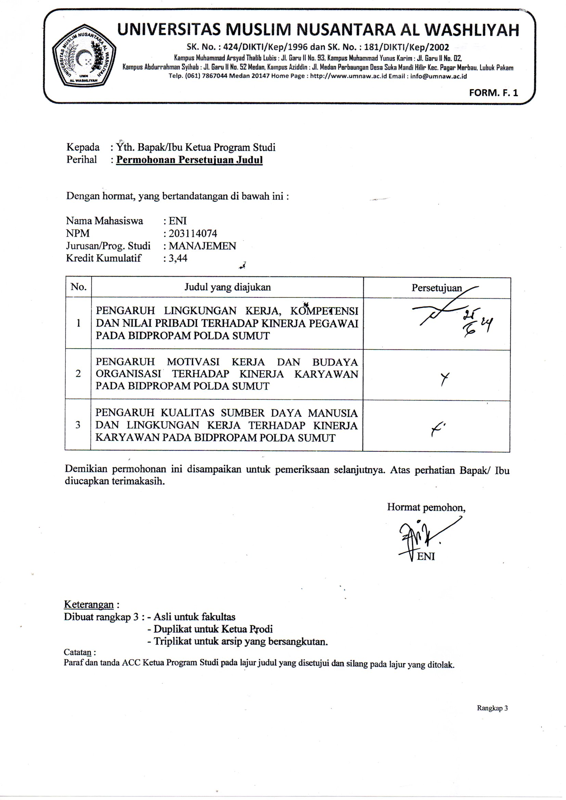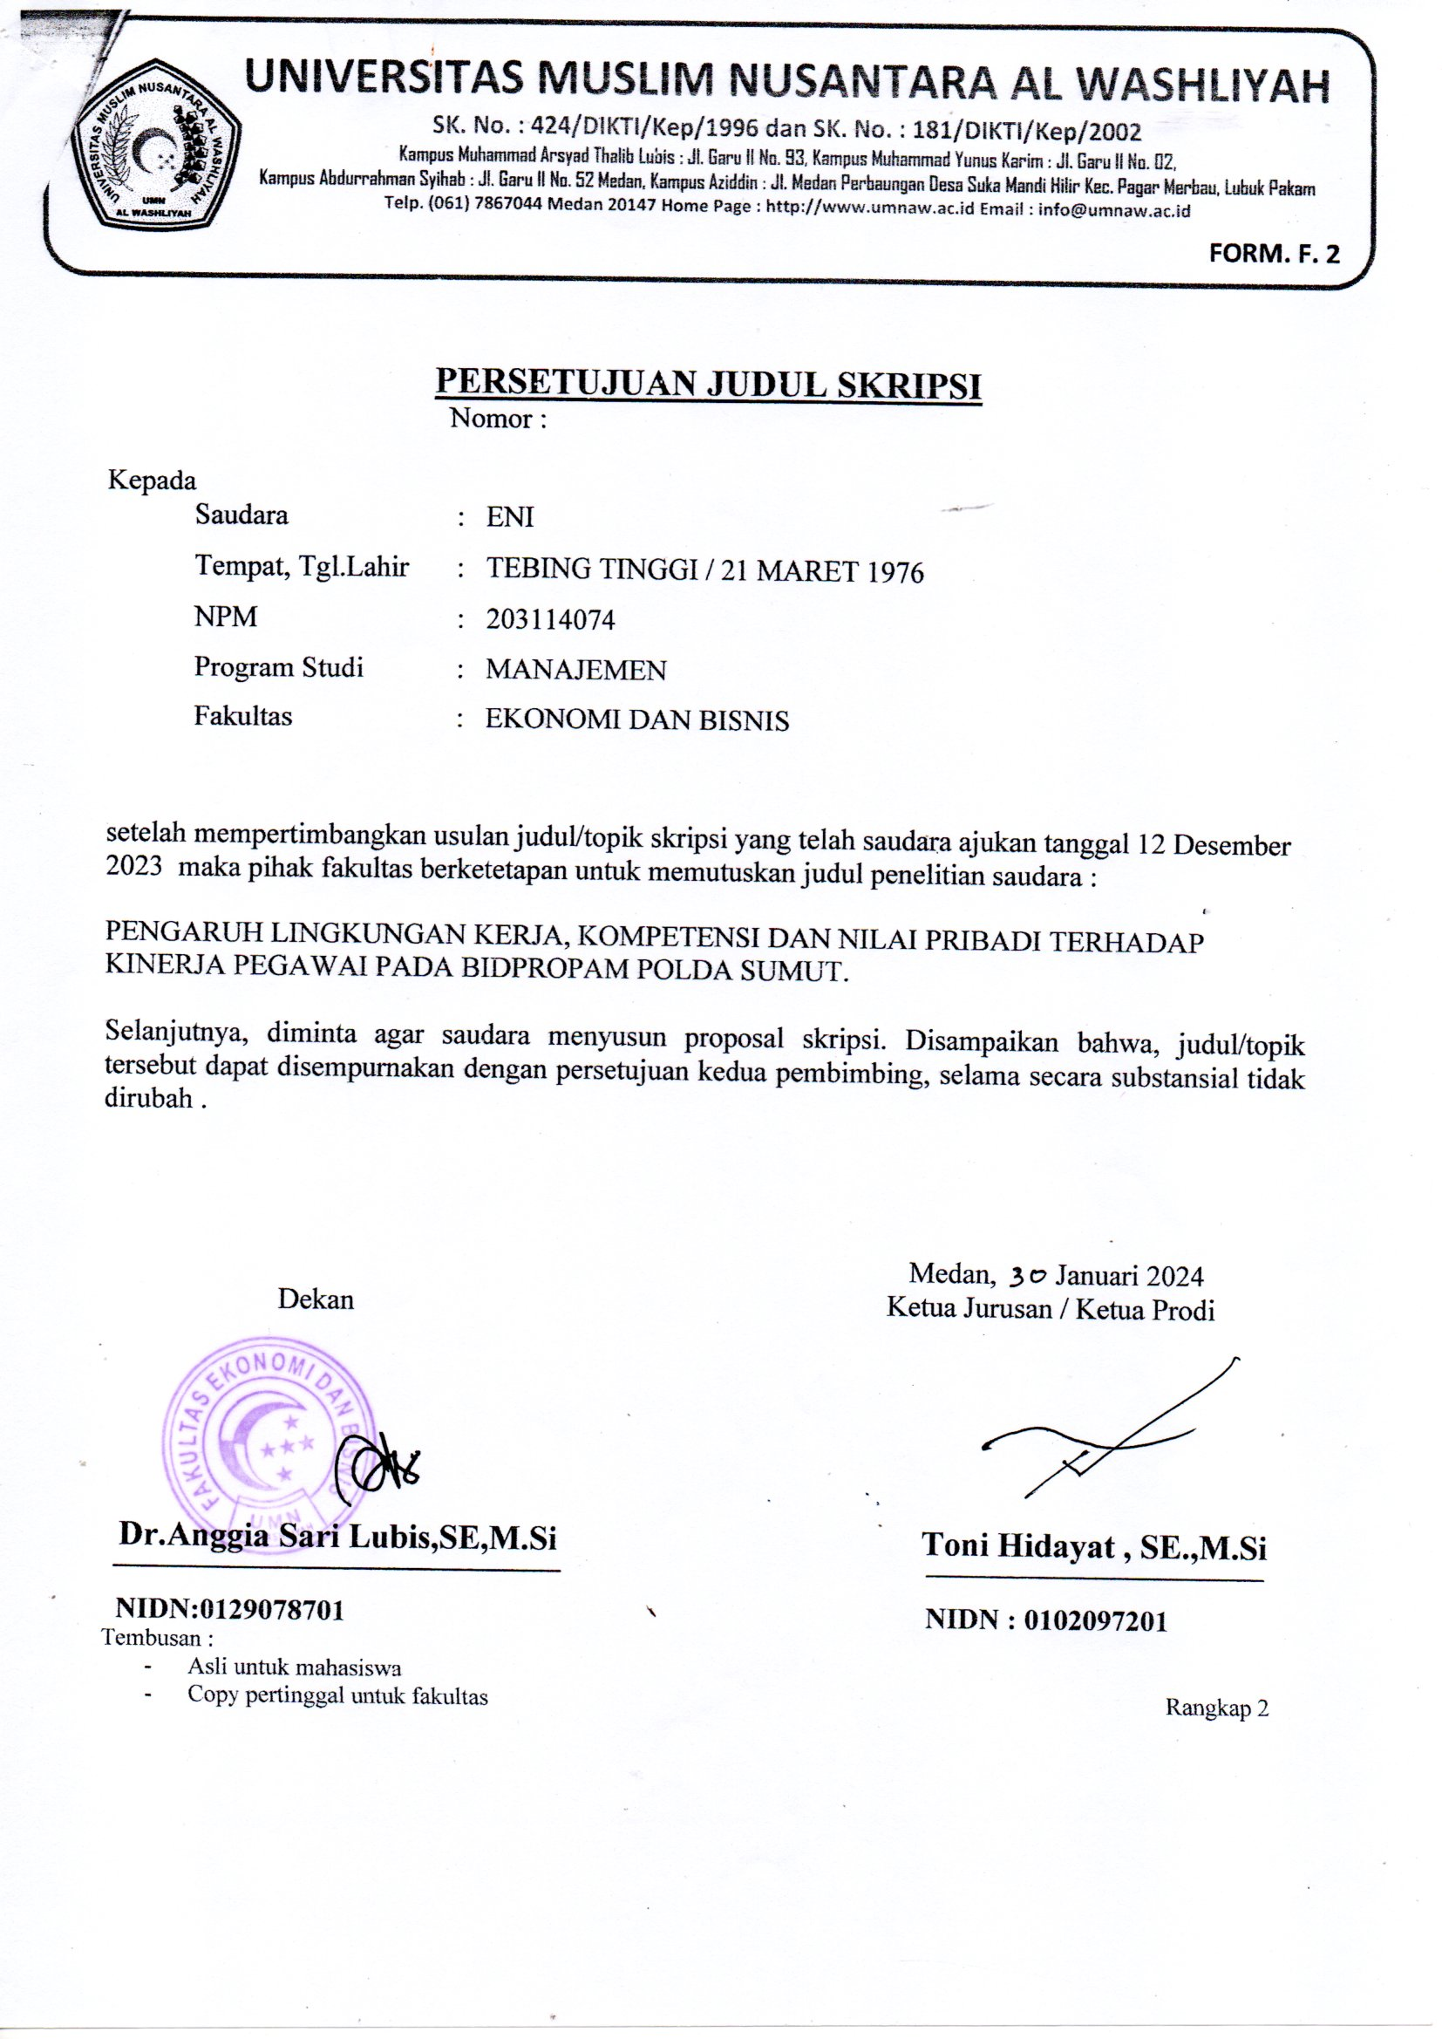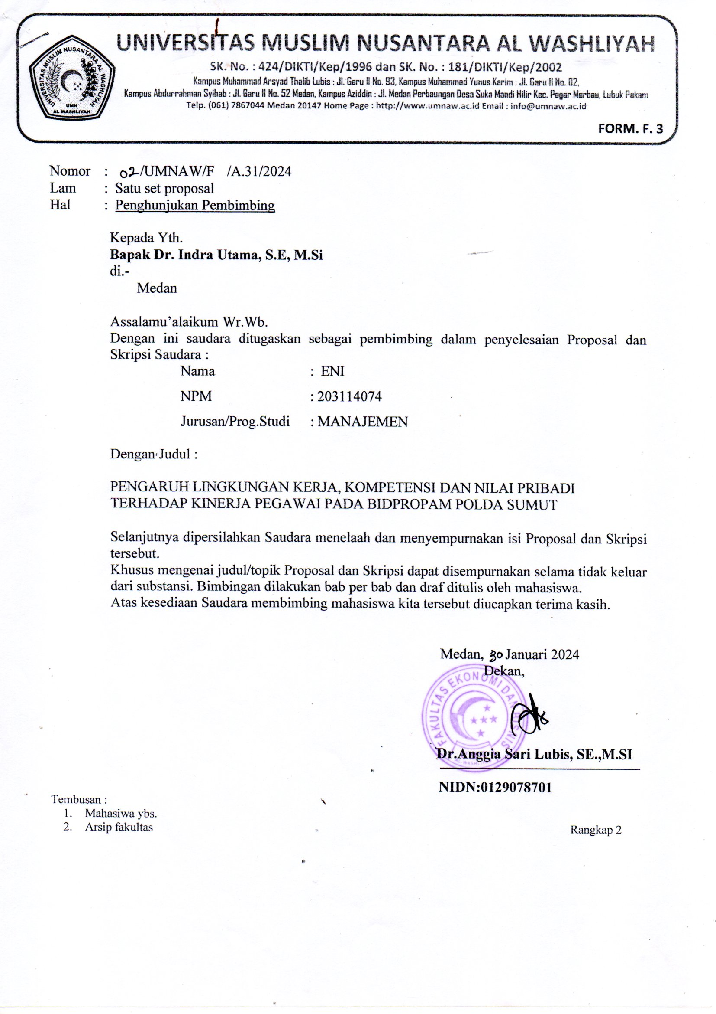

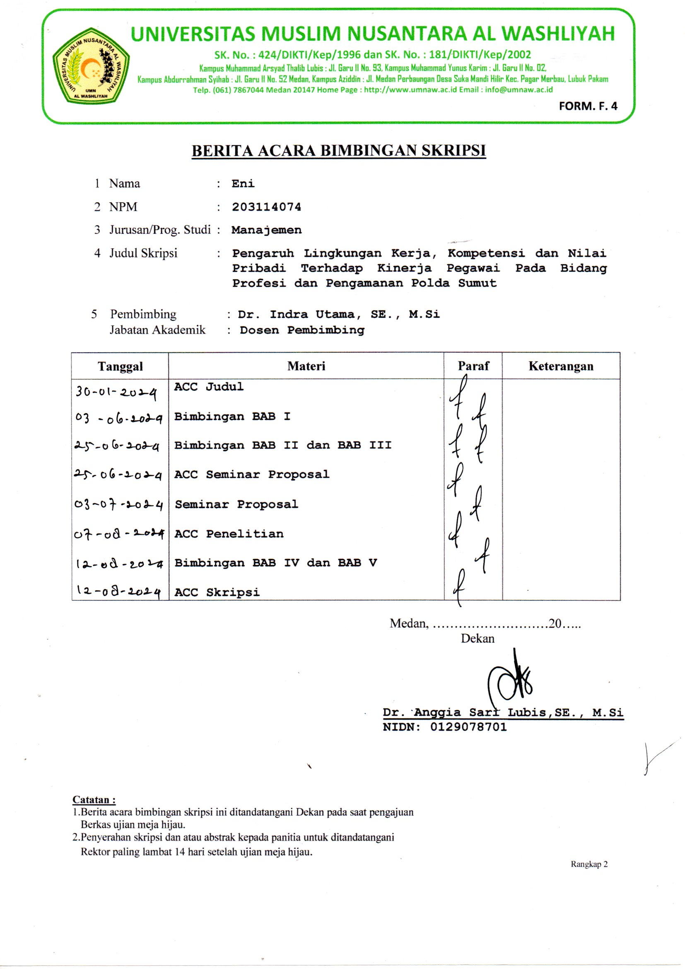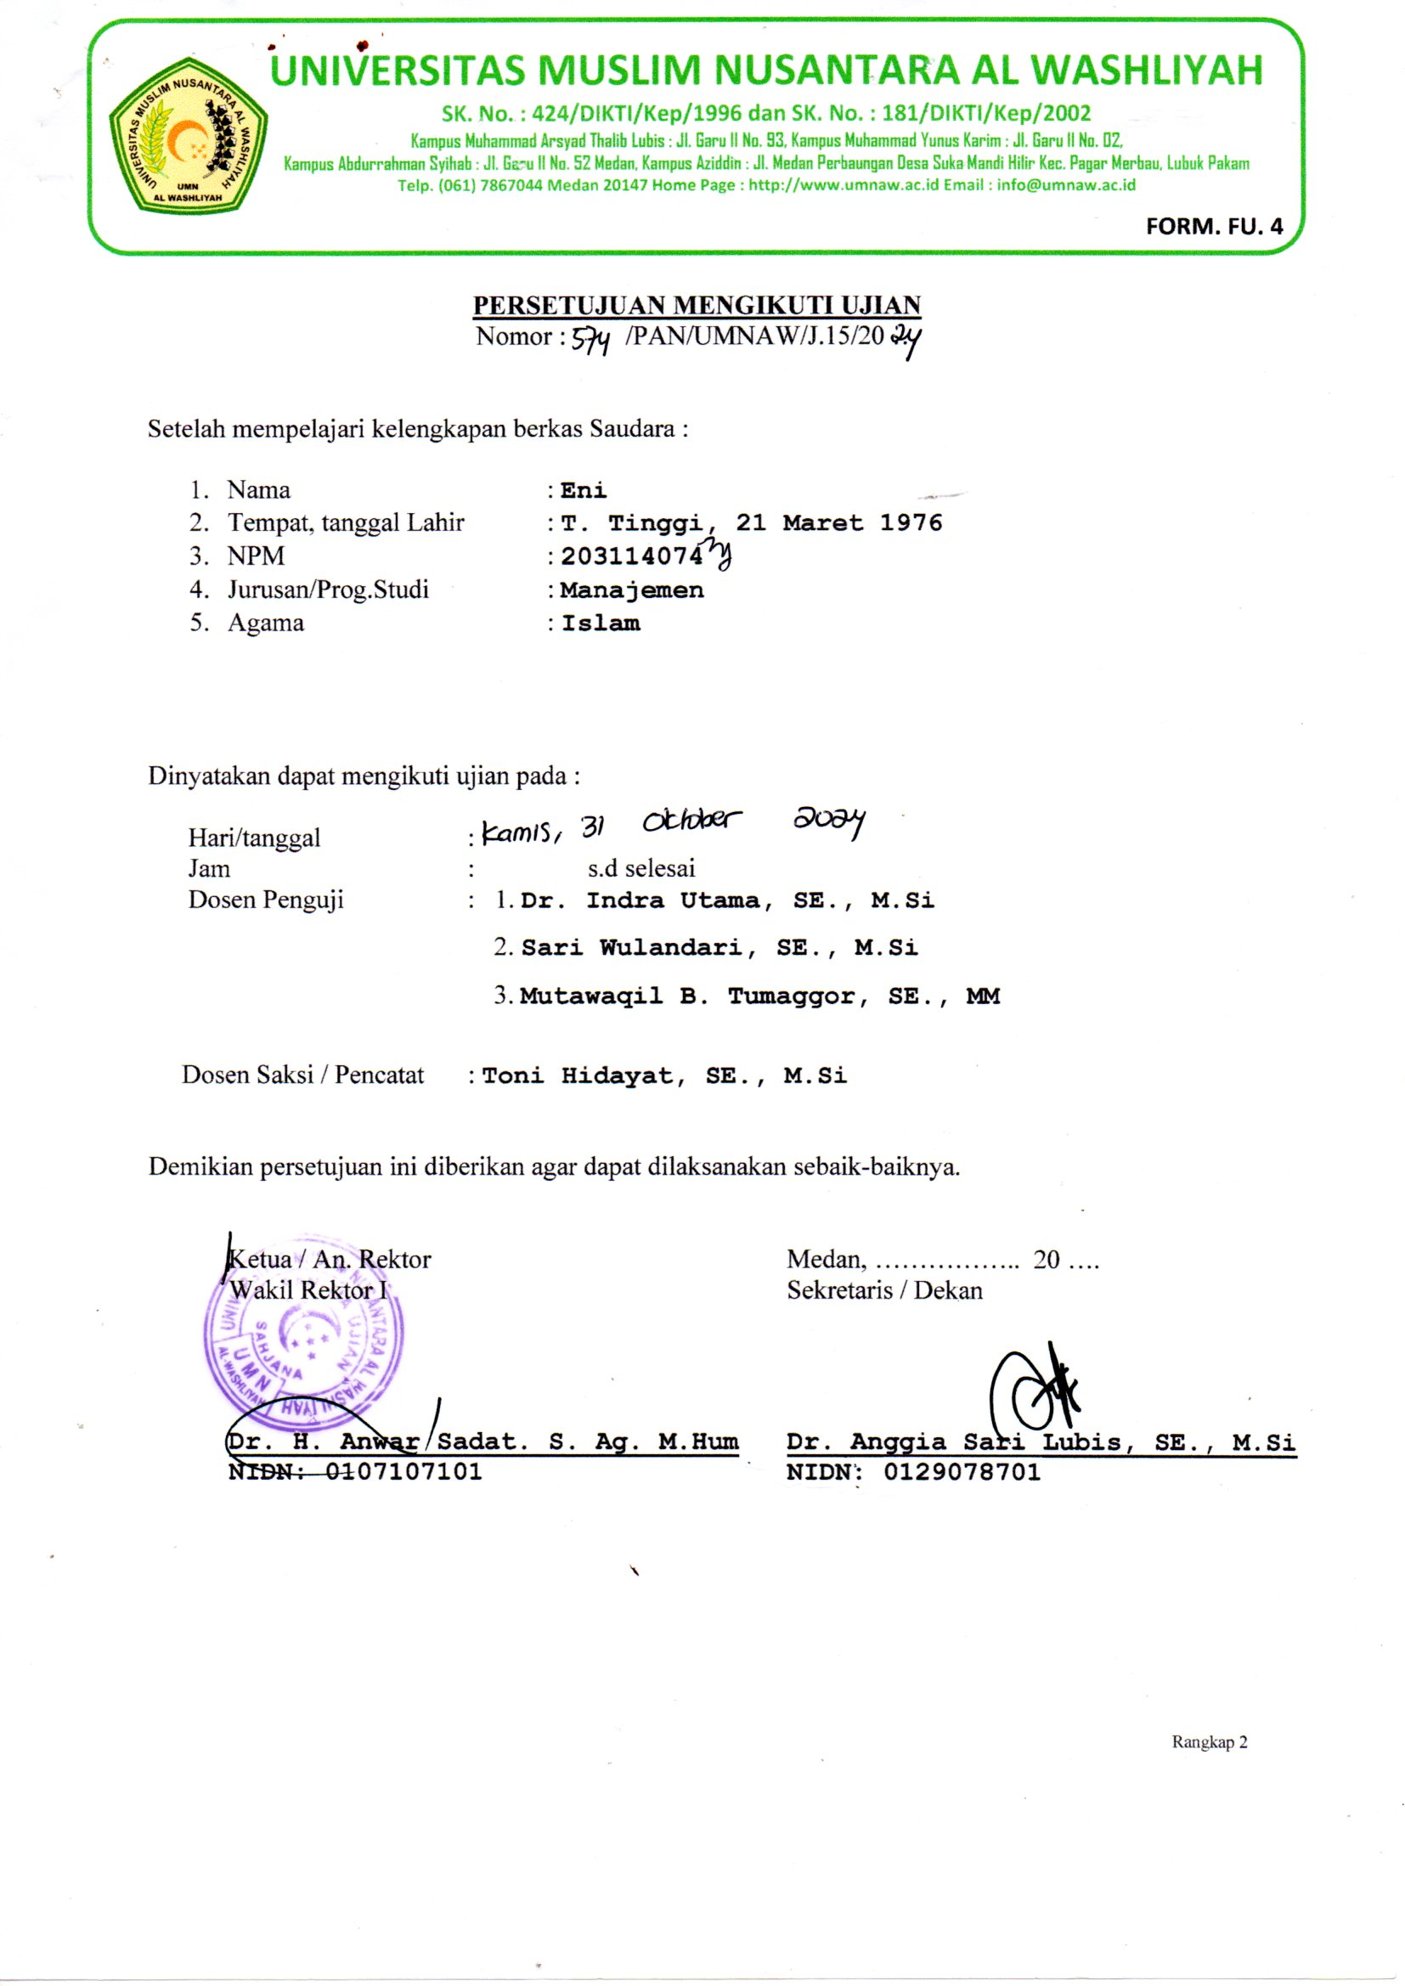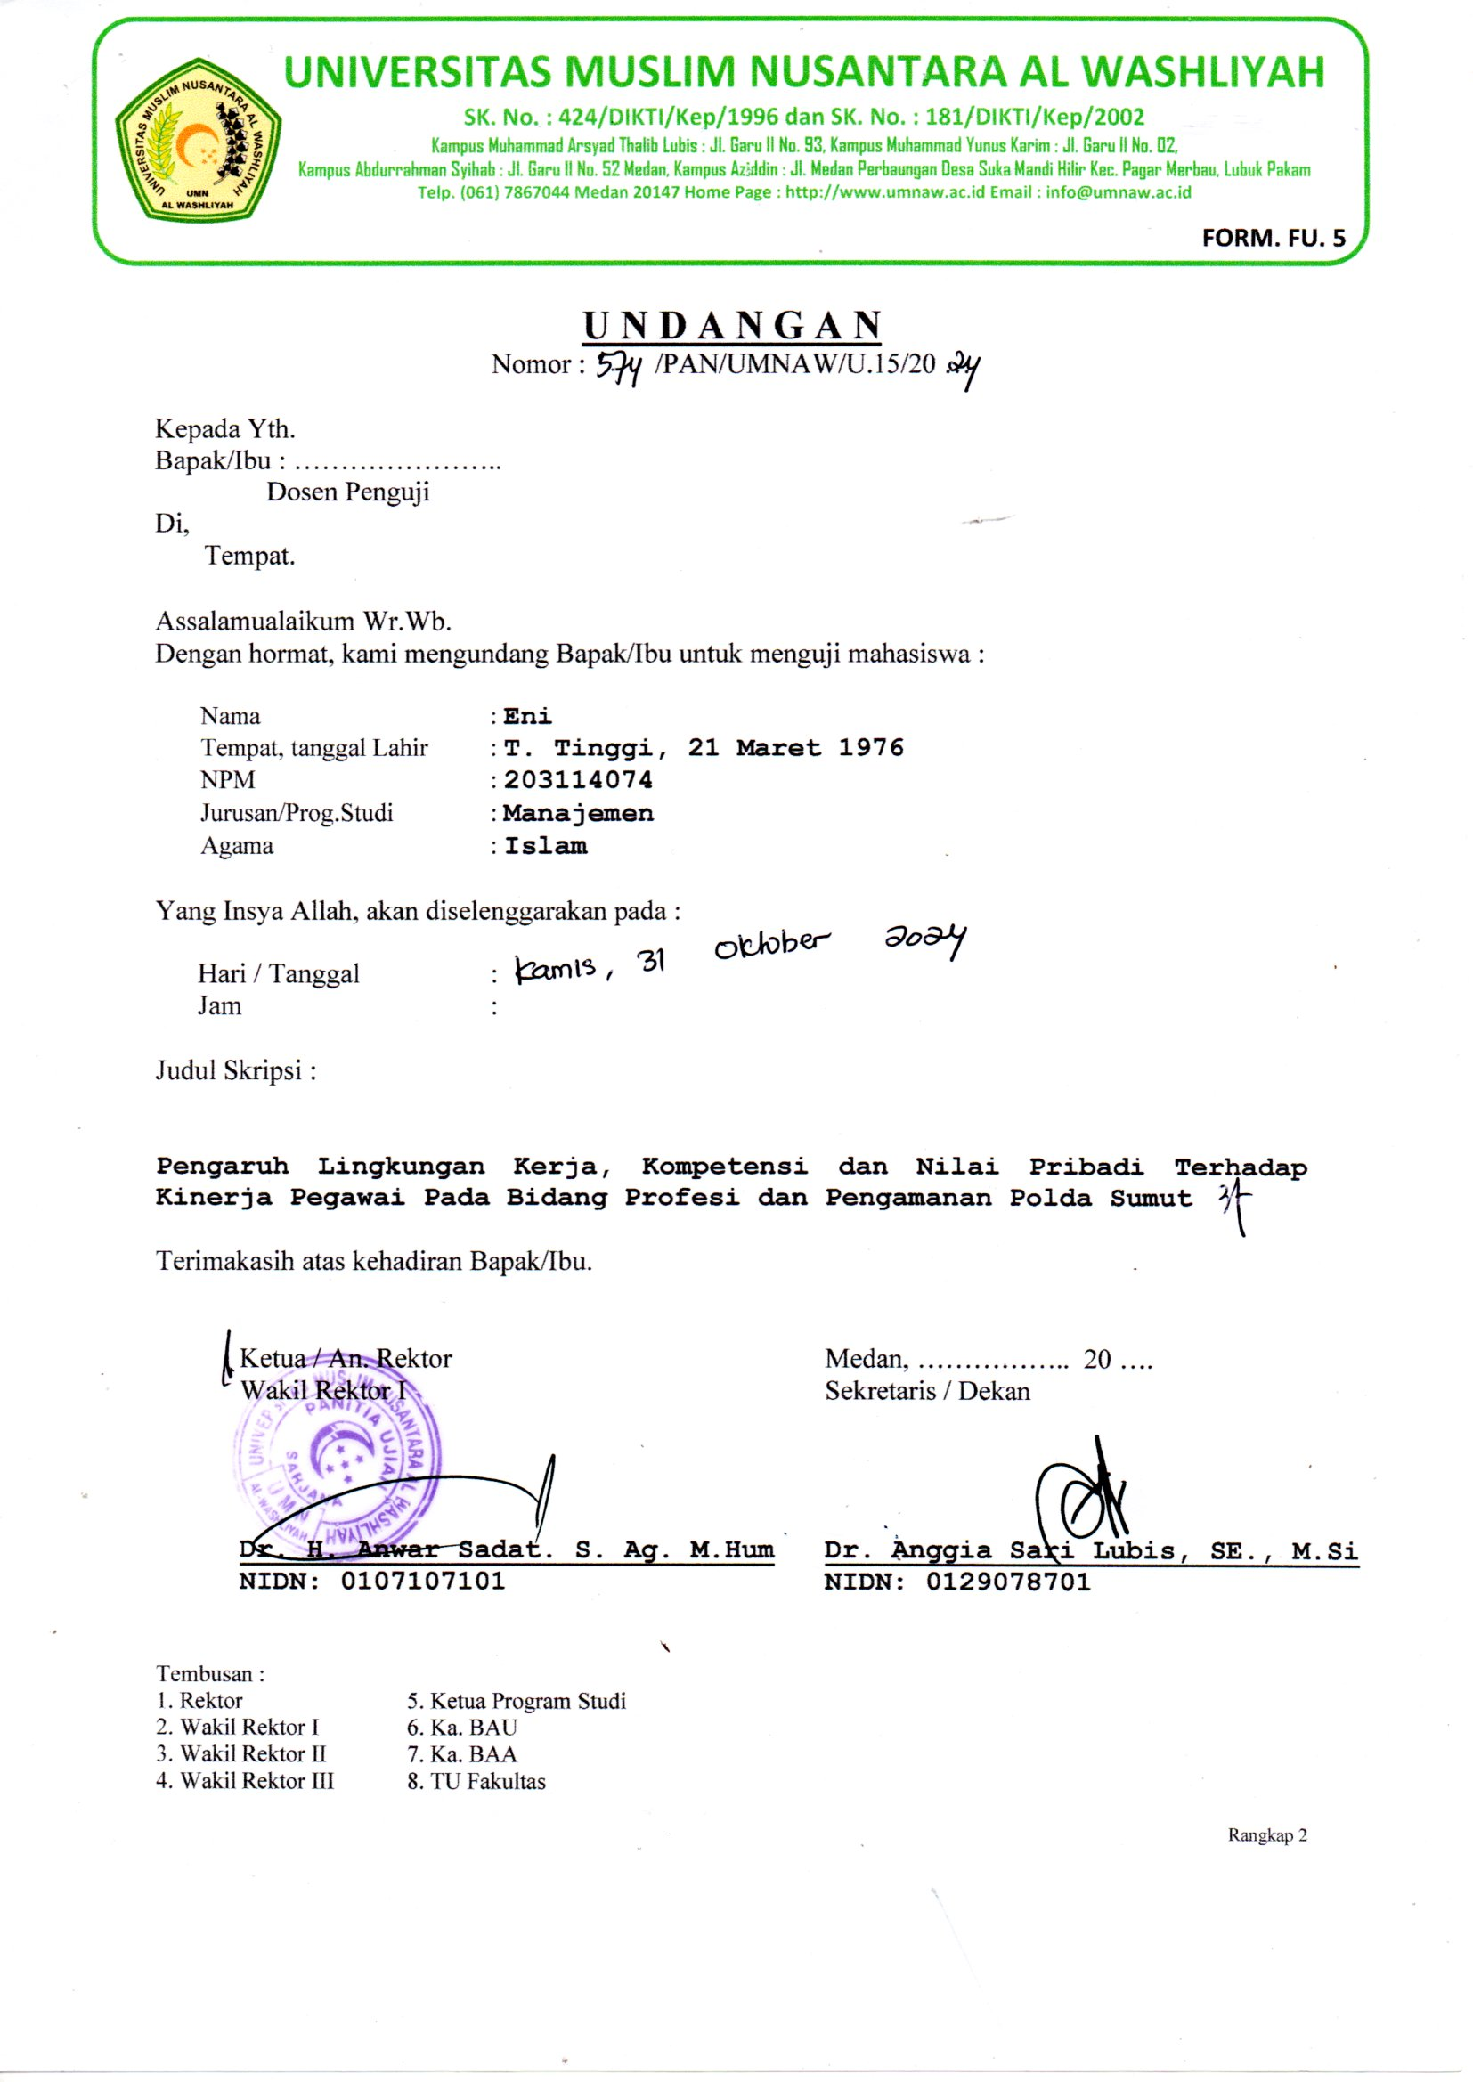
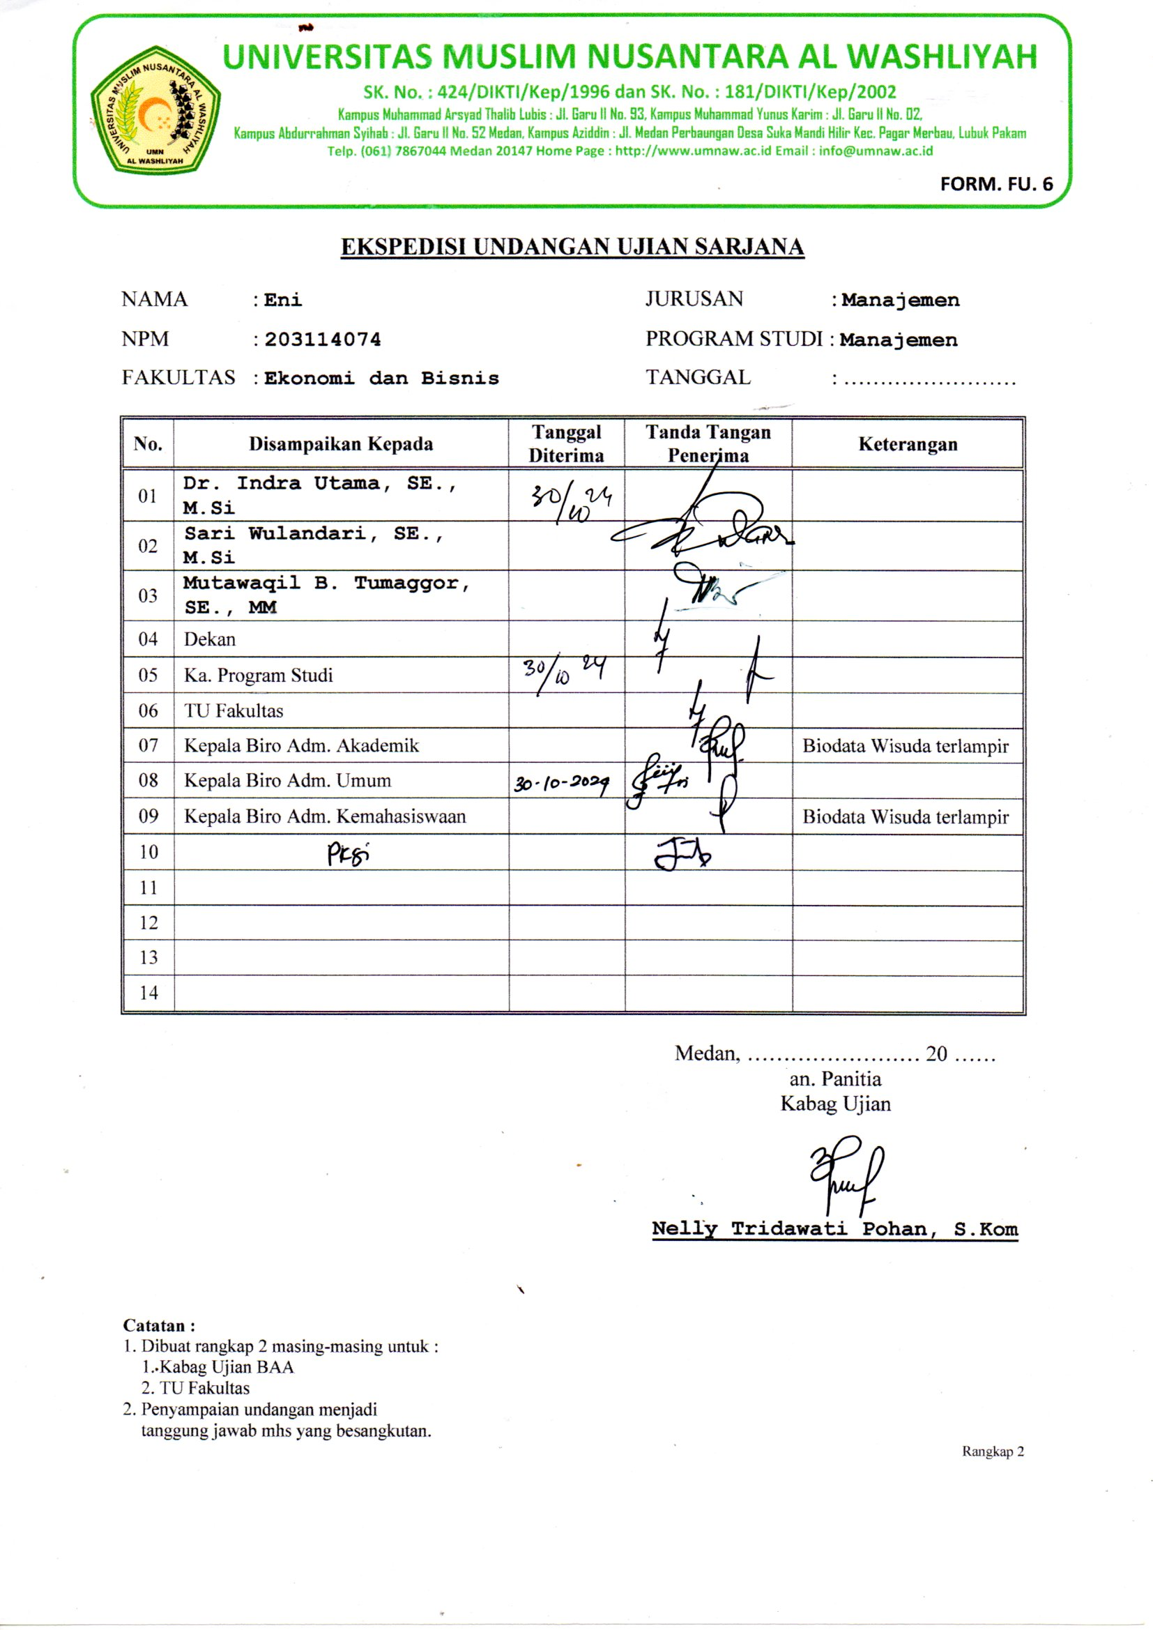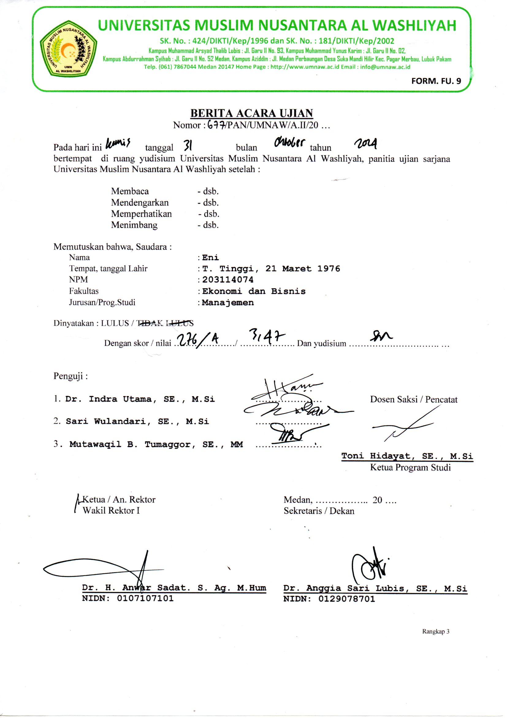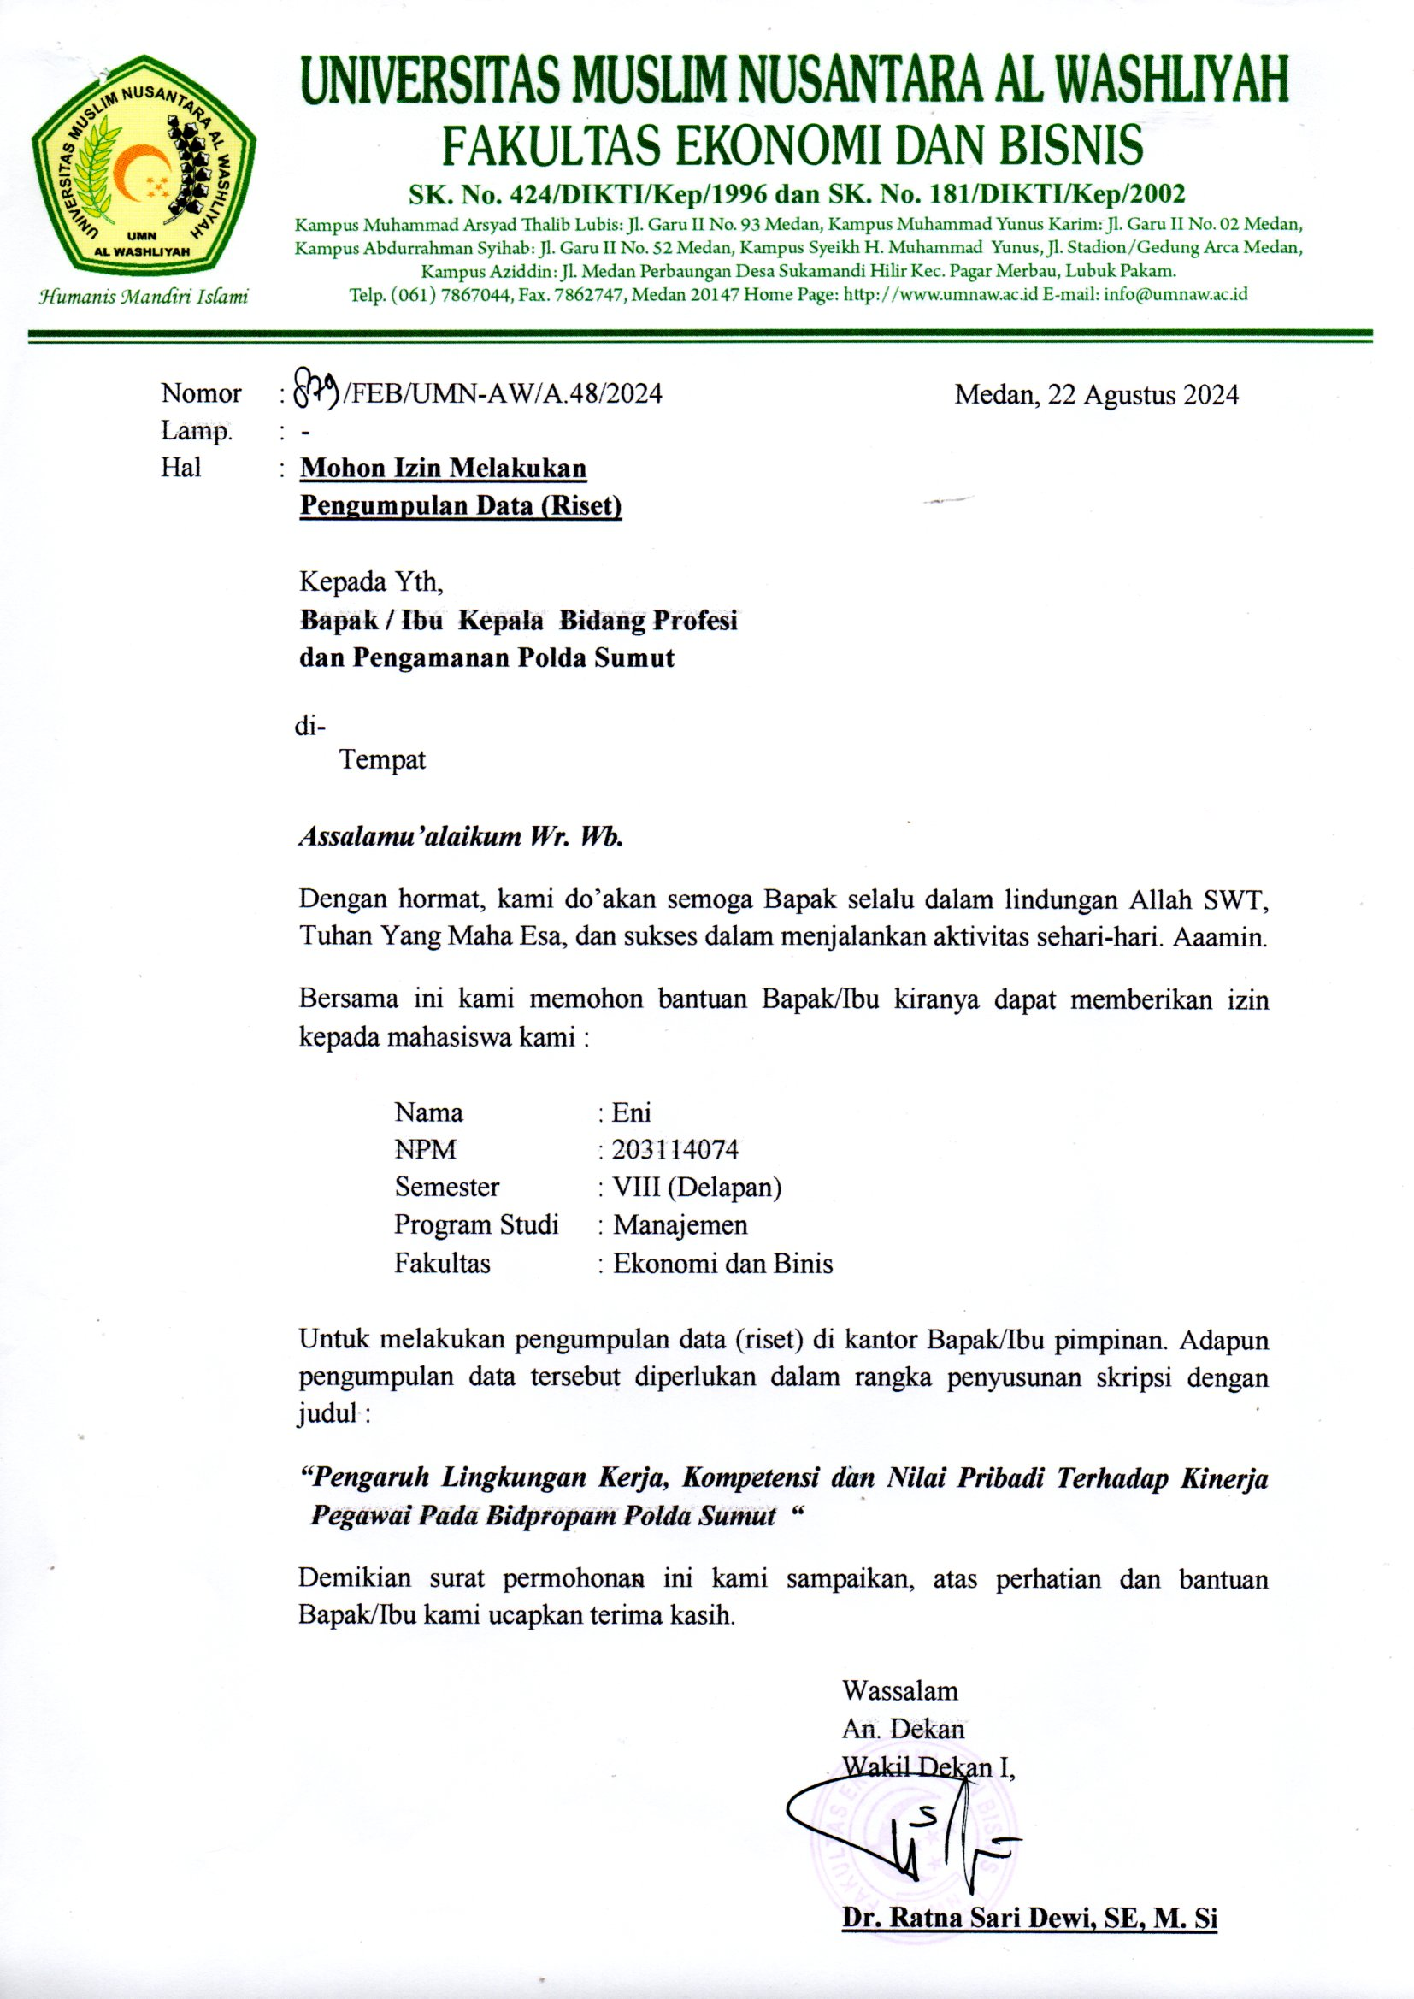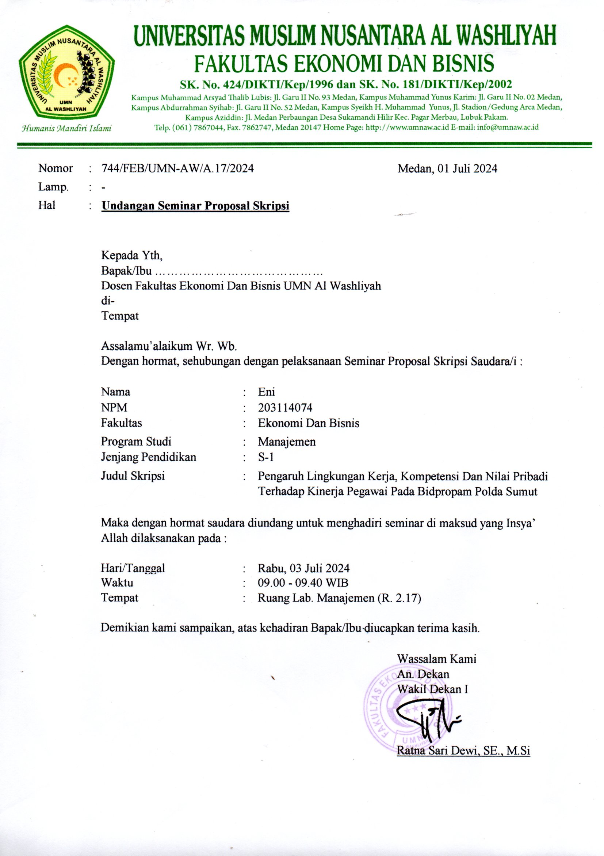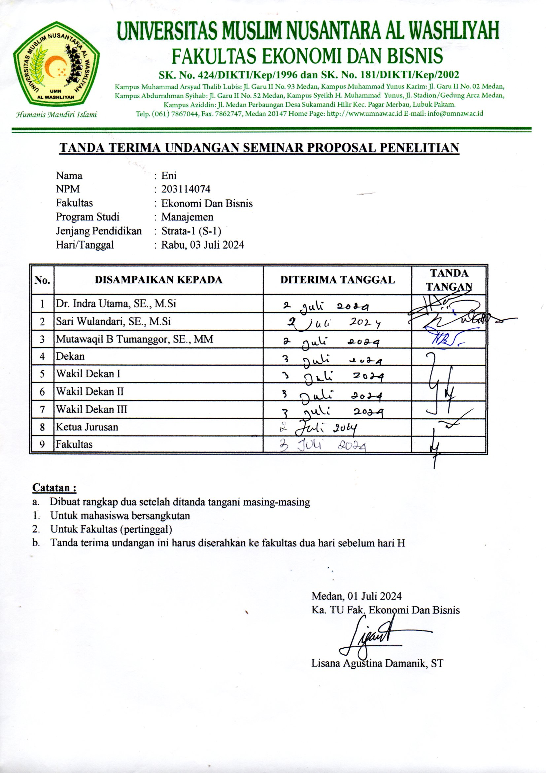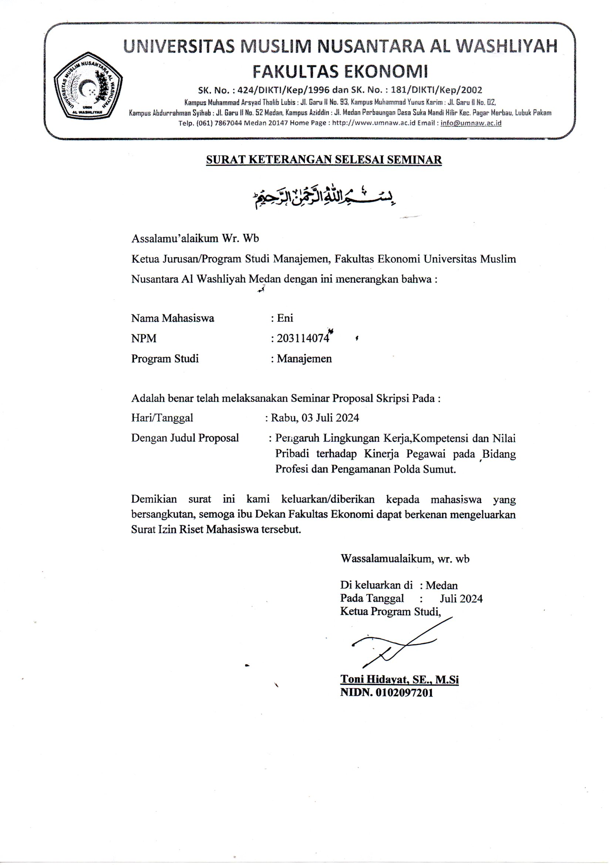

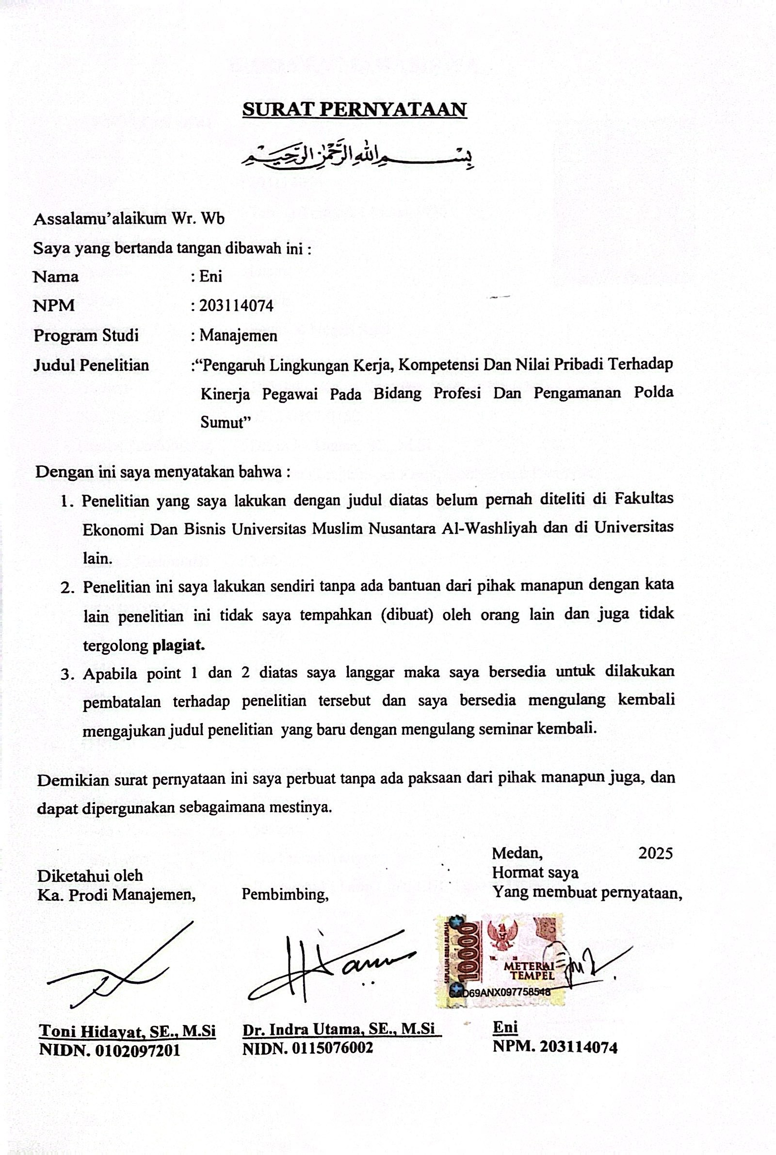

BIODATA MAHASISWA

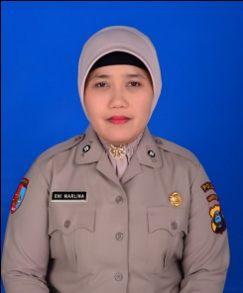
- IDENTITAS DIRI
Nama : Eni
NPM : 203114074
Tempat/ T.Lahir : Tebing Tinggi/21 Maret 1976
Jenis Kelamin : Perempuan
Agama : Islam
Status : Kawin
Pekerjaan : Pegawai Negeri Sipil
Anak Ke : 1 (satu)
Alamat : Jl. Infeksi Kanal Komplek Victoria No.99-D
No. Telp/HP : 0812-6407-0150
Dosen Pembimbing : Dr. Indra Utama, SE., M.Si
Judul Skripsi : Pengaruh Lingkungan Kerja, Kompetensi Dan Nilai
Pribadi Terhadap Kinerja Pegawai Pada Bidang Profesi Dan Pengamanan Polda Sumut
Indeks Kumulatif : 3.48

- PENDIDIKAN
SD : 1989
SMP : 1992
SMA : 1995

- ORANG TUA
Nama Ayah : Syamsuri
Pekerjaan : Wiraswasta
Nama Ibu : Sampi
Pekerjaan : Ibu Rumah Tangga
Alamat : Jl. Penghulu Tarip Link. IIIB, Tebing Tinggi


Medan, Desember 2024

Eni

