ACKNOWLEDGMENT

يٰۤاَيُّهَا الَّذِيۡنَ اٰمَنُوۡا هَلۡ اَدُلُّكُمۡ عَلٰى تِجَارَةٍ تُنۡجِيۡكُمۡ مِّنۡ عَذَابٍ اَلِيۡمٍ‏ ١٠
تُؤۡمِنُوۡنَ بِاللّٰهِ وَرَسُوۡلِهٖ وَتُجَاهِدُوۡنَ فِىۡ سَبِيۡلِ اللّٰهِ بِاَمۡوَالِكُمۡ وَاَنۡفُسِكُمۡ​ؕ ذٰلِكُمۡ خَيۡرٌ لَّـكُمۡ اِنۡ كُنۡتُمۡ تَعۡلَمُوۡنَۙ‏ ﻿﻿ ١١
10. Hai orang-orang yang beriman, sukakah kamu aku tunjukkan suatu perniagaan yang dapat menyelamatkanmu dari azab yang pedih?
11. (yaitu) kamu beriman kepada Allah dan RasulNya dan berjihad di jalan Allah dengan harta dan jiwamu. Itulah yang lebih baik bagimu, jika kamu mengetahui.

First and foremost, the writer would like to say alhamdulillahirobbilalamin and thanksgiving for the grace given by Allah SWT, the Lord of the universe, for His abundant mercy, guidance, and blessings, which have enabled the completion of this thesis. Sholawat and peace be upon our beloved prophet Muhammad SAW, a role model for all humankind, may we all receive his intercession on the Day of Judgment. Throughout the process of writing this thesis, the writer has received a great deal of support, encouragement, and assistance from many individuals. Therefore, with utmost humility, the writer would like to extend sincere appreciation and heartfelt thanks to all those who have contributed, either directly or indirectly, to the completion of this thesis, they are:
- Dr. H. Firmansyah, M.SI, the rector of Universitas Muslim Nusantara Al Washliyah.
- Ayu Melati Ningsih, S.Pd., M.S., M.Pd, the dean of Faculty of Letters.
- Diana Sopha, S.S., M.Hum, the deputy dean of Faculty of Letters.
- Vera Kristiana, S.Pd., M.Pd, the head of English Literature Study Program and also as the academic advisor.
- Rezky Khoirina Tarihoran, S.S., M.A as the thesis supervisor who has helped guide and provide solutions to every obstacle that exists in completing this thesis.
- All lecturers of the Faculty of Letters Universitas Muslim Nusantara Al Washliyah.
- The writer expresses heartfelt gratitude to both beloved parents for their endless prayers, love, moral support, and material assistance. A special and most sincere appreciation is dedicated to the late father. Although he is no longer physically present, his spirit, guidance, and love have remained a constant source of strength and inspiration throughout the completion of this thesis. May Allah SWT always bestow His mercy upon him and grant him the best place by His side.
- The writer would also like to express deepest gratitude to beloved siblings sister, brother, and younger brother for their prayers, encouragement, and constant support. Your presence and attention have been a source of motivation throughout the completion of this thesis. Thank you for being an important part of this journey. May Allah SWT always grant us good health and ease in fulfilling all of our hopes and aspirations.
- Thank you to all my friends who are both struggling to complete the thesis and give support to each other.
- And the last but not least, the writer also wishes to thank herself for the strength and perseverance in overcoming challenges to achieve this degree and become a source of pride for the family.

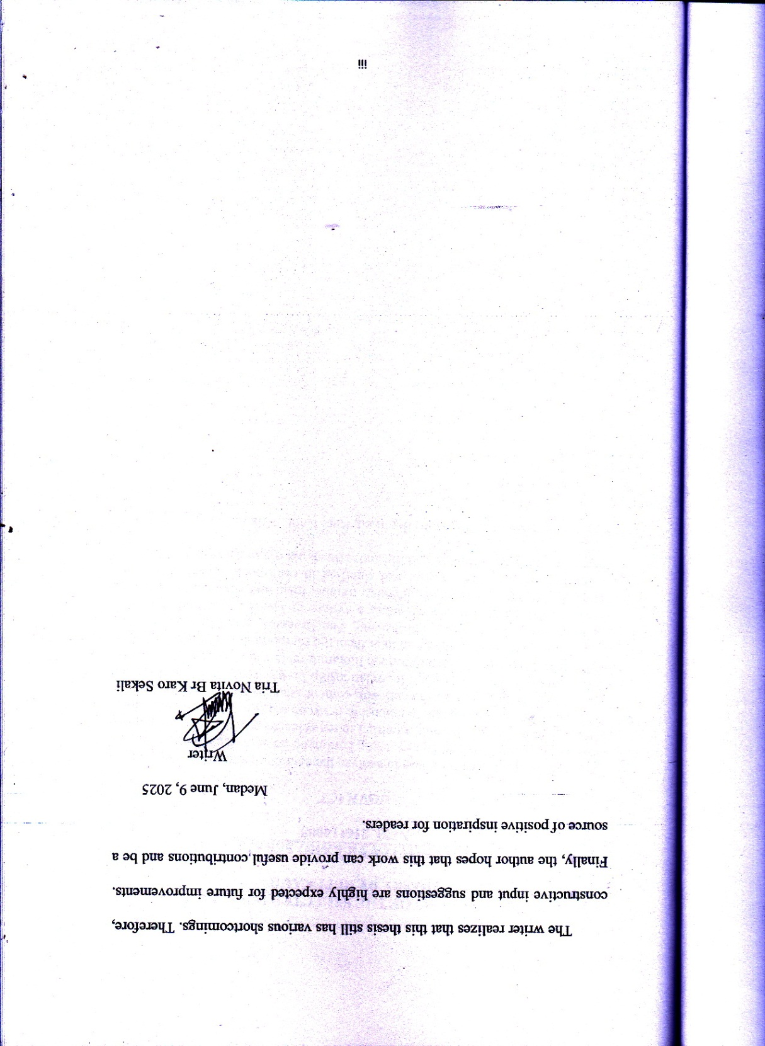
TABLES OF CONTENTS
ACKNOWLEDGMENT i
ABSTRACT iv
TABLES OF CONTENTS vi
LIST OF TABLES viii
LIST OF ILUSTRATIONS ix
CHAPTER I : INTRODUCTION 1
  - Background of Research 1
1.2 Identification of Problems 7
1.3 Limitation of Problem 7
1.4 Problems of Research 8
1.5 Objectives of Research 8
  - Significance of Research 8
CHAPTER II : REVIEW OF LITERATURE 9
- Semiotic 9
- Literary Works 13
- Poetry 14
- Synopsis of Milk and Honey 14
- Previous Researches 15
CHAPTER III : METHODOLOGY 17
- Method of Research 17
- Data and Source of Data 19
- Technique of Collecting Data 20
- Technique of Analysing Data 23
CHAPTER IV : FINDINGS AND DISCUSSIONS 25
4.1 Findings 26
4.2 Disccussions 33
CHAPTER V : CONCLUSIONS AND SUGGESTIONS 52
5.1 Conclusions 52
5.2 Suggestions 54
REFERENCES 55

LIST OF TABLES

Table 4.1.1 Signifier and Signified Found in Several Poem Titles in the Book Milk and Honey By Rupi Kaur 27
Table 4.1.2 Messages Found in Several Poem Titles in the Book Milk and Honey By Rupi Kaur 29

LIST OF ILUSTRATIONS
ILUSTRATION 1 33
ILUSTRATION 2 35
ILUSTRATION 3 37
ILUSTRATION 4 39
ILUSTRATION 5 41
ILUSTRATION 6 43
ILUSTRATION 7 44
ILUSTRATION 8 46
ILUSTRATION 9 48
ILUSTRATION 10 50

