CHAPTER IV
FINDINGS AND DISCUSSIONS
This chapter presents the results of an analysis of selected poems from Milk and Honey by Rupi Kaur, using a semiotic approach as outlined in the previous chapters. The analysis focuses on the relationship between signifier and signified, and how these elements work together to construct meaning and convey messages within the poems. In accordance with the research questions and objectives stated in chapter I, and the theoretical framework discussed in chapter II, this study was conducted using a qualitative descriptive approach through library research, as described in chapter III. Accordingly, the analysis in this chapter is grounded in a thorough examination of semiotic signs present in both the poems and accompanying illustrations in Milk and Honey.
From the results of the research conducted on ten selected poems in the book Milk and Honey by Rupi Kaur, it was found that each poem in this book is equipped with illustrations that are not merely visual complements, but serve as essential components in shaping the overall meaning and message of the poem. In addition, in the book Milk and Honey by Rupi there are four main themes, namely The Hurting, The Loving, The Breaking, and The Healing. Each theme has different characteristics and meanings, which are shown through a combination of words and illustrations that contain many meanings.

The following is a more detailed explanation of the four main themes in the milk and honey poems :
- In the theme The Hurting, the poems describe emotional vulnerability and loss of identity, which are greatly influenced by unhealthy parenting patterns and childhood experiences full of wounds.
- In the theme The Loving, the poems show the meaning of sincere and deep love, which is born from the recognition of important values ​​in life, such as the legacy of affection from a mother and the meaning of togetherness that is simple but meaningful.
- In the theme The Breaking, a description of pain and emotional attachment that is difficult to let go is found. The individuals in the poems are depicted as remaining in painful relationships because they are afraid of losing their loved ones.
- In The Healing theme, the poems convey messages about self-healing, inner reflection, and connecting with one’s true self. Symbols such as trees, roots, and the human body are used to depict the healing process and the strength that grows from within.
  - Findings
These findings indicate that the texts and illustrations in Rupi Kaur’s poems complement each other in conveying profound messages about life, love, pain, and healing. The interplay between signifiers and signifieds serves as the key to uncovering deeper meanings behind the simplicity of her language.
    - Signifier and Signified found in several poem titles in the book Milk and Honey by Rupi Kaur
Number of Poem | Title | Signifier | Signified
 | to fathers with daughters | A faceless girl drawn simply, looking fragile and innocent. | Feelings of loss of identity, emotional vulnerability, and the impact of wrong parenting.
2. | the art of being empty | A human skeleton, with simple lines showing ribs, and roots extending from under the body as if planted. | Depicting emptiness, fragility, and attachment to the environment or emotional ties that are limiting. The root symbol shows a connection to the past or place of origin that actually makes the individual lose his identity.
3. | _ | A detailed illustration of a human eye, complete with a sharp gaze and defined eyebrows. | Inherited values ​​and emotional ties to the past link memories of the mother figure, seen as a source of wisdom, to the character's understanding of love.
4. | the perfect date | Hand holding an open book, accompanied by a relaxed body posture folded legs, and a calm atmosphere depicting a quiet moment of reading together. | Depicting emotional intimacy, comfort, and closeness rooted in simplicity. An open book symbolizes openness, intellectual bonding, and emotional exchange between two individuals.
5. | _ | Illustration of a human figure drawn as a geometric frame resembling a mannequin. | A representation of human nature that is not defined by physical form but by emotional presence, hope, and the deeper meaning found in emotional connection. The simplicity of the mannequin suggests that the core of a person's being lies beyond physical appearance.
6. | _ | A cup of black coffee with simple steam line | Depicts emotional discomfort and hidden pain. It reflects a kind of emotional compromise, a silent acceptance of a love that brings pain, only because letting it go hurts even more.
7. | _ | An illustration of a woman's face, with only the lips, neck and strands of hair shown with special emphasis on the open lips. | Vulnerability, sensuality, emotional intensity and openness to deep love, but also emotional surrender that can cloud one's sense of self.
8. | _ | A woman who sits with her body folded, her head bowed, and her hands hugging her knees and there are horizontal lines that describe boundaries or surfaces. | The curled up body position depicts sadness, a closed and wounded emotional state, while the horizontal lines give the impression of a boundary that must be crossed to get out of the situation.
9. | _ | A tree shaped like a human body, the middle part resembling a woman's figure, with branches stretching upwards like hands, and strong roots at the bottom. | The human figure merging with the tree depicts the process of growth and healing that comes from awareness of one's own existence.
10. | women of color | Illustration of a woman's back with rough lines resembling wounds, as well as a circle around her head and irregular lines around it. | The back shown without a face represents the space where wounds are secretly stored, while the circle on the head implies mental pressure that continues to weigh on.

4.1.2 Messages found in several poem titles in the book Milk and Honey by Rupi Kaur
Number of Poem | Title | Message
1. | to fathers with daughters | The message conveyed through the relationship between the signifier and the signified in this poem describes the negative impact of harsh and angry parenting, which is then misinterpreted by the child as a form of affection. This poem is a warning that a lack of healthy affection in the relationship between parents and children can result in a loss of self-confidence, self-identity, and unhealthy relationship patterns later on, especially in the child's relationship with men.
2. | the art of being empty | The message conveyed through the relationship between the signifier and the signified in this poem is the importance of freedom in forming self-identity, as well as the need for a healthy space to grow without binding pressure.
3. | _ | The poem conveys the message that true love grows from values, experiences, and self-awareness, not from momentary feelings, but from a deep appreciation of the values ​​instilled early on by the mother figure, who is seen as a source of wisdom, with a character understanding of love.
4. | the perfect date | Through the relationship between signifier and signified, this poem conveys the message that true love and healthy relationships are not always defined by grand gestures or dramatic moments, but rather genuine and lasting love grows from simple actions, emotional presence and everyday interactions.
5. | _ | The fifth poem conveys the message that true love does not depend on physical appearance, but rather on the depth of emotional connection and inner bond between individuals.
6. | _ | The message conveyed through the sixth poem is that sometimes someone stays in a painful relationship not because they are happy, but because the fear of losing someone feels greater and more painful than the pain itself. This poem shows that love, even in its broken form, can still be present in a quiet and subtle way.
7. | _ | Through the relationship between the signifier and the signified, the seventh poem conveys a message about vulnerability, sensuality, and emotional intensity that love, although it looks beautiful, deep love can cause the loss of one's emotional boundaries and self-identity.
8. | _ | Through the relationship between the signifier and the signified, this eighth poem conveys a profound message about love, loss, and self-empowerment. This poem reminds us that love, if not balanced with self-esteem, can turn into a painful form of sacrifice. In essence, this poem has a message that loving others is important, but loving yourself is a part that should not be forgotten because loving yourself is the key to recovering from painful love.
9. | _ | This poem has a message that emphasizes the importance of re-discovering and loving yourself after going through a phase of hurt and loss, true healing begins from within and from the courage to make peace with the wound and reconnect with yourself.
10. | women of color | Through the relationship between the signifier and the signified, the tenth poem conveys the message that struggle and pain are part of the story that cannot be forgotten, although not all of them can be told. However, the best healing process comes from the courage to accept wounds and emotional burdens as part of one's identity and strength.

4.2 Discussions
4.2.1 The Hurting
Number of Poem : 1
Title : to fathers with daughters
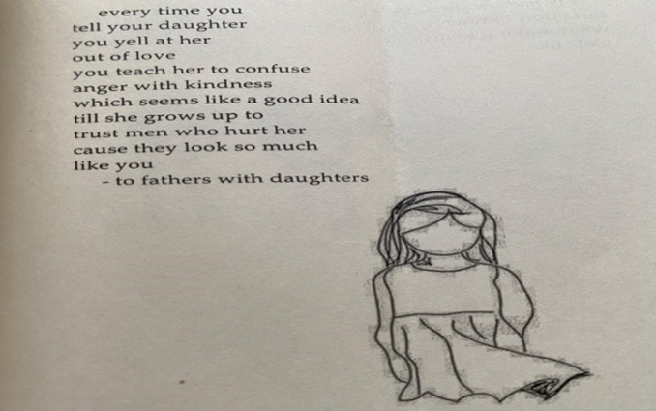
Ilustration 1
- Signifier and Signified
The first poem in the theme The Hurting features an illustration of a faceless girl drawn simply, looking fragile and innocent. This illustration functions as a signifier, namely a visual representation that can be observed physically. Meanwhile, the signified of the illustration is the implied meaning, namely the feeling of loss of identity, emotional vulnerability, and the impact of wrong parenting.
- Message
The contribution between the signifier and the signified in this poem is very important in forming the overall meaning and message. The illustration of a faceless girl who looks fragile as a signifier, combined with the meaning of the loss of identity due to unhealthy parenting as a signified, creates a complementary sign system. Within the framework of Ferdinand de Saussure's semiotic theory, meaning does not only emerge from written text, but also from the relationship between form (signifier) and concept (signified) in a sign. In this case, Rupi Kaur conveys a message not only through words, but also through illustrations that deepen the emotions in her poem. Therefore, the meaning of this poem can only be fully understood if the text and images are read as a mutually reinforcing unity.
The message conveyed through the relationship between the signifier and the signified in this poem illustrates the negative impact of harsh and angry parenting, which is then misinterpreted by the child as a form of affection. In this context, the father is depicted as a figure who vents his affection through anger, and this causes emotional turmoil in the daughter. This poem is a warning that a lack of healthy affection in a parent-child relationship can lead to a loss of self-confidence, self-identity, and unhealthy relationship patterns later in life, especially in a child’s relationship with a boy. This is strongly illustrated through the visual representation of the faceless girl, which reflects a loss of identity and emotional clarity.
The semiotic approach used in this poem also critiques a culture that allows emotional abuse to go unnoticed, and emphasizes that loving parenting is essential in shaping a child’s identity. Overall, the first poem in The Hurting shows how visual and verbal signs work together to form a powerful system of meaning. Through a semiotic approach, this poem is able to voice the emotional wounds of childhood and the importance of gentle parenting for healthy mental development.
Number of Poem : 2
Title : the art of being empty
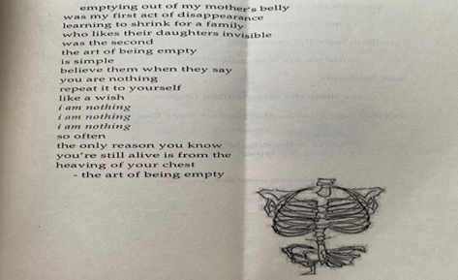
Ilustration 2
- Signifier and Signified
The second poem in The Hurting theme presents an illustration of a human skeleton, with simple lines showing ribs, and roots extending from under the body as if planted. This illustration forms a signifier in the semiotic sign system, while the signified depicts emptiness, fragility, and attachment to the environment or emotional ties that are limiting. The root symbol shows a connection to the past or place of origin that actually makes the individual lose his identity.

- Message
The contribution between the signifier and the signified plays a key role in constructing a comprehensive understanding of the poem. Through a semiotic approach, the interaction between the illustration and the written text forms a unified meaning that deepens the poem’s overall message. These signs do not function independently; instead, they complement each other: the illustration conveys emotional states that are not explicitly stated in the text, while the text clarifies the intended direction of the visual meaning. This shows that the poem's message does not solely rely on the written words, but also depends on the interpretation of visual symbols used by the poet to express inner emotions.
The message of this poem is to describe the condition of someone who feels emotionally constrained by an environment that does not empower him. The skeleton figure with visible roots symbolizes someone who appears physically present but has lost his psychological and emotional essence. The extending roots illustrate invisible yet powerful ties such as familial pressure, cultural expectations, or unresolved past wounds. This poem emphasizes the importance of personal freedom in shaping one’s identity and the need for a supportive space to grow without being restricted by oppressive forces.
Kaur illustrates the psychological realities of her characters with subtle yet powerful imagery. Through her concise poetic language and emotionally charged illustrations, she reveals how someone can appear whole on the outside while quietly enduring deep internal pressures. Unhealthy emotional attachments, if left unaddressed, can gradually erode self-confidence and lead to a loss of meaning in life.
Overall, this second poem demonstrates how semiotic elements are effectively used to voice complex emotional experiences. By combining text and illustration into a unified system of signs, Rupi Kaur delivers a strong depiction of an individual who has lost direction due to being trapped for too long in emotional bonds that hinder growth.

    - The Loving
Number of Poem : 3
Title : -
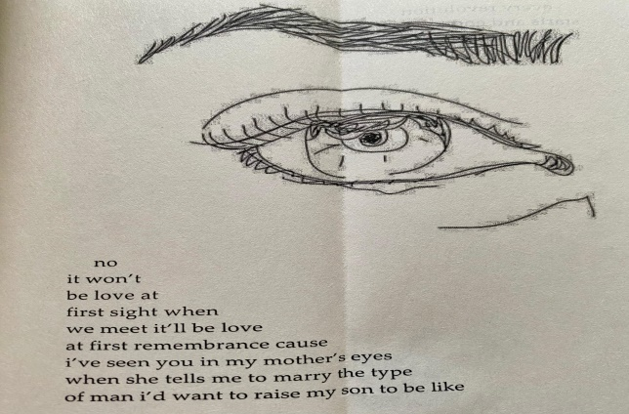
Ilustration 3
- Signifier and Signified
The third poem, included in the theme The Loving, presents an illustration of a human eye drawn in detail, complete with sharp gaze and defined eyebrows. This ilustration functions as the signifier, representing a visual element, while the signified is the underlying meaning reflection, inherited values, and emotional ties to the past. In this poem, the eye becomes a symbol that connects memories of the mother figure, viewed as a source of wisdom, with the character’s understanding of love.
- Message
The relationship between text and illustration conveys the message that true love does not arise from momentary attraction, but from a deep appreciation of values ​​instilled from an early age. The meaning in this poem becomes more impactful because of the integration of language and visuals. Both do not stand alone, but complement each other to convey a unified and emotionally touching message.
According to Ferdinand de Saussure's semiotic theory, meaning is produced through the relationship between form (signifier) ​​and concept (signified). In the context of this poem, the integration between the eye illustration and the text forms a complex and reflective sign system. The meaning offered does not only come from words, but also from a combined reading of visual and verbal signs that form a complete message.
With simple yet touching language, and symbolic illustrations, Rupi Kaur conveys a mature interpretation of love. She shows that love is not just an emotion, but also the result of a learning process, self-awareness, and appreciation of the values ​​inherited from the mother figure. Through a semiotic approach, this poem shows that healthy love is born from clarity of meaning, emotional heritage, and personal introspection.
The main message of this poem is that meaningful love is built on emotional awareness and values ​​internalized from an early age, not on impulsive urges or temporary attractions.
Number of Poem : 4
Title : the perfect date
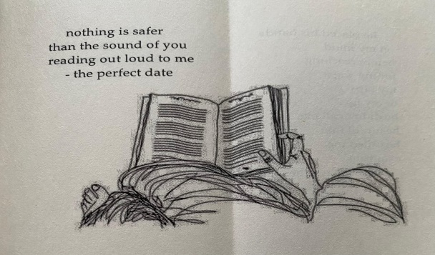
Ilustration 4
- Signifier and Signified
The fourth poem under the theme The Loving features an illustration of a hand holding an open book, accompanied by a relaxed body posture folded legs and a calm atmosphere depicting a quiet moment of reading together. This visual element serves as the signifier, while the signified lies in the symbolic meaning of emotional intimacy, comfort, and a shared closeness rooted in simplicity. The open book becomes a symbol of openness, intellectual bonding, and emotional exchange between two individuals.

- Message
The combination of text and illustration in this poem conveys the message that love is not always shown through dramatic expressions, but through presence and attention in everyday life. The act of reading together,as visualized in the illustration, indicates a subtle yet powerful form of intimacy. The meaning of love in this poem is described as something that grows from quiet togetherness, from the presence of someone completely in simple moments.
Through Ferdinand de Saussure's semiotic theory, the meaning in this poem is formed from the close relationship between the visual form and the concept it contains. Images and text form a system of signs that mutually reinforce each other. Kaur not only conveys meaning through poetic narrative, but also through visual symbols that support the emotional content of the poem. Illustrations become an important part that forms the reader's understanding of the meaning of mature and sincere love.
The language used in this poem is soft and reflective, in harmony with the simple yet meaningful visuals. Kaur conveys that true love does not always come in a large and flashy form, but in a consistent, comfortable presence that can make someone feel enough.
The main message of this poem is that complete love can grow from small things done with sincerity, where comfort and presence become the highest forms of affection.

Number of Poem : 5
Title : -
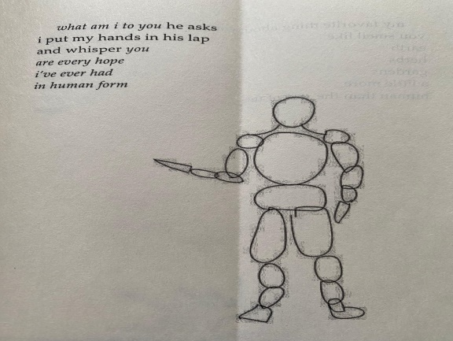
Ilustration 5
- Signifier and Signified
The fifth poem in the theme The Loving presents an illustration of a human figure drawn as a geometric frame resembling a mannequin. This visual acts as the signifier within the semiotic system, while the signified emerges as a representation of human essence that is not defined by physical form but by emotional presence, hope, and the deeper meaning found in emotional connection. The simplicity of the mannequin suggests that the core of one’s existence lies beyond physical appearance.
- Message
From a semiotic perspective, the combination of the mannequin illustration and poetic text forms a system of signs that emphasizes the importance of non-physical values in defining love. The illustration acts as the signifier, depicting a human figure without facial features or physical details. The signified in this context is the idea that love is rooted not in appearance, but in emotional and spiritual connection. According to Ferdinand de Saussure’s theory, meaning does not arise independently from words or images, but through the relationship between them. In this poem, that relationship is used effectively to show that what is loved is not the body, but the soul and the meaning it carries.
Rupi Kaur presents the idea that true love is not about physical possession, but about emotional safety, shared hope, and deep attachment. The faceless and simplified figure reinforces the notion that a person can hold great meaning without conforming to conventional ideas of physical perfection. This visual element enriches the emotional weight of the poem and strengthens the reader's interpretation of the text.
This poem conveys that love is not based on outward appearance, but on the depth of spiritual and emotional connection between individuals. A person becomes the embodiment of hope and affection not because of how they look, but because of the emotional role they play in someone’s life. This message underscores the idea that love is grounded in emotional depth, inner connection, and existential meaning rather than physical presence.

    - The Breaking
Number of Poem : 6
Title : -
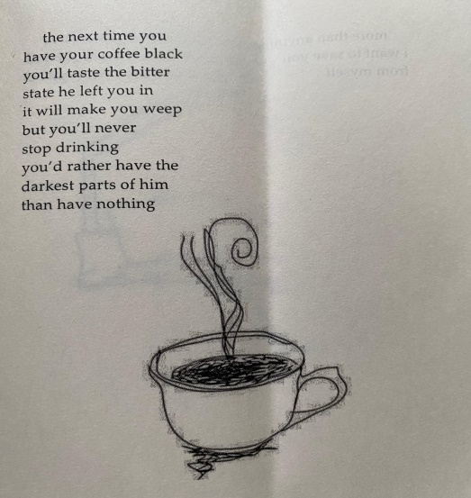
Ilustration 6
- Signifier and Signified
The sixth poem in the theme The Breaking presents an illustration of a black coffee cup with simple lines of steam. This image serves as a signifier, representing something familiar yet deeply symbolic. In the context of the poem, the signified refers to bitterness, restrained tension, and a sense of comfort derived from something that is actually painful.
- Message
The relationship between the illustration and the text forms a meaning that reveals how a person may choose to stay in a painful situation because the fear of loss feels heavier than the pain itself. The image of the coffee cup represents not only a daily habit, but also an emotional attachment that is difficult to release. The meaning of love in this poem is portrayed as paradoxical, where comfort can exist even in situations that hurt.
From the perspective of Ferdinand de Saussure’s semiotic theory, the illustration and the poetic text work together to build a complete sign system. Meaning arises not from a single element, but from the interaction between the visual signifier and the implied concept. This combination shows that the poem voices an emotional dilemma, namely to persist even though knowing that the pain will not go away.
The poem’s language is calm and restrained, reflecting a kind of silent and prolonged suffering. There are no dramatic outbursts, but in that stillness, deep meaning emerges. The main message of this poem is that people often remain in painful love because the fear of losing someone feels more unbearable than the pain of staying.
Number of Poem : 7
Title : -
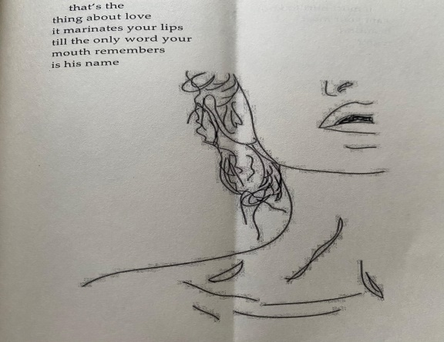
Ilustration 7

- Signifier and Signified
The seventh poem in the theme The Breaking features an illustration of a woman's partial face only the lips, neck, and strands of hair are shown with particular emphasis on the open lips. This visual element serves as the signifier, representing vulnerability, sensuality, and emotional intensity. The signified behind this image is the openness to deep love, but also the emotional surrender that can blur one's sense of self.
- Message
The meaning of the poem is shaped through the close relationship between the illustration and the text. The focus on the open lips conveys a sense of intimacy that is both physical and emotional. In this context, love is portrayed as a powerful force one that can consume an individual, blurring the lines between self-awareness and surrender. The meaning of love in this poem is shown as something seductive, yet capable of erasing one’s sense of identity.
According to Ferdinand de Saussure’s semiotic theory, a sign is formed through the connection between the signifier and the signified. In this poem, the visual and poetic elements combine into a complete sign system. The illustration amplifies the emotional depth of the text, while the text helps interpret the symbolic power of the image. Together, they convey that intense love may bring joy but also poses the risk of losing emotional balance and self-control.
The language used is simple yet emotionally charged. Without explicitly describing conflict, the poem invites readers to sense the quiet emotional weight experienced by the speaker. The main message of this poem is that while love can be fulfilling, it may also become a force that obscures one's identity when one becomes too deeply immersed in it.
Number of Poem : 8
Title : -
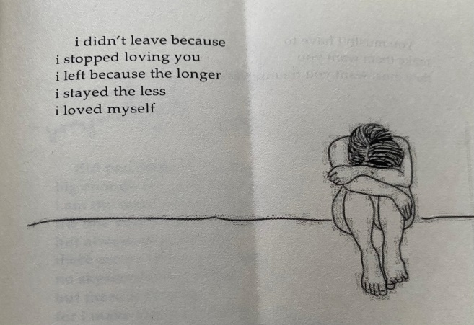
Ilustration 8
- Signifier and Signified
The eighth poem in the theme The Breaking features an illustration of a woman sitting with her body folded, her head bowed, and her hands hugging her knees. Below the image is a horizontal line that depicts a boundary or surface. This illustration functions as a signifier, while the signified contained in it is a symbol of sadness, alienation, and the need for self-reflection. The curled-up body position reflects a closed and wounded emotional condition, while the horizontal line gives the impression of a boundary that must be crossed to get out of the situation.

- Message
The meaning that arises from the combination of text and illustration points to the importance of emotional boundaries and recognizing when love has turned into painful self-sacrifice. The folded posture suggests a desire to protect oneself, while also indicating an imbalance in the relationship. Love in this poem is portrayed as an experience that can cause someone to forget themselves and lose their emotional safety within a relationship.
According to Ferdinand de Saussure’s semiotic theory, meaning is not derived from text or image alone, but through the interaction between both elements as a unified sign system. The image of the woman curled up enhances the emotional tone of the text, while the poem gives context to the illustration as an expression of inner hurt. This combination forms a message that healing cannot begin without the courage to admit that unhealthy love has caused harm to the self.
With simple yet emotionally charged language, Rupi Kaur expresses that true healing begins when one chooses to prioritize self-love. The main message of this poem is that protecting oneself and recognizing emotional boundaries is a vital form of love, especially when a relationship begins to erode one's inner balance.

    - The Healing
Number of Poem : 9
Title : -
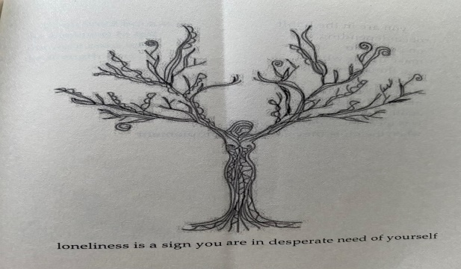
Ilustration 9
- Signifier and Signified
The ninth poem in the theme of The Healing presents an illustration of a tree in the shape of a human body, the middle part resembles a woman's figure, with branches that extend upward like hands, and strong roots below. This ilustration forms a signifier, while the signified that appears is a symbol of life, growth, and connection with oneself and nature. The human figure that merges with the tree illustrates the healing process that comes from awareness of one's existence.
- Message
The meaning constructed in this poem suggests that healing is not only emotional, but also spiritual and existential. The roots represent strength drawn from past experiences, while the branches symbolize forward movement and the potential to grow. The interplay of text and image creates the understanding that healing begins when a person learns to make peace with themselves and rediscovers the inner foundation that was once fractured.
According to Ferdinand de Saussure’s semiotic theory, the relationship between text and illustration forms a unified system of signs. The woman's body, integrated with elements of nature, reflects how the body holds both memory and the capacity for renewal. This interaction between visual signifier and conceptual signified expresses the idea that true healing arises from within, through the process of acknowledgment, acceptance, and personal growth.
The poem’s tone is calm and contemplative, echoing the symbolic weight of the visual, which represents the balance between pain and hope. The main message of this poem is that the strength to heal does not come from outside sources, but from within, through a deep connection with the self, life experience, and the foundational values that shape one’s being.

Number of Poem : 10
Title : women of color
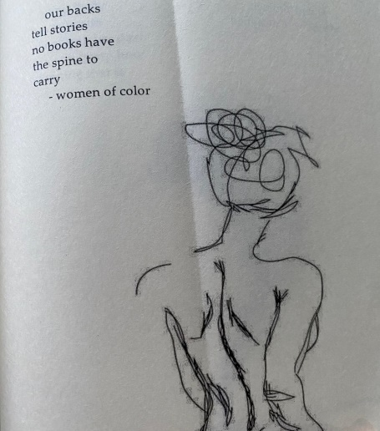
Ilustration 10
- Signifier and Signified
The tenth poem in The Healing theme features an illustration of a woman's back with rough lines resembling wounds, as well as a circle on the head and irregular lines surrounding it. This ilustration forms a signifier, while the signified that is interpreted from it is a symbol of the burden, trauma, and complexity of emotions inherent in the experiences of women, especially women of color. The back shown without a face depicts a space where wounds are secretly stored, while the circle on the head implies the mental pressure that continues to burden.
- Message
The meaning constructed through the relationship between text and illustration suggests that the body becomes a site where pain and personal history are carried in silence. The circle near the head implies ongoing mental pressure, while the wounded back indicates the weight of unspoken trauma. This poem conveys that healing does not mean erasing the pain, but having the courage to accept it as part of one's life journey.
From the perspective of Ferdinand de Saussure’s semiotic theory, the poem’s meaning arises from the interplay between visual form and conceptual message. The image and the poetic text form a sign system that works in harmony to deliver a deep emotional impact. The relationship between signifier and signified in this poem shows that women often carry unspoken histories of pain, etched not only in memory but also within the body itself.
The language used in the poem is concise but powerful, reflecting the emotional tension held in silence. Kaur does not express pain through anger but through meaningful, symbolic imagery. The main message of this poem is that strength lies not in forgetting one's wounds, but in the ability to live through them, to accept them, and to keep moving forward despite their presence.

