ACKNOWLEDGMENT

10. Hai orang-orang yang beriman, sukakah kamu aku tunjukkan suatu perniagaan yang dapat menyelamatkanmu dari azab yang pedih?
11. (yaitu) kamu beriman kepada Allah dan RasulNya dan berjihad di jalan Allah dengan harta dan jiwamu. Itulah yang lebih baik bagimu, jika kamu mengetahui.

First and foremost, the writer expresses deep gratitude to Allah SWT, the Lord of the Universe, for His endless mercy, guidance, and blessings that have made the completion of this thesis possible. Salutations and peace be upon the Prophet Muhammad SAW, the noble role model for all of humanity may we be among those who receive his intercession on the Day of Judgment. Throughout the journey of writing this thesis, the writer has been blessed with invaluable support, motivation, and assistance from many individuals. Therefore, with great humility and sincerity, I wishes to extend heartfelt thanks and appreciation to all who have contributed, whether directly or indirectly, to the completion of this thesis. They are:
- Dr. H. Firmansyah, M.SI, the rector of Universitas Muslim Nusantara Al Washliyah.
- Ayu Melati Ningsih, S.Pd., M.S., M.Pd, the dean of Faculty of Letters. Also served as my thesis advisor, whose invaluable guidance and support helped ease every difficulty the writer encountered throughout the process.
- Diana Sopha, S.S., M.Hum, the deputy dean of Faculty of Letters.

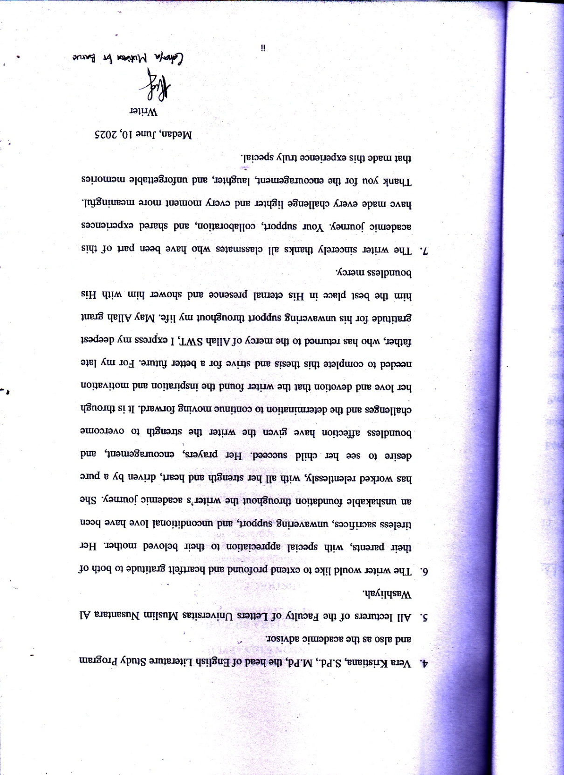

TABLE OF CONTENTS

ACKNOWLEDGMENT i
ABSTRACT iii
ABSTRAK iv
TABLE OF CONTENTS v
CHAPTER I INTRODUCTION 1
1.1 Background of Research 1
1.2 Identification of Problems 4
1.3 Limitation of Problems 4
1.4 Problems Statement 4
1.5 Objectives of Research 5
1.6 Significant of Research 5
CHAPTER II REVIEW OF LITERATURE 6
2.1 Struggle 6
2.2 Literary Works 9
2.3 Novel 11
2.4 Main Character 12
2.5 Synopsis Kidnapped by Robert Louis Stevenson 14
2.6 Previous Research 15
CHAPTER III METHODOLOGY 18
3.1 Method of Research 18
3.2 Data and Source of Data 20
3.3 Technique of Collecting Data 22
3.4 Technique of Analyzing Data 23
CHAPTER IV FINDINGS AND DISCUSSION 25
4.1 Findings 25
4.2 Discussion 29
CHAPTER V CONCLUSIONS 54
5.1 Conclusions 54
5.2 Suggestions 55
REFERENCES 56

LIST OF TABLES

Table 4. 1 Overall Findings of Struggle in The Novel Result 29
Table 4. 2 The Findings of The Struggle in The Chapter I 30
Table 4. 3 The Findings of The Struggle in The Chapter 3 31
Table 4. 4 The Findings of The Struggle in The Chapter 4 32
Table 4. 5 The Findings of The Struggle in The Chapter 5 33
Table 4. 6 The Findings of The Struggle in The Chapter 7 33
Table 4. 7 The Findings of The Struggle in The Chapter 8 34
Table 4. 8 The Findings of The Struggle in The Chapter 9 35
Table 4. 9 The Findings of The Struggle in The Chapter I3 36
Table 4. 10 The Findings of The Struggle in The Chapter I4 37
Table 4. 11 The Findings of The Struggle in The Chapter I5 38
Table 4. 12 The Findings of The Struggle in The Chapter 20 39
Table 4. 13 The Findings of The Struggle in The Chapter 23 41
Table 4. 14 The Findings of The Struggle in The Chapter 24 42
Table 4. 15 The Findings of The Struggle in The Chapter 26 44
Table 4. 16 The Findings of The Struggle in The Chapter 27 46
Table 4. 17 The Findings of The Struggle in The Chapter 28 46
Table 4. 18 The Findings of The Struggle in The Chapter 29 48
Table 4. 19 The Findings of The Struggle in The Chapter 30 50

