THE EFFECTS OF INSTRUCTIONAL APPROACHES AND MOTIVATION ON STUDENTS’ READING COMPREHENSIVE AT MTSs AMAL
SHALEH SIMALINGKAR

THESIS

By
KUMALA SARI
227215007



GRADUATE PROGRAME ENGLISH EDUCATION DEPARTMENT
MUSLIM NUSANTARA AL-WASHLIYAH UNIVERSITY
MEDAN

2024

THE EFFECTS OF INSTRUCTIONAL APPROACHES AND MOTIVATION ON STUDENTS’ READING COMPREHENSIVE AT MTSs AMAL
SHALEH SIMALINGKAR

THESIS

Submitted To Fulfill The Requirements To Obtain A Master's Degree In Education At Universitas Muslim Nusantara Al Washliyah

By
KUMALA SARI
227215007

GRADUATE PROGRAME ENGLISH EDUCATION DEPARTMENT
MUSLIM NUSANTARA AL-WASHLIYAH UNIVERSITY
MEDAN

2024

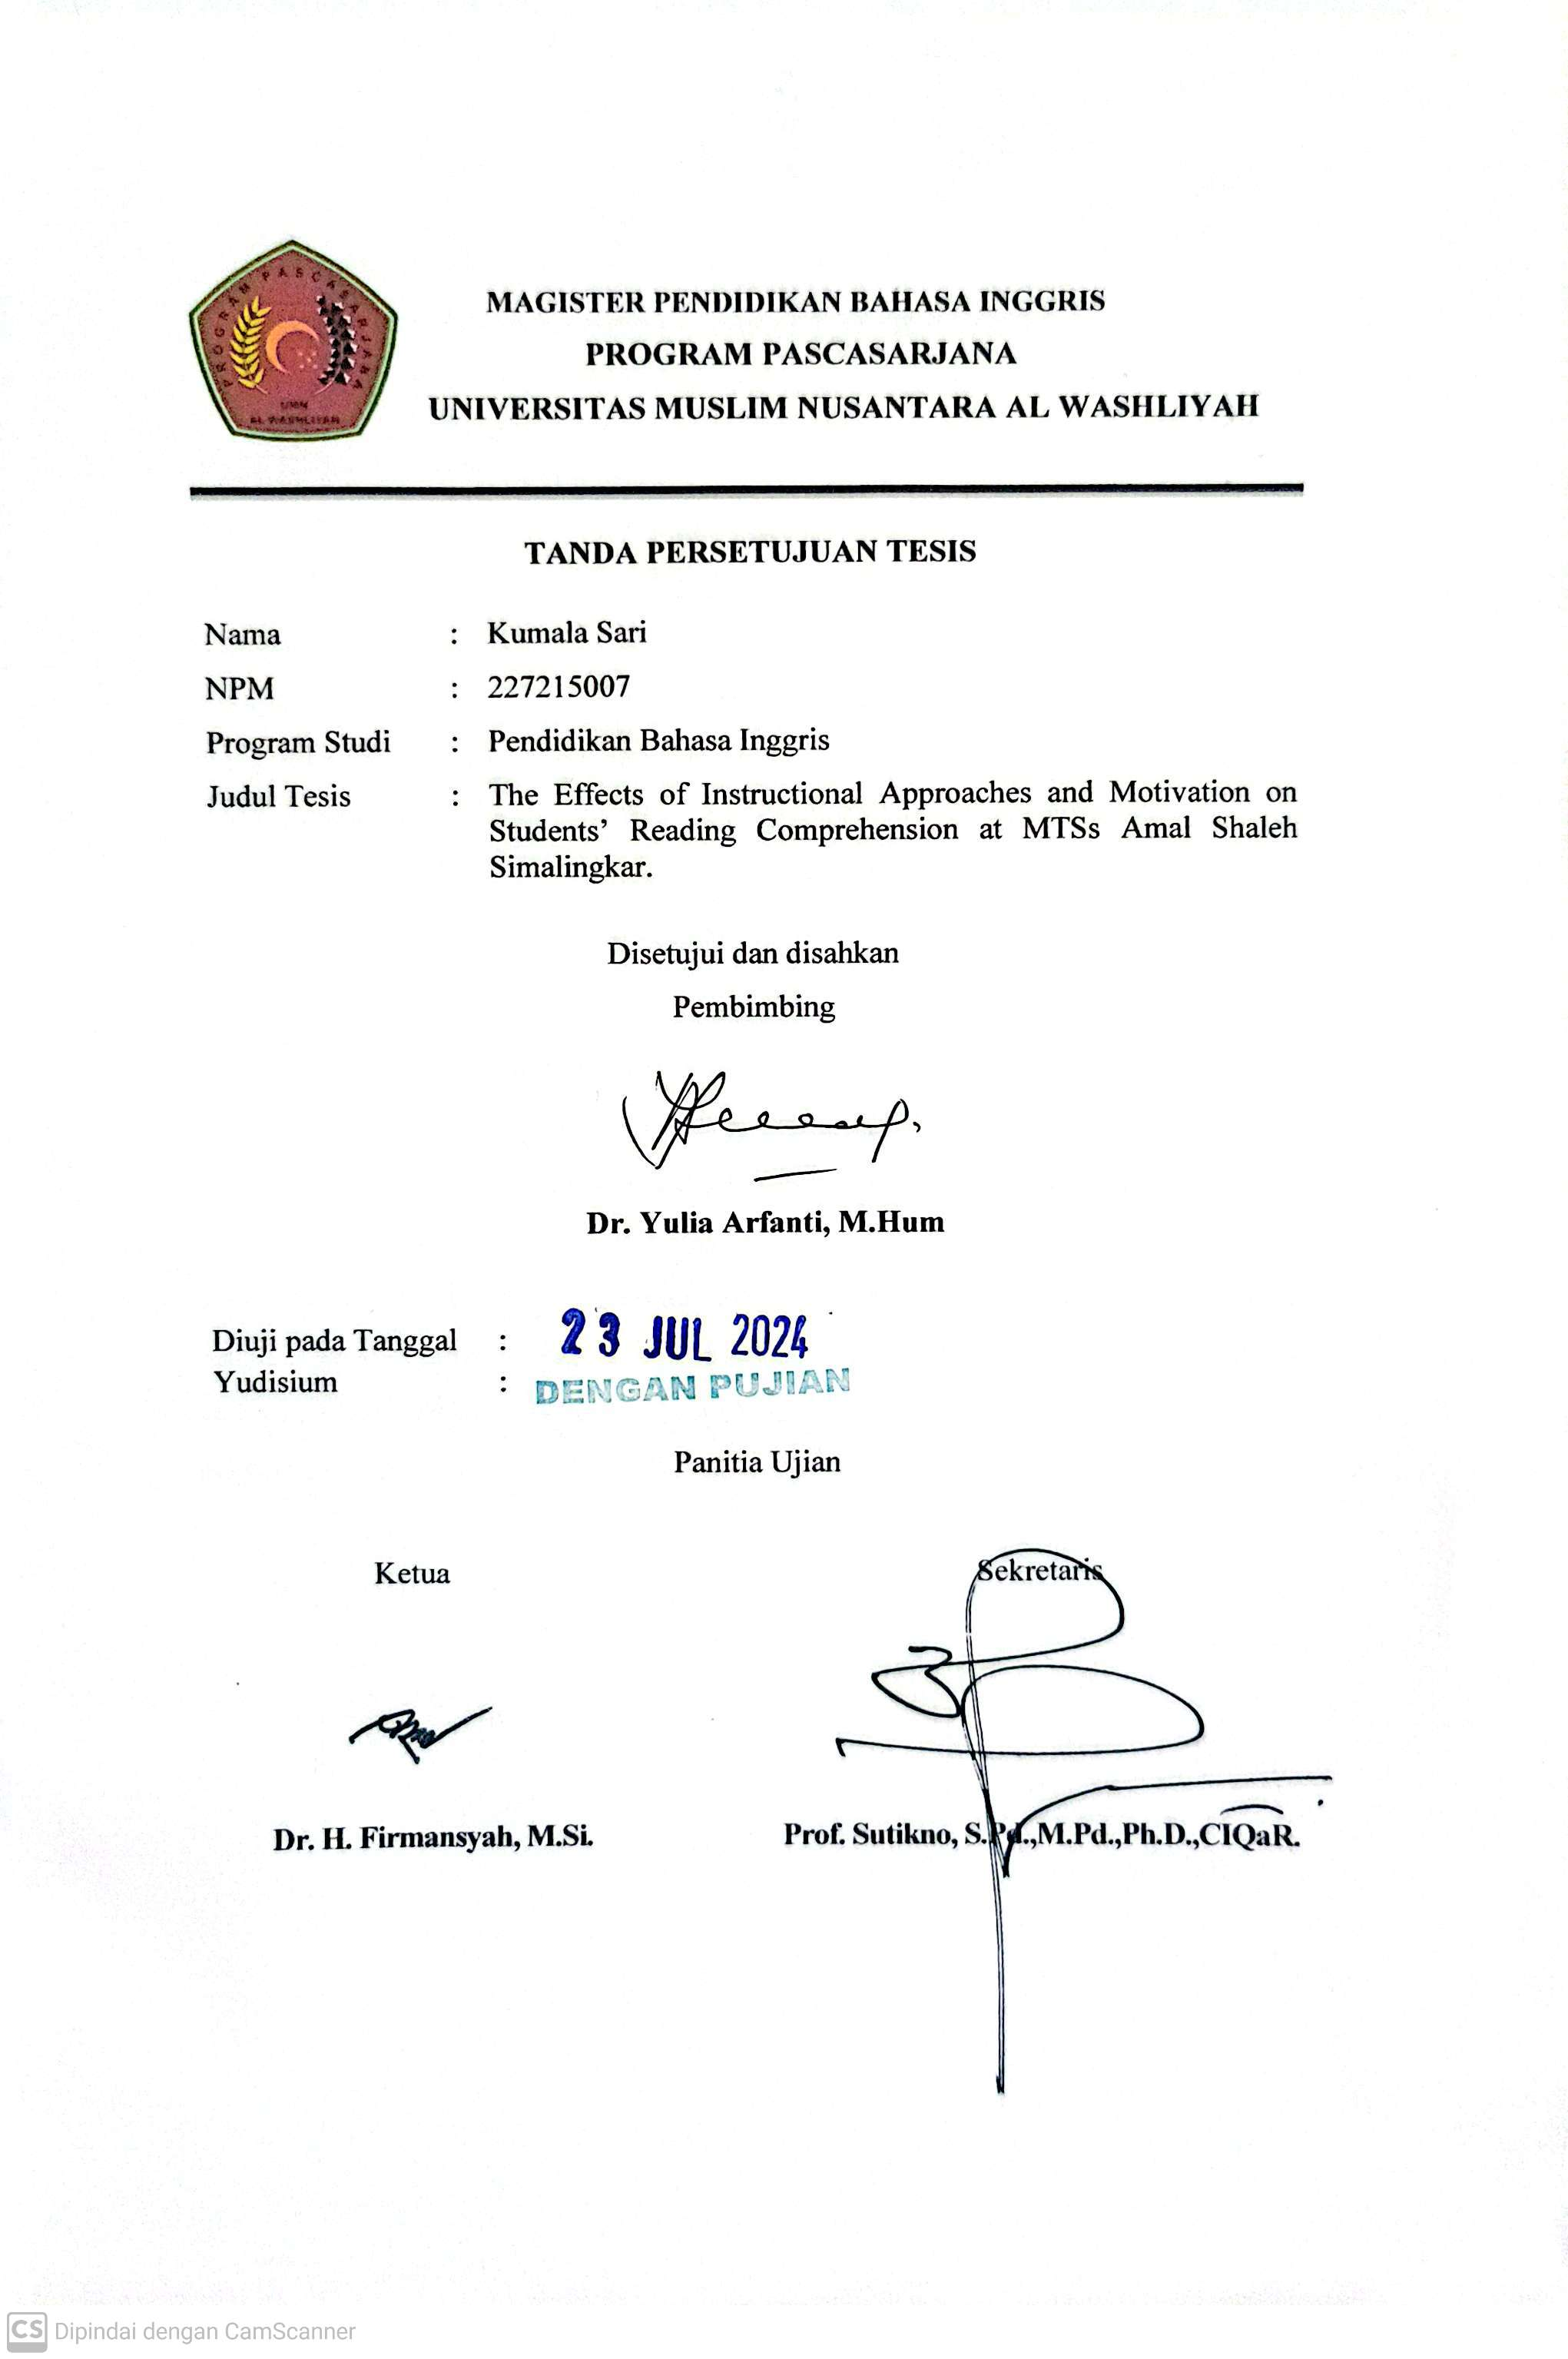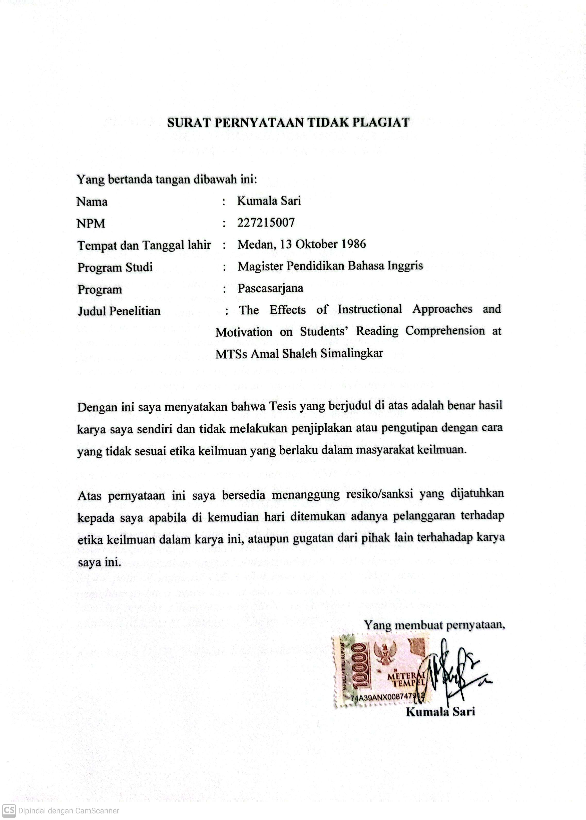

PENGARUH PENDEKATAN INSTRUKSIONAL DAN MOTIVASI TERHADAP PEMAHAMAN MEMBACA SISWA
DI MTS AMAL SHALEH SIMALINGKAR

KUMALA SARI
NPM. 227215007

ABSTRAK

Pemahaman baca (reading comprehension) adalah kemampuan penting yang menjadi dasar untuk pembelajaran yang efektif dan pertumbuhan intelektual siswa. Pendekatan GSSR yang komprehensif melampaui ruang kelas, menanamkan kecintaan membaca seumur hidup. Area penting dalam psikologi pendidikan adalah hubungan antara motivasi dan pemahaman baca, yang mempengaruhi keterlibatan siswa, ketekunan, dan pada akhirnya, prestasi akademik.Tujuan penelitian ini adalah untuk menentukan apakah pendekatan GSSR lebih baik daripada yang tidak diberikan perlakuan GSSR, untuk menentukan apakah pemahaman baca siswa yang diberi motivasi lebih baik daripada yang tidak diberi motivasi, dan untuk menentukan apakah ada hubungan antara pengajaran pendekatan GSSR versus pendekatan konvensional dan tingkat motivasi terhadap pemahaman baca siswa. Desain penelitian ini menggunakan desain kuantitatif. Lokasi penelitian ini di MTSs Amal Saleh. Sampel penelitian ini adalah siswa kelas 8A, 8B, dan 8C. yang berjumlah 62 orang siswa. Analisis data penelitian ini menggunakan analisis deskriptif, uji Wilcoxon, dan uji N-gain Score. Hasil penelitian menunjukkan bahwa metode GSSR lebih baik daripada metode konvensional dalam meningkatkan pemahaman baca siswa dengan persentase kelulusan siswa sebesar 55% dan 81,81% dan skor rata-rata siswa adalah 70,25 dan 77,75, yang diperoleh dari kelas 8B dan 8C. Peningkatan pemahaman baca siswa dengan motivasi tinggi lebih baik daripada peningkatan pemahaman baca siswa dengan motivasi rendah. Hal ini dibuktikan karena metode GSSR + Motivasi mampu meningkatkan tingkat kelulusan sebesar 76,81% dan skor rata-rata sebesar 38,44 poin. Kombinasi GSSR dan motivasi cukup efektif untuk meningkatkan pemahaman baca siswa karena nilai rata-rata persentase N-gain adalah 62,61. Skor ini berada dalam kisaran 56-75, yang berarti penerapan metode GSSR + Motivasi di kelas 8C dianggap "Cukup Efektif".

Kata kunci: GSSR, Motivasi, Pemahaman Baca, N-Gain

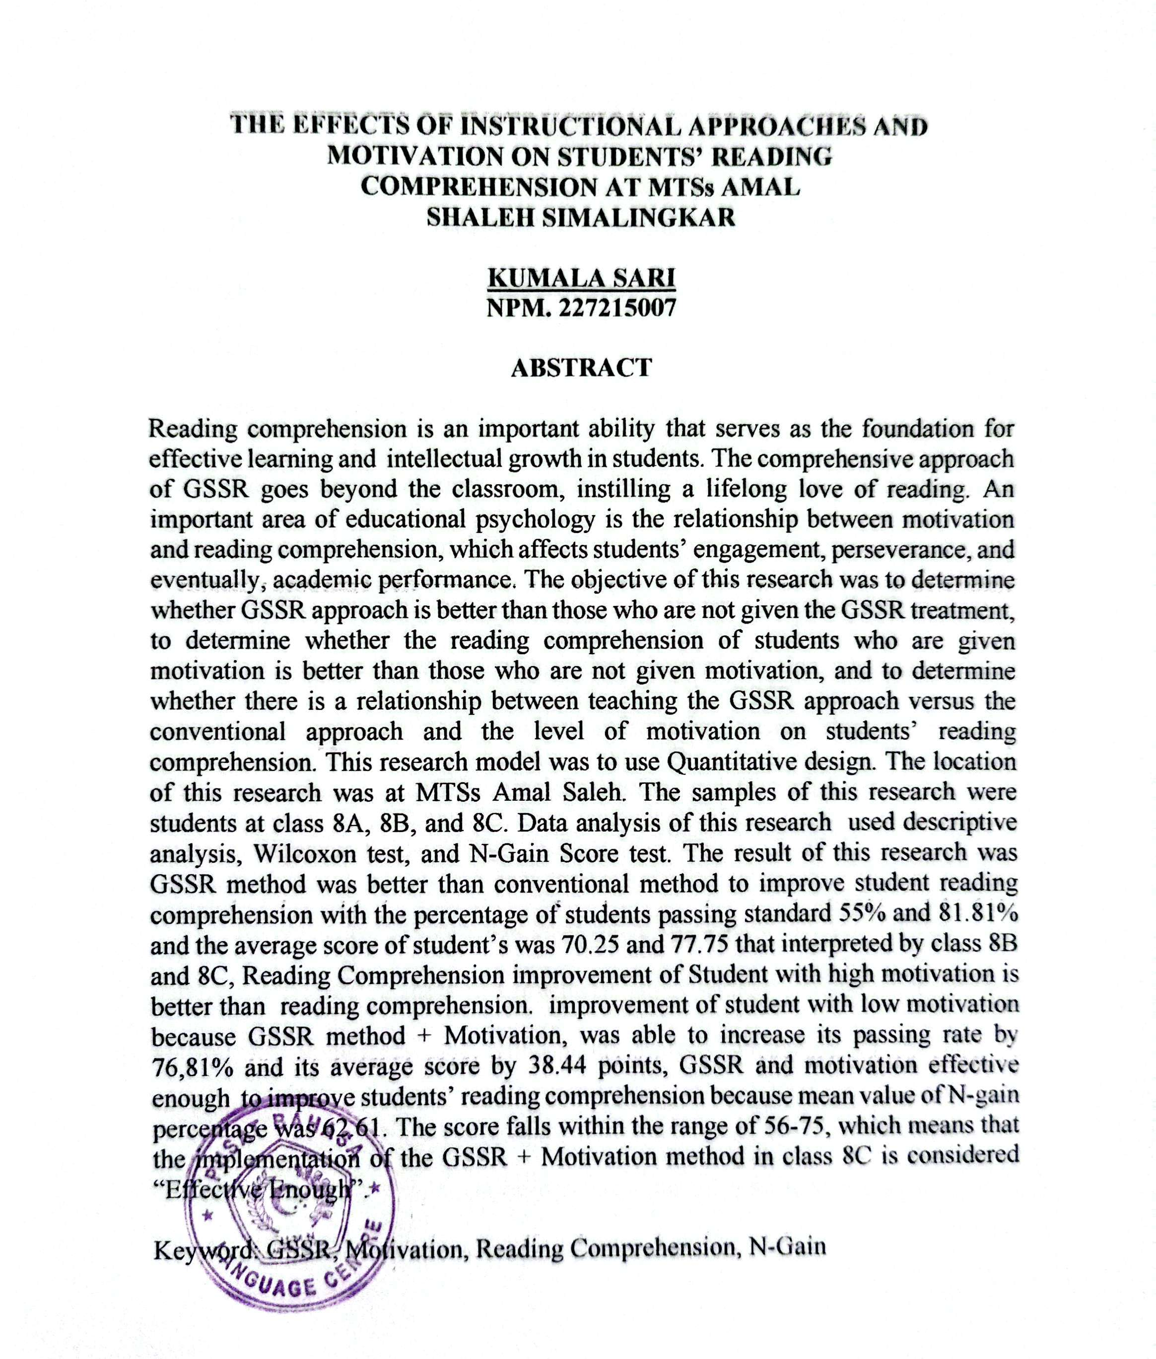

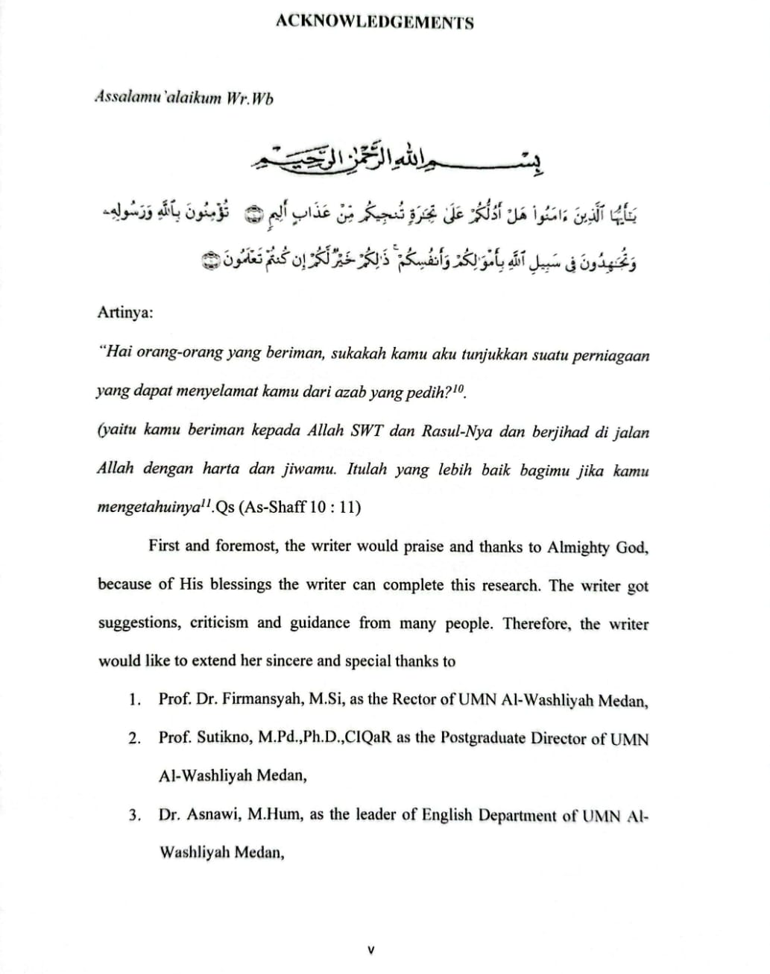

TABLE OF CONTENTS

TABLE of CONTENTS ii
LIST of TABLE iv
LIST of FIGURE v
LIST of APPENDICES vi
CHAPTER I INTRODUCTION 1
- Background of the Problem 1
- Problem Identification 15
- Problem Limitation 16
- Problem Formulation 17
- Research Objectives 17
- Signifcance of the Study 18
CHAPTER II REVIEW OF LITERATURE 19
- Theoritical Framework 19
  - Reading Comprehensive 19
  - Guided Self-Selected Reading (GSSR) Approach 21
    - Definition 21
    - The Principles of Guided Self-Selected Reading (GSSR) 29
    - Design 43
    - Procedure 52
    - Advantage and Disadvantage 69
  - Conventional Approach (Text-Based Questions) 72
    - Definition 72
    - The Principles of Text-Based Questions 73
    - Design 75
    - Procedure 77
    - Advantage and Disadvantage 79
  - Motivation 81
- Relevant Study 84
- Conceptual Framework 90
- Hypothesis 94
CHAPTER III RESEARCH METHODOLOGY 96
- Time and Place of Study 96
- Population and Sample 97
- Research Method 97
- Instrumentation 98
  - Reading Test 98
    - Conceptual Definition 98
    - Operational Definition 98
    - Spesification 98
    - Caliberation 100
      - Validity 100
      - Reliability 102
  - Motivation Questionaire 104
    - Conceptual Definition 104
    - Operational Definition 104
    - Spesification 105
    - Caliberation 105
      - Validity 105
      - Reliability 106
- Research Prosedure 107
  - Treatment 107
  - Internal and External Validity 107
- Data Analysis 107
CHAPER IV ANALYZE AND DISCUSSION 109
- Analyze 109
  - Pre-test Phase (Instrument Test) 109
    - Students’ Reading Comprehensive Observation 109
    - Students Motivation Observation 113
  - Post-test phase (Instrument Test) 114
    - Students Motivation Observation 114
    - Students Reading Comprehensive 116
  - Wilcoxon Test 120
  - N-Gain Percentage Test 125
  - Hypothesis Test 127
- Discussion 130
CHAPTER V CONCLUSION AND SUGESTION 134
- Conclusion 134
- Sugestion 134
REFERENCES 136
APPENDICES 141

LIST OF TABLE

Table 1 : Random Test | 5
Table 2 : Guided Self-Selected Reading | 50
Table 3: Time of Research Schedule | 95
Table 4: The Spesification of Students Success In Reading Comprehensive | 99
Table 5: Validity of Reading Comprehensive (pre-test) | 101
Table 6: Validity Of Reading Comprehensive (post-test) | 101
Tabel 7: Reliability Scale | 103
Table 8: Reliability of Reading Comprehensive (pre-test) | 103
Table 9: Reliability of Reading Comprehensive (pre-test) | 104
Table 10: Validity of Motivation Questionaire (pre-test) | 111
Table 11: Reliability of Motivation Questionaire (pre-test) | 112
Table 12: Status Category of N-Gain Effectivity | 107
Table 13: Reading Comprehensive Observation (8A Pre-test) | 109
Table 14: Reading Comprehensive Observation (8b Pre-Test) | 110
Table 15: Reading Comprehensive (8c) Pre-Test | 111
Table 16: Students’ Level of Motivation | 113
Table 17: Students’ Motivation Observed | 115
Table 18: Students’ Reading Comprehensive Level (8A) Untreatment Class | 116
Table 19: Students’ Reading Comprehensive (8B Gssr Class) | 117
Table 20: Students’ Reading Comprehensive Level (8C Class) | 119
Table 21: Wilcoxon Signed Rank Test | 120
Table 22: Test-Statistic (8A) | 121
Table 23: Wilcoxon Signed Rank Test | 122
Table 24: Test-Statistic (8B) | 123
Table 25: Wilcoxon Test (8C) | 124

Table 26: Test-Statistic (8C) 125
Table 27: N-Gain Percentage 126

LIST OF FIGURE
Figure 1: GSSR Design 52
Figure 2: Framework of Thinking 94
Figure 3: Students’development 127

LIST Of APPENDICES
Appendices 1: reading comprehensive 142
Appendices 2: Reading comprehensive tests 148
Appendices 3: reading comprehensive test (post-test) 154
Appendices 4 : obsevation chcklist:implementation of GSSR 158

CHAPTER I INTRODUCTION

Background of the Problem
Reading comprehensive is an important ability that serves as the foundation for effective learning and intellectual growth in student. Understanding texts enables students to not only absorb knowledge, but also evaluate, interpret, and link previously taught concepts. In this writing, we will look at the importance of reading comprehensive in the context of learning and students' intellectual development. First and foremost, reading comprehensive serves as a firm basis for the learning process.
Students with a thorough grasp of texts may access information offered in a variety of media, such as textbooks, articles, and course materials. This is critical since learning occurs not just in the classroom, but also via independent reading and study. When students have good reading and comprehensive abilities, they can successfully explore and learn from a variety of resources. Furthermore, reading comprehensive allows students to retrieve accurate information. This involves the capacity to locate data, understand major concepts, and recognize supporting details. With this talent, students can comprehend the substance of the texts they read, broadening their comprehensive of the issues under study.
Furthermore, reading comprehensive enables students to evaluate the substance of texts. They can assess the arguments offered, recognize text structures, and comprehend the author's intent and message. This helps students

develop critical thinking abilities, which are necessary for processing complicated material and reaching evidence-based decisions. Furthermore, reading comprehensive enables students to connect the topics they acquire to past knowledge. This allows them to have a better comprehensive of the things being studied and make connections between various concepts. Thus, reading comprehensive allows students to not only absorb isolated chunks of information, but also to integrate and broaden their total knowledge base.
Furthermore, reading comprehensive plays an important role in the development of students' critical thinking skills. Through text analysis and assessment, students learn to analyze material, generate evidence-based conclusions, and critique offered arguments. These critical thinking abilities are essential for preparing students to face academic and professional problems in the future. Mpofu and Mavambe (2023:352) in their research Teachers’ Self-Reported Instructional Practices for Reading Comprehensive Instruction to Non-Readers stated :
"The participants recommended reading aloud, the phonic method, prediction, summarisation and skimming and scanning as traditional strategies for teaching reading comprehensive to non-readers. Most importantly, they strongly believed that teachers’ beliefs and expertise enabled them to reflect on their teaching, identifying texts and pedagogical activities that were in line with non-readers’ level of literacy development. Above all, appropriate teaching strategies that incorporate schema theory, reflective practice, and teachers’ expertise, work collectively in improving non-readers’ competency in reading comprehensive”.

Based on this research, reading comprehensive helps children strengthen their literacy abilities overall. Students learn new vocabulary and linguistic structures by reading and comprehending a variety of books on a regular basis. This

improves their capacity to communicate effectively, both vocally and in writing, which is a necessary skill in many facets of life.
Educators use a variety of instructional techniques in the classroom, particularly when teaching reading comprehensive, to accommodate students' varying requirements and learning styles. These techniques include guided reading, self-selected reading, and a combination of the two. This writing goes into the complexities of each strategy and how they affect students' comprehensive skills and motivation to read. Guided reading is a structured strategy in which teachers offer explicit teaching and support to small groups of students while they read books appropriate for their instructional level. The instructor chooses appropriate books and helps students with reading methods, comprehensive skills, and vocabulary growth.
This strategy allows instructors to scaffold students' learning, progressively reducing responsibilities as students improve their reading skills. Guided reading creates a supportive atmosphere in which students may practice and apply reading skills with the assistance of their instructor, resulting in increased comprehensive and confidence. Self-selected reading, on the other hand, allows students to pick reading materials based on their own unique interests, preferences, and reading levels.
This method stresses student autonomy and intrinsic motivation in reading. Self-selected reading encourages student involvement and pleasure of reading activities by allowing them to choose books that are relevant to their interests.

Students are more likely to devote time and effort to reading when they are really interested in the subject matter, resulting in increased understanding and a good attitude toward reading. According to Paulson (2006:52) “reading for enjoyment, with all its implementation challenges, is key to the goal of creating life-long readers at the college level”.
Another equally important study in improving students' vocabulary acquisition and comprehensive through reading is the research on "Sustained Silent Reading" and "Extensive Reading Programs," which has shown that these programs have a moderate to strong effect on vocabulary development and reading comprehensive compared to traditional instruction, Self-selected reading is the kind of reading we do because we want to. SSR means allowing students to read whatever they want to read in school (within reason) for a short time each day, usually 10–15 minutes. Mason and Krashen (2017). Permatasari and Wienanda (2023:229) in their research Extensive Reading in Improving Reading Motivation: A Students’ Perspective stated :
“Extensive reading experiences and structured reading proggrams can significantly enhance students' reading motivation, efficacy,and engagement in reading activities. The evidence provided in this discussion aligns with previous research, indicating that when students are exposed to reading materials that are engaging, relevant to their interests, and offered in a structured program, they are more likely to develop a love for reading, which can lead to improved academic and personal growth. By providing students with a wide range of reading materials and activities to choose from, increasing the likelihood of finding material that resonates with their interests, teachers can help cultivate a love of reading in their students”.

Based on this research we know that students' motivation, effectiveness, and engagement in reading are greatly increased by extensive reading experiences and organized programs. Students develop a love of reading and achieve both academic and personal progress when they are exposed to interesting materials that are in line with their interests within a disesasciplined framework. Having a large selection of resources makes it more likely that students will discover something they can relate to, which promotes active reading. The development of a love of reading through organized programs enhances kids' academic performance and personal growth in the long run.
However, in reality, students' reading comprehensive level in foreign languages can still be considered low or even very inadequate. Sampel case is happen MTSs Amal Shaleh Simalingkar.
Table 1. Random test of Student’s Reading Comprehensive Level

NO | Name of Student | Reading Comprehensive | Criteria
1 | Fariza Aldafa | 5 | Not pass
2 | Nayla Nurul Azkia | 6 | Not pass
3 | Keysha Kania | 5 | Not pass
4 | Zakli Alvan Praditya | 7 | Not pass
5 | Nayla Khalisah | 5 | Not pass
6 | Citra Zhafirah | 5 | Not pass
7 | Raihan Fathaillah | 5 | Not pass
8 | Kaliana | 8 | Pass
9 | Clarissa Ufaira Hutauruk | 8 | Pass
10 | Nadira Syafira | 7 | Not pass

As can be seen from Table 1 above, just two of the ten students who took part in the random test on reading comprehensive passed it, meaning that only 20% of students have a decent level of reading comprehensive. Given that one of the first steps in teaching pupils is reading comprehensive, this presents serious concerns for the researcher.
Furthermore, some instructors use a blend of guided and self-selected reading to enjoy the benefits of both methods. In this hybrid method, teachers use guided reading sessions to give targeted teaching and assistance, while simultaneously giving time for self-selected reading activities in which students choose their own reading materials. This balanced approach builds on the benefits of each technique while responding to individuals' specific requirements and preferences. It promotes a comprehensive approach to reading education, covering both the instructional and motivating components of reading comprehensive. The educational style used can have a major impact on students' comprehensive and motivation to read.
Guided reading provides systematic guidance and targeted teaching, helping students improve their comprehensive abilities and gain confidence as readers. Self-selected reading fosters autonomy and intrinsic drive, resulting in greater engagement and enjoyment of reading. By integrating these techniques, educators may create a dynamic and inclusive learning environment that develops students' reading skills while instilling a love of reading. In the field of education, the method to teaching reading comprehensive has developed to incorporate a mix of

student autonomy and instructor assistance. One such strategy that is gaining popularity is Guided Self-Selected Reading (GSSR).
Another study that aligns with the concept of extensive reading found an exceptionally effective and worthy approach that does not impose pressure or burden on readers, even in challenging situations. This is due to the voluntary selection of graded reading materials, ranging from easy to difficult, based on each student's language proficiency (Al-Hamoud & Schmitt, 2009). Furthermore, in line with this, it has been found that reading for pleasure and voluntarily is six times faster than direct instruction programs in enhancing vocabulary growth and other skills such as writing and speaking fluently (McQuillan, 2020).
According to Mason (2019:448) “During this pre-instructional approach stage, books are selected beforehand by the teacher. The teacher's selection of books is based on their experience in knowing which books will be both engaging and easily understood by students”. She also added that based on experience, many students are unsure which books to choose and at what level when first introduced to this reading instruction program, so they require guidance and advice.
At its foundation, GSSR promotes student empowerment by allowing them to select reading materials based on their unique interests and levels of skill. This autonomy instills in kids a sense of ownership and passion for their reading experiences. However, what distinguishes GSSR is the teacher's critical role in offering direction and assistance throughout the process. The symbiotic link

between student autonomy and teacher direction is the foundation of GSSR. Students exercise their agency by choosing reading materials that are relevant to their interests and preferences. Students are encouraged to pursue their interests, whether it is in historical fiction, scientific discoveries, or magical places. This inner incentive drives their interest and investment in the reading experience.
However, despite the freedom of choice, the instructor plays an important role as a facilitator and mentor. The instructor, armed with pedagogical skills, advises students on how to pick acceptable texts, navigate challenging passages, and use comprehensive tactics. Teachers use scaffolded education to support students' knowledge and interpretation of texts. This individualized approach guarantees that students receive specialized assistance that addresses their specific requirements and concerns.
Motivation is a fundamental component of education, serving as a motivator for successful learning and academic accomplishment. It is the driving force behind students' involvement, perseverance, and eagerness to dive into the complexities of education. In this writing, we will look at motivation's varied function in the learning process, with a focus on how it affects students' engagement and understanding, particularly while reading. At its core, motivation refers to the internal and environmental elements that drive people to pursue and continue in their educational pursuits. While external prizes and recognition are important, intrinsic motivation stems from personal interest, curiosity, and a genuine want to learn. Students that are intrinsically motivated are driven by a

genuine desire to learn and comprehend, rather than by extrinsic rewards or demands.
In the field of reading comprehensive, intrinsic motivation emerges as a powerful factor that shapes students' attitudes and behaviors toward reading. Intrinsically motivated students have a real interest in investigating texts, driven by a desire to comprehend, evaluate, and draw meaning from the written word. They see reading as an enjoyable and intellectually stimulating hobby, rather than a necessary scholastic need. The intrinsic drive to learn has a significant impact on student participation in the learning process. Motivated students are more likely to actively participate in reading activities, excitedly immerse themselves in difficult books, and persevere in the face of challenges or failures. Their inner drive fosters a feeling of curiosity and inquiry, motivating people to seek new knowledge and get a better comprehensive of complicated subjects.
According to Pematasari and Wienanda (2023:220) : “......extensive reading practice helps students improving their reading motivation in general, through enjoyment on familiar subjects, reading efficacy, as well as engagement on new topics”. Furthermore, intrinsic drive promotes deeper learning and retention of knowledge. Students who are really engaged and invested in the subject matter are more likely to digest the content in depth, making connections, asking questions, and drawing conclusions.
This active interaction helps students build meaningful knowledge structures, allowing them to internalize and apply what they've learned. Furthermore,

intrinsic drive promotes self-regulated learning. Motivated students take the initiative and responsibility for their own learning, setting objectives, tracking their progress, and using successful learning practices. They have a growth mentality, perceiving problems as chances for development and seeing effort as a means to mastery.
Finally, motivation is critical in molding students' involvement and understanding in the learning process, especially when it comes to reading. Intrinsically motivated students are driven by a real desire to learn, which fuels their active involvement, profound knowledge, and self-regulated learning habits. As educators, we must promote and nurture intrinsic motivation in our students, instilling a love of learning that extends beyond the classroom and paves the path for lifelong intellectual growth and pleasure.
Guided Self-Selected Reading (GSSR) is an innovative method to reading education that combines student autonomy with instructor assistance. This writing digs into the complex link between GSSR and motivation, emphasizing how student choice may feed intrinsic motivation and promote a greater commitment to studying the material. The notion of allowing students to take control of their reading experiences by picking books that align with their interests, preferences, and skill levels is central to GSSR practice.
By allowing children to choose their own reading materials, GSSR fosters a sense of ownership and involvement in the reading experience. Students no longer see reading as a passive activity imposed by external forces, but rather as a chance

for inquiry, discovery, and personal progress. Making meaningful choices empowers students, instilling a feeling of intrinsic desire. Intrinsic motivation emerges from inside the individual, motivated by a real interest in the work at hand rather than external rewards or incentives. When students have the opportunity to choose reading materials that are relevant to their interests and curiosity, they are more likely to approach the job with excitement, engagement, and a real desire to comprehend the book.
According to Mason (2019:446) in her research Guided SSR before Self- Selected Reading :” The goal of the reading program is not limited to highly motivated students, but to help every student increase their English competence through reading to the point where once they graduate or finish the program, they can continue to improve and grow on their own”. This means that the reading program's objective is to help all students improve their English reading skills, rather than only those who are highly motivated. The goal is for students to be able to continue developing and evolving on their own once they graduate or finish the program.
This suggests that the goal of the reading program is to enable each student to become a proficient reader who can continue to study and grow in English even after they leave the traditional classroom. This writing digs into the intricacies of GSSR, explaining its technique, advantages, and influence on students' reading comprehensive. GSSR combines the core of two seemingly different ideas: student-selected reading and teacher-guided teaching. “Where students begin at the lowest level of graded readers in a GSSR curriculum. This guarantees stress-

free,. successful reading on the first day. The 200-headword level Penguin graded readers are the one I use.
On the first day of the program, I have seen that many older students (junior high school to senior citizens) who have little experience reading in English can read a graded reader at this level in 10 to 30 minutes in one sitting. Individuals who can read a book with 200 words or more in 10 minutes have the potential to advance quickly, while those who find it difficult to read and need 30 minutes to finish a book at this level will go more slowly and should be recommended to read something easier to difficult”. Mason (2019:447)
Furthermore, According to Mason (2019:446): “One of the primary goals for teachers is to help students discover captivating reading material, often in book form, that is so engaging that the reader forgets it's written in a foreign language. Encouraging self-selected reading is the best method to ensure this happens”. Based on this statement GSSR promotes differentiation and tailored learning. Students with various reading skills and interests are served by a wide range of reading resources. This flexibility meets the different requirements of students, allowing each person to proceed at their own speed and discover materials that are relevant to their interests and talents.
The comprehensive approach of GSSR goes beyond the classroom, instilling a lifelong love of reading. By letting students to choose their own reading materials, GSSR fosters independent reading and critical thinking practices. Furthermore, instructors' assistance provides students with key comprehensive

skills and methods, allowing them to confidently and proficiently traverse a diverse range of texts.
Guided Self-Selected Reading (GSSR) reflects a paradigm change in reading education, balancing student autonomy with instructor assistance. By combining choice with scaffolded education, GSSR prepares students to be discerning readers, critical thinkers, and lifelong learners. As instructors continue to embrace new techniques such as GSSR, they pave the path for a generation of kids who have the skills and enthusiasm for reading to excel beyond the classroom.
Furthermore, the sense of control provided by GSSR increases students' sense of agency and self-efficacy in their reading skills. When students have the freedom to choose what they read, they see themselves as active participants in their learning process, capable of making informed judgments and navigating the text's intricacies. This perception of expertise and mastery creates a positive feedback loop, which boosts students' confidence and willingness to tackle more difficult books. Additionally, because GSSR is individualized, students are able to create deep connections between the readings they are assigned and their own interests, experiences, and goals.
When students immerse themselves in texts that are relevant to their life, they are more likely to acquire a profound curiosity and emotional commitment in the subject. This emotional connection boosts intrinsic motivation, encouraging students to dive deeper into the material, ask probing questions, and seek solutions. Fundamentally, GSSR and motivation have a symbiotic connection in

which they both strengthen and magnify one another. By giving students power over their reading choices, GSSR sparks intrinsic drive, motivating students to deeper engagement, commitment, and comprehensive of the book. When educators adopt the concepts of GSSR, they not only foster a love of reading, but also the intrinsic desire that drives lifelong learning and intellectual inquiry.
An important area of educational psychology is the relationship between motivation and reading comprehensive, which affects students' engagement, perseverance, and eventually, academic performance. This writing explores the complex link between motivation and reading comprehensive, highlighting the fact that increased motivation, especially intrinsic motivation, is frequently correlated with improved reading comprehensive abilities. Students that are motivated are able to interact with and comprehend reading information on a deeper level. Students that possess intrinsic motivation have higher levels of attention, tenacity, and passion when it comes to reading assignments. Intrinsic motivation is the desire to learn something from within, driven by real interest and curiosity. Students are driven by an innate desire to learn new ideas, thoughts, and viewpoints, which prompts them to approach literature with a purpose. Students who are intrinsically driven are more likely to view reading as a fun and intellectually engaging activity rather than just a required academic task. This enthusiasm for reading creates a favorable learning atmosphere in which students are inspired to devote their time and energy to reading comprehensive and analysis. They are therefore more likely to actively interact with the information,

pose insightful queries, and make connections between concepts, all of which contribute to a better comprehensive of the subject matter.
Essentially, the relationship between reading comprehensive and motivation highlights the significant influence that intrinsic motivation has on students' involvement with and comprehensive of reading content. Students that are intrinsically motivated have a sincere love of learning, which fuels their curiosity, tenacity, and attention when completing reading assignments. It is our responsibility as educators to develop and support students’ intrinsic motivation in order to create a love of reading that extends beyond the classroom and establishes the groundwork for intellectual growth and lifetime learning.
Additionally, the study aims to investigate the ways in which motivation and Guided Self-Selected Reading (GSSR) might act as stimulants to improve students' reading comprehensive, offering priceless insights into successful teaching strategies for developing learners' complete literacy abilities.

Problem Identification

Many factors can cause the low level of students' reading comprehensive: Internal and external factors. Internally, factors such as reading skill level, concentration level, motivation, interest in reading topics, and language proficiency can influence reading comprehensive ability. Externally, factors such as the learning environment at home, access to suitable reading materials, support

from family and friends, and the quality of teaching at school also play a significant role in enhancing or hindering students' reading comprehensive.
Because there are many factors that can influence students' reading comprehensive, the researcher would like to limit them in order to focus on a more specific and directed study.

Problem Limitation

Because there are big number of factors that can influence the students’ reading comprehensive, the researcher limit only on the teaching approaches and motivation. There are many kinds of teching approaches. In this study, the researcher only apply GSSR as the Conventional approach and motivation because :
  - The study's focus solely on the GSSR method limits its applicability to other teaching approaches.
  - Motivation is solely emphasized due to its direct relevance to the research question.
  - Sample Size and Diversity: Constraints such as time and resources may limit sample size and diversity.

Problem Formulation

  - Is the students’ reading comprehensive who are taught by GSSR approach better than taught by conventional approach
  - Is the students’ reading comprehensive who have high motivation bettter than low motivation?
  - Is GSSR and motivation efeective enough to improve students' reading comprehensive?

Research Objectives

  - To determine whether the reading comprehensive ability of students who are given the GSSR approach is better than those who are not given the GSSR treatment
  - To determine whether the reading comprehensive of students who are given motivation is better than those who are not given motivation.
  - To determine whether any interaction between teaching approaches and motivation on the students’ reading comprehensive.

Significance of the Study

  - Enhancing knowledge of how teaching strategies, especially GSSR, and student motivation affect comprehensive of what they read.
  - Providing a foundation for the development of curricula and more effective learning strategies to enhance students' reading skills.
  - Giving teachers advice on how to help students become more proficient readers..

CHAPTER II REVIEW OF LITERATURE

Theoretical Framework

      - Reading comprehensive
Reading comprehensive is an important ability that serves as the foundation for effective learning and intellectual growth in student. Understanding texts enables students to not only absorb knowledge, but also evaluate, interpret, and link previously taught concepts. In this writing, we will look at the importance of reading comprehensive in the context of learning and students' intellectual development. First and foremost, reading comprehensive serves as a firm basis for the learning process.
According to Moore (2015:3) :

“ comprehensive is so complex and requires multiple cognitive skills and
stored memory, several barriers to improving comprehensive must be overcome. First, we must be able to identify weaknesses in specific cognitive skills. Further, we must also have procedures for enhancing those specific skills rather than general interventions that target a limited number of skills without regard for identified strengths or weaknesses. Finally, we have to recognize that several components of comprehensive—such as prior experience and vocabulary—are acquired over time, making them difficult targets for training and intervention. Therefore, the next section highlights research that identifies the cognitive skills and processes required for the development of reading comprehensive ability, followed by research supporting effective interventions for reading comprehensive development”.

19

According to Mpofu and Mavambe (2023:352) in their research Teachers’ Self-Reported Instructional Practices for Reading Comprehensive Instruction to Non-Readers stated : "The participants recommended reading aloud, the phonic method, prediction, summarisation and skimming and scanning as traditional strategies for teaching reading comprehensive to non- readers”. Most importantly, they strongly believed that teachers’ beliefs and expertise enabled them to reflect on their teaching, identifying texts and pedagogical activities that were in line with non-readers’ level of literacy development. Above all, appropriate teaching strategies that incorporate schema theory, reflective practice, and teachers’ expertise, work collectively in improving non-readers’ competency in reading comprehensive”.
According to PourhoseinGilakjani (2016:229) stated :

“Reading is an interactive process in which readers construct a meaningful representation of a text using effective reading strategies. Effective reading strategies are considered as significant skills that have received the special focus on students’ reading comprehensive proficiency. defined
reading comprehensive as the process of creating meaning from text. The purpose is to get an understanding of the text rather than to acquire meaning from individual words or sentences. The outcome of reading comprehensive is the mental representation of a text meaning that is combined with the readers’ previous knowledge”.
From the definitions above, it can be concluded that reading comprehensive according is a complex process that calls for a variety of stored memory and cognitive abilities. Recognizing deficiencies in certain cognitive skills and putting processes in place to strengthen those skills are necessary to overcome obstacles

to better understanding. It's critical to address each person's unique strengths and shortcomings as opposed to using general solutions. Furthermore, understanding requires elements that change with time, such as language and past experience, making training and intervention difficult.
Reading comprehensive involves various cognitive skills and stored memory. It's important to identify and enhance these skills while recognizing the influence of prior experience and vocabulary on comprehensive. Effective teaching strategies, guided by schema theory and teacher expertise, help improve the reading comprehensive skills of non-readers. Based on these understanding, reading comprehensive helps children strengthen their literacy abilities overall. Students learn new vocabulary and linguistic structures by reading and comprehending a variety of books on a regular basis. This improves their capacity to communicate effectively, both vocally and in writing, which is a necessary skill in many facets of life.

      - GSSR Approach
- Definition
The Guided Self-Selected Reading (GSSR) learning technique is a teaching strategy that blends aspects of student autonomy with instructor direction in the reading materials selection process. GSSR's primary goals are to increase reading comprehensive and encourage a love of reading by letting students select books that they are interested in while offering organized help and direction from the instructor. GSSR is a fundamentally inclusive program that acknowledges the value of providing reading

resources that meet each student's unique interests. With GSSR, reading material engagement and intrinsic drive are fostered by letting students choose books according to their own interests. It can improve students' entire reading experience when they have this freedom of choice since it gives them a sense of empowerment and control over their education. Mason (2021:396) stated:
“The GSSR program is based on the Reading Hypothesis, a subhypothesis of the Comprehensive (Input) Hypothesis. The Reading Hypothesis claims that vocabulary and other aspects of language are acquired through the comprehensive of texts, made possible due to context. GSSR neither deliberately teaches vocabulary nor the rules of the language via direct instruction. Instead, it relies on compelling, comprehensible, rich input through the reading of many stories”.
The foundation of the GSSR program is the Reading Hypothesis, a subset of language acquisition theory's Comprehensive (Input) Hypothesis. According to the Reading Hypothesis, vocabulary and other language components are organically learned through reading comprehensive, which is made easier by contextual awareness. Stated differently, students absorb and internalize the linguistic features included in a text at the same time that they read and comprehend the context of what they are reading.
According to Krashen (2017) : “The Comprehensive Hypothesis states that we acquire language and develop literacy when we understand messages, that is, when we understand what we hear and what we read, when we receive “comprehensible input”. This hypothesis suggests that

meaningful comprehensive is a key factor in language acquisition and literacy development. The most efficient way for students to learn language and literacy skills, in this theory, is to expose them to intelligible input—that is, language that is just a little bit difficult for them right now but nevertheless makes sense in context.
Practically speaking, even in cases when learners come across some foreign terminology or grammatical structures, they stand to gain most from exposure to texts, conversations, or other forms of communication where they can comprehend the overall meaning. This is the Comprehensive Hypothesis. This strategy is in opposition to conventional language teaching techniques, which place a strong emphasis on vocabulary and grammatical training, the GSSR curriculum does not teach these elements. Rather, it places emphasis on giving students enough of chances to read a wide range of interesting and understandable materials. By means of reading novels, articles, or other written materials that provide rich and relevant input, kids inadvertently come across and pick up new vocabulary, grammatical structures, and language patterns within the text's context.
The basic tenet is that learners acquire language more naturally when they are involved in meaningful communication and understanding than when they just get formal instruction. For this reason, it is crucial for the language and literacy development of students to provide them lots of chances to interact with engaging and understandable information.

According to Krashen (2017) : “Language acquisition is a subconscious process; while it is happening we are not aware that it is happening, and the competence developed this way is stored in the brain subconsciously. In contrast to the Skill Building Hypothesis, the Comprehensive Hypothesis claims that the acquisition of the components of language, the “skills” such as grammar and vocabulary, is the result of language acquisition, the result of obtaining comprehensible input”.
According to this concept, learning a language is an unconscious process that happens when we are not aware of it. The skill that is acquired in this way is then subliminally stored in the brain. Unlike the Skill Building Hypothesis, the Comprehensive Hypothesis suggests that language acquisition—which takes place by receiving understandable input—is the process that leads to the learning of language components, such as "skills" like grammar and vocabulary. This suggests that rather than focusing just on learning grammatical rules and vocabulary, the development of language skills, including comprehensive of messages in the language we naturally hear, is as important.
The goal of the GSSR program is to establish the best possible environment for language learning by immersing students in a language- rich setting and promoting extensive reading. By highlighting the significance of comprehensive as a way to develop language abilities naturally and acknowledging the influence of context in promoting

language acquisition, this method is consistent with the Reading Hypothesis.
According to Krashen (2004) : “GSSR method is closely related to the discovery made by Krashen regarding free voluntary reading, subsequently referred to as FVR”. In his findings, he explained that free reading is the most effective approach because there, we are free to choose any topic we want to read. We are not obligated to finish it if we don't want to; there are no quizzes at the end of chapters, no tests on vocabulary or grammar”. Everything goes as the reader wishes.
Moreover, this was later referred to as the preferred reading method, where there are three types of free reading programs that can be implemented in schools: sustained silent reading, self-selected reading, and extensive reading. Within the sustained silent reading, self-selected reading, and extensive reading programs, each of them involves conventions or discussions between teachers and students to discuss what has been read, the students' opinions on the reading topics, and how they respond to those opinions, whether they align with the topic or not. With such follow-ups in place, it is expected that students will become more proficient in reading, writing, and speaking, particularly in enhancing their overall language acquisition abilities for a second language or foreign language they wish to learn comprehensively.

Previous study has shown that GSSR has a good influence on reading motivation, comprehensive, and fluency. Furthermore, "Compelling Reading" or commonly known as "Free Voluntary Reading" (FVR) has been discovered as a powerful and effective learning approach in enhancing students' reading proficiency, both in formal and informal settings, according to their respective language proficiency levels. Books (and magazines, comics, and blogs) that we read because we are interested in them are, of course, comprehensible and interesting (otherwise, we wouldn’t read them), and have a good chance of being compelling. Krashen (2004 & 2017).
According to the statement, reading motivation, comprehensive, and fluency have all been positively impacted by guided self-selected reading (GSSR), according to earlier study. It also discusses the idea of "Compelling Reading," which is another name for "Free Voluntary Reading" (FVR), which has been shown to be a very successful strategy for raising students' reading competency across a range of ability levels. It highlights that readers are more likely to find reading materials they have selected based on own interests since they are more likely to be comprehensible and interesting. This suggests that students are more likely to interact with the text and achieve better reading results when they are allowed to choose reading materials that match their interests.
Another equally important study Krashen & Mason (2017) states: “in improving students' vocabulary acquisition and comprehensive through

reading is the research on "Sustained Silent Reading" and "Extensive Reading Programs," which has shown that these programs have a moderate to strong effect on vocabulary development and reading comprehensive compared to traditional instruction, Self-selected reading is the kind of reading we do because we want to. SSR means allowing students to read whatever they want to read in school (within reason) for a short time each day, usually 10–15 minutes.
The declaration emphasizes the importance of research on "Extensive Reading Programs" and "Sustained Silent Reading" (SSR) in improving students' reading-related vocabulary acquisition and comprehensive abilities. It has been discovered that these programs, which encourage students to read independently during specified school hours, significantly improve vocabulary growth and reading comprehensive. SSR is giving students the freedom to select the reading materials they want to read for a set amount of time each day, usually between ten and fifteen minutes, depending on their interests and preferences. Giving students the freedom to choose their own reading materials within appropriate bounds is emphasized in this method, which can lead to more fulfilling and pleasurable reading experiences.
Another study Al-Hamoud & Schmitt (2009) that aligns with the concept of extensive reading found “an exceptionally effective and worthy approach that does not impose pressure or burden on readers, even in challenging situations. This is due to the voluntary selection of graded

reading materials, ranging from easy to difficult, based on each student's language proficiency”.
The statement outlines a research that backs up the idea of comprehensive reading, in which students choose books of various reading levels on their own initiative, taking into account their degree of language skill. This strategy has shown to be quite successful and advantageous, especially since it doesn't put any strain or load on readers—even when they are reading difficult literature. The method encourages independence and self-directed learning by giving students the freedom to select graded reading resources that range in difficulty from simple to challenging depending on their language proficiency. It also guarantees that students interact with texts that are suitably difficult but remain accessible to them, encouraging ongoing language growth and understanding without overloading them.
From all the data findings above, it is explained that the guided approach to learning to read, extensive reading, free voluntary reading, and sustained silent reading are concrete steps that researchers can take today, tomorrow, and in the future, considering their high efficiency in developing a comprehensive understanding of vocabulary compared to implementing specific instructions for developing students' vocabulary. It has been proven that applying these aforementioned approaches provides great enjoyment to students in choosing reading topics, titles, and values that they find interesting without any coercion.

- The Principles of Guided Self-Selected Reading (GSSR)

  - Student Autonomy
The GSSR emphasizes the importance of students' independence and ability to choose their own reading materials. GSSR fosters intrinsic motivation and a sense of control over the reading process by letting students select books according to their tastes, interests, and reading levels. Students who have this liberty are better able to take charge of their education and develop a lifetime love of reading.
According to Goldenber in Bridges (2014) stated; “Free voluntary reading or independent reading is one of the most powerful tools we have in language education”. The practice of independent reading, also known as free voluntary reading, is highly valuable in language instruction because of its many advantages. Fluency and comprehensive abilities are also improved by this method in addition to language learning. Learners' vocabulary and cultural awareness grow as a result of being exposed to a variety of literature. Furthermore, by giving students the freedom to choose books that interest them, independent reading encourages intrinsic motivation and engagement. This approach, when included into language programs, produces flexible and competent students who can succeed in a variety of linguistic and cultural contexts.

According McQuillan (2019) states : “Make sure kids have lots of books to choose from. Take them to the public library to pick out their own books and encourage them to use the school library. Giving students a wide range of books to pick from is essential to ensuring that they have enough access to reading resources. A good approach to accomplish this is to take children to the public library, where they may peruse a large selection of books on a variety of subjects and genres. Giving kids the freedom to choose the books they want to read increases their likelihood of developing a love of reading and a sense of ownership.
The value of reading is further reinforced by encouraging kids to use the materials found in the school library. School libraries frequently provide students with a carefully chosen selection of books based on their reading abilities and areas of interest. Parents and teachers may help kids broaden their reading horizons and find new books by encouraging their children to utilize the school library. All things considered, giving kids access to a wealth of books via public and school libraries cultivates a love of reading and motivates them to investigate many genres, subjects, and writers. This improves their reading abilities while also encouraging a lifetime love of study, inventiveness, and curiosity.

  - Teacher Guidance
Although students are free to choose the books they want to read, instructors are essential in offering advice and assistance. Instructors help students select books that suit their reading levels and areas of interest. Teachers can help students' growth and development by teaching reading skills, giving feedback on comprehensive and fluency, and scaffolding the learning process.
According to Sarilah and Endriani (2023:93) state: “Teachers or educators are needed because teachers are one of the implementers of teaching and have a sense of responsibility in providing information about student development for the benefit of guidance and counseling”. Teachers play a crucial role in the educational system since they both carry out the task of fostering the growth of their students and execute instructional approaches. In addition to imparting knowledge, they are essential in offering advice and counseling, which greatly enhances students' overall development and well-being. Teachers create a nurturing environment in the classroom that supports both academic success and personal development via their commitment and experience.
Teachers have a variety of roles in students' educational journeys, acting as mentors, role models, and learning facilitators. Along with academic knowledge, they also

inculcate values, attitudes, and vital life skills that are important for success in a variety of spheres of life. Additionally, instructors are essential in recognizing and meeting the various requirements of students, offering them individualized assistance and direction to guarantee both their academic and personal growth. Their motivation, enthusiasm, and dedication make a big difference in influencing the next generation and creating a stimulating and enjoyable learning environment.
  - Gradual Progression
GSSR follows a structured progression that allows students to gradually increase the complexity and length of their reading materials over time. Students start with simpler texts and progress to more challenging ones as they build their reading skills and confidence. This gradual progression ensures that students are continuously challenged while also experiencing success and achievement. Guided Self-Selected Reading (GSSR) employs a systematic strategy called gradual progression, in which students progress gradually from easier to harder reading topics. This procedure is essential to their growth and education. This is the reason why:
First of all, by beginning with easier materials, students may develop their confidence and fundamental reading abilities. It makes sure kids can progressively get used to more

complicated information and don't feel overwhelmed. Students are constantly faced with books that get harder as they advance. This improves reading comprehensive and the investigation of a wide range of topics and genres, in addition to expanding their reading horizons. Furthermore, progressive growth may be easily adjusted to meet the demands of each unique pupil.
By customizing the reading materials' pace and difficulty to each student's skills and preferences, educators may maximize learning results and increase student engagement. Through a progressive increase in text complexity, steady development fosters students' self-assurance in their reading skills. When students succeed with increasingly difficult materials, they feel accomplished, which inspires them to keep pushing the envelope. It also makes it possible for teachers to efficiently track the progress of their students. Continuous evaluation makes it possible to provide students with the help and interventions they need to overcome any challenges in a timely manner. Finally, by developing a love of reading and critical thinking abilities, GSSR's progressive growth equips students for a lifetime of study. It makes sure every student has the chance to succeed by building a solid foundation for both academic and professional achievement. Mason (2019:447) states :

“In the first month, students read 20 books (almost one book a day), or 100 pages. In the second month, students read the same number of books, but the books are somewhat longer. In the third month, each book contains between 30 to 40 pages, and readers now read 100 pages per week”.
Students can enhance the volume and complexity of their reading over time with a clear framework provided by the GSSR approach's planned reading progression. Students are advised to read a total of 20 books in the first month, which is roughly one book every day or 100 pages. The purpose of this first phase is to introduce students to a variety of texts and help them become used to regular reading habits. Students continue to read the same amount of books in the second month, although the length of the texts has increased significantly. Students are challenged to read more while keeping their workload reasonable by the text's progressive growth in complexity. By the third month, books with between thirty and forty pages each are offered to the kids. Students are required to read 100 pages a week at this point in order to improve their reading endurance and comprehensive abilities.
Students continue to read books at the same level in the last stage of the reading progression in order to strengthen their reading comprehensive and increase their fluency. By the

conclusion of the first semester, students who have followed this planned method should have read a minimum of 1000 pages, indicating a notable development in their reading comprehensive and text engagement skills.
  - Tailored Training
To assist students' reading progress, GSSR offers tailored training that takes into account their varied requirements and skill levels. Teachers ensure that every student receives individualized support that is suited to their specific learning requirements by differentiating instruction based on the interests, strengths, and areas for growth of each individual student. In the framework of GSSR, tailored training entails offering students individualized help and direction according to their particular learning requirements, interests, and ability levels. Instructors conduct thorough assessments of each student's reading proficiency, interests, and areas for growth in order to create individualized lesson plans that are suited to the unique requirements and objectives of each person.
This method involves choosing reading materials that match each student's interests and competence level, using diversified teaching tactics to suit a range of learning styles and skills, and offering continuous evaluation and feedback to help students grow. Teachers stay adaptable and sensitive to the changing requirements

of their students throughout the program, giving them the confidence and independence to take charge of their education. All things considered, customized instruction guarantees that every student gets the unique help they require to succeed in honing their reading abilities and fostering a lifetime love of reading.
According to Calkins (2010:70) stated: “As the mentor readers in our classrooms, we talk about our own reading lives, the books we choose and love and those we abandon, and we read aloud as if every word were gold”. The relationship to GSSR is rooted in the critical function mentor readers play in the educational environment. In GSSR, mentor readers— typically educators or teachers—are essential in helping students develop a reading engagement culture. Mentor readers establish a genuine and meaningful relationship with their students by sharing their own reading preferences, experiences, and insights, which encourages them to delve into a variety of literary genres and works.
Additionally, through their excitement and love of books, mentor readers act as role models for kids, highlighting the benefits and joys of reading. Additionally, reading aloud sessions are a common activity for mentor readers in GSSR classes. During these sessions, they practice expressive and fluent reading strategies while bringing books to life. Students learn about a variety of literary genres and styles in addition to improving their listening

comprehensive abilities via these interactive reading experiences. Reading alouds also allow students the chance to actively interact with the text, pose questions, and take part in debates, all of which contribute to a deeper comprehensive of the subject matter.
In general, mentor readers in GSSR classes provide a kind and encouraging atmosphere that inspires and empowers students to delve further into the world of literature. Mentor readers are essential in helping kids build a lifetime love of reading and literacy by sharing their own reading journeys and leading captivating reading activities.
  - Promotion of Enjoyment
The main goal of GSSR is to encourage readers to read with pleasure and engagement. GSSR creates an environment that is conducive to a lifelong love of reading by letting students select books that pique their interest and offering chances for independent reading. Reading for pleasure benefits students' general growth and well-being in addition to their academic performance.
According to Chen et.al (2016:215) states: “pleasure reading of quality books in social studies and science should be stressed because these books are quite helpful for high school students’ academic learning”. Encouraging high school students to read well-written science and social studies books for pleasure is

essential for their academic growth. Although textbooks are crucial for imparting fundamental knowledge, other reading materials have special advantages that enhance a well-rounded education. First of all, students are exposed to a wider range of viewpoints, historical settings, and scientific discoveries through leisure reading in social studies and science than is often included in curricular materials. Their comprehensive of intricate subjects is expanded, critical thinking abilities are developed, and intellectual curiosity is stimulated by this exposure.
Furthermore, excellent literature in these disciplines frequently go deeper into certain themes or incidents, giving students richer perspectives and complex interpretations. Their capacity for analysis is strengthened by this depth of investigation, which also gets students ready for more challenging coursework. Pleasure reading also promotes self-motivation and autonomous learning. Students are more likely to connect with the content passionately and achieve greater comprehensive and retention when they are allowed to select books that are in line with their passions and interests.
According to Clark and Rumbold (2006:6) stated : “Reading for pleasure refers to reading that we to do of our own free will anticipating the satisfaction that we will get from the act of reading”. That is a clear and true description of what it means to

read for enjoyment. When someone reads for pleasure, they do so freely because they hope to get personal fulfillment, satisfaction, or enjoyment from the act of reading. This type of reading is driven by own interests, preferences, and goals for pleasure, leisure, or personal enrichment rather than being mandated or forced by outside forces like professional or academic responsibilities. Reading for pleasure is an intrinsically gratifying and fulfilling activity that promotes intellectual stimulation, personal development, and general well- being. It can take many forms, such as losing oneself in a gripping novel, discovering fresh concepts and viewpoints, or just enjoying the pleasures of language and storytelling.
  - Evaluation and Feedback
To track students' progress and guide instructional decisions, GSSR integrates continuous evaluation and feedback. Instructors use a range of formative and summative evaluation tools to evaluate students' reading ability, comprehensive, and engagement levels. Teachers provide students focused comments to help them with their reading habits and address any areas that require development based on the results of this evaluation. Mason (2014:251) states :
“For evaluation, I recommend the following reading and writing test. Have students read a text for thirty minutes, and

ask them to write a summary of the story, including as much as they can remember, in English (the target language) without referring to the text. The students’ writings can be evaluated both subjectively and objectively.Even though students do not engage in writing activities during the reading program, you will be amazed how much they produce and how well they write without any writing practice, grammar teaching, or error correction”.
The suggested assessment approach is consistent with the goals of the GSSR (Guided Self-Selected Reading) program, which are to improve students' language and reading comprehensive. The evaluation assesses students' comprehensive and articulation of concepts found in their reading materials by combining writing and reading activities. This method develops critical thinking abilities, autonomous learning, and active student engagement with literature.
Additionally, by letting students choose their own reading materials and write down what they've learned without adult supervision or correction, the evaluation embodies the GSSR values of autonomy and student-centered learning. The suggested evaluation technique is a useful tool for determining how well the program promotes language proficiency and reading comprehensive. The evaluation evaluates students' writing and comprehensive skills by having them read a text on their own for a

certain amount of time, after which they must write a summary in English without consulting the original work.
With this method, students are encouraged to actively interact with the topic, deepen their comprehensive of the book, and show that they can successfully articulate ideas in writing. Additionally, because students choose their own reading materials and complete the writing assignment on their own, the assessment technique embodies the fundamental GSSR concepts of learner autonomy and self-directed learning.
  - Integration of Reading Skills
Developing vocabulary, understanding, fluency, and critical thinking are just a few of the many reading techniques and skills that GSSR incorporates, GSSR equips students with the necessary abilities to navigate and comprehend a broad variety of texts in a variety of subject areas. To improve students' overall literacy skills, reading skills integration entails the smooth integration of a variety of reading tactics and approaches within the curriculum. This method acknowledges that reading interacts with other language abilities, including writing, speaking, and listening, rather than being as a stand-alone ability. Teachers may strengthen comprehensive, vocabulary development, critical thinking, and communication skills in a variety of circumstances by incorporating reading skills into a variety of subject areas and

instructional activities. By fostering a deeper knowledge, engagement, and mastery of reading abilities, this all- encompassing approach to literacy education equips students to become excellent and confident readers in a variety of academic subjects and real-world contexts.
Teachers may foster students' abilities to engage critically with complicated concepts, create informed viewpoints, and express reasoned arguments by implementing critical thinking tools into their curriculum. Through the development of intellectual curiosity, creativity, and flexibility, this multidisciplinary approach equips students to meet academic obstacles and make valuable contributions to society.
Better text comprehensive and the development of deep reading abilities are made possible in the context of Guided Self-Selected Reading (GSSR) by working with the critical thinking framework. Teachers may assist students in the analysis, evaluation, and synthesis of the material they come across in their readings by employing this approach. Through time, this helps students to enhance their critical thinking skills and have a more profound comprehensive of the material they read. Furthermore, by utilizing the critical thinking framework, students are encouraged to investigate other viewpoints, pose insightful questions, and get a deeper comprehensive of the subjects they read about.

Consequently, the incorporation of the critical thinking framework within GSSR enhances students' reading experiences and fortifies their cognitive abilities along their educational journey.
- Design
The guided self-selected reading (GSSR) learning

technique is a method of education that designed student choice in reading selection with aspects of instructor assistance. Based on their reading skills and interests, students in GSSR are allowed to select the books, articles, and other texts that they want to read. But instructors often offer directed help and encouragement during the reading process. The core of GSSR is giving students the freedom to take charge of their reading experiences while still getting guidance and support from their professors. This method seeks to foster a love of reading, improve understanding of what is read, and foster critical thinking abilities. In order to promote deeper knowledge, teachers might lead conversations, provide techniques for effective reading, and recommend appropriate reading resources.
According to Kasmiri et.al (2023:222):“....the technique creates an immersive and interactive learning environment that captivates students' interest and curiosity”. According to the statement, students' attention and curiosity are piqued by the

immersive and dynamic learning environment that the GSSR approach produces.
Through the provision of appropriate direction and support by the instructor, together with the opportunity for students to select their own reading resources, GSSR fosters an interactive and captivating reading experience. Students are encouraged to investigate themes that interest them and get a thorough comprehensive of the information they read by being given the opportunity to actively participate in the learning process in this learning environment. As a result, the GSSR approach fosters an enjoyable and demanding learning environment where students are inspired to improve their reading abilities.
The Guided Self-Selected Reading (GSSR) approach gives students the freedom to choose how they want to read while still receiving help and direction from their professors. This well- rounded approach seeks to foster an atmosphere in which kids may develop both the fundamental reading abilities and a sincere enjoyment in reading. The flexibility GSSR affords students in choosing their reading materials is one of its main features. GSSR encourages students' interest-based text selection, which in turn fosters their own motivation and engagement with reading. Students are more likely to actively participate in reading sessions and understand the content at a deeper level when they have a

personal stake in the subjects they are reading about. Simultaneously, GSSR highlights the significance of instructor direction and assistance during the reading process.
Instructors are essential in assisting students in choosing suitable reading materials, offering support and guidance when necessary, and fostering insightful conversations about the readings. Teachers may assist students in navigating difficult texts, increasing the scope of their vocabulary, and honing their critical thinking abilities by providing assistance that is specific to each student's requirements. Cho and Krashen (2016) have argued that the following factors help students develop a long-term pleasure reading habit.
- An initial pleasant reading experience.

- Access to interesting reading material.

- A time and place to read regularly.

- The freedom to select one’s own reading.

- No tests, no workbook exercises, and no rewards for reading.

Students are encouraged to investigate a variety of subjects and genres in GSSR's collaborative learning environment, all the while getting the support they need to improve their reading abilities. By encouraging both reading enjoyment and progress, this

well-rounded strategy equips kids to read and learn for the rest of their lives.
This is how the Guided Self-Selected Reading (GSSR) learning method is supposed to be followed:
- Introduction to GSSR: Give students a general rundown of the GSSR technique, outlining its guiding principles and advantages.
- Teacher Guidance: Describe how educators will assist and guide learners at every stage of the reading process. This might involve recommending appropriate books, offering reading tips, and leading conversations.
- Student Selection: Give students the freedom to select their own books according to their reading abilities and areas of interest. Stress the value of helping them choose readings that are both interesting and suitable for their level of ability.
- Reading Sessions: Establish regular reading sessions where students can spend time reading the books or resources of their choice. Track students' development and provide support as required.
- After reading sessions : lead conversations in which students may ask questions, share thoughts, and reflect on their reading experiences. Promote critical thinking and a more in-depth comprehensive of the literature.

- Evaluation and feedback : Assess students' development using a variety of techniques, including written reflections, conversations, and comprehensive tests. Give kids constructive criticism to help them advance their reading abilities

By following this procedure, teachers may successfully apply the GSSR approach and provide a nurturing learning environment where children can improve their comprehensive abilities and grow to enjoy reading. Mason (2019:449) stated :

“In a GSSR program, students start from the lowest level of graded readers. This ensures successful, stress-free reading on the very first day. The level that I use is the 200- headword level Penguin graded readers. I have observed many older students (junior high school to senior citizens) with little background in reading in English can read a graded reader at this level in 10 to 30 minutes in one sitting on the first day of the program. Those who can read a 200- headword level book in 10 minutes have a potential to progress rapidly, but those who struggle to read and spend 30 minutes to read one book at this level will progress more slowly and will need to be advised to read something simpler and shorter to begin with”

The passage describes the initial steps taken in a Guided Self-Selected Reading (GSSR) program, where students are introduced to graded readers starting from the lowest level to

ensure a successful and stress-free reading experience from the very beginning. In this program, the 200-headword level Penguin graded readers are commonly used as the starting point. It is observed that even older students with limited background in reading English can comfortably read a graded reader at this level within 10 to 30 minutes during their first session in the program. Those who are able to complete a 200-headword level book in 10 minutes demonstrate a potential for rapid progress. However, individuals who struggle with reading and require 30 minutes or more to complete a book at this level are likely to progress more slowly. In such cases, it is advisable for them to start with simpler and shorter reading materials until they build confidence and improve their reading proficiency.

According to Mason (2019:450) :

“In the first month, students read 20 books (almost one book a day), or 100 pages. In the second month, students read the same number of books, but the books are somewhat longer. In the third month, each book contains between 30 to 40 pages, and readers now read 100 pages per week. In the fourth week, readers continue to read books at the same level to get used to reading at this level. The goal is to read at least 1000 pages by the end of the first semester”.

The passage outlines the progression of students' reading activities over the course of several months in a Guided Self- Selected Reading (GSSR) program. First Month: During the initial month, students are tasked with reading a total of 20 books, which equates to nearly one book per day. Alternatively, they can aim to read around 100 pages in total within this month. This stage focuses on building a consistent reading habit and familiarizing students with the process of engaging with a variety of texts. Second Month: In the second month, students are expected to maintain the same number of books read as in the previous month. However, the books they choose are slightly longer in length. This encourages students to gradually increase their reading stamina and tackle more challenging texts while maintaining the frequency of their reading.
Third Month: By the third month, students progress to reading books that contain between 30 to 40 pages each. Additionally, they are now tasked with reading 100 pages per week, indicating a shift towards a more structured reading routine. This stage aims to further develop students' reading comprehensive skills and their ability to engage with longer texts over sustained periods. Fourth Week: In the fourth week, students continue to read books at the same level as the previous month. This allows them to consolidate their reading skills and become accustomed to reading

texts at this particular level. The overarching goal throughout these stages is to foster a love for reading and to cultivate students' ability to comprehend and analyze various types of texts effectively. Semester Goal: Finally, the passage mentions a long- term goal for the end of the first semester, which is for students to collectively read at least 1000 pages. This target serves as a measure of students' progress and achievement in terms of their reading fluency and comprehensive within the GSSR program.
Table 2: Guided Self-Selected Reading: A sample program for the first15-week semester for rapidly progressing students
Month | Each book | Books/week | Pages/week | Books/month | Total pages
1st (4 weeks) | 5 pages | 5 | 25 | 20 | 100
2nd (4 weeks) | 15 pages | 5 | 75 | 20 | 300
3rd (4 weeks) | 35 pages | 3 | 105 | 12 | 420
4th (3 weeks) | 35 pages | 3 | 105 | 9 | 315
TOTAL |  |  |  | 61 books | 1135
Source: (Mason, 2019)
That is why we can sum up that the reading comprehensive abilities of students are significantly impacted by the GSSR design:

- Better Content Understanding: Students are more likely to be engaged in reading when they choose books based on their own interests and skill levels. Because they are more engaged and invested in the subject matter, they are better able to comprehend it.

- Development of Strategic Skills: Teachers offer advice on efficient reading techniques as part of the GSSR design. Pupils gain knowledge on how to apply techniques like inference, prediction, and connection-making to enhance their comprehensive of the material.

- Specific comments: Teachers still give students specific comments on their comprehensive even when they select their own books. Students may get a deeper understanding of the material and pinpoint areas for growth with the aid of group discussions, comprehensive questions, and reflections.

- Development of Vocabulary and Language abilities: Students' language abilities and vocabulary are naturally strengthened as they read a wide range of literature. They are exposed to a range of vocabulary, sentence structures, and writing styles, all of which help to advance their language proficiency.

- Learning Independence: The GSSR design encourages students to learn independently. Along with learning efficient reading skills, students also learn how to select texts that align with their own interests and skill levels. They gain confidence and competence as readers as a result of this.

If represented in a figure, the GSSR design would be as follows:
Figure1: GSSR Design


Better Content
Understanding
Development of Strategic
Skills
Specific comments
Development of Vocabulary
and Language abilities
Learning Independence

- Procedure
With the goal of supporting students' reading development while respecting their individuality and preferences, Guided Self- Selected Reading (GSSR) blends student-selected reading materials with elements of teacher aid in a structured yet flexible way. The following provides a thorough description of how GSSR strikes this balance :

  - Student Choice

By giving students the freedom to choose their reading materials according to their interests, preferences, and skill levels, GSSR highlights the value of student autonomy. Students are able to select from a wide range of books, periodicals, comics, or blogs that suit their personal preferences and objectives. According to kraashen (2017:70) states : “A few minutes is set aside from the language class and students read what they want to read: There are no book reports or other forms of accountability”. During a Guided Self-Selected Reading (GSSR) session, a few minutes are allocated within the language class for students to engage in independent reading based on their personal preferences.
  - Guided Self-Selected Reading (GSSR)

The Sessions allow students to independently choose and read materials of their interest within a language class. During these sessions, students are given a few minutes to engage in uninterrupted reading without any accountability requirements like book reports. The primary aim is to promote enjoyment, autonomy, and exploration in reading. Teachers provide support and encouragement during these sessions to foster a positive reading environment. Overall, GSSR encourag1es students to develop a love for reading and enhance their

language skills in a relaxed and enjoyable manner. Mason (2021:387) states: “.....It is also to help our EFL students become independent readers in English, that is, capable of not only selecting interesting and comprehensible books on their own for pleasure reading, but also capable of seeking and finding information that is necessary for better understanding of what is happening in the world”. The goal is to empower our EFL (English as a Foreign Language) students to become independent readers in English.
  - Organized help

Although student choice is emphasized, GSSR offers teachers' organized help and advice to make sure students' reading experiences are fruitful and profitable. Teachers are essential in helping to facilitate the GSSR program by providing support and materials that are suited to the requirements of the students. "Organized help" in the context of Guided Self-Selected Reading (GSSR) refers to the role that teachers play in giving students structured direction and support. Teachers continue to be involved in directing and guiding students' reading processes even in cases when GSSR gives them the autonomy to select their own reading materials. Here are some ways in which teachers provide organized help in the GSSR program:

    - Selection of Reading Materials: Teachers assist students in choosing reading materials that align with their interests and skill levels. They may recommend relevant and engaging books and ensure that the reading materials are appropriate for the learning objectives.
    - Reading Guidance: Teachers provide guidance on how to read effectively and employ good reading strategies. They may offer tips on understanding texts, overcoming comprehensive difficulties, and increasing reading speed.
    - Support During Reading: While students read, teachers are available to provide support and answer any questions that arise. They may conduct small group discussion sessions on specific reading materials or offer individual assistance to students facing challenges.
    - Evaluation and Feedback: Teachers assess students' reading progress and provide constructive feedback. They may offer suggestions on improving reading comprehensive and provide positive encouragement to continue progressing.
    - Additional Resources: Teachers provide supplementary resources, such as dictionaries or reference materials, to help students understand more challenging content. They may also organize additional activities, such as book presentations or guest author visits, to broaden students' insights into literacy.

According to Mason (2021:391) states : “One of the teacher roles in a GSSR program is to suggest books for students to read that are so interesting that readers actually forget that they are reading in another language”. Teachers are responsible for suggesting books to students in a Guided Self-Selected Reading (GSSR) program that are both intriguing and engaging enough to draw them in and appropriate for their level of language skill. The intention is to choose novels that will captivate students to the point where they lose track of the fact they are reading in a language other than their mother tongue. Here's a detailed explanation of this role : 1. Having a solid awareness of the interests, hobbies, and preferences of their students is essential for teachers. Teachers are better able to suggest novels that will grab students' interest and hold it by knowing what kinds of books they love reading. 2. Choosing the Right Reading Materials: Instructors need to take great care to choose books that are appropriate for the level of language competency of their students. The books should ensure that students can understand the material without feeling overwhelmed by providing a reasonable degree of vocabulary and grammar difficulty. 3. Choosing Compelling and Engaging Books: Selecting books that are both linguistically suitable and provide a compelling and engaging content is a crucial part of this task. In order to engage students from the outset, teachers should seek for

stories with captivating storytelling styles, sympathetic characters, and intriguing storylines. 4. Creating an Immersive Reading Experience: Teachers want to provide their students an immersive reading experience, so they choose novels that are genuinely compelling. Students are more inclined to ignore the language barrier and concentrate on the plot and characters when they are drawn into a tale that they find interesting and pleasant. 5. Fostering a passion for Reading: The ultimate objective of recommending such engrossing novels to students is to cultivate a passion for reading. Students are more driven to advance their language proficiency and broaden their literary exploration when they really love reading and eagerly anticipate starting new works. By fulfilling this role effectively, teachers can contribute to creating a positive and enriching reading environment where students feel inspired and motivated to engage with texts in another language.
  - Selection of Reading Materials
Teachers assist students in choosing reading materials that align with their interests and skill levels. They may recommend relevant and engaging books and ensure that the reading materials are appropriate for the learning objectives. Teachers assist students in choosing reading materials that correspond with their interests and skill levels during GSSR sessions. They offer entertaining and

pertinent book recommendations that are in line with learning objectives and suitable for the age and cultural background of the students. Encouraging a pleasant reading experience that promotes enjoyment and learning is the aim. Mason (2019:450) states:
“Over the years, during my observations watching students select their books, I have noticed a common pattern. Students will typically choose books in the following manner: They look at the front cover; They read the title; They next look inside and see the font size of the letters; After this, they see how many pages there are, and they look at the pictures. Some of them start reading the first page, and then they decide which book to choose. They do all these things automatically and naturally. I do not have to teach them how to select books. While students are being guided from the starter books all the way to the upper level graded readers, they gradually acquire the skill of how to select books on their own.”
The importance of guidance and direction from teachers is evident in the of students selecting books for their reading. Despite the seemingly natural and automatic nature of this process, students benefit greatly from the support provided by teachers. Teachers play a crucial role in guiding students from selecting starter books to advancing to higher-level graded readers. While students may instinctively follow certain steps in choosing books, teachers offer valuable insights and recommendations to ensure that students make appropriate selections. By providing guidance on factors such as the relevance of the content, the complexity of the text, and

the alignment with students' interests and abilities, teachers empower students to make informed decisions. Through this process, students gradually acquire the skill of independent book selection, facilitated by the guidance and support of their teachers.
  - Initial Evaluation
In order to choose appropriate reading materials and establish realistic goals, teachers first evaluate the reading skills and interests of their students. This evaluation assists educators in gaining insight into the preferences, shortcomings, and talents of every student, enabling them to customize their instruction. Choosing the right reading materials and establishing reasonable goals for students both depend on the results of the initial examination. First, teachers evaluate their students' reading abilities and interests.
Teachers can get important insights into the preferences, abilities, strengths, and shortcomings of each student through this examination. Teachers may successfully fulfill the demands of each student by customizing their lesson based on their understanding of their specific needs. Teachers may make sure that students are motivated to study and engaged by using this individualized strategy. Furthermore, by doing an early assessment, educators may see any possible problems or obstacles to learning and take proactive measures to resolve them. All things considered,

the groundwork for effective reading teaching and academic success is laid by early evaluation.
  - Graded Readers

GSSR frequently includes tiered books or graded readers in the curriculum to provide students access to a variety of texts that get harder over time. To ensure that students have the best possible learning experience, teachers assist students in choosing books that challenge them to a suitable degree without being too difficult. The GSSR program is not complete without graded readers, which provide students with a variety of texts that get harder over time. These carefully chosen graded books provide kids a progressive reading experience that helps them develop their abilities and confidence little by bit. By assisting students in selecting texts that have an appropriate degree of challenge, teachers play a crucial part in this process. Teachers keep students interested and motivated to study by helping them choose texts that are just right—not too simple, not too hard. In general, the GSSR curriculum's use of graded readers improves students' reading abilities and fosters their general academic growth.
  - Reading tactics
To improve students' comprehensive, fluency, and vocabulary acquisition, instructors provide a variety of reading tactics and

skills. These techniques might involve, among other things, summarizing, inferencing, text structure analysis, and prediction. Teachers demonstrate these methods and give opportunity for guided practice and feedback. GSSR program, which aims to improve students' comprehensive, fluency, and vocabulary acquisition, includes reading techniques as essential components. This is a thorough breakdown of how teachers use different reading strategies and techniques:
    - Summarizing: Instructors instruct students on how to summarize a text's essential points and essential facts in brief summaries. Students can show that they comprehend the subject matter by summarizing and highlighting the key points.
    - Inferencing: Inferencing is the process of coming to logical conclusions from textual evidence or hints. Teachers assist students in identifying implicit information, speculating intelligently, and relating textual evidence to more general ideas.
    - Text Structure Analysis: Students are better able to understand the content of a text when they are aware of its structure. Teachers instruct students in recognizing various text structures, including chronological order, cause and effect, and issue and solution. Students can more effectively arrange material and derive meaning by identifying these patterns.

    - Prediction: Predicting is the process of inferring future events from a text by using textual cues and past knowledge. Predictive thinking is a skill that teachers help their students develop by asking them to forecast possible outcomes, events, or character acts. This enables readers to actively connect with the material and develop their critical thinking abilities.
    - Guided try and Feedback: Following the introduction of each reading strategy, teachers provide students the chance to try using these techniques to particular texts under guidance. By offering assistance and direction as students experience using the strategies on their own, teachers may scaffold education. Teachers also provide students with helpful criticism to help them hone their abilities and correct any misunderstandings or areas that need work.
Through the integration of these reading strategies into the GSSR curriculum, educators enable students to develop into adept readers capable of deciphering intricate texts, critically interacting with material, and successfully communicating their comprehensive. Students acquire fundamental reading abilities that are applicable to a variety of academic disciplines and real-world situations via focused instruction and frequent practice (Mason, 2019:450).

  - Monitoring and comments

During the GSSR program, instructors keep an eye on their students' development and offer regular comments to foster their learning. When necessary, they provide constructive criticism, encouragement, and praise based on their observations of the reading habits, comprehensive abilities, and engagement levels of the students. In the Guided Self- Selected Reading (GSSR) program, monitoring and comments are essential because teachers regularly evaluate students' progress and offer tailored feedback to enhance their learning process. The following provides a thorough overview of the implementation of comments and monitoring:
    - Ongoing Evaluation: Throughout the GSSR program, instructors keep a close eye on each student's reading habits, comprehensive skills, and degree of involvement. Teachers may monitor students' progress, pinpoint areas for development, and recognize accomplishments with the help of this continuous evaluation.
    - Collecting Observational Data: Instructors observe students throughout reading sessions and record their reading selections, tactics, and actions. The aforementioned qualitative data offers significant insights into the reading preferences, strengths, and issues of students.

    - Constructive Criticism: Teachers provide constructive criticism as needed to assist students in overcoming any obstacles or challenges they may run into while reading. This is targeted criticism that is clear, practical, and meant to encourage development.
    - Encouragement and Praise: Teachers provide students encouragement and praise in addition to constructive criticism to recognize their efforts, advancements, and accomplishments. Students that get positive feedback are more self-assured, motivated, and excited about reading.
    - Individualized Support: Based on their observations and assessment data, instructors offer individualized support tailored to each student's unique needs and learning goals. This personalized approach ensures that students receive targeted assistance and guidance to overcome challenges and maximize their reading potential.
    - Feedback Loop: Observation and remarks help teachers and students keep in constant contact and cooperation by providing a feedback loop. Students may actively participate in their learning process, establish objectives, and make educated decisions to improve their reading abilities via open discussion and reflection.

  - Scaffolding

As students gain proficiency and confidence, teachers gradually release responsibility for reading assignments, so scaffolding students' learning. Instructors may give more one-on- one direction and assistance at first, then progressively let students assume more autonomy and accountability for their reading. A key component of the Guided Self-Selected Reading (GSSR) curriculum is scaffolding, in which teachers offer students organized guidance to help them gain confidence and reading abilities. The GSSR framework's use of scaffolding is explained in detail below:
    - Gradual Release of Responsibility: Teachers use a gradual release approach in which they provide students a lot of help and direction at first, then gradually give them more responsibility for their reading assignments. Over time, this approach enables kids to become more independent and self- reliant in their reading habits.
    - Initial help: By choosing appropriate reading materials, demonstrating efficient reading techniques, and giving clear instructions on how to interact with texts, teachers provide students with a great deal of initial help at the start of the GSSR program.

Students who use this scaffolding feel more secure and supported as they work through the reading process.
    - One-on-One Guidance: As students study various texts and hone their reading abilities in the early phases of the program, teachers may provide additional one-on-one guidance and support. To address particular needs and obstacles, teachers might provide guided reading sessions, mini-lessons, or individual conferences.
    - Progressive Autonomy: Teachers progressively step back from providing as much help as they formerly did in order to give students greater freedom and accountability for their reading as they become more proficient and confident in their reading skills. Students now have the freedom to choose their own reading materials, study methods, and objectives thanks to this shift.
    - Continuous Monitoring and Feedback: Teachers keep a close eye on students' development during the scaffolding process and give timely feedback to help them on their learning path. Positive reinforcement for a job well done, advice on where to make developments, and inspiration to take on new tasks are all examples of feedback.
    - Flexibility and Adaptability: To accommodate students' varied requirements, the scaffolding in the GSSR curriculum is both flexible and adaptable. In order to optimize each student's

reading progress, teachers tailor their assistance tactics based on each student's unique skills, interests, and learning preferences.
  - Flexible Instruction

Although GSSR adheres to a set curriculum, teachers are adaptable and sensitive to the changing needs and interests of their students. They ensure that every learner has a unique and fulfilling learning experience by customizing their teaching methods, resources, and assistance based on continuous assessment data and student feedback. A key component of the Guided Self-Selected Reading (GSSR) approach is flexible instruction, which enables teachers to modify their lesson plans in response to each student's unique requirements and preferences. The GSSR framework's implementation of flexible instruction is explained in full below:
    - Tailored Curriculum: Although GSSR adheres to a set curriculum with designated reading lists and learning goals, instructors are free to alter the curriculum to suit the various learning styles and requirements of their students. They could include extra readings, exercises, or methods that fit the interests, learning preferences, and skill levels of the students.
    - Responsive Teaching approaches: Instructors modify their approaches based on ongoing assessments of their students'

development. They monitor the reading habits, comprehensive, and engagement of their students and adjust their teaching strategies to meet any difficulties or areas that require development. Students are guaranteed to get focused assistance and direction that addresses their changing requirements because to this responsiveness.
    - Resource Allocation: To enhance students' reading experiences, teachers in GSSR classes offer a range of materials. A wide range of books, e-readers, audiobooks, graphic organizers, and interactive exercises are a few examples of these materials. In order to provide access to materials that support meaningful learning experiences, teachers distribute resources depending on the interests, preferences, and ability levels of their students.
    - Personalized Support: Teachers provide students with personalized support according to their specific learning profiles. In order to meet the requirements of a variety of learners, they could give differentiated teaching, provide greater help to struggling readers, or present more difficult texts to advanced readers. Every student will receive the help and direction they require to achieve thanks to our tailored approach.

    - Regular Evaluation and Input: Data from continuous evaluations and input from students influence flexible education in GSSR. To make judgments about their lessons, teachers often evaluate their students' reading skills, track their development, and ask for input. Teachers are able to guarantee that education stays relevant to students' needs by implementing a cyclical process of evaluation and feedback. This approach also allows teachers to make timely developments to their techniques.
Students may enhance their reading abilities, confidence, and enjoyment of reading in an empowering and effective learning environment at GSSR because it combines organized yet flexible teacher support with student choice.
- Advantages and Disadvantages Advantages
- Enhanced Interest and Engagement: Giving students the freedom to select the books they want to read improves their interest and engagement with the topic. Students are more likely to remember material and take an interest in reading when they are engaged in what they are reading.
- Differentiated Instruction: Students' interests, reading levels, and learning styles may all be taken into account when designing guided self-selected reading lessons. The demands of

a variety of learners in the classroom can be better met with this individualized approach.
- Encourages Independence: Students are motivated to take charge of their education by choosing the books they want to read. They develop freedom and autonomy by learning to make decisions based on their interests and preferences.
- Cultural Relevance: Students are free to choose texts that speak to their own interests, experiences, and cultural origins. This encourages diversity and makes it possible for pupils to identify with the characters in the books they read.
- Builds Critical Thinking Skills: Students are more likely to carefully consider their reading choices and the learning objectives associated with them when they select their own books. This encourages metacognitive and critical thinking abilities.

Disadvantages:

- Unequal Access: A significant number of pupils lack equal access to a diverse range of reading resources beyond the classroom. Students' learning experiences may be impacted by differences in the caliber and applicability of the resources they select as a result of this.

- Restricted Exposure: Pupils may have a tendency to choose well-known genres or subjects, which might restrict their exposure to novel concepts, viewpoints, and literary forms. In the absence of direction, kids could pass up important educational possibilities presented by a wider variety of books.
- Difficulties for Struggling Readers: Students who experience difficulties with reading may find it challenging to choose reading materials that are appropriate for their interests and reading ability. Without assistance, they can select books that are overly difficult, which could cause them to become frustrated and demoralized.
- Lack of Accountability: Some students may not take their reading choices seriously or may not connect with the content deeply enough to extract meaningful learning experiences if there is no organized guidance and accountability methods in place.
- Teacher Preparation: In order to implement guided self- selected reading, teachers must put a lot of thought and effort into selecting acceptable reading materials, setting clear expectations, and supporting and encouraging students at every step of the way.

      - Conventional Approach (Text-Based Questions)

- Definition

According to Yanmei Liu (1349:2015) stated: “Schema is the abstract and organized knowledge structure. Access to pertinent schema in reading would greatly facilitated meaning extraction and meaning retention”. A structured, abstract knowledge structure is called a schema. The ability to retrieve and retain meaning while reading would be substantially aided by having access to pertinent schema. Within this context, "schema" describes an individual's understanding or foundation for a specific subject or idea. People who possess pertinent schema find it easier to understand the content they are reading since they can connect newly acquired knowledge to what they already know. They are more equipped to absorb and retain meaning as a result.
According to Domenic T et all (1851:2021) stated that conventional teaching approaches: “The key concepts are hierarchically ordered, with the essential items to memorize has been given top priority. The proposed representation involves necessary knowledge underlying word recognition. To prefer such over indistinguishable associative, rational opinions are provided. The proposed representation is used to explain the memory recall effects of verbal meaning”.

The hierarchical arrangement of important ideas is covered in this paragraph, with a focus on those that are most important to memorize first. It recommends a representation strategy that prioritizes the basic information needed for word recognition above related associative techniques. This choice is supported by reasonable viewpoints. The suggested representation is used to clarify the ways in which word meaning affects the consequences of memory recall.
Thus, from the two opinions above, it can be concluded that the conventional approach is the perspective emphasize the value of structured knowledge in enhancing understanding and retention of information across different contexts.

- The Principle of Conventional Approach

The guiding principles or ideas that underpin conventional or widely recognized approaches to teaching or problem-solving in a certain subject or discipline are referred to as the Principle of Conventional Approach. This idea highlights how important it is to follow customs, traditions, or guidelines that have been accepted and used for a long time. It implies that there is merit in depending on tried-and-true methods that have been shown to be successful in reaching desired results. Depending on the situation, the Conventional Approach Principle may change, but it usually

expresses a preference for consistency, stability, and familiarity in learning or problem-solving procedures.
The idea behind text-based questions is to help readers understand and interact with the literature they are reading on a deeper level. This approach highlights the value of using the text itself as the primary source of information rather than depending just on extrapolation or past knowledge. Among the fundamental ideas of text-based inquiries are:
- Direct Textual Reference: Questions are intended to elicit responses from readers by asking them to consult specific passages in the text for the answers.
- Stimulating Deep Understanding: Questions are meant to make readers think more deeply and examine, assess, and ponder the information that is offered in the book.
- Analytical Skill Development: By requiring readers to recognize, summarize, and make connections between the material offered in the text, questions aid in the development of readers' analytical abilities.
- Encouraging Critical Thinking: Questions are meant to make readers reflect critically by asking them to consider, contrast, and compare different parts of the material they are currently reading.

- Encouraging Evidence-Based Learning: Readers are assisted in developing compelling arguments based on the material presented in the text by using questions to direct them in their search for evidence in the text to support their replies.

- Design

In order to guarantee that text-based questions effectively foster deep understanding and engagement with the content, a number of criteria are carefully considered during the design process. Here are a few crucial elements of the layout:
- Alignment with Learning Objectives: Specific learning objectives or goals should be the basis for text-based question design. They ought to focus on the main ideas, abilities, or proficiencies that readers of the work are supposed to acquire.
- Text Selection: It's important to choose the right text. It should be pertinent to the learning objectives and suitably difficult for the target audience. There should be lots of opportunity for synthesis, interpretation, and analysis throughout the text.
- Question Types: Literal, inferential, and evaluative questions are just a few of the questions that can be included in text- based inquiries. While inferential questions ask students to draw conclusions or make assumptions based on implicit information, literal questions concentrate on extracting explicit

information from the text. Students are prompted to critically assess the material or form opinions on its substance using evaluative questions.
- Progression of Difficulty: The degree of intricacy and difficulty of text-based questions can vary. To help students build on their understanding and progressively enhance their grasp of the material, the questions should be arranged in a progression from basic to more sophisticated.
- Open-Ended Nature: To promote critical thinking and interpretation, certain text-based questions should be open- ended, even when others may have obvious solutions based on the text. Students are encouraged to express their comprehensive, offer proof from the text to back up their claims, and ponder more deeply when they are asked open- ended questions.
- Encouraging Deep Analysis: Text-based questions should be written in a way that encourages students to think and conduct in-depth analysis. Students should be encouraged by questions to examine other viewpoints, delve into underlying themes or motifs, and make connections between the text and larger settings or practical applications.
- Lastly, chances for feedback and reflection: should be incorporated into the design of text-based inquiries. In order to

assist students understand one other better, reinforce what they have learned, and direct future research, teachers might offer comments on their replies. Students should also be encouraged to think back on their answers and the learning process in order to pinpoint areas that need work and create objectives for their future reading comprehensive.

- Procedure

To guarantee that text-based questions are successfully included into the educational process and aid in significant text comprehensive, a number of actions must be taken in the implementation process. This is the standard protocol:
- Preparation and Text Selection: Start by choosing a text that fits the kids' reading levels, interests, and learning objectives. Make sure there are lots of chances for interpretation, inference, and analysis in the text. Assemble any additional resources or materials need to aid in the reading exercise.
- Introduction and Context Setting: Give the students an overview of the book by giving them the prior knowledge or context they need to improve their comprehensive. Examine important terms or ideas in brief and talk about the significance or goal of reading the material.

- Reading: Depending on the needs of the teacher and the dynamics of the classroom, assign readings to the students either individually or in small groups. Promote the use of active reading techniques including making notes, underlining important parts, and annotating the material.
- After students have finished reading, pose text-based questions to help them understand and analyze the material. Literal, inferential, and evaluative inquiries should all be included in the spectrum of cognitive abilities covered by the questions. Urge pupils to cite the text again to bolster their answers.
- Discussion and Response: Encourage students to contribute their answers to the text-based questions during a class discussion or small-group project. Urge pupils to respectfully discuss ideas with one another, provide justification for their positions, and identify relevant passages from the book.
- Extension Activities: Give students the chance to participate in activities that go beyond the text to further their comprehensive and foster critical thinking. This might be further reading assignments, writing assignments, art projects, or text-related multimedia presentations.
- Evaluation and Remarks: Use a variety of formative and summative evaluation tools to evaluate students' understanding and critical thinking abilities. Give students constructive

criticism on their text-based question answers, emphasizing their strong points and potential areas for development.
- Conclusion and Reflection: After the exercise, have a reflection period when students can discuss their own growth areas, the text's insights, and their learning experiences. Highlight the main conclusions from the conversation and reaffirm how the book relates to more general learning objectives.

- Advantage and Disadventage Advantages:
- Improves Comprehensive: content-based questions push students to interact closely with the content, which improves their knowledge and comprehensive of the subject matter.
- Encourages Critical Thinking: Text-based questions help students develop their critical thinking abilities by asking them to assess, consider, and evaluate the content they have read.

- Text-based questions encourage students to discover evidence from the text to support their responses, which strengthens the significance of textual evidence and supports the idea of evidence-based learning.

- Promotes Active Reading: Rather of having students passively absorb information, text-based questions encourage them to actively read and engage with the content.
- Differentiated education: By customizing text-based questions to each student's unique requirements and skill level, teachers may offer possibilities for education that is more focused and focused.

Disadventages:

- Time-consuming: Teachers may find it difficult to design and administer successful text-based questions, particularly when they aim to cover a range of cognitive difficulty levels.
- Overemphasis on Literal understanding: Students may not acquire higher-order thinking abilities if text-based inquiries are largely focused on literal understanding (e.g., memorizing facts or details from the book).
- Limited Transferability: Students' learning may be limited if they find it difficult to apply the abilities they have learned through text-based questioning to other subject areas or real- world situations.
- Possibility of Surface-Level Engagement: Some students may treat text-based questions more like a chore to be completed

than as a chance to interact deeply with the book, which might result in surface-level answers.
- Barriers related to language and accessibility: Students who are struggling with reading or who are English language learners may find it challenging to understand text-based inquiries, especially if the questions are not properly scaffolded or customized to meet their requirements.

      - Motivation

Motivation is the energy that propels someone to accomplish particular, specified goals, whether it comes from within or outside of them. Put differently, motivation can be understood as the mental drive towards persons or people as members of a community (Sumantri, 2015:375). Motivated students take the initiative and responsibility for their own learning, setting objectives, tracking their progress, and using successful learning practices. They have a growth mentality, perceiving problems as chances for development and seeing effort as a means to mastery. According to Arianti (2018:125) stated:
“Motivation is a psychological condition that drives someone to do something. There are three main components in motivation: needs, drives, and goals. Needs arise when an individual feels an imbalance between what

they have and what they expect. Meanwhile, drives are the mental force to engage in activities in order to fulfill expectations. Drives are mental forces oriented towards fulfilling expectations or achieving goals, and goals are what an individual aims to achieve. These goals will direct behavior, in this case, behavior towards learning”.
According to Widayat (2015:1) stated : “The Motivation Theory is formulated as drives, whether caused by internal or external factors, to achieve specific goals in order to fulfill/satisfy a need”. He also added on his saying (2015:2) “Motivation can be interpreted as the actualization of the inherent strength within an individual that can activate and direct behavior, which is the manifestation of the integrated interaction between motives and needs with the observed situation and can function to achieve the individual's desired goals, occurring in a dynamic process”.
According to Lase (2016:13) stated :“Motivation is everything that drives someone to act and do something in order to achieve specific goals. Motivation is the entire driving force within students that initiates learning activities, ensures the continuity of learning activities, and provides direction to learning activities, so that the desired goals of the students are achieved”.

Thus, it can be concluded that motivation refers to the intrinsic or extrinsic force that drives people toward particular objectives. Setting goals, exercising initiative, and utilizing efficient learning techniques are all part of it. Motivated people look at obstacles as chances to learn and work hard to become experts. Together, needs, urges, and objectives make up motivation, which, especially in educational settings, directs behavior toward desired results. Motivation is critical in molding students' involvement and understanding in the learning process, especially when it comes to reading. Intrinsically motivated students are driven by a real desire to learn, which fuels their active involvement, profound knowledge, and self-regulated learning habits. As educators, we must promote and nurture intrinsic motivation in our students, instilling a love of learning that extends beyond the classroom and paves the path for lifelong intellectual growth and pleasure.

a.1) Factors Affecting Motivation

According to Triono, et all (2021) Motivation is influenced by two variables: intrinsic factors, which come from an employee's inner self and spur them on to success. Achievement, acknowledgment, the growth of one's own potential, and

accountability are examples of intrinsic factors. The variables that originate from outside the person are known as extrinsic factors (Triono et al., 2021)
According to Damaianti (2021) One alternative learning strategy to improve motivation in a self-directed learning environment is self- regulated learning. Self-regulated learning is crucial for increasing students' academic motivation, according to study results. Students that are able to control their learning process also become masters of it. Motivation, metacognitive techniques, and cognitive strategies are the three basic pillars of self-regulated learning. Persistence is a crucial component that needs to be considered in order for the process of improving reading motivation to be successful.
Lestari et al., (2021) said, that “At SDN Sawohan 1 Buduran Sidoarjo, the factors impeding students' early reading difficulties include cognitive, physiological, environmental (including parental) and psychological variables.

Relevant Study

      - Title: Self-Selected Reading: A School Development Plan Authors: Langton Elizabeth
Publication Year: 2022

Summary: Research indicates that school-aged children today are less motivated to read for fun than in previous generations, opting instead to indulge in digital media and online gaming. Studies also demonstrate that small amounts of free reading without follow-up assessments have linguistic, academic, and socio-emotional benefits. This school development plan was driven by the developer’s success with guided self-selected reading (GSSR) and self-selected reading (SSR) in her classroom and a desire to assist other educators in the process of creating their own programs to optimize language acquisition, build enthusiasm for reading, and guide students to become autonomous readers (Langton, 2022).

      - Title: Story-Listening and Guided Self-Selected Reading: Short- Term Results from Indonesia
Author: Smith Ken, Beniko Mason, Stephen Krashen Publication 2021
Summary: The study considered how much input students received in-class in the form of SL and GSSR, input through GSSR outside of class, as well as efficiency rates. We concluded that substantial language acquisition occurs in a short-term course when optimal input is provided (Smith, Mason and Krashen, 2021).

      - Title : Guided SSR before Self-Selected Reading

Author : Beniko Mason Publication: 2019
Summary: The conclusion is that the Guided Self-Selected Reading program has proven effective in guiding students from the easiest graded readers to more complex authentic English books within two years. Although some teachers have concerns about the difficulty of getting students to read 100 pages or more per week, this approach has been shown to be better than direct teaching, which makes students feel uncomfortable and dislike reading in English even more. Through this approach, teachers can help build students' confidence by providing them with interesting books that match their reading abilities, thus transforming them into voluntary readers who enjoy the reading process.

- Title : Students’ Perception of Sustained Silent Reading(SSR) on Reading Comprehensive in MTSSN 1 Abang.
Author : Ni Made Kristin Natalia, Ni Luh Putu Eka Sulistia Dewi and Ni Putu Astiti Pratiwi.
Publication 2021
Summary : Based on the result of the study, the student's perception of using SSR to enhance students’reading comprehensive in MTSSN 1 Abang showed very positive qualifications, which implies that SSR is helpful to improve students’ reading comprehensive. Thus, Sustained

Silent Reading strategy is suggested to be implemented at the Junior High School level because it can help the students practice and improve their concentration. It also helps develop students’ understanding of the text and being good readers.

- Title : EFL Students’ Responses on the Implementation of Extensive Reading Program to Build Love of Reading in English. Author : Erna Iftanti & Arina Shofiya
Publication : 2018

Summary : This present study reveals two main points. Firstly, most of the EFL students claim that Guided ER Program done both inside and outside the classroom setting can establish their awareness of the importance of reading and nurture good habits of reading in English, in addition to strengthen good habits in reading both Indonesian and English readers and contribute to the establishment of “online reading”. However, it does not significantly work for reluctant (moody and lazy) EFL students. In accordance to this research finding, it is suggested to conduct further study to find a way of motivating the EFL students to abolish their laziness and mood because these are two great constraints of changing bad habit to good habit of reading in English specifically.

- Title : Guided Self-Selected Reading: A Steady Path to Independent Reading
Author : Beniko Mason and Ken Smith Publication : 2021
Summary : The GSSR program is based on the Reading Hypothesis, a subhypothesis of the Comprehensive (Input) Hypothesis. The Reading Hypothesis claims that vocabulary and other aspects of language are acquired through the comprehensive of texts, made possible due to context. GSSR neither deliberately teaches vocabulary nor the rules of the language via direct instruction. Instead, it relies on compelling, comprehensible, rich input through the reading of many stories. A major role of a GSSR teacher is to help students find reading that is compelling; material usually in the form of books, that are, as mentioned earlier, so interesting that the reader, in a sense, “forgets” that he or she is reading in another language. The best way to make sure that this happens is to encourage self-selected reading. Some additional explanation of self-selected reading is helpful. The teacher does not simply turn the students loose in the library but helps them develop the competence to select their own reading material (Mason, 2019). It involves the collection of suitable books for each level, Story- Listening instruction done in class that provides aural input, and individual guidance to match students with suitable books for maintaining interest in reading. Substantial gains have been observed

from input (reading) alone when students receive abundant, optimal input. GSSR attempts to facilitate the journey on the path to independent reading.

- Title: Effect of Teaching Reading Strategies on the Students’ Reading Comprehensive
Author: Shakoor MA, Muhammad I K, dan Muhammad I M. Publication: 2019
Summary: The sample consisted of 60 higher secondary school students of a private girls' college in Mansehra, Pakistan. Findings indicate that teaching reading strategies have a positive impact on the reading comprehensive of students at the higher secondary level. The study has important implications for teachers, students, curriculum planners, policymakers in the field of education and school leaders.
- Title : Self-Selected Reading and TOEIC Performance: Evidence from Case Histories
Author : Beniko Mason and Stephen Krashen Publication : 2017
Summary : Case histories are real science, as long as we do enough of them and pay attention to crucial characteristics of our subjects' experiences. The case studies presented here provide confirmation of central hypotheses in language acquisition and have interesting practical implications.

- Title : Extensive Reading in Improving Reading Motivation: A Students’ Perspective
Author : Permatasari and Wienanda Publication : 2023
Summary : Extensive reading experiences and structured reading proggrams can significantly enhance students' reading motivation, efficacy,and engagement in reading activities. The evidence provided in this discussion aligns with previous research, indicating that when students are exposed to reading materials that are engaging, relevant to their interests, and offered in a structured program, they are more likely to develop a love for reading, which can lead to improved academic and personal growth. By providing students with a wide range of reading materials and activities to choose from, increasing the likelihood of finding material that resonates with their interests, teachers can help cultivate a love of reading in their students

Conceptual Framework

According to Javorčíková et.al (2021:26) stated :“The critical thinking framework, which is based on best theories and practices certified by the researchers and specialists in this field, is suitable for any discipline and teaching in the field of humanities”. The critical thinking framework is useful in humanities education and may be applied to other fields. It has

been validated by prominent scholars and experts in the area. With its foundation in accepted theories and methods, this framework gives students the tools they need to analyze, assess, and synthesize data in a variety of settings
Reading comprehensive is an important ability that serves as the foundation for effective learning and intellectual growth in student. Understanding texts enables students to not only absorb knowledge, but also evaluate, interpret, and link previously taught concepts. In this writing, we will look at the importance of reading comprehensive in the context of learning and students' intellectual development. First and foremost, reading comprehensive serves as a firm basis for the learning process
According to Mpofu and Mavambe (2023:352) in their research Teachers’ Self-Reported Instructional Practices for Reading Comprehensive Instruction to Non-Readers stated :
"The participants recommended reading aloud, the phonic method, prediction, summarisation and skimming and scanning as traditional strategies for teaching reading comprehensive to non- readers. Most importantly, they strongly believed that teachers’ beliefs and expertise enabled them to reflect on their teaching, identifying texts and pedagogical activities that were in line with non-readers’ level of literacy development. Above all, appropriate teaching strategies that incorporate schema theory, reflective practice, and teachers’ expertise, work collectively in improving non-readers’ competency in reading comprehensive”.

Based on this research, reading comprehensive helps children strengthen their literacy abilities overall. Students learn new vocabulary

and linguistic structures by reading and comprehending a variety of books on a regular basis. This improves their capacity to communicate effectively, both vocally and in writing, which is a necessary skill in many facets of life.
According to Permatasari and Wienanda (2023:229) in their research Extensive Reading in Improving Reading Motivation: A Students’ Perspective stated:
“Extensive reading experiences and structured reading proggrams can significantly enhance students' reading motivation, efficacy,and engagement in reading activities. The evidence provided in this discussion aligns with previous research, indicating that when students are exposed to reading materials that are engaging, relevant to their interests, and offered in a structured program, they are more likely to develop a love for reading, which can lead to improved academic and personal growth. By providing students with a wide range of reading materials and activities to choose from, increasing the likelihood of finding material that resonates with their interests, teachers can help cultivate a love of reading in their students”.

Based on this research we know that students' motivation, effectiveness, and engagement in reading are greatly increased by extensive reading experiences and organized programs. Students develop a love of reading and achieve both academic and personal progress when they are exposed to interesting materials that are in line with their interests within a disesasciplined framework. Having a large selection of resources makes it more likely that students will discover something they can relate to, which promotes active reading. The development of a love of reading

through organized programs enhances kids' academic performance and personal growth in the long run.
Another study that aligns with the concept of extensive reading found an exceptionally effective and worthy approach that does not impose pressure or burden on readers, even in challenging situations. This is due to the voluntary selection of graded reading materials, ranging from easy to difficult, based on each student's language proficiency (Al- Hamoud & Schmitt, 2009). Furthermore, in line with this, it has been found that reading for pleasure and voluntarily is six times faster than direct instruction programs in enhancing vocabulary growth and other skills such as writing and speaking fluently (McQuillan, 2020).
Furthermore, some instructors use a blend of guided and self- selected reading to enjoy the benefits of both methods. In this hybrid method, teachers use guided reading sessions to give targeted teaching and assistance, while simultaneously giving time for self-selected reading activities in which students choose their own reading materials. This balanced approach builds on the benefits of each technique while responding to individuals' specific requirements and preferences. It promotes a comprehensive approach to reading education, covering both the instructional and motivating components of reading comprehensive.
According to Mason (2019:448) “During this pre-instructional approach stage, books are selected beforehand by the teacher. She also added that based on experience, many students are unsure which books to

choose and at what level when first introduced to this reading instruction program, so they require guidance and advice. At its foundation, GSSR promotes student empowerment by allowing them to select reading materials based on their unique interests and levels of skill. This autonomy instills in kids a sense of ownership and passion for their reading experiences. However, what distinguishes GSSR is the teacher's critical role in offering direction and assistance throughout the process. The symbiotic link between student autonomy and teacher direction is the foundation of GSSR.

According to expert explanation above, conseptual framework of this research is look like figure 3 below:

Figure 3 :Conseptual Framework
Lower condition of reading comprehensive of MTSSS WASHLIYANI
Medan Labuhan students

Research treatment with Instructional Approaches and Motivation (GSSR)

Student’s Reading Comprehensive Increases

Research Hypothesis

According to the explanation above, the hypothesis of this research are:

H1: GSSR method is better then conventional method to improve student reading comprehensive
H2: Reading Comprehensive development of Student with high motivation is better than reading comprehensive development of student with low motivation
H3: GSSR and motivation efeective enough to improve students' reading comprehensive
.

CHAPTER III METHODOLOGY OF THE RESEARCH

Time and Place of Study

  - Time of study

Time of this study could see at the schedule table below:

Table 3. Time of Research Schedule

No | Activity | Time
No | Activity | Aug- November 2023 |  |  |  | November 2023 |  |  |  | Desember 2023 |  |  |  | Jan-May 2024 |  |  |  | June 2024
No | Activity | I | II | II I | I V | I | I I | II I | I V | I | I I | II I | I V | I | I I | II I | I V | I | I I | II I | I V
1 | Find title of research
2 | Proposal mentoring
3 | Proposal Seminar
4 | Research preparation  , Study plan , and data collection
5 | Research analysis data
5 | Research mentoring
6 | Result Seminar

This study will take at least 3 weeks and each weeks take 2 meets

96

  - Place of Study

This research was conducted at MTSs Amal Shaleh, located at Jl. Sawit 1 No. 1, Simalingkar, Medan City, North Sumatra Province. The research will take place from 15 May 2024 to 31 May 2024 during the even semester of the 2023/2024 academic year.

Population and Sample

  - Population

Population is the number of students who involve in this research. In this research researcher involves 8thgrade students of MTSs Amal Shaleh that stays at 8A and 8B, and 8C
  - Sample

The total cluster random sampling 60 individuals, consists of 30 students in the treatment class and another 30 students in the control class.

Research Method

The research is a quantitative experimental study in which there are two classes that will serve as the data sampling: the control class and the class subjected to the GSSR teaching approach intervention.

Instrumentation

- Reading Test:

  - Conceptual Definition

Reading comprehensive refers to pupils' capacity to comprehend and analyze texts in their whole, pinpoint key details, and draw connections between newly learned material and prior knowledge.
  - Operational Definition: Students' ability to understand and interpret the texts they read. Through a sequence of questions about printed texts, a reading test may be used to assess the operational concept of reading comprehensive. The exam results can serve as an indicator of the students' comprehensive and interpretation of the material.
  - Spesification: Reading comprehensive specifications include explanations of the elements assessed in the reading exam, such as students' capacity to recognize significant features, deduce information, form judgments, and draw conclusions from the material they have read.

Table 4. The spesification of students’ succes in reading comprehensive

No | Spesification | Indicator
1 | Ability to Understand Texts Comprehensively | Students should be able to comprehend texts thoroughly, including understanding main ideas, supporting ideas, important details, and  connections between ideas in the text.
2 | Ability to Evaluate and Interpret Information | Students should be able to critically evaluate the information they read and interpret it accurately. This involves the ability to identify arguments, evaluate evidence, and draw conclusions based on the information  provided.
3 | Ability to Relate Related Concepts | Students should be able to relate concepts taught previously to new information they read. This enables them to build broader and  deeper knowledge about specific topics.
4 | Ability to Use Effective Reading Strategies | Students should master various effective reading strategies, such as identifying keywords, making predictions, drawing conclusions, and summarizing. The use of these strategies helps them understand and  remember the information they read.
5 | Ability to Relate Information to Prior Experience | Students should be able to relate the information they read to their prior experiences and knowledge. This allows them to understand the broader context of the text they read and make deeper connections  with the material they are learning.

  - Caliberation

    - Validity

A measure of a research instrument's validity, such as a questionnaire or paper test, is called validity. Items on a questionnaire are deemed valid if they are related to one another and consistently fall between 0 and 1. On the other hand, a questionnaire is said to have a poor level of validity if its questions are unrelated to one another. Researcher will employ SPSS assistance with the Pearson formula to determine the validity level (Arikunto ,2019).
Validity = 

Note:
x = X –: y= Y – 

= Mean by X = Mean by Y

Instrument testing is conducted to determine whether the instrument developed is a good result, as the quality of the instrument will affect the accuracy of the data and determine the quality of the research results
A total of 20 multiple-choice questions were prepared for this study. These questions will be administered to all three classes to minimize bias in the test material. This Validity test was did by using

SPSS 22 Software program. The result of thee test could saw at the table below:
Table 5: Validity of Reading Comprehensive Test (Pre-Test)

Question | R-Tabel | R-Count | Stat
1 | 0.25 | 0.491 | Valid
2 | 0.25 | 0.416 | Valid
3 | 0.25 | 0.280 | Valid
4 | 0.25 | 0.318 | Valid
5 | 0.25 | 0.385 | Valid
6 | 0.25 | 0.367 | Valid
7 | 0.25 | 0.362 | Valid
8 | 0.25 | 0.284 | Valid
9 | 0.25 | 0.375 | Valid
10 | 0.25 | 0.355 | Valid
11 | 0.25 | 0.338 | Valid
12 | 0.25 | 0.271 | Valid
13 | 0.25 | 0.315 | Valid
14 | 0.25 | 0.364 | Valid
15 | 0.25 | 0.280 | Valid
16 | 0.25 | 0.362 | Valid
17 | 0.25 | 0.308 | Valid
18 | 0.25 | 0.403 | Valid
19 | 0.25 | 0.385 | Valid
20 | 0.25 | 0.307 | Valid
(Source: Self data by Spss 22)

Based on Table 5 above, it can be concluded that all 20 items in the questionnaire are considered "valid" since the R-Count values are greater than the R-Table values.

Table 6: Validity of Reading Comprehensive (post-test)

Question | R-Tabel | R-Count | Stat
1 | 0.25 | 0.560 | Valid
2 | 0.25 | 0.536 | Valid
3 | 0.25 | 0.285 | Valid
4 | 0.25 | 0.433 | Valid
5 | 0.25 | 0.589 | Valid

Sustain: Table 6

Question | R-Tabel | R-Count | Stat
6 | 0.25 | 0.271 | Valid
7 | 0.25 | 0.540 | Valid
8 | 0.25 | 0.490 | Valid
9 | 0.25 | 0.271 | Valid
10 | 0.25 | 0.335 | Valid
11 | 0.25 | 0.416 | Valid
12 | 0.25 | 0.320 | Valid
13 | 0.25 | 0.440 | Valid
14 | 0.25 | 0.276 | Valid
15 | 0.25 | 0.296 | Valid
16 | 0.25 | 0.266 | Valid
17 | 0.25 | 0.272 | Valid
18 | 0.25 | 0.341 | Valid
19 | 0.25 | 0.461 | Valid
20 | 0.25 | 0.287 | Valid
(Source: Self Data by SPSS 22)

Based on Table 6 above, it can be concluded that all 20 items in the questionnaire are considered "valid" since the R-Count values are greater than the R-Table values.
    - Reliability

Reliability indicates how much data is presented without errors to measure data stability and consistency of research instruments such as questionnaires. In this study, data reliability will be tested using the Cronbach's Alpha formula (Arikunto, 2019) with the assistance
of SPSS.
Formulas = 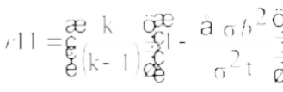 Note:
r₁₁ = reliability instrument

k = Numbers of Question.

∑σb² = Sum of varians σ²t = varians total

Table 7: Reliability Scale

Skala Reliabilitas

α < 0.60 Keandalan data rendah
0.60 < α < 0.80 Keandalan data yang dapat diterima
α > 0.80 Keandalan data yang baik
Sumber: Arikunto (2019)

Reliability indicates the extent to which data is presented without error, allowing for the measurement of data stability and consistency of the research instrument, such as a questionnaire. In this study, data reliability will be tested using Cronbach's Alpha formula (Arikunto, 2019). The result of reliability test could saw at table 8 below:
Table 8: Reliability of Reading Comprehensive Test (Pre-test)

Reliability Statistics
Cronbach's Alpha | N of Items
.619 | 20
(Source: Self data by SPSS 22)

According to the reliability table above, the Cronbach's alpha value is 0.619, which is greater than 0.60. This indicates that the questions used to assess students' reading comprehensives have "acceptable data reliability" or are reliable.

Table 9: Reliability of Reading Comprehensive Test (post-test)

Reliability Statistics
Cronbach's Alpha | N of Items
.692 | 20
(Source: Self Data by SPSS 22)

According to the reliability table above, the Cronbach's alpha value is 0.692, which is greater than 0.60. This indicates that the questions used to assess students' initial vocabulary skills have "Acceptable data reliability" or are reliable.
- Motivation Questionaire

  - Conceptual Definition

In the context of the text, motivation is defined as the intrinsic or extrinsic drive, either internal or external, that propels people to achieve particular goals or objectives. It includes things like desires, aspirations, and wants. It is very important in determining how people behave, especially in learning environments.
  - Operational Definition

Within this framework, motivation may be described as the mental state or condition that animates people to participate in educational activities and work toward their learning objectives. It encompasses things like goal-setting, initiative, using efficient learning techniques, and persevering in the face of difficulties.

  - Spesification

Factors that impact people's drive for success, both internal and external, are included in the specifications for motivation. Factors that are intrinsic come from within the person and include things like success, recognition, development, and responsibility. In contrast, extrinsic influences originate from outside sources and might take the form of incentives, awards, or recognition. Furthermore, self-regulated learning, metacognitive tactics, and cognitive methods that people employ to manage and steer their learning process are all included in the concept of motivation.
  - Caliberation

In the context of motivation, calibration entails evaluating and comprehending the several elements—both extrinsic and intrinsic—that affect people's drive to learn, as well as the efficacy of self-regulated learning techniques. To measure the questionare of motivation, researcher did validity dan reliability test.
Table 10: Validity of Motivation Questionaire (pre-test)

Question | R-Tabel | R-Count | Stat
1 | 0.422 | 0.921 | Valid
2 | 0.422 | 0.919 | Valid
3 | 0.422 | 0.975 | Valid
4 | 0.422 | 0.893 | Valid
5 | 0.422 | 0.908 | Valid
6 | 0.422 | 0.946 | Valid
7 | 0.422 | 0.946 | Valid
8 | 0.422 | 0.975 | Valid

Sustain: Table 8

Questionnaire | R-Tabel | R-Count | Stat
9 | 0.422 | 0.975 | Valid
10 | 0.422 | 0.959 | Valid
11 | 0.422 | 0.975 | Valid
12 | 0.422 | 0.946 | Valid
13 | 0.422 | 0.975 | Valid
14 | 0.422 | 0.964 | Valid
15 | 0.422 | 0.901 | Valid
16 | 0.422 | 0.628 | Valid
17 | 0.422 | 0.811 | Valid
18 | 0.422 | 0.911 | Valid
(Source: Self Data by SPSS 22)

Based on Table 10 above, it can be concluded that all 18 items in the questionnaire are considered "valid" since the R-Count values are greater than the R-Table values.

. Table 11: Reliability of Motivation Questionaire (pre-test)

Reliability Statistics
Cronbach's Alpha | N of Items
.988 | 18
(Source: Self Data by SPSS 22)

According to the reliability table above, the Cronbach's alpha value is 0.988, which is greater than 0.60. This indicates that the questionaire used to assess students' initial vocabulary skills have "Good data reliability" or are reliable.

Research Procedure

- Treatment

  - Obtain ethical approval from relevant institutional review boards.

  - Select schools or classrooms to participate in the study.

  - Administer surveys to students to assess their motivation for reading comprehensive.
  - Conduct reading comprehensive assessments with students to evaluate their comprehensive skills.
  - Observe instructional sessions to document the implementation of GSSR.
  - Collect and analyze the data using appropriate statistical methods.

- Internal and external validity

  - Internal validity is achieved by validity and reliability instrument test

  - External validity is achieved by assessing student learning outcomes through collaborative evaluation by teachers to eliminate bias and ensure that the researcher’s interests do not influence the research process.

Data Analysis Techniques

- To answer the first hypothesis of this research, which relatesd to the influence of the method, researcher uses Wilcoxon-test and to obtain accurate result. The result of Wilcoxon test would be explain about which method is better to applied to improve

student’s reading comprehensive. This test would be apply at spss 22.
- To answer the second hypothesis of this research, which relatesd to the influence of the method, researcher uses Wilcoxon-test and to obtain accurate result. The result of Wilcoxon test would be explain about which method is better to applied to improve student’s reading comprehensive. This test would be apply at spss 22.
- To answer the third hypothesis of this research, which is related to the effectiveness of the teaching method used, the researcher uses the N-Gain formula to obtain accurate results. The formula for N- Gain itself is as follows:
N-Gain = (post test-pretest)/(Ideal value-pretest) Note:
N-Gain = Value of gain-normality Post-test= sudent post-test score Pre-test= student pre-test score Ideal value = maksimum score

The results obtained from the test will be categorized based on the interpretation table of N-Gain effectiveness.
Table 12 :Status Category of N-Gain Effectivity

Table 12 :Status Category of N-Gain Effectivity
Percentage (%) | Status
< 40 | Not Effective
40-55 | Less Effective
56-75 | Effective enough
>75 | Effective
Reference: Jariyah et al (2022:113)

CHAPTER IV ANALYZE AND DISCUSSION

Analyze

The first step in this research is to conduct initial observations to determine students' initial vocabulary skills and to serve as a reference point for evaluating the effectiveness of the activities carried out. This was done in three classes: 8A, 8B, and 8C.
Before observing the students, a mandatory instrument test was conducted to assess the validity and reliability of the instrument prepared by the researcher.

Pre-test phase (Instrument test)

    - Students Reading Comprehensive Observation

Once the questionnaire has passed the validity and reliability tests, the next step is to administer the test to the students to assess their level of "reading comprehensive". The results of this observation can be seen in the table below.
Table 13: Reading Comprehensive Observation (8A Pre Test)

NO | Name of Student | Sex (L/P) | Reading Compre | Score | State
1 | ABDUL AZIZ GINTING | L | 11 | 55 | notpass
2 | ALFIN PRATAMA | L | 11 | 55 | notpass
3 | ALFINO RAMADHANI | L | 8 | 40 | notpass
4 | FACHRY ARDIANSYAH | L | 12 | 60 | notpass

109

Sustain: Table 13

5 | FEBRIYANSYAH | L | 7 | 35 | notpass
6 | KAMILA QUIN | P | 6 | 30 | notpass
7 | MHD RAFI | L | 9 | 45 | notpass
8 | M. HAFIZ AL-AMIN | L | 13 | 65 | notpass
9 | M. ICHSAN PRATAMA | L | 11 | 55 | notpass
10 | M. IQBAL LUTHFI | L | 7 | 35 | notpass
11 | NAYZILA AZZAHRA | P | 6 | 30 | notpass
12 | NIKITA SYABIRA | P | 7 | 35 | notpass
13 | QYTALUNA MIANISTY | P | 6 | 30 | notpass
14 | RAFIKAL JANNAH | P | 8 | 40 | notpass
15 | RAFI AHMAD | L | 8 | 40 | notpass
16 | RIZKY HALOMOAN | L | 10 | 50 | notpass
17 | SAFI RARA MIKEYLA | P | 11 | 55 | notpass
18 | RASYAH FADHIL | L | 17 | 85 | Pass
19 | TEGUH PRASETYA | L | 11 | 55 | notpass
20 | FAUZAN | L | 15 | 75 | Pass
Average |  |  |  | 48,5 | 10%

Based on Table 13 above, it is evident that the passing rate for students in class 8A is only 10%, with an average score of 48.5. This indicates that the reading comprehensive of students at MTS Amal Soleh, particularly in class A, remains low.
The next step researcher did observation to 8B class. The result of the observation follows:
Table 14: Reading Comprehensive Observation (8B Pre Test)

NO | Name of Student | Sex (L/P) | Reading Compre | Score | State
1 | ABIDZAR AFNAN | L | 6 | 30 | notpass
2 | AHMAD AIDAN HAREFA | L | 6 | 30 | notpass
3 | ALFI ANSYARI SINAGA | L | 11 | 55 | notpass
4 | ATTILA DZAMAR G | L | 11 | 55 | notpass

Sustain : Table 14

NO | Name of Student | Sex (L/P) | Reading Compre | Score | State
6 | DWI INAYAH | P | 12 | 60 | notpass
7 | DWERI SYAHARIS | L | 11 | 55 | notpass
8 | FAJAR MAULANA KELIAT | L | 13 | 65 | notpass
9 | RIZKA HRP | P | 12 | 60 | notpass
10 | INDAH NURAINI HRP | P | 15 | 75 | Pass
11 | JIHAN AZZAHRO | P | 5 | 25 | notpass
12 | MAHIDINA | P | 6 | 30 | notpass
13 | MALEEKA AZZAHRA | P | 9 | 45 | notpass
14 | MARWAH | P | 6 | 30 | notpass
15 | MHD. FATURRAHMAN | L | 13 | 65 | notpass
16 | MHD. ANANDA YASIN | L | 8 | 40 | notpass
17 | RADINA AHMAD | P | 5 | 25 | notpass
18 | REYHAN RAMADHAN | L | 5 | 25 | notpass
19 | RUSYDI AQIL MASYRI | L | 11 | 55 | notpass
20 | VICKY VIRANSYAH | L | 10 | 50 | notpass
Average |  |  |  | 47 | 5%

Based on Table 14 above, it is evident that the passing rate for students in class 8A is only 5%, with an average score of 47. This indicates that the reading comprehensive of students at MTS Amal Soleh, particularly in class B, remains low.
The next step researcher did observation to 8C class. The result of the observation follows:
Table 15: Reading Comprehensive Observation (8C Pre Test)

NO | Name of Student | Sex (L/P) | Reading Compre | Score | State
1 | ABRIL JULIZAR | L | 11 | 55 | notpass
2 | AHMAD HAMZAH | L | 14 | 70 | notpass
3 | AS-SHAFA RIZKY | L | 11 | 55 | notpass

Sustain : Table 15

4 | AZAAN HABIBATUS S | L | 9 | 45 | notpass
5 | BAMBANG BUDIONO | L | 5 | 25 | notpass
6 | DAFA ANUGRAH | L | 4 | 20 | notpass
7 | DAMAR RIZKY  RAMADHAN | L | 11 | 55 | notpass
8 | EGINA PUTRI | P | 5 | 25 | notpass
9 | GHAZI FAYYAD | L | 10 | 50 | notpass
10 | UTIZAM RAZAM | L | 5 | 25 | notpass
11 | INDAH AULIA | P | 6 | 30 | notpass
12 | M. ALIF THARIQ | L | 5 | 25 | notpass
13 | M. HAIKAL | L | 3 | 15 | notpass
14 | M. RAYFAN | L | 5 | 25 | notpass
15 | M. HAFIZ | L | 10 | 50 | notpass
16 | NAZWA OLIVA | P | 18 | 90 | Pass
17 | NOVI AJENG MARIFAH | P | 5 | 25 | notpass
18 | RAFLI TUAHTA | L | 9 | 45 | notpass
19 | SATRIA GILANG | L | 10 | 50 | notpass
20 | SILVIA AMANDA | P | 4 | 20 | notpass
21 | TSABITA ASIAH | P | 6 | 30 | notpass
22 | ZIDAN OKSEN | L | 7 | 35 | notpass
Average |  |  |  | 39.31 | 5%

According toTable 15 above, it is evident that the passing rate for students in class 8A is only 5%, with an average score of 39.31. This indicates that the reading comprehensive of students at MTS Amal Soleh, particularly in class C, remains low.
Based on the findings, it is evident that among the three classes (8A, 8B, and 8C), class 8C has the lowest achievement percentage and average score in terms of "reading comprehensive". Therefore, the GSSR+Motivation approach

method will be implemented in class 8C, the GSSR approach method will be designed for class 8B, and the usual school method will be continued for class 8A.
    - Student Motivation Observation

Once the questionnaire has passed the validity and reliability tests, the next step is to administer the test to the students to assess their level of "Motivation ". The results of this observation can be seen in the table below:

Table 16: Student Level of Motivation

NO | Name of Student | Sex (L/P) | Motivation | Condition
1 | ABRIL JULIZAR | L | 51 | Motivated  enough
2 | AHMAD HAMZAH | L | 25 | Lessmotivated
3 | AS-SHAFA RIZKY | L | 35 | Lessmotivated
4 | AZAAN HABIBATUS S | L | 55 | Motivated
5 | BAMBANG BUDIONO | L | 19 | Lessmotivated
6 | DAFA ANUGRAH | L | 26 | Lessmotivated
7 | DAMAR RIZKY  RAMADHAN | L | 19 | Lessmotivated
8 | EGINA PUTRI | P | 18 | Unmotivated
9 | GHAZI FAYYAD | L | 35 | Lessmotivated
10 | UTIZAM RAZAM | L | 53 | Motivated  enough
11 | INDAH AULIA | P | 56 | Motivated
12 | M. ALIF THARIQ | L | 26 | Lessmotivated
13 | M. HAIKAL | L | 18 | Unmotivated
14 | M. RAYFAN | L | 26 | Lessmotivated
15 | M. HAFIZ | L | 19 | Lessmotivated
16 | NAZWA OLIVA | P | 18 | Unmotivated
17 | NOVI AJENG MARIFAH | P | 35 | Lessmotivated
18 | RAFLI TUAHTA | L | 53 | Motivated  enough
19 | SATRIA GILANG | L | 25 | Lessmotivated

Sustain : Tabel 16

20 | SILVIA AMANDA | P | 19 | Lessmotivated
21 | TSABITA ASIAH | P | 19 | Lessmotivated
22 | ZIDAN OKSEN | L | 33 | Lessmotivated
Average |  |  | 31,04 | 22,72%

Based on Table 16 above, it can be observed that 5 students or 22.72% of the students in class 8C fall into the category of "sufficiently motivated" and "motivated", while the remaining 77.28% are still in the category of "insufficiently motivated" and "not at all motivated" in terms of "reading comprehensive" learning.
Based on the findings from the student observation results in Tables 10-14, it is evident that both students' "reading comprehensive" abilities and their "reading comprehensive" learning motivation remain low. This can be seen from the low passing rates, which do not exceed 30%. Therefore, in the next stage, the researcher will provide instruction using the GSSR method and provide motivation to students with the aim of improving student achievement in "reading comprehensive".

Post-test phase (Instrument test)

After implementing the learning activities using the GSSR method and providing motivation for 8 sessions, the researcher will first re-test the students to assess the changes in their motivation and reading comprehensive levels. Before conducting the post-test, the researcher will again conduct an instrument test on

the "reading comprehensive" test material because the questions used are different from the material used in the pre-test.
    - Student Motivation Observed

In assessing student motivation levels, the researcher followed the evaluation guidelines that had been previously established (see appendix)

Table 17: Student Motivated Observed

NO | Name of Student | Sex (L/P) | Motivation | Condition
1 | ABRIL JULIZAR | L | 64 | Motivated
2 | AHMAD HAMZAH | L | 56 | Motivated
3 | AS-SHAFA RIZKY | L | 62 | Motivated
4 | AZAAN HABIBATUS S | L | 55 | Motivated
5 | BAMBANG BUDIONO | L | 55 | Motivated
6 | DAFA ANUGRAH | L | 45 | Motivated enough
7 | DAMAR RIZKY RAMADHAN | L | 53 | Motivated enough
8 | EGINA PUTRI | P | 53 | Motivated enough
9 | GHAZI FAYYAD | L | 52 | Motivated enough
10 | UTIZAM RAZAM | L | 69 | Motivated
11 | INDAH AULIA | P | 56 | Motivated
12 | M. ALIF THARIQ | L | 45 | Motivated enough
13 | M. HAIKAL | L | 36 | Lessmotivated
14 | M. RAYFAN | L | 44 | Motivated enough
15 | M. HAFIZ | L | 37 | Motivated enough
16 | NAZWA OLIVA | P | 35 | Lessmotivated
17 | NOVI AJENG MARIFAH | P | 55 | Motivated
18 | RAFLI TUAHTA | L | 72 | Motivated
19 | SATRIA GILANG | L | 43 | Motivated enough
20 | SILVIA AMANDA | P | 71 | Motivated
21 | TSABITA ASIAH | P | 69 | Motivated
22 | ZIDAN OKSEN | L | 75 | Very Motivated
Average |  |  | 54.63 | 90,90%

Based on Table 17 above, it is evident that the average score for student conditions is 54.63, which falls into the "Motivated Enough" category. With a percentage of 90.90%, the majority of students have now reached a state of motivation.
    - Student’s Reading Comprehensive

After implementing the learning activities from May 15 to May 31, 2024, the result of research could see at the table below
- Student’s Reading Comprehensive (8A Un treatment class)

Table 18: Student’s Reading Comprehensive Level (8A Untreatment Class)

NO | Name of Student | Sex (L/P) | Reading Compre | Score | State
1 | ABDUL AZIZ GINTING | L | 16 | 80 | Pass
2 | ALFIN PRATAMA | L | 14 | 70 | notpass
3 | ALFINO RAMADHANI | L | 9 | 45 | notpass
4 | FACHRY ARDIANSYAH | L | 15 | 75 | Pass
5 | FEBRIYANSYAH | L | 8 | 40 | notpass
6 | KAMILA QUIN | P | 9 | 45 | notpass
7 | MHD RAFI | L | 9 | 45 | notpass
8 | M. HAFIZ AL-AMIN | L | 15 | 75 | Pass
9 | M. ICHSAN PRATAMA | L | 15 | 75 | Pass
10 | M. IQBAL LUTHFI | L | 9 | 45 | notpass
11 | NAYZILA AZZAHRA | P | 8 | 40 | notpass
12 | NIKITA SYABIRA | P | 6 | 30 | notpass
13 | QYTALUNA MIANISTY | P | 7 | 35 | notpass
14 | RAFIKAL JANNAH | P | 10 | 50 | notpass
15 | RAFI AHMAD | L | 10 | 50 | notpass

Sustain: Table 18

NO | Name of Student | Sex (L/P) | Reading Compre | Score | State
16 | ABDUL AZIZ GINTING | L | 11 | 55 | notpass
17 | ALFIN PRATAMA | L | 15 | 75 | Pass
18 | ALFINO RAMADHANI | L | 16 | 80 | Pass
19 | FACHRY ARDIANSYAH | L | 10 | 50 | Notpass
20 | FEBRIYANSYAH | L | 15 | 75 | Pass
Average |  |  |  | 56,75 | 30%

Based on Table 18, it was observed that the average score for students in class 8A was 56.75 with a passing rate of 30%. This meant that 6 students had met the passing standard with scores exceeding the minimum passing score (KKM) of
75. This also indicated that the teaching method used in class 8A (the school's teaching method) had not been able to meet the student achievement goal of improving Students "reading comprehensive".
- Student’s Reading Comprehensive (GSSR class)

Table 19: Student’s Reading Comprehensive (8B GSSR Class)

NO | Name of Student | Sex (L/P) | Reading Compre | Score | State
1 | ABIDZAR AFNAN | L | 11 | 55 | notpass
2 | AHMAD AIDAN HAREFA | L | 10 | 50 | notpass
3 | ALFI ANSYARI SINAGA | L | 15 | 75 | Pass
4 | ATTILA DZAMAR GUNAWAN | L | 12 | 60 | notpass
5 | DEVINA ALYA LUBIS | P | 17 | 85 | Pass
6 | DWI INAYAH | P | 15 | 75 | Pass
7 | DWERI SYAHARIS | L | 18 | 90 | Pass
8 | FAJAR MAULANA KELIAT | L | 17 | 85 | Pass

Sustain: table 19

NO | Name of Student | Sex (L/P) | Reading Compre | Score | State
9 | RIZKA HRP | P | 11 | 55 | notpass
10 | INDAH NURAINI HRP | P | 15 | 75 | Pass
11 | JIHAN AZZAHRO | P | 15 | 75 | Pass
12 | MAHIDINA | P | 7 | 35 | notpass
13 | MALEEKA AZZAHRA | P | 16 | 80 | Pass
14 | MARWAH | P | 14 | 70 | notpass
15 | MHD. FATURRAHMAN | L | 19 | 95 | Pass
16 | MHD. ANANDA YASIN | L | 16 | 80 | Pass
17 | RADINA AHMAD | P | 11 | 55 | notpass
18 | REYHAN RAMADHAN | L | 15 | 75 | Pass
19 | RUSYDI AQIL MASYRI | L | 14 | 70 | notpass
20 | VICKY VIRANSYAH | L | 13 | 65 | notpass
Average |  |  |  | 70,25 | 55%

Based on Table 18, it was observed that the average score for students in class 8B was 70.25 with a passing rate of 55%. This meant that 11 students had met the passing standard with scores exceeding the minimum passing score (KKM) of 75. This also indicated that the teaching method used in class 8B GSSR method) had not been able to meet the student achievement goal of improving Students "reading comprehensive".

- Student’s Reading Comprehensive (GSSR+Motivation class)
Table 20: Students Reading Comprehensive Level (8C Class)

NO | Name of Student | Sex (L/P) | Reading Compre | Score | State
1 | ABRIL JULIZAR | L | 17 | 85 | Pass
2 | AHMAD HAMZAH | L | 18 | 90 | Pass
3 | AS-SHAFA RIZKY | L | 18 | 90 | Pass
4 | AZAAN HABIBATUS S | L | 15 | 75 | Pass
5 | BAMBANG BUDIONO | L | 13 | 65 | notpass
6 | DAFA ANUGRAH | L | 11 | 55 | notpass
7 | DAMAR RIZKY  RAMADHAN | L | 16 | 80 | Pass
8 | EGINA PUTRI | P | 17 | 85 | Pass
9 | GHAZI FAYYAD | L | 17 | 85 | Pass
10 | UTIZAM RAZAM | L | 17 | 85 | Pass
11 | INDAH AULIA | P | 16 | 80 | Pass
12 | M. ALIF THARIQ | L | 17 | 85 | Pass
13 | M. HAIKAL | L | 15 | 75 | Pass
14 | M. RAYFAN | L | 18 | 90 | Pass
15 | M. HAFIZ | L | 18 | 90 | Pass
16 | NAZWA OLIVA | P | 18 | 90 | Pass
17 | NOVI AJENG MARIFAH | P | 8 | 40 | notpass
18 | RAFLI TUAHTA | L | 11 | 55 | notpass
19 | SATRIA GILANG | L | 20 | 100 | Pass
20 | SILVIA AMANDA | P | 15 | 75 | Pass
21 | TSABITA ASIAH | P | 15 | 75 | Pass
22 | ZIDAN OKSEN | L | 16 | 80 | Pass
Average |  |  |  | 77,75 | 81,811%

Based on Table 20, it was observed that the average score for students in class 8C was 77.75 with a passing rate of 81,81%. This meant that 18 students had met the passing standard with scores exceeding the minimum passing score

(KKM) of 75. This also indicated that the teaching method used in class 8C (GSSR method + motivation) had been able to meet the student achievement goal of improving Students "reading comprehensive".

Wilcoxon test

The Wilcoxon Signed-Rank Test is a non-parametric test used to assess the significance of differences between two paired data groups that are ordinal or interval-scaled but not normally distributed. The Wilcoxon Signed-Rank Test serves as an alternative to the paired t-test or t-paired test when the assumption of normality is not met. This test is also known as the Wilcoxon Match Pair Test.
    - Wilcoxon Test (8A Class)

Table 21: Wilcoxon Signed Rank Test
Ranks
 |  | N | Mean Rank | Sum of Ranks
Untreatment_post - Untreatment_Pre | Negative Ranks | 3a | 4.00 | 12.00
Untreatment_post - Untreatment_Pre | Positive Ranks | 15^{b} | 10.60 | 159.00
Untreatment_post - Untreatment_Pre | Ties | 2c
Untreatment_post - Untreatment_Pre | Total | 20
(Source: Self data by Spss 22)

Based on the table, the following observations were made:

- Negative Rank (3): This indicated that there were 3 data points that experienced a decrease in their scores after the post-test. This suggested that these 3 students did not benefit from the intervention or may have

experienced some external factors that negatively impacted their performance.
- Ties (2): This implied that there were 2 students who showed no significant change in their scores after the intervention. This could mean that these students were already performing well or that the intervention had a minimal effect on their performance.
- Positive Rank (15) and Average Change (10.60 points): This indicated that there were 15 students who experienced an increase in their scores with an average development of 10.60 points. This suggested that the intervention was effective for the majority of the students, leading to a noticeable positive impact on their performance

.

Table 22: Test-Statistic (8A)

Untreatment_po st -
Untreatment_Pr
e
Z | -3.232^{b}
Asymp. Sig. (2-tailed) | .001
(Source: Self data by Spss 22)

It was determined from Table 22 above that the significance value for class 8A was 0.001, which is less than 0.05. This indicates that the teaching method typically used in schools has an impact on changes in student ability.

Based on this data, the researchers were able to conclude that the teaching method used in class 8A, which is the typical method used in schools, was able to improve the "reading comprehensive" ability of 15 students

    - Wilcoxon Test (8B Class) Table 23: Wilcoxon Signed Rank test
Ranks
 |  | N | Mean Rank | Sum of Ranks
GSSR_post- GSSR_Pre | Negative Ranks | 1a | 2.00 | 2.00
GSSR_post- GSSR_Pre | Positive Ranks | 18^{b} | 10.44 | 188.00
GSSR_post- GSSR_Pre | Ties | 1c
GSSR_post- GSSR_Pre | Total | 20
(Source: Self data by Spss 22)

Based on the table, the following observations were made:

- Negative Rank (1): This indicated that there were 1 data points that experienced a decrease in their scores after the post-test. This suggested that these 1 students did not benefit from the intervention or may have experienced some external factors that negatively impacted their performance.
- Ties (1): This implied that there were 1 students who showed no significant change in their scores after the intervention. This could mean that these students were already performing well or that the intervention had a minimal effect on their performance.

- Positive Rank (18) and Average Change (10.44 points): This indicated that there were 18 students who experienced an increase in their scores with an average development of 10.44 points. This suggested that the intervention was effective for the majority of the students, leading to a noticeable positive impact on their performance

Table 24: Test-Statistic (8B)

 | GSSR_post - GSSRt_Pre
Z | -3.232^{b}
Asymp. Sig. (2-tailed) | .001
(Source: Self data by Spss 22)

According to Table 24 above that the significance value for class 8B was 0.000, which is less than 0.05. This indicates that the teaching method typically used in schools has an impact on changes in student ability.

Based on this data, the researchers were able to conclude that the teaching method used in class 8B, which is the typical method used in schools, was able to improve the "reading comprehensive" ability of 18 students.

    - Wilcoxon Test (8C Class) Table 25: Wilcoxon Signed Rank Test
Ranks
 |  | N | Mean Rank | Sum of Ranks
GSSR_post- GSSR_Pre | Negative Ranks | 0a | 2.00 | 2.00
GSSR_post- GSSR_Pre | Positive Ranks | 21^{b} | 11.00 | 231.00
GSSR_post- GSSR_Pre | Ties | 1c
GSSR_post- GSSR_Pre | Total | 22

Based on the table, the following observations were made:

- Negative Rank (0): This indicated that there were 0 data points that experienced a decrease in their scores after the post-test.
- Ties (1): This implied that there were 1 students who showed no significant change in their scores after the intervention. This could mean that these students were already performing well or that the intervention had a minimal effect on their performance.
- Positive Rank (21) and Average Change (11.00 points): This indicated that there were 21 students who experienced an increase in their scores with an average development of 21 points. This suggested that the intervention was effective for the majority of the students, leading to a noticeable positive impact on their performance

Table 26: Test-Statistic (8C)

 | GM_Post - GMt_Pre
Z | -3.232^{b}
Asymp. Sig. (2-tailed) | .000
(Source: Self data by Spss 22)

According to Table 26 above that the significance value for class 8B was 0.000, which is less than 0.05. This indicates that the teaching method typically used in schools has an impact on changes in student ability.

Based on this data, the researchers were able to conclude that the teaching method used in class 8C, which is the typical method used in schools, was able to improve the "reading comprehensive" ability of 21 students

Ngain Persentage test

To assess the effectiveness of the method used in each class, the researchers conducted an analysis using N-gain Score. The following are the results of data processing for each class (8A, 8B, 8C):

Table 27: N-gain perscentage
Descriptives
 | Class |  |  | Statistic
Ngain_Persentage | 8A (Untreatment) | Mean |  | 15.4657
Ngain_Persentage | 8A (Untreatment) | 95% Confidence Interval for Mean | Lower Bound | 5.4994
Ngain_Persentage | 8A (Untreatment) | 95% Confidence Interval for Mean | Upper Bound | 25.4319
Ngain_Persentage | 8A (Untreatment) | 5% Trimmed Mean |  | 15.9495
Ngain_Persentage | 8A (Untreatment) | Median |  | 14.8352
Ngain_Persentage | 8B (GSSR) | Mean |  | 42.6937
Ngain_Persentage | 8B (GSSR) | 95% Confidence Interval for Mean | Lower Bound | 30.2022
Ngain_Persentage | 8B (GSSR) | 95% Confidence Interval for Mean | Upper Bound | 55.1853
Ngain_Persentage | 8B (GSSR) | 5% Trimmed Mean |  | 43.3700
Ngain_Persentage | 8B (GSSR) | Median |  | 42.2222
Ngain_Persentage | 8C (GSSR + Motivation) | Mean |  | 62.6103
Ngain_Persentage | 8C (GSSR + Motivation) | 95% Confidence Interval for Mean | Lower Bound | 52.0135
Ngain_Persentage | 8C (GSSR + Motivation) | 95% Confidence Interval for Mean | Upper Bound | 73.2072
Ngain_Persentage | 8C (GSSR + Motivation) | 5% Trimmed Mean |  | 63.9870
Ngain_Persentage | 8C (GSSR + Motivation) | Median |  | 68.9904
(Source: Self data by Spss 22)

Based on Table 27 above, it is known that the mean value for class 8A is 15.465%, while for class 8B the mean value is 42.69%, and for class 8C the mean value is 62.61%.
It can be concluded that:

    - For class 8A, the mean score is < 40, which means that the application of the conventional method in class 8A is still not effective in improving students' reading comprehensive ability.
    - For class 8B, the mean score falls within the range of 40- 55, which means that the implementation of the GSSR

method in class 8B is considered "less effective" in improving students' reading comprehensive ability.
    - For class 8C, the mean score falls within the range of 56- 75, which means that the implementation of the GSSR + Motivation method in class 8C is considered “Effective Enough”.

Hypothesis Test

    - H1: GSSR method is better then conventional method to improve student reading comprehensive
To answer this hypothesis, researcher used Wilcoxon data result and student’s reading comprehensive test.

Figure 4.1 Student Development
Post
Pre
Post
Pre
5 5
10
39.31
31.04 30
22.7
55
54.63
48.5 47
56.57
90.9
81.81
77.75
70.25
Student Development
Reading Comprehension 8a Reading Comprehension 8b Reading Comprehension 8c Motivation 8C

The Wilcoxon test results from tables 22-27 indicate that the conventional method has a significant impact on improving students' "reading comprehensive" ability. This is also true for classes 8B and 8C, which used the GSSR and GSSR + Motivation methods, respectively. However, the impact on class 8A is not greater than that on classes that used the GSSR method in their instruction.

Figure 4.1 shows that class 8A had an average score of 48.5 and a passing rate of 10% in the pre-test phase. This increased to 56.57 with a passing rate of 30% after the post-test phase. In other words, class 8A, which used the conventional method in its instruction, was able to increase its passing rate by 20% and its average score by 8.07 points. However, when compared to the other classes that used the GSSR method, this increase is much smaller.

Class 8B had an average score of 47 and a passing rate of 5% in the pre- test phase. This increased to 70.25 with a passing rate of 55% after the post-test phase. In other words, class 8B, which used the GSSR method in its instruction, was able to increase its passing rate by 50% and its average score by 23.25 points.

Class 8C had an average score of 39.31 and a passing rate of 5% in the pre-test phase. This increased to 77.75 with a passing rate of 81.81% after the post-test phase. In other words, class 8C, which used the GSSR + Motivation method in its instruction, was able to increase its passing rate by 76.8% and its average score by 38.44 points.

Based on this data, the researchers can conclude that H1 of this study is Accepted.

    - H2: Reading Comprehensive development of Student with high motivation is better than reading comprehensive development of student with low motivation
According to figure 4.1 Class 8C had an average score of 39.31 and a passing rate of 5% in the pre-test phase. This increased to 77.75 with a passing rate of 81.81% after the post-test phase. In other words, class 8C, which used the GSSR + Motivation method in its instruction, was able to increase its passing rate by 76.8% and its average score by 38.44 points.

The average score of class 8C, which used the GSSR + Motivation method, is significantly higher than the average scores of classes 8A and 8B, which did not receive motivation in the learning process. Based on this, the researchers conclude that "Reading Comprehensive development of Student with high motivation is better than reading comprehensive development of student with low motivation". This means that H2 of this study is supported.

The conclution of the hypothesis was

- Class 8C, which used the GSSR + Motivation method, had the highest average score after the post-test phase.
- Classes 8A and 8B, which did not receive motivation in the learning process, had lower average scores after the post-test phase.

- This suggests that motivation has a positive impact on reading comprehensive development

    - GSSR and motivation efective enough to improve students' reading comprehensive
To answer this hypothesis, researcher would take Ngain percentage data of student’s reading comprehensive at each class.
Based on Table 27 above, it is known that the mean value for class 8C was 62.61%. It can be concluded that for class 8C, the mean score falls within the range of 56-75, which means that the implementation of the GSSR + Motivation method in class 8C is considered “Effective Enough”.
According to the data, researcher could toke an conclusion that GSSR and motivation efective enough to improve students' reading comprehensive and that’s mean H3 of this research was accepted.

Discussion

The analysis of the data above shows that the use of the GSSR method as a teaching method to improve students' "reading comprehensive" is much better than the conventional method that has been used at MTSs Amal Saleh School. This is because the GSSR method does not force reading materials on students, so students have the freedom to choose reading materials that they enjoy. This can

increase students' desire to read more. This statement by the researcher is in line with what Mason (2021:387) states: “.....It is also to help our EFL students become independent readers in English, that is, capable of not only selecting interesting and comprehensible books on their own for pleasure reading, but also capable of seeking and finding information that is necessary for better understanding of what is happening in the world”. The goal is to empower our EFL (English as a Foreign Language) students to become independent readers in English Benny Comason said in his scientific journal, she said that “
Another study Al-Hamoud & Schmitt (2009) that aligns with the concept of extensive reading found “an exceptionally effective and worthy approach that does not impose pressure or burden on readers, even in challenging situations. This is due to the voluntary selection of graded reading materials, ranging from easy to difficult, based on each student's language proficiency”.
According to the expert judgment above, researcher could say that” using GSSR to Improve student reading comprehensive was success because there are no preasure that sutudent’s had when their want to start to read ther favorite text and this could made student’s feel happy when started to learning about reading comprehensive.
GSSR + motivation effective enough to improve sudent’s reading comprehensive because in the application of this method, student’s has goals to learning about it and the students felt motivated. According to Widayat (2015:1) stated : “The Motivation Theory is formulated as drives, whether caused by

internal or external factors, to achieve specific goals in order to fulfill/satisfy a need. In this case Student’s could be motivated by “star labeling”, or by reward, or by benefit that their take (knowledge) that researcher gift if the student’s pass the test or quest that researcher prepared. According to Lase (2016:13) stated :“Motivation is everything that drives someone to act and do something in order to achieve specific goals. Motivation is the entire driving force within students that initiates learning activities, ensures the continuity of learning activities, and provides direction to learning activities, so that the desired goals of the students are achieved.
According to Triono, et all (2021) Motivation is influenced by two variables: intrinsic factors, which come from an employee's inner self and spur them on to success. Achievement, acknowledgment, the growth of one's own potential, and accountability are examples of intrinsic factors. The variables that originate from outside the person are known as extrinsic factors
According to Damaianti (2021) One alternative learning strategy to improve motivation in a self-directed learning environment is self- regulated learning. Self- regulated learning is crucial for increasing students' academic motivation, according to study results. Students that are able to control their learning process also become masters of it. Motivation, metacognitive techniques, and cognitive strategies are the three basic pillars of self-regulated learning.

As educators, we must promote and nurture intrinsic motivation in our students, instilling a love of learning that extends beyond the classroom and paves the path for lifelong intellectual growth and pleasure.

CHAPTER V CONCLUTION AND SUGESSTION

Conclution

  - GSSR method was better then conventional method to improve student reading comprehensive with the percentage of student’s passing standard 55% and 81.81% and the average score of student’s was 70.25 and 77.75 that interpertated by class 8B and 8C
  - Reading Comprehensive development of Student with high motivation is better than reading comprehensive development of student with low motivation because GSSR method + Motivation, was able to increase its passing rate by 76,81% and its average score by 38.44 points
  - GSSR and motivation efective enough to improve students' reading comprehensive because mean value of Ngain percentage was 62.61. The score falls within the range of 56-75, which means that the implementation of the GSSR + Motivation method in class 8C is considered “Effective Enough”

Sugesstion

  - Expand the scope of the research to include other grade levels. The GSSR method has been shown to be effective in improving reading comprehensive at the MTSs level. It would be interesting to see if the

135

method is also effective at other grade levels, such as elementary school or high school.
  - Investigate the use of motivation in other subjects. The study found that motivation was a positive factor in improving students' reading comprehensive ability. It would be interesting to see if motivation is also effective in improving students' ability in other subjects

REFERENCES
(2015). “Reading Aloud: What To Do and What Not to Do”. Language Magazine. ( July 2015). Hlm. 1-2.
(2018). “The Conduit Hypothesis: How Reading Leads to Academic Language Competence”. Language Magazine. (April 2018).
(2020). “Self-Selected Fiction: The Path to Academic Success?”. CATESOL Newsletter. (April, 2020). pp. 1-2.
Alfelia Nugky Permatasari1 and Wahyu Kartika. (2023). “WienandaExtensive Reading in Improving Reading Motivation: A Students’ Perspective.” Jurnal Pendidikan Bahasa Asing dan Sastra Vol.7, No.2. Hlm. 220-232.
Armstrong,Nathan. (2015) . Speed-reading The Comprehensive Guide To Speedreading – Increase Your Reading Speed By 300% In Less Than 24 Hours. USA: American Bar Publisher.
Aureliana and Loredana PETRE. (2017). “The role of Constant and Continuous Feedback on Students’ Learning Motivation”. Scientific Research And Education In The Air Force. Hlm. 161-166.
Arianti. (2018). “Peranan Guru Dalammeningkatkan Motivasi Belajar Siswa”.
DidaktikaJurnalKependidikan. Vol.12, No. 2. Hlm. 117-134.
Beniko Mason . (2019). “Guided SSR before Self-Selected Reading”. Shitennoji University Bulletin. (67). Hlm. 445-456.
Beniko Mason and Ken Smith. (2021). “Guided Self-Selected Reading: A Steady Path to Independent Reading”. Reflections on the English Language Teaching and Learning in the Global and Diversified World. Hlm. 385- 402.
Beniko Mason and Stephen Krashen. (2019). “Applying the Input (Reading) Hypothesis: Some history and a look ahead”. 四天王寺大学紀要 第 68号（年 9 月）. Hlm .451-458.
Beniko Mason and Stephen Krashen. (2019). “Direct Teaching of Vocabulary?”.
Journal of english language teaching. LXI (1). Hlm. 9-13.
Beniko Mason and Stephen Krashen. (2017). “Self-Selected Reading and TOEIC Performance: Evidence from Case Histories”. Shitennoji University Bulletin.No. 63, 469-475

Beniko Mason. (2018). “A Pure Comprehensive Approach: More Effective and Efficient than Eclectic Second Language Teaching?”. IBU Journal of Educational Research and Practice. (6). Hlm. 69-79.
Bidin A (2017) Metode Anova, 4(1), pp. 9-15.
Bryan Alan and Duncan Cramer. (2005). Quantitative data analysis with SPSS 12 and 13: A guide for social scientists. Psychology Press. Hlm 21. Cambridge: Cambridge University Press.
Bridges, Louis Ph.D. (2014). The Joy and Power of Reading | A Summary of Research and Expert Opinion. California : Scholastic Inc.
Butler,David. (2014). Reading With The Right Brain. Southern California.
Cain. Kate..Compton, Donald L & Parrila, Rauno K. (2017). Theories of Reading Development. Amsterdam / Philadelphia: John Benjamins Publishing Company.
Christina Clark and Kate Rumbold . (2006). “Reading for pleasure”. National Literacy Trust. Hlm. 5-29.
Damaianti, V.S. (2021) ‘Strategi Regulasi Diri dalam Peningkatan Motivasi Membaca’, Deiksis: Jurnal Pendidikan Bahasa dan Sastra Indonesia, 8(1), p. 52. Available at: https://doi.org/10.33603/dj.v8i1.4613.
David Miller, Andrew Hesler and Stephen Krashen. (2019). “The Star Method: Will They Do It?”. Language and Language Teaching. 8(1). Hlm.21-24.
Domenic T et all. (2021). “Interactive and Conventional Teaching Approaches to Optimizing Reading Comprehensive Performance”. Geintec. Vol. 11 No. 3.pg.1848-1858.
Eric J. Paulson. “Self-Selected Reading for Enjoyment as a College Developmental Reading Approach”. (2006). Journal of College Reading and Learning. 36 (2). Hlm. 51-58.
Erna Iftanti and Arina Shofiya. (2018). “Efl Students’ Responses On The Implementation Of Extensive Reading Program To Build Love Of Reading In English. Jurnal Bahasa Lingua Scientia. Vol. 10, No. 1. Hlm 143-158.
Firda Farisa.(2018). “Motivation And Its Relationship With Readin Achievement (A Survey at Junior High School No.6 Banda Aceh).” Tesis tidak diterbitkan. Ar-Raniry State Islamic University Darussalam – Banda Aceh.

Frances Smith, Karen Westberg & Anne Hejny. (2017). “Accelerated Reader Program: What do Teachers Really Think?”. International Journal of Higher Education. 6(3). Pp.138-146.
Heckhausen. Jutta .& Heckhausen.Heinz. (2018). Motivation and Action. 3rd ed.
Switzerland: Springer.
Kanonire, T., Lubenko, J. and Kuzmina, Y. (2022) ‘The Effects of Intrinsic and Extrinsic Reading Motivation on Reading Performance in Elementary School’, Journal of Research in Childhood Education, 36(1), pp. 1–13. Available at: https://doi.org/10.1080/02568543.2020.1822961.
Khasturi Ramalingam and Yeo Kee Jiar.( 2022). “Influence of Intrinsic and Extrinsic Motivation in Learning Among Primary School Students”. Central Asia And The Caucasus English Edition. Volume 23. Hlm. 1884- 1893.
Knoll, C.L. (2000) ‘The Relationship Between Motivation and Reading Comprehensive’, 5(February), pp. 605–619. Available at: http://scholarworks.gvsu.edu/theses.
Krashen, Stephen D. (2004). The Power of Reading: Insights From the Research2Nd Ed. London : Heinemann.
Kyung Sook Cho and Stephen Krashen. (2018). “The Impact of Sustained Silent Reading and a Visit to the Library on Establishing a Reading Habit: Helpful but not Sufficient”. Language and Language Teaching (Azim Premji University). 7(2), 1-3.
Kyung-Sook Choa & Stephen Krashen. (2019). “Pleasure Reading In A Foreign Language And Competence In Speaking, Listening, Reading And Writing”. TEFLIN Journal. 30 ( 2). Hlm. 231-236.
Langton, E. (2022) ‘NWCommons Self-Selected Reading : A School Development Plan’.
Lestari, N.D.D. et al. (2021) ‘Analisis Faktor-Faktor yang Menghambat Belajar Membaca Permulaan Pada Siswa Sekolah Dasar’, Jurnal Basicedu, 5(4),
pp. 2611–2616. Available at: https://jbasic.org/index.php/basicedu/article/view/1278.

Mikulecky, Beatrice S.(2007). Advanced Reading Power. USA: Longman.

Mohammad Reza Ahmadi. (2017). “The Impact of Motivation on Reading Comprehensive”. International Journal of Research in English Education.
1 (1). Hlm. 1-6.
Nhlanhla Mpofu and Tsitsi Mavambe. (2023). “Teachers’ Self-Reported Instructional Practices for Reading Comprehensive Instruction to Non- Readers”. Journal of english language teaching. Volume 10 Number 2. Hlm. 340-355.
Ni Made Kristin Natalia, Ni Luh Putu Eka Sulistia Dewi,and Ni Putu Astiti Pratiwi. (2021). “Students’ Perception of Sustained Silent Reading (SSR) on Reading Comprehensive in MTSSN 1 Abang”. Journal of Educational Study. Volume 1 Issue 3. Hlm. 182-190.
Serravallo,Jennifer. (2010). Teaching Reading in Small Groups. Portsmouth : Heinemann
Smith, K., Mason, B. and Krashen, S. (2021) ‘Story-listening and guided self- selected reading: Short-term results from Indonesia’, Language Issues, 1(3), pp. 1–14. Available at: https://www.researchgate.net/profile/Beniko- Mason/publication/352492192_Story-Listening_and_Guided_Self- Selected_Reading_Short- Term_Results_from_Indonesia/links/60cd67e792851ca3acaf6f23/Story- Listening-and-Guided-Self-Selected-Reading-Short-Term-Results-f.

Stephen Krashen & Beniko Mason. (2014). “Can Second Language Acquirers Reach High Levels of Proficiency Through Self-Selected Reading? An Attempt to Confirm Nation's (2014) Results”. The International Journal of Foreign Language Teaching. 10(2), 10-19.
Stephen Krashen & Beniko Mason. (2019). “ A Note on Comprehensive Checking . Journal of english language teaching”. LXI (1). Hlm. 23-32.
Stephen Krashen. (2020). “Aesthetic Reading: Efficient Enough”. Journal of English Language Teaching. 62 (2). 3-4.
Sumantri, Mohamad Syarif, (2015). Strategi Pembelajaran, Jakarta: Rajawali Three Watson. (2002). Reading Comprehensive Skills and Strategies Level
8. USA: Saddleback Educational: Publishing
Triono, T. et al. (2021) ‘Motivasi Kerja Pegawai Dalam Pelayanan Publik’, JISIP (Jurnal Ilmu Sosial dan Pendidikan), 5(4), pp. 1627–1631. Available at: https://doi.org/10.58258/jisip.v5i4.2583.

Toni Indrayadi. (2021). “Indonesian EFL Learners’ Reading Motivation”. Indonesian Journal of English Language Teaching and Applied Linguistics. Vol. 5(2). Hlm. 334-346.
Toste, J.R. et al. (2020) ‘A Meta-Analytic Review of the Relations Between Motivation and Reading Achievement for K–12 Students’, Review of Educational Research, 90(3), pp. 420–456. Available at: https://doi.org/10.3102/0034654320919352.
Ulrich Schiefele. et al. (2012). “Dimensions of Reading Motivation and Their Relation to Reading Behavior and Competence”. Reading Research Quarterly. 47(4) . pp. 427–463.
Utin Ainun Kasmiri, Dwi Riyanti, & Urai Mimmi Variami Nurul Fitriarti. (2023). “Enhancing Students’ Reading Comprehensive through the Implementation of TAR (Text Around the Room) Technique”. Lingua Didaktika. 17 (2). Hlm. 220-231.
Widayat Prihartanta. (2015). “Teori-Teori Motivasi”. Jurnal Adabiya. Vol. 1 No.
83. Hlm. 1-11.
Yanmei Liu. (2015). “An Empirical Study of Schema Theory and Its Role in Reading Comprehensive”. Journal of Language Teaching and Research. Vol. 6, No. 6, pp. 1349-1356.
Yohana Kifle Mekonen and Michael Agyemang Adarkwah. (2021). “Volunteers in the COVID-19 Pandemic Era: Intrinsic, Extrinsic, or Altruistic Motivation Postgraduate International Students in China”. .Journal of Social Service Research. Vol. 48, No. 2. Hlm. 147–162.


MODUL AJAR BAHASA INGGRIS KELAS X
ENGLISH LEARNING MODUL

Author | Kumala Sari
Institusion | MTSs Amala Saleh
Subject | English
Class | 8
Time | 8 Meet; 8 x 45 minutes (360 JP)
Domain konten (skill focus) | Reading comprehensive
Main Content | GSSR
Object of Learning | - Select books that match their reading interests and abilities.  - Engage in active and purposeful reading strategies to enhance comprehensive.  - Effectively monitor their understanding and identify areas for development.  - Respond to reading in various creative and thoughtful ways.  - Develop a lifelong love of reading
Pancasila’s Student Target | - Faithful, Fearful of God YME, and Noble  - Worked Together  - Creative  - Critical Thinking
Student | 30 Student
Model pembelajaran | GSSR
Learning Activity Session-1 Objective:  - Ability to Understand Texts Comprehensively)  - Ability to Evaluate and Interpret Information  - Ability to Relate Related Concepts | Phase-1  Introduction (5 Minutes)  Peserta didik diberikan pengenalan mengenai apa itu GSSR  - Begin by introducing the concept of Guided Self-Selected Reading (GSSR) and its benefits for improving reading skills and fostering a love of reading.  - Explain that GSSR allows students to choose books that genuinely interest them, promoting engagement and motivation.  Phase-2  Book Selection (5 minutes)  - Provide students with access to a diverse collection of age-appropriate and leveled books/articles/paper/journal.  - Guide students in selecting books that match their reading interests and abilities.  - Encourage students to explore different genres, authors, and writing styles.  - Emphasize the importance of choosing books that are challenging yet enjoyable.

Phase-3

Introduce GSSR Response Journals (10 minutes)

- Explain the purpose of GSSR Response Journals, which serve as a personal record of reading experiences and reflections.
- Demonstrate how to use Response Journals, including recording book titles, authors, and brief summaries.
- Encourage students to use Response Journals to jot down thoughts, questions, and connections while reading

Phase-4
Reading time and Test (20 minutes)

- Teacher tell the student’s the aim of reading session
- Teacher let the students to read their reading handout

Phase-5
Test and Evaluation ( 5 minutes)

- Teacher test the student’s by verbal test (The Question Could See at the lerning materials) to every single students
- Teacher make the summeries and the evaluation of the session
Assessment | Assessment Point:  - Ability to Understand Texts Comprehensively)  - Ability to Evaluate and Interpret Information  - Ability to Relate Related Concepts
Pedoman Penilaian | Appendix
Refleksi pembelajaran

Learning Activity Session-2 Objective:  - Ability to Use Effective Reading Strategies  - Ability to Relate Information to Prior Experience | Phase-1  Introduction (5 Minutes)  Teacher Explain the objective of the learning avtivity  - Begin by introducing the concept of Guided Self-Selected Reading (GSSR) and its benefits for improving reading skills and fostering a love of reading.  - Explain that GSSR allows students to choose books that genuinely interest them, promoting engagement and motivation.  Phase-2  Review Book Selection (10 minutes)  - Have students share the books/journal/paper/articles they have chosen and briefly explain their reasons for selection.  - Encourage students to seek recommendations from classmates or the teacher if needed.  Phase-3  Introduce to active Reading Strategy (40 minutes)  Introduce various active reading strategies that students can employ to enhance comprehensive, such as:  - Previewing: Skimming the text to get a general idea of the content.  - Predicting: Making educated guesses about what will happen next in the story.  - Questioning: Asking questions about the text to clarify understanding.  - Summarizing: Retelling the main points of the text in their own words.  - Clarifying: Seeking explanations for unfamiliar words or concepts
Assessmen | Formatif:  - When the students un-active or have a problem in learning process Teacher could make a direct suggesstion to them  Sumatif:  - Analyze the student’s answer about their “previewing, Predicting, Answering, summaraizing. And Clarifying
Pedoman Penilaian | Appendix
Refleksi Pembelajaran

Learning Activity Session-3 Objective  1) Monitoring Understanding and Identifying Areas for Development | Phase-1  Introduction (5 minutes)  - Explain the objective of the session to the students  - Explain the daily activity to the sudents  Phase-2  Review of Active Reading Strategies  - Have students share some of the active reading strategies they used in the previous session.  - Discuss the effectiveness of these strategies in enhancing comprehensive.  Phase-3  Introduction to Monitoring Understanding  - Explain the importance of monitoring understanding while reading to identify areas of difficulty.  - Introduce strategies for monitoring understanding, such as:  - Re-reading confusing passages.  - Consulting a dictionary or online resources for unfamiliar words.  - Discussing the text with others to gain different perspectives.
Learning Activity Session-4 | Test

Medan, 15 May 2024
Mengetahui
Kepala Sekolah MTSs Amal Saleh Main Teacher:

Muhammad Hasan, MA Putri Rayhan Nuri, S.S, S.Pd



- Pengertian Text Desciptive

Descriptive text is a text which says what a person or a thing is like. Its purpose is to describe and reveal a particular person, place, or thing. (Kane (2000: 352)
Descriptive Text (Teks Deskripsi) adalah suatu teks atau bacaan yang menggambarkan/ menjelaskan sesuatu (Orang, benda, hewan, atau tempat) secara rinci dan detil. Baik dari segi penggambaran bagian tubuh, sifat ataupun yang lainya.

- Tujuan Descriptive Text (Fungsi Sosial)

Untuk menjelaskan, mendeskripsikan, atau menggambarkan sesuatu yang bisa nama orang, benda, tempat ataupun hewan secara rinci.

- Generic Structure of Descriptive Text (Struktur Teks)

Dalam Descriptive text ada 2 bagian pokok yaitu Identification dan Description.
  - Identification (Pendahuluan)
Memperkenalkan/Menjelaskan tokoh utama yang akan dideskripsikan. Bagian ini terletak pada paragraf pertama.
  - Description (Penjabaran)
Dalam bagian ini dijelaskan secara jelas dan khusus tentang ciri- ciri, sifat, kebiasaan atau hal-hal lain yang berkaitan dengan objek yang akan dideskripsikan.

- Language features (Unsur Kebahasaan)

  - Using Simple Present Tense (Menggunakan kalimat Simple Present Tense)
  - Using tobe (Is, am, are)
  - Fokus pada satu objek
  - Using adjective (Menggunakan kata sifat)ex: slim, beautiful,big, etc

- Contoh Text Descriptive

  - Contoh Descriptive Text (Orang)


This is Anton, my little brother. When he was five, he had chubby cheeks and short blond hair with brown eyes. He liked playing online games and watching TV at home. He went nowhere not until our parents took us somewhere for a vacation or visiting our relatives. He was a totally homebody type.


Now, Anton is thirteen years old. He is so active and likes to hang out with his peers. He has blue eyes with short black hair. He looks slim and tall. He likes wearing a cap everytime. He goes out. He is a boy with a grey hat.

  - Contoh Descriptive Text (Tempat Wisata)

KUTA BEACH


Kuta Beach is located on the western side of the island’s narrow isthmus and is considered Bali’s most famous beach resort destination. Kuta Beach is also minutes away from the Ngurah Rai International Airport in Tuban. The nearby resorts of Tuban, Legian and Seminyak are all within close walking distance.
Once a simple, rustic and quiet fishing village, Kuta Beach has witnessed a transformation over the past years due to the rise of various accommodations, dining and shopping options. The rapid growth owes much to visitors, beachcombers and art lovers from nearby Australia.
Expatriates also helped pioneer surfing in Kuta, as well.
Although a rather frenzied traffic scene has become commonplace here, Kuta Beach continues to attract thousands of visitors every year with its unique charm. During the peak season from July to August and the holiday season for Christmas and New Year, Kuta Beach is regularly fully-booked by travellers looking forward to a pleasant and affordable Bali escape. (http://www.bali- indonesia[dot]com/kuta-beach/#)
Tanah Lot means “Land [sic: in the] Sea” in the Balinese language. Located in Tabanan, about 20 kilometres (12 mi) from Denpasar, the temple sits on a large offshore rock which has been shaped continuously over the years by the ocean tide.

  - Contoh Descriptive Text (Binatang)


I have a pet dog. His name is Thomas. We usually call him Tom. His body is covered with white long fur. My father and I bathe him twice a week. He looks very handsome after bathing. Tom has brown round eyes and quite long ears. He also has four legs with some strong claws. He uses them to catch rats, lizards, geckos or any animals who come to my house. He barks loudly when somebody comes to my house. He acts like a reliable guard for my family. When I come home, he waves his tail enthusiastically. All of my family likes to play with him. We love him very much.



151

- Powerpoint

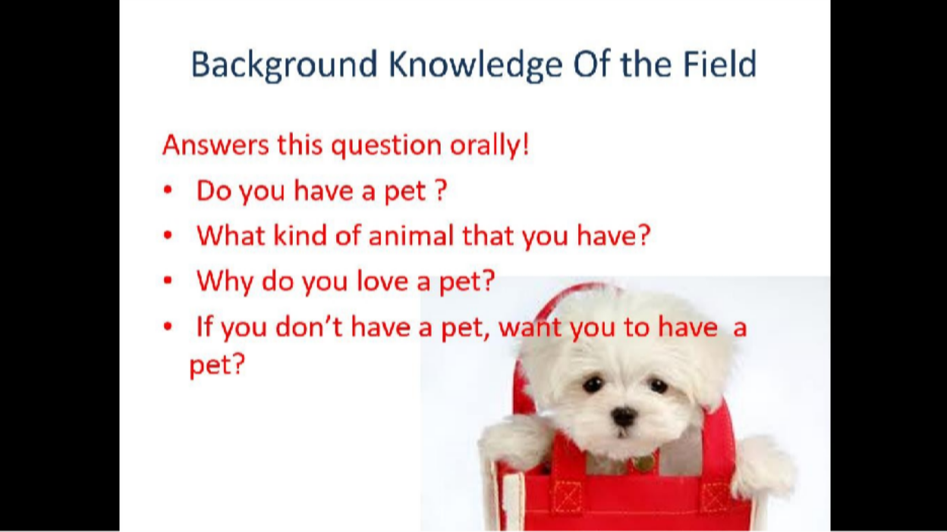

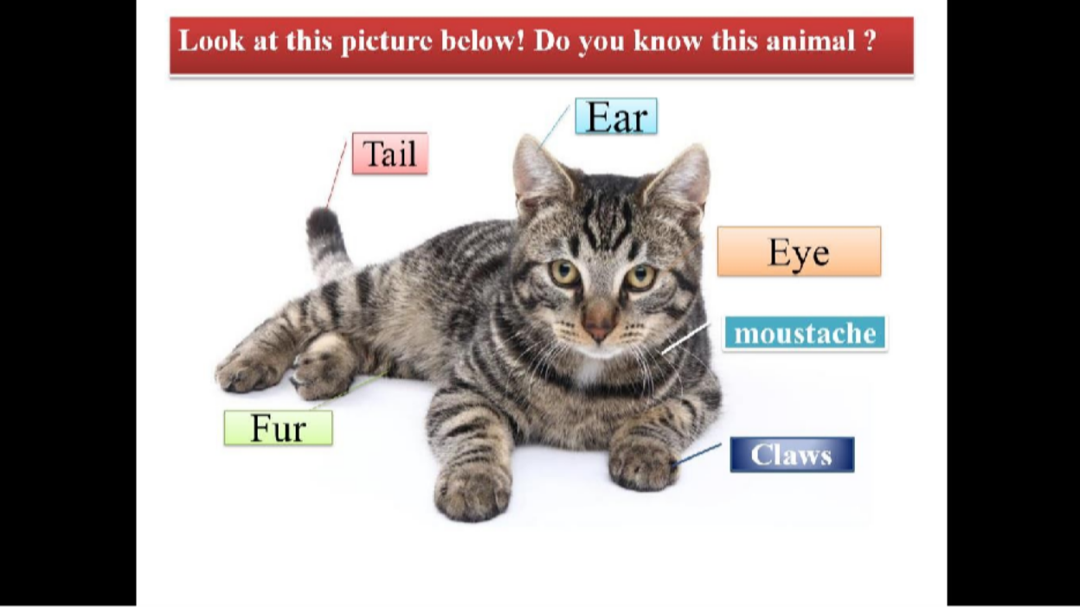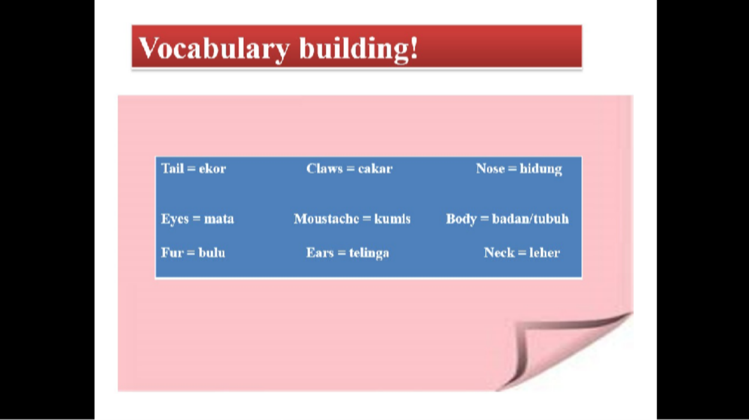

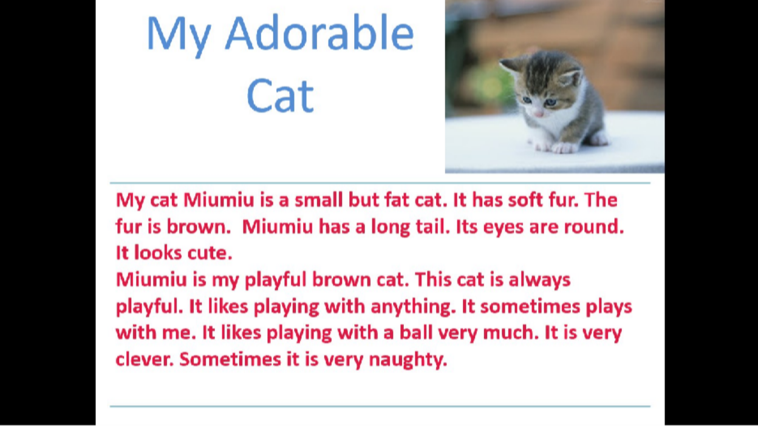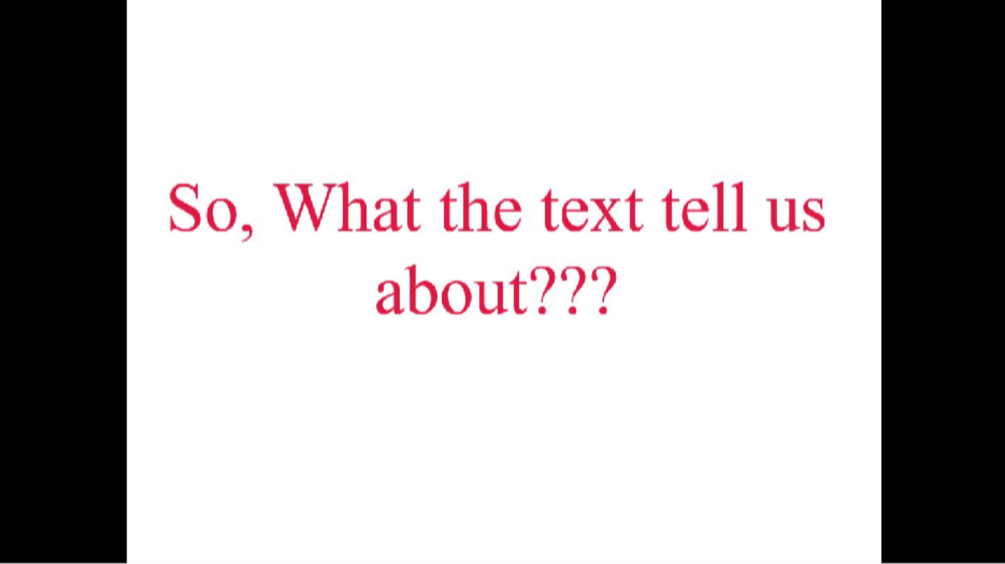

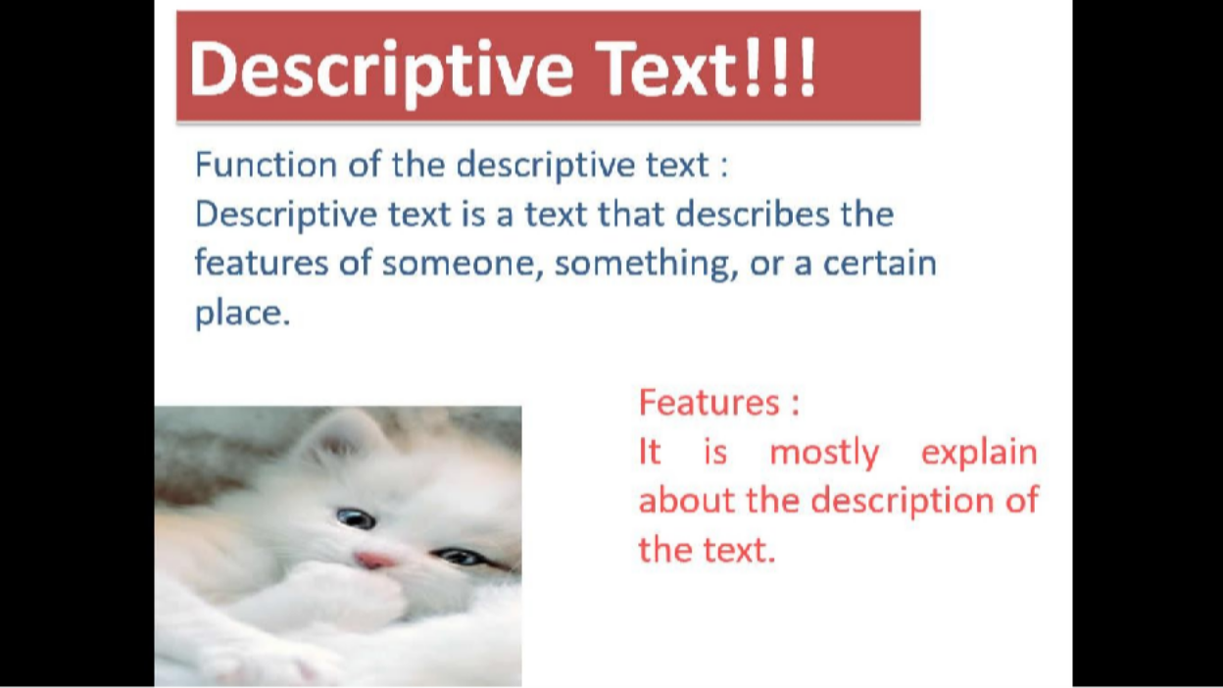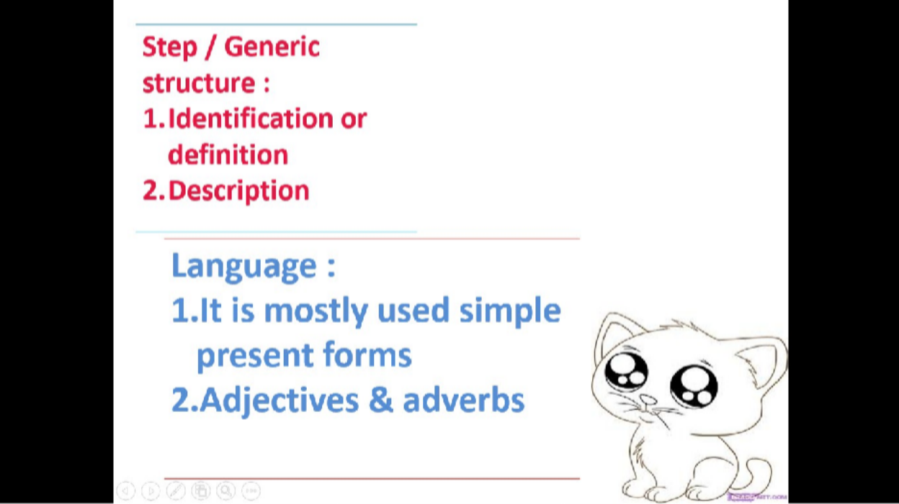

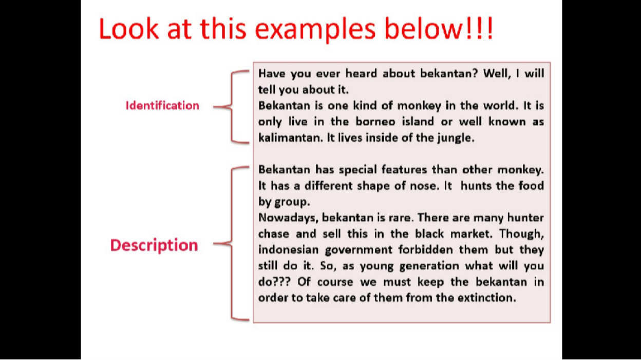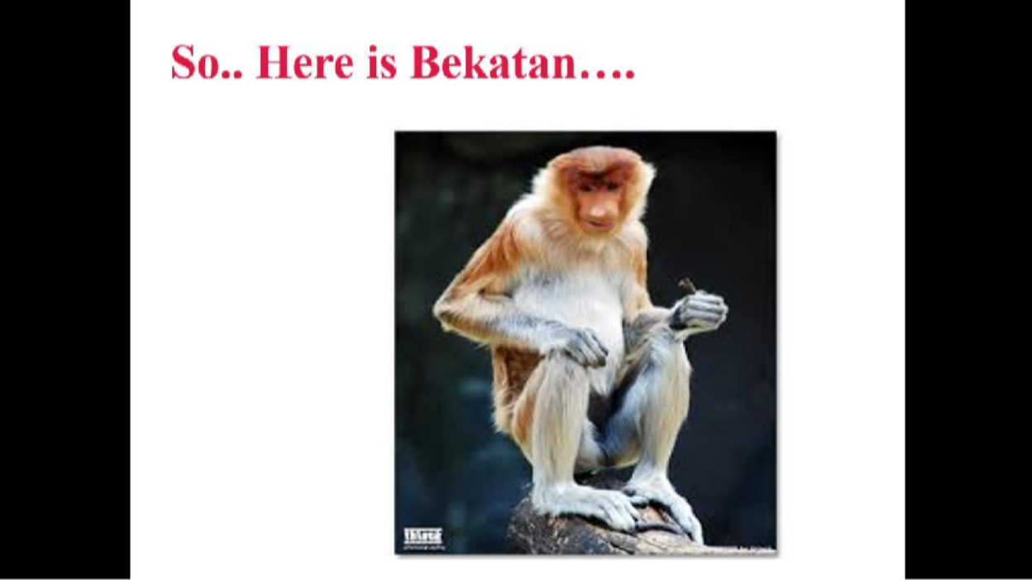



- Padlet

  - Padlet Pertemuan Ke 1 (https://id.padlet.com/putrirayhannuri/pd0w9qs7i7lvi1mz)
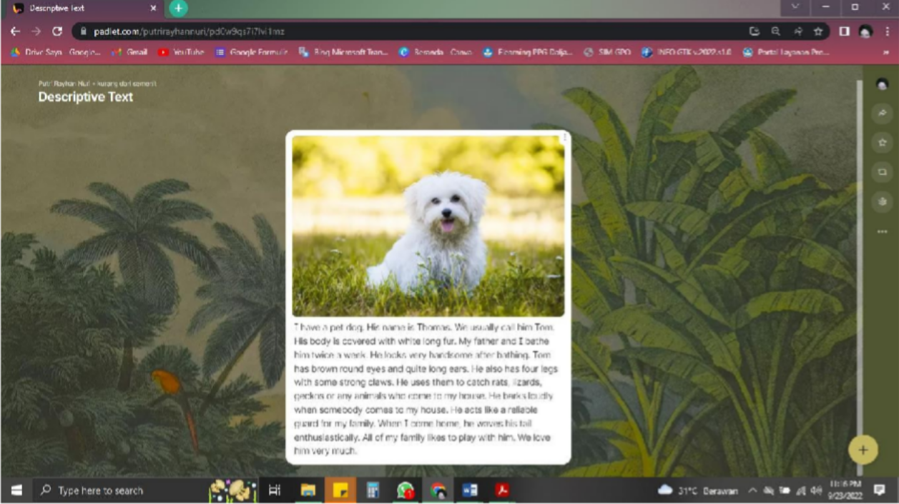

  - Padlet Pertemuan Ke 2 (https://padlet.com/putrirayhannuri/5cwxd6yhjlvmrr7l)
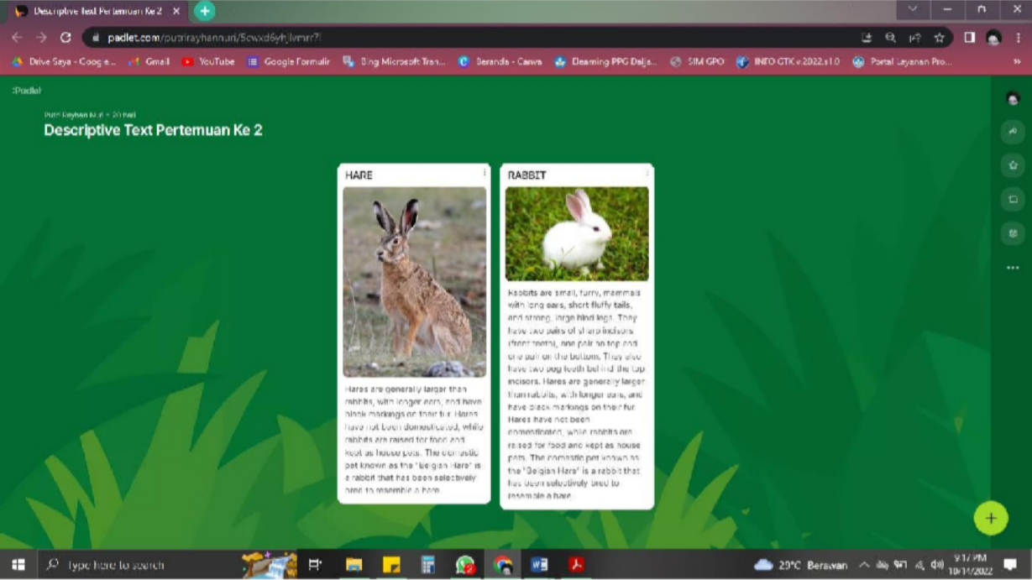



159

- LKPD PERTEMUAN KE - 1


I have a pet dog. His name is Thomas. We usually call him Tom. His body is covered with white long fur. My father and I bathe him twice a week. He looks very handsome after bathing. Tom has brown round eyes and quite long ears. He also has four legs with some strong claws. He uses them to catch rats, lizards, geckos or any animals who come to my house. He barks loudly when somebody comes to my house. He acts like a reliable guard for my family. When I come home, he waves his tail enthusiastically. All of my family likes to play with him. We love him very much.

  - Berdasarkan contoh teks deskripsi di atas. Diskusikan secara berkelompok untuk melengkapi tabel berikut !

Tabel analisis teks deskriptif

Aspek Bahasa | Analisis
Fungsi sosial

Struktur teks
Unsur Kebahasaan

KISI KISI PENULISAN SOAL PERTEMUAN KE 1

No. | Kompetensi Dasar | IPK | Materi Pokok | Indikator Soal | Level | Bentuk Soal | Nomor Soal
1 | 3.7 | 1. | Teks | Disajikan teks | C4 | Uraian | 1
 | Menganalisis | Mengidentifikasi | descriptive | tentang
 | fungsi | fungsi sosial, |  | binatang,
 | sosial, | struktur teks, dan |  | peserta didik
 | Struktur teks, | unsur kebahasaan |  | dapat
 | dan unsur | dari teks tulis |  | menganalisis
 | kebahasaan | sangat pendek dan |  | fungsi sosial,
 | teks deskriptif | sederhana tentang |  | struktur teks,
 | lisan dan tulis | deskripsi binatang |  | dan unsur
 | dengan | sesuai dengan |  | kebahasaan
 | memberi dan | konteks |  | dari teks tulis
 | meminta informasi | penggunaanya. |  | sangat pendek dan sederhana

 | terkait dengan deskripsi orang, binatang, dan benda, sangat pendek dan sederhana, sesuai dengan konteks | 2.  Menghubungkan pengetahuan tentang fungsi sosial, struktur teks, dan unsur kebahasaan dari teks tulis sangat pendek dan sederhana tentang deskripsi binatang sesuai dengan konteks penggunaanya. |  | tentang deskripsi binatang sesuai dengan konteks penggunaanya.
3. Menguraikan fungsi sosial, struktur teks, dan unsur kebahasaan dari teks tulis sangat pendek dan sederhana tentang deskripsi binatang sesuai
dengan konteks penggunaanya.

PEDOMAN PENILAIAN PERTEMUAN KE 1

Rubrik Penilaian Kemampuan Membaca (Reading Comprehensive)

ASPEK | SANGAT BAIK | BAIK | CUKUP | KURANG
Mengidentifikasi | Siswa dapat | Siswa dapat | Siswa dapat | Siswa dapat
fungsi sosial, | mengidentifikasi | mengidentifikasi | mengidentifikasi | mengidentifikasi
struktur teks, dan | fungsi sosial, | hanya sebagian | hanya sebagian | fungsi sosial,
unsur | struktur teks, dan | fungsi sosial, | fungsi sosial, | struktur teks, dan
kebahasaan dari | unsur kebahasaan | struktur teks, dan | struktur teks, dan | unsur
teks tulis sangat | dari teks tulis | unsur kebahasaan | unsur kebahasaan | kebahasaan dari
pendek dan | sangat pendek dan | dari teks tulis | dari teks tulis | teks tulis sangat
sederhana | sederhana tentang | sangat pendek dan | sangat pendek dan | pendek dan
tentang deskripsi | deskripsi binatang | sederhana tentang | sederhana tentang | sederhana

binatang sesuai dengan konteks penggunaanya. | sesuai dengan konteks penggunaanya. | deskripsi binatang sesuai dengan konteks penggunaanya.sec  ara mandiri | deskripsi binatang sesuai dengan konteks penggunaanya.dib  antu oleh guru | tentang deskripsi binatang sesuai dengan konteks penggunaanya.di  bantu oleh guru
Menghubungkan | Siswa dapat | Siswa dapat | Siswa dapat | Siswa dapat
pengetahuan | menghubungkan | menghubungkan | menghubungkan | menghubungkan
tentang fungsi | pengetahuan | sebagian | sebagian | pengetahuan
sosial, struktur | tentang fungsi | pengetahuan | pengetahuan | tentang fungsi
teks, dan unsur | sosial, struktur | tentang fungsi | tentang fungsi | sosial, struktur
kebahasaan dari | teks, dan unsur | sosial, struktur | sosial, struktur | teks, dan unsur
teks tulis sangat | kebahasaan dari | teks, dan unsur | teks, dan unsur | kebahasaan dari
pendek dan | teks tulis sangat | kebahasaan dari | kebahasaan dari | teks tulis sangat
sederhana | pendek dan | teks tulis sangat | teks tulis sangat | pendek dan
tentang deskripsi | sederhana tentang | pendek dan | pendek dan | sederhana
binatang sesuai | deskripsi binatang | sederhana tentang | sederhana tentang | tentang deskripsi
dengan konteks | sesuai dengan | deskripsi binatang | deskripsi binatang | binatang sesuai
penggunaanya. | konteks | sesuai dengan | sesuai dengan | dengan konteks
 | penggunaanya | konteks | konteks | penggunaanya.di
 | secara mandiri | penggunaanya | penggunaanya | bantu oleh guru
 |  | secara mandiri | dibantu oleh guru
Menguraikan | Siswa dapat menguraikan fungsi sosial, struktur teks, dan unsur kebahasaan dari teks tulis sangat pendek dan sederhana tentang deskripsi binatang sesuai dengan konteks penggunaanya.seca ra mandiri | Siswa dapat | Siswa dapat | Siswa dapat
fungsi sosial, |  | menguraikan | menguraikan | menguraikan
struktur teks, dan |  | sebagian | sebagian | fungsi sosial,
unsur kebahasaan  dari teks tulis sangat pendek dan sederhana tentang deskripsi binatang sesuai dengan konteks penggunaanya. |  | pengetahuan tentang fungsi sosial, struktur teks, dan unsur kebahasaan dari teks tulis sangat pendek dan sederhana tentang | pengetahuan tentang fungsi sosial, struktur teks, dan unsur kebahasaan dari teks tulis sangat pendek dan sederhana tentang | struktur teks, dan unsur kebahasaan dari teks tulis sangat pendek dan sederhana tentang deskripsi binatang sesuai
 |  | deskripsi binatang | deskripsi binatang | dengan konteks
 |  | sesuai dengan | sesuai dengan | penggunaanya.di
 |  | konteks | konteks | bantu oleh guru
 |  | penggunaanya.sec | penggunaanya.dib
 |  | ara mandiri | antu oleh guru

Kolom Aspek diisi dengan angka yang sesuai dengan kriteria berikut. 4 = sangat baik
3 = baik
2 = cukup
1 = kurang

Skor Penilaian

No. | Huruf | Rentang angka
1. | Sangat Baik (A) | 86-100
2. | Baik (B) | 71-85
3. | Cukup (C) | 56-70
4. | Kurang (D) | ≤ 55

- LKPD PERTEMUAN KE – 2

Look at the pictures below and answer the questions 1 to 5!


Rabbits are small, furry, mammals with long ears, short fluffy tails, and strong, large hind legs. They have two pairs of sharp incisors (front teeth), one pair on top and one pair on the bottom. They also have two peg teeth behind the top incisors. Hares are generally larger than rabbits, with longer ears, and have black markings on their fur. Hares have not been domesticated, while rabbits are raised for food and kept as house pets. The domestic pet known as the "Belgian Hare" is a rabbit that has been selectively bred to resemble a hare.


Hares are generally larger than rabbits, with longer ears, and have black markings on their fur. Hares have not been domesticated, while rabbits are raised for food and kept as house pets. The domestic pet known as the "Belgian Hare" is a rabbit that has been selectively bred to resemble a hare

- What is the differences between rabbits and hares?
- Who has the longest ears?
- Does all of the hares involved as a pet?
- Which one has the bigger body?
- What is the intention of the those text?

KISI KISI PENULISAN SOAL PERTEMUAN KE 2

No. | KD | Kelas | Materi | Level | Indikator
1 | 3.7 | VII | Descriptive | C4 | Membandingkan fungsi
 | Menganalisis fungsi sosial, |  | text |  | sosial, Struktur teks, dan
 | Struktur teks, dan unsur |  |  |  | unsur kebahasaan teks
 | kebahasaan teks deskriptif lisan |  |  |  | deskriptif lisan dan tulis
 | dan tulis dengan memberi dan |  |  |  | dengan memberi dan
 | meminta informasi terkait |  |  |  | meminta informasi terkait
 | dengan deskripsi orang, |  |  |  | dengan deskripsi orang,
 | binatang, dan benda, sangat |  |  |  | binatang, dan benda, sangat
 | pendek dan sederhana, |  |  |  | pendek dan sederhana,
 | sesuai dengan konteks |  |  |  | sesuai dengan konteks
2 |  |  |  | C1 | Mengidentifikasi fungsi
 |  |  |  |  | sosial, Struktur teks, dan
 |  |  |  |  | unsur kebahasaan teks
 |  |  |  |  | deskriptif lisan dan tulis
 |  |  |  |  | dengan memberi dan
 |  |  |  |  | meminta informasi terkait
 |  |  |  |  | dengan deskripsi orang,
 |  |  |  |  | binatang, dan benda, sangat
 |  |  |  |  | pendek dan sederhana,
 |  |  |  |  | sesuai dengan konteks
3 |  |  |  | C2 | Menyimpulkan fungsi
 |  |  |  |  | sosial, Struktur teks, dan
 |  |  |  |  | unsur kebahasaan teks
 |  |  |  |  | deskriptif lisan dan tulis
 |  |  |  |  | dengan memberi dan
 |  |  |  |  | meminta informasi terkait
 |  |  |  |  | dengan deskripsi orang,
 |  |  |  |  | binatang, dan benda, sangat
 |  |  |  |  | pendek dan sederhana,
 |  |  |  |  | sesuai dengan konteks
4 |  |  |  | C1 | Mengidentifikasi fungsi
 |  |  |  |  | sosial, Struktur teks, dan
 |  |  |  |  | unsur kebahasaan teks
 |  |  |  |  | deskriptif lisan dan tulis
 |  |  |  |  | dengan memberi dan
 |  |  |  |  | meminta informasi terkait
 |  |  |  |  | dengan deskripsi orang,
 |  |  |  |  | binatang, dan benda, sangat
 |  |  |  |  | pendek dan sederhana,
 |  |  |  |  | sesuai dengan konteks

5 |  |  |  | C4 | Menguraikan fungsi sosial, Struktur teks, dan unsur kebahasaan teks deskriptif lisan dan tulis dengan memberi dan meminta informasi terkait dengan deskripsi orang, binatang, dan benda, sangat pendek dan sederhana,  sesuai dengan konteks

PEDOMAN PENILAIAN PERTEMUAN KE 2

Rubrik Penilaian Kemampuan Membaca (Viewing)

No. | Butir Pertanyaan | Bobot Soal | Kriteria Penskoran |  |  |  |  | Nilai Akhir
No. | Butir Pertanyaan | Bobot Soal | 5 | 10 | 15 | 20 | 25 | Nilai Akhir
1 | What is the differences between rabbits and hares? | 25
2 | Who has the longest ears? | 15
3 | Does all of the hares involved as a pet? | 20
4 | Which one has the bigger body? | 15
5 | What is the intention of the those text? | 25
Jumlah skor maksimal = 100

LAMPIRAN

167

APPENDIX

Reading Comprehensive Test (Pre-Test)

The Tale of Timun Mas: A Cucumber's Magical Journey
In the heart of a lush Javanese village, there lived a humble couple who yearned for a child. One day, while working in their fields, the wife encountered a peculiar cucumber, shimmering with an otherworldly glow. Intrigued, she brought it home, unaware of the extraordinary surprise it held within.
As the days turned into weeks, the cucumber began to pulsate with life. To their astonishment, the couple watched as it cracked open, revealing a beautiful baby girl with emerald-green skin and sparkling eyes. They named her Timun Mas, meaning "Golden Cucumber," and showered her with love and care.
Years passed, and Timun Mas grew into a remarkable young woman, renowned for her kindness, intelligence, and beauty. However, their peaceful existence was shattered when a monstrous giant named Buto Ijo, known for his insatiable appetite for human flesh, set his sights on Timun Mas.
Fearing for their daughter's safety, Timun Mas's parents revealed the secret of her origin and the cucumber's magical powers. With a heavy heart, they bid her farewell as she embarked on a perilous journey to escape Buto Ijo's clutches.
Armed with four magical seeds gifted by her parents, Timun Mas ventured into the dense forest, her heart pounding with fear and determination. Buto Ijo, alerted by his wicked senses, relentlessly pursued her, his booming footsteps echoing through the trees.
As Timun Mas ran, she came across a vast field. Remembering her first seed, she tossed it behind her, transforming it into a sprawling cucumber plantation. Buto Ijo, blinded by his hunger, rushed into the field, feasting on the cucumbers, unaware of the precious time he was wasting.
Timun Mas continued her escape, reaching a river that seemed to stretch as far as the eye could see. She planted her second seed, and in an instant, a sturdy bridge materialized, spanning the mighty river. Buto Ijo, enraged by his delay, lumbered after her, pounding his feet on the bridge, causing it to sway dangerously.
Undeterred, Timun Mas pressed forward, arriving at a dense forest. She planted her third seed, and a thicket of thorny bamboo sprang up, blocking Buto Ijo's path. He struggled to break through the impenetrable barrier, his cries of frustration echoing through the trees.
Finally, Timun Mas reached a vast salt field, her heart pounding with hope. She planted her last seed, and in a blinding flash, the entire field transformed into a shimmering sea of salt. Buto Ijo, caught off guard, stumbled into the salt lake, his monstrous body dissolving into nothingness.
Exhausted but relieved, Timun Mas returned home, her parents embracing her with tears of joy and gratitude. They had witnessed the extraordinary bravery and resourcefulness of their daughter, who had outsmarted and defeated the fearsome Buto Ijo.

News of Timun Mas's heroic deed spread throughout the land, and she became a symbol of courage and resilience. Her story serves as a reminder that even in the face of overwhelming adversity, wit, determination, and a touch of magic can overcome any obstacle

Question 1-4 (Ability to Understand Texts Comprehensively)

- How did Timun Mas come into existence?

  - She was born from a magical cucumber found by her parents in their fields.
  - She was an orphan adopted by a kind couple in the village.
  - She was a princess who transformed into a cucumber to escape danger.
  - She was created by a powerful sorcerer using magic.

What was Buto Ijo's primary motive for pursuing Timun Mas?

  - He was seeking revenge for a past grievance against her family.
  - He was fascinated by her beauty and wanted to make her his queen.
  - He was driven by an insatiable hunger for human flesh.
  - He was under a curse that required him to capture a unique girl.

Which of the magical seeds did Timun Mas use to create an impenetrable barrier against Buto Ijo?

  - The first seed, which transformed into a vast cucumber plantation.
  - The second seed, which materialized a sturdy bridge across a river.
  - The third seed, which caused a thicket of thorny bamboo to sprout.
  - The fourth seed, which transformed a field into a shimmering sea of salt.

What is the central message conveyed by the story of Timun Mas?

  - The importance of material wealth and possessions in achieving happiness.
  - The power of fear and submission in overcoming challenges.
  - The value of intelligence, resourcefulness, and courage in facing adversity.
  - The belief in supernatural forces and the use of magic to solve problems.

Question 5-8 (Ability to Evaluate and Interpret Information)

- Timun Mas's parents' decision to keep her hidden from the world highlights their:

  - Overprotectiveness and fear for her safety.
  - Desire to shield her from the harsh realities of life.
  - Belief in her extraordinary abilities and potential.
  - Attempt to conceal her true identity from the villagers.

Buto Ijo's relentless pursuit of Timun Mas despite repeated obstacles suggests his:

  - Single-mindedness and unwavering determination.
  - Overconfidence in his strength and ability to capture her.
  - Lack of intelligence and inability to learn from his mistakes.
  - Ruthlessness and disregard for the consequences of his actions.

Timun Mas's clever utilization of the magical seeds demonstrates her:

  - Reliance on supernatural powers rather than her own skills.
  - Ability to think creatively and adapt to different situations.
  - Dependence on her parents' guidance and support to overcome challenges.
  - Possession of innate magical abilities that set her apart from others.

The story's ending, where Timun Mas triumphs over Buto Ijo, conveys the message that:

  - Evil forces will always be defeated by the power of good.
  - Cleverness and resourcefulness can overcome even the most formidable foes.
  - The importance of family and community support in overcoming adversity.
  - The need for magical intervention to achieve victory over evil.

Question 9-12 (Ability to Relate Related Concepts)

- The story of Timun Mas shares similarities with the tale of:

  - Cinderella, a young woman who transforms from rags to riches with the help of magic.
  - Jack and the Beanstalk, a boy who trades a cow for magic beans that lead him to a giant's castle.
  - The Little Mermaid, a mermaid who gives up her tail and voice to become human.
  - Rapunzel, a princess trapped in a tower who is rescued by a handsome prince.

The character of Buto Ijo can be compared to:

  - The Wicked Witch of the West in The Wizard of Oz, who seeks to destroy Dorothy and her companions.
  - The Ogre in Shrek, who initially captures Princess Fiona but later falls in love with her.
  - The Evil Queen in Snow White and the Seven Dwarfs, who plots to kill her stepdaughter out of jealousy.
  - The Dragon in Mulan, a fearsome creature that threatens the village but is ultimately defeated.

The use of magical seeds in the story of Timun Mas is analogous to the use of:

  - Enchanted objects in fairy tales, such as talking animals and magical artifacts.
  - Advanced technology in science fiction stories, which allows humans to achieve extraordinary feats.
  - Special powers possessed by superheroes, such as superhuman strength
  - Natural elements in folklore, such as talking trees or magical herbs with healing properties.

The theme of overcoming adversity through intelligence and resourcefulness is prevalent in:

  - Stories about overcoming personal challenges, such as poverty, illness, or discrimination.
  - Narratives about survival in extreme environments, such as shipwrecks or desert expeditions.
  - Tales of triumph over evil forces, such as battles against villains or monsters.
  - All of the above

Question 13-16 (Ability to Use Effective Reading Strategies)

- How did the author introduce the magical element of the story?

  - By explicitly stating the supernatural nature of the cucumber from which Timun Mas emerged.
  - By gradually revealing the magical abilities of Timun Mas and the seeds she possesses.
  - By incorporating fantastical elements into the setting and descriptions of the story.
  - By using symbolic language and imagery that hint at the presence of magic.

What strategy does the author employ to build suspense and anticipation throughout the narrative?

  - By describing Timun Mas's perilous journey in detail, emphasizing the dangers she faces.
  - By introducing Buto Ijo's monstrous character and relentless pursuit of Timun Mas early in the story.
  - By utilizing cliffhangers at the end of chapters, leaving readers eager to know what happens next.
  - By employing a fast-paced narrative style that keeps the reader engaged.

How does the author characterize Timun Mas as an intelligent and resourceful protagonist?

  - By explicitly stating her intelligence and resourcefulness in the narration.
  - By showcasing her ability to think creatively and adapt to different challenges.
  - By contrasting her actions and decisions with those of less intelligent or resourceful characters.
  - By emphasizing the positive outcomes of her actions and the success of her plans.

What overall tone or mood does the author establish for the story of Timun Mas?

  - Dark and ominous, with a sense of danger and foreboding.
  - Lighthearted and adventurous, with a focus on Timun Mas's cleverness and resourcefulness.
  - Hopeful and inspiring, conveying a message of triumph over adversity.
  - Humorous and lighthearted, with elements of exaggeration and fantasy.

Question 17-20 (Ability to Relate Information to Prior Experience)

- The story of Timun Mas shares a common theme with many folktales and fairy tales from different cultures, which is the:

  - Triumph of good over evil
  - Importance of family and community
  - Power of magic and supernatural forces
  - Value of hard work and perseverance

The character of Timun Mas can be related to other protagonists in literature who demonstrate:

  - Courage and determination in the face of adversity
  - Resourcefulness and creativity in solving problems
  - Kindness and compassion towards others
  - All of the above

The use of magical seeds in the story can be compared to the use of:

  - Special abilities or powers possessed by characters in other stories
  - Symbolic objects that represent deeper meanings or themes
  - Tools or resources that aid characters in achieving their goals
  - All of the above

The overall message of the story of Timun Mas resonates with many real-life experiences, such as:

  - Overcoming personal challenges and obstacles
  - Facing discrimination or prejudice
  - Utilizing intelligence and resourcefulness to succeed
  - All of the above

Key Test

Story Comprehensive

    - (a) She was born from a magical cucumber found by her parents in their fields.
    - (c) He was driven by an insatiable hunger for human flesh.
    - (c) The third seed, which caused a thicket of thorny bamboo to sprout.
    - (c) The value of intelligence, resourcefulness, and courage in facing adversity.

Evaluation and Interpretation

    - (a) Overprotectiveness and fear for her safety.
    - (a) Single-mindedness and unwavering determination.
    - (b) Ability to think creatively and adapt to different situations.
    - (b) Cleverness and resourcefulness can overcome even the most formidable foes.

Relating Related Concepts

    - (b) Jack and the Beanstalk, a boy who trades a cow for magic beans that lead him to a giant's castle.
    - (c) The Evil Queen in Snow White and the Seven Dwarfs, who plots to kill her stepdaughter out of jealousy.
    - (d) Natural elements in folklore, such as talking trees or magical herbs with healing properties.
    - (a) Stories about overcoming personal challenges, such as poverty, illness, or discrimination.

Effective Reading Strategies

    - (b) By gradually revealing the magical abilities of Timun Mas and the seeds she possesses.
    - (b) By introducing Buto Ijo's monstrous character and relentless pursuit of Timun Mas early in the story.
    - (b) By showcasing her ability to think creatively and adapt to different challenges.
    - (c) Hopeful and inspiring, conveying a message of triumph over adversity.

Relating Information to Prior Experience

    - (a) Triumph of good over evil
    - (d) All of the above
    - (d) All of the above
    - (d) All of the above

20 Likert Scale-Questions Focusing on Motivation for Reading Comprehensive

Name :
Class :
Please rate the following statements based on your feelings and experiences using the scale provided.
- I enjoy reading challenging texts.
  - Strongly Disagree
    - Disagree
    - Neutral
    - Agree
    - Strongly Agree
- I feel motivated to read every day.
  - Strongly Disagree
    - Disagree
    - Neutral
    - Agree
    - Strongly Agree
- Understanding complex texts is important for my academic success.
  - Strongly Disagree
    - Disagree
    - Neutral
    - Agree
    - Strongly Agree
- I feel confident in my ability to comprehend difficult reading materials.
  - Strongly Disagree
    - Disagree
    - Neutral
    - Agree
    - Strongly Agree
- I find pleasure in exploring new ideas through reading.
  - Strongly Disagree
    - Disagree
    - Neutral
    - Agree
    - Strongly Agree
- Reading helps me expand my knowledge.
  - Strongly Disagree
    - Disagree
    - Neutral
    - Agree
    - Strongly Agree
- I believe that improving my reading comprehensive skills will benefit me in the future.
  - Strongly Disagree
    - Disagree
    - Neutral
    - Agree
    - Strongly Agree
- I set specific goals for my reading comprehensive development.

  - Strongly Disagree
    - Disagree
    - Neutral
    - Agree
    - Strongly Agree
- I actively seek out opportunities to engage with different types of texts.
  - Strongly Disagree
    - Disagree
    - Neutral
    - Agree
    - Strongly Agree
- I feel a sense of accomplishment when I understand a challenging text.
  - Strongly Disagree
    - Disagree
    - Neutral
    - Agree
    - Strongly Agree
- I am motivated to read even when the material is difficult.
  - Strongly Disagree
    - Disagree
    - Neutral
    - Agree
    - Strongly Agree
- I believe that reading comprehensive is a valuable skill for life beyond academics.
  - Strongly Disagree
    - Disagree
    - Neutral
    - Agree
    - Strongly Agree
- I enjoy discussing what I have read with others.
  - Strongly Disagree
    - Disagree
    - Neutral
    - Agree
    - Strongly Agree
- I am curious to learn new information through reading.
  - Strongly Disagree
    - Disagree
    - Neutral
    - Agree
    - Strongly Agree
- I feel motivated to read when I can relate the text to my personal experiences.
  - Strongly Disagree
    - Disagree
    - Neutral
    - Agree
    - Strongly Agree
- I believe that reading comprehensive is essential for critical thinking.

  - Strongly Disagree
19-36 | Less motivated
0-18 | Unmotivated

    - Disagree
    - Neutral
    - Agree
    - Strongly Agree
- I feel motivated to read when I see the practical applications of the material.
  - Strongly Disagree
    - Disagree
    - Neutral
    - Agree
    - Strongly Agree
- I enjoy exploring different perspectives presented in texts.
  - Strongly Disagree
    - Disagree
    - Neutral
    - Agree
    - Strongly Agree

Scale of Motivated Level

Score | Category Level
73-90 | Very Motivated
55-72 | Motivated
37-54 | Motivated enough

Reading comprehensive tests (Post test) Read the texts below and anwer no.1-5!
Many different kinds of life cohabit peacefully in a lovely, verdant forest. With its thick hair, a large brown bear is frequently spotted meandering amid the woods. He is not alone, though, for cheeky monkeys frequently pursue him.
A family of seagulls lives together in the lofty trees. Together, they tenderly tend to their nest. A family of red foxes plays nimbly in the shrubs not far away.
Meanwhile, a group of ducks and geese can be seen swimming contentedly in the crystal-clear stream. They frequently sing as they love living in the outdoors and glide across the tranquil water.
But there are times when woodland life is not tranquil. Occasionally, violent storms pass through, causing the sky to light up with lightning strikes and the earth to get drenched in rain. However, the rain also provides blessings, as the forest's flora and plants are revitalized and renewed.
In the clear blue sky, a stunning rainbow appears following the storm. For all the forest's inhabitants, the rainbow becomes a symbol of hope that, despite adversity, happiness is just around the corner. Thus, life goes on in the wonder-filled forest surrounded by breathtaking scenery.
Berikut adalah 5 pertanyaan pilihan ganda dengan tingkat kesulitan yang telah ditentukan:
- Kesulitan Sedang (60%)
Question: What is the main idea of the passage?
  - The behaviors of animals in the forest.
  - The importance of harmony in nature.
  - The different types of trees in the forest.
  - The dangers of storms in the forest.
- Kesulitan Sedang (60%)
Question: Which reading strategy is most effective for understanding complex texts?
  - Skimming and scanning.
  - Making predictions.
  - Summarizing main ideas.
  - Analyzing vocabulary words.

- Kesulitan Gampang (30%)
Question: How do ducks and geese contribute to the ecosystem of the forest?
  - By building nests in tall trees.
  - By singing songs to entertain other animals.
  - By swimming and keeping the stream clean.
  - By climbing mountains and exploring new territories.
- Kesulitan Gampang (30%)
Question: Which of the following is an example of relating information to prior experience?
  - A bear learning to climb trees by watching other bears.
  - A fox discovering a new hiding spot in the bushes.
  - A seagull building a nest using twigs and leaves.
  - A duck swimming in the stream for the first time.
- Kesulitan Gampang (30%)
Question: Why is it important to use effective reading strategies?
  - To impress others with your reading skills.
  - To quickly finish reading assignments.
  - To improve understanding and retention of information.
  - To avoid reading altogether.

Answer no. 6-10
In a distant kingdom, there lived a king and queen who longed for a child. They prayed to God every day to be blessed with a child. Finally, their prayers were answered, and the queen gave birth to a beautiful princess. They named her Rapunzel.
Unfortunately, shortly after Rapunzel's birth, an evil witch stole the baby. The witch locked Rapunzel in a tall tower in the middle of the forest and instructed her to let her beautiful hair grow long.
Years passed, and Rapunzel grew into a beautiful girl with incredibly long hair. Every day, the witch would come and call Rapunzel by climbing up her long hair. Rapunzel, being naive, never knew about the outside world.

One day, a handsome prince passed by the tower and heard Rapunzel's beautiful singing voice. Curious, he climbed up Rapunzel's hair to see who was in the tower. They met, and the prince fell in love with Rapunzel.
With Rapunzel's help, the prince managed to bring Rapunzel out of the tower. They lived happily ever after, and Rapunzel learned that true love conquers all obstacles. And the tale of Rapunzel and the prince became a legend in the kingdom.
- Difficulty 10% (Easy)
- Question: What is the essence of the story you read?
  - A) Main character of the story.
  - B) Setting of the story.
  - C) Main conflict in the story.
  - D) Time of the story events.
- Difficulty 60% (Medium)
- Question: What moral message can you take from the story?
  - A) Friendship is the key to happiness.
  - B) Loyalty is an important trait.
  - C) Wisdom in decision-making.
  - D) Simplicity leads to happiness.
- Difficulty 30% (Moderate)
- Question: How are the concepts in the story related to each other?
  - A) Relationship between main and supporting characters.
  - B) Seasonal changes affecting the story plot.
  - C) Main conflict and its resolution.
  - D) Antagonist characters and their motives.
- Difficulty 10% (Easy)
- Question: What is the first step you should take before reading the story?
  - A) Read the story title.
  - B) Predict the story content.

  - C) Find out the number of story pages.
  - D) Look for illustration pictures in the story.
- Difficulty 60% (Medium)
- Question: How do supporting characters in the story contribute to the main character's development?
  - A) Create intriguing conflicts.
  - B) Provide emotional support.
  - C) Offer physical assistance.
  - D) Build a complex storyline.

Answer no. 11-15
In a small village in West Java, there lived a boy named Andi. Andi was very curious about the stories circulating in his village about Tangkuban Perahu, a volcano not far from his home. Despite having heard many scary stories about the volcano, his curiosity only grew.
One morning, Andi decided to explore Tangkuban Perahu alone. He gathered simple equipment like water, snacks, and a camera to capture his adventure. With a heart full of enthusiasm, he set off for the volcano.
Upon reaching Tangkuban Perahu, Andi was captivated by the natural beauty around him. He could see the large crater emitting thin smoke from a distance. However, fear still haunted his mind. He walked around the crater carefully, but he remained tense.

While enjoying photographing the scenery, suddenly Andi felt a small tremor in the ground. He immediately realized that this could be a sign of danger. Without hesitation, Andi quickly sought a safe place for shelter.
A few moments later, the volcano began to emit a frightening rumble. Thick smoke started pouring out of the crater. Andi felt scared, but he remained calm and followed the instructions he had learned earlier.
Finally, after several tense moments, the volcanic eruption subsided. Andi felt relieved that he had survived the danger. In his heart, he promised to always respect nature and listen to the advice of more experienced people. Through this experience, Andi realized that bravery doesn't always mean disregarding caution.
- When the main character visited Tangkuban Perahu, what made him feel afraid?
- The rumbling sound from the crater

- Small vibrations in the ground
- Beautiful natural scenery
- Pungent smell of sulfur
- What made the main character finally feel relieved after the volcanic eruption subsided?
- He managed to save himself
- He got great photos
- He met friendly people
- He found a way out of the crater
- How did the main character respond to the instructions of the officer during the volcanic eruption?
- He ignored the instructions
- He followed the instructions in panic
- He regretted not listening to the instructions
- He remained calm and followed the instructions well
- Pertanyaan yang menguji kemampuan menggunakan strategi membaca yang efektif: What was the first step taken by the main character when feeling vibrations in the ground?
- Finding a safe place to take cover
- Running away as fast as possible
- Stopping and checking the surroundings
- Continuing the journey without caring
- How did the main character feel after visiting Tangkuban Perahu?
- Afraid and traumatized
- Happy and satisfied
- Angry and disappointed
- No change in feelings

Answer no.16-20
In a village, there lived a mother with her twin children, Bawang Merah and Bawang Putih. Although they were twins, their personalities were very different. Bawang Merah often behaved wickedly, while Bawang Putih was always kind-hearted and obedient to her mother.
One day, their mother fell ill and asked her two children to go into the forest to gather spices for medicine. Before leaving, she warned them not to separate and to be careful. However, in the forest, Bawang Merah decided to separate and devise a wicked plan.
Bawang Merah succeeded in making Bawang Putih lost in the forest. However, Bawang Putih encountered a kind old person who gave her shelter for the night. The next day, Bawang Putih managed to return to the village with the necessary spices.
When Bawang Merah returned, he pretended to have lost his way and lied that Bawang Putih had died in the forest. However, their mother became suspicious and eventually uncovered Bawang Merah's deceit. As punishment, Bawang Merah was expelled from the house, while Bawang Putih was given love and adopted as a good child by her mother.
This story teaches the importance of loyalty, honesty, and affection within a family. Although Bawang Putih's kindness always triumphed over Bawang Merah's wickedness in the end, she also received abundant blessings from her goodness.
- What makes Bawang Merah and Bawang Putih different?
- Their hair color
- Their personalities and behaviors
- Their place of residence
- Their hobbies

- Why did Bawang Merah and Bawang Putih go to the forest?
- To play around
- To gather medicinal spices
- To search for treasure
- To see wild animals
- Who did Bawang Putih meet when she got lost in the forest?
- An evil person
- A hungry lion

- A kind old person
- A demon
- What did Bawang Merah do when Bawang Putih got lost?
- He patiently searched for Bawang Putih
- He devised a wicked plan
- He helped others in the village
- He returned home to inform his mother
- What was the ending of the story for Bawang Merah and Bawang Putih?
- They parted ways forever
- They reconciled and lived happily together
- They continued to quarrel and fight
- They forgot about each other and went on with their lives

KEY ANSWER
- B) The importance of harmony in nature.
- C) Summarizing main ideas.
- C) By swimming and keeping the stream clean.
- A) A bear learning to climb trees by watching other bears.
- C) To improve understanding and retention of information.
- C) Main conflict in the story.
- B) Loyalty is an important trait.
- C) Main conflict and its resolution.
- B) Predict the story content.
- A) Create intriguing conflicts.

**Observation Checklist: Implementation of Guided Self-Selected Reading (GSSR)**

Observer's Name: [ ] Date of Observation: [ ] Class/Grade: [ ]

- **Introduction**
  - [ ] Teacher introduces the concept of GSSR to the students.
  - [ ] Clear instructions are given regarding how GSSR sessions will be conducted.

- **Book Selection**
  - [ ] Students are given the opportunity to choose their own reading materials.
  - [ ] Teacher provides guidance to students in selecting appropriate reading materials based on their interests and reading levels.

- **Reading Session**
  - [ ] Students engage in independent reading for the designated time period.
  - [ ] Teacher circulates among students, providing assistance and support as needed.
  - [ ] Students are observed actively reading and showing signs of engagement with their chosen texts.
- **Discussion and Reflection**
  - [ ] After the reading session, students participate in a discussion about their reading experiences.
  - [ ] Teacher facilitates reflection by asking questions about the content, characters, and themes of the texts.

- **Assessment**
  - [ ] Teacher assesses students' comprehensive through informal observation and/or discussions.
  - [ ] Any difficulties or challenges faced by students during the reading session are noted for future support.

- **Closure**
  - [ ] Session concludes with a brief summary of key points discussed during the reading and reflection.
  - [ ] Students are encouraged to continue reading independently outside of the classroom.

This checklist is designed to ensure thorough observation and documentation of the implementation of GSSR techniques in the classroom setting.

Validityof Reading Comprehensive Test (Pre-Test)
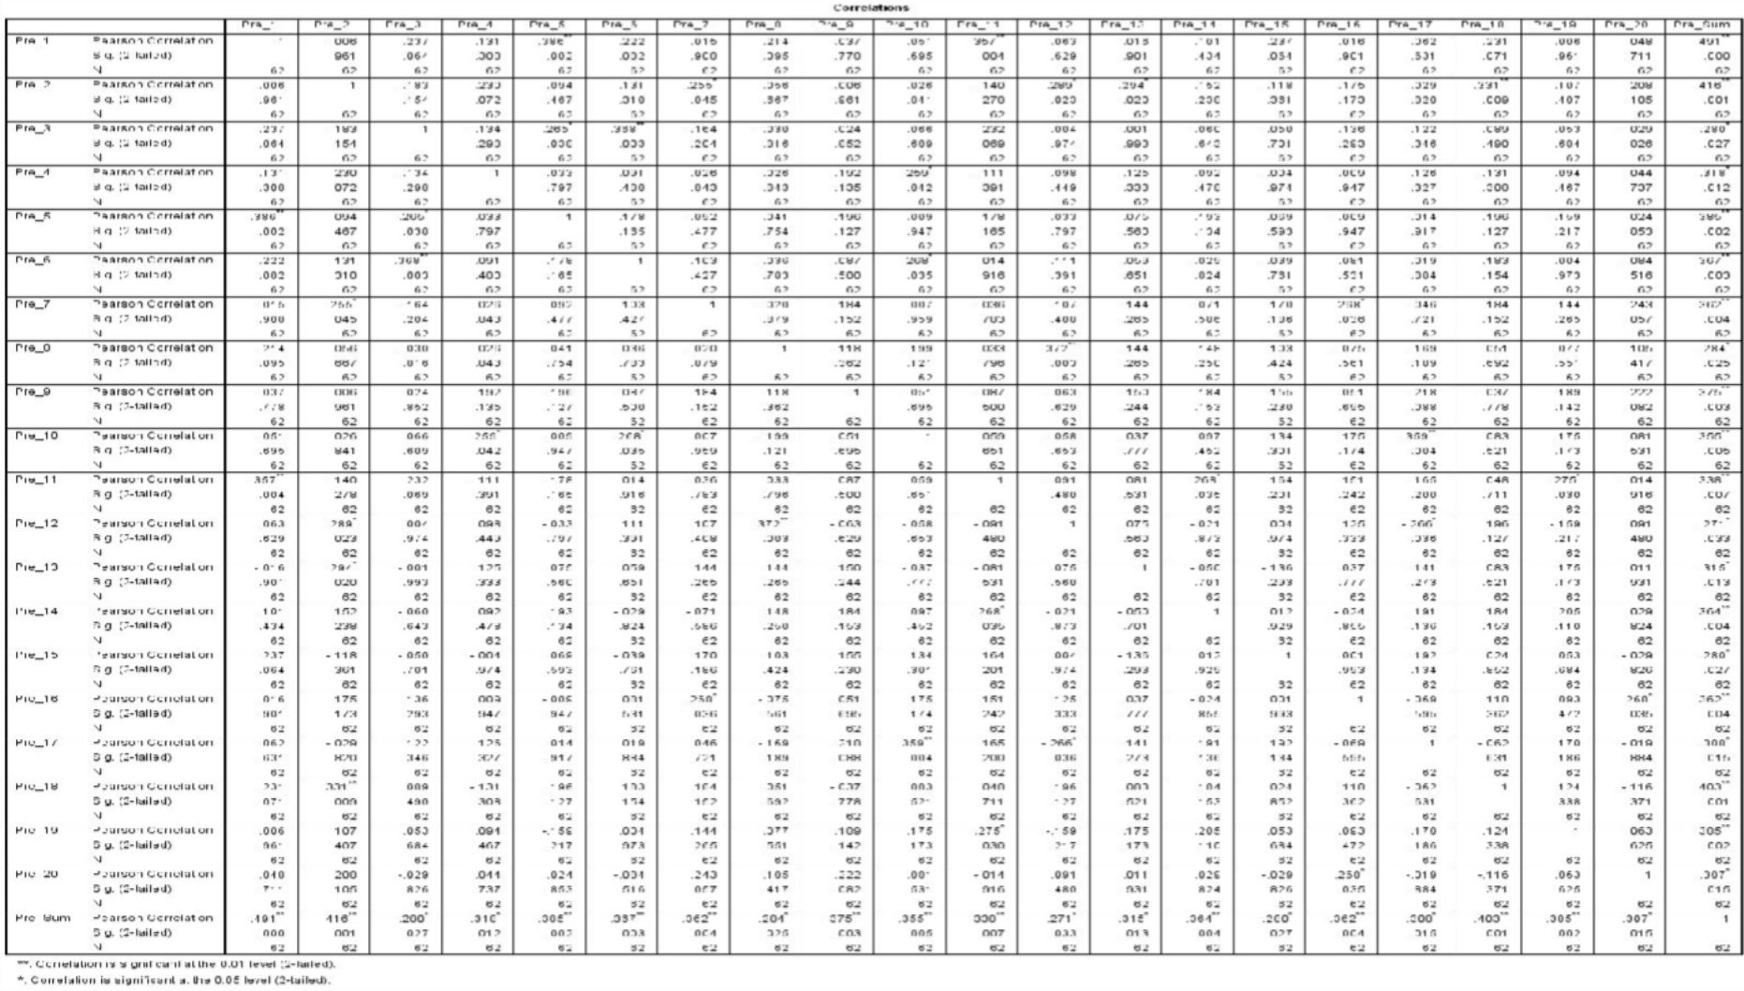

186

187

Validity of Student Reading Comprehensive Test (Post-Test)
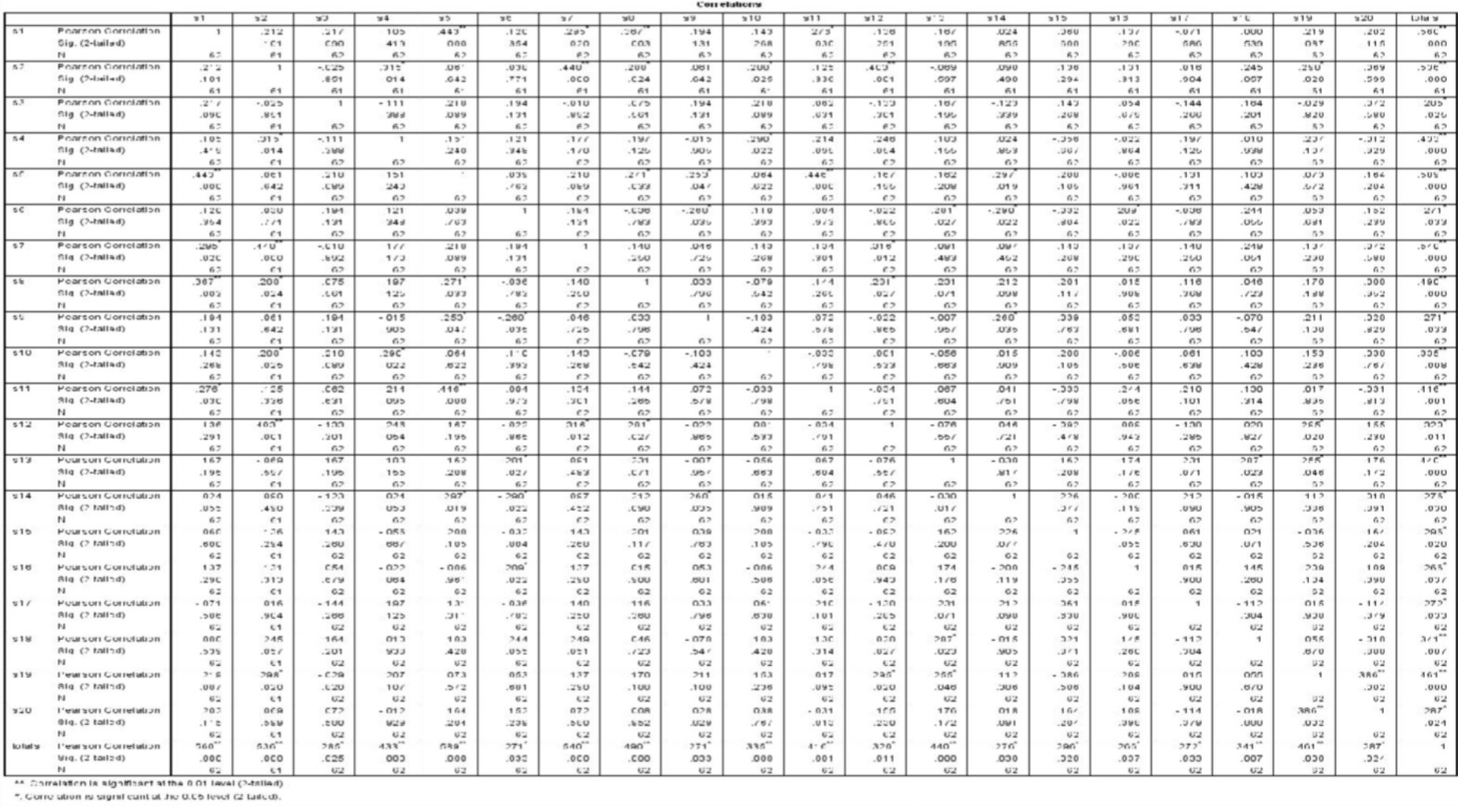

Reliability of Motivation Questionaire

Reliability Statistics
Cronbach's Alpha | N of Items
.988 | 18

Reliability of Students reading Comprehensive Test (Pre-Test)

Reliability Statistics
Cronbach's Alpha | N of Items
.619 | 20

Reliability of Student Reading Comprehensive (Post-Test)

Reliability Statistics
Cronbach's Alpha | N of Items
.692 | 20

188

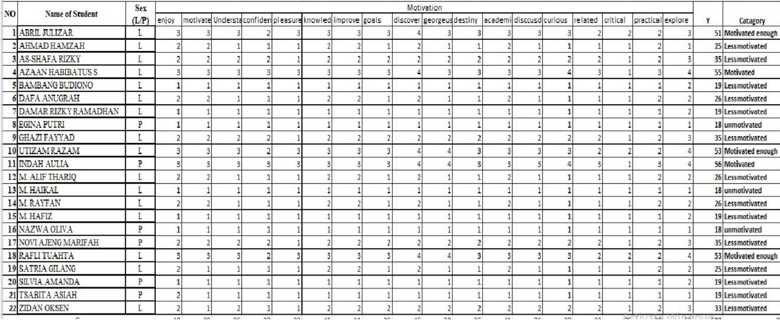

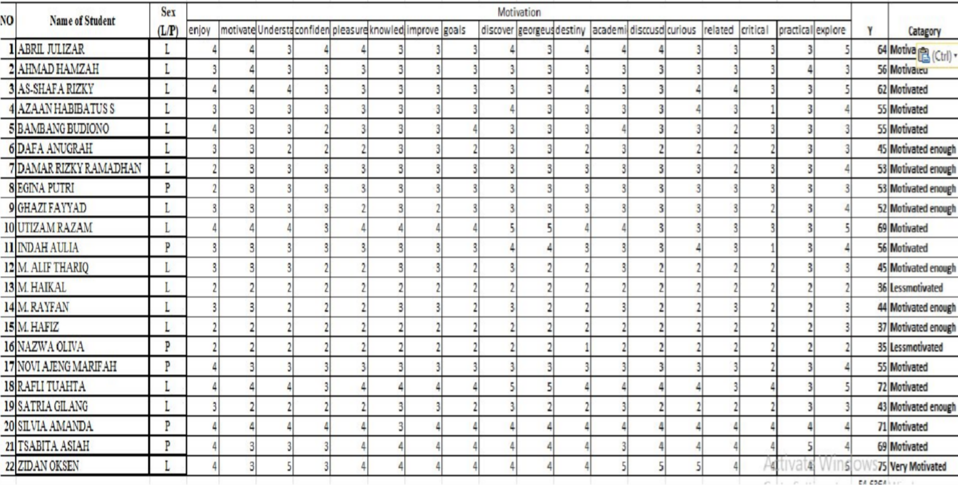

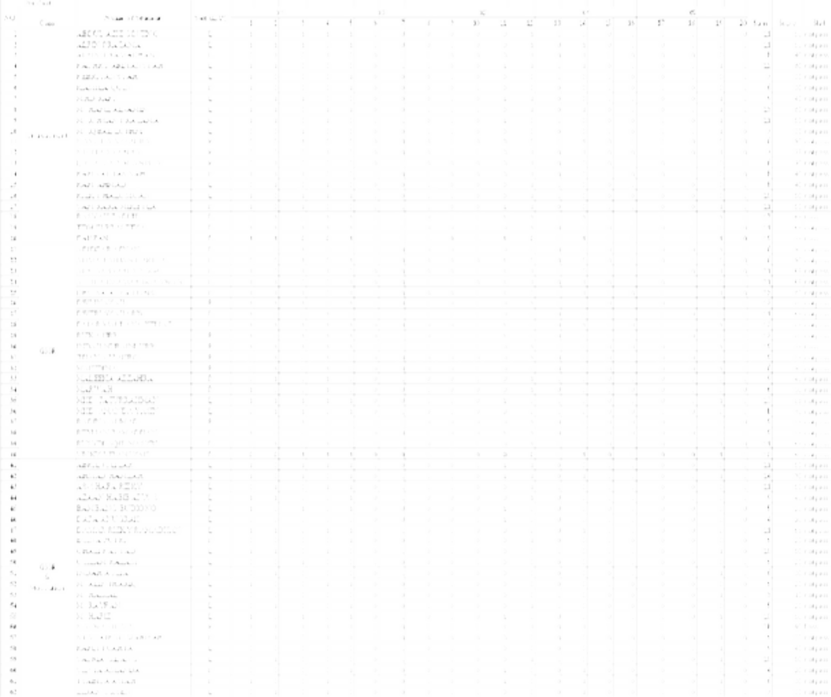


192

Student Development

Average score
Variable | Class | Average score |  | Passing Standard (%)
Variable | Class | Pre | Post | Pre | Post
Reading Comprehensive | 8a | 48,5 | 56,57 | 10 | 30
Reading Comprehensive | 8b | 47 | 70,25 | 5 | 55
Reading Comprehensive | 8c | 39,31 | 77,75 | 5 | 81,81
Motivation | 8C | 31,04 | 54,63 | 22,7 | 90,9

Post
Pre
Post
Pre
5 5
10
39.31
31.04 30
22.7
55
54.63
48.5 47
56.57
90.9
81.81
77.75
70.25
Student Development
Reading Comprehension 8a Reading Comprehension 8b Reading Comprehension 8c Motivation 8C

193

