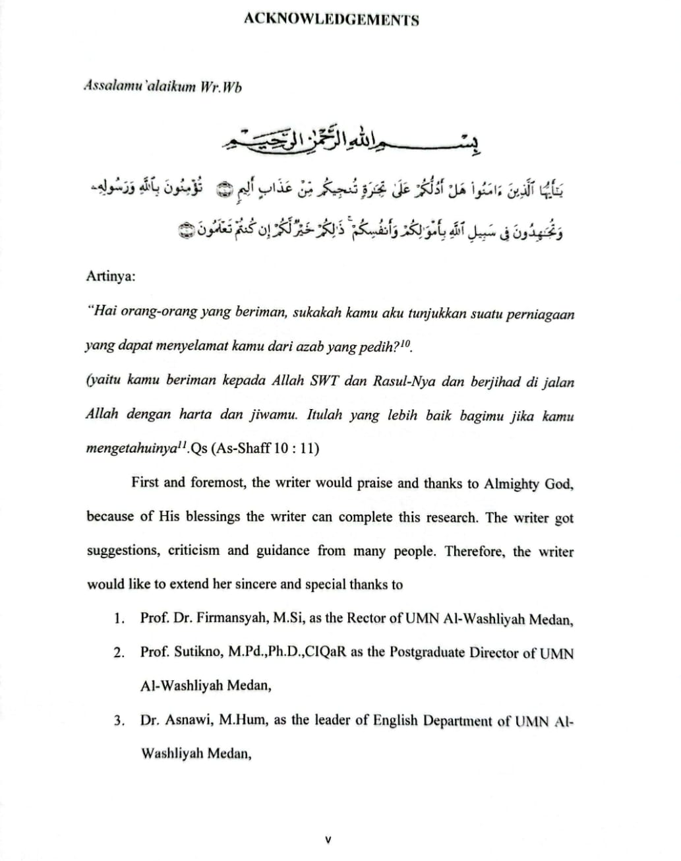

TABLE OF CONTENTS

TABLE of CONTENTS ii
LIST of TABLE iv
LIST of FIGURE v
LIST of APPENDICES vi
CHAPTER I INTRODUCTION 1
- Background of the Problem 1
- Problem Identification 15
- Problem Limitation 16
- Problem Formulation 17
- Research Objectives 17
- Signifcance of the Study 18
CHAPTER II REVIEW OF LITERATURE 19
- Theoritical Framework 19
  - Reading Comprehensive 19
  - Guided Self-Selected Reading (GSSR) Approach 21
    - Definition 21
    - The Principles of Guided Self-Selected Reading (GSSR) 29
    - Design 43
    - Procedure 52
    - Advantage and Disadvantage 69
  - Conventional Approach (Text-Based Questions) 72
    - Definition 72
    - The Principles of Text-Based Questions 73
    - Design 75
    - Procedure 77
    - Advantage and Disadvantage 79
  - Motivation 81
- Relevant Study 84
- Conceptual Framework 90
- Hypothesis 94
CHAPTER III RESEARCH METHODOLOGY 96
- Time and Place of Study 96
- Population and Sample 97
- Research Method 97
- Instrumentation 98
  - Reading Test 98
    - Conceptual Definition 98
    - Operational Definition 98
    - Spesification 98
    - Caliberation 100
      - Validity 100
      - Reliability 102
  - Motivation Questionaire 104
    - Conceptual Definition 104
    - Operational Definition 104
    - Spesification 105
    - Caliberation 105
      - Validity 105
      - Reliability 106
- Research Prosedure 107
  - Treatment 107
  - Internal and External Validity 107
- Data Analysis 107
CHAPER IV ANALYZE AND DISCUSSION 109
- Analyze 109
  - Pre-test Phase (Instrument Test) 109
    - Students’ Reading Comprehensive Observation 109
    - Students Motivation Observation 113
  - Post-test phase (Instrument Test) 114
    - Students Motivation Observation 114
    - Students Reading Comprehensive 116
  - Wilcoxon Test 120
  - N-Gain Percentage Test 125
  - Hypothesis Test 127
- Discussion 130
CHAPTER V CONCLUSION AND SUGESTION 134
- Conclusion 134
- Sugestion 134
REFERENCES 136
APPENDICES 141

LIST OF TABLE

Table 1 : Random Test | 5
Table 2 : Guided Self-Selected Reading | 50
Table 3: Time of Research Schedule | 95
Table 4: The Spesification of Students Success In Reading Comprehensive | 99
Table 5: Validity of Reading Comprehensive (pre-test) | 101
Table 6: Validity Of Reading Comprehensive (post-test) | 101
Tabel 7: Reliability Scale | 103
Table 8: Reliability of Reading Comprehensive (pre-test) | 103
Table 9: Reliability of Reading Comprehensive (pre-test) | 104
Table 10: Validity of Motivation Questionaire (pre-test) | 111
Table 11: Reliability of Motivation Questionaire (pre-test) | 112
Table 12: Status Category of N-Gain Effectivity | 107
Table 13: Reading Comprehensive Observation (8A Pre-test) | 109
Table 14: Reading Comprehensive Observation (8b Pre-Test) | 110
Table 15: Reading Comprehensive (8c) Pre-Test | 111
Table 16: Students’ Level of Motivation | 113
Table 17: Students’ Motivation Observed | 115
Table 18: Students’ Reading Comprehensive Level (8A) Untreatment Class | 116
Table 19: Students’ Reading Comprehensive (8B Gssr Class) | 117
Table 20: Students’ Reading Comprehensive Level (8C Class) | 119
Table 21: Wilcoxon Signed Rank Test | 120
Table 22: Test-Statistic (8A) | 121
Table 23: Wilcoxon Signed Rank Test | 122
Table 24: Test-Statistic (8B) | 123
Table 25: Wilcoxon Test (8C) | 124

Table 26: Test-Statistic (8C) 125
Table 27: N-Gain Percentage 126

LIST OF FIGURE
Figure 1: GSSR Design 52
Figure 2: Framework of Thinking 94
Figure 3: Students’development 127

LIST Of APPENDICES
Appendices 1: reading comprehensive 142
Appendices 2: Reading comprehensive tests 148
Appendices 3: reading comprehensive test (post-test) 154
Appendices 4 : obsevation chcklist:implementation of GSSR 158

