REFERENCES
(2015). “Reading Aloud: What To Do and What Not to Do”. Language Magazine. ( July 2015). Hlm. 1-2.
(2018). “The Conduit Hypothesis: How Reading Leads to Academic Language Competence”. Language Magazine. (April 2018).
(2020). “Self-Selected Fiction: The Path to Academic Success?”. CATESOL Newsletter. (April, 2020). pp. 1-2.
Alfelia Nugky Permatasari1 and Wahyu Kartika. (2023). “WienandaExtensive Reading in Improving Reading Motivation: A Students’ Perspective.” Jurnal Pendidikan Bahasa Asing dan Sastra Vol.7, No.2. Hlm. 220-232.
Armstrong,Nathan. (2015) . Speed-reading The Comprehensive Guide To Speedreading – Increase Your Reading Speed By 300% In Less Than 24 Hours. USA: American Bar Publisher.
Aureliana and Loredana PETRE. (2017). “The role of Constant and Continuous Feedback on Students’ Learning Motivation”. Scientific Research And Education In The Air Force. Hlm. 161-166.
Arianti. (2018). “Peranan Guru Dalammeningkatkan Motivasi Belajar Siswa”.
DidaktikaJurnalKependidikan. Vol.12, No. 2. Hlm. 117-134.
Beniko Mason . (2019). “Guided SSR before Self-Selected Reading”. Shitennoji University Bulletin. (67). Hlm. 445-456.
Beniko Mason and Ken Smith. (2021). “Guided Self-Selected Reading: A Steady Path to Independent Reading”. Reflections on the English Language Teaching and Learning in the Global and Diversified World. Hlm. 385- 402.
Beniko Mason and Stephen Krashen. (2019). “Applying the Input (Reading) Hypothesis: Some history and a look ahead”. 四天王寺大学紀要 第 68号（年 9 月）. Hlm .451-458.
Beniko Mason and Stephen Krashen. (2019). “Direct Teaching of Vocabulary?”.
Journal of english language teaching. LXI (1). Hlm. 9-13.
Beniko Mason and Stephen Krashen. (2017). “Self-Selected Reading and TOEIC Performance: Evidence from Case Histories”. Shitennoji University Bulletin.No. 63, 469-475

Beniko Mason. (2018). “A Pure Comprehensive Approach: More Effective and Efficient than Eclectic Second Language Teaching?”. IBU Journal of Educational Research and Practice. (6). Hlm. 69-79.
Bidin A (2017) Metode Anova, 4(1), pp. 9-15.
Bryan Alan and Duncan Cramer. (2005). Quantitative data analysis with SPSS 12 and 13: A guide for social scientists. Psychology Press. Hlm 21. Cambridge: Cambridge University Press.
Bridges, Louis Ph.D. (2014). The Joy and Power of Reading | A Summary of Research and Expert Opinion. California : Scholastic Inc.
Butler,David. (2014). Reading With The Right Brain. Southern California.
Cain. Kate..Compton, Donald L & Parrila, Rauno K. (2017). Theories of Reading Development. Amsterdam / Philadelphia: John Benjamins Publishing Company.
Christina Clark and Kate Rumbold . (2006). “Reading for pleasure”. National Literacy Trust. Hlm. 5-29.
Damaianti, V.S. (2021) ‘Strategi Regulasi Diri dalam Peningkatan Motivasi Membaca’, Deiksis: Jurnal Pendidikan Bahasa dan Sastra Indonesia, 8(1), p. 52. Available at: https://doi.org/10.33603/dj.v8i1.4613.
David Miller, Andrew Hesler and Stephen Krashen. (2019). “The Star Method: Will They Do It?”. Language and Language Teaching. 8(1). Hlm.21-24.
Domenic T et all. (2021). “Interactive and Conventional Teaching Approaches to Optimizing Reading Comprehensive Performance”. Geintec. Vol. 11 No. 3.pg.1848-1858.
Eric J. Paulson. “Self-Selected Reading for Enjoyment as a College Developmental Reading Approach”. (2006). Journal of College Reading and Learning. 36 (2). Hlm. 51-58.
Erna Iftanti and Arina Shofiya. (2018). “Efl Students’ Responses On The Implementation Of Extensive Reading Program To Build Love Of Reading In English. Jurnal Bahasa Lingua Scientia. Vol. 10, No. 1. Hlm 143-158.
Firda Farisa.(2018). “Motivation And Its Relationship With Readin Achievement (A Survey at Junior High School No.6 Banda Aceh).” Tesis tidak diterbitkan. Ar-Raniry State Islamic University Darussalam – Banda Aceh.

Frances Smith, Karen Westberg & Anne Hejny. (2017). “Accelerated Reader Program: What do Teachers Really Think?”. International Journal of Higher Education. 6(3). Pp.138-146.
Heckhausen. Jutta .& Heckhausen.Heinz. (2018). Motivation and Action. 3rd ed.
Switzerland: Springer.
Kanonire, T., Lubenko, J. and Kuzmina, Y. (2022) ‘The Effects of Intrinsic and Extrinsic Reading Motivation on Reading Performance in Elementary School’, Journal of Research in Childhood Education, 36(1), pp. 1–13. Available at: https://doi.org/10.1080/02568543.2020.1822961.
Khasturi Ramalingam and Yeo Kee Jiar.( 2022). “Influence of Intrinsic and Extrinsic Motivation in Learning Among Primary School Students”. Central Asia And The Caucasus English Edition. Volume 23. Hlm. 1884- 1893.
Knoll, C.L. (2000) ‘The Relationship Between Motivation and Reading Comprehensive’, 5(February), pp. 605–619. Available at: http://scholarworks.gvsu.edu/theses.
Krashen, Stephen D. (2004). The Power of Reading: Insights From the Research2Nd Ed. London : Heinemann.
Kyung Sook Cho and Stephen Krashen. (2018). “The Impact of Sustained Silent Reading and a Visit to the Library on Establishing a Reading Habit: Helpful but not Sufficient”. Language and Language Teaching (Azim Premji University). 7(2), 1-3.
Kyung-Sook Choa & Stephen Krashen. (2019). “Pleasure Reading In A Foreign Language And Competence In Speaking, Listening, Reading And Writing”. TEFLIN Journal. 30 ( 2). Hlm. 231-236.
Langton, E. (2022) ‘NWCommons Self-Selected Reading : A School Development Plan’.
Lestari, N.D.D. et al. (2021) ‘Analisis Faktor-Faktor yang Menghambat Belajar Membaca Permulaan Pada Siswa Sekolah Dasar’, Jurnal Basicedu, 5(4),
pp. 2611–2616. Available at: https://jbasic.org/index.php/basicedu/article/view/1278.

Mikulecky, Beatrice S.(2007). Advanced Reading Power. USA: Longman.

Mohammad Reza Ahmadi. (2017). “The Impact of Motivation on Reading Comprehensive”. International Journal of Research in English Education.
1 (1). Hlm. 1-6.
Nhlanhla Mpofu and Tsitsi Mavambe. (2023). “Teachers’ Self-Reported Instructional Practices for Reading Comprehensive Instruction to Non- Readers”. Journal of english language teaching. Volume 10 Number 2. Hlm. 340-355.
Ni Made Kristin Natalia, Ni Luh Putu Eka Sulistia Dewi,and Ni Putu Astiti Pratiwi. (2021). “Students’ Perception of Sustained Silent Reading (SSR) on Reading Comprehensive in MTSSN 1 Abang”. Journal of Educational Study. Volume 1 Issue 3. Hlm. 182-190.
Serravallo,Jennifer. (2010). Teaching Reading in Small Groups. Portsmouth : Heinemann
Smith, K., Mason, B. and Krashen, S. (2021) ‘Story-listening and guided self- selected reading: Short-term results from Indonesia’, Language Issues, 1(3), pp. 1–14. Available at: https://www.researchgate.net/profile/Beniko- Mason/publication/352492192_Story-Listening_and_Guided_Self- Selected_Reading_Short- Term_Results_from_Indonesia/links/60cd67e792851ca3acaf6f23/Story- Listening-and-Guided-Self-Selected-Reading-Short-Term-Results-f.

Stephen Krashen & Beniko Mason. (2014). “Can Second Language Acquirers Reach High Levels of Proficiency Through Self-Selected Reading? An Attempt to Confirm Nation's (2014) Results”. The International Journal of Foreign Language Teaching. 10(2), 10-19.
Stephen Krashen & Beniko Mason. (2019). “ A Note on Comprehensive Checking . Journal of english language teaching”. LXI (1). Hlm. 23-32.
Stephen Krashen. (2020). “Aesthetic Reading: Efficient Enough”. Journal of English Language Teaching. 62 (2). 3-4.
Sumantri, Mohamad Syarif, (2015). Strategi Pembelajaran, Jakarta: Rajawali Three Watson. (2002). Reading Comprehensive Skills and Strategies Level
8. USA: Saddleback Educational: Publishing
Triono, T. et al. (2021) ‘Motivasi Kerja Pegawai Dalam Pelayanan Publik’, JISIP (Jurnal Ilmu Sosial dan Pendidikan), 5(4), pp. 1627–1631. Available at: https://doi.org/10.58258/jisip.v5i4.2583.

Toni Indrayadi. (2021). “Indonesian EFL Learners’ Reading Motivation”. Indonesian Journal of English Language Teaching and Applied Linguistics. Vol. 5(2). Hlm. 334-346.
Toste, J.R. et al. (2020) ‘A Meta-Analytic Review of the Relations Between Motivation and Reading Achievement for K–12 Students’, Review of Educational Research, 90(3), pp. 420–456. Available at: https://doi.org/10.3102/0034654320919352.
Ulrich Schiefele. et al. (2012). “Dimensions of Reading Motivation and Their Relation to Reading Behavior and Competence”. Reading Research Quarterly. 47(4) . pp. 427–463.
Utin Ainun Kasmiri, Dwi Riyanti, & Urai Mimmi Variami Nurul Fitriarti. (2023). “Enhancing Students’ Reading Comprehensive through the Implementation of TAR (Text Around the Room) Technique”. Lingua Didaktika. 17 (2). Hlm. 220-231.
Widayat Prihartanta. (2015). “Teori-Teori Motivasi”. Jurnal Adabiya. Vol. 1 No.
83. Hlm. 1-11.
Yanmei Liu. (2015). “An Empirical Study of Schema Theory and Its Role in Reading Comprehensive”. Journal of Language Teaching and Research. Vol. 6, No. 6, pp. 1349-1356.
Yohana Kifle Mekonen and Michael Agyemang Adarkwah. (2021). “Volunteers in the COVID-19 Pandemic Era: Intrinsic, Extrinsic, or Altruistic Motivation Postgraduate International Students in China”. .Journal of Social Service Research. Vol. 48, No. 2. Hlm. 147–162.


MODUL AJAR BAHASA INGGRIS KELAS X
ENGLISH LEARNING MODUL

Author | Kumala Sari
Institusion | MTSs Amala Saleh
Subject | English
Class | 8
Time | 8 Meet; 8 x 45 minutes (360 JP)
Domain konten (skill focus) | Reading comprehensive
Main Content | GSSR
Object of Learning | - Select books that match their reading interests and abilities.  - Engage in active and purposeful reading strategies to enhance comprehensive.  - Effectively monitor their understanding and identify areas for development.  - Respond to reading in various creative and thoughtful ways.  - Develop a lifelong love of reading
Pancasila’s Student Target | - Faithful, Fearful of God YME, and Noble  - Worked Together  - Creative  - Critical Thinking
Student | 30 Student
Model pembelajaran | GSSR
Learning Activity Session-1 Objective:  - Ability to Understand Texts Comprehensively)  - Ability to Evaluate and Interpret Information  - Ability to Relate Related Concepts | Phase-1  Introduction (5 Minutes)  Peserta didik diberikan pengenalan mengenai apa itu GSSR  - Begin by introducing the concept of Guided Self-Selected Reading (GSSR) and its benefits for improving reading skills and fostering a love of reading.  - Explain that GSSR allows students to choose books that genuinely interest them, promoting engagement and motivation.  Phase-2  Book Selection (5 minutes)  - Provide students with access to a diverse collection of age-appropriate and leveled books/articles/paper/journal.  - Guide students in selecting books that match their reading interests and abilities.  - Encourage students to explore different genres, authors, and writing styles.  - Emphasize the importance of choosing books that are challenging yet enjoyable.

Phase-3

Introduce GSSR Response Journals (10 minutes)

- Explain the purpose of GSSR Response Journals, which serve as a personal record of reading experiences and reflections.
- Demonstrate how to use Response Journals, including recording book titles, authors, and brief summaries.
- Encourage students to use Response Journals to jot down thoughts, questions, and connections while reading

Phase-4
Reading time and Test (20 minutes)

- Teacher tell the student’s the aim of reading session
- Teacher let the students to read their reading handout

Phase-5
Test and Evaluation ( 5 minutes)

- Teacher test the student’s by verbal test (The Question Could See at the lerning materials) to every single students
- Teacher make the summeries and the evaluation of the session
Assessment | Assessment Point:  - Ability to Understand Texts Comprehensively)  - Ability to Evaluate and Interpret Information  - Ability to Relate Related Concepts
Pedoman Penilaian | Appendix
Refleksi pembelajaran

Learning Activity Session-2 Objective:  - Ability to Use Effective Reading Strategies  - Ability to Relate Information to Prior Experience | Phase-1  Introduction (5 Minutes)  Teacher Explain the objective of the learning avtivity  - Begin by introducing the concept of Guided Self-Selected Reading (GSSR) and its benefits for improving reading skills and fostering a love of reading.  - Explain that GSSR allows students to choose books that genuinely interest them, promoting engagement and motivation.  Phase-2  Review Book Selection (10 minutes)  - Have students share the books/journal/paper/articles they have chosen and briefly explain their reasons for selection.  - Encourage students to seek recommendations from classmates or the teacher if needed.  Phase-3  Introduce to active Reading Strategy (40 minutes)  Introduce various active reading strategies that students can employ to enhance comprehensive, such as:  - Previewing: Skimming the text to get a general idea of the content.  - Predicting: Making educated guesses about what will happen next in the story.  - Questioning: Asking questions about the text to clarify understanding.  - Summarizing: Retelling the main points of the text in their own words.  - Clarifying: Seeking explanations for unfamiliar words or concepts
Assessmen | Formatif:  - When the students un-active or have a problem in learning process Teacher could make a direct suggesstion to them  Sumatif:  - Analyze the student’s answer about their “previewing, Predicting, Answering, summaraizing. And Clarifying
Pedoman Penilaian | Appendix
Refleksi Pembelajaran

Learning Activity Session-3 Objective  1) Monitoring Understanding and Identifying Areas for Development | Phase-1  Introduction (5 minutes)  - Explain the objective of the session to the students  - Explain the daily activity to the sudents  Phase-2  Review of Active Reading Strategies  - Have students share some of the active reading strategies they used in the previous session.  - Discuss the effectiveness of these strategies in enhancing comprehensive.  Phase-3  Introduction to Monitoring Understanding  - Explain the importance of monitoring understanding while reading to identify areas of difficulty.  - Introduce strategies for monitoring understanding, such as:  - Re-reading confusing passages.  - Consulting a dictionary or online resources for unfamiliar words.  - Discussing the text with others to gain different perspectives.
Learning Activity Session-4 | Test

Medan, 15 May 2024
Mengetahui
Kepala Sekolah MTSs Amal Saleh Main Teacher:

Muhammad Hasan, MA Putri Rayhan Nuri, S.S, S.Pd



- Pengertian Text Desciptive

Descriptive text is a text which says what a person or a thing is like. Its purpose is to describe and reveal a particular person, place, or thing. (Kane (2000: 352)
Descriptive Text (Teks Deskripsi) adalah suatu teks atau bacaan yang menggambarkan/ menjelaskan sesuatu (Orang, benda, hewan, atau tempat) secara rinci dan detil. Baik dari segi penggambaran bagian tubuh, sifat ataupun yang lainya.

- Tujuan Descriptive Text (Fungsi Sosial)

Untuk menjelaskan, mendeskripsikan, atau menggambarkan sesuatu yang bisa nama orang, benda, tempat ataupun hewan secara rinci.

- Generic Structure of Descriptive Text (Struktur Teks)

Dalam Descriptive text ada 2 bagian pokok yaitu Identification dan Description.
  - Identification (Pendahuluan)
Memperkenalkan/Menjelaskan tokoh utama yang akan dideskripsikan. Bagian ini terletak pada paragraf pertama.
  - Description (Penjabaran)
Dalam bagian ini dijelaskan secara jelas dan khusus tentang ciri- ciri, sifat, kebiasaan atau hal-hal lain yang berkaitan dengan objek yang akan dideskripsikan.

- Language features (Unsur Kebahasaan)

  - Using Simple Present Tense (Menggunakan kalimat Simple Present Tense)
  - Using tobe (Is, am, are)
  - Fokus pada satu objek
  - Using adjective (Menggunakan kata sifat)ex: slim, beautiful,big, etc

- Contoh Text Descriptive

  - Contoh Descriptive Text (Orang)


This is Anton, my little brother. When he was five, he had chubby cheeks and short blond hair with brown eyes. He liked playing online games and watching TV at home. He went nowhere not until our parents took us somewhere for a vacation or visiting our relatives. He was a totally homebody type.


Now, Anton is thirteen years old. He is so active and likes to hang out with his peers. He has blue eyes with short black hair. He looks slim and tall. He likes wearing a cap everytime. He goes out. He is a boy with a grey hat.

  - Contoh Descriptive Text (Tempat Wisata)

KUTA BEACH


Kuta Beach is located on the western side of the island’s narrow isthmus and is considered Bali’s most famous beach resort destination. Kuta Beach is also minutes away from the Ngurah Rai International Airport in Tuban. The nearby resorts of Tuban, Legian and Seminyak are all within close walking distance.
Once a simple, rustic and quiet fishing village, Kuta Beach has witnessed a transformation over the past years due to the rise of various accommodations, dining and shopping options. The rapid growth owes much to visitors, beachcombers and art lovers from nearby Australia.
Expatriates also helped pioneer surfing in Kuta, as well.
Although a rather frenzied traffic scene has become commonplace here, Kuta Beach continues to attract thousands of visitors every year with its unique charm. During the peak season from July to August and the holiday season for Christmas and New Year, Kuta Beach is regularly fully-booked by travellers looking forward to a pleasant and affordable Bali escape. (http://www.bali- indonesia[dot]com/kuta-beach/#)
Tanah Lot means “Land [sic: in the] Sea” in the Balinese language. Located in Tabanan, about 20 kilometres (12 mi) from Denpasar, the temple sits on a large offshore rock which has been shaped continuously over the years by the ocean tide.

  - Contoh Descriptive Text (Binatang)


I have a pet dog. His name is Thomas. We usually call him Tom. His body is covered with white long fur. My father and I bathe him twice a week. He looks very handsome after bathing. Tom has brown round eyes and quite long ears. He also has four legs with some strong claws. He uses them to catch rats, lizards, geckos or any animals who come to my house. He barks loudly when somebody comes to my house. He acts like a reliable guard for my family. When I come home, he waves his tail enthusiastically. All of my family likes to play with him. We love him very much.



151

- Powerpoint

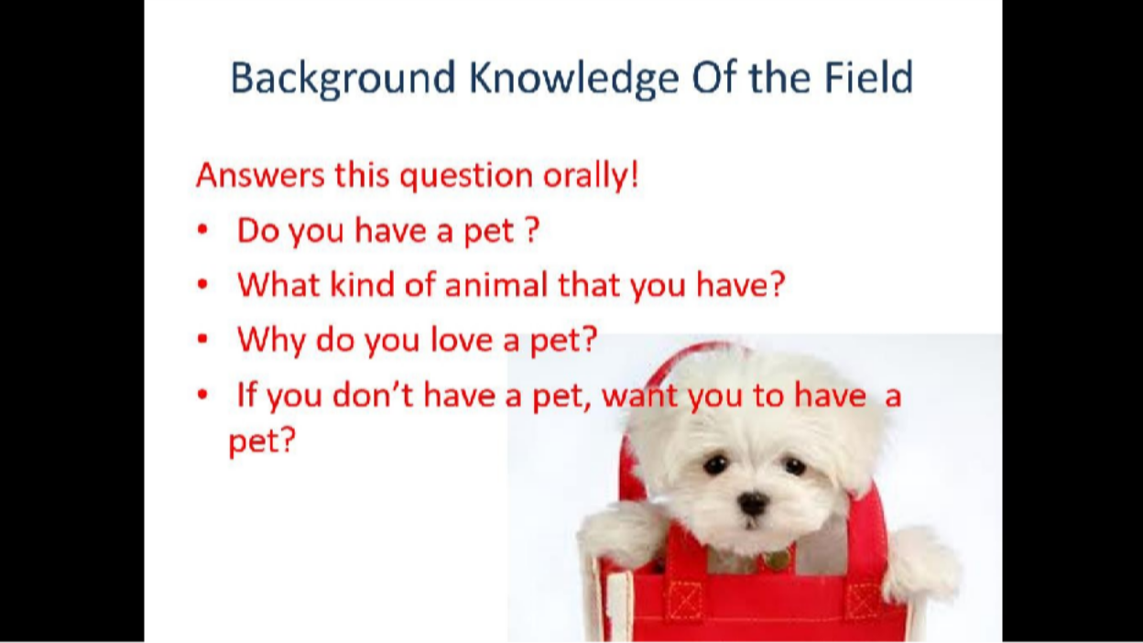

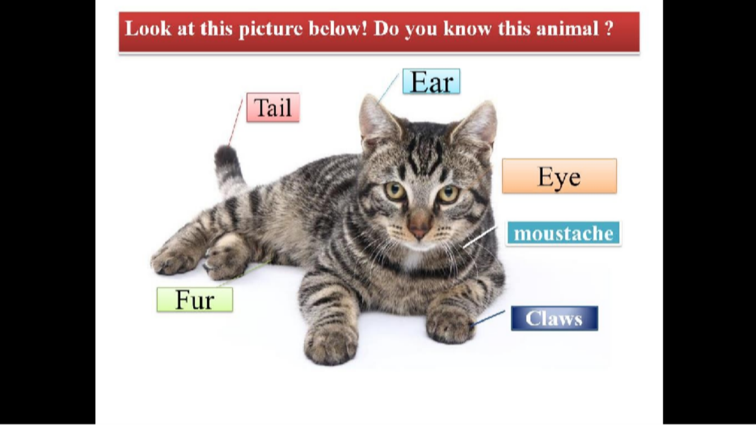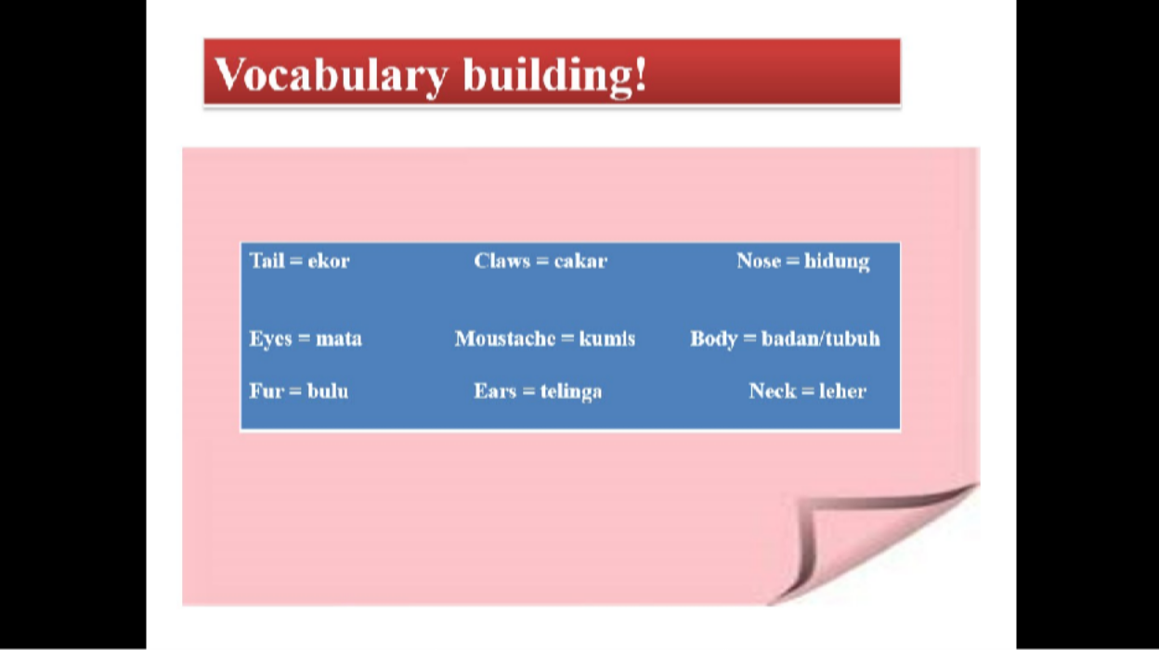

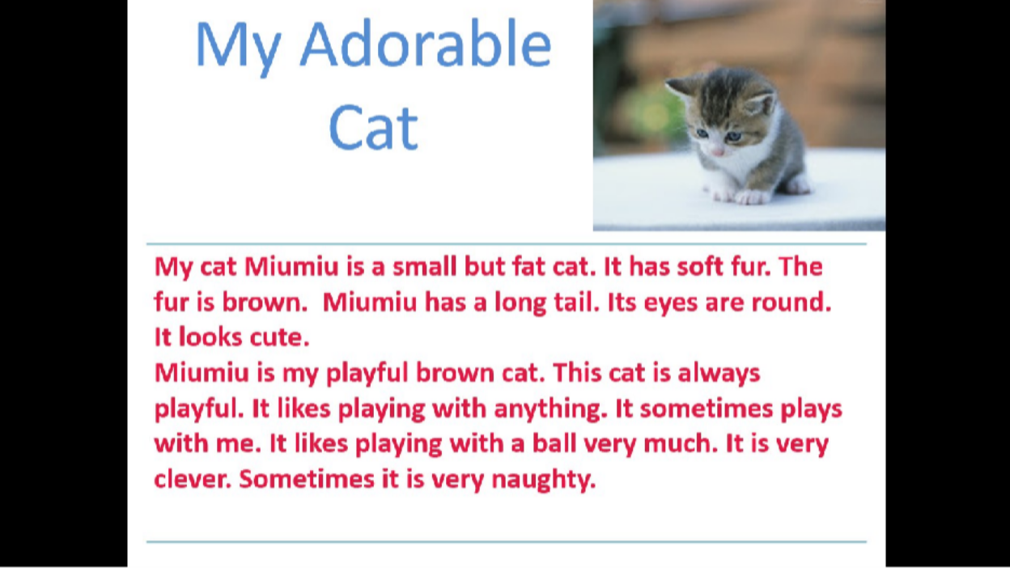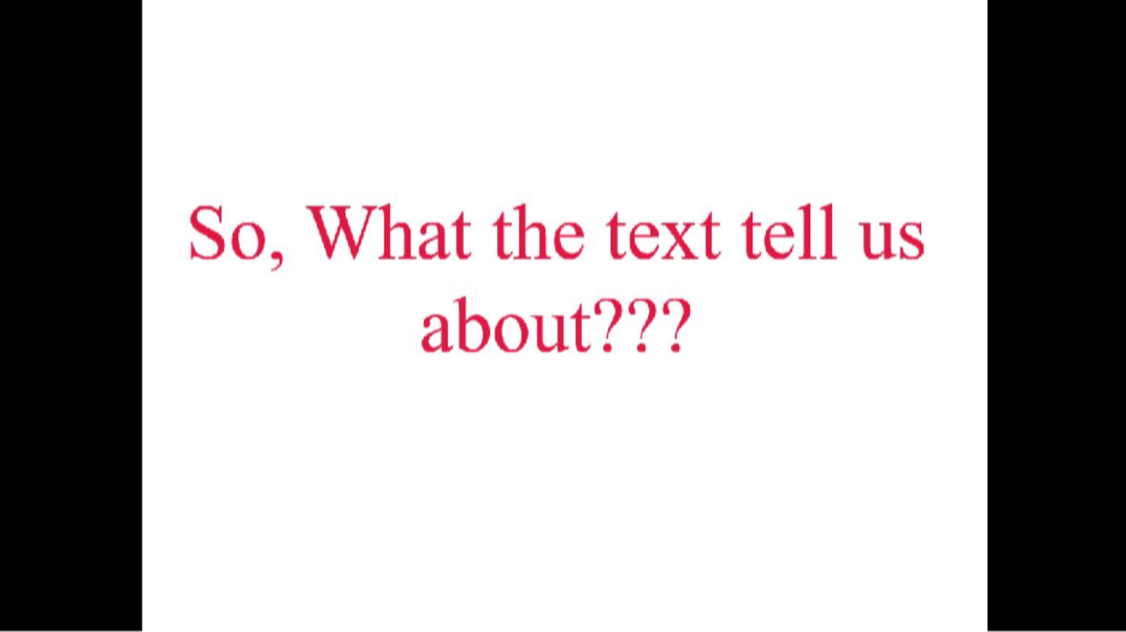

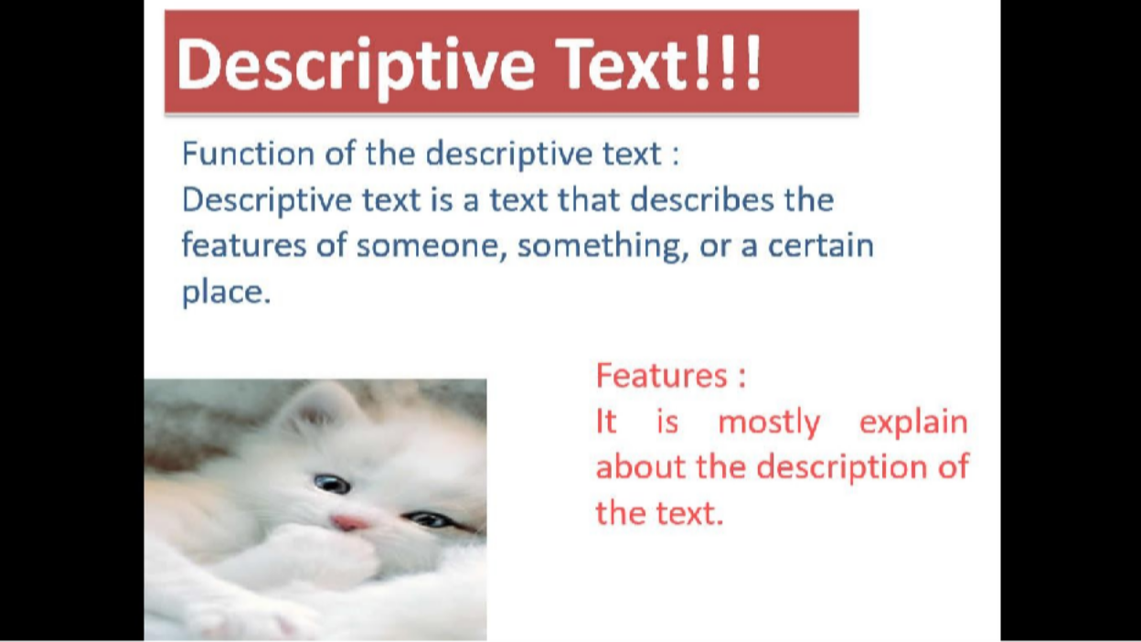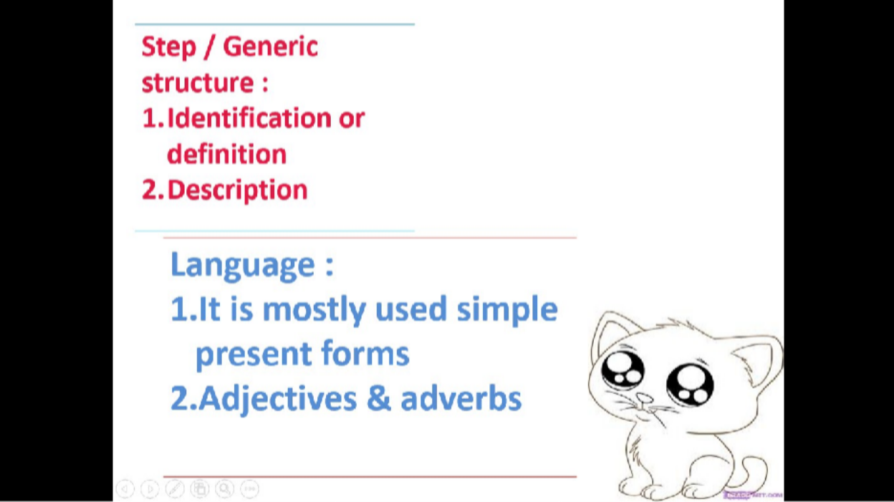

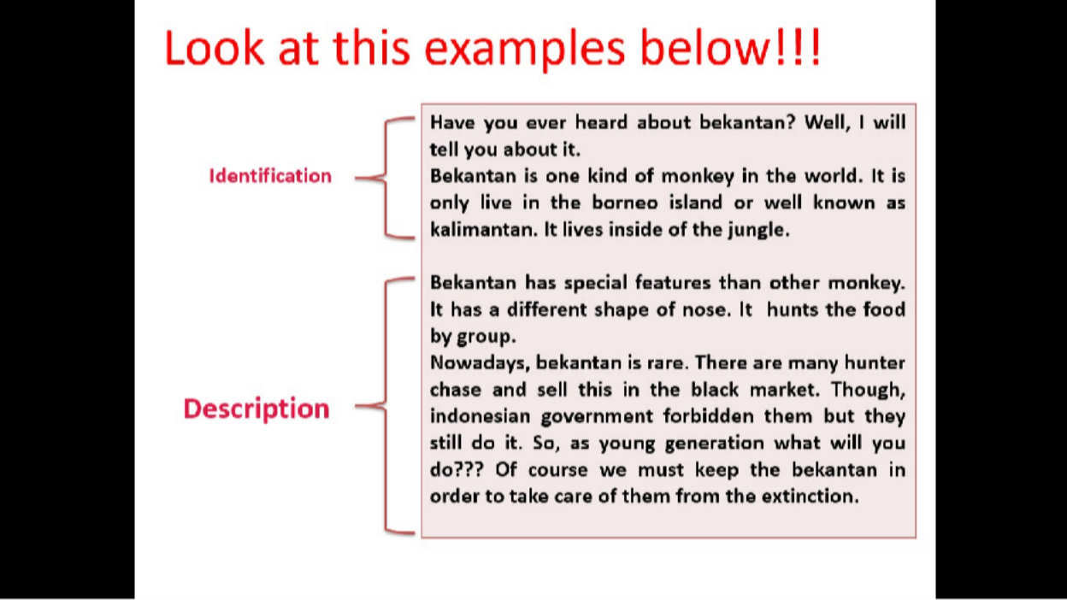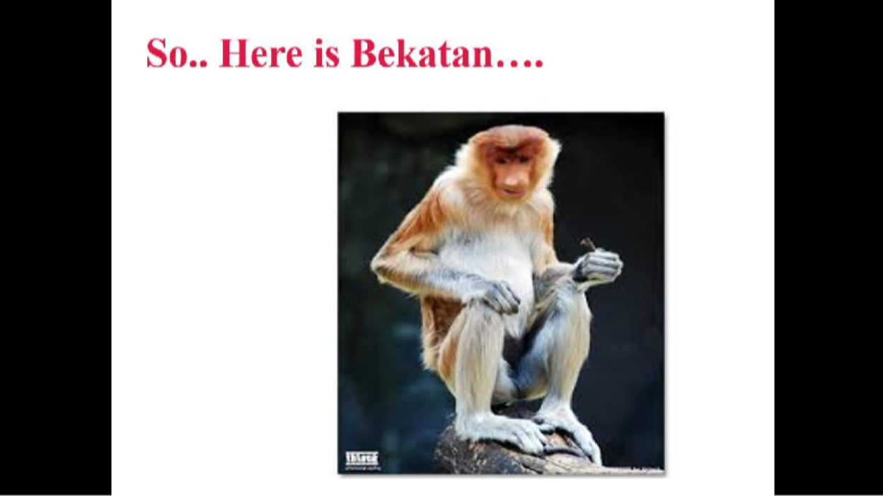

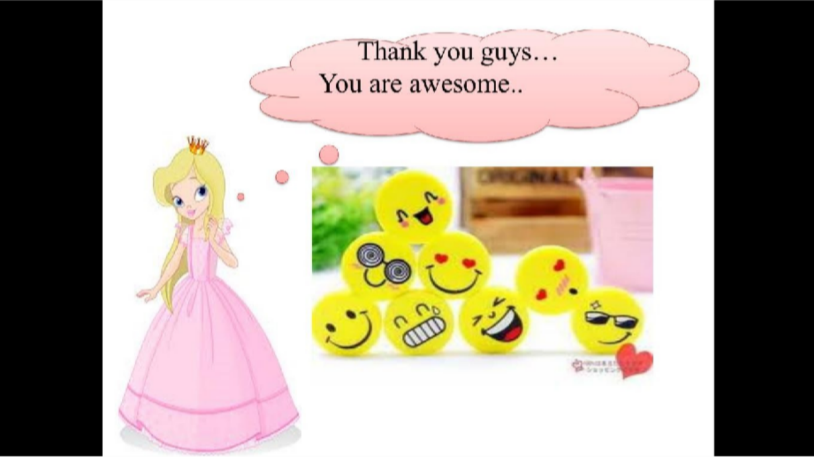

- Padlet

  - Padlet Pertemuan Ke 1 (https://id.padlet.com/putrirayhannuri/pd0w9qs7i7lvi1mz)
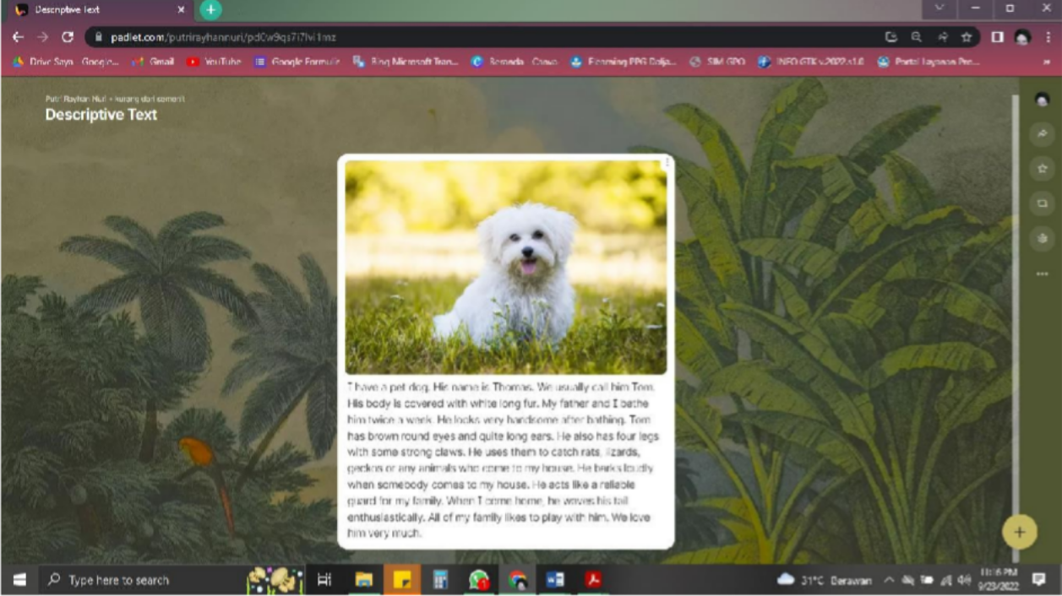

  - Padlet Pertemuan Ke 2 (https://padlet.com/putrirayhannuri/5cwxd6yhjlvmrr7l)
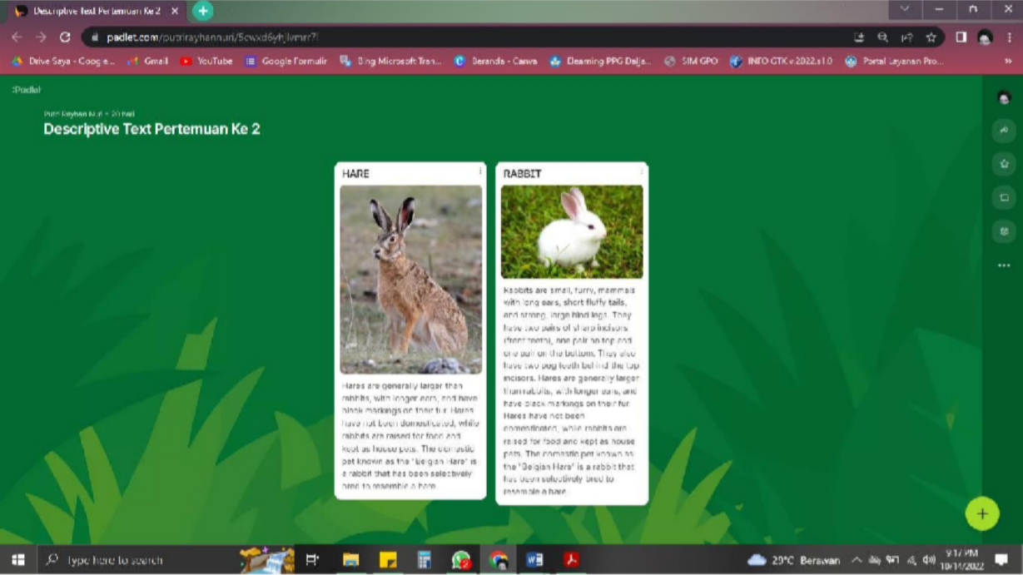



159

- LKPD PERTEMUAN KE - 1


I have a pet dog. His name is Thomas. We usually call him Tom. His body is covered with white long fur. My father and I bathe him twice a week. He looks very handsome after bathing. Tom has brown round eyes and quite long ears. He also has four legs with some strong claws. He uses them to catch rats, lizards, geckos or any animals who come to my house. He barks loudly when somebody comes to my house. He acts like a reliable guard for my family. When I come home, he waves his tail enthusiastically. All of my family likes to play with him. We love him very much.

  - Berdasarkan contoh teks deskripsi di atas. Diskusikan secara berkelompok untuk melengkapi tabel berikut !

Tabel analisis teks deskriptif

Aspek Bahasa | Analisis
Fungsi sosial

Struktur teks
Unsur Kebahasaan

KISI KISI PENULISAN SOAL PERTEMUAN KE 1

No. | Kompetensi Dasar | IPK | Materi Pokok | Indikator Soal | Level | Bentuk Soal | Nomor Soal
1 | 3.7 | 1. | Teks | Disajikan teks | C4 | Uraian | 1
 | Menganalisis | Mengidentifikasi | descriptive | tentang
 | fungsi | fungsi sosial, |  | binatang,
 | sosial, | struktur teks, dan |  | peserta didik
 | Struktur teks, | unsur kebahasaan |  | dapat
 | dan unsur | dari teks tulis |  | menganalisis
 | kebahasaan | sangat pendek dan |  | fungsi sosial,
 | teks deskriptif | sederhana tentang |  | struktur teks,
 | lisan dan tulis | deskripsi binatang |  | dan unsur
 | dengan | sesuai dengan |  | kebahasaan
 | memberi dan | konteks |  | dari teks tulis
 | meminta informasi | penggunaanya. |  | sangat pendek dan sederhana

 | terkait dengan deskripsi orang, binatang, dan benda, sangat pendek dan sederhana, sesuai dengan konteks | 2.  Menghubungkan pengetahuan tentang fungsi sosial, struktur teks, dan unsur kebahasaan dari teks tulis sangat pendek dan sederhana tentang deskripsi binatang sesuai dengan konteks penggunaanya. |  | tentang deskripsi binatang sesuai dengan konteks penggunaanya.
3. Menguraikan fungsi sosial, struktur teks, dan unsur kebahasaan dari teks tulis sangat pendek dan sederhana tentang deskripsi binatang sesuai
dengan konteks penggunaanya.

PEDOMAN PENILAIAN PERTEMUAN KE 1

Rubrik Penilaian Kemampuan Membaca (Reading Comprehensive)

ASPEK | SANGAT BAIK | BAIK | CUKUP | KURANG
Mengidentifikasi | Siswa dapat | Siswa dapat | Siswa dapat | Siswa dapat
fungsi sosial, | mengidentifikasi | mengidentifikasi | mengidentifikasi | mengidentifikasi
struktur teks, dan | fungsi sosial, | hanya sebagian | hanya sebagian | fungsi sosial,
unsur | struktur teks, dan | fungsi sosial, | fungsi sosial, | struktur teks, dan
kebahasaan dari | unsur kebahasaan | struktur teks, dan | struktur teks, dan | unsur
teks tulis sangat | dari teks tulis | unsur kebahasaan | unsur kebahasaan | kebahasaan dari
pendek dan | sangat pendek dan | dari teks tulis | dari teks tulis | teks tulis sangat
sederhana | sederhana tentang | sangat pendek dan | sangat pendek dan | pendek dan
tentang deskripsi | deskripsi binatang | sederhana tentang | sederhana tentang | sederhana

binatang sesuai dengan konteks penggunaanya. | sesuai dengan konteks penggunaanya. | deskripsi binatang sesuai dengan konteks penggunaanya.sec  ara mandiri | deskripsi binatang sesuai dengan konteks penggunaanya.dib  antu oleh guru | tentang deskripsi binatang sesuai dengan konteks penggunaanya.di  bantu oleh guru
Menghubungkan | Siswa dapat | Siswa dapat | Siswa dapat | Siswa dapat
pengetahuan | menghubungkan | menghubungkan | menghubungkan | menghubungkan
tentang fungsi | pengetahuan | sebagian | sebagian | pengetahuan
sosial, struktur | tentang fungsi | pengetahuan | pengetahuan | tentang fungsi
teks, dan unsur | sosial, struktur | tentang fungsi | tentang fungsi | sosial, struktur
kebahasaan dari | teks, dan unsur | sosial, struktur | sosial, struktur | teks, dan unsur
teks tulis sangat | kebahasaan dari | teks, dan unsur | teks, dan unsur | kebahasaan dari
pendek dan | teks tulis sangat | kebahasaan dari | kebahasaan dari | teks tulis sangat
sederhana | pendek dan | teks tulis sangat | teks tulis sangat | pendek dan
tentang deskripsi | sederhana tentang | pendek dan | pendek dan | sederhana
binatang sesuai | deskripsi binatang | sederhana tentang | sederhana tentang | tentang deskripsi
dengan konteks | sesuai dengan | deskripsi binatang | deskripsi binatang | binatang sesuai
penggunaanya. | konteks | sesuai dengan | sesuai dengan | dengan konteks
 | penggunaanya | konteks | konteks | penggunaanya.di
 | secara mandiri | penggunaanya | penggunaanya | bantu oleh guru
 |  | secara mandiri | dibantu oleh guru
Menguraikan | Siswa dapat menguraikan fungsi sosial, struktur teks, dan unsur kebahasaan dari teks tulis sangat pendek dan sederhana tentang deskripsi binatang sesuai dengan konteks penggunaanya.seca ra mandiri | Siswa dapat | Siswa dapat | Siswa dapat
fungsi sosial, |  | menguraikan | menguraikan | menguraikan
struktur teks, dan |  | sebagian | sebagian | fungsi sosial,
unsur kebahasaan  dari teks tulis sangat pendek dan sederhana tentang deskripsi binatang sesuai dengan konteks penggunaanya. |  | pengetahuan tentang fungsi sosial, struktur teks, dan unsur kebahasaan dari teks tulis sangat pendek dan sederhana tentang | pengetahuan tentang fungsi sosial, struktur teks, dan unsur kebahasaan dari teks tulis sangat pendek dan sederhana tentang | struktur teks, dan unsur kebahasaan dari teks tulis sangat pendek dan sederhana tentang deskripsi binatang sesuai
 |  | deskripsi binatang | deskripsi binatang | dengan konteks
 |  | sesuai dengan | sesuai dengan | penggunaanya.di
 |  | konteks | konteks | bantu oleh guru
 |  | penggunaanya.sec | penggunaanya.dib
 |  | ara mandiri | antu oleh guru

Kolom Aspek diisi dengan angka yang sesuai dengan kriteria berikut. 4 = sangat baik
3 = baik
2 = cukup
1 = kurang

Skor Penilaian

No. | Huruf | Rentang angka
1. | Sangat Baik (A) | 86-100
2. | Baik (B) | 71-85
3. | Cukup (C) | 56-70
4. | Kurang (D) | ≤ 55

- LKPD PERTEMUAN KE – 2

Look at the pictures below and answer the questions 1 to 5!
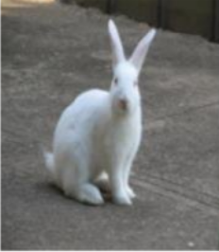

Rabbits are small, furry, mammals with long ears, short fluffy tails, and strong, large hind legs. They have two pairs of sharp incisors (front teeth), one pair on top and one pair on the bottom. They also have two peg teeth behind the top incisors. Hares are generally larger than rabbits, with longer ears, and have black markings on their fur. Hares have not been domesticated, while rabbits are raised for food and kept as house pets. The domestic pet known as the "Belgian Hare" is a rabbit that has been selectively bred to resemble a hare.
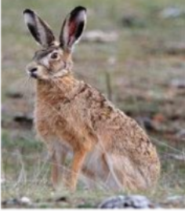

Hares are generally larger than rabbits, with longer ears, and have black markings on their fur. Hares have not been domesticated, while rabbits are raised for food and kept as house pets. The domestic pet known as the "Belgian Hare" is a rabbit that has been selectively bred to resemble a hare

- What is the differences between rabbits and hares?
- Who has the longest ears?
- Does all of the hares involved as a pet?
- Which one has the bigger body?
- What is the intention of the those text?

KISI KISI PENULISAN SOAL PERTEMUAN KE 2

No. | KD | Kelas | Materi | Level | Indikator
1 | 3.7 | VII | Descriptive | C4 | Membandingkan fungsi
 | Menganalisis fungsi sosial, |  | text |  | sosial, Struktur teks, dan
 | Struktur teks, dan unsur |  |  |  | unsur kebahasaan teks
 | kebahasaan teks deskriptif lisan |  |  |  | deskriptif lisan dan tulis
 | dan tulis dengan memberi dan |  |  |  | dengan memberi dan
 | meminta informasi terkait |  |  |  | meminta informasi terkait
 | dengan deskripsi orang, |  |  |  | dengan deskripsi orang,
 | binatang, dan benda, sangat |  |  |  | binatang, dan benda, sangat
 | pendek dan sederhana, |  |  |  | pendek dan sederhana,
 | sesuai dengan konteks |  |  |  | sesuai dengan konteks
2 |  |  |  | C1 | Mengidentifikasi fungsi
 |  |  |  |  | sosial, Struktur teks, dan
 |  |  |  |  | unsur kebahasaan teks
 |  |  |  |  | deskriptif lisan dan tulis
 |  |  |  |  | dengan memberi dan
 |  |  |  |  | meminta informasi terkait
 |  |  |  |  | dengan deskripsi orang,
 |  |  |  |  | binatang, dan benda, sangat
 |  |  |  |  | pendek dan sederhana,
 |  |  |  |  | sesuai dengan konteks
3 |  |  |  | C2 | Menyimpulkan fungsi
 |  |  |  |  | sosial, Struktur teks, dan
 |  |  |  |  | unsur kebahasaan teks
 |  |  |  |  | deskriptif lisan dan tulis
 |  |  |  |  | dengan memberi dan
 |  |  |  |  | meminta informasi terkait
 |  |  |  |  | dengan deskripsi orang,
 |  |  |  |  | binatang, dan benda, sangat
 |  |  |  |  | pendek dan sederhana,
 |  |  |  |  | sesuai dengan konteks
4 |  |  |  | C1 | Mengidentifikasi fungsi
 |  |  |  |  | sosial, Struktur teks, dan
 |  |  |  |  | unsur kebahasaan teks
 |  |  |  |  | deskriptif lisan dan tulis
 |  |  |  |  | dengan memberi dan
 |  |  |  |  | meminta informasi terkait
 |  |  |  |  | dengan deskripsi orang,
 |  |  |  |  | binatang, dan benda, sangat
 |  |  |  |  | pendek dan sederhana,
 |  |  |  |  | sesuai dengan konteks

5 |  |  |  | C4 | Menguraikan fungsi sosial, Struktur teks, dan unsur kebahasaan teks deskriptif lisan dan tulis dengan memberi dan meminta informasi terkait dengan deskripsi orang, binatang, dan benda, sangat pendek dan sederhana,  sesuai dengan konteks

PEDOMAN PENILAIAN PERTEMUAN KE 2

Rubrik Penilaian Kemampuan Membaca (Viewing)

No. | Butir Pertanyaan | Bobot Soal | Kriteria Penskoran |  |  |  |  | Nilai Akhir
No. | Butir Pertanyaan | Bobot Soal | 5 | 10 | 15 | 20 | 25 | Nilai Akhir
1 | What is the differences between rabbits and hares? | 25
2 | Who has the longest ears? | 15
3 | Does all of the hares involved as a pet? | 20
4 | Which one has the bigger body? | 15
5 | What is the intention of the those text? | 25
Jumlah skor maksimal = 100

LAMPIRAN

167

APPENDIX

Reading Comprehensive Test (Pre-Test)

The Tale of Timun Mas: A Cucumber's Magical Journey
In the heart of a lush Javanese village, there lived a humble couple who yearned for a child. One day, while working in their fields, the wife encountered a peculiar cucumber, shimmering with an otherworldly glow. Intrigued, she brought it home, unaware of the extraordinary surprise it held within.
As the days turned into weeks, the cucumber began to pulsate with life. To their astonishment, the couple watched as it cracked open, revealing a beautiful baby girl with emerald-green skin and sparkling eyes. They named her Timun Mas, meaning "Golden Cucumber," and showered her with love and care.
Years passed, and Timun Mas grew into a remarkable young woman, renowned for her kindness, intelligence, and beauty. However, their peaceful existence was shattered when a monstrous giant named Buto Ijo, known for his insatiable appetite for human flesh, set his sights on Timun Mas.
Fearing for their daughter's safety, Timun Mas's parents revealed the secret of her origin and the cucumber's magical powers. With a heavy heart, they bid her farewell as she embarked on a perilous journey to escape Buto Ijo's clutches.
Armed with four magical seeds gifted by her parents, Timun Mas ventured into the dense forest, her heart pounding with fear and determination. Buto Ijo, alerted by his wicked senses, relentlessly pursued her, his booming footsteps echoing through the trees.
As Timun Mas ran, she came across a vast field. Remembering her first seed, she tossed it behind her, transforming it into a sprawling cucumber plantation. Buto Ijo, blinded by his hunger, rushed into the field, feasting on the cucumbers, unaware of the precious time he was wasting.
Timun Mas continued her escape, reaching a river that seemed to stretch as far as the eye could see. She planted her second seed, and in an instant, a sturdy bridge materialized, spanning the mighty river. Buto Ijo, enraged by his delay, lumbered after her, pounding his feet on the bridge, causing it to sway dangerously.
Undeterred, Timun Mas pressed forward, arriving at a dense forest. She planted her third seed, and a thicket of thorny bamboo sprang up, blocking Buto Ijo's path. He struggled to break through the impenetrable barrier, his cries of frustration echoing through the trees.
Finally, Timun Mas reached a vast salt field, her heart pounding with hope. She planted her last seed, and in a blinding flash, the entire field transformed into a shimmering sea of salt. Buto Ijo, caught off guard, stumbled into the salt lake, his monstrous body dissolving into nothingness.
Exhausted but relieved, Timun Mas returned home, her parents embracing her with tears of joy and gratitude. They had witnessed the extraordinary bravery and resourcefulness of their daughter, who had outsmarted and defeated the fearsome Buto Ijo.

News of Timun Mas's heroic deed spread throughout the land, and she became a symbol of courage and resilience. Her story serves as a reminder that even in the face of overwhelming adversity, wit, determination, and a touch of magic can overcome any obstacle

Question 1-4 (Ability to Understand Texts Comprehensively)

- How did Timun Mas come into existence?

  - She was born from a magical cucumber found by her parents in their fields.
  - She was an orphan adopted by a kind couple in the village.
  - She was a princess who transformed into a cucumber to escape danger.
  - She was created by a powerful sorcerer using magic.

What was Buto Ijo's primary motive for pursuing Timun Mas?

  - He was seeking revenge for a past grievance against her family.
  - He was fascinated by her beauty and wanted to make her his queen.
  - He was driven by an insatiable hunger for human flesh.
  - He was under a curse that required him to capture a unique girl.

Which of the magical seeds did Timun Mas use to create an impenetrable barrier against Buto Ijo?

  - The first seed, which transformed into a vast cucumber plantation.
  - The second seed, which materialized a sturdy bridge across a river.
  - The third seed, which caused a thicket of thorny bamboo to sprout.
  - The fourth seed, which transformed a field into a shimmering sea of salt.

What is the central message conveyed by the story of Timun Mas?

  - The importance of material wealth and possessions in achieving happiness.
  - The power of fear and submission in overcoming challenges.
  - The value of intelligence, resourcefulness, and courage in facing adversity.
  - The belief in supernatural forces and the use of magic to solve problems.

Question 5-8 (Ability to Evaluate and Interpret Information)

- Timun Mas's parents' decision to keep her hidden from the world highlights their:

  - Overprotectiveness and fear for her safety.
  - Desire to shield her from the harsh realities of life.
  - Belief in her extraordinary abilities and potential.
  - Attempt to conceal her true identity from the villagers.

Buto Ijo's relentless pursuit of Timun Mas despite repeated obstacles suggests his:

  - Single-mindedness and unwavering determination.
  - Overconfidence in his strength and ability to capture her.
  - Lack of intelligence and inability to learn from his mistakes.
  - Ruthlessness and disregard for the consequences of his actions.

Timun Mas's clever utilization of the magical seeds demonstrates her:

  - Reliance on supernatural powers rather than her own skills.
  - Ability to think creatively and adapt to different situations.
  - Dependence on her parents' guidance and support to overcome challenges.
  - Possession of innate magical abilities that set her apart from others.

The story's ending, where Timun Mas triumphs over Buto Ijo, conveys the message that:

  - Evil forces will always be defeated by the power of good.
  - Cleverness and resourcefulness can overcome even the most formidable foes.
  - The importance of family and community support in overcoming adversity.
  - The need for magical intervention to achieve victory over evil.

Question 9-12 (Ability to Relate Related Concepts)

- The story of Timun Mas shares similarities with the tale of:

  - Cinderella, a young woman who transforms from rags to riches with the help of magic.
  - Jack and the Beanstalk, a boy who trades a cow for magic beans that lead him to a giant's castle.
  - The Little Mermaid, a mermaid who gives up her tail and voice to become human.
  - Rapunzel, a princess trapped in a tower who is rescued by a handsome prince.

The character of Buto Ijo can be compared to:

  - The Wicked Witch of the West in The Wizard of Oz, who seeks to destroy Dorothy and her companions.
  - The Ogre in Shrek, who initially captures Princess Fiona but later falls in love with her.
  - The Evil Queen in Snow White and the Seven Dwarfs, who plots to kill her stepdaughter out of jealousy.
  - The Dragon in Mulan, a fearsome creature that threatens the village but is ultimately defeated.

The use of magical seeds in the story of Timun Mas is analogous to the use of:

  - Enchanted objects in fairy tales, such as talking animals and magical artifacts.
  - Advanced technology in science fiction stories, which allows humans to achieve extraordinary feats.
  - Special powers possessed by superheroes, such as superhuman strength
  - Natural elements in folklore, such as talking trees or magical herbs with healing properties.

The theme of overcoming adversity through intelligence and resourcefulness is prevalent in:

  - Stories about overcoming personal challenges, such as poverty, illness, or discrimination.
  - Narratives about survival in extreme environments, such as shipwrecks or desert expeditions.
  - Tales of triumph over evil forces, such as battles against villains or monsters.
  - All of the above

Question 13-16 (Ability to Use Effective Reading Strategies)

- How did the author introduce the magical element of the story?

  - By explicitly stating the supernatural nature of the cucumber from which Timun Mas emerged.
  - By gradually revealing the magical abilities of Timun Mas and the seeds she possesses.
  - By incorporating fantastical elements into the setting and descriptions of the story.
  - By using symbolic language and imagery that hint at the presence of magic.

What strategy does the author employ to build suspense and anticipation throughout the narrative?

  - By describing Timun Mas's perilous journey in detail, emphasizing the dangers she faces.
  - By introducing Buto Ijo's monstrous character and relentless pursuit of Timun Mas early in the story.
  - By utilizing cliffhangers at the end of chapters, leaving readers eager to know what happens next.
  - By employing a fast-paced narrative style that keeps the reader engaged.

How does the author characterize Timun Mas as an intelligent and resourceful protagonist?

  - By explicitly stating her intelligence and resourcefulness in the narration.
  - By showcasing her ability to think creatively and adapt to different challenges.
  - By contrasting her actions and decisions with those of less intelligent or resourceful characters.
  - By emphasizing the positive outcomes of her actions and the success of her plans.

What overall tone or mood does the author establish for the story of Timun Mas?

  - Dark and ominous, with a sense of danger and foreboding.
  - Lighthearted and adventurous, with a focus on Timun Mas's cleverness and resourcefulness.
  - Hopeful and inspiring, conveying a message of triumph over adversity.
  - Humorous and lighthearted, with elements of exaggeration and fantasy.

Question 17-20 (Ability to Relate Information to Prior Experience)

- The story of Timun Mas shares a common theme with many folktales and fairy tales from different cultures, which is the:

  - Triumph of good over evil
  - Importance of family and community
  - Power of magic and supernatural forces
  - Value of hard work and perseverance

The character of Timun Mas can be related to other protagonists in literature who demonstrate:

  - Courage and determination in the face of adversity
  - Resourcefulness and creativity in solving problems
  - Kindness and compassion towards others
  - All of the above

The use of magical seeds in the story can be compared to the use of:

  - Special abilities or powers possessed by characters in other stories
  - Symbolic objects that represent deeper meanings or themes
  - Tools or resources that aid characters in achieving their goals
  - All of the above

The overall message of the story of Timun Mas resonates with many real-life experiences, such as:

  - Overcoming personal challenges and obstacles
  - Facing discrimination or prejudice
  - Utilizing intelligence and resourcefulness to succeed
  - All of the above

Key Test

Story Comprehensive

    - (a) She was born from a magical cucumber found by her parents in their fields.
    - (c) He was driven by an insatiable hunger for human flesh.
    - (c) The third seed, which caused a thicket of thorny bamboo to sprout.
    - (c) The value of intelligence, resourcefulness, and courage in facing adversity.

Evaluation and Interpretation

    - (a) Overprotectiveness and fear for her safety.
    - (a) Single-mindedness and unwavering determination.
    - (b) Ability to think creatively and adapt to different situations.
    - (b) Cleverness and resourcefulness can overcome even the most formidable foes.

Relating Related Concepts

    - (b) Jack and the Beanstalk, a boy who trades a cow for magic beans that lead him to a giant's castle.
    - (c) The Evil Queen in Snow White and the Seven Dwarfs, who plots to kill her stepdaughter out of jealousy.
    - (d) Natural elements in folklore, such as talking trees or magical herbs with healing properties.
    - (a) Stories about overcoming personal challenges, such as poverty, illness, or discrimination.

Effective Reading Strategies

    - (b) By gradually revealing the magical abilities of Timun Mas and the seeds she possesses.
    - (b) By introducing Buto Ijo's monstrous character and relentless pursuit of Timun Mas early in the story.
    - (b) By showcasing her ability to think creatively and adapt to different challenges.
    - (c) Hopeful and inspiring, conveying a message of triumph over adversity.

Relating Information to Prior Experience

    - (a) Triumph of good over evil
    - (d) All of the above
    - (d) All of the above
    - (d) All of the above

20 Likert Scale-Questions Focusing on Motivation for Reading Comprehensive

Name :
Class :
Please rate the following statements based on your feelings and experiences using the scale provided.
- I enjoy reading challenging texts.
  - Strongly Disagree
    - Disagree
    - Neutral
    - Agree
    - Strongly Agree
- I feel motivated to read every day.
  - Strongly Disagree
    - Disagree
    - Neutral
    - Agree
    - Strongly Agree
- Understanding complex texts is important for my academic success.
  - Strongly Disagree
    - Disagree
    - Neutral
    - Agree
    - Strongly Agree
- I feel confident in my ability to comprehend difficult reading materials.
  - Strongly Disagree
    - Disagree
    - Neutral
    - Agree
    - Strongly Agree
- I find pleasure in exploring new ideas through reading.
  - Strongly Disagree
    - Disagree
    - Neutral
    - Agree
    - Strongly Agree
- Reading helps me expand my knowledge.
  - Strongly Disagree
    - Disagree
    - Neutral
    - Agree
    - Strongly Agree
- I believe that improving my reading comprehensive skills will benefit me in the future.
  - Strongly Disagree
    - Disagree
    - Neutral
    - Agree
    - Strongly Agree
- I set specific goals for my reading comprehensive development.

  - Strongly Disagree
    - Disagree
    - Neutral
    - Agree
    - Strongly Agree
- I actively seek out opportunities to engage with different types of texts.
  - Strongly Disagree
    - Disagree
    - Neutral
    - Agree
    - Strongly Agree
- I feel a sense of accomplishment when I understand a challenging text.
  - Strongly Disagree
    - Disagree
    - Neutral
    - Agree
    - Strongly Agree
- I am motivated to read even when the material is difficult.
  - Strongly Disagree
    - Disagree
    - Neutral
    - Agree
    - Strongly Agree
- I believe that reading comprehensive is a valuable skill for life beyond academics.
  - Strongly Disagree
    - Disagree
    - Neutral
    - Agree
    - Strongly Agree
- I enjoy discussing what I have read with others.
  - Strongly Disagree
    - Disagree
    - Neutral
    - Agree
    - Strongly Agree
- I am curious to learn new information through reading.
  - Strongly Disagree
    - Disagree
    - Neutral
    - Agree
    - Strongly Agree
- I feel motivated to read when I can relate the text to my personal experiences.
  - Strongly Disagree
    - Disagree
    - Neutral
    - Agree
    - Strongly Agree
- I believe that reading comprehensive is essential for critical thinking.

  - Strongly Disagree
19-36 | Less motivated
0-18 | Unmotivated

    - Disagree
    - Neutral
    - Agree
    - Strongly Agree
- I feel motivated to read when I see the practical applications of the material.
  - Strongly Disagree
    - Disagree
    - Neutral
    - Agree
    - Strongly Agree
- I enjoy exploring different perspectives presented in texts.
  - Strongly Disagree
    - Disagree
    - Neutral
    - Agree
    - Strongly Agree

Scale of Motivated Level

Score | Category Level
73-90 | Very Motivated
55-72 | Motivated
37-54 | Motivated enough

Reading comprehensive tests (Post test) Read the texts below and anwer no.1-5!
Many different kinds of life cohabit peacefully in a lovely, verdant forest. With its thick hair, a large brown bear is frequently spotted meandering amid the woods. He is not alone, though, for cheeky monkeys frequently pursue him.
A family of seagulls lives together in the lofty trees. Together, they tenderly tend to their nest. A family of red foxes plays nimbly in the shrubs not far away.
Meanwhile, a group of ducks and geese can be seen swimming contentedly in the crystal-clear stream. They frequently sing as they love living in the outdoors and glide across the tranquil water.
But there are times when woodland life is not tranquil. Occasionally, violent storms pass through, causing the sky to light up with lightning strikes and the earth to get drenched in rain. However, the rain also provides blessings, as the forest's flora and plants are revitalized and renewed.
In the clear blue sky, a stunning rainbow appears following the storm. For all the forest's inhabitants, the rainbow becomes a symbol of hope that, despite adversity, happiness is just around the corner. Thus, life goes on in the wonder-filled forest surrounded by breathtaking scenery.
Berikut adalah 5 pertanyaan pilihan ganda dengan tingkat kesulitan yang telah ditentukan:
- Kesulitan Sedang (60%)
Question: What is the main idea of the passage?
  - The behaviors of animals in the forest.
  - The importance of harmony in nature.
  - The different types of trees in the forest.
  - The dangers of storms in the forest.
- Kesulitan Sedang (60%)
Question: Which reading strategy is most effective for understanding complex texts?
  - Skimming and scanning.
  - Making predictions.
  - Summarizing main ideas.
  - Analyzing vocabulary words.

- Kesulitan Gampang (30%)
Question: How do ducks and geese contribute to the ecosystem of the forest?
  - By building nests in tall trees.
  - By singing songs to entertain other animals.
  - By swimming and keeping the stream clean.
  - By climbing mountains and exploring new territories.
- Kesulitan Gampang (30%)
Question: Which of the following is an example of relating information to prior experience?
  - A bear learning to climb trees by watching other bears.
  - A fox discovering a new hiding spot in the bushes.
  - A seagull building a nest using twigs and leaves.
  - A duck swimming in the stream for the first time.
- Kesulitan Gampang (30%)
Question: Why is it important to use effective reading strategies?
  - To impress others with your reading skills.
  - To quickly finish reading assignments.
  - To improve understanding and retention of information.
  - To avoid reading altogether.

Answer no. 6-10
In a distant kingdom, there lived a king and queen who longed for a child. They prayed to God every day to be blessed with a child. Finally, their prayers were answered, and the queen gave birth to a beautiful princess. They named her Rapunzel.
Unfortunately, shortly after Rapunzel's birth, an evil witch stole the baby. The witch locked Rapunzel in a tall tower in the middle of the forest and instructed her to let her beautiful hair grow long.
Years passed, and Rapunzel grew into a beautiful girl with incredibly long hair. Every day, the witch would come and call Rapunzel by climbing up her long hair. Rapunzel, being naive, never knew about the outside world.

One day, a handsome prince passed by the tower and heard Rapunzel's beautiful singing voice. Curious, he climbed up Rapunzel's hair to see who was in the tower. They met, and the prince fell in love with Rapunzel.
With Rapunzel's help, the prince managed to bring Rapunzel out of the tower. They lived happily ever after, and Rapunzel learned that true love conquers all obstacles. And the tale of Rapunzel and the prince became a legend in the kingdom.
- Difficulty 10% (Easy)
- Question: What is the essence of the story you read?
  - A) Main character of the story.
  - B) Setting of the story.
  - C) Main conflict in the story.
  - D) Time of the story events.
- Difficulty 60% (Medium)
- Question: What moral message can you take from the story?
  - A) Friendship is the key to happiness.
  - B) Loyalty is an important trait.
  - C) Wisdom in decision-making.
  - D) Simplicity leads to happiness.
- Difficulty 30% (Moderate)
- Question: How are the concepts in the story related to each other?
  - A) Relationship between main and supporting characters.
  - B) Seasonal changes affecting the story plot.
  - C) Main conflict and its resolution.
  - D) Antagonist characters and their motives.
- Difficulty 10% (Easy)
- Question: What is the first step you should take before reading the story?
  - A) Read the story title.
  - B) Predict the story content.

  - C) Find out the number of story pages.
  - D) Look for illustration pictures in the story.
- Difficulty 60% (Medium)
- Question: How do supporting characters in the story contribute to the main character's development?
  - A) Create intriguing conflicts.
  - B) Provide emotional support.
  - C) Offer physical assistance.
  - D) Build a complex storyline.

Answer no. 11-15
In a small village in West Java, there lived a boy named Andi. Andi was very curious about the stories circulating in his village about Tangkuban Perahu, a volcano not far from his home. Despite having heard many scary stories about the volcano, his curiosity only grew.
One morning, Andi decided to explore Tangkuban Perahu alone. He gathered simple equipment like water, snacks, and a camera to capture his adventure. With a heart full of enthusiasm, he set off for the volcano.
Upon reaching Tangkuban Perahu, Andi was captivated by the natural beauty around him. He could see the large crater emitting thin smoke from a distance. However, fear still haunted his mind. He walked around the crater carefully, but he remained tense.

While enjoying photographing the scenery, suddenly Andi felt a small tremor in the ground. He immediately realized that this could be a sign of danger. Without hesitation, Andi quickly sought a safe place for shelter.
A few moments later, the volcano began to emit a frightening rumble. Thick smoke started pouring out of the crater. Andi felt scared, but he remained calm and followed the instructions he had learned earlier.
Finally, after several tense moments, the volcanic eruption subsided. Andi felt relieved that he had survived the danger. In his heart, he promised to always respect nature and listen to the advice of more experienced people. Through this experience, Andi realized that bravery doesn't always mean disregarding caution.
- When the main character visited Tangkuban Perahu, what made him feel afraid?
- The rumbling sound from the crater

- Small vibrations in the ground
- Beautiful natural scenery
- Pungent smell of sulfur
- What made the main character finally feel relieved after the volcanic eruption subsided?
- He managed to save himself
- He got great photos
- He met friendly people
- He found a way out of the crater
- How did the main character respond to the instructions of the officer during the volcanic eruption?
- He ignored the instructions
- He followed the instructions in panic
- He regretted not listening to the instructions
- He remained calm and followed the instructions well
- Pertanyaan yang menguji kemampuan menggunakan strategi membaca yang efektif: What was the first step taken by the main character when feeling vibrations in the ground?
- Finding a safe place to take cover
- Running away as fast as possible
- Stopping and checking the surroundings
- Continuing the journey without caring
- How did the main character feel after visiting Tangkuban Perahu?
- Afraid and traumatized
- Happy and satisfied
- Angry and disappointed
- No change in feelings

Answer no.16-20
In a village, there lived a mother with her twin children, Bawang Merah and Bawang Putih. Although they were twins, their personalities were very different. Bawang Merah often behaved wickedly, while Bawang Putih was always kind-hearted and obedient to her mother.
One day, their mother fell ill and asked her two children to go into the forest to gather spices for medicine. Before leaving, she warned them not to separate and to be careful. However, in the forest, Bawang Merah decided to separate and devise a wicked plan.
Bawang Merah succeeded in making Bawang Putih lost in the forest. However, Bawang Putih encountered a kind old person who gave her shelter for the night. The next day, Bawang Putih managed to return to the village with the necessary spices.
When Bawang Merah returned, he pretended to have lost his way and lied that Bawang Putih had died in the forest. However, their mother became suspicious and eventually uncovered Bawang Merah's deceit. As punishment, Bawang Merah was expelled from the house, while Bawang Putih was given love and adopted as a good child by her mother.
This story teaches the importance of loyalty, honesty, and affection within a family. Although Bawang Putih's kindness always triumphed over Bawang Merah's wickedness in the end, she also received abundant blessings from her goodness.
- What makes Bawang Merah and Bawang Putih different?
- Their hair color
- Their personalities and behaviors
- Their place of residence
- Their hobbies

- Why did Bawang Merah and Bawang Putih go to the forest?
- To play around
- To gather medicinal spices
- To search for treasure
- To see wild animals
- Who did Bawang Putih meet when she got lost in the forest?
- An evil person
- A hungry lion

- A kind old person
- A demon
- What did Bawang Merah do when Bawang Putih got lost?
- He patiently searched for Bawang Putih
- He devised a wicked plan
- He helped others in the village
- He returned home to inform his mother
- What was the ending of the story for Bawang Merah and Bawang Putih?
- They parted ways forever
- They reconciled and lived happily together
- They continued to quarrel and fight
- They forgot about each other and went on with their lives

KEY ANSWER
- B) The importance of harmony in nature.
- C) Summarizing main ideas.
- C) By swimming and keeping the stream clean.
- A) A bear learning to climb trees by watching other bears.
- C) To improve understanding and retention of information.
- C) Main conflict in the story.
- B) Loyalty is an important trait.
- C) Main conflict and its resolution.
- B) Predict the story content.
- A) Create intriguing conflicts.

**Observation Checklist: Implementation of Guided Self-Selected Reading (GSSR)**

Observer's Name: [ ] Date of Observation: [ ] Class/Grade: [ ]

- **Introduction**
  - [ ] Teacher introduces the concept of GSSR to the students.
  - [ ] Clear instructions are given regarding how GSSR sessions will be conducted.

- **Book Selection**
  - [ ] Students are given the opportunity to choose their own reading materials.
  - [ ] Teacher provides guidance to students in selecting appropriate reading materials based on their interests and reading levels.

- **Reading Session**
  - [ ] Students engage in independent reading for the designated time period.
  - [ ] Teacher circulates among students, providing assistance and support as needed.
  - [ ] Students are observed actively reading and showing signs of engagement with their chosen texts.
- **Discussion and Reflection**
  - [ ] After the reading session, students participate in a discussion about their reading experiences.
  - [ ] Teacher facilitates reflection by asking questions about the content, characters, and themes of the texts.

- **Assessment**
  - [ ] Teacher assesses students' comprehensive through informal observation and/or discussions.
  - [ ] Any difficulties or challenges faced by students during the reading session are noted for future support.

- **Closure**
  - [ ] Session concludes with a brief summary of key points discussed during the reading and reflection.
  - [ ] Students are encouraged to continue reading independently outside of the classroom.

This checklist is designed to ensure thorough observation and documentation of the implementation of GSSR techniques in the classroom setting.

Validityof Reading Comprehensive Test (Pre-Test)
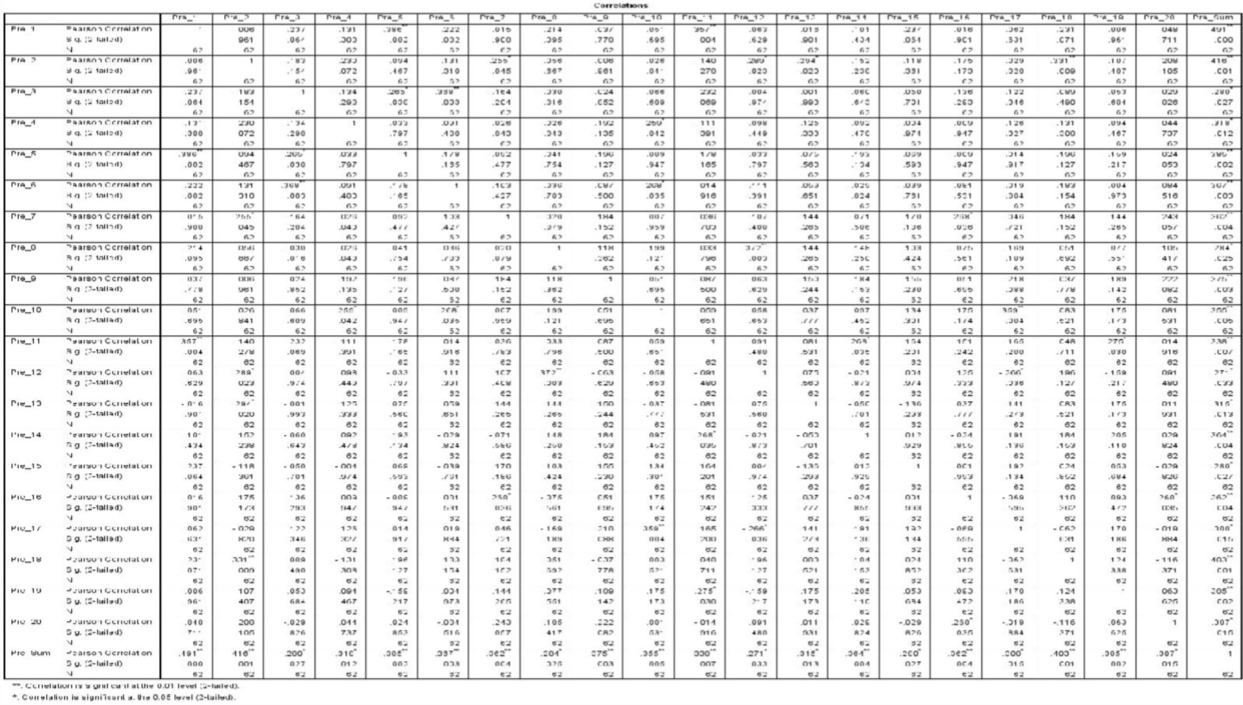

186

187

Validity of Student Reading Comprehensive Test (Post-Test)
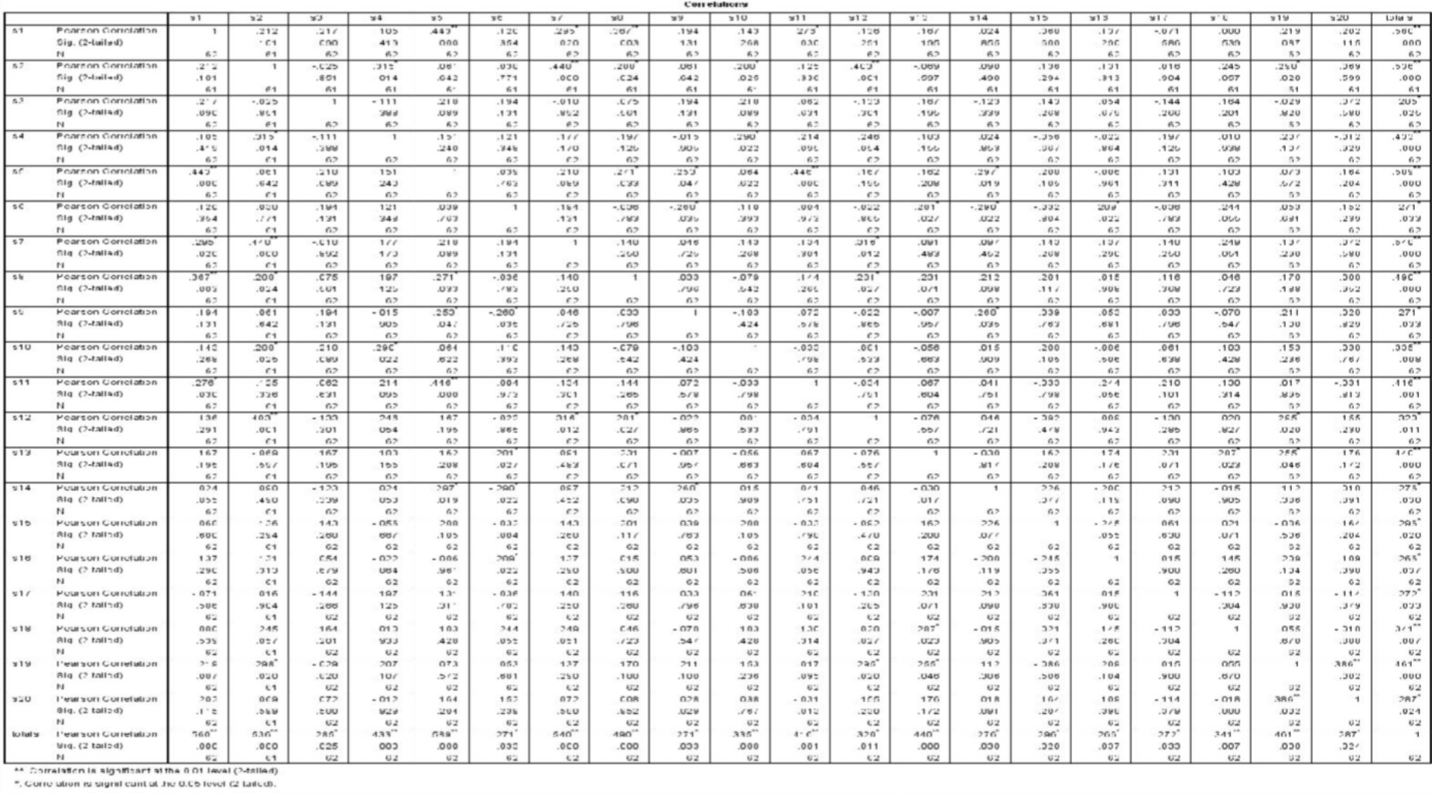

Reliability of Motivation Questionaire

Reliability Statistics
Cronbach's Alpha | N of Items
.988 | 18

Reliability of Students reading Comprehensive Test (Pre-Test)

Reliability Statistics
Cronbach's Alpha | N of Items
.619 | 20

Reliability of Student Reading Comprehensive (Post-Test)

Reliability Statistics
Cronbach's Alpha | N of Items
.692 | 20

188

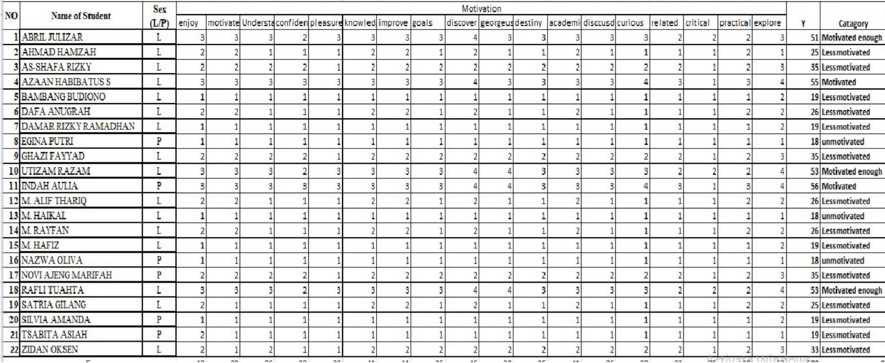

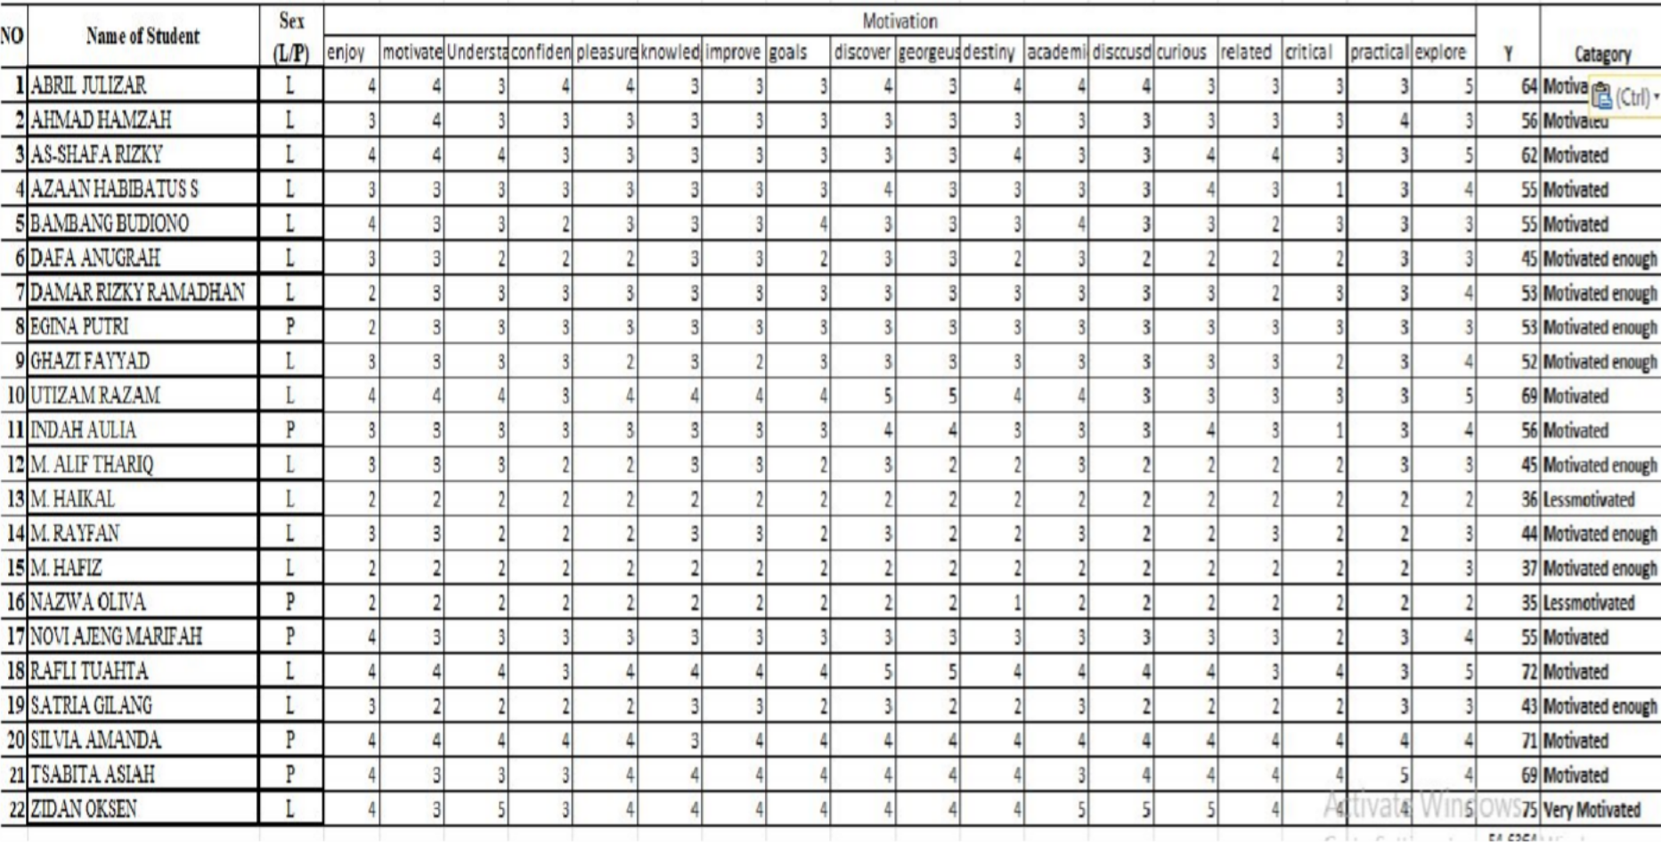

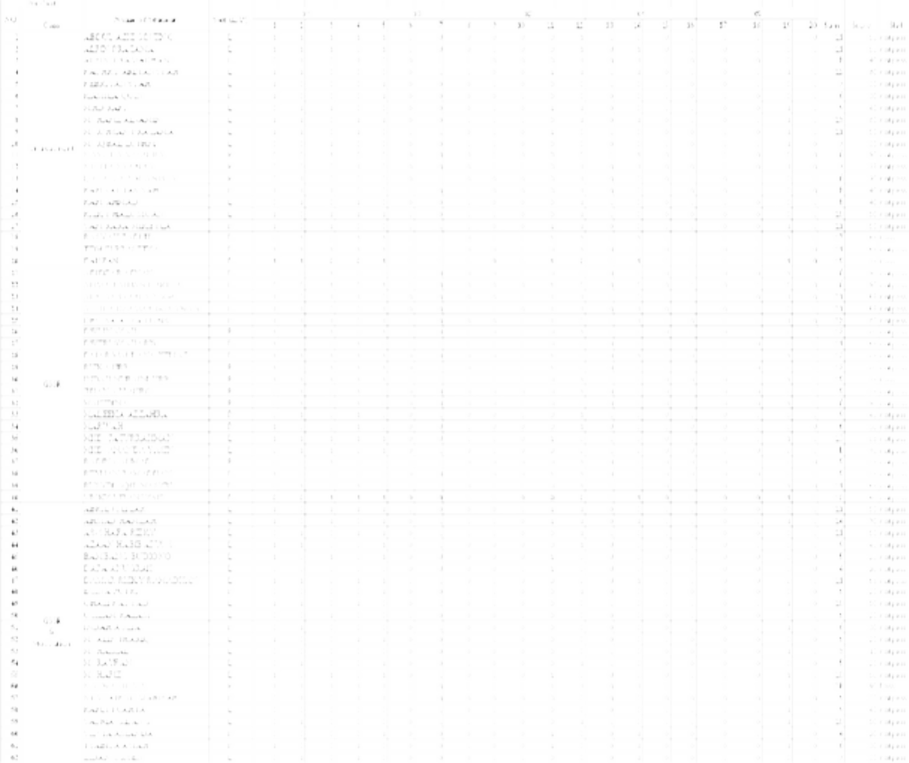


192

Student Development

Average score
Variable | Class | Average score |  | Passing Standard (%)
Variable | Class | Pre | Post | Pre | Post
Reading Comprehensive | 8a | 48,5 | 56,57 | 10 | 30
Reading Comprehensive | 8b | 47 | 70,25 | 5 | 55
Reading Comprehensive | 8c | 39,31 | 77,75 | 5 | 81,81
Motivation | 8C | 31,04 | 54,63 | 22,7 | 90,9

Post
Pre
Post
Pre
5 5
10
39.31
31.04 30
22.7
55
54.63
48.5 47
56.57
90.9
81.81
77.75
70.25
Student Development
Reading Comprehension 8a Reading Comprehension 8b Reading Comprehension 8c Motivation 8C

193

