NARRATIVE STRUCTURE ANALYSIS OF F. SCOTT FITZGERALD’S THE GREAT GATSBY MOVIE

A THESIS

Submitted to the English Literature Study Program in Partial Fulfillment of the Requirements for the Degree of Literature

BY
FADHILAH IRAWAN
Registration Number: 216114014


FACULTY OF LETTERS
UNIVERSITAS MUSLIM NUSANTARA AL WASHLIYAH
MEDAN
2025

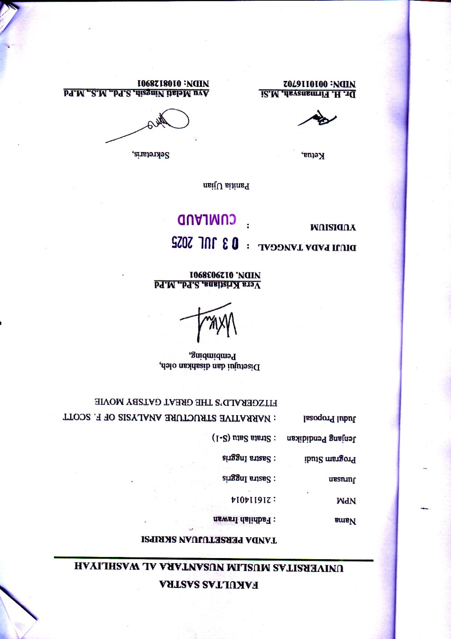
NARRATIVE STRUCTURE ANALYSIS OF F. SCOTT FITZGERALD’S THE GREAT GATSBY MOVIE

FADHILAH IRAWAN

NPM. 216114014

ABSTRACT

This thesis analyzes the narrative structure of Baz Luhrmann’s 2013 adaptation of The Great Gatsby using A.J. Greimas’ actantial model. The study aims to explore how the roles of actants influence the story’s progression and themes, and how the narrative structure shapes character relationships within the film. Employing a qualitative descriptive method, the research identifies and categorizes the six actants—Subject, Object, Sender, Receiver, Helper, and Opponent—within the movie’s plot. The analysis reveals that Jay Gatsby functions as the Subject in pursuit of Daisy Buchanan, the Object, with the supporting characters embodying various actantial roles that shape the film’s development. The study also applies Greimas’ canonical narrative schema to examine the narrative progression through stages of Manipulation, Competence, Performance, and Sanction. Findings show that the movie’s narrative structure not only follows a classical storytelling model but also reflects deeper socio-cultural themes such as the illusion of the American Dream, class struggle, and identity. Through this approach, the research highlights how structuralist narrative theory enhances the understanding of character dynamics and thematic complexity in cinematic adaptations of literary works.

Keywords: Narrative Structure, The Great Gatsby, A.J. Greimas

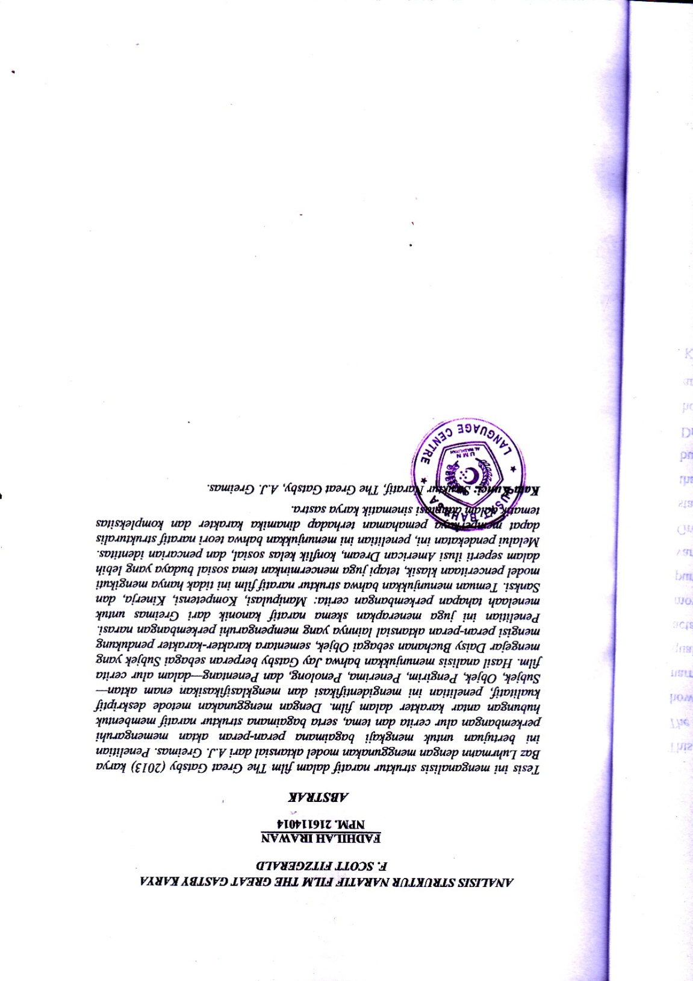

ACKNOWLEDGEMENT

بِسْــــــــــــــــــمِ اللهِ الرَّحْمَنِ الرَّحِيْمِ

يَا أَيُّهَا الَّذِينَ آمَنُوا هَلْ أَدُلُّكُمْ عَلَىٰ تِجَارَةٍ تُنْجِيكُمْ مِنْ عَذَابٍ أَلِيمٍ (١٠) تُؤْمِنُونَ بِاللَّهِ وَرَسُولِهِوَتُجَاهِدُونَ فِي سَبِيلِ اللَّهِ بِأَمْوَالِكُمْ وَأَنْفُسِكُمْ ۚ ذَٰلِكُمْ خَيْرٌ لَكُمْ إِنْ كُنْتُمْ تَعْلَمُونَ (١١)
Artinya :
Wahai orang-orang yang beriman! Maukah kamu aku tunjukan suatu perdagangan yang dapat menyelamatkanmu dari azab yang pedih?
(Q.S. Ash-Shaff : 10)
(Yaitu) kamu beriman kepada Allah dan Rasul-Nya dan berjihad di jalan Allah dengan harta dan jiwamu. Itulah yang baik bagi kamu jika kamu mengetahui. (Q.S. Ash-Shaff : 11)
The author always gives thanks to Allah SWT for His abundant grace, blessings, and guidance, which have enabled the author to complete the writing of this thesis successfully. Shalawat and greetings are also continuously offered to the Prophet Muhammad SAW, who has brought Islamic teachings to guide humanity to become people of faith and obedience to Allah SWT. Therefore, the author wholeheartedly extends gratitude to :
- Dr. H. Firmansyah, M.Si as Rector of UMN Al-Washliyah.
- Mrs. Ayu Melati Ningsih, S.Pd., M.S as Dean of English Literature of UMN Al-Washliyah.
- Mrs. Diana Sopha, S.S., M.Hum as Deputy Dean of English Literature UMN Al-Washliyah.
- Mrs. Vera Kristiana S.Pd., M.Pd as Supervisor has patiently guided the author, and provided various valuable inputs, which with kindness and sincerity guided the author in completing this thesis.
- Prof. Dr. Ahmad Laut Hasibuan M.Pd as Examining Lecturer I has provided input and suggestions in preparing this thesis.
- Dr. Dewi Nurmala S.S,. M.Hum as Examining Lecturer II has also provided very meaningful guidance, suggestions, criticism, and encouragement in completing this thesis.
- All lecturers at the Faculty of Letters, Universitas Muslim Nusantara Al-Washliyah.
- The author especially expresses heartfelt thanks and deepest gratitude to his beloved parents, Irwanto (father) and T. Masna Hanum (mother), who have always given their unwavering love and sincere prayers, enabling the author to complete this thesis successfully. May Allah SWT continue to bless you both with health, happiness, and endless blessings.
- My beloved sisters, brother and cousin , Indry Syafitri Irawan, Faiza Nadia, Olivia Syafira, M. Fajar Satrio and Arief Muliyasa Siregar, thank you for always providing the best embrace, support, prayers, and love for the author in completing this thesis.
- My best classmates during lectures, Mas Andika Fahreza and Rifky Sultan Nico Sembiring, thank you for being such wonderful companions. Thank you for all the laughter, joy, and unforgettable moments we shared during our time together. Your valuable

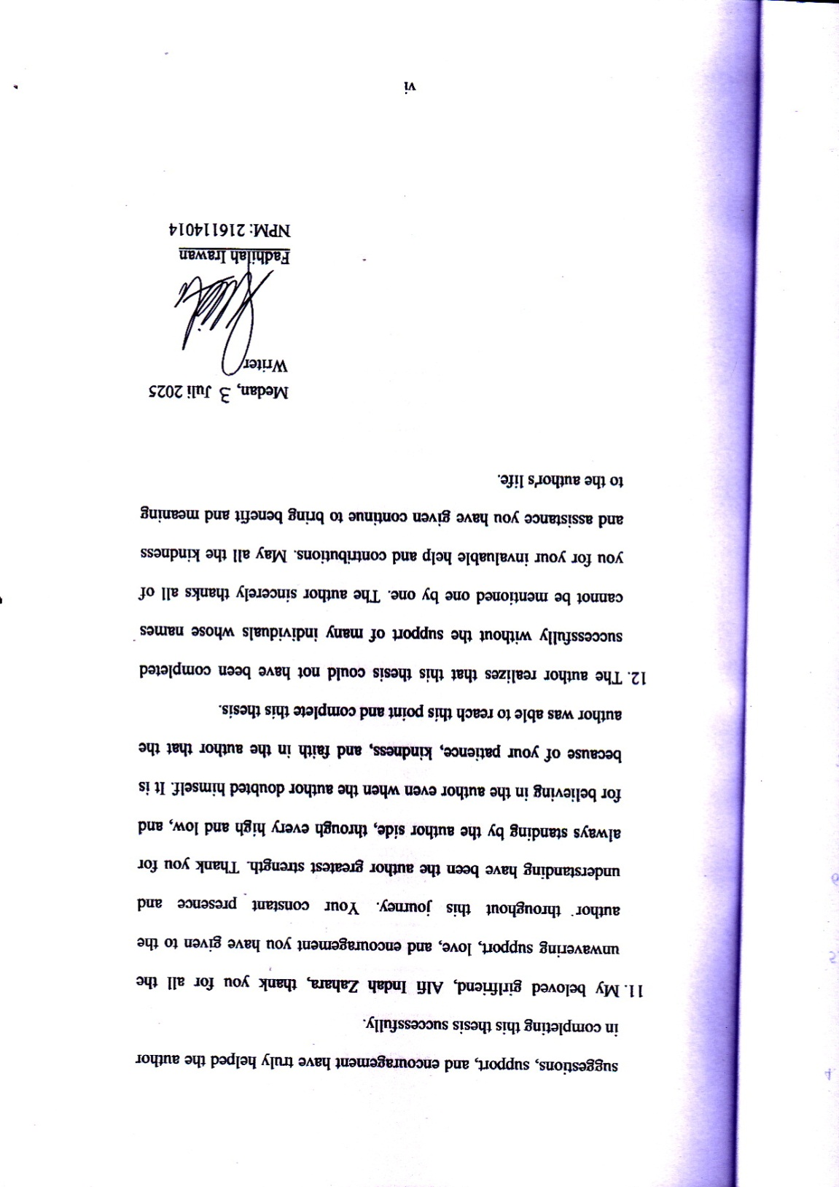
TABLE OF CONTENTS

COVER i
ABSTRACT ii
ABSTRAK iii
ACKNOWLEDGEMENT iv
TABLE OF CONTENTS vii
CHAPTER I : INTRODUCTION 1
1.1 Background Of Research 1
1.2 Identification of Problems 8
1.3 Limitation of Problems 9
1.4 Problem Statements 10
1.5 Objective Of Research 10
1.6 Significance of Research 11
CHAPTER II : REVIEW OF LITERATURE 12
2.1 Narrative Structure 12
2.1.1 A.J. Greimas's Narrative Theory 15
2.2 Movie 20
2.2.1 Types of Movie 21
2.2.2 Elements of Movie 22
2.3 Synopsis of The Great Gatsby Movie 25
2.4 Previous Research 26
CHAPTER III : METHOD OF RESEARCH 30
3.1 Method of Research 30
3.2 Data and Source of Data 31
3.3 Technique of Collecting Data 32
3.4 Technique of Analyzing Data 33
CHAPTER IV : FINDINGS AND DISCUSSION 36
4.1 Findings 36
4.2 Discussions 38
CHAPTER V : CONCLUSION AND SUGGESTION 60
5.1 Conclusions 60
5.2 Suggestions 61
REFERENCES 62

CHAPTER I

INTRODUCTION

1.1 Background Of Research

Literary work refers to written or oral compositions that convey ideas, emotions, stories, or concepts through language. Endraswara (2011: 78) states that literary work is an expression of human life that cannot be separated from its roots people. Literary work is a portrait of life that contains it about reflections of real life that give rise to social characteristics in human. According to Klarer (2004:1), literature is referred to as the entirety of written expression, but with the limitation that not every written form can be classify as literature in the more exact sense of the word.
These works encompass a wide range of forms and genres, including novels, poems, short stories, movies, essays, and more. In addition, literary works function as more than mere artistic creations; they act as mirrors reflecting the complexities of human existence, cultural roots, and societal attributes. These compositions encapsulate the essence of life, offering insights, reflections, and interpretations that resonate with individuals and societies, thereby contributing to a deeper understanding of the human experience and the world we inhabit. Overall, literary works as expressed by scholars like Endraswara and Klarer, are intricate reflections of human life, portraying emotions, stories, and concepts through language. They serve as vital mirrors reflecting societal attributes and cultural roots, transcending mere artistic creations. These compositions encompass various forms and genres, such as novels, poems, movies, and essays, offering profound insights into the complexities of human existence. Ultimately, literary works contribute significantly to our understanding of the human experience and the intricate tapestry of the world we live in.
As the work of literature has function to entertain, it can also be a movie. Harmer (2001: 282-283) states that there are many reasons why movie can be used in language learning. Through movies, humans can learn positive things that will be useful for their future lives. Humans certainly have different goals when watching movies, for example, such as studying foreign languages, understanding foreign cultures, getting information and perspective, and most importantly someone watching a movie for refreshing when they are free. According to Hornby (2005: 573) Movie is a story or event which is recorded by the camera as a set of moving images and shown on television on a theatre in a motion picture violence, extended fighting, physical feats, and frantic chases. Movies are similar to novels or short stories where both present a story to entertain people. Unlike novels or short stories, movies combine story, visual, characters and other elements, namely music and visual effect. It can be concluded that movies took command of more to the senses to create special feelings, atmospheres, or emotions. Achieving the objective of the movie, a good story is needed to be the base of the movie.
Characters serve as the driving force through which the narrative unfolds in films. They are the vessels that carry the story forward, allowing viewers to form emotional connections and invest in the plot's development. Through well-developed characters, audiences can relate to the struggles, triumphs, and transformations portrayed on screen, making the viewing experience more meaningful and impactful. These character arcs are intimately woven into the narrative structure, as each character's journey helps shape and define the story's key turning points. The narrative structure in films can be observed through various elements, including plot progression, scene sequencing, dialogue, and visual storytelling techniques. It manifests in how scenes are arranged, how information is revealed to viewers, and how conflict and resolution are presented throughout the story. This structure can be analyzed through key story components such as the exposition, rising action, climax, falling action, and resolution. Additionally, narrative structure appears in stylistic choices like flashbacks, parallel storylines, or non-linear storytelling, which all contribute to how the story engages and resonates with its audience. Based on this understanding, a further study of narrative structure in movies becomes relevant to analyze in order to understand how a story is structured and conveyed to the audience. Therefore, the study of narrative structure plays an essential role in understanding how a movie delivers meaning and creates an experience for its viewers.
The study of narrative structure is called narratology. A.J. Greimas' narratology theory (1966) builds upon Vladimir Propp's structuralism theory, as noted by Selden. According to Suwondo (2011), Vladimir Propp was the pioneer in developing structural theory through his research on fairy tales, which he detailed in his book Morphology of the Folk Tale (originally in Russian). This work was later translated into Morphology of Folk Stories by Noriah Taslim in 1987. In his analysis, Propp explored the structural elements of stories, proposing that their organization is similar to syntactic structures, consisting of basic constructions like subjects and predicates. Algirdas Julien Greimas, a French structuralist, expanded upon Vladimir Propp's narrative theory. Building on Propp's ideas, Greimas developed his own narrative structuralism theory. He introduced the concept of the actant, which he defined as the smallest narrative unit in literary texts (Rokhmansyah, 2014). Zaimar in (Suwondo, 2011) stated that, apart from introducing the actant scheme as a structuralist epistemological concept, Greimas also proposed a story model structured around a plot. This model is composed of various actions referred to as functions and is known as the functional model. According to Greimas, this model operates in a fixed pattern, as stories typically progress from an initial situation to a final situation. The functional model is designed to outline the subject's responsibility in completing tasks assigned by the sender, as identified within the actant framework. Greimas introduced three binary oppositions, comprising six functions collectively known as actants. Actants represent abstract roles that can be carried out by individuals or various actors.
According to Greimas in (Susanto, 2012), the six actant roles are defined as follows: The sender is the individual or entity that desires the object. The subject is the person or tool used by the sender to obtain the object. The object represents the person or thing desired by the sender through the subject. The helper is an individual or entity that assists the subject in accomplishing their task to achieve the object. The opponent is the one who hinders the subject's efforts to reach the object. Lastly, the recipient is the individual or entity that benefits from the subject's work in obtaining the object; in some cases, the recipient may also be the sender. In this thesis, the application of narrative theory by A.J Greimas will be studied in The Great Gatsby Movie. Understanding the elements of narrative is crucial for comprehensive literary analysis, as these elements work in concert to create meaningful and engaging stories that resonate with readers and viewers alike. The plot serves as the foundational structure, organizing events into a coherent sequence that typically follows a pattern of exposition, rising action, climax, falling action, and resolution, while characters bring the story to life through their actions, development, and relationships, whether they are major or minor players in the narrative. The setting provides the temporal, spatial, and contextual framework within which the story unfolds, encompassing both physical environments and broader social, cultural, and historical contexts, while themes emerge as the central ideas or messages that the narrative explores. Point of view determines how the story is presented to the audience, affecting their interpretation and engagement with the material, and conflict, whether external or internal, drives the narrative forward by creating tension and motivation for character actions and plot development.
The study of narrative structure through theories developed by scholars like Propp and Greimas has revolutionized our understanding of how stories are constructed and function across different media and cultures, with Greimas' actantial model providing a sophisticated framework for analyzing character relationships and narrative roles. By examining stories through these theoretical lenses, we can identify universal patterns in storytelling that transcend cultural and temporal boundaries, and the application of these frameworks to contemporary works, such as The Great Gatsby Movie, demonstrates their enduring relevance in modern narrative analysis. This theoretical approach not only enhances our appreciation of storytelling craft but also reveals how successful narratives achieve their impact while adhering to fundamental structural principles, allowing us to gain deeper insight into the ways stories continue to captivate and resonate with audiences across generations and cultures. In conclusion, the study of narrative structure through theories developed by scholars like Propp and Greimas has fundamentally transformed our understanding of storytelling mechanisms across different media and cultures. Their theoretical frameworks, particularly Greimas' actantial model, provide valuable tools for analyzing character relationships and narrative roles in both classical and contemporary works. The application of these theories to The Great Gatsby Movie demonstrates not only their continued relevance but also reveals how modern adaptations maintain fundamental narrative structures while incorporating contemporary storytelling techniques. This research contributes to the broader field of narrative analysis by examining how traditional theoretical frameworks can illuminate our understanding of modern cinematic storytelling, offering insights into the ways stories continue to evolve while maintaining their power to engage and resonate with audiences across different generations and cultural contexts.
A prime example of this narrative evolution across media can be found in "The Great Gatsby," by F. Scott Fitzgerald, a classic published in 1925. "The Great Gatsby” has grown to become one of the most significant objects of cinematic adaptation in movie history. It poses peculiar challenges to translate the intricate narrative structure of the story on screen, as told through the eyes of the narrator Nick Carraway, about the mysterious millionaire Jay Gatsby and his obsessive passion for Daisy Buchanan. The 2013 adaptation, directed by Baz Luhrmann, brings a fresh and visually dynamic take on the classic novel, featuring Leonardo DiCaprio as the enigmatic Jay Gatsby, Carey Mulligan as the captivating Daisy Buchanan, and Tobey Maguire as the observant narrator Nick Carraway. The supporting cast includes Joel Edgerton as Tom Buchanan, Elizabeth Debicki as Jordan Baker, and Isla Fisher as Myrtle Wilson. Luhrmann's distinctive directorial style, known for its extravagant visuals and contemporary musical elements, brings the Roaring Twenties to life with a modern twist. The film employs cutting-edge 3D technology and a soundtrack that blends period jazz with contemporary hip-hop and pop music, produced by Jay-Z. This bold artistic choice creates a bridge between the past and present, making the story accessible to modern audiences while maintaining the novel's themes of the American Dream, excess, love, and betrayal. The film's visual interpretation emphasizes the grandeur and decadence of Gatsby's world through elaborate party scenes, stunning costume design by Catherine Martin, and spectacular set pieces that bring 1920s New York to vibrant life. The adaptation stays true to the source material's core narrative while adding distinctive stylistic elements that reflect both the excess of the Jazz Age and contemporary sensibilities. The critical reception of this adaptation has particularly focused on its innovative visual approach, DiCaprio's compelling portrayal of Gatsby, and how the modern elements either enhance or detract from Fitzgerald's original story. The film successfully captures the themes of wealth, materialism, and class privilege while presenting them in a way that resonates with contemporary audiences, demonstrating how classic literary narratives can be transformed into visual storytelling while retaining their thematic depth and cultural significance.
The choice of the thesis topic "Narrative Structure Analysis of F. Scott Fitzgerald's The Great Gatsby Movie" is based on a number of valid reasons and aims. Theoretically, the given research is relevant because Greimas's actantial model is applicable to the character interactions and opposing forces that take place in The Great Gatsby in a very specific way, which corresponds to the six actantial roles proposed by Greimas. The selection of Baz Luhrmann's 2013 adaptation was driven by its unique modern interpretation, innovative visual style, and commercial success, making it a significant piece of contemporary cinema. The focus on narrative structure through Greimas's model was influenced by the film's complex narrative techniques, including non-linear storytelling, multiple timeline shifts, and Nick Carraway's retrospective narration from a sanitarium. Additionally, the intricate web of relationships between characters aligns well with Greimas's actantial model. Based on the researcher's preliminary literature review, this study appears to be the first to specifically analyze this adaptation using Greimas's actantial model, thus filling a significant gap in existing scholarship while contributing to academic discourse through proving the applicability of Greimas's narrative theory in film analysis, providing new insights into the adaptation of classical literary narratives, and enriching the field of narrative analysis in movie studies. The research serves to identify and analyze six different types of actantial functions in the main structure of this movie, while analyzing how cinematic aspects support these relations with the actantials, taking Greimas's theoretical frame on the transformative way in which a novel transacts to a cinematic rendering.

1.2 Identification of Problems

In this thesis, titled Narrative Structure Analysis of F. Scott Fitzgerald's The Great Gatsby Movie, the focus is on examining the film’s narrative structure using A.J. Greimas’ narrative theory. The primary issue identified is understanding how the structural elements of the narrative shape the overall storytelling. The first problem statement explores how the narrative structure influences the plot and character relationships, emphasizing how the sequencing of events and interactions among characters contribute to the film's meaning. The second problem statement examines the roles of actants within the narrative and how they affect the story’s progression and thematic depth. By analyzing these aspects, this study aims to provide a deeper understanding of the film’s storytelling mechanics and its impact on audience interpretation. The research extends to multiple aspects including sociocultural dimensions (social class divisions, American Dream, gender roles), stylistic elements (cinematography, soundtrack, dialogue adaptation), symbolic analysis (recurring symbols, settings), psychological aspects (identity, memory, nostalgia), cultural commentary (materialism, wealth, morality), and language analysis (speech patterns, non-verbal communication). Through this comprehensive analysis, the study aims to provide a deeper understanding of the film's storytelling mechanics, its thematic complexity, and its impact on audience interpretation, while examining how it functions both as an adaptation and as a contemporary piece of cinematic art.

1.3 Limitation of Problems

This thesis has confined the scope to analyzing the narrative structure in the movie of The Great Gatsby for those aspects that will make it constitute a story. Precisely, this paper investigates such narrative elements resting on the theory developed by Algirdas Julien Greimas: the actantial model and functional model to comprehend the development of plot characters, events, and symbols. Other aspects like cinematography, sound design, or visual effects will not be considered, as the paper focuses on the narrative structure. It will also involve establishing the relations of the six actants: sender, subject, object, helper, opponent, and recipient, along with how the story develops from the opening situation to the resolution. By narrowing the focus to these factors, this work intends to offer a tight understanding of how the movie organizes its narrative without broader thematic and sociocultural interpretations. In line with this focus, the research aims to address two main problem statements which are how does the narrative structure in The Great Gatsby movie influence the character relationships? and how do the roles of the actants affect the story’s progression and themes in The Great Gatsby movie? Through these questions, the study seeks to analyze how the narrative framework shapes character dynamics and story development while also evaluating the contribution of actants in reinforcing the film’s core themes.

1.4 Problem Statements

Based on the scope of the thesis problems described above, the thesis problems are as follows:
- How do the roles of the actants affect the story's progression and themes in The Great Gatsby movie?
- How does the narrative structure in The Great Gatsby movie influence the character relationships?

1.5 Objective Of Research

Based on the problem formulation described above, the thesis objectives are as follows:
- To examine how the roles of the actants contribute to the story's progression and themes in The Great Gatsby movie.

- To analyze how the narrative structure in The Great Gatsby movie influences the character relationships.

1.6 Significance of Research

This research is significant for both readers and researchers as it provides a structured analysis of the narrative framework in The Great Gatsby movie using A.J. Greimas’ narrative theory. For readers, it offers a deeper understanding of how the film’s narrative structure influences character relationships, and thematic development, allowing them to appreciate the storytelling techniques beyond the surface-level plot. By examining the actantial and functional models, readers can gain insight into the roles and interactions of characters within the story, enhancing their literary and cinematic literacy. For researchers, this study serves as a reference for future narrative structure analyses, particularly in film studies, by applying Greimas' theory to visual storytelling. It contributes to the broader field of narratology by showcasing how actantial roles influence story development and thematic expression in film adaptations. Additionally, the findings may serve as a foundation for comparative studies on other adaptations of The Great Gatsby or similar works within literary and cinematic discourse.

CHAPTER II

REVIEW OF LITERATURE

2.1 Narrative Structure
The narrative structure refers to the basic format or guideline through which stories are organised and perceived. The framework molds the audiences' experiences and understandings of a story; thus, it brings into being the coherent and meaningful progression of events, characters, and themes guiding the very start of a story to its resolution. As Herman and Vervaeck (2019) put it, narrative structure is a systematic way of organizing these elements in constructing meaning within a text, thus allowing audiences to engage with the story on both intellectual and emotional levels.
In the context of movie, narrative structure becomes particularly significant as it bridges the gap between written literature and visual storytelling. Adapting works into movie faces a host of challenges with regard to such thematic elements' translation from an intricately crafted written work to a primarily visual and audio medium. In doing so, structural elements are taken and carefully reinterpreted or remade to capture a new set of unique demands concerning the expression of cinematic storytelling. For example, Baz Luhrmann's adaptation of The Great Gatsby transposes the rich, multi-layered prose and complex themes of Fitzgerald's work into a visual and emotionally engaging cinematic experience.
Chatman (2018) points out that very often, even though the medium is changed, the deep structures of the narrative remain intact, thus providing continuity between the original text and its adaptation. These, however, are in film conveyed by other semiotic systems, including visual imagery, dialogue, sound design, and editing. Each bears its unique contribution to storytelling in harmony with one another in a multidimensional way. For instance, in The Great Gatsby, the green light was a symbol of Gatsby's elusive dream, while the extravagant party scenes were a display of the hedonism and moral decay associated with the Jazz Age. These visual and symbolic elements point to the deeper currents of the story-the pursuit of the American Dream and the essential hollowness of material success.
Contemporary narrative theory expands upon traditional plot analysis by focusing on the dynamic interaction between structural elements such as character relationships, symbolic motifs, and thematic developments. Richardson (2021) argues that in modern movie adaptation studies, narrative structure explores how these elements interplay to achieve coherence and complexity in storytelling. This interplay provides insights into how narrative structure impacts audience interpretation, emotional resonance, and the overall meaning of the story.
The movie adaptation of The Great Gatsby employs a number of ways to enrich the narrative structure: non-linear, flashbacks, and the first-person narration by Nick Carraway-the reflective narrator-are layers in the story told. This gives the introspective, fragmented tone found in Fitzgerald's novel and allows the audience to explore relationships between characters and broader themes at work. The flashbacks, for example, indicate the most significant moments in Gatsby's life, which have been the foundation of his obsessive love for Daisy and his idealized dream of the past.
The narrative structure in the movie enhances the emotional and thematic depth. The movie carries out dramatic contrasts between appearance and reality, hope and disillusionment, love and loss by placing scenes of glamour and excess up against moments of vulnerability and despair. The multiple layers of storytelling ensure that audiences experience both the superficial actions of the characters and the emotional and thematic undercurrents.
The narrative structure is further developed with the help of visual and audio techniques that turn Fitzgerald's literary devices into cinematic ones. The soundtrack perceptibly combines contemporary music with 1920s jazz, connecting the past and present while signaling that the story's themes are timeless. Similarly, vibrant cinematography and rapid cuts during party scenes contrast with muted tones and slower pacing when Gatsby is introspective, reflecting the contrast in his life.
In conclusion, the narrative structure employed in the movie adaptation of The Great Gatsby demonstrates the intricate relationship between literary and cinematic storytelling techniques. Through careful consideration of structural elements from non-linear storytelling and flashbacks to visual symbolism and audio design the adaptation successfully translates Fitzgerald's complex narrative into a compelling cinematic experience. The multilayered approach to storytelling not only preserves the fundamental themes of the original work but also enriches them through the unique possibilities offered by the movie medium. This adaptation illustrates how narrative structure can effectively bridge different artistic mediums while maintaining thematic integrity and emotional depth. Furthermore, the actantial roles significantly influence the story's progression and themes by establishing clear power dynamics and motivations. Gatsby, as both Subject and Helper in different narrative programs, drives the story forward through his pursuit of Daisy (the Object) while simultaneously serving as a catalyst for exploring themes of wealth, ambition, and the American Dream. The Opposition forces, embodied primarily by Tom Buchanan and the established social order, create essential conflicts that highlight the story's central themes of class division and the corruption of the American Dream. The strategic positioning of characters within these actantial roles effectively communicates the story's critique of 1920s society while maintaining the emotional resonance of the personal narratives. Through this analysis, we can observe how the film's narrative structure not only preserves Fitzgerald's intricate character dynamics but also enhances them through cinematic techniques, creating a layered storytelling experience that effectively conveys both the personal and social dimensions of the narrative. The careful integration of actantial roles within the film's structure demonstrates how form and content work together to create a compelling exploration of love, ambition, and social criticism in the Jazz Age.

2.1.1 A.J. Greimas's Narrative Theory

A.J. Greimas's theory of the narrative, specifically his actantial model, provides a comprehensive framework for the deep structure of the analysis of narratives across media. Greimas argued that there exists an underlying deep structure common to all narratives beyond conventional constraints of both culture and medium. The six different essences or "actants" in his actantial model constitute the centerpiece of his theory of the narrative as Subject, Object, Sender, Receiver, Helper, and Opponent. These actants function within what Greimas labels as the "narrative program," by which he designates the dynamic process of change and transformation of events within the story. Key Terms of the Actantial Model include:
1. Subject and Object:
- The Subject is the major figure or protagonist who desires or aspires to achieve a certain objective.
- The Object is the objective desired, the result which the Subject seeks to accomplish.
2. Sender and Receiver:
- The Sender sets the action in motion or provides the motivation for the Subject's quest.
- The Receiver is the one for whom the result of the story is produced or to whom it happens.
3. Helper and Opponent:
- The Helper assists the Subject in surmounting the obstacles and attaining the Object.
- The Opponent complicates the Subject's progress, thus providing conflict within the story.
Martinez (2020) points out that the most important contribution of Greimas's actantial model is that it offers a systematic and orderly way of conducting narrative analysis across various media. The model brings into view both surface-level plot dynamics and deeper structural patterns, which can be combined to form a holistic understanding of the progressions of the narrative. This is especially true in movie adaptations where the interplay of visual, auditory, and narrative elements complicates storytelling.
In The Great Gatsby, this actantial model illuminates very well the relations and functions operated by characters because their roles speed up the story's action. The role of Gatsby as a Subject is underlined by his irrepressible pursuit of Daisy while Daisy's status as an Object underlines that his dream is unreachable. Secondary characters and thematic elements of Nick Carraway's support (Helper) or even class/privilege in society as being an opponent elaborate on the dynamic even more. In this respect, Thompson (2022) underlines the continued relevance and appeal of Greimas's structural and prescriptive concept of narrative, taking into consideration only complex movie narrations. In itself, the actantial model already proves effective for locating patterns of desire, power, and conflict in the cinematic version that offers ideas regarding how or to what degree a story may reinterpret the source material while losing structural integrity. The tension exists in the opposing elements of Gatsby's idealized dream set against the unromantic details of his actual world, demonstrated within the shifting combinations of actants-these point to his ambitious, lover, and disappointment in society.
Kumar (2021) emphasizes how the theory of Greimas is relevant in the case of movie adaptations of literary works, such as The Great Gatsby. The model shows how the basic narrative structures of Fitzgerald, based on the themes of aspiration and rotting of the American Dream, are transformed through camera techniques. Even as the medium changed, the actantial model shows, character functions and relationships remain consistent to preserve the story's core meaning.
Anderson (2023) examines the application of Greimas's theory in the analysis of modal structures in a narrative, such as desires, obligations, and abilities. These modal structures are reflected in movie adaptations through sensory resources to create what Anderson has called "multimodal narrative sequences." In The Great Gatsby, Gatsby's desires are represented through the recurring motifs of the green light and his large mansion, whereas his obligations and abilities are inferred from his actions and relations with others.
The flexibility of the actantial model by Greimas allows it to accommodate both traditional and experimental narratives. Attending to basic structural patterns allows the model to help explain how certain elements in a narrative have been reinterpreted in adaptations, as with this cinematic translation of The Great Gatsby, where the various actants add depth to the role and the relationships between actants through use of visual symbolism, music, and editing.
In other words, the theory of A.J. Greimas about the narrative is an influential instrument in analyzing the structures of narration in a work and its adaptation. By tracing the actantial roles and functions, the theory discloses a dynamic that forms the drive in the course of narration. In the case of The Great Gatsby, the actantial model underlines not only the persistence of the core elements of the story but also their transformation through cinematic language. According to Kumar (2021), the approach of Greimas fills in the gap between literature and movie and helps the reader develop a deeper understanding of the narrative as a universal and versatile art.
Greimas's actantial model demonstrates how narrative structure can be analyzed through six fundamental actants (essential roles) that exist across all stories, regardless of medium or culture. In The Great Gatsby, these actantial roles are clearly defined: Jay Gatsby serves as the Subject in his relentless pursuit of Daisy Buchanan (the Object of his desire), while Nick Carraway functions as the Helper, supporting Gatsby's quest, and the rigid class system and social privilege act as the Opponent, creating obstacles in Gatsby's path. The Sender can be identified as Gatsby's internal motivation, driven by love and ambition, with Gatsby himself as the ultimate Receiver of his quest's outcome. The strength of this model lies in its ability to demonstrate how basic narrative structures remain intact even as stories transition between different media, such as from novel to film, where the relationships between actants maintain their consistency to preserve the story's core meaning, while visual and cinematic elements enhance these actantial roles - for instance, the green light serves as a powerful visual symbol of Gatsby's desire.
Greimas's model makes several significant contributions: it provides a systematic framework for analyzing narratives across different media, reveals deeper structural patterns beneath surface-level plots, and helps understand how adaptations can reinterpret source material while maintaining structural integrity. The model's effectiveness is particularly evident in how it accommodates both traditional and experimental narratives, revealing how the fundamental narrative structure remains intact while being transformed through cinematic language, demonstrating that while the medium may change, the basic narrative structure can be preserved through appropriate transformations that align with the characteristics of the new medium, ultimately enriching our understanding of storytelling across different forms.

2.2 Movie

Movies are the visual mediums that meld together in order to present stories and evoke emotion through the vehicle of cinematography, acting, direction, sound design, and editing. They engage an audience through moving images, soundtrack music, and performances in multichromatic sensations that carry their viewers through worlds, stories, and emotions.
Base on Webster movie is a motion pictures considered especially as a source of entertainment or as an art from. A movie or motion picture is a story with moving images. It is produced by recording photographic images with cameras, or by creating images using animation techniques or visual effect. The movie art form is in many ways a composite of all the others, including writing, performance, visual elements, sound, music, and design. Some of the most important artists of our time have chosen movies as their means of communication (Kennedy & Gioia, 2002). Movie is of the media of audio visual that can used to build the attitude, emotion and evolving the problems. Movie is a medium of communication rich with social implication, created within different social, historical, and culture context. The language of movie is specific to the industry, and students learn how to use it. They also learn critical approaches to the analysis theories of movie aesthetics (Afdlila, 2015).
Every movie has a storyline, which is the very story projected on screen. The storyline is driven by the characters, conflict, stories, and solution all combined in a dynamic and engaging plot that keeps viewers interested. Movies are meant to entertain and also provide art, insight into cultures, and storytelling. They entertain people all over the world by depicting different points of view, discussing some very personal topics, and changing lives with their stories and emotions.
Movies are a combination of artistry and engineering, propelling viewers into a visual experience that teases the imagination, tickles the emotions, and puts the thinking on an overdrive. Movies are one of the most loved and strong ways of telling tales that engrave indelible marks in the psyche of society and culture, keeping people inspired, entertained, and enthralled across ages.

2.2.1 Types of Movie

Movies can be categorized into several main genres, each with distinct characteristics:
- Drama - These films focus on realistic characters dealing with emotional themes. They often explore human relationships, personal crises, and social issues. Examples include "The Godfather," "Schindler's List," and "12 Years a Slave."
- Comedy - Films designed to amuse and provoke laughter through humor, witty dialogue, or absurd situations. This includes subgenres like romantic comedies, slapstick, and dark comedy. Examples include "Some Like It Hot," "Bridesmaids," and "The Grand Budapest Hotel."
- Action - Characterized by physical stunts, chases, fights, and spectacular special effects. These films typically feature heroic protagonists facing clear antagonists. Examples include the "Mission: Impossible" series and "Die Hard."
- Horror - Movies intended to frighten viewers through supernatural elements, psychological tension, or gore. Subgenres include supernatural horror, slasher films, and psychological horror. Examples include "The Exorcist," "Get Out," and "A Quiet Place."
- Science Fiction - Films that explore imaginative concepts involving future technology, space travel, time travel, or alternate realities. Examples include "2001: A Space Odyssey," "Blade Runner," and "Inception."
- Documentary - Non-fiction films that document real events, people, or issues. These can be observational, participatory, or expository in nature. Examples include "March of the Penguins" and "The Last Dance."
- Animation - Films created through various animation techniques, including traditional hand-drawn animation, computer-generated imagery (CGI), or stop-motion. Examples include "Spirited Away," "Toy Story," and "Spider-Man: Into the Spider-Verse."
- Musical - Films where characters express their emotions and advance the plot through song and dance numbers. Examples include "Singin' in the Rain," "La La Land," and "West Side Story."

2.2.2 Elements of Movie

Movies are composed of several crucial elements that work together to create the final product:
- Cinematography - The art of capturing moving images on film or digital media. This includes:
- Camera angles and movements
- Lighting techniques
- Composition and framing
- Color grading
- Visual effects
- Sound Design - The technical and creative aspects of audio in film:
  - Dialogue recording and mixing
  - Sound effects
  - Ambient sound
  - Music score and soundtrack
  - Audio mixing and editing
- Narrative Structure - The way the story is told:
  - Plot development
  - Character arcs
  - Pacing
  - Conflict and resolution
  - Theme exploration
- Mise-en-scène - Everything that appears in the frame:
  - Set design and decoration
  - Costume and makeup
  - Props
  - Actor positioning and movement
  - Lighting arrangements
- Editing - The process of assembling the footage:
  - Continuity editing
  - Montage sequences
  - Transitions
  - Pacing and rhythm
  - Visual effects integration
- Performance - The acting and character portrayal:
  - Acting style and technique
  - Character development
  - Physical performance
  - Emotional expression
  - Dialogue delivery
- Direction - The overall creative vision and guidance:
  - Scene composition
  - Actor direction
  - Visual storytelling
  - Tonal consistency
  - Creative decision-making
- Production Design - The overall visual concept:
  - Art direction
  - Location selection
  - Set construction
  - Props and decorations
  - Visual atmosphere creation
These elements must work harmoniously to create a cohesive and engaging film experience. The successful integration of these components determines the quality and impact of the final product, allowing filmmakers to effectively convey their stories and messages to audiences.

2.3 Synopsis of The Great Gatsby Movie

The Great Gatsby is a 2013 adaptation by Baz Luhrmann of F. Scott Fitzgerald's iconic 1925 novel into a visually stunning movie. The movie is a study in ambition, love, and wealth, which is an elusive pursuit of the American Dream set against the opulent and morally complex Roaring Twenties. Through the eyes of Nick Carraway, a bond salesman and an aspiring writer, the audience is taken into the lives of the wealthy elite living in Long Island's West and East Egg.
Nick, who has just moved into a modest house in West Egg, becomes fascinated with his mysterious neighbor, Jay Gatsby-a millionaire who throws ostentatious, extravagant parties, attended by New York's social elite. Despite his wealth and fame, Gatsby is a mysterious figure whose personal life is shrouded in secrecy. As Nick gets to know Gatsby, he discovers that the latter has been conducting an obsessive and romantic pursuit of Daisy Buchanan, Nick's cousin, who lives across the bay in East Egg with her husband, Tom Buchanan.
Daisy, on one hand, and Gatsby share a romantic history which was disrupted by the class system, and Gatsby's lack of money during those times. Now that Gatsby has gained immense wealth through questionable means, he attempts to resume their romance. However, Daisy's husband, Tom-a man of inherited wealth and arrogance-is suspicious of Gatsby and seeks to expose his shady past.
The story is one of a heated love triangle further complicated by infidelity, greed, and moral corruption through wealth. Nick finds himself in the middle of all this, but he both becomes an observer of and participant in the action unfolding before his eyes. The reader sees the mismatch between the illusions of love and happiness which Gatsby creates and the cruel reality of class and privilege, as well as moral disintegration, through Nick.
The climax reveals the fragility of Gatsby's dream as his romantic idealism is shattered by Daisy's inability to leave her life of privilege. This, coupled with the tragic consequences of this disillusion-a betrayal, violence, and finally Gatsby's untimely death-somehow strikes with full force. The story culminates in Nick's disillusionment with the decadence and carelessness of the wealthy elite, prompting his retreat from the East Coast.
Luhrmann's adaptation brings life to the movie with its bright cinematography, updated music, and stunning visual spectacles that bring both glamour and excess of the Jazz Age but, more importantly, point to the emptiness underneath. The Great Gatsby is essentially a poignant moving portrayal of shattered dreams, the cost of obsession, and superficiality in American life. It serves as an eternal critique of the fantasies of money and love, making it etched in the viewer's psyche forever.

2.4 Previous Research

Several previous studies used as references are bases for this study. These were studies conducted by other researchers prior to the present study. The following are some previous studies relating to this study.
- Rois, A. S. (2016). The Narrative Structure of Luc Besson’s movie:“Lucy” in Greimas Narratology. Universitas Islam Negeri Sunan Kalijaga. This research applies the Greimas's actantial model in character roles and general narrative dynamics to Lucy as subject in intellectual and physical evolution. ROIS shows in this paper that such a film structure supports its investigation into themes such as knowledge, consciousness, and human potential. The research thus reveals the use of narratology in the analysis of movies for having a structured approach toward understanding movie storytelling.
- Mahdy, U. A. (2019). Greimas's Structural Narrative In Green Lantern Movie (2011) (Doctoral dissertation, Universitas PGRI Adi Buana Surabaya). The research applies the investigation of character roles according to Greimas's actantial model, namely subject, object, sender, receiver, helper, and opponent, and how they drive the plot. Mahdy explores how Hal Jordan's path to becoming a hero, and how his struggle against the antagonist Parallax, is in conformity with narratology. The present research thereby indicates that narratology can be applied successfully to superhero films, providing fresh insight into their story construction.
- Saraswati, R. (2022). Greimas's Actantial Model In The Hunger Games Movie. Akrab Juara: Jurnal Ilmu-ilmu Sosial, 7(3), 314-321. The research points out the actantial roles of Katniss as the subject, characters such as Peeta as helpers, and President Snow as the opponent. Saraswati further expounds how these actantial roles provide structure to the narrative while bringing into the fore themes related to survival, rebellion, and sacrifice. It proves how narratological analysis avail deeper insights regarding character interactions in films.
- Rantung, A. J., Olii, S. T., & Kumayas, T. (2022). An Analysis of Language In "The Great Gatsby" Movie. JoTELL: Journal of Teaching English, Linguistics, and Literature, 1(2), 261-279. The research examines the language styles used in The Great Gatsby movie based on Martin Joos’s (1967) classification of language styles: frozen, formal, consultative, casual, and intimate. Using a qualitative descriptive method, the study analyzes dialogues from the film to identify and categorize these styles. The findings reveal that casual style is the most dominant, with formal, consultative, and intimate styles also appearing, while frozen style is absent. The study highlights how these language styles reflect character relationships and social dynamics, contributing to a deeper understanding of communication in the film.
- Wijaya, D., Hawa, F., & Ardini, S. N. (2021, March). An Analysis Of Social Conflict In The Great Gatsby Movie. In Proceeding Of English Teaching, Literature And Linguistics (Eternal) Conference (Vol. 1, No. 1, pp. 427-447). The research identifies three types of social conflicts depicted in The Great Gatsby movie: social conflicts of positions, social conflicts of interest, and social conflicts of roles. The study uncovers eight instances of social conflict of positions, seven of social conflict of interest, and nine of social conflict of roles. Additionally, the researchers identify 24 causes of these social conflicts within the narrative. The paper also highlights seven messages conveyed through these conflicts, providing insights into the societal tensions and character dynamics portrayed in the film.

CHAPTER III

METHOD OF RESEARCH

3.1 Method of Research

A research method involves any orderly procedure or technique that a researcher uses to collect data, analyze information, and obtain insight or answers to particular questions or objectives. According to Darmadi (2013: 153), a method is a scientific way to obtain data for certain purposes. Scientific means that the activities in research are based on scientific characteristics, namely rational, empirical, and systematic.
Creswell (2012) state that qualitative methods are categorized in five type to describe the ways data is depicted: Phenomenological research, grounded theory, ethnography, Case study, narrative research. Base on the statement above, a qualitative method supports a writer to be able to describe data and the resultant analyses create descriptive summaries of how study the observations occur individually or on group levels of. Qualitative method, particularly descriptive qualitative research, is the most appropriate approach to help the writer analyze the data. Qualitative method has been applied in this research since it is an appropriate approach to analyze the narrative structure of The Great Gatsby movie by F. Scott Fitzgerald. The qualitative method allows, by means of A.J. Greimas' Narrative Theory, a deeper look into the narrative elements of the movie, such as plot structure, character relationships, and thematic development. Greimas's actantial model articulates a framework upon which to understand the functioning of the narrative through the roles of the actants: subject, object, sender, receiver, helper, and opponent. This approach will enable the researcher to explore the complex narrative patterns, symbolic representations, and structural elements that shape the storytelling in the movie. The qualitative approach is especially applicable for analyzing how the movie adaptation translates Fitzgerald's narrative into a visual medium, with an emphasis on the transformation of textual elements into cinematic language. Using Greimas's actantial model will give the research deep insight into how the profoundness of the narration dynamics contributes to the overall story of The Great Gatsby. This is going to provide insight into how the sustenance of the structure of narration nurtures the development of themes in the movie and character development with symbolic meaning being given to the story.

3.2 Data and Source of Data

The data are systematically collected in the current study on the narrative structure of Baz Luhrmann’s The Great Gatsby, 2013, using A.J. Greimas’s theory of narrative as the analytical framework. According to Creswell (2014), qualitative data is defined as data that consists of words, observations, or images collected from participants to explore and understand the meaning individuals or groups ascribe to a social or human problem. This type of data focuses on exploring experiences, perceptions, and behaviors in-depth, often gathered through interviews, observations, documents, or audio-visual materials. The data in this study consists of narrative elements derived from The Great Gatsby movie, directed by Baz Luhrmann (2013). This film adaptation of F. Scott Fitzgerald’s novel serves as the primary source for analyzing the narrative structure using A.J. Greimas’ actantial model.
The primary data includes dialogues, character interactions, and key plot events that contribute to the film’s overall narrative structure. These elements are examined to identify the roles of actants and their influence on the story’s progression and thematic development.
Secondary data is obtained from various scholarly sources, including books, journal articles, and critical analyses related to Greimas’ narrative theory, film studies, and The Great Gatsby. These sources provide theoretical support and contextual understanding for the analysis.

3.3 Technique of Collecting Data

According to Creswell (2014) data collection is a process of delimitation, observation, document, and visual material gathering, and recording protocol development. Cresswell (2017:254) states that data collection procedures in qualitative research involve four types of strategies, namely: qualitative observation, qualitative interviews, archival or qualitative documents, and qualitative audio-visual material. The analysis involves identifying patterns and themes using an inductive process.
The data collection in this study follows a qualitative approach, focusing on the narrative elements of The Great Gatsby (2013) movie. The techniques used to collect data are as follows:
1. Watching and Observing the Movie
The researcher carefully watches The Great Gatsby (2013) multiple times to identify significant narrative structures, character interactions, and key events that contribute to the story's development. This process helps in understanding the overall plot and how the actants function within the film.
2. Transcribing and Analyzing Dialogues
Important dialogues and monologues from the movie are transcribed to examine how they contribute to character roles, motivations, and narrative progression. The transcriptions serve as textual data for further analysis using Greimas' actantial model.
3. Identifying Actants and Narrative Functions
Based on A.J. Greimas' narrative theory, the researcher categorizes characters and elements into six actantial roles (Subject, Object, Sender, Receiver, Helper, and Opponent). This classification helps in understanding the relationships between characters and their impact on the story’s structure.
4. Reviewing Secondary Sources
Supporting data is collected from books, journal articles, and scholarly discussions related to Greimas’ narrative theory, film studies, and The Great Gatsby. These sources provide theoretical foundations and strengthen the analysis.
5. Taking Notes and Making Annotations
While analyzing the movie, the researcher takes detailed notes and annotations on significant scenes, character developments, and thematic elements relevant to the study. These notes help in structuring the analysis and forming conclusions.
Through these techniques, the study ensures a systematic approach to collecting and analyzing data, allowing for a comprehensive examination of The Great Gatsby movie's narrative structure.

3.4 Technique of Analyzing Data

The method used for analysis was qualitative, as Creswell (2009) that analyzing the data comprises gathering data, making interpretations and writing reports. This study employs a qualitative descriptive approach to analyze the narrative structure of Baz Luhrmann's 2013 film adaptation of The Great Gatsby using A.J. Greimas's narrative theory. The data analysis in this study follows a qualitative descriptive approach, focusing on the narrative structure of The Great Gatsby (2013) movie through the lens of A.J. Greimas’ actantial model. The steps for analyzing the data are as follows:
1. Data Reduction
The collected data, including transcriptions of dialogues, observations from the movie, and notes on key scenes, are sorted and categorized. Only relevant data related to the narrative structure and actantial roles are retained for further analysis.
2. Identifying Narrative Elements
The researcher analyzes the movie’s plot structure by identifying major events, character interactions, and thematic developments. This step involves breaking down the story into key narrative components, such as exposition, conflict, climax, and resolution.
3. Applying Greimas’ Actantial Model
The characters and narrative elements are classified into Greimas’ six actantial roles:
- Subject (the main character driving the story)
- Object (the goal or desire pursued by the subject)
- Sender (the force that motivates the subject)
- Receiver (the character or group benefiting from the subject’s actions)
- Helper (those assisting the subject in achieving the goal)
- Opponent (characters or obstacles hindering the subject)
This categorization helps in understanding the relationships between actants and how they influence the movie’s plot.
4. Interpreting the Narrative Structure
After identifying the actants, the researcher examines how these elements contribute to the film’s progression and themes. The analysis focuses on how character motivations, conflicts, and resolutions align with the movie’s overall narrative framework.
5. Comparing with Theoretical Perspectives
The findings are compared with existing literature on Greimas’ narrative theory and studies on The Great Gatsby. This step ensures that the analysis aligns with established narrative frameworks and provides a deeper understanding of the film’s storytelling techniques.
6. Drawing Conclusions
The final step involves summarizing the findings and explaining how the narrative structure of The Great Gatsby (2013) influences its plot and character relationships. The impact of the actantial model on the movie’s thematic and storytelling aspects is highlighted.
By following these steps, the study provides a structured and in-depth analysis of The Great Gatsby movie’s narrative framework, demonstrating the effectiveness of Greimas’ theory in understanding cinematic storytelling.

CHAPTER IV

FINDINGS AND DISCUSSION

4.1 Findings
The analysis of The Great Gatsby through Greimas' actantial model and canonical narrative schema reveals not only the mechanics of the film's plot but also the ideological tensions and contradictions embedded within the narrative. One key observation is how the narrative roles reflect the fragmentation of identity in modernist literature and cinema. Jay Gatsby, while positioned structurally as the Subject, embodies multiple identities James Gatz, the poor farm boy; Jay Gatsby, the wealthy gentleman; and ultimately, a tragic figure doomed by his illusions. This fluidity aligns with the modernist theme of fragmented selfhood, as discussed by theorists like Fredric Jameson, who argue that modern characters often wrestle with unstable identities shaped by consumerism and memory.
The Object, Daisy Buchanan, complicates the narrative progression due to her ambiguity. While she serves as the central goal of Gatsby’s desire, she is also a symbol of the American Dream’s unattainability. Her indecisiveness and moral weakness reflect the corrupting influence of privilege and social expectation. This adds a psychological dimension to the narrative structure Daisy becomes a projection of Gatsby’s ideal rather than a fully realized individual. This dynamic supports Greimas’ notion that the Object is often more symbolic than literal, carrying thematic weight beyond its surface role.
The interactions among Helpers and Opponents highlight the instability of narrative roles and how they evolve based on character development and contextual shifts. Nick Carraway begins as a neutral observer and becomes an active participant, embodying the Helper role by facilitating Gatsby's reunion with Daisy. Yet, by the film's conclusion, he shifts into a commentator whose disillusionment colors the entire narrative. This shift resonates with Linda Hutcheon’s theory of the “narrator as moral witness,” common in postmodern narratives that interrogate truth and subjectivity.
Meanwhile, Tom Buchanan’s role as Opponent is reinforced not just by his antagonism toward Gatsby but by his function as the gatekeeper of social class. He represents old money, a symbol of entrenched power that resists upward mobility. His conflict with Gatsby is thus not only personal but systemic mirroring the class conflict embedded within the American capitalist structure. In this regard, Tom’s success in dismantling Gatsby’s dream illustrates the failure of meritocracy and the illusion of equal opportunity, echoing themes explored in Marxist literary criticism.
From a structural perspective, Greimas’ canonical narrative schema uncovers the cyclical nature of desire, failure, and consequence. The Manipulation and Competence stages generate momentum, but the Performance phase reveals the unsustainability of illusion-driven actions. The Sanction, or resolution, does not deliver justice or closure, but rather reaffirms societal inequalities. This trajectory reinforces the film's critical stance on the American Dream and the emotional toll it exacts on those who chase it.
Furthermore, the canonical structure helps frame the transformation of interpersonal relationships as symptomatic of larger ideological shifts. Gatsby and Daisy’s relationship, once intimate and hopeful, becomes strained and unsustainable as external forces assert control. Nick’s bond with Gatsby evolves into one of empathy and moral reckoning, whereas his view of the Buchanans becomes increasingly cynical. These developments suggest that narrative structure is not just a tool for organizing plot but a mechanism through which films explore the ethics and psychology of human relationships.
Lastly, the symbolism and mise-en-scène in key scenes such as the green light, the lavish parties, and Gatsby’s death in the pool act as narrative devices that reinforce structural elements. The green light, often interpreted through a psychoanalytic or semiotic lens, is not only a motivator in the Manipulation phase but also a persistent symbol of unattainable desire. Its repeated presence illustrates how structural elements can be visually and thematically encoded into cinematic language.
In conclusion, the use of Greimas’ narrative theory enables a multidimensional interpretation of The Great Gatsby not only as a romantic tragedy but as a layered critique of socio-economic structures, identity construction, and the fragility of human aspiration. The model helps us see how character roles and plot progression are intricately bound to the ideological messages conveyed through the narrative form.

4.2 Discussions
1. The Roles of Actants and Their Effects on the Story’s Progression and Themes
According to Greimas (1983), six fundamental actants Subject, Object, Sender, Receiver, Helper, and Opponent are present in any complete narrative. These actants function as structural positions rather than fixed character roles, and they interact to move the story forward while conveying key themes. In The Great Gatsby, these actants can be identified within the central narrative of Jay Gatsby’s pursuit of an idealized love and identity.
A. Subject and Object
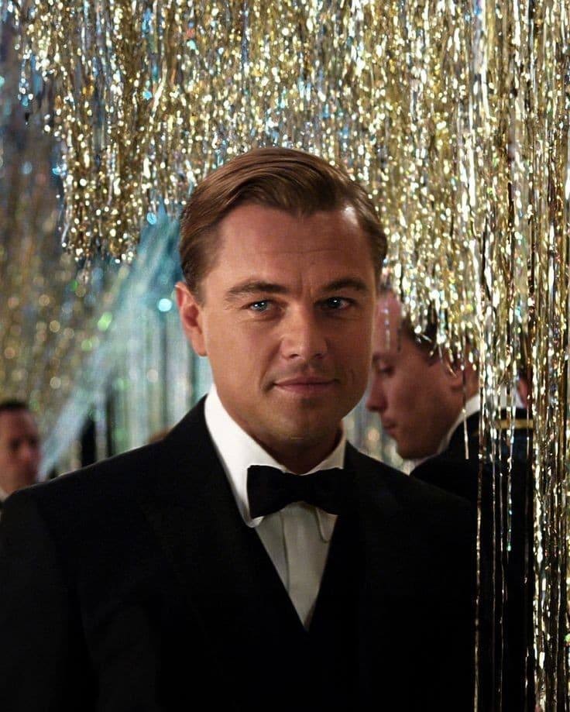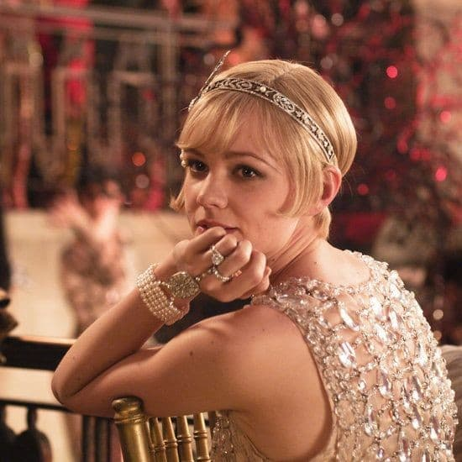
Jay Gatsby Daisy

Jay Gatsby serves as the central Subject, driven by his pursuit of Daisy Buchanan, who is the Object of his quest. Gatsby's goal extends beyond Daisy herself to encompass what she symbolizes: wealth, status, and the elusive American Dream. This pursuit of a lost love and a romanticized past forms the foundation of the narrative's progression.
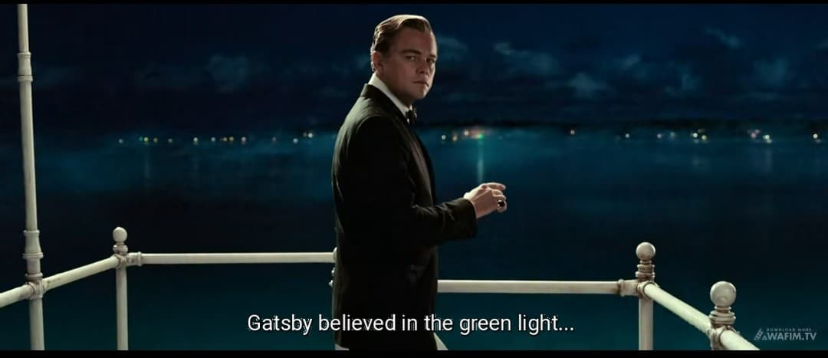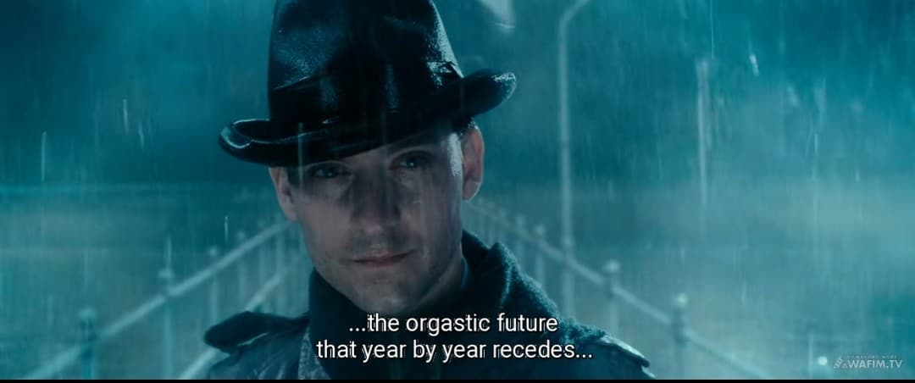
A pivotal scene illustrating this is Gatsby gazing across the bay at the green light on Daisy's dock, which symbolizes his longing and the illusionary nature of his dream. This dynamic highlights the idealism and eventual hollowness of the American Dream. The symbolic significance is reinforced by Nick's narration in the film: "Gatsby believed in the green light, the orgastic future that year by year recedes before us".
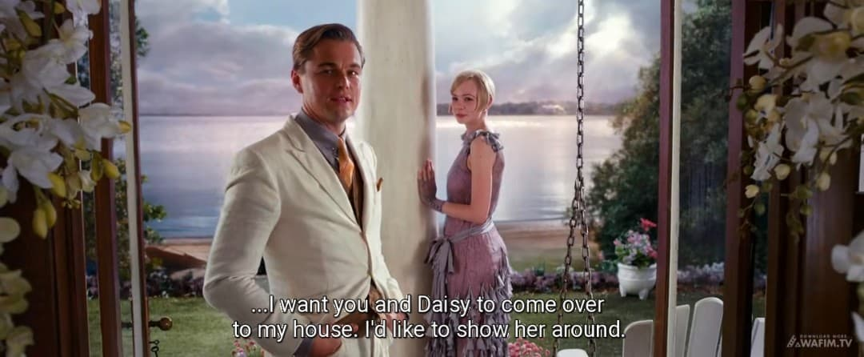
Another scene that illustrates this is when Gatsby shows Daisy his lavish mansion, hoping to impress her with his accumulated wealth, signifying his belief that his riches are a means to win her back and fulfill his idealized past. This scene is validated by Gatsby's dialogue in the film: "I want you and Daisy to come over to my house. I’d like to show her around"

B. Sender and Receiver
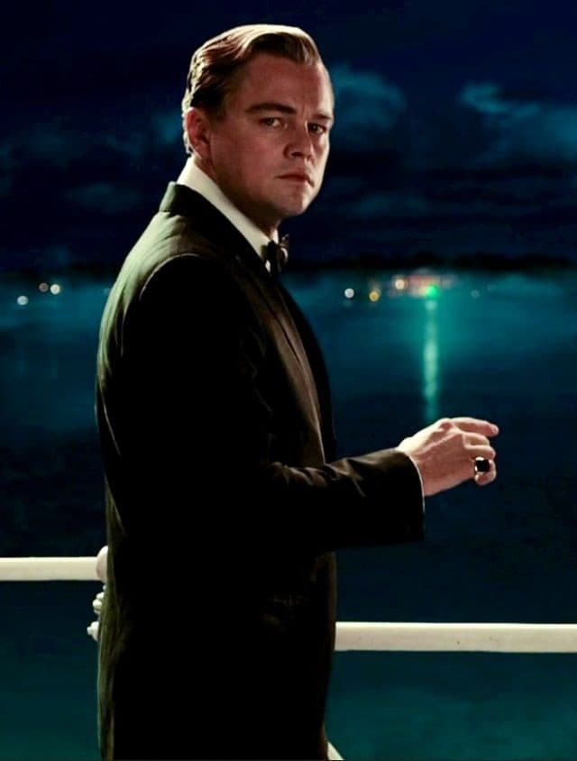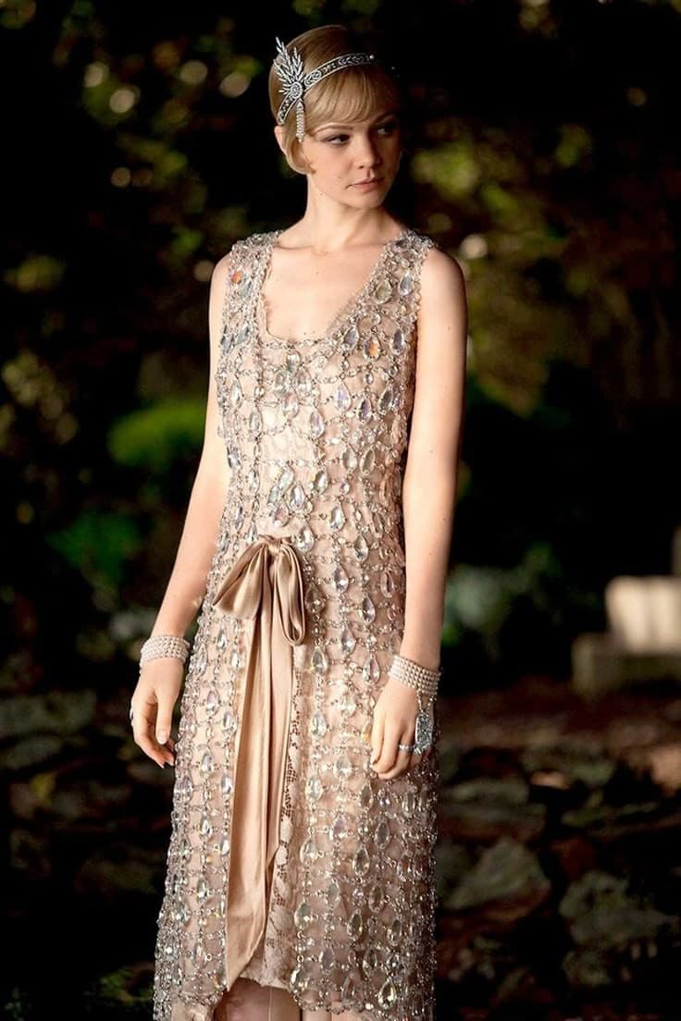
Jay Gatsby Daisy

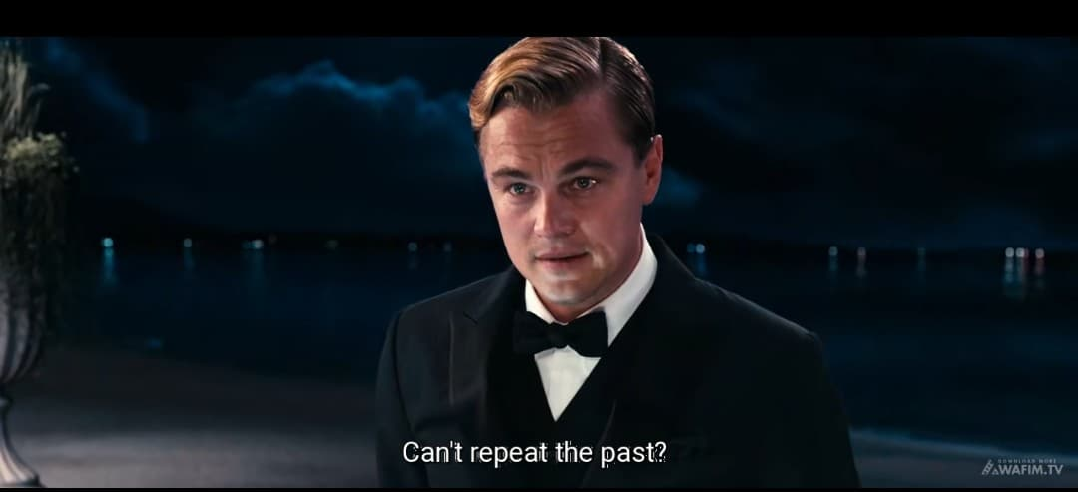
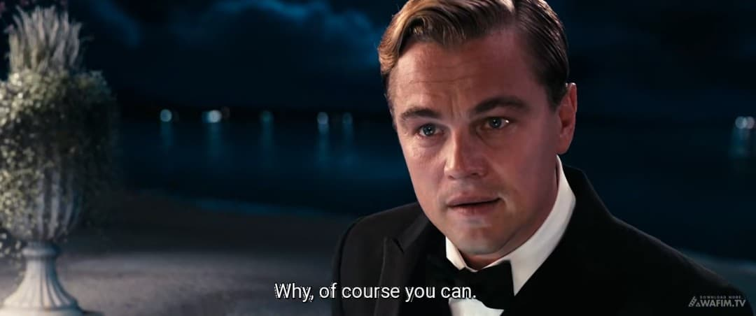
Gatsby's internalized desire, stemming from a nostalgic and idealized past, functions as the Sender. His memories of Daisy and their time together before the war are the driving force behind his transformation into the wealthy Jay Gatsby. Gatsby also acts as the Receiver, seeking personal fulfillment and meaning through the realization of his dream. This dual role is evident when Gatsby tells Nick, "Can't repeat the past? Why of course you can!" underscores his deep psychological investment in the past as a catalyst for his actions.
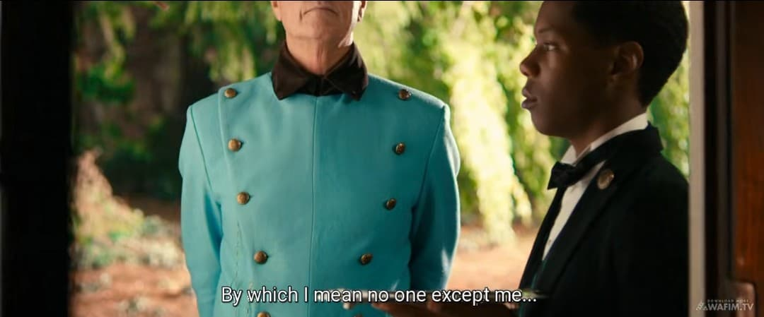
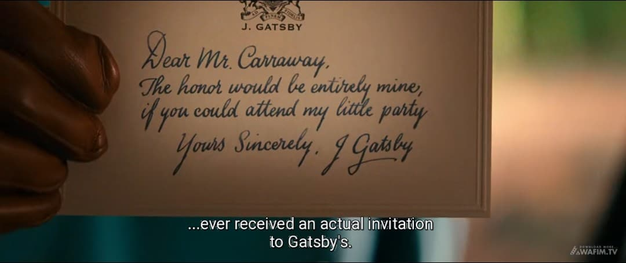
Another key scene is when Gatsby meticulously plans and orchestrates his lavish parties serving as a "sender" of an invitation to Daisy, hoping his wealth and social standing will be the "receiver" of her admiration and ultimately, her return to him. Nick's narration in the film confirms this motivation: "By which I mean no one except me ever received an actual invitation to Gatsby’s”.
C. Helper and Opponent
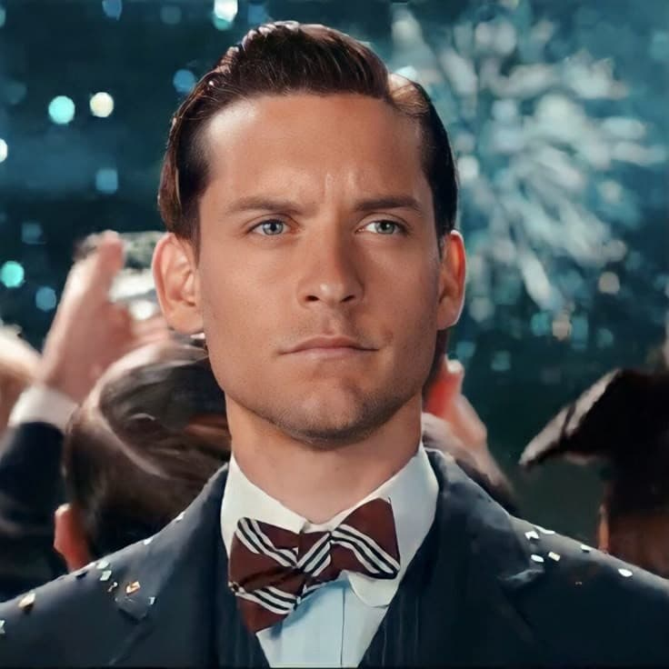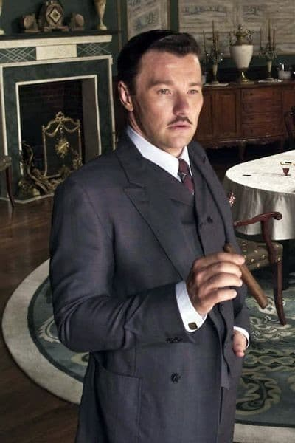
Nick Carraway Tom Buchanan

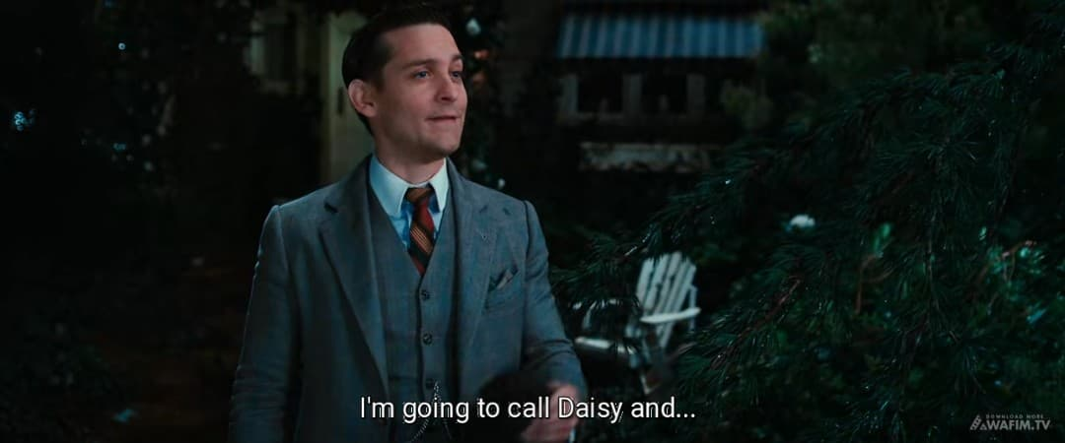
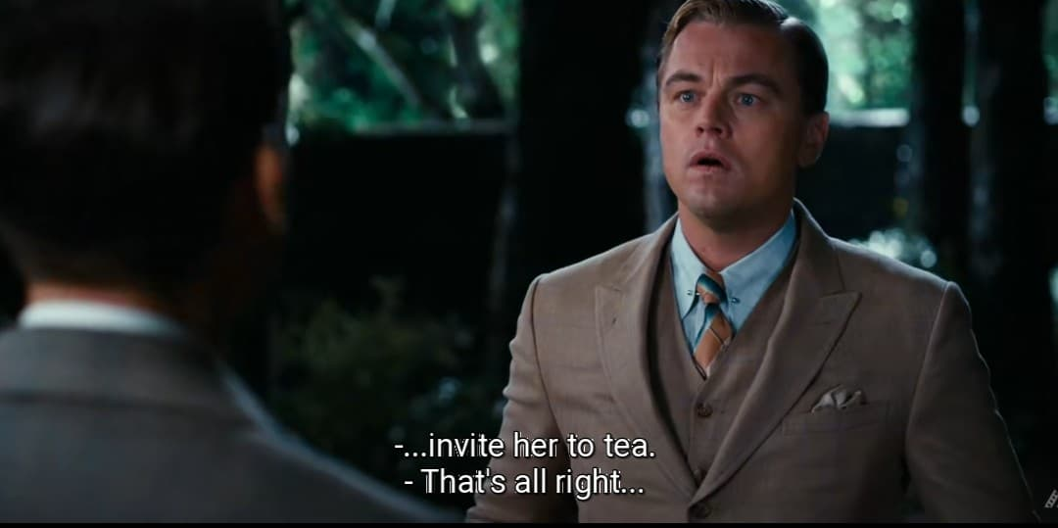
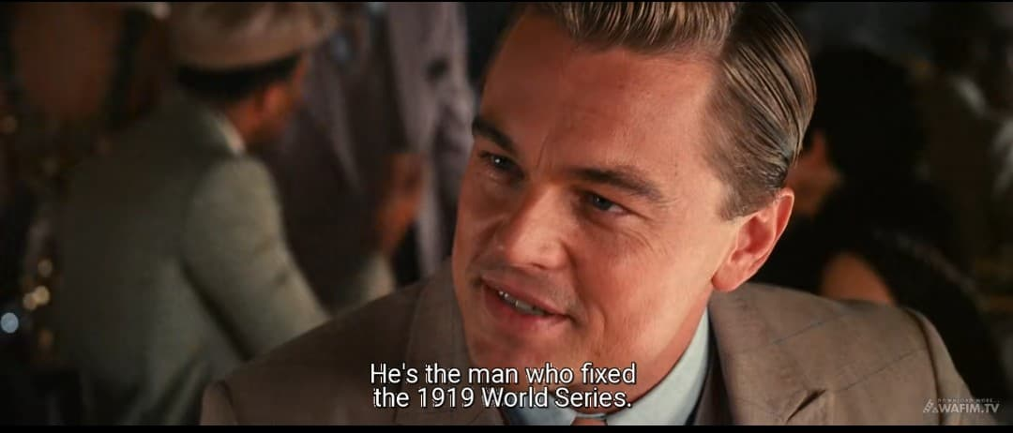
Nick Carraway functions as a Helper, both narratively and within the plot. He arranges Gatsby and Daisy's reunion, becoming a mediator of Gatsby's dream. Nick's role is established when he agrees to facilitate their meeting: "I'm going to call Daisy and invite her to tea". In addition, Meyer Wolfsheim helps Gatsby acquire wealth, thereby enabling his social transformation. Gatsby acknowledges this debt: “He's the man who fixed the World's Series back in 1919". However, these Helpers also expose the moral ambiguity of Gatsby's pursuit, especially given the criminal origins of his fortune.
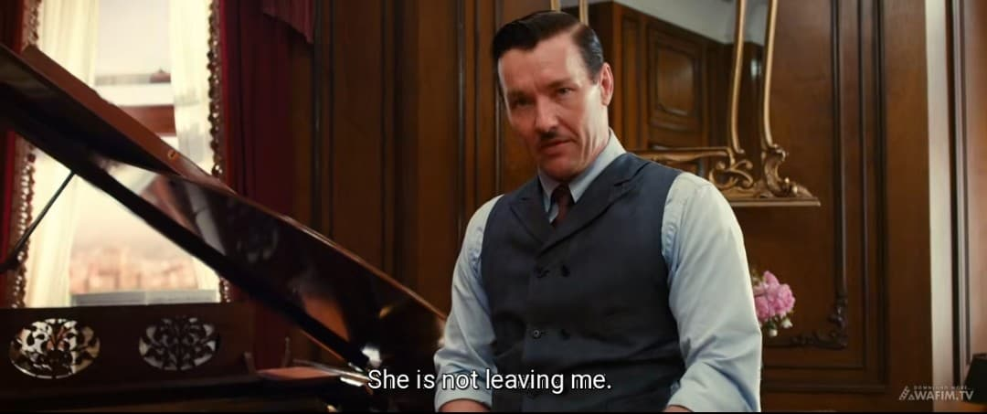
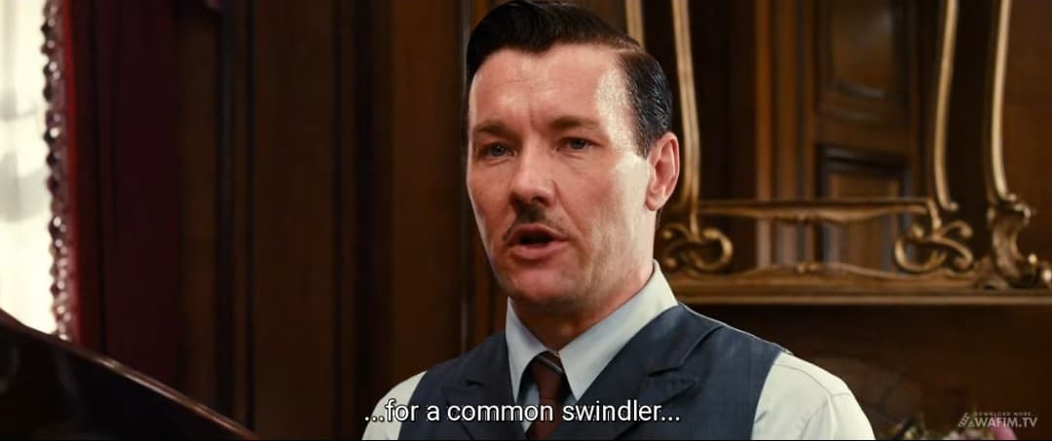
The Opponent is primarily Tom Buchanan, who actively works to dismantle Gatsby's dream by exposing his background and reasserting his dominance over Daisy. The confrontation at the Plaza Hotel is the climactic moment in which Tom successfully breaks Gatsby's illusion by declaring that Daisy will never leave him. Tom's dominance is asserted through his declaration: "She's not leaving me! Certainly not for a common swindler. This interaction crystallizes the themes of class rigidity, social hypocrisy, and the corruption of the American Dream by materialism and elitism.
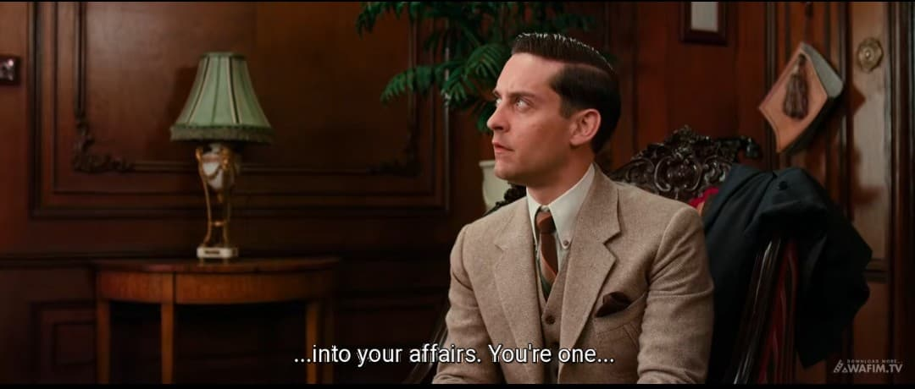
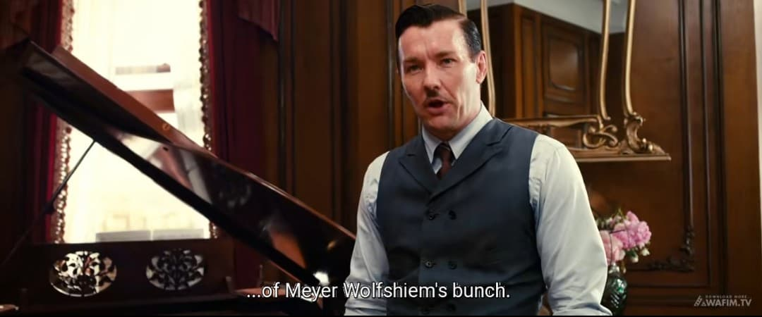
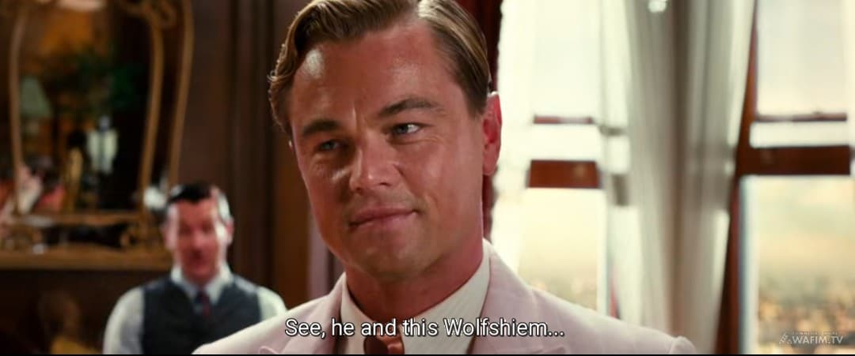
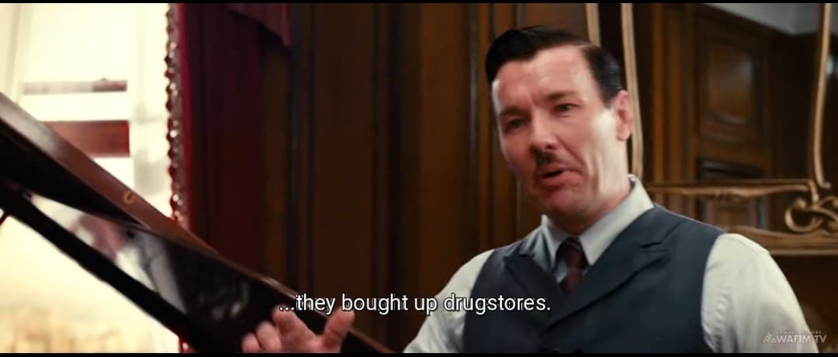
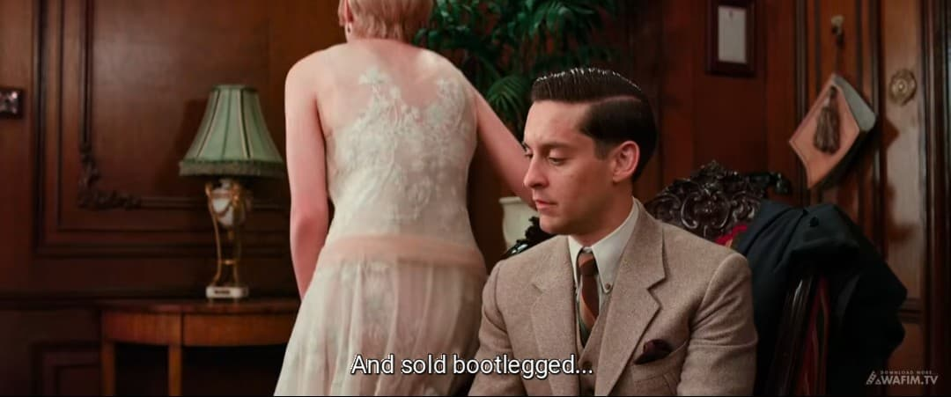
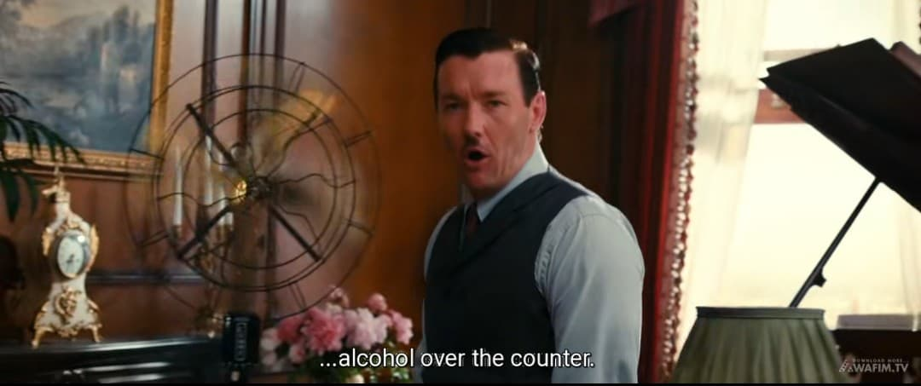
Another instance of Tom as an Opponent is when he subtly investigates Gatsby's past, revealing his illegal activities to Nick and others effectively undermining Gatsby's carefully constructed facade. Tom's investigative nature is revealed when he states: "You’re one of Meyer Wolfsheim’s bunch". A quote that exemplifies Tom's role as opponent is his cutting remark about Gatsby: "See, He and Wolfsheim bought up a lot of drug-stores here and sold bootlegged alcohol over the counter!.
2. Narrative Structure and Its Influence on Character Relationships
Greimas' canonical narrative schema outlines four stages of narrative action: Manipulation, Competence, Performance, and Sanction. This structural progression helps explain the development and transformation of relationships among the characters in The Great Gatsby.
A. Manipulation and Competence
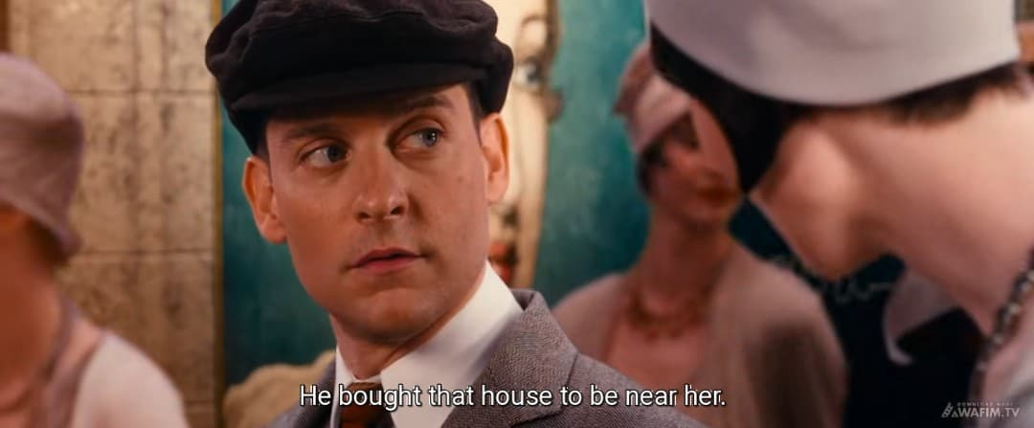
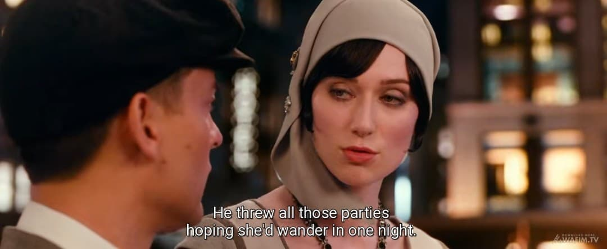
In the Manipulation phase, Gatsby is motivated by his idealized memory of Daisy. His decision to move to West Egg, throw extravagant parties, and reconnect with Daisy is rooted in this nostalgic desire. Nick and Jordan function as intermediaries, with Nick arranging the pivotal meeting between Gatsby and Daisy. Jordan's role as manipulator is confirmed when he reveals: "He bought that house to be near her, he threw all those parties hoping she’ wander in one night”.
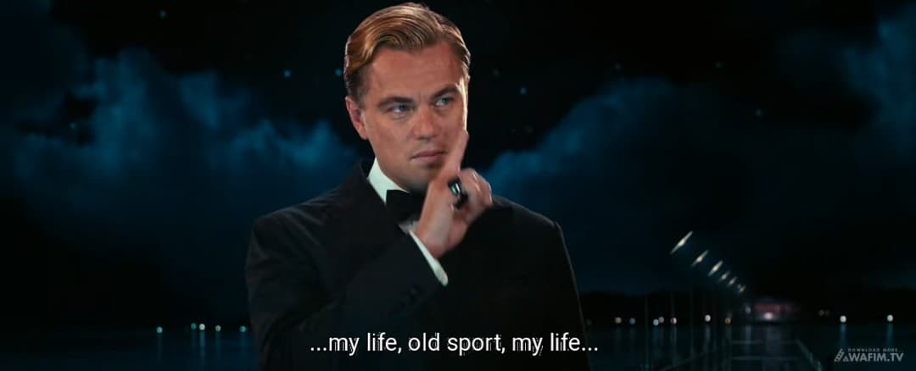
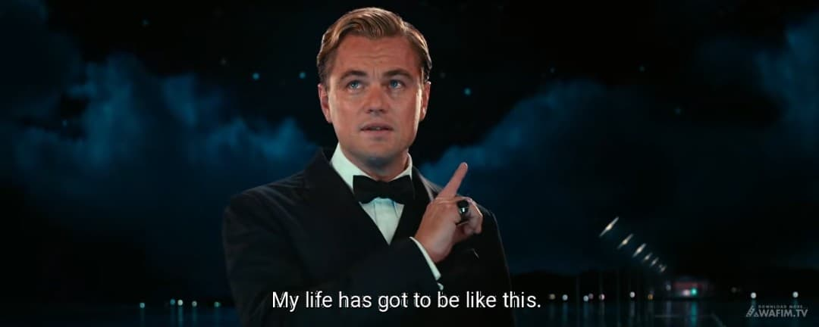
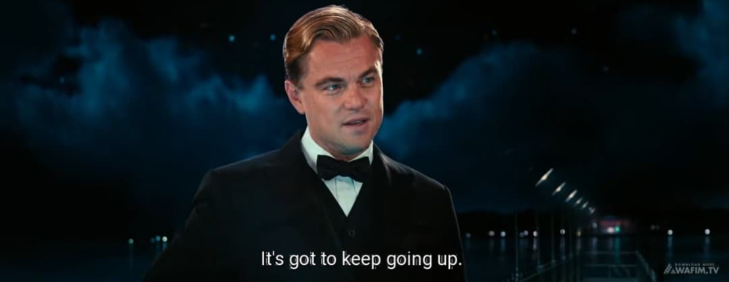
Another scene illustrating competence is Gatsby's meticulous planning and execution of his business dealings, which, though morally questionable, solidify his financial standing and make him a "legitimate figure" in Daisy's eyes. His transformation is captured in his own words: "My life, old sport, my life... my life has got to be like this. It's got to keep going up".
B. Performance
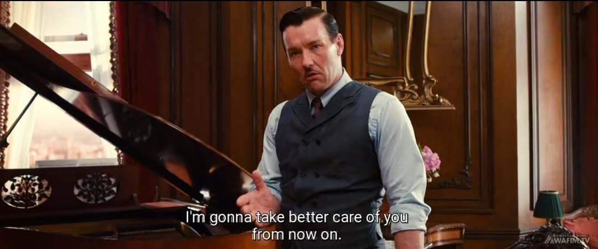
The Performance occurs when Gatsby and Daisy begin their affair. At this stage, Gatsby believes he is on the verge of achieving his dream. However, this relationship destabilizes the equilibrium of all surrounding characters. Tom becomes increasingly suspicious, Nick grows disillusioned, and Daisy becomes conflicted between love and societal obligation. Gatsby's confidence during this phase is evident: "I'm going to take better care of you from now on".
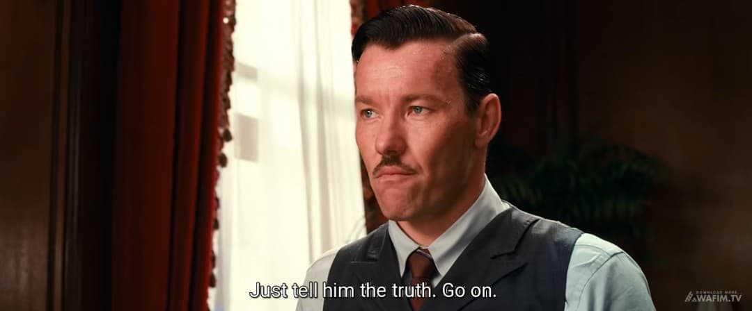
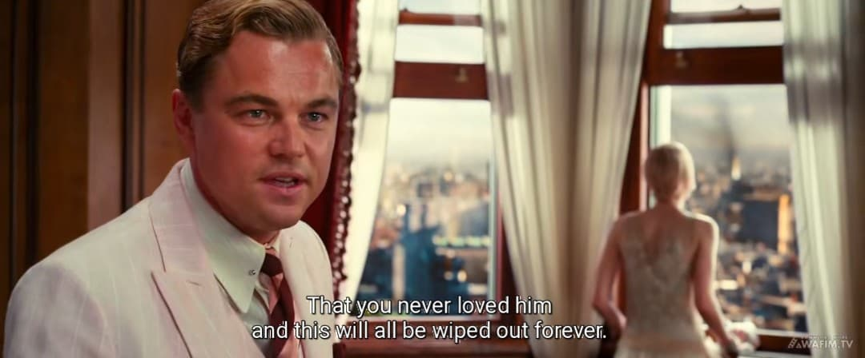
The confrontation scene at the Plaza Hotel serves as the turning point. Gatsby's demand that Daisy claim she never loved Tom illustrates his inability to separate his dream from reality. His demanding nature is shown when he insists: "Just tell him the truth. Go on. That you never loved him and this will all be wiped out forever". This moment shifts the dynamics of all relationships and marks the beginning of the narrative decline.
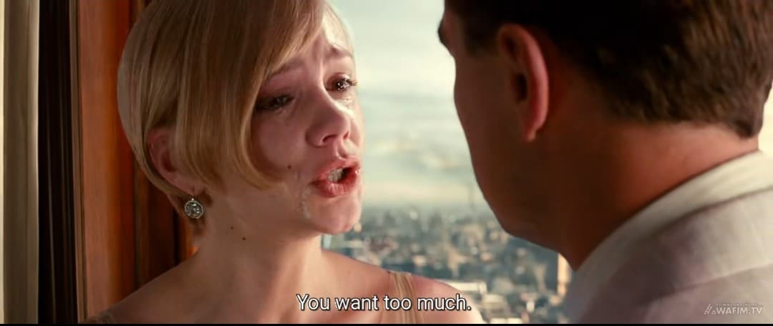
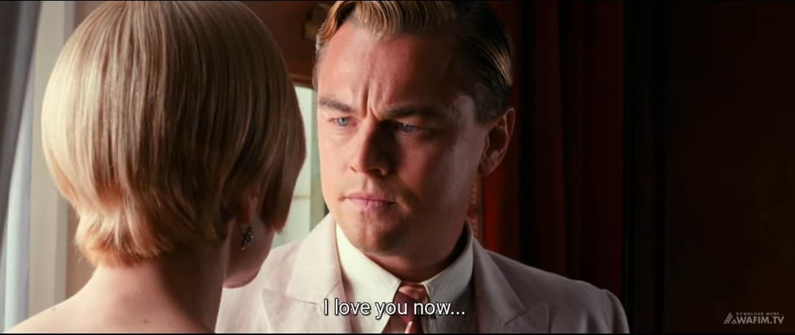
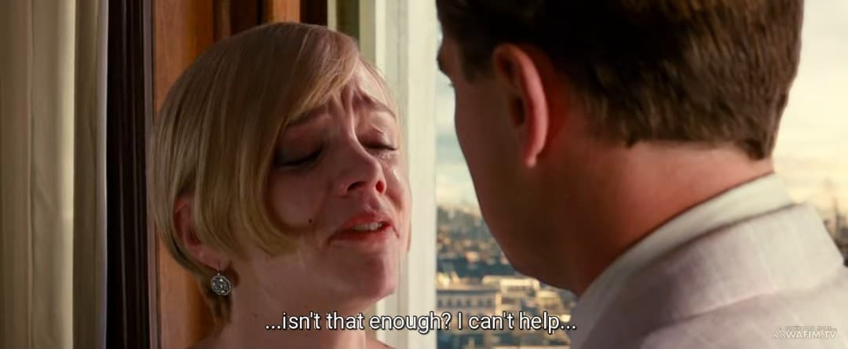
Another scene in the performance stage is when Gatsby and Daisy spend an afternoon together at his mansion, seemingly recapturing their past intimacy, which represents the peak of Gatsby's perceived success in his quest. Gatsby's unwavering insistence to Daisy, "You want too much!" he cried to Daisy. "I love you now isn't that enough? I can’t help" clearly demonstrates the performance of his demanding love.

C. Sanction
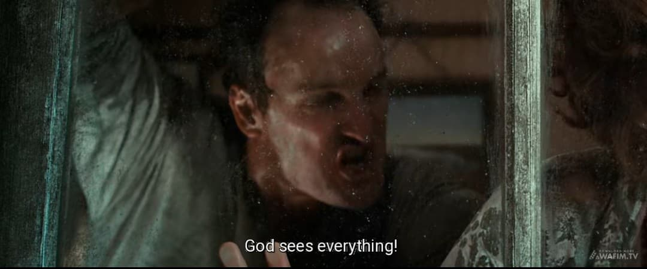
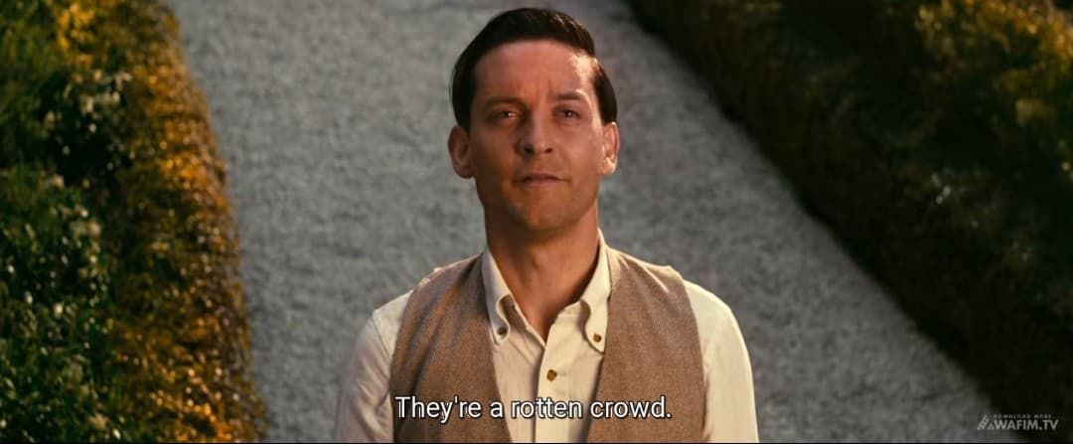
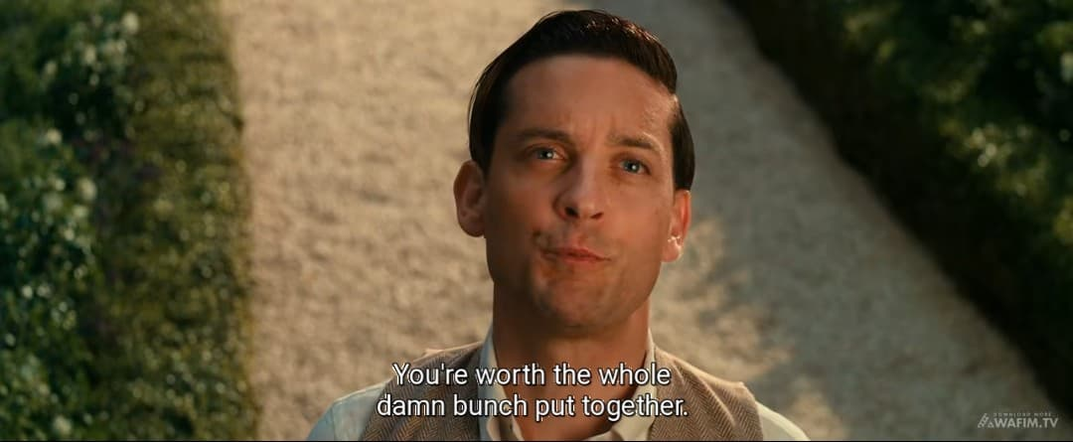
The Sanction stage results in Gatsby's tragic downfall. Misled by Tom, George Wilson kills Gatsby, believing he was Myrtle's lover and murderer Wilson's motivation is revealed through his desperate words: "God sees everything" before he commits the fatal act. Daisy retreats into her privileged life with Tom, abandoning Gatsby to his fate. Her abandonment is symbolized by her absence at his funeral and Nick's realization: "They’re a rotten crowd... You're worth the whole damn bunch put together".
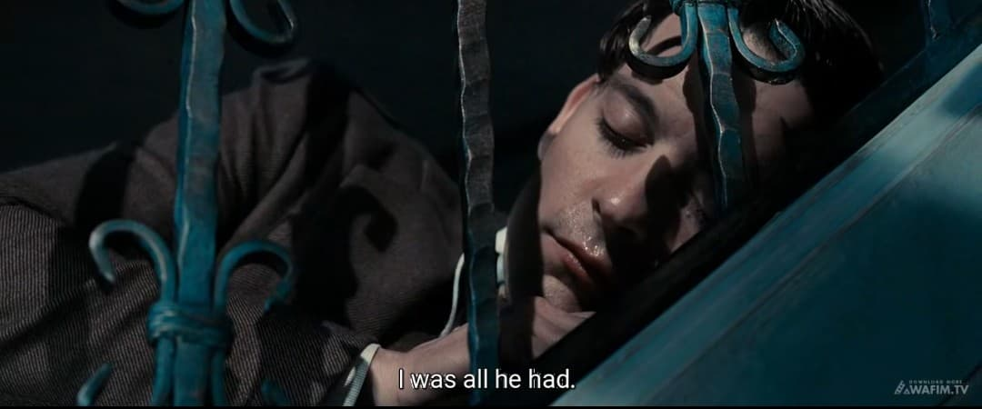
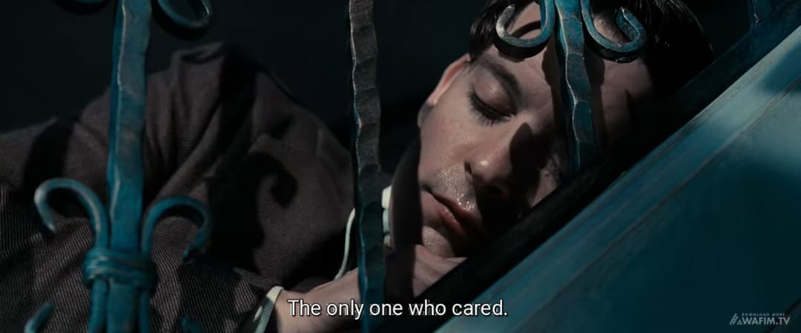
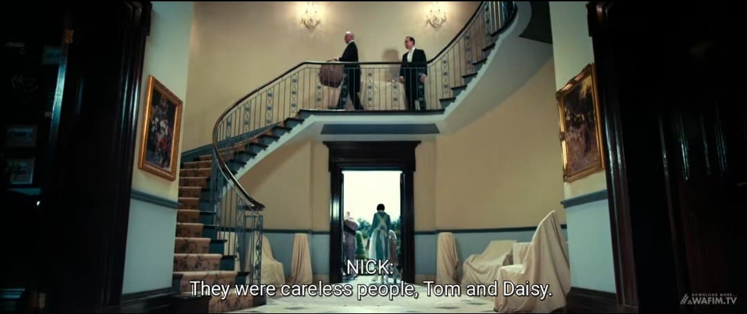
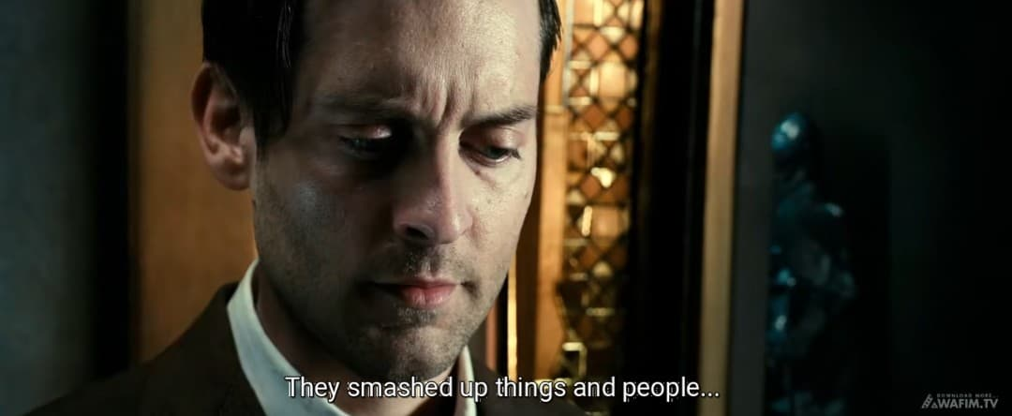
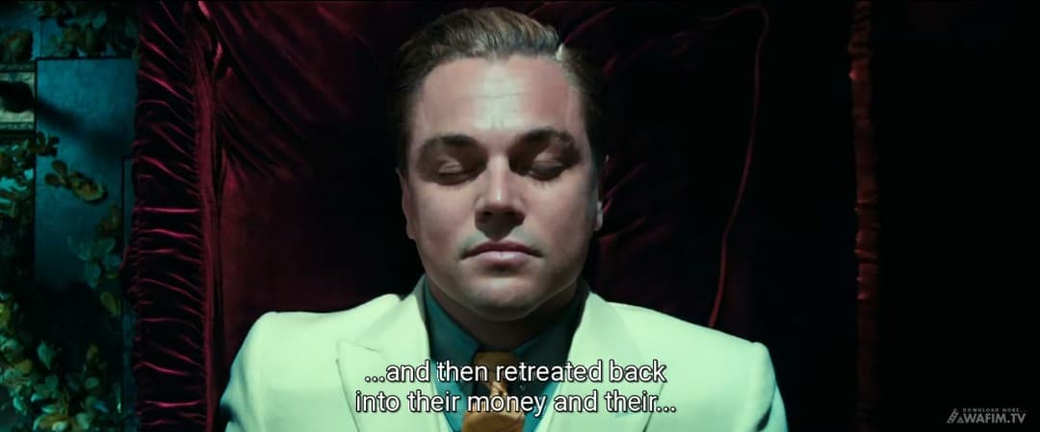
The funeral scene, where only Nick and Gatsby's father attend underscores the emptiness of Gatsby's relationships and the failure of his dream. The tragic isolation is emphasized by Nick's observation: "I was all he had. The only one who cared. Nick's final reflection "They were careless people, Tom and Daisy. They smashed up things and people and then retreated back into their money…" cements the theme of moral irresponsibility in the face of wealth and status.
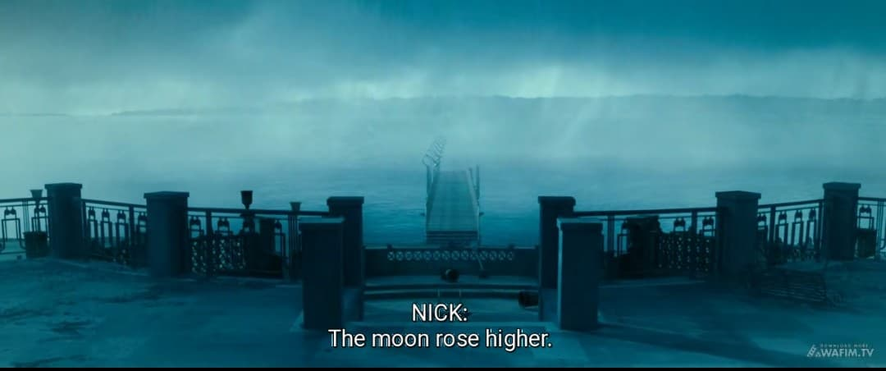
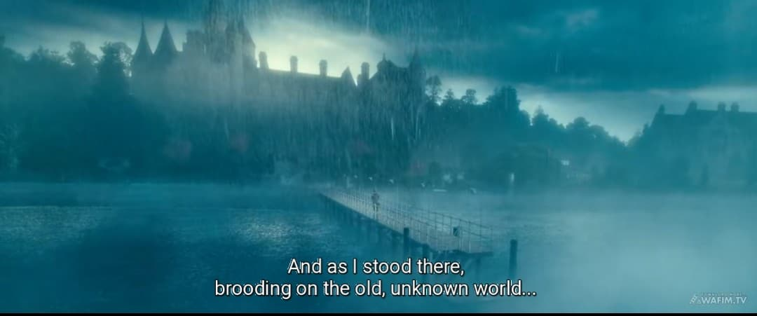
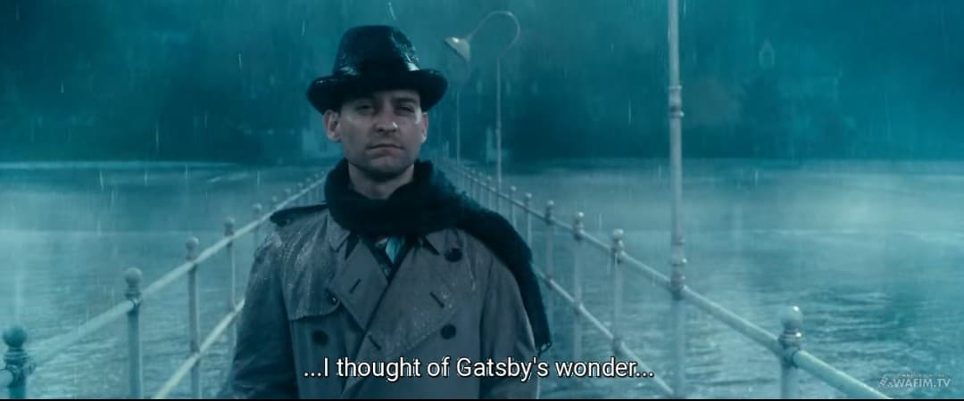
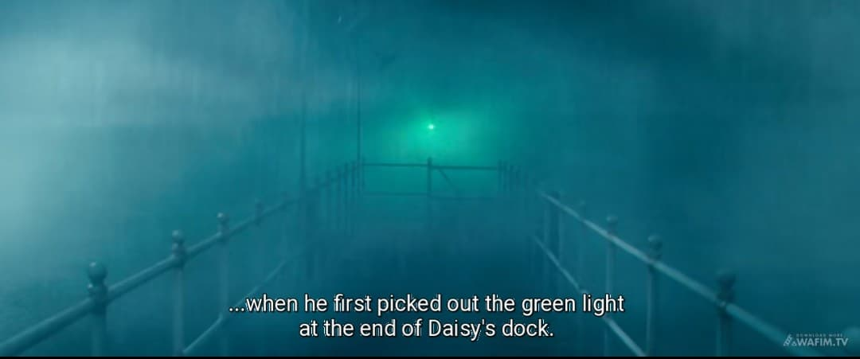
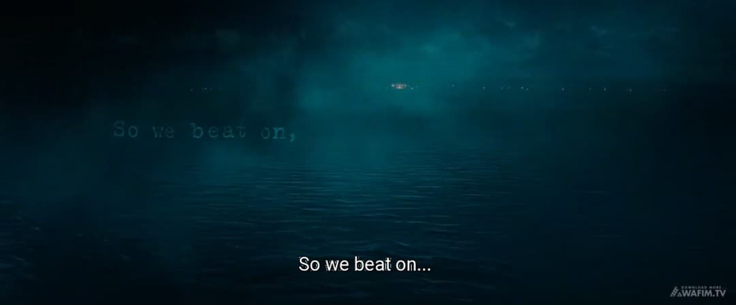
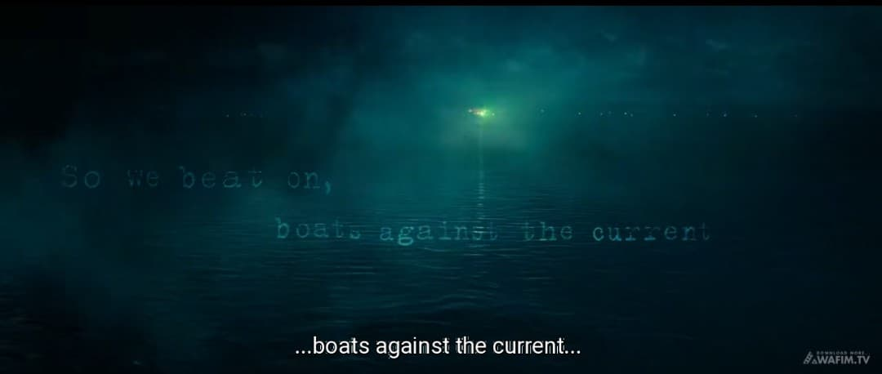
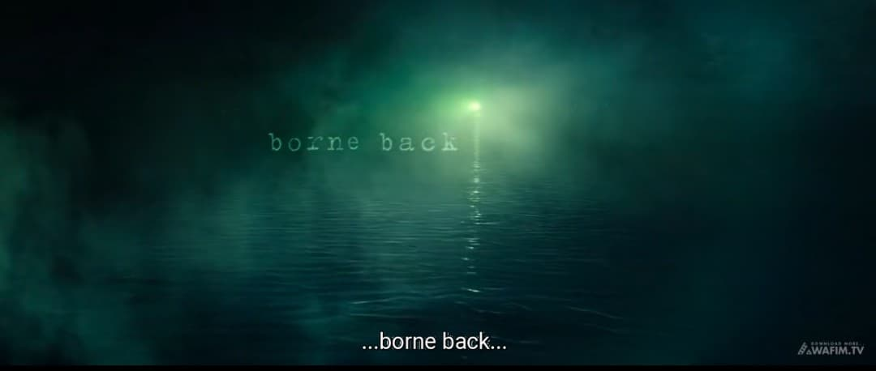
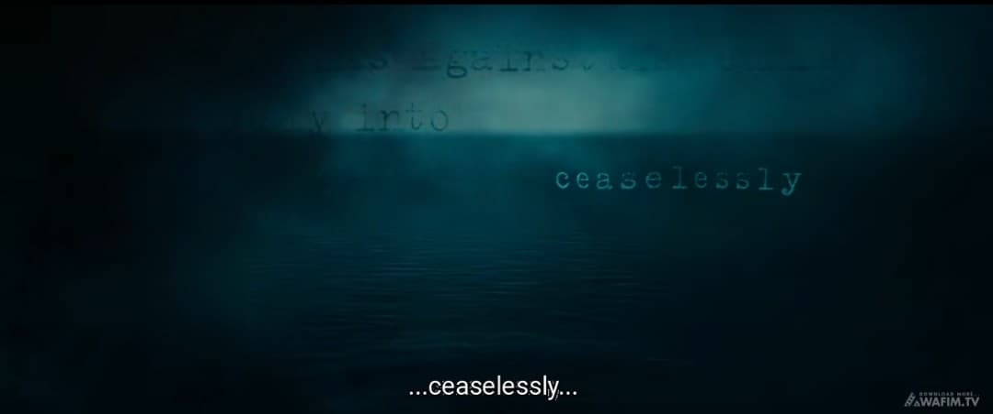
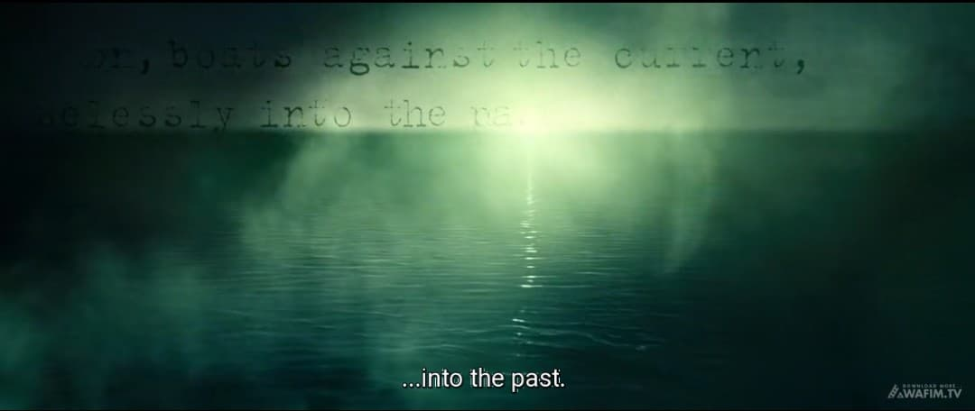
Another scene that signifies the sanction is when Nick returns to West Egg after Gatsby's death and finds the mansion desolate highlighting the rapid collapse of Gatsby's world and the superficiality of his connections. The desolation is captured in Nick's description: "The moon rose higher. And as I stood there, brooding on the old, unknown world, I thought of Gatsby’s wonder when he first picked out the green light at the end of Daisy’s dock" Nick's poignant conclusion, "So we beat on, boats against the current, borne back ceaselessly into the past", powerfully encapsulates the futility and tragic finality of Gatsby's quest.
Using A.J. Greimas’ actantial model and canonical narrative schema reveals the deeper narrative structure and thematic depth of The Great Gatsby. Jay Gatsby, as the Subject, is driven by his pursuit of Daisy Buchanan—the Object—who represents both a lost love and the idealized promise of the American Dream. His romanticized memories and longing for the past serve as the Sender, motivating his transformation into a wealthy, mysterious figure, while he himself acts as the Receiver, seeking emotional and personal fulfillment. Helpers like Nick Carraway and Meyer Wolfsheim assist Gatsby’s quest, though their involvement also highlights the moral ambiguity surrounding his rise. Opposing him is Tom Buchanan, who defends his social position by exposing Gatsby’s criminal past and unraveling his carefully crafted identity. The canonical phases of Manipulation, Competence, Performance, and Sanction trace Gatsby’s journey from hope to disillusionment, revealing how his dream collapses under the weight of reality. Ultimately, Gatsby’s tragic downfall reflects the illusion of the American Dream, the impossibility of recreating the past, and the emptiness that lies beneath wealth and privilege in a morally decaying society.

CHAPTER V

CONCLUSION AND SUGGESTION

5.1 Conclusions

After analyzing the data, the following conclusions can be drawn:

The shifting roles and alignments between characters underscore the fluidity of narrative function, particularly as seen in Nick Carraway’s transformation from passive observer to active commentator.

Furthermore, the interplay between Helpers and Opponents underscores the complexity of external forces economic status, social expectation, and gender roles which ultimately determine the outcome of the narrative.

These roles are not static; rather, they reflect the characters’ development and the thematic arc of the story.

The application of Greimas’ canonical narrative schema reveals that The Great Gatsby does not simply present a linear romantic tragedy, but instead constructs a cyclical, symbolic narrative rooted in desire, illusion, and disillusionment. The Manipulation phase exposes Gatsby’s internal motivation and idealization of Daisy; the Competence phase is marked by Gatsby’s elaborate efforts and Nick’s involvement; the Performance is reached when Gatsby reunites with Daisy; and the Sanction culminates in Gatsby’s tragic death—symbolizing the futility of his quest and the collapse of his dream.

In terms of character relationships, the narrative structure reveals underlying tensions that are shaped by both personal desires and socio-economic divisions. Gatsby’s relationship with Daisy is doomed not merely by personal failure but by the entrenched class divide that renders his dream unattainable. Similarly, the relationship between Nick and Gatsby grows stronger as Nick becomes morally aware of the corruption surrounding them, while his relationship with the Buchanans deteriorates due to their moral emptiness.

5.2 Suggestions

The findings suggest that Greimas’ narrative theory offers a valuable framework for understanding how narrative functions operate in film, not only as devices to structure story but as tools to uncover deeper thematic and ideological meanings. This analysis contributes to literary and film studies by highlighting how classical narrative models can be adapted to modern cinematic texts.

For future research, scholars might apply Greimas' model to other film adaptations of literary works to examine how narrative structures are maintained or transformed across media. Additionally, comparative studies between the novel and film versions of The Great Gatsby using structuralist or post-structuralist frameworks could yield further insights into adaptation theory, intertextuality, and medium-specific storytelling techniques.

REFERENCES

Afdlila, (2015). The role of movies in communication and cultural representation.
Anderson, J. (2023). Multimodal narrative sequences: Applying Greimas' theory to film analysis. Journal of Narrative Theory, 53(1), 45-67.
Arikunto, S. (2002). Prosedur penelitian: Suatu pendekatan praktik. Rineka Cipta.
Cardwell, S. (2022). Adaptive resonance in literary and filmic elements. Journal of Adaptation in Film & Performance, 15(2), 123-138.
Chatman, S. (2018). Story and discourse: Narrative structure in fiction and film. Cornell University Press.
Cobb, S. (2022). Adaptation as cultural bridge: The legacy of classic literature in film. Adaptation, 15(1), 1-17.
Creswell, J. W. (2014). Research design: Qualitative, quantitative, and mixed methods approaches. SAGE Publications.
Cutchins, D. (2018). Living texts: Adaptation and the transformation of literature in film. University Press of Mississipi.
Darmadi, H. (2013). Metode penelitian pendidikan. Alfabeta.
Elliott, K. (2020). Transmedia ecosystems: Literature and film in the digital age. Oxford University Press.
Endraswara, S. (2011). Metodologi penelitian sastra: Epistemologi, model, teori, dan aplikasi. CAPS (Pusat Akademik dan Studi Sastra.
Geraghty, C. (2018). Narrative structures and media interpretations. Journal of Media Practice, 19(3), 302-316.
Herman, D. (2021). Narrative theory and the study of literary adaptations. Narrative, 29(2), 155-173.
Herman, L., & Vervaeck, B. (2019). Handbook of narrative analysis. University of Nebraska Press.
Hornby, A. S. (2005). Oxford advanced learner’s dictionary. Oxford University Press.
Kennedy, X. J., & Gioia, D. (2002). Literature: An introduction to fiction, poetry, and drama. Pearson.
Klarer, M. (2004). An introduction to literary studies. Routledge.
Kristiana, V. (2021). THE IMPLEMENTATION OF COLLABORATIVE LEARNING MODELS IN THE TEACHING METHOD SUBJECT FOR ENGLISH LITERATURE STUDENTS OF UMN AL-WASHLIYAH MEDAN. PHILOLOGY Journal of English Language and Literature, 1(1), 49-54.
Kumar, R. (2021). Structural narrative analysis of film adaptations: The application of Greimas' model. Journal of Literary Theory and Criticism, 5(1), 44-58.
Leitch, T. (2012). Adaptation as a process of reinterpretation. In D. Cartmell (Ed.), A companion to literature, film, and adaptation (pp. 85-100). Wiley-Blackwell.
Mahdy, U. A. (2019). Greimas’ structural narrative in Green Lantern movie (2011) (Doctoral dissertation, Universitas PGRI Adi Buana Surabaya).
Martinez, J. (2020). Greimas’ actantial model and its application to film analysis. Narrative Inquiry, 30(2), 175-192.
Meikle, K. (2023). New narrative spaces: Adaptation beyond source material. Journal of Adaptation Studies, 11(1), 23-41.
Murray, S. (2021). Temporal dialogue in adaptation studies. Adaptation, 14(2), 122-136.
Nurmala, D. (2022). MULTIMODAL ANALYSIS OF RIAU ARCHIPELAGO PROMOTION VIDEO. PHILOLOGY Journal of English Language and Literature, 2(1), 1-9.
Prasetya, R. S., Tambusai, A., Hasibuan, A. L., & Susanto, D. (2025). DEVELOPING ENGLISH WRITING MATERIALS BASED ON FISHBONE TECHNIQUE FOR GRADE X STUDENTS OF SMKS AL WASHLIYAH 12 SEI RAMPAH. PHILOLOGY Journal of English Language and Literature, 5(1), 73-80.
Richardson, B. (2021). Modern movie adaptation studies and narrative structure. Journal of Narrative Theory, 51(3), 298-312.
Rokhmansyah, A. (2014). Strukturalisme naratif: Teori dan penerapan. Graha Ilmu.
Rois, A. S. (2016). The narrative structure of Luc Besson’s movie: Lucy in Greimas narratology. (Undergraduate thesis, Universitas Islam Negeri Sunan Kalijaga).
Rantung, A. J., Olii, S. T., & Kumayas, T. (2022). An analysis of language in The Great Gatsby movie. JoTELL: Journal of Teaching English, Linguistics, and Literature, 1(2), 261-279.
Saraswati, R. (2022). Greimas's actantial model in The Hunger Games movie. Akrab Juara: Jurnal Ilmu-ilmu Sosial, 7(3), 314-321.
Sanders, J. (2020). Palimpsest adaptation: Layers of narrative in literature and film. Bloomsbury Academic.
Schober, R. (2023). Adaptive interfaces: Literature and film in the digital age.
Selden, R. (1985). A reader’s guide to contemporary literary theory. University of Kentucky Press.
Susanto, A. (2012). Structuralist theories in literary analysis: Greimas and beyond.
Suwondo, S. (2011). Narrative theory and its development: From Propp to Greimas.
Thompson, J. (2022). Complex narratives in film and the relevance of Greimas' model. Journal of Narrative and Media Studies, 6(2), 101-118.
Wijaya, D., Hawa, F., & Ardini, S. N. (2021, March). An analysis of social conflict in The Great Gatsby movie. Proceeding of English Teaching, Literature and Linguistics (Eternal) Conference, 1(1), 427-447.
Yakub, J. (2012). Metodologi penelitian kualitatif dan kuantitatif. Alfabet.
Zaimar, O. (2011). Introduction to structuralist literary criticism.

