ACKNOWLEDGEMENT

بِسْــــــــــــــــــمِ اللهِ الرَّحْمَنِ الرَّحِيْمِ

يَا أَيُّهَا الَّذِينَ آمَنُوا هَلْ أَدُلُّكُمْ عَلَىٰ تِجَارَةٍ تُنْجِيكُمْ مِنْ عَذَابٍ أَلِيمٍ (١٠) تُؤْمِنُونَ بِاللَّهِ وَرَسُولِهِوَتُجَاهِدُونَ فِي سَبِيلِ اللَّهِ بِأَمْوَالِكُمْ وَأَنْفُسِكُمْ ۚ ذَٰلِكُمْ خَيْرٌ لَكُمْ إِنْ كُنْتُمْ تَعْلَمُونَ (١١)
Artinya :
Wahai orang-orang yang beriman! Maukah kamu aku tunjukan suatu perdagangan yang dapat menyelamatkanmu dari azab yang pedih?
(Q.S. Ash-Shaff : 10)
(Yaitu) kamu beriman kepada Allah dan Rasul-Nya dan berjihad di jalan Allah dengan harta dan jiwamu. Itulah yang baik bagi kamu jika kamu mengetahui. (Q.S. Ash-Shaff : 11)
The author always gives thanks to Allah SWT for His abundant grace, blessings, and guidance, which have enabled the author to complete the writing of this thesis successfully. Shalawat and greetings are also continuously offered to the Prophet Muhammad SAW, who has brought Islamic teachings to guide humanity to become people of faith and obedience to Allah SWT. Therefore, the author wholeheartedly extends gratitude to :
- Dr. H. Firmansyah, M.Si as Rector of UMN Al-Washliyah.
- Mrs. Ayu Melati Ningsih, S.Pd., M.S as Dean of English Literature of UMN Al-Washliyah.
- Mrs. Diana Sopha, S.S., M.Hum as Deputy Dean of English Literature UMN Al-Washliyah.
- Mrs. Vera Kristiana S.Pd., M.Pd as Supervisor has patiently guided the author, and provided various valuable inputs, which with kindness and sincerity guided the author in completing this thesis.
- Prof. Dr. Ahmad Laut Hasibuan M.Pd as Examining Lecturer I has provided input and suggestions in preparing this thesis.
- Dr. Dewi Nurmala S.S,. M.Hum as Examining Lecturer II has also provided very meaningful guidance, suggestions, criticism, and encouragement in completing this thesis.
- All lecturers at the Faculty of Letters, Universitas Muslim Nusantara Al-Washliyah.
- The author especially expresses heartfelt thanks and deepest gratitude to his beloved parents, Irwanto (father) and T. Masna Hanum (mother), who have always given their unwavering love and sincere prayers, enabling the author to complete this thesis successfully. May Allah SWT continue to bless you both with health, happiness, and endless blessings.
- My beloved sisters, brother and cousin , Indry Syafitri Irawan, Faiza Nadia, Olivia Syafira, M. Fajar Satrio and Arief Muliyasa Siregar, thank you for always providing the best embrace, support, prayers, and love for the author in completing this thesis.
- My best classmates during lectures, Mas Andika Fahreza and Rifky Sultan Nico Sembiring, thank you for being such wonderful companions. Thank you for all the laughter, joy, and unforgettable moments we shared during our time together. Your valuable

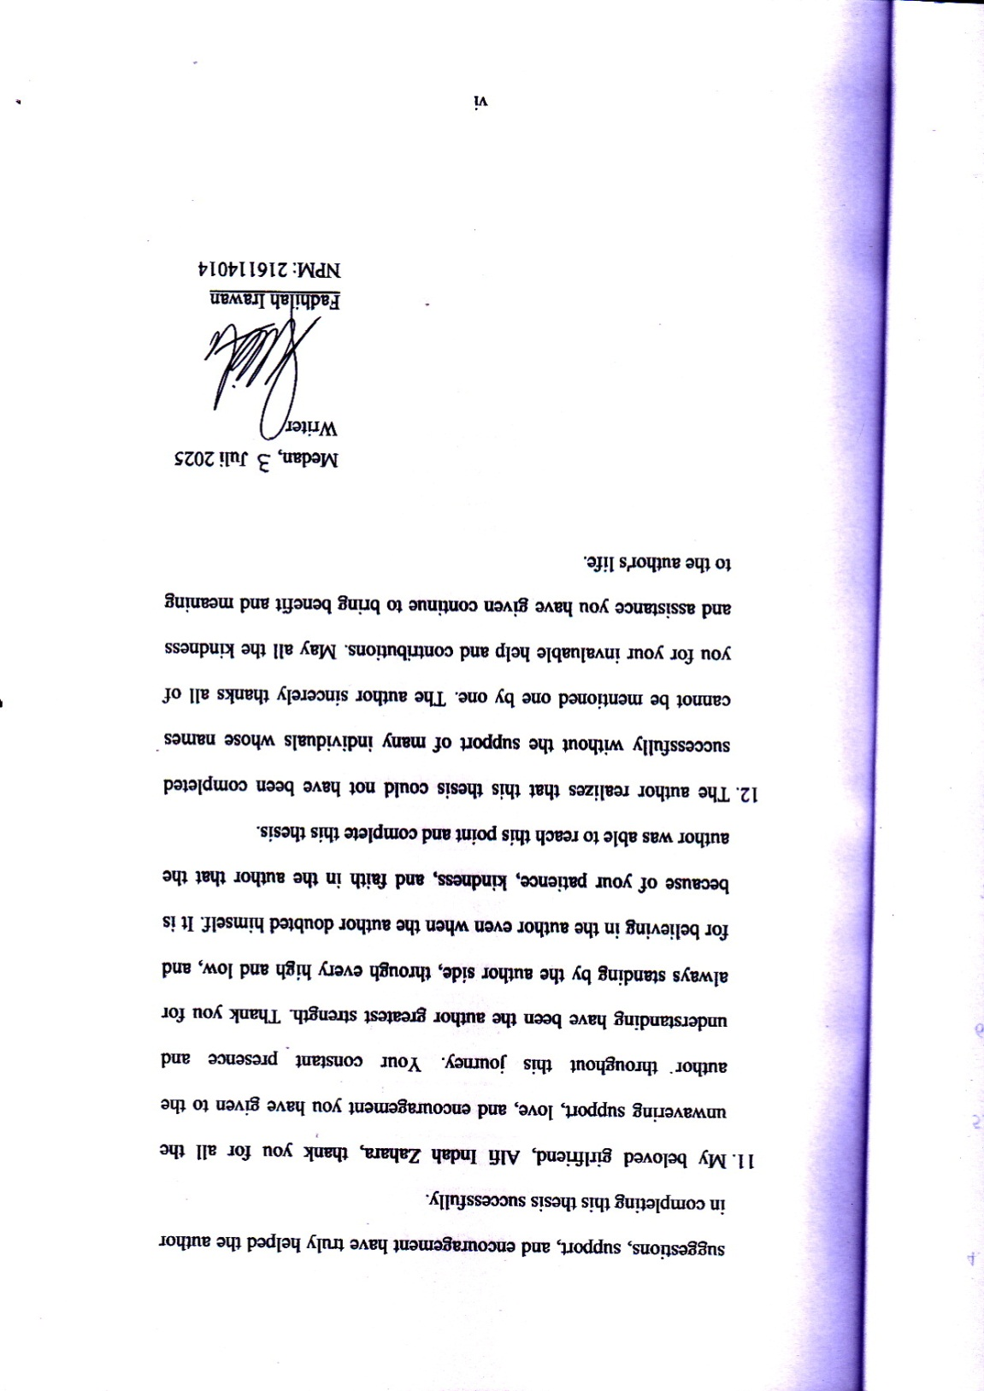
TABLE OF CONTENTS

COVER i
ABSTRACT ii
ABSTRAK iii
ACKNOWLEDGEMENT iv
TABLE OF CONTENTS vii
CHAPTER I : INTRODUCTION 1
1.1 Background Of Research 1
1.2 Identification of Problems 8
1.3 Limitation of Problems 9
1.4 Problem Statements 10
1.5 Objective Of Research 10
1.6 Significance of Research 11
CHAPTER II : REVIEW OF LITERATURE 12
2.1 Narrative Structure 12
2.1.1 A.J. Greimas's Narrative Theory 15
2.2 Movie 20
2.2.1 Types of Movie 21
2.2.2 Elements of Movie 22
2.3 Synopsis of The Great Gatsby Movie 25
2.4 Previous Research 26
CHAPTER III : METHOD OF RESEARCH 30
3.1 Method of Research 30
3.2 Data and Source of Data 31
3.3 Technique of Collecting Data 32
3.4 Technique of Analyzing Data 33
CHAPTER IV : FINDINGS AND DISCUSSION 36
4.1 Findings 36
4.2 Discussions 38
CHAPTER V : CONCLUSION AND SUGGESTION 60
5.1 Conclusions 60
5.2 Suggestions 61
REFERENCES 62

