CHAPTER IV

FINDINGS AND DISCUSSION

4.1 Findings
The analysis of The Great Gatsby through Greimas' actantial model and canonical narrative schema reveals not only the mechanics of the film's plot but also the ideological tensions and contradictions embedded within the narrative. One key observation is how the narrative roles reflect the fragmentation of identity in modernist literature and cinema. Jay Gatsby, while positioned structurally as the Subject, embodies multiple identities James Gatz, the poor farm boy; Jay Gatsby, the wealthy gentleman; and ultimately, a tragic figure doomed by his illusions. This fluidity aligns with the modernist theme of fragmented selfhood, as discussed by theorists like Fredric Jameson, who argue that modern characters often wrestle with unstable identities shaped by consumerism and memory.
The Object, Daisy Buchanan, complicates the narrative progression due to her ambiguity. While she serves as the central goal of Gatsby’s desire, she is also a symbol of the American Dream’s unattainability. Her indecisiveness and moral weakness reflect the corrupting influence of privilege and social expectation. This adds a psychological dimension to the narrative structure Daisy becomes a projection of Gatsby’s ideal rather than a fully realized individual. This dynamic supports Greimas’ notion that the Object is often more symbolic than literal, carrying thematic weight beyond its surface role.
The interactions among Helpers and Opponents highlight the instability of narrative roles and how they evolve based on character development and contextual shifts. Nick Carraway begins as a neutral observer and becomes an active participant, embodying the Helper role by facilitating Gatsby's reunion with Daisy. Yet, by the film's conclusion, he shifts into a commentator whose disillusionment colors the entire narrative. This shift resonates with Linda Hutcheon’s theory of the “narrator as moral witness,” common in postmodern narratives that interrogate truth and subjectivity.
Meanwhile, Tom Buchanan’s role as Opponent is reinforced not just by his antagonism toward Gatsby but by his function as the gatekeeper of social class. He represents old money, a symbol of entrenched power that resists upward mobility. His conflict with Gatsby is thus not only personal but systemic mirroring the class conflict embedded within the American capitalist structure. In this regard, Tom’s success in dismantling Gatsby’s dream illustrates the failure of meritocracy and the illusion of equal opportunity, echoing themes explored in Marxist literary criticism.
From a structural perspective, Greimas’ canonical narrative schema uncovers the cyclical nature of desire, failure, and consequence. The Manipulation and Competence stages generate momentum, but the Performance phase reveals the unsustainability of illusion-driven actions. The Sanction, or resolution, does not deliver justice or closure, but rather reaffirms societal inequalities. This trajectory reinforces the film's critical stance on the American Dream and the emotional toll it exacts on those who chase it.
Furthermore, the canonical structure helps frame the transformation of interpersonal relationships as symptomatic of larger ideological shifts. Gatsby and Daisy’s relationship, once intimate and hopeful, becomes strained and unsustainable as external forces assert control. Nick’s bond with Gatsby evolves into one of empathy and moral reckoning, whereas his view of the Buchanans becomes increasingly cynical. These developments suggest that narrative structure is not just a tool for organizing plot but a mechanism through which films explore the ethics and psychology of human relationships.
Lastly, the symbolism and mise-en-scène in key scenes such as the green light, the lavish parties, and Gatsby’s death in the pool act as narrative devices that reinforce structural elements. The green light, often interpreted through a psychoanalytic or semiotic lens, is not only a motivator in the Manipulation phase but also a persistent symbol of unattainable desire. Its repeated presence illustrates how structural elements can be visually and thematically encoded into cinematic language.
In conclusion, the use of Greimas’ narrative theory enables a multidimensional interpretation of The Great Gatsby not only as a romantic tragedy but as a layered critique of socio-economic structures, identity construction, and the fragility of human aspiration. The model helps us see how character roles and plot progression are intricately bound to the ideological messages conveyed through the narrative form.

4.2 Discussions
1. The Roles of Actants and Their Effects on the Story’s Progression and Themes
According to Greimas (1983), six fundamental actants Subject, Object, Sender, Receiver, Helper, and Opponent are present in any complete narrative. These actants function as structural positions rather than fixed character roles, and they interact to move the story forward while conveying key themes. In The Great Gatsby, these actants can be identified within the central narrative of Jay Gatsby’s pursuit of an idealized love and identity.
A. Subject and Object
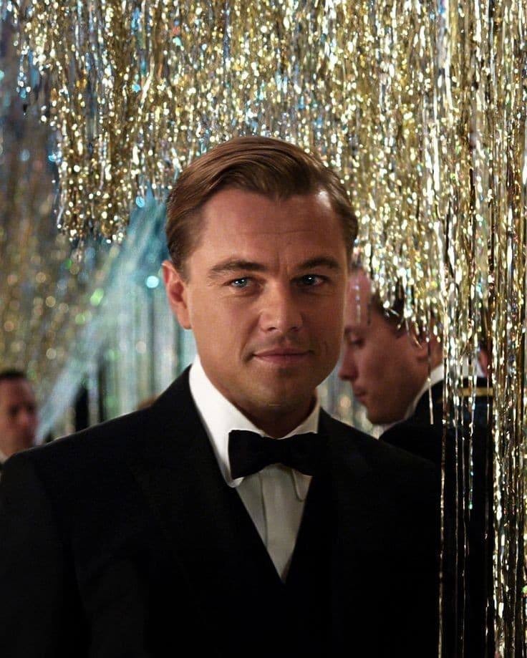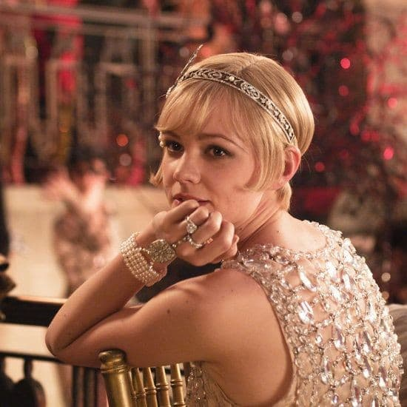
Jay Gatsby Daisy

Jay Gatsby serves as the central Subject, driven by his pursuit of Daisy Buchanan, who is the Object of his quest. Gatsby's goal extends beyond Daisy herself to encompass what she symbolizes: wealth, status, and the elusive American Dream. This pursuit of a lost love and a romanticized past forms the foundation of the narrative's progression.
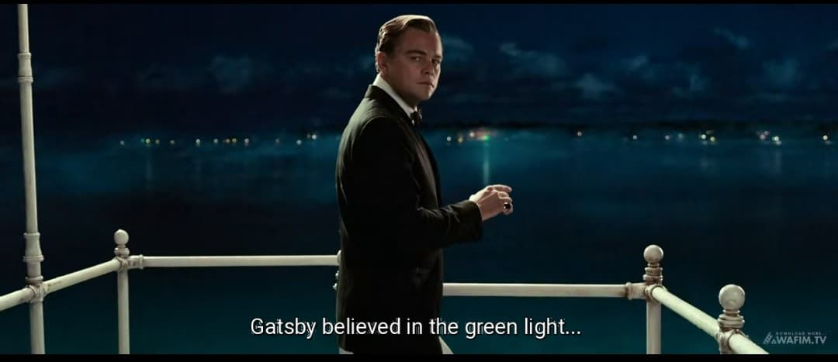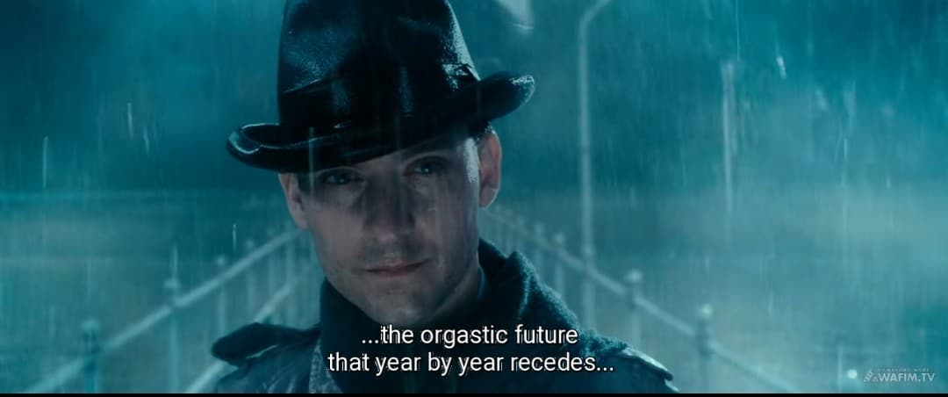
A pivotal scene illustrating this is Gatsby gazing across the bay at the green light on Daisy's dock, which symbolizes his longing and the illusionary nature of his dream. This dynamic highlights the idealism and eventual hollowness of the American Dream. The symbolic significance is reinforced by Nick's narration in the film: "Gatsby believed in the green light, the orgastic future that year by year recedes before us".
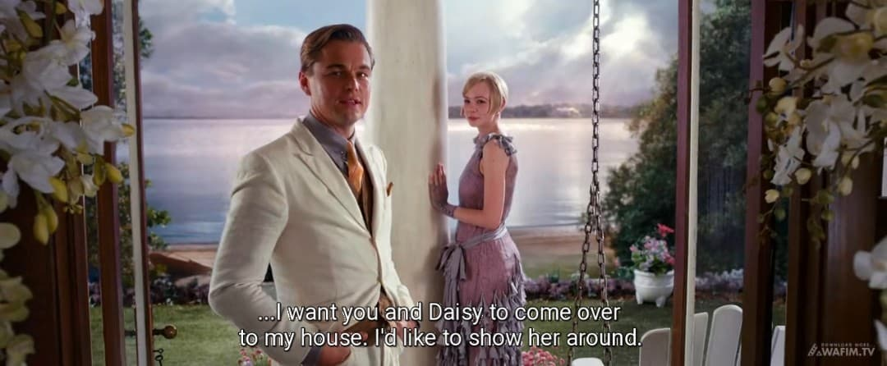
Another scene that illustrates this is when Gatsby shows Daisy his lavish mansion, hoping to impress her with his accumulated wealth, signifying his belief that his riches are a means to win her back and fulfill his idealized past. This scene is validated by Gatsby's dialogue in the film: "I want you and Daisy to come over to my house. I’d like to show her around"

B. Sender and Receiver
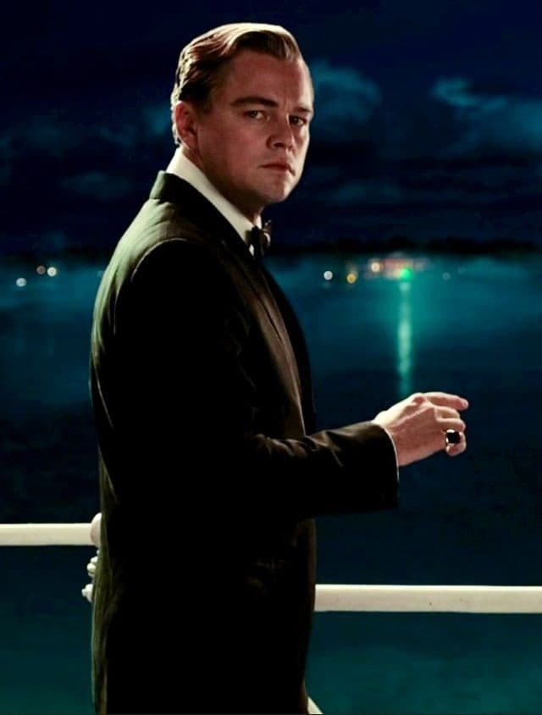
Jay Gatsby Daisy

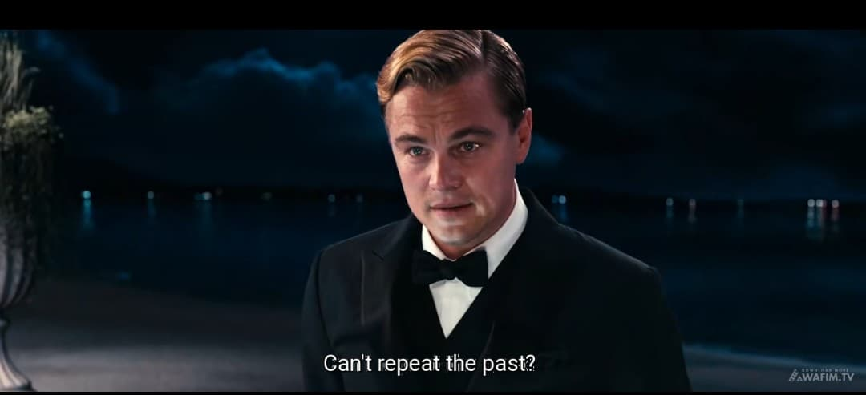
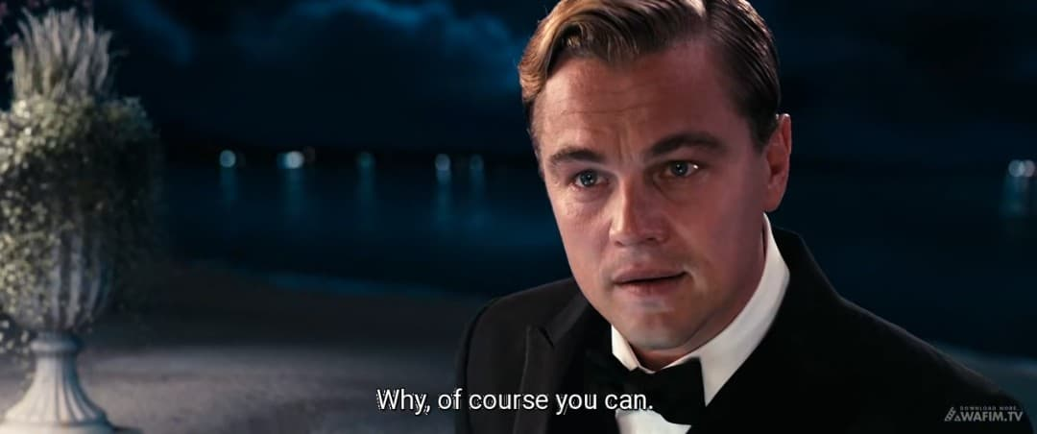
Gatsby's internalized desire, stemming from a nostalgic and idealized past, functions as the Sender. His memories of Daisy and their time together before the war are the driving force behind his transformation into the wealthy Jay Gatsby. Gatsby also acts as the Receiver, seeking personal fulfillment and meaning through the realization of his dream. This dual role is evident when Gatsby tells Nick, "Can't repeat the past? Why of course you can!" underscores his deep psychological investment in the past as a catalyst for his actions.
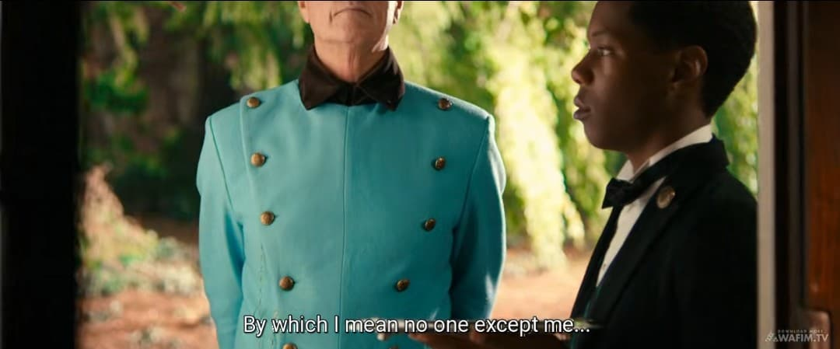
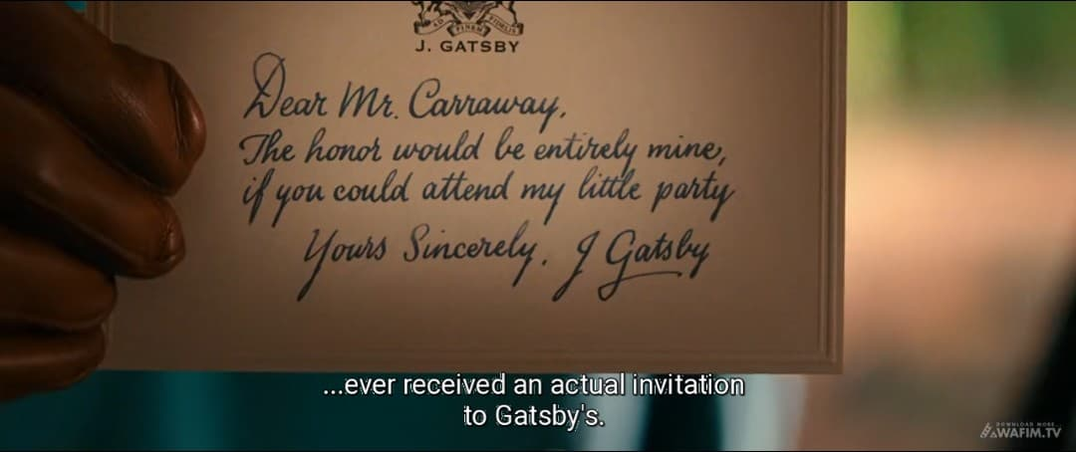
Another key scene is when Gatsby meticulously plans and orchestrates his lavish parties serving as a "sender" of an invitation to Daisy, hoping his wealth and social standing will be the "receiver" of her admiration and ultimately, her return to him. Nick's narration in the film confirms this motivation: "By which I mean no one except me ever received an actual invitation to Gatsby’s”.
C. Helper and Opponent
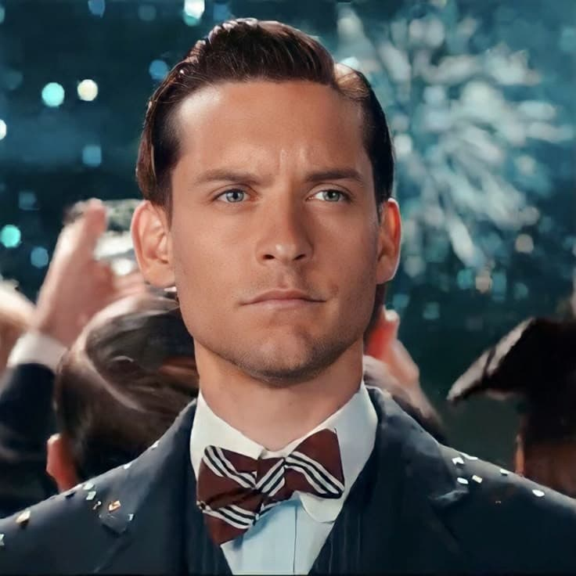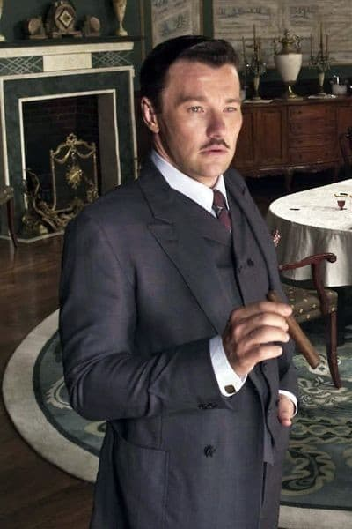
Nick Carraway Tom Buchanan

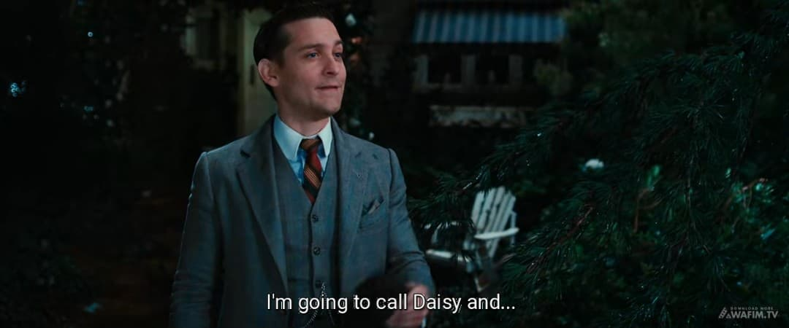
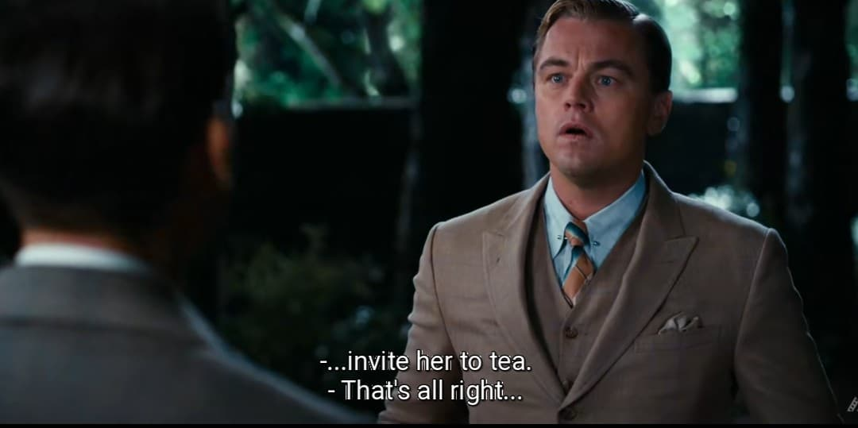
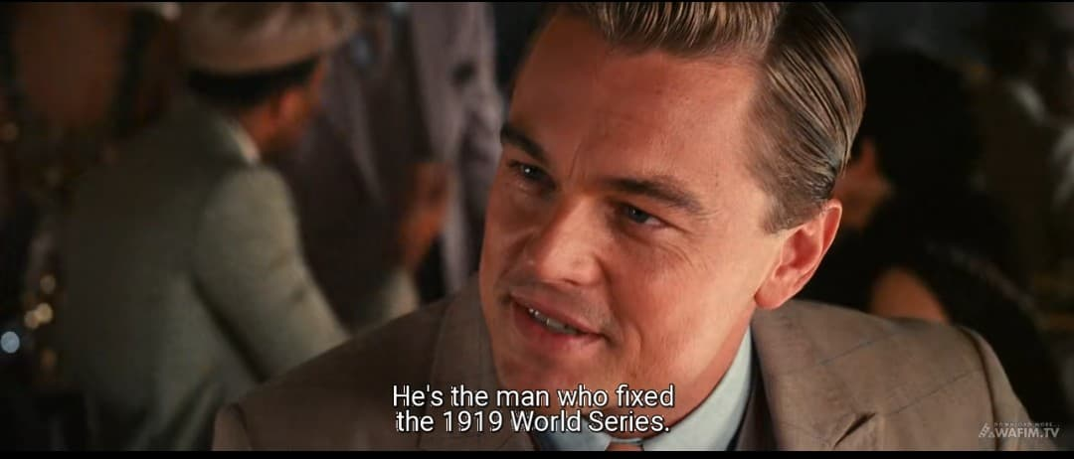
Nick Carraway functions as a Helper, both narratively and within the plot. He arranges Gatsby and Daisy's reunion, becoming a mediator of Gatsby's dream. Nick's role is established when he agrees to facilitate their meeting: "I'm going to call Daisy and invite her to tea". In addition, Meyer Wolfsheim helps Gatsby acquire wealth, thereby enabling his social transformation. Gatsby acknowledges this debt: “He's the man who fixed the World's Series back in 1919". However, these Helpers also expose the moral ambiguity of Gatsby's pursuit, especially given the criminal origins of his fortune.
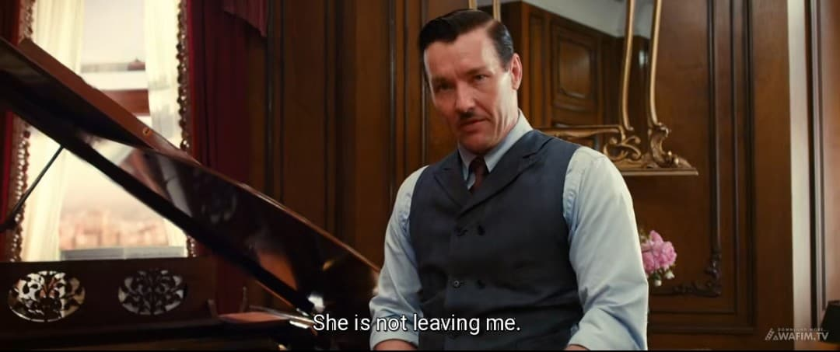
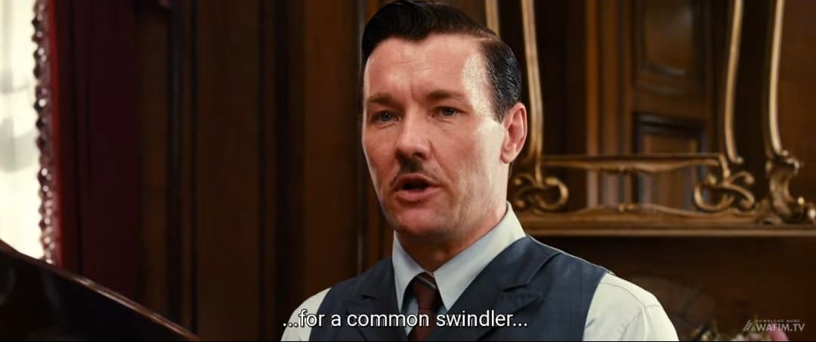
The Opponent is primarily Tom Buchanan, who actively works to dismantle Gatsby's dream by exposing his background and reasserting his dominance over Daisy. The confrontation at the Plaza Hotel is the climactic moment in which Tom successfully breaks Gatsby's illusion by declaring that Daisy will never leave him. Tom's dominance is asserted through his declaration: "She's not leaving me! Certainly not for a common swindler. This interaction crystallizes the themes of class rigidity, social hypocrisy, and the corruption of the American Dream by materialism and elitism.
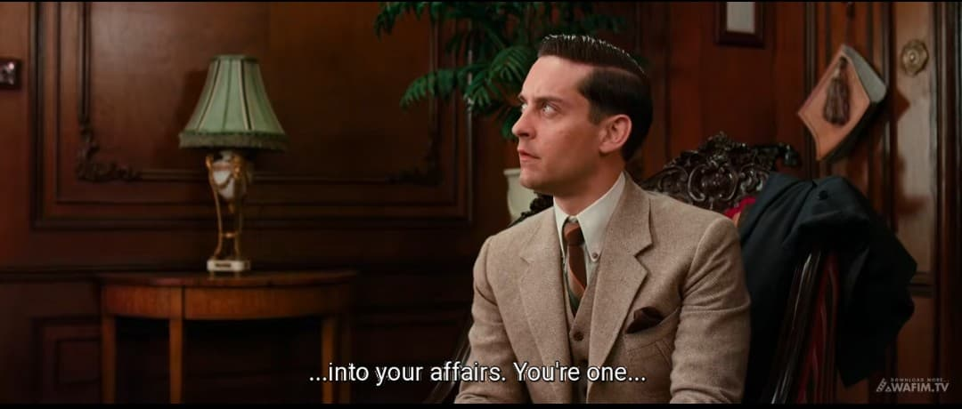
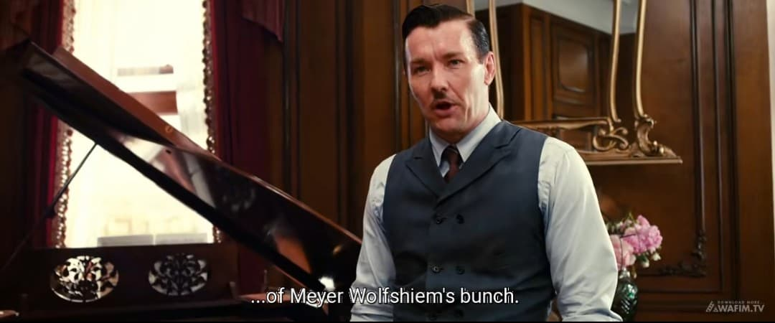
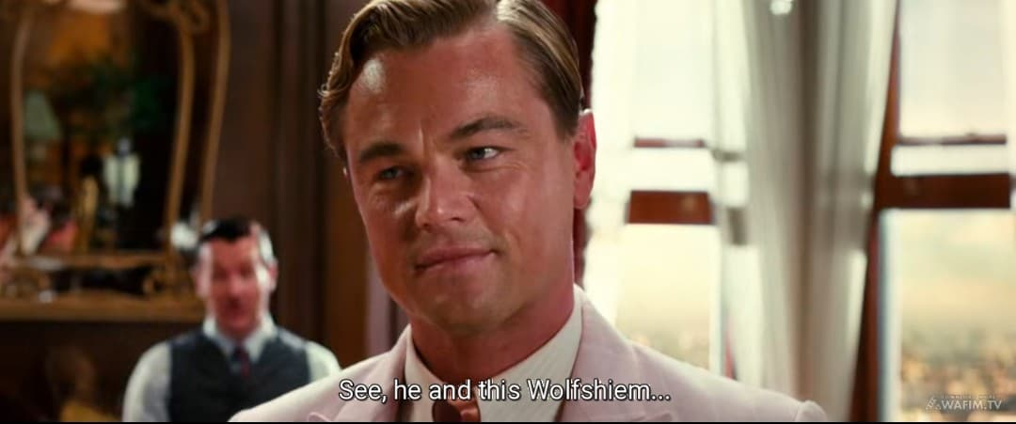
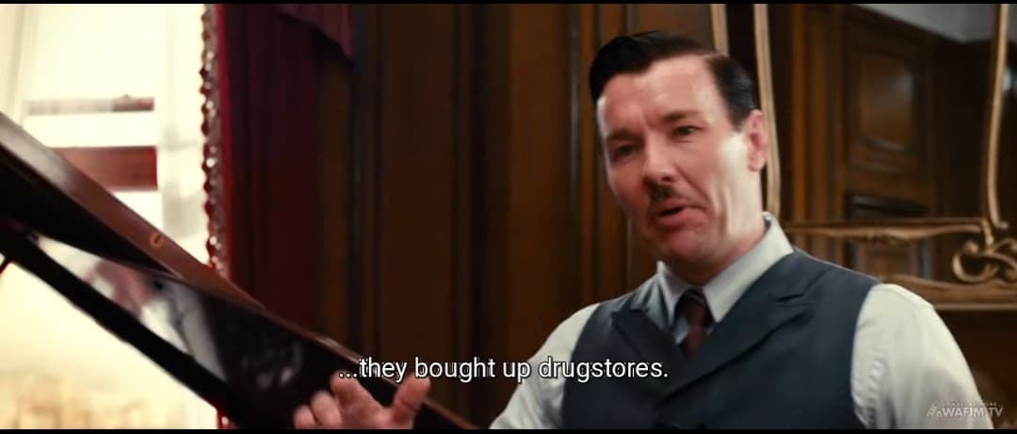
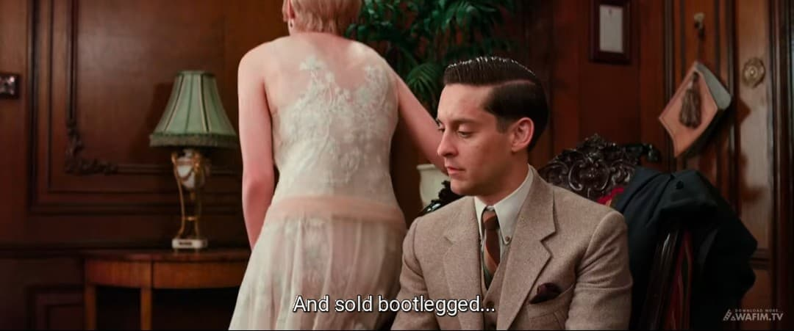
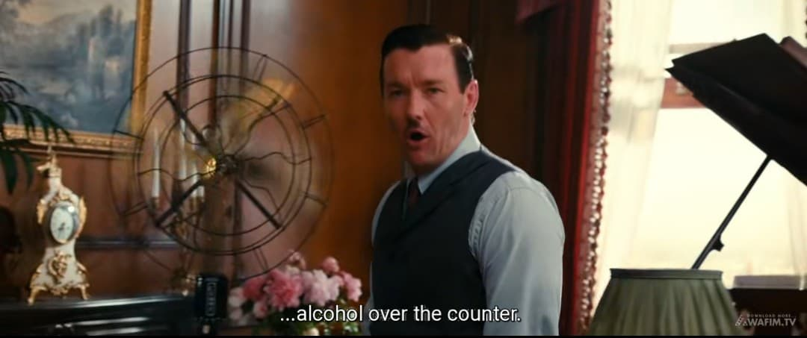
Another instance of Tom as an Opponent is when he subtly investigates Gatsby's past, revealing his illegal activities to Nick and others effectively undermining Gatsby's carefully constructed facade. Tom's investigative nature is revealed when he states: "You’re one of Meyer Wolfsheim’s bunch". A quote that exemplifies Tom's role as opponent is his cutting remark about Gatsby: "See, He and Wolfsheim bought up a lot of drug-stores here and sold bootlegged alcohol over the counter!.
2. Narrative Structure and Its Influence on Character Relationships
Greimas' canonical narrative schema outlines four stages of narrative action: Manipulation, Competence, Performance, and Sanction. This structural progression helps explain the development and transformation of relationships among the characters in The Great Gatsby.
A. Manipulation and Competence
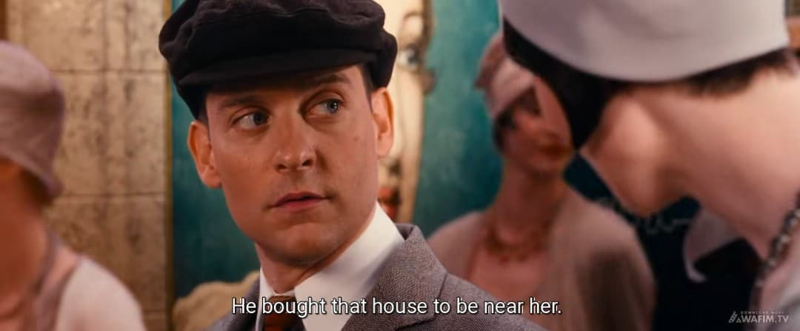
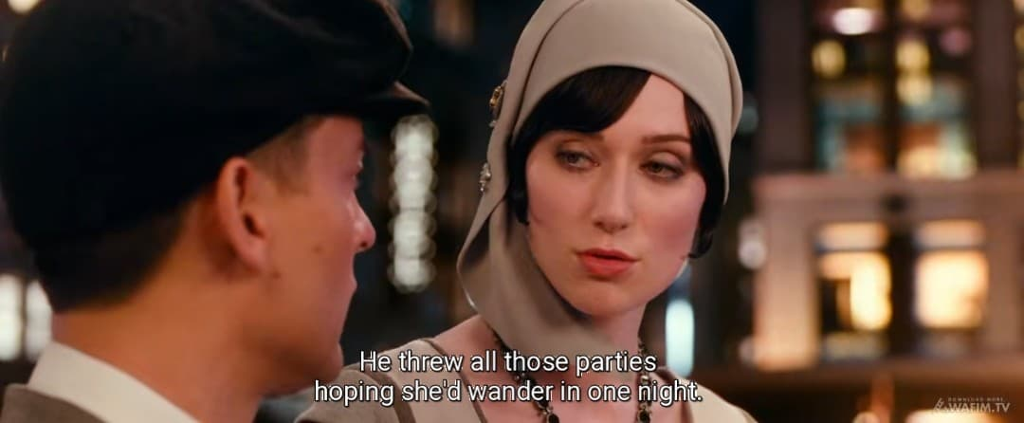
In the Manipulation phase, Gatsby is motivated by his idealized memory of Daisy. His decision to move to West Egg, throw extravagant parties, and reconnect with Daisy is rooted in this nostalgic desire. Nick and Jordan function as intermediaries, with Nick arranging the pivotal meeting between Gatsby and Daisy. Jordan's role as manipulator is confirmed when he reveals: "He bought that house to be near her, he threw all those parties hoping she’ wander in one night”.
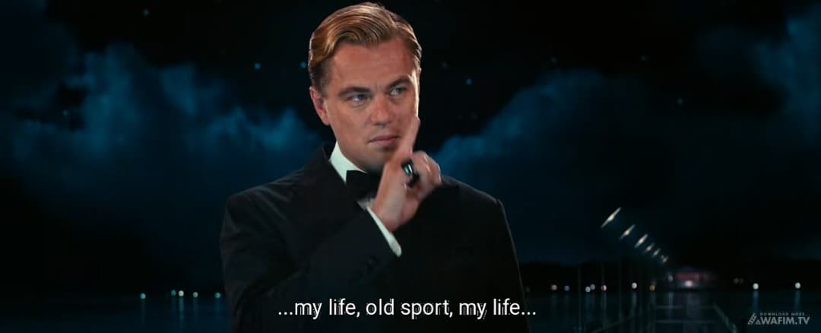
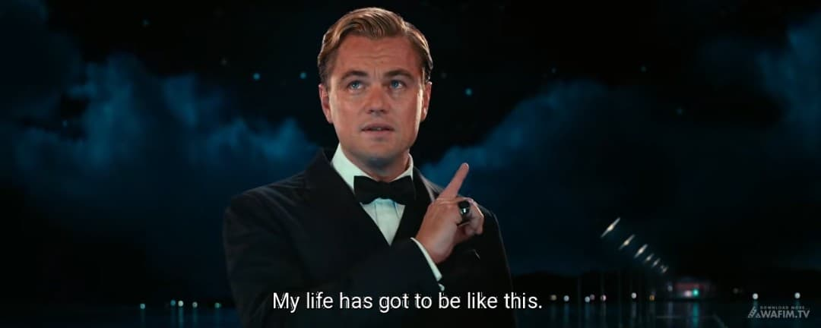
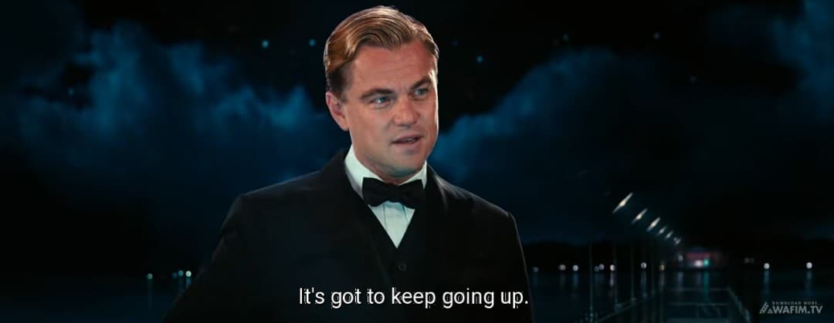
Another scene illustrating competence is Gatsby's meticulous planning and execution of his business dealings, which, though morally questionable, solidify his financial standing and make him a "legitimate figure" in Daisy's eyes. His transformation is captured in his own words: "My life, old sport, my life... my life has got to be like this. It's got to keep going up".
B. Performance
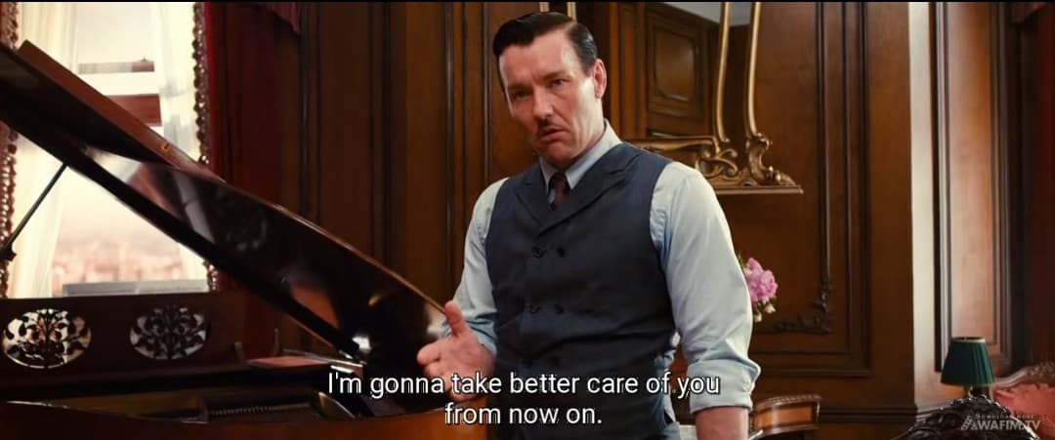
The Performance occurs when Gatsby and Daisy begin their affair. At this stage, Gatsby believes he is on the verge of achieving his dream. However, this relationship destabilizes the equilibrium of all surrounding characters. Tom becomes increasingly suspicious, Nick grows disillusioned, and Daisy becomes conflicted between love and societal obligation. Gatsby's confidence during this phase is evident: "I'm going to take better care of you from now on".
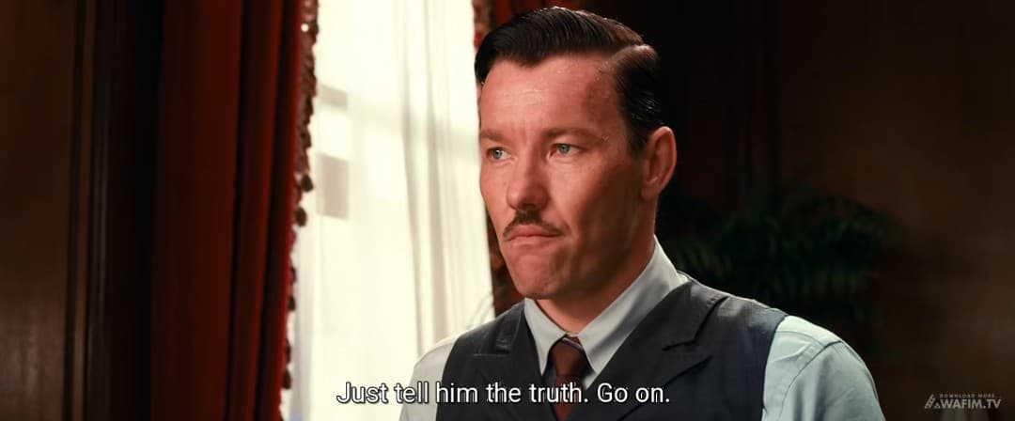
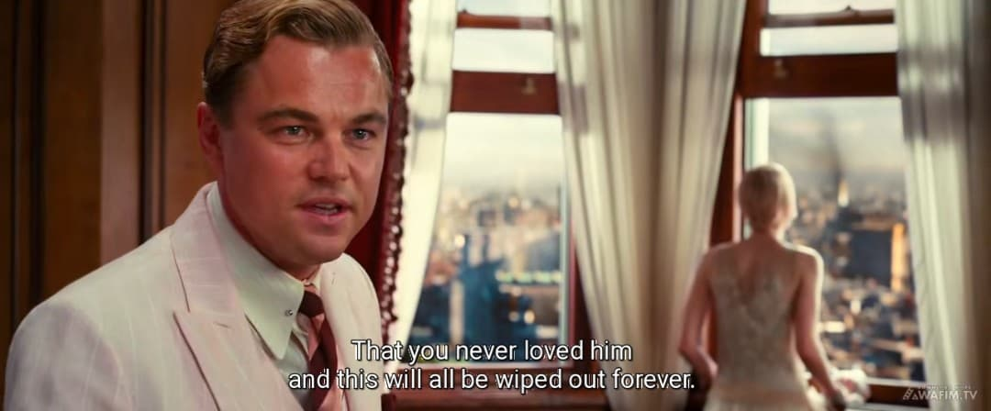
The confrontation scene at the Plaza Hotel serves as the turning point. Gatsby's demand that Daisy claim she never loved Tom illustrates his inability to separate his dream from reality. His demanding nature is shown when he insists: "Just tell him the truth. Go on. That you never loved him and this will all be wiped out forever". This moment shifts the dynamics of all relationships and marks the beginning of the narrative decline.
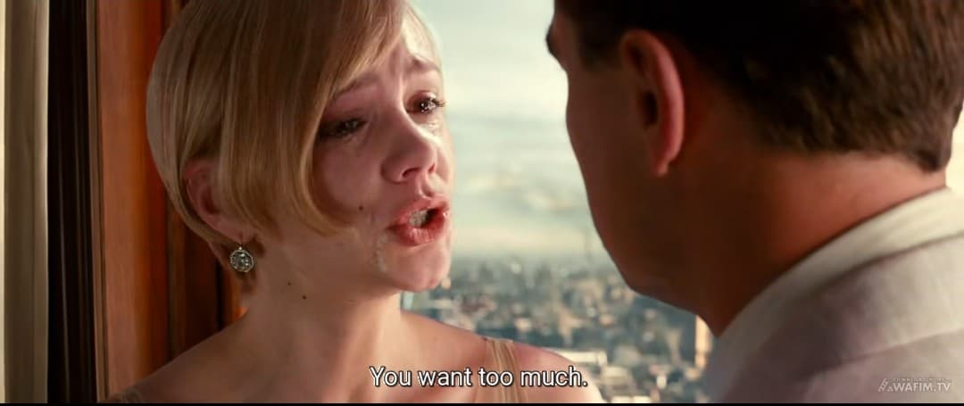
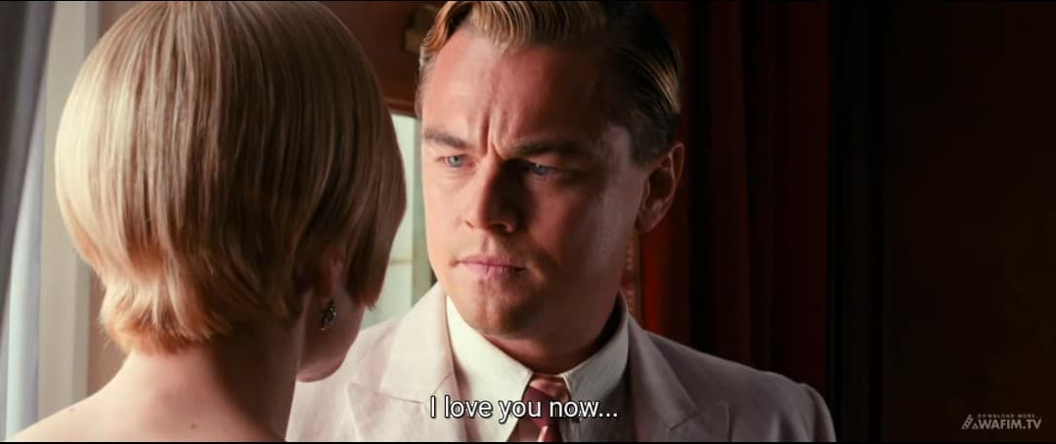
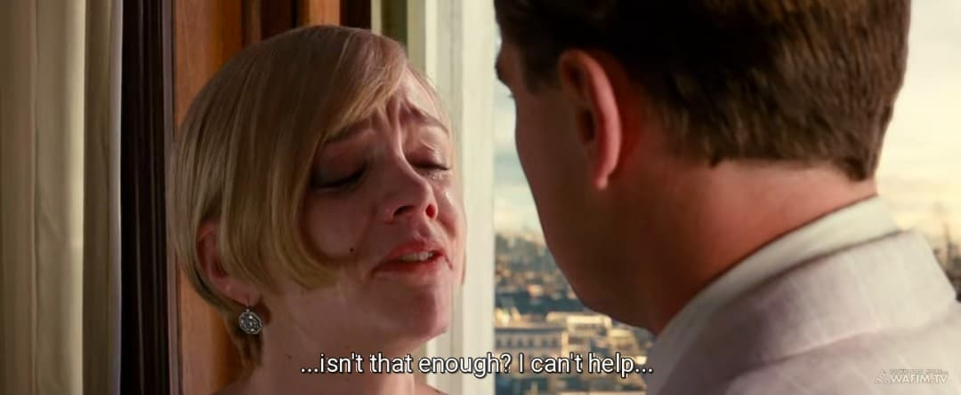
Another scene in the performance stage is when Gatsby and Daisy spend an afternoon together at his mansion, seemingly recapturing their past intimacy, which represents the peak of Gatsby's perceived success in his quest. Gatsby's unwavering insistence to Daisy, "You want too much!" he cried to Daisy. "I love you now isn't that enough? I can’t help" clearly demonstrates the performance of his demanding love.

C. Sanction
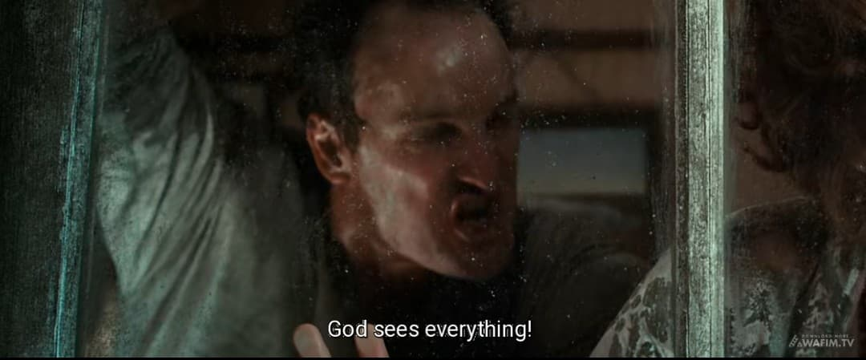
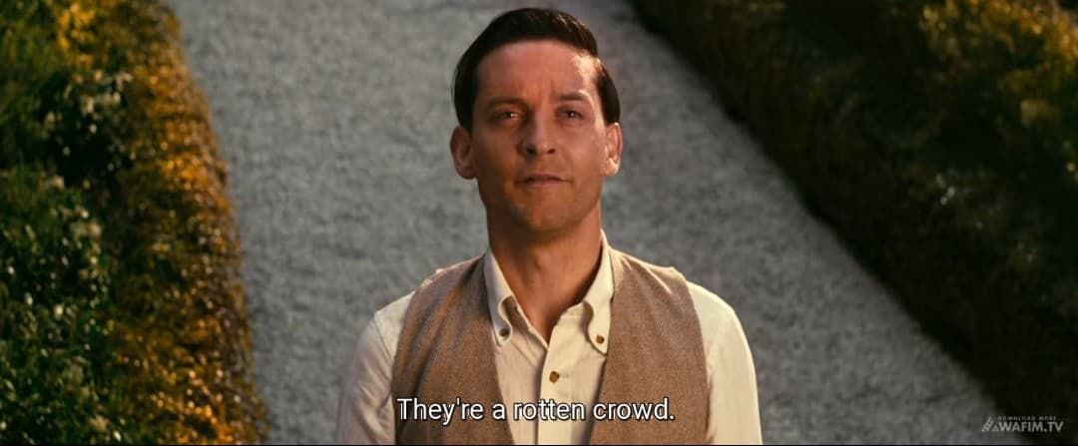
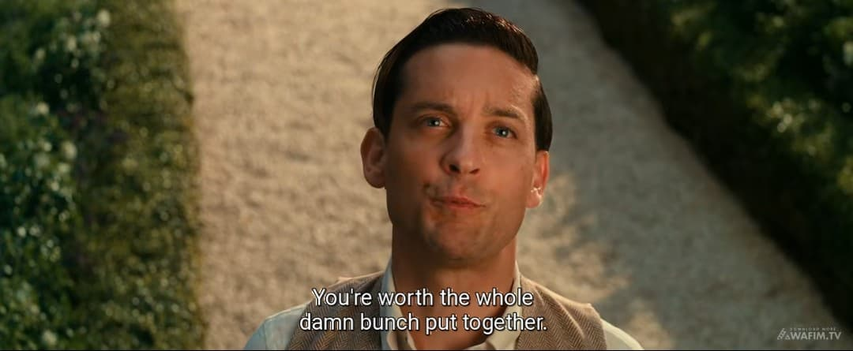
The Sanction stage results in Gatsby's tragic downfall. Misled by Tom, George Wilson kills Gatsby, believing he was Myrtle's lover and murderer Wilson's motivation is revealed through his desperate words: "God sees everything" before he commits the fatal act. Daisy retreats into her privileged life with Tom, abandoning Gatsby to his fate. Her abandonment is symbolized by her absence at his funeral and Nick's realization: "They’re a rotten crowd... You're worth the whole damn bunch put together".
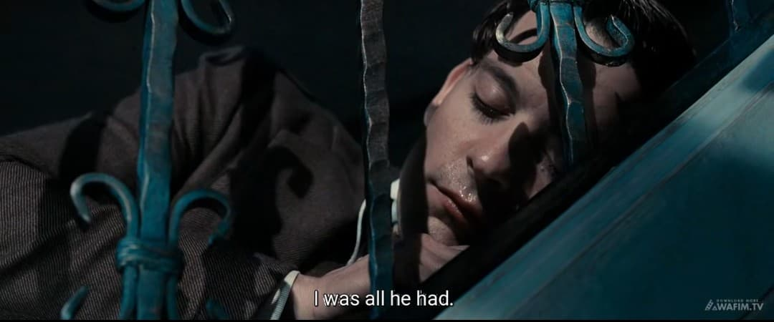
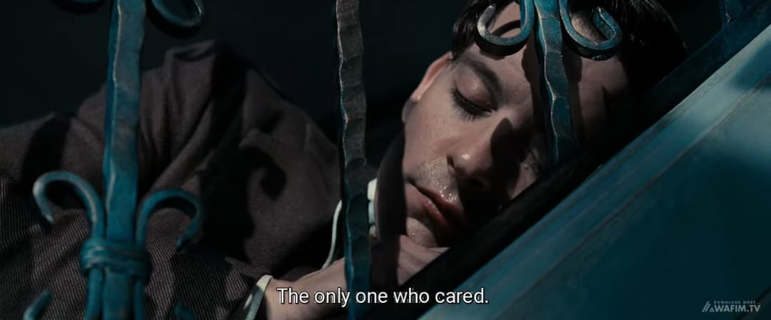
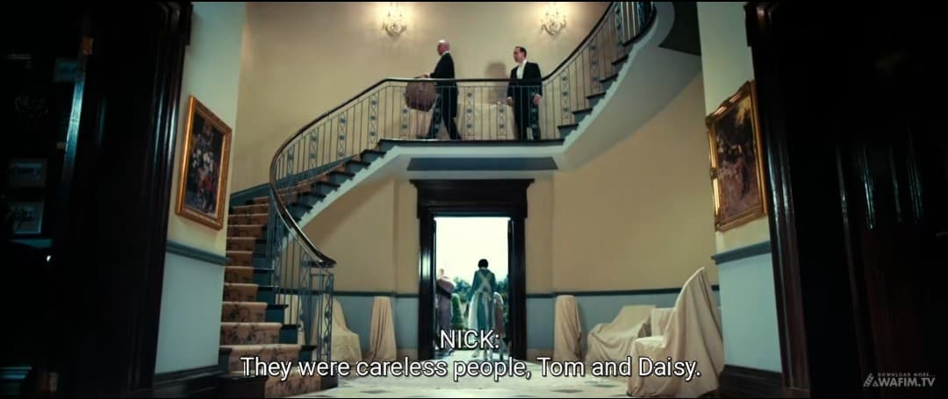
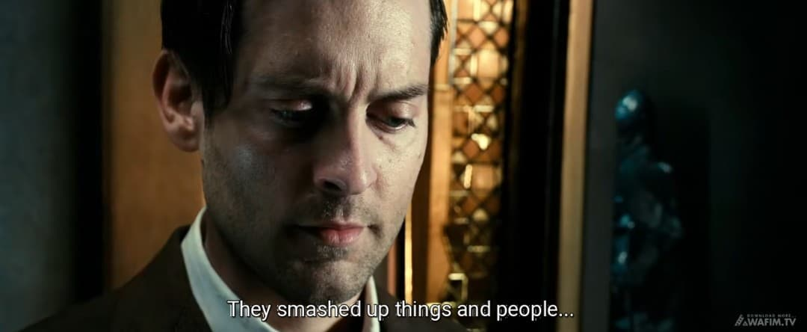
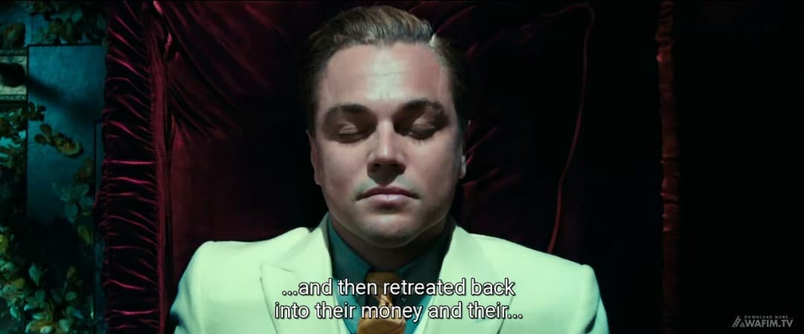
The funeral scene, where only Nick and Gatsby's father attend underscores the emptiness of Gatsby's relationships and the failure of his dream. The tragic isolation is emphasized by Nick's observation: "I was all he had. The only one who cared. Nick's final reflection "They were careless people, Tom and Daisy. They smashed up things and people and then retreated back into their money…" cements the theme of moral irresponsibility in the face of wealth and status.
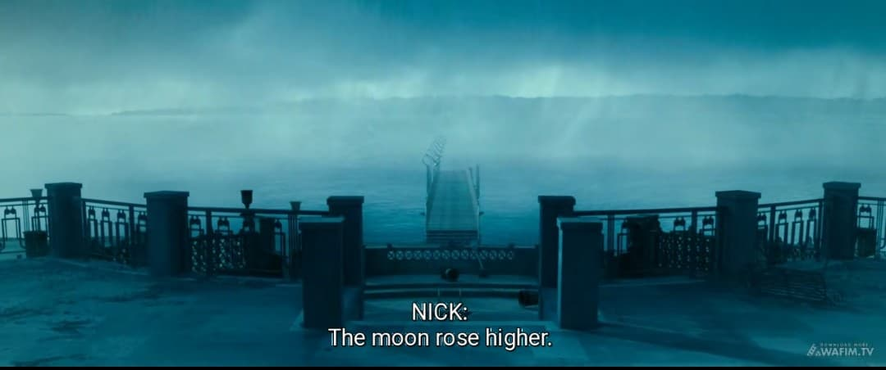
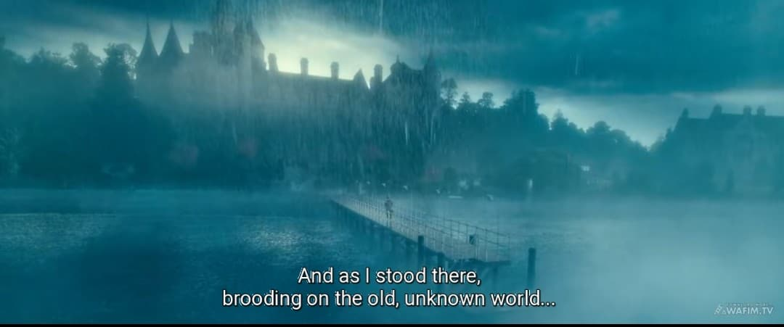
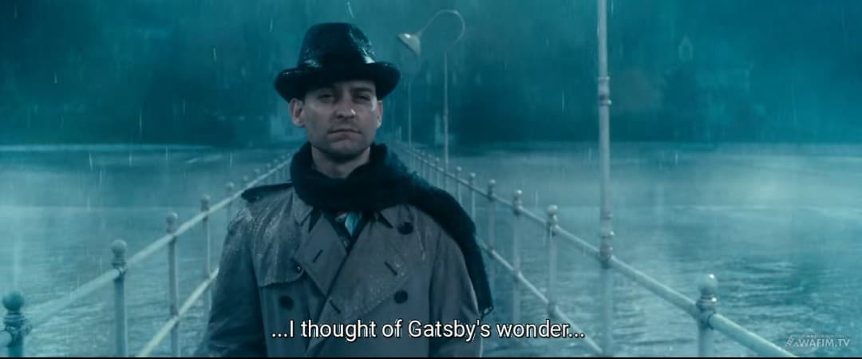
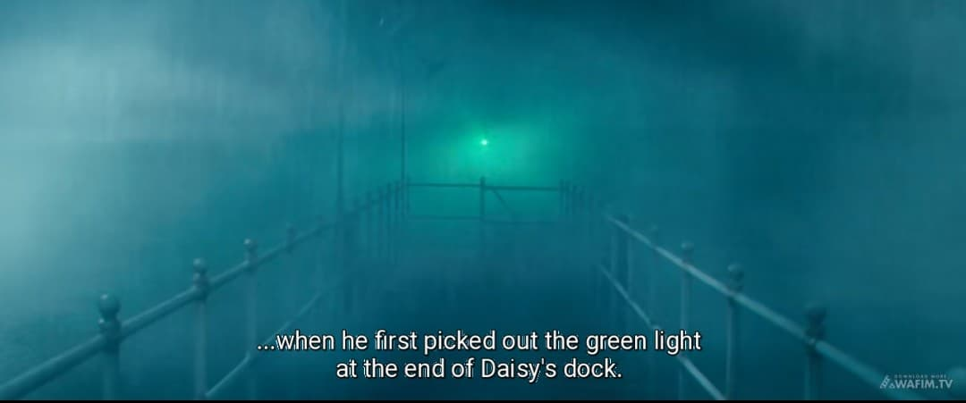
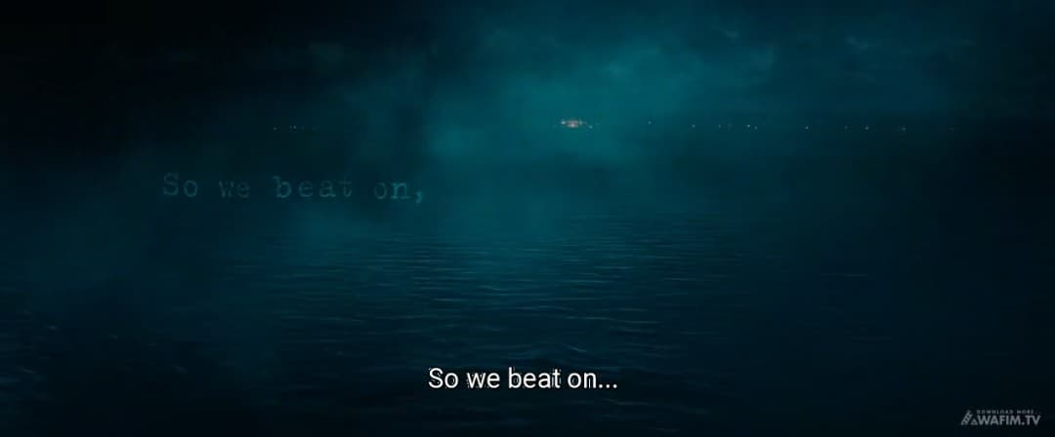
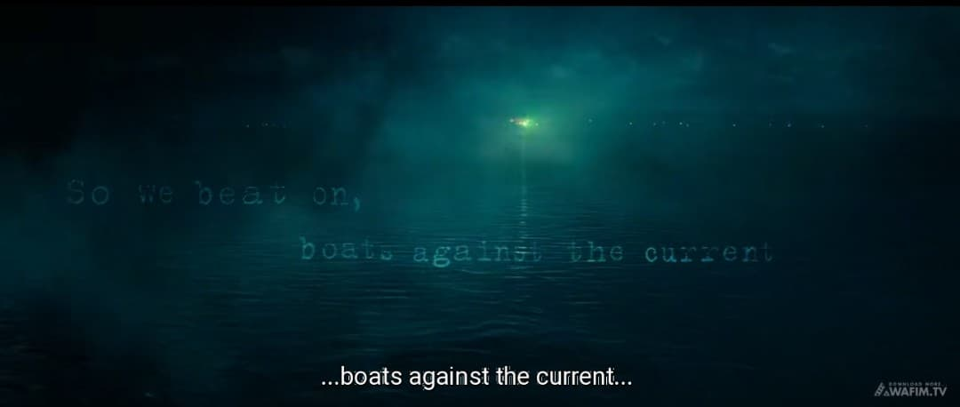
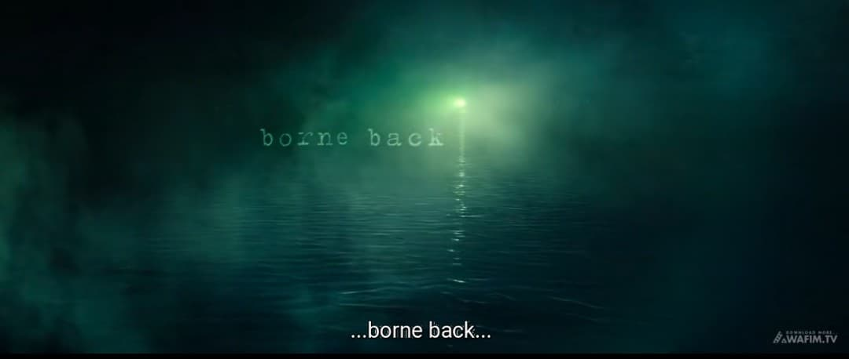
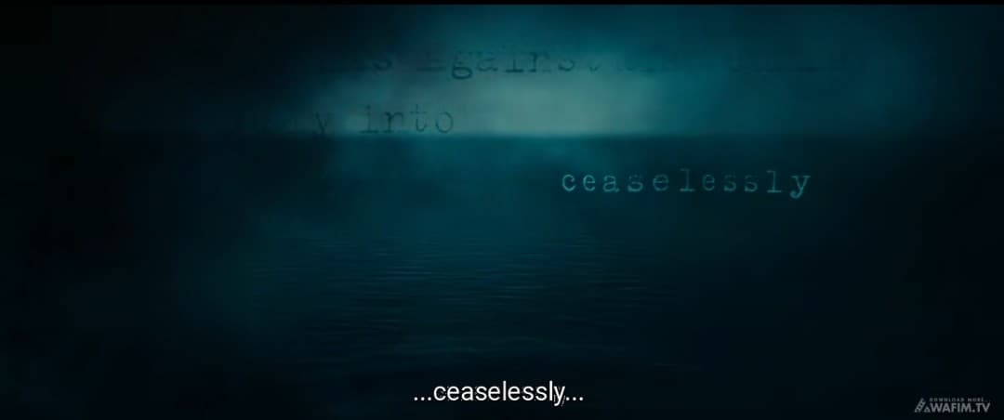
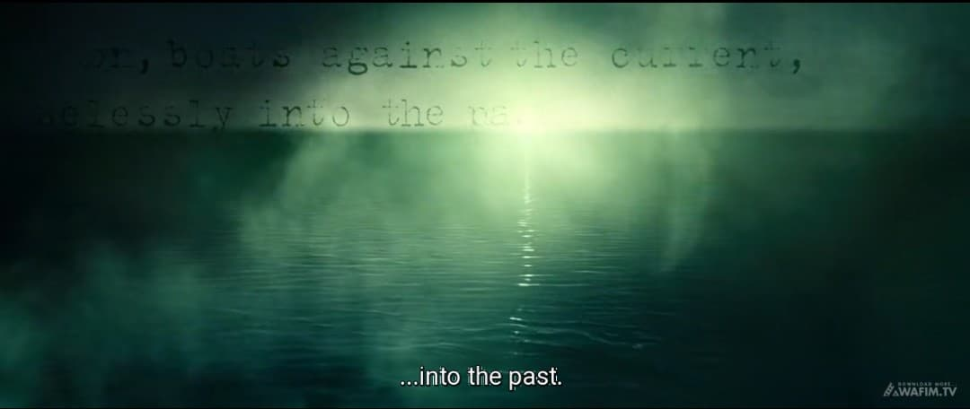
Another scene that signifies the sanction is when Nick returns to West Egg after Gatsby's death and finds the mansion desolate highlighting the rapid collapse of Gatsby's world and the superficiality of his connections. The desolation is captured in Nick's description: "The moon rose higher. And as I stood there, brooding on the old, unknown world, I thought of Gatsby’s wonder when he first picked out the green light at the end of Daisy’s dock" Nick's poignant conclusion, "So we beat on, boats against the current, borne back ceaselessly into the past", powerfully encapsulates the futility and tragic finality of Gatsby's quest.
Using A.J. Greimas’ actantial model and canonical narrative schema reveals the deeper narrative structure and thematic depth of The Great Gatsby. Jay Gatsby, as the Subject, is driven by his pursuit of Daisy Buchanan—the Object—who represents both a lost love and the idealized promise of the American Dream. His romanticized memories and longing for the past serve as the Sender, motivating his transformation into a wealthy, mysterious figure, while he himself acts as the Receiver, seeking emotional and personal fulfillment. Helpers like Nick Carraway and Meyer Wolfsheim assist Gatsby’s quest, though their involvement also highlights the moral ambiguity surrounding his rise. Opposing him is Tom Buchanan, who defends his social position by exposing Gatsby’s criminal past and unraveling his carefully crafted identity. The canonical phases of Manipulation, Competence, Performance, and Sanction trace Gatsby’s journey from hope to disillusionment, revealing how his dream collapses under the weight of reality. Ultimately, Gatsby’s tragic downfall reflects the illusion of the American Dream, the impossibility of recreating the past, and the emptiness that lies beneath wealth and privilege in a morally decaying society.

