LANGUAGE STYLE IN THE LYRICS OF THE PINK ALBUM SONGS

BY LUKAS GRAHAM

A THESIS

Submitted to the English Literature Study Program in Partial Fulfillment of the Requirements for the Degree of Literature

BY

RIFKY SULTAN NICO SEMBIRING
Registration Number: 216114015
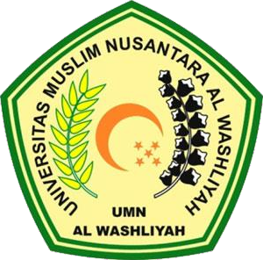

THE FACULTY OF LETTERS UNIVERSITAS MUSLIM NUSANTARA AL WASHLIYAH
MEDAN 2025

