ACKNOWLEDGEMENTS

بِسْمِ اِلل الرَّحْمَنِ الرَّحِيْمِ
’ٰيٓاَيُّهَا الَّذِيْنَ ’امَنُوْا هَلْ اَدُلُّكُمْ عَ ’لى تِجَارَة„ تُنْجِيْكُمْ مِِّنْ عَذَا „ب اَلِيْم(10) تُؤْمِنُوْنَ بِاٰللِّ وَرَسُوْلِ ,ه وَتُجَاهِدُوْنَ فِيْ سَبِيْلِ ٰاللِّ بِاَمْوَالِكُمْ وَاَنْفُسِكُ مْ ’ذلِكُمْ خَيْ ر لَّكُمْ اِنْ كُنْتُمْ تَعْلَمُوْنََۙ11) („
First and foremost, He writer is deeply grateful to Allah SWT for His blessings, mercy, and guidance, which have enabled me to complete this thesis entitled "Language Style in the Lyrics of the Pink Album Songs by Lukas Graham." He would like to take this opportunity to express his heartfelt gratitude to everyone who has supported me throughout the process of completing this research. His sincerest thanks and appreciation go to Dr. Azhary Tambusai, M.A., His thesis advisor, for his invaluable guidance, corrections, suggestions, and advice throughout the writing of this thesis. He is also truly grateful to the following individuals:
- Dr. H. Firmansyah, M.Si, as a Rector of University of Muslim Nusantara Al Washliyah
- Ayu Melati Ningsih, S.Pd., M.S. as a Dean of Faculty of Letter of University of Muslim Nusantara Al Washliyah.
- Diana Shopa, S.S.,M.Hum. as a Vice Dean of Faculty of Letter of University of Muslim Nusantara Al Washliyah.
- Vera Kristiana, S.Pd., M.Pd. as a Head of Faculty of Letter of University of Muslim Nusantara Al Washliyah.
- Mr. Harianto, S.S., M.S., Ph.D., and Mrs. Dr. Dewi Nurmala, S.S., M.Hum. Who served as my thesis examiners and provided crucial input to ensure this thesis adheres to academic standards.
- All lecturers of the English Literature Department, who have generously shared their knowledge and inspiring experiences.
- My beloved parents, whose love, prayers, and unwavering support have been one of my greatest sources of motivation in completing this thesis.
- My younger brother, Fatih Al-Ikhsan Sembiring, thank you for your encouragement, affection, and constant attention.

- My extended family grandmother, aunts, and uncles thank you for your support and motivation throughout my studies.
- My dear classmates Mas Andika Fahreza and Fadhillah Irawan, thank you for the laughter, support, and help you have given me during this journey.
- My old friend Dimas Prayoga and Surya Pangaribuan who are not related by blood but have supported me like relatives thank you.
He humbly acknowledges that this thesis is far from perfect. Therefore, He truly welcome any constructive feedback or suggestions for its improvement. In closing, He hopes this thesis proves to be useful not only for readers but also for himself and future researchers.

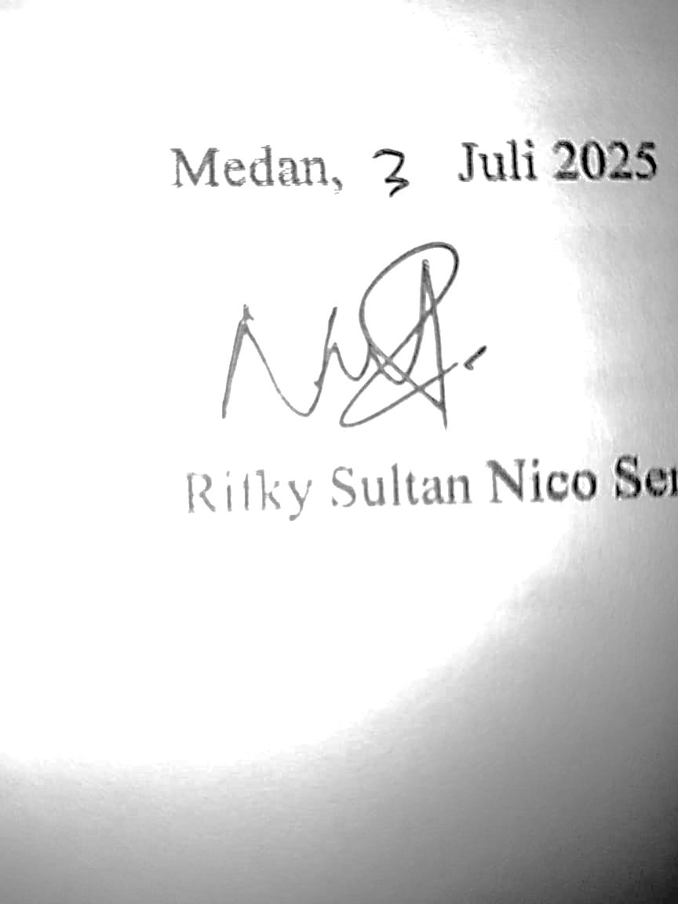
Medan, Juli 2025

Rifky Sultan Nico Sembiring

TABLE OF CONTENTS

TABLE OF CONTENTS

ACKNOWLEDGEMENTS i
ABSTRACT iii
ABSTRAK iv
CHAPTER I 1
INTRODUCTION 1
  - Background of Research 1
  - Identification of Problem 4
  - Limitation of Problem 4
  - Problems Statement 4
  - Objectives of Research 5
  - Significance of Research 5
CHAPTER II 6
REVIEW OF LITERATURE 6
  - Language Style 6
    - Language Style Based on Structure 7
    - Language Styles based on The Meanings 9
  - Semantics 20
  - Lukas Graham’s Song Lyric 21
  - Previous Researches 23
CHAPTER III 25
METHODOLOGY 25
  - Method of Research 25
  - Data and Source of Data 26
  - Technique of Collecting Data 27
  - Technique of Analyzing Data 27
CHAPTER IV 29
RESULTS AND DISCUSSIONS 29
  - RESULTS 29
  - DISCUSSIONS 30
    - Language Style based on Sentence Structure 30
    - Language Style based on the Meaning. 45
CHAPTER V 76
CONCLUSIONS AND SUGGESTIONS 76
  - Conclusions 76
REFERENCES 79
APPENDIECES 82

