AN ANALYSIS OF FEMINISM IN THE NOVEL THE GIRL WITH THE LOUDING VOICE BY ABI DARE

A THASIS

BY

GITA SAPUTRI
Registration Number: 186114001



FACULTY OF LETTERS
UNIVERSITAS MUSLIM NUSANTARA ALWASHLIYAH
MEDAN
2022
AN ANALYSIS OF FEMINISM IN THE NOVEL THE GIRL WITH THE LOUDING VOICE BY ABI DARE

A THASIS

Submitted to the English Literature Study Program In Partial Fulfilment Of The Requirements For The Degree of Literature

BY

GITA SAPUTRI
Registration Number: 186114001

FACULTY OF LETTERS
UNIVERSITAS MUSLIM NUSANTARA ALWASHLIYAH
MEDAN
2022

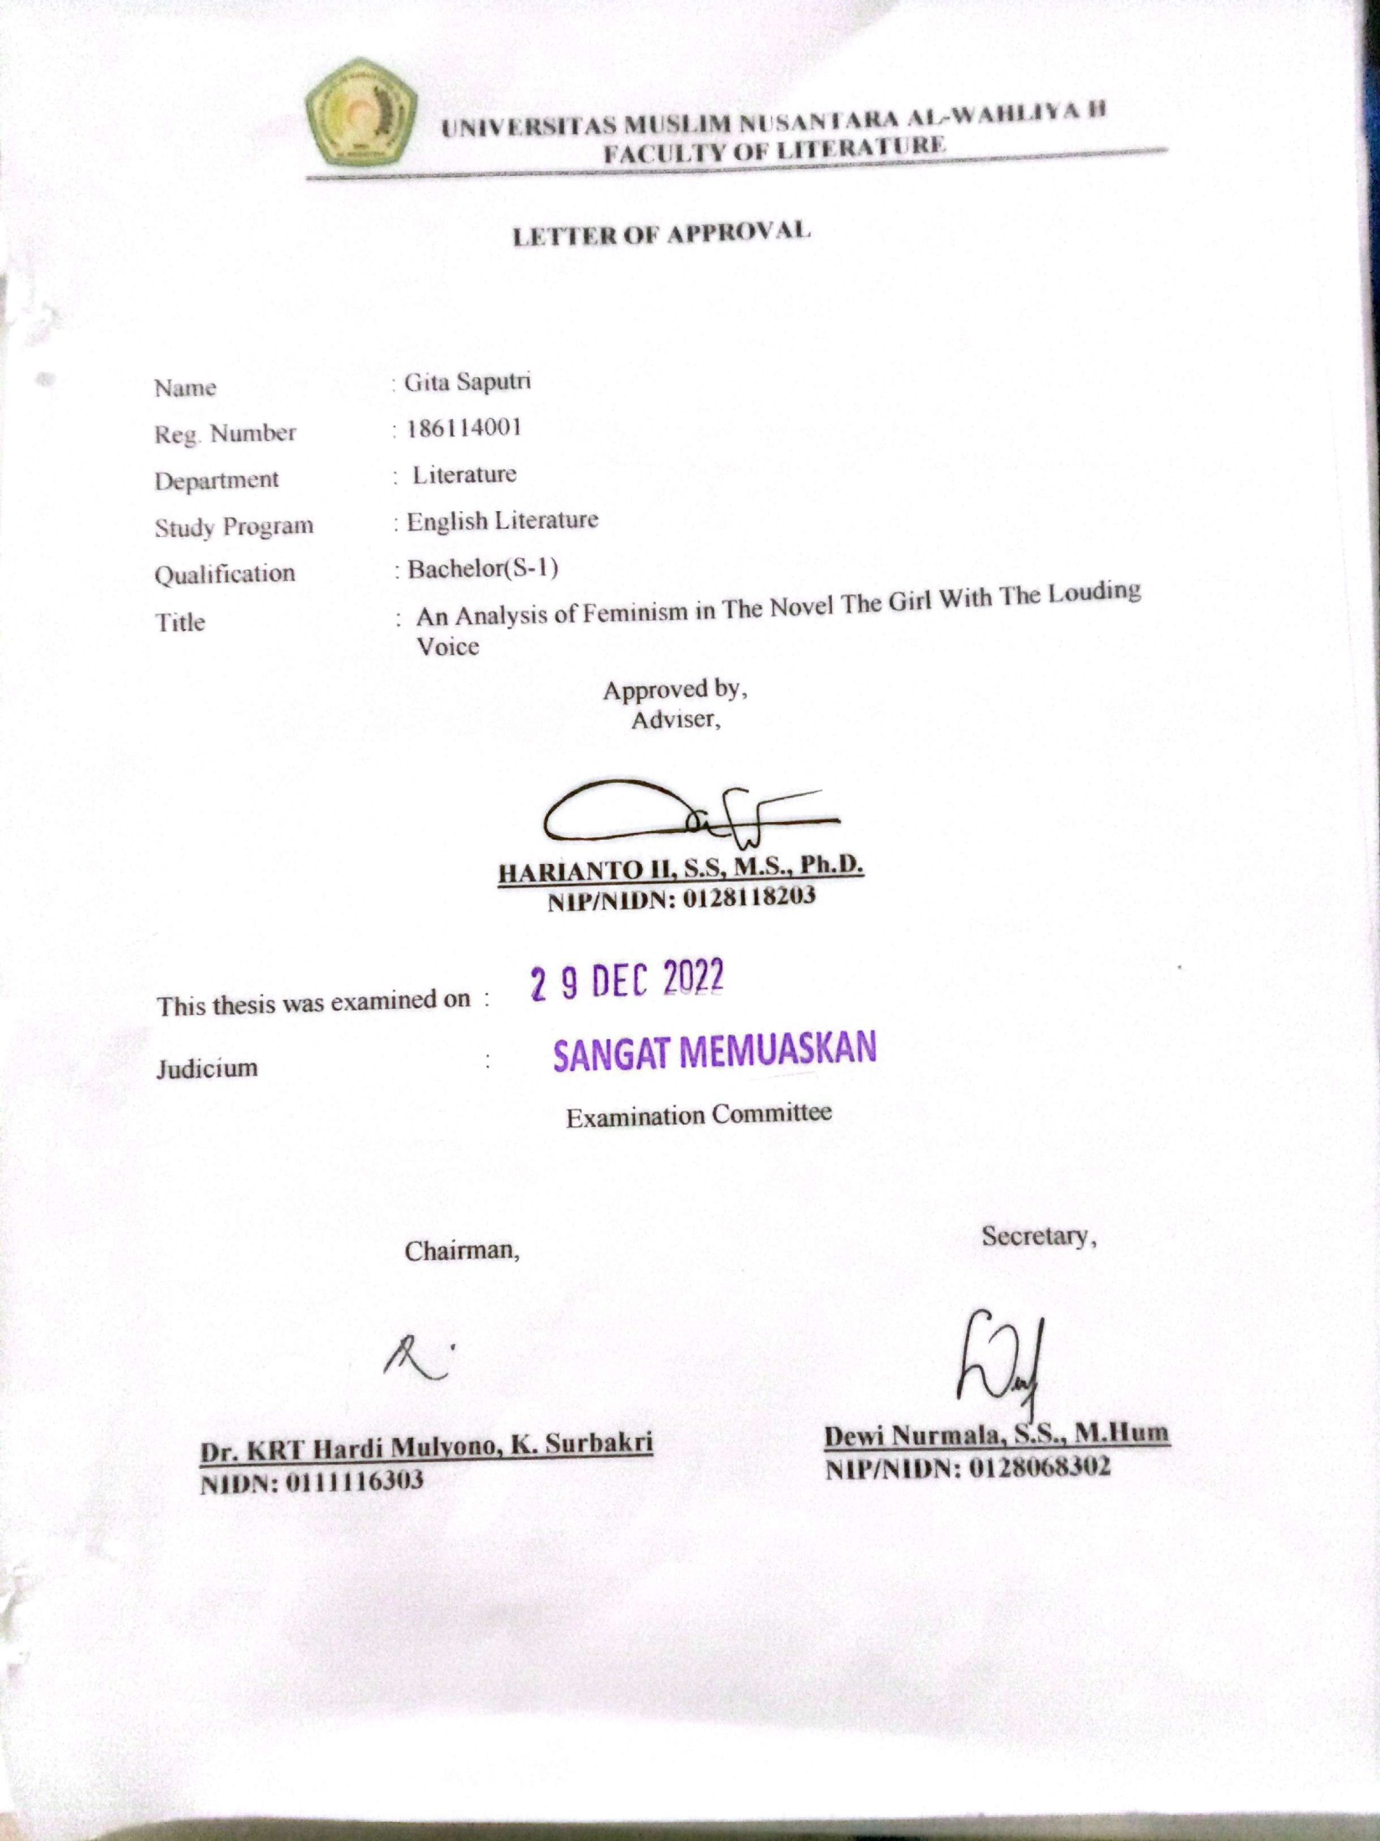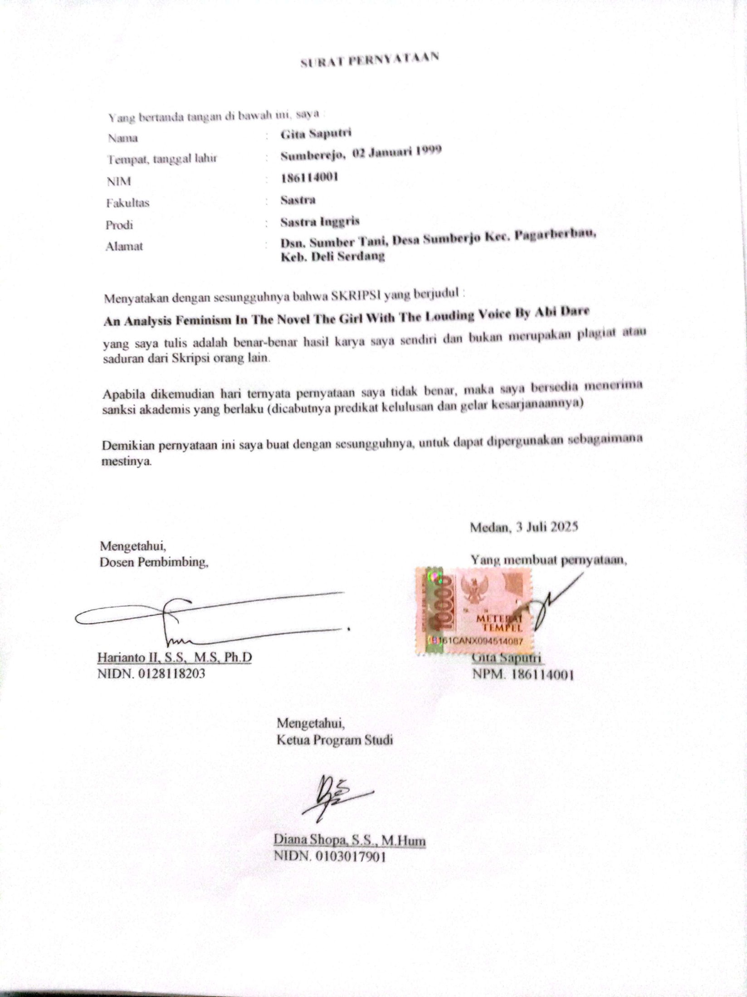
ACKNOWLEDMENT
First of all, the writer would like to say alhamdulillahirobbilalamin and thank giving for the grance given by Allah SWT. The Lord of all creatures until this thesis can be completed. Then sholawat along with greetings to the great prophet Muhammad SAW as a role model for Muslims, hopefully we will get this intercession latter as the last day. In completing this thesis, the writer always gets support and motivation from many people. The writer would like to thanks them for the contributions they have made, they are :
- Dr. KRT. HardiMulyono K. Surbakti, the rector of Universitas Muslim Nusantara Al- Washliyah.
- DewiNurmala, S.S., MHum., the dean of Faculty of Letters.
- Harianto, S.S., M.S., Ph.D., the deputy dean of Faculty of Letters and also as the thesis advisor.
- AyuMelatiNingsih, S.Pd., M.S., the head of English literature Study Program.
- RezkyKhoirinaTarihoran, S.S., M.A., the lecture of English Literature who has helped to provide solution to every obstacle that existed in the completion of this thesis.
- All lecturers of the Faculty of Letters Uiversotas Muslim Nusantara Al- Washliya
- The most Important appreciation to my parents asspecialy for my mother and my younger siblings who always give full support for the completion of this thesis.
- And the last but not least, to all my friends who are both struggling to complete the thesis and give support to each other.
This thesis may be far from perfect, so this thesis requires critiaism and suggestion so that it can be improved and become batter in the future. And lastly, the writer hope that this thesis can make a positive and educational contribution to all its readers.
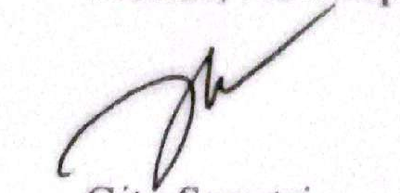
Medan, ……September 2022

Gita Saputri

ABSTRACT

AN ANALYSIS OF FEMINIST IN THE NOVEL THE GIRL WITH THE LOUDING VOICE BY ABI DARE

GITA SAPUTRI
106114001

The study analyses the forms of feminism by Abi Dare. The Girl with the Louding Voice tells about the experience of girl who is tough, strong and brave. She experienced exploitation, oppression and slavery in a patriarchal society and was able to resist them. This research shows the forms of feminism movement by women. The purpose of this study is first, to find out the types of feminism contained in the novel. Second, to find out the resistance shown in the novel. This study uses a structuralism approach by Ferdinand de Saussure. The method used is a qualitative descriptive method to analyse the data source is taken from the story quote in the novel The Girl with the Louding Voice by Abi Dare. The findings in this study are first, the types of feminism that occur in The Girl With The Louding Voice novel are liberal feminism, Marxist feminism, socialist feminism and existential feminism. Second, the resistance shown the novel The Girl With TheLouding Voice is closed resistance and open resistance

Key Word : Feminism, Resistance, Structuralism

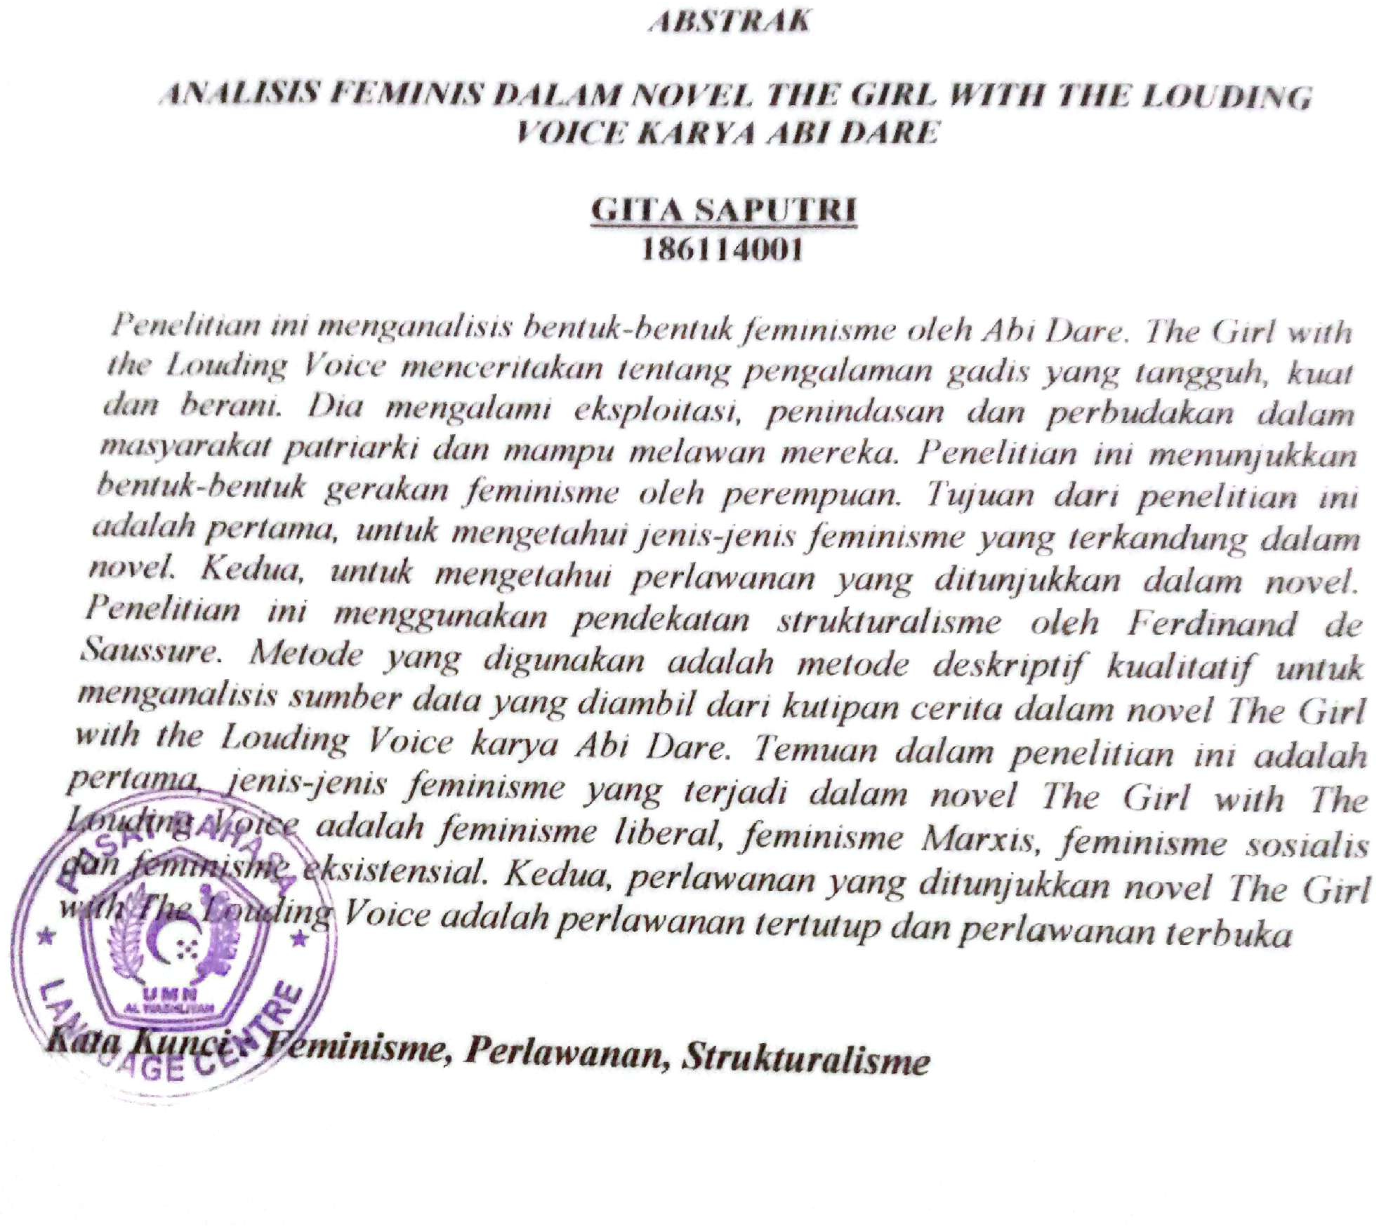

TABLES OF CONTENTS
ACKNOWLEDGMENT i
ABSTRACT iii
TABLES OF CONTENTES iv
CHAPTER I : INTRDUCTION 1
  - Background of Research 1
  - Identification of the Problem 4
  - Limitation of Problem 4
  - Problem of the Research 5
  - Objectives of the Research 5
  - Significance of the Research 5
CHAPTER II : REVIEW OF LITERATURE 6
2.1. Novel 6
2.2. Feminism 8
2.3. Resistance 10
2.4. Structuralism 16
2.5. Summary of the Novel 17
2.6. Review of Related Research 20
CHAPTER III : METHODOLODY 23
3.1. Method of Research 23
3.2. Data and Source of Data 24
3.3. Technique of Collecting Data 24
3.4. Technique of Analysing Data 24
CHAPTER IV : FINDINGS AND DISCUSSIONS 26
4.1. Findings 26
4.2. Discussions 26
CHAPTER V : CONCLUSION AND SUGESTIONS 38
5.1. Conclusions 38
5.2. Suggestion 38
REFERENCES 40

CHAPTER I
INTRODUCTION

  - Background of Research
Literary work is mind of someone who is imaginative and creative. Literary works are usually based on experience or imagination of the whiter. According to Eagleton (2008) literature is defined not explain to whether it is fictional or imaginative, but because it use language in peculiar way. So literary works are different from other works is the use of language with imaginative and artistic value which is its trademark.
Literary work is be composed of many form is like poem, novel, drama, song etc. in this study the writer will examine one of the literary works, namely the novel is a fictitious prose story with a certain length which describe the characters, movements and scenes of life that are imaginative. Novel as a literary work that has intrinsic. The intrinsic element that build the literary work itself. It is this element that causes the literary work to be factually present when reading literary works ( Nurgiantoro2013). In this study the writer will examine one of the literary works, namely the novel.
Novel a form of literary work tells about humans and the complexity of their lives. The novel contains conflict. The conflict in the novel reflects the inner reality public. These conflict are interrelated to form a plot (Dian Khristiyanti,2017). According to teeuw in (Ira Rahayu ,2014) Novel is a prose genre that featuring story elements that most complete, has extensive media, it is also a novel that presents the broadest social problems. In general, a novel tells a
story about the characters and their behaviour in daily life. Kosasih in (FhetiWulanLubis 2020) states that the novel is an imaginative works that tells the whole side of the problem of life a person or several characters. Stories in novels begins with the emergence of a problem that experienced by the character to the stage of completion. So that it can be interpreted that the novel is a literary work in the form of prose that tells a problem in the life of a person or several characters, both based on reality or only the imagination of the author of the novel. The novel has a complex story theme, many characters, a longer storyline and various background and storytelling. Novel quality always presents entertainment and values of life through a series of events that make up the storyline in the novel.
The Girl with the Louding Voice is a novel in a country that adheres to a patriarchal system, a novel that tells about the life of the girl who fight for her right in a patriarchal society until she is able to fight forwomen’s rights in obtaining their rights such as voting rights, education, employment and so on .
According to Hollows (in Lit Kurnia 2013) feminism is considered a form of movement that aims to intervene and change the unequal power between men and women. Than support by Lit Kurnia( 2013) Feminism is an awareness of gender exploitation that afflicts women both in the family and in society. From this statement, feminism is a movement that fight for women equality in the political, economic, education, and public spaces but it is not the movement that spread of hatred to the men. The Purpose of the general election is to increase the dignity and equalize the position of women with men. There are 8 types of feminism. That are Liberal feminism, Radical feminism, Marxist feminism, Socialist feminism, Anarchist feminism, Existentialist feminism, Post- Modern feminism, Ecofeminism. In this novel, there are some signs of racism that can be seen in several of page, the feminism form was found in the page where adunniwords speak up “a day will come when my voice will sound so loud all over Nigeria and the world of it, when I will be able to make a way for other girl to have their own louding voice, because I know that when I finish my education, I will to help them to go to school.” If the grouped by type, it is classified as liberal feminism.
Then after feminism treatment, there are also signs of resistance from the characters who receive racist treatment. Suriadi( inkomorina and Utami, 2017 ) resistance is action taken by weak communities who are in the lower structure against the strong parties who are in the super structure or ruler. The relationship between a weak part and a party the real strong is in a relationship unbalanced power, then the weak side tries to balance their relationship through resistance so as not to be oppressed. Than Scott (in komarina and Utami, 2017) there are 2 part of the resistance, namely: open resistance and close resistance. One of resistance was found in this novel when adunni said “How a girl like me born children? Why will I fill up the world with sad children that are not having a chance to go to school? Why make a world to be one big, sad, silent place because all the children are not having a voice? “. This resistance is a word of resistance which is classified in closed resistance, because it is carried out in an indirect way.

There are many type of theories that are used as tools for approaches in finding ideas contained in a literary work. According to Bressler (2011) literary theory gives a selection of methodologies that permit reader to interpret a text from unique and frequently conflicting point of view. One of the approaches to literary theory is structuralism. Structuralism of literary works as a residing organism like it or not, one must first apprehend the structure of the story as a literary reality (FadlilMulawwarManshur, 2019). So that we are able to understand the whole storyline and fact in the novel.
Statement from Richard Taylor (1986) a novel is normally a prose work of quite some length and complexity which attempts to reflect and express something of the equality value of human experience or conduct than it is combined with the states of Goldamn (1980) is universal factor all human mind, sensitivity or attitudes, and capable of update human as the of history. Then the author will conduct a study entitled “ An Analysis of feminism in the Novel of the Girls with the louding voice” by using structuralism approach to reveal the feminism and resistance meanings contained in the novel thought resulting signs and classify based the types.
1.2 Identification of Problem
The research was discuss the analysis of feminism in theNovelThe Girl with the Louding Voice. The analysis that has carried out in thisresearch are the acts of feminism that occur in the novel and explain the resistance of the main character.
1.3. Limitation Of Problem
The objects analysed in the research are the aspects of feminism and resistance in the novel by abi dare. Entitled the girl with the louding voice.
1.4 Problem of Research
Some of the problem formulations to be analysed are as follows:
- What types of feminism found in the novel?
- What kind of resistance is shown in the novel?
1.5 Objectives of the Research
Objectives of this research are:
- To find out types of feminism in the novel
- To find out the resistance is shown in the novel
1.6. Significances of the Research
In this study, there are several benefits that we can look, namely:
- Academic Significance
This research can be a teaching material or media for student and for readers who read the research to understand about the type of feminism and forms of resistance.
- Practical Significance
This research can be the results of this study can be used as a reference to improve student’s knowledge in understanding about the types of feminism and resistance. For teachers, the study can help teachers to easily present material about feminism and another research. This research can provide additional information and references for other research who to carry out further research in related fields.

CHAPTER II
REVIEW OF LITERATURE
  - NOVEL
Novel is a form of literary work in the form of prose and review daily life. The novel has become a popular and entertain for readers. The reason that novel has be able to the most popular form of literature is that a novel carries a massage and moral value and education and this literary form in the most widely printed and the most widely spread, because of the power of the community that is wide in the society.
Novel based on Teeuw (1967) is one of the kind of prose basically a form of long story then according to Kenney (1966) that novels are a long narrative fiction and is an imitation of the real situation this explanation reinforced by Kosasih (2012) novel is an imaginative work that tells the whole side of the problems of the life of a person or several characters. From some of the definitions above, it can be concluded that novel is a type of work prose literature that has a rich story complex and is a form of a long story, involving many characters with each character and problematic and is a series of events related to human life. The level of depth and breadth of the story is what makes the novel different from the short story and romance.
Nurgiantoro (2000) explains that novel are divided into two, namely popular novels and serious novels. The popular novels are more entertaining, commercial, easy to enjoy. While serious novels known as literary novels require seriousness when read it in order to understand the whole story in the novel.
Somad (2010) explain that are two elements in the novel, namely extrinsic elements and intrinsic elements. Extrinsic element include the background of the making, biographies of the author and other things that complete a story building. Extrinsic elements will help the accuracy of the content of a literary work. The intrinsic elements of the novel include the theme, plot, setting, characterizations, author’s point of view, massage and styles of language. The explanation of the novel is as follows:
- Theme
Theme is the basic idea that becomes the core or main idea that put forward by the poet
- Plot
Plot is a series of events that make up the storyline
- Background ( setting )
Setting is a picture of time, place and atmosphere.
- Characterizations
Characterization are part of the intrinsic that include the characters in the story and their characters.
- Author’s point of view
Point of view is the way the author positions himself in the story
- Mandate
The mandate is the massage conveyed by the author in this literary work.
- Language Style
The use of language in literary works serves to create a tone and atmosphere.
Novel are generally divided two types, namely fiction and nonfiction. Then novel genre by type such us romance, fantasy, science fiction(Sci-Fi), horror, mystery, thriller, comedy, inspirational, history, psychology, saga or family, adventure. In this study, the researcher is conducted in a film entitled The Girl With TheLouding Voice, which was written by Abi Dare. This novel is a fiction genre based on real life stories by combining inspirational element in it.
  - Structuralism
Structuralism focuses on literature as a system of signs in which meaning is constructed within a context. Word inscribed with meaning may be compared to other words and structures to determine their meaning.
Structural approach is an intrinsic approach, which is talk about the work on the elements that build from within. This approach examines literary works into works that are autonomous and independent of social, history, the author’s biography, and everything that is outside the literary work (Santoto.1993) in line with santoto’s opinion the structural approach ia an intrinsic approach, with is to reveal the work to the elements that build literary work from within ( Suwarno,2012) it can be concluded that structuralism is an intrinsic approach, namely to analyse the building elements contained in the novel.
The structural approach tries to describe the relationship and function of each element of a literary work as a structural unit that together forms an overall meaning. (Teeuw,1983). Literary structuralism is an approach which emphasizes the intrinsic element that build the work. Therefore, with the absence of analysis through structural, intrinsic meaning in a literary work cannot be explored in depth. in addition, structural analysis has a purpose is to understand carefully, present, properly disassemble, and as accurately as possible through structural analysis in the form of a content with result good meaning on a works (Teeuw,1984) .
As for the explanation of the elements the intrinsics of the novel are as follows:
- Theme
Theme is the basic idea that become the core or main idea put forward by the post
- Plot
Plot is a series of events that form the storyline
- Background (Setting )
Background is a picture of time, place and atmosphere
- Characterizations
Characterization is part of the elements intrinsic which include the characters in the story and characters
- The author’s point of view
Point of view is the author’s way position himself in the story
- Mandate
Mandate is a massage that conveyed by the author in the work his literature
- Language Style
Use of language in literary works serves to create a tone and atmosphere. Structural has three properties, namely total, transformation an and self-regulation. Total means the structure is formed as whole with a series of element that still have rules and the arrangement of the series makes a single unit that becomes a concept perfect. Furthermore, the intended transformation that there is a change that occurs in a structural element that will change make a difference between other elements. Self-regulation what is meant is that the structure is formed by the intrinsic rules of relationships between structures that can self-regulate if one element is missing.
Piaget in (Sangidu,2004) as for the analysis steps structure is as follows:
- Can identify the intrinsic element by constructing a complete and clear literary work, can distinguish between themes and figure
- Can examine an element that has been identified so that it can describe the differences in theme, plot, characterization, and setting in a work literature
- Can connect each element so as to get cohesion the total meaning of a literary work.
  - Feminism
Feminism was born 20th century, were pioneered by Virginia Woolf in by her book a Room of One’s Own (1929). Etymologically derived from the word feminist are famous for the women’s movement , s mean that women who aim fight for the right of women equality in the vote , political, culture, education, economic , a private room and public spaces but it is not the ideology that spread of hatred to the man. Ratna (2005) state that feminism is the concept generalization of women. A critical of social theory which have the purpose is to obtain women right. In line with Ratna’s Opinion feminism is kind of critical social theory which included in social context, political, economic, and history that is facing by injustice people.
Feminism is not only a movement that fight women in the vote, political, education, culture or public spaces but also it is fight for objectifications, family, love, exploitation, sexuality. Feminism want to make the same equality between men and women. Davies (1996) feminism is women’s assertion of their equality with men and their demand for access to roles and positions in public life that have historically been considered the domain of men. Lit Kurnia.A. TotokPriadi, AgusWartiningsih(2013) Feminism is an awareness of gender injustice that befalls women, both in the family and in society.
Women become object of beauty dominated by patriarchs who try to keep them at the home taking care of the household, cooking, giving birth to offspring without having the right to education, politic, culture, and act. For this reason, the feminist movement emerged to support equal right for women against men.
According to Handayani and Novianto (2004) men more competent , good orientation, strong, competitive, confidence and active than women, in line with Montag (1953) in almost every society there believe that the men are superior and women are inferior, women also think that their right, because it believe as what really happen, which this view cannot be supposed as a person that position of women is under the men.
The purpose of feminism theory is also to understand women’s injustice in term of race, gender, sexual, class, and how change it because women are weaker than men biologically, different physically and this theory want to change stereotype patriarch society against women who sad women weak characters, be able only work a little men, and unable to work hard like men.
AccordingRosenstand (2006) the principle of equality does not imply that everyone should be treated as equals unless special circumstance apply. Acoording to Marriam in (Webster, 2017) feminism is theory about gender equality in the flied of politicall. Social and economic. In line with Rosenstand (2006) support this theory if women should have equal opportunities and the women should not be discriminated against based on their gender, and between men and women should get equal right. In feminism movement There are 8 types of feminism.
- Liberal Feminism
Liberal feminist are based on the declaration of independence that men and women are created equal ( Suprio,1986) this is in line with Tog(2004) Liberal feminism developed from 18th century. The feminist movement in that country had the basic assumption that there is no difference between and women. Women have the same right in getting an education. The liberal feminist movement in the century in the 19th century, there were many efforts to fight for women to get the same civil and economic right as men. In the twentieth century liberal feminism was engaged in the formation of women’s organisation to oppose sexual discrimination, in the political, social, economic and personal field. That cause of Female oppression is known as lack of opportunity and education for women either individually or groups, few jobs, no ownership right object, or marriage laws that are detrimental to men for that the purpose of liberal feminism toward women’s individual right.
- Radical Feminism
According Arivia (2005) the core of the radical feminist movement in the issue of about the oppression of women. They suspect that oppression this is due to the separation between the private sphere and the private sphere public, which means that the private sphere is valued lower than public sphere, where this condition allow patriarchy to flourish. This movement considers that women’s subordination is both cultural and universal that is women have lower status and authority than men because women relate to the domestic sphere, while men are in the public sphere. This division is based on women’s responsibilities in pregnancy and child care. Therefore, in its development, the theory of radical feminism has become one of the most extreme theories of feminism. They focus on fighting for women’s biological right.
- Marxist Feminism
Marxist Feminism theory believe that gender inequality occurs because of capitalism’s oppression of women. Therefore, this feminist movement aims to overthrow the capitalist system. Capitalism is the main oppression. Class oppression is especially associated, women considered a cheap power. Women are pressured because of the economic structure after economic oppression is solved, patriarchal oppression can be abolished. The implementation of Marxist feminism is to fight for radical social changes in the structure of the economy and eliminate class-based inequalities (Ollenburger,1996).
- Socialist Feminism
The socialist feminism movement bases its knowledge on materialist Marxist theory or materialist determinism, namely knowledge which proclaims that subculture and societies are rooted in a material or economic basic. The existence of the community is based on the economic pattern of family members which continuously causes problem. Socialist feminist believe that the problem experienced by women today are not caused by capitalism existed, women’s position was already under men. So the main purpose of the existence of social feminism is to abolish the system of male ownership in the social structure of society.
- Anarchist Feminism
Anarchist feminism theory just like radical feminism, anarchist feminism theory is one of the most extreme feminist theories. Adherents of this theory believe that the canter of the problem experienced by women today is the state and men. Therefore, anarchist feminist aim to destroy the state and overthrow male-led government.
- Existentialist Feminism
- Existentialist Feminism is a flow of feminism that entered the second wave of feminism and developed around the 1940s. Existentialist Feminism strongly supports women to be able to freely define the meaning of women’s existence in this world. Existentialist feminism also invites women to make themselves as subjects they want, instead of just being objects.
- Post-modern Feminism
Post- Modern Feminism also known as “academic Feminism” this sect is difficult to understand and is considered in real revolutionary struggles, such as protests, boycotts and demonstrations. This sect turned things around by celebrating the oppression it received
- Post-Modern Feminism similar to existentialism theory, in Post-Modern feminism women is also considered as “ the other”. A women is alienated because her way of thinking, her way of being and the language of women who hider the creation of openness, plurality, diversification and difference. By looking at language as a system, Postmodern Feminists trying to uncover the alienation of women in sexuality, psychology and literature (Arivis,2003)
- Ecofeminism
Ecofeminism focuses on women’s spiritual relationship with the surrounding ecology. In this flow the position of women as “ nurses” is more in need, and is closer and sensitive to nature than men. Like women, nature is “cultivated”, “raped” and “exploited” by capitalism which is dominated.

  - Resistance
According to Scott ( in Alisjahbana,2005) resistance is every action of class members low society with the intention of softening or reject the demands made on that classes or of make its claims against the this top class. The resistance actually means action taken by the weak people who are in the lower structure against the strong parties who are in the upper structure or rulers. The relationship between one weak party and another strong party is actually is a correlation power that is not balanced, then the weak side who being on the bottom structure trying to balance their correlation through resistance so as not to be oppressed ( Suriadi,2008). This mean that resistances is a form of resistances out by the inferior to again power rights that are balanced with the superior.
Resistance in this study is a form of resistance behaviour carried out by the oppressed in the novel The Girl with The Loding Voice. This resistance was carried out by a women’s struggle against patriarchal stereotypes and becomes subordinate to men. This resistance she did as form of defense against her an the stereotype of the patriarchal against her. Scott in ( Rahayu, Mediyansyah, &Zuhro, 2020) distinguish the form of resistance into two parts, namely:
- Hidden or closed resistance,
Resistance, hidden resistance is characterized by closed, non-exclusive relationships between subordinates and superordinate classes. Hidden resistance or meaning of resistance carried out by someone through a less systematic mechanism. Closed resistance tends to refer to a resistance movement that is not real by taking into account the form of resistance, the achievements obtained and the determination of individual behaviour in setting goals and the ability to fight. Closed resistance has four characteristics, occurs irregularly, individually (aims to seek profit by focusing in individual interests), does not have a personal change impact.
- Open Resistance
Open resistance is characterised by an open interaction between the superordinate class and the subordinate class conveying that there are four characteristics of open resistance. First, resistance which is intangible in accordance with the prevailing system, is organized between one party using another, and works together. Second, there are consequences ( revolutionary consequences) one the movement that can affect survival. Third, rational by prioritizing the interests of many people. Fourth, it aims to eliminate acts of domination and oppression from the authorities. Open resistance leads to movement carried out systematically in coordination between leader and member taking part in the resistance.
  - Summary of the Novel
The Girl with The Louding Voice is a the novel portrays the life of young Nigerian girl named adunni. Adunni is a 14 year old Nigerian girl who lives with her poor family in a small village. Her father is an alcoholic and her mother is dead. As the family struggles to pay the rent on their dilapidated home, adunni’s father arranges for her to marry and elderly taxi driver named Morufo. In exchange, Morufu is willing to pay her father a reasonable sum of money. Adunni does not want to marry Morufu and moves into the house he shares with his other wives and their children. Morufo is desperate to have two sons, but all of this children are female. He wants adunniti give birth to a son. Khadija develops an herbal remedy to stop adunni from becoming pregnant. She drinks it before having sex with Morufu.
Aduuni and Kahdija become close friends. Khadija is heavily pregnant and hopes that she will finally give birth to a son. Labeka treats Adunni with nothing but contempt, and Morufu wants her for sex and procreation. One day, Khadija feels sick and asks Adunni to accompany her to the midwife. Adunni agrees. Khadija reveals that they are actually going to visit her baby’s real father. Panicked at the prospect of giving birth to another daughter, she asked an old boyfriend named Bamidele to impregnate.
They seek out Bamidele in a neighbour village. He explains that the women in this family must perform a ritual, otherwise they will be cursed. He leads Khadija to a river but then runs away. Khadija lay down and dies beside the river. Worried that she will be accused of murder, Adunni she runs away. She tries to explain the situation to her father but he does not understand. She spends the night hiding with an elderly friend of her dead mother, whose brother Kola agrees to sneak her away to the Nigerian city of Lagos. He will arrange a job for her with a wealthy family. Desperate, adunni agrees to take the job.
Kola drivers Adunni to Lagos. He shows her the size and the spectacle of the city before they arrive at Big Madam’s mansion. Big Madam is a rich business women who owns a fabric shop in the city. He husband, Big Daddy is a disgraced executive who leeches money from his wife and spend it on affairs, alcohol, and gambling. Adunni mistakenly believe that Big Madam might put her through school but soon discovers the reality of her new job. She spends all of the day cleaning the house for very little money, while Big Madam beats her savagely for the most minor indiscretions. A chef named Kofi also works in the house. He helps Adunni deal with her horrible new job. Adunni is the latest in a long line of mistreated housemaids. The previous girl, Rebacca, vanished mysteriously. Kofi suggests that Adunni apply for a local scholarship which educates young girls. Seeing it as her last chance to attend school, she plans her application.
One day, Big Madam throws a party for the women of the wealthy neighbourhood. Adunniservers food but accidently drops a tray, causing Big Madam to beat her with a shoe until she is unconscious. One of the younger neighbourhood women, Tia takes pity on Adunni. Over the coming weeks, Adunni and Tia become friend. Adunni asks Tia to help with her scholarship application. Worried how Big Madam will react, Tia agrees but keeps their meeting secret. Tia also worries about Big Daddy’s sexual advances toward Adunni. One day, Adunni sees Big Madam and Big Deddy fight. Although Big Madam is desperate for her husband to love her, he only treats her with contempt.
As Tia and Adinni spend more time together, they grow close and Tia admits that she and her husband are trying to have a child. Tia asks Adunni to accompany her to a traditional Nigerian ritual, which she feels pressured into attending by her mother-in-law. Adunni agrees. The ritual is little more than violent beating, and Tia is shocked and bruised. Meanwhile, Adunni worries about her scholarship application. The essay she submitted was a brutal, honest account of her life. Tia read the essay, and her beating during ritual allows her to sympathize with Adunni.
While his wife is away, Big Daddy tries to rape Adunni, but Big Madam catches him in the act. They fight and she kick Big Daddy out of the house. Adunni begins to suspect that Rabeccawas murdered. She discovers that the she won the scholarship so will be going to school. No longer scared of Big Madam, she confronts her about Rebecca. She learn that Big Daddy impregnated Rebecca and then forced her to miscarry. Big Madam then arranged for Rebecca to leave. Adunni chooses to believe her. She leaves the house with Tia to begin her new life.
  - Review of Related Research
According Hasibuan in ( Syafnidawaty, 2020) literature review contains a description of the theory, findings and other research materials obtained from reference materials to be used as the basis for research activities. It is means that previous research is a reference for research in formulating theories, hypotheses and frameworks of thought. Previous research consists of theses and journal related to the topic or research problem. Therefore, research on previous research is very important to find out its relevance. Previous studies that are relevant to this research included the following.
First, the research conducted by Lisa Firgiawaty and EkaNurcahyani
(2020) from the University of Negeri Jakarta with the title “ Emoiroment in The Girl with the Louding Voice by Abi Dare (2020): the study discusses how is a women’s empowerment reflected in Abi Dare The Girl with the Louding Voice and using a descriptive-analytical research method, this study applies collins’ Matrix of Domination and Self-Definition Theories to analyse how the female characters are oppressed and empower themselves to resist it
Second, the researchwa conducted by AthiyyahRahmahZamrud (2018) from Hasanudin University with the title “ AnalisiStrukturalismeDalam Novel MuzakkaratTabibahkaryaNawal Al-sa’dawi” this study discusses building structures (intrinsic elements) and analyse the relationship between various elements in the novel MuzakkaratTabibah by Nawal Al-Sa’dawi. The type of the research by following qualitative research procedures.
Third. The research conducted by Yuningsih, Muhammad Fuad and NurlaksanaEkoRusminto (2015) with the title “ FeminismeDalam Novel PerempuanBerkalungSorbanKaryaAbidah El KhalieqydanKelayakannya” this study discusses how feminism in the novel entitle PerempuanBerkalungSurban by Abidah El Khalieqy. The purpose of this study was to describe feminism, one of the radical feminist novel and as a Marxist/socialist feminism critique. The method used in this research was descriptive research method.
From some of the research reviews above. It can see that there are different between previous research and the research being conducted by the author, namely the author analyses feminism which focuses on the types of feminism and analyse the forms of reviews contained in the novel The Girl with the Louding Voice. The type of approach used by the author is a structuralism approach which refers to the research of signs and this approach is different from the approach used by several studies above. Then in taking the source of citation is also different from previous research.

CHAPTER III
METHODOLOGY

This chapter describes about the procedure in analysing the research. It includes of method of research, data and source data, technique of collecting data and then technique of analysing data.
3.1. Method of Research
Research method is a method or steps used to conduct a research. This research method is useful as evidence in data collation in order to complete the data updating information. In data analysis, we need to do techniques systematically to evaluate the data. This type of data analysis consists of two methods, namely qualitative and quantitative.
According to Moleong (2006) quantitative research is research that intends to understand the phenomenon of what is experienced by the subject of research, such as behaviour, perceptions, motivation, action, and so forth. Supported by Sugiono (2013) states that qualitative method are used to obtain in-depth data, word that contains meaning based on expert opinion above it can be interpreted that qualitative research methods are methods that use way of reviewing social phenomena and describing action or behaviour contained in a data. Therefore the research uses qualitative method to describe actions, behaviour, and words that contain elements of feminism and resistance in the novel The Girl With the Louding Voice.

3.2. Data and Sources of Data
According to sugiyono (2013) qualitative data is the stated data in the form of words, sentence, and picture. Therefore, the author collect data from the novelthe Girl With the Louding Voice in the form of sentence. Several source of citations are also taken from sources such as thesis, journal, books, and the internet to support data obtained.
3.3. Technique of Collecting Data
In a research of course must have data. In obtaining data the author has techniques in data collection, namely as follow.
- Reading the novel for several times in order to get understanding about the story and the topic that will be observed which is showing every data about the straggle of women. All of the data are read carefully line by line find out the relation with study
- Collecting the references concerning the study in this novel then analysis it
- Selecting the data based on the problem which the right data are divided into parts to suit the parts of the study
  - Technique of Analysing data
Analysing data means looking for the data related to problem formulation through interviews, field notes and other material and the organizing them systematically to be understand and informed to others.
This research used descriptive analysis techniques. Descriptive analysis was carried out on the data that had been collected by explaining the phenomena in detail. The researcher explains the data by looking the dialog in the novel the Girl with The Louding Voice.
The researcher has some steps in analysing the data as follow:
- Read the novel
- Finding any important detail that support this research
- Analysis the data based on books, journal, and other supporting sources related to this research
- Researcher makes conclusions based on the data that has been analysed and that has been explained in the research

CHAPTER IV
FINDING AND DISCUSSIONS

  - Finding
From the data that the research analysed, the first thing that the researchers found was about the resistance of female figures in liberal feminist, Marxist feminist, socialist feminist and existential feminism. Furthermore, the research found the characters who were involved in the novel such as the main female character: Adunni and the supporting characters: her father, Kayus, Mr.Bada, Morufu, Alao, Enitan, Mr.Ade, Aunty sisi, Ruka, Kike, Alfian, Kofo, Labake, Khadija, Bamidele, Mr. Kola, Kofi , Big Madam, Big Daddy, Mr. Tia. And finally regarding the conflict experienced by the female characters in the novel, the research found that the female character experienced oppression such as slavery, exploitation on her, it made her a female character in the novel to fight back. The research also found that the Feminism movement was experienced by a female characters, namely in a loud voice she wanted to change the patriarchal perspective in her country on oppression, discrimination against herself and women. With a loud voice she wants women to get equal right in education, works, socialsociety and so on.
  - Discussions
The finding in the novel that the research has mentioned, the author describes the discussion as follows.

    - Structuralism
Novel the girl with the lauding voice using approach structural. The structure of the novel under study includes factual structures or facts story (plot, characters, setting), theme, and literary means (title, point of view, style and tone). Chronologically, the story featured by the author in the novel the novel the girl with the lauding voice uses forward flow. Character analysis in the novel the Girl with the Louding Voice refers to the analysis of the main character and character analysis subordinate. The female character in the novel The Girl with the Louding Voice is Adunni In the novel that become the main canter of storytelling are events thathappened in adunni’s life. Character the Girl with the Lauding Voice is a teenage girl who independent, brave, assertive, and speak loudly for herself. Figure adunni is present from the beginning of the story, events and actions of other characters refer to the process Adunni’s life until the end of the story. There are twenty characters subordinates in the nove the Girl with The Loding Voice among them are her father, Kayus, Mr.Bada, Morufu, Alao, Enitan, Mr.Ade, Aunty sisi, Ruka, Kike, Alfian, Kofo, Labake, Khadija, Bamidele, Mr. Kola, Kofi , Big Madam, Big Daddy, Mr. Tia.
Background analysis in the novel the Girl with the Louding Voice includes palse setting, time setting and social background. The background of the place found in the novel the Girl with the Louding Voice including Nigeria, Lagos city, Ikati village, home, river, market square, shop, library.
Pictured timeline the author of the novel the Girl with the Louding Voice reflects on the life of post-independence era and during violet rebellions between muslims and Christians. In novels the Girl with the Louding Voice, events started in 2014 when a 14 year old child was forced into marriage by her father and family and ended in early 2015 story closed with her getting a scholarship to go back to school and with a loud voice in wanting to help women in Nigeria to get women’s voice and right in education, themselves, works and so on. Here’s the background time specific found in novels the Girl with the Louding Voice, including: 1984, Ikati village 2014 year, 1960 year, 2012 year, 2006 year and ended lagos in 2014 and early 2015.
A social setting where the main character live in environment filled with poverty and in a patriarchal society. For this reason, the character tries to get out of the environment to improve her fate in various ways, for example by going to school after school, getting a good job and earning money to meet the needs of her and her family. However, in a patriarchal society in Nigeria Girl are prohibited from going to school and only forced to marry when they are teenagers to provide for themselves and their families. Base on the observations of research about the whole story as well as the conflicts that exist in novel The Girl with the Loudingg Voice, can be concluded that the theme in this novel is the struggle and the achievement of dreams. This is confirmed by identifying the conflicts that arise the author in her novel related to the problem the main character’s fight, namely dreams and dreams of women’s dreams.
The writer expresses her main ideas through the conflict of slavery and exploitation of teenager girl in Nigeria in a patriarchal society. The conflict started when Adunni wanted to stay in school but her father sold her to become the third wife of an old man who wanted to have son in adunni’s womb and become an heir then adunni got bed behaviour from the man’ first wife.
When A Adunni flees to the City of Lago, hoping for a better life, her finds that the only other before her is to serve a wealth family. As a submissive daughter. Submissive wife, and helpless slave, adunni was told, by word and deed that she was nothing
But while misfortune might muffle his voice for a time. they couldn’t mute it and when she realized that she must be determined to be able to go to school again with a scholarship that was helped by her best friend Mrs. Tia and she finally got the scholarship and stand up not only for herself but for other girls, for the ones who come before her and ware lost and for the next girl, who will surely follow; she finds the resolve to speak, however she could in a whisper, in song in broken English until she was heard.
The title in this novel by Abi Dare is the girl with the Louding Voice. This little seems to be taken because the whole story includes about all things related with the life of the female characters in the novel is aadunni. Adunni a character central to the story. All event, conflicts, and actions that intertwined in the story is essentially focused on the process of life teenage girl in the novel. Therefore , the teenage girl with a loud voice becomes the main canter of the story so the girl with the louding voice is chosen by abi dare as title of the novel.
The point of view chosen by the writer in the novel the Girl with the Loding Voice is a first person point of view as the main character. By using first person point of view as the main characters of the writer refers to the point of view of the pion of view the first person or the main character of the writer as if ‘entered’ into the story as the main character or central character in the story. Everything related to the thoughts, feelings and behaviour or the events of the “I” character described in the story. She will then become the center of consciousness as well as the center of the story. Where the type of first person point of view the writer can be the figure herself.
Related to the style used by the writer in the novel the Girl with the Louding Voice, the writer uses language firmly, detailed, full imagining and sometimes presenting a metaphor that can move the reader into beauty the words in the story. Perhaps there readers can get carried away in that story then the next that present in the form of metaphors. In the novel the Girl with the Louding Voice, it is found some of the tones presented by the writer in telling the story, namely emotion, sadness, happiness, peaceful, tense (resistance), curious, ironic, disappointed and full of feeling.
    - Feminism
Feminism is the movement or ideology women to get some equal right with men. The purpose of feminism is to there are not discrimination, exploitation, slavery so this relate to the girl who gets such treatment.
- Liberal Feminism
Liberal feminist which focuses on the individual and individual autonomy and leads to women’s right in the realm of economy, social culture and education as well as those faced by adunni as a girl characters themselves in dealing with patriarchal society and she had to drop out of school and marry with old men who provided for her father and family.
“Community rent is thirty thousand naira and if we cannot pay the money we must find another place to live”papa say
Where we will find that kind money? I ask .
“Morufu.” Papa say. “if we cannot pay to the moneys, we must find another place to live.” Thirty thousand naira is very plenty moneys. I know papa cannot find that money even if he is searching the whole of the Nigeria because even my school fees money of seven thousand, papa didn’t have. It was mama who was paying for school fees and rent moneys and feeding money and everything money before she was dead.
“where we will find that kind money?” I ask.
“Marufu,”papa say. “ you know him? He come here yesterday. To see me.
“Morufu the taxi driver?” Morufu is a old man taxi driver in our village with the face of a he-goat. Apart from his two wifes, morufu is having four children that didn’t go to school. They just be running around the village stream in their dirty pant, pulling sugar cartons with string, playing suwe and clapping their hand until the skin about to peel off. Why was Morufu visiting our house? What was he finding ?
“yes,” papa say with a tight smile “He is a good man, that morufu. He surprise me yesterday when he say he will pay community rent for us. All the thirty-thousan.” Papa say
“The rest money is among you owo-ori” papa say
“My owo-ori? You mean my bride-price?’ my heart is starting to break because I am only fourteen year going fifteen and I am not marring any foolish stupid old man because I am wanting to go back to school and learn teacher work and become aadult women have a money to be driving car and living in fine house with cushion sofa and be helping my papa” (2020,p.7)

Her father who likes drink alcohol sells herself to a old man to become his third wife she must harbour her dreams and is helpless, she has no rights over her.
“what happen ?”papa ask when I begin to cry . “ why are you crying ?”
As I am talking, I feel his leg slack, feel as he remove hisse lf from my hand and fall hisself inside the sofa. “ Khadija is dead?’ he ask , talking whisper. “your senior wife is dead ?.” it’s bamidele,” I say . “ she have a man-friend, a lover. Bamidele is his name. He is a welder from kere village. He give her pregnant and now he is leaving her to die because he didn’t come back with soap to baff away evil curse . “ Even a I am talking, I know it is sounding as if I am telling lie. “ I am talking true, papa. God is seeing my heart! God knows it is true! Bamidele have a soap and he didn’t come back and Khadijah is dead because of him. It is true, papa!” (2020,p.62)
After that incident she leave home not knowing where he was going
“ I draw a deep breath, look our house on my left, the dusty road on my right, then I press my nylon bag tight to my chest, and I begin to run “ (2020,P.64)
In the end she leave the village and got a new job, a hope emerged in her wish that all her dreams would be in Lagos.
“ Lagos, the big, shining city? The Lagos of plenty airplane and motorcars and money ? the Lagos that me and my friend Enitan, we was talking about all the time ? and dreaming of going when we have small money ?
My heart is turning of excitement and sadness. I am feeling much sadness because I was wanting to go to Lagos to see what it is looking like and learn about the place, not because I am running away. But the man is wanting for my answer, and Papa and Marufu can come back anything now” (2020,P.75)
When she realized she had a right over her . She stand up and get up and want to go to school again. She try to get scholarship with apply essay and she get it.
“As I wipe my face and enter the kitchen, my phone vibrates in my chest. I pluck it out to peep it quick : a text message from Ms. Tia that seem like it been waiting there for nearly one hour:
A text massage from Ms. Tia. “ Adunni!! You got in!! youwon a place in the scheme! I am not waiting one more day! I will fight Florence if I have to. I am coming to get you now!!. Pack your stuff”
I stand there, in the middle of the kitchen, my back to kofi as he is putting plates and spoon into the dishwasher with a happy whistle, as he is busying himself with work , forgetting about Adunni and all her troubles. I read the text message again: with my voice trapped inside of my chest, a whisper in a container, with my eyes wide-open; and then with my eyes closed inside a deep darkness, the word running bright, a ribbon of fire, of hope ” ( 2020. P.201)
Her dream started to come true. This is a new start in her life and in the end she can speak out and want to help girls in Nigeria get their right to education.
“ A day will come when my voice will sound so load all over Nigeria and the world of it, when I will be able to make a way for other girl to have their own louding voice, because I know that when I finish my education, I will find a way to help them to go to school.
A day will come when I will become a teacher, send money to buy papa a car, or build a new house for him, or maybe I can even build a school in Ikati in the memory of my mama and of Khadija, and who knows what else tomorrow will bring ? So, I nod my head yes, because it is true, the future is always working, always busy unfolding better things, and even if it doesn’t seem so sometimes, we have hope of it ” (2020, p.208)

- Marxist Feminism
This movement was formed because of the oppression of women from class in relations of production and exploitation of women. The weaker physical condition of women is naturally not used as an excuse to put women in the lowest position. Just like in the main girl character getting exploitation by illegal slave selling agents.
“Hello? Big Madam? Morning, ma. This is Mr.kola the agent calling. Sorry I am waking you up this early morning. There is a small, important problem. The girl I was bringing today is developing typhoid fever. Too sick to travel long journey. I have another girl. Good one. Her name is adunni. Yes same price. Small girl, yes. Did I ever disappoint you, ma? Of course, yes. She has passed all the medical tests. Thank you”’ he press the number on the mobile thing again and put it inside his pocket.
“All is done”. He say. “Packyour thing. We are going to Lagos.” (2020,p.75.)
When the agency brought aduni to big madam and faked her medical check up so that the minor could work as a maid
“ when will we reach this Lagos ?” I ask as I use my palm to cover my eyes from the sun. it is not yet midday, but the heat is much, feel as if the sub is spitting fire from the sky. Everywhere is burning , even the rubber of the car chair is frying my buttocks, and sometimes I am sitting on my palm to be keeping my buttocks cool. When he didn’t answer me, I ask him again.
“Soon,” he say, looking up in the car looking-glass and cutting to another lane in the road.
“what will be happening to me ?”
“you work,” he say. “ that reminds me. Adunni, listen. I have a medical result in my boot. My doctor friend made it for me. Big madam want to sure you are not carrying sickness. “he slide his eyes to me. “ are you carrying sickness?”
“No,sah”
“Good, I will write your name on the medical result and show it to Big Madam. If she asks you if we went to the doctor, you must say yes, we went to Idanra Clinic, okey? If you say no, no work for you.”
“ I will say yes.” I say, shifting in my seat, not understanding why Mr. Kola is lying. If he is lying about doctor, what else he be lying about? Did I really think it well before I was running to leave Ikati and follow this man? I look him, the flesh of his jaws moving up and down as if he is eating the air, and sigh. If he is telling lies to me, noting I can do about it. I cannot be going back to Ikati or running to anywhere now.
“ you will stay with me in this work ?” I ask
“No. I will visit you every three months.”
“ I will be going to school in this work?” I ask
He look me one kind, clear his throat. “if you are behaving and Big madam like you she may put you in school.” ( 2020, p.77)

She thought when she went to Lagos she got a better life and get education from Big Madam but in reality she was treated badly by her employer.
“ adunni, you know you are meant to be at the backyard,” I hear big madam say as I turn around. Her red boubou is sweeping thwe floor, the yellow bows on shoulder area jumping up down. She is holding a wineglass, the read drink inside turning around and around as she is walking and talking.” Serve the stick-meat and get out of here. If hear your voice again, I will break your head with my cup.” (2020,p.110)

- Socialism Feminism
Feminist focus on the interrelationships between patriarchy and capitalism. Social feminist assert that women cannot be free because of their financial dependence on women this is related with life of adunni
“ I marry the second wife, khadija. Big mistake! Why ? because Khadija is having three girls: Alfia, Kofo, and I forget the name of the last born now. No boy. Adunni, your eyes are not blind, you can see very wall that Khadija is carrying a new baby. I have warned her that if it is not a boy child inside that stomach, her family will not collect food again. I swear I will kick back to her hungry father’s house. Not so ” morufu says
God is not wicked, “Khadija say to the wall. “ this is a boy-child.” (2020, p.28)

Then the understanding of the patriarchy that exists in her country makes her dreams to go to school hindered
“ Why are you looking sad?” Enitan ask. “ you are still feeling sad to marry Morufu?”
I try to give her answer, but I think I will just cry and cry and not talk anything sense and mess up all the makeups she is putting on my face .
morufu is a rich man” Enitan says with a sigh, as if she is just tired of me and all my troubles. “He will be taking care of you and your family. What more are you finding in this life when you have a good husband?”
“ you know he have two wifes,” I manage to say.” And four children.”
“ and so? Look you,” Enitan say with laugh. “ you are having luck to be marring! Be thanking to god for this thing and stop all this nonsense crying.”
“ morufu will not help me to finish school.” I say, my heart swelling so full up, it push the tears down my face. “ hisself didn’t go to school. And if I am not going to school, then how will I be finding a job and having money?” How will I have a louding voice ?
“ you can worry,eh,”Enitan say. “ school is not having any meaning in this village. We are not in lagos. Forget about schooling this and, marry Morufu and born fine, fine boys for him.”(2020.p.20)
Her compulsion to marry a old man contradict her desire with her friends who still understand patriarch in which women cannot live without men. This makes freedom achieved only by ending the economic and cultural of women’s oppression.
- Existential Feminism
This feminism support women to freely define the meaning of existence in this world. This is experienced by adunni the main girl character in the novel .when she was sold by a old man to become a third wife and received bad treatment by his first wife.
“she click her finger in my face, and push my chest so that I am falling inside the sofa “ I will suffer you till you run back to your father’s house” labakesay (2020.p.29)”
When she gets oppression from marufu’s first wife and various problem befall her life. She went to Lagos city with the hope of getting a good life but on the contrary but in the and she did not to stay silent, the oppression, slavery and exploitation that happened to her, she was able to face it in the end she was able to loding her voice and help women who share the same fate as her.
His consciousness about how she and other women were being build then followed by actions that showed desire to change conditions. This has been shown by several women character. After talking to adunni, Ms. Tia changed her perception. She previously defined herself would not be a good mother. Sharing with adunni has been opened her mind that she has the choice to be what she really wants to be.
“ you made me realize that I can be a good mother. That I could choose not to be like my mother (2020,p.164)
change in consciousness were also shown by big madam Florence. Adunni helps him realize he is more valuable. She always lets herself humiliated and abused by her husband. She though that she would be nothing without him and everyone in his society would see it the same way. Adunni is the one who told her the truth. She told her that her husband was a bad man who filled her up angry and sad all the time. Because of that, old madan slowly changed. She treats adunni better by allowing her to have breakfast. She even kicked her out her husband and called the police officers to get him arrested. All the facilities that he has given by the big madam and she took them all in the end. Unlike tia and big madam who represented change for themselves, the main character represents the spirit to change herself and others. Adunnilikes share knowledge and passion with others. She taught the lessons he learned from school for the children in hervillage and her brothers. She told them that studying would help them to have a bright future. Her mother told her that education would give her a voice that other will hear.
“ I want more than just a voice. Ms. Tia. I want a loding voice” (2020,p.191)
Become a teacher who has a loud voice so that others will hear is her dream. She believe it will help other girls to have their own voice also. Therefore she refuses to be oppressed or dominated. She success to be free maybe because of other people’s support too, but the most important thing came from herself.

4.2.3. Resistance
1. Close Resistance
Close Resistance hidden resistance is characterized by a closed indirect interaction between the minority class and the majority clas. Resistance that is marked by issues, this resistance is usually organized, contains ideas and goals, just likes what adunnididi in secret resistance.
“ That day, I told myself that event though I getting nothing in life , I will go to school. I want a loud voice” (2020,p.23).
Before she managed to leave the old Landy’s House, adunni struggled a lot hard to get a scholarship. Luckily, she has Kofi and Tia who always support her. Kofi was the one who told her about the scholarship, the way for her to be free. He also her savior from the evil big amdam or big daddy in addition, Kofi represents the important if male support in equal right of women . meanwhile, tia is adunni’s friend savior in the process of getting her scholarship.
Tia remind her of the power to define her own self.
“ I want you to remind yourself that tomorrow will be better than today. That you are person of value. That you are important” (2020,p.192)
Although it was hard for her to face her reality, adunni chose to follow tia that she must believe on herself. I wish I can just believe for a good life and it will magic and happen for me, just like that, but maybe to believe it in my mind is the start, so I nod my head, drag it real slop up and dwon as I am saying “ tomorrow will be better than today. I am a somebody of value” (2020,p. 191-192)

- Open resistance
Open resistance can be interpreted as a form of direct resistance which can be said to be the highest peak of all forms of resistance because it is forms of direct resistance and direct action. It is an open resistance that adunni does.
Her resistance against her father’s decision about marriage also show her demands to be valued and respected. Her valuation upon herself also reflected when anyone degrading herself. Once at school, her classmate mocked her for being the oldest in class. The boy was calling her ‘Aunty’ to make her feel alienated. However, she used her voice to slap him back.
“ In the years I was in school, I was always having my head up because I know I am in school to be learning. Learning is not having age” (2020,p.18)
And she told her father that there is a chance for her because of her intelligence that also has been recognized by many people in Ikati like her teacher, her mother, kike and even herself.
“ if I marry Morufum, that means you are throwing all my futures inside the dustbin. I have a good brain, papa. You know it, teacher know it. If I can be finding a way to go to school , I can be helping you when I get a good job. I am not minding to go back to school and ne old of all in the class, I know I can learn thing quick. Soon, I finish all my education, become teacher, and then I will collect monthly salary-moneys to build you a house, buy you a gine car, a black Benz ” (2020,p.24)
She knows that she deserves to pursue her education and dreams instead of being a third wife atfourteen year old.

CHAPTER V
CONCLUSION AND SUGGESTION

5.1 Conclusion
In the novel the Girl with the Louding Voice, In a patriarchal society, there is often oppression, exploitation and slavery against women, for that reason as the girl character in the novel does resistance and movement to help other women and she think women have the equal right with men.
there are four type of feminism, namely Liberal Feminism, Marxist Feminism, Socialist Feminist and Existential Feminism. Feminism in this novel is more common to Adunni. The feminism movement in this novel is a movement carried out by the female character in the novel, namely the patriarchal society in the country which emphasizes the perspective that women must be submissive and obedient to men and where men rule over women and where women are only at home and take care of the house.

5.2 Suggestion
There are some suggestion found that problem of the novel made in this research about the novel conclusion, the author put forward suggestions.
- The writer hopes with this research to be more respectful of follow humans, and not differentiate from another one just because the person is different
- The further researcher, the writer hopes this study will develop the further research that conveys another sub-material related to this study
- The writer hopes that this research can be a reference in research related to exploitation, slavery, and oppression. Then the writer hopes this research can be source of the work of other writer’s in understanding and further research on exploitation, slavery, and oppression.
Finally, for the last of this study, the writer would like to invite the reader to give some critics and the researcher suggest that this research can be used as learning as a provision for social life and also to develop the creativity of readers in studying a literary work and also as a reference for further research that will be carried out by other research.

REFERENCE

Teeuw, A. 1983. Membaca dan Menilai Sastra. Jakarta: Gramedia.

Sudjiman, Panuti. 1992. Memahami Cerita Rekaan. Jakarta: Pustaka Jaya.

Satoto, Sudiro. 1993. Metode Penelitian Sastra. Surakarta: UNS Press.

Zaidan, Abdul Rozak; Anita K. Rustapa; Hani‘ah. Kamus Istilah Sastra. Jakarta Balai Pustaka.

Hasibuan ( in Syafnidawaty). (2020, October 13). Literature Review. Retrieved December 30, 2021, from Universitas Raharja: https://raharja.ac.id/2020/10/13/literature-review/

Eagleton, T. (2008). Literary Theory An Intoduction. Great Britain: Blackwell Publishers Ltd.

Moleong, Lexy J. 2010. Metodologi Penelitian Kuantitatif. Bandung : Remaja Rosdakarya.

Nurgiyantoro, Burhan. 2000. Teori Pengkajian Fiksi. Yogyakarta : Gadjah Mada University Press.

Khristiyanti, D. (2017). Novel Ayah Karya Andrea Hirata dalam Perspektif Formalisme Rusia. Alayasastra, 13(2), 183-191.

Rahayu, I. (2014). Analisis bumi manusia karya pramoedya ananta toer dengan pendekatan mimetik. Deiksis Jurnal Pendidikan Bahasa dan Sastra Indonesia, 1(1).

Lubis, F. W. (2020). Analisis Androgini Pada Novel “Amelia” Karya Tere-Liye. Jurnal Serunai Bahasa Indonesia, 17(1), 1-6.

Kosasih, E. 2004. Ketatabahasaan dan Kesusasteraan. Bandung : Yrama Widya. Liye, Tere.2013. Amelia. Jakarta: Republika.

Somad, Adi Abdul. 2010. Mengenal Berbagai Karya Sastra. Bekasi : Adhi Aksara Abadi Indonesia.

Kurniawati, A., Liana, L., Asharina, N. P. A., & Permana, I. (2018). Kajian Feminis Dalam Novel Cantik Itu Luka Karya Eka Kurniawan. Jurnal Pendidikan Bahasa dan sastra Indonesia, 1(2), 195-206.
Komorina, S. R., & Utami, D. (2017). Resistensi Masyarakat Kelurahan Gunung Anyar Kecamatan Gunung Anyar Surabaya tentang Rencana Pembangunan Apartemen dan Mall. Paradigma, 5(1), 1-6.

Bressler, C. E. (2011). Literary Criticism. United States: Pearson Education,Inc.

Manshur, FM (2019). Kajian teori formalisme dan strukturalisme. SASDAYA: Jurnal Kemanusiaan Gadjah Mada , 3 (1), 79-93.

Scott (in Lilja, M). (2022). The Definition of Resistance. Journal of Political Power, 1-19

Scott (in Rahayu, M., Mediyansyah, & Zuhro, H. F). (2020). Desperately Seeking Justice in Okky Madasari's Bound. Jurnal Pembelajaran Sastra, II, 101-110.

Sugiyono. 2010. Metode Penelitian Kuantitatif dan R d D. Bandung : Alfebeta.

Teeuw, A. (1984). Sastra dan Ilmu Sastra:Pengantar Teori Sastra. Jakarta: Dunia Pustaka Jaya.

Stanton, R. (2012). Teori Fiksi Robert Stanton. Yogyakarta: Pustaka Pelajar.

Nurgiyantoro, B. (2013). Teori Pengkajian Fiksi. Yogyakarta: Gadjah Mada University Press.

Handayani, C. S., & Novianto, A. (2004). Kuasa wanita jawa. LKIS PELANGI AKSARA.

Tobin, G. A., & Ollenburger, J. C. (1996). Predicting levels of postdisaster stress in adults following the 1993 floods in the upper midwest. Environment and Behavior, 28(3), 340-357.

Hasibuan ( in Syafnidawaty). (2020, October 13). Literature Review. Retrieved December 30, 2021, from Universitas Raharja: https://raharja.ac.id/2020/10/13/literature-review/

Tyson (in Aprillia, (2020). Internalized Racism in Angie Thomas’ The Hate U Give'. Unesa, VIII, 1-12.
Daré, Abi. (2020).The Girl With the Louding Voice. New York: E.P. Dutton

