ACKNOWLEDMENT
First of all, the writer would like to say alhamdulillahirobbilalamin and thank giving for the grance given by Allah SWT. The Lord of all creatures until this thesis can be completed. Then sholawat along with greetings to the great prophet Muhammad SAW as a role model for Muslims, hopefully we will get this intercession latter as the last day. In completing this thesis, the writer always gets support and motivation from many people. The writer would like to thanks them for the contributions they have made, they are :
- Dr. KRT. HardiMulyono K. Surbakti, the rector of Universitas Muslim Nusantara Al- Washliyah.
- DewiNurmala, S.S., MHum., the dean of Faculty of Letters.
- Harianto, S.S., M.S., Ph.D., the deputy dean of Faculty of Letters and also as the thesis advisor.
- AyuMelatiNingsih, S.Pd., M.S., the head of English literature Study Program.
- RezkyKhoirinaTarihoran, S.S., M.A., the lecture of English Literature who has helped to provide solution to every obstacle that existed in the completion of this thesis.
- All lecturers of the Faculty of Letters Uiversotas Muslim Nusantara Al- Washliya
- The most Important appreciation to my parents asspecialy for my mother and my younger siblings who always give full support for the completion of this thesis.
- And the last but not least, to all my friends who are both struggling to complete the thesis and give support to each other.
This thesis may be far from perfect, so this thesis requires critiaism and suggestion so that it can be improved and become batter in the future. And lastly, the writer hope that this thesis can make a positive and educational contribution to all its readers.
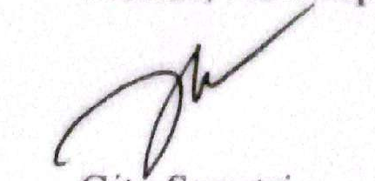
Medan, ……September 2022

Gita Saputri

TABLES OF CONTENTS
ACKNOWLEDGMENT i
ABSTRACT iii
TABLES OF CONTENTES iv
CHAPTER I : INTRDUCTION 1
  - Background of Research 1
  - Identification of the Problem 4
  - Limitation of Problem 4
  - Problem of the Research 5
  - Objectives of the Research 5
  - Significance of the Research 5
CHAPTER II : REVIEW OF LITERATURE 6
2.1. Novel 6
2.2. Feminism 8
2.3. Resistance 10
2.4. Structuralism 16
2.5. Summary of the Novel 17
2.6. Review of Related Research 20
CHAPTER III : METHODOLODY 23
3.1. Method of Research 23
3.2. Data and Source of Data 24
3.3. Technique of Collecting Data 24
3.4. Technique of Analysing Data 24
CHAPTER IV : FINDINGS AND DISCUSSIONS 26
4.1. Findings 26
4.2. Discussions 26
CHAPTER V : CONCLUSION AND SUGESTIONS 38
5.1. Conclusions 38
5.2. Suggestion 38
REFERENCES 40

