MORAL VALUES THROUGH THE VIDEO GAME CAMPAIGN OF RESIDENT EVIL 6

A THESIS

Submitted English Literature Study Program in Partial Fulfillment of the Requirements for the Degree of Literature

BY

AISYAH PUTRI MUHANDRA
Registration Number: 216114011



FACULTY OF LETTERS
UNIVERSITAS MUSLIM NUSANTARA AL-WASHLIYAH
MEDAN
2025

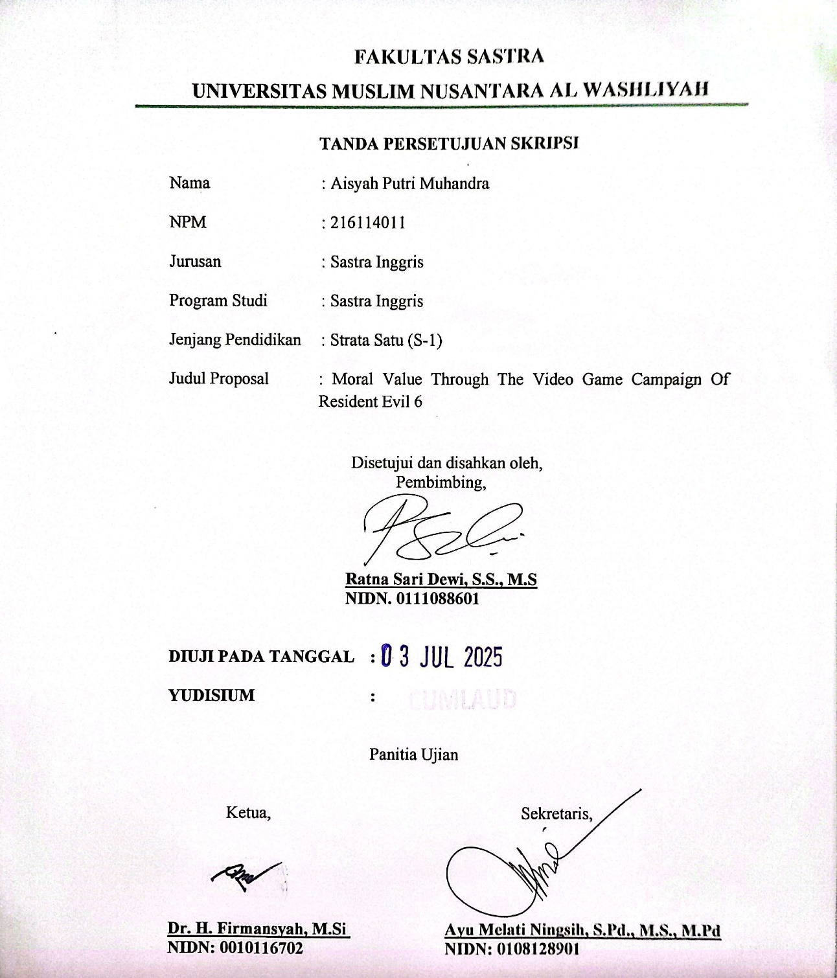

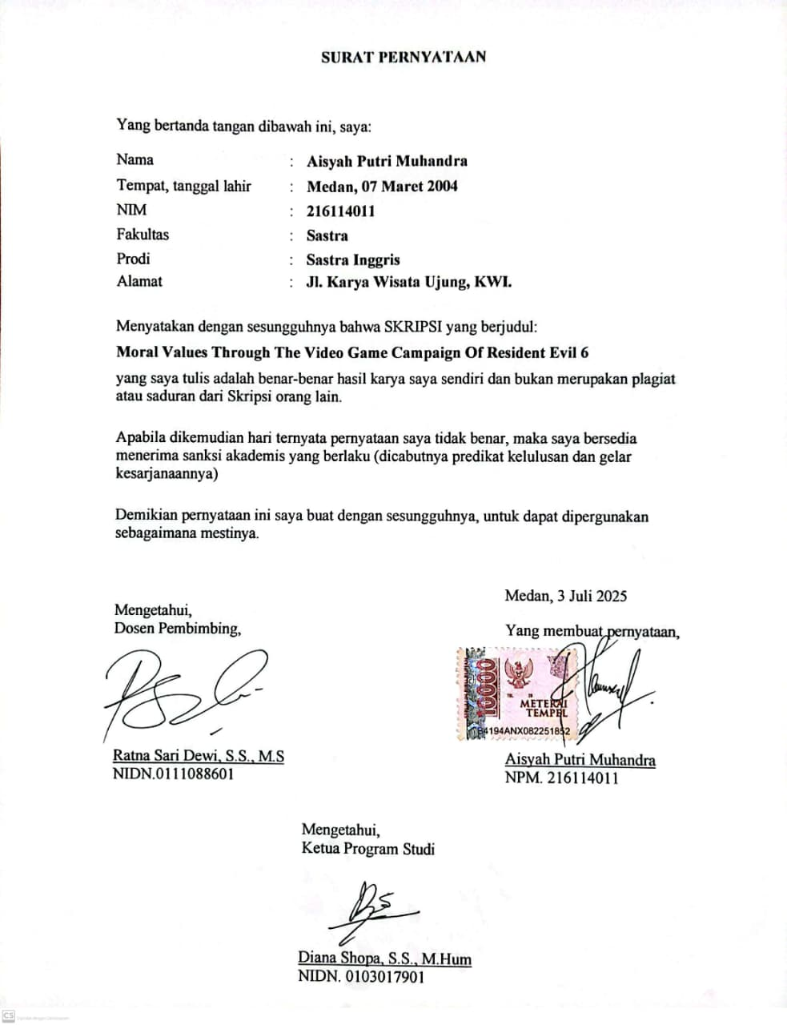

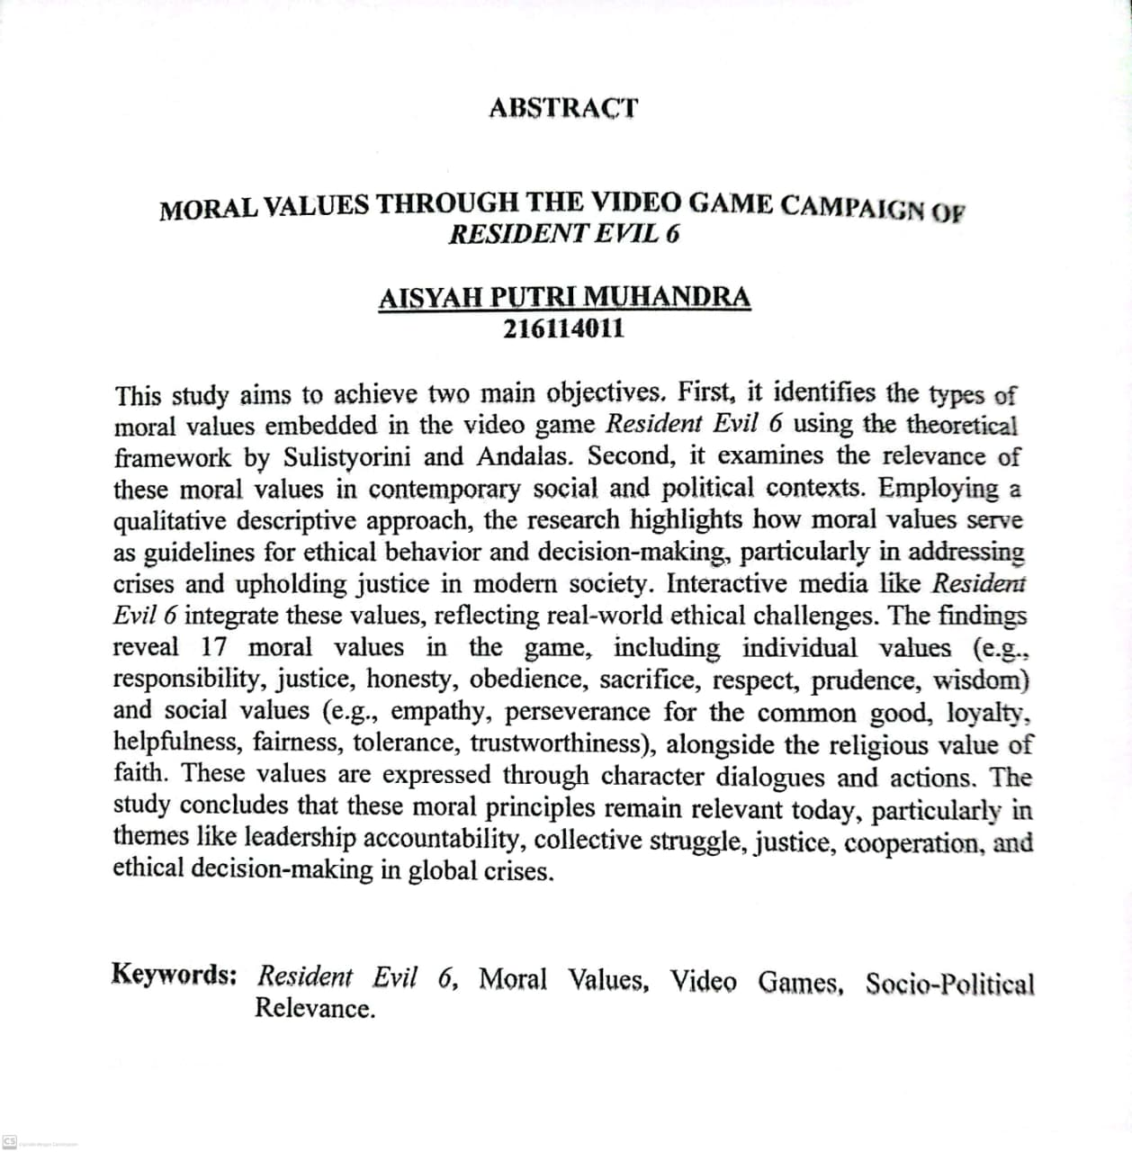

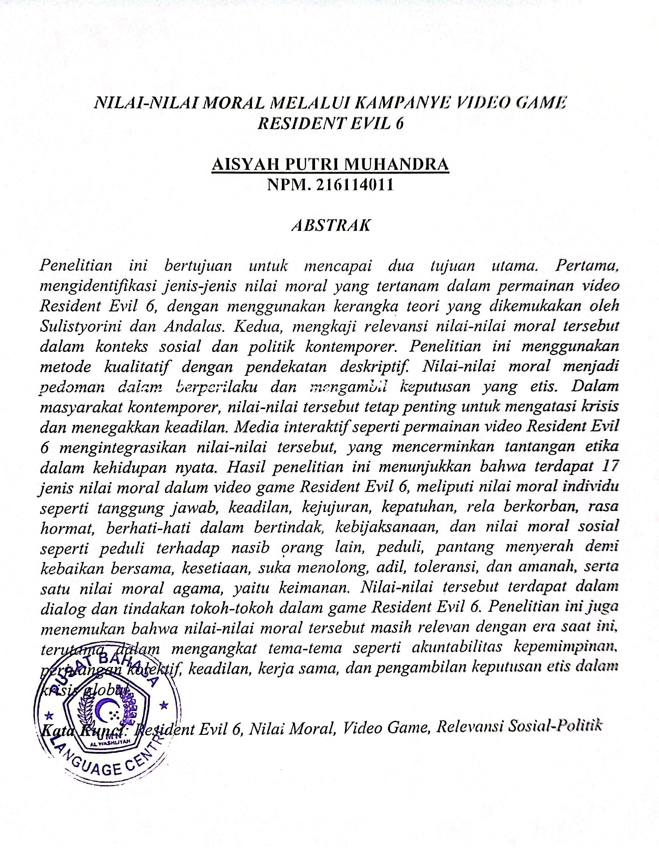

ACKNOWLEDGMENT
بِسْــــــــــــــــــمِ اللهِ الرَّحْمَنِ الرَّحِيْمِ
يَا أَيُّهَا الَّذِينَ آمَنُوا هَلْ أَدُلُّكُمْ عَلَىٰ تِجَارَةٍ تُنْجِيكُمْ مِنْ عَذَابٍ أَلِيمٍ (١٠) تُؤْمِنُونَ بِاللَّهِ وَرَسُولِهِوَتُجَاهِدُونَ فِي سَبِيلِ اللَّهِ بِأَمْوَالِكُمْ وَأَنْفُسِكُمْ ۚ ذَٰلِكُمْ خَيْرٌ لَكُمْ إِنْ كُنْتُمْ تَعْلَمُونَ (١١)
Artinya:
Wahai orang-orang yang beriman! Maukah kamu aku tunjukan suatu perdagangan yang dapat menyelamatkanmu dari azab yang pedih?
(Q.S. Ash-Shaff: 10)
(Yaitu) kamu beriman kepada Allah dan Rasul-Nya dan berjihad di jalan Allah dengan harta dan jiwamu. Itulah yang baik bagi kamu jika kamu mengetahui. (Q.S. Ash-Shaff: 11)
First and foremost, all praise and gratitude are due to Allah SWT for His countless blessings, health, strength, and abundant inspiration throughout the completion of this thesis. May peace and blessings always be upon the Prophet Muhammad SAW. This thesis is dedicated as a testament to the writer’s perseverance, as well as a reflection of love and devotion to the most cherished individuals in the writer’s life. For this humble work, the writer dedicates it to:
- Dr. H. Firmansyah, M.SI, the rector of Universitas Muslim Nusantara Al Washliyah.
- Ayu Melati Ningsih, S.Pd., M.S., M.Pd., the Dean of the Faculty of Letters. She has been an exceptional leader, always supportive of her students, and a dedicated examiner in this thesis process.
- Diana Sopha, S.S., M.Hum, Deputy Dean of the Faculty of Letters, who has also served as a dedicated thesis examiner and has provided valuable feedback on the author’s thesis.
- Vera Kristiana, S.Pd., M.Pd, the head of English Literature Study Program and also as the academic advisor, has been a very generous lecturer who always supports her students.
- Ratna Sari Dewi, S.S., M.S., the thesis advisor, for her invaluable guidance, patience, and support throughout the completion of this research. Her insightful feedback, encouragement, and dedication have been instrumental in helping the writer overcome challenges and refine this thesis. The writer is truly grateful for her time, expertise, and unwavering commitment, which have greatly contributed to the development of this academic work
- All lecturers of the Faculty of Letters Universitas Muslim Nusantara Al-Washliyah.
- To the writer's first hero and guiding light, Said Hendra, has become a beloved father whose strength and wisdom have been the foundation of this journey. The writer owes endless gratitude for his unwavering support, quiet sacrifices, and boundless belief even when the path seemed unclear. His hands that worked tirelessly, his prayers that never ceased, and his heart that always made room for dreams, these are the invisible forces behind every achievement. Though he may never have walked the halls of academia himself, it is his lessons in perseverance, integrity, and unconditional love that made this academic milestone possible. The writer can only hope this accomplishment brings him the same pride and joy he has always inspired. May life returns to him a fraction of the happiness he has given.
- To the writer’s greatest strength, Sukowati, has become a beloved mother whose love knows no bounds. She is the silent hero behind every achievement, the unwavering light in moments of doubt, and the endless source of warmth and encouragement. The writer is eternally grateful for her sacrifices, prayers, and unconditional support for the nights she stayed awake worrying, the days she worked tirelessly, and the countless ways she put the writer’s dreams before her own. Though words could never repay her devotion, this milestone is a testament to her resilience and love. May she be blessed with health, happiness, and the pride of seeing her child succeed.
- The writer would also like to extend sincere gratitude to Adinda Putri Maharani, a cherished friend and companion throughout the academic journey. Her unwavering support, laughter, and shared struggles made the challenges of university life more bearable and the victories even sweeter. Her presence has been a source of strength and motivation and countless campus memories. Thank you for the camaraderie, the encouragement, and the priceless moments that kept the writer going. This achievement is as much hers as it is the writers. May our friendship continue to thrive beyond these university walls.
- The writer would like to express sincere gratitude to all classmates for the support, laughter, and shared struggles throughout this academic journey. Your companionship made the challenges easier and the successes more meaningful. Thank you for the memories and motivation.
- To the writer, Aisyah Putri Muhandra, thank you for not giving up, even when the path seemed endless. For the late nights, the doubts overcome, and the small victories celebrated alone. This thesis is not just an academic achievement, but proof that perseverance outshines perfection. This journey has been a testament to resilience, growth, and the quiet strength found in solitude. May this milestone remind you that you are capable of far more than you imagine.
Medan, June 10, 2025
Researcher

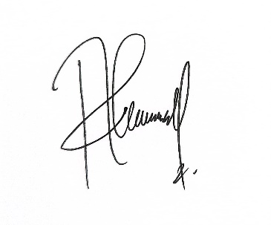

Aisyah Putri Muhandra
NPM. 216114011

TABLE OF CONTENT

ACKNOWLEDGMENT i
ABSTRACT v
ABSTRAK vi
TABLE OF CONTENT vii
CHAPTER I INTRODUCTION 1
1.1 Background of Research 1
1.2 Identification of Problems 4
1.3 Limitation of Problems 4
1.4 Problem of Research 4
1.5 Objective of Research 5
1.6 Significances of Research 5
1.6.1 Theoretical Benefits 5
1.6.2 Practical Benefits 5
CHAPTER II LITERATURE OF REVIEW 6
2.1 Moral Values 6
2.2 Types of Moral Values 8
2.2.1 Individual Morals 8
2.2.2 Social Morals 10
2.2.3 Religious Morals. 14
2.3 Moral values are relevant to political and social conditions. 16
2.4 Video Games 16
2.5 Resident Evil 6 21
2.6 Previous of Research 25
CHAPTER III METHODOLOGY 27
3.1 Method of Research 27
3.2 Data and Sources of Data 27
3.3 Technique of Collecting Data 28
3.4 Technique of Analyzing Data 28
CHAPTER IV FINDINGS AND DISCUSSION 30
4.1 Findings 30
4.2 Discussion 31
CHAPTER V CONCLUSION AND SUGGESTIONS 58
5.1 Conclusion 58
5.2 Suggestions 59
REFERENCES 60

CHAPTER I

INTRODUCTION

1.1 Background of Research
Literature is a reflection of the complexity of human life, which not only conveys the beauty of language but also describes the values, culture, and social dynamics of a society, making it a relevant object of study in understanding the development of thought and civilization. (Minderop, 2016) said, "Literature is a written work that provides entertainment and is delivered in a unique, beautiful, and artistic language and contains life values ​​and moral teachings so that it can arouse: experience, morals, spirituality, and morals, spiritual awareness, emotions of the reader.". (Fananie, 2001) states, "Literary works are works of fiction that are the result of creation based on spontaneous emotional outbursts that can express the ability of aspects of beauty, both based on linguistic aspects and aspects of meaning." Literary works are essentially very close to life because they express the author's ideas related to social environmental conditions, life values, and human existence, including dimensions of humanity, society, culture, morals, divinity, and others.
Although the form of Video Games is very different from the form of conventional written literary works, this work can still be classified as a literary work. Saptanto discusses the adaptation of a video game titled Assassin's Creed: Brotherhood. Based on his analysis, Saptanto concluded that a video game that has a strong structure and patterned rules is a literary work in a new format
(Saptanto, 2013). Video games are not just interactive entertainment, but also a medium that often conveys moral values ​​through stories, characters, and the choices players must make during the game.
Video games have evolved into a powerful and influential medium for storytelling, offering immersive experiences that often reflect complex themes, including moral values. As interactive entertainment, video games uniquely engage players by allowing them to actively participate in narratives, making the exploration of ethical dilemmas and moral lessons more impactful. Resident Evil 6, a prominent entry in the action-survival horror genre, stands out for its intricate storytelling and multi-perspective campaign. The game features four interconnected campaigns, each focusing on different characters: Leon S. Kennedy, Chris Redfield, Jake Muller, and Ada Wong. Through these campaigns, Resident Evil 6 delves into themes such as sacrifice, loyalty, justice, redemption, and the consequences of human ambition, particularly in the context of bioterrorism and the misuse of scientific advancements. As video games continue to grow as a cultural and artistic medium, their potential to convey moral values and influence players’ perspectives has become a significant area of study. Resident Evil 6 serves as an excellent case study for analyzing how moral values are embedded in video game narratives and how they are communicated through gameplay mechanics, character development, and storytelling techniques. By examining the moral dimensions of Resident Evil 6, this study seeks to contribute to the broader understanding of how video games can serve as a platform for exploring and teaching ethical principles, ultimately highlighting their role as a meaningful medium for moral reflection and discourse in modern society. (Cuddon, 2013) states that moral values ​​are lessons that can be learned from a story, poem, fable, drama, or indeed any work that is intended to teach something, either directly or indirectly. Third-person shooter games focus on fast movement, gunfights, and survival from a third-person perspective (Gunawan et al., 2017). Survival horror games, inspired by horror fiction, challenge players to endure fear, while action-adventure games combine physical challenges, puzzles, and storytelling. Resident Evil 6 (2012) is a game that merges these genres, offering an intense experience with four interconnected campaigns. The game presents a bioterrorist conspiracy alongside ethical dilemmas.
The reason researchers are interested in analyzing moral values ​​is that moral values ​​are the basis for acting and behaving by the values ​​of goodness in life, and can live in harmony with others. Researchers chose the video game Resident Evil 6 because this video game is a very popular modern video game. At first glance, this video game is just a shooting game and survival, but this video game contains many moral values ​​and important educational messages. By analyzing moral values ​​in video games, it is expected to build good character in players and be sensitive to moral values ​​in game narratives. Through this research, players are expected to understand that life is a struggle that must be fought for, be sensitive to the dynamics of the real world, improve political literacy, and understand the importance of cooperation and responsibility in facing the global crisis. The researcher hopes that the results of this study can help players to further emphasize the importance of moral values, provide insight into how to make moral values ​​more ethical and civilized in everyday life and society, as well as increase academic studies on moral values ​​in action and horror games.
Analysis of moral values ​​in the video game “Resident Evil 6” is the main topic of this study. Therefore, researchers conducted a study entitled “Moral Values ​​Through The Video Game Resident Evil 6”. Based on the explanation mentioned previously.

1.2 Identification of Problems
Video games, including Resident Evil 6, not only serve as a medium for entertainment but also convey moral values. The campaign in Resident Evil 6 presents situations that require players to make difficult decisions, face the consequences of their actions, and reflect on individual and collective responsibility. However, in-depth studies on how these moral values ​​are conveyed through the storyline, characters, and player interactions are still limited. This raises questions about what types of moral values ​​exist and how elements in the Resident Evil 6 campaign reflect how these moral values ​​are relevant to the current situation.

1.3 Limitation of Problems
The limitation of this research is to find out the moral values ​​contained in the Video Game Resident Evil 6. The theory used is the theory of Sulistyorini and Andalas which puts forward moral values ​​and current socio-political relevance.

1.4 Problem of Research
- What are the types of moral values in the Video Game Resident Evil 6?
- How are the moral values ​​in the Video Game Resident Evil 6 relevant to the current social and political context?

1.5 Objective of Research
- To identify the types of moral values ​​in the Video Game Resident Evil 6
- To find out the moral values ​​in the Video Game Resident Evil 6 that are relevant to the current social and political context.

1.6 Significances of Research
The importance of this research can be seen from the theoretical and practical aspects discussed below:

1.6.1 Theoretical Benefits
In Theoretical Benefits, Researchers hope that the results of this study can play a role in the formation of moral values ​​in the Video Game Resident Evil 6. Researchers also hope that the results of this study can provide information to readers on how to dig deeper into the moral values ​​that underlie this video game.

1.6.2 Practical Benefits
In terms of Practical Benefits, this research is expected to provide benefits for parties such as: Increasing insight and knowledge about moral values ​​in the Video Game Resident Evil 6. This research is expected to provide information to better understand moral values ​​in the Video Game Resident Evil 6 to students, teachers, and lecturers. Providing reference sources and materials for further research so that it can be developed further.

CHAPTER II

LITERATURE OF REVIEW

2.1 Moral Values
(Bertens, 2011), stated that “morality is the values and norms that guide human behavior within society”. (Kurniawan, 2020) said “norms in social interactions and limitations imposed by laws affect how people live their daily lives”. According to (Umanailo, 2020), “morals refer to the good and bad qualities of a person, namely his mental attitude, which is manifested in his outward actions and his actions through his actions in life”. As noted by (Burhan Nurgiyantoro, 2015), in Burhan Nurgiyantoro's states that “morals in literary works are usually intended as suggestions related to certain practical moral teachings, which can be taken or interpreted through the story by the reader”. (Puspitoningrum Encil, 2022) Said “moral values have goals and interests that can be accepted by society, which means that the context of good and bad behavior, and attitudes”. Learning moral values can create a positive sense of value in a person, making them sensitive to issues related to social life and promoting good behavior. (Kinnunen, 2016) states that interactive media like video games offer a unique opportunity to instill moral values through direct decision-making by players. Video games often present moral dilemmas, allowing players to reflect on their own values. From the explanation above, it can be concluded that morality refers to the values and norms that guide human behavior in society, influencing how individuals live their daily lives and interact with others. It involves the distinction between good and bad qualities, which are reflected in a person's mental attitudes and outward actions.
As noted by (Lina & Setiawan, 2017), “values are determining whether a person or a group is right or wrong”. Values play a very important role in human life because they are the foundation of life, guidelines for resolving conflicts, motivation, and direction in a person's outlook on life. (Marlina, 2013) states that “values ​​are something that interests us, something we look for, something that is fun, something that is loved, and in short, values ​​are something good”. Values ​​have good connotations. As highlighted by (Warsilah, 2013), “value refers to the price, content, and meaning of purposeful action”. Values are a priority and can shape and animate human behavior. Then, (Aminuddin, 2014) stated that "Moral values ​​are rules that contain the good and bad of something, something that has value, regarding actions carried out by humans in everyday life, in the relationship between humans and themselves, the relationship between humans and other humans, the relationship between humans and the social environment, and the relationship between humans and their God." It can be concluded that values are essential in human life as they serve as the foundation for decision-making, guiding individuals in determining what is right or wrong. They play a crucial role in resolving conflicts, providing motivation, and shaping a person’s perspective on life. Values also represent the significance, purpose, and meaning behind actions, acting as priorities that influence and drive human behavior.

2.2 Types of Moral Values
Moral values include honesty, responsibility, justice, and courage, which influence how a person behaves in different situations. In the context of media, such as video games, moral values can be conveyed through stories, characters, and the choices players must make. There are three types of moral values, ​​From the perspective of (Sulistyorini and Andalas, 2017), namely individual, social, and religious moral values.

2.2.1 Individual Morals
Individual morals are morals that concern human relationships with their own personal lives or how humans treat themselves. Individual morals include obedience, courage, willingness to sacrifice, honesty, justice, wisdom, respect and appreciation, hard work, responsibility, humility, careful in acting, and trust.
- Obedience
In the view of (Sarbaini, 2019), obedience is an essential basic element of the structure of social life that is necessary for living together. He emphasized the importance of obedience to authority in various contexts, such as family, school, and state.
- Courage
(Bella Dilia Maharina, 2019) stated that the moral value of courage dominates the story. Courage is shown through the struggle of the main character in facing life's challenges, which reflects the importance of moral courage in everyday life.
- Willing to Sacrifice
(Ridwan Tangkilisan, 2018) describes the concept of someone who is willing to give or sacrifice something, even his life, as a noble, right, innocent, virtuous, and good role. This shows that being willing to sacrifice involves sacrificing oneself for the greater good.
- Honesty
As argued by (Paul Suparno, 2015), honesty is an action that is in accordance with conscience and prevailing norms. This includes keeping promises, avoiding lies, acknowledging the strengths of others, and acknowledging one's own shortcomings or mistakes.
- Justice and Wisdom
(Ahmad, 2023) emphasized the importance of upholding the values ​​of justice in everyday life. According to Ahmad, by implementing the values ​​of justice, everyone gets equal rights and opportunities so that social inequality can be reduced and create a harmonious society can be created. (Irawan, 2023) explains that wisdom is the ability to use the mind based on experience and knowledge, with integration between thoughts, emotions, and behavior. In the context of Pancasila, wisdom reflects an ethical orientation achieved through reason, consensus, and commitment to justice.
- Respect and Appreciation
As highlighted by (Vélez and Olivencia, 2017), respect for diversity is the key to harmonious social relations; society can create more harmonious relationships and make diversity a strength in social life. (Lickona, 2013) emphasizes that respect is the basis of universal moral values. Respecting others means valuing them, and this is closely related to responsibility.
- Hard Work
(Jansen H. Sinamo, 2011) emphasizes that hard work is a form of self-actualization that is done with enthusiasm. Sinamo states that work is actualization, which means working hard with enthusiasm.
- Responsibility
(Mardiyah & Setiawati, 2014) Define responsibility as an attitude of not avoiding when asked for an explanation of one's actions. Being responsible means being able to be asked for an explanation of one's behavior, and not only being able to answer but also having to answer.
- Humility and Careful in Acting
(Permatasari, 2016) states that humility is considered the basis of moral life as a whole. This attitude makes individuals aware of their own imperfections, dare to admit mistakes, be responsible for what has been done, and try to be better people. Poedjawiyatna (2014) highlights the role of conscience as an evaluator of the goodness or badness of human actions. This moral awareness, referred to as 'conscience,' functions as an internal judge that judges one's actions, emphasizing the importance of caution in every decision taken.

2.2.2 Social Morals
Social and moral values ​​are values ​​related to human relationships as social beings who interact with others in the family environment, society, or as citizens such as respect for opinions, being tolerant, democratic, friendly, polite, loyal, fair, helpful, cooperative, caring, harmonious, cares about the fate of others, never gives up on the common good.
- Respect Opinions
In the article "Respect: Ethical Imperative or Skills for Success?" (2015), it is stated that actively listening and showing interest in what others are saying, such as by nodding, maintaining eye contact, and asking relevant questions, can make individuals feel heard and respected. Conversely, demeaning non-verbal cues can lead to feelings of insult and damage trust.
- Tolerant
As noted by (Malik Siregar, 2019), tolerance also means respecting, allowing, and permitting different beliefs or religions to exist, even though they are different from one's beliefs. This does not mean that someone has to give up their beliefs, but allows the differences to exist.
- Democratic
According to (Ma'mun Murod, 2024), the moral values ​​of democracy play an important role in everyday life because they form the basis for healthy social interaction and just governance. Morality is a limitation for humans in acting, which is necessary in a democracy. In addition, the importance of morality in democracy is also emphasized by various experts.
- Friendly and Trust between Individuals
(Kailani, 2023) emphasized the importance of a friendly attitude shown through a smile to others. This attitude is considered a moral value that should be emulated in everyday interactions. In addition, Trust between individuals in social life is one of the fundamental moral values. Trust is defined as "a positive belief that another party will not act opportunistically, whether in words, actions, or decisions" (Robbins & Judge, 2019).
- Polite
In the opinion of (Nayyiroh and Fikri, 2022) emphasize that politeness is a basic character that supports good social interaction. Thus, the moral value of politeness not only reflects a person's personality but also plays a role in creating a harmonious and civilized social life.
- Loyal and Helpful
In the context of social values, loyalty serves as a guideline for individuals to live harmoniously and responsibly in society. (Sari, 2022) states that loyalty is "a commitment to continue to support and not betray someone or something, even when facing temptation or difficulties”. The moral value of helping each other, or often referred to as altruism, is an important aspect of social life. As indicated by (Saragih, 2020), altruistic behavior and moral values ​​are very much needed in social and community life, where each individual must help each other according to religious teachings, norms, and applicable rules.
- Fair and Cooperative
Various experts with different perspectives have explained the moral value of fair in social life. (Agus Santoso, 2015) stated that morality is the character of an individual or society that upholds the value of fair in social interactions. Thus, the moral value of fair not only reflects the balance in rights and obligations, but also becomes the foundation for the formation of a harmonious and ethical society.
- Caring and Harmonious.
As mentioned by (Hidayati, 2015), a caring attitude is reflected in the act of helping and supporting other individuals in society, which shows empathy and social solidarity. Meanwhile, harmony in social life refers to a state in which relationships between individuals or groups take place peacefully and in balance. (Sari, 2019) explains that harmonious values ​​are reflected in attitudes of tolerance, respect for differences, and good cooperation between members of society, all of which contribute to the creation of social cohesion. Thus, the moral values ​​of caring and harmony play a role in strengthening positive social interactions and building a more inclusive and peaceful society.
- Caring about the Fate of Others and Never Giving Up for the Common Good.
As asserted by (Zuchdi, 2019), social concern is an attitude and action that always wants to provide assistance to people in need. This attitude is important to create balance in community life. In addition, the attitude of never giving up is defined by (Ermanto et al. 2014) as an attitude of doing something seriously and not giving up easily. This attitude encourages individuals to continue trying to achieve goals despite facing various obstacles. These two values, namely concern for others and never giving up, play an important role in forming a harmonious and mutually supportive social order.

2.2.3 Religious Morals.
This value reflects how a person lives his life according to the principles of the religion he adheres to, and how he maintains a harmonious relationship with his God. In everyday life, religious moral values ​​are reflected in attitudes and behaviors that reflect faith, piety, and obedience to religious teachings. Examples of these values ​​are faith, sincerity, regret/repentance, optimism, worshiping earnestly, and obeying the teachings of the religion they believe in.
- Faith
Various experts have defined faith in religious moral values ​​since 2014. (Anwar, 2016) explains that religious character reflects belief and obedience manifested in good attitudes and behavior. (Irma, 2016) adds that religiosity is a norm that regulates a person's life based on religious values ​​that come from the psychological aspects of the individual.
- Sincerity
(Agus Wibowo, 2013) stated that religious character is defined as an attitude or behavior that is obedient in carrying out the teachings of the religion that is believed, tolerant of the implementation of worship, and living in harmony with others. This confirms that sincerity is reflected in obedience without coercion and tolerance in religious life.
- Regret/Repentance
Regret and repentance are important concepts in religious moral values ​​that have been discussed by various experts. As cited by (Faraz, 2017), regret is a negative emotion that arises when someone compares the behavior that has been done with the behavior that should be, which then encourages the individual to improve themselves and increase their piety.
- Optimism
(Carver and Scheier, 2014) define optimism as a positive way of thinking that future outcomes tend to be positive. Religiosity, which includes the appreciation of religious values ​​that are internalized in a person and actualized through behavior (Aminah, 2016), plays an important role in shaping this optimistic attitude.
- Worshiping Earnestly
As presented by (Faturrohman, 2015), Religiosity is defined as an attitude and behavior that is obedient in carrying out the teachings of the religion one adheres to, tolerant of carrying out the worship of other religions, and living in harmony with adherents of other religions.
- Obeying the Teachings
As detailed by (Jalaluddin, 2016), Religiosity is defined as the appreciation of religious teachings that are internalized in a person and manifested through behavior in everyday life. This emphasizes that religious individuals not only understand the commands and prohibitions of their religion, but also obey and carry them out.

2.3 Moral values are relevant to political and social conditions.
(Steven Levitsky and Daniel Ziblatt, 2018) argue that the sustainability of democracy depends on moral values like tolerance, mutual restraint, and respect for institutions, and that neglecting these principles can lead to democratic erosion and authoritarianism. On the other hand, (Nancy Fraser, 2014) contends that social justice must encompass three key dimensions: recognition, redistribution, and representation, the absence of which exacerbates social inequality. (Michael Sandel, 2020) critiques meritocratic systems that disregard social justice and empathy, advocating instead for a political reorientation toward inclusive common good. These theories collectively highlight that moral principles including justice, freedom, tolerance, and collective responsibility serve as fundamental pillars for both democratic governance and social equity. These values prove essential in maintaining institutional stability while addressing systemic inequalities. Their integration into political systems appears crucial for preventing democratic decline and fostering inclusive societal development, demonstrating how ethical foundations directly shape sustainable political and social structures.

2.4 Video Games
(Egenfeldt-Nielsen et al., 2016) states that “video games have undergone a long evolution since their inception in the 1950s, developing from scientific experiments into a massive entertainment industry. From the simple era of Pong by Atari in 1972 to the 3D graphics revolution in the 1990s with Super Mario 64 by Nintendo in 1996, this development paved the way for the emergence of various new genres, including survival horror. This genre was popularized by Resident Evil in 1996, developed by Capcom as a horror game with survival mechanics (survival horror)”. (Bogost, 2020) stated “as video game technology evolved, Capcom continued to enhance the series with more realistic graphics, complex storylines, and increasingly dynamic gameplay”.
(Malaby's, 2012) shows that how to play the game is shaped by the culture itself. An important modern cultural product today is technology. Games have been a cultural product since ancient times. The development of increasingly sophisticated technology has given rise to new game models, one of which is video games. Game genres consist of action, adventure, RPG, simulation, strategy, sports & racing, puzzle/party, horror/survival horror, sandbox/open world, and rhythm/music. Survival horror games are quite popular today, one of the popular games today is the survival horror game. Moreover, (Taylor, 2018) said video game streaming platforms such as Twitch have influenced game development, with developers incorporating more engaging mechanics to attract audiences.
The word Game comes from English which means match or game. According to (Hikmatyar, 2015) game can be interpreted as an activity carried out to seek pleasure and develop imagination. Meanwhile, as supported by (Hermawan, 2013), besides being a structured activity, games are also used as a learning tool. From the various definitions above, it can be concluded that a game is a structured activity and is carried out to seek pleasure and also as a learning tool. (Wahyuningtyas and Herning, 2018) stated "Video games, which are known as a means of entertainment and leisure time filler, have elements that build literary works such as themes, characters, settings, and plots, so that video games are included as literary works. As part of popular culture, video games are included in the type of electronic literature because they can be accessed via personal computers (PCs) or smartphones. Electronic literature focuses more on digital things, as part of digital culture (cyberculture)."
Although the form of Video Games is very different from the form of conventional written literary works, this work can still be classified as a literary work. This is based on Damono's opinion regarding what is actually meant by literary works, the following is a quote below,
“However, isn’t what we call literature actually not the fairy tale but the way it is conveyed? ... If what we mean by literature is a series of letters arranged in such a way that they are able to accommodate a fairy tale, then we are talking about literature as a picture.” (Damono, 2018).
Damono believes that if literature is discussed in the context of a series of characters, where characters are actually symbols or images that represent the sound of a word, then narrative images can be considered as literary works. Damono also emphasized that literature is not actually a fairy tale or the content of the story, but the way it is conveyed. Thus, based on this statement, it is clear that Video Games can be classified as literary works.
A video game is an interactive medium that uses computer technology to create an immersive playing experience. The word Game comes from English which means match or game. As demonstrated by (Arif Wibisono, 2017), games are a medium used to convey a message to the general public in the form of entertaining games. (Johnson, D., 2018) explains that video games are not only a means of entertainment, but also a powerful medium for exploring and understanding moral and ethical issues. From the explanation above it can be concluded Video games like Resident Evil 6 immerse players in dynamic environments where they face moral dilemmas, such as risking personal safety to save others or choosing between individual and collective interests. While primarily for entertainment, these interactive experiences also serve as tools for exploring complex ethical and moral themes. As an evolving art form, video games explore social, moral, and philosophical issues. Studies indicate they can shape players' values, particularly in moral dilemmas. For example, Resident Evil 6 forces players to choose between personal safety and the greater good.
(Ian Bogost, 2014) explains that campaign games are a form of "persuasive games" or games designed to influence players. Campaign games are not only intended to entertain, but also to convey certain messages and encourage changes in behavior or attitudes. (José Zagal, 2017) argues that campaign games are part of "serious games", which are games designed with a primary purpose other than entertainment. Campaign games fall into this category because they have a clear purpose, such as educating, advocating, or promoting social change. From the explanation above, it can be concluded that campaign games are a unique form of interactive media designed not only to entertain but also to influence players by conveying a specific message and encouraging changes in behavior or attitudes. As part of the broader category of "serious games", these games are created with a clear purpose beyond entertainment, such as educating, advocating for a cause, or promoting social change.
Campaign games fall under the category of serious games or persuasive games, with a primary purpose that goes beyond entertainment, such as education, training, or advocacy for specific issues. Resident Evil 6 can be considered a campaign game because its themes, narrative, and impact on players align with the campaign’s goal of raising awareness about social, political, and ethical issues. Its elements such as criticizing corruption, abuse of power, and unethical biological experiments make it relevant to the concept of a campaign game. Thus, Resident Evil 6 can be seen as a form of interactive campaign that uses the medium of games to convey messages and spark critical thinking about important issues.
(Adams, 2014) defines genre as a category that helps players and developers understand the type of game experience, such as action-adventure that combines exploration, narrative, and action. (Järvinen, 2015) emphasizes that genre is not only about content, but also about player interaction, such as in puzzle games that focus on cognitive challenges. (Zagal, Rick, & Hsi, 2016) add that genre also reflects patterns of interaction between players, such as in cooperative gameplay that emphasizes collaboration. (Perron, 2018) highlights emotional and thematic aspects, for example in survival horror that creates fear through limited resources. (Rogers, 2015) sees genre as a means of communicating player expectations, such as in first-person shooters (FPS) that offer a shooting experience from a first-person perspective. Meanwhile, (Juul, 2019) explains that genres develop through a combination of existing conventions and creative innovation. Overall, game genres are a framework that helps understand and categorize gaming experiences, while continuing to evolve as the industry and player preferences develop. From the explanation above, it can be concluded that the game genre is a classification system that groups games based on mechanics, themes, player interactions, and the experiences offered. Genres not only reflect content, but also how players interact, such as cognitive challenges in puzzle games or cooperation in cooperative gameplay. Genres also shape player expectations, for example through tension in survival horror or action in first-person shooters. Continuing to evolve through a combination of traditional elements and innovation, game genres become a framework for understanding diverse and dynamic gaming experiences, adapting to industry developments and player preferences.

2.5 Resident Evil 6
As indicated by (Masyhudi, 2017) survival horror games are games where players are required to survive in various horror situations with limited resources. Horror games are so popular that game developer companies have made development versions of them, such as Resident Evil 6. In the words of (Taylor, 2018) in 2012, Resident Evil 6 was released as part of the ongoing evolution of the video game industry, which had undergone significant changes since its early days. (Kerr, 2017) stated that the globalization of the gaming industry has also led to more diverse storytelling approaches, as seen in how Resident Evil 6 intertwines multiple character perspectives in a complex narrative structure. Thus, (Huntemann & Payne, 2019) said the evolution of video games since the 1950s has not only influenced technical aspects but also the way stories are told and gameplay mechanics are developed, as seen in Resident Evil 6, which marks a shift from classic horror to modern action. (Wolf, 2014) stated the technological advancements from the 2D to 3D era played a crucial role in making Resident Evil 6 a game with more detailed visuals, realistic animations, and multiplayer modes that allowed for a more dynamic and social gaming experience.
Unlike classic survival horror games that relied on eerie atmospheres and limited resources, Resident Evil 6 combined intense action with cinematic storytelling, reflecting the industry's trend toward immersive, film-like gaming experiences and each campaign follows a different set of characters, presenting players with unique perspectives, challenges, and moral dilemmas. The game's branching storyline and diverse protagonists create an intricate narrative tapestry that explores profound themes, including the complexity of human nature and the struggle to uphold moral values in the face of overwhelming adversity. Resident Evil 6 tells the story of various characters' struggle against a global bioterrorism attack that spreads the C virus. The game’s narrative is deeply rooted in its exploration of moral values, including courage, sacrifice, justice, and the weight of responsibility. Unlike conventional survival horror games that focus solely on physical threats, Resident Evil 6 engages players in emotional and ethical decision-making, where choices often reflect broader moral conflicts. Players are not merely fighting zombies and bio-organic weapons (B.O.W.s) but are also tasked with navigating dilemmas that challenge their perception of right and wrong. (Capcom, 2012) explains that this game is divided into 4 campaigns and has 7 characters.

- Leon and Helena Campaign
In Resident Evil 6, Leon S. Kennedy, a veteran government agent, teams up with DSO agent Helena Harper to investigate a C-virus outbreak in Tall Oaks, USA. Leon remains calm and experienced, while Helena is driven by personal guilt over her sister Deborah’s involvement in the conspiracy. Together, they battle zombies and B.O.W.s, uncovering a plot led by National Security Advisor Derek C. Simmons. In the Leon S. Kennedy and Helena Harper campaign, there are five chapters in the game, namely:
Chapter 1: The Incident
Chapter 2: The Cathedral
Chapter 3: The Struggle
Chapter 4: The Coup
Chapter 5: The Siege
- Chris and Piers Campaign
In Resident Evil 6, the Chris and Piers campaign follows BSAA veterans Chris Redfield, a battle-hardened but traumatized leader, and his loyal partner Piers Nivans. Together, they combat bioterrorist threats like the J'avo across Eastern Europe and China. Their dynamic blends intense action with emotional depth, Chris struggles with guilt but learns to overcome it, while Piers proves his unwavering dedication, ultimately sacrificing himself to save Chris and complete their mission. Their mentor-apprentice bond and teamwork make them a standout duo in the game. In Chris and Piers campaign, there are five chapters in the game, namely:
Chapter 1: The Beginning
Chapter 2: The Ambush
Chapter 3: The Submarine
Chapter 4: The Aircraft Carrier
Chapter 5: The Legacy
- Jake and Sherry's Campaign
The main characters in Resident Evil 6's Jake and Sherry campaign are Jake Muller, a mercenary and son of Albert Wesker with immunity to the C-virus, and Sherry Birkin, a government agent who first appeared as a child in Resident Evil 2. Their mission involves escaping bioterror threats while being pursued by the relentless bioweapon Ustanak. In Jake Muller and Sherry Birkin campaign, there are five chapters in the game, namely:
Chapter 1: The Experiment
Chapter 2: The Connection
Chapter 3: The Snowfield
Chapter 4: The Underground
Chapter 5: The Revelation
- Ada Wong's Campaign
In Resident Evil 6, Ada Wong's campaign focuses on her investigation of a global C-virus conspiracy while interacting with characters like Leon, Chris, and Jake. As a skilled spy, she undertakes stealthy missions, combat, and puzzles, showcasing her intelligence and independence. A key plot involves a doppelgänger tarnishing her name, forcing Ada to clear her identity and stop the virus's spread. This campaign provides deeper insight into her motivations, making her more than just a supporting character. In Ada Wong campaign, there are five chapters in the game, namely:
Chapter 1: The Intruder
Chapter 2: The Underground
Chapter 3: The Ship
Chapter 4: The Laboratory
Chapter 5: The Truth

2.6 Previous of Research
In an effort to sort out the similarities and differences between the current and previous investigations, the first author has three previous studies, "Moral Values in The Video Game Doraemon: Nobita No Bokujou Monogatari" is the title of the previous study conducted by Naufalqilla Rizkia Wijaya (2020). The purpose of this study is to examine the moral values ​​contained in the video game Doraemon: Nobita no Bokujou Monogatari. The results of the study indicate that it is known that the four relationships in moral education as the standard of Japanese moral values ​​have been met. The four relationships are 1) relationship with oneself; 2) relationship with others; 3) relationship with nature and noble values; and 4) relationship with society. The differences and similarities in the current research are that the difference is that this research uses the game Resident Evil 6 as data, while the similarity in the research is that both examine the moral values ​​contained in video games.
"Educating Good Moral ValuesThrough Video Game: Harvest Moon Back To Nature Perspective" is the title of the second previous study conducted by Fikry Prastya and Mahmud Arief (2023). The aim of this research is to identify the moral values ​​in a video game called Harvest Moon: Back to Nature. The research results show that, Harvest Moon: Back to Nature video game presents not only entertaining gameplay to the gamers but also several moral values ​​that construct a good personality to them. The differences and similarities in the current research are that the difference is this research uses the game Resident Evil 6 as data, while the similarities in the research are that both examine and identify moral values ​​contained in video games.
Chairina Nasir (2019) conducted research entitled "An Analysis Moral Values in The Movie “Coco”" as the third previous researcher. The aim of this research effort is to identify and describe the types of moral values ​​in the film. Research findings show that there are nine types of moral values ​​found in the "Coco" movie. They are honesty, courage, peace of ability, self-confidence and potential, loyalty and dependability, respect, love and affection, unselfishness and sensitivity, and finally, kindness and friendliness. The love and affection type is dominantly used by the characters in this film rather than the other types. The differences and similarities in the current research are that the difference is this research uses the video game Resident Evil 6 as data, while the similarities in the research are that both study and describe the moral values ​​contained in video games.

CHAPTER III

METHODOLOGY

3.1 Method of Research
This study uses a qualitative descriptive method. The qualitative method was chosen to understand in-depth information about moral values ​​in the Resident Evil 6 video game. (Creswell, 2016) explains that qualitative research is a method for exploring and understanding the meanings ascribed to several individuals or groups of people from social or humanitarian problems. Meanwhile based on (Walidin AK, 2015) stated that “qualitative research is a research process to understand human or social phenomena by creating a clear picture”. Comprehensive and complex that can be presented in words, detailed views reports obtained from informant sources, and carried out in a natural setting. From the statement above, the researcher concludes that qualitative research is a method used to explore and understand the meanings attributed to various individuals or groups within social or humanitarian contexts. It aims to create a clear and comprehensive picture of human or social phenomena, often providing detailed reports based on the perspectives of informants.

3.2 Data and Sources of Data
The data used in this study is qualitative data. As described by (Ramdhan, 2021) "qualitative research data can be said to be data that is presented or communicated in the form of words, sentences, narrative expressions, and images. Qualitative descriptive method data was collected from the Resident Evil 6 video game. Researchers divide sources into primary data sources and secondary data sources. In this study, primary sources were taken from quotes in the Resident Evil 6 video game. Secondary data sources for this study were taken from books, journals, theses, and several relevant materials to support and complement primary data sources.

3.3 Technique of Collecting Data
As indicated by (Abdussamad, 2021) observation is "a data collection technique carried out by observing and recording, and is done intentionally." Data collection is carried out using observation study techniques, namely by observing and recording. The observation technique is carried out by watching the Resident Evil 6 video game. Initially, a complete video game observation was carried out for general identification purposes. Then observe carefully and interpret the moral elements in the video game. After observing carefully, the data is recorded. The next step is recording which is done by recording direct quotes from the video game being studied.

3.4 Technique of Analyzing Data
As pointed out by (Muhammad, 2021) "data analysis techniques are strategies for converting data into information". This research is a content analysis study. The data obtained were analyzed using a qualitative descriptive method. Data analysis was carried out to determine the moral aspects contained in the Resident Evil 6 video game. The data analysis technique used in this study is qualitative descriptive because the data requires descriptive explanation. The descriptive method is used to determine the overall research objectives. This research is a content analysis study on the Resident Evil 6 video game. To analyze moral values ​​in the Resident Evil 6 video game, the first thing to do is to identify the values ​​that appear in the game's storyline, and then analyze how these values ​​are expressed by the characters. This content analysis method can be marked in the excerpts of dialogue texts that show these moral values ​​and finally draw conclusions about how these values ​​affect the whole.

CHAPTER IV

FINDINGS AND DISCUSSION

4.1 Findings
This study aims to identify the types of moral values ​​depicted in Resident Evil 6 using the theoretical framework by (Sulistyorini and Andalas, 2017). Furthermore, it examines the relevance of these moral values ​​in contemporary socio-political contexts. The findings reveal three categories of moral values: individual, social, and religious, consisting of a total of 17 distinct moral principles derived from an analysis of 40 selected in-game dialogues. These results highlight a significant correlation between the game's ethical constructs and current socio-political conditions.
The first finding of this study, which discusses the types of moral values ​​related to the theory of Sulistyorini and Andalas contained in the video game, is 8 social moral values were identified, with a total of 17 citations, including Caring about the Fate of Others (4 citations), Caring (3 citations), Never Giving Up for the Common Good (2 citations), Loyal (3 citations), Helpful (2 citations), Fair (1 citation), Tolerant (1 citation), and Trust (1 citation).
Meanwhile, in the domain of individual moral values, 8 values were found with a total of 22 citations, encompassing Responsibility (5 citations), Justice (4 citations), Honesty (3 citations), Obedience (2 citations), Willingness to Sacrifice (5 citations), Respect (1 citation), Careful in Acting (1 citation), and Wisdom (1 citation).
Additionally, 1 religious moral value was identified, Faith, which appeared once. These findings demonstrate the diversity of moral values reflected in the data, with a greater emphasis on individual values compared to social and religious values.
The study’s second finding highlights how these moral values are reflected in today’s political and social climate. Since the game mirrors real-world dynamics, all the moral values identified, such as leadership accountability, collective struggle, justice, cooperation, and ethical decision-making during a global crisis, are deeply connected to current societal and political issues.

4.2 Discussion
Building upon the research problems outlined in Chapter One, this chapter examines the moral values embedded within Resident Evil 6, a video game developed and released by Capcom. The analysis focuses on the ethical principles conveyed through character dialogues. Additionally, this chapter explores the relevance of these moral values within contemporary social and political contexts. In addressing the previously established research questions, this chapter provides the following critical insights:
- (Social Morals) Caring about the Fate of Others.
Jake: “Dying on a blade is the last way you wanna go. It’s a bitch. Mercs like me? We don’t get a say in how we die. That’s just how it goes.”
Sherry: “It’s… kind of what you signed up for, isn’t it? “
Jake: “Dying for money’s one thing. That’s my choice. But dying for no good reason? That doesn’t sit right with me.”
(Resident Evil 6, CapCom 2012, Jake and Sherry Campaign, Chapter 3)
The dialogue reflects the moral value of caring for the fate of others because the character Jake, even though he is a mercenary, refuses to die without a meaningful reason, showing that he does not only think about personal gain but also considers the impact of his death on others or greater principles. This illustrates concern for the value of life and moral responsibility, even in the context of hard work. In the current political or social context, this dialogue is relevant because it reflects a critique of a system that uses people as tools, such as mercenaries or workers who are employed without any guarantee of safety. When Jake states that dying for money is still acceptable, but dying in vain is not, it reminds us of the issue of social injustice where many people are forced to take dangerous risks in order to survive, while those in power often ignore the value of human life for pragmatic interests.
Another example of concern for the fate of others is also shown by Ada Wong, who shows the importance of this moral value when concern for the fate of others has disappeared.
Ada: “We're beyond sympathy at this point. We're beyond humanity”.
(Resident Evil 6, CapCom 2012, Ada Wong Campaign, Chapter 5)
The Ada dialogue reflects despair at the loss of social moral values, especially concern for the fate of others, because it describes a situation where empathy and collective responsibility have been abandoned. In the current political and social context, this statement is relevant to the phenomenon of indifference to injustice, humanitarian crises, or extreme polarization in society, where personal or group interests override solidarity. This dialogue highlights the dangers when human values ​​such as cooperation, justice, and concern for others are ignored, which can worsen conflicts or social inequality.
Another example of concern for the fate of others was also shown by Leon, who expressed his sadness at the innocent people who died tragically.
Leon: “They escape the infection, only to die like this…”
(Resident Evil 6, CapCom 2012, Leon and Helena Campaign, Chapter 3)
Leon's dialogue reflects the social moral value of caring for the fate of others because the expression shows empathy and sadness for the deaths of people who should have survived the previous threat. Leon not only focuses on his own safety, but also mourns the fate of others, which is the essence of social concern. In the current political and social context, this dialogue is relevant to situations where many people have managed to survive crises such as pandemics or wars but then face new dangers, such as hunger, violence, or systems that fail to protect them. This highlights the failure of policies or social structures that should guarantee the safety of citizens, but instead leave them trapped in new suffering. Thus, Leon's words not only describe personal tragedy, but also implicit criticism of systemic injustice.
Another example of concern for the fate of others was shown by Piers, who expressed his views on the fate of people who died as victims of experiments.
Piers: “They killed them indiscriminately. There’s no reasoning with these bastards. They’re killing unarmed civilians.”
(Resident Evil 6, CapCom 2012, Chris and Piers Campaign, Chapter 2)
Piers' dialogue reflects the social moral values ​​that care about the fate of others by firmly condemning the killing of unarmed civilians. His statement shows deep empathy for victims of injustice and a strong rejection of violence that ignores human values. In the current political and social context, this dialogue is relevant in the context of armed conflict or systematic violence in various parts of the world, where civilians are often victims without adequate protection. Piers is a voice against impunity and reminds us of the importance of global solidarity in condemning atrocities, regardless of the political background of the perpetrators. His criticism highlights the systemic failure to protect vulnerable communities while encouraging collective awareness to be more vocal in rejecting violence in any name.
- (Social Morals) Caring.
Leon: “Too many good agents have died here today… You’re not getting added to that list.”
(Resident Evil 6, CapCom 2012, Leon and Helena Campaign, Chapter 1)
Leon's dialogue highlights the moral value of caring through his empathy and determination to protect Helena, reflecting his respect for others' sacrifices and refusal to let more harm come to them. This attitude resonates in today's social and political contexts, where solidarity and courage are essential in fighting injustice or protecting vulnerable individuals. Leon's unwavering support for his comrades exemplifies the importance of unity and resilience in times of crisis.
Another example of caring was also shown by Chris, who expressed his concern for the members of his army team.
Chris: “I know you’re nervous, Finn, but the team’s got your back. Okay?”
Finn: “Yes, sir. I’ll give this everything I’ve got!”
(Resident Evil 6, CapCom 2012, Chris and Piers Campaign, Chapter 1)
This dialogue illustrates the moral value of caring through Chris' empathy and support for the nervous Finn, thus motivating Finn to try his best. This shows how caring is not just attention, but also real actions that build self-confidence and commitment. Its relevance is seen in socio-political contexts, such as mental support in the workplace, community solidarity, or empathetic leadership that strengthens group cohesion in facing common challenges.
Another example of caring is also shown by Chris, who expresses his caring for Ada.
Leon: “Come on, wake up. If you're really Ada, I know you can pull through this. We both can.”
(Resident Evil 6, CapCom 2012, Leon and Helena Campaign, Chapter 5)
Leon's dialogue reflects the social moral value of caring for the fate of others because he not only motivates Ada to rise, but also affirms that they will get through this difficulty together. This shows empathy, support, and a willingness to share the burden, which is the essence of social care. In the current political and social context, this dialogue is relevant to situations where solidarity is needed, such as in humanitarian crises, injustice, or social pressures. Leon represents a figure who rejects individualism and chooses collaboration, reminiscent of collective movements that fight for the common good amid challenges such as inequality or political polarization.

- (Social Morals) Never Giving Up for the Common Good.
Leon: “You’re not gettin’ off that easy. Come on. After all we’ve been through. It’d be a waste to give up now.”
(Resident Evil 6, CapCom 2012, Leon and Helena Campaign, Chapter 1)
This dialogue reflects the never-give-up for the common good because Leon refuses to give up and emphasizes that stopping now would waste all their struggles. By using the word “we”, he shows a collective commitment that success is a shared responsibility, not just an individual matter. In the current political and social context, this dialogue is relevant to collective movements that maintain solidarity in the midst of a crisis, such as protests against injustice or efforts to defend people's rights. Leon embodies the spirit that despair is not an option when what is at stake is a shared future, an important message in an era when many groups face systematic oppression but persist in the pursuit of change for the better.
Another example of concern for the fate of others was also shown by Piers, who showed a strong motivating attitude towards Chris who was almost giving up.
Piers: “You owe it to them to remember, Chris! If you walk away now, then this was all for nothing!”
(Resident Evil 6, CapCom 2012, Chris and Piers Campaign, Chapter 2)
The dialogue embodies "Never Give Up for the Common Good" as Piers urges Chris to persevere despite trauma, stressing that abandoning their cause would waste past sacrifices. His plea, rooted in responsibility to others and their shared purpose, highlights commitment to the collective over personal struggle, reflecting resilience and dedication to a greater good. In the current political and social context, this dialogue is relevant to situations where collective movements such as protests against injustice, human rights struggles, or efforts against corruption, require consistency. Piers represents a voice that reminds us that to retreat is to betray the common struggle, a message that often appears in social movements demanding sustainable change.
- (Social Morals) Loyal.
Chris: “Listen up. In the BSAA, our job is to rid the world of bioterrorism, and the only way we’re gonna do that is by sticking together.”
Piers: “Nobody’s expendable.”
Chris: “Exactly. Now each and every one of you may be ready to die for our cause, but it’s my job to make sure we all get through this alive. No one gets left behind. Not on my watch. Understood?”
(Resident Evil 6, CapCom 2012, Chris and Piers Campaign, Chapter 1)
The dialogue reflects the moral value of loyalty through Chris and Piers' commitment to protect each other and leave no one behind, affirming loyalty to the team and the shared mission. As a leader, Chris rejects reckless sacrifice and emphasizes the value of each team member, while Piers reinforces the principle of "no one should be sacrificed," reinforcing solidarity and collective responsibility. This loyalty is not only to the organization (BSAA), but also to fellow comrades, demonstrating unconditional devotion. In today's socio-political context, this value is relevant to issues of responsible leadership, resistance to policies that victimize minorities, or social justice movements, reflecting the spirit of inclusivity and solidarity needed in the midst of injustice or humanitarian crises.
Another example of concern for the fate of others was also shown by Leon, who showed his loyalty to his cooperative relationship with the president.
Leon: “Whatever you decide, sir, I’m with you.”
President: “I’ve always valued your friendship, Leon. It’s time we take responsibility and end this mess.”
(Resident Evil 6, CapCom 2012, Leon and Helena Campaign, Chapter 1)
The dialogue between Leon and the President in Resident Evil 6 reflects a profound moral value of loyalty, as Leon demonstrates unconditional commitment despite the severe consequences. This loyalty is not mere obedience but also a form of moral support and solidarity in difficult times, emphasizing the importance of trust and sacrifice in social relationships. In today's political and social context, this value remains relevant, as the world often faces crises that require leaders and citizens to trust one another and collaborate to resolve issues. However, loyalty must also be tempered with wisdom to avoid blind fanaticism, especially in an era where information is easily manipulated and political decisions can divide societies. This dialogue reminds us that true loyalty should be built on responsibility and ethics, not just pragmatic interests.
Another example of concern for the fate of others is also shown by Helena, who shows her loyalty to her mutated sister “Deborah” on the verge of death.
Helena: “No more tears. Not until I avenge your death. Please, forgive me…”
(Resident Evil 6, CapCom 2012, Leon and Helena Campaign, Chapter 2)
Helena’s dialogue reflects a profound moral value of loyalty, where one is willing to sacrifice personal emotions and interests to seek justice for a loved one. This loyalty is not just personal but can also be seen as a form of resistance against injustice. In today's political and social context, this line resonates with many protest movements or collective actions that arise from dissatisfaction with corrupt or oppressive systems. Many individuals or groups, like Helena, are determined to keep fighting for justice, even at great personal risk. This sense of loyalty to truth and solidarity often drives change in an era of political uncertainty and social inequality.
- (Social Morals) Helpful.
Chris: “I owe you one, Finn. How’s our injured friend?”
Finn: “Still with us! I’m going to administer first aid!”
Chris: “OK, people! Getting to the wounded is priority one!”
(Resident Evil 6, CapCom 2012, Chris and Piers Campaign, Chapter 1)
The dialogue above reflects the moral value of helpfulness, where Finn immediately provides first aid to his injured friend, while Chris prioritizes evacuating victims, showing solidarity and responsibility for the lives of others. In the current political or social context, in today's socio-political context, this dialogue is relevant to humanitarian issues and collective responses to crises, such as evacuation of victims of war, natural disasters, or pandemics, where cooperation and speed of relief are the determinants of safety. Chris and Finn's attitudes reflect the importance of public safety-oriented leadership and collaboration in emergencies, values ​​that are much needed in societies often divided by conflict or indifference.
Another example of a helpful attitude was also shown by Leon, who showed a helpful attitude to help a father who lost his daughter.
Father of Liz: “Liz...”
Leon: “Is that your daughter? All right, let's find her.”
Helena: “Leon, we don't have time to...”
Leon: “We're making the time.”
(Resident Evil 6, CapCom 2012, Leon and Helena Campaign, Chapter 1)
The dialogue illustrates a strong moral value of helping others through Leon's character, who insists on assisting in finding someone's daughter despite time constraints. This reflects empathy, responsibility, and the courage to take action for others, even in difficult situations. In today's political and social context, this value is relevant because many issues such as injustice, poverty, or humanitarian crises, require individuals who care and dare to act, even when facing bureaucratic obstacles or societal apathy. Leon represents the spirit of solidarity needed in a society often fragmented by self-interest or political polarization. Thus, this dialogue serves as a reminder of the importance of collaboration and social compassion to drive positive change.
- (Social Morals) Fair.
Piers: “You can’t hide from your past, Chris, no matter where you go or what you do.”
(Resident Evil 6, CapCom 2012, Chris and Piers Campaign, Chapter 2)
The dialogue between Finn and Chris about trauma and the consequences of the past reflects the moral value of fair, where every action must be accounted for without being avoided. This is relevant in the current socio-political context, especially regarding the accountability of leaders or public figures who often avoid past mistakes, such as corruption or human rights violations. This dialogue emphasizes that true justice demands transparency and responsibility, especially in an era where society is increasingly critical of demanding fair.
- (Social Morals) Tolerant.
Jake: “You know in the country I was born in, people think Uncle Sam causes most of the problems in this world.”
Sherry: “Yeah, sure, everyone loves to blame America for everything. We're not the bad guy, Jake. Look, these terrorists have unleashed bioweapons on our country, too!”
(Resident Evil 6, CapCom 2012, Jake and Sherry Campaign, Chapter 4)
The dialogue between Jake and Sherry shows a lack of tolerance in the discussion. Sherry immediately becomes defensive towards Jake’s criticism of the United States, without trying to understand his perspective. This reflects the current political polarization, where criticism is often perceived as a personal attack rather than a reflection. Jake represents the voice of a country that feels the impact of US policies, while Sherry generalizes the criticism as anti-American. The lack of empathy and constructive dialogue in this conversation illustrates a major challenge in contemporary political discussions, where differences of opinion are often met with closedness rather than openness.
- (Social Morals) Trust.
Leon: “Chris, wait! We both want the same thing here.”
Chris: “All right. The BSAA will handle Ada. You take care of Simmons.”
Leon: “Chris. I know you'll do the right thing.”
Helena: “Are you sure we can rely on him?”
Leon: “He's been in this as long as I have. I trust him.”
(Resident Evil 6, CapCom 2012, Leon and Helena Campaign, Chapter 5)
The dialogue reflects the social moral value of trust, where Leon fully trusts Chris even though Helena doubts him. This trust is the foundation of cooperation without supervision or coercion, especially in critical situations. In the current political or social context, this dialogue is relevant to the importance of collaboration between institutions or groups, such as global cooperation on security or environmental issues. Leon's attitude in rejecting Helena's doubts also emphasizes the need to avoid polarization and build trust for the common good.
- (Individual Morals) Responsibility.
President: “A lot of people are questioning my desire to reveal the truth. I know where they’re coming from. It might create more problems than it solves. A lesson I learned well in the military. Bio-organic weapons are a global threat, and we are partly to blame. We have to come clean and start working with the rest of the world... if we want to have any chance of fighting this.”
(Resident Evil 6, CapCom 2012, Leon and Helena Campaign, Chapter 1)
The President’s dialogue reflects the moral value of responsibility as he openly admitted his country’s culpability in the bio-weapons threat and was willing to “come clean” for a global solution, even if it risks triggering political problems. This shows his willingness to bear the consequences of past policies, rather than hiding mistakes for short-term stability. In the current political context, where transparency and accountability are often sacrificed for nationalist interests, this statement is relevant as a critique of governments that cover up crises such as pandemics or pollution or are reluctant to collaborate internationally. By emphasizing global cooperation, this dialogue also implies that moral responsibility does not stop at national borders, but concerns the safety of humanity.
Another example of a responsible attitude is shown by Ada Wong, who shows her responsible attitude by sticking to her mission.
Ada: “I suppose I could go introduce myself. But I don’t want to fall behind schedule.”
(Resident Evil 6, CapCom 2012, Ada Wong Campaign, Chapter 1)
Ada's dialogue reflects the moral value of responsibility, where she faces a choice between introducing herself to others or sticking to her planned schedule. Responsibility here is demonstrated through her commitment to time and tasks, despite the desire to socialize. This value is highly relevant in today's political and social climate, where discipline and consistency are often key to success. Amid numerous distractions and social demands, the ability to prioritize personal or professional responsibilities reflects maturity and integrity. In politics, leaders who uphold responsibility in fulfilling their promises earn greater public trust, while in social life, disciplined individuals tend to contribute positively to community order. Thus, this dialogue reminds us that responsibility is not just about obligation but also about choices that shape character and impact the surrounding environment.
Another example of a responsible attitude shown by Chris who shows his responsible attitude to remain loyal to his responsibilities as a soldier.
Chris: “I can’t keep running away. I have to face the truth, accept responsibility. That’s the only way I’ll ever remember. The only way I’ll get my life back.”
(Resident Evil 6, CapCom 2012, Chris and Piers Campaign, Chapter 1)
Chris’s dialogue reflects the moral value of responsibility because he acknowledges the importance of facing the truth and the consequences of his actions, rather than avoiding them, a key principle in personal integrity. In today’s political or social context, this statement is relevant to public figures or leaders who often avoid accountability for scandals or detrimental policies. For example, when officials refuse to admit fault in cases of corruption or policy failures, society demands an attitude like Chris’: the courage to admit mistakes, take responsibility, and strive to improve. This dialogue emphasizes that responsibility is not only an individual moral value but also the foundation of trust in social and political systems.
Another example of a responsible attitude shown by Chris who shows his responsible attitude to continue to be able to protect his team of soldiers.
Piers: “What the hell were you thinking, pulling a kamikaze stunt like that?!”
Chris: “These are my men. You follow my lead or I'll find someone who will.”
Piers: “Do you even hear yourself?”
Chris: “Fall in line, soldier”
(Resident Evil 6, CapCom 2012, Chris and Piers Campaign, Chapter 4)
This dialogue shows two views on the responsibility of a leader. Chris, as a leader, wants his subordinates to obey unconditionally because he feels responsible for their safety. However, Piers opposes it because Chris's actions are considered reckless and endanger the team. This illustrates that true responsibility is not only giving orders, but also listening to input and thinking rationally. Its relevance is seen in socio-political contexts, many leaders like Chris, are authoritarian and do not want to be criticized, whether in politics, the military, or companies. They use the excuse of "responsibility" to force people to obey. Meanwhile, voices like Piers want a leader who is more open and cooperative. In essence, good leadership requires a balance between being firm and willing to listen to others.
Another example of the responsible attitude shown by Piers who showed an attitude of reprimanding Chris about the responsibilities as a soldier.
Piers: “Chris, we need to stay calm.”
Chris: “After what she's done to us? How many of our men are dead because of that bitch!”
Piers: “I'm right there with you, Captain, but your personal vendetta isn't gonna get us anywhere. If you hadn't been blinded by vengeance, we could have prevented some of those deaths.”
Chris: “Shut up.”
Piers: “Do you even care about our mission anymore?”
Chris: “SHUT UP!”
Piers: “I feel sorry for all the men that died believing in you”.
(Resident Evil 6, CapCom 2012, Chris and Piers Campaign, Chapter 4)
The dialogue between Piers and Chris highlights the moral value of responsibility in leadership and the consequences of letting emotions override duty. Piers reprimands Chris for being consumed by personal vengeance, leading to the deaths of their teammates and neglecting their primary mission. This reflects how a leader must prioritize responsibility toward their team and collective goals over personal emotions. Its relevance is seen in socio-political contexts, where leaders or public figures often make decisions based on emotions, personal interests, or power ambitions rather than considering the broader impact on society. When leaders neglect their responsibilities, the result is a crisis of trust, internal conflict, and even loss of lives, much like in the dialogue. This serves as a reminder that good leadership requires maturity, emotional control, and an awareness of the consequences of one's actions on the greater community.
- (Individual Morals) Justice.
Ada: “If you think I’m going to sit back and be your scapegoat, Simmons, you’ve got another thing coming.”
(Resident Evil 6, CapCom 2012, Ada Wong Campaign, Chapter 1)
Ada's dialogue reflects the moral value of justice because she refuses to be a scapegoat for the mistakes of others, shows resistance to injustice and refusal to accept false accusations. This attitude reflects the principle of justice that demands equality and protection from arbitrary treatment. In the current political or social context, this dialogue is relevant because many individuals or groups are often used as scapegoats to cover up the mistakes of those in power, social inequality, or policy failures. For example, in the issue of economic crisis, minority groups or the opposition are often blamed instead of the corrupt system. By refusing to be silent and fighting back, Ada represents the voice of those who demand accountability and justice, an important attitude in fighting manipulative narratives in the public sphere.
Another example of an attitude of justice shown by Leon who showed his attitude of justice in his conversation with Helena.
Leon: “How're you holdin' up?”
Helena: “Why didn't you turn me in? You could have cleared your name.”
Leon: “Maybe, but it wouldn't have stopped Simmons. Besides, you're starting to grow on me a little bit.”
(Resident Evil 6, CapCom 2012, Leon and Helena Campaign, Chapter 3)
The above dialogue reflects the individual moral value of Justice because Leon chooses not to hand over Helena even though it could clear his name. He realizes that handing her over will not stop the main threat (Simmons), showing an understanding that true justice is not simply about fulfilling personal interests, but fighting for a greater truth. In today's political or social context, this dialogue is relevant to situations where individuals are often faced with the choice between sacrificing others for their own interests (as in cases of corruption, betrayal, or revenge politics) or sticking to the broader principles of justice. Leon chooses the latter, reflecting a rare but important stance in a society where power is often abused for narrow interests.
Another example of an attitude of justice is shown by Leon who demands justice in his conversation with the antagonist Simmons.
Sherry: “They said you were involved in the terrorist attack. Is it true?”
Simmons: “What, are they running down the streets, screaming it to anyone who'll listen?”
Sherry: “Answer me!”
Simmons: “It's for the benefit of the United States... and global security.”
Leon: “I can't see how killing the president is good for the country.”
(Resident Evil 6, CapCom 2012, Leon and Helena Campaign, Chapter 4)
This dialogue reflects the individual moral values ​​of Justice as Leon challenges the justification of extreme actions such as the assassination of the president claimed for the sake of "global security" and "US interests." His attitude shows the principle of justice that rejects the justification of violence in the name of political goals, emphasizing that immoral acts cannot be justified even if wrapped in patriotic rhetoric. In the current political context, this dialogue is relevant to the issue of the legitimacy of state violence such as covert operations or political assassinations that are often justified with the narrative of national security, but are criticized for ignoring human rights and democratic principles. Simmons represents an authoritarian attitude that sacrifices morality for power, while Leon becomes a moral voice that questions the truth behind the propaganda, a reflection of the modern debate about ethics in security policy vs. social accountability.
Another example of an attitude of justice shown by Helena who demands justice from Simmons.
Simmons: “Are you here to avenge the president? Is that it? You fool. Had he disclosed the truth behind Raccoon City, the U.S. would have lost all its authority, and the global political order would have collapsed!
Helena: So, to avoid one possible disaster you create another? No matter how many people die!
Simmons: He had to be stopped!! He was leading my country, and this world, into complete chaos!”
(Resident Evil 6, CapCom 2012, Ada Wong Campaign, Chapter 1)
This dialogue reflects the individual moral value of “Justice” as Helena holds Simmons accountable for his actions that sacrificed the lives of many people in order to maintain political stability, while Simmons justifies his lies under the pretext of “the greater good.” Justice here is absolute. Helena believes that truth and accountability must be upheld, regardless of the consequences, while Simmons adheres to utilitarian justice that sacrifices morals for political ends. In the current political/social context, this dialogue is relevant to the issue of government cover-ups, disinformation, and the battle between transparency vs. stability. Many countries face similar dilemmas, where the authorities cover up scandals (corruption, human rights violations, or health crises) under the pretext of “national order,” while the public demands justice and truth, such as in the case of Wikileaks, the COVID-19 pandemic, or information warfare. This conflict shows how power often ignores morals in order to maintain control, fueling public distrust.
- (Individual Morals) Honesty.
Ada: “That can’t be right. I don’t remember those orders. Maybe they were passed on to someone else. All I’ve found are those mysterious orders from half a year ago. Maybe he’s trying to manipulate me.”
(Resident Evil 6, CapCom 2012, Ada Wong Campaign, Chapter 1)
The dialogue between Ada and the others reflects the moral value of honesty because it shows the speaker's efforts to seek the truth amidst ambiguity. through seeking the truth amidst ambiguity, a critical attitude towards suspicious information and distrust of "mysterious orders" demonstrate integrity and commitment to transparency. This is relevant in political or social contexts that are rife with disinformation and abuse of power, where narratives are often manipulated for the benefit of those in power. Thus, this dialogue illustrates individual resistance to systemic dishonesty, a crucial value for maintaining social accountability.
Another example of an attitude of justice shown by Helena who demands honesty in her conversation with Simmons.
Simmons: “You’re the one who planned all this! With what evidence could you base such an outrageous accusation? I am the National Security Advisor. It’s my job to prevent terrorist attacks, not cause them.”
Helena: “You liar!”
Simmons: “If the two of you feel so strongly about your innocence, then you should have no problem turning yourselves in.”
(Resident Evil 6, CapCom 2012, Leon and Helena Campaign, Chapter 2)
The dialogue reflects the moral value of honesty in political conflict, where Helena accuses Simmons of lying about his involvement in the terror attack, while Simmons denies it by using his position as National Security Advisor. This shows how dishonesty erodes trust, especially when political elites abuse their power to cover up the truth. This conflict is relevant to today's politics, where information manipulation and polarization make it difficult for the public to distinguish facts from lies, similar to cases of corruption or abuse of power. In essence, this dialogue emphasizes how honesty is an important foundation in political relations, while a lack of transparency only deepens the crisis of trust.
Another example of fairness is shown by Piers, who expressed his honesty during his argument with Chris.
Chris: “You wanna follow me around, fine. Just make sure you stay out of my way.”
Piers: “As long as you don't cross the line again, that won't be a problem. Ada's just playing with you. When are you gonna realize that?”
Chris: “I'm not stupid enough to fall for her bullshit. You should have a little more faith in your captain.”
(Resident Evil 6, CapCom 2012, Leon and Helena Campaign, Chapter 2)
This dialogue reflects the moral value of honesty through Chris and Piers' attitude of refusing to lie or cover up the truth for momentary interests, even though it risks causing tension. In today's socio-political context is relevant to the phenomenon of polarization and distrust in society, where authority figures like Chris are often faced with skepticism, while others like Piers try to bridge the gap by exposing power games. The tension between trust and manipulation in this conversation also illustrates the dynamics of post-truth politics, where the truth is often obscured by certain interests, as Ada does in their narrative.
- (Individual Morals) Obedience.
Piers: “Captain, we can't let them go!”
Chris: “Our mission is to terminate the B.O.W.s.”
Piers: “But Neo-Umbrella is after them. Shouldn't we...”
Chris: “I said, our mission is to terminate the B.O.W.s.”
(Resident Evil 6, CapCom 2012, Chris and Piers Campaign, Chapter 1)
The dialogue illustrates the conflict between absolute obedience to authority and broader moral considerations, such as humanitarian responsibility. Chris embodies the values ​​of loyalty and a hierarchy of command that places the mission above all else, while Piers brings critical thinking that questions the impact of their actions. This conflict is relevant in a political or social context, where blind obedience to the "common good" policy is often pitted against social accountability. The dialogue reflects the perennial tension between institutional discipline and personal ethics.
Another example of obedience shown by Leon who adheres to his main mission.
Helena: “Leon, are you really sure you're OK with this?”
Leon: “Our target is Simmons. Always has been.”
Helena: “You don't regret not following her, do you?”
Leon: “We'll have to worry about Ada later... Right now, we need to focus on Simmons.”
(Resident Evil 6, CapCom 2012, Leon and Helena Campaign, Chapter 2)
The above dialogue reflects the individual moral value of obedience as Leon sticks to his primary mission of capturing Simmons, despite the temptation to go after Ada. His adherence to duty shows loyalty to his responsibilities as an agent, putting the greater good before personal desires. In today’s political or social context, this can be compared to a situation where a leader or public official must remain focused on a common goal, such as justice or the stability of the country, rather than being distracted by personal or group interests. Leon and Helena working together as a team reflects the importance of collaboration in the face of a major threat, similar to how society needs to unite against challenges such as corruption, security crises, or social injustice.
- (Individual Morals) Willingness to Sacrifice.
Leon: “You and I are in the same boat now. I’d say that officially makes us partners. Like it or not.”
Helena: “Fine by me. As long as you help me get to Simmons”.
(Resident Evil 6, CapCom 2012, Leon and Helena Campaign, Chapter 1)
The dialogue between Leon and Helena reflects the moral value of self-sacrifice as both are willing to work together in a dangerous situation for a common goal, even though they may not fully agree. Leon insists that they must support each other, while Helena agrees as long as Leon helps her reach Simmons, showing her willingness to put aside her differences for the greater good. In today's political or social context, this dialogue is relevant because it illustrates how individuals with differing interests or views are often forced to work together to face a common threat, such as in political coalitions, social movements, or global crises. This reflects a reality where collaboration and compromise are necessary despite tensions, in order to achieve a greater goal.
Another example of the attitude of willingness to sacrifice shown by Leon and Helena who are ready to sacrifice for their mission.
Leon: “We need to stop Simmons and take him into custody right away.”
Hunnigan: “We have no evidence. And right now, you two are on the top of their list of suspects.”
Leon: “Listen, Hunnigan. I need you to fake our deaths. Can you do that?”
Hunnigan: “Of course, but they’ll figure it out eventually.”
(Resident Evil 6, CapCom 2012, Leon and Helena Campaign, Chapter 2)
The dialogue reflects the moral value of self-sacrifice, where Leon and Helena are willing to risk their reputation and safety to uphold justice. This is relevant to the current socio-political context, where many truth fighters such as whistleblowers or activists must work in secret or face pressure from the authorities to fight injustice. This story shows that personal sacrifice remains an important element in fighting for the truth, especially in the midst of a corrupt or oppressive system.
Another example of willingness to sacrifice is shown by Piers who had to kill his partner who had become a mutant.
Chris: “Wait!”
Piers: “We've got no choice - we have to kill him! He'd do the same for us.”
(Resident Evil 6, CapCom 2012, Chris and Piers Campaign, Chapter 3)
The dialogue reflects the moral value of self-sacrifice in an individual context because Piers believes that killing his mutant comrade is an act that "must" be done for the safety of his group, even though it goes against the principles of humanity. He sacrifices other moral values ​​, such as justice and respect for the lives of others for the sake of group justification showing the individual's moral sacrifice for the sake of a perceived greater good. In the current political or social context, this dialogue is relevant to situations where a group or state justifies violence under the pretext of self-defense or national security, such as in war, armed conflict, or repressive policies. Piers represents the "us or them" logic that is often used to legitimize extreme actions.
Another example of willingness to sacrifice is shown by Piers who makes the sacrifice at the end.
Chris: “Just stay with me! You're gonna be OK!”
Piers: “I'm sorry... captain... I did it for the BSAA... ...For the future.”
(Resident Evil 6, CapCom 2012, Chris and Piers Campaign, Chapter 5)
This dialogue reflects the moral value of self-sacrifice because Piers sacrifices himself who has mutated into a monster to save Chris and still be able to stop the terror and for the mission of his organization (BSAA) and a greater purpose in the future. His sacrifice shows extreme loyalty and responsibility as a soldier, where he prioritizes collective interests over personal safety. In the current political or social context, this is parallel to soldiers, activists, or frontline workers who take great risks, even sacrificing their lives for ideology, country, or social change, such as in war, rescue operations, or revolutionary movements.
Another example of willingness to sacrifice is shown by Leon who sacrificed for Helena's safety.
Leon: “I just shot the president.”
Hunnigan: “What are you…”
Helena: “He had already been infected by the time we found him. Leon… Leon did what he had to. He saved my life.”
Huningan: “God help us.”
(Resident Evil 6, CapCom 2012, Leon and Helena Campaign, Chapter 1)
This dialogue illustrates the value of self-sacrifice through Leon's actions in willingly taking moral and reputational risks to prevent greater danger, supported by Helena who understands her decision as an effort to save many lives. This conflict is relevant in a political or social context, leaders or public figures who must make difficult choices for the common good, such as emergency policies during a pandemic or handling security threats. Leon represents a figure who is forced to go beyond norms for the sake of collective responsibility, reflecting the tension between law and ethics in a crisis situation.
- (Individual Morals) Respect.
Jake: “What happened to your father?”
Sherry: “His research killed him. By the time he died, his body had mutated so much he wasn’t even recognizable.”
Jake: “I’m sorry. I didn't... I didn’t mean to…”
Sherry: “That’s all right.”
(Resident Evil 6, CapCom 2012, Jake and Sherry Campaign, Chapter 3)
This dialogue reflects the individual moral value of respect as Jake shows empathy and regret after realizing his question touched Sherry's deep wounds, while Sherry responds with forgiveness, showing mutual respect for each other's feelings. In today's social context, this conversation is relevant to the issue of trauma caused by scientific advancement without ethics. This conversation also highlights the importance of empathy in communication, especially in an era where the exploitation of personal tragedies is often used for political narratives or media sensationalism.
- (Individual Morals) Careful in Acting.
Ada: “The water’s coming in fast. I’d better hurry. One slip and I’m going down with this sub.”
(Resident Evil 6, Capcom 2012, Ada Wong Campaign, Chapter 1)
The dialogue reflects the moral value of caution in acting because Ada realizes how critical the situation is; a small mistake can be fatal. She moves quickly but remains vigilant, showing awareness of the risks and responsibilities to avoid disaster. In the current political or social context, this dialogue could be a metaphor for a crisis that requires quick but measured action, such as climate change or geopolitical tensions. Haste without calculation can make things worse, while inaction risks sinking many parties.
- (Individual Morals) Wisdom.
Ada: "Simmons would never be foolish enough to show his cards. He and his Family want one thing - to stabilize and sustain the system they’ve created. But you… You want to destroy it."
(Resident Evil 6, CapCom 2012, Ada Wong Campaign, Chapter 3)
The dialogue reflects the moral value of wisdom because Ada describes Simmons as a figure who is not reckless in taking action, showing strategic thinking and caution in maintaining the system he built. This reflects wisdom as the ability to consider long-term consequences and act rationally. In the current political or social context, this dialogue is relevant to the phenomenon of power where political elites or leaders often try to maintain the status quo for stability, even though it may sacrifice more just changes, representing reformist or revolutionary groups that challenge established structures, reflecting the tension between cautious conservatism and bold radicalism, a dynamic seen in various contemporary social movements or political conflicts.
- (Religious Morals) Faith.
Leon: “Wish I believed God were looking out for us right now, but I think we’re on our own.”
(Resident Evil 6, CapCom 2012, Leon and Helena Campaign, Chapter 1)
Leon’s dialogue reflects a crisis of faith amid the uncertainty of political and social conditions. Religious moral values, particularly the belief in divine protection, are often relied upon in times of instability. However, when political realities are marked by injustice or conflict, and societies are divided, that faith can waver—as seen in Leon’s words. This is relevant to current socio-political conditions in many countries, where political tensions, social inequality, or global crises (such as pandemics or war) make people feel "abandoned" by a higher power. Leon represents those who question whether religion can still serve as a guide in chaos or if humanity must rely on its own efforts. This illustrates how modern challenges test the resilience of faith while prompting reflection on religion’s role in collective life.

CHAPTER V

CONCLUSION AND SUGGESTIONS

5.1 Conclusion
This study successfully identified the various moral values present in the video game Resident Evil 6 and analyzed their relevance to contemporary social and political contexts. Through an examination of the narrative, character dialogues, and actions, the research found that the game incorporates moral values that can be categorized into three main aspects: individual, social, and religious morals. Individual moral values such as responsibility, justice, honesty, obedience, willingness to sacrifice, respect, carefulness in acting, and wisdom are reflected in the struggles of its characters. Meanwhile, social moral values like caring about the fate of others, caring, never giving up for the common good, loyal, helpful, fair, tolerant, trust, are evident in character interactions. Though less prominent, religious values appear through themes of faith in certain story arcs. Resident Evil 6 is not merely a horror-action game but also presents complex moral dilemmas relevant to real-world issues. The game depicts how political corruption, bioterrorism, and unethical leadership can lead to societal catastrophe, mirroring real-life problems such as power abuse, global pandemics, and leadership crises. Through its different campaign stories, the game teaches the importance of accountability, personal growth, and the consequences of one's choices. Characters like Leon and Helena exemplify honesty and sacrifice, while Chris and Piers demonstrate unwavering principles despite failure. Meanwhile, Jake's transformation from a selfish individual to a caring person and Ada Wong's moral dilemmas, using manipulative methods for noble ends, deepen the game's moral lessons.
Resident Evil 6 shows that entertainment media such as video games are not only entertaining but also able to convey moral messages and social criticism effectively. Through a complex narrative, this game allows players to reflect on contemporary issues without coercion, so that the values ​​of life displayed feel more natural and impactful. This study proves that even horror-action genre games such as Resident Evil 6 can be a learning tool that is relevant to today's social reality.

5.2 Suggestions
This study offers valuable insights for future research, game development, and educational applications regarding moral values in gaming. For researchers, expanding the analysis to other game series or genres while considering cultural influences on moral interpretation would enhance understanding of games as narrative platforms that both reflect and shape societal values. The findings also suggest practical applications in education and player communities. Educators might incorporate games like Resident Evil 6 into ethics and media literacy curricula, using them as interactive tools to analyze decision-making processes. Meanwhile, players could adopt a more reflective approach to gaming by examining in-game moral choices and participating in discussions about their real-world implications. Such collaborative efforts between scholars, developers, and gamers could foster a more thoughtful gaming culture that values both entertainment and ethical discourse.

REFERENCES
Abdussamad, Z. (2021). Metode Penelitian Kualitatif. Makassar: Syakir Media. Press.
Adams, E. (2014). Fundamentals of game design (3rd ed.). New Riders.
Agus Santoso. (2015). Ethics, Morality, and Law Enforcement. Menara Ilmu, 9(2), 2425.
Ahmad. (2023). Pancasila in Action: Implementation of Noble Values in Daily Life. Kompasiana. Retrieved from https://www.kompasiana.com/ahmad090104/671b9df1c925c4707076cb52/pancasila-dalam-aksi-penerapan-nilai-nilai-luhur-dalam-kehidupan-sehari-hari?page=all&page_images=1
Albarracin, D., & Johnson, B. T. (Eds.). (2018). Handbook of Attitudes, Volume 2: Applications. New York: Routledge.
Aminah, S. (2016). Religiusitas: Konsep dan Implementasinya. IAIN Lhokseumawe Press.
Aminuddin. (2014). Pengantar Apresiasi Karya Sastra. Bandung: Sinar Baru Algensindo.
Ananda, R. (2017). Moral Education and Its Relevance to Character Formation. Journal of Character Education, 7(1), 45-58.
Anwar, M. (2016). Religious Characters in Islamic Perspective. Ta’dibuna: Journal of Islamic Religious Education, 5(1), 1-15.
Bandura, A. (2002). Social cognitive theory in cultural context. Applied Psychology: An International Review, 51(2), 269-290. https://doi.org/10.1111/1464-0597.00092.
Bertens, K. (2011). Etika. Jakarta: Gramedia Pustaka Utama.
Bogost, I. (2011). How to Do Things with Videogames. Minneapolis: University of Minnesota Press.
Bogost, I. (2014). Persuasive games: The expressive power of videogames. MIT Press.
Bogost, I. (2020). Play anything: The pleasure of limits, the uses of boredom, and the secret of games. Basic Books.
Capcom. (2012). Resident Evil 6 [Video game]. Capcom.
Carver, C. S., & Scheier, M. F. (2014). Optimism. In A. C. Michalos (Ed.), Encyclopedia of Quality of Life and Well-Being Research (pp. 4510-4513). Springer.
Creswell, J. W. (2016). Research design: Qualitative, quantitative, and mixed methods approaches (5th ed.). Sage Publications.
Damono, SD (2018). Media transfer. Gramedia Pustaka Utama.
Egenfeldt-Nielsen, S., Smith, J. H., & Tosca, S. P. (2016). Understanding video games: The essential introduction (3rd ed.). Routledge.
Ermanto, E., Ningsih, E. F., & Wahyuni, D. (2014). Analysis of Moral Values ​​in the Novel Sang Pencerah by Akmal Nasery Basral. Journal of Language and Literature Education, 3(1), 97-108.
Fananie, Zainuddin. 2001. Telaah Sastra. Surakarta: Muhammadiyah University Press
Faraz, M. (2017). Repentance Psychotherapy: A Mental Therapy Model in Islam. Journal of Mental Health Psychology, 2(1), 54-68.
Faturrohman. (2015). Religious Culture in Improving the Quality of Education: A Theoretical Review and Practice of Contextualization of Religious Education in Schools. Yogyakarta: Kalimedia
Fraser, N. (2014). Justice interruptus: Critical reflections on the ‘postsocialist’ condition. Routledge.
Gunawan, F., Soelistya, D., & Febriyanti, N. (2017). Game development: Survival horror game with action-adventure elements using finite state machine. Prosiding Seminar Nasional Teknologi Informasi dan Komunikasi (SENTIKA), 2017, 1–8
H Warsilah. Journal of Society and Culture 15 (1), 97-130, 2013. 18, 2013. Maleh dadi sea: socio-ecological crisis of the Semarang-Demak coastal area. B Batubara.
Herman, B. (2007). Moral literacy. Cambridge, MA: Harvard University Press.
Hidayati, N. (2015). Moral Values ​​in the Perspective of Sociology of Literature in the Novel Paradigma by Syahid Muhammad. Hasta Wiyata Journal, 4(1), 62-70. https://media.neliti.com/media/publications/395784-nilai-moral-dalam-perspektif-sosiologi-s-00f8a98a.pdf
Huntemann, N. B., & Payne, M. T. (2019). How games move us: Emotion by design. MIT Press.
Irma, I. (2016). Religious Values ​​in the Animated Film Nussa. Perseda Journal, 3(1), 45-60.
Jalaluddin. (2016). Psikologi Agama. Rajawali Pers.
Järvinen, A. (2015). Game design fundamentals. MIT Press.
Juul, J. (2019). Handmade pixels: Independent video games and the quest for authenticity. MIT Press.
Kailani, K. (2023). Moral Values ​​in the Short Story “Dw Almyz” by Kamil Kailani: A Study of Sociology of Literature. Academica.
Kerr, A. (2017). Global games: Production, circulation and policy in the networked era. Routledge.
Kinnunen, J. (2016). Moral decision-making in video games: An empirical approach to studying ethics in gaming. [Publisher if available]. [City, State if applicable].
Kurniawan, W. F. (2020). PROGRAM STUDI PENDIDIKAN BAHASA DAN SASTRA INDONESIA FAKULTAS KEGURUAN DAN ILMU PENDIDIKAN UNIVERSITAS MUHAMMADIYAH SURAKARTA. 2020
L. Hermawan and R. Kristoforus Jawa Bendi, “Application of A* Algorithm in Puzzle Application,” in National Seminar on Information and Communication Technology, Palembang, 2013.
Levitsky, S., & Ziblatt, D. (2018). How democracies die. Crown.
Lickona, T. (2013). Character Education: A Complete Guide to Educating Students to be Smart and Good. Bandung: Nusa Media.
Lina, D., & Setiawan, D. B. (2017). An Analysis of Culture Shock from West to East as Seen in Reilly’s The Tournament. TEKNOSASTIK, 15(1), 14. https://doi.org/10.33365/ts.v15i1.16
Maharina, B. D. (2019). Moral Values in the Novel Merdeka sejak Hati by A. Fuadi (James Rachels Morality Study). BAPALA, 6(1). https://ejournal.unesa.ac.id/index.php/bapala/article/view/32757
Ma'mun Murod. (2024). Morality of important values ​​in democracy. Muhammadiyah University of Jakarta. Retrieved from https://umj.ac.id/kabar-kampus/2024/04/rektor-umj-moralitas-nilai-penting-dalam-demokrasi/
Mardiyah, A., & Setiawati, F. A. (2014). Character Education in Elementary Schools. Jakarta: Kencana Prenada Media Group.
Masyhudi, A. (2017). Pengembangan game survival horror 3D RAPTA menggunakan metode finite state machine. JATI (Jurnal Mahasiswa Teknik Informatika), 1(1), 695–701.
Mayer, R. C., Davis, J. H., & Schoorman, F. D. (2006). An integrative model of organizational trust. Academy of Management Review, 20(3), 709–734. https://doi.org/10.5465/amr.2006.20530356.
Muhammad, R. (2021). METODE PENELITIAN. Cipta Media Nusantara.
Nayyiroh, F., & Fikri, M. (2022). Formation of Polite Character of Children Aged 12-15 Years in RW 03 Bedug Village, Pangkah District, Tegal Regency. Unnes Citizenship Education Journal, 8(1), 216-225.
Nurgiyantoro, B. (2015). Teori Pengkajian Fiksi. Yogyakarta: Gadjah Mada University Press.
Perron, B. (2018). The world of scary video games: A study in videoludic horror. Bloomsbury Academic.
Poedjawijatna. (2014). Theory of Behavioral Ethics. Retrieved from https://123dok.com/article/teori-etika-tingkah-laku-tinjauan-pustaka.y8godko2
Puspitoningrum, E. (2022). ANALYSIS OF THE MORAL VALUES OF ANDEANDE MOSS SCRIPTS THROUGH PRAGMATIC APPROACHES.
Ramdhan, M. (2021). Metode Penelitian Bisnis. Surabaya: Cipta Media Nusantara.
Rawan, I. (2023, October 11). 12 important moral characters in Pancasila: [7] Wisdom. Character Building BINUS University. Retrieved from https://binus.ac.id/character-building/2023/10/12-kharakter-moral-penting-dalam-pancasila-7-kebijaksanaan/
ripp, T. M., Bies, R. J., & Aquino, K. (2002). Poetic justice or petty jealousy? The emotional and behavioral consequences of revenge in the workplace. Organizational Behavior and Human Decision Processes, 89(1), 966-984. https://doi.org/10.1016/S0749-5978(02)00037-9.
Robbins, S. P., & Judge, T. A. (2019). Organizational behavior (18th ed.). Pearson.
Rogers, S. (2015). Level up! The guide to great video game design (2nd ed.). Wiley.
Ryan, R. M., & Deci, E. L. (2000). Self-determination theory and the facilitation of intrinsic motivation, social development, and well-being. American Psychologist, 55(1), 68-78. https://doi.org/10.1037/0003-066X.55.1.68
Salen, K., & Zimmerman, E. (2004). Rules of play: Game design fundamentals. MIT Press.
Sandel, M. J. (2020). The tyranny of merit: What’s become of the common good? Farrar, Straus and Giroux.
Saragih, I. R. (2020). The Relationship Between Moral Values ​​and Altruistic Behavior. Medan Area University.
Sarbaini. (2019). Building Values, Morals, Character, and Compliance with Order Norms in Schools. Accessed from https://www.academia.edu/40912673/PEMBINAAN_NILAI_MORAL_KARAKTER_KEPATUHAN_TERHADAP_NORMA_KETERTIBAN_DI_SEKOLAH
Sari, A. (2022). Loyalty from the Perspective of Social Psychology. Jakarta: Library of Science.
Sari, D. R. (2019). Harmonization of Social Life of the Multiethnic Community of Mataiwoi Village. Journal of PPKn and IPS, 2(1), 1-12. https://selami.uho.ac.id/index.php/PPKN_IPS/article/download/18/82/461
Sinamo, J. H. (2011). 8 Professional Work Ethics. Darma Mahardika Institute.
Siregar, M. (2019). Building Values ​​of Tolerance Between Religious Communities and. Copisusu Journal, 1(1), 1-10.
Smetana, J. G. (2019). The Role of Trust in Children's Moral Development. Prajaiswara Journal, 1(1), 53–68.
Sulistyorini, D. and Eggy F. A. (2017). Oral Literature: A Study of Theory and Its Application in Research. Malang: Madani.
Suparno, P. (2015). Character Education in Schools. Yogyakarta.
Suseno, Franz Magnis. 2007. Etika Dasar Masalah-Masalah Pokok Filsafat Moral. Yogyakarta: Kanisius.
Tabi'in, A. (2019). Implementation of Social Concern Attitudes in Society. Thesis, Sunan Kalijaga State Islamic University of Yogyakarta.
Tangkilisan, R. (2018). The morality of suicide and its relation to the morality of heroism according to Christian ethics. Retrieved from https://www.academia.edu
Tannenbaum, S. I., Beard, R., & Salas, E. (2012). Team building and team effectiveness: 25 years of progress. Annual Review of Psychology, 63, 125-148. https://doi.org/10.1146/annurev-psych-120710-100413.
Taylor, T. L. (2018). Watch me play: Twitch and the rise of game live streaming. Princeton University Press.
The Social Worker. (2015). Respect: Ethical Imperative or Skills for Success? Diakses dari https://www.socialworker.com/feature-articles/ethics-articles/respect-ethical-imperative-or-skills-for-success/
Umanailo, M. C. B. (2020). Human nature as Individual and Social Beings, the Dynamics and Dilemma of Social Interaction. https://doi.org/10.13140/RG.2.2.26220.92805
Vélez, W., & Olivencia, M. (2017). Respect for Diversity in Educational Settings. Journal of Education and Learning, 6(3), 150-158.
Wacana : Jurnal Bahasa, Seni, dan Pengajaran, 4(2), 62–69. https://doi.org/10.29407/jbsp.v4i2.17653
Wahyuningtyas, S., & Puspitarini, H. (2018). Alih Wahana Game Touken Ranbu Menjadi Drama Musikal sebagai Representasi Identitas Latar dan Budaya Jepang. NUSA, 13(1), 99–109.
Walidin AK, W., dkk. (2015). Metodologi Penelitian Kualitatif & Grounded Theory. FTK Ar-Raniry Press.
Walker, L. J., & Taylor, D. A. (2016). Moral development in adulthood: A study of the relationship between moral reasoning and moral behavior. Journal of Adult Development, 23(1), 1-13. https://doi.org/10.1007/s10804-016-9223-2.
Warsilah, H. (2013). PERAN FOODHABITS MASYARAKAT PERDESAAN PESISIR DALAM MENDUKUNG KETAHANAN PANGAN: KASUS DESA BAHOI DAN BULUTUI DI KABUPATEN MINAHASA UTARA. Jurnal Masyarakat Dan Budaya, 15(1). https://doi.org/10.14203/jmb.v15i1.143
Wibowo, A. (2013). Character Education: Strategy for Building the Character of a Civilized Nation. Yogyakarta: Pustaka Pelajar.
Wolf, M. J. P. (2014). The video game explosion: A history from Pong to PlayStation and beyond. ABC-CLIO.
Zagal, J. P. (2017). Ludoliteracy: Defining, understanding, and supporting games education. ETC Press.
Zagal, J. P., Rick, J., & Hsi, I. (2016). Collaborative games: Lessons learned from board games. Simulation & Gaming, 47(1), 75-96. https://doi.org/10.1177/1046878115624788

