ANALYSIS OF NON-VERBAL EXPRESSIONS IN THE "TIMUN EMAS DRAMA PERFORMANCE" FOR CHILDREN AGED 10-18 YEARS AT FASTi (FORUM ANAK SAMBIREJO TIMUR)

THESIS

BY
RIZKA FADHILLAH 186114009



FACULTY OF LITERATURE NUSANTARA MUSLIM UNIVERSITY AL WASHLIYAH
MEDAN 2025

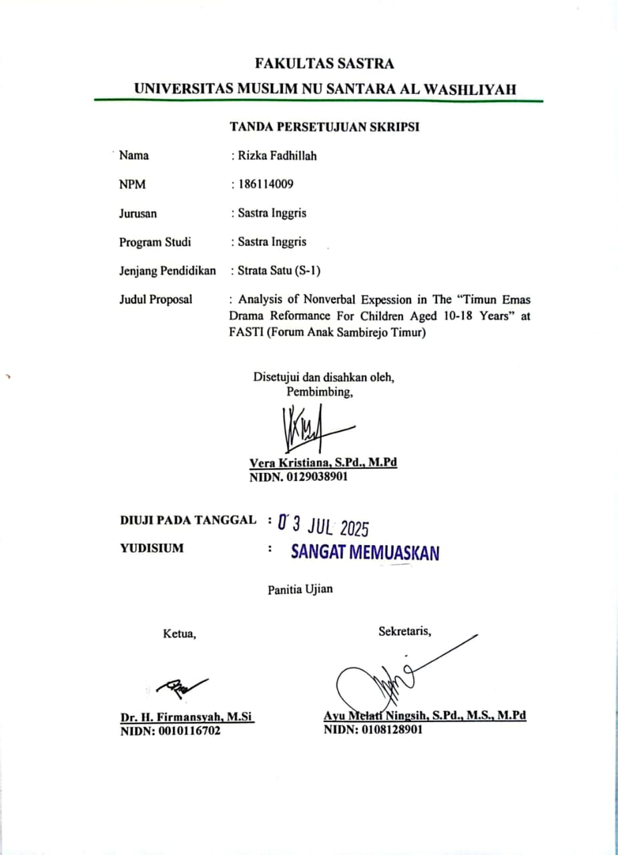
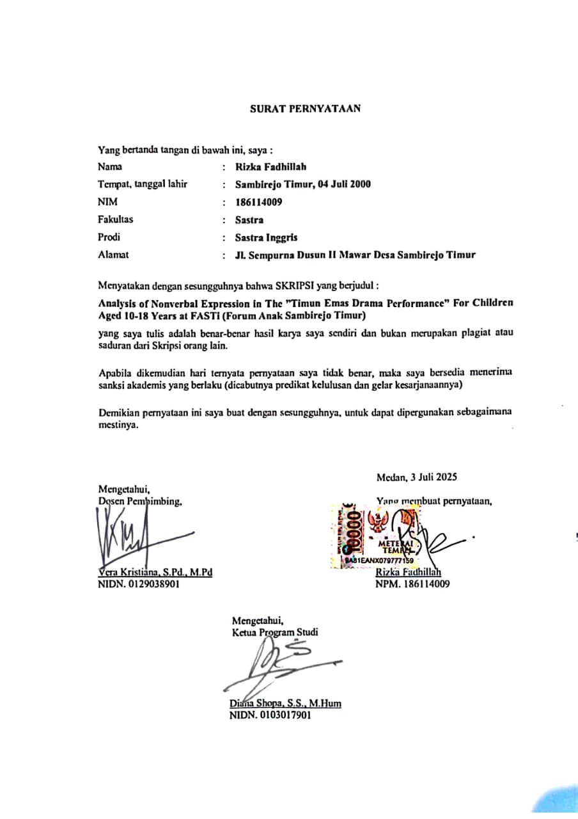
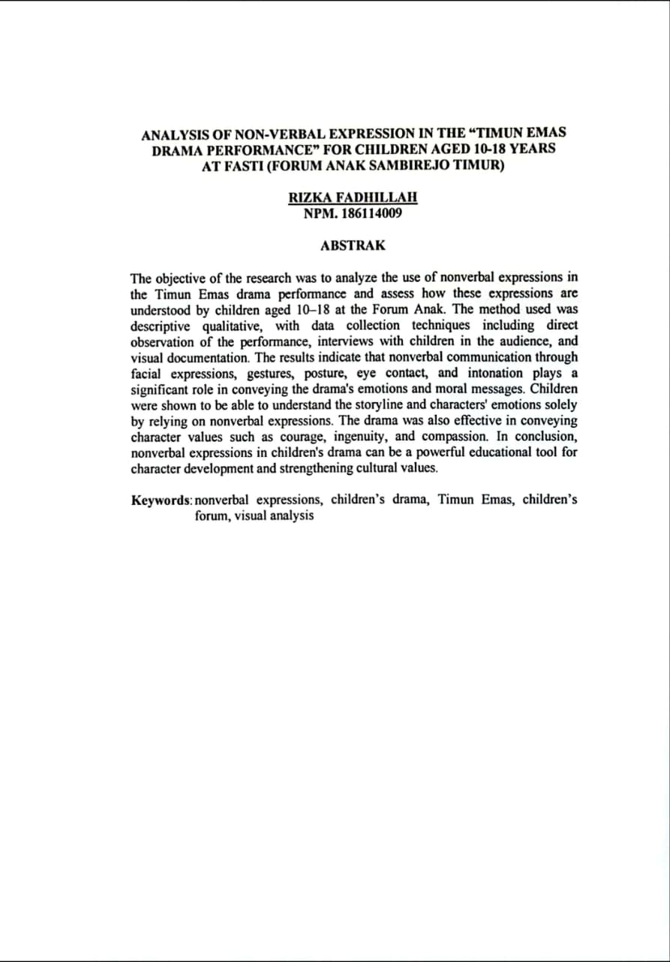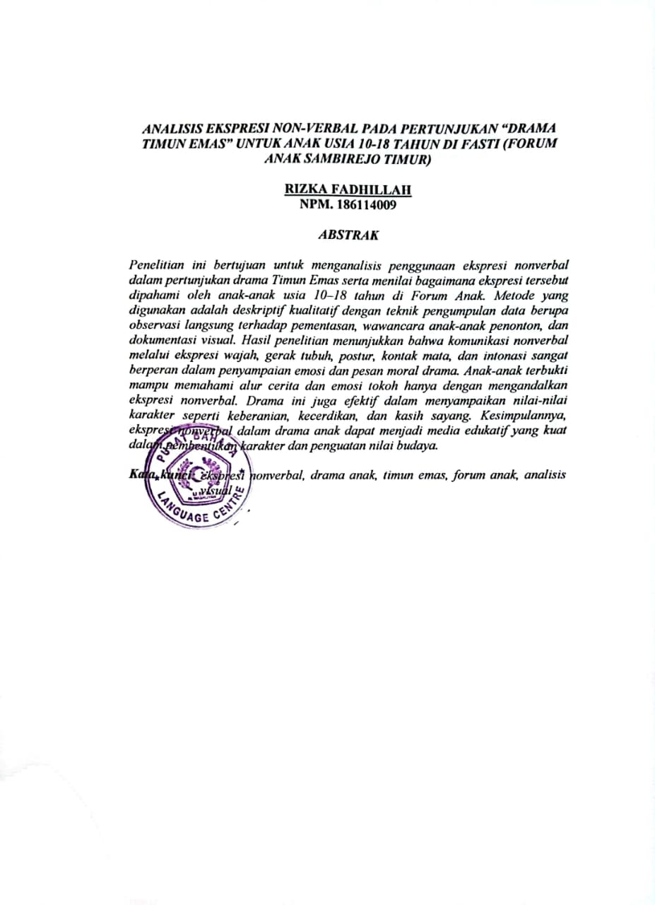

ACKNOWLEDGEMENT



Means:

O you who have believed, would you like me to show you a business that can save you from a painful punishment? (That is) you believe in Allah and His Messenger and wage jihad in the cause of Allah with your wealth and soul. That's what you'd be better off if you knew it. (As- Shaff: 10-11)
Praise the presence of God Almighty because by His grace and grace, the author was able to complete a thesis entitled "Analysis of Non-Verbal Expressions in The Timun Emas Drama Performances" for Children Aged 10-18 Years at FASTi (East Sambirejo Children's Forum) as one of the requirements to obtain a Bachelor of Literature degree in English Literature Study Program, Faculty of Letters, Muslim Nusantara Al Washliyah University Medan. The writing of this thesis is inseparable from the help, support, and prayers of various parties. Therefore, the author expresses his deepest gratitude to:

- Mr. Dr. H. Firmansyah, M.Si, as the Rector of the Muslim University of Nusantara Al Washliyah Medan
- Mrs. Ayu Melati Ningsih, S.Pd., M.S., M.Pd as the Dean of the Faculty of Letters, Muslim Nusantara University Al Washliyah Medan;
- Mrs. Vera Kristiana, S.Pd., M.Pd as the Head of the English Literature Study Program as well as a supervisor who has guided with patience and precision;
- All resource persons from the Forum Anak Sambirejo Timur (FASTi) who have been willing to be respondents in this study;
- Dear Father, Damiran and Mother, Susiyanti, I dedicate this thesis to you who have filled my world with so much happiness that a lifetime is not enough to enjoy it all. Because of the two of you, life feels so easy and full of happiness. Thank you for always letting me pursue my dreams no matter what. Health and long life to you both, I love you very much.
- My two dear brothers and sisters, Muhammad Ferry Hidayat, Muhammad Arief Aldiansya, and Shinta Anzani, always helped and accompanied me all the time. Thank you so much, I'm lucky to have you guys;
- Dear husband of Saka Palwaguna S.Pd and dear ananda Aretha Gistara Megumi for their extraordinary understanding, prayers and enthusiasm so that it became the driving force for me to complete this thesis. Thank you for your love and prayers that always cool your heart. Hopefully this thesis can be proof of our sincerity and hard work together.
- The entire extended family is grateful for your support and prayers for the author, providing the input and even direction that the author needs during the completion of this thesis;
- To my two dear friends Tiara Arianto S.S and Defitri Herlambang S.S from

the first semester to the last semester who have provided great support, motivation, helped me in completing this thesis, always there when I was meed. I love you so much friends.
- The writer's friend in the English Literature Study Program who always provides support during the process of preparing this thesis. The author realizes that this thesis is still far from perfect.

Therefore, the author is very much looking forward to constructive criticism and suggestions for future improvements. Hopefully this thesis can provide benefits for the development of science, especially in the field of literature and non-verbal communication.
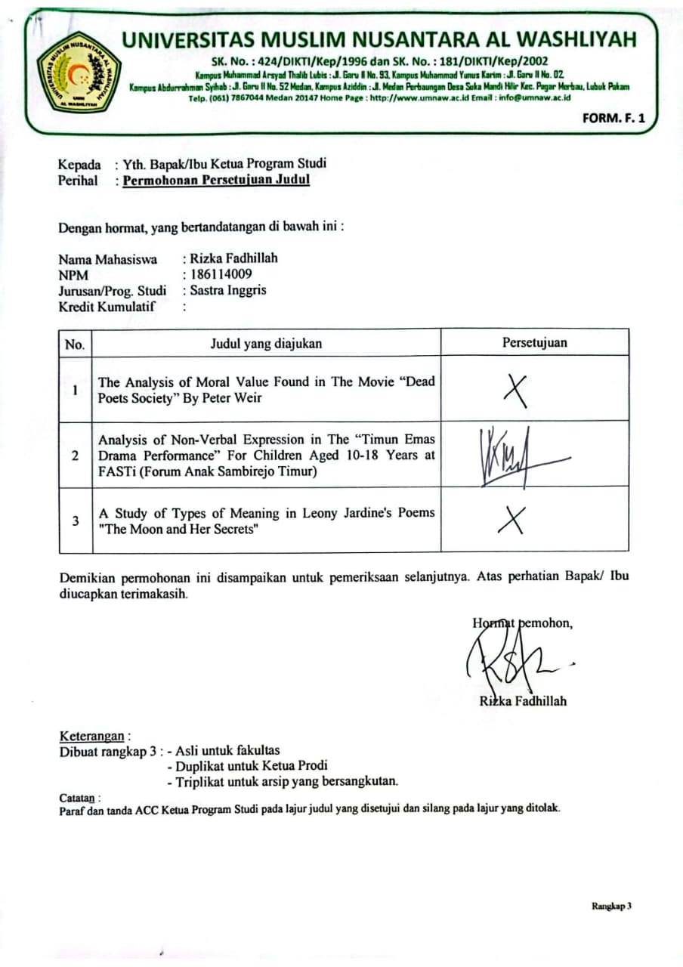
Medan, 03 Juli 2025

BIBLIOGRAPHY

VERIFICATION SHEET I
ABSTRACT II
FOREWORD III
BIBLIOGRAPHY IV
CHAPTER I INTRODUCTION 1
  - Background of the Problem 1
  - Problem Identification 3
  - Problem Limitation 4
  - Problem Formulation 4
  - Research Objectives 5
CHAPTER II LITERATURE REVIEW 6
  - Theoretical Framework 6
  - Previous Research 10
  - Conceptual Framework 11
  - Hipotesis 12
CHAPTER III RESEARCH METHODOLOGY 13
  - Types of Research 13
  - Population/Sample 13
  - Research Location 15
  - Variables and Indicators 16
  - Research Instruments 16
  - Data Collection Techniques 17
  - Data Analysis Techniques 18
CHAPTER IV RESULTS AND DISCUSSION 19
  - Research Results 19
  - Research Discussion 27
CLOSING OF CHAPTER V 30
  - Conclusion 30
  - Suggestion 32
REFERENCE 33

ATTACHMENT………………………………………………………………...

CHAPTER I INTRODUCTION
  - Research Background
Communication is one of the fundamental aspects of human life. In daily activities, communication does not only occur through verbal language in the form of words, but also through nonverbal language which includes facial expressions, gestures, posture, eye contact, and voice intonation. Burgoon, Guerrero, & Floyd (2010) assert that nonverbal communication plays a role in shaping emotional meaning, regulating interactions, and reinforcing or even replacing verbal messages. In other words, nonverbal communication cannot be seen as a mere complement, but rather a key element in the process of delivering a message.
In the performing arts, especially drama, nonverbal communication is actually the core of storytelling. An actor not only reads the dialogue, but also animates the character through body movements, facial expressions, and appropriate intonation. Knapp & Hall (2010) assert that most meaning in interpersonal communication is transmitted through nonverbal channels, and this is especially relevant in visual drama. Therefore, the actor's ability to process nonverbal communication will determine the success of the drama in presenting a message to the audience.
For children, especially 10–18 years old, nonverbal communication plays a more dominant role. According to Santrock

(2011), at this stage of development, children enter a transition period from concrete to abstract thinking. However, they still rely on visual and emotional stimuli to understand a message. This makes dramas with an emphasis on nonverbal expressions easier for children to understand than stories that rely only on verbal narratives.
In the context of Indonesian culture, the Timun Emas folklore is a classic story full of moral values, such as courage to face challenges, ingenuity in solving problems, and the affection of parents for their children. These values can not only be learned through storylines, but also through the expressions of the characters. For example, the fear of the Timun Emas when chased by Buto Ijo is depicted through panicked facial expressions, rapid body movements, and anxious eye gazes; or a mother's affection for her child displayed through a soft voice, warm hugs, and a touching gaze.
Matsumoto & Hwang (2013) added that facial expressions are a form of nonverbal communication that is universal and understandable by everyone, including children. Therefore, the analysis of nonverbal expressions in the Timun Emas drama is very important to assess how children capture moral messages through the body language and emotional expressions of the characters.
Based on this thought, this study was conducted to examine more deeply the forms of nonverbal expression in the Timun Emas drama and the extent to which children aged 10–18 years are able to understand the moral messages conveyed through these expressions. This research is also
expected to contribute to the study of nonverbal communication in

children's performing arts, as well as become practical input for educators and art activists.

Problem Identification
From the background description above, the problems that can be identified are as follows:
    - The drama performance of Timun Emas emphasizes nonverbal communication, but its effectiveness for children's understanding has not been scientifically tested.
    - Children aged 10–18 years are at different stages of cognitive development, so their interpretations of nonverbal expressions also vary.
    - Previous research has examined many nonverbal communication in traditional theater or educational dramas, but has not specifically discussed the drama of Timun Emas in the Children's Forum.
    - The dominant forms of nonverbal expression that actors use in performances have not been mapped in detail.
    - It is necessary to know the relationship between the nonverbal expressions displayed and the child's ability to understand the moral message in the play.

  - Problem Limitations
In order to make the research more focused, the scope of the research is limited as follows:
    - The analysis was only focused on nonverbal forms of communication, namely facial expressions, gestures, posture, eye contact, and voice intonation.
    - The subjects of the study were children aged 10–18 years who watched the drama Timun Emas at the East Sambirejo Children's Forum (FASTi).
    - The verbal aspects (dialogue and narrative) are only used as supporting contexts, not discussed in depth.

Problem Formulation

Based on the identification of these problems, the formulation of the problem in this study is:
    - What are the forms of nonverbal expression used in the Timun Emas drama performance?
    - How are these nonverbal expressions perceived by children aged 10– 18 years at the Forum Anak Sambirejo Timur?
    - How effective are nonverbal expressions in conveying moral messages to children's audiences?

Research Objectives
    - Identify the forms of nonverbal expression displayed by actors in the drama performance of Golden Cucumber.
    - Analyze the perception of children aged 10–18 years towards nonverbal expressions that appear in performances.
    - Assess the effectiveness of nonverbal expressions in conveying moral messages such as courage, ingenuity, and compassion to a children's audience.

CHAPTER II

LITERATURE REVIEW

Theoretical Framework

Children's Drama
Drama is a form of performing arts that combines verbal elements in the form of dialogue with nonverbal elements in the form of facial expressions, gestures, and voice intonation. Through drama, emotional and moral messages can be conveyed in a more lively and contextual way. According to Supriyadi (2016), children's drama functions as a fun educational tool because it combines entertainment with learning values. Drama can stimulate imagination, creativity, and foster children's social skills.
Children's dramas have their own characteristics compared to dramas for adults. First, the storyline is simple and easy to understand. Second, the characters are usually taken from familiar folklore or fairy tales. Third, the element of nonverbal expression is highlighted so that moral messages can be more easily understood by children who tend to be more sensitive to visual symbols. This is in line with Wulandari (2020) who states that children's drama games help children recognize basic emotions, such as joy, sadness, fear, and anger, through nonverbal expressions.

In the context of education, children's drama not only conveys entertainment, but also forms character. Folklore such as Timun Emas is a very suitable performance material because it is loaded with the values of courage, ingenuity, compassion, and sacrifice. According to Lestari (2021), folklore performances are able to instill character values more deeply because children not only hear or read, but also experience emotionally through the expressions of the characters they play.

Non-Verbal Communication in the Performing Arts
Nonverbal communication is the delivery of messages without using words. This form of communication includes facial expressions, body movements, posture, intonation, and the use of space. Burgoon, Guerrero, & Floyd (2010) stated that nonverbal communication accounts for a larger portion than verbal communication in conveying a person's emotions and attitudes. As such, nonverbal communication is often more honest and spontaneous than speech.
In the performing arts, nonverbal communication is one of the main elements. Knapp & Hall (2010) explain that in human interaction, the nonverbal aspect contributes significantly to the meaning that the audience receives. Ekman (2003) added that facial expressions are universal and can be understood across cultures, so they are able to convey emotions clearly even without the help of words.
Matsumoto & Hwang (2013) further emphasized that nonverbal expressions, particularly facial expressions, serve as the main indicators of emotions that can be understood by all age groups, including children.

Therefore, actors in drama performances must master the skills of nonverbal expression in order for moral messages to be conveyed effectively.
The types of nonverbal communication in drama can be classified as follows:
- Kinesik, in the form of facial expressions, hand movements, and body language that describes the emotions of the character.
- Proxemic, which is the use of physical distance between characters that shows closeness, conflict, or dominance.
- Paralingual, which is vocal aspects such as intonation, volume, and tempo of the voice that reinforce the meaning of words.
- Haptics, which are communication through touch, for example a hug to show affection or an urge to show anger.
In the context of the drama Timun Emas, the kinetic and paralinguistic aspects are very dominant, because the tension of the story is often shown through the movements of the Golden Cucumber's running body or the terrifying loud voice of Buto Ijo.

Development of Children Aged 10-18 Years
Understanding how 10–18-year-olds interpret nonverbal expressions in drama requires an understanding of their cognitive and psychosocial development. Piaget (in Santrock, 2011) states that children aged 7–11 years are at the stage of concrete operation, where they begin to think logically but are still attached to concrete and visual things.
Children aged 12 and above enter the formal surgery stage, where they

begin to be able to think abstractly, understand symbols, and interpret moral meanings implicitly.
In addition, according to Erikson (2014), children aged 10–18 years are in the industrial phase vs inferiority (10–13 years) and identity vs role confusion (14–18 years). In this phase, children try to find their identity and values that they can hold. Therefore, dramas with strong moral messages can help them reinforce positive identities while instilling the values of courage, ingenuity, and compassion.
Thus, children aged 10–18 years are a group of viewers who have the potential to receive moral messages through nonverbal expressions. They are able to understand the characters' emotions through facial expressions and body movements, and begin to relate them to abstract values such as honesty and courage.

Folklore as a Medium for Character Understanding
Folklore is a form of oral tradition that is passed down from generation to generation and is loaded with moral, social, and cultural values. According to Lestari (2021), folklore functions as a means of character education because it presents conflicts, characters, and solutions that can be an example for children. Timun Emas , for example, teaches the value of courage to face challenges, ingenuity in facing problems, and sincere parental affection.
Amalia (2020) found that folklore-based drama is effective in forming children's social empathy. Through the nonverbal expression of
the characters, children can learn to feel the emotions of other characters,

making it easier to cultivate an empathetic attitude. Prasetyo (2019) also emphasized that nonverbal communication in traditional theater is easier for children to understand and remember than long dialogues.
Therefore, the use of folklore in children's dramas can be an effective medium for character education, as it presents moral values through strong visual and emotional experiences.

Previous Research
Studies relevant to this topic include:

- Amalia (2020) researches children's drama in the formation of social empathy. The results showed that actors' nonverbal expressions made it easier for children to understand the value of empathy than verbal delivery.
- Prasetyo (2019) examined nonverbal communication in traditional theater and found that gestures and mimicry are more effective in conveying moral messages to children than long words.
- Lestari (2021) researched folklore-based drama as a medium for character building, and the results showed an increase in the value of courage and honesty in elementary school children.
- Wulandari (2020) emphasized the role of children's drama games in strengthening the understanding of local cultural values through nonverbal communication.
- Matsumoto & Hwang (2013) affirm that facial expressions are universal so that children can understand emotional messages across cultures and ages.

From the previous study, it can be concluded that research on nonverbal communication in children's drama has been quite extensive, but it is still limited to traditional plays or general educational dramas. This research fills the gap by focusing on the Timun Emas drama at the Forum Anak Sambirejo Timur as a specific local context.

Conceptual Framework
Based on previous theories and research, the conceptual framework of this research can be explained as follows:
- Children's Drama is a medium that combines verbal and nonverbal to convey stories.
- Nonverbal communication serves as the main channel in conveying emotional messages, particularly through facial expressions, body movements, posture, eye contact, and voice intonation.
- Children aged 10–18 years are a group of spectators who are sensitive to nonverbal expressions, so their understanding of moral values is greatly influenced by visual cues.
- Timun Emas Folklore is a material that is rich in moral values and suitable for use in children's dramas.
This framework shows that the effectiveness of the Timun Emas drama in conveying moral messages is largely determined by the use of nonverbal expressions, and the perception of children aged 10–18 years is an indicator of its success.

The following illustrates the relationship between children's drama, nonverbal communication, Timun Emas folklore, 10–18-year-old audiences, and their understanding of moral messages.

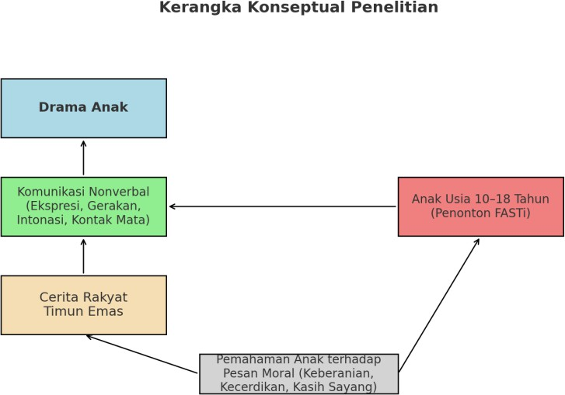

Hipotesis
Based on the conceptual framework, the hypothesis of this study is:

"The nonverbal expressions displayed in the drama performance of Timun Emas have a significant effect on the understanding of children aged 10–18 years in capturing the moral message of the story."

CHAPTER III RESEARCH METHODOLOGY

Types of Research
This study uses a descriptive qualitative approach. The qualitative approach was chosen because the purpose of the study was to understand the phenomenon of nonverbal expression in the performance of the drama Timun Emas in depth from the perspective of the audience of children aged 10–18 years.

Creswell (2014) explains that qualitative research is an approach to explore and understand the meaning that individuals or groups perceive to a social problem. Thus, qualitative research allows researchers to interpret how children capture moral messages through nonverbal expressions in drama.

The type of research used is descriptive because it tries to describe the phenomenon of nonverbal communication as it is, without manipulating variables. According to Sugiyono (2018), qualitative descriptive research aims to describe real conditions in the field and explain the meaning of data based on context.

In other words, this study seeks to present a detailed description of the forms of nonverbal expression in the drama Golden Cucumber and children's perception of these expressions.

  - Population and Sample

Populasi

The population in this study is all children aged 10–18 years who are spectators or participants in the Forum Anak Sambirejo Timur (FASTi) activities when the drama performance of Timun Emas is staged. According to Sugiyono (2018), population is a generalized area consisting of objects or subjects that have certain qualities and characteristics that the researcher sets to be studied.

Sample
Because this study uses a qualitative approach, the sampling technique used is purposive sampling, which is the selection of samples based on certain considerations. Etikan, Musa, & Alkassim (2016) stated that purposive sampling is used when researchers want to get in-depth information from the participants who are considered to know the most about the phenomenon being studied.

In this study, the sample consisted of 20–30 children aged 10–18 years who were divided into two categories:

- Children aged 10–13 years ( concrete surgery phase according to Piaget).
- Adolescents aged 14–18 years (formal surgical phase according to Piaget).

This age group division was intended so that researchers could compare differences in perceptions between children and adolescents to nonverbal expressions displayed in performances.

Research Location
The location of this research is the Forum Anak Sambirejo Timur (FASTi), a children's organization in Sambirejo Timur Village that actively organizes arts, culture, and character education activities. This forum was chosen because it is a forum for children to express themselves while learning social and cultural values.

The performance of the drama Timun Emas which became the object of research was shown at the "Theater Reflection Night 2019" activity by the theater group Sanggar Tetas and then documented on Muhammad Rifki Ramdhana's YouTube channel.
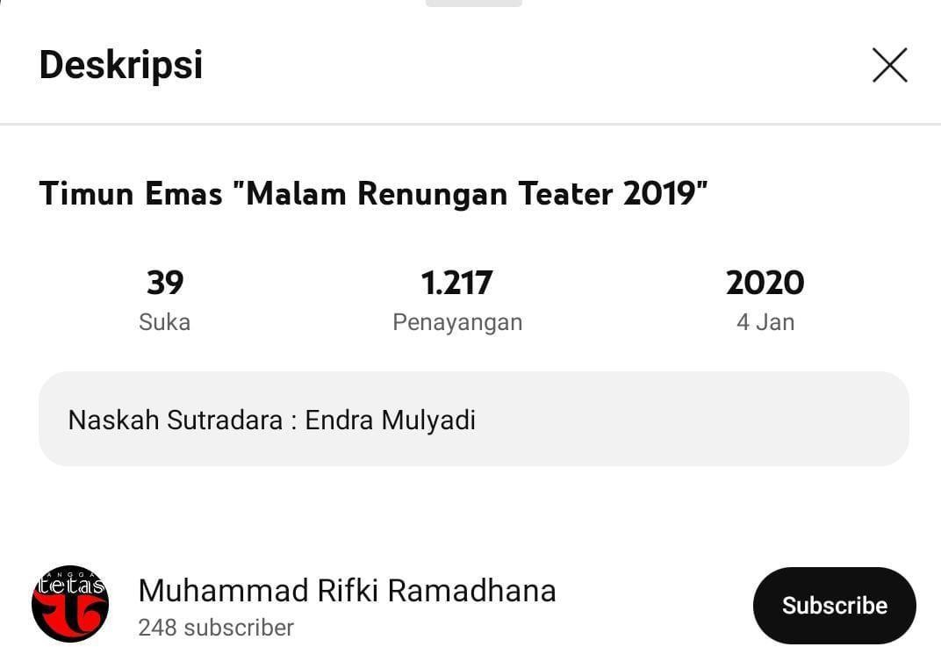
Photograph. Youtube Channel and Drama Titles

According to Yin (2011), the selection of research locations must consider the relationship of phenomena with their social context. In this study, the location was chosen because it provided a real experience for

children in watching the play and interpreting the nonverbal expressions displayed.

Variables and Indicators

Variabel
The main variable in this study was nonverbal expression in the performance of the drama Timun Emas.

Indicator
The indicators analyzed include:

- Facial expressions: describe emotions such as fear, sadness, anger, happiness (Ekman, 2003).
- Gestures: physical movements such as running, bending, waving (Burgoon et al., 2010).
- Posture: an upright, lethargic, aggressive body posture that reflects the feelings of the character.
- Eye contact: sharp gaze, avoidance, glance as a sign of emotional connection between characters (Knapp & Hall, 2010).
- Voice intonation: volume, tempo, and tone of voice that support the meaning of the message (Matsumoto & Hwang, 2013).

This indicator was chosen because according to Birdwhistell (2010), nonverbal communication encompasses almost all human behaviors that can provide meaning other than words.

Research Instruments
The main instrument in qualitative research is the researcher

himself. According to Sugiyono (2018), researchers play the role of the main instrument that plans, implements, collects data, analyzes, and concludes research results.
Auxiliary instruments in this study include:

- Observation Sheet, used to record nonverbal expressions displayed by actors.
- Semi-Structured Interview Guide, contains a list of open-ended questions about a child's perception of nonverbal expression.
- Documentation tools, in the form of cameras, video recordings, and field notes as visual data.

According to Creswell (2014), the use of this auxiliary instrument is needed to increase the reliability of data through triangulation methods.

Data Collection Techniques
The three main techniques used in this study are:

- Direct Observation

Observations were made while the children were watching the drama Timun Emas. The goal is to identify the nonverbal expressions displayed by the actor. Spradley (2016) stated that field observation provides a detailed picture of behaviors that arise in natural contexts.

- Semi-Structured Interviews

Interviews were conducted with 20–30 children who were selected as informants. The questions were focused on how they interpreted nonverbal expressions. Esterberg (2002) explained that semi-structured interviews provide a space for researchers to dig deeper into information according to the child's response.

- Documentation

Data in the form of photos, videos, and field notes were collected as empirical evidence. Bowen (2009) states that documentation is an important secondary data source to complement observations and interviews.

Data Analysis Techniques
The data were analyzed using the Miles & Huberman (1994)

model which consists of three main steps:

- Data Reduction, which is sorting out relevant data from observations, interviews, and documentation.
- Data Presentation, which is compiling data in the form of descriptive narratives, tables, or charts to facilitate understanding.
- Drawing Conclusions and Verification, which is compiling the final interpretation and verifying the findings with other data.
According to Creswell (2014), qualitative data analysis is cyclical and takes place throughout the research process, not just at the end.

CHAPTER IV RESULTS AND DISCUSSION

Research Results

Overview of Golden Cucumber Drama Show
The drama performance of Timun Emas was staged by the theater group Sanggar Tetas in the activities of Forum Anak Sambirejo Timur (FASTi). The performance lasted about 30 minutes and was attended by more than 30 children aged 10–18 years. The story follows a classic plot: the Timun Emas is chased by Buto Ijo, then saves himself with the help of a magical object from a hermit.
The dialogue in the show is kept short so that children can easily understand the plot. However, the meaning of the story is transmitted more through nonverbal expressions: face, gestures, posture, eye contact, and voice intonation. This reinforces the theory of Knapp & Hall (2010) that most emotional meanings in communication are captured through nonverbal channels.

Nonverbal Forms of Expression
The results of the performance observations show that there are several dominant forms of nonverbal expression that are effective in conveying the emotions of the characters and strengthening the story.

Nonverbal  Aspects | Emotions/Behavior  Indicators | Examples in the Show | Meaning Conveyed
Facial Expressions | Scared, angry, sad, happy | - Timun Emas: eyes enlarged, lips open when chased by Buto Ijo. - Mother: face down, eyes teary when separated. - Buto Ijo: eyebrows lowered, mouth gaping while screaming. | Communicate fear, compassion, and anger.
Gestures | Running, pointing, clenching hands, bending | - Timun runs in a hurry. - Buto Ijo clenched his fists aggressively. | Shows tension, dominance, and conflict.
Posture | Stooped, stooped, lethargic | - Buto Ijo always stands upright. – Timun Emas tend to bend over when frightened. | Shows the difference in the strength and vulnerability of the  characters.
Eye Contact | Sharp, soft, evasive gaze | - Buto Ijo gaze pressed against the Timun Emas. - Mother's gaze is loving. | Conveying the emotional relationship between the characters.
Voice Intonation | Hard, soft, firm | - Buto Ijo shouted in a loud voice. - Mother speaks softly. | Reinforcing scary vs loving effects.
Table 4.1
Nonverbal Forms of Expression in the Timun Emas Performance

These findings support Ekman's (2003) assertion that facial expressions are universal in nature so they can be easily understood by everyone, including children.
a. Buto Ijo fights against the legacy of the Timun Emas
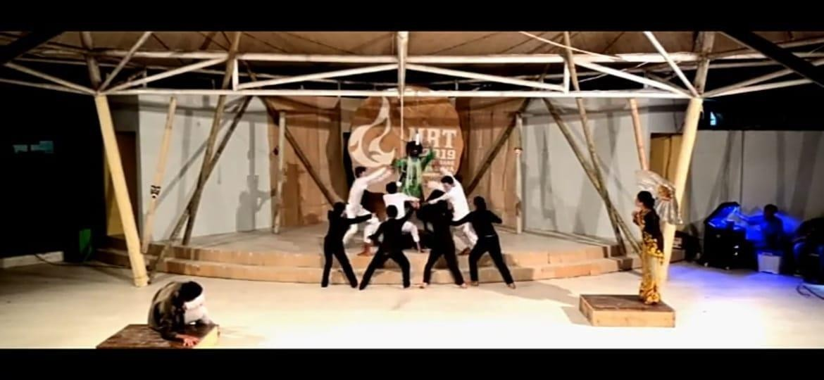

- Timun Emas Mother: Shows sadness with a downcast face, teary eyes, and slow movements when parting with her child.
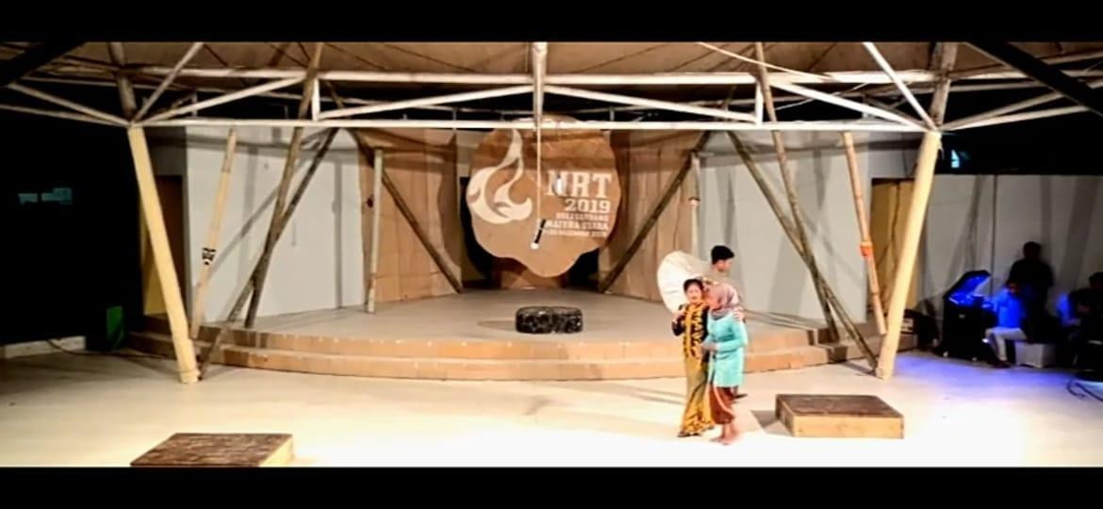

- Buto Ijo: Uses an angry expression with downward arched eyebrows, sharp eyes, and a gaping mouth while making a loud noise.

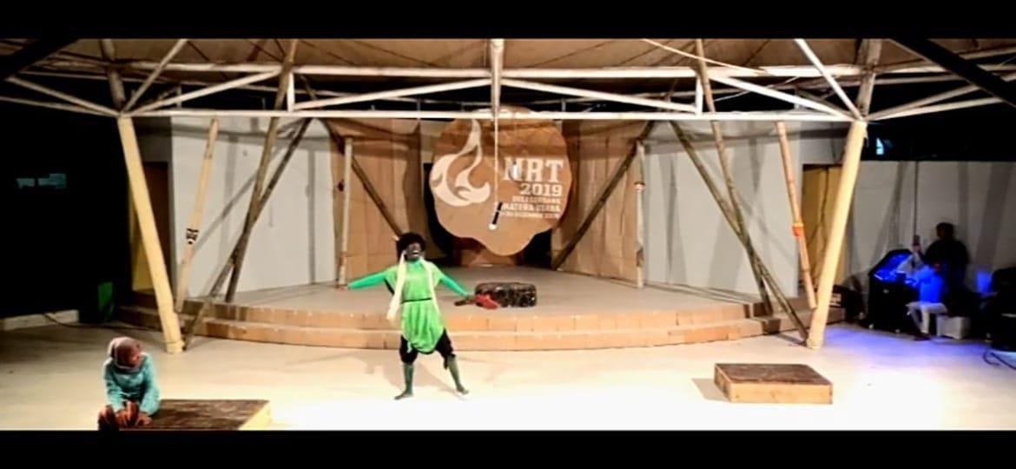

- Movement

  - The Timun Emas movement of running, bending, and pointing is used to clarify feelings of fear or anger.
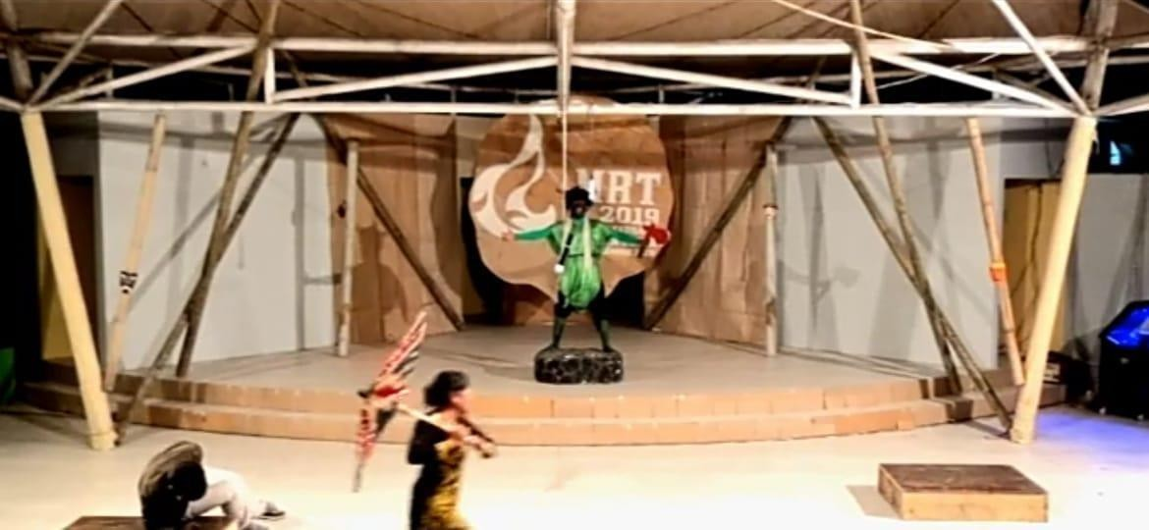
Photograph. Golden Cucumber Running
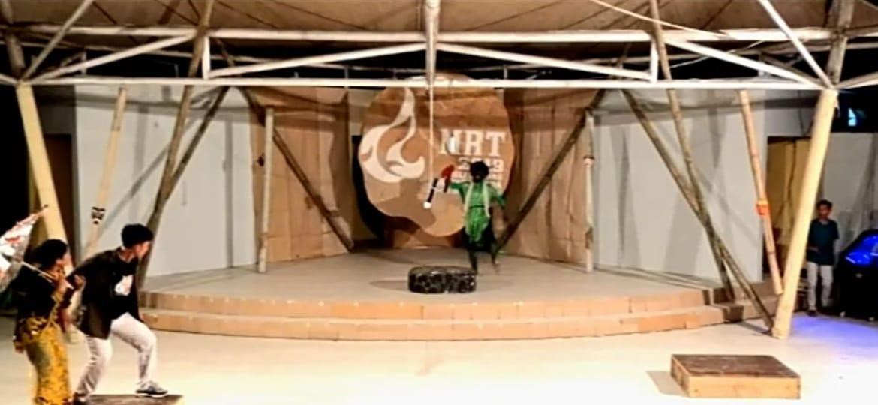

Photograph. Golden Cucumber Bows in Fear

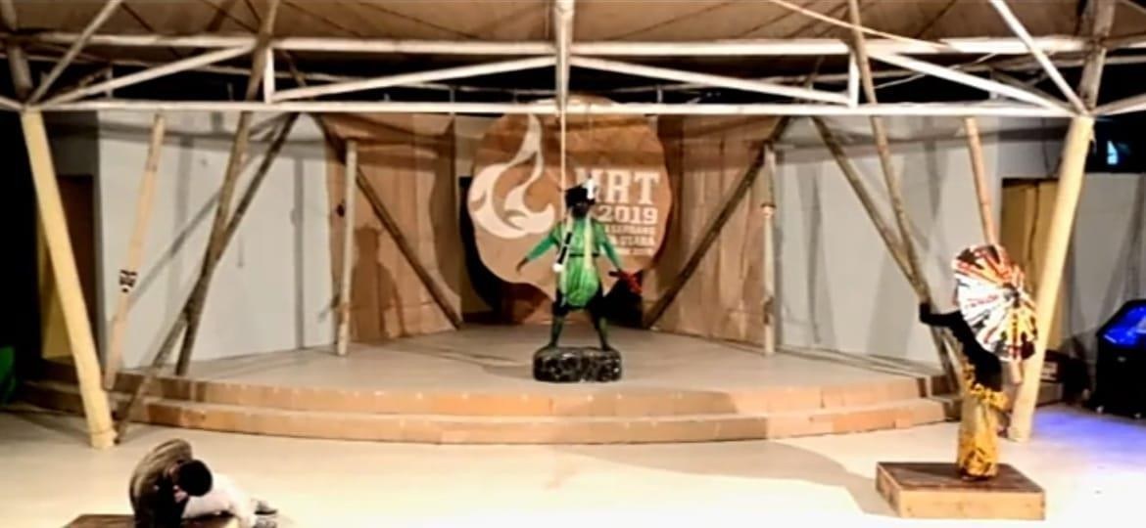
Photo. Golden Cucumber Show

  - Buto Ijo often clenched his fists and swung them forward, reinforcing his aggressive impression.

  - The movement of the Golden Cucumber's hand grasping hermit objects

done carefully and expressively
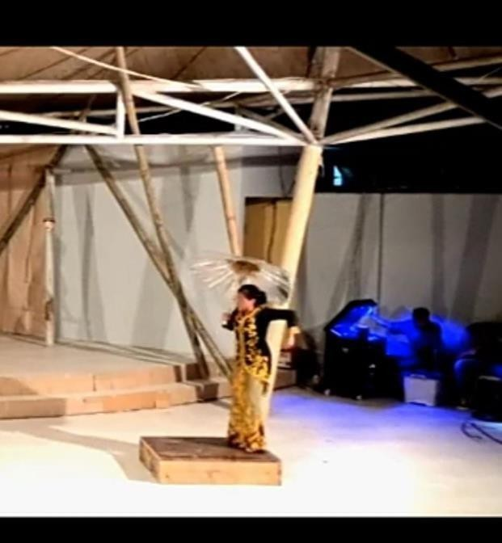
  - Timun Emas was frightened when his lover lost against Buto Ijo, while Buto Ijo stood tall and dominated the stage.
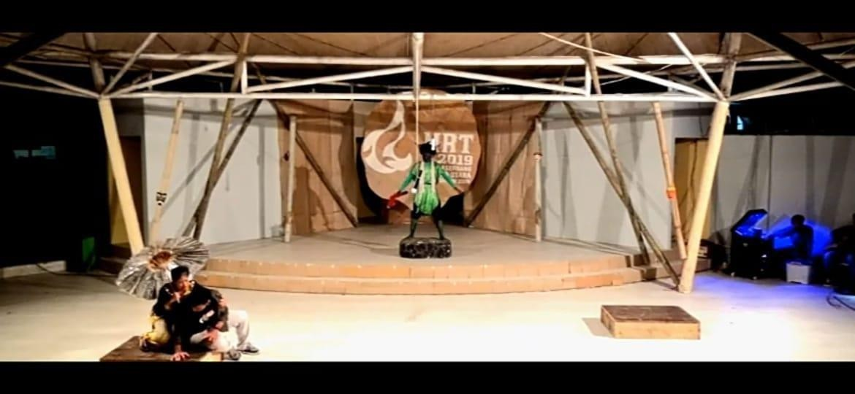
Photograph. Golden Cucumber Feared

  - Buto Ijo fights against the legacy of the Timun Emas

- Intonation and Volume of Sound

  - The volume of the voice increased as the conflict peaked, especially when Buto Ijo shouted angrily.
  - A soft voice is used by Mother Timun Emas when giving advice to her child, showing affection.

Children's Perception of Performing Arts
The results of interviews with 25 children in the audience showed:
      - Understanding Character Emotions

        - 80% of children stated that they can find out the feelings of a character only through facial expressions and body movements.
        - Children aged 10–13 years emphasize more concrete visual aspects, such as the fear face of the Timun Emas.
        - Children aged 14–18 years are already able to interpret symbolic meanings, for example, magical objects of ascetics are understood as symbols of hope.
      - Emotional Response

        - Most children feel "scared but happy" when they watch the chase scene.
        - In the farewell scene, many children admitted that they felt sad because of the expression on their mother's face.
      - Moral Values Captured

        - Almost all children cite the values of courage, ingenuity, and parental affection as the main message of the drama.
        - Adolescents (14–18 years old) tend to emphasize courage in the face of problems, while 10–13 year olds highlight maternal affection more.
These findings are in line with Piaget's developmental theory (in Santrock, 2011) that children of concrete surgical age

understand real things, while children of formal surgery age are able to interpret abstract and symbolic meanings.

Research Discussion

The Effectiveness of Nonverbal Expressions in Telling Stories
The results of the study show that nonverbal communication is effective in helping children understand the story of the Timun Emas. Without much dialogue, children are able to capture the emotions of the characters and the core of the story through facial expressions, gestures, and voice intonation.
This supports the findings of Burgoon, Guerrero, & Floyd (2010) who stated that nonverbal communication has an important role in the formation of emotional meaning. Even according to Mehrabian (in Knapp & Hall, 2010), 93% of emotional meaning is transmitted through nonverbal aspects.

Differences in Children's Perceptions by Age
The difference in comprehension between 10–13 year olds and 14–18 year olds is obvious:
      - Children aged 10–13 focus on concrete signs (face, movement).
      - Children aged 14–18 can already understand symbolic meanings (e.g., magical objects as a symbol of ingenuity).
This difference is consistent with Piaget's theory, that children at the concrete surgery stage understand things visually, while at the formal surgery stage they are already able to think abstractly (Santrock, 2011).

Children's Drama as a Medium for Character Understanding

The drama Timun Emas has proven to function as a medium of character education. Moral values such as courage, ingenuity, and compassion are clearly conveyed.
This research supports the results of Lestari (2021) who found that folklore can be used as a means of shaping children's character because it presents conflicts and solutions that are in accordance with real life. In addition, these results also strengthen the findings of Amalia (2020) that children's drama increases social empathy through the appreciation of nonverbal expressions. Thus, folklore-based dramas are not only entertainment,
but also an effective educational means in shaping children's characters.

Relevance to Nonverbal Theory of Expression
The findings of this study reinforce the theories of nonverbal communication from Burgoon et al. (2010), Ekman (2003), and Matsumoto & Hwang (2013). Children are proven to understand moral messages through body language, facial expressions, eye contact, and the intonation of actors' voices.
In other words, nonverbal communication in children's dramas can be seen as an effective character education medium, because it is able to channel moral messages visually and emotionally, according to the child's stage of cognitive development.

CLOSING CHAPTER V

Conclusion
Based on the results of research and discussion on the analysis of nonverbal expressions in the drama performance of Timun Emas for children aged 10–18 years at the Forum Anak Sambirejo Timur (FASTi), several conclusions can be drawn as follows:
    - Forms of Nonverbal Expression in Drama
The Timun performance uses a lot of nonverbal expressions which include facial expressions, gestures, posture, eye contact, and voice intonation. Facial expressions are the most dominant component in conveying the character's emotions, for example the fear of the Timun Emas, the mother's affection, and the anger of Buto Ijo. Body movements and voice intonation also play a big role in emphasizing the conflict of the story. These findings support Ekman's (2003) theory that facial expressions are a universal form of communication that is able to convey emotions across cultures.
    - Children's Perception of Nonverbal Expressions

Children are able to capture the meaning of stories through nonverbal expressions. Most (80%) stated that they could understand the characters' feelings just by looking at facial expressions and body movements. Children aged 10–13 years tend to understand concrete visual aspects, while children aged 14–18 years are already able to grasp symbolic meanings, for example magical objects are understood

as symbols of ingenuity and hope. This is in accordance with Piaget's theory (in Santrock, 2011) about cognitive development from the stage of concrete operation to the stage of formal operation.
    - The Effectiveness of Nonverbal Expressions in Conveying Moral Messages
The drama Timun Emas has proven to be effective in conveying moral values through nonverbal communication. Children not only understand the storyline, but also absorb the values of courage, ingenuity, and compassion. These results strengthen the research of Lestari (2021) which states that folklore is effectively used as a medium for character formation, and supports the findings of Amalia (2020) on the role of children's drama in increasing social empathy.
    - Children's Drama as a Character Education Media

Drama performances based on folklore can have a dual function, namely as entertainment and at the same time as a means of character education. Nonverbal communication has proven to be a medium that is easier for children to understand, in line with the view of Burgoon, Guerrero, & Floyd (2010) that nonverbal has a significant contribution in shaping the audience's understanding and emotional attitudes.
In general, it can be concluded that nonverbal communication in children's drama performances is not just supportive, but is at the core of conveying moral messages. The drama of Timun Emas at the
Forum Anak Sambirejo Timur succeeded in showing that nonverbal

expressions can be an effective means of character learning for children aged 10–18 years.

Suggestion
Based on the findings of the research, the author provides the following suggestions:
    - For Children's Theatre Activists
It is recommended to further optimize the use of nonverbal expressions in performances. Body movements, facial expressions, and voice intonation need to be deepened so that moral messages are conveyed more strongly. This is in line with the recommendation of Matsumoto & Hwang (2013) that nonverbal communication is the most effective means of conveying emotions to cross-age audiences.
    - For Teachers and Children's Facilitators

Children's dramas can be used as an alternative to character learning methods that are more fun than conventional methods such as lectures. The Timun Emas Performance can be used as an educational medium to instill the values of courage, honesty, and compassion. Teachers should take advantage of folklore-based dramas because they are relevant to children's lives and full of local cultural values (Lestari, 2021).
    - For Children's Forum (FASTi) and Similar Institutions

Art performances such as dramas should be held regularly, because in addition to entertaining, they are also effective as a means of character education. Children's Forum can make drama a medium

of expression as well as contextual learning according to children's needs.
    - For the Next Researcher

This research can be further developed by:

      - Comparing the effectiveness of verbal and nonverbal communication in children's drama.
      - Examine how children re-express moral values through role-play.

      - Conduct comparative research with other folklore to see how different their effects affect character formation.
- For Parents

Parents are expected to support their children to engage in arts activities, especially local culture-based dramas. Thus, the child is not only entertained, but also learns moral values through emotional experiences.

Closing
This study proves that nonverbal communication in the drama performance of Timun Emas is effective as a medium for conveying moral messages and forming children's character. Through facial expressions, body movements, eye contact, posture, and voice intonation, children aged 10–18 can understand the value of courage, ingenuity, and compassion well.
The results of this study are expected to enrich the study of nonverbal communication in the performing arts while making a practical

contribution to the world of education, art, and children's character development.

BIBLIOGRAPHY

Amalia, R. (2020). Children's drama as a medium for the formation of social empathy. Journal of Character Education, 10(2), 145–156
Bowen, GA (2009). Document analysis as a qualitative research method. Journal of Qualitative Research, 9(2), 27–40.
Burgoon, JK, Guerrero, LK, & Floyd, K. (2010). Komunikasi nonverbal. Routledge.
Creswell, JW (2014). Research design: Qualitative, quantitative, and mixed method approaches (4th edition). SAGE Publications.
Ekman, P. (2003). Emotions revealed: Recognizing faces and feelings to improve communication and emotional life. Times Books.
Esterberg, K. G. (2002). Qualitative methods in social research. McGraw-Hill.
Etikan, I., Musa, S.A., & Alkassim, R.S. (2016). Comparison of convenience sampling and intended sampling. American Journal of Theoretical and Applied Statistics, 5(1), 1–4.
Knapp, M.L., & Hall, J.A. (2010). Nonverbal communication in human interaction (7th edition). Wadsworth Cengage Learning.
Lestari, N. (2021). Folklore as a means of forming children's characters. Journal of Education and Culture, 6(1), 33–45.
Matsumoto, D., & Hwang, H.S. (2013). Cultural similarities and differences in symbolic movements. Journal of Nonverbal Behavior, 37(1), Miles, MB, & Huberman, A.M. (1994). Qualitative data analysis: An
expanded source book (2nd edition). SAGE Publications.

Patton, MQ (2015). Qualitative research & evaluation methods: Integrating theory and practice (4th edition). SAGE Publications.
Prasetyo, A. (2019). Nonverbal communication in traditional theater as a means of character education. Journal of Performing Arts, 8(2), 77–89.
Santrock, J.W. (2011). Child development (13th edition). McGraw-Hill. Spradley, J.P. (2016). Participant observation. Press Waveland.
Sugiyono. (2018). Qualitative, Quantitative, and R&D Research Methods. Alfabeta.
Supriyadi, D. (2016). Children's drama as a means of character education. Bandung: Pustaka Setia.
Wulandari, F. (2020). Children's drama games and an understanding of local cultural values. Journal of Educational Sciences, 12(3), 201–212.
Yin, R.K. (2011). Qualitative research from start to finish. Guilford Press.

ATTACHMENT

Appendix 1 – Interview Sheet Appendix 2 – Interview Transcript
Appendix 3 – Appendix Nonverbal Expression Observation Sheet

Appendix 1

Interview Guide

Respondent Identity (anonymous):

Interview Code: W01–W25 Age:............
Gender:............

Interview Date: ............

Location: East Sambirejo Children's Forum Interview Questions:
How do you feel after watching the Golden Cucumber Drama? Which scene do you like or remember the most? Why?
How do you think Mencupinun Emas feels when chased by Buto Ijo? Without words, you can tell how the character feels? Where do you know? Which part makes you happy, scared, or sad?
Do you understand the story better from their movements and facial expressions? What message or lesson did you get from the play?

Appendix 2

Interview Transcript

Interview Code: W07 Age: 12 years old Gender: Female Date: March 21, 2025

Researcher: Do you like the drama? Respondent: I like it, because it's fun and Buto Ijo is funny but also scary. Researcher: Do you know where Buto Ijo got angry from? Answer: From his face he was so fierce, he kept shouting while chasing. Researcher: Is there a part that makes you sad? Answer: It's time for the Golden Cucumber to say goodbye to his mother. His mother cried, but she didn't say anything, she was very sad. Researcher: What do you think this play teaches? Respondent: We must be brave and obedient to our parents.

Appendix 3

Non-Verbal Expression Observation Sheet

Yes | Observed Aspects | Indicator | Observation Notes
1 | Facial expressions | Fear, anger, sadness, joy | Buto Ijo showed anger with bulging eyes and lowered eyebrows. Golden Cucumber looked frightened as he retreated with a tense face.
2 | Movement | Run, bend, show, hug | The Golden Cucumber fled in a hurry while looking back. Mother hugged the Golden Cucumber slowly, expressively.
3 | Attitude | Firm, lethargic, ready to attack | Buto Ijo always stands tall and dominant. Golden Cucumbers tend to bow when frightened.
4 | Eye Contact | Intense, evasive, glancing | There was sharp eye contact between Buto Ijo and Golden Cucumber during the chase scene.
5 | Voice | Loud, slow, firm | Buto Ijo shouted loudly while chasing. Mother spoke softly while giving advice.
6 | Children | Laugh | The children laughed when Buto Ijo slipped. He was  silent during the farewell scene of the Golden Cucumber and

Yes | Observed Aspects | Indicator | Observation Notes
 | Reaction | Fear, silence | mother.

