ACKNOWLEDGEMENT

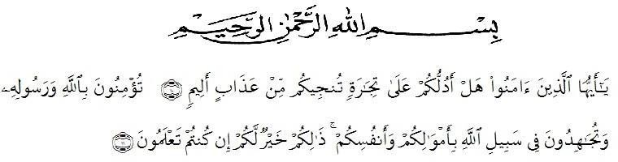

Means:

O you who have believed, would you like me to show you a business that can save you from a painful punishment? (That is) you believe in Allah and His Messenger and wage jihad in the cause of Allah with your wealth and soul. That's what you'd be better off if you knew it. (As- Shaff: 10-11)
Praise the presence of God Almighty because by His grace and grace, the author was able to complete a thesis entitled "Analysis of Non-Verbal Expressions in The Timun Emas Drama Performances" for Children Aged 10-18 Years at FASTi (East Sambirejo Children's Forum) as one of the requirements to obtain a Bachelor of Literature degree in English Literature Study Program, Faculty of Letters, Muslim Nusantara Al Washliyah University Medan. The writing of this thesis is inseparable from the help, support, and prayers of various parties. Therefore, the author expresses his deepest gratitude to:

- Mr. Dr. H. Firmansyah, M.Si, as the Rector of the Muslim University of Nusantara Al Washliyah Medan
- Mrs. Ayu Melati Ningsih, S.Pd., M.S., M.Pd as the Dean of the Faculty of Letters, Muslim Nusantara University Al Washliyah Medan;
- Mrs. Vera Kristiana, S.Pd., M.Pd as the Head of the English Literature Study Program as well as a supervisor who has guided with patience and precision;
- All resource persons from the Forum Anak Sambirejo Timur (FASTi) who have been willing to be respondents in this study;
- Dear Father, Damiran and Mother, Susiyanti, I dedicate this thesis to you who have filled my world with so much happiness that a lifetime is not enough to enjoy it all. Because of the two of you, life feels so easy and full of happiness. Thank you for always letting me pursue my dreams no matter what. Health and long life to you both, I love you very much.
- My two dear brothers and sisters, Muhammad Ferry Hidayat, Muhammad Arief Aldiansya, and Shinta Anzani, always helped and accompanied me all the time. Thank you so much, I'm lucky to have you guys;
- Dear husband of Saka Palwaguna S.Pd and dear ananda Aretha Gistara Megumi for their extraordinary understanding, prayers and enthusiasm so that it became the driving force for me to complete this thesis. Thank you for your love and prayers that always cool your heart. Hopefully this thesis can be proof of our sincerity and hard work together.
- The entire extended family is grateful for your support and prayers for the author, providing the input and even direction that the author needs during the completion of this thesis;
- To my two dear friends Tiara Arianto S.S and Defitri Herlambang S.S from

the first semester to the last semester who have provided great support, motivation, helped me in completing this thesis, always there when I was meed. I love you so much friends.
- The writer's friend in the English Literature Study Program who always provides support during the process of preparing this thesis. The author realizes that this thesis is still far from perfect.

Therefore, the author is very much looking forward to constructive criticism and suggestions for future improvements. Hopefully this thesis can provide benefits for the development of science, especially in the field of literature and non-verbal communication.
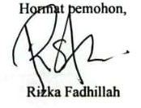
Medan, 03 Juli 2025

BIBLIOGRAPHY

VERIFICATION SHEET I
ABSTRACT II
FOREWORD III
BIBLIOGRAPHY IV
CHAPTER I INTRODUCTION 1
  - Background of the Problem 1
  - Problem Identification 3
  - Problem Limitation 4
  - Problem Formulation 4
  - Research Objectives 5
CHAPTER II LITERATURE REVIEW 6
  - Theoretical Framework 6
  - Previous Research 10
  - Conceptual Framework 11
  - Hipotesis 12
CHAPTER III RESEARCH METHODOLOGY 13
  - Types of Research 13
  - Population/Sample 13
  - Research Location 15
  - Variables and Indicators 16
  - Research Instruments 16
  - Data Collection Techniques 17
  - Data Analysis Techniques 18
CHAPTER IV RESULTS AND DISCUSSION 19
  - Research Results 19
  - Research Discussion 27
CLOSING OF CHAPTER V 30
  - Conclusion 30
  - Suggestion 32
REFERENCE 33

ATTACHMENT………………………………………………………………...

