CHAPTER II

LITERATURE REVIEW

Theoretical Framework

Children's Drama
Drama is a form of performing arts that combines verbal elements in the form of dialogue with nonverbal elements in the form of facial expressions, gestures, and voice intonation. Through drama, emotional and moral messages can be conveyed in a more lively and contextual way. According to Supriyadi (2016), children's drama functions as a fun educational tool because it combines entertainment with learning values. Drama can stimulate imagination, creativity, and foster children's social skills.
Children's dramas have their own characteristics compared to dramas for adults. First, the storyline is simple and easy to understand. Second, the characters are usually taken from familiar folklore or fairy tales. Third, the element of nonverbal expression is highlighted so that moral messages can be more easily understood by children who tend to be more sensitive to visual symbols. This is in line with Wulandari (2020) who states that children's drama games help children recognize basic emotions, such as joy, sadness, fear, and anger, through nonverbal expressions.

In the context of education, children's drama not only conveys entertainment, but also forms character. Folklore such as Timun Emas is a very suitable performance material because it is loaded with the values of courage, ingenuity, compassion, and sacrifice. According to Lestari (2021), folklore performances are able to instill character values more deeply because children not only hear or read, but also experience emotionally through the expressions of the characters they play.

Non-Verbal Communication in the Performing Arts
Nonverbal communication is the delivery of messages without using words. This form of communication includes facial expressions, body movements, posture, intonation, and the use of space. Burgoon, Guerrero, & Floyd (2010) stated that nonverbal communication accounts for a larger portion than verbal communication in conveying a person's emotions and attitudes. As such, nonverbal communication is often more honest and spontaneous than speech.
In the performing arts, nonverbal communication is one of the main elements. Knapp & Hall (2010) explain that in human interaction, the nonverbal aspect contributes significantly to the meaning that the audience receives. Ekman (2003) added that facial expressions are universal and can be understood across cultures, so they are able to convey emotions clearly even without the help of words.
Matsumoto & Hwang (2013) further emphasized that nonverbal expressions, particularly facial expressions, serve as the main indicators of emotions that can be understood by all age groups, including children.

Therefore, actors in drama performances must master the skills of nonverbal expression in order for moral messages to be conveyed effectively.
The types of nonverbal communication in drama can be classified as follows:
- Kinesik, in the form of facial expressions, hand movements, and body language that describes the emotions of the character.
- Proxemic, which is the use of physical distance between characters that shows closeness, conflict, or dominance.
- Paralingual, which is vocal aspects such as intonation, volume, and tempo of the voice that reinforce the meaning of words.
- Haptics, which are communication through touch, for example a hug to show affection or an urge to show anger.
In the context of the drama Timun Emas, the kinetic and paralinguistic aspects are very dominant, because the tension of the story is often shown through the movements of the Golden Cucumber's running body or the terrifying loud voice of Buto Ijo.

Development of Children Aged 10-18 Years
Understanding how 10–18-year-olds interpret nonverbal expressions in drama requires an understanding of their cognitive and psychosocial development. Piaget (in Santrock, 2011) states that children aged 7–11 years are at the stage of concrete operation, where they begin to think logically but are still attached to concrete and visual things.
Children aged 12 and above enter the formal surgery stage, where they

begin to be able to think abstractly, understand symbols, and interpret moral meanings implicitly.
In addition, according to Erikson (2014), children aged 10–18 years are in the industrial phase vs inferiority (10–13 years) and identity vs role confusion (14–18 years). In this phase, children try to find their identity and values that they can hold. Therefore, dramas with strong moral messages can help them reinforce positive identities while instilling the values of courage, ingenuity, and compassion.
Thus, children aged 10–18 years are a group of viewers who have the potential to receive moral messages through nonverbal expressions. They are able to understand the characters' emotions through facial expressions and body movements, and begin to relate them to abstract values such as honesty and courage.

Folklore as a Medium for Character Understanding
Folklore is a form of oral tradition that is passed down from generation to generation and is loaded with moral, social, and cultural values. According to Lestari (2021), folklore functions as a means of character education because it presents conflicts, characters, and solutions that can be an example for children. Timun Emas , for example, teaches the value of courage to face challenges, ingenuity in facing problems, and sincere parental affection.
Amalia (2020) found that folklore-based drama is effective in forming children's social empathy. Through the nonverbal expression of
the characters, children can learn to feel the emotions of other characters,

making it easier to cultivate an empathetic attitude. Prasetyo (2019) also emphasized that nonverbal communication in traditional theater is easier for children to understand and remember than long dialogues.
Therefore, the use of folklore in children's dramas can be an effective medium for character education, as it presents moral values through strong visual and emotional experiences.

Previous Research
Studies relevant to this topic include:

- Amalia (2020) researches children's drama in the formation of social empathy. The results showed that actors' nonverbal expressions made it easier for children to understand the value of empathy than verbal delivery.
- Prasetyo (2019) examined nonverbal communication in traditional theater and found that gestures and mimicry are more effective in conveying moral messages to children than long words.
- Lestari (2021) researched folklore-based drama as a medium for character building, and the results showed an increase in the value of courage and honesty in elementary school children.
- Wulandari (2020) emphasized the role of children's drama games in strengthening the understanding of local cultural values through nonverbal communication.
- Matsumoto & Hwang (2013) affirm that facial expressions are universal so that children can understand emotional messages across cultures and ages.

From the previous study, it can be concluded that research on nonverbal communication in children's drama has been quite extensive, but it is still limited to traditional plays or general educational dramas. This research fills the gap by focusing on the Timun Emas drama at the Forum Anak Sambirejo Timur as a specific local context.

Conceptual Framework
Based on previous theories and research, the conceptual framework of this research can be explained as follows:
- Children's Drama is a medium that combines verbal and nonverbal to convey stories.
- Nonverbal communication serves as the main channel in conveying emotional messages, particularly through facial expressions, body movements, posture, eye contact, and voice intonation.
- Children aged 10–18 years are a group of spectators who are sensitive to nonverbal expressions, so their understanding of moral values is greatly influenced by visual cues.
- Timun Emas Folklore is a material that is rich in moral values and suitable for use in children's dramas.
This framework shows that the effectiveness of the Timun Emas drama in conveying moral messages is largely determined by the use of nonverbal expressions, and the perception of children aged 10–18 years is an indicator of its success.

The following illustrates the relationship between children's drama, nonverbal communication, Timun Emas folklore, 10–18-year-old audiences, and their understanding of moral messages.

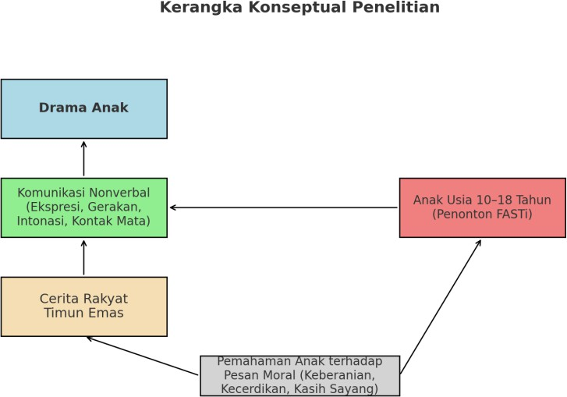

Hipotesis
Based on the conceptual framework, the hypothesis of this study is:

"The nonverbal expressions displayed in the drama performance of Timun Emas have a significant effect on the understanding of children aged 10–18 years in capturing the moral message of the story."

