CHAPTER III RESEARCH METHODOLOGY

Types of Research
This study uses a descriptive qualitative approach. The qualitative approach was chosen because the purpose of the study was to understand the phenomenon of nonverbal expression in the performance of the drama Timun Emas in depth from the perspective of the audience of children aged 10–18 years.

Creswell (2014) explains that qualitative research is an approach to explore and understand the meaning that individuals or groups perceive to a social problem. Thus, qualitative research allows researchers to interpret how children capture moral messages through nonverbal expressions in drama.

The type of research used is descriptive because it tries to describe the phenomenon of nonverbal communication as it is, without manipulating variables. According to Sugiyono (2018), qualitative descriptive research aims to describe real conditions in the field and explain the meaning of data based on context.

In other words, this study seeks to present a detailed description of the forms of nonverbal expression in the drama Golden Cucumber and children's perception of these expressions.

  - Population and Sample

Populasi

The population in this study is all children aged 10–18 years who are spectators or participants in the Forum Anak Sambirejo Timur (FASTi) activities when the drama performance of Timun Emas is staged. According to Sugiyono (2018), population is a generalized area consisting of objects or subjects that have certain qualities and characteristics that the researcher sets to be studied.

Sample
Because this study uses a qualitative approach, the sampling technique used is purposive sampling, which is the selection of samples based on certain considerations. Etikan, Musa, & Alkassim (2016) stated that purposive sampling is used when researchers want to get in-depth information from the participants who are considered to know the most about the phenomenon being studied.

In this study, the sample consisted of 20–30 children aged 10–18 years who were divided into two categories:

- Children aged 10–13 years ( concrete surgery phase according to Piaget).
- Adolescents aged 14–18 years (formal surgical phase according to Piaget).

This age group division was intended so that researchers could compare differences in perceptions between children and adolescents to nonverbal expressions displayed in performances.

Research Location
The location of this research is the Forum Anak Sambirejo Timur (FASTi), a children's organization in Sambirejo Timur Village that actively organizes arts, culture, and character education activities. This forum was chosen because it is a forum for children to express themselves while learning social and cultural values.

The performance of the drama Timun Emas which became the object of research was shown at the "Theater Reflection Night 2019" activity by the theater group Sanggar Tetas and then documented on Muhammad Rifki Ramdhana's YouTube channel.
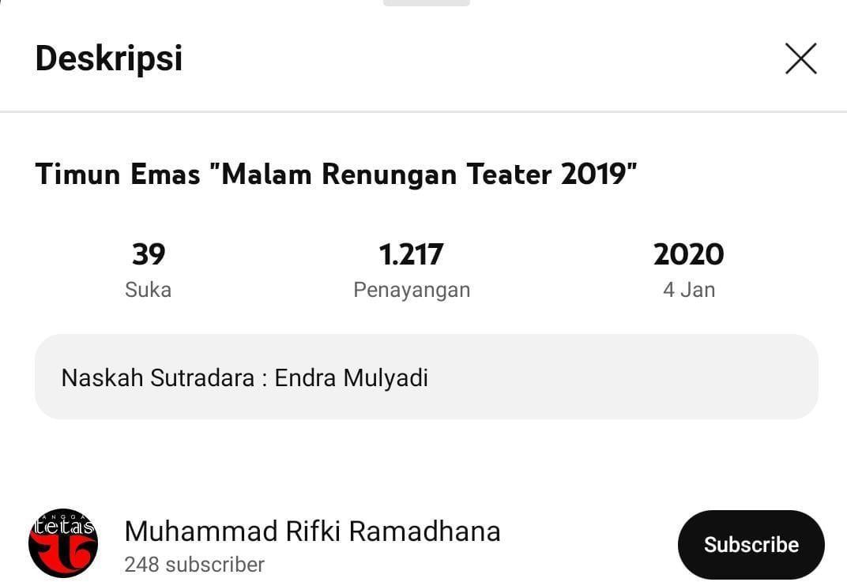
Photograph. Youtube Channel and Drama Titles

According to Yin (2011), the selection of research locations must consider the relationship of phenomena with their social context. In this study, the location was chosen because it provided a real experience for

children in watching the play and interpreting the nonverbal expressions displayed.

Variables and Indicators

Variabel
The main variable in this study was nonverbal expression in the performance of the drama Timun Emas.

Indicator
The indicators analyzed include:

- Facial expressions: describe emotions such as fear, sadness, anger, happiness (Ekman, 2003).
- Gestures: physical movements such as running, bending, waving (Burgoon et al., 2010).
- Posture: an upright, lethargic, aggressive body posture that reflects the feelings of the character.
- Eye contact: sharp gaze, avoidance, glance as a sign of emotional connection between characters (Knapp & Hall, 2010).
- Voice intonation: volume, tempo, and tone of voice that support the meaning of the message (Matsumoto & Hwang, 2013).

This indicator was chosen because according to Birdwhistell (2010), nonverbal communication encompasses almost all human behaviors that can provide meaning other than words.

Research Instruments
The main instrument in qualitative research is the researcher

himself. According to Sugiyono (2018), researchers play the role of the main instrument that plans, implements, collects data, analyzes, and concludes research results.
Auxiliary instruments in this study include:

- Observation Sheet, used to record nonverbal expressions displayed by actors.
- Semi-Structured Interview Guide, contains a list of open-ended questions about a child's perception of nonverbal expression.
- Documentation tools, in the form of cameras, video recordings, and field notes as visual data.

According to Creswell (2014), the use of this auxiliary instrument is needed to increase the reliability of data through triangulation methods.

Data Collection Techniques
The three main techniques used in this study are:

- Direct Observation

Observations were made while the children were watching the drama Timun Emas. The goal is to identify the nonverbal expressions displayed by the actor. Spradley (2016) stated that field observation provides a detailed picture of behaviors that arise in natural contexts.

- Semi-Structured Interviews

Interviews were conducted with 20–30 children who were selected as informants. The questions were focused on how they interpreted nonverbal expressions. Esterberg (2002) explained that semi-structured interviews provide a space for researchers to dig deeper into information according to the child's response.

- Documentation

Data in the form of photos, videos, and field notes were collected as empirical evidence. Bowen (2009) states that documentation is an important secondary data source to complement observations and interviews.

Data Analysis Techniques
The data were analyzed using the Miles & Huberman (1994)

model which consists of three main steps:

- Data Reduction, which is sorting out relevant data from observations, interviews, and documentation.
- Data Presentation, which is compiling data in the form of descriptive narratives, tables, or charts to facilitate understanding.
- Drawing Conclusions and Verification, which is compiling the final interpretation and verifying the findings with other data.
According to Creswell (2014), qualitative data analysis is cyclical and takes place throughout the research process, not just at the end.

