CHAPTER IV RESULTS AND DISCUSSION

Research Results

Overview of Golden Cucumber Drama Show
The drama performance of Timun Emas was staged by the theater group Sanggar Tetas in the activities of Forum Anak Sambirejo Timur (FASTi). The performance lasted about 30 minutes and was attended by more than 30 children aged 10–18 years. The story follows a classic plot: the Timun Emas is chased by Buto Ijo, then saves himself with the help of a magical object from a hermit.
The dialogue in the show is kept short so that children can easily understand the plot. However, the meaning of the story is transmitted more through nonverbal expressions: face, gestures, posture, eye contact, and voice intonation. This reinforces the theory of Knapp & Hall (2010) that most emotional meanings in communication are captured through nonverbal channels.

Nonverbal Forms of Expression
The results of the performance observations show that there are several dominant forms of nonverbal expression that are effective in conveying the emotions of the characters and strengthening the story.

Nonverbal  Aspects | Emotions/Behavior  Indicators | Examples in the Show | Meaning Conveyed
Facial Expressions | Scared, angry, sad, happy | - Timun Emas: eyes enlarged, lips open when chased by Buto Ijo. - Mother: face down, eyes teary when separated. - Buto Ijo: eyebrows lowered, mouth gaping while screaming. | Communicate fear, compassion, and anger.
Gestures | Running, pointing, clenching hands, bending | - Timun runs in a hurry. - Buto Ijo clenched his fists aggressively. | Shows tension, dominance, and conflict.
Posture | Stooped, stooped, lethargic | - Buto Ijo always stands upright. – Timun Emas tend to bend over when frightened. | Shows the difference in the strength and vulnerability of the  characters.
Eye Contact | Sharp, soft, evasive gaze | - Buto Ijo gaze pressed against the Timun Emas. - Mother's gaze is loving. | Conveying the emotional relationship between the characters.
Voice Intonation | Hard, soft, firm | - Buto Ijo shouted in a loud voice. - Mother speaks softly. | Reinforcing scary vs loving effects.
Table 4.1
Nonverbal Forms of Expression in the Timun Emas Performance

These findings support Ekman's (2003) assertion that facial expressions are universal in nature so they can be easily understood by everyone, including children.
a. Buto Ijo fights against the legacy of the Timun Emas
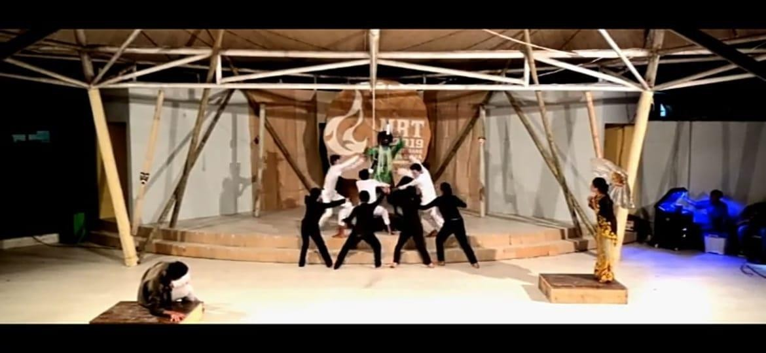

- Timun Emas Mother: Shows sadness with a downcast face, teary eyes, and slow movements when parting with her child.
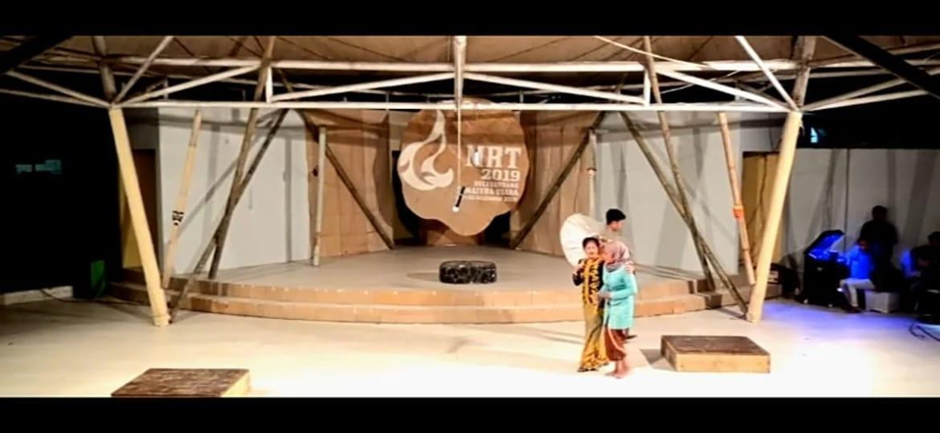

- Buto Ijo: Uses an angry expression with downward arched eyebrows, sharp eyes, and a gaping mouth while making a loud noise.

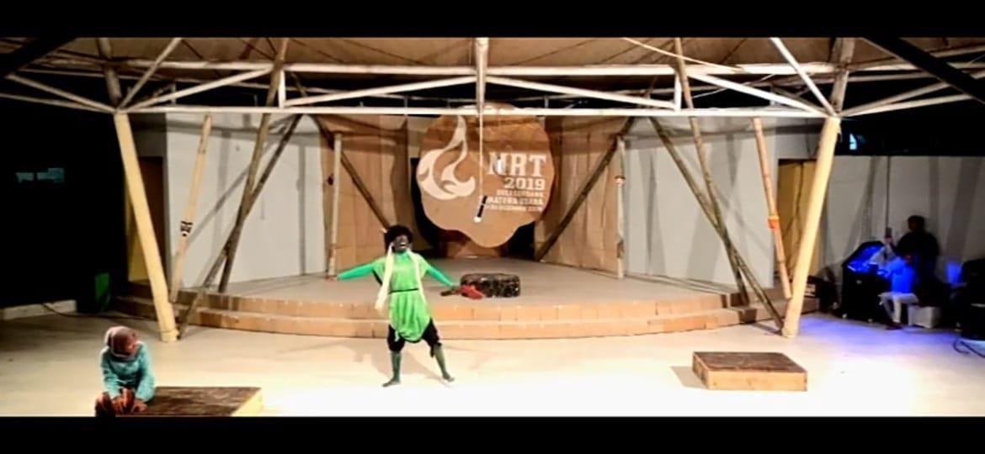

- Movement

  - The Timun Emas movement of running, bending, and pointing is used to clarify feelings of fear or anger.
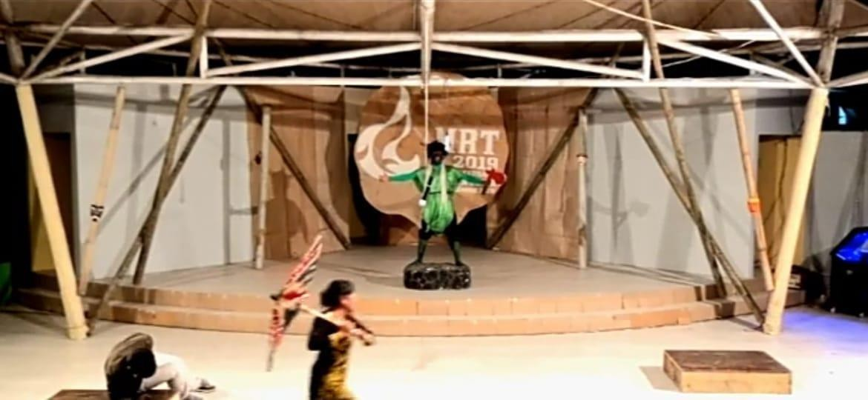
Photograph. Golden Cucumber Running


Photograph. Golden Cucumber Bows in Fear

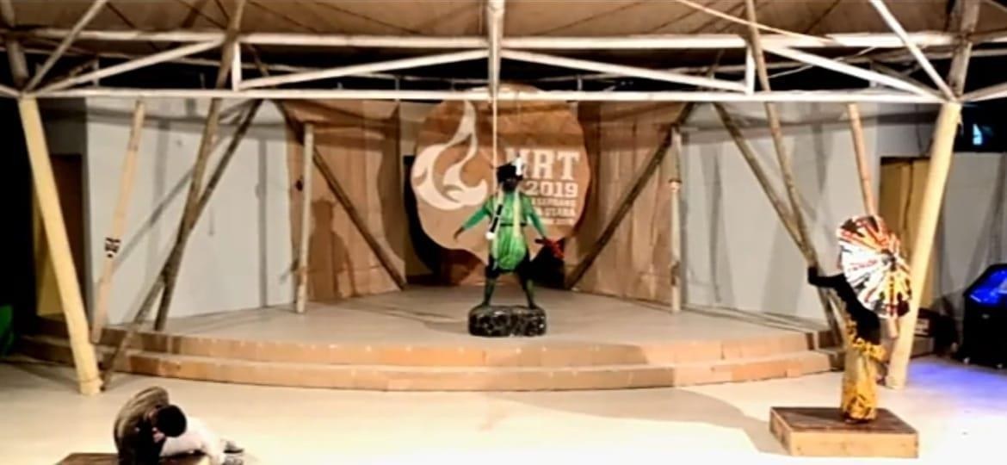
Photo. Golden Cucumber Show

  - Buto Ijo often clenched his fists and swung them forward, reinforcing his aggressive impression.

  - The movement of the Golden Cucumber's hand grasping hermit objects

done carefully and expressively
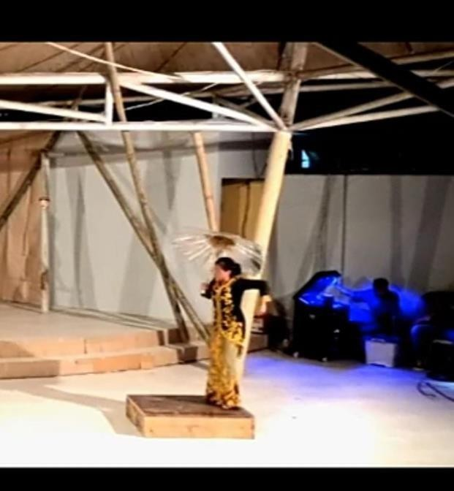
  - Timun Emas was frightened when his lover lost against Buto Ijo, while Buto Ijo stood tall and dominated the stage.
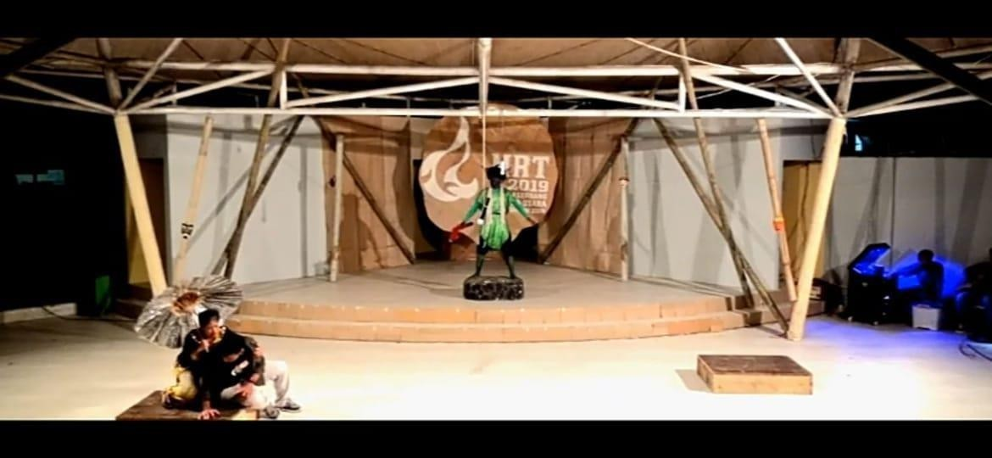
Photograph. Golden Cucumber Feared

  - Buto Ijo fights against the legacy of the Timun Emas

- Intonation and Volume of Sound

  - The volume of the voice increased as the conflict peaked, especially when Buto Ijo shouted angrily.
  - A soft voice is used by Mother Timun Emas when giving advice to her child, showing affection.

Children's Perception of Performing Arts
The results of interviews with 25 children in the audience showed:
      - Understanding Character Emotions

        - 80% of children stated that they can find out the feelings of a character only through facial expressions and body movements.
        - Children aged 10–13 years emphasize more concrete visual aspects, such as the fear face of the Timun Emas.
        - Children aged 14–18 years are already able to interpret symbolic meanings, for example, magical objects of ascetics are understood as symbols of hope.
      - Emotional Response

        - Most children feel "scared but happy" when they watch the chase scene.
        - In the farewell scene, many children admitted that they felt sad because of the expression on their mother's face.
      - Moral Values Captured

        - Almost all children cite the values of courage, ingenuity, and parental affection as the main message of the drama.
        - Adolescents (14–18 years old) tend to emphasize courage in the face of problems, while 10–13 year olds highlight maternal affection more.
These findings are in line with Piaget's developmental theory (in Santrock, 2011) that children of concrete surgical age

understand real things, while children of formal surgery age are able to interpret abstract and symbolic meanings.

Research Discussion

The Effectiveness of Nonverbal Expressions in Telling Stories
The results of the study show that nonverbal communication is effective in helping children understand the story of the Timun Emas. Without much dialogue, children are able to capture the emotions of the characters and the core of the story through facial expressions, gestures, and voice intonation.
This supports the findings of Burgoon, Guerrero, & Floyd (2010) who stated that nonverbal communication has an important role in the formation of emotional meaning. Even according to Mehrabian (in Knapp & Hall, 2010), 93% of emotional meaning is transmitted through nonverbal aspects.

Differences in Children's Perceptions by Age
The difference in comprehension between 10–13 year olds and 14–18 year olds is obvious:
      - Children aged 10–13 focus on concrete signs (face, movement).
      - Children aged 14–18 can already understand symbolic meanings (e.g., magical objects as a symbol of ingenuity).
This difference is consistent with Piaget's theory, that children at the concrete surgery stage understand things visually, while at the formal surgery stage they are already able to think abstractly (Santrock, 2011).

Children's Drama as a Medium for Character Understanding

The drama Timun Emas has proven to function as a medium of character education. Moral values such as courage, ingenuity, and compassion are clearly conveyed.
This research supports the results of Lestari (2021) who found that folklore can be used as a means of shaping children's character because it presents conflicts and solutions that are in accordance with real life. In addition, these results also strengthen the findings of Amalia (2020) that children's drama increases social empathy through the appreciation of nonverbal expressions. Thus, folklore-based dramas are not only entertainment,
but also an effective educational means in shaping children's characters.

Relevance to Nonverbal Theory of Expression
The findings of this study reinforce the theories of nonverbal communication from Burgoon et al. (2010), Ekman (2003), and Matsumoto & Hwang (2013). Children are proven to understand moral messages through body language, facial expressions, eye contact, and the intonation of actors' voices.
In other words, nonverbal communication in children's dramas can be seen as an effective character education medium, because it is able to channel moral messages visually and emotionally, according to the child's stage of cognitive development.

