APPENDIX I

LESSON PLAN

School : SD AL-FAUZI MEDAN
Subject : English
Class : II
Topic : Coloring pictures
Time : 2 x 40 Minutes (4 meetings)
- Standard Competences
- Introducing yourself
- Responding to instruction/commands is very simple in a class context
- Recognioze the color and shape of shape

- Indicator
- Giving and answering greetings and introducing yourself with correct speech and pronounciation
- Giving and demonstrating very simple commands in a classroom context properly and correctly
- Mention the color and shape of the shape appropriately
- Bold words written in dashes

- Learning Objectives
- Giving and answering greetings and introducing yourself with correct speech and pronounciation
- Giving and demonstrating very simple commands in a classroom context properly and correctly
- Mention the color and shape of the shape appropriately
- Bold words written in dashes

- Learning Material
Meeting 1- Teacher greets the students and say hello with good and correct, then the students answer hello again with the correct greeting
Meeting 2- Teacher greets the students and say listen and look with good and correct, then the students repeat the word correctly
Meeting 3- Teacher greets the students and say hello, how are you? Then, the students answer I’m fine with the correct greeting
Meeting 4- Teacher greets students and invites students to sing a song will you be a friend or mine?

- Learning Sources
Media : White board, board marker, laptop, script

- Learning Activities
Opening
- Greeting the students
- Asking the students to pray before starting the lesson
- Checking attendance list
- Giving the motivation and apperception
Give the Material
- The researcher gives the students some questions orally related to the topic.
- Do you know The Eiffel Tower?
- Where is the Eiffel Tower?
- Can you tell me about The Eiffel Tower? Just a little.
- The researcher shows a pictures of The Eiffel Tower.
- The researcher asks some question related to the picture, such as:
- What picture is it?
- What is it big or small?
- How is it? Etc
- The researcher asks the students to guess what topic is going to be discuss/the researcher tell the students about the topic to be discuss.

Closing
- The researcher gives chance to the students to ask some questions
- The researcher gives conclusion about the lesson and close the lesson
- Greeting

- Assessment

Technique : Test

Types : Essay

Scoring Guide: correct answer x 100
maximum score

Known by Medan………….March 2021
English Teacher The Researcher

Mawaddah, S.Pd Fitriyani Rambe

Headmaster of SD AL-FAUZI MEDAN

Purwansari, S.Pd

APPENDIX II

INSTRUMENT OF RESEARCH

POST-TEST

Name :
Class :

Nama warna dalam Bahasa Inggris
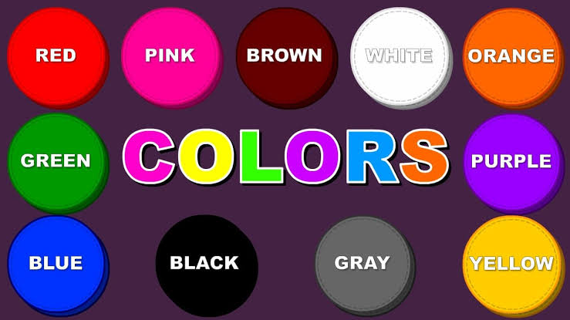

- Lingkarilah benda berwarna merah…….
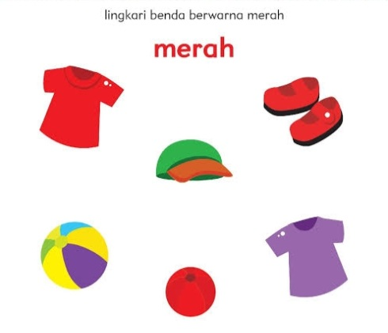

- Yang manakah berwarna kuning?
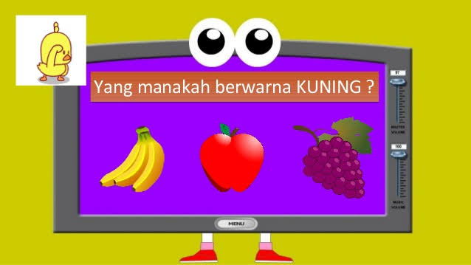
- Cocok kan lah gambar dibawah dengan label warna yang benar….
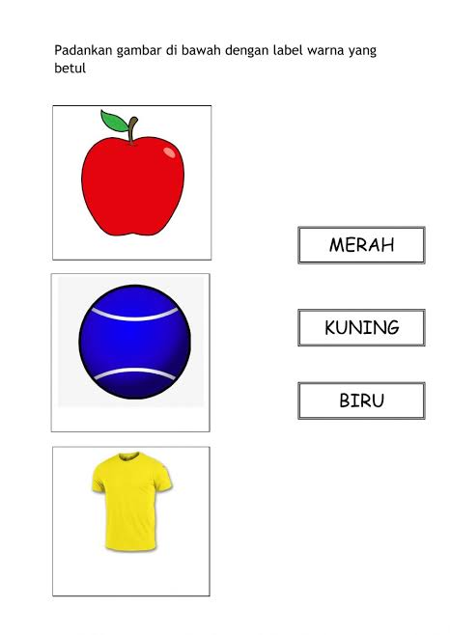
- Cocok kan lah warna yang sama dengan benar…..
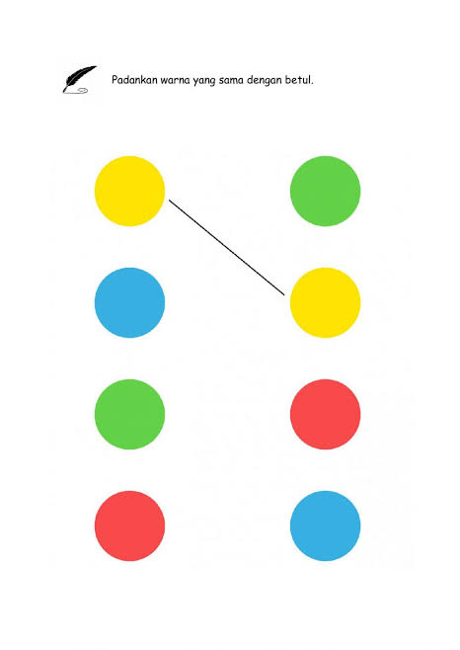
- What color is it?......

- Lingkarilah benda berwarna hijau…....

- Warna apakah ikan dibawah ini?........

- Lingkari es krim berwarna coklat

- Lingkari donat berwarna biru…..

- Cocok kan lah gambar dibawah dengan benar…
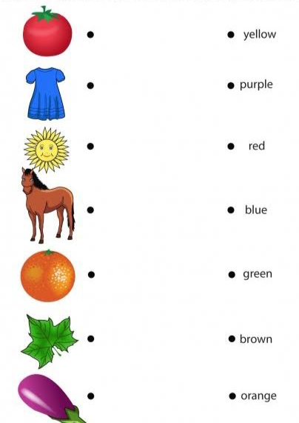
APPENDIX III

Observation Sheet “Students Attitude”

Fill in the information requested!
1. Name :
2. Class :
3. No. Absent :
4. Gender : L / P (circle one)

Directions : Choose one of the statements that match your choice by marking
(√) in the column provided.

Information :

4 : Always, if always do according to the statement
3 : Often, if often do according to the statement and sometimes not doing
2 : Sometimes, if sometimes do and often do not do
1 : Never, if never do

No | Observed Aspects | Answer
 |  | 4 | 3 | 2 | 1
1 | I listen to the teacher very well when explaining the lesson
2 | I respect other people's opinions when discussing
3 | I actively cooperate in completing group assignments
4 | I prefer English lessons more than other lessons
5 | I like to follow lessons with discussions
6 | I like learning English to be divided into groups so that I can work together with friends
7 | I feel happy when I can solve English questions
8 | Learning English with discussions becomes more interesting
9 | I am interested if the teacher often uses pictures when explaining English lessons
10 | I like to study groups rather than individuals

Observation Sheet “Students Response”

Fill in the information requested!
1. Name :
2. Class :
3. No. Absent :
4. Gender : L / P (circle one)

Directions : Choose one of the statements that match your choice by marking
(√) in the column provided.

Information :

4 : Always, if always do according to the statement
3 : Often, if often do according to the statement and sometimes not doing
2 : Sometimes, if sometimes do and often do not do
1 : Never, if never do

No | Observed Aspects | Answer
 |  | 4 | 3 | 2 | 1
1 | I dare to convey an opinion or idea that I know
2 | Learning by discussing makes it easy for me to understand the lesson
3 | Discussions make it easier for me to work with friends
4 | I feel more active and motivated to learn
5 | Learning English by discussing trains me to be able to express my opinion
6 | I often write down materials or vocabulary that I don't understand
7 | I asked if the subject matter presented was difficult to understand
8 | When the teacher gave a quiz, I dared to answer it directly
9 | I asked the teacher when the questions were not clear
10 | I do not find it difficult to do the assigned task

Observation Sheet “Students Responsibility”

Fill in the information requested!
1. Name :
2. Class :
3. No. Absent :
4. Gender : L / P (circle one)

Directions : Choose one of the statements that match your choice by marking
(√) in the column provided.

Information :

4 : Always, if always do according to the statement
3 : Often, if often do according to the statement and sometimes not doing
2 : Sometimes, if sometimes do and often do not do
1 : Never, if never do

No | Observed Aspects | Answer
 |  | 4 | 3 | 2 | 1
1 | I finished my homework ontime
2 | I am able to complete tasks independently
3 | I follow the rules in school
4 | I adhere to a predetermined schedule of lessons at school
5 | Dare to admit mistakes, not throw mistakes to friend
6 | I do assignments even though It's are difficult to do
7 | I study on time according to schedule
8 | I am not thorough in doing my assignments
9 | I complain easily when I do assignments
10 | I help friends who are struggling with study problems

APPENDIX IV

INTERVIEW GUIDELINES FOR STUDENTS

School Name : SD AL-FAUZI MEDAN

Teacher Name :

Date :

No | Question | Answer
1. | Do you like when English subject?
2. | What do you like when English lessons are delivered?
3. | What would be your difficulties if the English subjects were delivered?
4. | In your opinion, is English the most difficult subject?
5. | What do you think about English lessons?
6. | How do you attitude when in class?
7. | What do you think when given an assignment by your teacher?
8. | What do you like when learning English?
9. | Do you like to response when the teacher asks questions?
10. | What learning materials are often used in class

APPENDIX V

DOCUMENTATION OF RESEARCH
