AN ANALYSIS OF STUDENTS’ SPEAKING SKILL
USING DUOLINGO APPLICATION AT SMPS
NUR HASANAH MEDAN

A Thesis

Submitted to the Department of English Education in Partial
Fulfillment of the Requirements for the Degree of
Bachelor of Education

by

RIZKY DELHIANA BR BUKIT
NPM. 211224008



ENGLISH EDUCATION DEPARTMENT
FACULTY OF TEACHERS’ TRAINING AND EDUCATION
UNIVERSITAS MUSLIM NUSANTARA AL WASHLIYAH
MEDAN
2025
AN ANALYSIS OF STUDENTS’ SPEAKING SKILL
USING DUOLINGO APPLICATION AT SMPS
NUR HASANAH MEDAN

A Thesis

Submitted to the Department of English Education in Partial
Fulfillment of the Requirements for the Degree of
Bachelor of Education

by

RIZKY DELHIANA BR BUKIT
NPM. 211224008

ENGLISH EDUCATION DEPARTMENT
FACULTY OF TEACHERS’ TRAINING AND EDUCATION
UNIVERSITAS MUSLIM NUSANTARA AL WASHLIYAH
MEDAN
2025

ACKNOWLEDGEMENTS

That means :
10. “O you who believe, would I show you a secret that can save you from a painful torment ?!”. 11. You give to Allah and His Messenger and fight in the way of Allah with your wealth and your soul. That’s better for you, if you know it.” (QS. Ash Shaff: 10-11).
Artinya:
“Hai orang-orang yang beriman sukakah kamu aku tunjukkan suatu perniagaan yang dapat menyelamatkanmu dari azab yang pedih ?!. (Yaitu) kamu beriman kepada Allah dan Rasul-Nya dan berjihad di jalan Allah dengan harta dan jiwamu. Itulah yang lebih baik bagimu, jika kamu mengetahuinya.” (QS.Ash Shaff: 10-11).
First of all, the greatest gratitude to Allah SWT, the Almighty God for the blesing which has been given to the writer so that she finally completed this thesis in partial fulfillment of the rewuirements for the degree of Bachelor at the English Education, the Faculty of Teachers’ Training and Education, the University of Muslim Nusantara Al Washliyah Medan. This Thesis could not have been accomplished without the guidances, suggetions, and comments from several people so the resercher would like to express her deep gratitude to the following people:
- Dr. H. Firmansyah, M.Si., as the Rector of Muslim Nusantara Al Washliyah University Medan.
- Dr. Abdul Mujib, S.Pd., M.PMat., as the Dean of FKIP of Muslim Nusantara Al Washliyah University Medan.
- Wariyati, S.Pd., M.Hum., M.Pd., as the Head of the English Education Department of Muslim Nusantara Al Washliyah University Medan.
- Yugi Diraga Prawiyata., S.Pd., M.Hum., M.Pd., as the adviser who gives the suggestion toward the researcher in finishing the underthesis.
- Wariyati, S.Pd., M.Hum., M.Pd and., as the first examiner who gives the sugestion.
- Dr. Yulia Arfanti, M.Hum., as the seconde examiner who gives the suggestion.
- The beloved Mrs. Nursiah, researcher’s parents source of strength in every step. Thank you for your never-ending spirit and support, for the prayers that continue to flow in every prostration and for the love that is always the reason the researcher endure. The researcher dedicate this underthesis as a form of the researcher’s gratitude.
- The beloved Mr. Maju Bukit, the researcher’s love for him never fades when the researcher remember that incident until now the researcher still can't believe it he lose, now the reseacher can be at this stage as the last form. Although in the end the researcher have to go through this journey without him. Thank you for always teaching the researcher to stay strong and patient. The feeling of envy and longing that is not conveyed, unrequited hugs often make the resracher fall but all that does not reduce the researcher’s pride and gratitude for the life that my father has given the reseacher.
- The beloved to the researcher’s best firiend, Reny Madhani and Nur Aminah Tanjung, thank you for being a part of this journey. You are not only friends, but also a place to share laughter, tiredness, and enthusiasm. When the steps feel heavy, your presence and support have strengthened the researcher. This thesis cannot be separated from the prayers, encouragement and togetherness that we knit together. May this friendship continue to be maintained, no matter how much time passes.
- The reseacher’s deepest gratitude to my friend (P), who has always faithfully encouraged, supported and helped the reseacher in the process of completing this underthesis. Thank you for understanding the researcher, accompanying the researcher in difficult times and patiently always accompanying the researcher without complaining. Your presence is one of the greatest strengths that has enabled the researcher to reach this point.
- All of the lecturers of the English Education Department of Muslim Nusantara Al Washliyah University Medan, for your priceless sacrifice and affection.
- All of the Academic Administration Staffs and the Librarians of Muslim Nusantara Al Washliyah University Medan.
- All friends of the English Education class 2021 UMN Al Washliyah.
Finally, the researcher realizes that this thesis is far from being perfect. Therefore, constructive suggestion is needed for the resercher.
Medan, Juni 2025
The Researcher,

Rizky Delhiana br Bukit

TABLE OF CONTENT

ACKNOWLEDGEMENTS ii
TABLE OF CONTENT v
LIST OF TABLES vi
LIST OF FIGURE vii
LIST OF DIAGRAM viii
ABSTRACT ix
ABSTRAK x
CHAPTER I 1
INTRODUCTION 1
1.1 Background of the Problem 1
1.2 Identification of the Problem 3
1.3 Limitation of the Problem 4
1.4 The Problem of the Research 4
1.5 The Objective of the Research 4
1.6 Significances of the Research 5
CHAPTER II 6
REVIEW OF RELATED LITERATURE 6
2.1 Theoritical Framework 6
2.1.1 Definition of Speaking 6
2.1.2 The Difficulties of Speaking 9
2.1.3 The Benefit of Speaking 9
2.1.4 Mobile Application in Learning English 10
2.1.5 Duolingo Application 14
2.1.6 Learning Speaking Skill through Duolingo Application 20
2.2 Conceptual Framework 22
2.3 Previous Relevant Researches 22
2.3.1 Researcher 1 23
2.3.2 Researcher 2 23
2.3.3 Researcher 3 24
CHAPTER III 27
RESEARCH METHODOLOGY 27
3.1 Research Design 27
3.2 Seting and Subject of the Research 28
3.3 Instrument of Collecting Data 28
3.4 Technique of Collecting Data 29
3.5 Technique of Analyzing Data 29
CHAPTER IV 30
RESEARCH RESULT AND DISCUSSION 30
4.1 Research Result 30
4.1.1 Speaking Test Results Using the Duolingo Application 30
4.1.2 Interview Results 31
4.1.3 Assessment Results Based on Speaking Rubric 34
4.1.4 Documentation 41
4.2 Discussion of Research Results 42
4.2.1 Students' Speaking Skills after using the Duolingo Application 43
4.2.2 Student Perceptions of the Use of Duolingo 43
4.2.3 Assessment Results Based on Speaking Rubric 44
4.2.4 Documentation of Learning Activities 45
4.3 Results and Discussion of Qualitative Research 45
4.3.1 Analysis of Findings Based on Tests and Assessment Rubrics 46
4.3.2 Analysis of Findings Based on Interviews 46
4.3.3 Integration of Findings: Duolingo as a Technology-Based Learning Media 47
4.3.4 Relation to Theory 48
BAB V 51
CONCLUSION AND SUGGESTION 51
5.1 Conclusion 51
5.2 Suggestions 52
REFERENCES 54
APPENDIX 58

LIST OF TABLES

Table 4. 1. Assessment Rubric 34
Table 4. 2. Final Score Summary 1 36
Table 4. 3. Final Score Summary 2 37
Table 4. 4. Final Score Summary 3 39
Table 4. 5. Final Score Summary 4 40
Table 4. 6. Final Score Summary 5 41

LIST OF FIGURE

Figure 2. 1. Duolingo Application 16
Figure 2. 2. Duolingo App in App Store 17
Figure 2. 3. Some languages will be learned and spoken 17
Figure 2. 4. Pick a daily goal 18
Figure 2. 5. Option when join the Duolingo 18

LIST OF DIAGRAM

Diagram 2. 3. 1. Conceptual Framework 22

AN ANALYSIS OF STUDENTS’ SPEAKING SKILL USING DUOLINGO APPLICATION AT SMPS NUR HASANAH MEDAN

RIZKY DELHIANA BR BUKIT
NPM. 211224008

ABSTRACT

The objective of the research is to analyze how using the Duolingo app has affected the speaking abilities of seventh-grade students at SMPS Nur Hasanah Medan. The research used a qualitative descriptive approach which included five students as subjects of the research. Information was gathered through observation and interviews. The result suggests that using Duolingo has helped improve students’ speaking skills, especially their confidence and pronunciation. Most students expressed that they enjoyed learning with Duolingo because it provided a fun, non-threatening, and interactive learning environment. Students demonstrated noticeable improvements in fluency, vocabulary use, and motivation to speak English. However, some challenges remained, especially in terms of spontaneous speech and constructing complex sentences. In other words, Duolingo can be an effective supplementary tool in improving students’ English-speaking skills, though it should be accompanied by guided instruction to develop deeper communication competence.

Keywords: Duolingo, Mobile Application, Speaking Skill, English

ANALISIS KETERAMPILAN BERBICARA SISWA MENGGUNAKAN APLIKASI DUOLINGO DI SMP NUR HASANAH MEDAN

RIZKY DELHIANA BR BUKIT
NPM. 211224008

ABSTRACT

Tujuan penelitian ini adalah untuk menganalisis bagaimana penggunaan aplikasi Duolingo mempengaruhi kemampuan berbicara siswa kelas tujuh di SMPS Nur Hasanah Medan. Penelitian ini menggunakan pendekatan deskriptif kualitatif dengan subjek penelitian lima siswa. Informasi dikumpulkan melalui observasi dan wawancara. Hasil penelitian menunjukkan bahwa penggunaan Duolingo telah membantu meningkatkan keterampilan berbicara siswa, terutama kepercayaan diri dan pengucapan mereka. Sebagian besar siswa menyatakan bahwa mereka menikmati belajar dengan Duolingo karena menyediakan lingkungan belajar yang menyenangkan, tidak mengancam, dan interaktif. Siswa menunjukkan peningkatan yang nyata dalam kelancaran, penggunaan kosakata, dan motivasi untuk berbicara bahasa Inggris. Namun, masih terdapat beberapa tantangan, terutama dalam hal berbicara spontan dan menyusun kalimat kompleks. Dengan kata lain, Duolingo dapat menjadi alat bantu tambahan yang efektif dalam meningkatkan keterampilan berbicara bahasa Inggris siswa, meskipun perlu disertai dengan instruksi terbimbing untuk mengembangkan kompetensi komunikasi yang lebih mendalam.

Kata Kunci: Duolingo, Aplikasi Seluler, Keterampilan Berbicara, Bahasa Inggris

CHAPTER I

INTRODUCTION

Background of the Problem
The ability to speak English was a basic skill needed by someone in the information and globalization era, because the introduction and mastery of science and technology were mostly written and delivered in English. Starting from the world of education, work, to everyday life, English was increasingly being used. There were so many advantages if students were able to speak English, such as higher opportunities to research or work abroad. Currently, even though researching or working in the country, it was also required to include a certificate of English proficiency. The aim was to prove that language skills had been mastered because the learning or communication process in the workplace often involved language.
In this modern era there are many applications that can help students to improve their English skills, but here the researcher only focuses on one application, namely Duolingo which provides 66 different language courses available in 23 languages, there are 22 more courses that are still being developed (Teske, 2017) About 120 million users from all over the world have registered on this application. Duolingo is one of the most popular English learning applications for beginners today, because it has been downloaded by more than 200 million users and has around 30 translator languages. Uniquely, users will not feel bored learning foreign languages ​​through this application, because Duolingo is designed to resemble a game display that can be adjusted to your activities and learning style. Another advantage of Duolingo is that it provides daily reports of learning progress and materials that can be saved offline.
In learning, the use of media is an effort to create quality and support the learning process. So that students can enjoy participating in learning activities. Very helpful in conveying information and can help facilitate the teaching process and allows teachers to practice the principles of illustration of teaching and learning objects (Matra, 2020) Media is one of the things that can convey information between the source and the recipient (Indrasari, Novita, & Megawati, 2018).
Duolingo has a very motivating learning system that uses a strategy game mechanism to create learners in learning. This is made very similar to a computer game where participants must pass certain levels. Students must complete the tasks provided by the Duolingo application. For example, in speaking, students must be able to pronounce the sentences that have been provided correctly to proceed to the next, more complicated sentence stage. Users can complete various types of exercises including multiple choice, writing and also speaking through a microphone. Duolingo mainly uses drills and repetitive exercises in lessons.
Based on the pre-interview obtained from a teacher from at SMPS Nur Hasanah Medan, it has found that there are several students lacking motivation. Many students feel bored and unmotivated in learning English, resulting in low participation in speaking activities. Research by (Herlina, Yundayani, & Astuti, 2021) discusses the use of the Duolingo application as a technology-based learning media to improve students' speaking skills in English. The research was conducted with a qualitative approach and classroom action research design at a high school in Bandung, involving 35 students. Data were collected through observation, interviews, and tests. The results showed a significant increase in students' speaking skills in each cycle, with the percentage of learning completion increasing from 57.14% (cycle I) to 91.43% (cycle III). Duolingo has also been shown to increase students' self-confidence and motivation. These findings support the use of Duolingo as an alternative media in learning English.
Based on the background and formulation of the problem that has been explained, this research focuses on the use of the Duolingo application as a technology-based learning media in improving students' speaking skills. Unlike previous studies that were classroom action and focused on achieving KKM scores through several cycles, this research uses a qualitative descriptive approach to explore changes in students' self-confidence and speaking skills after using Duolingo. The instruments used are also more varied, such as in-app tests, interviews, assessment rubrics, and documentation.
This research is expected to contribute to the development of innovative learning media that are in accordance with the needs of students in the digital era, as well as being a reference for teachers, the researcher, and education practitioners in implementing technology as part of an effective English learning strategy.

Identification of the Problem
Based on the background of the research, it can be identified problems related to this research:
1. Students have difficulty in speaking English since their lacking of good pronunciation.
2. Students are less interested in speaking English since the teacher often uses conventional way to teach speaking.
3. Students are less confident in speaking English

Limitation of the Problem
Based on identification of the problem above, this research focuses on the analysis of students’ speaking ability of saying simple sentence using the Duolingo application on Speaking level basic, and this research limited for grade VII students of SMPS Nur Hasanah Medan in academic year 2024/2025 consisted of five participants.

The Problem of the Research
On the background of the research, the research problems of this research is formulated as the following: can students speak using Duolingo application?

The Objective of the Research
The objective of the research is to describing the implementation of an analysis of students’ speaking skill using Duolingo application.

Significances of the Research
The results of this research are expected to be beneficial both theoretically and practically elaborated in the following section.
1. Theoretically
The results of the research are expected to support theories dealing with application to help students in improve their speaking skill
2. Practically
a. The results of this research are expected to give information to the English teachers, especially in guiding students to improving speaking skill effective way.
b. It is also expected to encourage students’ awareness for using the useful application like Duolingo in learning especially in improving speaking ability.

CHAPTER II

REVIEW OF RELATED LITERATURE
This chapter covers some theories as the basis of the discussion. It is aimed toward more understandings about the topic of the research. This chapter presents definition of speaking, the difficulties of speaking, teaching speaking through Duolingo application and definition of Duolingo application.

Theoritical Framework
In conducting a research, theories were needed to explain some concepts or terms which were applied in this research. Some terms in this research and they need to be theoretical explained. Thus, the following explanation aimed toward the clear explanation.

2.1.1 Definition of Speaking
Speaking is one of the skills that must be mastered by English learners because language is used to communicate with others in everyday life. In communicating, the speaker often conveys ideas and feelings towards the other person (Herlina, Yundayani, & Astuti, 2021).
In this delivery, the speaker uses verbal and nonverbal symbols in various situations (Thornbury, 2005). Speaking is not only about delivering ideas with the right intonation, but also related to how to deliver the contents of the conversation. Furthermore, speaking skill requires the speaker to know how to interact as about speaking turn (Jondaya & Rania, 2011). Speaking requires productive and receptive skills that involve the speaker and the listener.
It is undeniable thing that students should practice their English frequently. Therefore, the obligation of teachers is to foster the students’ self-confidence so that they are brave to use English (Niah, 2019).
Speaking is the ability to produce words in language practice. Speaking is an important skill that students have to master. It is because in speaking we can know the students’ ability to produce the target language or English. Speaking is to express thought a loud using the voice or talk. It means that when someone interacts with other by using a language as a mean, certainly, they want to convey something important. For example, they want to utter their feeling and thought. It is strongly impossible for someone to make a communication with other without having any purpose. As people communicate, there must be speaker and interlocutor. Therefore, communication involves at least two people; sender and receiver. They need communication to exchange information, ideas, opinion, view or feeling.
Keith and marrow say “Speaking is an activity to produce utterance to oral communication”. It means that this activity involves two or more people in whom the participants are both hearers and speakers having to react to whatever they hear and make their contribution a high speed, so each participant has intention or a set of intention that he wants. So, the English teacher should active the students speaking ability by providing communicative language activities in the classroom and then giving them the opportunities to practice their speaking skill as much as possible.
According to (Bailey, 2006), speaking is a process of interaction where speakers intend to build meaning through producing, receiving and processing information.
Speaking is an important skill in learning English, especially for junior high school students who are in the early stages of mastering a foreign language. Speaking skills allow students to convey ideas, ask questions, respond, and express themselves in various communication situations, both inside and outside the classroom.
Using applications such as Duolingo can provide additional benefits in improving students' speaking skills. This application provides interactive pronunciation and conversation exercises, which can help students practice pronunciation and build confidence when speaking in English. With features such as speech recognition and direct correction, students can learn from their mistakes independently and in a fun atmosphere.
In addition, speaking actively through Duolingo can help students enrich their vocabulary, improve fluency, and hone their ability to construct sentences spontaneously. Another benefit that is felt is increased motivation to learn because students feel freer and are not afraid of making mistakes when practicing speaking on their own using the application.
Thus, speaking not only helps students in mastering English practically, but also forms their communication skills, self-confidence, and readiness to face the challenges of learning at the next level.

2.1.2 The Difficulties of Speaking
1. Low Confidence
Because they are often exposed to traditional learning methods that use one-way communication patterns, usually students at school will have low self-confidence, especially in terms of speaking. This is a big scourge for the Indonesian people to be able to become a competitive society in the world of global competition. There are students who understand English very well but do not have self-confidence, thus closing the opportunity or opportunity for them to develop. There are also students who previously did not have self-confidence, but after they mastered English, it made them more confident and not afraid of obstacles in every opportunity that they will take in the future (Fitri & Apriliaswati, 2015)

2.1.3 The Benefit of Speaking
The benefits of speaking skills are to facilitate communication between students, notification of various information, so that the message can be received in its entirety, and increase self-confidence and self-authority. Language skills that develop in students' lives, which are only preceded by listening skills, and at that time the ability to speak.
Benefits of Speaking for Students
1. Improve academic skills
Students can more easily understand the subject matter, especially for subjects such as Science.

2. Broaden horizons
Students can broaden their horizons and knowledge about culture and life in other countries.
3. Improve thinking skills
Students can train their memory and develop thinking skills by learning new words and adopting grammar rules.
4. Improve problem-solving skills
Students can practice problem-solving skills by understanding a second language such as English.
5. Make it easier to socialize and adapt
Students can more easily socialize and adapt in new environments.
6. Open up job opportunities and career paths
Students can have the opportunity to get jobs and career paths.
7. Make friends with foreign students
Students can expand their network of friends by making friends with foreigners.

2.1.4 Mobile Application in Learning English
When it comes to learning English, few can beat the comfort and control of portable apps. These advanced learning devices make it simple to consider English “on the go” in parts of one of a kind and curiously ways (Wong, 2023).
- Best for Fast Vocab Learning: Bright
Bright is a simple and efficient app that promises to teach you 500 essential words in two months.
- Best for Basic English : Mondly
Mondly is a well-known app that does a great job teaching conversational phrases you can use in real life, from shopping to going on a date.
- Best for Test Preparation: Knudge.me
Knudge.me app uses English games to test out your English skills.
- Best for Fun Beginner Lessons: Lingodeer
Lingodeer takes a gamified approach to language learning with a goal-oriented curriculum consisting of structured lessons and regular reviews.
- Best for Authentic Content: LingQ
LingQ is here to help you practice English with more than 1,000 hours of audio files, including podcasts and audiobooks.
- Best for Reading: Beelinguapp
If you prefer music and audiobooks, Beelinguapp is for you. You can choose your reading material from a number of short stories and novels and learn at your own pace.
- Best for Native Speaker Practice: Lingbe
Lingbe connects you with native speakers for language conversation practice. To contact native speakers on Lingbe, all you have to do is press the call button. The app will immediately match you with someone who will patiently help you learn the language.
- Best for English Immersion: Rosetta Stone
Usually, an English app teaches you English with explanations in your native language, but Rosetta Stone teaches you English with English.
- Best for Pronunciation Practice: ELSA Speak
ELSA Speak is probably the best mobile app around for helping you improve your English pronunciation.
- Best for Video-based Immersion: FluentU
FluentU takes real-world videos—like music videos, movie trailers, news and inspiring talks—and turns them into personalized language learning lessons.
- Best for Casual Learning: Duolingo.
Duolingo is designed to help you learn English quickly, so you can use it even if you’re just a beginner.
- Best for Practical Topics: Babbel
Babbel teaches you English through 15-minute lessons that feature realistic conversations on topics that you’re interested in. You can also take optional live classes.
- Best for Memorizing Vocabulary: Memrise
This app is very flashcard-based and is focused on teaching you English words. It uses some creative, funny ways to help you remember what words mean.
- Best for Essential Vocabulary: Mosalingua
Mosalingua is focused on two things: teaching you the 1,500 most important words and phrases that you should have in your English word bank, and solving the problem of forgetting what you’ve learned over time.
- Best for Community Learning: Busuu
Busuu is a little bit different from many of the apps we’ve mentioned here. With Busuu, you can talk with native English speakers to practice your conversational skills.
- Best for Audio-based Learning: Pimsleur
Pimsleur’s structured curriculum is based on the idea that you will listen to one 30-minute lesson a day centered around English dialogue with explanations from the narrator. The audio has plenty of pauses where you’ll be prompted to talk out loud or repeat what the narrator said.
- Best for Different Learning Levels: Innovative Language
It also has notes for each lesson that you can use to review and remember the content better. The lessons are divided according to learning levels, and you can also download specific lessons for offline use.
- Best for Group Learning: ABA English
ABA English offers more than 100 grammar videos on American and British English for your daily lessons. It also gives you access to short and full-length films designed to teach expressions, vocabulary and other things.
- Best for English Chatting: Andy
The Andy chatbot uses a question-and-answer format to help you learn more things about English conversation. It also reads out the messages so you can practice English listening and pronunciation along with reading and texting.
- Best for Grammar: Learn English Grammar
What’s great about Learn English Grammar is that it incorporates activities into every lesson to help make grammar easier to learn. Each section is divided into skill levels—Beginner, Elementary, Intermediate and Advanced—so finding the right level for you shouldn’t be a problem.
Students will have their claim take on what makes the leading English learning app, so discover what works best for then. Then, in this research, the researcher focuses on Duolingo application only.

2.1.5 Duolingo Application
Duolingo is a free language learning app created by Luis von Ahn and Severin Hacker. This application is not only available in web version but also available in Android, iOS and Windows Phone versions. Today, many students use mobile applications (apps) to support their language learning both inside and outside the classroom (Klimova, 2020) Media in learning is very important in helping convey information. Because teaching vocabulary without using any media will not give good results. Duolingo can be a medium in learning a second language, especially vocabulary. Duolingo offers "gamification" learning, for users. The games in this application provide benefits for users to learn the target language (Nushi & Eqbali, 2017).
Now that technology has taken part in education, the role of technology in education is fourfold: including as part of the curriculum, as an instructional delivery system, as a means to assist instruction and also as a tool to improve the entire learning process. Stated that Game-based learning is a very popular technology trend that uses game elements (Raja & Nagasubramani, 2018).
(Mahmudah, 2015) and (Mendez Bermudez, 2017) have conducted a research on the Duolingo application. The similarity between these two studies is using Qualitative descriptive in Duolingo's research. In the research conducted by Mahmudah, the field of research is pronunciation while Bermudez's research is about the possible effects of applying Duolingo for learning English. Another research previously conducted by Vasselinov from Queen College University and Grego from the University of South Carolina (2012) entitled "Duolingo Effectiveness Research" shows that using Duolingo is effective for language tests because it can measure hourly research time to improve language. The results of this research indicate that Duolingo can be used as a language test medium that can measure students' ability in language competencies, namely listening, reading, writing, and speaking.
Research conducted by (Khan & Ali, 2010) show other problems that occur in the field which certainly affect the students' speaking abilities Research shows that many students do not dare to use English in class because they are afraid of the teacher, and many students are reluctant to practice both inside and outside the classroom for fear of being laughed at by friends.
The researcher will conduct this research on seventh grade students of junior high school. In addition, the researcher uses the random topic based on the Duolingo application as an instrument in conducting this research. The objective of this research is to research the analysis of using the Duolingo application in improving students' speaking skills.
Based on the explanation above, the researcher can conclude that Duolingo is an online platform and mobile application that offers users a free and innovative way to learn speaking.
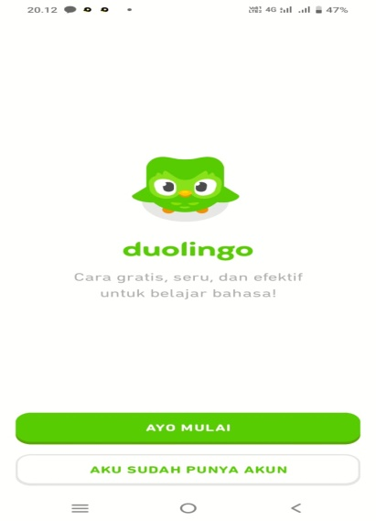
Figure 2. 1. Duolingo Application
- The steps to use Duolingo
There are some steps you must do when you want to use Duolingo application, they are:
1) Download the Duolingo app in Google Play Store or app store.2.2.6 Game on Level 1.
Types of Game di Level 1
1. Vocabulary Translation (Include SS)
2. Guessing the Audio

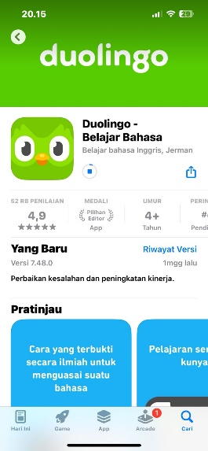
Figure 2. 2. Duolingo App in App Store
2) Select the language you want to learn and speak
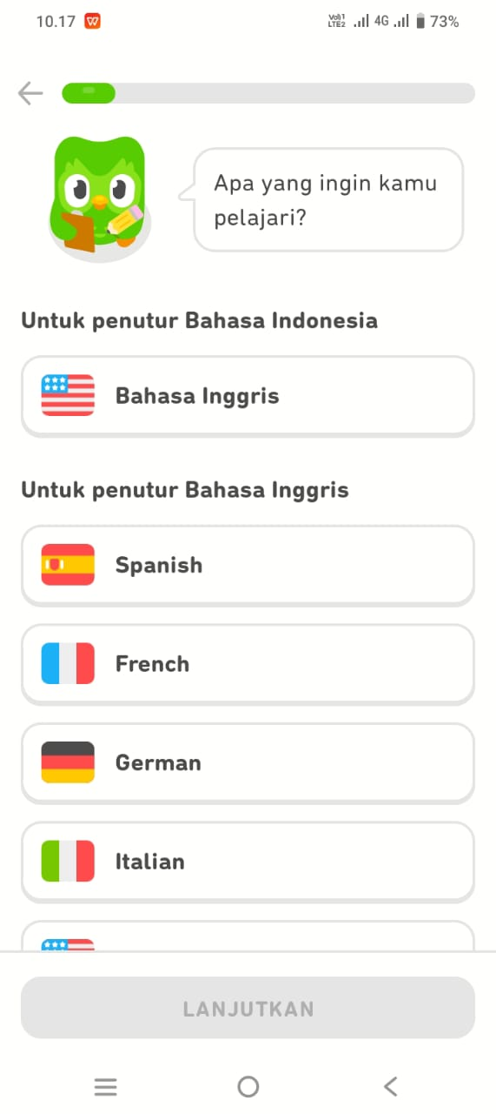
Figure 2. 3. Some languages will be learned and spoken

3) You must set your pick a daily goal
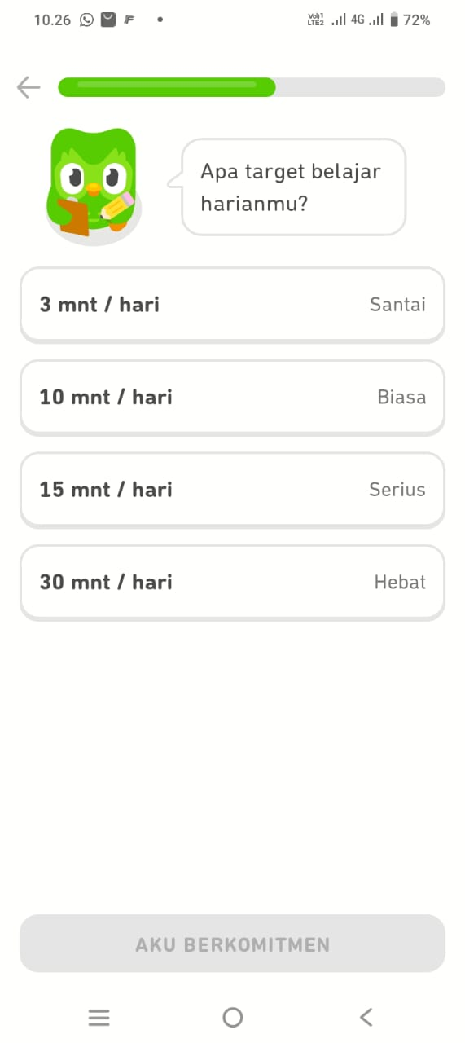
Figure 2. 4. Pick a daily goal
4) The app will ask you to choose one of them below.
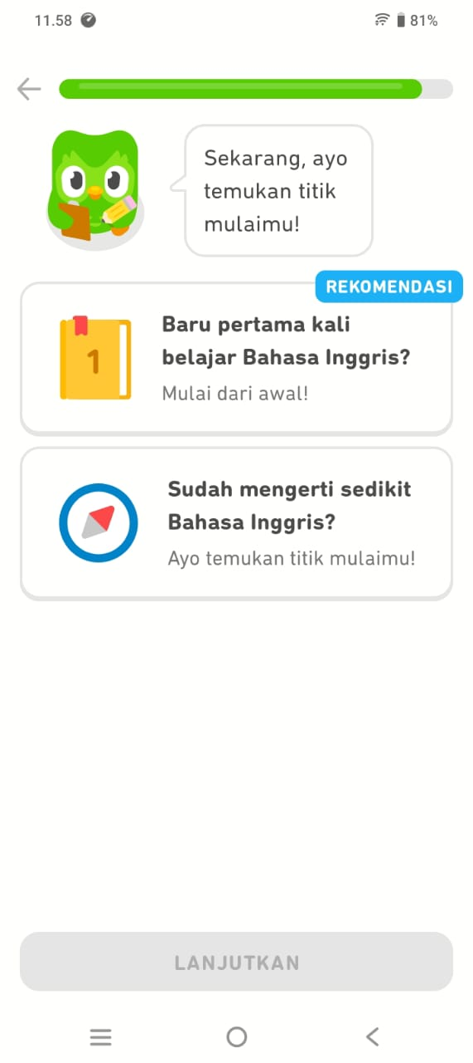
Figure 2. 5. Option when join the Duolingo
In just a few years, Duolingo has emerged organically as the most widely used online method for learning languages. Duolingo has a variety of cutting-edge methods for learning languages, especially speaking. These methods can make it easier for students to speak, so that increase their interest and enjoyment, during the learning process. The Duolingo Language Learning App is also free and can be downloaded on mobile phones or PCs, so users can practice anytime and anywhere, especially for young English learners.
Launched in November 2011, Duolingo boasts already at the time of writing 300,000 active language learners ready for the task. It's possible that some people are already familiar with this application because it is very beneficial to its users. According to the play store, more than 100 million people have downloaded it, and more than one million people have given it a five star rating, where the number of five rating is a perfect rating on play store. Additionally, the play store provided category editor or "editor's choice". This means that the application is highly recommended, even recommending this application is the editor himself that no other official staff from google.
As of 2022, Duolingo offers more than 100 total courses for 41 different languages, ranging from Spanish, French, German and Japanese to Navajo and Yiddish. There are even artificial or fictional languages, such as Klingon and High Valyrian. You can change the language you will learn, adding languages will not make you lose progress in existing courses. You can switch between the courses you have started, it is very easy to learn with multiple languages.
This application could be considered a game, but games on Duolingo are very much connected to education, especially when it comes to learning a new language. When the device is turned on, the user will receive five hearts that function as the other user's life. The user loses one life point for each incorrect response, and so on. Additionally, if the heart has become worn out, it ought to learn the lesson all over again. In a very user-friendly manner, this application combines audio, visual, and grammar-related questions.

2.1.6 Learning Speaking Skill through Duolingo Application
The use of Duolingo App can improve students' speaking skills in terms of pronunciation, and fluency. Duolingo App offers speaking practices that simulate conversations with native speakers, students can check their pronunciation with the speech recognition on the Duolingo App. Simply students also get to record their voice and get immediate feedback. Soon students will learn to sound like a native speaker. The Collins dictionary defines it as: “Someone who speaks that language as their first language, rather than having learned it as a foreign language” So, technically, anyone with English as a first language from birth is a 'native English speaker'. Teachers can use the Duolingo App in many techniques or activities in order to meet the goal of speaking class (Hafifah, 2021).
Talking issue is still a noteworthy issue confronted by EFL learners in Indonesia, counting in North Sumatera. Concurring to (Putri & Ismiati, 2018), one viewpoint that understudies require offer assistance with is talking. Everything is included when talking, and understudies battle to memorize how to utilize language structure, lexicon, and elocution. Talking and composing are considered expressive aptitudes (profitable), and they are included within the four aptitudes that understudies must ace since they illustrate that understudies can talk English and express thoughts or considerations that they will say. Agreeing to (Haryudin & Jamilah, 2018), talking English could be a world dialect that needs much work out to ace. Understudies must hone both interior and exterior of the classroom and can utilize the suitable media to create their capacity to talk English fluidly. With respect to students' capacity in English, learners for the most part utilize a particular stage to back their learning, such as Duolingo. They utilize this application to assist them hone talking. Be that as it may, a few other understudies still have distinctive issues in talking for a few reasons, such as need of certainty, need of lexicon, and fear of making botches in pronunciation and grammar.
It is crucial to highlight that speaking is a skill that exhibits a person's proficiency in a particular language (Syahputri & Ismail, 2022), specifically English, and facilitates direct self-expression. When speaking, a person acts as a translator or interpreter of what they are saying to another person, which requires the brain to process information twice: first in the appropriate Indonesian form and then in the correct English form. According to (Eliyasun & Urai, 2018), speaking is a method of verbal communication or idea exchange. In addition, Brown (Brown & Yule, 2006) state that the complexity of the information to be communicated affects communication. However, sometimes, students experience difficulty comprehending what they mean. They need to consider their words more carefully, and their ability to communicate with others may be challenging. Hence, teachers and instructors must consider the learning environment to be more conducive and supportive of learning (Ismail & Yoestara, 2022). In addition, according to (Efrizal, 2012), students must recognize that speaking entails three areas of knowledge mechanics (pronunciation, grammar, and vocabulary), so that problems in speaking can be resolved by mastering these mechanics.

Conceptual Framework
This research can be shown in logical and clear relationship in the following framework:
Learning Speaking

Using Duolingo

Test

Data Analysis

Result

Diagram 2. 3. 1. Conceptual Framework

Previous Relevant Researches
There are three related researches that the researcher found in this thesis proposal.

2.3.1 Researcher 1
(Prawiyata & Barus, 2021) Analysis Of Speaking Ability Of Students Of English Education Research Program Of UMN Al Washliyah Through Vlog On Instructional Planning and Media Course.
The objective of this research was to determine how students’ speaking skill of UMN Al Washliyah English Education Research Program through vlogs on Instructional Planning and Media course was. This research used a descriptive qualitative research design, in which the researcher described and analyses speaking skill. The population in the research was 10 students of UMN Al Washliyah English Education Research Program in semester III-V in Academic Year 2020/2021, totaling 10 people. Based on the research results, it can be concluded that the students’ speaking skill was between the levels “Above Average” and “Excellent.” In other phrases, it may be concluded that vlog media may be an interesting alternative media that may be used to improve college students’ speaking skill.

2.3.2 Researcher 2
(Prawiyata & Sulistianingsih, 2023) The Effect of Using Small Group Discussion toward Students’ Speaking Ability at SMA Al-Washliyah 1 Medan.
The purpose of this research was to determine whether there was a significant effect of the use of small group discussions on students' speaking ability. This type of research is quantitative research and was conducted using two classes as research samples, namely class X-IPS 2 as an experimental class consisting of 20 students and class X-IPA 1 as a control class consisting of 20 students. In data collection techniques, the researcher conducted pre-tests, treatments and post-tests by providing tests in the form of speaking test examples.
The results of this research indicate that there is a significant effect of small group discussions on students' speaking ability. This can be seen after the data was analyzed, in the post-test of the control group, an average score of 69.75 was obtained, which means that students' speaking ability achievement is included in the sufficient category, and in the post-test of the experimental group, an average score of 76.25 means that students' achievement in speaking ability is included in the good category, then after testing the research hypothesis, it turned out that the hypothesis was accepted. This means that class X students of SMA AL-Washliyah 1 Medan apply small group discussions in speaking learning higher than without small group discussions.

2.3.3 Researcher 3
(Ardiansah, 2023) (A Research on Project-based Learning (Pjbl) Model and English Conversational Gambits in Classroom Speaking Practices).
This research aims to determine the effectiveness of a contemporary teaching model of Project-Based Learning (PjBL) using English Conversational Gambits as language material, which focuses on improving students' speaking skills. However, this research examines students' attitudes toward implementing learning models in terms of behavioral, cognitive, and emotional aspects. This present research was conducted at a university in Tasikmalaya.
This present research used quantitative and qualitative designs following the purpose of the present research. As the results of quantitative data, it was found that the sig. (2-tailed) of t-test value is 001 which is smaller than 05 value.
The results showed that the use of PjBL model improves students' proficiency in speaking by optimizing the process of EFL teaching and learning using material of English conversational gambits. In addition, according to the qualitative data analysis, this research shows that most of the students showed a positive attitude toward the implementation of the learning model. This research demonstrated by implementing PjBL model with English Conversational Gambits can be alternative strategy in EFL instructional techniques that can improve students' speaking skills.
As seen from the three previous relevant researches, the difference of this research would be on analysis of using Duolingo.
2.3.4 Researcher 4
(Youlanda & Wariyati, 2023) (The Effectiveness of Using Duolingo Application for Student’s Grammar Ability in English).
The purpose of this research is to investigate whether or not Duolingo can improve students’ grammar ability in English. This research use quantitative method and conducted in VII-B SMP Satria Dharma Perbaungan. In this research, the researcher used one class as the sample with total number of 26 students. The data was collected by giving pre-test and post-test as the instruments. The result of this research was calculated by using T-test. The findings showed that the students’ post-test scores was (80,76) it was higher than their pre-test scores (61,73). The result that is showed by using t-test, the scores of calculation (8,57) was higher than score of table (1,705) at significant level 5%. This finding reveals that Duolingo gives the significant result at 7th grade students of SMP Satria Dharma Perbaungan to increase students grammar ability in English.

CHAPTER III

RESEARCH METHODOLOGY

Research Design
This research used a qualitative method. According to (Creswell, J. W; Creswell, J. D., 2017) “Qualitative research Was an approach for exploring and understanding the meaning individual or groups ascribed to a social or human problem”. Further, Donal Ary stated that “qualitative research was research that sought to understand a phenomenon by focusing on the total picture rather than breaking it down into variable. The goal of qualitative research was a holistic picture and depth of understanding rather than a numeric analysis of data’’. It meant that the data in this research were analyzed in the form of description and identification or analysis of the text.
The researcher used descriptive as a kind of research. Cresswell stated that qualitative research was descriptive in that the researcher was interested in the process, meaning, and understanding gained through words or pictures. It meant that the researcher was interested in the process, meaning, and understanding then described it in the form of words or pictures. The researcher chose qualitative descriptive because the researcher described the data taken. It described the goals, material, procedure, and evaluation of learning speaking skills through the Duolingo application for grade VII students of SMPS Nur Hasanah Medan.

Seting and Subject of the Research
Based on the observation by the research, the researcher will took the participant five students rendomly for a class in VII grade SMPS Nur Hasanah Medan in academic year 2024/2025.

Instrument of Collecting Data
The instruments that will be used in this research are:
a. Test
The test that will be used in this research is an online test on the duolingo application and the questions uses in the application are random according to the duolingo system, for a more complete duolingo application test can be seen in the Appendix.
b. Interview
In this research, the researcher will ask several questions about students' enthusiasm in learning English after using the duolingo application. The list of questions can be seen in the Appendix.
c. Assessment Rubric
The Assessment Rubric in this research is needed to see the influence obtained by students after using the duolingo application. The assessment rubric can be seen in the Appendix.
d. Documentation
Qualitative research cannot be separated from documentation as a research instrument, therefore the researcher will also attach documentation to the attachment as Research Validity.

Technique of Collecting Data
The researcher uses Duolingo which is directly practiced to each student where students must complete challenges at speaking level. The researcher records the course of the activity by taking screenshots of each item/question that appears in the game.

Technique of Analyzing Data
The collected data are analyzed using qualitative analysis techniques, such as narrative analysis, to identify patterns and key findings in the data.
Each student's SS results were then analyzed by breaking down whether each item is correct or incorrect.

CHAPTER IV

RESEARCH RESULT AND DISCUSSION

4.1 Research Result
This research presents the results of data collected through tests, interviews, assessment rubrics, and documentation. This research aims to analyze students' speaking skills after using the Duolingo application. The research was conducted on five students of grade VII of SMPS Nur Hasanah Medan in the 2024/2025 academic year.

4.1.1 Speaking Test Results Using the Duolingo Application
In this research, the researcher analyzed the speaking ability of seventh grade students at SMPS Nur Hasanah Medan after using the Duolingo application. One of the instruments used was a speaking test through the speaking feature on the application. The following are the results of the researcher's observations of five students who were the subjects of the research:
1. WA
WA showed speaking skills that still need to be improved. Her pronunciation was not clear and sounded not fluent. This shows that WA still has difficulty pronouncing words in English correctly. Lack of clarity in pronunciation can hinder the process of effective oral communication.
2.MZY
MZY was able to pronounce phrases in English completely and enthusiastically. He showed enthusiasm in answering instructions from the application, and used good intonation when speaking. This shows that MZY has started to get used to speaking English with a natural and confident expression.
3. ZM
ZM appeared confident and expressive when speaking using the Duolingo application. She not only pronounced words fluently, but also used appropriate facial expressions and tone of voice. This shows that ZM has a good understanding of how to communicate verbally in English.
4. KMS
KMS seems to have to read first before speaking. She needs time to process and deliver sentences in English. This shows that although she is able to pronounce words, her speed and spontaneity in speaking are still low. KMS needs more time and practice to be able to speak more fluently and naturally.
5. ANK
ANK shows good and clear pronunciation skills. She also seems confident when speaking through the application. Her ability shows that she already has a sufficient understanding of pronunciation and the courage to use English verbally.

4.1.2 Interview Results
The interview was conducted to determine students' perceptions of the use of the Duolingo application in improving their speaking skills. The following is a summary of the results of interviews with five students:

1. WA
WA stated that she likes to imitate the voices from the Duolingo application and feels very happy using the application. She admitted that she often practices sentences such as "Hello, how are you?" in class. In addition, WA feels confident when using Duolingo and considers talking to a cellphone as easy.
Important statements:
"I like to imitate the voices from the Duolingo application."
"I am very confident using the Duolingo application."
"Just talk to the cellphone."
2. MZY
MZY6 said that learning to speak through Duolingo did not scare him. He felt comfortable because he could try many times and could find out if his words were wrong or right. MZY also mentioned that he understood the sound of words when spoken by the application.
Important statements:
"Learning to speak doesn't scare me."
"I record my voice so I know whether my answer is right or wrong."
“It’s not difficult to use the application.”
3. ZM
ZM initially felt confused using the application, but gradually understood it. She felt happier talking directly to her cellphone and was confident in saying simple sentences such as “My name is…”. ZM also stated that she is better at speaking with just one word and knows when to start speaking.
Important statements:
“I prefer talking to my cellphone.”
“I am better at speaking with 1 word.”
“I understand when to speak.”
4. KMS
KMS admitted that she was nervous at first, but she was able to learn slowly. She said that Duolingo helped her learn to pronounce words correctly and become more courageous in trying new words. She felt that this application was easy because she just followed the sound she heard.
Important statements:
“I was nervous but I was able to learn a new language.”
“I know how to pronounce words correctly.”
“It’s easy, just follow it.”
5. ANK
ANK stated that she likes using Duolingo because she can hear and immediately imitate the sound. She also said that she is not embarrassed to speak, finds it easier to memorize words, and can pronounce them immediately. ANK said that she can speak little by little and feels comfortable because she only talks to her cellphone.
Important statements:
"I like it because I can hear and join in the conversation."
"I memorize words and pronounce them immediately."
"I can speak little by little."

Assessment Results Based on Speaking Rubric
Assessment of students' speaking ability was carried out using an analytical rubric that covers four main aspects, namely: fluency, pronunciation, content, and confidence. The assessment was carried out on a scale of 1(One) to 4(Four), where a score of 4(Four) indicates very good performance and a score of 1(One) indicates poor performance.
This rubric was compiled by adapting theories from (Brown, 2004), (CEFR, 2001) and (O'Malley & Pierce, 1996), which suggest that speaking assessment should be carried out analytically in order to describe students' strengths and weaknesses specifically.
The following is the assessment rubric used in this research:
Table 4. 1. Assessment Rubric
Aspect | Criterion 4  (Very Good) | Criterion 3  (Good) | Criterion 2  (Fair) | Criterion 1
Fluency | Speaks fluently without meaningful pauses. | Speaks fairly fluently with a few pauses. | Frequently pauses but can continue. | Frequently pauses and has difficulty continuing.
Pronunciation | Clear pronunciation and almost perfect. | Clear pronunciation with a few errors. | Unclear pronunciation with several errors. | Unclear pronunciation with many errors.
Content | Dialogue is highly relevant to the context and complete. | Dialogue fits the context with minor deficiencies. | Dialogue is somewhat off-context and fairly complete. | Dialogue does not fit the context and is lacking in completeness.

Based on the results of the speaking test through the Duolingo application, 1. WA got the following scores:
1. Fluency
The student speaks quite fluently, although there are small pauses that indicate the thinking process. There are not too many pauses that interfere with understanding.
Score: 3 (Good)
2. Pronunciation
The pronunciation is quite clear but there are still some errors in pronunciation. These errors do not interfere with the meaning too much, but are still audible.
Score: 2 (Fair)
3. Content
The content of the conversation is in context and quite complete, although there are parts that can be contradictory. The message is conveyed well.
Score: 3 (Good)
4. Confidence
The student seems a little hesitant when speaking, there are some signs of lack of confidence such as unstable rising and falling intonation or a voice that is too soft.
Score: 2 (Fair)
Table 4. 2. Final Score Summary 1
Aspect | Score | Information
Fluency | 3 | (Good)
Pronunciation | 2 | (Fair)
Content | 3 | (Good)
Confidence | 2 | (Fair)

2. MZY got the following scores:
1. Fluency
MZY is able to speak quite fluently. He shows a relatively stable flow of conversation, although there are some small pauses when thinking. However, these pauses do not interfere too much with the flow of communication.
Score: 3 (Good) – The student speaks quite fluently, with a few pauses that are still reasonable.
2. Pronunciation
MZY pronunciation is quite good. Most words are pronounced clearly and can be understood. Although there are some minor errors in pronunciation, they do not interfere with understanding the message.
Score: 3 (Good) – Minor pronunciation errors, but can still be understood well.
3. Content
The content of the conversation delivered is quite relevant to the topic and is structured. However, the student can still develop ideas in more depth to make them more complex and informative.
Score: 3 (Good) – The content is quite appropriate and coherent, although not yet optimal.
4. Confidence
MZY shows a very confident performance. He speaks with a calm facial expression, a steady voice, and no hesitation. His steady gaze and body posture indicate that he is comfortable using English orally. This is a strong indicator of successful practice using the Duolingo app.
Score: 4 (Very Good) – The student shows high confidence and is comfortable when speaking.
Table 4. 3. Final Score Summary 2
Aspect | Score | Information
Fluency | 3 | (Good)
Pronunciation | 3 | (Good)
Content | 3 | (Good)
Confidence | 4 | (Very Good)

3. ZM got the following scores:
1. Fluency:
ZM speaks quite fluently and flowingly. There are some pauses, but they do not interfere with understanding. She can complete her sentences quite steadily.
Score: 3 (Good)
2. Pronunciation:
There are some pronunciations that are unclear or imprecise, especially in words ending in "-ed" and vowels. However, it is still understandable.
Score: 2 (Fair)
3. Content:
The content delivered is in accordance with the context. There is a sentence structure and ideas that are delivered well, although there are parts that could be developed more fully.
Score: 3 (Good)
4. Confidence:
ZM looks quite confident when speaking. Although not very expressive, she does not seem hesitant or nervous when conveying her opinion.
Score: 3 (Good)
Table 4. 4. Final Score Summary 3
Aspect | Score | Information
Fluency | 3 | (Good)
Pronunciation | 2 | (Fair)
Content | 3 | (Good)
Confidence | 3 | (Good)

4. KMS got the following scores:
1. Fluency
There are some pauses and repetitions, but the student is able to complete the sentence.
Score: 2 (Fair)
2. Pronunciation
Pronunciation is quite clear, there are only a few minor errors that do not interfere with understanding.
Score: 3 (Good)
3. Content
The content is contextual and quite structured, although not too detailed.
Score: 3 (Good)
4. Confidence
The student appears quite confident, speaks with a steady voice and is not too hesitant.
Score: 3 (Good)
Table 4. 5. Final Score Summary 4
Aspect | Score | Information
Fluency | 2 | (Fair)
Pronunciation | 3 | (Good)
Content | 3 | (Good)
Confidence | 3 | (Good)

5. ANK got the following scores:
1. Fluency
ANK speaks quite fluently. Although there are small pauses, her delivery still flows and can be understood well.
Score: 3 (Good)
2. Pronunciation
Most of the pronunciation is quite clear and understandable. There are a few errors, but they do not interfere with the meaning.
Score: 3 (Good)
3. Content
The content is in accordance with the topic and is delivered logically. Sentences are quite structured, although they can still be developed more completely.
Score: 3 (Good)
4. Confidence
ANK looks very confident. She speaks with a steady voice, without hesitation, and shows good readiness.
Score: 4 (Very Good)
Table 4. 6. Final Score Summary 5
Aspect | Score | Information
Fluency | 3 | (Good)
Pronunciation | 3 | (Good)
Content | 3 | (Good)
Confidence | 4 | (Very Good)

4.1.4 Documentation
Test and Interview Documentation
During the data collection process, the researcher documented two main activities, namely the speaking test and interviews. Documentation was carried out in the form of video recordings and observation notes, with the aim of strengthening the data and providing a real picture of students' speaking abilities after using the Duolingo application.
1. Speaking Test Documentation
The speaking test was carried out individually, with each student asked to deliver a short sentence or paragraph in English. The topics used were in accordance with the material they had learned through the Duolingo application. This activity was recorded using video and assessed based on four aspects: fluency, pronunciation, content, and confidence.
Based on the video documentation, it appears that students can deliver the material quite fluently and confidently. Although there were still some minor errors in pronunciation, overall students were able to convey the ideas or topics given well. Some students even showed mastery of appropriate vocabulary and expressions.
2. Interview Documentation
After the speaking test, the researcher continued with an interview session to explore students' experiences in using the Duolingo application. Interviews were conducted face-to-face and recorded.
The documentation results show that all students did not experience significant difficulties in using the Duolingo application. They felt helped because the application provided practical and easy-to-understand pronunciation exercises. In addition, the voice repetition and direct correction features in Duolingo were considered very helpful in increasing their confidence when speaking.
Most students said that using this application made learning English more fun, and they were motivated to continue practicing, especially in speaking skills.

4.2 Discussion of Research Results
The objective of the research was to analyze the speaking skills of grade VII students of SMPS Nur Hasanah Medan after using the Duolingo application. Based on data obtained through speaking tests, interviews, assessment rubrics, and documentation, a fairly clear picture is obtained regarding the effect of using the Duolingo application on students' speaking skills.

4.2.1 Students' Speaking Skills after using the Duolingo Application
Based on the results of the speaking test using the speaking feature on the Duolingo application, most students showed improvements in fluency, pronunciation, content, and confidence.
Although not all students achieved a high level of ability, the results showed that using Duolingo had a positive impact, especially in terms of confidence and pronunciation. For example, students such as MZY and ANK showed fairly good abilities with high scores in terms of confidence and pronunciation. They can speak fluently, clearly, and confidently, although there are still a few mistakes.
On the other hand, students such as WA and KMS still showed some difficulties, especially in terms of pronunciation and fluency. This showed that although the Duolingo application helped improve speaking skills, the success of its use was highly dependent on the intensity of practice and the individual's readiness to receive the material.

4.2.2 Student Perceptions of the Use of Duolingo
The results of the interview showed that students gave positive responses to the use of the Duolingo application. Most students felt that this application was fun, easy to use, and provided a different learning experience from conventional methods. Features such as voice repetition and direct correction greatly helped them in understanding and imitating the correct pronunciation.
Some students, such as ZM and ANK, felt more comfortable talking on their cellphones than speaking in front of others, which suggests that the use of technological media such as Duolingo can reduce speaking anxiety. This is in line with Krashen's affective filter theory, where emotional factors such as self-confidence and comfort have a major influence on the success of language learning.
However, there were also students such as WA and KMS who still felt they needed more time to adjust. This indicates that independent learning through applications still needs to be accompanied by teachers or facilitators to help students understand the material more deeply and provide learning motivation.

4.2.3 Assessment Results Based on Speaking Rubric
Analysis of the speaking assessment rubric shows that most students are in the “Good” category in the aspects of fluency, pronunciation, content, and confidence. No students scored 1 (poor) in all aspects, indicating that all participants have at least basic English-speaking skills that can be further developed.
Fluency Aspect: Most students are able to speak quite fluently with reasonable pauses. This shows that Duolingo is quite effective in getting students used to speaking English.
Pronunciation Aspect: There are still some mistakes, especially at the end of words and vowels. However, students are generally able to convey their meaning clearly, which shows an improvement from before.
Content Aspect: The content of students' speech is quite appropriate to the context, although not all are able to develop ideas in depth. This may be due to limited vocabulary or sentence structure that is still simple.
Confidence Aspect: This aspect shows quite high results, especially in students like MZY and ANK who appear confident when speaking. This shows that the use of interactive and personal applications such as Duolingo can increase students' self-confidence.

4.2.4 Documentation of Learning Activities
Documentation in the form of video recordings and observation notes supports the data that students can convey their ideas in English quite well after using Duolingo. Learning activities through the application provide a more relaxed and enjoyable atmosphere, so that students are more motivated to try and are not afraid to make mistakes.
Interview recordings also strengthen the finding that most students feel helped in learning to speak through Duolingo. The voice repetition feature, direct correction, and interactive forms of practice are a special attraction that encourages students to continue practicing independently.

4.3 Results and Discussion of Qualitative Research
This research uses a qualitative descriptive approach to describe students' speaking ability after using the Duolingo application. Data were obtained through tests, interviews, assessment rubrics, and documentation, then analyzed descriptively to describe students' abilities, perceptions, and experiences in the process of learning to speak English using digital applications.

4.3.1 Analysis of Findings Based on Tests and Assessment Rubrics
From the results of the speaking test and assessment rubric, it was found that students' speaking ability varied in four main aspects:
Fluency: Most students were able to speak quite fluently, although there were still pauses or repetitions of words. Students such as MZY and ANK showed good fluency, while KMS and WA still seemed hesitant in constructing sentences spontaneously.
Pronunciation: Pronunciation is one of the main challenges. Some students such as ZM and WA still have difficulty pronouncing words clearly. However, using Duolingo helps them recognize the correct English sounds.
Content: The majority of students were able to convey the content of the conversation according to the context. However, the sentence structure and development of ideas are still simple and limited.
Confidence: This aspect shows the most significant improvement. Duolingo provides space for students to speak without social pressure. This is evident in students such as ANK and MZY who appear confident when speaking in front of their phones.

4.3.2 Analysis of Findings Based on Interviews
The results of the interviews show that students have a positive view of the use of the Duolingo application. Qualitative findings show three main patterns:
1. Duolingo increases the courage to speak
Most students stated that they felt more confident when practicing with the application because they did not have to speak directly in front of other people. Example statements:
> "I like talking to my cellphone, so I'm not embarrassed." (ZM)
2. Duolingo helps pronunciation and comprehension
The voice repetition feature in Duolingo helps students understand and imitate the correct pronunciation of words.
> "I know how to speak because I just follow the voice in the application." (KMS)
3. Duolingo makes learning more fun
Students feel happy because they can learn while playing and get direct feedback.
> "Learning is not scary. You can keep trying." (MZY)

4.3.3 Integration of Findings: Duolingo as a Technology-Based Learning Media
From the findings above, it can be seen that Duolingo is able to act as a speaking learning media that is:
Interactive and adaptive, because it provides direct feedback;
Provides a sense of security, because students are not afraid when they make mistakes;
Increases engagement, because the appearance is attractive and makes students feel challenged.
However, while these apps are effective in providing pronunciation practice and building confidence, their use does not completely solve problems with fluency or in-depth sentence structure development.

4.3.4 Relation to Theory
This finding is in line with Stephen Krashen's theory of the Affective Filter Hypothesis, which states that second language learners will be more successful if they feel comfortable and not stressed. In this context, Duolingo helps reduce students' affective barriers, especially shame and fear of making mistakes.
In addition, based on the communicative approach to language learning, speaking practice through technology such as Duolingo supports the language learning process that focuses on real language use, not just memorizing theory.
Significance of Findings and Research Novelty
Based on comparisons with previous studies, this study has strong significance in providing an overview of the influence of the Duolingo app on junior high school students' speaking skills, particularly in pronunciation. The research findings indicate that regular use of Duolingo can help students develop confidence and accuracy in English pronunciation, although teacher guidance is still required in sentence structure and grammar.
Compared to:
Prawiyata & Barus (2021), who used vlogs in a university context to improve speaking skills, this study differs in terms of the level of students (junior high school) and the medium used (Duolingo).
Prawiyata & Sulistianingsih (2023) examined the influence of small group discussions using a quantitative approach, while this study used descriptive qualitative methods to explore students' learning processes and experiences in greater depth.
Ardiansah (2023) focused on the Project-Based Learning model and the use of gambits, and examined affective aspects (student attitudes). Meanwhile, this study places greater emphasis on real-time verbal skills through digital applications.
Youlanda & Wariyati (2023) also used Duolingo, but their focus was on junior high school students' grammar skills, not speaking or pronunciation skills.
From this comparison, it can be concluded that the novelty of this study lies in:
1. The focus on pronunciation aspects of speaking skills, rather than grammar or fluency in general.
2. The use of Duolingo with junior high school students is a primary medium, not a supplement, and not at the higher education level.
3. The qualitative descriptive approach, rarely used in Duolingo studies in the junior high school context, provides a richer understanding of the students' learning experiences.
4. The emphasis on technology integration in students' self-directed learning, while still highlighting the importance of teacher involvement in the classroom process.
Thus, this study makes a new contribution to the field of technology-based English language learning, particularly in the context of junior high school students in Indonesia.

BAB V

CONCLUSION AND SUGGESTION

5.1 Conclusion
Based on the results of a research conducted on five seventh grade students of SMPS Nur Hasanah Medan in the 2024/2025 academic year, the following conclusions can be drawn:
1. Students' speaking ability after using Duolingo has increased, especially in terms of self-confidence and pronunciation.
Most students showed an increase in speaking courage, word pronunciation, and fluency, although there were still some obstacles such as inaccurate pronunciation and pauses in speaking.
2. Duolingo as a learning medium has a positive impact on students' motivation and attitudes in learning English.
Students feel more comfortable and interested when learning to speak using this application because the method is interactive, fun, and non-pressuring. The voice and auto-correction features of the application greatly help them in understanding and practicing English independently.
3. Learning to speak through Duolingo has not been able to optimally develop complex sentence structures and two-way communication.
Although students are more confident, they still need guidance to build more complex sentences and to hone real and contextual communication skills. In other words, Duolingo is effective as a supporting medium, but not the only primary tool.

Suggestions
Based on the findings and conclusions above, the researcher provides several suggestions as follows:
1. For English Teachers
Teachers are advised to utilize applications such as Duolingo as supporting media for learning, especially in improving students' speaking skills. However, teachers must still guide students in grammatical aspects, sentence structure, and provide two-way communication exercises in class.
2. For Students
Students are advised to continue using Duolingo routinely as independent practice, especially in improving pronunciation and increasing vocabulary. Students also need to practice speaking skills with friends or teachers so that their communication skills develop further.
3. For Schools
Schools should support the use of technology in language learning, such as providing internet facilities or integrating learning applications into extracurricular activities to improve students' English skills.
4. For Further The researcher
Further the researcher are expected to conduct research with a larger number of respondents and longer application usage times, as well as compare the effectiveness of Duolingo with other media or learning methods.

REFERENCES

Ardiansah, D. (2023). A Study on Project Based Learning (PJBL) Model and English Conversational Gambits in Classroom Speaking Practices.
Bailey, K. M. (2006). Issues in teaching speaking skill to adult ESOL learning.
Brown. (2004). Brown, H. Douglas. (2004). Language Assessment: Principles and Classroom Practices. Pearson Education.
Brown, G., & Yule, G. (2006). The study of language. Cambridge University Press.
CEFR. (2001). Common European Framework of Reference for Languages: Learning, Teaching, Assessment.
Creswell, J. W; Creswell, J. D. (2017). Research design: Qualitative, quantitative, and mixed methods. 27 november 2017.
Devita, A. (2015). pengaruh metode pembelajaran dan dialek suku terhadap hasil belajar inggris siswa/i sma padamu negeri. (Doctoral dissertation,UNIMED).
Efrizal, D. (2012). Improving students’ speaking through communicative language teaching method at Mts Ja-alhaq, Sentot Ali Basa Islamic Boarding School of Bengkulu. Unpublished thesis.
Eliyasun, E. R., & Urai, S. (2018). Improving students’ speaking ability through guided questions. Journal Pendidikan dan Pembelajaran.
Fitri, D. A., & Apriliaswati, R. (2015, september 16). A study on student's English speaking problems in speaking performance. jurnal pendidikan dan pembelajaran Khatulistiwa (JPPK.
Haryudin, A., & Jamilah, S. (2018). Teacher’s Difficulties in Teaching Speaking Using Audio Visual AID for. ELTN Journal.
Herlina, E., Yundayani, A., & Astuti, S. (2021). stipkusumanegara.ac.id/index.php/semnara2020.
Herlina, E., Yundayani, A., & Astuti, S. (2021). Penggunaan Duolingo sebagai Media Pembelajaran. Jurnal Pendidikan.
Indrasari, A., Novita, D., & Megawati, F. (2018, october 11). BIG Book: Attractive media for teaching vocabulary to lower class of young learners. JEES (Journal of English Educators Society).
Ismail, N. M., & Yoestara, M. (2022). The development of learning environment based on learning materials in EFL speaking class. Journal of Linguistics, Literature and Language Teaching.
Jondaya, & Rania. (2011). The effectiveness of using information gap on developing speaking skill for the eighth graders in Gaza governorate schools.
Khan, N., & Ali, A. (2010). Improving the speaking ability in English: The students’ perspective. Procedia - Social and Behavioral Sciences.
Klimova, B. (2020). Benefits of the Use of Mobile Applications for Learning a foreign Language by elderly Population.
Mahmudah, L. (2015). An analysis of pronunciation exercises in Duolingo application and its contribution as english learning media.
Matra, D. S. (2020, February 1). Duolingo Application as vocabulary learning tools. Journal of english literature,linguistics, and education.
Mendez Bermudez, N. M. (2017). Duolingo: An Useful Complementary Mobile Tool to Improve English as a Foreign Language Learning and Teaching.
Niah, S. (2019). The Utilization of Duolingo to Improve the Speaking and listening skill of junior high school students in pekan baru. Social Sciences and Humanites track (ICCELST-SS.
Nushi, M., & Eqbali, M. H. (2017). Duolingo: A mobile application to assist second language learning. Teaching English with Technology.
O'Malley, & Pierce. (1996). Authentic Assessment for English Language Learners: Practical Approaches for Teachers. Longman.
Prawiyata, Y. D., & Barus, U. (2021, August 8). Analysis of Speaking Ability of Students of English Education Study Program of UMN Al Washliyah through Vlog on Instructional Planning and Media Course. Journal of Research and Review.
Prawiyata, Y., & Sulistianingsih, T. (2023, Desember ). Jurnal Pendidikan Tambusai . The Effect of Using Small Group Discussion Toward Students’ Speaking Ability at SMA Al-Washliyah 1 Medan.
Putri, L. M., & Ismiati, A. (2018). Teaching listening using Duolingo application. Journal of English Education.
Raja, R., & Nagasubramani, P. C. (2018). Impact of modern technology in education. Journal of Applied and Advanced Research.
Scott, & Thornbury. (2005). How to Teach-Speaking.
Syahputri, V. N., & Ismail, N. M. (2022). Instructional Methods in Speaking Classes: Reviewing Literature. International Conference on Multidisciplinary Research.
Teske, K. (2017). Duolingo. CALICO.
Thornbury, S. (2005). How to Teach Speaking.
Wong, B. (2023, February 11). 20 Best Apps for Learning English. Retrieved from FluentU: https://www.fluentu.com/blog/english/best-apps-for-learning-english.
Youlanda, P., & Wariyati. (2023, February 1). The Effectiveness Of Using Duolingo Application For Students` Grammar Ability In English. Journal of the Center for People's Education.

APPENDIX
A.TEST
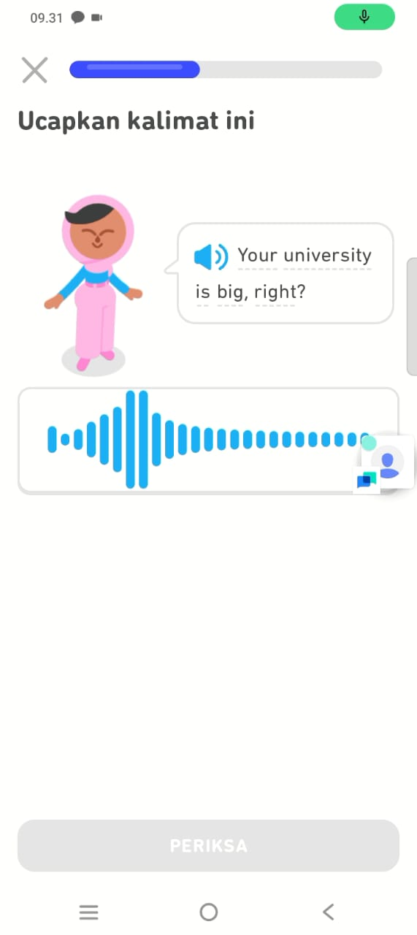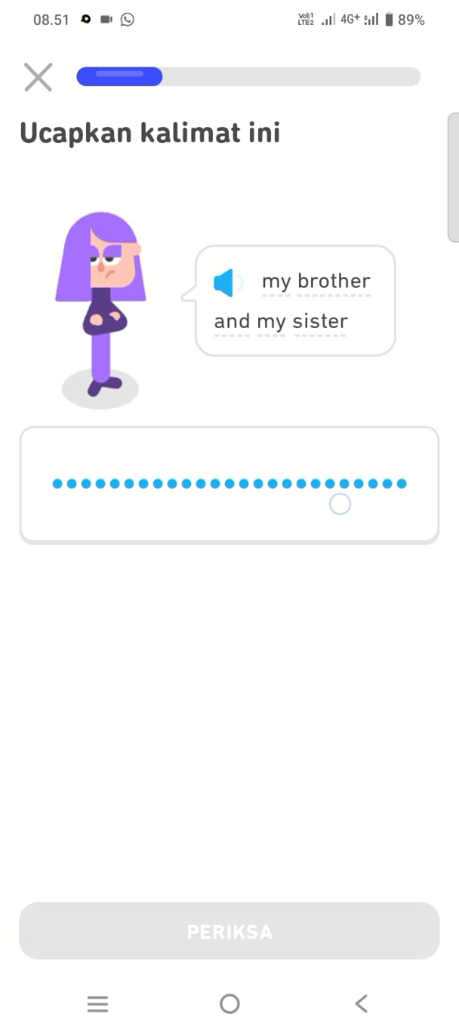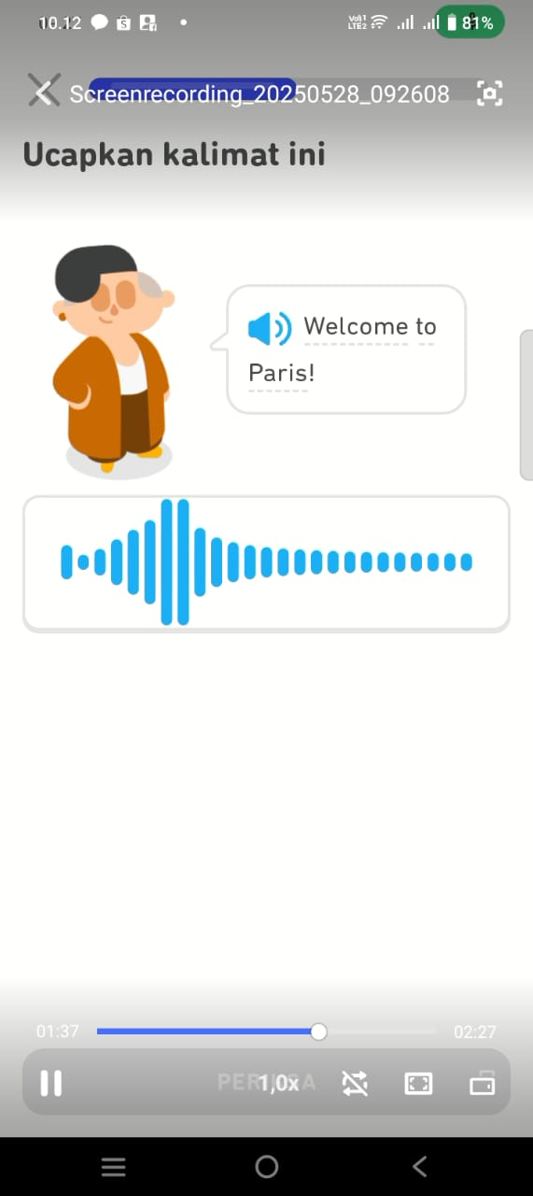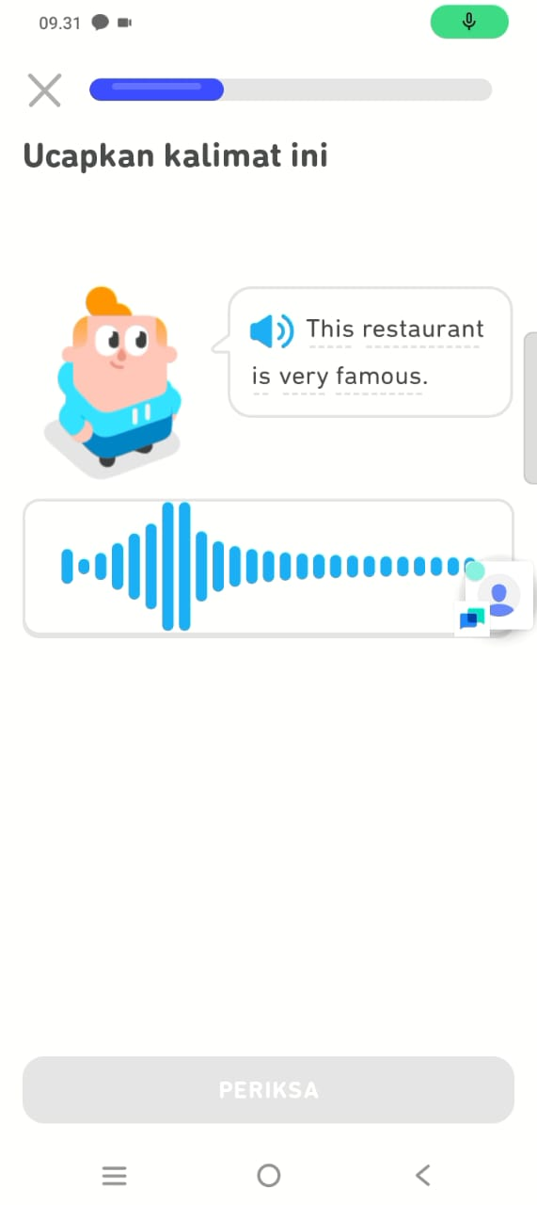

B. INTERVIEW GUIDE
1. How do you feel about learning English with Duolingo?
2. Is learning with Duolingo more fun than in class?
3. What is the thing you learned the most from Duolingo?
4. After using Duolingo, are you more confident in speaking English?
5. Do you think Duolingo is easy to use for learning?
C. SPEAKING ASSESSMENT RUBRIC
Aspect | Criterion 4  (Very Good) | Criterion 3  (Good) | Criterion 2  (Fair) | Criterion 1  (Poor)
Fluency | Speaks fluently without meaningful pauses. | Speaks fairly fluently with a few pauses. | Frequently pauses but can continue. | Frequently pauses and has difficulty continuing.
Pronunciation | Clear pronunciation and almost perfect. | Clear pronunciation with a few errors. | Unclear pronunciation with several errors. | Unclear pronunciation with many errors.
Content | Dialogue is highly relevant to the context and complete. | Dialogue fits the context with minor deficiencies. | Dialogue is somewhat off-context and fairly complete. | Dialogue does not fit the context and is lacking in completeness.
Confidence | Very confident, speaks without hesitation. | Fairly confident, with slight hesitation. | Lacks confidence, somewhat hesitant. | Not confident, very hesitant or refuses to speak.

D. DOCUMENTATION
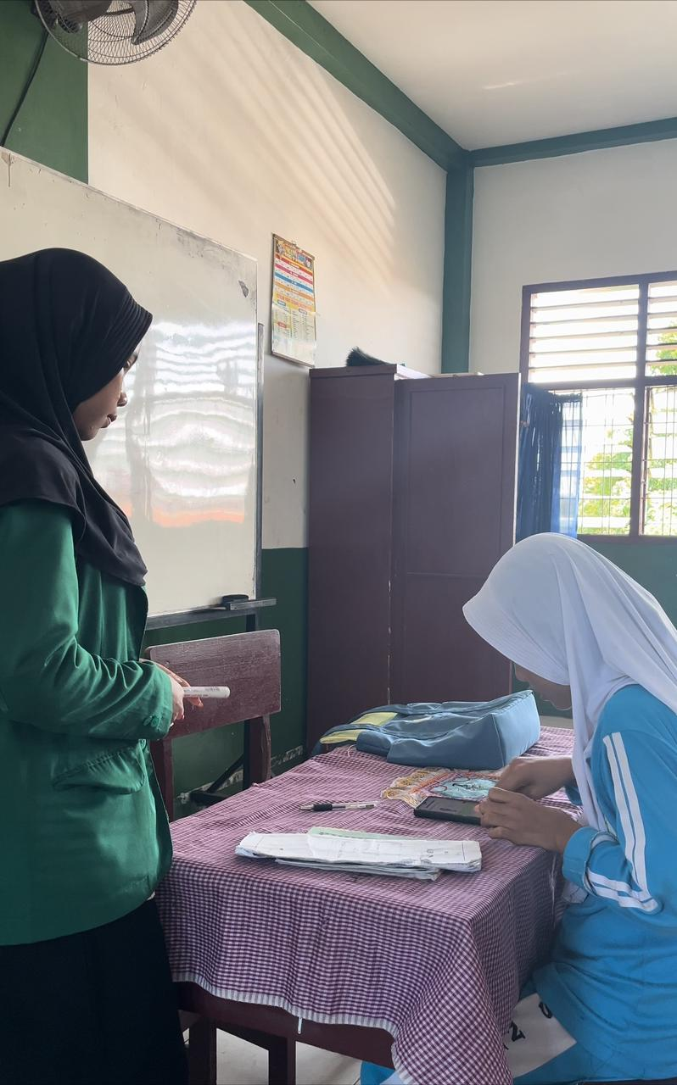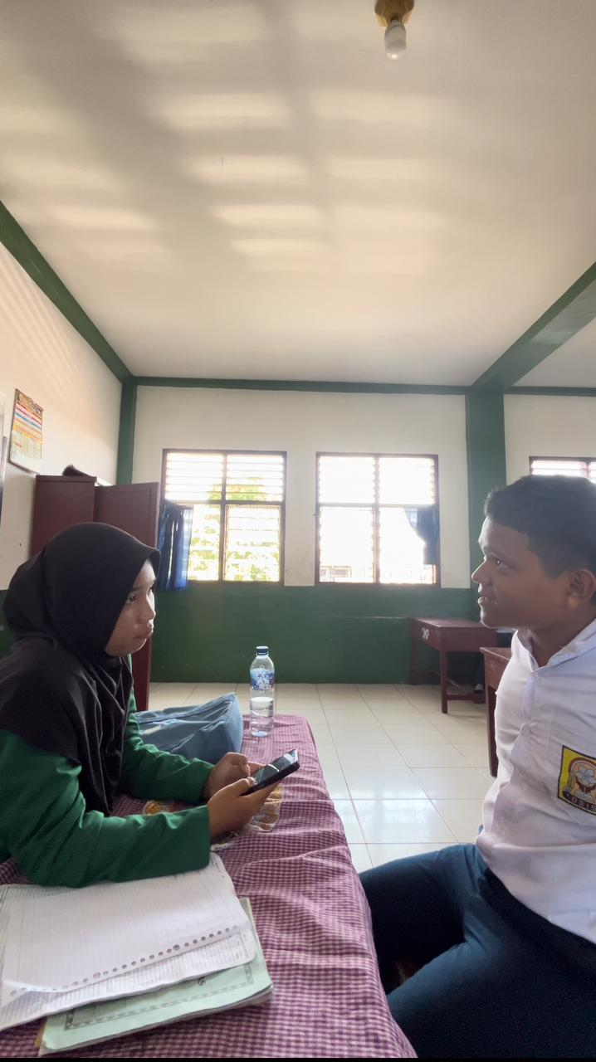
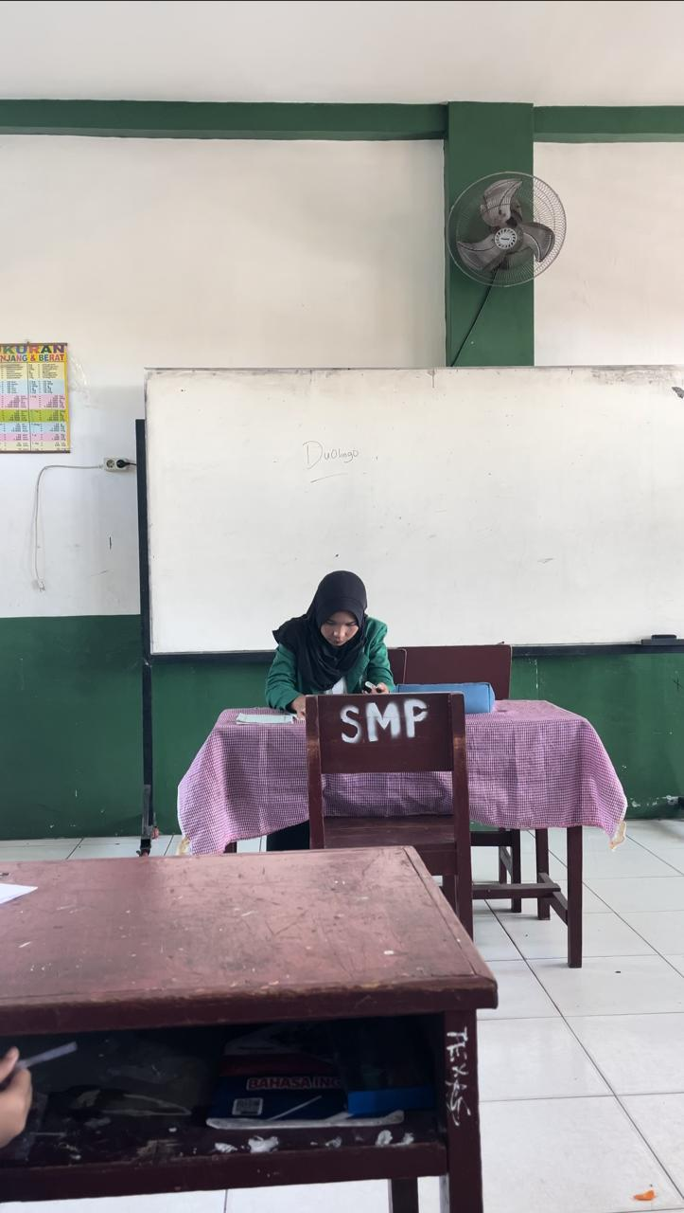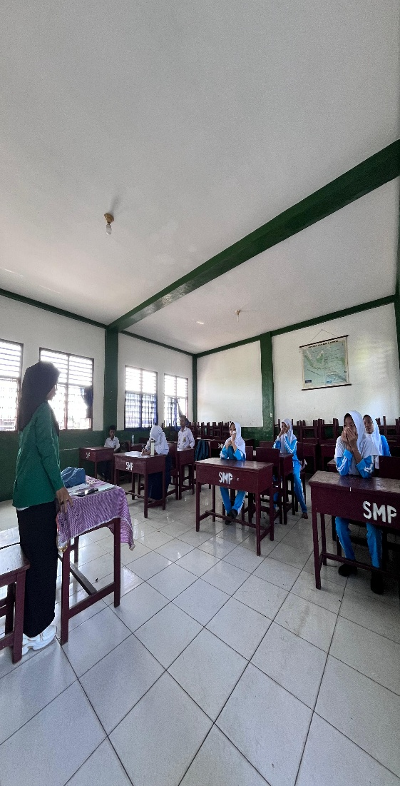
Interview Transcript
WA:
I like imitating from the app.
Yes, I prefer using the Duolingo app to classes.
Hello, how are you?
Yes, I really believe in using Duolingo.
Yes, I just talk to my phone.

MZY:
Learning to speak isn't scary.
With Duolingo, you can try it several times.
I understand the sound of the words when they're spoken.
I record my voice to see if my answers are correct or incorrect.
The app isn't difficult to use.
ZT:
I was confused at first, but then I got used to it.
I prefer using my phone.
I can say my name.
I've mastered pronouncing one word.
I understand when to speak.
KY:
I'm nervous, but I can learn a new language.
I can take it slow and don't rush.
I know how to learn words correctly.
I'm more confident in saying new words.
It's easy, just follow along.

ANK:
I like it because I can listen and join in.
Yes, because I'm shy about speaking.
I memorize it and say it straight away.
Yes, I can say a little bit.
Yes, because I just talk to my phone.
test and interview link
https://drive.google.com/drive/folders/12GmRDwjOIm1D4jRtYPVasBAYUqNa84dt

