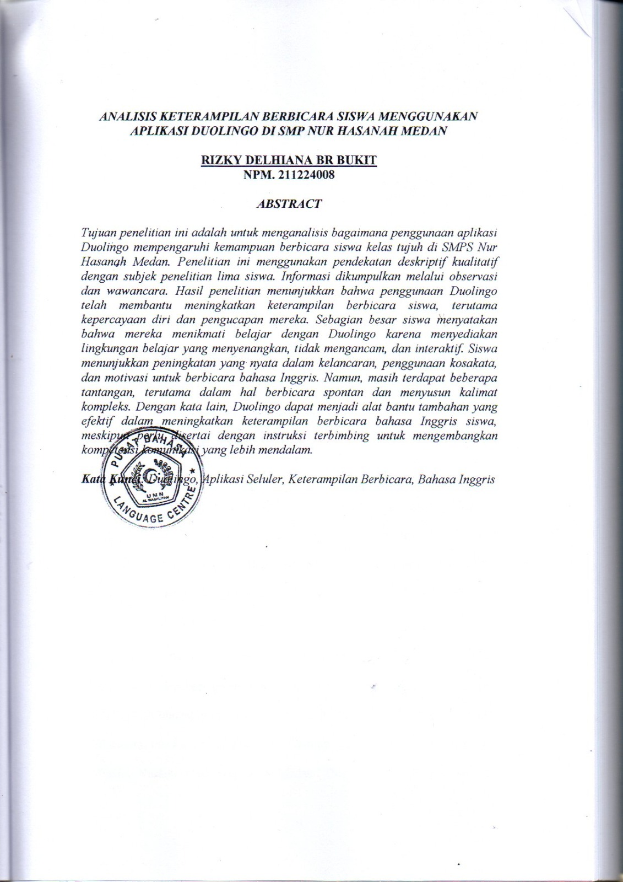
AN ANALYSIS OF STUDENTS’ SPEAKING SKILL USING DUOLINGO APPLICATION AT SMPS NUR HASANAH MEDAN

RIZKY DELHIANA BR BUKIT
NPM. 211224008

ABSTRACT

The objective of the research is to analyze how using the Duolingo app has affected the speaking abilities of seventh-grade students at SMPS Nur Hasanah Medan. The research used a qualitative descriptive approach which included five students as subjects of the research. Information was gathered through observation and interviews. The result suggests that using Duolingo has helped improve students’ speaking skills, especially their confidence and pronunciation. Most students expressed that they enjoyed learning with Duolingo because it provided a fun, non-threatening, and interactive learning environment. Students demonstrated noticeable improvements in fluency, vocabulary use, and motivation to speak English. However, some challenges remained, especially in terms of spontaneous speech and constructing complex sentences. In other words, Duolingo can be an effective supplementary tool in improving students’ English-speaking skills, though it should be accompanied by guided instruction to develop deeper communication competence.

Keywords: Duolingo, Mobile Application, Speaking Skill, English

