ACKNOWLEDGEMENTS

That means :
10. “O you who believe, would I show you a secret that can save you from a painful torment ?!”. 11. You give to Allah and His Messenger and fight in the way of Allah with your wealth and your soul. That’s better for you, if you know it.” (QS. Ash Shaff: 10-11).
Artinya:
“Hai orang-orang yang beriman sukakah kamu aku tunjukkan suatu perniagaan yang dapat menyelamatkanmu dari azab yang pedih ?!. (Yaitu) kamu beriman kepada Allah dan Rasul-Nya dan berjihad di jalan Allah dengan harta dan jiwamu. Itulah yang lebih baik bagimu, jika kamu mengetahuinya.” (QS.Ash Shaff: 10-11).
First of all, the greatest gratitude to Allah SWT, the Almighty God for the blesing which has been given to the writer so that she finally completed this thesis in partial fulfillment of the rewuirements for the degree of Bachelor at the English Education, the Faculty of Teachers’ Training and Education, the University of Muslim Nusantara Al Washliyah Medan. This Thesis could not have been accomplished without the guidances, suggetions, and comments from several people so the resercher would like to express her deep gratitude to the following people:
- Dr. H. Firmansyah, M.Si., as the Rector of Muslim Nusantara Al Washliyah University Medan.
- Dr. Abdul Mujib, S.Pd., M.PMat., as the Dean of FKIP of Muslim Nusantara Al Washliyah University Medan.
- Wariyati, S.Pd., M.Hum., M.Pd., as the Head of the English Education Department of Muslim Nusantara Al Washliyah University Medan.
- Yugi Diraga Prawiyata., S.Pd., M.Hum., M.Pd., as the adviser who gives the suggestion toward the researcher in finishing the underthesis.
- Wariyati, S.Pd., M.Hum., M.Pd and., as the first examiner who gives the sugestion.
- Dr. Yulia Arfanti, M.Hum., as the seconde examiner who gives the suggestion.
- The beloved Mrs. Nursiah, researcher’s parents source of strength in every step. Thank you for your never-ending spirit and support, for the prayers that continue to flow in every prostration and for the love that is always the reason the researcher endure. The researcher dedicate this underthesis as a form of the researcher’s gratitude.
- The beloved Mr. Maju Bukit, the researcher’s love for him never fades when the researcher remember that incident until now the researcher still can't believe it he lose, now the reseacher can be at this stage as the last form. Although in the end the researcher have to go through this journey without him. Thank you for always teaching the researcher to stay strong and patient. The feeling of envy and longing that is not conveyed, unrequited hugs often make the resracher fall but all that does not reduce the researcher’s pride and gratitude for the life that my father has given the reseacher.
- The beloved to the researcher’s best firiend, Reny Madhani and Nur Aminah Tanjung, thank you for being a part of this journey. You are not only friends, but also a place to share laughter, tiredness, and enthusiasm. When the steps feel heavy, your presence and support have strengthened the researcher. This thesis cannot be separated from the prayers, encouragement and togetherness that we knit together. May this friendship continue to be maintained, no matter how much time passes.
- The reseacher’s deepest gratitude to my friend (P), who has always faithfully encouraged, supported and helped the reseacher in the process of completing this underthesis. Thank you for understanding the researcher, accompanying the researcher in difficult times and patiently always accompanying the researcher without complaining. Your presence is one of the greatest strengths that has enabled the researcher to reach this point.
- All of the lecturers of the English Education Department of Muslim Nusantara Al Washliyah University Medan, for your priceless sacrifice and affection.
- All of the Academic Administration Staffs and the Librarians of Muslim Nusantara Al Washliyah University Medan.
- All friends of the English Education class 2021 UMN Al Washliyah.
Finally, the researcher realizes that this thesis is far from being perfect. Therefore, constructive suggestion is needed for the resercher.
Medan, Juni 2025
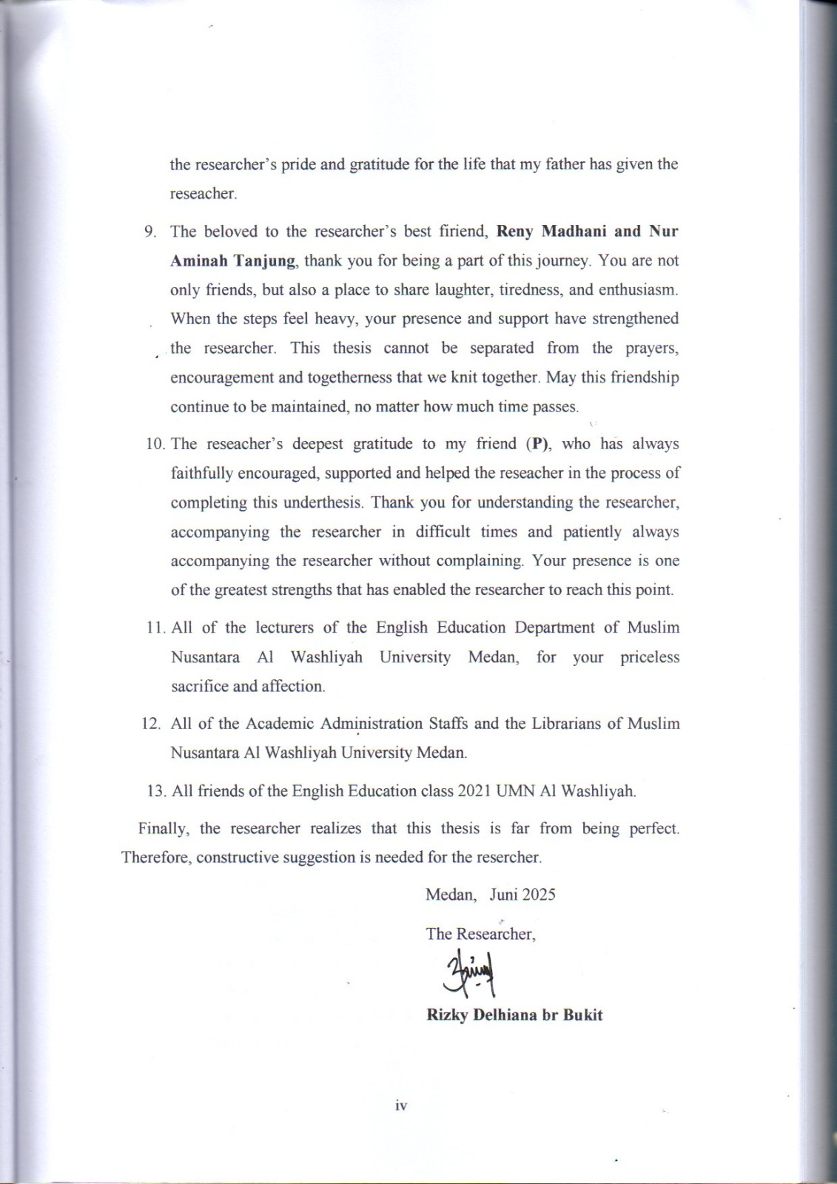
The Researcher,

Rizky Delhiana br Bukit

TABLE OF CONTENT

ACKNOWLEDGEMENTS ii
TABLE OF CONTENT v
LIST OF TABLES vi
LIST OF FIGURE vii
LIST OF DIAGRAM viii
ABSTRACT ix
ABSTRAK x
CHAPTER I 1
INTRODUCTION 1
1.1 Background of the Problem 1
1.2 Identification of the Problem 3
1.3 Limitation of the Problem 4
1.4 The Problem of the Research 4
1.5 The Objective of the Research 4
1.6 Significances of the Research 5
CHAPTER II 6
REVIEW OF RELATED LITERATURE 6
2.1 Theoritical Framework 6
2.1.1 Definition of Speaking 6
2.1.2 The Difficulties of Speaking 9
2.1.3 The Benefit of Speaking 9
2.1.4 Mobile Application in Learning English 10
2.1.5 Duolingo Application 14
2.1.6 Learning Speaking Skill through Duolingo Application 20
2.2 Conceptual Framework 22
2.3 Previous Relevant Researches 22
2.3.1 Researcher 1 23
2.3.2 Researcher 2 23
2.3.3 Researcher 3 24
CHAPTER III 27
RESEARCH METHODOLOGY 27
3.1 Research Design 27
3.2 Seting and Subject of the Research 28
3.3 Instrument of Collecting Data 28
3.4 Technique of Collecting Data 29
3.5 Technique of Analyzing Data 29
CHAPTER IV 30
RESEARCH RESULT AND DISCUSSION 30
4.1 Research Result 30
4.1.1 Speaking Test Results Using the Duolingo Application 30
4.1.2 Interview Results 31
4.1.3 Assessment Results Based on Speaking Rubric 34
4.1.4 Documentation 41
4.2 Discussion of Research Results 42
4.2.1 Students' Speaking Skills after using the Duolingo Application 43
4.2.2 Student Perceptions of the Use of Duolingo 43
4.2.3 Assessment Results Based on Speaking Rubric 44
4.2.4 Documentation of Learning Activities 45
4.3 Results and Discussion of Qualitative Research 45
4.3.1 Analysis of Findings Based on Tests and Assessment Rubrics 46
4.3.2 Analysis of Findings Based on Interviews 46
4.3.3 Integration of Findings: Duolingo as a Technology-Based Learning Media 47
4.3.4 Relation to Theory 48
BAB V 51
CONCLUSION AND SUGGESTION 51
5.1 Conclusion 51
5.2 Suggestions 52
REFERENCES 54
APPENDIX 58

LIST OF TABLES

Table 4. 1. Assessment Rubric 34
Table 4. 2. Final Score Summary 1 36
Table 4. 3. Final Score Summary 2 37
Table 4. 4. Final Score Summary 3 39
Table 4. 5. Final Score Summary 4 40
Table 4. 6. Final Score Summary 5 41

LIST OF FIGURE

Figure 2. 1. Duolingo Application 16
Figure 2. 2. Duolingo App in App Store 17
Figure 2. 3. Some languages will be learned and spoken 17
Figure 2. 4. Pick a daily goal 18
Figure 2. 5. Option when join the Duolingo 18

LIST OF DIAGRAM

Diagram 2. 3. 1. Conceptual Framework 22

