CHAPTER II

REVIEW OF RELATED LITERATURE
This chapter covers some theories as the basis of the discussion. It is aimed toward more understandings about the topic of the research. This chapter presents definition of speaking, the difficulties of speaking, teaching speaking through Duolingo application and definition of Duolingo application.

Theoritical Framework
In conducting a research, theories were needed to explain some concepts or terms which were applied in this research. Some terms in this research and they need to be theoretical explained. Thus, the following explanation aimed toward the clear explanation.

2.1.1 Definition of Speaking
Speaking is one of the skills that must be mastered by English learners because language is used to communicate with others in everyday life. In communicating, the speaker often conveys ideas and feelings towards the other person (Herlina, Yundayani, & Astuti, 2021).
In this delivery, the speaker uses verbal and nonverbal symbols in various situations (Thornbury, 2005). Speaking is not only about delivering ideas with the right intonation, but also related to how to deliver the contents of the conversation. Furthermore, speaking skill requires the speaker to know how to interact as about speaking turn (Jondaya & Rania, 2011). Speaking requires productive and receptive skills that involve the speaker and the listener.
It is undeniable thing that students should practice their English frequently. Therefore, the obligation of teachers is to foster the students’ self-confidence so that they are brave to use English (Niah, 2019).
Speaking is the ability to produce words in language practice. Speaking is an important skill that students have to master. It is because in speaking we can know the students’ ability to produce the target language or English. Speaking is to express thought a loud using the voice or talk. It means that when someone interacts with other by using a language as a mean, certainly, they want to convey something important. For example, they want to utter their feeling and thought. It is strongly impossible for someone to make a communication with other without having any purpose. As people communicate, there must be speaker and interlocutor. Therefore, communication involves at least two people; sender and receiver. They need communication to exchange information, ideas, opinion, view or feeling.
Keith and marrow say “Speaking is an activity to produce utterance to oral communication”. It means that this activity involves two or more people in whom the participants are both hearers and speakers having to react to whatever they hear and make their contribution a high speed, so each participant has intention or a set of intention that he wants. So, the English teacher should active the students speaking ability by providing communicative language activities in the classroom and then giving them the opportunities to practice their speaking skill as much as possible.
According to (Bailey, 2006), speaking is a process of interaction where speakers intend to build meaning through producing, receiving and processing information.
Speaking is an important skill in learning English, especially for junior high school students who are in the early stages of mastering a foreign language. Speaking skills allow students to convey ideas, ask questions, respond, and express themselves in various communication situations, both inside and outside the classroom.
Using applications such as Duolingo can provide additional benefits in improving students' speaking skills. This application provides interactive pronunciation and conversation exercises, which can help students practice pronunciation and build confidence when speaking in English. With features such as speech recognition and direct correction, students can learn from their mistakes independently and in a fun atmosphere.
In addition, speaking actively through Duolingo can help students enrich their vocabulary, improve fluency, and hone their ability to construct sentences spontaneously. Another benefit that is felt is increased motivation to learn because students feel freer and are not afraid of making mistakes when practicing speaking on their own using the application.
Thus, speaking not only helps students in mastering English practically, but also forms their communication skills, self-confidence, and readiness to face the challenges of learning at the next level.

2.1.2 The Difficulties of Speaking
1. Low Confidence
Because they are often exposed to traditional learning methods that use one-way communication patterns, usually students at school will have low self-confidence, especially in terms of speaking. This is a big scourge for the Indonesian people to be able to become a competitive society in the world of global competition. There are students who understand English very well but do not have self-confidence, thus closing the opportunity or opportunity for them to develop. There are also students who previously did not have self-confidence, but after they mastered English, it made them more confident and not afraid of obstacles in every opportunity that they will take in the future (Fitri & Apriliaswati, 2015)

2.1.3 The Benefit of Speaking
The benefits of speaking skills are to facilitate communication between students, notification of various information, so that the message can be received in its entirety, and increase self-confidence and self-authority. Language skills that develop in students' lives, which are only preceded by listening skills, and at that time the ability to speak.
Benefits of Speaking for Students
1. Improve academic skills
Students can more easily understand the subject matter, especially for subjects such as Science.

2. Broaden horizons
Students can broaden their horizons and knowledge about culture and life in other countries.
3. Improve thinking skills
Students can train their memory and develop thinking skills by learning new words and adopting grammar rules.
4. Improve problem-solving skills
Students can practice problem-solving skills by understanding a second language such as English.
5. Make it easier to socialize and adapt
Students can more easily socialize and adapt in new environments.
6. Open up job opportunities and career paths
Students can have the opportunity to get jobs and career paths.
7. Make friends with foreign students
Students can expand their network of friends by making friends with foreigners.

2.1.4 Mobile Application in Learning English
When it comes to learning English, few can beat the comfort and control of portable apps. These advanced learning devices make it simple to consider English “on the go” in parts of one of a kind and curiously ways (Wong, 2023).
- Best for Fast Vocab Learning: Bright
Bright is a simple and efficient app that promises to teach you 500 essential words in two months.
- Best for Basic English : Mondly
Mondly is a well-known app that does a great job teaching conversational phrases you can use in real life, from shopping to going on a date.
- Best for Test Preparation: Knudge.me
Knudge.me app uses English games to test out your English skills.
- Best for Fun Beginner Lessons: Lingodeer
Lingodeer takes a gamified approach to language learning with a goal-oriented curriculum consisting of structured lessons and regular reviews.
- Best for Authentic Content: LingQ
LingQ is here to help you practice English with more than 1,000 hours of audio files, including podcasts and audiobooks.
- Best for Reading: Beelinguapp
If you prefer music and audiobooks, Beelinguapp is for you. You can choose your reading material from a number of short stories and novels and learn at your own pace.
- Best for Native Speaker Practice: Lingbe
Lingbe connects you with native speakers for language conversation practice. To contact native speakers on Lingbe, all you have to do is press the call button. The app will immediately match you with someone who will patiently help you learn the language.
- Best for English Immersion: Rosetta Stone
Usually, an English app teaches you English with explanations in your native language, but Rosetta Stone teaches you English with English.
- Best for Pronunciation Practice: ELSA Speak
ELSA Speak is probably the best mobile app around for helping you improve your English pronunciation.
- Best for Video-based Immersion: FluentU
FluentU takes real-world videos—like music videos, movie trailers, news and inspiring talks—and turns them into personalized language learning lessons.
- Best for Casual Learning: Duolingo.
Duolingo is designed to help you learn English quickly, so you can use it even if you’re just a beginner.
- Best for Practical Topics: Babbel
Babbel teaches you English through 15-minute lessons that feature realistic conversations on topics that you’re interested in. You can also take optional live classes.
- Best for Memorizing Vocabulary: Memrise
This app is very flashcard-based and is focused on teaching you English words. It uses some creative, funny ways to help you remember what words mean.
- Best for Essential Vocabulary: Mosalingua
Mosalingua is focused on two things: teaching you the 1,500 most important words and phrases that you should have in your English word bank, and solving the problem of forgetting what you’ve learned over time.
- Best for Community Learning: Busuu
Busuu is a little bit different from many of the apps we’ve mentioned here. With Busuu, you can talk with native English speakers to practice your conversational skills.
- Best for Audio-based Learning: Pimsleur
Pimsleur’s structured curriculum is based on the idea that you will listen to one 30-minute lesson a day centered around English dialogue with explanations from the narrator. The audio has plenty of pauses where you’ll be prompted to talk out loud or repeat what the narrator said.
- Best for Different Learning Levels: Innovative Language
It also has notes for each lesson that you can use to review and remember the content better. The lessons are divided according to learning levels, and you can also download specific lessons for offline use.
- Best for Group Learning: ABA English
ABA English offers more than 100 grammar videos on American and British English for your daily lessons. It also gives you access to short and full-length films designed to teach expressions, vocabulary and other things.
- Best for English Chatting: Andy
The Andy chatbot uses a question-and-answer format to help you learn more things about English conversation. It also reads out the messages so you can practice English listening and pronunciation along with reading and texting.
- Best for Grammar: Learn English Grammar
What’s great about Learn English Grammar is that it incorporates activities into every lesson to help make grammar easier to learn. Each section is divided into skill levels—Beginner, Elementary, Intermediate and Advanced—so finding the right level for you shouldn’t be a problem.
Students will have their claim take on what makes the leading English learning app, so discover what works best for then. Then, in this research, the researcher focuses on Duolingo application only.

2.1.5 Duolingo Application
Duolingo is a free language learning app created by Luis von Ahn and Severin Hacker. This application is not only available in web version but also available in Android, iOS and Windows Phone versions. Today, many students use mobile applications (apps) to support their language learning both inside and outside the classroom (Klimova, 2020) Media in learning is very important in helping convey information. Because teaching vocabulary without using any media will not give good results. Duolingo can be a medium in learning a second language, especially vocabulary. Duolingo offers "gamification" learning, for users. The games in this application provide benefits for users to learn the target language (Nushi & Eqbali, 2017).
Now that technology has taken part in education, the role of technology in education is fourfold: including as part of the curriculum, as an instructional delivery system, as a means to assist instruction and also as a tool to improve the entire learning process. Stated that Game-based learning is a very popular technology trend that uses game elements (Raja & Nagasubramani, 2018).
(Mahmudah, 2015) and (Mendez Bermudez, 2017) have conducted a research on the Duolingo application. The similarity between these two studies is using Qualitative descriptive in Duolingo's research. In the research conducted by Mahmudah, the field of research is pronunciation while Bermudez's research is about the possible effects of applying Duolingo for learning English. Another research previously conducted by Vasselinov from Queen College University and Grego from the University of South Carolina (2012) entitled "Duolingo Effectiveness Research" shows that using Duolingo is effective for language tests because it can measure hourly research time to improve language. The results of this research indicate that Duolingo can be used as a language test medium that can measure students' ability in language competencies, namely listening, reading, writing, and speaking.
Research conducted by (Khan & Ali, 2010) show other problems that occur in the field which certainly affect the students' speaking abilities Research shows that many students do not dare to use English in class because they are afraid of the teacher, and many students are reluctant to practice both inside and outside the classroom for fear of being laughed at by friends.
The researcher will conduct this research on seventh grade students of junior high school. In addition, the researcher uses the random topic based on the Duolingo application as an instrument in conducting this research. The objective of this research is to research the analysis of using the Duolingo application in improving students' speaking skills.
Based on the explanation above, the researcher can conclude that Duolingo is an online platform and mobile application that offers users a free and innovative way to learn speaking.
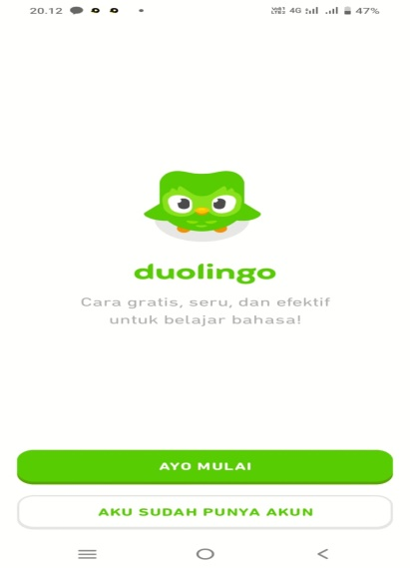
Figure 2. 1. Duolingo Application
- The steps to use Duolingo
There are some steps you must do when you want to use Duolingo application, they are:
1) Download the Duolingo app in Google Play Store or app store.2.2.6 Game on Level 1.
Types of Game di Level 1
1. Vocabulary Translation (Include SS)
2. Guessing the Audio

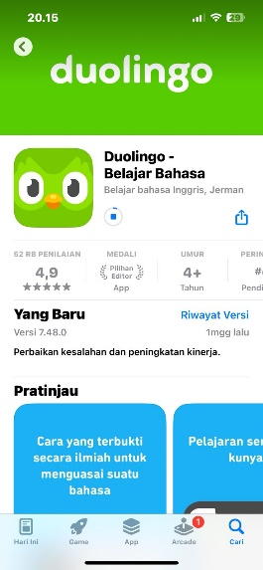
Figure 2. 2. Duolingo App in App Store
2) Select the language you want to learn and speak
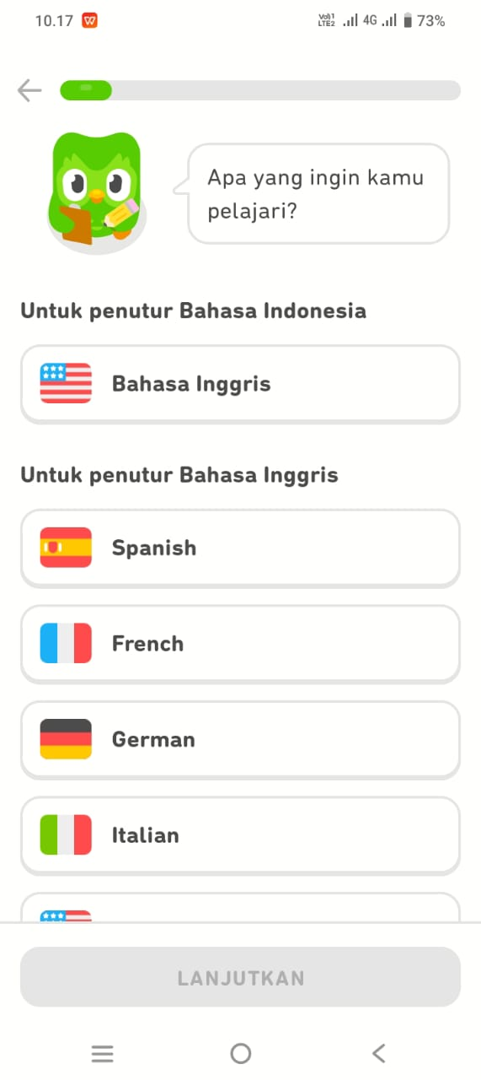
Figure 2. 3. Some languages will be learned and spoken

3) You must set your pick a daily goal
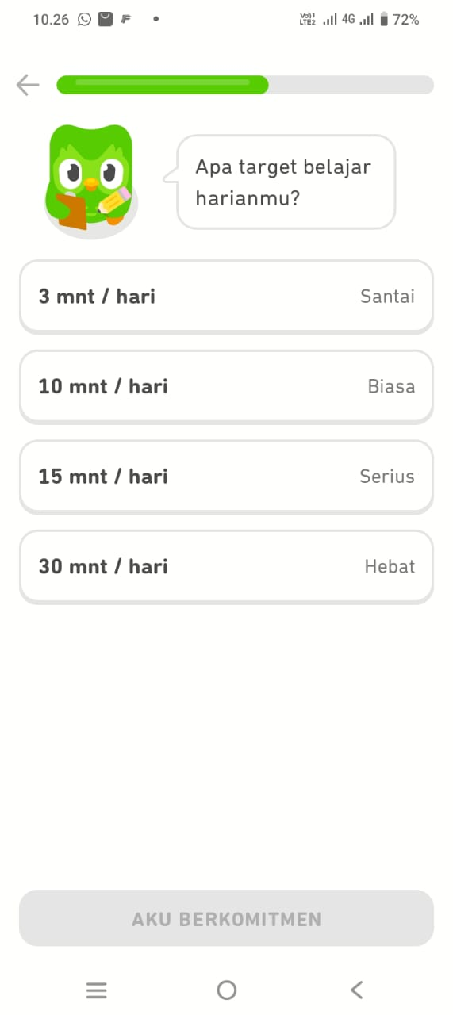
Figure 2. 4. Pick a daily goal
4) The app will ask you to choose one of them below.
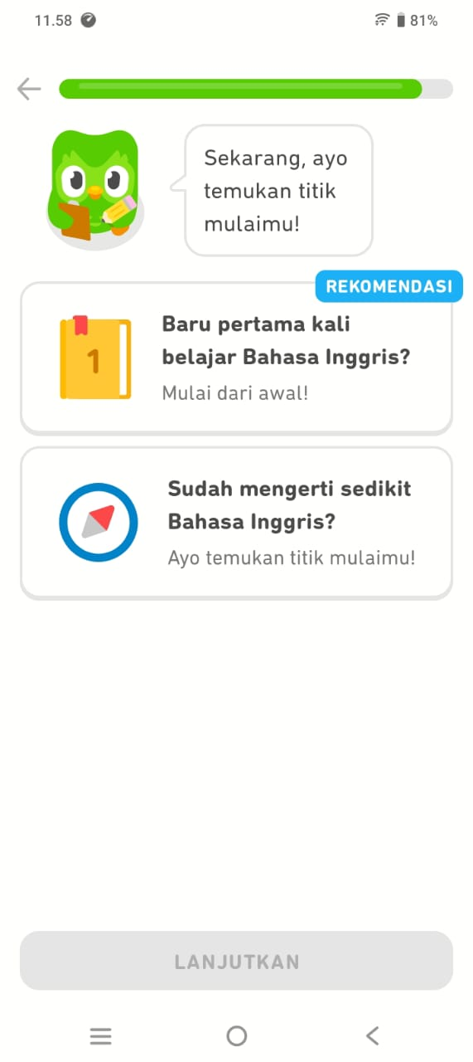
Figure 2. 5. Option when join the Duolingo
In just a few years, Duolingo has emerged organically as the most widely used online method for learning languages. Duolingo has a variety of cutting-edge methods for learning languages, especially speaking. These methods can make it easier for students to speak, so that increase their interest and enjoyment, during the learning process. The Duolingo Language Learning App is also free and can be downloaded on mobile phones or PCs, so users can practice anytime and anywhere, especially for young English learners.
Launched in November 2011, Duolingo boasts already at the time of writing 300,000 active language learners ready for the task. It's possible that some people are already familiar with this application because it is very beneficial to its users. According to the play store, more than 100 million people have downloaded it, and more than one million people have given it a five star rating, where the number of five rating is a perfect rating on play store. Additionally, the play store provided category editor or "editor's choice". This means that the application is highly recommended, even recommending this application is the editor himself that no other official staff from google.
As of 2022, Duolingo offers more than 100 total courses for 41 different languages, ranging from Spanish, French, German and Japanese to Navajo and Yiddish. There are even artificial or fictional languages, such as Klingon and High Valyrian. You can change the language you will learn, adding languages will not make you lose progress in existing courses. You can switch between the courses you have started, it is very easy to learn with multiple languages.
This application could be considered a game, but games on Duolingo are very much connected to education, especially when it comes to learning a new language. When the device is turned on, the user will receive five hearts that function as the other user's life. The user loses one life point for each incorrect response, and so on. Additionally, if the heart has become worn out, it ought to learn the lesson all over again. In a very user-friendly manner, this application combines audio, visual, and grammar-related questions.

2.1.6 Learning Speaking Skill through Duolingo Application
The use of Duolingo App can improve students' speaking skills in terms of pronunciation, and fluency. Duolingo App offers speaking practices that simulate conversations with native speakers, students can check their pronunciation with the speech recognition on the Duolingo App. Simply students also get to record their voice and get immediate feedback. Soon students will learn to sound like a native speaker. The Collins dictionary defines it as: “Someone who speaks that language as their first language, rather than having learned it as a foreign language” So, technically, anyone with English as a first language from birth is a 'native English speaker'. Teachers can use the Duolingo App in many techniques or activities in order to meet the goal of speaking class (Hafifah, 2021).
Talking issue is still a noteworthy issue confronted by EFL learners in Indonesia, counting in North Sumatera. Concurring to (Putri & Ismiati, 2018), one viewpoint that understudies require offer assistance with is talking. Everything is included when talking, and understudies battle to memorize how to utilize language structure, lexicon, and elocution. Talking and composing are considered expressive aptitudes (profitable), and they are included within the four aptitudes that understudies must ace since they illustrate that understudies can talk English and express thoughts or considerations that they will say. Agreeing to (Haryudin & Jamilah, 2018), talking English could be a world dialect that needs much work out to ace. Understudies must hone both interior and exterior of the classroom and can utilize the suitable media to create their capacity to talk English fluidly. With respect to students' capacity in English, learners for the most part utilize a particular stage to back their learning, such as Duolingo. They utilize this application to assist them hone talking. Be that as it may, a few other understudies still have distinctive issues in talking for a few reasons, such as need of certainty, need of lexicon, and fear of making botches in pronunciation and grammar.
It is crucial to highlight that speaking is a skill that exhibits a person's proficiency in a particular language (Syahputri & Ismail, 2022), specifically English, and facilitates direct self-expression. When speaking, a person acts as a translator or interpreter of what they are saying to another person, which requires the brain to process information twice: first in the appropriate Indonesian form and then in the correct English form. According to (Eliyasun & Urai, 2018), speaking is a method of verbal communication or idea exchange. In addition, Brown (Brown & Yule, 2006) state that the complexity of the information to be communicated affects communication. However, sometimes, students experience difficulty comprehending what they mean. They need to consider their words more carefully, and their ability to communicate with others may be challenging. Hence, teachers and instructors must consider the learning environment to be more conducive and supportive of learning (Ismail & Yoestara, 2022). In addition, according to (Efrizal, 2012), students must recognize that speaking entails three areas of knowledge mechanics (pronunciation, grammar, and vocabulary), so that problems in speaking can be resolved by mastering these mechanics.

Conceptual Framework
This research can be shown in logical and clear relationship in the following framework:
Learning Speaking

Using Duolingo

Test

Data Analysis

Result

Diagram 2. 3. 1. Conceptual Framework

Previous Relevant Researches
There are three related researches that the researcher found in this thesis proposal.

2.3.1 Researcher 1
(Prawiyata & Barus, 2021) Analysis Of Speaking Ability Of Students Of English Education Research Program Of UMN Al Washliyah Through Vlog On Instructional Planning and Media Course.
The objective of this research was to determine how students’ speaking skill of UMN Al Washliyah English Education Research Program through vlogs on Instructional Planning and Media course was. This research used a descriptive qualitative research design, in which the researcher described and analyses speaking skill. The population in the research was 10 students of UMN Al Washliyah English Education Research Program in semester III-V in Academic Year 2020/2021, totaling 10 people. Based on the research results, it can be concluded that the students’ speaking skill was between the levels “Above Average” and “Excellent.” In other phrases, it may be concluded that vlog media may be an interesting alternative media that may be used to improve college students’ speaking skill.

2.3.2 Researcher 2
(Prawiyata & Sulistianingsih, 2023) The Effect of Using Small Group Discussion toward Students’ Speaking Ability at SMA Al-Washliyah 1 Medan.
The purpose of this research was to determine whether there was a significant effect of the use of small group discussions on students' speaking ability. This type of research is quantitative research and was conducted using two classes as research samples, namely class X-IPS 2 as an experimental class consisting of 20 students and class X-IPA 1 as a control class consisting of 20 students. In data collection techniques, the researcher conducted pre-tests, treatments and post-tests by providing tests in the form of speaking test examples.
The results of this research indicate that there is a significant effect of small group discussions on students' speaking ability. This can be seen after the data was analyzed, in the post-test of the control group, an average score of 69.75 was obtained, which means that students' speaking ability achievement is included in the sufficient category, and in the post-test of the experimental group, an average score of 76.25 means that students' achievement in speaking ability is included in the good category, then after testing the research hypothesis, it turned out that the hypothesis was accepted. This means that class X students of SMA AL-Washliyah 1 Medan apply small group discussions in speaking learning higher than without small group discussions.

2.3.3 Researcher 3
(Ardiansah, 2023) (A Research on Project-based Learning (Pjbl) Model and English Conversational Gambits in Classroom Speaking Practices).
This research aims to determine the effectiveness of a contemporary teaching model of Project-Based Learning (PjBL) using English Conversational Gambits as language material, which focuses on improving students' speaking skills. However, this research examines students' attitudes toward implementing learning models in terms of behavioral, cognitive, and emotional aspects. This present research was conducted at a university in Tasikmalaya.
This present research used quantitative and qualitative designs following the purpose of the present research. As the results of quantitative data, it was found that the sig. (2-tailed) of t-test value is 001 which is smaller than 05 value.
The results showed that the use of PjBL model improves students' proficiency in speaking by optimizing the process of EFL teaching and learning using material of English conversational gambits. In addition, according to the qualitative data analysis, this research shows that most of the students showed a positive attitude toward the implementation of the learning model. This research demonstrated by implementing PjBL model with English Conversational Gambits can be alternative strategy in EFL instructional techniques that can improve students' speaking skills.
As seen from the three previous relevant researches, the difference of this research would be on analysis of using Duolingo.
2.3.4 Researcher 4
(Youlanda & Wariyati, 2023) (The Effectiveness of Using Duolingo Application for Student’s Grammar Ability in English).
The purpose of this research is to investigate whether or not Duolingo can improve students’ grammar ability in English. This research use quantitative method and conducted in VII-B SMP Satria Dharma Perbaungan. In this research, the researcher used one class as the sample with total number of 26 students. The data was collected by giving pre-test and post-test as the instruments. The result of this research was calculated by using T-test. The findings showed that the students’ post-test scores was (80,76) it was higher than their pre-test scores (61,73). The result that is showed by using t-test, the scores of calculation (8,57) was higher than score of table (1,705) at significant level 5%. This finding reveals that Duolingo gives the significant result at 7th grade students of SMP Satria Dharma Perbaungan to increase students grammar ability in English.

