REFERENCES

Ardiansah, D. (2023). A Study on Project Based Learning (PJBL) Model and English Conversational Gambits in Classroom Speaking Practices.
Bailey, K. M. (2006). Issues in teaching speaking skill to adult ESOL learning.
Brown. (2004). Brown, H. Douglas. (2004). Language Assessment: Principles and Classroom Practices. Pearson Education.
Brown, G., & Yule, G. (2006). The study of language. Cambridge University Press.
CEFR. (2001). Common European Framework of Reference for Languages: Learning, Teaching, Assessment.
Creswell, J. W; Creswell, J. D. (2017). Research design: Qualitative, quantitative, and mixed methods. 27 november 2017.
Devita, A. (2015). pengaruh metode pembelajaran dan dialek suku terhadap hasil belajar inggris siswa/i sma padamu negeri. (Doctoral dissertation,UNIMED).
Efrizal, D. (2012). Improving students’ speaking through communicative language teaching method at Mts Ja-alhaq, Sentot Ali Basa Islamic Boarding School of Bengkulu. Unpublished thesis.
Eliyasun, E. R., & Urai, S. (2018). Improving students’ speaking ability through guided questions. Journal Pendidikan dan Pembelajaran.
Fitri, D. A., & Apriliaswati, R. (2015, september 16). A study on student's English speaking problems in speaking performance. jurnal pendidikan dan pembelajaran Khatulistiwa (JPPK.
Haryudin, A., & Jamilah, S. (2018). Teacher’s Difficulties in Teaching Speaking Using Audio Visual AID for. ELTN Journal.
Herlina, E., Yundayani, A., & Astuti, S. (2021). stipkusumanegara.ac.id/index.php/semnara2020.
Herlina, E., Yundayani, A., & Astuti, S. (2021). Penggunaan Duolingo sebagai Media Pembelajaran. Jurnal Pendidikan.
Indrasari, A., Novita, D., & Megawati, F. (2018, october 11). BIG Book: Attractive media for teaching vocabulary to lower class of young learners. JEES (Journal of English Educators Society).
Ismail, N. M., & Yoestara, M. (2022). The development of learning environment based on learning materials in EFL speaking class. Journal of Linguistics, Literature and Language Teaching.
Jondaya, & Rania. (2011). The effectiveness of using information gap on developing speaking skill for the eighth graders in Gaza governorate schools.
Khan, N., & Ali, A. (2010). Improving the speaking ability in English: The students’ perspective. Procedia - Social and Behavioral Sciences.
Klimova, B. (2020). Benefits of the Use of Mobile Applications for Learning a foreign Language by elderly Population.
Mahmudah, L. (2015). An analysis of pronunciation exercises in Duolingo application and its contribution as english learning media.
Matra, D. S. (2020, February 1). Duolingo Application as vocabulary learning tools. Journal of english literature,linguistics, and education.
Mendez Bermudez, N. M. (2017). Duolingo: An Useful Complementary Mobile Tool to Improve English as a Foreign Language Learning and Teaching.
Niah, S. (2019). The Utilization of Duolingo to Improve the Speaking and listening skill of junior high school students in pekan baru. Social Sciences and Humanites track (ICCELST-SS.
Nushi, M., & Eqbali, M. H. (2017). Duolingo: A mobile application to assist second language learning. Teaching English with Technology.
O'Malley, & Pierce. (1996). Authentic Assessment for English Language Learners: Practical Approaches for Teachers. Longman.
Prawiyata, Y. D., & Barus, U. (2021, August 8). Analysis of Speaking Ability of Students of English Education Study Program of UMN Al Washliyah through Vlog on Instructional Planning and Media Course. Journal of Research and Review.
Prawiyata, Y., & Sulistianingsih, T. (2023, Desember ). Jurnal Pendidikan Tambusai . The Effect of Using Small Group Discussion Toward Students’ Speaking Ability at SMA Al-Washliyah 1 Medan.
Putri, L. M., & Ismiati, A. (2018). Teaching listening using Duolingo application. Journal of English Education.
Raja, R., & Nagasubramani, P. C. (2018). Impact of modern technology in education. Journal of Applied and Advanced Research.
Scott, & Thornbury. (2005). How to Teach-Speaking.
Syahputri, V. N., & Ismail, N. M. (2022). Instructional Methods in Speaking Classes: Reviewing Literature. International Conference on Multidisciplinary Research.
Teske, K. (2017). Duolingo. CALICO.
Thornbury, S. (2005). How to Teach Speaking.
Wong, B. (2023, February 11). 20 Best Apps for Learning English. Retrieved from FluentU: https://www.fluentu.com/blog/english/best-apps-for-learning-english.
Youlanda, P., & Wariyati. (2023, February 1). The Effectiveness Of Using Duolingo Application For Students` Grammar Ability In English. Journal of the Center for People's Education.

APPENDIX
A.TEST
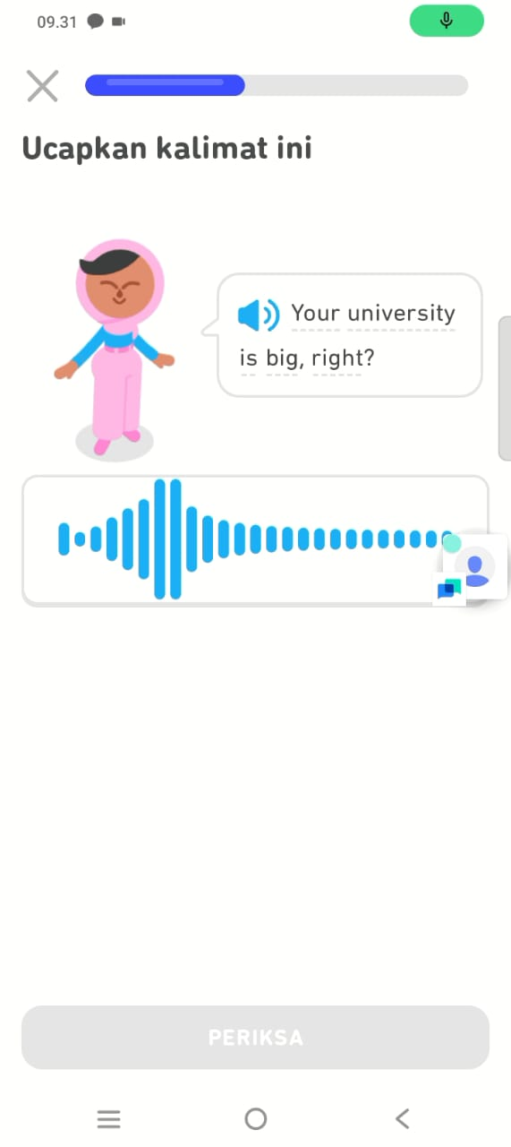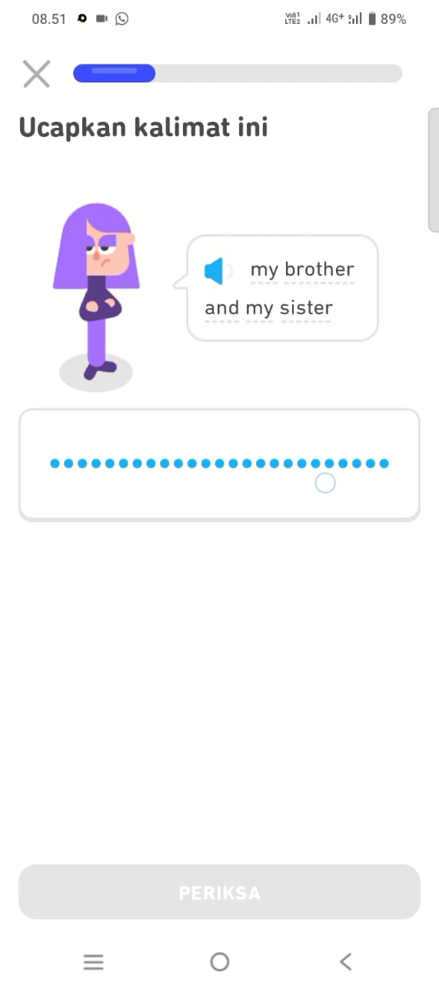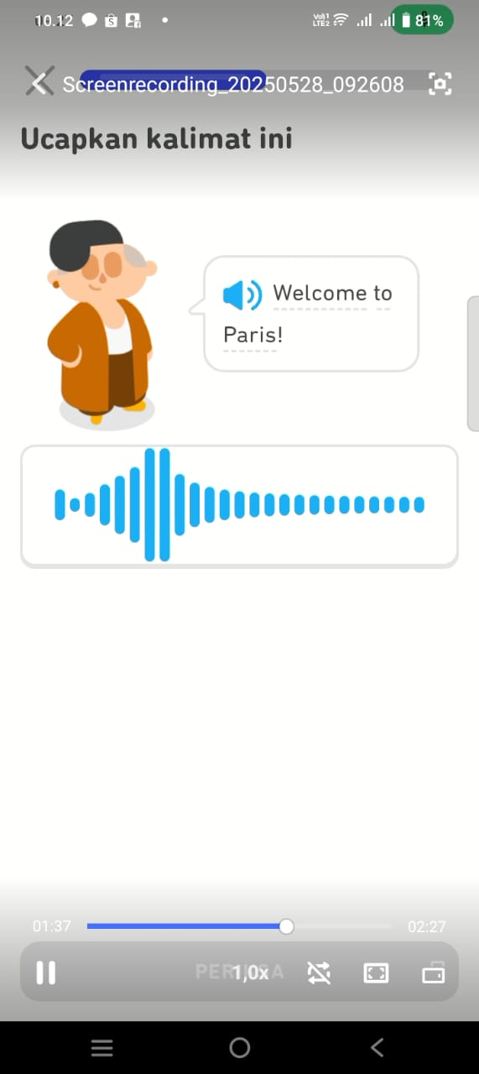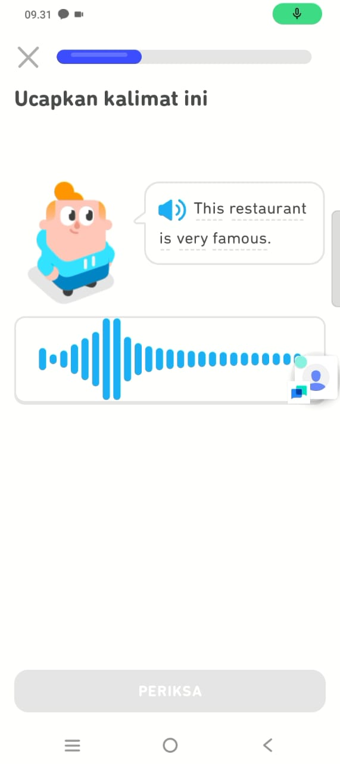

B. INTERVIEW GUIDE
1. How do you feel about learning English with Duolingo?
2. Is learning with Duolingo more fun than in class?
3. What is the thing you learned the most from Duolingo?
4. After using Duolingo, are you more confident in speaking English?
5. Do you think Duolingo is easy to use for learning?
C. SPEAKING ASSESSMENT RUBRIC
Aspect | Criterion 4  (Very Good) | Criterion 3  (Good) | Criterion 2  (Fair) | Criterion 1  (Poor)
Fluency | Speaks fluently without meaningful pauses. | Speaks fairly fluently with a few pauses. | Frequently pauses but can continue. | Frequently pauses and has difficulty continuing.
Pronunciation | Clear pronunciation and almost perfect. | Clear pronunciation with a few errors. | Unclear pronunciation with several errors. | Unclear pronunciation with many errors.
Content | Dialogue is highly relevant to the context and complete. | Dialogue fits the context with minor deficiencies. | Dialogue is somewhat off-context and fairly complete. | Dialogue does not fit the context and is lacking in completeness.
Confidence | Very confident, speaks without hesitation. | Fairly confident, with slight hesitation. | Lacks confidence, somewhat hesitant. | Not confident, very hesitant or refuses to speak.

D. DOCUMENTATION
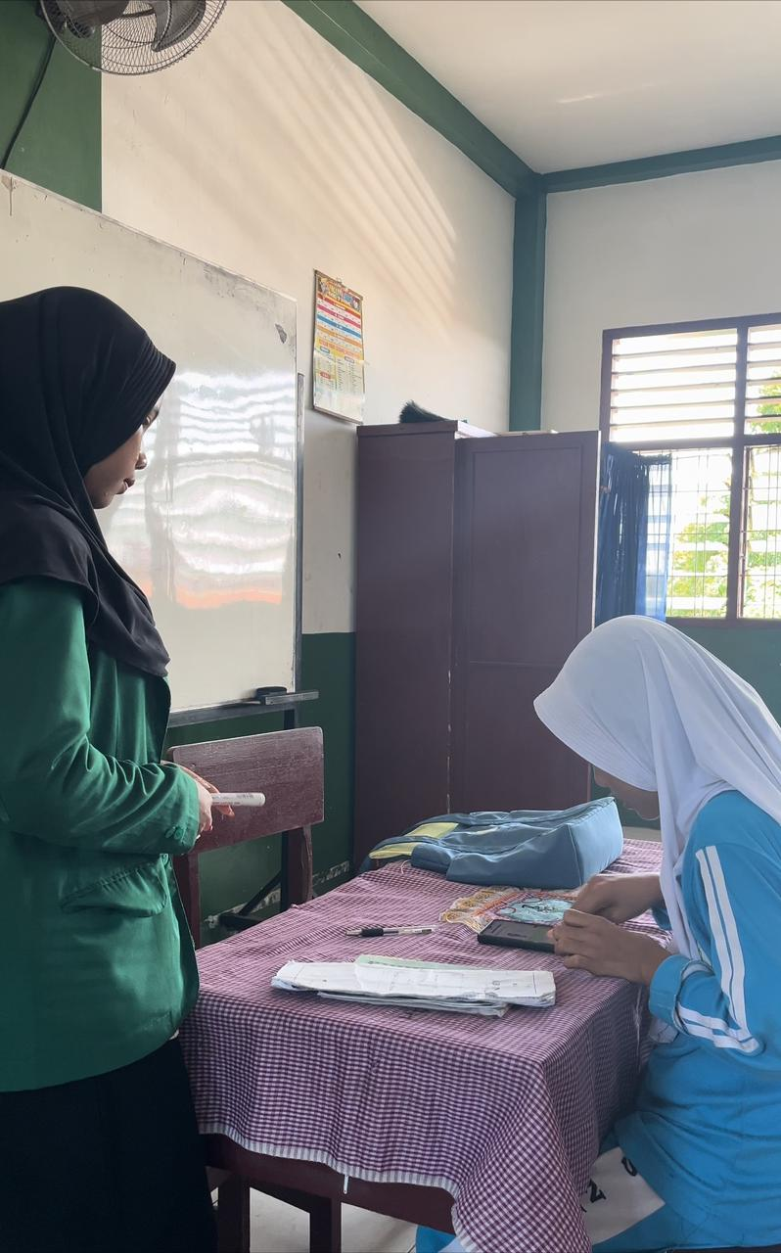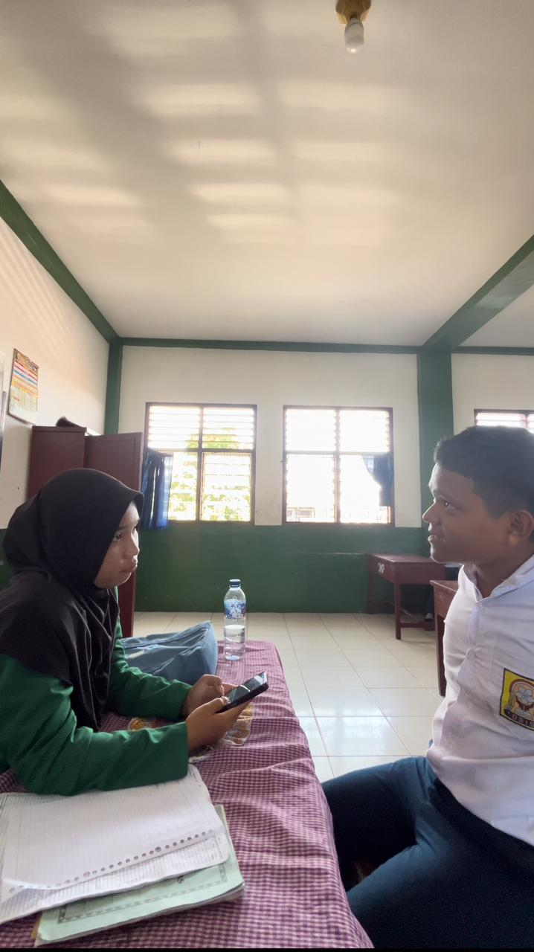
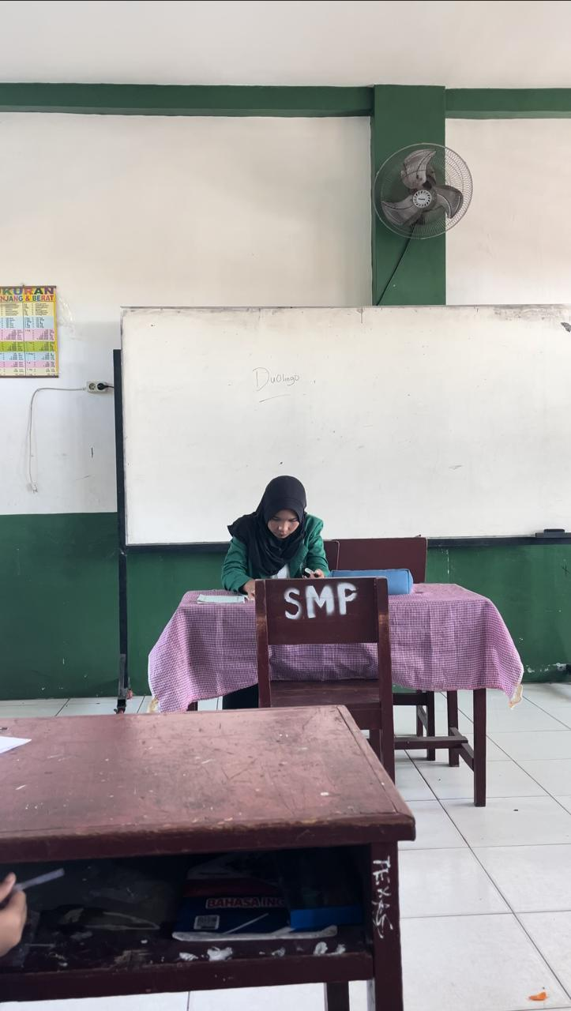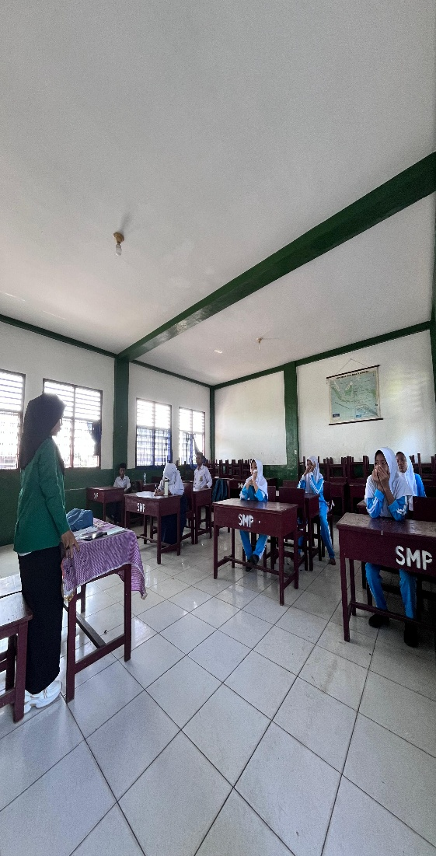
Interview Transcript
WA:
I like imitating from the app.
Yes, I prefer using the Duolingo app to classes.
Hello, how are you?
Yes, I really believe in using Duolingo.
Yes, I just talk to my phone.

MZY:
Learning to speak isn't scary.
With Duolingo, you can try it several times.
I understand the sound of the words when they're spoken.
I record my voice to see if my answers are correct or incorrect.
The app isn't difficult to use.
ZT:
I was confused at first, but then I got used to it.
I prefer using my phone.
I can say my name.
I've mastered pronouncing one word.
I understand when to speak.
KY:
I'm nervous, but I can learn a new language.
I can take it slow and don't rush.
I know how to learn words correctly.
I'm more confident in saying new words.
It's easy, just follow along.

ANK:
I like it because I can listen and join in.
Yes, because I'm shy about speaking.
I memorize it and say it straight away.
Yes, I can say a little bit.
Yes, because I just talk to my phone.
test and interview link
https://drive.google.com/drive/folders/12GmRDwjOIm1D4jRtYPVasBAYUqNa84dt

