AN ANALYSIS OF STUDENTS’ SPEAKING ABILITY THROUGH THE ROLE PLAY TECHNIQUE

Thesis

Submitted to the Department of English Language Education in Partial Fulfilment of the Requirement for the Degree of Sarjana Pendidikan

By:
DEA NIRWANDA PUTRI NPM: 201224008



ENGLISH EDUCATION DEPARTMENT FACULTY OF TEACHERS TRAINING AND EDUCATION UNIVERSITAS MUSLIM NUSANTARA AL WASHLIYAH
2024

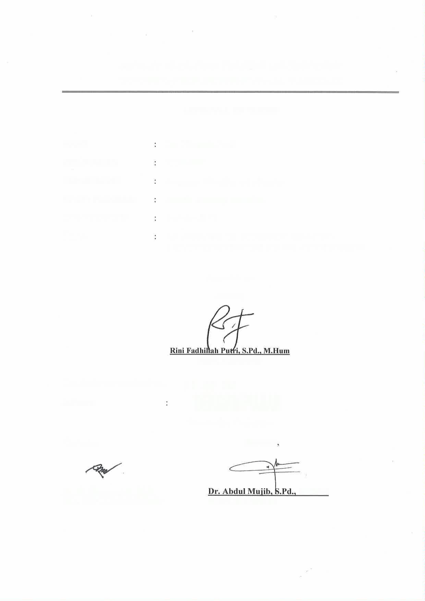
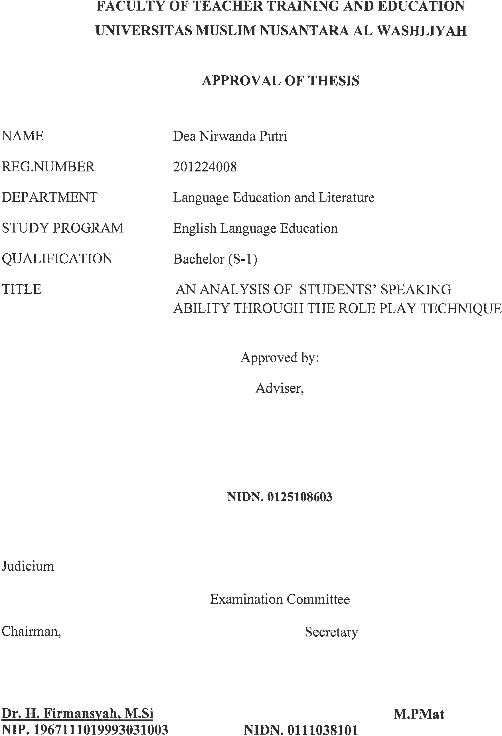



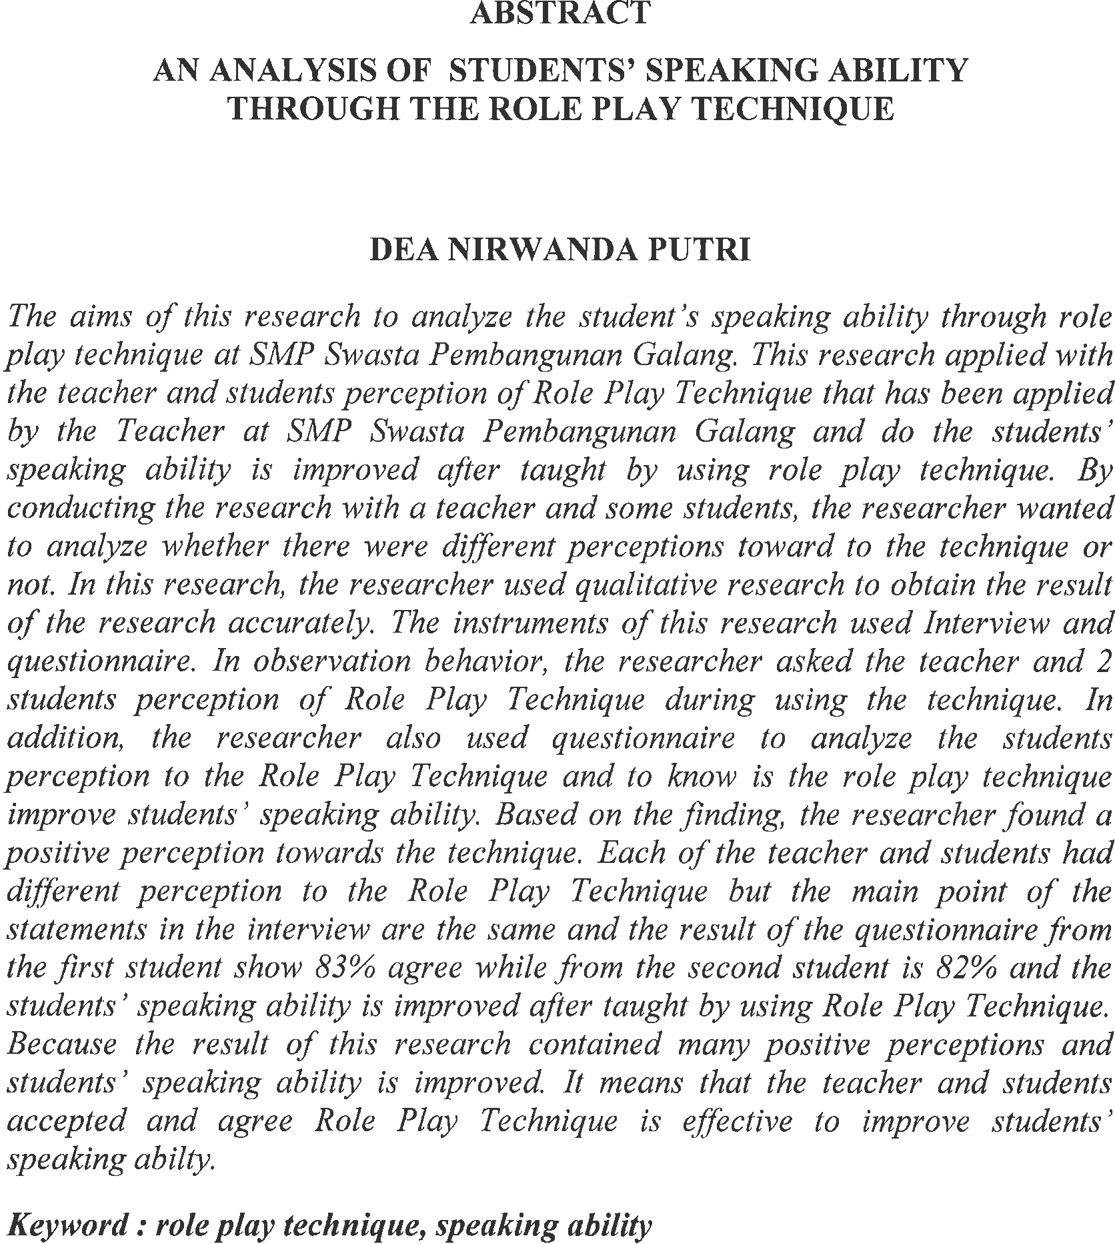


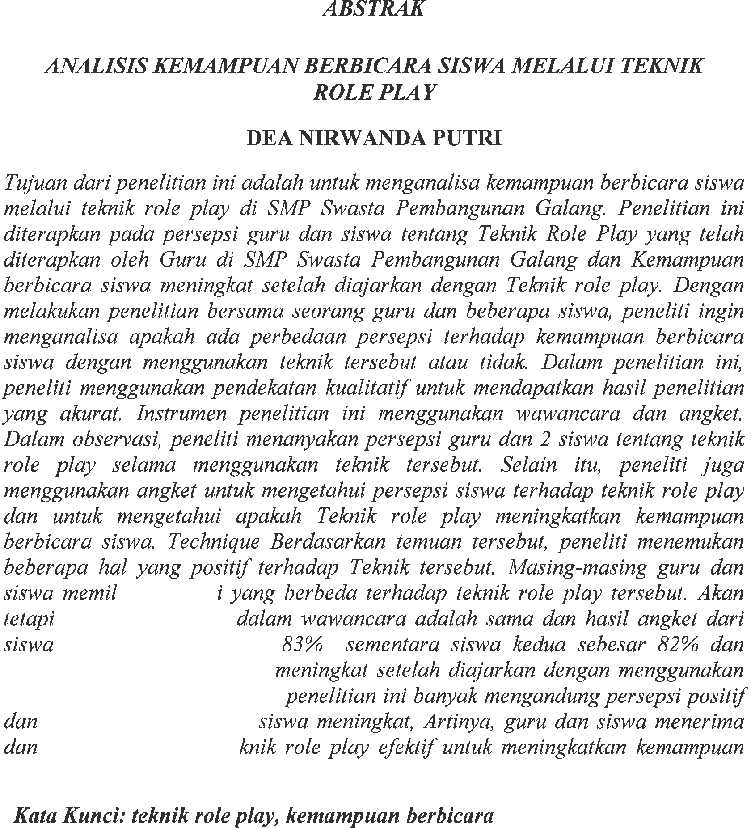

ACKNOWLEDGMENT

بِسْمِ هاللَِّ ال هرحْمَنِ ال هرحِيمِ
يَا أَيُّهَا الهذِينَ آمَنُوا هَلْ أَدُلُّكُمْ عَلَى تِجَارَةٍ تُنْجِيكُمْ مِنْ عَذَابٍ أَلِيمٍ (١٠) تُؤْمِنُونَ بِا هللَِّ وَرَسُولِهِ وَتُجَاهِدُونَ فِي سَبِيلِ هاللَِّ بِأَمْوَالِكُمْ وَأَنْفُسِكُمْ ذَلِكُمْ خَيْرٌ لَكُمْ إِنْ كُنْتُمْ تَعْلَمُونَ (١١)
- O ye who believes! Shall I show you a commere that will save you from a painful doom?
- Ye should believe in Allah and His messenger, and should strive for the cause of Allah with your wealth and your lives. That is better for you, if ye did, but know.
The meanings
- Hai orang-orang yang beriman maukah kamu aku nampakkan suatu perniagaan yang dapat menyelamatkanmu dari azab yang pedih?
- (yaitu) kamu beriman kepada Allah dan Rasul-Nya dan berjihad di jalan Allah dengan harta dan jiwamu. Inilah yang lebih baik bagimu, jika kamu mengetahuinya.
Alhamdulillah, all praise to Allah SWT, the Lord of the worlds, who has blessed the researcher with strength, health, and resolve in finishing this thesis entitled ”An Analysis of Student’s Speaking Ability Through the Role Play Technique” as the final assignment in her study. Peace and salutation may always be upon the Prophet Muhammad SAW, the savior of the human kind, who has brought the light onto this world and turn edit into a better place.
This thesis a scientific paper that is presented as one of the requirements for the degree “S.Pd.” in English Education. There are many people who have been very helpful and supportive during the writing of this thesis. At this opportunity, the researcher would like to convey her utmost gratitude to them. The first ones are her small family; her dearest father Amirudin for his incomparable love and kindness. The researcher would also like to express her gratitude and appreciation to:
iii

- Dr. Firmansyah, M.Si as the rector of Universitas Muslim Nusantara Al- Washliyah

- Dr. Abdul Mujib, S.PD., M.PMat as a Dean of Teacher Training and Education Department Universitas Muslim Nusantara Al- Washliyah
- Zulfitri, S.S., M.A., M. Pd., as the Head of English Education Department

- Rini Fadhillah Putri, S.Pd., M.Hum., as the lovely advisor who gave the dearest motivations, commands, critics, suggestions, supports and love to the researcher in finishing this thesis.
- Yulia Sari Harahap S.Pd., M.Hum. as academic advisor.

- Thank you for my Examiner lecturer Dr. Azhary Tambusai, M.A

- Thank you for my Examiner lecturer Wariyati, S.Pd. M.a., M.Pd

- All of the lectures of English Education Department of Muslim Nusantara Al Washliyah University who have given much knowledge, the researcher deeply thank you all.
- All of the Academic Administration Staffs of Muslim Nusantara Al Washliyah University.
- To my father, Alm. Anton my first love, although he only hugged the author for a few years, but until now the author always feels his presence.
- To my mother yunerlis, she is very very important in the completion of the author's study program, she did not have time to feel education until the lecture bench, but the prayers she always gave until the author completed his studies until the bachelor's degree.

iv

- To my brother Andre Mahendra, thank you very much for your support, thank you also for the motivation and calmness given to the author so that the author is able to complete his studies to graduate school.
- To Adi Purwanto as the author's continued parent, thank you for helping, and caring for the author's mother and supporting the author to complete the author's education until the bachelor's degree.
- Her beloved friends, especially the members of class A of 2020, for the friendship, love, knowledge, support, and time that they have provided unconditionally.
- Her beloved precious friends in finishing this thesis, Thank you to my classmates who have fought together and supported each other accompanied the researcher in many situation and become a good listener with an irreplaceable friendship.
- Everyone who has helped the researcher, not only in the finishing of this thesis, but also through the ups and downs of university life. She cannot mention them one by one; all she can say is she could not be more grateful for their contribution. May Allah bless them all.
- To someone who is always there with the author during ups and downs, I cannot mention his name. Thank you for the happiness and sadness that are passed together. It turns out that the existence of you can make a motivation for an effort for the author to continue what the author has started to process into a person who understands what experience, maturation, patience and loss and strengthening are. Thank you for always wanting to be part of every writer's process until now.
- Last but not least, to myself Dea Nirwanda Putri, thank you for being so strong.

Thank you for still choosing to live and try even though you often feel left behind for

all achievements. Be happy wherever you are, for me “whatever you lack and more
let's celebrate ourselves”
v

Lastly, the researcher realizes that this thesis is still far from being perfect. Despite the help from the aforementioned people, there are weaknesses and shortages in this thesis that remain as the researcher’s responsibility. Therefore, she welcomes all kinds of correction and suggestions for a better writing.

Sincerely,

Dea Nirwanda Putri

vi

TABLE OF CONTENTS

APPROVAL OF THESIS

ABSTRACT i
ABSTRAK ii
ACKNOWLEDGMENT iii
TABLE OF CONTENTS vii
CHAPTER I INTRODUCTION 1
  - Background of the Problem 1
  - Identification of the Problem 3
  - Limitation of the Problem 4
  - Formulation of the Problem 4
  - The Objective of the Research 4
  - Significances of the Research 5
CHAPTER IIREVIEW OF LITERATURE 6
  - Theoritical Framework 6
    - Speaking 6
    - The Aims of Speaking 9
    - Classroom Speaking Activities 10
    - Teaching Speaking 13
  - Role Play 17
    - Types of Role Play 21
    - The Use of Role Play 23
  - Conceptual Framework 24
  - Relevant Researches 24
CHAPTER III METHODOLOGY OF RESEARCH 27
  - Design of the Research 27
  - Subject of the Research 27
  - Instrumen of Collecting Data 28
    - Questioner 28
    - Observation 29
    - Interview 29
  - Instrument of the Research 30
vii
  - Technique of Collecting Data 30
  - Technique of Analysis Data 31
CHAPTER IV RESEARCH FINDINGS AND DISCUSSIONS 35
  - Research Findings 35
    - Students’ Speaking Ability Through Role Play
Technique 36
    - Teacher and Students’ Perception of Role Play
Technique by Interview 36
    - The Data Scoring Based on Questionnaire with the Teacher 41
  - Discussion 47
CHAPTER V CONCLUSION AND SUGGESTION 48
  - Conclusion 48
  - Suggestion 49

REFERENCES 41

viii

CHAPTER I INTRODUCTION

Background of the Problem

Speaking ability is one of the most important language skills in

education. In the context of learning, speaking ability is not only important

for interpersonal communication, but also as a tool for conveying ideas,

presenting understanding and participating in various academic activities.

The importance of speaking ability in education can be seen from

several perspectives. First of all, speaking ability is key for students to

actively participate in classroom learning. By being able to articulate their

thoughts and ideas orally, students can contribute to class discussions,

exchange information with classmates, and express their questions or
incomprehension to the teacher. This creates an interactive learning
environment and promotes the exchange of ideas between students and

teachers.

A teacher's effective communication significantly impacts

student’s learning and relationship. In the classroom, effective

communication by teachers can creat a supportive environment. It can

encourage active student participation and improve the quality of

instruction.

Based on the researcher’s observation in SMP Swasta Pembangunan Galang on March 2024, it is clear that the students are getting difficulty in English subject, particularly the students made some
errors in speaking. In the classroom, students often struggle with practical
1

experience, anxiety, limited vocabularry, insuffcient feedback , and a lack of effective role models when learning to speak English. They also face challenges with understanding body language and facial experessions, developing speaking speed and clarity, and receiving encouragement and motivation.
In the other hand the students are busy with their own activities,

such as speak with their classmate, play any game, and sleep during the

class. It will be effect to students understanding in learning speaking

ability, students still get low score in English test. Their score was below

76, which was far from KKM (kriteria ketuntasan minimum). The KKM

of English subject in this school was 76 and difficulties in learning foreign
language speaking ability can be caused by several factors.

According to Fadilah (2016), speaking is perhaps the most

fundamental of human skills. Since we do it constantly, we may not pay

attention to the processes involved. Students often encounter problems

when practicing English speaking. One frequent problem is that their

native language makes it difficult for them to use the foreign language.

After analyzing the problems in schools, reseacher have found a

solustion that can be implementated in the classroom to enhance learning

using role-play thecniques. Suryani (2015) mentioned that role-play is a technique that can motivate students to speak in the classroom. Role-play is a teaching method where students are assigned specific roles and they must speak and act according to the roles they are given. Arham et al (2016) stated that implementing the role-play technique echances students’

speaking ability and self-confidence. In the field of management, discrepancies in identifying roles can lead to role conflict. However, using role play as a teaching method involves conscious practice and discussion of the role in a group. During class, role play activities can help students identify with different roles in a situation.
To overcome these difficulties, teachers can apply various strategies, such as providing more opportunities to practice speaking in class, building a supportive atmosphere to increase students' self- confidence, introducing activities that involve role-playing or real communicative situations, providing constructive feedback to help students correct their mistakes, and integrate vocabulary and grammar practice in speaking learning. Based on the explanation above the researcher conduct a research entitled : ” An Analysis of Student’s Speaking Ability Through the Role Play Technique at SMP Swasta Pembangunan Galang in 2024”.

Identification of the Problem

The research is identified in order to avoid trouble in conducting research. In other words, it could lead the researcher focues on her research. So, the identification of the problems in this research are as follow:
    - Lack of practical practice

    - Lack of confidence

    - Lack of communication skills

    - There is no active interaction between students and teacher.
    - The teaching technique used by the teacher is monotonous.

Limitation of the Problem

In research, it is very important to limit the scope of analysis to get the relevant data. It will be better by limting the analysis in this research into the errors in speaking ability with role play. It is also necessary to explore the extent to which students are involved in roleplay and how their level of participation influences learning outcomes. This can include aspects such as activeness in the role, ability to collaborate, and level of emotional involvement. Evaluation of the effectiveness of roleplay is also an important part of the analysis, including determining whether learning objectives were achieved, whether there was improvement in students' interpersonal skills, and the extent to which roleplay promoted a deep understanding of the topics covered.

Formulation of the Problem
Based on what has been described in the background of the research, the researcher formulates the problem as follows:
    - How is the student’s speaking ability using role play technique at SMP Swasta Pembangunan Galang?

The Objective of the Research
    - To analyse the student’s speaking ability in role paly technique

at SMP Swasta Pembangunan Galang.

Significances of the Research
This method is very useful for anyone who is interested in English, especially for students, teachers and institutions.
    - For students, it helps them their problems in speaking activities and can help them solve improve their speaking skills. Through role- playing activities students learn how to express ideas, opinions or feeling to other people using words or articulatory sounds.
    - For teachers, providing alternative solutions in teaching speaking.

    - For future researchers, this research can be used as a reference for conducting further research on English speaking skills using role play techniques that are more innovative and appropriate to the context, setting and research subject.
    - For the institution, this includes improving the school's reputation as a progressive educational institution that uses innovative methods, increasing student satisfaction with the learning process, and improving student academic outcomes. In addition, roleplay techniques can also prepare students for life after school by improving interpersonal, communication and problem solving skills. This can create alumni who are better prepared professionally and socially, which in turn can improve the image and prestige of the school institute in the eyes of society.

CHAPTER II REVIEW OF LITERATURE

Theoritical Framework

Speaking

According to Spratt and Williams in Juvrianto (2018), speaking is almost the same as writing because they are productive skills. In speaking, we produce speech, while in reading we produce a text. Speaking involves using speech to express meaning to other people. Speaking is the delivery of a language by mouth. When we speak, we produce sounds using various parts of our body, such as the lungs, vocal tract, vocal cords, tongue, teeth, and mouth. Speaking can be formal or informal:
      - Formal speaking is typically used in business or academic situations, or when meeting strangers for the first time.
      - Informal speaking is usually used when talking to close family or friends, or with people who are already well known.
In today's globalized world, effective communication is essential for success in all areas. Language serves as the primary tool for communication, and without it, achieving goals and objectives becomes challenging. As English is widely spoken across the world, it serves as a common language for people from different regions, states, countries, and continents to communicate with each other.

6

It is important for students to be able to express their ideas orally (Saputra, 2023), and according to Khairita et al (2023) speaking is an interactive process of building meaning, creating, and obtaining information. Therefore, the ability to speak English is a crucial skill that students must master as a life skill.
One of the popular techniques in pedagogical activity in communicative language-teaching classes is role-play. Role play is a technique that copying a character, generally, students act as someone else (Pinatih, 2021). In line with (Ruslan, 2020) role-play is an activity that is a situation close to real life or involves fantasy or imagination to be someone else or to be ourselves in a specific situation for a while, improving dialogue and creating a real-world scenario. (Krebt, 2017) states role play is one of the classroom teaching techniques that encourage students to actively participate in the learning process. Furthermore, students can practice the language such as real situations. With Role-play, students not only learn about the language but also learn about real situations in society. so this research focuses on determining the effect of the f role-play technique in teaching speaking by Khairita at al (2023).
Speaking is a crucial skill that learners should develop in order to communicate fluently. Rao (2019), defines speaking as the oral mode or productive skill that involves more than just pronouncing words. In the acquisition of a foreign or second language, speaking plays a dominant role. Teachers usually focus on

developing speaking skills to help their students communicate effectively, as speaking builds people’s link, personality, and character. It is essential for expressing ideas and opinions, as well as making a positive impression on others. Good speakers can impress and engage their audience. Among all the language skills, speaking seems to be the most important one and is a crucial part of teaching and learning a foreign or second language.
The process of learning and applying speaking skills in English are closely related, as this technique allows learners to connect what they learn with how they apply it while speaking in the classroom.
Based on various theories, it can be concluded that speaking skills are closely related to effective communication. Speaking is the ability to use language appropriately to express one’s ideas, opinions, or feelings in order to share or receive information and knowledge from others who engage in communication.
Furthermore, Smith and Jones's (2018) research demonstrate that proficient communicators can foster an inclusive classroom culture in which each student feels respected and heard. This can boost students' interest in their studies and provide them all the chance to grow to their full potential.
In the process of teaching speaking, it is essential for the teacher to employ effective techniques to enhance students' speaking

skills (Dwiyanti, A., & Lolita, Y., 2023). As previously explained, if students lack the intention and desire to learn how to speak English properly, or if they do not have the opportunity to speak in class, they may lose motivation and interest in learning to speak English. In the classroom, teachers who can communicate well can foster a supportive and upbeat environment. Teachers can foster strong relationships with students and promote active involvement in class discussions by employing a range of communication tactics, including acceptable body language, suitable intonation, and active listening skills. Well-spoken teachers can foster a supportive learning atmosphere that will boost students' enthusiasm to study and raise the standard of instruction.

The Aims of Speaking

According to Hartati (2016), speaking is primarily done for communication. Speaking is a crucial tool for conveying ideas to others and delivering messages to the speaker's community. For this reason, speaking is crucial. Speaking essentially has three major goals which are as follows:
- To inform

This means that the speaker intends to share ideas, information, feelings, or opinions with the listener, with the purpose of providing knowledge. Informative speaking is used to explain concepts, processes, and writing styles.

- To entertain

Entertaining speech aims to make the listener feel happy and is selected primarily for its entertainment value. For example, a teacher telling a story to students or parents sharing a funny story with their children. Using this approach, the speaker can capture the audience's attention more effectively.
- To persuade

Persuasive speaking is used when the speaker wants to convince the audience to take a specific action or engage in a particular activity.
- To discuss

Discussing something through speaking is aimed at making decisions and plans.
In conclusion, speaking allows people to inform others, make decisions, and prompt action based on the information provided.

Classroom Speaking Activities

Speaking lessons ought to be imparted through engaging and interactive exercises. Speaking exercises in the classroom come in a variety of forms. According to Becker and Roos (2016) to achieve true communicative competence, learners should have plenty of opportunities to become independent language users

through activities that encourage their natural desire to interact with peers and allow them to utilize their "rich resources of imagination, creativity, curiosity, and playfulness". Based on the discussed findings, a creative speaking approach was developed to promote productive language use in the young learners' classroom. They are participating in role-playing, dialogue, communication games, acting from a script, and problem-solving.
      - Performing from a script: In this method of instruction, the instructor assigns the students to act out a play that is based on their own-written dialogues or coursebooks. Stated differently, the instructor needs to guide the student through the screenplay as though they were fellow directors.
      - Communication games can be a great tool for helping students to relax while learning a new language. This technique is especially effective for young learners. Games that involve speaking activities can be a fun and engaging way to provide students with valuable practice. These games can include oral strategies such as describing, predicting, and asking for feedback.
      - Discussion is a common activity in oral skills classes. Its purpose can be to reach a conclusion, share ideas, or find solutions. The teacher should set the discussion's purpose beforehand to keep it relevant.

      - Problem solving involves students working in pairs or groups, sharing their problems, opinions, and feelings. The teacher facilitates communication among participants. Students ask and answer questions, practicing expressing their ideas in spoken language.
      - Simulations and role play are useful for improving oral fluency and preparing students for specific situations. They are often used in conversation groups where participants take on different characters to express thoughts and feelings realistically. Role play is an effective way to stimulate real communication beyond the classroom.
Speaking skills are crucial for learners to thrive in today's globalized world. English teachers need to incorporate a variety of techniques in their classrooms, using simple and engaging materials to capture the interest and attention of English language learners (ELLs) and help them develop their speaking skills.
Speaking skills are particularly important for ELLs as they are essential for effective communication in various situations. Therefore, teachers must make a concerted effort to enhance these skills. They should regularly update their teaching materials and adopt diverse techniques and approaches to improve speaking skills in the English classroom. Additionally, teachers should select appropriate materials that match the learners' proficiency levels. Encouraging participation in classroom discussions is also crucial, as

it greatly contributes to improving speaking skills. Furthermore, learners should actively seek out opportunities to practice speaking, both inside and outside the classroom. Following teachers' instructions is also important, as their guidance can significantly benefit learners and help them communicate effectively in different circumstances. EFL/ESL teachers need to implement various strategies and techniques in their teaching to ensure that their learners become proficient in speaking skills. In turn, ELLs need to dedicate themselves to practicing speaking skills and allocate sufficient time to these activities in order to excel in the modern world.
The approach to creative speaking activities presented here illustrates how to prepare and encourage more autonomy in language use and guide children systematically from stages of reproductive language use towards creative and productive speaking. Available research shows that tasks and improvisation activities are not too difficult for young learners to master, as is often assumed, but have great potential to promote their communicative competence from the beginning.

Teaching Speaking

Learning English as a foreign language can be a challenging task for most Indonesian students, as it cannot be acquired naturally like their mother tongue. Typically, learning a

new language involves acquiring knowledge of the dictionary, grammar rules, and pronunciation. While focusing on language form is crucial in foreign language learning, the ultimate goal of an English language course is to develop the ability to communicate effectively in English, both inside and outside the classroom, for academic, professional, or leisure purposes.
Speaking is one of the four basic skills in English. In Indonesia, English is considered a foreign language (EFL), making the speaking skill essential to learn. According to Purnamawati et al. (2015), speaking is an interactive process of oral communication used to express ideas, feelings, and share information. The main purpose of learning English is to be able to use it as a communication tool, especially when speaking with foreigners. Pinatih (2021), stated that speaking is a productive skill that involves delivering information from one person to another using language. Pinatih (2021), also mentioned that there are two components of speaking that students should master: accuracy and fluency. Accuracy refers to the correct use of language in terms of grammar, vocabulary, and pronunciation, while fluency is the ability to convey a language at a continuous speed, meaning speaking fluently.
Here are some common reasons why students may have difficulty in improving their speaking skills:

      - Lack of practice: The ability to speak a foreign language requires consistent practice. Students who do not have the opportunity or motivation to actively practice speaking may have difficulty in improving their speaking abilities.
      - Lack of confidence: Some students may not feel confident when speaking a foreign language because they are afraid of making mistakes or feel unable to express themselves fluently.
      - Limited vocabulary: Limited vocabulary can be an obstacle in speaking fluently and variedly. Students may have difficulty finding the right words to convey their thoughts or ideas.
      - Difficulty understanding grammar: Not understanding proper grammar in a foreign language can make it difficult for students to construct sentences correctly and understand the sentence structures used by native speakers.
      - Incomprehension of slangs and accents: Some students may have difficulty understanding different accents or accents in a foreign language, especially if they are only familiar with certain variants of the foreign language.
      - Lack of communicative context: Students may have difficulty developing speaking skills if they are not placed in situations that allow them to communicate actively in a foreign language, such as in classes that focus on written assignments or language practice.

      - Inability to deal with mistakes: Some students may be afraid of making mistakes and tend to avoid speaking a foreign language for fear of being criticized or ridiculed by classmates or teachers.
According to Laksana (2016) teaching speaking is particularly challenging, given that English is not a native language in Indonesia. People face several difficulties in learning it, as they do not have many opportunities to practice speaking it in their daily lives. They only get to use it during lessons, which is not enough. Therefore, teachers need to employ various strategies to help language learners practice speaking in the target language.
        - Balancing fluency and accuracy in speech.

Fluency refers to the smoothness of speech, while accuracy pertains to the absence of errors in grammar, vocabulary, punctuation, and the like. Teachers must provide practice opportunities for both fluency and accuracy, while acknowledging that making mistakes is part of the learning process.
        - Encouraging student participation through group work and pair work, and minimizing teacher talk.
Teachers should be mindful of their own speaking time in class, and instead create opportunities for students to practice speaking through group work and pair work activities.

        - Planning speaking activities that involve negotiating for meaning.

To learn a new language, learners must communicate with others. In doing so, they engage in negotiating for meaning, which involves checking for understanding, clarifying misunderstandings, and confirming that one's message has been understood.
        - Classroom activities should offer guidance and practice in both transactional and interpersonal speaking.
When people communicate outside the classroom, they do so for either interpersonal or transactional purposes. Interpersonal speech is used for social purposes, while transactional speech involves communicating to achieve a specific task or goal, such as the exchange of goods or services.
Therefore, teachers have a crucial role in designing classroom activities that provide guidance and practice in both types of speaking. They should be able to teach speaking skills effectively and make the activities engaging for students. This will help to develop their speaking abilities and keep them interested in participating in speaking activities.

Role Play

In language education, there are various methods for alternative educators to convey lesson materials in the classroom. One of these methods is Role-Play. Role-play, also known as acting, is a teaching technique that encourages students

to imagine themselves in situations outside the classroom or to portray different characters using language appropriate to the context.
According to Zulfitri and Harahap (2019), is a learning approach that helps develop students' imagination and appreciation by having them play the role of a character, whether living or deceased. This allows students to practice understanding and skillfully using the material being studied. Meanwhile, Sagala (2003) as cited by Zulfitri and Harahap (2019) explains that the role-playing method is a way of presenting learning material by demonstrating and acting out behaviors in social relationships. When implementing the role-playing method, students are assigned by the teacher to act out a social situation that contains a problem, enabling them to develop problem-solving skills in a social context. Based on expert opinions, it can be concluded that the role-playing method emphasizes the portrayal of various characters and experiences, aiming to foster responsibility, teamwork, respect for others' opinions, and decision-making within
a group setting.

Therefore, the researcher defines role playing technique as a methodology for teaching, which involves conscious representation and discussion.
Suryani (2015) stated that role-play is a technique that can encourage students to speak in the classroom. Role-play is a teaching technique in which students are assigned specific roles and they must speak and behave based on the roles they receive. Arham et al. (2016) stated that the implementation of the role- play technique improves students' speaking ability and self-confidence. According to Osuafor (2017), role-play teaching is a technique that has many advantages.

- Role-play emphasize on students centered.

- Role-play can increase students’ interest in learning.

- Role-play serves many opportunities to practice the language and their social skill.
- Role-play can help students to grow a real-world concept and get more deepen knowledge.
- Role-play can grow a good habit for students in their social life. They learn how to behave in a specific situation.
According to Jakob (2018), to make the role-play teaching technique run smoothly in the classroom, here are several steps of the implementation of the role-play teaching technique:
- Explain to students about the technical implementation of the role-play

- Dividing students into groups

- Tell a story or situation to students

- Provide vocabulary that reflects the story or situation

- Give students time to prepare the dialogue from the role-play that will be present
- Give time to students in each group to present their role-play in front of the class
- Allow each student an opportunity to provide feedback among the group

Through these steps, the use of role-play to improve students' speaking skills demonstrates the 4C concept of teaching techniques in the 21st century. Firstly, providing students with vocabulary to use in the role-play reflects the concept of critical thinking. Secondly, when students create the dialogue for the role-play, it demonstrates the concept of creativity and innovation. Lastly, when students perform the role-play, it showcases the concept of collaboration and communication.
The establishment of cooperative and collaborative fellow students is important because students are directly involved in learning activities (Setiawan, 2019). Therefore, when students are more engaged, it will lead to increased student learning outcomes" (Setiawan, 2019). Based on the descriptions above, the authors have concluded that implementing roleplay in learning can improve students' speaking skills.
According to Krebt (2017), explain that the surroundings or the situation the student will face can impact his/her way of acting. When we see ourselves or other role-players as members of a congregation, an audience, or students in a parade, then the way we behave changes by our surroundings. For instance, the way that we used to behave with our friends is different from the way that we behave in formal situations. They acknowledged that roles can also be affected by a person's function or purpose. For example, people in the hotel industry may be carrying out the tasks of a manager, front desk staff, bell person, or representative. People who work in an airport will be carrying out the tasks of a travel agent, flight attendant, captain, or passenger. Since roles are dependent on situations, function, and purpose, the instructor needs to carefully think through the

enactment when he/she would like to employ the role-play technique in the classroom. The teacher should consider the student's engagement, role assessment, duration of the technique, and conclusion of the idea.

Types of Role Play

There are three types of role-play: fully scripted, semi- scripted, and non-scripted. In fully scripted role-play, every word is given, and students must understand or memorize their role. This type is useful for low-level students who may not be familiar with the situation in semi-scripted role-play.
In semi-scripted role-play, a model conversation is provided with some missing words that students must fill in with suitable words in the given context. This type is less structured and less controlled than fully scripted role-play, making it appropriate for students with upper-beginner to intermediate levels of proficiency. Students should be familiar with the main procedures and seek to progress to higher level tasks.
Non-scripted role-play is the freest form of role-play, where no script or guidelines are provided. Students are given a scenario or situation and must create their own dialogue and actions. This type is best suited for advanced students who are comfortable with the language and can think creatively.

The roleplay method has several definitions according to experts. Negara, I.M (2021) defines it as an activity where students can express ideas, opinions, or feelings through words or articulation to others. Negara, I.M (2021) describes roleplay as a technique that requires student interaction as role players and conducting discussions with members in role-playing. Therefore, the roleplay method is a series of learning that provides opportunities for students to build interaction, communication, cooperation, and discussion, develop and express ideas to others, and train proficiency in speaking orally.
Roleplay is considered a useful tool for students to learn the basics of English conversation (Rayhan, 2014). By using roleplay in teaching speaking, students have the opportunity to practice communication and different social roles, as well as create and place themselves (Fadilah, 2016). Additionally, Rahayu (2015) argued that roleplay helps shy students who have difficulty in conversation by providing a mask, enabling them to improve their ability to speak and interact in any situation. Based on the information above, it is clear that the roleplay method is an effective approach to teaching speaking, as it helps to improve students' confidence and fluency in speaking, encourages active learning, and promotes dialogue and interaction with others.

The Use of Role Play

Ladousse further states that role play is a communication method that can significantly develop students' language fluency, promote interaction in the classroom, and increase motivation. Role play encourages students to learn together with their peers and fosters a sense of togetherness between teachers and students, who share responsibility for the learning process. Role play is perhaps the most flexible method, and teachers who use it immediately can meet unlimited needs with role play practice effectively and appropriately.
Increased student motivation can help reduce feelings of self-doubt and lack of confidence when expressing opinions, answering questions, and asking questions in class. Although some students still struggle with using correct tenses, pronunciation, and vocabulary, during group role-playing exercises, many students were actively participating and using English. They showed courage by asking the teacher about certain words in English and even volunteered to practice speaking in front of the class.
Many studies have discussed the implementation of roleplay in learning, particularly in language learning to improve students' speaking skills. Roleplay can be implemented in two forms: scripted, where a script is used to convey language meaning, and unscripted, where students improvise and develop language and

conversation content. Both teachers and students need to prepare for this method (Suryani, 2015).

Conceptual Framework

Conceptual Framework is the concept used to clarify the theories used in this research in order to avoid misunderstanding. According to Syafi’i (2016) operational concept is the shift of words used in theoretical concepts to the more operational and empirical or applicable words. Operational concept is derived from related theoretical concept on all of the variables that should be practically and empirically operated in academic writing a research paper. The method use in this research is descriptive method, which focuses on students’ error in writing sentences with passive voice. And what type that most often made error by the students.
Operational concept is guidance used to avoid misunderstanding in carrying out the researcher. It necessary to clarify briefly the variable used in this research.

Relevant Researches

In a study conducted by Wang et al. (2020), the potential of role play in enhancing students' language skills in second language learning was highlighted. The research revealed that students who participated in role play demonstrated a significant improvement in their ability to speak and comprehend a second language. Role play provides a natural and meaningful context for students to practice using language in relevant communicative situations, thereby aiding them

in acquiring language skills more effectively. These findings strongly support the use of role play as an effective tool in developing students' cognitive and language skills.
Another study by Lin and Lan (2017) showed that role play is effective in enhancing students' critical thinking skills. The research indicated that students who took part in role play experienced significant improvements in their ability to analyze situations, evaluate various options, and make informed decisions. This suggests that role play not only enhances concept understanding but also enriches students' cognitive abilities.
Through role playing, students can engage in situations that require problem solving, collaboration, and critical thinking. Research has shown that the application of role play in education has a positive impact on various aspects of student development.
- Development of Social Abilities

Role-playing games provide a platform for students to interact with others in realistic situations and simulate various social roles. In research conducted by Smith (2018), they found that role playing can improve students' social skills, such as empathy, cooperation, and conflict resolution. Through acting as characters in different scenarios, students learn to understand other people's perspectives and develop important interpersonal communication skills.
- Active Learning and Problem Solving

Role playing also promotes active learning where students are actively involved in their learning process. Research by Jones and Ryan

(2018) shows that through role playing, students have the opportunity to apply the knowledge they learn in relevant contexts and solve complex problems. This helps improve students' conceptual understanding and critical thinking skills.
- Increased Student Motivation and Engagement
Role playing often increases student motivation and engagement in learning. According to a study by Chen et al. (2020), students tend to be more involved and enthusiastic in learning when they have the opportunity to act as characters in situations that are interesting and meaningful to them. This can help increase information retention and student interest in the subject matter.
- Development of Language Skills

Role playing is also an effective tool in language teaching, especially in the context of second language learning. In research conducted by Li (2017), role playing has been proven to help students practice and improve their speaking skills in the target language. By acting as characters in the scenarios provided, students can develop speaking skills naturally and contextually.

CHAPTER III METHODOLOGY OF RESEARCH

This chapter focuses on the methodology of the research. It presents the research design, time and location of the research, subject and object of the research and than technique of the data collection of the data analysis.

Design of the Research

Research design is a comprehensive plan detailing the activities that will be carried out during the research. Its purpose is to provide an overview of the research process and its intended outcomes. The research design is crucial in guiding the research implementation to ensure its success. In qualitative research, the author utilized data analysis methods to analyze the research problems.
This research use a qualitative approach with case studies as the main method. A qualitative approach provides the freedom to explore qualitative aspects that cannot be measured quantitatively, such as students' perceptions of their speaking abilities and experiences in communication situations.

Subject of the Research

The subject of the research will the first year students of SMP Swasta Pembangunan Galang especially in the nine grade students. In academic year 2024.

27

Instrumen of Collecting Data

The writing uses triangulation techniques, namely a combination of interviews, observations, and documentation. Judging from the 5W and 1H elements, to answer what, where, when, and who, the author uses data collection techniques in the form of documents. Apart from that, to answer why, and how, the author uses data collection techniques through in-depth interviews and observations of situations in the field.
Data collection methods used for data collection in qualitative research generally use questioner, observation, interview, and documentation. Based on this concept, the three data collection techniques above were used in this research.

Questioner

According to Brace (2018), the text discusses the different ways questionnaires can be written and used across various data- gathering media. It emphasizes the importance of following general rules and principles applicable to writing any type of questionnaire. The target audience includes students, market researchers, social researchers, political opinion and advocacy pollsters, and anyone else who needs to create a structured interview to gather information.
The text also highlights the use of structured interviews with different data collection methods such as face-to-face interviews, telephone interviews, self-completed questionnaires, mailed questionnaires, and online questionnaires. It stresses that despite the various data collection methods, the fundamental

principles of questionnaire construction and writing remain consistent.
Furthermore, the text underscores that the purpose of the questionnaire is to provide a standardized interview across all subjects to ensure that all respondents are asked appropriate questions in a consistent manner. It explains that asking questions in the same way to different people is crucial in survey research for accurate data interpretation, despite recognizing that in some cases, questions may need to be tailored differently for distinct respondent groups. However, the text concludes that for large-scale surveys, a standardized question format is essential for handling and interpreting data effectively.

Observation

In this research, observation techniques was used to strengthen the data. This observation was used to directly observe speaking ability learning activities at the Galang Development Private Middle School and interactions between teachers and students.

Interview

The research was conducted interviews in two forms - structured interview and unstructured interview. Structured interviews was conducted using predetermined questions that have been prepared according to the research problem. On the other hand, unstructured

interview was carried out if the answers develop beyond the structured questions but cannot be separated from the research problem. The primary purpose of the interviews in this research is to communicate with the related parties or research subjects.

Instrument of the Research

In this research, the researcher used observation and interview guidelines to identify problems and needs in the field. Additionally, they distributed student reflection sheets at the Galang Development Private Middle School to strengthen their reflections.
- Observation guidelines involve direct research techniques in the field where the researcher not only observes but also records data about what happens during speaking ability learning at the school.
- On the other hand, interview guidelines are a research technique where the researcher engages in an oral dialogue to obtain information from the participants.

Technique of Collecting Data

According to Jailani (2023), Qualitative research utilizes data collection techniques including interviews, observations, documentation studies, case studies, and focus groups, enabling researchers to gain an in-depth understanding of respondents' views, experiences, and perceptions.
The research involved data processing through data reduction, data display, and data verification. To ensure the accuracy and validity of the research,

triangulation techniques were employed. These included triangulation of data collection and methods, triangulation of research data sources, and triangulation of data analysis results.
- Source triangulation involves comparing observational data with interview results, and comparing interview results with the contents of related documents.
- Method triangulation involves checking the degree of confidence in research findings using several data sources, all using the same method.
- Investigator triangulation involves using other researchers or observations to double-check the degree of trust in the data.
- Theoretical triangulation is used when a certain fact cannot be checked for the degree of confidence with one or more theories, but can be done with a comparative explanation (rival explanation).

Technique of Analysis Data

The analysis of qualitative data is an essential technique for understanding how role-playing can enhance speaking skills. This approach allows researcher to delve into different aspects of speech skills that are influenced by role-playing, such as clarity of expression and the ability to respond effectively. Studies conducted in the past decade have demonstrated that role-playing methods have significant potential for improving speaking skills in a variety of settings, including educational and professional contexts. Therefore, a thorough understanding of data analysis techniques related to role-playing methods can offer valuable insights for the development of future communication skills.

Role play has become an effective technique for practicing speaking skills. In the last 10 years, data analysis techniques have increasingly dominated the development and evaluation of the effectiveness of role-play in the context of speaking training. Data analysis provides deep insight into the communication dynamics, participant preferences, and the impact of role-play exercises. Here are some important aspects of data analysis related to role play as a method of practicing speaking:
- Identification of Communication Objectives: Data analysis allows researchers and educators to identify the exact communication goals to be achieved through role play. Through surveys, interviews, or observations, data can be collected to understand the needs of participants in speaking skill development. For example, data can show whether participants are more interested in persuasive, negotiation, presentation, or conflict resolution skills.
- Selection of Relevant Scenarios: Data analysis helps in the selection of relevant and authentic role play scenarios. By analyzing trends and issues raised in surveys or interviews, educators can design scenarios that match the needs and interests of participants. Data can also reveal the most common situations faced by participants in real life, thus ensuring the role play exercise has high practical value.
- Collecting Data on Participants' Preferences and Perceptions: Through pre-training surveys and post-training evaluations, data can be collected on participants' preferences regarding learning methods, desired learning atmosphere, and their perceptions of the effectiveness of role plays. Analysis of this data helps

instructors to customize their learning approaches to improve participant engagement and learning outcomes.
- Evaluation of Participant Performance: Once the role play session is over, data analysis is used to evaluate participant performance. Data on various aspects of communication, such as clarity of message, success in achieving communication goals, and adaptability to situations, can help in providing targeted feedback to participants. Thus, participants can identify their strengths and weaknesses in speaking and develop improvement strategies accordingly.
- Use of Recordings and Observations: Video recording and direct observation are important data collection methods in role play analysis. This visual data allows the observer to examine details of communication that may be missed in a live evaluation. By analyzing recordings and observations, teachers and participants can gain deeper insights into nonverbal expressions, voice intonation, and interactions between participants in the role play.
- Development of Data-Based Learning Strategies: Based on data analysis of role play results, teachers can develop more effective learning strategies. Data can be used to determine areas where participants need additional support, such as the development of formal speaking skills, improvisation, or conflict management. By utilizing data, teachers can design more targeted and relevant exercises.
- Continuous Improvement: Data analysis allows for a cycle of continuous improvement in the use of role play as a learning method. By tracking participants' progress over time, educators can identify positive trends and areas

where improvement is still needed. Thus, role play is not only a tool for speaking practice, but also for continuous personal development.

CHAPTER IV
RESEARCH FINDINGS AND DISCUSSIONS

Research Findings

The objective of this research was to analyze the student’s speaking ability in role play technique at SMP Swasta Pembangunan Galang. The first year students of SMP Swasta Pembangunan Galang in the nine grade students is the subject of this research. All the data found was completely discussed in this chapter. Based on the result of interview, questionnaire and observation, it was found that teaching speaking through role play can improve students’ speaking ability. By looking the lesson plan as guidance in teaching speaking it was known that the teacher used technique. Through this technique, students learned how to express ideas, opinions or feeling to other people using words or articulatory sounds.
Using role play techcique involves assessing how well individuals can communicate effectively in simulated real-life situation.
Fluency : How smoothly and naturally the individual speaks, including their ability to maintain a conversation flow.
Accuracy : The correctness of their language use, including grammar, vocabulary, and pronunciation.
Vocabulary : The range and appropriateness of words and phrases use in context. Pronunciation : How clearly and correctly they pronounce words and phrases.
Interaction : Their ability to engage with others, respond to questions or statements, and initate conversation.
Contextual Understanding : How well they understand the situation and adapt

35

their language accordingly.

Students’ Speaking Ability Through Role Play Technique

In this research, the data was collected in two instruments. They were interview and questionnaire. Each of the instruments were analyzed separately so that the result of this research can be known clearly. The researcher was interviewed students at SMP Swasta Pembangunan Galang. During the lesson, role play technique was by the students. It was given during teaching learning process. The data was gained through classroom observation and interview with the teacher and students. The table below showed the interview of the researcher and the students. The researcher interviewed the teacher with some questions below.

Teacher and Students’ Perception of Role Play Technique by
Interview

The first day of interview was conducted on 9th July 2024 with the teacher.
R as the researcher T as the Teacher
R : What the method is used most often when learning English? Especially for the speaking?
T : Many methods used in teaching but in speaking but I often used singing and role play to help students memorizing the words. It will increase students’ memory to remember the vocabulary so that their

ability in speaking is also increased. The students’ main problem in this class was the vocabulary and uncomfortable in speaking English. R : What are the teacher efforts in teaching English especially for speaking?
T : In teaching, I adjusted student handbook, and viewing in social media material of speaking which related with student material in class so that the students will not be bored and saturated when listening to me explain the material.
R : Why the teacher choose Role Play technique to teach speaking?
T : In my opinion, role play technique is so easy to master, the students do not need a lot of effort to think, they just have to act and speak as described. Sometimes when this technique is used, students are able to create a humor, so this technique can make students enjoy in speaking in the class.
The first day of interview was conducted on 9th July 2024 with the student.
R as the researcher S1 as the student1 S2 as the student2
R : How do you think the role play experience affected your speaking in English?
S1 :Role play helps me be more confident in speaking because I can practice in situations similar to the real world.

S2 : Role Play helps me gain more confidence than I usually do when speaking.
R : What was the biggest challenge you faced when doing a role play in English?
S1 : I feel nerveous when I want to speak

S2 : I often struggle to find the right vocabulary and feel nervous speaking in front of my friends.
R : Does role play help you in understanding sentence structure and vocabulary usage? Give specific examples.
S1 : Yes, during the role play I learned how to use proper colloquial phrases. For example, during the role play as a restaurant waiter, I practiced the polite phrases I had just learned.
S2 : Yes, as long as I use the role play I am more confident for example when playing the role of a restaurant waiter, everything flows smoothly at the time.
R : How would you rate the feedback you received after the role play? Did it help you improve your speaking skills?
S1 : Feedback not only helps in correctly deficiancies, but also motivates me to continue learning and developing in my speaking skills.
S2 : The feedback I received was quite helpful, especially when the teacher or friends pointed out mistakes I made and gave suggestions for improvement.

R : Do you feel that role play is more effective than other English learning methods? Explain your reasons.
S1 : I feel role play is more effective because it gives me the opportunity to practice speaking directly and gain practical experience.
S2 : Through role play, I can practice speaking, listening and directly. This helped me improve my speaking and active listening skills.
R : How do you prepare yourself before doing a role play in English? S1 : Usually I, practice speaking English or practicing in front of the mirror. This can help me feel more confortable and confident when playing a role play
S2 : I usually read the role play material first, take notes on new vocabulary, and practice with friends to make sure I'm ready.
R : Do you feel comfortable practicing speaking with your group mates during the role play? Why or why not?
S1 : Sometimes I feel comfortable, but sometimes I feel pressured if my friends are very critical.
S2 : Sometimes I feel uncomfortable more often because I see friends more quickly.
R : Does role play affect the way you speak in real situations? Give an example if so.
S1 : Yes, role play can influence the was I speak in real situation, especially in terms of communication skills, selfconfidence and

language mistery, for example, I can speak fluently when explaning the food I want at a restaurant.
S2 : Yes, role play makes me more confident when talking to strangers. For example, I can speak more fluently when ordering food in a restaurant.
R : What aspect of role play do you enjoy the most and why?

S1 : I enjoyed the improvisational aspect of the role play the most because it allowed me to think fast and use English in a more creative way.
S2 : Role play not only expands my understanding of different types of motivation, but it can also be a lot of fun and creativiting satisfying.
R : What are your suggestions to improve the effectiveness of role play in English language learning?
S1 : In my opinion, role play should done repeatedly to ensure language skills continue to consistent practice helps reinforce learning and increases participants’ confidence.
S2 : I think it would be better if role plays involve a variety of real- life scenarios and more time is given for preparation and practice.

Based on the interview with the English teacher and students above, the English teacher of SMP Swasta Pembangunan Galang used Role Play technique to improve students’ speaking ability. Meanwhile, the students when using Role play technique in learning English feel

comfortable and enjoying learning process. They felt more confident in speaking after using Role Play technique.
Teachers should do variety of technique in teaching in order to adapt to the circumstances faced by students. If the teacher teaching method is poor, it will affect students learning style. For example, the teacher is less prepared in learning material then the teacher will present the lesson less clearly, so the students are not pleased and not interested with the lesson or the teacher. Consequently, students will be lazy to study. Based on the information the researcher obtained, teacher in SMP Swasta Pembangunan Galang always mastered the material and able to maintain good communication to students. The learning material selected properly to help students in achieving basic competence standards.
Whether or not the result of students’ learning can be determined from learning process in classroom. During the learning process, interaction activities between teacher and students with various teaching technique will lead the students more actively and understand the material that presented by the teacher.

The Data Scoring Based on Questionnaire with the Teacher
The researcher distributed questionnaire to the teacher on 12th July 2024 by using WhatsApp in SMP Swasta Pembangunan Galang. The questionnaire is answered by one teacher who teach English in nine grade of SMP Swasta Pembangunan Galang.

Questionnaire Result

To know the result of this research, the researcher asked the teacher to fill out the questionnaire. Teacher responses to each statement of questionnaire were presented in the form of table.
There were sixteen statements with five numbers of values that teacher can choose. They were Strongly Agree (SA) = 5, Agree (A) = 4, Undecide (U) = 3, Disagree (DA) = 2, Strongly disagree (SDA) = 1.

Table 4.1 Questionnaire Result From Student 1
No. | Statement | Score | Explanation
1 | The role play exercise helped me feel more  confident when speaking in public | 5 | Strongly  Agree
2 | I feel that role play provides a realistic  experience in speaking in real situations | 4 | Agree
3 | The role play exercise improved my ability  to communicate effectively with others | 4 | Agree
4 | I feel that role play helps me overcome my  concerns about public speaking | 4 | Agree
5 | Role play helps me understand how to use  the right vocabulary in conversation | 3 | Undecide
6 | The role play exercise was effective in  improving my pronunciation and intonation | 3 | Undecide
7 | I felt that role play motivated me to  participate more actively in class discussions | 5 | Strongly  Agree
8 | Role play provides useful feedback to | 5 | Strongly

 | improve my speaking skills |  | Agree
9 | The role play exercise helped me to understand and cope with different  communication situations | 4 | Agree
10 | I would recommend using the role play technique to my friends to practice speaking  skills | 4 | Agree
11 | I am more active when learning speaking  use role play technique | 4 | Agree
12 | Role play technique more interesting used  for learning | 4 | Agree
13 | Role play technique helps me to understand  the material easily | 4 | Agree
14 | The atmosphere that emerges become more  active and interesting | 4 | Agree
15 | I easily gave off their speaking ability | 4 | Agree
16 | My speaking ability is improved after using  Role Play technique | 5 | Strongly  Agree
 | TOTAL SCORE | 66
 | MEAN | Total score (66) : Total  statement (16) = 4.1
 | PERCENTAGE | Average (4.1) / Higher Score (5) x 100%  = 83%

Table 4.2 Questionnaire Result From Student 2
No. | Statement | Score | Explanation
1 | The role play exercise helped me feel more  confident when speaking in public | 4 | Agree
2 | I feel that role play provides a realistic  experience in speaking in real situations | 4 | Agree
3 | The role play exercise improved my ability  to communicate effectively with others | 5 | Strongly  Agree
4 | I feel that role play helps me overcome my  concerns about public speaking | 4 | Agree
5 | Role play helps me understand how to use  the right vocabulary in conversation | 3 | Undecide
6 | The role play exercise was effective in  improving my pronunciation and intonation | 3 | Undecide
7 | I felt that role play motivated me to  participate more actively in class discussions | 4 | Agree
8 | Role play provides useful feedback to  improve my speaking skills | 3 | Agree
9 | The role play exercise helped me to understand and cope with different  communication situations | 4 | Agree
10 | I would recommend using the role play | 4 | Agree

technique to my friends to practice speaking

skills
11 | I am more active when learning speaking  use role play technique | 4 | Agree
12 | Role play technique more interesting used  for learning | 4 | Agree
13 | Role play technique helps me to understand  the material easily | 5 | Strongly  Agree
14 | The atmosphere that emerges become more  active and interesting | 4 | Agree
15 | I easily gave off their speaking ability | 4 | Agree
16 | My speaking ability is improved after using  Role Play technique | 5 | Strongly  Agree
 | TOTAL SCORE | 65
 | MEAN | Total score (65) : Total  statement (16) = 4.0
 | PERCENTAGE | Average (4.0) / Higher Score (5) x 100%  = 82%

Here is the data of questionnaire that was given out by the students. Based on the data above, the students showed a good result of the questionnaire.

Students’ Speaking Ability After Using Role Play Technique

Based on Interview and Questionnaire

Based on the data, the students at SMP Swasta Pembangungan Galang already improved after taught by using Role Play technique. The teacher also knew how to enhancing students’ speaking ability with using role play technique.
After using Role Play technique the students are able to speak confident in front of the class. They were enjoying learning process because the teacher are able to apply many technique including role play technique. If the teacher do not know how to apply the technique in teaching itu will affect students in learning process. The teacher who cannot master the material will make students inactive. Because of these risks, the teacher makes many effort in learning process as learning about the technique in teaching especially role play technique.

Table 4.3
The Student 1 Response to “My speaking ability is improved after using Role Play technique”
No | Statement | Score | Explanation
1 | My speaking ability is improved after using  Role Play technique | 5 | Strongly  Agree
2 | Easily gave off their speaking ability | 4 | Agree

3 | The role play exercise was effective in  improving my pronunciation and intonation | 3 | Undecide

Based on the answer above, some students do not understanding using role play techniques. But there are more students strongly agree with the statement.
So, students’ speaking ability is improved after taught by using role play

technique in teaching speaking.

Discussion

Based on the result above, the researcher has discussed some theories concerning result interview at SMP Swasta Pembangunan Galang, which have been observed and studied in various way. The theories are discussed the result of data analysis. In order to justify the research finding, the researcher tried to discussed the references to theories related to the effectiveness of role play towards students’ speaking ability.
Role play technique as technique in teaching speaking English is a suitable strategy in developing students’ speaking ability. The progress in developing students’ ability in speaking through role play technique was convincing because this technique can encourage students’ enthusiasm, interest and motivation to increase their speaking ability.
Role play technique is very interesting when it applied in increase students’ speaking ability. Students have a lot of opportunity to practice their speaking by using this technique. Teaching speaking through role play technique can be enjoyable experience for students. In fact, the students can improve their speaking ability after being taught by using role play technique.

CHAPTER V CONCLUSION AND SUGGESTION

Conclusion

After conducting the research, the researcher draws the conclusions that have been described as follows:
- The teacher and students’ perception of role play on teaching speaking got positive effects to the teacher and students. The positive implication that students of SMP Swasta Pembangunan Galang experienced were: the students felt their speaking ability is improved and they felt easier in memorizing the word after using role play technique in learning. For the teacher, it could be the way that helps them to make the students interested in learning especially in speaking. The teacher felt this technique is able to make students’ vocabulary increase than before.
- The students’ speaking ability at SMP Swasta Pembangunan Galang in first year of nine grade after taught by using role play technique is improved. Based on the result, the students strongly agree with the statement of questionnaire, so the researcher conclude that students’ speaking ability is improved after taught by using role play technique because they feel more confident in speaking based on their way.
The advantages of role play gave positive effects to the students. So, role play technique is effective for teaching especially for improving students’ speaking ability. The implication of role play as technique in speaking English subject should be developed from any aspects to help the students maximally in learning English.

48

49

Suggestion

After analyzed the data and made the conclusions, the researcher has some suggestion to the teacher, students and other researchers. The suggestions as follows:
- For the teacher

The teacher should give guiding about how to speak by role play technique to attract students to learn English more and manage the class to be relax and enjoy during learning process. So, the students would get more significant result and have good experience with the teacher.
- For the students
The researcher suggested the students to try another type of role play, so that the students will have many experiences in learning speaking English by using role play technique. This way to get more vocabularies and improving their speaking ability. It probably will make the students have a lot of perception and educate them, the way they talks will be respected.
- For other researchers

The last suggestion is for other researcher who will make the similar research. This research is not perfect yet but it can be a reference to conduct the research deeper on other aspect of role play technique in teaching to increase students’ speaking ability.

REFERENCES

Arham, R., Yassi, A. H., & Arafah, B. (2016). The Use of Role Play to Improve Teaching Speaking. INternational Journal of Scientific and Research Publication, 6(3), 239–241

Ayuningtias, D. (2019). The Use of Role Play to Improve Students’ Speaking
Skill. 2(3), 416–420.

Becker, C., & Roos, J. (2016). An approach to creative speaking activities in the
young learners’ classroom. Education Inquiry, 7(1), 27613.

Brace, I. (2018). Questionnaire design: How to plan, structure and write survey material for effective market research. Kogan Page Publishers.

Dwiyanti, A., & Lolita, Y. (2023). The Effectiveness of Role Play in Improving Speaking Skill of EFL Students. Prosodi, 17(2), 138-148.

Doan, N. T. P. (2024). Using Role Play to Motivate High-School Students in Efl Speaking Classes. European Journal of Foreign Language Teaching, 8(1).

Fadilah. (2016). Teaching Speaking By Role-Play Activity. OKARA: Jurnal Bahasa Dan Sastra, 10(2), 209.

Huda, K. (2015). Peningkatan Keterampilan Berbicara Bahasa Inggris Melalui Metode Role Playing. Didaktikum, 16(3).

Jailani, M. S. (2023). Teknik Pengumpulan Data Dan Instrumen Penelitian Ilmiah Pendidikan Pada Pendekatan Kualitatif dan Kuantitatif. IHSAN: Jurnal Pendidikan Islam, 1(2), 1-9.

Jakob, J. C. (2018). IJET (Indonesian Journal of English Teaching) Volume, 8.

Khairita, M. N., Saputra, R., & Iranta, M. (2023). Journal on Teacher Education, 5(1), 426-434.

41

Krebt, D. M. (2017). The Effectiveness of Role Play Techniques in Teaching Speaking for EFL College Students. Journal of Language Teaching and Research, 8(5), 863–870.

Laksana, A. J. (2016). The effectiveness of using chain story game in teaching speaking. An Experimental Research at the Eighth Grade Students of SMP Negeri, 1.

Lin, Y., & Lan, S. W. (2017). The Effect of Role-Playing on Critical Thinking of EFL Learners. International Journal of Instruction, 10(4), 137–152.

Negara, I. M. (2021). Literature Review: Why use roleplay method in teaching speaking. Journal Ilmiah Spectral STBA, 7(1).

Osuafor, A. M. (2017). ROLE – PLAY: An Effective Strategy For Teaching And Learning Of Basic Science In Primary Schools.

Pinatih, I. G. A. D. P. (2021). Improving Students' Speaking Skill Through Role- Play Technique in 21st Century. Journal of Educational Study, 1(1), 103- 108.

Purnamawati, S., & Suhartono, L. (2015). The use of role play in teaching speaking. Jurnal Pendidikan Dan Pembelajaran Khatulistiwa (JPPK), 4(9).

Ruslan, R. (2020). Students Perception On The Use of Role Play By Tutor in Classroom. TLEMC (Teaching and Learning English in Multicultural Contexts), 4(1), 46-54.

Rao, P. S. (2019). The importance of speaking skills in English classrooms. Alford Council of International English & Literature Journal (ACIELJ), 2(2), 6-18.

Rahayu, P. (2015). Role Play Strategy in Teaching Speaking. Jurnal Ilmiah Edu Research, 4(1), 61–70

Rayhan, J. M. (2014). The Impact of Using Role Play Techniques on Improving
Pupils’ Speaking Skill for Primary School Ass . prof . Dr . Jassim

Mohammed Rayhan Babylon University \ College of Basic Education. Journal of Basic Education, 15, 516–530.

Setiawan, D. (2019). Penerapan Role Playing Untuk Meningkatkan Aktivitas Belajar dan Kemampuan Berbicara Bahasa Inggris. Jurnal Pendidikan Dasar, 2(2), 26–32.

Smith, A., & Jones, B. (2018). The Importance of Effective Communication Skills for Teachers. Journal of Education Research, 25(2), 45-62.

Suryani, L. (2015). The Effectiveness of Role Play in Teaching Speaking. ELTIN Journal, 3(II), 106–109.

Wang, Y., Chin, C., & Sun, J. (2020). The Effects of Role-Play in Improving the Speaking Skills of College English Majors. English Language Teaching, 13(5), 38–45.

Zulfitri, Y. H. (2019, October). In Prosiding Seminar Nasional Hasil Penelitian
(Vol. 2, No. 2, pp. 1674-1684).

https://doi.org/10.19105/ojbs.v10i2.980

https://doi.org/10.17507/jltr.0805.04

https://doi.org/10.30653/006.201922.24

DOCUMENTATION
