DAFTAR PUSTAKA
Amaliyah, K., & Yusuf, W. F. (2020). Implementasi Metode Inquiry Learning Dalam Permainan Ular Tangga Pada Pelajaran Tauhid Di Kelas 3 Madrasah Diniyah Di Ponpes Ngalah. Jurnal Mu’allim, 2(2)
Bahri, S., & Darwin Surbakti, S. (2018). Perbedaan Hasil Belajar Mahasiswa Berbasis Minat Belajar Dan Aktivitas Belajar. In Prosiding Seminar Nasional Hasil Penelitian
Bungsu, T. K., Vilardi, M., Akbar, P., & Bernard, M. (2019). Pengaruh kemandirian belajar terhadap hasil belajar matematika di SMKN 1 Cihampelas. Journal on Education, 1(2).
Cakrawati, D. K. 2022. Model Aktivitas Jasmani Tematik Integratif Berbasis Permainan Untuk Mengembangkan Kecerdasan Interpersonal Dan Keterampilan Gerak Dasar Manipulatif Bagi Siswa Taman Kanak-Kanak.
Febrianti, A. P., & Landong, A. (2022). Pengaruh Model Pembelajaran Picture and Picture terhadap Motivasi Belajar Siswa di SD IT Riyadhul Habibi Perbaungan. Journal on Teacher Education, 4(2), 122-130.
Firli, C. (2020). Efektivitas Permainan Tradisional Sondah Dalam Mengembangkan Kecerdasan Interpersonal Anak Usia Dini 5-6 Tahun di Tk Islam Al-Fauza Tahun Ajaran 2018-2019 (Doctoral dissertation, Universitas Muhammadiyah Sukabumi).
Harahap, D. H., & Landong, A. (2023). Pengaruh Model Problem Based Learning terhadap Kemampuan Berfikir Siswa pada Tema Cita-Citaku Kelas IV MIS Alhusna. Jurnal Dirosah Islamiyah, 5(3), 887-897.
Harefa, D., Gee, E., Ndruru, M., Sarumaha, M., Ndraha, L. D. M., Ndruru, K., & Telaumbanua, T. (2020). Penerapan Model Pembelajaran Cooperative Script untuk Meningkatkan Hasil Belajar Matematika. JKPM (Jurnal Kajian Pendidikan Matematika), 6(1), 13-26.
Hastjarjo, T. D. (2019). Rancangan eksperimen-kuasi. Buletin Psikologi, 27(2), 187-203.
Hayatinnupus, H., & Permatasari, I. (2019). Penerapan Metode Permainan dalam Peningkatan Keterampilan Membaca Permulaan di Kelas I Sekolah Dasar. Sekolah Dasar: Kajian Teori dan Praktik Pendidikan, 28(1), 50-54.
Jaya, H. (2019). Pengaruh Pelaksanaan Metode Permainan Terhadap Kesenangan Belajar Matematika Murid Sdn 45 Carigading Kecamatan Awangpone Kabupaten Bone (Doctoral dissertation, Universitas Negeri Makassar).
Khairani, N., & Sukmawarti, S. (2022). Pengembangan Komik Matematika Berbasis Budaya Tradisional Batak pada Materi Geometri untuk Siswa Sekolah Dasar. Jurnal Riset Pendidikan dan Inovasi Pembelajaran Matematika (JRPIPM) , 6 (1), 78-92.
Kusuma, J. W., & Hamidah, H. (2020). Perbandingan hasil belajar matematika dengan penggunaan platform Whatsapp Group dan webinar Zoom dalam pembelajaran jarak jauh pada masa pandemik Covid 19. JIPMat, 5(1).
Landong, A. (2019). Pengaruh Model Pembelajaran Quantum Berbasis Budaya Mandailing Natal Terhadap Motivasi dan Hasil Belajar Matematika Siswa. Jurnal Pendidikan Dan Pembelajaran Terpadu (JPPT), 1(2), 72-78.
Landong, A., Nurjannah, I., Rambe, S. C., & Azzahara, A. (2023). Improving students' literacy skills through PBL model and interactive media canva class v theme II clean air for health at Pelita Private Elementary School. Cendikia: Media Jurnal Ilmiah Pendidikan, 13(6), 933-942.
Landong, A., Pransiska, R., Ramadhani, D., & Ayuni, A. P. (2023). Using word square and scramble methods to improve residential thematic learning outcomes in class IV students of SD negeri 104205 Tembung. Cendikia: Media Jurnal Ilmiah Pendidikan, 13(6), 925-932.
Lestari, N. C., Hidayah, Y., & Zannah, F. (2023). Penerapan Metode Pembelajaran Permainan Edukatif Terhadap Hasil Belajar IPA di SDN Sungai Miai 7 Banjarmasin. Journal on Education, 5(3).
Maswar, M. (2019). Strategi pembelajaran matematika menyenangkan siswa (MMS) berbasis metode permainan mathemagic, teka-teki dan cerita matematis. Alifmatika: Jurnal Pendidikan Dan Pembelajaran Matematika, 1(1), 28-43.
Mulyati, S., & Evendi, H. (2020). Pembelajaran matematika melalui media game quizizz untuk meningkatkan hasil belajar matematika SMP. GAUSS: Jurnal Pendidikan Matematika, 3(1), 64-73.
Nasution, N. U. H., & Sukmawarti, S. (2022). Pengembangan Bahan Ajar Matematika Sd Bernuansa Melayu. Jurnal Inovasi Penelitian, 3(4), 5953-5962.
Oktaviani, T., & Dewi, E. R. S. (2019). Penerapan Pembelajaran Aktif dengan Metode Permainan Bingo untuk Meningkatkan Hasil Belajar Matematika. Mimbar Ilmu, 24(1), 47-52.
Pramudya, L. N., Nurtamam, M. E., & Siswoyo, A. A. (2021). Pengaruh Metode Permainan Berdasarkan Teori Diesnes Terhadap Motivasi dan Hasil Belajar Siswa Kelas IV SDN Grabagan Sidoarjo.
Pratiwi, K., & Sukmawarti, S. (2022). PENGEMBANGAN BAHAN AJAR MATEMATIKA SD BERNUANSA MOTIF BATIK BATAK. Jurnal Inovasi Penelitian, 3(7), 6907-6914.
Putri, S. E., & Landong, A. (2023). Efforts to Improve Student Learning Activities Using the Quantum Learning Model Theme of Events in Life Class V SD 101911 Sidodadi Batu 8 Pagar Merbau. Widyagogik: Jurnal Pendidikan dan Pembelajaran Sekolah Dasar, 10(2), 273-283.
Rahmi, L., & Landong, A. (2023). The Influence of Problem-Based Learning Model on Student Learning Outcomes in the Theme of Technology Development Class III SD Negeri 101731 Kp. Lalang. Widyagogik: Jurnal Pendidikan dan Pembelajaran Sekolah Dasar, 10(2), 284-294.
Ramadan, F., Awalia, H., Wulandari, M., & Nofriyadi, R. A. (2022). Manajemen Tri Pusat Pendidikan Sebagai Sarana Pembentukan Karakter Anak. Bunayya: Jurnal Pendidikan Anak, 8(1), 70-82.
Riduwan. 2018. Belajar Mudah Penelitian. Bandung : Alfabeta
Suciati, I. (2020). Penggunaan Metode Permainan “Uno Matematika” Pada Materi Bilangan Pecahan. Guru Tua: Jurnal Pendidikan dan Pembelajaran, 3(2), 15-22.
Sueni, N. M. (2019). Metode, Model dan Bentuk Model Pembelajaran (Tinjauan Pustaka). Wacana Saraswati Majalah Ilmiah Tentang Bahasa Sastra Dan Pembelajarannya, 19(1).
Sugiyono. (2017). Metode Penelitian Pendidikan. Bandung: Alfabeta
Sukmawarti, S., Hidayat, H., & Liliani, O. (2022). Implementasi Model Problem Based Learning untuk Meningkatkan Kemampuan Pemecahan Masalah Matematika Siswa SD. Jurnal Pendidikan dan Konseling (JPDK), 4(4), 886-894.
Sulasmi, E. (2019). Analisis Faktor-Faktor Yang Mempengaruhi Hasil belajar Siswa Ditinjau Dari Aspek Manajemen Belajar Siswa (Studi Pada Siswa SMP Gajah Mada Medan). Jurnal Manajemen Pendidikan Dasar, Menengah dan Tinggi [JMP-DMT], 1(1), 10-17.
Sulastri, E. (2019). 9 Aplikasi Metode Pembelajaran. Guepedia.

Lampiran 1. Tabulasi Data Pre Test
Tabulasi Data Pre Test
No | Item Soal |  |  |  |  |  |  |  |  |  |  |  |  |  |  |  |  |  |  |  | Total
No | 1 | 2 | 3 | 4 | 5 | 6 | 7 | 8 | 9 | 10 | 11 | 12 | 13 | 14 | 15 | 16 | 17 | 18 | 19 | 20 | Total
1 | 5 | 5 | 5 | 5 | 5 | 0 | 0 | 5 | 5 | 0 | 5 | 0 | 5 | 5 | 5 | 5 | 5 | 5 | 5 | 5 | 80
2 | 0 | 5 | 0 | 5 | 0 | 5 | 5 | 0 | 5 | 0 | 5 | 0 | 5 | 5 | 0 | 5 | 0 | 0 | 0 | 5 | 50
3 | 5 | 5 | 0 | 0 | 0 | 0 | 5 | 0 | 0 | 5 | 5 | 5 | 0 | 0 | 5 | 0 | 5 | 5 | 5 | 5 | 55
4 | 0 | 0 | 0 | 0 | 5 | 0 | 5 | 0 | 5 | 5 | 0 | 5 | 0 | 5 | 0 | 5 | 5 | 0 | 5 | 5 | 50
5 | 0 | 0 | 0 | 0 | 5 | 0 | 0 | 0 | 5 | 0 | 0 | 0 | 0 | 5 | 0 | 5 | 0 | 5 | 5 | 0 | 30
6 | 5 | 0 | 5 | 0 | 5 | 0 | 0 | 5 | 5 | 0 | 0 | 0 | 0 | 5 | 0 | 5 | 5 | 0 | 0 | 0 | 40
7 | 0 | 5 | 0 | 0 | 0 | 0 | 0 | 5 | 5 | 0 | 0 | 5 | 0 | 0 | 0 | 5 | 5 | 5 | 5 | 5 | 45
8 | 0 | 0 | 5 | 5 | 5 | 5 | 5 | 0 | 0 | 0 | 0 | 5 | 0 | 0 | 0 | 0 | 0 | 5 | 5 | 0 | 40
9 | 0 | 0 | 0 | 0 | 5 | 0 | 0 | 0 | 5 | 5 | 0 | 0 | 5 | 5 | 5 | 5 | 0 | 5 | 0 | 5 | 45
10 | 5 | 5 | 5 | 5 | 0 | 5 | 0 | 5 | 5 | 5 | 5 | 5 | 5 | 5 | 5 | 5 | 5 | 5 | 5 | 0 | 85
11 | 5 | 5 | 5 | 0 | 0 | 5 | 0 | 5 | 0 | 5 | 5 | 5 | 5 | 5 | 0 | 5 | 5 | 0 | 5 | 5 | 70
12 | 5 | 0 | 0 | 0 | 0 | 0 | 5 | 5 | 0 | 5 | 0 | 0 | 0 | 0 | 0 | 5 | 5 | 5 | 0 | 5 | 40
13 | 0 | 0 | 0 | 0 | 5 | 0 | 0 | 0 | 0 | 0 | 5 | 5 | 0 | 5 | 0 | 0 | 0 | 0 | 5 | 5 | 30
14 | 5 | 0 | 0 | 0 | 0 | 5 | 0 | 5 | 0 | 0 | 0 | 0 | 0 | 0 | 5 | 0 | 0 | 5 | 5 | 5 | 35
15 | 0 | 5 | 5 | 0 | 5 | 5 | 5 | 5 | 5 | 5 | 5 | 5 | 5 | 5 | 5 | 5 | 5 | 5 | 5 | 5 | 90
16 | 0 | 0 | 5 | 0 | 5 | 0 | 0 | 0 | 5 | 0 | 0 | 0 | 0 | 5 | 5 | 0 | 5 | 5 | 0 | 0 | 35
17 | 0 | 0 | 5 | 0 | 0 | 5 | 0 | 0 | 0 | 0 | 5 | 5 | 0 | 5 | 5 | 5 | 0 | 5 | 5 | 5 | 50
18 | 5 | 5 | 0 | 0 | 0 | 0 | 0 | 5 | 0 | 0 | 5 | 5 | 0 | 0 | 5 | 5 | 5 | 0 | 0 | 5 | 45
19 | 5 | 0 | 0 | 0 | 0 | 5 | 0 | 5 | 5 | 0 | 0 | 0 | 5 | 0 | 0 | 0 | 0 | 5 | 5 | 0 | 35
20 | 5 | 0 | 0 | 5 | 0 | 0 | 0 | 0 | 0 | 5 | 0 | 0 | 5 | 0 | 0 | 0 | 5 | 0 | 0 | 0 | 25
21 | 0 | 0 | 5 | 0 | 0 | 0 | 5 | 0 | 0 | 0 | 0 | 0 | 0 | 5 | 5 | 0 | 5 | 0 | 5 | 0 | 30
22 | 0 | 0 | 5 | 0 | 0 | 0 | 0 | 0 | 0 | 0 | 0 | 5 | 0 | 5 | 0 | 0 | 0 | 0 | 0 | 5 | 20
23 | 5 | 5 | 5 | 0 | 5 | 5 | 5 | 0 | 5 | 5 | 5 | 0 | 0 | 5 | 5 | 5 | 0 | 5 | 0 | 5 | 70
24 | 5 | 0 | 5 | 0 | 5 | 5 | 5 | 0 | 5 | 5 | 5 | 5 | 5 | 5 | 5 | 0 | 5 | 5 | 5 | 5 | 80
25 | 5 | 5 | 0 | 5 | 5 | 5 | 5 | 5 | 5 | 0 | 0 | 5 | 0 | 5 | 0 | 5 | 5 | 5 | 5 | 5 | 75
26 | 5 | 5 | 5 | 0 | 0 | 0 | 0 | 0 | 0 | 0 | 5 | 5 | 5 | 5 | 5 | 0 | 0 | 5 | 5 | 5 | 55
27 | 5 | 0 | 5 | 5 | 5 | 5 | 5 | 5 | 5 | 0 | 5 | 5 | 5 | 5 | 5 | 0 | 5 | 5 | 5 | 5 | 85
28 | 5 | 0 | 5 | 0 | 5 | 0 | 5 | 5 | 5 | 5 | 5 | 5 | 5 | 5 | 5 | 5 | 5 | 5 | 5 | 5 | 85
29 | 5 | 5 | 5 | 5 | 5 | 5 | 5 | 5 | 5 | 5 | 0 | 5 | 0 | 5 | 5 | 5 | 5 | 5 | 5 | 5 | 90
30 | 5 | 0 | 5 | 5 | 5 | 0 | 5 | 5 | 5 | 5 | 5 | 5 | 0 | 5 | 0 | 5 | 5 | 5 | 5 | 5 | 80
r hitung | 0.448 | 0.476 | 0.473 | 0.390 | 0.393 | 0.440 | 0.469 | 0.483 | 0.511 | 0.471 | 0.576 | 0.448 | 0.398 | 0.412 | 0.423 | 0.417 | 0.4564 | 0.447 | 0.414 | 0.418 | 90
r tabel | 0.361 | 0.361 | 0.361 | 0.361 | 0.361 | 0.361 | 0.361 | 0.361 | 0.361 | 0.361 | 0.361 | 0.361 | 0.361 | 0.361 | 0.361 | 0.361 | 0.361 | 0.361 | 0.361 | 0.361 | 20
v/t | V | V | V | V | V | V | V | V | V | V | V | V | V | V | V | V | V | V | V | V | 1645
Lampiran 2. Data Tabulasi Post Test

Tabulasi Data Post Test
No | Item Soal |  |  |  |  |  |  |  |  |  |  |  |  |  |  |  |  |  |  |  | Total
No | 1 | 2 | 3 | 4 | 5 | 6 | 7 | 8 | 9 | 10 | 11 | 12 | 13 | 14 | 15 | 16 | 17 | 18 | 19 | 20 | Total
1 | 5 | 5 | 5 | 5 | 5 | 5 | 5 | 5 | 5 | 5 | 5 | 5 | 5 | 5 | 5 | 5 | 5 | 5 | 5 | 0 | 95
2 | 0 | 0 | 5 | 0 | 5 | 0 | 5 | 5 | 0 | 5 | 5 | 5 | 0 | 5 | 5 | 5 | 5 | 0 | 0 | 5 | 60
3 | 5 | 5 | 0 | 5 | 5 | 5 | 0 | 5 | 5 | 0 | 0 | 5 | 5 | 0 | 5 | 5 | 5 | 0 | 0 | 5 | 65
4 | 0 | 5 | 5 | 5 | 5 | 0 | 5 | 5 | 0 | 5 | 5 | 5 | 5 | 0 | 5 | 5 | 0 | 0 | 5 | 5 | 70
5 | 0 | 5 | 5 | 0 | 5 | 5 | 5 | 5 | 0 | 0 | 0 | 0 | 0 | 0 | 5 | 0 | 0 | 0 | 5 | 5 | 45
6 | 5 | 5 | 5 | 0 | 5 | 0 | 0 | 5 | 5 | 5 | 5 | 0 | 0 | 5 | 5 | 0 | 0 | 0 | 0 | 0 | 50
7 | 0 | 0 | 5 | 5 | 5 | 5 | 0 | 5 | 5 | 0 | 5 | 5 | 5 | 5 | 5 | 5 | 0 | 0 | 0 | 0 | 60
8 | 5 | 0 | 5 | 5 | 0 | 0 | 0 | 5 | 0 | 5 | 5 | 5 | 5 | 0 | 5 | 0 | 5 | 0 | 0 | 5 | 55
9 | 5 | 5 | 0 | 0 | 0 | 0 | 0 | 0 | 5 | 5 | 5 | 5 | 5 | 0 | 5 | 5 | 5 | 0 | 0 | 5 | 55
10 | 5 | 5 | 5 | 5 | 5 | 5 | 5 | 5 | 5 | 5 | 5 | 5 | 5 | 5 | 5 | 5 | 5 | 5 | 5 | 5 | 100
11 | 5 | 5 | 5 | 5 | 5 | 5 | 5 | 0 | 5 | 0 | 5 | 5 | 5 | 0 | 5 | 5 | 5 | 5 | 5 | 5 | 85
12 | 5 | 5 | 5 | 0 | 0 | 5 | 0 | 0 | 5 | 0 | 5 | 5 | 5 | 0 | 0 | 0 | 5 | 5 | 5 | 0 | 55
13 | 5 | 0 | 5 | 5 | 5 | 0 | 5 | 5 | 5 | 5 | 0 | 5 | 0 | 0 | 0 | 0 | 0 | 5 | 5 | 0 | 55
14 | 0 | 5 | 5 | 5 | 0 | 5 | 0 | 5 | 5 | 0 | 0 | 0 | 5 | 0 | 5 | 0 | 0 | 0 | 5 | 0 | 45
15 | 5 | 5 | 5 | 5 | 5 | 5 | 5 | 5 | 5 | 5 | 5 | 5 | 5 | 5 | 5 | 5 | 5 | 5 | 5 | 5 | 100
16 | 5 | 0 | 5 | 0 | 5 | 0 | 0 | 5 | 0 | 0 | 5 | 0 | 0 | 5 | 0 | 5 | 0 | 0 | 5 | 0 | 40
17 | 0 | 0 | 0 | 0 | 0 | 5 | 5 | 0 | 5 | 0 | 5 | 5 | 5 | 5 | 5 | 5 | 5 | 5 | 5 | 5 | 65
18 | 5 | 5 | 5 | 0 | 5 | 0 | 0 | 0 | 0 | 0 | 0 | 5 | 0 | 5 | 5 | 5 | 5 | 0 | 5 | 5 | 55
19 | 0 | 5 | 0 | 5 | 5 | 5 | 5 | 0 | 0 | 5 | 5 | 5 | 0 | 0 | 0 | 0 | 0 | 0 | 0 | 5 | 45
20 | 0 | 0 | 0 | 5 | 0 | 0 | 0 | 0 | 0 | 5 | 0 | 0 | 5 | 5 | 0 | 5 | 0 | 0 | 0 | 5 | 30
21 | 5 | 0 | 0 | 5 | 0 | 0 | 0 | 0 | 5 | 0 | 0 | 0 | 0 | 5 | 0 | 5 | 5 | 5 | 5 | 5 | 45
22 | 5 | 5 | 0 | 0 | 5 | 5 | 5 | 0 | 0 | 0 | 0 | 0 | 0 | 0 | 5 | 0 | 0 | 5 | 0 | 0 | 35
23 | 5 | 5 | 5 | 5 | 5 | 5 | 0 | 5 | 5 | 0 | 5 | 0 | 5 | 0 | 5 | 5 | 5 | 5 | 5 | 5 | 80
24 | 5 | 5 | 5 | 5 | 5 | 5 | 5 | 5 | 0 | 5 | 5 | 5 | 5 | 5 | 5 | 5 | 5 | 5 | 5 | 5 | 95
25 | 5 | 5 | 5 | 5 | 5 | 5 | 5 | 5 | 5 | 5 | 5 | 5 | 5 | 5 | 0 | 5 | 5 | 5 | 5 | 5 | 95
26 | 5 | 5 | 5 | 0 | 0 | 5 | 5 | 5 | 5 | 0 | 0 | 5 | 0 | 5 | 0 | 5 | 5 | 5 | 5 | 5 | 70
27 | 5 | 5 | 5 | 5 | 5 | 5 | 5 | 5 | 5 | 5 | 5 | 5 | 5 | 5 | 5 | 0 | 5 | 0 | 5 | 5 | 90
28 | 5 | 5 | 5 | 5 | 5 | 5 | 5 | 5 | 5 | 5 | 0 | 5 | 0 | 5 | 5 | 5 | 5 | 5 | 5 | 5 | 90
29 | 5 | 5 | 5 | 5 | 5 | 5 | 5 | 5 | 5 | 5 | 5 | 5 | 5 | 5 | 5 | 5 | 0 | 5 | 5 | 5 | 95
30 | 5 | 5 | 5 | 5 | 5 | 5 | 5 | 5 | 5 | 5 | 5 | 5 | 5 | 5 | 5 | 5 | 0 | 5 | 5 | 5 | 95
r hitung | 0.416 | 0.451 | 0.481 | 0.471 | 0.416 | 0.521 | 0.548 | 0.460 | 0.471 | 0.408 | 0.455 | 0.591 | 0.485 | 0.373 | 0.363 | 0.443 | 0.453 | 0.552 | 0.511 | 0.562 | 2020
r tabel | 0.361 | 0.361 | 0.361 | 0.361 | 0.361 | 0.361 | 0.361 | 0.361 | 0.361 | 0.361 | 0.361 | 0.361 | 0.361 | 0.361 | 0.361 | 0.361 | 0.361 | 0.361 | 0.361 | 0.361 | 100
v/t | V | V | V | V | V | V | V | V | V | V | V | V | V | V | V | V | V | V | V | V | 30

Lampiran 3. Data Validitas Pre Test dan Post Test

No Item | r hitung | r tabel | Keterangan
1 | 0.441 | 0.361 | Valid
2 | 0.461 | 0.361 | Valid
3 | 0.466 | 0.361 | Valid
4 | 0.382 | 0.361 | Valid
5 | 0.382 | 0.361 | Valid
6 | 0.426 | 0.361 | Valid
7 | 0.457 | 0.361 | Valid
8 | 0.489 | 0.361 | Valid
9 | 0.506 | 0.361 | Valid
10 | 0.457 | 0.361 | Valid
11 | 0.600 | 0.361 | Valid
12 | 0.370 | 0.361 | Valid
13 | 0.428 | 0.361 | Valid
14 | 0.409 | 0.361 | Valid
15 | 0.413 | 0.361 | Valid
16 | 0.409 | 0.361 | Valid
17 | 0.377 | 0.361 | Valid
18 | 0.444 | 0.361 | Valid
19 | 0.427 | 0.361 | Valid
20 | 0.418 | 0.361 | Valid

No Item | r hitung | r tabel | Keterangan
1 | 0.417 | 0.361 | Valid
2 | 0.452 | 0.361 | Valid
3 | 0.482 | 0.361 | Valid
4 | 0.472 | 0.361 | Valid
5 | 0.417 | 0.361 | Valid
6 | 0.521 | 0.361 | Valid
7 | 0.548 | 0.361 | Valid
8 | 0.461 | 0.361 | Valid
9 | 0.472 | 0.361 | Valid
10 | 0.408 | 0.361 | Valid
11 | 0.455 | 0.361 | Valid
12 | 0.592 | 0.361 | Valid
13 | 0.485 | 0.361 | Valid
14 | 0.374 | 0.361 | Valid
15 | 0.364 | 0.361 | Valid
16 | 0.444 | 0.361 | Valid
17 | 0.453 | 0.361 | Valid
18 | 0.553 | 0.361 | Valid
19 | 0.511 | 0.361 | Valid
20 | 0.562 | 0.361 | Valid

Lampiran 4. Hasil Uji Validitas SPSS Pre Test

 |  |  | Soal1 | Soal2 | Soal3 | Soal4 | Soal5 | Soal6 | Soal7 | Soal8 | Soal9 | Soal10 | Soal11 | Soal12 | Soal13 | Soal14 | Soal15 | Soal16 | Soal17 | Soal18 | 19 | 20 | PreTest
1 |  | Pearson Correlation | 1 | .318 | .202 | .053 | .148 | .053 | -.031 | .099 | .373* | .081 | .053 | .148 | .010 | .123 | -.023 | .099 | .431* | .494** | .263 | -.023 | .417*
 |  | Sig. (2-tailed) |  | .087 | .284 | .780 | .436 | .780 | .872 | .604 | .042 | .670 | .780 | .436 | .956 | .517 | .905 | .604 | .017 | .006 | .160 | .905 | .022
 |  | N | 30 | 30 | 30 | 30 | 30 | 30 | 30 | 30 | 30 | 30 | 30 | 30 | 30 | 30 | 30 | 30 | 30 | 30 | 30 | 30 | 30
2 |  | Pearson Correlation | .318 | 1 | .202 | .053 | .318 | .533** | .277 | .099 | .213 | .081 | .053 | .148 | .167 | -.185 | .318 | -.066 | .123 | .191 | .263 | .148 | .452*
 |  | Sig. (2-tailed) | .087 |  | .284 | .780 | .087 | .002 | .138 | .604 | .258 | .670 | .780 | .436 | .378 | .329 | .087 | .730 | .517 | .311 | .160 | .436 | .012
 |  | N | 30 | 30 | 30 | 30 | 30 | 30 | 30 | 30 | 30 | 30 | 30 | 30 | 30 | 30 | 30 | 30 | 30 | 30 | 30 | 30 | 30
3 |  | Pearson Correlation | .202 | .202 | 1 | .111 | .380* | .111 | .193 | .671** | .111 | .154 | .279 | .202 | .071 | .193 | .202 | -.017 | .032 | .116 | .499** | -.154 | .482**
 |  | Sig. (2-tailed) | .284 | .284 |  | .558 | .038 | .558 | .307 | .000 | .558 | .417 | .136 | .284 | .710 | .307 | .284 | .928 | .866 | .542 | .005 | .415 | .007
 |  | N | 30 | 30 | 30 | 30 | 30 | 30 | 30 | 30 | 30 | 30 | 30 | 30 | 30 | 30 | 30 | 30 | 30 | 30 | 30 | 30 | 30
4 |  | Pearson Correlation | .053 | .053 | .111 | 1 | .213 | .250 | .144 | .309 | .250 | .381* | .100 | .213 | .489** | .000 | .053 | .154 | .000 | .189 | .154 | .213 | .472**
 |  | Sig. (2-tailed) | .780 | .780 | .558 |  | .258 | .183 | .447 | .097 | .183 | .038 | .599 | .258 | .006 | 1.000 | .780 | .416 | 1.000 | .317 | .416 | .258 | .008
 |  | N | 30 | 30 | 30 | 30 | 30 | 30 | 30 | 30 | 30 | 30 | 30 | 30 | 30 | 30 | 30 | 30 | 30 | 30 | 30 | 30 | 30
5 |  | Pearson Correlation | .148 | .318 | .380* | .213 | 1 | .213 | .431* | .428* | -.107 | .233 | .213 | .148 | -.146 | .123 | .318 | .099 | -.185 | .040 | .099 | -.023 | .417*
 |  | Sig. (2-tailed) | .436 | .087 | .038 | .258 |  | .258 | .017 | .018 | .575 | .215 | .258 | .436 | .441 | .517 | .087 | .604 | .329 | .833 | .604 | .905 | .022
 |  | N | 30 | 30 | 30 | 30 | 30 | 30 | 30 | 30 | 30 | 30 | 30 | 30 | 30 | 30 | 30 | 30 | 30 | 30 | 30 | 30 | 30
6 | Pearson Correlation |  | .053 | .533** | .111 | .250 | .213 | 1 | .433* | .154 | .400* | -.190 | .100 | .213 | .342 | .000 | .213 | .000 | .144 | .472** | .309 | .053 | .521**
6 | Sig. (2-tailed) |  | .780 | .002 | .558 | .183 | .258 |  | .017 | .416 | .029 | .314 | .599 | .258 | .064 | 1.000 | .258 | 1.000 | .447 | .008 | .097 | .780 | .003
6 | N |  | 30 | 30 | 30 | 30 | 30 | 30 | 30 | 30 | 30 | 30 | 30 | 30 | 30 | 30 | 30 | 30 | 30 | 30 | 30 | 30 | 30
7 | Pearson Correlation |  | -.031 | .277 | .193 | .144 | .431* | .433* | 1 | .208 | .000 | .384* | .144 | .431* | -.056 | .167 | .123 | .059 | .028 | .464** | .356 | .277 | .548**
7 | Sig. (2-tailed) |  | .872 | .138 | .307 | .447 | .017 | .017 |  | .270 | 1.000 | .036 | .447 | .017 | .767 | .379 | .517 | .755 | .884 | .010 | .053 | .138 | .002
7 | N |  | 30 | 30 | 30 | 30 | 30 | 30 | 30 | 30 | 30 | 30 | 30 | 30 | 30 | 30 | 30 | 30 | 30 | 30 | 30 | 30 | 30
8 | Pearson Correlation |  | .099 | .099 | .671** | .309 | .428* | .154 | .208 | 1 | .154 | .308 | .154 | .099 | .106 | .208 | .263 | .048 | -.089 | -.029 | .206 | -.066 | .461*
8 | Sig. (2-tailed) |  | .604 | .604 | .000 | .097 | .018 | .416 | .270 |  | .416 | .097 | .416 | .604 | .578 | .270 | .160 | .803 | .640 | .878 | .274 | .730 | .010
8 | N |  | 30 | 30 | 30 | 30 | 30 | 30 | 30 | 30 | 30 | 30 | 30 | 30 | 30 | 30 | 30 | 30 | 30 | 30 | 30 | 30 | 30
9 | Pearson Correlation |  | .373* | .213 | .111 | .250 | -.107 | .400* | .000 | .154 | 1 | -.048 | .100 | .213 | .342 | .144 | .053 | .154 | .289 | .472** | .309 | -.107 | .472**
9 | Sig. (2-tailed) |  | .042 | .258 | .558 | .183 | .575 | .029 | 1.000 | .416 |  | .803 | .599 | .258 | .064 | .447 | .780 | .416 | .122 | .008 | .097 | .575 | .008
9 | N |  | 30 | 30 | 30 | 30 | 30 | 30 | 30 | 30 | 30 | 30 | 30 | 30 | 30 | 30 | 30 | 30 | 30 | 30 | 30 | 30 | 30
Soal10 | Pearson Correlation |  | .081 | .081 | .154 | .381* | .233 | -.190 | .384* | .308 | -.048 | 1 | .381* | .385* | .172 | .247 | .081 | .015 | -.027 | -.009 | -.132 | .233 | .408*
Soal10 | Sig. (2-tailed) |  | .670 | .670 | .417 | .038 | .215 | .314 | .036 | .097 | .803 |  | .038 | .035 | .363 | .188 | .670 | .939 | .885 | .962 | .486 | .215 | .025
Soal10 | N |  | 30 | 30 | 30 | 30 | 30 | 30 | 30 | 30 | 30 | 30 | 30 | 30 | 30 | 30 | 30 | 30 | 30 | 30 | 30 | 30 | 30
11 | Pearson Correlation |  | .053 | .053 | .279 | .100 | .213 | .100 | .144 | .154 | .100 | .381* | 1 | .373* | .489** | .144 | .213 | .154 | .144 | .047 | .000 | .053 | .455*
11 | Sig. (2-tailed) |  | .780 | .780 | .136 | .599 | .258 | .599 | .447 | .416 | .599 | .038 |  | .042 | .006 | .447 | .258 | .416 | .447 | .804 | 1.000 | .780 | .011
11 | N |  | 30 | 30 | 30 | 30 | 30 | 30 | 30 | 30 | 30 | 30 | 30 | 30 | 30 | 30 | 30 | 30 | 30 | 30 | 30 | 30 | 30
12 | Pearson Correlation |  | .148 | .148 | .202 | .213 | .148 | .213 | .431* | .099 | .213 | .385* | .373* | 1 | .323 | .123 | .148 | .263 | .431* | .191 | .099 | .318 | .592**
12 | Sig. (2-tailed) |  | .436 | .436 | .284 | .258 | .436 | .258 | .017 | .604 | .258 | .035 | .042 |  | .081 | .517 | .436 | .160 | .017 | .311 | .604 | .087 | .001
12 | N |  | 30 | 30 | 30 | 30 | 30 | 30 | 30 | 30 | 30 | 30 | 30 | 30 | 30 | 30 | 30 | 30 | 30 | 30 | 30 | 30 | 30
13 | Pearson Correlation |  | .010 | .167 | .071 | .489** | -.146 | .342 | -.056 | .106 | .342 | .172 | .489** | .323 | 1 | -.056 | .323 | .257 | .226 | .120 | .106 | .167 | .485**
13 | Sig. (2-tailed) |  | .956 | .378 | .710 | .006 | .441 | .064 | .767 | .578 | .064 | .363 | .006 | .081 |  | .767 | .081 | .171 | .230 | .527 | .578 | .378 | .007
13 | N |  | 30 | 30 | 30 | 30 | 30 | 30 | 30 | 30 | 30 | 30 | 30 | 30 | 30 | 30 | 30 | 30 | 30 | 30 | 30 | 30 | 30
14 | Pearson Correlation |  | .123 | -.185 | .193 | .000 | .123 | .000 | .167 | .208 | .144 | .247 | .144 | .123 | -.056 | 1 | -.031 | .505** | .167 | .191 | .208 | .123 | .374*
14 | Sig. (2-tailed) |  | .517 | .329 | .307 | 1.000 | .517 | 1.000 | .379 | .270 | .447 | .188 | .447 | .517 | .767 |  | .872 | .004 | .379 | .312 | .270 | .517 | .042
14 | N |  | 30 | 30 | 30 | 30 | 30 | 30 | 30 | 30 | 30 | 30 | 30 | 30 | 30 | 30 | 30 | 30 | 30 | 30 | 30 | 30 | 30
15 | Pearson Correlation |  | -.023 | .318 | .202 | .053 | .318 | .213 | .123 | .263 | .053 | .081 | .213 | .148 | .323 | -.031 | 1 | .099 | .123 | -.111 | -.066 | .148 | .364*
15 | Sig. (2-tailed) |  | .905 | .087 | .284 | .780 | .087 | .258 | .517 | .160 | .780 | .670 | .258 | .436 | .081 | .872 |  | .604 | .517 | .560 | .730 | .436 | .048
15 | N |  | 30 | 30 | 30 | 30 | 30 | 30 | 30 | 30 | 30 | 30 | 30 | 30 | 30 | 30 | 30 | 30 | 30 | 30 | 30 | 30 | 30
16 | Pearson Correlation |  | .099 | -.066 | -.017 | .154 | .099 | .000 | .059 | .048 | .154 | .015 | .154 | .263 | .257 | .505** | .099 | 1 | .356 | .262 | .206 | .428* | .444*
16 | Sig. (2-tailed) |  | .604 | .730 | .928 | .416 | .604 | 1.000 | .755 | .803 | .416 | .939 | .416 | .160 | .171 | .004 | .604 |  | .053 | .161 | .274 | .018 | .014
16 | N |  | 30 | 30 | 30 | 30 | 30 | 30 | 30 | 30 | 30 | 30 | 30 | 30 | 30 | 30 | 30 | 30 | 30 | 30 | 30 | 30 | 30
17 | Pearson Correlation |  | .431* | .123 | .032 | .000 | -.185 | .144 | .028 | -.089 | .289 | -.027 | .144 | .431* | .226 | .167 | .123 | .356 | 1 | .327 | .208 | .431* | .453*
17 | Sig. (2-tailed) |  | .017 | .517 | .866 | 1.000 | .329 | .447 | .884 | .640 | .122 | .885 | .447 | .017 | .230 | .379 | .517 | .053 |  | .077 | .270 | .017 | .012
17 | N |  | 30 | 30 | 30 | 30 | 30 | 30 | 30 | 30 | 30 | 30 | 30 | 30 | 30 | 30 | 30 | 30 | 30 | 30 | 30 | 30 | 30
18 | Pearson Correlation |  | .494** | .191 | .116 | .189 | .040 | .472** | .464** | -.029 | .472** | -.009 | .047 | .191 | .120 | .191 | -.111 | .262 | .327 | 1 | .554** | .040 | .553**
18 | Sig. (2-tailed) |  | .006 | .311 | .542 | .317 | .833 | .008 | .010 | .878 | .008 | .962 | .804 | .311 | .527 | .312 | .560 | .161 | .077 |  | .001 | .833 | .002
18 | N |  | 30 | 30 | 30 | 30 | 30 | 30 | 30 | 30 | 30 | 30 | 30 | 30 | 30 | 30 | 30 | 30 | 30 | 30 | 30 | 30 | 30
19 | Pearson Correlation |  | .263 | .263 | .499** | .154 | .099 | .309 | .356 | .206 | .309 | -.132 | .000 | .099 | .106 | .208 | -.066 | .206 | .208 | .554** | 1 | .099 | .511**
19 | Sig. (2-tailed) |  | .160 | .160 | .005 | .416 | .604 | .097 | .053 | .274 | .097 | .486 | 1.000 | .604 | .578 | .270 | .730 | .274 | .270 | .001 |  | .604 | .004
19 | N |  | 30 | 30 | 30 | 30 | 30 | 30 | 30 | 30 | 30 | 30 | 30 | 30 | 30 | 30 | 30 | 30 | 30 | 30 | 30 | 30 | 30
20 | Pearson Correlation |  | -.023 | .148 | -.154 | .213 | -.023 | .053 | .277 | -.066 | -.107 | .233 | .053 | .318 | .167 | .123 | .148 | .428* | .431* | .040 | .099 | 1 | .364*
20 | Sig. (2-tailed) |  | .905 | .436 | .415 | .258 | .905 | .780 | .138 | .730 | .575 | .215 | .780 | .087 | .378 | .517 | .436 | .018 | .017 | .833 | .604 |  | .048
20 | N |  | 30 | 30 | 30 | 30 | 30 | 30 | 30 | 30 | 30 | 30 | 30 | 30 | 30 | 30 | 30 | 30 | 30 | 30 | 30 | 30 | 30
PreTes | Pearson Correlation |  | .417* | .452* | .482** | .472** | .417* | .521** | .548** | .461* | .472** | .408* | .455* | .592** | .485** | .374* | .364* | .444* | .453* | .553** | .511** | .364* | 1
PreTes | Sig. (2-tailed) |  | .022 | .012 | .007 | .008 | .022 | .003 | .002 | .010 | .008 | .025 | .011 | .001 | .007 | .042 | .048 | .014 | .012 | .002 | .004 | .048
PreTes | N |  | 30 | 30 | 30 | 30 | 30 | 30 | 30 | 30 | 30 | 30 | 30 | 30 | 30 | 30 | 30 | 30 | 30 | 30 | 30 | 30 | 30

Case Processing Summary
 |  | N | %
Cases | Valid | 30 | 100.0
Cases | Excludedª | 0 | 0.0
Cases | Total | 30 | 100.0
a. Listwise deletion based on all variables in the procedure.

Reliability Statistics
Cronbach's Alpha | N of Items
.800 | 20

Item-Total Statistics
 | Scale Mean if Item Deleted | Scale Variance if Item Deleted | Corrected Item-Total Correlation | Cronbach's Alpha if Item Deleted
Soal1 | 63.67 | 441.264 | .326 | .801
Soal2 | 63.67 | 437.816 | .364 | .799
Soal3 | 63.50 | 436.466 | .401 | .797
Soal4 | 64.00 | 433.448 | .380 | .798
Soal5 | 63.67 | 441.264 | .326 | .801
Soal6 | 64.00 | 428.276 | .434 | .794
Soal7 | 64.33 | 423.678 | .461 | .793
Soal8 | 63.83 | 435.661 | .370 | .798
Soal9 | 64.00 | 433.448 | .380 | .798
Soal10 | 64.50 | 438.534 | .305 | .802
Soal11 | 64.00 | 435.172 | .362 | .799
Soal12 | 63.67 | 424.023 | .519 | .790
Soal13 | 64.17 | 431.178 | .392 | .797
Soal14 | 64.33 | 442.644 | .270 | .804
Soal15 | 63.67 | 446.437 | .270 | .803
Soal16 | 63.83 | 437.385 | .352 | .799
Soal17 | 64.33 | 434.023 | .355 | .799
Soal18 | 64.67 | 422.299 | .464 | .793
Soal19 | 63.83 | 430.489 | .426 | .795
Soal20 | 63.67 | 446.437 | .270 | .803

Lampiran 5. Hasil Uji Validitas Post Test

 |  | Soal1 | Soal2 | Soal3 | Soal4 | Soal5 | Soal6 | Soal7 | Soal8 | Soal9 | Soal10 | Soal11 | Soal12 | Soal13 | Soal14 | Soal15 | Soal16 | Soal17 | 18 | 19 | 20 | PosTest
1 | Pearson Correlation | 1 | .318 | .202 | .053 | .148 | .053 | -.031 | .099 | .373* | .081 | .053 | .148 | .010 | .123 | -.023 | .099 | .431* | .494** | .263 | -.023 | .417*
1 | Sig. (2-tailed) |  | .087 | .284 | .780 | .436 | .780 | .872 | .604 | .042 | .670 | .780 | .436 | .956 | .517 | .905 | .604 | .017 | .006 | .160 | .905 | .022
1 | N | 30 | 30 | 30 | 30 | 30 | 30 | 30 | 30 | 30 | 30 | 30 | 30 | 30 | 30 | 30 | 30 | 30 | 30 | 30 | 30 | 30
2 | Pearson Correlation | .318 | 1 | .202 | .053 | .318 | .533** | .277 | .099 | .213 | .081 | .053 | .148 | .167 | -.185 | .318 | -.066 | .123 | .191 | .263 | .148 | .452*
2 | Sig. (2-tailed) | .087 |  | .284 | .780 | .087 | .002 | .138 | .604 | .258 | .670 | .780 | .436 | .378 | .329 | .087 | .730 | .517 | .311 | .160 | .436 | .012
2 | N | 30 | 30 | 30 | 30 | 30 | 30 | 30 | 30 | 30 | 30 | 30 | 30 | 30 | 30 | 30 | 30 | 30 | 30 | 30 | 30 | 30
3 | Pearson Correlation | .202 | .202 | 1 | .111 | .380* | .111 | .193 | .671** | .111 | .154 | .279 | .202 | .071 | .193 | .202 | -.017 | .032 | .116 | .499** | -.154 | .482**
3 | Sig. (2-tailed) | .284 | .284 |  | .558 | .038 | .558 | .307 | .000 | .558 | .417 | .136 | .284 | .710 | .307 | .284 | .928 | .866 | .542 | .005 | .415 | .007
3 | N | 30 | 30 | 30 | 30 | 30 | 30 | 30 | 30 | 30 | 30 | 30 | 30 | 30 | 30 | 30 | 30 | 30 | 30 | 30 | 30 | 30
4 | Pearson Correlation | .053 | .053 | .111 | 1 | .213 | .250 | .144 | .309 | .250 | .381* | .100 | .213 | .489** | .000 | .053 | .154 | .000 | .189 | .154 | .213 | .472**
4 | Sig. (2-tailed) | .780 | .780 | .558 |  | .258 | .183 | .447 | .097 | .183 | .038 | .599 | .258 | .006 | 1.000 | .780 | .416 | 1.000 | .317 | .416 | .258 | .008
4 | N | 30 | 30 | 30 | 30 | 30 | 30 | 30 | 30 | 30 | 30 | 30 | 30 | 30 | 30 | 30 | 30 | 30 | 30 | 30 | 30 | 30
5 | Pearson Correlation | .148 | .318 | .380* | .213 | 1 | .213 | .431* | .428* | -.107 | .233 | .213 | .148 | -.146 | .123 | .318 | .099 | -.185 | .040 | .099 | -.023 | .417*
5 | Sig. (2-tailed) | .436 | .087 | .038 | .258 |  | .258 | .017 | .018 | .575 | .215 | .258 | .436 | .441 | .517 | .087 | .604 | .329 | .833 | .604 | .905 | .022
5 | N | 30 | 30 | 30 | 30 | 30 | 30 | 30 | 30 | 30 | 30 | 30 | 30 | 30 | 30 | 30 | 30 | 30 | 30 | 30 | 30 | 30
6 | Pearson Correlation | .053 | .533** | .111 | .250 | .213 | 1 | .433* | .154 | .400* | -.190 | .100 | .213 | .342 | .000 | .213 | .000 | .144 | .472** | .309 | .053 | .521**
6 | Sig. (2-tailed) | .780 | .002 | .558 | .183 | .258 |  | .017 | .416 | .029 | .314 | .599 | .258 | .064 | 1.000 | .258 | 1.000 | .447 | .008 | .097 | .780 | .003
6 | N | 30 | 30 | 30 | 30 | 30 | 30 | 30 | 30 | 30 | 30 | 30 | 30 | 30 | 30 | 30 | 30 | 30 | 30 | 30 | 30 | 30
7 | Pearson Correlation | -.031 | .277 | .193 | .144 | .431* | .433* | 1 | .208 | .000 | .384* | .144 | .431* | -.056 | .167 | .123 | .059 | .028 | .464** | .356 | .277 | .548**
7 | Sig. (2-tailed) | .872 | .138 | .307 | .447 | .017 | .017 |  | .270 | 1.000 | .036 | .447 | .017 | .767 | .379 | .517 | .755 | .884 | .010 | .053 | .138 | .002
7 | N | 30 | 30 | 30 | 30 | 30 | 30 | 30 | 30 | 30 | 30 | 30 | 30 | 30 | 30 | 30 | 30 | 30 | 30 | 30 | 30 | 30
8 | Pearson Correlation | .099 | .099 | .671** | .309 | .428* | .154 | .208 | 1 | .154 | .308 | .154 | .099 | .106 | .208 | .263 | .048 | -.089 | -.029 | .206 | -.066 | .461*
8 | Sig. (2-tailed) | .604 | .604 | .000 | .097 | .018 | .416 | .270 |  | .416 | .097 | .416 | .604 | .578 | .270 | .160 | .803 | .640 | .878 | .274 | .730 | .010
8 | N | 30 | 30 | 30 | 30 | 30 | 30 | 30 | 30 | 30 | 30 | 30 | 30 | 30 | 30 | 30 | 30 | 30 | 30 | 30 | 30 | 30
9 | Pearson Correlation | .373* | .213 | .111 | .250 | -.107 | .400* | .000 | .154 | 1 | -.048 | .100 | .213 | .342 | .144 | .053 | .154 | .289 | .472** | .309 | -.107 | .472**
9 | Sig. (2-tailed) | .042 | .258 | .558 | .183 | .575 | .029 | 1.000 | .416 |  | .803 | .599 | .258 | .064 | .447 | .780 | .416 | .122 | .008 | .097 | .575 | .008
9 | N | 30 | 30 | 30 | 30 | 30 | 30 | 30 | 30 | 30 | 30 | 30 | 30 | 30 | 30 | 30 | 30 | 30 | 30 | 30 | 30 | 30
10 | Pearson Correlation | .081 | .081 | .154 | .381* | .233 | -.190 | .384* | .308 | -.048 | 1 | .381* | .385* | .172 | .247 | .081 | .015 | -.027 | -.009 | -.132 | .233 | .408*
10 | Sig. (2-tailed) | .670 | .670 | .417 | .038 | .215 | .314 | .036 | .097 | .803 |  | .038 | .035 | .363 | .188 | .670 | .939 | .885 | .962 | .486 | .215 | .025
10 | N | 30 | 30 | 30 | 30 | 30 | 30 | 30 | 30 | 30 | 30 | 30 | 30 | 30 | 30 | 30 | 30 | 30 | 30 | 30 | 30 | 30
11 | Pearson Correlation | .053 | .053 | .279 | .100 | .213 | .100 | .144 | .154 | .100 | .381* | 1 | .373* | .489** | .144 | .213 | .154 | .144 | .047 | .000 | .053 | .455*
11 | Sig. (2-tailed) | .780 | .780 | .136 | .599 | .258 | .599 | .447 | .416 | .599 | .038 |  | .042 | .006 | .447 | .258 | .416 | .447 | .804 | 1.000 | .780 | .011
11 | N | 30 | 30 | 30 | 30 | 30 | 30 | 30 | 30 | 30 | 30 | 30 | 30 | 30 | 30 | 30 | 30 | 30 | 30 | 30 | 30 | 30
12 | Pearson Correlation | .148 | .148 | .202 | .213 | .148 | .213 | .431* | .099 | .213 | .385* | .373* | 1 | .323 | .123 | .148 | .263 | .431* | .191 | .099 | .318 | .592**
12 | Sig. (2-tailed) | .436 | .436 | .284 | .258 | .436 | .258 | .017 | .604 | .258 | .035 | .042 |  | .081 | .517 | .436 | .160 | .017 | .311 | .604 | .087 | .001
12 | N | 30 | 30 | 30 | 30 | 30 | 30 | 30 | 30 | 30 | 30 | 30 | 30 | 30 | 30 | 30 | 30 | 30 | 30 | 30 | 30 | 30
13 | Pearson Correlation | .010 | .167 | .071 | .489** | -.146 | .342 | -.056 | .106 | .342 | .172 | .489** | .323 | 1 | -.056 | .323 | .257 | .226 | .120 | .106 | .167 | .485**
13 | Sig. (2-tailed) | .956 | .378 | .710 | .006 | .441 | .064 | .767 | .578 | .064 | .363 | .006 | .081 |  | .767 | .081 | .171 | .230 | .527 | .578 | .378 | .007
13 | N | 30 | 30 | 30 | 30 | 30 | 30 | 30 | 30 | 30 | 30 | 30 | 30 | 30 | 30 | 30 | 30 | 30 | 30 | 30 | 30 | 30
14 | Pearson Correlation | .123 | -.185 | .193 | .000 | .123 | .000 | .167 | .208 | .144 | .247 | .144 | .123 | -.056 | 1 | -.031 | .505** | .167 | .191 | .208 | .123 | .374*
14 | Sig. (2-tailed) | .517 | .329 | .307 | 1.000 | .517 | 1.000 | .379 | .270 | .447 | .188 | .447 | .517 | .767 |  | .872 | .004 | .379 | .312 | .270 | .517 | .042
14 | N | 30 | 30 | 30 | 30 | 30 | 30 | 30 | 30 | 30 | 30 | 30 | 30 | 30 | 30 | 30 | 30 | 30 | 30 | 30 | 30 | 30
15 | Pearson Correlation | -.023 | .318 | .202 | .053 | .318 | .213 | .123 | .263 | .053 | .081 | .213 | .148 | .323 | -.031 | 1 | .099 | .123 | -.111 | -.066 | .148 | .364*
15 | Sig. (2-tailed) | .905 | .087 | .284 | .780 | .087 | .258 | .517 | .160 | .780 | .670 | .258 | .436 | .081 | .872 |  | .604 | .517 | .560 | .730 | .436 | .048
15 | N | 30 | 30 | 30 | 30 | 30 | 30 | 30 | 30 | 30 | 30 | 30 | 30 | 30 | 30 | 30 | 30 | 30 | 30 | 30 | 30 | 30
16 | Pearson Correlation | .099 | -.066 | -.017 | .154 | .099 | .000 | .059 | .048 | .154 | .015 | .154 | .263 | .257 | .505** | .099 | 1 | .356 | .262 | .206 | .428* | .444*
16 | Sig. (2-tailed) | .604 | .730 | .928 | .416 | .604 | 1.000 | .755 | .803 | .416 | .939 | .416 | .160 | .171 | .004 | .604 |  | .053 | .161 | .274 | .018 | .014
16 | N | 30 | 30 | 30 | 30 | 30 | 30 | 30 | 30 | 30 | 30 | 30 | 30 | 30 | 30 | 30 | 30 | 30 | 30 | 30 | 30 | 30
17 | Pearson Correlation | .431* | .123 | .032 | .000 | -.185 | .144 | .028 | -.089 | .289 | -.027 | .144 | .431* | .226 | .167 | .123 | .356 | 1 | .327 | .208 | .431* | .453*
17 | Sig. (2-tailed) | .017 | .517 | .866 | 1.000 | .329 | .447 | .884 | .640 | .122 | .885 | .447 | .017 | .230 | .379 | .517 | .053 |  | .077 | .270 | .017 | .012
17 | N | 30 | 30 | 30 | 30 | 30 | 30 | 30 | 30 | 30 | 30 | 30 | 30 | 30 | 30 | 30 | 30 | 30 | 30 | 30 | 30 | 30
18 | Pearson Correlation | .494** | .191 | .116 | .189 | .040 | .472** | .464** | -.029 | .472** | -.009 | .047 | .191 | .120 | .191 | -.111 | .262 | .327 | 1 | .554** | .040 | .553**
18 | Sig. (2-tailed) | .006 | .311 | .542 | .317 | .833 | .008 | .010 | .878 | .008 | .962 | .804 | .311 | .527 | .312 | .560 | .161 | .077 |  | .001 | .833 | .002
18 | N | 30 | 30 | 30 | 30 | 30 | 30 | 30 | 30 | 30 | 30 | 30 | 30 | 30 | 30 | 30 | 30 | 30 | 30 | 30 | 30 | 30
19 | Pearson Correlation | .263 | .263 | .499** | .154 | .099 | .309 | .356 | .206 | .309 | -.132 | .000 | .099 | .106 | .208 | -.066 | .206 | .208 | .554** | 1 | .099 | .511**
19 | Sig. (2-tailed) | .160 | .160 | .005 | .416 | .604 | .097 | .053 | .274 | .097 | .486 | 1.000 | .604 | .578 | .270 | .730 | .274 | .270 | .001 |  | .604 | .004
19 | N | 30 | 30 | 30 | 30 | 30 | 30 | 30 | 30 | 30 | 30 | 30 | 30 | 30 | 30 | 30 | 30 | 30 | 30 | 30 | 30 | 30
20 | Pearson Correlation | -.023 | .148 | -.154 | .213 | -.023 | .053 | .277 | -.066 | -.107 | .233 | .053 | .318 | .167 | .123 | .148 | .428* | .431* | .040 | .099 | 1 | .364*
20 | Sig. (2-tailed) | .905 | .436 | .415 | .258 | .905 | .780 | .138 | .730 | .575 | .215 | .780 | .087 | .378 | .517 | .436 | .018 | .017 | .833 | .604 |  | .048
20 | N | 30 | 30 | 30 | 30 | 30 | 30 | 30 | 30 | 30 | 30 | 30 | 30 | 30 | 30 | 30 | 30 | 30 | 30 | 30 | 30 | 30
PostTest | Pearson Correlation | .417* | .452* | .482** | .472** | .417* | .521** | .548** | .461* | .472** | .408* | .455* | .592** | .485** | .374* | .364* | .444* | .453* | .553** | .511** | .364* | 1
PostTest | Sig. (2-tailed) | .022 | .012 | .007 | .008 | .022 | .003 | .002 | .010 | .008 | .025 | .011 | .001 | .007 | .042 | .048 | .014 | .012 | .002 | .004 | .048
PostTest | N | 30 | 30 | 30 | 30 | 30 | 30 | 30 | 30 | 30 | 30 | 30 | 30 | 30 | 30 | 30 | 30 | 30 | 30 | 30 | 30 | 30

Case Processing Summary
 |  | N | %
Cases | Valid | 30 | 100.0
Cases | Excludedª | 0 | 0.0
Cases | Total | 30 | 100.0
a. Listwise deletion based on all variables in the procedure.

Reliability Statistics
Cronbach's Alpha | N of Items
.806 | 20

Item-Total Statistics
 | Scale Mean if Item Deleted | Scale Variance if Item Deleted | Corrected Item-Total Correlation | Cronbach's Alpha if Item Deleted
Soal1 | 63.67 | 441.264 | .326 | .801
Soal2 | 63.67 | 437.816 | .364 | .799
Soal3 | 63.50 | 436.466 | .401 | .797
Soal4 | 64.00 | 433.448 | .380 | .798
Soal5 | 63.67 | 441.264 | .326 | .801
Soal6 | 64.00 | 428.276 | .434 | .794
Soal7 | 64.33 | 423.678 | .461 | .793
Soal8 | 63.83 | 435.661 | .370 | .798
Soal9 | 64.00 | 433.448 | .380 | .798
Soal10 | 64.50 | 438.534 | .305 | .802
Soal11 | 64.00 | 435.172 | .362 | .799
Soal12 | 63.67 | 424.023 | .519 | .790
Soal13 | 64.17 | 431.178 | .392 | .797
Soal14 | 64.33 | 442.644 | .270 | .804
Soal15 | 63.67 | 446.437 | .270 | .803
Soal16 | 63.83 | 437.385 | .352 | .799
Soal17 | 64.33 | 434.023 | .355 | .799
Soal18 | 64.67 | 422.299 | .464 | .793
Soal19 | 63.83 | 430.489 | .426 | .795
Soal20 | 63.67 | 446.437 | .270 | .803

Lampiran 6 RPP

RENCANA PELAKSANAAN PEMBELAJARAN (RPP) KELAS EKSPERIMEN

Satuan Pendidikan | : | SD Swasta Al Washliyah Sei Rampah
Kelas | : | V
Pelajaran | : | Bangun Ruang
Alokasi Waktu | : | 3 x 30 Menit

- KOMPETENSI INTI
- Menerima, menjalankan, dan menghargai ajaran agama yang dianutnya.
- Memiliki perilaku jujur, disiplin, tanggung jawab, santun, peduli, dan percaya diri dalam berinteraksi dengan keluarga, teman, guru, dan tetangga serta cinta tanah air
- Memahami pengetahuan faktual dengan cara mengamati [mendengar, melihat, membaca] dan menanya berdasarkan rasa ingin tahu tentang dirinya, makhluk ciptaan Tuhan dan kegiatannya, dan benda-benda yang dijumpainya di rumah, sekolah, dan tempat bermain.
- Menyajikan pengetahuan faktual dalam bahasa yang jelas, sistematis, dan logis, dalam karya yang estetis, dalam gerakan yang mencerminkan anak sehat, dan dalam tindakan yang mencerminkan perilaku anak beriman dan berakhlak mulia.

- KOMPETENSI DASAR DAN INDIKATOR
Kompetensi Dasar | Indikator
3.5. Menjelaskan, dan menentukan volume bangun ruang dengan menggunakan satuan volume (seperti kubus satuan) serta hubungan pangkat tiga dengan akar pangkat tiga | 3.5.1.Memahami bangun ruang  3.5.2.Menentukan satuan bangun ruang  3.5.3 Menentukan volume bangun ruang
4.5. Menyelesaikan masalah yang berkaitan dengan volume bangun ruang dengan menggunakan satuan volume (seperti kubus satuan)  melibatkan pangkat tiga dan akar pangkat tiga | 4.5.1. Menentukan masalah yang berkaitan dengan satuan bangun ruang  4.5.2 Menentunkan masalah yang berkaitan dengan volume bangun ruang

- TUJUAN
- Melalui permaina jungle survive math , siswa mampu memahami volume bangun ruang dengan menggunakan satuan volume (seperti balok)
- Melalui berbagai latihan siswa mampu menyelesaikan masalah yang berkaitan dengan volume bangun ruang dengan menggunakan satuan volume (seperti balok)

- MATERI
Bangun Ruang

- PENDEKATAN & METODE
- Pendekatan : Scientific
- Strategi : Cooperative Learning
- Metode : Permainan Jungle Math Survive

- KEGIATAN PEMBELAJARAN
Kegiatan | Deskripsi Kegiatan | Alokasi Waktu
Pendahuluan | - Kelas dimulai dengan dibuka dengan salam, menanyakan kabar dan mengecek kehadiran siswa.  - Kelas dilanjutkan dengan do’a dipimpin oleh salah seorang siswa. Siswa yang diminta membaca do’a adalah siswa siswa yang hari ini datang paling awal. (Religius dan Integritas)  - Menyampaikan tujuan pembelajaran hari ini. | 10 menit
Inti | - Mengamati  - Guru memperkenalkan permainan Jungle Math Survive kepada siswa dan menjelaskan aturan mainnya. Permainan ini melibatkan beberapa siswa yang akan bertindak sebagai penghuni hutan dan harus bertahan hidup dengan menjawab pertanyaan matematika.  - Siswa dibagi menjadi beberapa kelompok dan diminta untuk memilih pemimpin kelompok. Setiap kelompok akan diberikan satu set kartu pertanyaan matematika.  - Setiap kelompok diberikan waktu untuk mempelajari kartu pertanyaan mereka dan membuat strategi untuk bertahan hidup dalam permainan.  - Setelah semua kelompok siap, permainan dimulai. Setiap kelompok akan memilih seorang perwakilan untuk menjawab pertanyaan matematika yang tertera pada kartu mereka. Jika jawaban benar, kelompok tersebut dapat melangkah maju di papan permainan. Namun, jika jawaban salah, kelompok tersebut harus mundur beberapa langkah.  - Permainan berakhir ketika hanya ada satu kelompok yang masih bertahan hidup. Kelompok tersebut dianggap sebagai pemenang dan akan mendapatkan hadiah.  - Menanya  - Guru memberikan kesempatan kepada siswa untuk bertanya tentang materi yang telah disampaikan oleh guru. (Critical Thinking and Problem Solving)  - Siswa menanyakan penjelasan guru yang belum di pahami  - Guru menjelasakan pertanyaan siswa  - Menalar  - Siswa mencoba berdiskusi dengan temannya tentang bangun ruang kubus. (Gotong Royong, Mandiri)  - Guru menunjuk beberapa siswa untuk maju dan menjelaskan hasil diskusi tentang bangun ruang kubus dengan bimbingan guru.  - Guru memberikan pembenaran dan masukan apabila terdapat kesalahan atau kekurangan pada siswa.  - Guru menyatakan bahwa siswa telah paham tentang bangun ruang  - Mencoba  - Guru memberikan soal latihan bangun ruang kubus kepada siswa.(Creativity and Innovation)  - Guru meminta siswa untuk mengerjakan soal latihan tersebut secara individu  - Guru menunjuk beberapa siswa untuk menuliskan hasil pekerjaanya didepan kelas secara bergantia  - Mengkomunikasikan  - Siswa mempresentasikan secara lisan kepada teman- temanya tentang bangun ruang (Comunicatian)  - Siswa menyampaikan manfaat belajar bangun ruang kubus yang dilakukan secara lisan di depan teman dan guru. | 55 menit
Penutup | - Guru memberikan penguatan materi tentang bangun ruang.  - Guru mengapresiasi hasil kerja siswa dan memberikan motivasi untuk menambah semangat belajar siswa  - Salam dan do’a penutup di pimpin oleh salah satu siswa. (Religius) | 5 menit

- SUMBER DAN MEDIA
    - Buku Pedoman Guru Kelas 5 dan Buku Siswa Kelas 5 (Buku Tematik Terpadu Kurikulum 2013, Jakarta: Kementerian Pendidikan dan Kebudayaan, 2016).
- PENILAIAN DAN EVALUASI
      - Penilaian Sikap Spiritual dan Sosial

Sekolah : SD Swasta Al-Washliyah Sei Rampah
Kelas : V
Mata pelajaran : Matematika

No | Nama Siswa | Catatan perilaku | Keterangan
1
2
3
4

      - Penilaian Pengetahuan
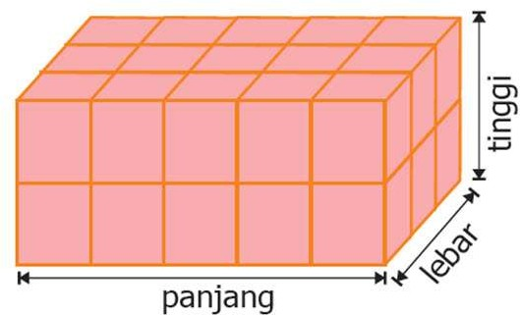
Kegiatan 1
Perhatikan gambar bangun di atas, kemudian hitunglah volumenya (menggunakan kubus satuan )!
Kegiatan 2
Asyiknya Mencoba
Tentukan volume balok di bawah ini dalam kubus satuan!
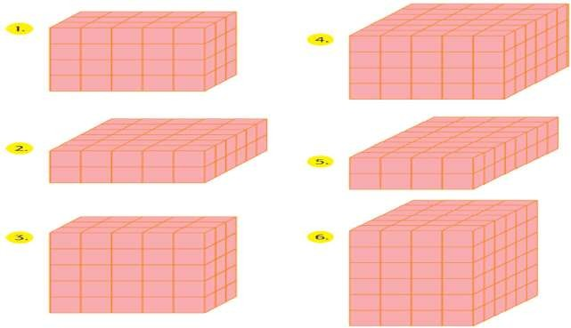
Kegiatan 3
Tentukan volume balok berikut dalam kubus satuan!

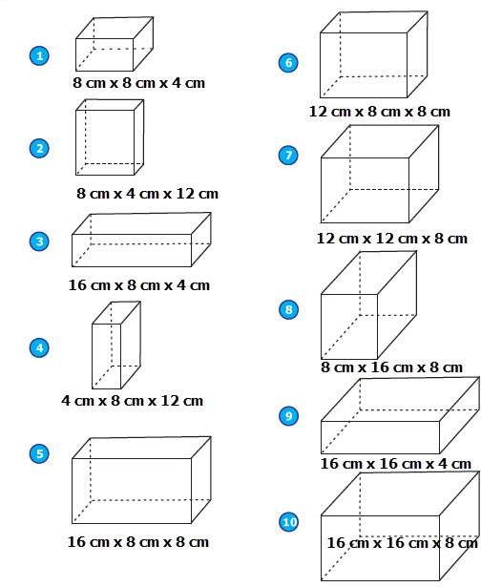
Kegiatan 4

Carilah 5 kotak minuman kemasan yang ukurannya berbeda !lihatlah volume minuman yang tertera pada kotak minuman tersebut! Kemudian ukurlah panjang, lebar, dan tinggin kotak minuman tersebut! Hitunglah volume kotak minuman tersebut! Apakah volume minuman yang tertera pada kemasan sama dengan volume kotak tersebut? Catatlah hasil kegiatanmu pada buku tugas!

RENCANA PELAKSANAAN PEMBELAJARAN (RPP) KELAS KONTROL

Mata Pelajaran : MATEMATIKA
Kelas/Semester : V (Lima) / II (Dua)
Materi Pokok : Sifat-Sifat Bangun Ruang
Alokasi Waktu : 2 x 35 menit

Standar Kompentensi
3. Memahami sifat-sifat bangun dan hubungan antar bangun ruang.

Kompetensi Dasar
3.5 Mengidentifikasi sifat-sifat bangun ruang.

Indikator
    - Menyebutkan jenis-jenis bangun ruang
    - Menyebutkan contoh-contoh benda bentuk bangun ruang di lingkungan sekitar
    - Mengidentifikasi sifat-sifat bangun ruang tabung.

Tujuan Pembelajaran
- Setelah mendengarkan guru dan bertanya jawab, siswa dapat menyebutkan jenis- jenis bangun ruang dengan benar.
- Setelah bertanya jawab, siswa dapat menyebutkan contoh-contoh benda berbentuk bangun ruang di lingkungan sekitarnya dengan benar.
- Setelah berdiskusi secara kelompok, siswa dapat mengidentifikasi sifat-sifat bangun ruang tabung dengan benar.

Tujuan Perbaikan
- Siswa dapat Memahami sifat-sifat bangun dan hubungan antar bangun ruang dengan tepat.
- Siswa dapat Mengidentifikasi sifat-sifat bangun ruang dengan benar.

Materi ajar
- Bentuk-bentuk bangun ruang
- Sifat-sifat bangun ruang tabung
- Bentuk-bentuk bangun ruang

Bangun ruang merupakan bangun yang memiliki tiga dimensi, yaitu panjang lebar dan tinggi.
  - Prisma Tegak
    - prisma segiempat. Contohnya balok dan kubus
    - prisma segitiga
  - limas
  - tabung
  - kerucut
  - Bola
  - Sifat-sifat tabung sebagai berikut:
    - Memiliki alas dan atap yang berupa lingkaran yang sebangun dan sejajar.
    - Tidak memiliki titik sudut
    - Memiliki tinggi yang merupakan jarak alas dan sisi atas tabung.
    - Memiliki sisi lengkung.

Metode Pembelajaran
Ekspositori, tanya jawab dan diskusi

Langkah-langkah Pembelajaran

Jenis Kegiatan | Kegiatan Guru | Alokasi Waktu
Kegiatan Pendahuluan | - Guru memasuki ruangan kelas dengan mengucapkan salam  - Guru mengkondisikan ruangan kelas  - Guru menginstruksikan Ketua Kelas untuk memimpin doa dan mengabsen  - Guru melakukan apersepsi dengan memberikan pertanyaan berikut :  - Apakah kalian masih ingat tentang bangun datar?  - Apakah kalian masih ingat sifat-sifat bangun datar tersebut?  - Dan apakah kalian tahu apa itu bangun ruang? | 10 menit
 | Nah, hari ini kita akan belajar mengenai bangun ruang. Bangun ruang merupakan kumpulan dari beberapa bangun datar. Jadi, terdapat kaitan antara bangun datar dan bangun ruang.
 | 5. Guru menyampaikan indikator dan tujuan pembelajaran
Kegiatan Inti | - Guru bertanya kepada siswa mengenai bangun ruang dengan bertanya mengenai ruang kelas yang sedang mereka tempati.  - Setelah itu, guru memperlihatkan kerangka bangun ruang, guru bertanya kepada siswa nama- nama bangun ruang tersebut (dalam hal ini adalah tabung)  - Setelah memperlihatkan bangun- bangun ruang tabung tersebut, guru bertanya kepada siswa tentang contoh nyata bentuk bangun ruang tabung yang ada di sekitar.  - Guru mendemonstrasikan kepada siswa tentang struktur yang membentuk bangun ruang tabung tersebut ada sisi, rusuk, dan sudut.  - Guru menginsturksikan siswa untuk membentuk kelompok yang terdiri dari 4-5 orang siswa.  - Guru menginstruksikan kepada setiap kelompok untuk megidentifikasi sifat-sifat bangun- bangun ruang tabung yang sudah disediakan oleh guru  - Guru memberikan waktu kepada siswa untuk berdiskusi mengenai bangun ruang tersebut. Selama kegiatan berdiskusi guru memberikan bimbingan dan memfasilitasi kegiatan diskusi siswa  - Setelah selesai, guru menginstruksikan kepada setiap kelompok untuk  mempresentasikan hasil kerjanya.  - Guru menggunakan kerangka bangun ruang tabung untuk membuktikan hasil kerja dari setiap kelompok  Guru memberikan tanggapan positif tentang penampilan setiap kelompok tersebut  - Guru menginstruksikan siswa untuk kembali duduk ke tempatnya masing-masing  - Guru bertanya kepada siswa tentang pemahamanya mengenai materi yang telah dipelajari  - Guru memberikan lembar evaluasi dari kegiatan yang telah dilakukan | 50 menit
Kegiatan Akhir | - Guru melakukan refleksi dari kegiatan yang telah dilakukan dengan bertanya tentang kesimpulan dari kegiatan pembelajaran yang telah dilakukan.  - Guru menutup kegiatan pembelajaran, dan mengingatkan siswa untuk belajar materi pembelajaran selanjutnya  - Guru menutup pelajaran dengan doa | - menit

Alat/Bahan/Sumber Pembelajaran Alat :
- Kertas, kardus, gunting,lem,pena, pensil.

Bahan :
- Gambar bangun datar.
- Benda berbentuk tabung
- Kerangka bangun ruang tabung

Sumber Pembelajaran
- Buku matematika SD/MI siswa dan guru kelas V

Penilaian

Indikator Pencapaian Kompetensi | Teknik Penilaian | Bentuk Instrumen | Instrumen/ Soal
- Menyebutkan jenis-jenis bangun ruang  - Menyebutkan contoh-contoh benda bentuk bangun ruang di lingkungan sekitar  - Mengidentifikasi sifat-sifat bangun ruang tabung | Tes Tulis | Uraian | 1. Sebutkan jenis-jenis bangun ruang yang kamu ketahui! (minimal 3)  2 Sebutkan contoh bentuk bangun ruang yang ada di sekitar mu!  3. Sifat-sifat dari bangun ruang tabung di bawah ini adalah :.

Evaluasi
- Sebutkan jenis-jenis bangun ruang yang kamu ketahui! (minimal 3)
- Sebutkan contoh bentuk bangun ruang yang ada di sekitar mu!
- Sifat-sifat dari bangun ruang tabung adalah.....

FORMAT KRITERIA PENILAIAN
PRODUK
No. | Aspek yang Dinilai | Kriteria Penilaian  (skor)
No. | Aspek yang Dinilai | 4 | 3 | 2 | 1
1. | Ketelitian menentukan jumlah sisi, rusuk dan titik sudut setiap bangun ruang tabung
Kesesuaian dalam
menentukan sifat-sifat
khusus bangun ruang tabung

Ket:

Skor 4 : Sangat Baik

Skor 3 : Baik

Skor 2 : Cukup

Skor 1 : Kurang

SIKAP

No | Nama Siswa | Aspek Yang Di Nilai
No | Nama Siswa | Disiplin |  |  | Tekun |  |  | Tanggung  Jawab |  |  | Percaya  Diri |  |  | Bekerjasama |  |  | Ketelitian
No | Nama Siswa | 3 | 2 | 1 | 3 | 2 | 1 | 3 | 2 | 1 | 3 | 2 | 1 | 3 | 2 | 1 | 3 | 2 | 1
Keterangan nilai:

Skor 3 : Baik

Skor 2 : Cukup Baik

Skor 1 : Kurang Baik

PSIKOMOTOR

No. | Aspek | Kriteria | Skor
 | Pengetahuan  Praktek  Sikap |  | 4  2  1  4  2  1  4  2  1

LEMBAR PENILAIAN

No | Nama Siswa | Performan
No | Nama Siswa | Produk | Sikap | Psikomotor

CATATAN :
Nilai = ( Jumlah skor : jumlah skor maksimal ) X 10.

Untuk siswa yang tidak memenuhi syarat penilaian KKM maka diadakan Remedial.

Lampiran 7 Hasil Pretes
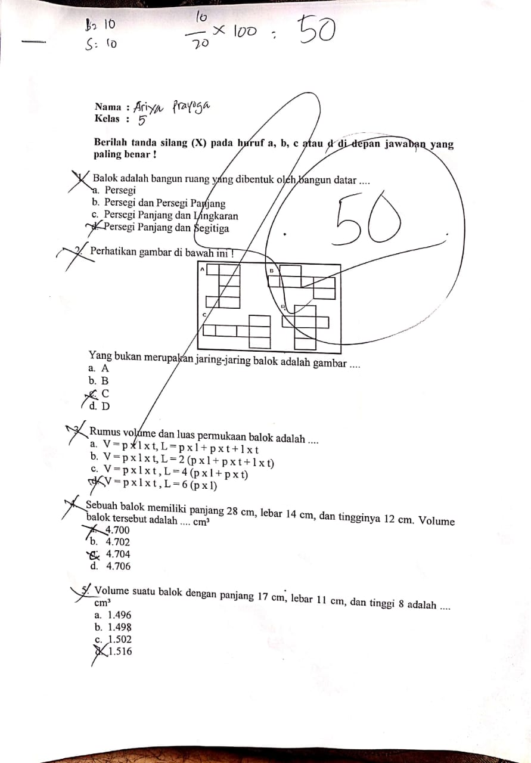
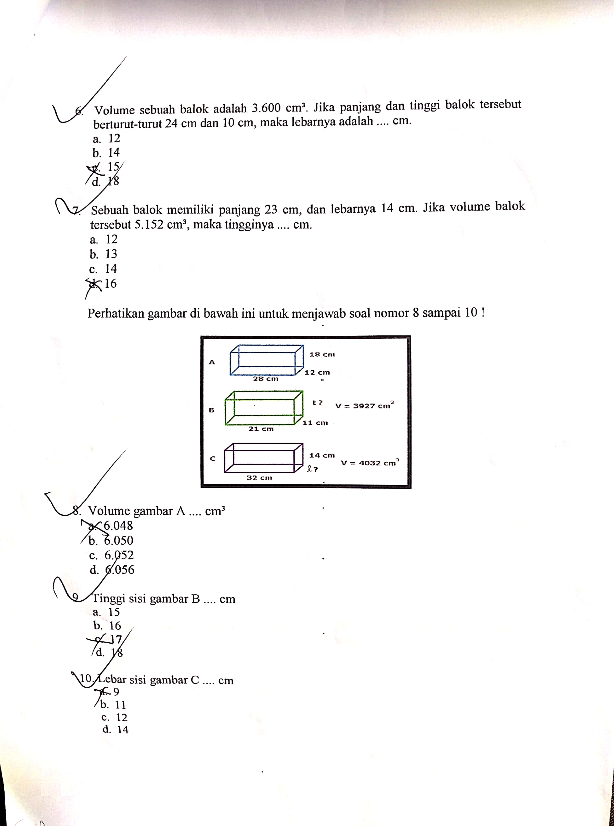

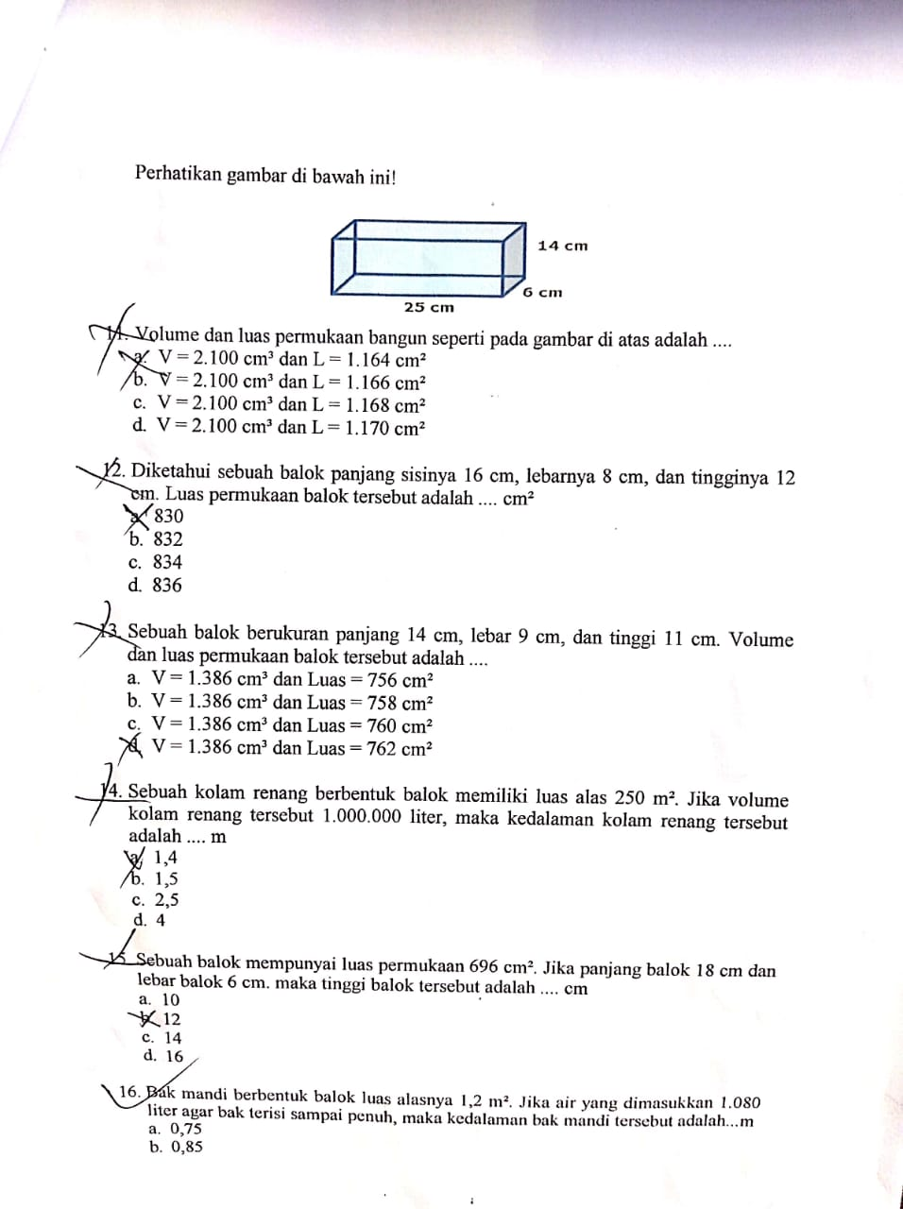

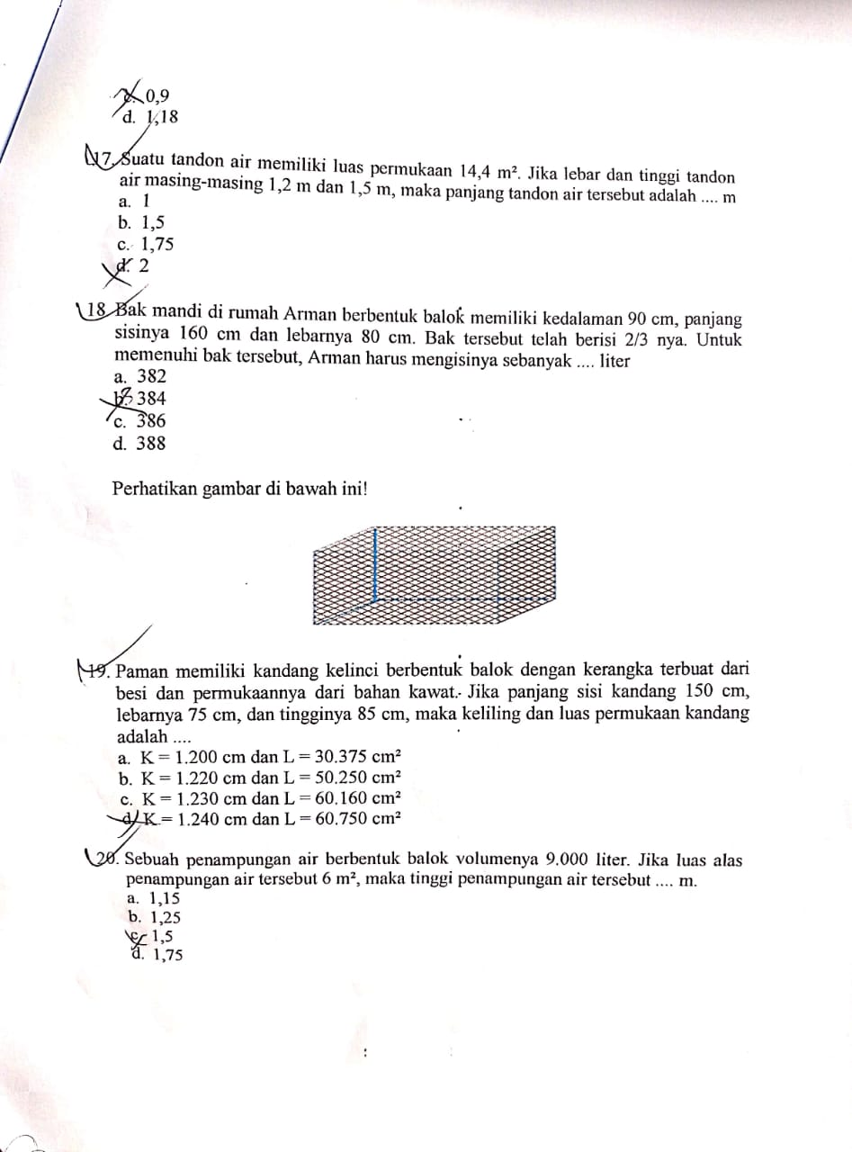
Lampiran 8 Hasil Posttes
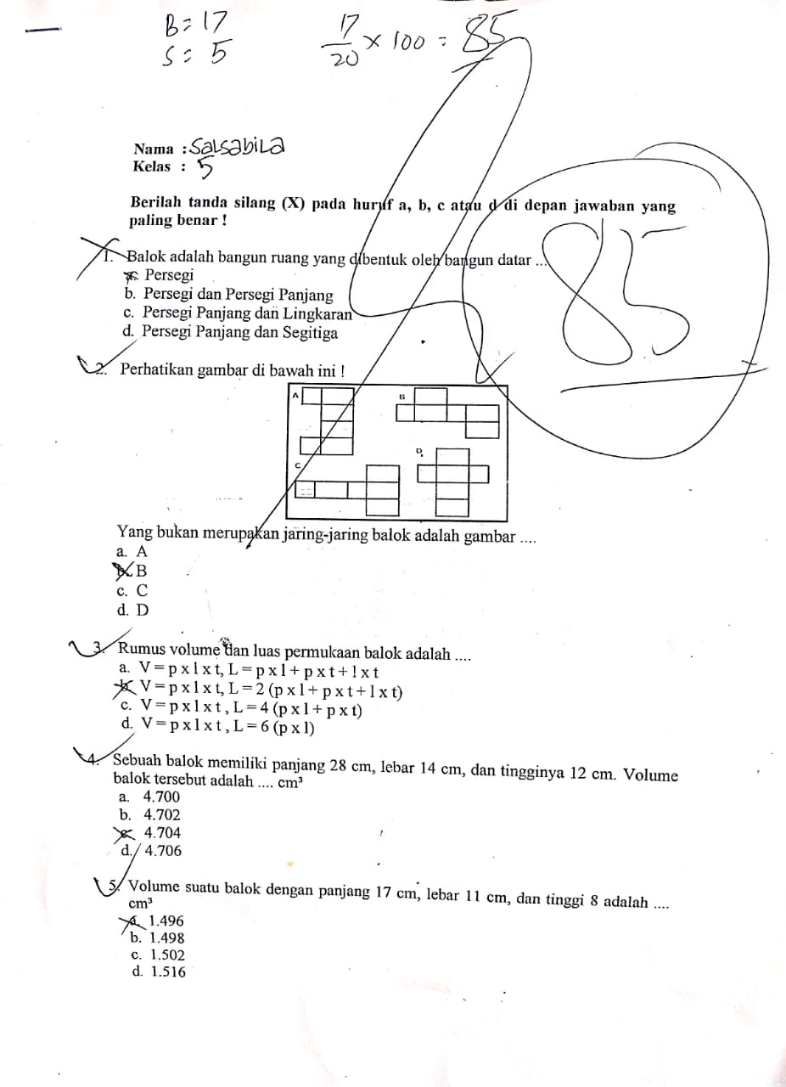
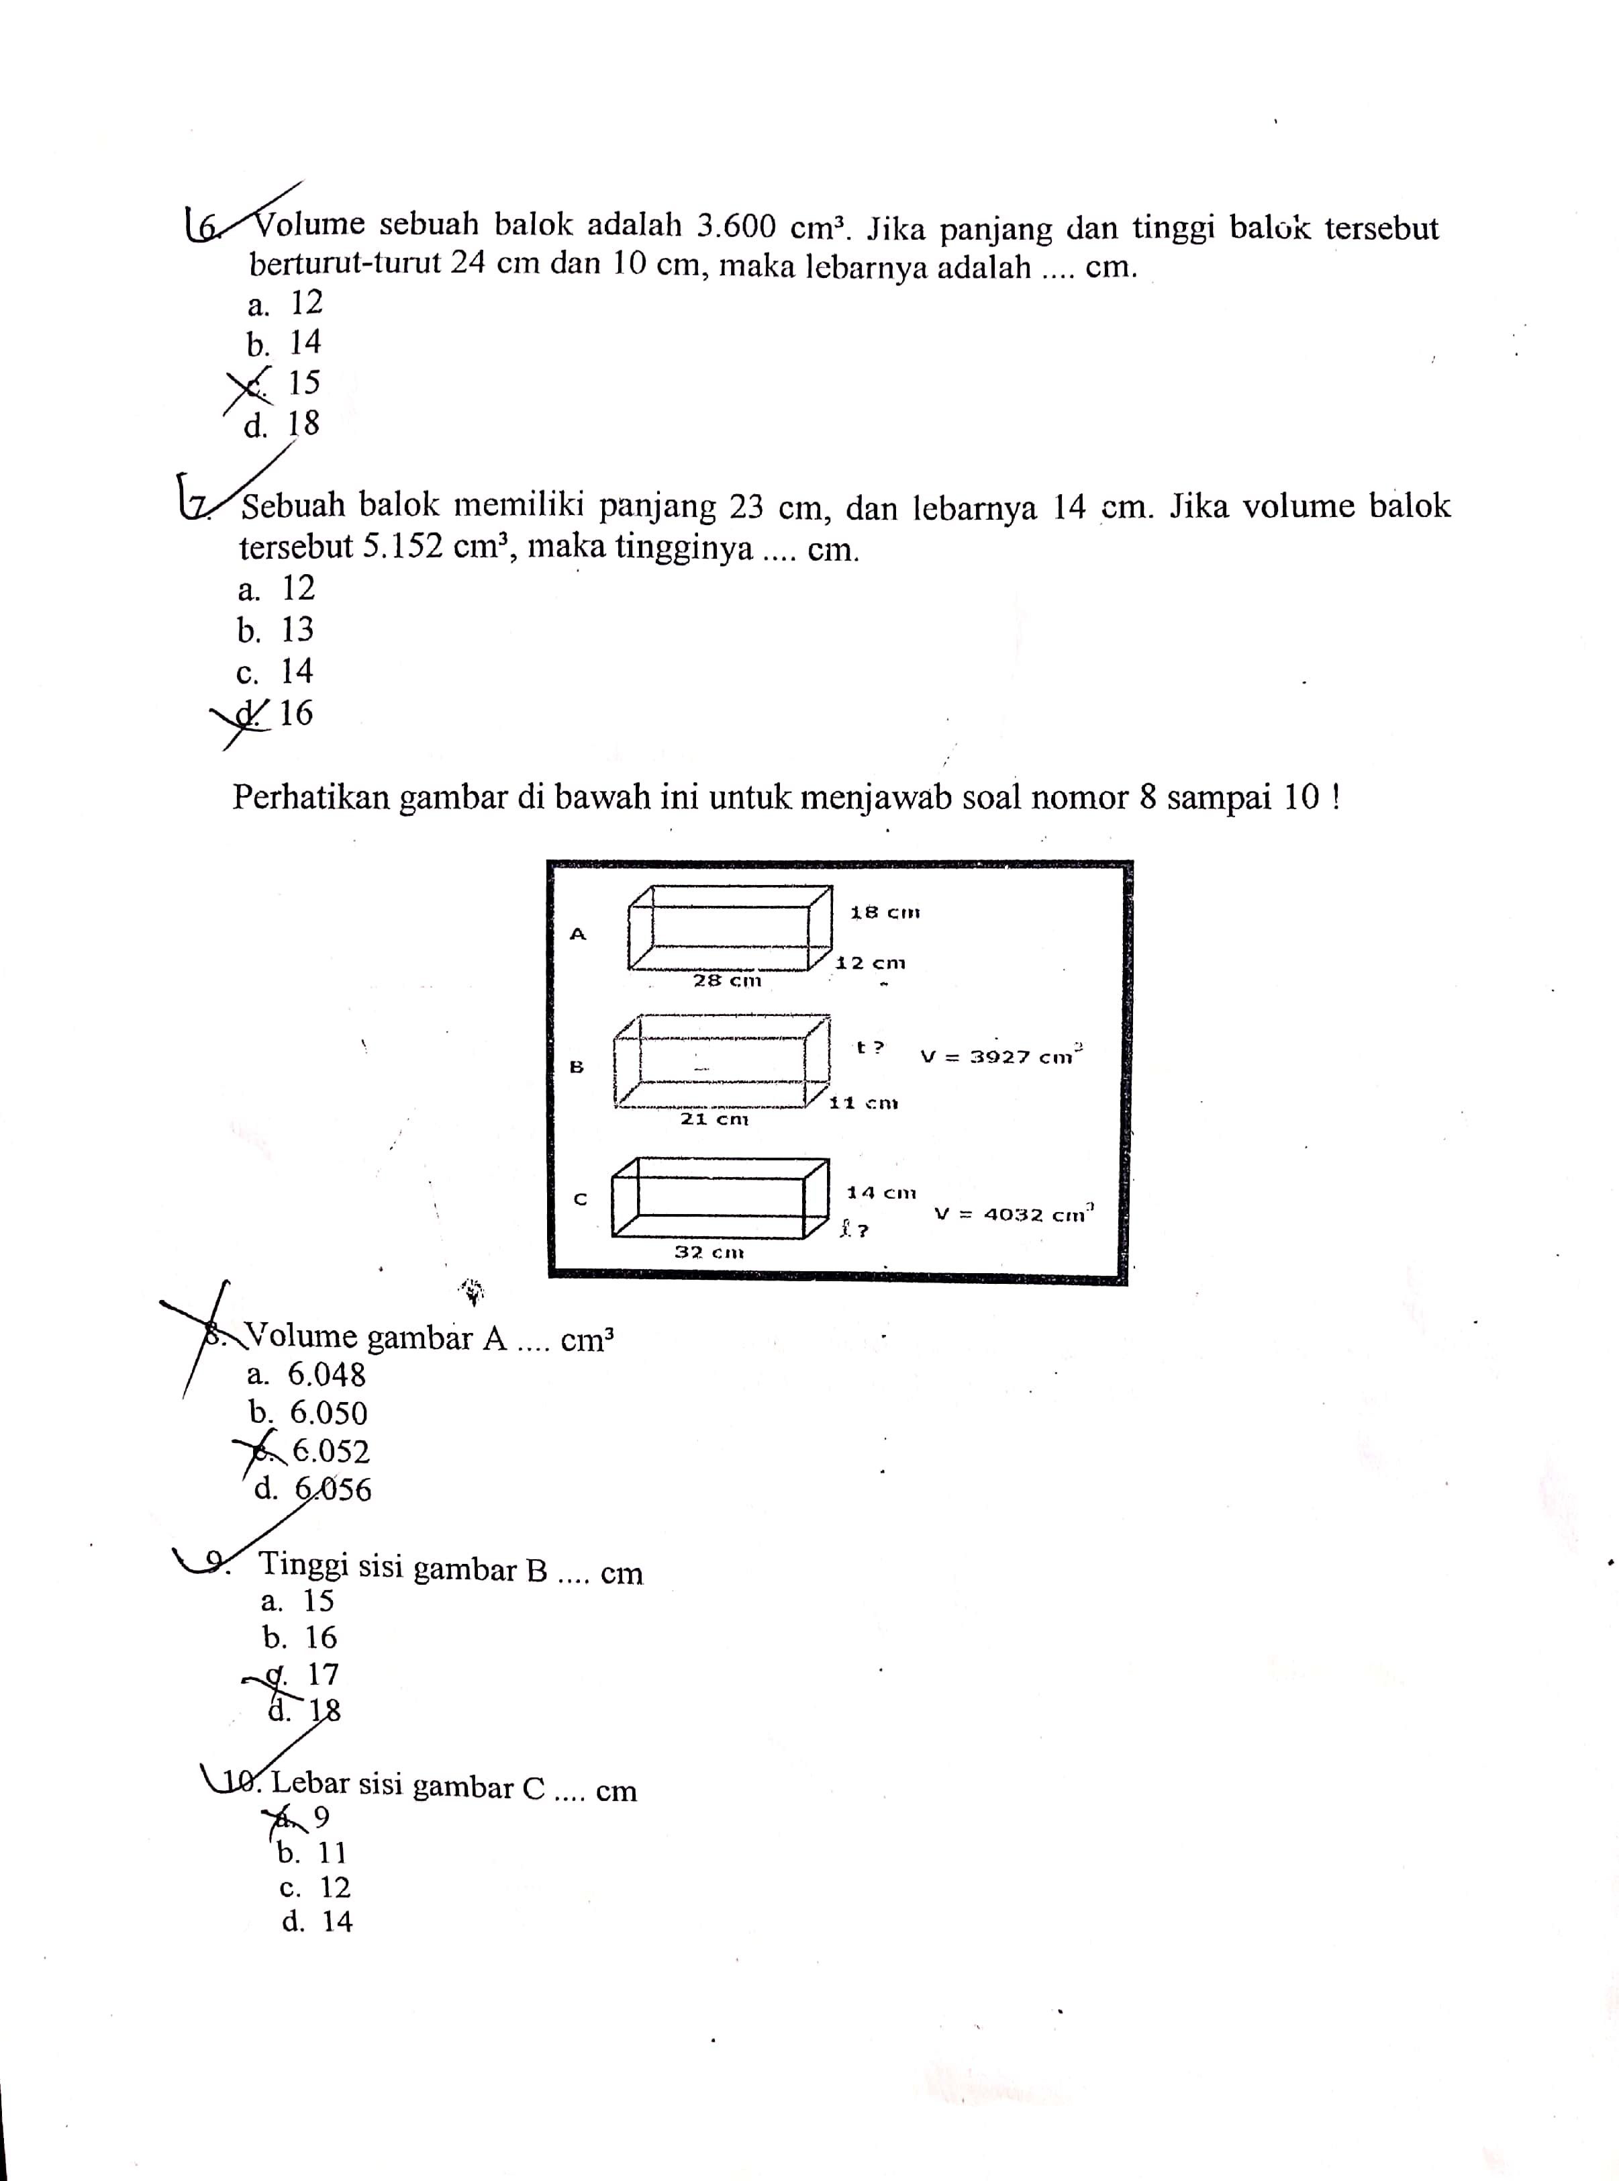

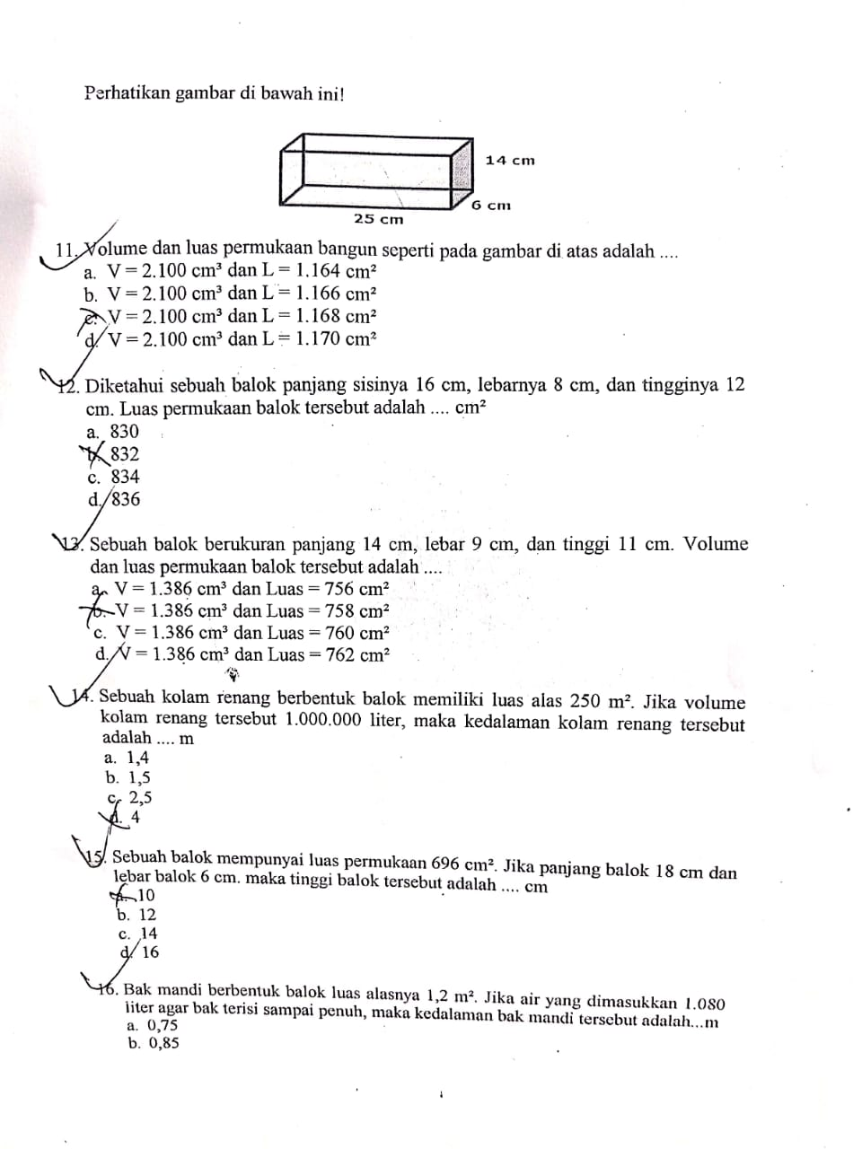
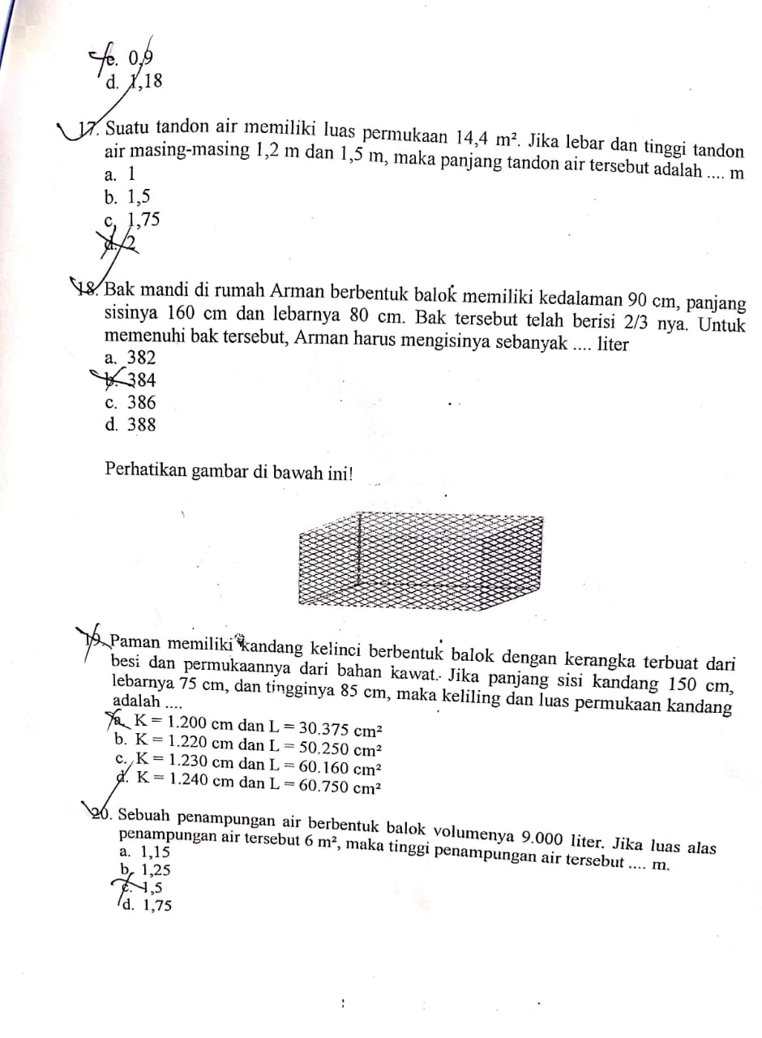

Lampiran 9 Data Hasil Pretes dan Posttes Kelas Eksperimen

No. | Nama Responden | Pretes | Posttes
1. | Res1 | 35 | 80
2. | Res2 | 50 | 80
3. | Res3 | 20 | 80
4. | Res4 | 65 | 90
5. | Res5 | 35 | 60
6. | Res6 | 55 | 75
7. | Res7 | 75 | 100
8. | Res8 | 45 | 85
9. | Res9 | 35 | 75
10. | Res10 | 30 | 75
11. | Res11 | 45 | 80
12. | Res12 | 55 | 85
13. | Res13 | 65 | 90
14. | Res14 | 50 | 75
15. | Res15 | 25 | 75
16. | Res16 | 35 | 75
17. | Res17 | 50 | 90
18. | Res18 | 35 | 80
19. | Res19 | 40 | 75
20. | Res20 | 53 | 90
21. | Res21 | 35 | 65
22. | Res22 | 45 | 75
23. | Res23 | 25 | 80
24. | Res24 | 30 | 75
25. | Res25 | 65 | 100
26 | Res26 | 75 | 85
27 | Res27 | 70 | 80
28 | Res28 | 70 | 75
29 | Res29 | 65 | 80
30 | Res30 | 60 | 85
Jumlah |  | 1438 | 2415
Rata-rata |  | 48 | 80,5
Nilai tertinggi |  | 75 | 100
Nilai Terendah |  | 20 | 75

Lampiran 10 Data Hasil Pretes dan Posttes Kelas Kontrol

No. | Nama Responden | Pretes | Posttes
1. | Res1 | 35 | 75
2. | Res2 | 50 | 80
3. | Res3 | 20 | 75
4. | Res4 | 55 | 80
5. | Res5 | 35 | 60
6. | Res6 | 55 | 75
7. | Res7 | 75 | 95
8. | Res8 | 45 | 85
9. | Res9 | 30 | 75
10. | Res10 | 30 | 75
11. | Res11 | 45 | 80
12. | Res12 | 55 | 85
13. | Res13 | 60 | 85
14. | Res14 | 50 | 75
15. | Res15 | 25 | 75
16. | Res16 | 35 | 75
17. | Res17 | 50 | 80
18. | Res18 | 35 | 80
19. | Res19 | 40 | 75
20. | Res20 | 50 | 80
21. | Res21 | 35 | 65
22. | Res22 | 45 | 75
23. | Res23 | 25 | 80
24. | Res24 | 30 | 75
25. | Res25 | 65 | 95
26 | Res26 | 75 | 85
27 | Res27 | 70 | 80
28 | Res28 | 70 | 75
29 | Res29 | 65 | 80
30 | Res30 | 60 | 85
Jumlah |  | 1415 | 2360
Rata-rata |  | 47 | 78
Nilai tertinggi |  | 75 | 95
Nilai Terendah |  | 20 | 75

Lampiran 11 Dokumentasi
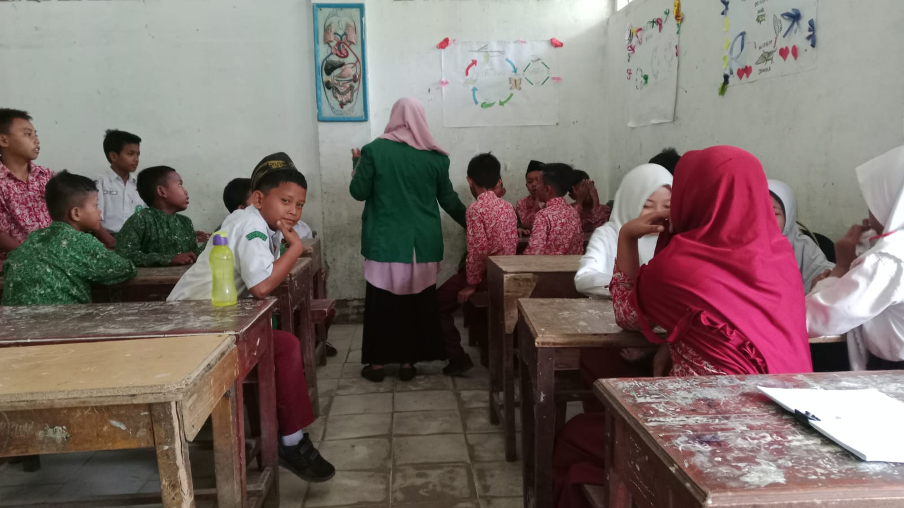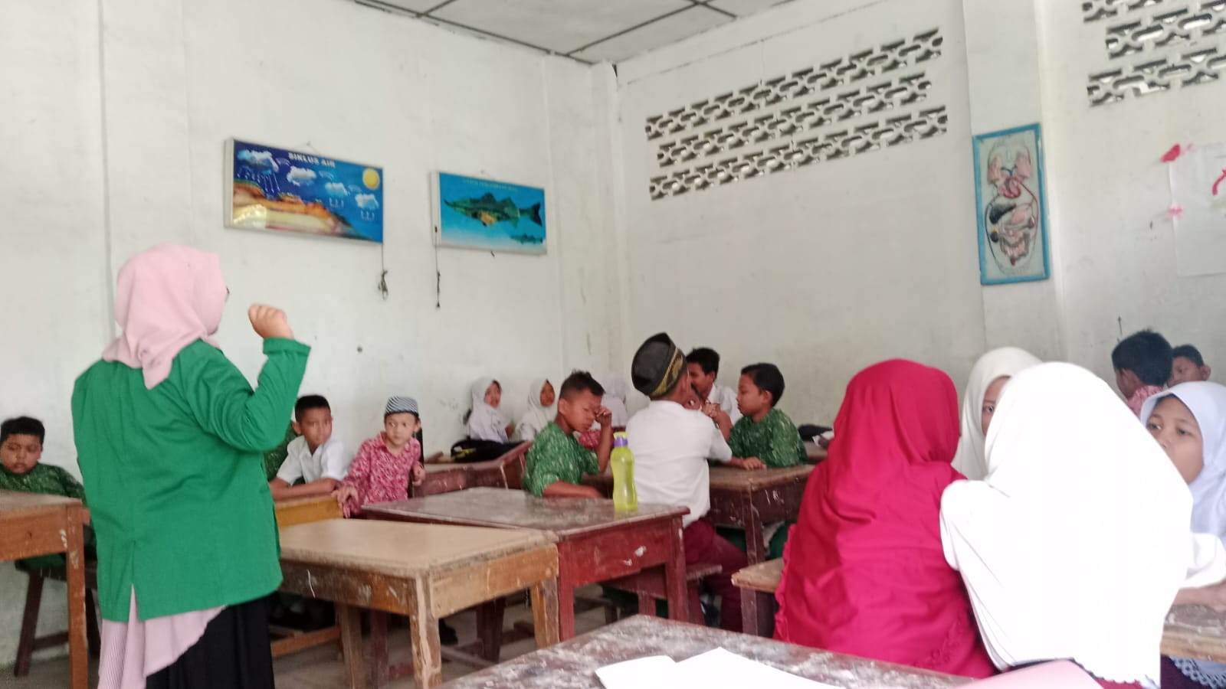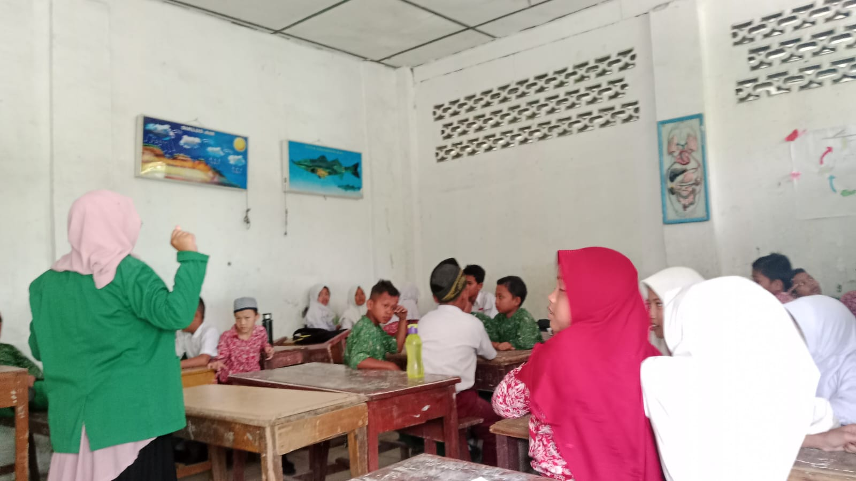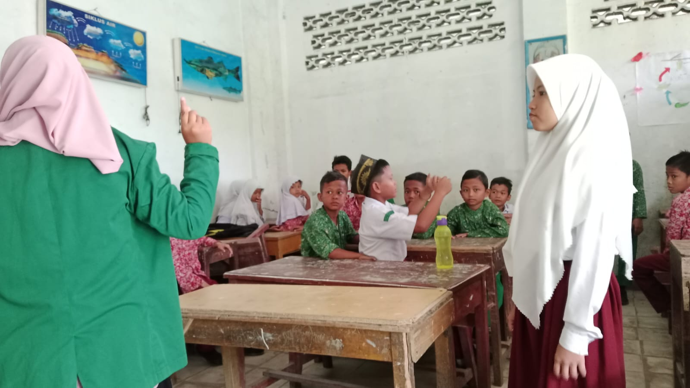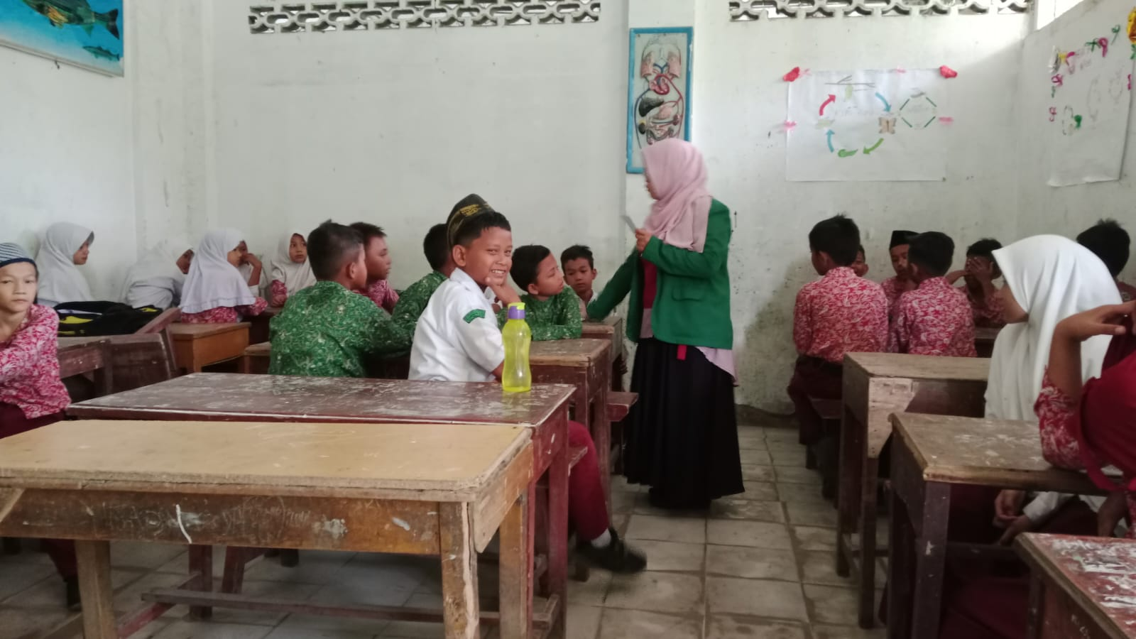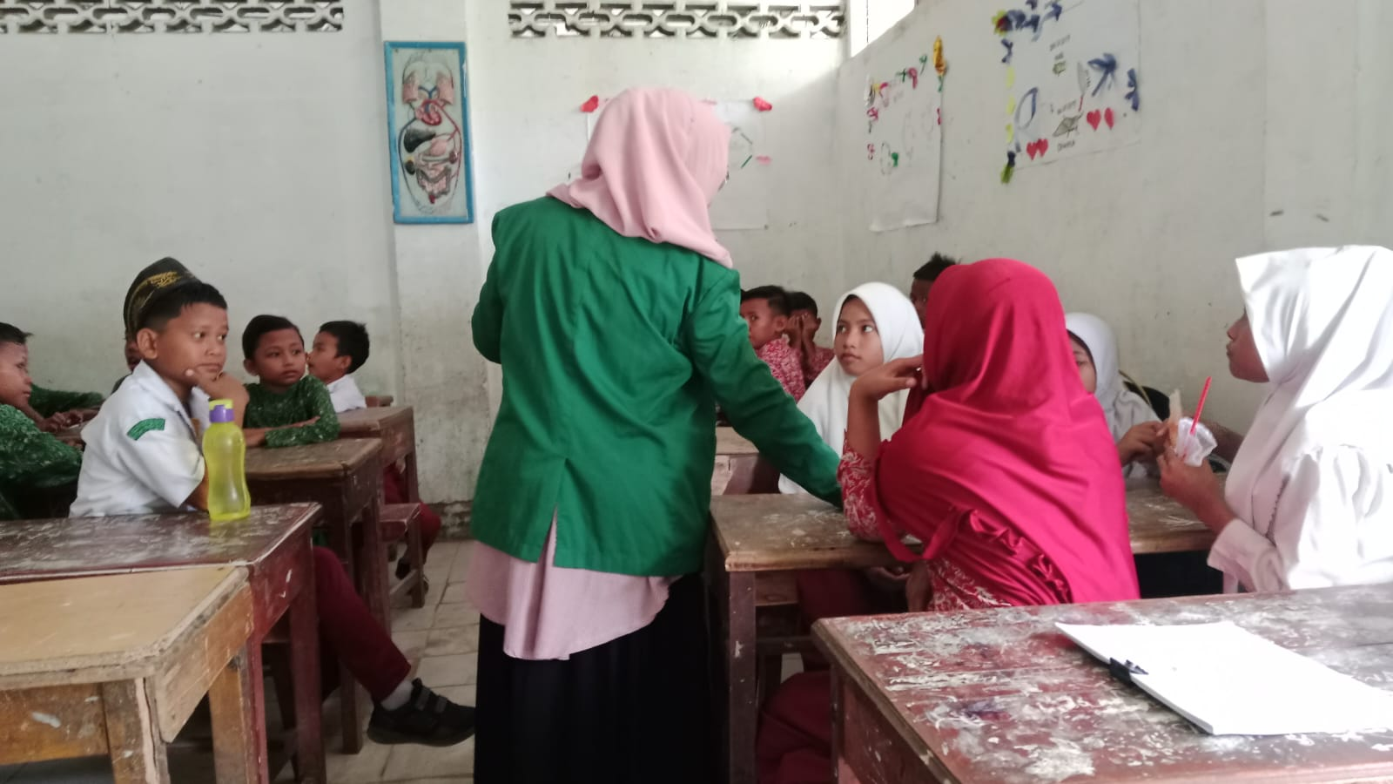

Lembar Penilaian Rencana Pelaksanaan Pembelajaran (RPP)

Petunjuk Pengisian:
Lembar penilaian ini digunakan untuk mengetahui pendapat Bapak/Ibu mengenai kualitas dari Rencana Pelaksanaan Pembelajaran (RPP) Metode Permainan Jungle Math Survive yang akan digunakan pada penelitian dengan judul “Pengaruh Metode Permainan Jungle Math Survive Terhadap Hasil Belajar Bangun Ruang Siswa Kelas V SD Swasta Al-Washliyah Sei Rampah”.

Lembar penilaian ini terdiri dari format, kegiatan pembelajaran dan bahasa. Bapak/ Ibu mohon untuk memberikan tanda “√” pada salah satu kolom 1,2,3,4 dan 5 sesuai dengan rubrik penilaian sebagai berikut:
1: Tidak Relevan
2: Kurang Relevan
3: Cukup Relevan
4: Relevan
5: Sangat Relevan
Kolom keterangan digunakan untuk memberikan kritik/saran bapak/Ibu.
Mohon Bapak/Ibu memberikan kesimpulan secara umum dari hasil penilaian RPP ini dengan memberikan tanda “√” pada salah satu kolom pernyataan.
Atas bantuan dan kesediaan Bapak/Ibu, Saya ucapkan terimakasih.
No | Pernyataan | Skor Penilaian
No | Pernyataan | 5 | 4 | 3 | 2 | 1
Format
1 | Komponen RPP terdapat tujuan, langkah-langkah dan penilaian pembelajaran
2 | RPP disusun secara runtut
3 | Mencantumkan nama satuan  pendidikan
4 | Mencantumkan Tema/Mata  pelajaran
5 | Mencantumkan kelas/Semester
6 | Menyiapkan siswa secara fisik maupun mental sebelum memulai  pembelajaran
7 | Memberikan apersepsi dan motivasi
8 | Menyampaikan tujuan pembelajaran
9 | Skenario pembelajaran disusun sesuai dengan metode permainan jungle math survive
10 | Penyampaian materi menggunakan media
11 | Skenario pembelajaran tersusun secara runtut
12 | Kegiatan pembelajaran berpusat kepada siswa dan membuat siswa aktif dalam belajar
13 | Kegiatan belajar berorientasi pada kebutuhan belajar siswa
14 | Ketetapan penarikan kesimpulan
15 | Terdapat kegiatan pemberian umpan balik
Bahasa
16 | Menggunakan bahasa Indonesia yang baik dan benar
17 | Kalimat yang digunakan sederhana dan mudah dipahami

Kritik dan saran secara keseluruhan

Kesimpulan umum
Berdasarkan penilaian yang dilakukan, maka Rencana Pelaksanaan Pembelajaran (RPP) Metode Permainan Jungle Math Survive dinyatakan:
Layak untuk digunakan tanpa revisi
Layak untuk digunakan dengan revisi sesuai masukan
Belum layak digunakan dalam pembelajaran
Medan, .........2024
Validator

( )

Lembar Penilaian Rencana Pelaksanaan Pembelajaran (RPP)

Petunjuk Pengisian:
Lembar penilaian ini digunakan untuk mengetahui pendapat Bapak/Ibu mengenai kualitas dari Rencana Pelaksanaan Pembelajaran (RPP) Metode Ekspositori yang akan digunakan pada penelitian dengan judul “Pengaruh Metode Permainan Jungle Math Survive Terhadap Hasil Belajar Bangun Ruang Siswa Kelas V SD Swasta Al-Washliyah Sei Rampah”.

Lembar penilaian ini terdiri dari format, kegiatan pembelajaran dan bahasa. Bapak/ Ibu mohon untuk memberikan tanda “√” pada salah satu kolom 1,2,3,4 dan 5 sesuai dengan rubrik penilaian sebagai berikut:
1: Tidak Relevan
2: Kurang Relevan
3: Cukup Relevan
4: Relevan
5: Sangat Relevan
Kolom keterangan digunakan untuk memberikan kritik/saran bapak/Ibu.
Mohon Bapak/Ibu memberikan kesimpulan secara umum dari hasil penilaian RPP ini dengan memberikan tanda “√” pada salah satu kolom pernyataan.
Atas bantuan dan kesediaan Bapak/Ibu, Saya ucapkan terimakasih.
No | Pernyataan | Skor Penilaian
No | Pernyataan | 5 | 4 | 3 | 2 | 1
Format
1 | Komponen RPP terdapat tujuan, langkah-langkah dan penilaian pembelajaran
2 | RPP disusun secara runtut
3 | Mencantumkan nama satuan  pendidikan
4 | Mencantumkan Tema/Mata  pelajaran
5 | Mencantumkan kelas/Semester
6 | Menyiapkan siswa secara fisik maupun mental sebelum memulai  pembelajaran
7 | Memberikan apersepsi dan motivasi
8 | Menyampaikan tujuan pembelajaran
9 | Skenario pembelajaran disusun sesuai dengan metode ekspositori
10 | Penyampaian materi menggunakan media
11 | Skenario pembelajaran tersusun secara runtut
12 | Kegiatan pembelajaran berpusat kepada siswa dan membuat siswa aktif dalam belajar
13 | Kegiatan belajar berorientasi pada kebutuhan belajar siswa
14 | Ketetapan penarikan kesimpulan
15 | Terdapat kegiatan pemberian umpan balik
Bahasa
16 | Menggunakan bahasa Indonesia yang baik dan benar
17 | Kalimat yang digunakan sederhana dan mudah dipahami

Kritik dan saran secara keseluruhan

Kesimpulan umum
Berdasarkan penilaian yang dilakukan, maka Rencana Pelaksanaan Pembelajaran (RPP) Metode Ekspositori dinyatakan:
Layak untuk digunakan tanpa revisi
Layak untuk digunakan dengan revisi sesuai masukan
Belum layak digunakan dalam pembelajaran
Medan, .........2024
Validator

( )

