DEVELOPING ADVERTISMENT MATERIAL FOR DIFFERENT LEARNING STYLES OF STUDENTS
BASED CANVA POWER POINT TO THE NINTH
GRADE OF SMP NEGERI 2 PERBAUNGAN IN
ACADEMIC YEAR 2023/2024

THESIS

By:

SRY RAHAYU NINGSIH
REGISTRATION NUMBER : 227215018



ENGLISH EDUCATION DEPARTEMENT
POSTGRADUATE SCHOOL
UNIVERSITAS MUSLIM NUSANTARA AL-WASHLIYAH
MEDAN
2024
DEVELOPING ADVERTISMENT MATERIAL FOR DIFFERENT LEARNING STYLES OF STUDENTS
BASED CANVA POWER POINT TO THE NINTH
GRADE OF SMP NEGERI 2 PERBAUNGAN IN
ACADEMIC YEAR 2023/2024

THESIS

To Obtain a master Degree in English Education (M.Pd ) in the Postgraduate Master Program in English Language education (S2) Universitas Muslim Nusantara Al - Washliyah

By:

SRY RAHAYU NINGSIH
REGISTRATION NUMBER : 227215018

ENGLISH EDUCATION DEPARTEMENT
POSTGRADUATE SCHOOL
UNIVERSITAS MUSLIM NUSANTARA AL-WASHLIYAH
MEDAN
2024

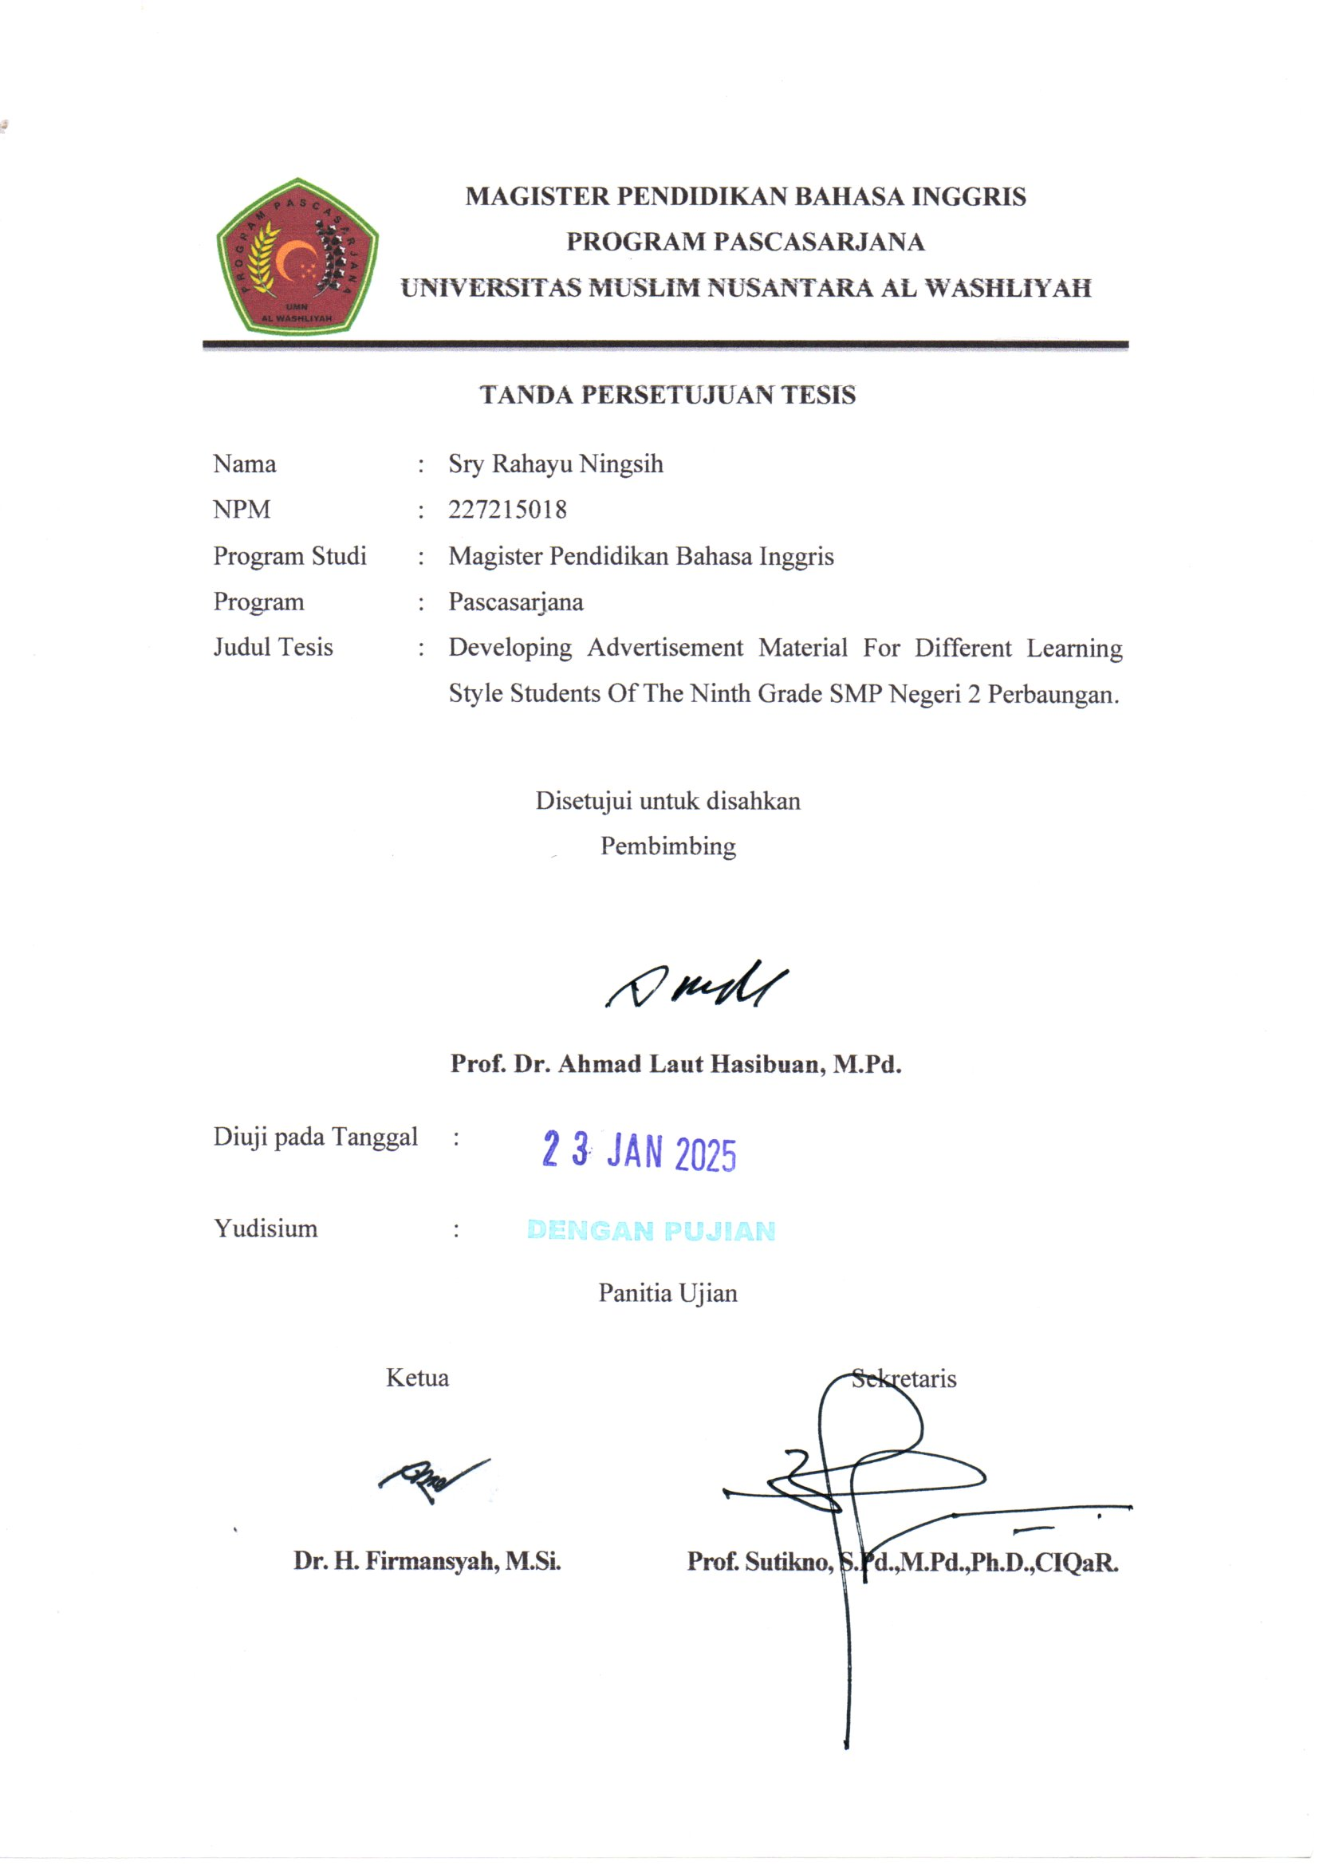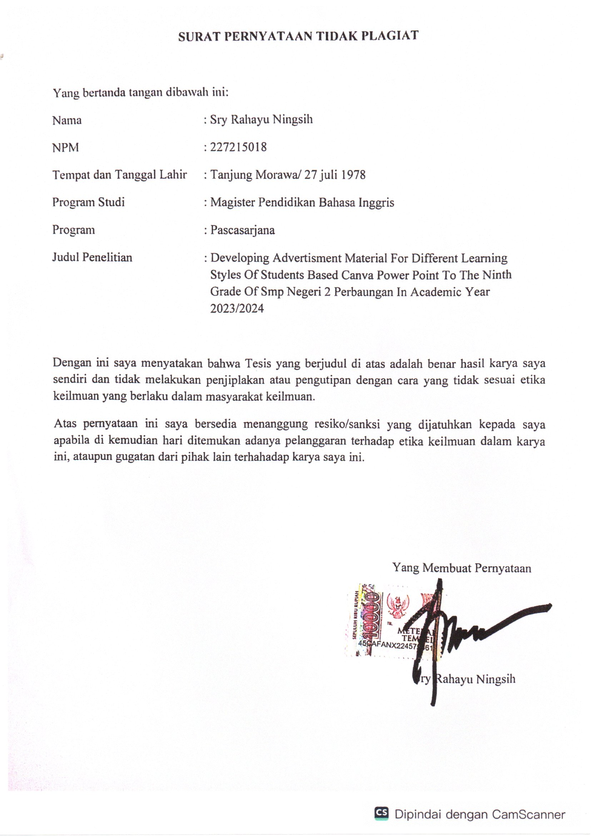
ABSTRACT

DEVELOPING ADVERTISMENT MATERIAL FOR DIFFERENT LEARNING STYLES OF STUDENTS BASED CANVA POWER
POINT TO THE NINTH GRADE OF SMP NEGERI 2
PERBAUNGAN IN ACADEMIC YEAR 2023/2024

BY

SRY RAHAYU NINGSIH
NPM : 2272150019

This research focuses on the design of developing advertising materials tailored to various learning styles among grade nine students at SMP Negeri 2 Perbaungan, Serdang Bedagai Regency. Recognising the diversity in learning preferences of visual, auditory, and kinesthetic students, this research aims to create Advertising materials using Canva's PowerPoint (PPT) to effectively address and engage various learning styles more effectively. This research follows a research and development (R&D) methodology, using the ADDIE model (Analysis, Design, Development, Implementation, Evaluation) to design the materials. Through analysis, students' predominantly visual, auditory, and kinesthetic learning styles can be identified to guide the material development process. The resulting materials are intended to be visually appealing, interactive, and flexible, which improves comprehension and retention. Data collected through student feedback, teacher evaluations, and pre- and post-assessment scores indicate that the customised materials have a positive impact on students' engagement and understanding of advertising concepts to enhance the learning experience and accommodate individual needs in a classroom setting.The results of the validator test of the overall media design meet the eligibility criteria (88.9%) so that the teaching materials can be used as teaching materials for students in the learning process. The results of the assessment of English teaching materials by experts regarding the substance of the material as a whole from the aspects assessed get the eligibility criteria (87.5%) so that the teaching materials can be used in the learning process. and the trial results show the average student score of 81. 18% so that the criteria for effective teaching materials for different learning styles of students by using advertisements on reading skills in class IX SMPN 2 Perbaungan. research and development, implementation and evaluation) The instruments used are questionnaires to students, interviews to teachers, and the results of the last trial given to students. The results of the validator's test of the media design as a whole met the feasible criteria (88.9%) so that the teaching materials could be used as teaching materials for students in the learning process.

Key words: R&D advertisement, Different learning style, Canva Power point

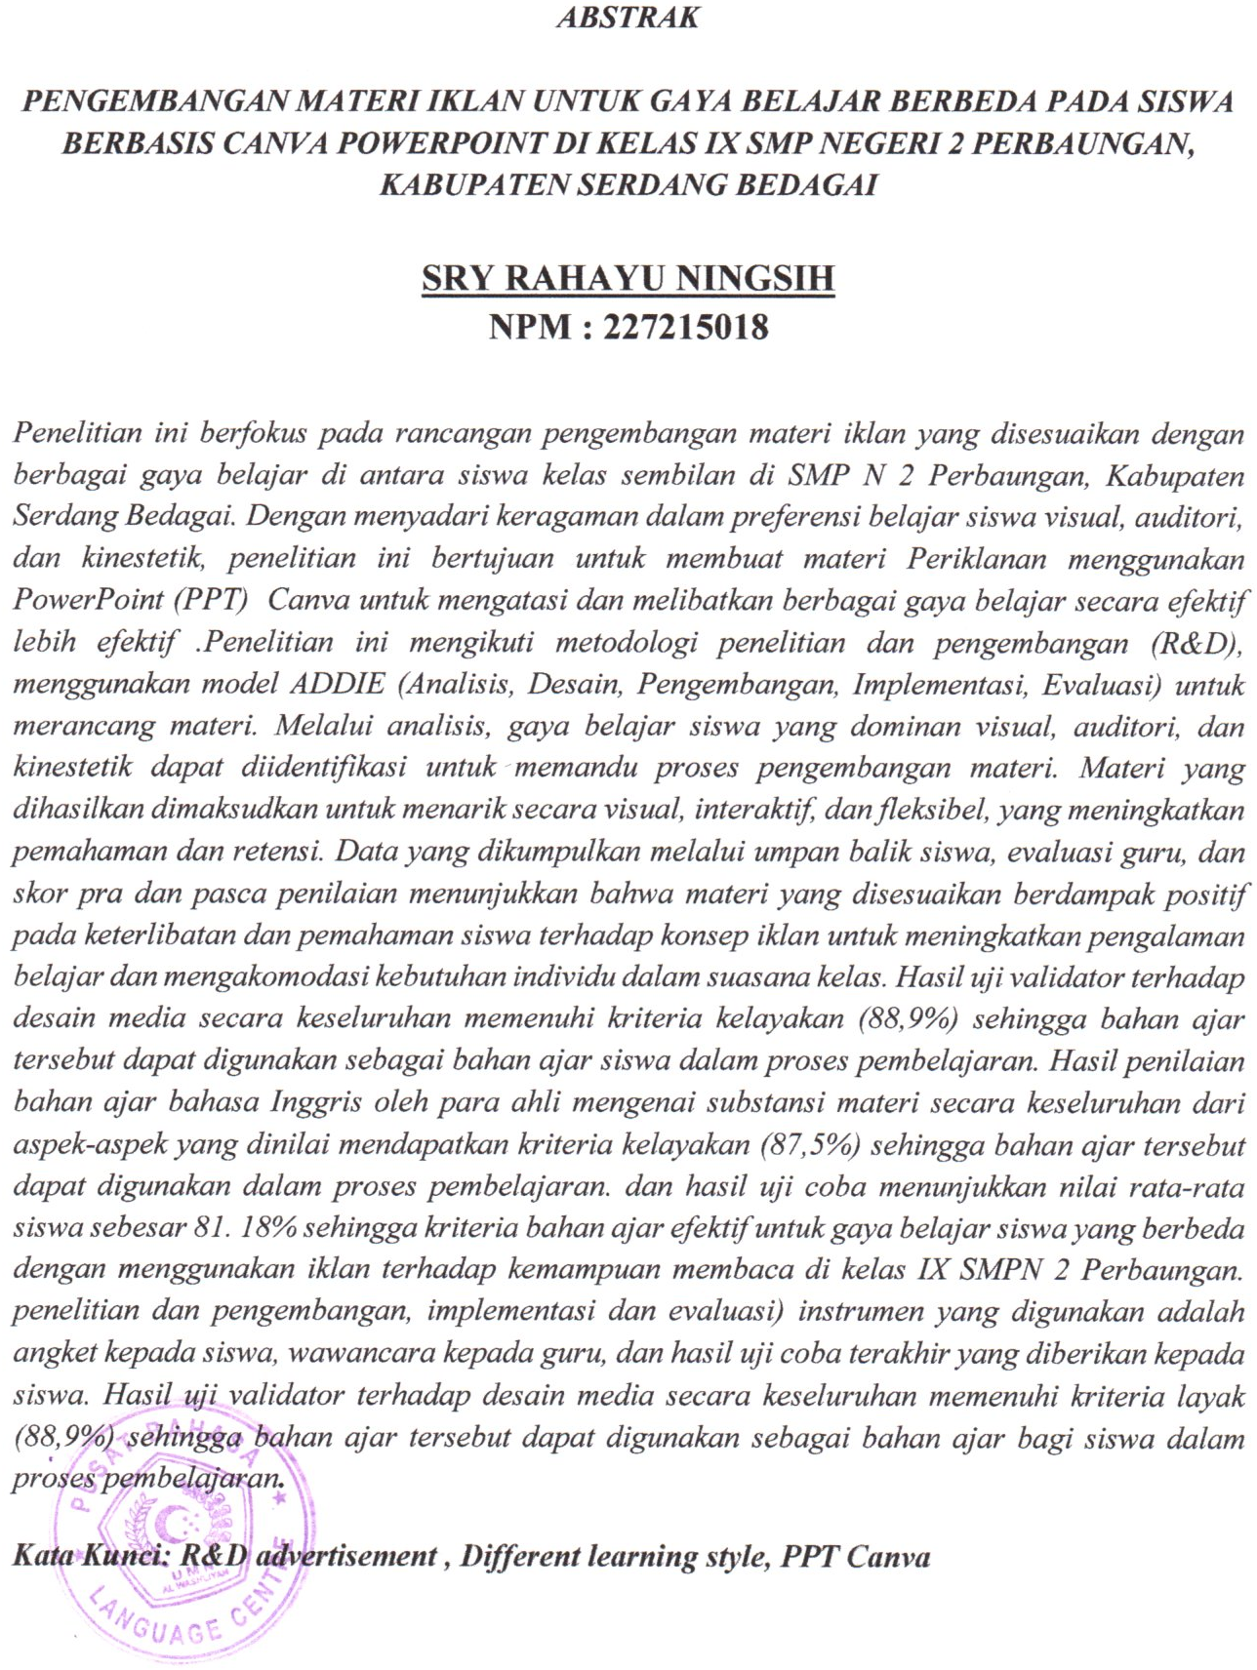

ACKNOWLEDGMENT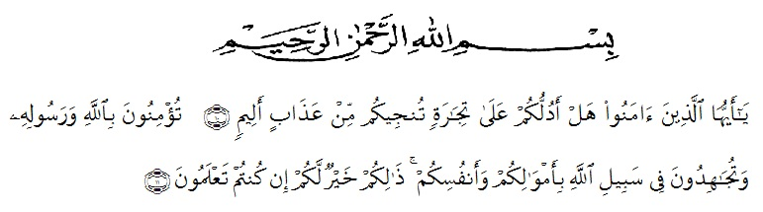
Meaning:
“O you who believe! Shall I show you a commerce that will save you from a painful doom?. you should believe in Allah and His messenger, and should strive for the cause of Allah with your wealth and your lives. That is better for you,if you did but know.” (Surah Ash Shaff Verse10-11)
Alhamdulillah, all praises be to الله the single power, the Lord of the universe, master of the Day of Judgment, the most merciful and the most gracious one, for all blessings and mercies so the researcher was able to finish this thesis entitled " Developing Advertisment Teaching Material for Different Learning Styles of Students Based PPT Canva In The Ninth Grade of SMP N 2 Perbaungan Kabupaten Serdang Bedagai " Peace be upon Prophet Muhammad , the great leader and good inspiration of world revolution.
The researcher is sure that this thesis would not be completed without the helps supports, and suggestions from several sides. Thus, the researcher would like to expres her deepest thanks to all of those who had helped, supported, and suggested her during the process of this writing thesis. This goes to :

- Dr.H.Firmansyah, M.Si, The Rector of UMN Al - Wasliyah Medan .
- Sutikno, S.Pd. M.Pd, Ph.D, The Postgraduate Director of UMN Al- Wasliyah Medan.
- Dr. Asnawi, M. Hum, The head of English Department who has given a lot of valuable suggestions, comments, and criticism for completing this research.
- Prof.Dr. Ahmad Laut Hasibuan. M.Pd, The adviser, who has given her a lot of valuable suggestions, comments and criticism for completing this research.
- The lectures of the English Department of FKIP UMN Al Washliyah Medan who have taught him.
- She’ s beloved parents and husband who always motivation and support me by Morallity, Financially and their love and praying in finishing her study at PascaSarjana UMN AL – Wasliyah Medan.
The researcher hopes that this thesis is useful for the researcher in particular and readers in general.
Finally,She does all of suggestion and Criticism which can be useful and meaningful for the writer. God Bless Us.
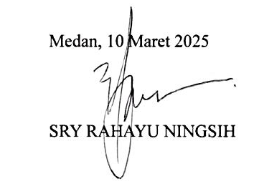

TABLE OF CONTENTS
ABSTRACT i
ABSTRAK ii
ACKNOWLEDGMENT iii
TABLE OF CONTENTS v
LIST OF TABLE viii
FIGURE ix
LIST OF APPENDIX xi
CHAPTER I INTRODUCTION 1
1.1 Background Of The Problem 1
1.2 Identification of problems 6
1.3 Scope of problem 6
1.4 Problem Formulation 7
1.5 Research Objectives 8
1.6 Benefits of research 8
1.7 Theoretical Research 9
1.8 Practical Research 9
1.9 Basic assumptions 10
CHAPTER II LITERATURE REVIEW 11
2.1 Development Concept 11
2.2 Advertisement 15
2.2.1 Definition of advertisement 15
2.2.2 The types of advertising based on their function 17
2.2.3 Types of Advertising based on Media 18
2.2.4 Types of advertising based on Purpose 18
2.2.5 Types of Advertisements Based on Content 19
2.2.6 Types of advertising in the form of delivery 21
2.3 Material Development 22
2.4 A Brief Overview Of Student Character Differences 24
2.5 A Brief View Of Canva Power point 28
2.5.1 Definition 28
2.5.2 Canva Application History 28
2.5.3 Objectives and benefits of multiple experts 29
2.5.4 The Fuction of Canva 30
2.6 Relevant research 34
2.7 Framework of thinking 36
2.8 Hypothesis 37
CHAPTER III METHOD OF RESEARCH 38
3.1 Research Models 38
3.2 Research Design 40
3.3. Subject, Object and Time of Research 41
3.4 Development Research Procedures 43
3.5 Data Collection Instruments and Techniques 45
3.6 Data analysis 47
3.7 Instruments for research 48
3.8 Data Analyzing Techniques 55
3.9 Needs analysis questionnaire 56
CHAPTER IV FINDING AND DISSCUSSION 60
4.1 Developing advertisement Material 60
4.1.1 Media Expert 65
4.1.2 Material Substance 66
4.1.3 Implementation Stage 68
4.2 Expert Validation Results 71
4.2.1. Analysis 71
4.2.2 Design Stage 78
4.2.3 Media Expert Validation 78
4.2.4 Material Substance Expert Assessment 79
4.2.5 Implementation Stage 80
4.2.6 Evaluation stage 82
4.2.7 The Effectiveness of Using advertisement material in writing for different learning style of Students based of Canva Power point 94
4.3 Discussion 97
CHAPTER V CONCLUSION AND SUGGESTION 101
5.1 Conclusion 101
5.2 Sugesstions 101
REFERENCE 105
APPENDICES 108

LIST OF TABLE
Tabel 3.1 Research Schedule 42
Table 4.1 The Questions Number 9 and 10 72
Table 4.2 The question Number 4,8, and 12 73
Table 4.3 The question Number 5,6,7 and 15 74
Table 4.4 The question Number 11 75
Table 4.5 The question Number 1,2.3 and 14 76
Table 4.6 The question Number 13 77
Table 4.7 Data on the Results of Assessment of English Teaching Media Design Experts 78
Table 4.8 Data on the result of assessment of English Teaching materials design experts 80
Table 4.9 Student Response Questionnaire Result Data 81
Table 4.10 Score assessment students last 83
Table 4.11 Date of Pre Test Advertisment Writing 84
Table .4.12 Date Of Pre Test Advertisment of Presentation Assessment 85
Table 4.13 The Date of Post Test Advertisment Writing 87
Table 4.14 The Data of Post Test Advertisment Writing of Presentation 88
Tabel 4.15 The Data of Different Score Pre Test and Post Test Advertisment Writing of Presentation 90
Tabel 4.16 The Data of Different Score Pre Test and Post Test Advertisment Writing test 93

FIGURE

Figure 1. Research design 41
Figure 2. Research Procedure 43
Figure 3. The old material advertisement 60
Figure 4. The material advertisement Test 61
Figure 5. Developing advertisment Material by You tobe 61
Figure 6. The Developing of material advertisement 62
Figure 7. The Developing of material advertisement from Generic Structure 62
Figure 8. The Developing of material advertisement 62
Figure 9. The Developing of material advertisement from Generic Structure 63
Figure 10. The Developing of material advertisement from Generic Structure 63
Figure 11. The Developing of material advertisement from Generic Structure 63
Figure 12. The Developing of material advertisemen 64
Figure 13. The Developing of material advertisement 64

Figure 14. The Developing of material advertisement 64

Figure 15. The Developing of material advertisement 65

Figure 16. The Developing of material advertisement 65

Figure 17. The Developing of material advertisement from Generic Structure Using Vidio of a Product by Power point Canva 66

Figure 18. The Developing of materia 66

Figure 19. Example of Non Commercial advertisement 67
Figure 20. Example of a Commercial Advertisement 68
Figure 21. The first step to writing advertisement by Canva 68
Figure 22. The second Step, The students can be choice a picture in Canva 68
Figure 23. The Third step, after choice a picture and write a sentence with Text 69
Figure 24. The Third step, after choice a picture and write a sentence with Text 69
Figure 25. The fourth step, The students write a product and elements 69
Figure 26. The result of Canva Power point cab be download and share to wa group to presentation 70
Figure 27. The way to download it is to press the top corner, there is a share text, then press download you can choose the file type according to your worksheet 70
Figure 28. The after choice a picture and write a sentence with Text 70

LIST OF APPENDIX
Appendix 1 Pre test adverisment with visual, Auditory and Kinesthetic learning Style 108
Appendix 2 Pre – Test Assessment Criteria 109
Appendix 3 Post test adverisment with visual, Auditory and Kinesthetic learning Style 110
Appendix 4 Post-Test Assessment Rubric 111
Appendixes 5 Rubrik Penilaian Presentasi 112

Appendixes 6 (for Further see attachment) student-made print advertising by Pictures of Carton 113

Appendixes 7. The students make An Advertisment by Canva 114

Appendixes 8. The Result students to make An Advertisment by Canva 115

Appendixes 9. The Result students make An Advertisment by Canva 116

Appendix 10 : Modul 9 The design of Lesson Plan 117

CHAPTER I
INTRODUCTION
1.1 Background Of The Problem
In teaching advertising materials,The teacher’s strategy should be relevant to the differentiation students’ need and using a good and affective language style gives a special attraction for students. Currently, there are platforms to place publications of products made by students in P5 learning (Project strengthening the Profile of Pancasila Students on the theme of entrepreneurship), local wisdom and suitable lifestyle can promote their work on media such as television, newspapers, radio, and other social media. Usually producers will be very careful in placing their publications. They will look at media that are passively used by the public and are interesting to see, hear or read. Advertising makers mostly use simple and interesting language styles to create beautiful sentences and persuade or influence readers or viewers to use the product.
Language is a fundamental aspect of human life. To communicate and establish relationship with other, people use language as tool of their communication (Wardhaugh, 2009: 29). To communicate means to transfer ideas from one person to the others. If people did not have a tool to communicate, every people’s activities and interactions would be stagnant. Wardhaugh (2009:1) states that language is what the members of a particular society speak. Therefore, the relationship between language and human or society is dependent. Wardhaugh (2009:1) further states that the definition of language and society is not independent. Thus, from the statement above, the researcher concludes that if there is no language in society, there will be nothing.
There are two kinds of language, spoken language and written language. Spoken language is an utterance which is formed from sound, such as conversation, speech, storytelling, discussion, radio, television broadcast, social media and etc. While, written language is an utterance which is formed in the written form, such as novels, comics, newspapers, magazines, letters, books, journals, articles, and etc. In expressing or delivering ideas in both forms, spoken and written language, people have and use their own style because it is related to the social aspect. Chaika (1982:29) states that style refers to the selection of the linguistic forms to convey social or artistic effects. Style also acts as a set of instructions.
Other opinions come from Keraf (2002:112). He states that style is the ability and the competence to make a sentence in a good way. Considering the problem above, the researcher enthusiastically will focus her study on the language style in writing simple adverising because style forms communication in the right way and determines how a social interaction will proceed (Chaika, 1982:20). In this case, style determines how a speaker speaks and how the listener takes the meaning of the communication in the right way; whether it is serious, humorous, dubious, or any other possible senses.
As stated above, people use written utterance in expressing their idea in written language. One example of written languages that is created by human being is an advertisement. Lapanska (2006:37) state advertisement is one of human life activities that can be found in radio, television, magazine, newspaper, and other source.
Writing skill is defined as the ability to use language to express ideas, thoughts or felling to others using written language. However its implementation most students have problems in productive skill. One of them faced by writing skill. Advertising maerials must provide students in the ninth grade with an understanding of advertising materials that are rich, meaningful and easy to understand or developing through the features contained in the Canva application. Uechi ( 2016 )has added five principles to design writing materials: materials should help learners to develop their confidence, expose them to language in authentic use, be culturally relevant, stretch/challenge learners, and build their intercultural awareness.
Learning is an internal process that is measured through behavior. The existence of cognitive, affective and psychomotor differences between students influences their learning choices which appear in the form of differences in learning styles. Learning styles can explain learning differences between students in the same learning setting.
This research aims to develop advertising materials tailored to different student learning styles through the Canva Power point presentation platform. "By using Canva, this research focuses on how various visual, text and animation elements can be designed to meet the needs of students with diverse learning styles, such as visual, auditory and kinesthetic, so that it is hoped that it can increase effectiveness. and the appeal of advertising in learning.
Until now, research on developing advertisements based on student learning styles using Canva Power point has never been carried out in schools by teachers and students at SMP Negeri 2 Perbaungan. So this topic is a new opportunity to explore. It is hoped that this research can provide new insights in designing advertising materials that are more effective and attractive according to students' different learning styles.Learning styles are specific behavioral patterns in receiving new information and developing new skills, as well as the process of storing new information or skills (Sarasin, 1999).
for others. So, learning style is related to the way children learn, as well as their preferred way of learning. Meanwhile, according to Nasution (2009) learning style is a consistent way used by a student in capturing stimulus or information, how to remember, think and solve problems.
The teacher's strategy must be relevant to the advertising learning needed in the school environment and where participants live with the different character needs of students.This strategy makes it possible to activate their various learning styles. The various learning styles in the classroom are generally categorized into auditory, visual and kinesthetic.
- Auditory learning style is a type of learning that prioritizes the listener's senses.
- Visual learning style is a type of learning process that relies on vision as a recipient of information and knowledge.
- Kinesthetic learning style is a learning process where individuals or students usually like to touch something that provides certain information and knowledge so that they can remember it or experience it directly when learning with active hands.
After understanding advertising learning and student learning styles, researchers created a teacher strategy, namely in the form of effective learning media through aspects material,process and product. Researchers call it a creative learning media created by Power point Canva which implements students' learning readiness through initial diagnostic assessments in independent learning in the form of cognitive assessments at the start of learning and non-cognitive assessments. specifically with the aim of knowing the characteristics, conditions, competencies, strengths and weaknesses of students' learning models so that they know how far the students are understand advertising learning by designing according to the conditions of students' competency needs.
Differentiated Learning Media, initially delivered through Power point, is hoped by researchers to be transitioned to Canva, It is able to increase the success of learning Reading Comprehension, speaking, listening and writing quickly, enthusiastically on short functional text teaching materials in the form of Advertising so as to create a Pancasila student profile character, namely their self able to exchange information, understand information, provide ideas independently which are the characteristics expected in working together, Independent, critical and creative reasoning because the three components of student learning styles are available in the learning process through this learning.
Media and can be used as examples/references for teachers English at SMPN 2 Perbaungan or English. teachers in the Serdang Bedagai district area. and throughout Indonesia by looking at the condition of the learning environment.
1.2. Identification of problems
Based on the description above, researchers can identify:
- Develop attractive advertising teaching materials without compromising the essence of education for grade IX.
- Students at SMP NEGERI 2 PERBAUNGAN have different learning styles.
- It is necessary to design advertising materials through Canva Power point to optimally improve the writing skills of SMP NEGERI 2 PERBAUNGAN students.
1.3 Scope of problem
To discuss a particular problem there must be a scope of the topic being discussed in order to achieve good perception and resolution, without this limitation the scope and discussion will be uncertain. Based on the description above as the research background, the focus of the research is Developing Advertisment Material for Different Learning Styles of Students Based Power Point Canva In The Ninth Grade of SMP Negeri 2 Perbaungan Kabupaten Serdang Bedagai.
These include auditory, visual and kinestatic learning styles in learning familiar or unfamiliar English language advertising materials in the school environment or where students live. Canva Power Point learning media for middle school students. The sub focus is
- Analysis of student learning readiness towards Advertising materials in writing that are currently developing.
- Analyze different student learning styles.
- Canva Power Point Analysis
- Design learning media Writing Advertising which combines different learning styles based on Power Point Canva Advertising Teaching Materials.
- Implementation Learning Media Advertisment Teaching Material in writing for Different Learning Styles of Students Based Power Point Canva In The Ninth Grade.
- Effectiveness Developing Advertisment Material in writing for Different Learning Styles of Students Based Power Point Canva In The Ninth Grade of SMP Negeri 2 Perbaungan Kabupaten Serdang Bedagai
1.4. Problem Formulation
Based on the problems above, the questions are as follows:
- How is the development of Advertisement material in writing for different learning style of student based on canva Power point ?
- How is the validation of the development of teaching materials for writing advertisements for different learning styles of students based on canva Power point?
- How is the Effectiveness of the development of teaching materials for writing advertisements to different learning styles of students based on canva Power point?
1.5. Research Objectives
The objectives of this research are :
- To find out about developing advertising materials in writing for different learning styles students need in junior high school ?
- To find out the validation development of advertising teaching materials in writing for different Learning Style Of Students based on Canva Power Point in the ninth Grade.
- To find out the effectiveness of advertising teaching materials in writing for different Learning Style Of Students based on Canva Power Point for Phase.
1.6. Benefits of research
There are several benefits expected from this research, the first benefit is that it helps teachers convey Advertising material more easily. It is easy to understand, more interesting, and does not make students bored when carrying out Advertising writing learning activities. by looking at the students’ learning style in a simple, easy to understand way using Canva Power Point.
The second advantage is that it provides different experiences and variety to stimulate students' motivation to learn English. The third advantage is the creation of unforgettable learning situations for students and effective learning conditions. The aim of this study Developing Advertisment Teaching Material in writing for Different Learning Styles of Students Based Power Point Canva In The Ninth Grade of SMP Negeri 2 Perbaungan Kabupaten Serdang Bedagai . English learning media for class IX SMP students. This chapter discuss the background,research scope, research formulation, research objectives and research interest.
1.7.Theoretical Research.
The findings of this research can help the development, teaching and learning activities of short functional text material in the form of Developing Advertisment Material in writing for Different Learning Styles of Students Based Power Point Canva In The Ninth Grade.
1.8 Practical Research.
There are 2 proposed research benefits
- It is hoped that junior high school students will be more interested in English. material, active in improving mastery of English vocabulary learning through the process of learning English vocabulary using textbook media, English visual media related to writing comprehension material for advertising texts.Middle School English teachers can use their time to explain reading comprehension material and increase the effectiveness of learning on Advertising .
- Writing comprehension material, especially vocabulary and words and Great Sentences of to invite someone to be interested in our advertisement. Every students have a lots of imagination to promote P5 products in co-curricular learning.

1.9 Basic assumptions
A basic assumption is something that the researcher believes to be true which will be used as a basis for the researcher in carrying out his research. The basic assumption in this research is the Developing Advertisment Material in writing for Different Learning Styles of Students Based Powerpoint Canva In The Ninth Grade of SMP Negeri 2 Perbaungan.

CHAPTER II
LITERATURE REVIEW
2.1. Development Concept
- Theoretical Review
Recent research says that the learning environment, students' learning styles, and media technology can improve students' grades, their attitudes toward learning, and their evaluation of their learning experiences. Technology can also help increase interaction between teachers and students, as well as create a smooth student-centred learning process. In other words, designing learning media using audio, visual and kinesthetic media or computers in one Canva Power Point design can certainly help students obtain useful learning. Teachers as learning media developers must know the differences in learning approaches so they can choose the right learning strategy. Learning strategies must be chosen to motivate student learners, facilitate the learning process, shape the whole person, cater to individual differences, encourage meaningful, creative and fun learning, encourage interaction, and facilitate contextual learning. There are several learning theories that underlie the use of technology/computers in learning, namely behaviorism, cognitivism, and constructivism.
Behaviorist theory views the mind as a "black box" in response to stimuli that can be observed quantitatively, completely ignoring the thought processes that occur in the brain. This group views behavior that can be observed and measured as an indicator of learning. The application of this principle in designing learning media is as follows: Students must be informed explicitly about the results of their learning. Students must be tested. Learning materials must be sequenced appropriately to enhance learning. Students must be given feedback
Cognitive Theory: This theory focuses on mental processes such as memory, problem solving, and critical thinking. In English learning, it means engaging in activities that challenge the mind, such as solving puzzles, reading complex texts, and thinking critically about language use Constructivist Theory: In this theory, learning is seen as an active process where students build their understanding. In English language learning, this involves creating opportunities for students to engage with the language actively, such as through project-based learning or creative writing.
Sociocultural Theory: This theory emphasizes the importance of social interaction in language development. Learning English in a social context, through conversation, group activities, and immersive experiences, is consistent with this theory.
Krashen's Input Hypothesis: This theory states that language learners acquire language best when they are exposed to input that is slightly above their current proficiency level. For English learners, this means being exposed to content that is challenging but understandable. These theories and approaches can be combined to create an effective and dynamic English learning experience, tailored to the needs and preferences of students. I chose to incorporate these three theories in my thesis research because they are in line with the thesis title, namely:
Development of advertising materials for students with different learning styles based on Canva Power Point in class IX at SMPN 2 Perbangan, Behaviourism Theory, Cognitivism Theory and Constructivism Theory where behaviourism theory explains. Students should be told explicitly about learning outcomes so they can set expectations. The Students should be tested on whether they have achieved their learning outcomes. Learning materials should be sequenced appropriately to enhance learning. Students should be given feedback.
In cognitive theory, learning materials must include activities for different learning styles. In addition to activities, information, adequate support should be provided to students with different learning styles. Students must be motivated to learn and when learning, students must be given the opportunity to reflect, while the constructivism theory of learning must be an active process. Students construct their own knowledge, not just accept what is given by the teacher. Knowledge construction is facilitated by good interactive learning, working with other students and students must be given control in the learning process. Students must be given time and opportunities to reflect. Learning must be made meaningful for students. Learning should be interactive and elevate learning to a higher level of social presence.
The development model in this research will be ADDIE according to Carry as cited by Endang (2011, p 200), that model is to design a learning system, There is an example of the activities at each stage of the development.
- Analysis
At this stage, the main activity is to analyze the need for the development of models and new learning methods and analyze the feasibility and the terms of the development of models or new learning methods. The development of new learning methods is preceded by a problem in the model or learning methods that have been applied. Problems can occur because current models and learning methods environment, technology, characteristics of learners, etc.
Following the analysis of the problem, the researcher must develop models or new learning methods, researchers also need to analyze the capabilities and the terms of the development of models or new learning methods. In this analysis, there should be no draft models or methods. Good but cannot be implemented due to limitations such as lack of tools or teachers are not able to carry it out. Analysis of new learning methods needs to be conducted to determine the feasibility of learning methods being applied.
- Design
In designing the model or learning methods, stage design has similarities with designing learning activities. This activity is a systematic process that starts from the set of learning objectives. Designing scenarios or learning activities, designing learning tools, designing learning evaluation of learning outcomes using materials and tools the design of the model and learning methods are still conceptual and will underpin the next development process.
- Development
The development model of ADDIE contains the realization of product design activities. It was prepared during the design phase. Conceptual framework and application of the model or new learning methods in the development phase, which is still a conceptual framework, is realized. Into products ready to be implemented. For example, if the design stage has been designed using the model or new methods that are still conceptual, then, at the development stage, it is prepared of transformed into a learning model or new methods such as lesson plans, and subject matter device .
- Implementation
At this stage, the designs and methods that have been developed are implemented in a real situation, which is in the classroom. During implementation of the design models and methods that have been developed applied to the actual conditions the material that is presented in accordance with the model or new method that was developed. Following the application of the method, an initial test will be performed evaluation to provide feedback on the application of the next model / method.
- Evaluation
The evaluation stage is a procedure used to determine whether the system of development is either successful or unsuccessful. The purpose of evaluation is to evaluate. Each step in the process of creating the product is beneficial.
2.2. ADVERTISEMENT
2.2.1. Definition of advertisement
Advertising is a form of promotion in a short film that contains goods or food that will be sold or more specifically, promotion of a product or service that will be introduced to the public on various specific media. Advertisements also have unique story content so that the audience feels like the advertisements presented on television. It also has operational costs that vary depending on the characteristics of the film to be made.
Advertising creative is an advertisement that is served to users on an Application page, or other digital environment. Advertising materials can be images, videos, audio and other forms that are displayed to users. Advertising materials must be added to line items in order to display advertisements.
The purpose of advertising is to inform about a product, service or company. The advertisement will be carried out and addressed to a wide audience. Through advertising, awareness of products, services, brands or ideas will be created. The purpose of advertising is to provide information about products or services by: 1. providing information (telling the market about a new product and price changes, explaining the use or benefits of a new product, explaining how it works and also building the company's image, 2. persuading (can shape brand preferences, changing consumer perceptions of product attributes, can persuade consumers to try the advertised product or service and invite consumers to buy it or choose it now, 3. Remind (The aim is to protect the company's brand and remain fresh in consumers' minds about the existing brand existed before, 4. Adding Value (giving added value in the form of innovation, improving the quality of products/services and also changing consumer perceptions, 5. Accompanying (The aim is to act as a companion who facilitates other efforts of the company in marketing communications so that the advertiser can be faster achieve the desired target.
The following things we need to know about advertising are as follows:
- Target Audience in Advertising. ...
- Message in Advertising. ...
- Explore Creative Ideas for Advertising. ...
- Marketing Communication Close to Consumers. ...
- Performance Measurement in Advertising. ...
- Advertising Optimization. ...
- Use of Relevant Media.
2.2.2.The types of advertising based on their function
1. Various types based on the content
- Offer Advertisement
This type of fish aims to offer goods or services to the public so that they are interested in buying and using them. For example, products such as bags, clothes, and so on, while for services such as online translation services, consulting services, educational services and so on .
- Public service announcements
This type of advertisement generally comes from an institution, institution or community. Where this advertisement aims to educate the public regarding something, for example advertisements about the dangers of drugs, tax advertisements and so on.
- Announcement advertisement
This announcement advertisement usually contains an appeal to the community and is usually inviting in nature. For example, event advertisements, competition advertisements and so on.

- Demand advertising
This type of advertisement is generally made at the request of individuals, institutions or institutions who want their information to be made and known by many people, such as job vacancy advertisements and so on.
2.2.3 Types of Advertising based on Media
Several types of advertising are differentiated based on the media used to display them.
- Electronic Advertisement
Electronic advertising is a type of advertising delivered via electronic means, for example radio advertising which focuses on audio, advertising and social media which focuses on video and audio.
- Print media
Print media is a type of advertisement that is created by printing it and then distributing it to the public. These advertisements can be in the form of newspapers, magazines, flyers, brochures and so on.
2.2.4 Types of advertising based on Purpose
- Types of Commercial Advertising,
From the name you may already know that this advertising activity will be related to business. Commercial advertising has a clear objective to increase sales of a product or item so as to obtain greater profits.
Commercial advertisements are usually created by people with the aim of seeking profits from the business side and also the image of products, services and companies. Another purpose of commercial advertising is to convey the purpose of a product or service so that people can get to know it well so that they trust it or seek legitimacy.
- Types of Non-Commercial Advertising
Non-commercial advertising is a type of advertising that tends to contain information in the form of attractiveness. Usually people create non-commercial advertisements to convey information with educational purposes so that people know something they didn't know before.
The parties that most often create non-commercial advertisements include the government and community organizations, sometimes also prisons. These advertisements tend to offer public service information about social life and other things so that they can increase public awareness of something.
2.2.5. Types of Advertisements Based on Content
You can also differentiate advertisements from each other by aspects of their content. Maybe at first glance they will look similar, but advertisements based on this content are different, starting from the target and delivery. The following is the explanation.
- Offer Advertising,
It is a type that provides information about offers from a manufacturer for a good or service. This advertisement will ultimately make someone interested in using the service or product.2. Public Service Advertisements
Public service advertisements essentially have a clear target to educate and encourage people to do good deeds in society. Examples include advertisements about maintaining cleanliness or the obligation to pay taxes regularly.
- Announcement Advertisement
Announcement advertising is a type that contains an appeal or invitation to the general public. Usually you will find this type of advertisement when there is a big event, for example an advertisement announcing a seminar on campus or a concert advertisement for an artist coming to celebrate a regional birthday.
- Ad Request
which are generally created by people personally or by certain groups with more specific content. An example of a request advertisement is a job vacancy where the information is very clear about who the advertisement is for.
- Types of Advertising Based on Media
As previously explained, currently strategic developments in advertising have changed according to the times. This creates many media that you can use for advertising. The following is the explanation.
- Electronic Media Advertising
The presence of the digital era has also slightly changed society's advertising system. Now electronic media such as radio, television and internet channels have become potential advertising venues that offer audio and video elements when the advertising process is delivered.
- Print Media Advertising
Unlike the first type, print media does not have audio or video elements when conveying advertising messages. You can usually find this type of advertisement in magazines, browsers or newspapers which are rarely used nowadays.

2.2.6. Types of advertising in the form of delivery.
Several types of advertising are differentiated based on the form of delivery, including:
- Spot advertising. Spot advertising is a type of short and generally long duration advertisementbroadcast on radio or television and social media by linking a sound, animage, and also music.
- Column and row ads. Column and row advertisements are types of advertisements that are usually published in print media based on the width of the column and also the length of the sentence of the advertisement. Column and row advertisements are usually created by combining sentences and several relevant sentences
- Adlib. Adlib Is an advertisement that is delivered by saying/reading it by radio or television broadcasters and social media. The advantage of this type of advertisement is that it is packaged in a chat way, so that viewers usually don't think that it is an advertisement. Advertorial or atvertising editorial is a type of advertisement whose presentation is more complete and also more detailed, even resembling news as an explanation of the product or service being advertised.
- Sponsors. Sponsorship is a type of advertising that is carried out by buying or renting space and time slots from a media, starting from 30 minutes to completion.

2.3. Material Development
Teaching materials are all forms of material or learning resources that are arranged systematically both written and not so that a learning process is formed to help students understand a certain concept or skill. These teaching materials can be in the form of books, modules, worksheets, videos, audio, presentations, and interactive digital media. The aim is to support the learning process to be more effective, help students achieve the expected competencies, and facilitate the teacher in delivering the material. According to givrn (2011), development is a multi-dimensional concept in its nature because any improvement of complex systems, as indeed actual socioeconomic systems are, can occur in different parts or ways, at different speeds, an driven by different forces. Additionally, the development of one part of the system may be detrimental to other parts, giving rise to conflicting objectives (trade-offs) and conflicts. Consequently, measuring development, i.e., determining whether and to what extent a system is developing, is an intrinsically multidimensional exercise.
A teaching material needs to be developed to meet the learning needs of teaching material development with teaching material development is an activity to bring up teaching materials that are in accordance with the demands of the curriculum. The development of teaching materials is intended to provide teaching materials according to the characteristics of students to solve problems (Depdiknas, 2008).
Epalen, Siburian, and Lubis (2018) state that the learning material and module development is one of the supported innovations that supports Indonesian language learning results in advantages such as: by applying modules, students can follow learning activities based on rate and self-ability ; modules can be utilized everywhere; learning activities can be improved; and by using teaching materials, students can understand their learning results.
Tamba, wargan and Simbolonargue (2018) say that in the module there is a learning guide that allows students to learn on their own without the guidance of teachers, which is why it is often called the medium used.Each aspect, such as language, design structures, and patterns , is also designed in such a way that makes students think easier when learning. A module is a means that teachers can utilize in teaching because the module is a means that includes materials, methods, limitations, and how evaluate it in a regularly designed and interested way to reach the foreseen competence.
Holgun and Morales (2014) reported that materials development is a field of study that has recently gained importance in the Colombian context due to the fact that teachers, as materials developers, consider developing materials as a field of knowledge that helps them to improve their teaching practices.
Richard in Rahimi (2015) alerts us that material development does not receive enough attention. It should be accepted in the language of the second teacher, sometimes its position is underestimated in graduate education.
To develop teaching materials, various references can be used as sources, among others: Curriculum and Educational Standards, books, Journal Articles related to the material, mass media, internet, Sources from the Ministry or Educational Institutions and Feedback and Evaluation from Previous Users.
Developing teaching materials about advertisements can be done in several steps so that students can effectively understand the concept, type, and purpose of advertisements. The following is a guide to developing teaching materials on adverts: Identify Learning Objectives, Select Relevant and Interesting Content, Use Visual and Interactive Media such as Canva Power point, Preparation of Learning Evaluation and feedback, Trial of Teaching Materials and finally Continuous Evaluation and Improvement.
Based on the statement above, it can be argued that development is a process to make existing potential into something better and more useful. Research and development is a process or set of steps to develop a product of perfection and an existing product that can be justified.
2.4. A BRIEF OVERVIEW OF STUDENT CHARACTER DIFFERENCES
Learning is an internal process that is measured through behavior. The existence of cognitive, affective and psychomotor differences between students influences their learning choices which appear in the form of differences in learning styles. Learning styles can explain learning differences between students in the same learning setting. Learning styles are specific behavioral patterns in receiving new information and developing new skills, as well as the process of storing new information or skills (Sarasin, 1999).Learning style is a collection of personal characteristics that make learning effective for some people and ineffective for others (Dunn & Dunn, 1993).
Keefe (1988) states that learning styles are related to the way children learn, as well as their preferred way of learning. Students in general will find it difficult to process information in a way that is uncomfortable for them. Students have their own learning needs, learn in different ways, and process information in different ways (Sarasin, 1999). Therefore, if a teacher's teaching style does not take into account their specific needs, then learning will not occur. When teachers teach according to students' learning styles, the teacher is telling students that he knows they are individuals who may learn differently from other students.
According to DePoter and Hernacki, learning style is a combination of absorbing and processing information. According to Sugihartono (2007) explains that learning style is a collection of personal characteristics that make learning effective for some people and ineffective for some people.
The various learning styles in Advertising materials classes are generally categorized into auditory, visual, and kinesthetic.
(1.) Auditory learning style is a type of learning that prioritizes the listener's senses. This learning style is done by listening to something, which can be by listening to audio cassettes, lectures, discussions, debates, verbal instructions. Students enjoy studying in study groups seeking a calm environment. Voicing Study Material, Listening to material again through recordings or other people's explanations. listen to material via podcast.
2. Visual learning style is a type of learning process that relies on sight as a recipient of information and knowledge. Someone who has a visual learning style will easily accept ideas, concepts, data and information packaged in the form of images. Students with a visual learning style usually have stronger memories of what they see than what they hear, are more interested in reading than being read to, read quickly and diligently, and have an interest in art.
3. Kinesthetic learning style is a learning process where individuals or students usually like to touch something that provides certain information and knowledge so that they can remember it or feel it directly when learning with active hands. Difficult to stay still in a chair, always wants to move, likes to use real objects as learning aids, abstract objects such as maps, symbols and symbols. This student likes exercises/experiments, games and physical activities.
Strengthened by Howard Ear Gardner's opinion in the theory of multiple intelligences, namely kinesthetic intelligence is when we are able to use body movements well such as running, dancing, building something such as art or crafts. More happy with physical activity and direct learning experiences (exercises outside the classroom). It's easy to get bored when studying in class because you have to listen and write. It is easier to understand information through movement. Likes sports activities.
Fleming and Mills (1992) in Slameto (2003) proposed learning styles which include: VARK (Visual, Auditory, Read-write, Kinesthetic). The visual learning style emphasizes visual acuity, meaning that concrete evidence must be shown first so that students understand. This trend includes depicting information in the form of maps, diagrams, graphs, flow charts and visual symbols such as arrows, circles, hierarchies, and other materials that instructors use to present things that can be conveyed in words. The Auditory learning style relies on hearing to understand and remember. This means that to remember and understand certain information, the person concerned must hear it first. The kinesthetic learning style requires the individual concerned to touch something that provides certain information so that students can remember it.
Learning achievement or learning outcomes will appear in any changes in aspects of knowledge, understanding, habits, skills, appreciation, emotional, social, physical relationships, character (ethics), attitudes, and so on. (Hamalik, 2013, p.38). Furthermore, it is stated that learning achievement is an indication of the level of individual ability in carrying out the learning process.The human ability to use reason is the basic potential that enables humans to learn. Winkel (2014, p.59) defines learning as a psychological process that takes place in active interaction with the environment, which results in a number of changes in knowledge, understanding, skills, values and attitudes that are constant/lasting. The success of a learning process is shown by learning achievement.
Character values are very important for students in the early grades of elementary school. This is in accordance with the opinion of Mustadi (2011: 6), namely considering the importance of cultivating character at elementary school age and considering that elementary school age is the initial period of self-formation, cultivating good character at elementary school age is a very important thing to do. Lack of instilling character values such as polite character and responsibility can affect student achievement.

2.5 A Brief View Of Canva Power point
2.5.1. Definition
The Canva application is an application that is very helpful in designing images, be it posters, promotional advertising images, creating Power points and so on. The Canva application is an application for beginner users or those who are still in the initial learning stages of basic design such as designing PowerPoint using the Canva application which provides many templates and additional materials such as images, elements and so on. Canva is also an online design and visual communication platform with a mission to empower people around the world to create any design and publish it anywhere and was created and launched in 2015 and created by Melanie Perkins, Cliff Obrecht, and Cameron Adams on January 1, 2012.
2.5.2. Canva Application History
During 2016-2017, Canva's revenue increased from A$6.8 million to A$23.5 million, with losses reaching A$3.3 million. In 2017, the company was profitable with 294,000 paying customers. A year later, Melanie announced that her company raised A$40 million from Sequoia Capital, Blackbird Ventures, and Felicis Ventures. This brings the company's valuation to A$1 billion. In May 2019, Canva suffered a security breach that resulted in 139 million users' data being compromised. This hacked data included users' real names, usernames, addresses, geographic information, and even keywords for some users.At the same time, the company raised another A$70 million in funding from General Catalyst and Bond.
Canva also received funding from previous investors Blackbird Ventures and Felicis Ventures bringing Canva's valuation to A$2.5 billion. Five months later, Canva announced that it had raised an additional A$85 million bringing its valuation to A$3.2 billion. In December 2019, Canva launched Canva for Education, a free product aimed at schools and educational institutions that aims to facilitate collaboration between students and teachers In January 2020, Canva published a privacy policy in English and various other languages for users to comply with and understand. In August 2020 Canva then released a report that the hack had occurred in February. There were reportedly 4,200 suspicious emails created in Canva.
2.5.3 Objectives and benefits of multiple experts
According to Jennah in Rahmaniati (2015), the aim of Canva Power Point media is :
- Develop visual, auditory and kinesthetic abilities in writing edvertisment material for personal or group.
- Develop children's imagination in writing material for personal or group.
- Help develop and improve children's mastery of advertising material in the school environment or presented on social media in class.
- Develop students' creative powers.
The benefits of Canva Power Point media in the learning process according to Jennah in Rahmaniati (2015) are as follows.
- Teaching will attract more students' attention so that it can foster motivation to learn,
- Teaching materials will have a clearer meaning,
- Teaching methods will be more varied so that students do not get bored and teachers do not run out of energy, because they are facilitators.
- Students are active in learning in class.
Apart from that, Sudjana and Rivani in Rumalean (2014) stated the benefits
Canva Power Points in terms of education viz:
- As motivation for students,
- As a warning, and
- Increase student creativity.
Based on the opinion above, it can be concluded that posters are learning Media has benefits, namely :
- Develop advertising creativity and imagination in students,
- Attract students' attention so that the learning process becomes effective and conducive,
- Make students active in the learning process in class and outside of class.
- Increase student learning motivation.
2.5.4 The Fuction of Canva.
Canva is a versatile design tool that helps teachers create visually appealing advertisement materials for educational purposes. In the context of teaching, Canva offers several benefits:
- Simplifies Design Creation: Canva provides an intuitive, drag-and-drop interface with pre-designed templates. This makes it easy for teachers, even those with minimal design experience, to create polished advertisements that catch students' attention.
- Canva has many features to enhance your design and make it easier to create visual materials: 1. Ready-made Templates Canva provides thousands of ready-made templates for various needs, such as presentations, posters, infographics, social media, and more. These templates make it easy for users to start designing right away without having to create from scratch. 2. Element Graph.
- Canva Power Point is a presentation created using Canva, an online design platform that provides tools and templates for creating visually appealing presentations. With Canva Power Point, users can create professional-looking and aesthetically pleasing presentations without the need to use presentation software such as Microsoft PowerPoint or Google Slides. Here are some interesting features of Canva Power Point: 1. Diverse Presentation Templates i.e. Canva provides hundreds of presentation templates for various needs, such as business presentations, education, portfolios, or even training materials. Each template can be changed and customised as needed.
- Canva Power Point has many important functions in education, especially for teachers and students, as it makes the process of creating and delivering materials more effective, interesting, and interactive. Here are some of Canva's Power Point functions in education: 1. Simplify the Creation of Learning Materials where Canva offers various templates that make it easy for teachers to create learning material presentations quickly and without the need for high design skills. This allows teachers to focus on the content rather than the design.For students with auditory learning styles, who find it easier to understand information through listening, learning to create adverts using Canva needs some adjustments to be more effective. Here are some ways to help auditory students have an effective learning experience:
- Add Live Verbal Explanations :When teaching Canva, teachers can provide verbal explanations of design steps, such as colour selection, fonts, and ad composition.The teacher can explain the basic concepts of advertising, such as message, target audience, and communication style, through discussion or short lectures.
- Use Narration or Voice Recording Teachers can provide audio or video instructionsthat explain each stage of the design process in Canva. Auditory students can listen to these instructions repeatedly to understand the design steps more deeply.Students can also record their own narration explaining the design process or the concept of the advert they created, so that they can narrate it.
- Group Discussion or Q&A :Group discussions can be very beneficial for auditory students. In this session, they can share ideas or discuss the elements of the advert, such as the message, The teacher can also organise a question and answer session, where auditory students can ask questions or get additional explanations on things they don't understand.
- Use Narration in Ad Design :Invite auditory students to create an advert with a story that aims to sell the product so that people who listen to the story will be influenced to buy or try it.
- Create a script for the advert
- Use Supporting Apps with Audio Features
- Ask Students to Explain Their Designs in Ver
- Provide Instruction Through Podcast or Audio Recording.
To help kinesthetic students learn how to create adverts using Canva, here are a few strategies: Hands-on Practice and Free Exploration in Canva, Provide Task or Project Based Activities, Use Physical Media to Jumpstart the Creative Process, Provide Challenges or Simulations in Ad Design, Use Mind Mapping Techniques with Physical Elements, Involve Movement in Learning, Use Canva's Collaborative Features for Group Learning, Provide Active Step-Based Instruction. Involve Projects that can be Physically Displayed where an expert in digital education is Dr Christine Greenhow (Michigan State University)say” revealing that tools like Canva support students in developing digital and visual literacy skills that are much needed in the modern era. She states that Canva helps students master important design skills, such as an understanding of visual layout and composition that can be applied in presentations, reports, and other visual projects. Canva allows students to learn design in an engaging and accessible way.
Other experts like Prof Yvonne Rogers (University College London) Prof Rogers, an expert in educational technology, highlighted that Canva allows students with various learning styles (visual, auditory, and kinesthetic) to engage in the learning process actively. She argued that tools like Canva, which support various multimedia elements, can increase student motivation and make the learning process more enjoyable.
Dr. Helen Crompton and Dr. Crompton (Old Dominion University) are an expert in educational technology, states that tools like Canva teach students crucial 21st century skills, such as visual communication and critical thinking skills. According to her, Canva gets students accustomed to a structured and creative way of thinking as they arrange design elements, choose colours and match fonts, ultimately improving their thinking skills.
Association for Educational Communications and Technology (AECT). According to the AECT, platforms like Canva encourage project-based learning which is highly effective for students. The tool allows them to create more complex and authentic visual projects, such as adverts, posters or infographics, so that students not only understand the material but also how to apply it in a real-world context. These opinions from experts show that Canva is not just a design tool, but also a learning tool that supports various modern educational methods. Canva allows students to learn in a more active, collaborative, and creative way.
2.6. Relevant research
In this research, a search has been carried out for sources or references that have the same topic or relevance to the subject matter. There are several studies as follows: According to Nur Hidayat, who conducted research on "Developing and completing English Advertisment Teaching materials for ninth grade students," he believes that developing Advertisment Teaching materials through Canva media, therefore, Advertisment Teaching materials used in class need to be supported by supplementary materials.
These results indicate that Canva Power Point can be accepted by ninth grade students.Hayatı Akyol, Ahmet Cakiroglu, and Hayriye Gul Kuruyer in their journal explained that this research showed several developments that occurred in the participants' words of Advertisment recognition skill and understanding advertising sentences in the school environment where the main consumers are friends, teachers, staff officer, Small Traders in the SMPN 2 PerbaunganArea and their environment where they live.
The Students with their different learning style through Canva Power Point learning take the initiative to develop advertising materials that are marketed Globally. It is concluded that for the development English advertisement Teaching material of students who have difficulty writing, the application of an enrichment writing program in building an appropriate reading and writing school literacy environment can be effective. And Karman in his research explained that the use of reading materials is very important for students. The final aim of this research is to develop English Advertisment Teaching materials that are suitable for Junior High School Students.
The results of the needs analysis show that all students need English Teaching materials based on their study background. Each unit of English Developing Teaching material consists of 3 tasks from The sixth type advertising and focuses on , Advertising types, and grammar.
The results of the quantitative analysis of the evaluation questionnaire showed that the highest average was 3.47 and the lowest was 2.89 based on categorization using the ideal average (Mi) and ideal standard deviation (SDi), 23 of the 32 statements about the material included in the category " good” and nine statements fall into the “very good” category.
Based on several previous research findings, the researcher concluded to develop the material. It should be based on the needs of the learner.
2.7. Framework of thinking
This system represents the relevant theoretical framework used in this research
Theories of Advertisement Material

Development Advertising Material using PPT Canva
Theories of Differentiation Character student development

Theories of Advertising Material Design

The Product for Students Nine Grade of SMP Negeri 2 Perbaungan Serdang Bedagai Regency

2.8 HYPOTHESIS
According to explanation above. The hypotheses of this research are :
H1 :Implementation of Development of Advertising Materials in Writing in Class IX SMP Negeri 2 Perbaungan, Serdang Bedagai Regency.
H2: Implementation of developing advertising materials in writing for students with different characters based on Canva power point in class IX SMP Negeri 2 Perbaungan.
H3.The learning design of developing written advertising materials for students with different characters based on Canva power point in class IX SMP Negeri 2 Perbaungan.

CHAPTER III
METHOD OF RESEARCH
3.1. Research Models.
Research methods in developing English advertising materials may vary depending on the specific aspects of learning or teaching we are interested in and need. The process includes a cycle of research and development, R&D on field testing, reviewing and refining the findings in the research. Commonly used research methods in the field of English language learning.
- Experimental Research: This method involves conducting controlled experiments to test the effectiveness of a particular teaching method, material, or intervention. For example, the researcher might test the impact of a new language learning application on vocabulary acquisition.
- Surveys and Questionnaires: Surveys and questionnaires can be used to collect information about students' attitudes, motivation and experiences in learning English. This method is useful for understanding student preferences and perceptions.
- Case Study: A case study involves an in-depth examination of an individual or small group of English language learners. Researchers can explore specific learning strategies, challenges, or success stories in detail.
- Observational Research: Observational research involves systematically observing and documenting language learning in real classroom environments. Researchers can analyze classroom dynamics, teacher-student interactions, and student engagement.
- Correlation Study: Correlational research examines the relationship between variables. For example, you could investigate whether there is a correlation between the amount of time students spend practicing English and their level of proficiency.
- Content Analysis: Content analysis is used to review and evaluate teaching materials, textbooks, or language assessments. Researchers can assess the suitability and effectiveness of the material for English language learners.
- Longitudinal Studies: Longitudinal research involves studying the same group of learners over a long period to track their language development and changes in attitudes and motivation.
- Action Research: Action research is often conducted by teachers in their own classrooms. They investigate and reflect on their teaching practices to improve English learning outcomes.
- Experimental Design: Researchers can design experiments to test the impact of a particular teaching strategy or intervention. For example, they might compare the effectiveness of two different vocabulary teaching methods.
Qualitative Research: Qualitative research methods, such as interviews and focus groups, can provide deep insight into the experiences and perceptions of English language learners.
Quantitative Research: Quantitative research involves collecting numerical data to analyze trends, patterns, and statistical relationships in English language learning.
When conducting research in the field of English language learning, it is important to choose the most appropriate method based on our research questions and objectives. Combining multiple research methods can also provide a comprehensive understanding of the subject. In addition, ethical considerations and participant consent must always be taken into account in research involving human subjects.
Researcher chose to use Qualitative and Quantitative Research because Qualitative Research: Qualitative research methods such as interviews with students after carrying out the learning activity process, of course the researcher has designed a differentiated learning process plan and learning media and determined learning groups that focus on different understandings. level of knowledge - different, can provide deep insight into the experiences and perceptions of English language learners and Quantitative Research: also involves collecting numerical data to analyze trends, patterns and statistical relationships in English language learning.
3.2. Research Design
The R&D cycle of ADDIE (2020:32), an approach development process that is often used in the development of learning products or training Programs to produce effective and targeted materials. The R&D cycle with the ADDIE model integrates the research and development process in the five stages of ADDIE to ensure that the resulting product or programs meets the needs of users. Furthermore, it will proceed to the validation and revision steps.
From the definition above, researchers can conclude that Research and Development is related to certain materials, processes and products. Researchers developed the ADDIE model as a guide for developing material development. According to Risa Nur Sa’adah, Wahyu (202o: 30), developing a product using the ADDIE model is quite good. The reason is, the ADDIE model has 5 steps which are sufficient to be carried out.
The model ADDIE consists of Analysis, Design, Development, Implementation and Evaluation. The steps for research development can be seen in Figure 1. below:
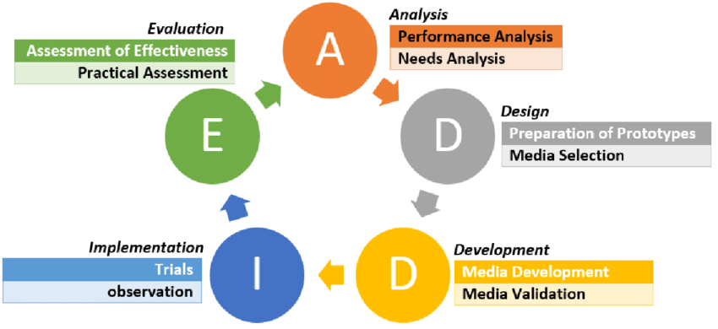
Figure 1. Research design
3.3. Subject, Object and Time of Research
The subjects in this research and study were students in grade 9 - 3 totaling 32 students at SMP NEGERI 2 PERBAUNGAN and research time. Research and development will be carried out at SMP NEGERI 2 PERBAUNGAN the implementation of the research is from beginning of - Nopember 2024

No | Activity | TIME
No | Activity | Januari 2024 |  |  |  | Pebruari 2024 |  |  |  | Maret 2024 |  |  |  | Juli-October  2024 |  |  |  | October –Desember  2024
No | Activity | I | II | III | IV | I | II | III | IV | I | II | III | IV | I | II | III | IV | I | II | III | IV
1 | Find title of research
2 | Proposal mentoring
3 | Proposal Seminar
4 | Research preparation, Study plan , and data collection
5 | Research analysis data
6 | Research mentoring
7 | Result Seminar

Table 3.1. Research Schedule

3.4.Development Research Procedures.
Analyze
Revision
Evaluation
implement
Design
Revision
Evaluation
Revision
Revision

Figure 2. Research Procedure
- Analysis
Based on observations made at SMP NEGERI 2 PERBAUNGAN by administering a questionnaire, the researcher believes that it is important to develop appropriate and interesting material so that students can easily master the material as well as additional material besides the existing material.
- Design
Researchers develop material that suits students' needs based on core competencies. Then appropriate teaching materials are given to students by making the material interesting because there are various pictures and colors.

- Development
At this stage, the material design results need to be revised and validated by experts. Researchers develop reading materials according to the research environment, because it can help researchers develop these materials. The product is a book that will motivate and increase students' interest in learning. This product is used for grade 9 students of SMP NEGERI 2 PPERBAUNGAN. Therefore, at this stage students study based on the design of the Advertising teaching material. Data is collected from experts using a closed item questionnaire which will be analyzed to find out whether the material is good and suitable for students. The product will be revised again. These revisions will be completed until the product is validated by experts and meets student needs. The expert team consists of two experts; they are one material expert and one design expert. The expert team will provide comments and suggestions through an open-ended item questionnaire.
- Implementation
The implementation stage is product testing. This means that the product that has been designed is implemented for users of the product. If revisions are still found, then revise them again until it becomes a good product. Users of this product are students
- Evaluation
Evaluation is an important process in this research. This is the completion of the stage. At this stage, action will be taken to improve product development and research. Evaluation results are used to provide feedback to model/method users. Revisions are carried out according to the new model/method.
3.5. Data Collection Instruments and Techniques
Questionnaire One of the data collection techniques in this research is a questionnaire. According to Sugiyono (2013, p 199), a questionnaire is a data collection technique that is carried out by giving statements to respondents to answer. It will be distributed to experts, teachers and students, which will be used to collect data on the suitability of the book, it will be filled in by experts, a questionnaire for teachers will be given before the learning process, and a student response questionnaire will be given after the learning process. The instrument, the results of data collection from the questionnaire, is a data collection instrument, namely (2008) as quoted by research participants. This is analyzed with various aspects of student attitudes. Aspects of student needs and interests will be considered in this research. Apart from choosing the appropriate answer, participants are also given the opportunity to provide comments and suggestions regarding the product.
Sugiyono's documentation (2013: 240) states that "Documents are records of events that have passed. Documents can be text, images, or someone's monumental work.” In this research, documentation is used to collect school data, such as curriculum, syllabus and worksheets.In developing advertising teaching materials based on various student learning styles using Canva Power Point, data collection techniques that can be used include:
      - Interview. To explore students' needs and preferences for learning media.Steps:Interview students to understand their learning style (visual, auditory, kinesthetic).Ask students about their experience in using tools such as Canva Power point.
      - Questionnaire. Its Objective To collect quantitative data on students' learning style preferences by Steps: Distribute a questionnaire related to learning styles (e.g. VAK Learning Styles Questionnaire). Include questions about experience using presentations or digital tools.
      - Observation.To observe how students interact with existing teaching materials.Steps : Observe how students understand and respond to the advertising materials in Power Point or Canva format. Document non-verbal responses, such as interest or confusion.
      - Literature Study.Collect references on learning styles and effective teaching methods by Steps: Review journals or articles on student learning styles. Study guidelines on using Canva to support learning.
      - Material Trial.To test the effectiveness of the developed teaching materials by Steps : Present the Canva Power Point adapted to various learning styles.Collect feedback from students on ease, appeal, and comprehension.
      - Focus Group Discussion (FGD).To discuss teaching material ideas with teachers, students or education experts by Steps: Engage the discussion participants to give feedback on the design of the teaching materials.Focus the discussion on visual, audio, and interactive elements in Canva.
With data from these various techniques, we can develop teaching materials that are engaging, interactive, and suited to the needs of students' learning styles. Canva Power Point can be utilised to display visual (images, graphics), auditory (narration, music), and kinesthetic (animation, interaction) elements.
3.6. Data analysis
Data analysis The development of advertising materials for students with different learning styles can be done with several approaches, especially using visual tools such as Power point Canva that have features that can be customised to suit various learning needs So to understand the data collected, the data is analyzed based on its characteristics and purpose. Subject responses to the questionnaire will be calculated in percentage form. The answer to each question score is based on a Likert scale (Ridwan & Sunarto, 2010, p.21).
The data collected was Questionnaire: Results of identification of students' learning styles (Visual, Auditory, Kinesthetic or VAK).Interview/Observation: Students' preferences regarding the format of teaching materials. Material Trial: Student responses to Canva Power Point teaching materials. Response to media: Evaluation of elements such as visual (images, colours), auditory (narration, audio), and interactivity (animation, hyperlinks).
Compare the effectiveness of Canva Power Point-based teaching materials for each learning style with Comprehension time: How long it takes students to understand the material using this method.Grade improvement: Student performance before and after using the teaching materials.As Example results: Visual learners: 80% of visual students understood the ad concept faster with contrasting images and colours.Auditory learners: Narration supports 60% of auditory students in remembering key points. Kinesthetic learners: 70% of kinesthetic students understand better through interactive elements.
Inference and Recommendation.The analysis results show Canva Power Point-based teaching materials was More effective for visual learners (pictures and infographics) and Needs additional audio or music for auditory learners.Add simulations or quizzes for kinesthetic learners. Combine visual, audio and interactive elements to reach all learning styles.Use customisable Canva templates to be engaging and flexible. With this analysis, teaching materials can be optimised to improve the understanding of advertising concepts in grade 9 students according to their learning styles.
3.7. Instruments for research.
Research instruments are tools used to measure observed phenomena or social events (Pratiwi, 2019). The instrument used in this research is data on interactive learning media needs which has been validated by media experts and content experts The first data collection instrument used :
            - Questionnaire or Survey where Purpose To gather data on students' learning styles of the advertising materials based Power point Canva , Content: Questions could include items about the effective and Format: Likert scale questions to gauge agreement levels on understanding, engagement, and relevance; open-ended questions for qualitative insights.
            - Observation .To observe how students interact with the advertising materials and identify any differences in engagement based on their learning styles.Content: Observational notes on students’ engagement, ease of navigation, interaction with content and Technique: Structured observation where specific behaviors (e.g., types of interaction with visual, auditory, and kinesthetic elements) are noted for further analysis.
            - Pre- and Post-Tests. To measure the effectiveness of the advertising material in terms of knowledge retention and understanding before and after using Canva or PowerPoint-based materials.
            - Interviews or Focus Group Discussions (FGD) has Purpose to gain in-depth insights into students' experiences with the advertising materials, understanding which elements appealed to different learning styles and Technique One-on-one interviews or focus groups for more nuanced feedback on how each learning style experienced the materials.
            - Document Analysis. To analyze any student-produced work or reflections related to the advertising materials, providing indirect insights into their understanding and application of content. With Technique: Using a rubric to evaluate aspects like accuracy, creativity, and relevance to key advertising concepts and the last 6.Learning Analytics (if available) To collect data on how long students interact with specific elements in Canva or PowerPoint materials, which can help identify which parts of the material are most engaging or challenging and Technique: Analysis of digital usage data, if the learning platform or tools (like Canva Pro or advanced PowerPoint analytics) provide this feature.
Therefore, researchers conducted a needs analysis for students at SMP Negeri 2 Perbaungan. The content validity sheet used in this study is an assessment sheet regarding learning design, content, language and communication. Validity of Canva Power point-based learning media on Android used in this study. The research concerns aspects of usefulness, functional aspects, text quality aspects, image quality aspects, design quality aspects, and the use of words or language.
Here is an example of an advertising pre-test for writing skills, designed to identify the early potential of grade 9 students based on their learning styles (Visual, Auditory, Kinesthetic).
Pre Test Advertisment Writing
Pre Test Advertisment
No | Visual Learning Style | Auditory learning style | Kinesthetic Learning Styles
1 | Write a suitable advertising text for this product.  Create a slogan that is short, catchy and memorable.  State the main benefits of the product in two sentences.  Visual Support: Include pictures of the product such as sports shoes, snacks, or gadgets.  Sample Answer:  Slogan: ‘Go Further in Style!’ ’These trainers are lightweight, comfortable and suitable for any activity.’ | Listen to an audio description of a new product (e.g. sports shoes, snacks, or gadgets.).  Write a 30-second radio advert script for the product.  Include at least three product advantages in text.  Audio Support: Provide an audio description (short narration) that can be played in class. such as sports shoes, snacks, or gadgets.  Sample Answer:  Slogan: ‘Go Further in Style!’ ’These trainers are lightweight, comfortable and suitable for any activity.’ | Instructions: Observe the product packaging around you (e.g. sports shoes, snacks, or gadgets.)  Write down an advertising design idea that can be placed on the product packaging.  Create one promotional sentence that is suitable to be printed on the front of the packaging.  Write down who the target market of the product is.  Interactive Support: Bring real packaging to class for students to hold and observe.  Target Market: ‘Active teenagers and young adults who love Sport shoes, Snack or Gadgets.’

Combined Test (All Learning Styles) .Instructions: Create an advert for a new product, for example: ‘Sports shoes, snacks and smart mobile phones’. Choose one of the following ways: (Visual) Create an attractive advertising text for a poster. (Auditory) Write a persuasive radio advert script and (Kinesthetic) Write down the idea of the advert to be displayed on the product packaging.
Pre – Test Assessment Criteria
 | Assessment Criteria
1 |  | Creativity | (30%): Unique and fresh ideas in ad writing.
2 |  | Appropriateness | (30%): Content is appropriate to the learning style and context of the product.
3 |  | Language | (20%): Interesting, persuasive, and easy-to-understand language
4 |  | Structure | (20%): Clear, logical, and effective sentence structure

This test accommodates the variety of learning styles of grade 9 students, encourages creativity, and trains writing skills with an advertising approach.
Total Skor Maksimum: 100

Rating Scale
- 1 = Deficient( - 78 )
- 2 = Fair (78-83 )
- 3 = Good ( 84 – 89 )
- 4 = Very Good ( 90 – 100 )
Post Test Advertisment Writing
Post Test Advertisment
No | Visual Learning Style | Auditory learning style | Kinesthetic Learning Styles
 | Write a suitable advertising text for this product.  Create a slogan that is short, catchy and memorable.  State the main benefits of the product in two sentences.  Visual Support: Include pictures of the product such as sports shoes, snacks, or gadgets.  Sample Answer:Slogan: ‘Go Further in Style!’ ’These trainers are lightweight, comfortable and suitable for any activity.’ | Listen to an audio description of a new product (e.g. sports shoes, snacks, or gadgets.).  Write a 30-second radio advert script for the product.  Include at least three product advantages in text.  Audio Support: Provide an audio description (short narration) that can be played in class. such as sports shoes, snacks, or gadgets.  Sample Answer:Slogan: ‘Go Further in Style!’ ’These trainers are lightweight, comfortable and suitable for any activity.’ | Instructions: Observe the product packaging around you (e.g. sports shoes, snacks, or gadgets.)  Write down an advertising design idea that can be placed on the product packaging.  Create one promotional sentence that is suitable to be printed on the front of the packaging.  Write down who the target market of the product is.  Interactive Support: Bring real packaging to class for students to hold and observe.  Target Market: ‘Active teenagers and young adults who love Sport shoes, Snack or Gadgets.’

Combined Test (All Learning Styles) Instructions: Make an advert for a new product, for example: ‘Sports shoes, snacks and smart phones’. Choose one of the following ways: (Visual) Write a compelling ad text for a poster, (Auditory) Write a persuasive radio ad script, and (Kinesthetic) Write an ad idea that will be displayed on the product packaging using Canva Power point and present it in front of the class individually or in groups.

Post-Test Assessment Rubric
Kriteria | Deskripsi | Maximum score
Creativity | Unique, innovative, and interesting ideas in the ad text | 25
Content Alignment | Conformity of the ad text with the product purpose, learning style, and Canva Power Point design elements. | 20
Language and Grammar | Use of persuasive, clear, and effective language; no spelling/grammar errors. | 20
Writing Structure | Logical sentence structure, easy to understand, and appropriate for the chosen advert format. | 15
Media Utilisation | Utilisation of design elements from Canva Power Point such as images, audio, or real product simulations. | 20

Total Skor Maksimum: 100Rating Scale
- 1. Poor : If Score < 50
- 2. Deficient : If Score < 78
- 3. Fair : If Score 78 – 83
- 4. Good : If Score 84 – 89
- 5. Very Good : If score 90 – 100
Presentation Assessment Rubric
Aspek Penilaian | Assessment Criteria | Skor  (1-4)
1. Presentation Content | - Information is relevant and appropriate to the topic.
1. Presentation Content | - Data/facts are presented accurately
1. Presentation Content | - Material is organised systematically (introduction, body, conclusion).
2. Material Delivery | - Use of clear, straightforward, and easy-to-understand language.
2. Material Delivery | - Effective tone of voice and intonation.
2. Material Delivery | - Speech speed is appropriate (not too fast/slow).
3. Use of Media | - Supporting media (slides, videos, etc.) are relevant and interesting.
3. Use of Media | - Slides are neat and not too much text.
3. Use of Media | - Visualisations (pictures, graphs) support the material.
4. Audience Engagement | Ability to answer questions from the audience.
4. Audience Engagement | - Good interaction with audience (eye contact, invitation to discussion).
4. Audience Engagement | - Respect for the audience (not patronising).
5. Appearance and Attitude | - Confident and professional
5. Appearance and Attitude | - Body language supports the presentation.
5. Appearance and Attitude | - Respect for the audience (not patronising).

Rating Scale
- 1 = Deficient
- 2 = Fair
- 3 = Good
- 4 = Very Good

This pre-test gives insight into students' foundational understanding of advertising concepts like purpose, target audience, media channels, and features of effective ads. The results will help instructors tailor the Canva and PowerPoint materials based on areas where students may need more guidance.
- Data from needs analysis
The first questionnaire is used to obtain a needs analysis from students. It is analyzed into a percentage. This percentage is obtained from dividing the frequency by the number of respondents multiplied by 100%. The formula is
shown as follows:

Percentage (%) = fx ( 100 )
N
P = Percentage
F = frequency
N = number of participants
100% = fixed number
- Data from expert assessments
The second question questionnaire was ale is used as a questionnaire measuring tool in evaluating the material developedused to obtain data from experts to revise the material developed. The Likert sc. The data obtained from this questionnaire was analyzed using the formula proposed by Suharto (2005: 52-53) as follows :

R = Xh - Xi 4
R = Range
Xh = Highest score
Xi = Lowest score
4 = Likert Scale range
Then, the data results were converted into descriptive analysis which had good benefits as stated by Suharto (2006:52-53). The indicator measured is Mean (X). The average is calculated using the data conversion formula below :

Mn = ∑ fX N

M N = means
∑ fx = total score
N = number of cases
Scale | Hose | Category
1 | 0 % - 2 % | Very Low
2 | 21 % - 40 % | Low
3 | 41 % - 60 % | Sufficient
4 | 61 % - 80 % | High
5 | 81 % - 100 % | Very High

3.8. Data Analyzing Techniques
Data collection was obtained based on primary and secondary data. Primary data was obtained by interviews, online questionnaires related to student needs and questionnaires related to product validity, while secondary data was obtained by case studies.
- Interview
Interviews can be conducted by researchers for two weeks with the resource person being a junior high school English teacher. The main topics relate to the information researched in English writing materials. The results of teacher interviews can be analyzed so that the product developed has the right purpose. The composition of the questionnaire for expert assessment is shown below:

NO | Question aspect | The purpose of the question | Reference
1. | Contents | Evaluate the first draft of interactive multimedia in terms of the suitability of the material | BNSP
2. | Language | To evaluate the first draft of interactive multimedia in terms of language suitability. | BNSP
3. | Presentation | Evaluate the first draft of interactive multimedia in terms of the presentation of the material | BNSP  Alessi & Trolip (2001: 60-62)
4. | Screen display | Evaluate the first design of interactive multimedia in terms of suitability of the screen display. | Alessi & Trolip (2001:60-77)
5. | Multimedia elements | Evaluate the first draft of interactive multimedia in terms of the suitability of its elements | Alessi & Trolip  (2001:62-68)
6. | Navigation  knob | To evaluate the interactive first draft of the suitability of the button | Alessi & Trolip (2001:53-54)
7. | Input | To evaluate the first draft of interactive multimedia in terms of its suitability for feedback. | Alessi & Trolip  (2001)

3.9. Needs analysis questionnaire.
Data collection was carried out to determine the analysis of students' needs regarding English reading and writing materials in teaching and learning activities. Questions will be made through a questionnaire. The subjects of the questionnaire were English teachers. Data results can be analyzed as an addition to product development guidelines. The structure of the questionnaire for needs analysis is shown below:
NO | Question aspect | The purpose of the question | Reference
1. | Need | To find out students' needs related to the material | Hutchinson & Waters (1987 : 55)
2. | Lack | To find out students' shortcomings regarding the material. | Hutchinson & Waters (1987: 55 - 56)
3. | want to | To find out students' desires regarding the material. | Hutchinson & Waters (1987 : 56)
Learning needs
4. | Enter | To find out students' preferences for input types | Nunan (2004 : 47-52)
5. | Design | To find out students' preferences for multimedia design | Alessi & Trolip (2001 : 53-54; 68-77)
6. | Procedure | To find out students' preferences for learning activities | Nunan (2004: 52-56)
7. | The role of the teacher | To find out students' preferences regarding the role of the teacher | Nunan (2004 : 64-70)
8. | Arrangement | To find out student preferences related to learning settings | Nunan (2004: 70-73)

The final primary data collection was a product validity test questionnaire. This helps researchers to see the advantages and disadvantages of the creator's designed Canva Power Point-based learning media product. Questionnaires were distributed to teachers and experts. The validator's job is to provide assessments and corrections and then provide suggestions or comments to revise the English writing material based on the smart application the creator has designed.
The data analysis technique for this research was analyzed using descriptive techniques. The following steps are taken to follow the descriptive technique:
- Stage 1. Evaluation and Needs Analysis
Before learning materials are developed and designed, there are two main activities in this stage, namely first, evaluation of the phenomena in the learning materials and second, needs analysis. Evaluation is carried out to determine the reality and existing conditions of learning materials and a needs analysis is carried out to determine the need for learning materials. The instruments used to collect data were questionnaires, documentation sheets and interviews. The data was analyzed descriptively.
The evaluation stage was carried out to determine the continuity of the teaching and learning process at SMP Negeri 2 Tanjungpura in real terms. Including the existing syllabus and existing English writing material for junior high schools. Data were analyzed using descriptive techniques.
The needs analysis stage is carried out after the evaluation. After the evaluation process is complete and the existing data is available, a needs analysis is then carried out to find out what English writing materials for junior high school students and teachers are needed. At this stage the data sources are students and teachers. Data collection was carried out using documentation sheets, questionnaires and interviews, then the data was analyzed using descriptive techniques.
- Phase 2. Syllabus Development
Before the English writing material for junior high school is designed and developed, the syllabus of the material is first designed and developed with the theory in the Cognitive Relevance principle, namely that the human mind is naturally oriented to seek relevant information where the relevance of information is measured by how much cognitive impact it produces (such as providing new insights or improving understanding) compared to the effort required to process the information.
On the other hand, we must understand the Principle of Relevance Communication In communication, the speaker or writer tries to convey the message in a way that is considered most relevant to the audience. This means that the message is designed to provide maximum benefits (cognitive effects) with the processing effort that is applied in the context of designing advertising learning materials by ( Byrne, B. 2004 occasion paper 31).
The development of the syllabus is truly based on the results of the evaluation and needs analysis. This process truly bridges the creation and production of a syllabus that is relevant to the material that is designed and developed. The syllabus that is designed and developed contains the topic/theme of the English writing material for grade IX.
- Stage 3. Developing and Designing Learning Materials.
In principle, the following stages are carried out in order to develop and design English writing materials for junior high school students:
- Stage I: Identification of material topics and adjustments and matching with the syllabus, student needs, learning guidelines and teachers.
- Stage II: Preparation. The development of English writing materials for junior high school students is prepared in line with Canva Power point.

CHAPTER IV
FINDING AND DISSCUSSION
4. Finding
4.1 Developing advertisement Material
The development of teaching materials, as a follow-up to the design that has been carried out. The learning tools developed in this research are based teaching materials. Teaching materials developed at this stage will be evaluated by expert lecturers. The structure or framework chosen in the development of teaching materials should be simple and appropriate to the needs. After everything is finished, to get a valid and good teaching material, the researcher gives teaching materials to experts so that they are validated. The purpose of the development stage is to produce a product that has been revised based on input from the validator.
Figure 3.The old material advertisment
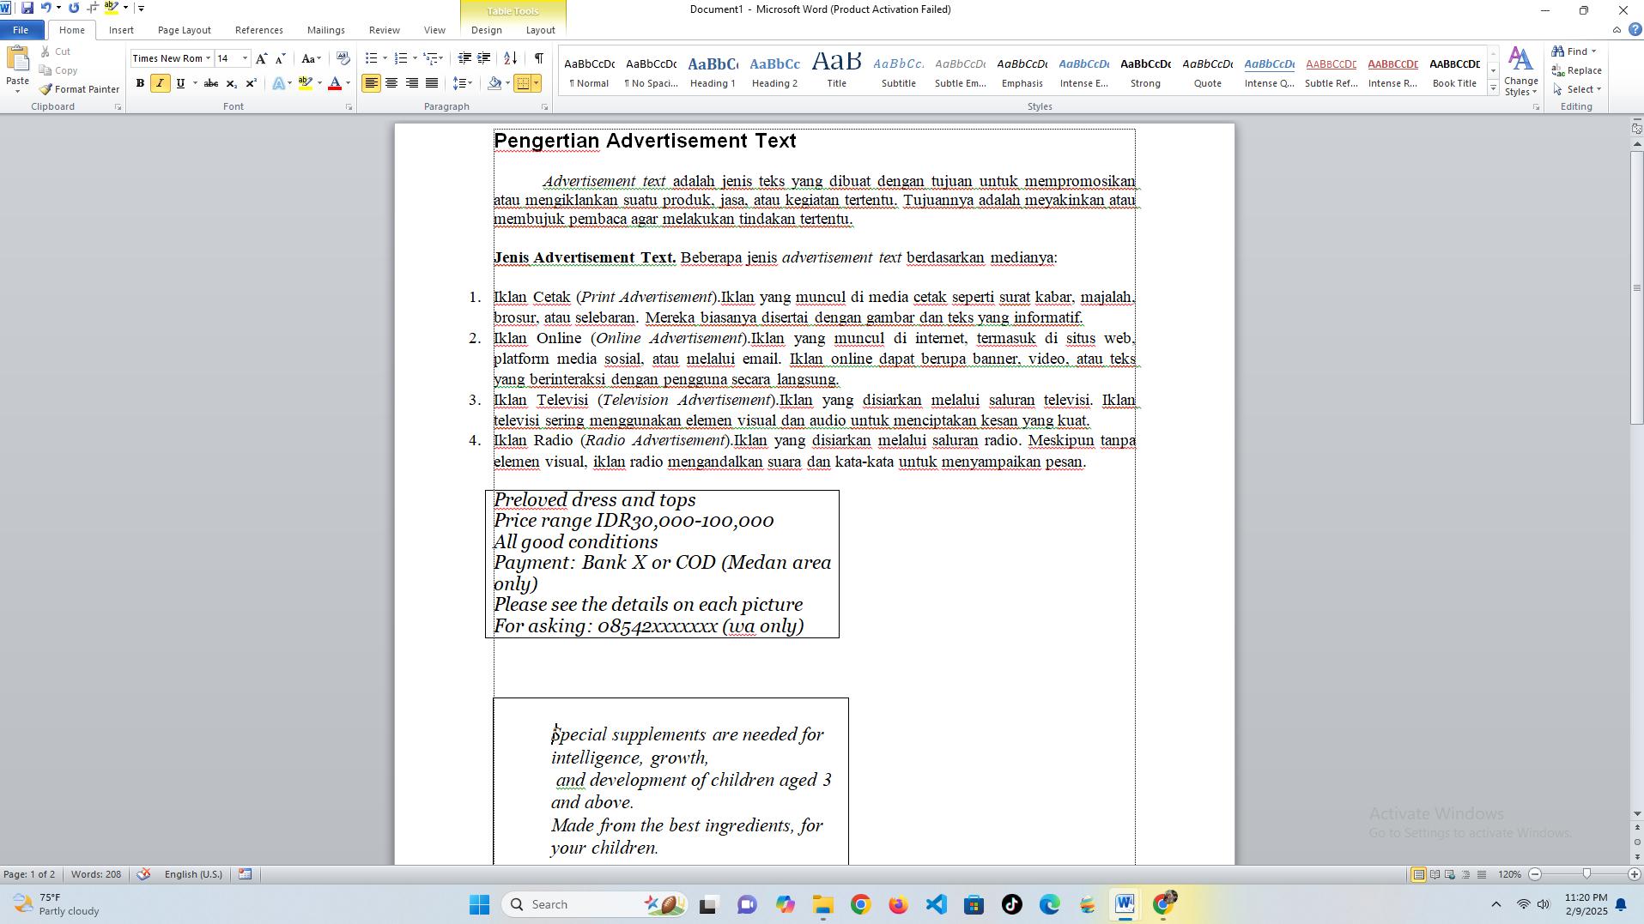

Figure 4.The material advertisement Test
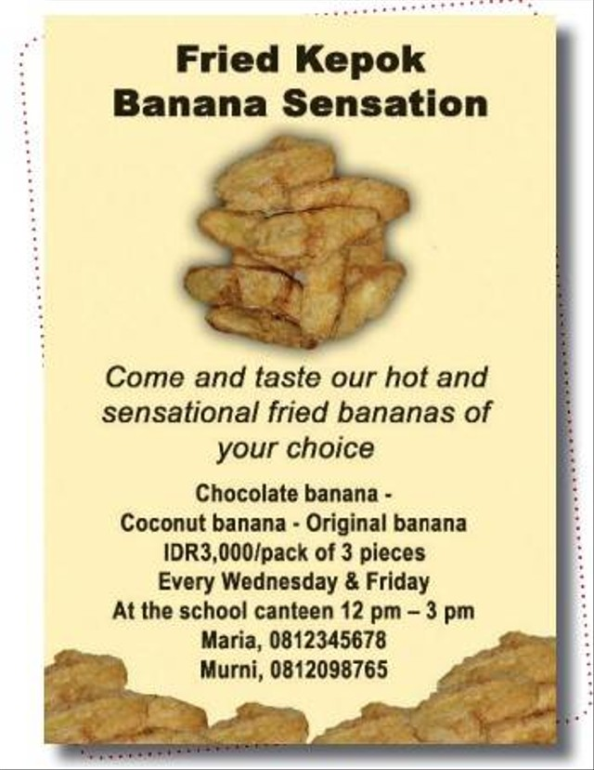
1. What is the purpose of the text?
a. To persuade the readers to buy fried kapok banana.
b. To inform the readers about banana.
c. To announce the readers about Maria and Murni.
d. To inform the readers to buy fried kepok.
The old advertisment material always about reading text and answer based of the the text. Many teachers teach advertisment material by reading skill and it almost never to teach with writing
Figure 5.Developing advertisment Material by You tobe
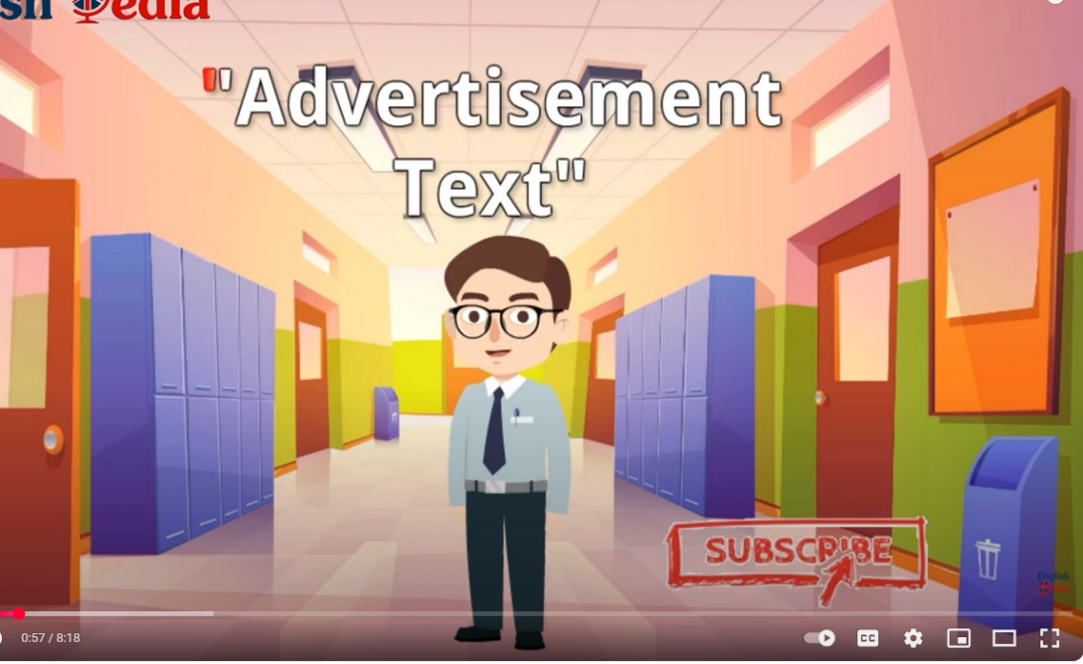
Figure 6.The Developing of material advertisment
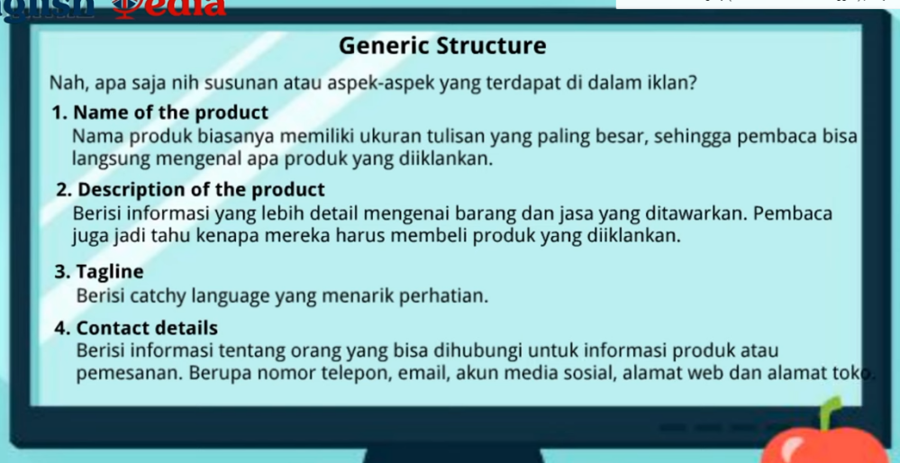
The explanation generic struture of advertising material is collaborated with Indonesian so that It can be understood by students clearly.
Figure 7.The Developing of material advertisement from Generic Structure
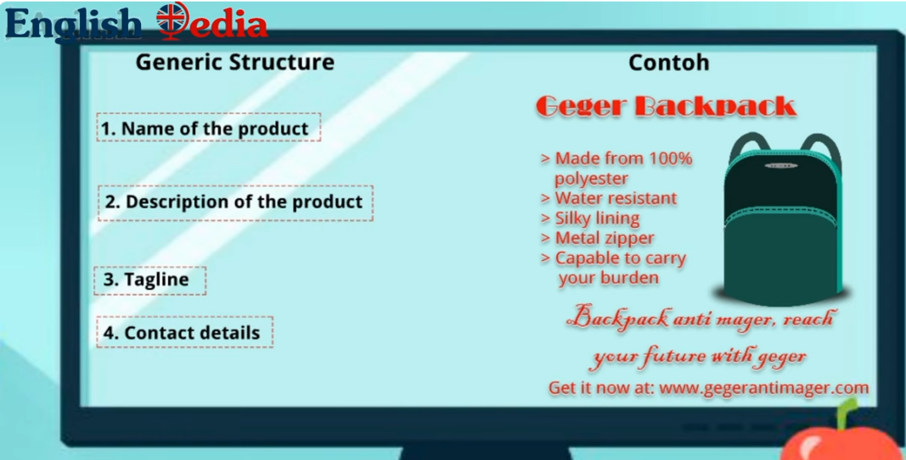
Explanation Generic Structure and example a product by picture
Figure 8.The Developing of material advertisement
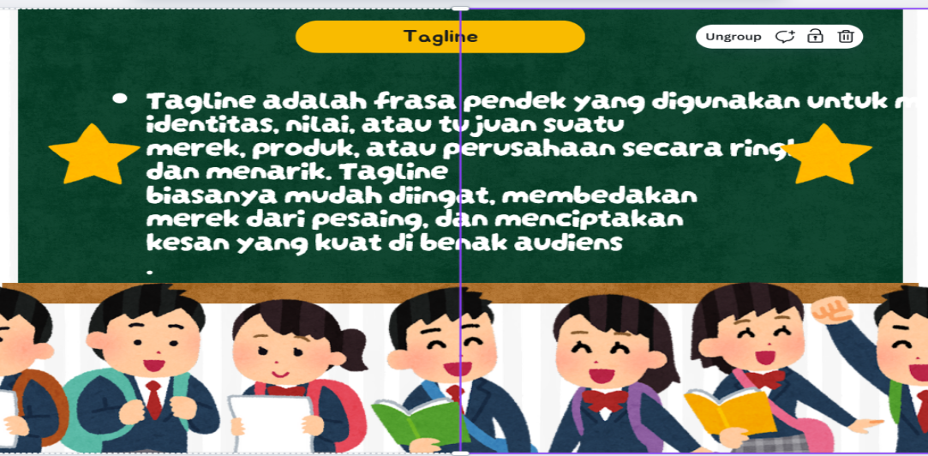
A tagline is a short phrase used to convey the identity, values, or purpose of a brand, product, or company in a concise and compelling manner.
Figure 9. the Developing of material advertisement from Generic Structure
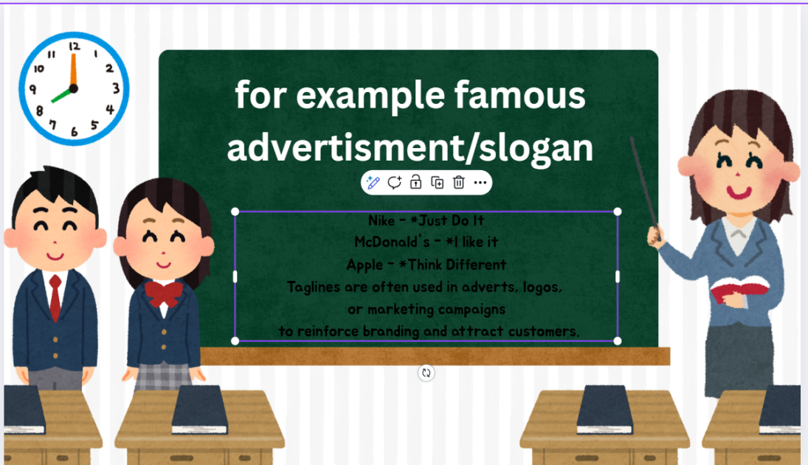
The words or sentences are used in advertisement by Power point Canva
Figure 10. The Developing of material advertisement from Generic Structure
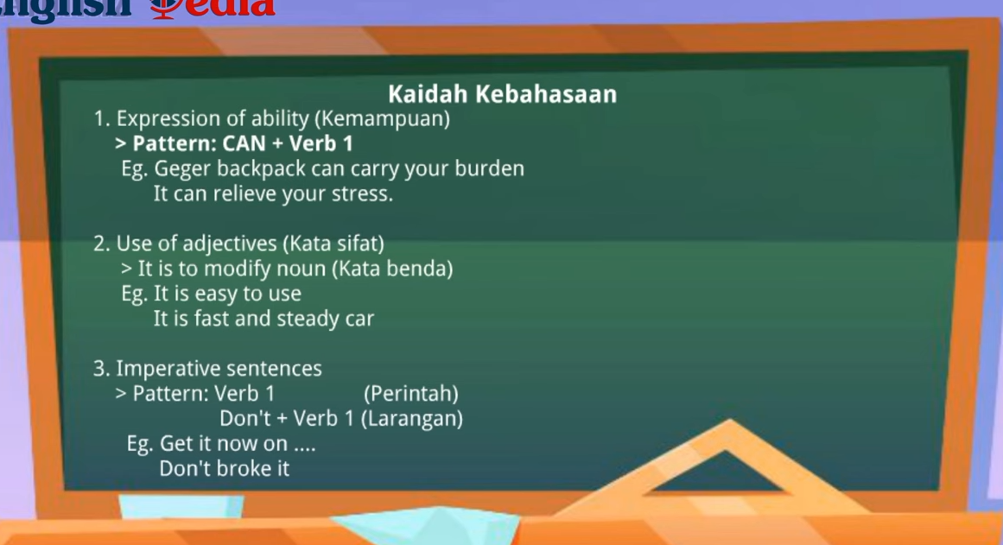
The learners also need to understand the linguistic rules in writing advertisements.
Figure 11.The Developing of material advertisement from Generic Structure
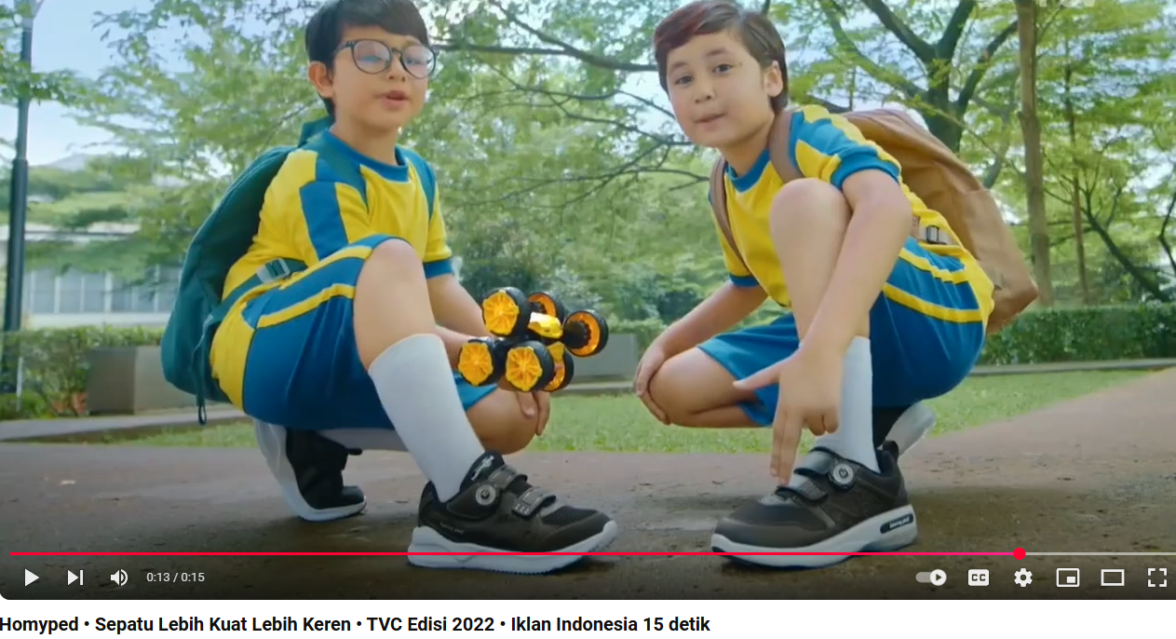
Developing advertising material based need of students and things are interesting and favoured by children in class IX. Giving many Example advertisiments
Simple Advertisment
Figure 12.The Developing of material advertisemen
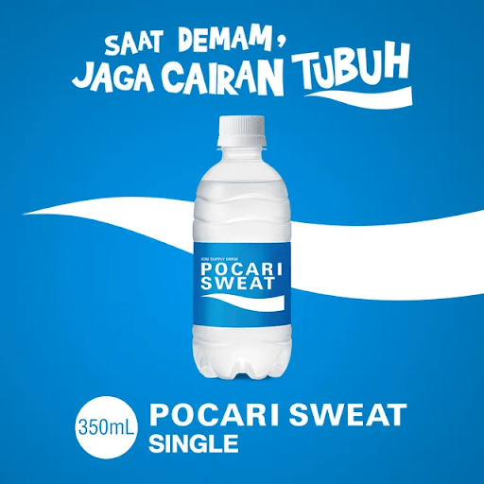
Interisting adverisment
Figure 13.The Developing of material advertisement
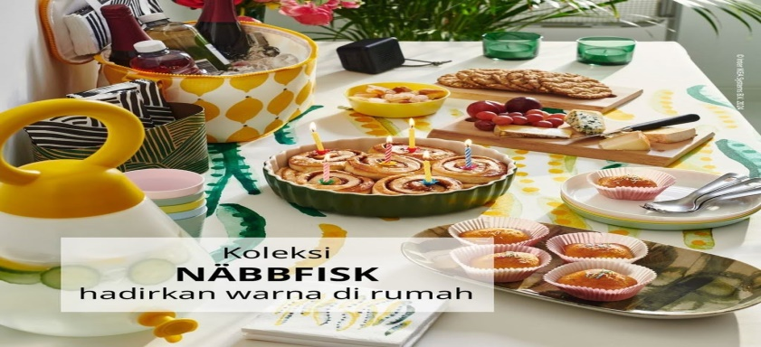

Public Service Advertisement

Figure 14.The Developing of material advertisement
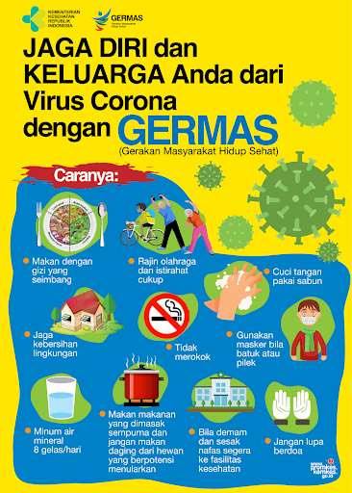

The Example of Column Advertisment

Figure 15.The Developing of material advertisement

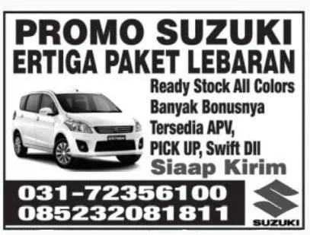

Provide many examples of advertising to students can open students' minds to be more imaginative in making a reminiscent advertisement that they like.

Figure 16.The Developing of material advertisement

Example of Display Advertising
4.1.1 Media Expert
The assessment by media design experts aims to determine the feasibility of based English teaching materials in terms of media design. Media design experts give an assessment according to the media design expert grid. In the preparation of teaching materials, it is necessary for authors to master design skills, so that the physical appearance of teaching English materials will be able to arouse students' motivation in writing and studying them.

Figure 17.The Developing of material advertisement from Generic Structure Using Vidio of a Product by Power point Canva


Figure 18.The Developing of materia


Example of a Print Media Advertisement
4.1.2. Material Substance
The validation of the English advertisement material in this teaching material is intended to be able to see the feasibility of the material in the developed teaching material. The material substance expert assessment includes three aspects, namely, content feasibility aspects, presentation feasibility aspects and linguistic aspects.
- Conten feasibility aspect is Assess whether the content of the advert is fit for purpose, accurate, relevant, and does not scatter the audience. This includes clarity of message, truthfulness of information, and alignment with prevailing values and norms.
- Presentation feasibility aspects are Presentation feasibility aspects include: Layout and Visual Design by looking at the composition of advertising elements (text, images, colours, and graphics) must be balanced, harmonious and the use of illustrations or photos must be relevant to the message to be conveyed. for Visuals must be of high quality and not blurry or broken. Advertising materials must have uniqueness so as not to be boring and Presentation of messages can use storytelling or interesting surprise elements.
- The linguistic aspect of being able to use correct grammar according to the rules of English by using a familiar or persuasive language style according to the context of the advert. Effectiveness in Communication Sentences should be short, concise, and clear to be easily digested in a short time,Use words that have an emotional impact according to the purpose of the advert.
Figure 19. Example of Non Commercial advertisement
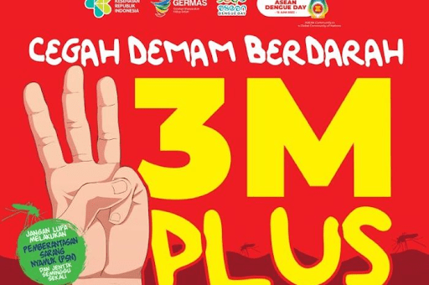

Figure 20.Example of a Commercial Advertisement

4.1.3 Implementation Stage.
The first step for the Canva power point application in making or creating simple adverts according to the learners' wishes.

Figure 21. The First Step to Writing Advertisement by Canva
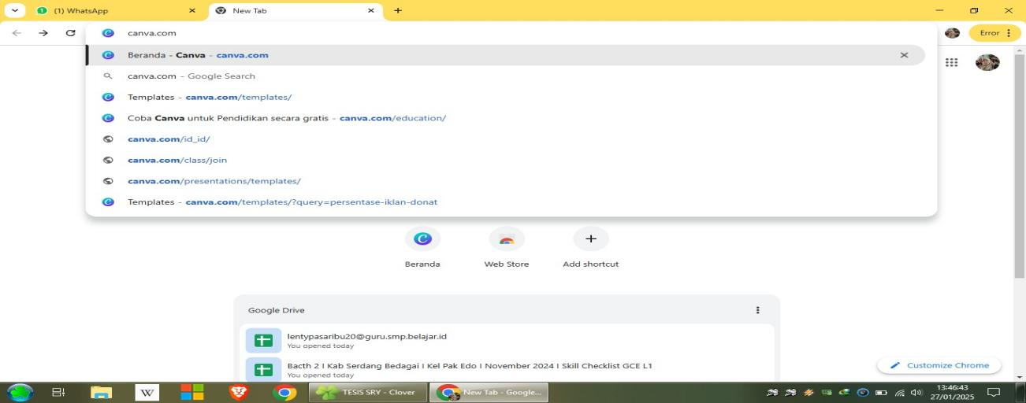
Figure 22.The Second Step, The students can be choice a picture in Canva
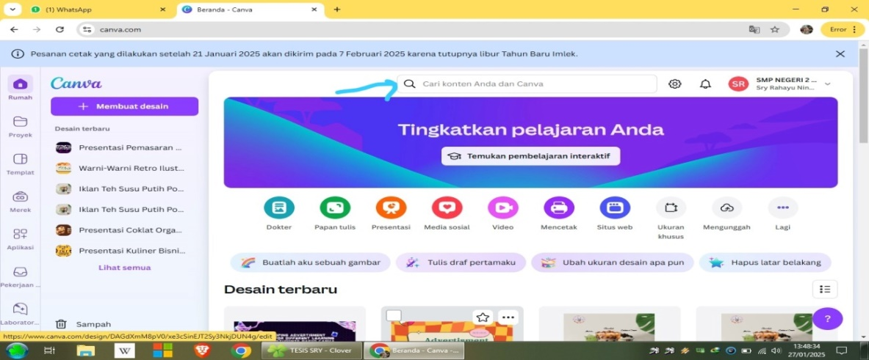
Figure 23.The Third step, after choice a picture and write a sentence with Text
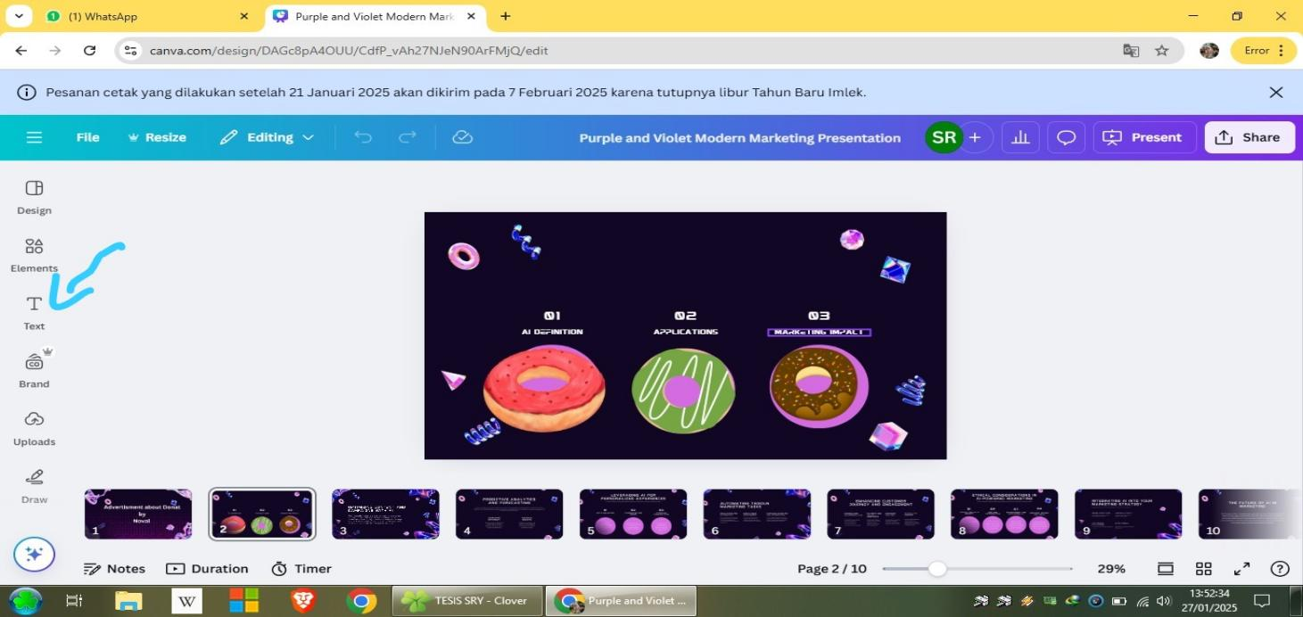
Figure 24.The Third step, after choice a picture and write a sentence with Text
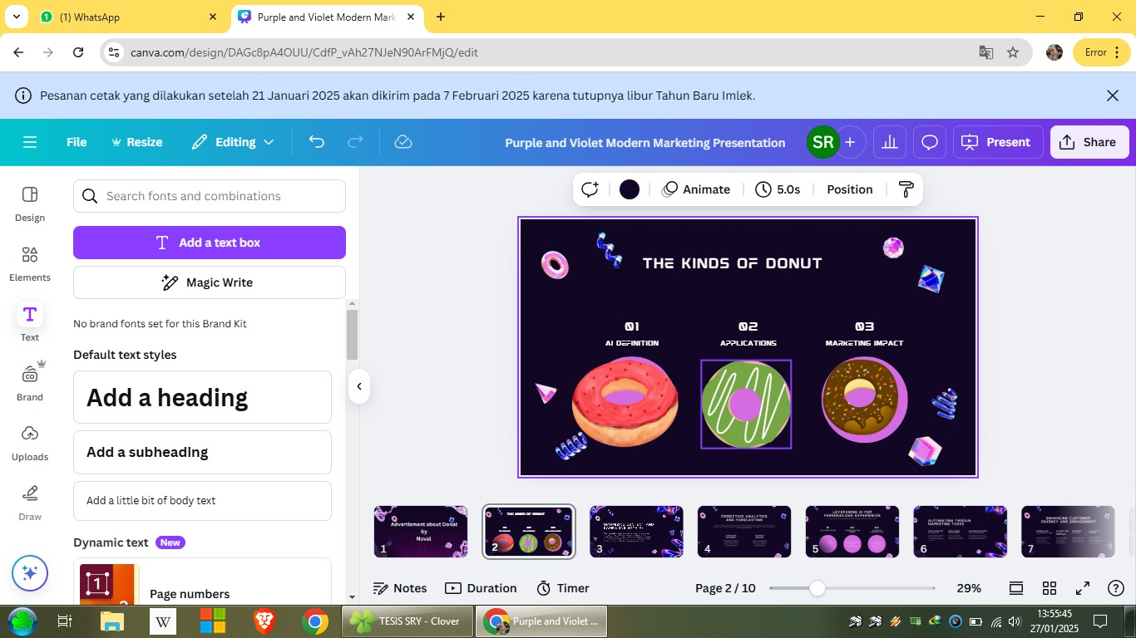
Figure 25. The fourth step, The students write a product and elements
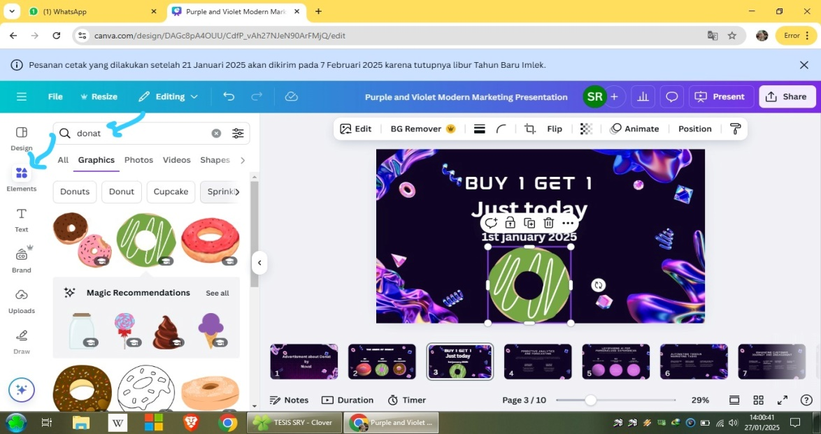
Figure 26.The result of Canva Power point cab be download and share to wa group to presentation.
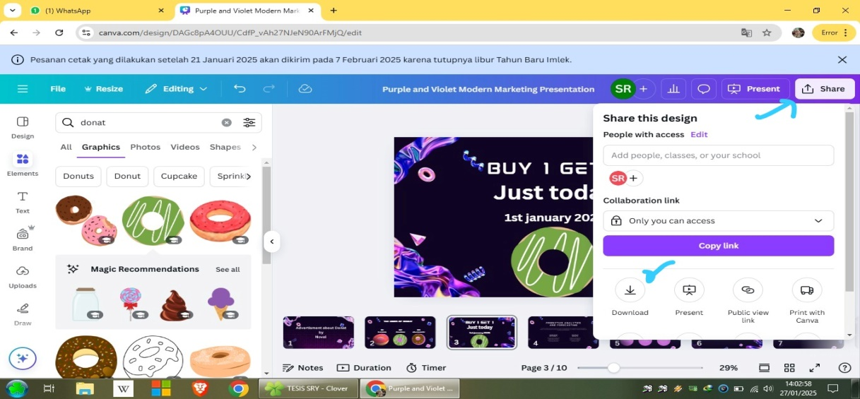
Figure 27.The way to download it is to press the top corner, there is a share text, then press download you can choose the file type according to your worksheet
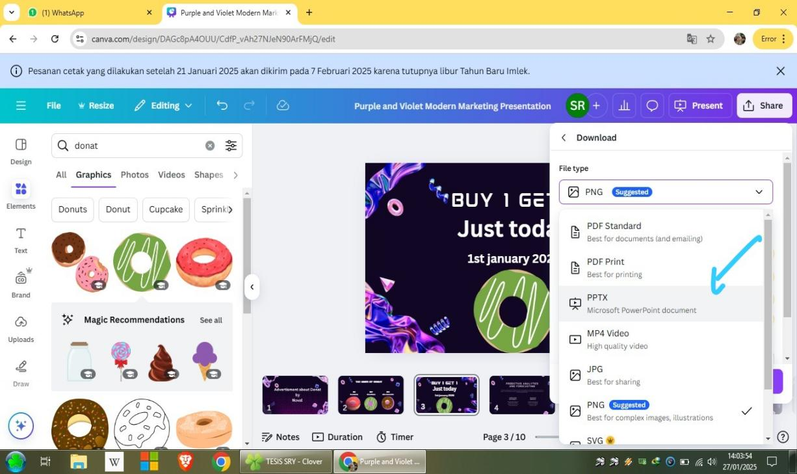

Figure 28.The after choice a picture and write a sentence with Text
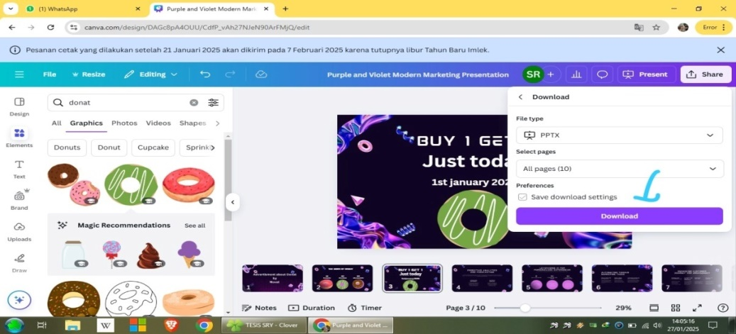
Finally just press download
4.2. Expert Validation Results
After validating the English Advertisment Material, the process is carried out tests on students Ninth Grade at SMP Negeri 2 Perbaungan. The researcher gave test to know the practicalities of English Advertisment Writing materials. While, in developing English Advertisment Writing materials the researcher used ADDIE model. Researcher was consisted of five phases that include analysis, design, development, implementation, and evaluation.
4.2.1. Analysis
Analysis In analysis step, the researcher analyzed students' needs and students' interest. Students' needs was analyzed through syllabus that is managed by Freedom Curriculum (Kurikulum merdeka ). Besides, the researcher also analyzed the Worksheet that students used in learning English. While, students' interest was analyzed by identifying the students' interest by giving the questionnares.
The needs analysis included the syllabus and students' needs. Firstly, the analysis of the syllabus of junior high school grade IX students should learn to write about the type of advertisement they choose. In the competency standards and basic competencies, students are expected to be able to write simple and interesting Advertising sentences with the display of using Canva Power point as a student presentation where student achievement is measured by indicators. Secondly, students‘ needs are analysed by identifying students’ needs, interests and performance. In terms of performance context, there are two meetings in a week, it takes 80 minutes for each meeting.
The standard competence and basic competences for The Ninth grade students can be seen in appendix.
1). The result of qoustionaire for the Nineth grade students the questionnaire consisted of 15 questions with four answers.
A). goal
Table 4.1 The Questions Number 9 and 10
NO | QUESTION | ITEM | N | PERCENTAGE
9 | In your opinion, how is the learning process of English Advertising especially writing skills in the classroom. | a. very interesting | 14 | 46.7%
9 |  | b. Less intersting | 2 | 3%
9 |  | c. Not interesting | 16 | 50%
9 |  | d. Very not intersting | 0 | 0%
10 | How important do you think it is to be able to write advertising in English? | a. Very important | 19 | 60%
10 |  | b. Quiet important | 4 | 10%
10 |  | c. Less important | 9 | 30%
10 |  | d. Not important | 0 | 0%

Questions 9 and 10 aimed to seek information about students' opinions and interest in classroom learning activities, especially writing in advertising English. Based on the results of the questionnaire on question number 9 (50%) of students thought that writing activities in class were less interesting to them. This is because in the teaching and learning process, they only use English reading materials and explanations from teachers that are less interesting to them. In question number 10, most students said that learning to write advertising is very important in English. This means that students need writing activities to improve their English material in advertising material in an interesting activity with different learning styles of students based on Canva Power Point.

B). Necessities
Table 4.2. The question Number 4,8, and 12
NO | QUESTION | ITEM | N | PERCENTAGE
4 | In your opinion , in addition to teaching materials / learning resources that are currently used in learning English , especially English Advertisment , is there still needed additional material to support English Advertisment Writing | a. very Needed | 24 | 80%
4 |  | b. Less Needed | 1 | 0,3%
4 |  | c. Not Needed | 5 | 16,7%
4 |  | d. Very not Needed | 0 | 0%
8 | Is understanding of the kind advertisement very necessary before understand in writing with student choice | a. Very necessary | 10 | 27%
8 |  | b. Necessary | 6 | 20%
8 |  | c. Less Necessary | 15 | 50%
8 |  | d. Unnecessary | 1 | 0,3%
12 | Do you think it is necessary to provide understanding and example images of writing interesting short advertisement sentences using canva Power point? | a. Verry necessary | 12 | 40%
12 |  | b. Necessary | 9 | 30%
12 |  | c. Less necessary | 9 | 30 %
12 |  | d.unnecessary | 0 | 0%

Questions 4, 8 and 12 aimed to find out students' needs for materials. In question number 4 (86.7%) students said that they need additional materials in learning English about advertisements. While in question number 8 and 12 most of the students said that types of advertising, providing examples of advertising images along with short sentences of canva Power point-based advertisements are important in learning English. This shows that they need more canva in making advertisements with Power point for their presentation as an understanding of the material. And English advertisement teaching materials are in written form so students are lazy to write short advertisements, they think the materials they use now are not interesting to them.
C). Wants
Table 4.3. The question Number 5,6,7 and 15
NO | QUESTION | ITEM | N | PERCENTAGE
5 | What kind advertisement writing materials do you want in learning English ? | a. picture | 12 | 40%
5 |  | b. short story / functional text | 7 | 16 %
5 |  | c. advertisement vidios | 13 | 44 %
5 |  | d. games | 0 | 0%
6 | What kind of advertisement task do you want in learning writing ? | a. multiple choices | 18 | 60%
6 |  | b. essay | 6 | 20%
6 |  | c. fill in the blank text | 0 | 0%
6 |  | d. answer based on picture | 6 | 20%
7 | What capacity building do you expect from learning English, especially in advertising? | a. To be able to add new vocabulary in advertising texts | 12 | 36,7%
7 |  | b. To be able to write short and interesting advertisement sentences well | 7 | 23,33%
7 |  | c. To be able to write short and interesting advertisement sentences well | 1 | 0,3 %
7 |  | d.To be able to comprehend the text and anwer questions correctly | 12 | 36,7%
15 | What kind of learning do you like | a. Individually | 3 | 10%
15 | What kind of learning do you like | b. In pair | 23 | 70%
15 | What kind of learning do you like | c. In group | 6 | 10%
15 | What kind of learning do you like | d. Whole class | 3 | 10%

The purpose of this questionnaire was to find out the students' desire to learn English especially in writing advertisements. In questions 5, 6, 7, and 15, there were no significantly different answers in each question. In questions 5, and 6, it was clear that the students liked English materials combined with lots of pictures, advertising videos, listening to dialogues. They also preferred to do multiple-choice tasks, although there was no significant difference between the 4 options. However, the researcher made the tasks in the English writing materials not only focused on multiple choice so that the tasks designed by the researcher still had varied exercises although most of them were in multiple choice form.
Based on the answers to questions number 7 and 15, there was no significant difference between the 4 answer choices, but most of the students hoped that they would like to be able to create short advertisements in the form of written text, images, videos, and podcasts using Canva powerpoints according to the type of text they want by linking project learning which is to produce products and market them in the school and residential environment with friends, teachers, neighbours, or the general public in traditional and modern ways such as social media. they prefer to work in pairs, and groups.
D). Topic
Table 4.4. The question Number 11
NO | QUESTION | ITEM | N | PERCENTAGE
11 | In your opinion , what topics of do you like in learning English advertisement , especially writing | a. Daily Life  ( family, school life , and community, etc) | 25 | 76,7%
11 |  | b. Health | 1 | 13,33%
11 |  | c. Nature | 6 | 6,7%
11 |  | d. Economics And socioculture | 0 | 0%

The purpose of this question was to find the information about the students' preference for the topic of advertisement materials. Based on xl the table above, there is 60% students' choose daily life topic. It was present in the English advertisment writing material, because the material was designed by the researcher related to daily life.

E). Material
Table 4.5. The question Number 1,2.3 and 14
NO | QUESTION | ITEM | N | PERCENTAGE
1 | Are teaching advertisement materials / learning resources used in writing in the classroom interesting ? | a. very  interesting | 12 | 40%
1 |  | b. Less  interesting | 4 | 13,33%
1 |  | c. Not interesting | 16 | 46,7%
1 |  | d. Very not improving reading ability | 0 | 0%
2 | Have the teaching advertisement materials / learning resources currently used in Writing in the classroom improving your Writing ability | a. Very improving reading ability | 19 | 63%
2 |  | b. Quite improving reading ability | 11 | 36,7%
2 |  | c. Not impoving eading ability yet | 0 | 0%
2 |  | d. Not improving reading ability | 0 | 0%
3 | What capacity building do you expect form learning English especially in advertisement writing to different learning style students | a. To be able to improve vocabulary | 2 | 6,7%
3 |  | b. To be able to read well and correctly | 8 | 26,7%
3 |  | c. To be able to use the language used in text in daily activity | 22 | 66,7%
3 |  | d. To be able to comprehend the text and answer questions correctly | 0 | 0%
14. | Is the teaching materials / learning resources that are how used in English ressons especially sufficient your advertisment writing needs ? | a. Very sufficient | 25 | 76,7%
14. |  | b. sufficient | 1 | 3%
14. |  | c. Less sufficient | 6 | 20%
14. |  | d. Not sufficient | 0 | 0%

The purpose of these questions were to find out the appropriateness of the material especially in reading. To make the students' interested and easier to understand the material, the researcher combined the material in English reading materials with many pictures. It can seen that most of the students (60%) assumed that picture is important in learning reading, it can make students motivated and interested in learning. Beside, these questions were to measure wheter the worksheet currently used interesting or not. Based on question number 1, the worksheet currently used was less interesting. However, in questions number 2 and 3, it can be seen that the worksheet was still unable to improve their reading ability yet and sufficient the students' reading need. It can be conclude that the worksheet which used was less interesting, so it was not improving the students' reading ability yet.
F). lack
Table 4.6. The question Number 13
NO | QUESTION | ITEM | N | PERCENTAGE
13 | What are the difficulties factors in learning advertisement writing ? | a. Comperhend of the advertisement material | 17 | 56,7%
13 |  | b. Comperhend the kind of text advertisement | 7 | 23%
13 |  | c. Comprehend the vocabulary of advertisement text | 6 | 20%
13 |  | d. Comprehend the functions of the advertisement material | 0 | 0%

The purpose of this question was to know the students' difficulties in learning writing. Based on the table above, there were different answers from 4 options. It can be seen that most of the students (86,7%) feel difficult advertisement material.
4.2.2. Design Stage
After doing the analysis, the next step is to design. This design stage includes two parts, namely compiling research instruments, making questions and teaching materials. (for Further see attachment A.2) student-made print advertising or short video adverts and podcasts.
4.2.3 Media Expert Validation
The assessment by media design experts aims to determine the feasibility of based English teaching materials in terms of media design. Media design experts give an assessment according to the media design expert grid. In the preparation of teaching materials, it is necessary for authors to master design skills, so that the physical appearance of teaching English materials will be able to arouse students' motivation in writing and studying them. The assessment was carried out by two lecturers, Sutikno, S.Pd., M.Pd., Ph.D (Graduate Director at Al-Washliyah Nusantara Muslim University Medan), and H. Asnawi, S.Pd., M. Hum (head of study program in English at Al-Washliyah Nusantara Muslim University Medan).
Table 4.7. Data on the Results of Assessment of English Teaching Media Design Experts
No | Statement | Evaluator |  | Maximum score
No | Statement | (1) | (2) | Maximum score
(1) | (2) | (3) | (4) | (5)
 | 1 | 3 | 4 | 4
2 | Picture on English advertisment writing material has illustrated the material outlined | 3 | 4 | 4
3. | The font size used in the English advertisement maerials module in writing is appropriate. | 3 | 4 | 4
4. | The clear variation of letters/fonts for the display of writing on the English advertismnet writing materials module is interesting. | 3 | 4 | 4
5. | The use of colour combinations between background text and images on this English advertisement writing materials module is appropriate. | 3 | 3 | 4
6. | The layout of the images used in this English advertisement Writing materials module is appropriate. | 3 | 4 | 4
7. | The images used in this English advertisement writing materials module are overall attractive. | 4 | 4 | 4
8. | The overall appearance of the English advertisement writing materials module is attractive | 4 | 4 | 4
9. | This English advertisement writing materials module is suitable for use by students. | 3 | 4 | 4
 | SMP
 | $$\sum{SCORE}$$ | 29 | 35 | 36
 | Percentage | 80,5% | 97,2% | 100%
 | criteria | Very high

Based on the questionnaire that has been filled by expert, there were some parts that need revision, there are following comments and suggestions from design expert. Design expert stated that the design of the product is very good and appropriate for the student-s, but it needs perfection of the product.
4.2.4 Material Substance Expert Assessment
The validation of the English advertisement material in this teaching material is intended to be able to see the feasibility of the material in the developed teaching material. The material substance expert assessment includes three aspects, namely, content feasibility aspects, presentation feasibility aspects and linguistic aspects.
The assessment was carried out by two lecturers, Sutikno, S.Pd., M.Pd., Ph.D (Graduate Director at Al-Washliyah Nusantara Muslim University Medan), and H. Asnawi, S.Pd., M. Hum (head of study program in English at Al-Washliyah Nusantara Muslim University Medan).
Table 4.8 data on the result of assessment of English Teaching materials design experts
NO | Statement aspect | Assessment criteria | Evaluator |  | Maximum score
NO | Statement aspect | Assessment criteria | (I) | (II) | Maximum score
(1) | (2) | (3) | (3) | (4) | (5)
A | content feasibility | 1 | 3 | 4 | 4
A | content feasibility | 2 | 3 | 4 | 4
A | content feasibility | 4 | 3 | 4 | 4
A | content feasibility | 5 | 4 | 4 | 4
A | content feasibility | 6 | 3 | 4 | 4
A | content feasibility | 7 | 3 | 4 | 4
 |  | 8 | 3 | 4 | 4
 |  | 9 | 3 | 4 | 4
 |  | 10 | 3 | 4 | 4
 |  | 11 | 3 | 4 | 4
 |  | 12 | 3 | 4 | 4
B | Komponen  kebahasaan | 1 | 3 | 4 | 4
B | Komponen  kebahasaan | 2 | 4 | 4 | 4
B | Komponen  kebahasaan | 3 | 3 | 4 | 4
Score |  |  | 45 | 60 | 60
Precentage |  |  | 75% | 100% | 100%
Criteria |  |  | Very high

Based on the questionnaires that have been filled out by experts, there are several parts that need to be revised. The design expert stated that the product design was very good and suitable for students, but there was a need for product improvement.
4.2.5 Implementation Stage
The implementation stage is the stage of applying the learning tools that have been developed in the design and development stages. At this stage, learning to write advertising texts is carried out in accordance with the teaching modules that have been compiled. The learning activities begin with preliminary activities, which include greeting the students, checking attendance, and conveying the learning objectives. The teacher also conducts an apperception by relating the learning material to the students' experiences with advertisements that are often encountered in everyday life.
In the core activity, the teacher presents examples of advertising texts in various media forms, such as posters and advertising videos. Next, the teacher explains the meaning, purpose, and characteristics of advertising texts. Students are divided into several groups to analyse the elements of advertising through the worksheets provided. Based on the results of the analysis, students write advertising texts according to the specified products. During the learning process, the teacher acts as a facilitator by providing guidance and feedback to students.
The learning activity ends with a closing activity that includes learning reflection, reinforcement of the material that has been learned, and delivery of learning conclusions. The teacher also conveys the follow-up to the learning in the next meeting.There were thirty two students of IX -3 class of SMP NEGRI 2 PERBAUNGAN. Before the students used the product, the researcher show the product to the students in order to explain the process of using the product.
Table 4.9. Student Response Questionnaire Result Data
No | Respon  dent | Evaluation
No | Respon  dent | 1 | 2 | 3 | 4 | 5 | 6 | 7 | 8 | 9 | 10 | 11 | 12 | 13 | 14 | 15 | 16 | 17
1 | AK | 3 | 3 | 3 | 3 | 3 | 3 | 3 | 3 | 3 | 3 | 3 | 3 | 3 | 3 | 3 | 3 | 3
2 | ACPA | 4 | 3 | 2 | 3 | 3 | 2 | 3 | 2 | 3 | 3 | 4 | 3 | 3 | 4 | 3 | 3 | 4
3 | AAP | 4 | 3 | 3 | 3 | 3 | 3 | 3 | 3 | 4 | 3 | 4 | 4 | 4 | 3 | 4 | 3 | 3
4 | ASG | 1 | 1 | 1 | 3 | 4 | 4 | 1 | 1 | 4 | 1 | 4 | 3 | 1 | 1 | 3 | 1 | 4
5 | APB | 4 | 4 | 4 | 3 | 3 | 4 | 4 | 4 | 3 | 3 | 4 | 3 | 3 | 4 | 4 | 3 | 3
6 | ALOS | 3 | 3 | 3 | 3 | 3 | 3 | 3 | 3 | 3 | 3 | 2 | 2 | 2 | 2 | 3 | 2 | 1
7 | AS | 3 | 3 | 3 | 3 | 3 | 3 | 3 | 3 | 4 | 3 | 3 | 3 | 3 | 3 | 3 | 3 | 3
8 | AP | 3 | 3 | 4 | 3 | 4 | 4 | 3 | 3 | 3 | 3 | 3 | 3 | 3 | 3 | 4 | 3 | 3
9 | BN | 3 | 3 | 3 | 3 | 3 | 3 | 2 | 1 | 3 | 3 | 3 | 3 | 3 | 3 | 3 | 3 | 3
10 | DHI | 3 | 2 | 4 | 2 | 4 | 3 | 1 | 2 | 3 | 2 | 2 | 1 | 4 | 3 | 3 | 2 | 4
11 | FA | 4 | 3 | 4 | 4 | 3 | 3 | 3 | 4 | 3 | 4 | 4 | 3 | 4 | 4 | 3 | 3 | 4
12 | KBH | 3 | 3 | 4 | 3 | 3 | 3 | 3 | 3 | 3 | 3 | 2 | 3 | 2 | 3 | 3 | 3 | 3
13 | MPAD | 3 | 4 | 3 | 3 | 3 | 4 | 3 | 2 | 3 | 3 | 3 | 3 | 2 | 4 | 3 | 4 | 3
14 | MAR | 4 | 3 | 3 | 3 | 3 | 4 | 4 | 4 | 4 | 3 | 4 | 4 | 3 | 3 | 3 | 4 | 3
15 | MAB | 4 | 1 | 3 | 2 | 4 | 2 | 3 | 2 | 4 | 4 | 4 | 3 | 2 | 4 | 1 | 4 | 4
16 | MR | 4 | 3 | 4 | 2 | 3 | 3 | 3 | 2 | 3 | 3 | 4 | 3 | 3 | 4 | 3 | 3 | 4
17 | MHM | 3 | 3 | 3 | 4 | 3 | 3 | 3 | 2 | 2 | 3 | 4 | 3 | 3 | 3 | 3 | 2 | 2
18 | MR | 3 | 3 | 3 | 3 | 3 | 3 | 3 | 3 | 3 | 3 | 3 | 3 | 3 | 3 | 3 | 3 | 3
19 | MRRS | 3 | 2 | 4 | 4 | 3 | 3 | 4 | 3 | 4 | 3 | 4 | 3 | 4 | 3 | 3 | 4 | 3
20 | MZH | 3 | 3 | 3 | 4 | 2 | 3 | 3 | 4 | 3 | 3 | 3 | 3 | 3 | 3 | 3 | 3 | 3
21 | MA | 3 | 2 | 3 | 3 | 3 | 2 | 3 | 2 | 3 | 3 | 3 | 2 | 3 | 3 | 3 | 3 | 3
22 | NACD | 3 | 3 | 3 | 2 | 3 | 2 | 3 | 3 | 3 | 3 | 2 | 3 | 3 | 3 | 3 | 3 | 3
23 | PFLG | 3 | 3 | 3 | 2 | 3 | 2 | 3 | 3 | 3 | 2 | 3 | 3 | 2 | 3 | 3 | 3 | 3
24 | PMS | 3 | 3 | 3 | 3 | 3 | 2 | 4 | 2 | 3 | 3 | 3 | 3 | 3 | 3 | 3 | 3 | 3
25 | NS | 3 | 3 | 4 | 3 | 3 | 3 | 4 | 4 | 4 | 4 | 4 | 4 | 4 | 4 | 4 | 4 | 3
26 | RS | 3 | 3 | 3 | 3 | 3 | 3 | 3 | 3 | 3 | 3 | 3 | 3 | 3 | 3 | 3 | 3 | 3
27 | RDA | 3 | 3 | 2 | 3 | 3 | 3 | 2 | 3 | 3 | 3 | 3 | 3 | 3 | 3 | 3 | 3 | 3
28 | RW | 3 | 2 | 3 | 4 | 3 | 4 | 4 | 4 | 3 | 4 | 4 | 3 | 4 | 3 | 4 | 4 | 3
29 | SM | 2 | 3 | 3 | 2 | 3 | 3 | 2 | 2 | 3 | 2 | 3 | 3 | 3 | 3 | 3 | 2 | 2
30 | WMY | 2 | 3 | 3 | 2 | 3 | 3 | 3 | 2 | 3 | 2 | 3 | 3 | 4 | 2 | 3 | 3 | 3
31 | WA | 2 | 3 | 3 | 3 | 3 | 3 | 3 | 3 | 3 | 3 | 3 | 3 | 3 | 3 | 3 | 3 | 3
32 | YA | 2 | 3 | 4 | 4 | 3 | 3 | 4 | 3 | 4 | 3 | 4 | 3 | 4 | 3 | 3 | 4 | 3
Total score |  | 97 | 89 | 94 | 88 | 93 | 90 | 89 | 82 | 96 | 87 | 99 | 89 | 89 | 93 | 93 | 90 | 94
percentage |  | 76.07 %
category |  | Very high

Based on the table above, it shows that the average number of students' responses received an average of 76,07% which was included in the very High category.
4.2.6 Evaluation stage
The last stage in ADDIE is the evaluation stage. The researcher assessed this ability by following the results of the assessment test which was distributed to the students getting a good assessment with the overall average of the students' tests showing the categories.
The following is the assessment of all students in grade IX.
Table 4.10. score assessment students last
NO | The initials of the student | Total
1 | AK | 80
2 | ACP | 80
3 | AAP | 80
4 | ASG | 80
5 | AFB | 80
6 | ALON | 80
7 | AS | 80
8 | AP | 80
9 | B | 80
10 | DHI | 80
11 | FA | 80
12 | KBH | 80
13 | MPAD | 80
14 | MAR | 80
15 | MA | 80
16 | MR | 80
17 | MHM | 80
18 | MR | 80
19 | MRRN | 80
20 | MZH | 80
21 | MA | 80
22 | NACD | 95
23 | PFBLG | 80
24 | PMS | 80
25 | RS | 80
26 | RS | 100
27 | RDA | 80
28 | RW | 80
29 | SM | 80
30 | WMY | 80
31 | WA | 80
32 | YA | 80
Total score
Percentage Amount
Category

Based on the table above shows that the average value of students obtained an average number of 81,18%.

6. The Date of Pre test and Post Test Result
After validation the English advertisement material, the process is carried out pre test and post test result student ninth grade at SMP Negeri 2 Perbaungan. The researcher gave test to know the practicalities of English advertisement writing material.
Table 4.11. Date of Pre Test Advertisment Writing
No | Nama Peserta Didik | Assessment Criteria |  |  |  | Maximum score
 | IX-3 | Creativity  Unique and Fresh ideas in advertisment writing | Appropriate  Content is to the learning style and context of the product. | Language  Interesting, persuasive, and easy-to-understand language | Structure  Clear, logical, and effective sentence structure | Creativity= 30 %  Appropriate=30%  Language  =20 %  Structure =20 %
1 | Aldi Khoirullansyah | 20 | 20 | 15 | 15 | 70%
2 | Alicia Cristiani P. | 25 | 20 | 15 | 15 | 75%
3 | Almira Anindya Prayogi. | 20 | 25 | 15 | 15 | 75%
4 | Angel Syafudin Br G | 20 | 20 | 15 | 20 | 75%
5 | Angelina Florensia B. | 15 | 15 | 15 | 15 | 60%
6 | Arina Letisa Oktapia Nst. | 20 | 15 | 15 | 15 | 65%
7 | Aynun Syahfitri | 20 | 25 | 15 | 15 | 75%
8 | Azril Pratama | 20 | 15 | 15 | 15 | 60%
9 | Badaruddin | 20 | 15 | 15 | 15 | 60%
10 | Daffa Hafiz Ibni | 20 | 20 | 15 | 15 | 70%
11 | Fatimah Azzahra | 20 | 20 | 15 | 20 | 75%
12 | Kesi Br Hombing | 15 | 15 | 20 | 20 | 70%
13 | MHD. Prabu aditya Dharma | 15 | 20 | 15 | 20 | 70%
14 | MHD. Alfata Riza | 20 | 15 | 15 | 15 | 65%
15 | Minorinis Amelia Baene. | 20 | 25 | 15 | 19 | 79%
16 | M. Haqqi Mullafatih | 20 | 20 | 15 | 15 | 70%
17 | M. Rehan | 20 | 15 | 20 | 15 | 70%
18 | M. Risky Ramadhan Nst. | 20 | 20 | 15 | 15 | 70%
19 | M. Zildan Habib | 20 | 20 | 20 | 15 | 75%
20 | Mutiara Anjari | 20 | 15 | 15 | 15 | 65%
21 | Natasya Abel Charistiany | 20 | 20 | 20 | 15 | 75%
22 | Pricilia Vanesa Br LG | 25 | 25 | 15 | 20 | 85%
23 | Prinsah Melati Surbakti. | 20 | 15 | 15 | 15 | 65%
24 | Rama Singgih | 15 | 15 | 15 | 20 | 65%
25 | Renaldi Syah Putra | 15 | 15 | 15 | 20 | 65%
26 | Reza dwi ananda | 15 | 15 | 20 | 15 | 65%
27 | Risky Wardana | 20 | 20 | 15 | 15 | 70%
28 | Syakila Mutaza | 20 | 20 | 15 | 20 | 75%
29 | Wesley Monang Youwe | 20 | 20 | 15 | 20 | 75%
30 | Wildan Afiya | 20 | 15 | 15 | 20 | 70%
31 | Winar | 20 | 20 | 15 | 20 | 75%
32 | Yuda Apriansyah | 15 | 15 | 15 | 15 | 60%

Based on the table above shows that the average value of students obtained an average number of 67,63 %
Table .4.12. Date Of Pre Test Advertisment of Presentation Assessment
No | Nama Peserta Didik | Assessment Criteria |  |  |  | Maximum score
 | IX-3 | Creativity  Unique and Fresh ideas in advertisment writing | Appropriate  Content is to the learning style and context of the product. | Language  Interesting, persuasive, and easy-to-understand language | Structure  Clear, logical, and effective sentence structure | Creativity= 30 %  Appropriate=30%  Language  =20 %  Structure =20 %
1 | Aldi Khoirullansyah | 20 | 20 | 15 | 15 | 70%
2 | Alicia Cristiani P. | 25 | 20 | 15 | 15 | 75%
3 | Almira Anindya Prayogi. | 20 | 25 | 15 | 15 | 75%
4 | Angel Syafudin Br G | 20 | 20 | 15 | 20 | 75%
5 | Angelina Florensia B. | 15 | 15 | 15 | 15 | 60%
6 | Arina Letisa Oktapia Nst. | 20 | 15 | 15 | 15 | 65%
7 | Aynun Syahfitri | 20 | 25 | 15 | 15 | 75%
8 | Azril Pratama | 20 | 15 | 15 | 15 | 60%
9 | Badaruddin | 20 | 15 | 15 | 15 | 60%
10 | Daffa Hafiz Ibni | 20 | 20 | 15 | 15 | 70%
11 | Fatimah Azzahra | 20 | 20 | 15 | 20 | 75%
12 | Kesi Br Hombing | 15 | 15 | 20 | 20 | 70%
13 | MHD. Prabu aditya D | 15 | 20 | 15 | 20 | 70%
14 | MHD. Alfata Riza | 20 | 15 | 15 | 15 | 65%
15 | Minorinis Amelia Baene. | 20 | 25 | 15 | 19 | 79%
16 | M. Haqqi Mullafatih | 20 | 20 | 15 | 15 | 70%
17 | M. Rehan | 20 | 15 | 20 | 15 | 70%
18 | M. Risky Ramadhan Nst. | 20 | 20 | 15 | 15 | 70%
19 | M. Zildan Habib | 20 | 20 | 20 | 15 | 75%
20 | Mutiara Anjari | 20 | 15 | 15 | 15 | 65%
21 | Natasya Abel Charistiany | 20 | 20 | 20 | 15 | 75%
22 | Pricilia Vanesa Br LG | 25 | 25 | 15 | 20 | 85%
23 | Prinsah Melati Surbakti. | 20 | 15 | 15 | 15 | 65%
24 | Rama Singgih | 15 | 15 | 15 | 20 | 65%
25 | Renaldi Syah Putra | 15 | 15 | 15 | 20 | 65%
26 | Reza dwi ananda | 15 | 15 | 20 | 15 | 65%
27 | Risky Wardana | 20 | 20 | 15 | 15 | 70%
28 | Syakila Mutaza | 20 | 20 | 15 | 20 | 75%
29 | Wesley Monang Youwe | 20 | 20 | 15 | 20 | 75%
30 | Wildan Afiya | 20 | 15 | 15 | 20 | 70%
31 | Winar | 20 | 20 | 15 | 20 | 75%
32 | Yuda Apriansyah | 15 | 15 | 15 | 15 | 60%

Rating Scale : 1 = Deficient 2 = Fair 3 = Good 4 = Very Good
To make it easier to understand, We can calculate the percentage of students in each grade range based on the total number of students: Range 1: 5 Student does not understand the material about 15,62 %.
Range 2:10 Students understand the material but need improvement about 31,25 %
Range 3: 12 Students understand the material well about 37,5 %
Range 4: 5 Students have demonstrated excellent understanding about 15,62 %.
Table 4.13. The Date of Post Test Advertisment Writing
No | Nama Peserta didik | Assessment Criteria
 |  | Creativity  ( 25 % ) | Content Alignment( 20 % ) | Language and Grammar( 20 % ) | Writing Structure  ( 15 % ) | Media Utilisation  ( 20 % ) | Maximum score
1 | Aldi Khoirullansyah | 15 | 20 | 20 | 12 | 15 | 82%
2 | Alicia Cristiani P. | 20 | 20 | 15 | 15 | 20 | 90%
3 | Almira Anindya Prayogi. | 20 | 15 | 20 | 25 | 20 | 90%
4 | Angel Syafudin Br Ginting | 22 | 15 | 20 | 15 | 20 | 92%
5 | Angelina Florensia B. | 15 | 15 | 20 | 15 | 13 | 78%
6 | Arina Letisa Oktapia Nst. | 15 | 16 | 20 | 15 | 13 | 79%
7 | Aynun Syahfitri | 15 | 20 | 20 | 15 | 20 | 90%
8 | Azril Pratama | 20 | 20 | 15 | 12 | 15 | 82%
9 | Badaruddin | 16 | 15 | 20 | 15 | 13 | 79%
10 | Daffa Hafiz Ibni | 20 | 16 | 15 | 15 | 13 | 79%
11 | Fatimah Azzahra | 17 | 20 | 15 | 15 | 17 | 84%
12 | Kesi Br Hombing | 16 | 20 | 15 | 15 | 17 | 83%
13 | MHD. Prabu aditya D | 16 | 19 | 15 | 15 | 17 | 82%
14 | MHD. Alfata Riza | 18 | 19 | 15 | 15 | 19 | 86%
15 | Minorinis Amelia Baene | 20 | 20 | 15 | 15 | 20 | 90%
16 | M. Haqqi Mullafatih | 15 | 19 | 18 | 15 | 19 | 86%
17 | M. Rehan | 20 | 17 | 15 | 15 | 17 | 84%
18 | M. Risky Ramadhan Nst | 20 | 17 | 15 | 15 | 20 | 88%
19 | M. Zildan Habib | 15 | 20 | 17 | 15 | 17 | 84%
20 | Mutiara Anjari | 20 | 17 | 15 | 15 | 16 | 85%
21 | Natasya Abel Charistiany. | 19 | 15 | 18 | 15 | 19 | 86%
22 | Pricilia Vanesa Br Lg | 23 | 20 | 15 | 15 | 20 | 93%
23 | Prinsah Melati Surbakti. | 17 | 14 | 20 | 15 | 13 | 79%
24 | Rama singgih | 17 | 20 | 15 | 15 | 16 | 85%
25 | Renaldi Syah Putra | 15 | 20 | 16 | 15 | 16 | 84%
26 | Reza dwi ananda | 15 | 19 | 19 | 14 | 19 | 86%
27 | Risky Wardana | 21 | 20 | 15 | 12 | 13 | 83%
28 | Syakila Mutaza | 15 | 20 | 20 | 13 | 13 | 83%
29 | Wesley Monang Youwe | 15 | 20 | 20 | 13 | 14 | 84%
30 | Wildan Afiya | 20 | 20 | 15 | 13 | 14 | 84%
31 | Winar | 20 | 20 | 15 | 15 | 20 | 90%
32 | Yuda Apriansyah | 17 | 14 | 20 | 15 | 13 | 79%

Based on the table above shows that the average value of students obtained an average number of 8,5 % .
Table 4.14. The Data of Post Test Advertisment Writing of Presentation
No | Nama Siswa | Assessment Criteria
 | IX-3 | Presentation Content | . Material Delivery | Use of Media | Audience Engagement | Appearance and Attitude | Assessment score  (1-4)
1 | Aldi Khoirullansyah | 4 | 2 | 3 | 3 | 3 | 3
2 | Alicia Cristiani P | 4 | 4 | 4 | 4 | 4 | 4
3 | Almira Anindya Prayogi. | 4 | 4 | 4 | 4 | 4 | 4
4 | Angel Syafudin | 4 | 4 | 4 | 4 | 4 | 4
5 | Angelina Florensia B. | 2 | 2 | 2 | 2 | 2 | 2
6 | Arina Letisa Oktapia Br Nst. | 2 | 3 | 2 | 4 | 4 | 3
7 | Aynun Syahfitri | 4 | 4 | 4 | 4 | 4 | 4
8 | Azril Pratama | 4 | 2 | 3 | 3 | 4 | 3
9 | Badaruddin | 2 | 2 | 2 | 2 | 2 | 2
10 | Daffa Hafiz Ibni | 4 | 4 | 4 | 3 | 4 | 4
11 | Fatimah Azzahra | 3 | 3 | 3 | 3 | 3 | 3
12 | Kesi Br Hombing | 3 | 3 | 3 | 3 | 3 | 3
13 | MHD. Prabu aditya.D | 3 | 3 | 3 | 3 | 3 | 3
14 | MHD. Alfata Riza | 3 | 3 | 3 | 3 | 3 | 3
15 | Minorinis Amelia .B | 4 | 4 | 4 | 4 | 4 | 4
16 | M. Haqqi Mullafatih | 3 | 3 | 3 | 3 | 3 | 3
17 | M. Rehan | 3 | 3 | 3 | 3 | 3 | 3
18 | M. Risky Ramadhan Nst | 3 | 3 | 3 | 3 | 3 | 3
19 | M. Zildan Habib | 4 | 4 | 3 | 4 | 4 | 4
20 | Mutiara Anjari | 3 | 3 | 3 | 3 | 3 | 3
21 | Natasya Abel Charistiany.. | 3 | 3 | 3 | 3 | 3 | 3
22 | Pricilia Vanesa Br LB | 4 | 4 | 4 | 4 | 4 | 4
23 | Prinsah Melati Surbakti | 2 | 2 | 2 | 2 | 2 | 2
24 | Rama singgih | 3 | 3 | 3 | 3 | 3 | 3
25 | Renaldi Syah Putra | 3 | 3 | 3 | 3 | 3 | 3
26 | Reza dwi ananda | 3 | 3 | 3 | 3 | 3 | 3
27 | Risky Wardana | 3 | 3 | 3 | 3 | 3 | 3
28 | Syakila Mutaza | 3 | 3 | 3 | 3 | 3 | 3
29 | Wesley Monang Youwe | 3 | 3 | 3 | 3 | 3 | 3
30 | Wildan Afiya | 3 | 3 | 3 | 3 | 3 | 3
31 | Winar | 4 | 4 | 4 | 4 | 4 | 4
32 | Yuda Apriansyah | 2 | 3 | 1 | 2 | 2 | 2

The percentage of students in each grade range based on the total number of students:
Range 1: No Student does not understand the Advertidment material about 0 % ,
Range 2: Students understand the material but need improvement about 6,25 %.
Range 3:17 Students understand the material well about 53,12 %,
Range 4: 13 Students have demonstrated excellent understanding about 40,63 %
Rating Scale
- 1 = Deficient
- 2 = Fair
- 3 = Good
- 4 = Very Good
The following is a table of pre-test, post-test advertisment Writing of Different Learning Style Based Power point Canva at the Ninth Grade Three and the difference in scores for each students.
Diketahui : dˉ(is the average difference) =
n is the number of pair data (students) = 32
𝑑i(Calculate the score difference) = 470

dˉ=∑ 𝑑𝑖
n
dˉ = 470
32
dˉ = 14,69 %
- The following is a table of pre-test, post-test Presentation advertisment Writing of Different Learning Style Based Power point Canva at the Ninth Grade Three and the difference in scores for each students
Table 4.15.The Data of Different Score Pre Test and Post Test Advertisment Writing of Presentation
Nama Peserta Didik Pre Post D
Aldi Khoirullansyah 70 82 5740
Alicia Cristiani P. 75 90 67125
Almira Anindya Prayogi 75 90 67125
Angel Syafudin Br G 75 92 68925
Angelina Florensia B. 60 78 46620
Arina Letisa Oktapia Nst. 65 79 51270
Aynun Syahfitri 75 90 67125
Azril Pratama 60 82 48900
Badaruddin 60 79 47040
Daffa Hafiz Ibni 70 79 54960
Fatimah Azzahra 75 84 62925
Kesi Br Hombing 70 83 57820
MHD. Prabu aditya Dharma 70 82 56790
MHD. Alfata Riza 65 86 55805
Minorinis Amelia Baene. 79 90 71051
M. Haqqi Mullafatih 70 86 60050
M. Rehan 70 84 58130
M. Risky Ramadhan Nst. 70 88 61570
M. Zildan Habib 75 84 62925
Mutiara Anjari 65 85 54910
Natasya Abel Charistiany 75 86 64425
Pricilia Vanesa Br LG 85 93 78920
Prinsah Melati Surbakti 65 79 51270
Rama Singgih 65 85 54910
Renaldi Syah Putra 65 84 54275
Reza dwi ananda 65 86 55555
Risky Wardana 70 83 57820
Syakila Mutaza 75 83 61725
Wesley Monang Youwe 75 84 62925
Wildan Afiya 70 84 58130
Winar 75 90 67125
Yuda Apriansyah 60 79 47040

D=(X1​×X2​)−X1​
- X1X_1X1​ = nilai Pre Test
- X2X_2X2​ = nilai Post Test
For calculation Example :
- Aldi Khoirullansyah → Pre Test = 70, Post Test = 82
D=(70×82)−70=5740D = (70 \times 82) - 70 = 5740D=(70×82)−70=5740
So the result is much bigger because we multiply first and then subtract.
I'll explain step by step so it's clear how to get the value D with the formula::
D=(X1×X2)−X1D = (X_1 \times X_2) - X_1
Where :
- X1X_1 = nilai Pre Test
- X2X_2 = nilai Post Test

The First Example: Aldi Khoirullansyah
- Pre Test (X1X_1) = 70
- Post Test (X2X_2) = 82
D=(70×82)−70D = (70 \times 82) - 70 D=5740−70=5670D = 5740 - 70 = 5670 . I wrote 5740 directly before, but it turns out that after calculating in detail, it has to be reduced by 70 again → the final result is 5670

The second Example :Pricilia Vanesa Br LG
- Pre Test (X1X_1) = 85
- Post Test (X2X_2) = 93
D=(85×93)−85D = (85 \times 93) - 85 D=7905−85=7820D = 7905 - 85 = 7820

The Third Example :Azril Pratama
- Pre Test (X1X_1) = 60
- Post Test (X2X_2) = 82
D=(60×82)−60D = (60 \times 82) - 60 D=4920−60=4860D = 4920 - 60 = 4860
So, the process is to first multiply the pre-value by the post-value, then subtract the pre-value from the result. That is why the result D is large, because it is the multiplication of two percentages.
using the latest reduction results so that everything is accurate
Diketahui : dˉ(is the average difference) =
n is the number of pair data (students) = 32
𝑑i(Calculate the score difference) = 23
dˉ=∑ 𝑑𝑖
n
dˉ = 23
32
dˉ = 0,7
Table 4.16. The Data of Different Score Pre Test and Post Test Advertisment Writing test
No | Nama Peserta Didik | Pre Test | Post Test | Difference
1 | Aldi Khoirullansyah | 70 | 82 | 12
2 | Alicia Cristiani P. | 75 | 90 | 15
3 | Almira Anindya Prayogi | 75 | 90 | 15
4 | Angel Syafudin Br G | 75 | 92 | 17
5 | Angelina Florensia B. | 60 | 78 | 18
6 | Arina Letisa Oktapia Nst. | 65 | 79 | 14
7 | Aynun Syahfitri | 75 | 90 | 15
8 | Azril Pratama | 60 | 82 | 22
9 | Badaruddin | 60 | 79 | 19
10 | Daffa Hafiz Ibni | 70 | 79 | 9
11 | Fatimah Azzahra | 75 | 84 | 9
12 | Kesi Br Hombing | 70 | 83 | 13
13 | MHD. Prabu A. Dharma | 70 | 82 | 12
14 | MHD. Alfata Riza | 65 | 86 | 21
15 | Minorinis Amelia Baene | 79 | 90 | 11
16 | M. Haqqi Mullafatih | 70 | 86 | 16
17 | M. Rehan | 70 | 84 | 14
18 | M. Risky Ramadhan Nst. | 70 | 88 | 18
19 | M. Zildan Habib | 75 | 84 | 9
20 | Mutiara Anjari | 65 | 85 | 20
21 | Natasya Abel Charistiany | 75 | 86 | 11
22 | Pricilia Vanesa Br LG | 85 | 93 | 8
23 | Prinsah Melati Surbakti | 65 | 79 | 14
24 | Rama Singgih | 65 | 85 | 20
25 | Renaldi Syah Putra | 65 | 84 | 19
26 | Reza Dwi Ananda | 65 | 86 | 21
27 | Risky Wardana | 70 | 83 | 13
28 | Syakila Mutaza | 75 | 83 | 8
29 | Wesley Monang Youwe | 75 | 84 | 9
30 | Wildan Afiya | 70 | 84 | 14
31 | Winar | 75 | 90 | 15
32 | Yuda Apriansyah | 60 | 79 | 19

I calculated the data using a very simple formula, namely: Difference = Post-Test Score − Pre-Test Score\text{Difference} = \text{Post-Test Score} - \text{Pre-Test Score}

So:
• Pre-Test → initial score before treatment/learning.
• Post-test → score after treatment/learning.
• Difference → the result of subtracting the pre-test score from the post-test score to see how much each student has improved.
Contoh:
- Aldi Khoirullansyah → Pre Test = 70, Post Test = 82 Selisih=82−70=12\text{Selisih} = 82 - 70 = 12
4.2.7 The Effectiveness of Using advertisement material in writing for different learning style of Students based of Canva Power point.
From the previous advertising material, there needs to be an addition to complete the material.material is more perfect because advertising material is a functional text material is a short functional text that requires a development of material through learning media by using Canva Power point. We know Canva has dynamic features which of course have many fun learning innovations for learners who have different learning styles.
For learners who have different learning styles such as kinesthetic, visual and auditory learning styles.Kinesthetic, Visual and auditory learning styles. As explained in the previous chapters chapters that Visual learners, namely Canva Power point, are inherently suitable for teaching and learning activities in class IX SMP Negeri 2 Perbaungan,offering well-designed layouts, infographics, and sample adverts that visually explain abstract concepts.Auditory Learners: Additional voice-overs, embedded audio clips, or video adverts enhance the comprehension of students who learn through Kinesthetic Learners:
Interactive activities such as designing a mock advert in Canva or drag-and-drop exercises can reinforce learning through listening. drag-and-drop exercises can reinforce learning through hands-on experience.
Writing lesson with advertising material through Power point canva where text-based slides whose sentences invite viewers, readers in the world of social media with the design of taking pictures, sounds or videos.Social media world with the design of taking pictures, sound or video on features in the Canva application can be make sure that students who prefer to write short adverts to promote the results of their work on P5 learning ( Project strengthening of Pancasila Student Profile through Canva Power point can be directly presented on social media.
They directly present in front of the class while explaining them in front of the class while explaining the purpose and purpose of the advertisement they made in the form of their work or products.in the form of the results of his work or products - products that are of interest to students such as Smart Phones, Sport Shoes, Snacks, School Equipment and other products. The world of adolescence is full of puberty - full of love stories with disclosure through chat What's App is always the subject of conversation. both in the school environment and the place of residence, viral things, Trending teenagers and symbols.
The Learning Outcomes that the authors aim to achieve are Increased Retention, learners by Combining visual, auditory, and interactive elements to increase retention of advertising principles by catering for a wide range of audiences. Interactive elements to improve retention of advertising principles by catering for multiple senses. multiple senses. On Practical applications, The Canva design tool allows students to apply theoretical knowledge, encouraging deeper learning and skill development in writing and designing adverts.
In writing and designing adverts. In Inclusiveness, the results of the needs of students about advertising writing materials have been carried out for several months, namely from February 2024 to April 2024. From the findings, researchers combine existing materials / old advertising materials by looking at the advantages and disadvantages of these materials.With the refinement of the development of new advertising materials, the results of the theoretical Model. Ideal principles of writing advertising material with Canva Power point media or different learning strengths tend to be more engaged and perform better when the materials match their individual needs better if the material suits their individual needs.
After completing the needs analysis between the development of advertisement material for writing skills with Canva Power point, we will get a new model, namely the development of short functional text material about advertising with writing skills based on Canva Power point is very useful, innovative, creative and fun because students become eager to write a short advertisement by connecting images in the Canva application, making videos equipped with sounds that match the writing of advertising sentences that they expect according to the wishes of their students or groups. Furthermore, testing the model from May, July to November 2024 and the results show that the Pre test results are still low, doing the assignment takes a long time about 3 x meetings and the results can be seen in the table above, for the Post Test writing - presenting students in class IX-3 is more effective, enthusiastic and takes less time only 1 x meeting which is 80 minutes and gets good grades seen from the table above in the 2024 to 2025 academic year of SMP Negeri 2 Perbaungan with a population of 32 students.
4.3 Discussion
The data was analyzed by using descriptive quantitative analysis. The quantitative analysis was used to describe data of close-ended questionnaire from media expert, material expert, students validation, and test. The following is discussion of English Writig materials validity. The validation result in term of material is good, but it still need revision to perfection the product. The expert suggested to add the basic of competence. Based on the data, scores obtained is 88,9 %, it was high category. Where is the maximum score is 72, then the percentage is Based the data. The product is in the high category. But it still needs to be revised reach to perfection the product. Thus, the English reading.
Materials has been acquired after some revision and a was proper to be implemented. The validation result in term of English advertisement material is very good and appropriate to the students. Based on the data, scores obtained is 87,5%, it was very high category Where is the maximum score is 120, then the percentage is, the product is in the very high category. After the material and media expert said that the product can be used for the students, then the product is given to the teacher as one to one trial.
He gave comment about the English Advertisment Material are interesting, good product and appropriate in learning as writing learning media. The validation result in term of material is very good and appropriate to the students. Based on the data, scores obtained are 76,07%, it was high category. Where is the maximum score is 2040, then the percentage is 76,07%, the product is in the high category. He recommended to continued for the implementation to the students.. There were 32 students as the users. Data from test was collected by using test. Based on the data, scores obtained is 2435, it was very high category. Whereas the maximum score is 3000, then the percentage is 81,18%, the product is in the very high category.
To conclude, a good learning media should have an impact to the students to attract their interest to learn such as a English advertisement materials writing should has good material based on the curriculum and syllabus, good performance of English reading materials design which is suitable with the students'need.
The use of Canva PowerPoint as a learning medium for advertising writing has proven to facilitate teachers and students in the process of designing and presenting advertising material. Canva PowerPoint provides various templates, visual elements, and design features that support the delivery of advertising message For teachers, the use of Canva PowerPoint helps in compiling advertising learning materials more efficiently and creatively, as well as facilitating the presentation of advertising examples that are relevant to students' lives. This medium also supports teachers in developing innovative learning that is in line with the characteristics and learning styles of students.
For students, Canva PowerPoint facilitates the process of writing and developing advertising texts through attractive and easy-to-use visual displays. Students become more active, motivated, and assisted in expressing their creative ideas in the form of structured advertisements. In addition, the use of this media encourages students to collaborate, think creatively, and improve their digital literacy skills.s in an attractive, systematic, and communicative manner.
A research canva of expert that The results of the study indicate that the use of Canva PowerPoint in advertising writing instruction has a positive impact on students' comprehension, creativity, and motivation to learn. These findings are consistent with the views of learning experts who emphasise the importance of visual media in supporting the learning process. According to Mayer (2009) in his Multimedia Learning theory, learning will be more effective if information is presented through a combination of text and visuals, as this can help students construct more meaningful understanding. Canva, as a visual and text-based medium, supports this principle in advertising learning.
In the context of language learning, particularly advertising writing, Harmer (2007) states that writing skills will develop optimally if students are given the opportunity to express their ideas creatively through contextual and meaningful tasks. The use of Canva allows students to express their advertising ideas not only in text form but also through visual design, making the writing process more interesting and less monotonous. This reinforces research findings that show an increase in student engagement during the learning process.
Furthermore, Arsyad (2017) emphasises that learning media serves as a tool to clarify learning messages and increase student attention. Canva PowerPoint plays a role in clarifying advertising concepts through structured templates, colours, images, and layouts. Thus, students find it easier to understand the elements of advertising. Smaldino et al. (2015) state that the integration of technology in learning can increase teaching effectiveness when used appropriately and in line with learning objectives. Canva PowerPoint makes it easier for teachers to design advertising materials that are in line with the curriculum and syllabus, while helping students develop 21st-century skills, such as creativity, collaboration, and digital literacy.
Although the use of Canva provides many benefits, experts also emphasise the importance of readiness of facilities and infrastructure. Sanjaya (2016) states that the effectiveness of learning media is greatly influenced by the availability of facilities and the ability of teachers to manage learning. Therefore, the use of Canva needs to be supported by careful planning and alternative learning strategies to anticipate technological limitations.
Based on the discussion of these experts' opinions, it can be concluded that the use of Canva PowerPoint in advertising learning has a strong theoretical basis. Canva not only functions as a visual medium but also as a tool that supports active, creative, and meaningful learning. The findings of this study reinforce previous theories and research results that the use of digital media such as Canva can improve the quality of advertising writing learning.
CHAPTER V
CONCLUSION AND SUGGESTION
5.1 Conclusion
This English reading materials was developed using ADDIE model. It was analysis, design, development, implementation and evaluation.
      - The result of the English writing materils had valid criteria with the score is 76,07% and by the students was practical with score 81,18%. It showed that the English writing materials was easy to use, helpful both of students or teacher and learning time more efficient.
      - Based on the research that has be done, it can be concluded that the researcher made English reading materials for the first and second semester of eight grade students of SMP NEGERI 2 PERBAUNGAN .
      - The English Writing materials in the form of a printed instructional materials with 5A size (half of A4). It contains preaface, table content, syllabus, using instruction, learning materials, taks, bibliography/ references and writer’s profile. Each page of the English writing materials have different color and interest zone. The worksheet is presented in two language ( English and Indonesian ) . the conclusion based on the result it showed that the English writing materials as additional learning for English lesson that is interesting contextual, and congruen to syllabus.
5.2 Sugesstions
After conducting this study, the researcher proposes some suggestions to Curiculum, students, teaches, School and other researchers. For students the researcher hopes that they will use this product, they must read and understand the intructions for using English advertisement writing materials.
- Curriculum developers are advised to:
- Provide more space for the use of interactive digital media in English language learning, especially in advertising text materials.
- Encourage the development of teaching materials that are adaptive to differences in student learning styles, so that learning becomes more inclusive.
- Integrate 21st-century skills, such as creativity, digital literacy, and communication, into functional text learning.
- The Teachers are advised to:
- Develop advertising learning materials that are in line with the learning outcomes and basic competencies listed in the curriculum.
- Particularly in the skill of writing functional texts such as advertisements,Optimise the use of Canva PowerPoint by adapting the design of advertising materials to suit various learning styles of students, such as visual, auditory, and kinesthetic
- Integrate text, images, colours, and layout in Canva PowerPoint to make advertising materials more appealing and easier for students to understand.
- Actively playing the role of a facilitator who guides students in using Canva effectively, so that the use of technology remains focused on achieving learning objectives.
- Combining the use of Canva with relevant learning models, such as Project Based Learning or Discovery Learning, in accordance with curriculum requirements that emphasise active and meaningful learning.
- Recommendations for Students
- The Students are advised to: Utilise Canva PowerPoint as a means to develop creativity and advertising writing skills, not only in terms of language but also visually.
- Use Canva responsibly and focus on the learning objectives set out in the curriculum.Participate actively in project-based learning activities, discussions.
- Presentations in order to develop communication, collaboration, and critical thinking skills.
- Adapt the use of Canva to their individual learning styles so that the learning process becomes more effective and enjoyable.
- The Schools are advised to:
- Provide supporting facilities, such as access to digital devices and the internet, to support the implementation of digital media-based learning.
- Encourage teachers to participate in training on the development of digital learning media, particularly the use of Canva Power Point.
- Support the implementation of innovative, student-centred learning in line with curriculum policy directions.

- Researchers are advised to:
- Develop Canva-based advertising materials at different educational levels or for other language skills, such as speaking or reading.
- Examine the effectiveness of using Canva PowerPoint with different research methods, such as experiments or longitudinal studies.
- Further investigate the effect of using Canva on students' learning motivation, creativity, and critical thinking skills.
- With these suggestions, it is hoped that the development of Canva PowerPoint-based advertising materials can be implemented more optimally in accordance with the curriculum and accommodate differences in students' learning styles in English language learning in Grade IX.

REFERENCE
- Abidin, Yunus. ( 2012 ) . Pembelajaan membaca berbasis pendidikan karakter. Bandung : PT Refika Aditama.
- Akbon, Riduwan. 2016 Improving Students’ reading skills thourgh Communicative Language Teaching. English Education Journal ( Progam Pascasarjana Universitas Negeri Semarang ) , 7 ( 4) , 468-480. Aksara.
- Aliwar, S.Ag.,M.Pd 2021 .”Buku Ajar Instruksional Design Edisi Revisi.
- Amiah , A ( 2016 ) . Designing English Worksheet To Teach Writing Skill For Sevent Grade Students Of Islamic State Junior High School Jambi Timur. Thesis Jambi : The State Institute For Islamic Studies Sulthan Thaha Saifuddin Jambi . UIN STS Jambi .
- Arsyad, A. (2017). Media pembelajaran. Jakarta: PT RajaGrafindo Persada
- Wardhaugh, R. (2009). *An Introduction to Sociolinguistics* (edisi ke-6). Wiley-Blackwell.
- Byrne, B. (2004). Relevance theory and the language of advertising, Centre for Language and Communication Studies, Occasional paper No.31, Trinity College, Dublin, Ireland.
- Chaika .E.( 1982 ) Language: The Social Mirror,common platforms for availability: Newbury House Publishers.
- Depdiknas. ( 2008 ). Indonesian Ministry of National Education to national education policies in Indonesia .Departemen Pendidikan Nasional.
- Dewayani. Sofie. 2023 .Memetakan kompetensi dan kebutuhan murid.Platform Merdeka Belajar.Kementerian pendidikan kebudayaan, Riset dan Teknology.
- Dyer, G., (2004). Advertising as communication. London: Metheun & Company.
- Endang.M. ( 2011 ). Metode Penelitian Terapan Bidang Pendidikan focuses on applied research methods in education .Alfabeta in Bandung.
- Epalen, Siburian and Lubis. ( 2018 ) .The Development of Teaching Material of Writing Complex-Procedure Text Based on Thinking Map for X Grade Students of State Vocational School 7 Medan. the International Journal of Education, Learning and Development (IJELD).
- Fleming and mills (1987). Teaching and learning Style : Vark.Armazon.Com.
- Fleming and Mills.(1992). Learning and Factors That Influence Learning," is a well-known work in the field of education in Indonesia. in Slameto. ( 2003 ).
- Gaw, W. A. (1965). Advertising Method Media. San Fransisco: Wadsworth Publishing Company.
- Givrn .( 2011 ). Development as a multi-dimensional concept. The statement suggests that development, particularly in complex systems like socio-economic ones. Amartya Sen.
- Gunawan.Wawan. : 2023.Modul Pendidikan Inklusif SMP. Kemitraan UNICEF.Platfom Merdeka Mengajar.
- Hidayat. (2011).Language Styles of Advertisement . Java Pos.
- Holgun and Morales. ( 2014 ). material development in the Colombian educational context. [jurnal HOW]
- Harmer, J. (2007). How to teach English. Harlow: Pearson Education Limited.
- Keefe. W. (1988 ). Profiling and Utilizing Learning Style. National Association of Secondary School Principals, based in Reston, Virginia. https://eric.ed.gov/?id=ED296440.
- Keraf. G.( 2002 ). the art of argumentation and narration, exploring how to construct logical arguments and compelling stories. Gramedia Pustaka Utama.
- Konder .Manurung 2017.” Desiging Instructional Material .Universitas Tadulako .
- Lapanska, J. (2006). Language of advertising with the concentration on the linguistic means and analysis of advertising slogans. Bratislava.
- Mustari dan Rahman . ( 2012 ). Pengantar Penelitian Pendidikan . LaksBang Pressindo, Yogyakarta
- Mayer, R. E. (2020). Multimedia learning (3rd ed.). Cambridge: Cambridge University .
- Nasution. S. ( 2009 ). "Metode Penelitian Naturalistik Kualitatif" (Qualitative Naturalistic Research Methods). Tarsito, Indonesian publishing house.
- Nordlund Mercei.2003.Meeting the education Needs of All Students in your Classroom Lanham, Maryland and Oxford. The Scarecrow Press.
- Parkins, Melanie,Vloiff Obrecht, Adams Cameron. (2012) “ Canva Application “Canfa for education. Canva.Com.
- Richard and Rahim. ( 2015 ). Key Issues in Language Teaching. Cambridge Core, Oxford Academic.
- Ruhimat, Toto, (2009), “Kurikulum & Pembelajaran” jurusan kurtekpend, fakultas ilmu pendidikan, universitas pendidikan Indonesia.
- Smaldino, S. E., Lowther, D. L., & Russell, J. D. (2015). Instructional technology and media for learning (11th ed.). Boston: Pearson Education.
- Sarasin. L. C. ( 1999 ). "Learning Style Perspectives: Impact in the Classroom". It focuses on understanding learning styles to enhance classroom teaching strategies. Atwood Publishing.
- Sugihartono. (2007 ). Education of Psikologi, its influence on education, and the application of psychological theory in the teaching and learning process.Universitas Negeri Yogyakarta (UNY).
- Sanjaya, W. (2016). Strategi pembelajaran berorientasi standar proses pendidikan. Jakarta: Kencana Prenada Media Group.
- Tambah, Wargan and Simbolonarge .( 2018 ). community health, education, or socio-economic issues in Indonesia.IJELD.
- Tomilnson, Carol 2010.Leading and Managing a differentiated Classroom.Virginia.ASCD.
- Uechi. M. (2016 ) Help learners develop confidence. www.uechiryu-karate.com/store/uechi-ryu-karate-a-masters-secrets-of-uechi-ryu-expanded-edition).
- Wibowo Nugroho. 2016. “Upaya Peningkatan Keaktifan Siswa Melalui Pembelajaran Berdasarkan Gaya Belajar Di SMK Negeri 1 Saptosari”. Jurnal Electronics, Informatics, and Vocational Education (ELINVO). Vol 1 No 2. http://journal.uny.ac.id.

APPENDICES
Appendix 1 Pre test adverisment with visual, Auditory and Kinesthetic learning Style
Pre Test Advertisment
No | Visual Learning Style | Auditory learning style | Kinesthetic Learning Styles
 | Write a suitable advertising text for this product.  Create a slogan that is short, catchy and memorable.  State the main benefits of the product in two sentences.  Visual Support: Include pictures of the product such as sports shoes, snacks, or gadgets.  Sample Answer:  Slogan: ‘Go Further in Style!’ ’These trainers are lightweight, comfortable and suitable for any activity.’ | Listen to an audio description of a new product (e.g. sports shoes, snacks, or gadgets.).  Write a 30-second radio advert script for the product.  Include at least three product advantages in text.  Audio Support: Provide an audio description (short narration) that can be played in class. such as sports shoes, snacks, or gadgets.  Sample Answer:  Slogan: ‘Go Further in Style!’ ’These trainers are lightweight, comfortable and suitable for any activity.’ | Instructions: Observe the product packaging around you (e.g. sports shoes, snacks, or gadgets.)  Write down an advertising design idea that can be placed on the product packaging.  Create one promotional sentence that is suitable to be printed on the front of the packaging.  Write down who the target market of the product is.  Interactive Support: Bring real packaging to class for students to hold and observe.  Target Market: ‘Active teenagers and young adults who love Sport shoes, Snack or Gadgets.’
Combined Test (All Learning Styles). Instructions: Create an advert for a new product, for example: ‘Sports shoes, snacks and smart mobile phones’. Choose one of the following ways: (Visual) Create an attractive advertising text for a poster. (Auditory) Write a persuasive radio advert script and (Kinesthetic) Write down the idea of the advert to be displayed on the product packaging.

Appendix 2 : Pre – Test Assessment Criteria
 | Assessment Criteria
1 |  | Creativity | (30%): Unique and fresh ideas in ad writing.
2 |  | Appropriateness | (30%): Content is appropriate to the learning style and context of the product.
3 |  | Language | (20%): Interesting, persuasive, and easy-to-understand language
4 |  | Structure | (20%): Clear, logical, and effective sentence structure
This test accommodates the variety of learning styles of grade 9 students, encourages creativity, and trains writing skills with an advertising approach.

Appendix 3: Post test adverisment with visual, Auditory and Kinesthetic learning Style
Post Test Advertisment
No | Visual Learning Style | Auditory learning style | Kinesthetic Learning Styles
 | Write a suitable advertising text for this product.  Create a slogan that is short, catchy and memorable.  State the main benefits of the product in two sentences.  Visual Support: Include pictures of the product such as sports shoes, snacks, or gadgets.  Sample Answer:Slogan: ‘Go Further in Style!’ ’These trainers are lightweight, comfortable and suitable for any activity.’ | Listen to an audio description of a new product (e.g. sports shoes, snacks, or gadgets.).  Write a 30-second radio advert script for the product.  Include at least three product advantages in text.  Audio Support: Provide an audio description (short narration) that can be played in class. such as sports shoes, snacks, or gadgets.  Sample Answer:Slogan: ‘Go Further in Style!’ ’These trainers are lightweight, comfortable and suitable for any activity.’ | Instructions: Observe the product packaging around you (e.g. sports shoes, snacks, or gadgets.)  Write down an advertising design idea that can be placed on the product packaging.  Create one promotional sentence that is suitable to be printed on the front of the packaging.  Write down who the target market of the product is.  Interactive Support: Bring real packaging to class for students to hold and observe.  Target Market: ‘Active teenagers and young adults who love Sport shoes, Snack or Gadgets.’
Combined Test (All Learning Styles) Instructions: Make an advert for a new product, for example: ‘Sports shoes, snacks and smart phones’. Choose one of the following ways: (Visual) Write a compelling ad text for a poster, (Auditory) Write a persuasive radio ad script, and (Kinesthetic) Write an ad idea that will be displayed on the product packaging using Canva power point and present it in front of the class individually or in groups.
Appendix 4 : Post-Test Assessment Rubric
Kriteria | Deskripsi | Skor Maksimum
Creativity | Unique, innovative, and interesting ideas in the ad text | 30
Content Alignment | Conformity of the ad text with the product purpose, learning style, and Canva PPT design elements. | 25
Language and Grammar | Use of persuasive, clear, and effective language; no spelling/grammar errors. | 20
Writing Structure | Logical sentence structure, easy to understand, and appropriate for the chosen advert format. | 15
Media Utilisation | Utilisation of design elements from Canva PPT such as images, audio, or real product simulations. | 10
Total Skor Maksimum: 100

Appendixes 5 : Rubrik Penilaian Presentasi
Aspek Penilaian | Kriteria Penilaian | Skor  (1-5)
1. Presentation Content | - Information is relevant and appropriate to the topic.
1. Presentation Content | - Data/facts are presented accurately
1. Presentation Content | - Material is organised systematically (introduction, body, conclusion).
2. Material Delivery | - Use of clear, straightforward, and easy-to-understand language.
2. Material Delivery | - Effective tone of voice and intonation.
2. Material Delivery | - Speech speed is appropriate (not too fast/slow).
3. Use of Media | - Supporting media (slides, videos, etc.) are relevant and interesting.
3. Use of Media | - Slides are neat and not too much text.
3. Use of Media | - Visualisations (pictures, graphs) support the material.
4. Audience Engagement | - Ability to answer questions from the audience.
4. Audience Engagement | - Good interaction with audience (eye contact, invitation to discussion).
4. Audience Engagement | - Respect for the audience (not patronising).
5. Appearance and Attitude | - Confident and professional
5. Appearance and Attitude | - Body language supports the presentation.
5. Appearance and Attitude | - Respect for the audience (not patronising).

Explaination Skor ( 1 sd 5 )
- Point 3
- Point 5
- Point 7
- Point 15
- Point 20

Appendixes 6

(for Further see attachment) student-made print advertising by Pictures of Carton

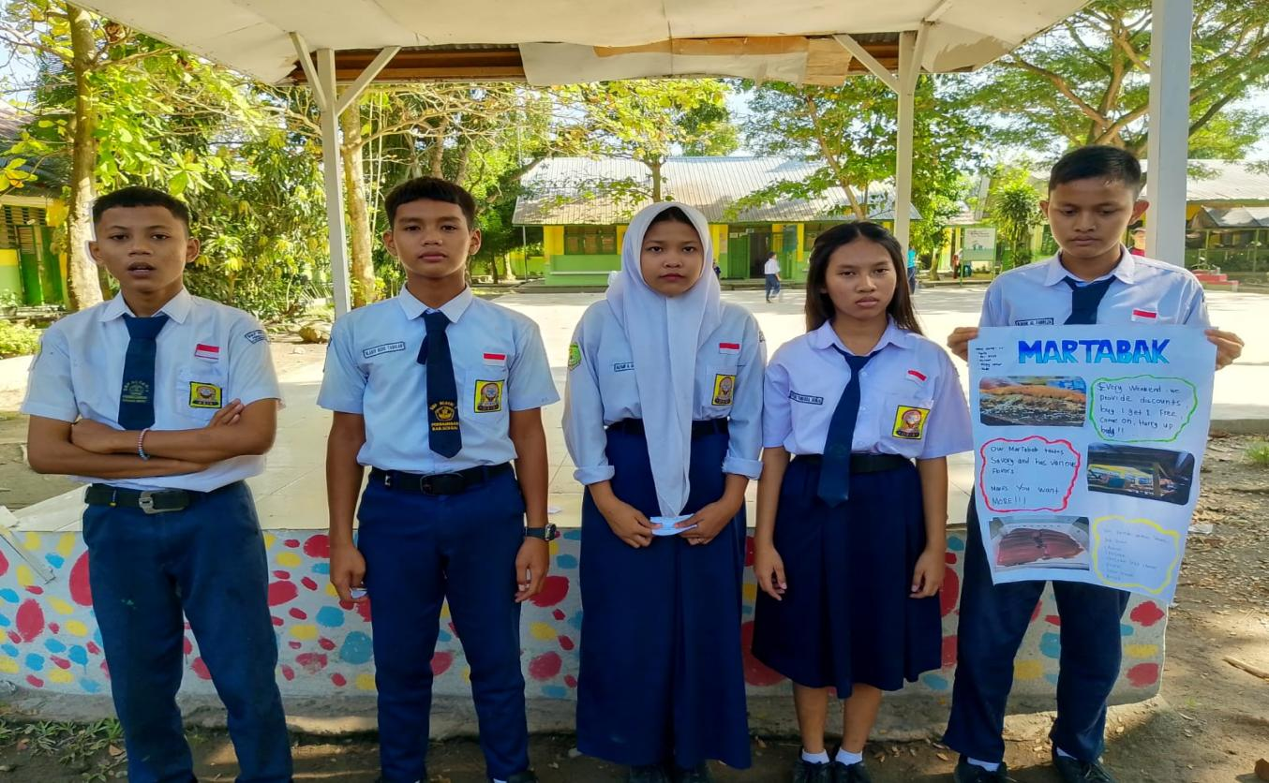

Appendixes 7. The students make An Advertisment by Canva

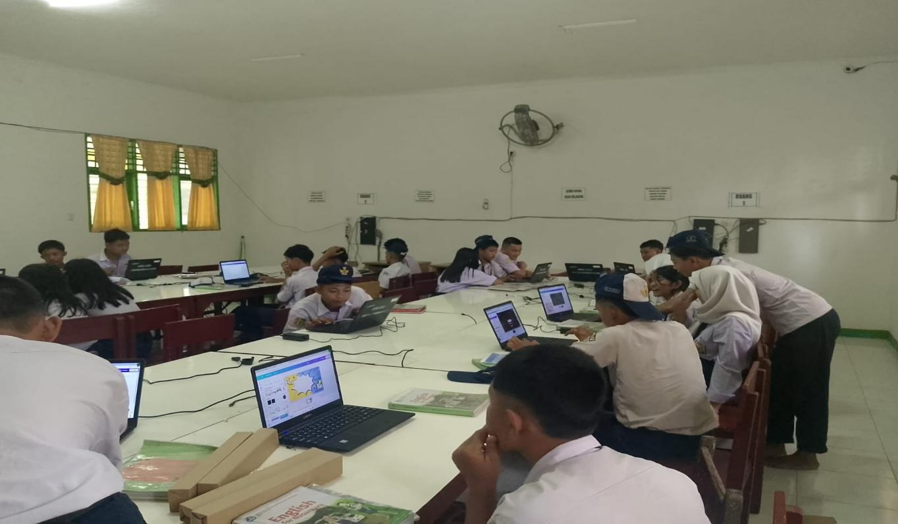

Appendixes 8. The Result students to make An Advertisment by Canva

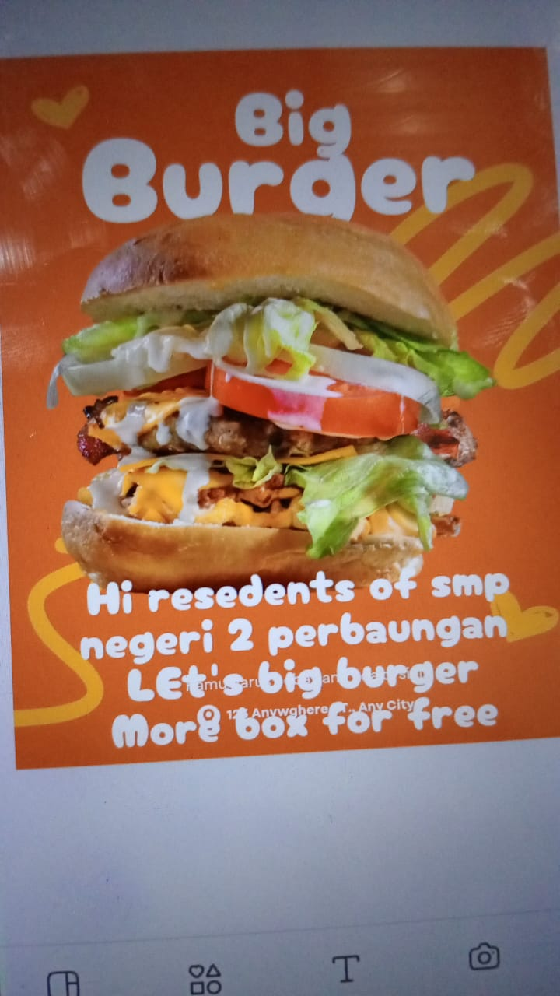

Appendixes 9. The Result students make An Advertisment by Canva

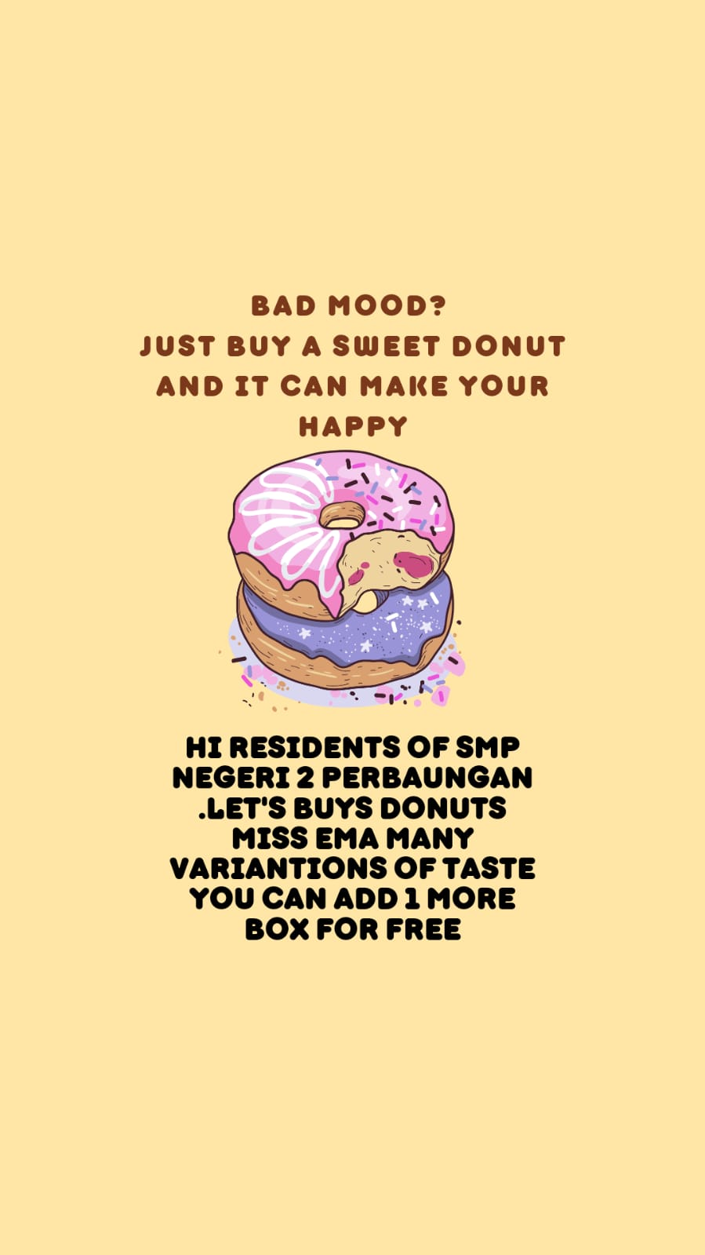

Appendix 10 : Modul 9 The design of Lesson Plan

MODUL BAHASA INGGRIS
ADVERTISMENT

TEKS FUNGSIONAL KHUSUS BERBENTUK
TEKS PERIKLANAN
KELAS IX



PENYUSUN
SRY RAHAYU NINGSIH
NIP : 197807272002122004

SMP NEGERI 2 PERBUNGAN
KABUPATEN SERDANG BEDAGAI
TAHUN AJARAN 20224/ 2025
MODUL AJAR BAHASA INGGRIS KELAS IX SMPN 2 PERBAUNGAN, KABUPATEN SERDANG BEDAGAI SEMESTER GANJIL TAHUN AJARAN 2024/2025

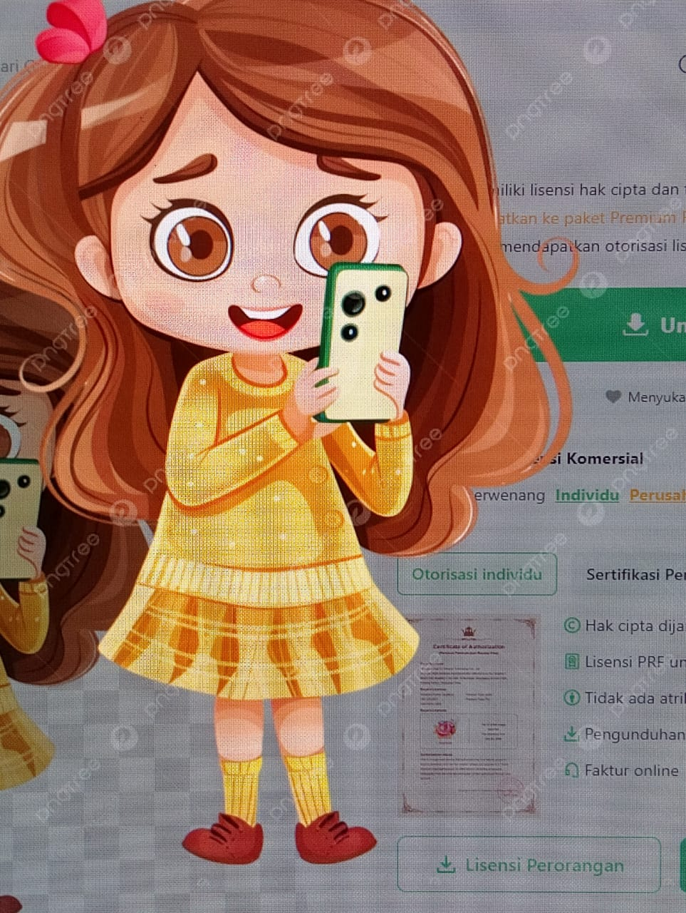
TEKS FUNGSIONAL TERTENTU
ADVERTISMENT

OLEH : SRY RAHAYU NINGSIH
NIP : 197807272002122004

KARAKTER PROFIL PELAJAR PANCASILA YANG DI HARAPKAN ADALAH MANDIRI, KREATIF DAN BERNALAR KRITIS

GLOSARIUM

Advertisment: Periklanan / Promosi sebuah Produk
- concurrent : Simultan/berkelanjutan
- containing : berisi
- outstanding : Sangat bagus/mengagumkan
- consult : Mencek/memastikan
- differences : perbedaan
- marketing plans : rencana pemasaran
- publish : mempublikasi
- reminder : peringatkan
- similarities : kesamaan
- substantial : sangat penting
- Consumen : Pelanggan
- Revolusioner : Terbaik
- Eksklusif : Murah meriah
- Bahasa Persuasif
Segera dapatkan!
Jangan lewatkan penawaran spesial ini!"
- Pilihan Kata yang Menarik (Diksi)
- Bahasa Iklan
Hidup sehat mulai hari ini.
- Slogan
Just Do It" (Nike), "Karena Anda Berharga" (L'Oréal).
- Bahasa Emosional
Lindungi keluarga Anda dengan asuransi terbaik."
- Hiperbola
Rasakan sensasi luar biasa hanya dengan satu gigitan."
- Retorika atau Pertanyaan
Apakah Anda sudah siap berubah?"
- Penggunaan Kata Perintah
Beli sekarang!", "Coba gratis hari ini!"
- Bahasa Visual (Terkait Deskripsi)
Kesegaran alami dari pegunungan.
- Penggunaan Kata-kata Teknologi atau Inovasi
Menggunakan teknologi terbaru untuk kenyamanan Anda."


PETA KONSEP
Konteks: lingkungan sosial di sekolah, rumah, tempat kerja.Social Media
Fungsi sosial: Menjalin kedekatan emosional antar Peserta didik , Guru di lingkugan sekolah, Orang Tua , Teman di tempat Tinggal. Dan Social Media.
Mpat tinggallingkungan dsb.
Struktrur teks: Dapat mencakup:Gagasan utama
- Informasi rinci
Unsurkebahasaan:Ungkapan dan kosa kata yang lazim digunakan dalam AdvertismentTeks periklanan.)unsur-unsur periklanan yang mencakup digunakan untuk menarik perhatian, membujuk, dan menyampaikan pesan kepada audienPenggunaan kata kerja secara tepat dalambentuk aktif dan pasif.Penggunaan preposisi untuk tempat dan waktu secara tepat.Ucapan, tekanan kata, intonasi Ejaan dan tanda baca

MODUL AJAR KURIKULUM MERDEKA
INFORMASI UMUM
IDENTITAS MODUL
Nama : Sry Rahayu Ningsih. S.Pd.
Asal Sekolah : SMP Negeri 2 Perbaungan Kabupaten Serdang Bedagai .
Tahun Penyusunan : 2024
Mata Pelajaran : Bahasa Inggris
Fase / Kelas / Semester : D / IX / I (Ganjil)
Alokasi Waktu : 3 Pertemuan atau setara 6 JP (2 x 40 menit)
CAPAIAN PEMBELAJARAN FASE D
Pada akhir Fase D, peserta didik menggunakan teks lisan, tulisan dan visual dalam bahasa Inggris untuk berinteraksi dan berkomunikasi dalam konteks yang lebih beragam dan dalam situasi formal dan informal. Peserta didik dapat menggunakan berbagai jenis teks seperti narasi, deskripsi, prosedur, teks khusus (pesan singkat, iklan) dan teks otentik menjadi rujukan utama dalam mempelajari bahasa Inggris di fase ini. Peserta didik menggunakan bahasa Inggris untuk berdiskusi dan menyampaikan keinginan/perasaan. Pemahaman mereka terhadap teks tulisan semakin berkembang dan keterampilan inferensi mulai tampak ketika memahami informasi tersirat. Mereka memproduksi teks tulisan dan visual dalam bahasa Inggris yang terstruktur dengan kosakata yang lebih beragam. Mereka memahami tujuan dan pemirsa ketika memproduksi teks tulisan dan visual dalam bahasa Inggris.

Menyimak – Berbicara | Pada akhir fase D, siswa menggunakan Bahasa Inggris untuk berinteraksi dan saling bertukar ide, pengalaman, minat, pendapat dan pandangan dengan guru, teman sebaya dan orang lain dalam berbagai macam konteks familiar yang formal dan informal. Dengan pengulangan dan pergantian kosa kata, pelajar memahami ide utama dan detil yang relevan dari diskusi atau presentasi mengenai berbagai macam topik yang telah familiar dan dalam konteks kehidupan di sekolah dan di rumah. Mereka terlibat dalam diskusi, misalnya memberikan pendapat, membuat perbandingan dan menyampaikan preferensi. Mereka menjelaskan dan memperjelas jawaban mereka menggunakan struktur kalimat dan kata kerja sederhana.
Membaca – memirsa | Pada akhir fase D, peserta didik membaca dan merespon teks familiar dan tidak familiar yang mengandung struktur yang telah dipelajari dan kosakata yang familiar secara mandiri. Mereka mencari dan mengevaluasi ide utama dan informasi spesifik dalam berbagai jenis teks. Teks ini dapat berbentuk cetak atau digital, termasuk diantaranya teks visual, multimodal atau interaktif. Mereka mengidentifikasi tujuan teks dan mulai melakukan inferensi untuk memahami informasi tersirat dalam sebuah teks.
Menulis - Mempresentasikan | Pada akhir Fase D, peserta didik mengomunikasikan ide dan pengalaman mereka melalui paragraf sederhana dan terstruktur, menunjukkan perkembangan dalam penggunaan kosakata spesifik dan struktur kalimat sederhana. Menggunakan contoh, mereka membuat perencanaan, menulis, dan menyajikan teks informasi, imajinasi dan persuasi dengan menggunakan kalimat  sederhana dan majemuk untuk menyusun argumen dan menjelaskan atau mempertahankan suatu pendapat. Mereka juga menyertakan informasi dasar dan detail, dan memvariasikan

PROFIL PELAJAR PANCASILA
MANDIRI, KREATIF DAN BERNALAR KRITIS
SARANA DAN PRASARANA
Gawai, laptop/komputer, akses internet, Layar interaktif/papan tulis/white board, lembar kerja, dan referensi yang mendukung..
Element Menulis - Mempresentasikan
Kelas IX
Tujuan Pembelajaran | Peserta didik mampu mengomunikasikan ide, pengalaman mereka melalui paragrap sederhana, berstrukture dengan menulis teks informasi, imajinasi secara mandiri maupun berkelompok yang berkaitan dengan materi Periklanan.
Kata Frasa/Kunci | Mengomunikasikan ide, pengalaman mereka melalui paragrap sederhana, berstrukture dengan menulis teks informasi, imajinasi secara mandiri, maupun berkelompok yang berkaitan dengan materi Periklanan.
Topik/Konten Inti | Teks Fungsional Pendek/ Periklanan
Penjelasan Singkat | Peserta didik lebih fokus dalam Pembelajaran tentang aktivitas menulis dan mempresentasikan sebuah teks fungsional pendek dan menggunakan kata-kata singkat dan kalimat – kalimat sederhana menarik.  Jenis kegiatan pembelajaran yang dapat di terapkan guru :  1.Peserta didik Mampu memahami tayangan Power Point Canva teks fungsional pendek berupa iklan tentang shoes, snacks,or gadgets secara Mandiri maupun kelompok.  2. Peserta didik mampu mengidentifikasi, Menggemukakan Tujuan informasi makna yang ada di teks yang di tuliskan secara mandiri/kelompok.  3.Peserta didik Mampu menulis kata – kata menarik tentang teks ungsional pendek berupa iklan melalui Power Point canva secara Mandiri maupun kelompok.  4.Peserta didik Mampu mengkomunikasikan ide tayangan Power Point Canva tentang teks fungsional pendek berupa iklan secara Mandiri maupun kelompok  5. Peserta didik mampu menulis dan mempresentasikan Tujuan informasi makna yang ada di teks periklanan yang di tuliskan secara mandiri/kelompok.

Informasi Umum

Nama | - Sry Rahayu Ningsih.S.Pd |  |  | Jenjang Kelas |  | IX
Asal Sekolah | SMP Negeri 2 Perbaungan |  |  | Mapel |  | Bahasa Inggris
Alokasi Waktu | 2 JP ( 80 Menit ) |  |  | Jumlah Siswa |  | 32 Siswa
Profil Pelajar Pancasila | MANDIRI, KREATIF DAN BERNALAR KRITIS |  |  | Model Pembelajaran  berdiferensasi |  | - Tatap Muka
Fase | D |  |  | Domain Mapel |  | Menulis - Mempresentasikan
Tujuan Pembelajaran | Peserta didik mampu mengomunikasikan ide, pengalaman mereka melalui paragrap sederhana, berstrukture dengan menulis teks informasi, imajinasi secara mandiri maupun berkelompok yang berkaitan dengan materi Periklanan
Kata Kunci | Mengomunikasikan ide, pengalaman mereka melalui paragrap sederhana, berstrukture dengan menulis teks informasi, imajinasi secara mandiri maupun berkelompok yang berkaitan dengan materi Periklanan
Deskripsi Umum | Fokus Mengomunikasikan ide, pengalaman mereka tentang teks periklanan melalui kata – kata menarik , kalimat – kalimat sederhana menarik berhubungan dengan materi yang di sepakati oleh guru dan siswa berstrukture dengan menulis teks informasi, imajinasi secara mandiri maupun berkelompok .
Materi ajar, alat dan bahan | 1.Materi Ajar:  - explain the context  - Ask and answer question to exchange detailed information  - Alat:  - Foto/gambar  - Lembar Kerja  3.Bahan  - Buku Teks  - http………….
- Layar Interaktif ,Komputer/Laptop, proyektor, gawai (HP), speaker, jaringan internet
- Lingkungan Kelas
- Halaman Sekolah
Assesmen | Cara Penilaian  1.Rubrik Assesmen Individu(lampiran)  2.Jenis Assesmen  Performa(Persentase)
Kegiatan Pembelajaran (Pertemuan Ke- 1)

Persiapan  Pembelajaran |  |  | Guru menyiapkan (10 menit)  - File audio  - File Visual  - Alat penyambung ( Cok sambung )  - Les speaker  - Lembar Kerja untuk kegiatan  - Lapto masing-masing kelompok
Urutan Kegiatan Pembelajaran | Pengaturan Siswa | Metode

Pendahuluan  (8 Menit) |  | - Guru mengucapkan salam dan bertegur sapa dengan siswa  Menanyakan kabar mereka.  “Good Morning?”  “How are You?” AND Other Simple Questions  Guru Menayakan Kehadiran Siswa-siswa.  - Guru Melakukan Brain Gym Bersama  - Guru mengajak siswa untuk berdoa karakter sebelum memulai pembelajaran  - Memberikan ruang kepada siswa untuk mengekspresikan keadaan mereka dan membuat kesepakatan kelas |  |  | - Individual/berkelompok |  | - PJBL
Inti  (65 Menit) |  | - Guru dan siswa membuat kelompok belajar yang terdiri dari Kesiapan Belajar Peserta didik (Kurang, Sedang, Cukup,Baik dan Sangat baik)  - Guru memperlihatkan Power point tentang iklan di layar interaktif untuk membuat teks iklan siswa menyimaknya.  - Guru menunjukan powerpoint yang berisikan penjelasan tentang kanva.  - Guru menunjukan video tentang iklan.  - Guru membuka applikasi Canva dan menjelaskan tentang penggunaan Canva dalam membuat iklan sederhana sesuai pilihan siswa.  - Siswa dan guru melakukan Tanya jawab terkait materi periklanan.  - Peserta didik bersama teman satu kelompok berdiskusi untuk membuat iklan sesuai dengan jenis – jenis iklan ytang mereka inginkan.  - Siswa mengerjakan lkpd berkelompok dengan mendengarkan arahan guru.  - Peserta didik bekerja secara berkelompok dan membagi tugas kerja agar iklan yang mereka buat bagus dengan menggunakan appikasi Canva power Point.  - Siswa bersama kelompoknya di berikan kesempatan untuk mempresetasikan conclusion pada teks. |  |  | - Individu  - Berkelompok |  | - Diskusi  - Persentase
Penutup  (7 menit) |  | - Siswa menjawab pertanyaan guru tentang pengalaman dan kesulitan mereka dalam membuat iklan dengan bantuan aplikasi Powerpoint Canva.  - Guru memberikan apresiasi kepada seluruh siswa yang bekerja dengan baik.  - Guru memberikan apresiasi kepada kelompok yang melakukan presentasi di depan kelas.  - Siswa berdoa sebelum menutup kegiatan.  - Guru mengucapkan banyak terima kasih kepada siswa karena sudah semangat belajar. |  |  | - Individu |  | - Diskusi
Refleksi
Refleksi Guru | - Apakah Kegiatan pembelajaran berjalan sesuai rencana?  - Apakah siswa dapat mengikuti proses pembelajaran dengan baik?  - Apakah siswa senang dan antusias mengikuti kegiatan pembelajaran dengan menggunakan Aplikasi Power point Canva?  - Kesulitan apa yang dialami ketika melaksanakan kegiatan pembelajaran ini?  - Apa langkah yang perlu dilakukan untuk memperbaiki proses pembelajaran?
Refleksi Siswa | LEMBAR REFLEKSI SISWA  PERTEMUAN PERTAMA  NAMA SISWA :
  PERTANYAAN |  | 
  Apakah kamu suka dengan kegiatan pembelajaran ini?
  Apakah belajar tentang menulis iklan bermanfaat untukmu?
  Apakah dengan belajar dengan cara berkelompok membantumu lebih mudah dalam mempraktekkan pembelajaran menuliskan Iklan menggunakan Canva pada power point ?
  Apakah semua kelompok mau mendengarkan Ketika mempresentasikan hasil karya kelompok tentang iklan dengan menggunakan Power point canva?
  Apakah belajar tentang menulis dan mempresentasikan sebuah iklan ini mudah untuk di kerjakan dengan kelompok belajar?
  Apakah kamu menemukan kesulitan ketika bekerjasama dan berdiskusi pada kelompok ketika
  Menulis iklan sederhana menggunakan aplikasi powerpoint Canva
  Apakah kamu ingin terus mempraktekan melatih mrnulis iklan dengan menggunakan
  Aplikasi Powerpoint Canva bahasa Inggris dengan temanmu, gurumu di lingkungan sekolah
  atau lingkungan tempat Tinggalmu ?

Lampiran Materi Advertisment

Di sini kita akan membaca beberapa Periklanan tertulis. Pertama mari kita berlatih memahami teks untuk mencari gagasan utama. Anda tentu masih ingat bagaimana mencari gagasan utama (main idea) dari sebuah teks Advertisment Good! Namun demikian mari diulang kembali bagaimana mencari gagasan utama.
Untuk menemukan gambaran umum dari sebuah wacana Anda harus membaca wacana tersebut dengan cepat atau sekilas. Misalnya, ketika Anda melihat periklana komersial dan non komersial sebelum dibaca ada pertanyaan di benak Anda “Tentang apakah gerangan?” Lalu Anda baca Periklanan tersebut dengan cepat.
Nah sekarang mari coba membaca perikalan berikut dan berlatih menganalisis fungsi sosial, struktur teks, dan unsur kebahasaan teks pengumuman dengan menjawab pertanyaan-pertanyaan terkait pengumuman tersebut.

Read text 1 one more time then analize the following table. Text Structures of an advertisement.
 | Parts of Advertisment | Functions of the Parts
1. | Main Idea (Gagasan Utama) | Summarizing the information in an intention Advertisment text
 | I would like to advertisment promotion  of Special Food Menu by 50 % This weekend. | The Subject about Special Food Menu  The Issues : Promotion 50 % discount this weekend
2. | Details of information  A Big and familiar Restaurant in a City to Promotion to people or Public about Soecial Food Menu.  The Special Food Menu has Discount Up to 50 % Price of This Weekend.  The Owner of Restaurant to Promote a special food Menu and other foods menu and people will interest about the Advertisment. | Supporting data or idea  Informing Reason  - bought a huge percentage of the company business.  - possess an excellent record of customer relations and timely service delivery.  - taking a 50 % Discount of this Weekend To Sprcial Food Menu.  2) Informing hope  People know about a Promotion about advertisment.  3) Informing Restaurant Owner duties  To Promote special Food Menu  Get Discount 50 % of the special Food Menu just this weekend.  Advertisment of the special food menu can be order by home or Come to The Restaurant.

Read text 1 one more time then analize this table. The Grammatical Features of an Announcement
Main Idea
I would like to advertisment the promotion Special food Menu by 50 % discount of this weekend. o
- Using intention text - I would like to
- Noun Phrase - the promotion of, Special Food Menu
Details
- A sentence or sentences in the second paragraph containing all important facts about the subject of the Advertisment: (1) the reason and (2) the hope; Noun Phrases
  - The Owner has bought a huge percentage of the company business.
  - His influence on sale and business retention has been substantial and he possesses an excellent record of customer relations and timely service delivery.

- A sentence or sentences in the third paragraph containing all important facts
about the subject of the Advertisment t: (3) duties; future progressive.
  - The owner will be leading the marketing team through this five-year project and will also be working on various other concurrent projects.

Rangkuman
- Struktur Teks
Struktur pengumuman dapat berbentuk:
  - Gagasan utama
  - Informasi rinci
- Unsur Kebahasaan
  - Ungkapan dan kosa kata yang lazim digunakan dalam Advertisment (periklanan ).

- Topik
Peristiwa atau kegiatan penting yang terkait dengan hidup peserta didik di sekolah, rumah, dan masyarakat, dengan memberikan keteladanan tentang perilaku jujur, disiplin, percaya diri, kerjasama dan bertanggung jawab.

B. Latihan Soal

Agar lebih mahir dalam menangkap makna berbagai teks Periklanan mari berlatih melakukan hal yang sama untuk dua teks berbeda

Exercise 1:

Read these two advertisment below. Then answer the following questions for each text. Write your answer with a complete answer on your notebook.
  - What is the advertisment about?
  - Who might be interested in reading this Advertisment?
  - What is the purpose of publishing the Advertisment ?
  - What will happen after the Advertisment published?

C. Penilaian Diri
No | Pernyataan | SS | S | TS | STS
1 | Saya berdoa sebelum dan sesudah melakukan kegiatan belajar menggunakan modul ini.
2 | Saya belajar menggunakan modul ini secara terjadwal
3 | Saya mengerjakan modul ini sendiri tanpa bantuan  orang lain
4 | Saya sudah memahami fungsi social, struktur teks dan unsur kebahasaan teks advertisement.
5 | Saya dapat menangkap makna serta informasi terkait  teks advertisment

KEGIATAN PEMBELAJARAN 2

LET’S WRITE

Tujuan Pembelajaran
Setelah mempelajari modul yang berjudul “Advertisment ” terutama learning
activity 2 ini, Anda akan mampu:
  - merancang teks khusus dalam bentuk periklanan (Advertisment ).
  - menggunakan kata kerja be dan infinitive.
  - Menulis teks khusus dalam bentuk periklanan (Advertisment).

Uraian Materi
Setelah membaca beberapa teks periklanan pada Learning Activity 1, maka sekarang saatnya berlatih menuliskan periklan. Sebelumnya mari rancang dulu iklan yang akan ditulis dengan mengisi mind mapping. Kemudian berdasarkan data dari mind mapping tersebut, dibuat pengumuman.
Perhatikan kembali.
Main Idea
I would like to announce the promotion of John David as a new marketing Head of Resource inc.
Using intention text - I would like to
Noun Phrase - the promotion of, a new marketing Head of
Details
A sentence or sentences in the second paragraph containing all important facts about the subject of the announcement: (1) the reason and (2) the hope; the verb in the present perfect tense.
He has bought a huge percentage of the company business.
His influence on sale and business retention has been substantial and he possesses an excellent record of customer relations and timely service delivery.
A sentence or sentences in the third paragraph containing all important facts
about the subject of the announcement: (3) duties; future progressive.
- He will be leading the marketing team through this five-year project and will also be working on various other concurrent projects.

Untuk mempermudah kita menbuat periklanan silahkan Anda ikuti bagan di bawah

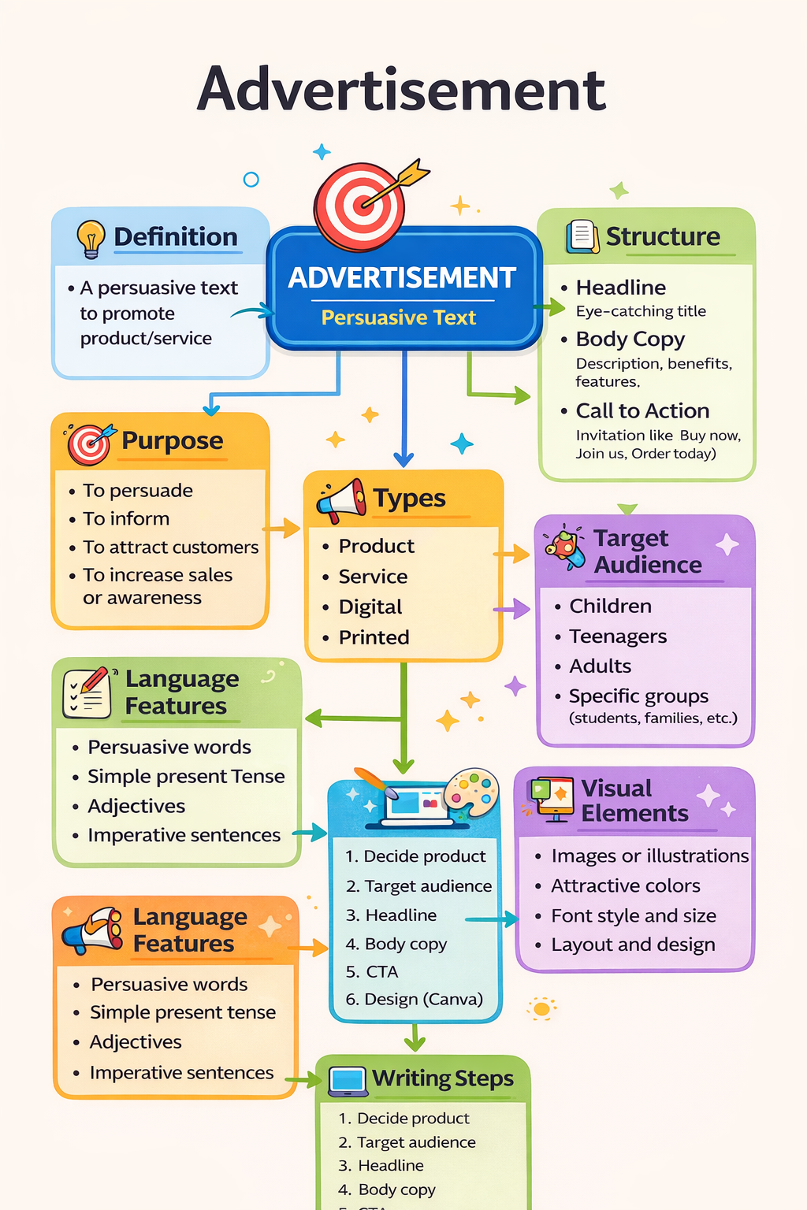

Rangkuman

Penugasan Mandiri

Untuk lebih memiliki keterampilan untuk berkomunikasi terkait teks periklanan, silahkan Anda mencari contoh teks iklan yang paling menarik menurut Anda. Jika teks periklanan tersebut berbentuk teks gambar dengan tulisan singkat menarik sesuai bahasa periklanan silahkan tuliskan kembali dalam buku catatan masing-masing, kemudian tuliskan contoh periklan yang menarik buat siswa dengan menggambar/ menempelkan prodak tersebut oleh masingm – masing siswa.

Practice 1: Fill in the missing word/phrase of this Advertisment

Practice 2: Design an Advertisment by poster
- Social Function
Build emotional closeness between relatives, co-workers, office staff, entrepreneurs and customers, etc. by writing announcements about important events, such as births, marriages, graduations, moving to new buildings, etc.
- Text Structure
  - Main idea
  - Detailed information
- Language Features
  - Expressions and vocabulary commonly used in sdvertisment.
  - The use of singular and plural nominals precisely with or without a, the, this,
those, my, their, etc. in nominal phrases.
  - The use of verbs accurately in active and passive forms.
  - Proper use of prepositions for place and time.
  - Spelling, punctuation, and handwriting

Contoh


Bagaimana, Anda tentu bisa mengisi bagan tadi dengan rincian informasi terkait pengumuman yang akan dibuat, bukan? Good job! Nah sekarang saatnya berlatih menuliskan pengumuman dalam bahasa Inggris menggunakan bahasa Anda sendiri. Jangan putus asa jika ada kata yang tidak Anda ketahui bahasa Inggrisnya. Anda boleh melihat kamus baik cetak maupun digital.

Penilaian Diri
No | Pernyataan | SS | S | TS | STS
1 | Saya berdoa sebelum dan sesudah melakukan kegiatan  belajar menggunakan modul ini.
2 | Saya belajar menggunakan modul ini secara terjadwal
3 | Saya mengerjakan modul ini sendiri tanpa bantuan  orang lain
4 | Saya sudah memahami untuk membuat diagram atau  chart untuk mempermudaah membuat pengumuman.
5 | Saya dapat menyusun teks advertisment dengan benar

Lampiran Lembar Kerja 1 ( Kelompok )
Pre Test Advertisment
No | Visual Learning Style | Auditory learning style | Kinesthetic Learning Styles
 | Write a suitable advertising text for this product.  Create a slogan that is short, catchy and memorable.  State the main benefits of the product in two sentences.  Visual Support: Include pictures of the product such as sports shoes, snacks, or gadgets.  Sample Answer:  Slogan: ‘Go Further in Style!’ ’These trainers are lightweight, comfortable and suitable for any activity.’ | Listen to an audio description of a new product (e.g. sports shoes, snacks, or gadgets.).  Write a 30-second radio advert script for the product.  Include at least three product advantages in text.  Audio Support: Provide an audio description (short narration) that can be played in class. such as sports shoes, snacks, or gadgets.  Sample Answer:  Slogan: ‘Go Further in Style!’ ’These trainers are lightweight, comfortable and suitable for any activity.’ | Instructions: Observe the product packaging around you (e.g. sports shoes, snacks, or gadgets.)  Write down an advertising design idea that can be placed on the product packaging.  Create one promotional sentence that is suitable to be printed on the front of the packaging.  Write down who the target market of the product is.  Interactive Support: Bring real packaging to class for students to hold and observe.  Target Market: ‘Active teenagers and young adults who love Sport shoes, Snack or Gadgets.’

Combined Test (All Learning Styles) Instructions: Make an advert for a new product, for example: ‘Sports shoes, snacks and smart phones’. Choose one of the following ways: (Visual) Write a compelling ad text for a poster, (Auditory) Write a persuasive radio ad script, and (Kinesthetic) Write an ad idea that will be displayed on the product packaging using Canva power point and present it in front of the class individually or in groups.
Teks yang di nilai berdasarkan teks yang di Presentasikan terlebih Dahulu oleh Peserta Didik

RUBRIK PENILAIAN
Rubrik penilaian ini digunakan untuk Pertemuan pertama sampai ke dua
Penilaian kelompok.
NO | KRITERIA | TINGKAT KEMAMPUAN
NO | KRITERIA | 1 | 2 | 3
1 | Merespon secara verbal/non verbal | Belum menunjukkan kemampuan sama sekali | Mampu menunjukkan hanya salah satu dari bahasa verbal/non verbal | Mampu menunjukkan pemahaman melalui bahasa nonverbal, dan verbal.
 | Memberikan salam (greetings) | Mampu bertanya dan menjawab greetings | Mampu bertanya dan menjawab salam, dan mampu melakukan salah satu dari menjawab alamat atau menjawab usia | Mampu bertanya dan menjawab salam dengan benar, menjawab usia, dan menjawab alamat/tempat tinggal
2 | Partisipasi dalam proses kegiatanbelajar | Tidak semua anggota kelompok mengikuti kegiatan | Semua anggota kelompok mengikuti semua kegiatan, tetapi ada beberapa peserta yang tidak tuntas mengerjakan tugasnya. | Semua anggota kelompok mengikuti semua kegiatan dengan tuntas
3 | Berdiskusi | Tidak semua anggota kelompok mengikuti kegiatan | Semua anggota kelompok mengikuti semua kegiatan, tetapi ada beberapa peserta yang tidak tuntas mengerjakan tugasnya. | Semua anggota kelompok mengikuti semua kegiatan dengan tuntas
4 | Mempresentasikan. | Tidak semua anggota kelompok ikut bagian dalam presentasi | Semua anggota kelompok mengikuti semua kegiatan presentasi, tetapi ada beberapa peserta yang tidak tuntas mengerjakan tugasnya. | Semua anggota kelompok mengikuti presentasisemua kegiatan dengan tuntas
Jumlah skor

PENILAIAN INDIVIDU
UNTUK PERTEMUAN 1 SAMPAI 3
GURU MENGISI DENGAN CARA CEK LIST

NO | NAMA SISWA | MERESPONS VERBAL |  |  | MERESPONS NON VERBAL
NO | NAMA SISWA | 1 | 2 | 3 | 1 | 2 |  |  | 3
1
2
3
4
5
6
7
8
9
10
11
12
13
14
15

RUBRIK PENILAIAN
Rubrik penilaian ini digunakan untuk Pertemuan pertama sampai ke dua
Penilaian kelompok pada karakter Profil yang diharapkan pada Modul.
Nama-nama siswa :
1.
2.
NO | Element Dimensi P3 | TINGKAT KEMAMPUAN
NO | Element Dimensi P3 | 1 | 2 | 3
1 | Mandiri. | Belum menunjukkan kemampuan sama sekali | Mampu menunjukkan hanya salah satu dari bahasa verbal/non verbal | Mampu menunjukkan pemahaman melalui bahasa nonverbal, dan verbal.
 |  | Mampu bertanya dan menjawab greetings | Mampu bertanya dan menjawab salam, dan mampu melakukan salah satu dari menjawab alamat atau menjawab usia | Mampu bertanya dan menjawab salam dengan benar, menjawab usia, dan menjawab alamat/tempat tinggal
2 | Kreatif | Tidak semua anggota kelompok mengikuti kegiatan | Semua anggota kelompok mengikuti semua kegiatan, tetapi ada beberapa peserta yang tidak tuntas mengerjakan tugasnya. | Semua anggota kelompok mengikuti semua kegiatan dengan tuntas
3 | Bernalar Kritis | Belum menunjukkan kemampuan sama sekali | Mampu memberikan ide dalam berdiskusi | Mampu menjalankan tugas sesuai kesepakan kelompok.( Moderator, Penyaji, Penulis soal dan Menjawab soal.
 | Penampilan | Kurang Percaya diri | Percaya diri | Sangat Percaya diri
Jumlah skor |  | 70-79 | 80-89 | 90-100
Penghitungan nilai: pada soal Essay
Skor maksimal = 10
NILAI AKHIR = Skor perolehan X 10 Skor maksimal

Kelas IX
Tujuan Pembelajaran | Peserta didik mampu mengomunikasikan ide, pengalaman mereka melalui teks iklan berstrukture dengan menulis teks iklan , imajinasi secara mandiri maupun berkelompok yang berkaitan dengan materi Periklanan.
Kata Frasa/Kunci | Mengomunikasikan ide, pengalaman mereka melalui iklan sederhana, berstrukture dengan menulis teks informasi, imajinasi secara mandiri maupun berkelompok yang berkaitan dengan materi Periklanan.
Topik/Konten Inti | Teks Fungsional Pendek/ Periklanan
Penjelasan Singkat | Peserta didik lebih fokus dalam Pembelajaran tentang aktivitas menulis dan mempresentasikan sebuah teks fungsional pendek berbentuk iklan dan menggunakan kata-kata singkat atau kalimat – kalimat sederhana menarik dengan menggunakan Power point Canva  Jenis kegiatan pembelajaran yang dapat di terapkan guru :  1.Peserta didik Mampu memahami tayangan Power Point Canva teks fungsional pendek berupa iklan tentang shoes, snacks,or gadgets secara kelompok dengan menggunakan Canva  2.Peserta didik mampu mengidentifikasi, Menggemukakan Tujuan informasi makna yang ada di teks iklan berupa gambar dan tulisan secara kelompok.  3.Peserta didik Mampu menulis kata – kata menarik tentang teks fungsional pendek berupa iklan melalui Power Point canva secara Mandiri maupun kelompok.  4.Peserta didik Mampu mengkomunikasikan ide tayangan Power Point Canva tentang teks fungsional pendek berupa iklan secara Mandiri maupun kelompok  5. Peserta didik mampu mempresentasikan Tujuan informasi makna yang ada di teks periklanan yang di tuliskan secara kelompok.

Informasi Umum

Nama | - Sry Rahayu Ningsih.S.Pd |  |  | Jenjang Kelas |  | IX
Asal Sekolah | SMP Negeri 2 Perbaungan |  |  | Mapel |  | Bahasa Inggris
Alokasi Waktu | 2 JP ( 80 Menit ) |  |  | Jumlah Siswa |  | 32 Siswa
Profil Pelajar Pancasila | KREATIF , bergotong Royong DAN BERNALAR KRITIS |  |  | Model Pembelajaran  berdiferensasi |  | - Tatap Muka
Fase | D |  |  | Domain Mapel |  | Menulis - Mempresentasikan
Tujuan Pembelajaran | Peserta didik mampu mengomunikasikan ide, pengalaman mereka melalui teks iklan berstrukture dengan menulis teks iklan , imajinasi secara mandiri maupun berkelompok yang berkaitan dengan materi Periklanan.
Kata Kunci | Mengomunikasikan ide, pengalaman mereka melalui iklan sederhana, berstrukture dengan menulis teks informasi, imajinasi secara mandiri maupun berkelompok yang berkaitan dengan materi Periklanan.
Deskripsi Umum | Fokus Mengomunikasikan ide, pengalaman mereka tentang teks periklanan melalui kata – kata menarik , kalimat – kalimat sederhana menarik berhubungan dengan materi yang di sepakati oleh guru dan siswa berstrukture dengan menulis teks informasi, imajinasi secara berkelompok .
Materi ajar, alat dan bahan | 1.Materi Ajar:  - explain the context  - Ask and answer question to exchange detailed information  - Alat:  - Foto/gambar  - Lembar Kerja  3.Bahan  - Buku Teks  - http………….
- Layar Interaktif ,Komputer/Laptop, proyektor, gawai (HP), speaker, jaringan internet
- Lingkungan Kelas
- Halaman Sekolah
Assesmen | Cara Penilaian  1.Rubrik Assesmen Individu(lampiran)  2.Jenis Assesmen  Performa(Persentase)
Kegiatan Pembelajaran (Pertemuan Ke- 3)

Persiapan  Pembelajaran |  |  | Guru menyiapkan (10 menit)  - File audio  - File Visual  - Alat penyambung ( Cok sambung )  - Les speaker  - Lembar Kerja untuk kegiatan  - Lapto masing-masing kelompok
Urutan Kegiatan Pembelajaran | Pengaturan Siswa | Metode

Pendahuluan  (8 Menit) |  | - Guru mengucapkan salam dan bertegur sapa dengan siswa  Menanyakan kabar mereka.  “Good Morning?”  “How are You?” AND Other Simple Questions  Guru Menayakan Kehadiran Siswa-siswa.  - Guru Melakukan Brain Gym Bersama  - Guru mengajak siswa untuk berdoa karakter sebelum memulai pembelajaran  - Memberikan ruang kepada siswa untuk mengekspresikan keadaan mereka dan membuat kesepakatan kelas |  |  | - Individual/berkelompok |  | - PJBL
Inti  (65 Menit) |  | - Guru dan siswa membuat kelompok belajar yang terdiri dari Kesiapan Belajar Peserta didik (Kurang, Sedang, Cukup,Baik dan Sangat baik)  - Guru memperlihatkan Power point tentang iklan di layar interaktif untuk membuat teks iklan siswa menyimaknya.  - Guru menunjukan powerpoint yang berisikan penjelasan tentang kanva.  - Guru menunjukan video tentang iklan.  - Guru membuka applikasi Canva dan menjelaskan tentang penggunaan Canva dalam membuat iklan sederhana sesuai pilihan siswa.  - Siswa dan guru melakukan Tanya jawab terkait materi periklanan.  - Peserta didik bersama teman satu kelompok berdiskusi untuk membuat iklan sesuai dengan jenis – jenis iklan yang mereka inginkan.  - kelompok Siswa mengerjakan lkpd berkelompok dengan mendengarkan arahan guru.  - Peserta didik bekerja secara berkelompok dan membagi tugas kerja agar iklan yang mereka buat bagus dengan menggunakan appikasi Canva power Point.  - Siswa bersama kelompoknya di berikan kesempatan untuk mempresetasikan iklan yang di buatnya dengan menggunakan kanva.  - Siswa bisa menampilkan hasil video iklanya di sosial Media. |  |  | - Individu  - Berkelompok |  | - Diskusi  - Persentase
Penutup  (7 menit) |  | - Siswa menjawab pertanyaan guru tentang pengalaman dan kesulitan mereka dalam membuat iklan dengan bantuan aplikasi Powerpoint Canva.  - Guru memberikan apresiasi kepada seluruh siswa yang bekerja dengan baik.  - Guru memberikan apresiasi kepada kelompok yang melakukan presentasi di depan kelas.  - Siswa berdoa sebelum menutup kegiatan.  - Guru mengucapkan banyak terima kasih kepada siswa karena sudah semangat belajar. |  |  | - Individu |  | - Diskusi
Refleksi
Refleksi Guru | - Apakah Kegiatan pembelajaran berjalan sesuai rencana?  - Apakah siswa dapat mengikuti proses pembelajaran dengan baik?  - Apakah siswa senang dan antusias mengikuti kegiatan pembelajaran dengan menggunakan Aplikasi Power point Canva?  - Kesulitan apa yang dialami ketika melaksanakan kegiatan pembelajaran ini?  - Apa langkah yang perlu dilakukan untuk memperbaiki proses pembelajaran?
Refleksi Siswa | LEMBAR REFLEKSI SISWA  PERTEMUAN PERTAMA  NAMA SISWA :
  PERTANYAAN
  Apakah kamu suka dengan kegiatan pembelajaran presentasi iklan ini?
  Apakah belajar tentang mempresentasikan iklan bermanfaat untukmu?
  Apakah dengan belajar dengan cara berkelompok membantumu lebih mudah dalam mempraktekkan pembelajaran menuliskan Iklan menggunakan Canva pada power point ?
  Apakah semua kelompok mau mendengarkan Ketika mempresentasikan hasil karya kelompok tentang iklan dengan menggunakan Power point canva?
  Apakah belajar tentang menulis dan mempresentasikan sebuah iklan ini mudah untuk di kerjakan dengan kelompok belajar?
  Apakah kamu menemukan kesulitan ketika bekerjasama dan berdiskusi pada kelompok ketika
  Menulis iklan sederhana menggunakan aplikasi powerpoint Canva
  Apakah kamu ingin terus mempraktekan melatih mrnulis iklan dengan menggunakan
  Aplikasi Powerpoint Canva bahasa Inggris dengan temanmu, gurumu di lingkungan sekolah
  atau lingkungan tempat Tinggalmu ?

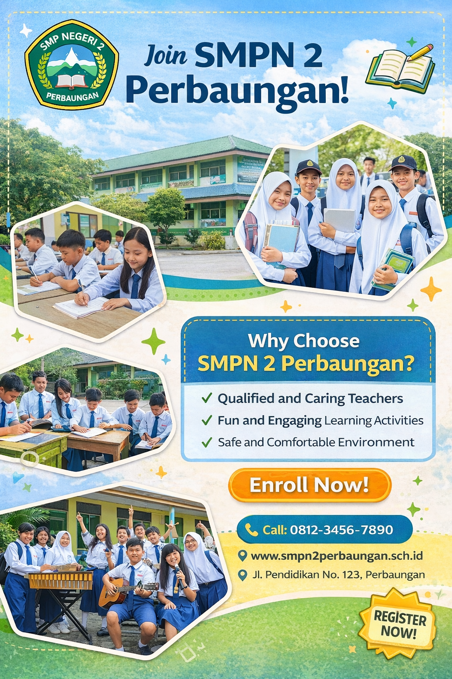

Di sini kita akan membaca sebuah iklan sekolah . Pertama mari kita berlatih memahami teks untuk mencari gagasan utama. Anda tentu masih ingat bagaimana mencari gagasan utama (main idea) dari sebuah teks Advertisment SCHOOL Namun demikian mari diulang kembali bagaimana mencari kata – kata menarik pada iklan tersebut
Untuk menemukan gambaran umum dari sebuah wacana Anda harus membaca wacana tersebut dengan cepat atau sekilas. Misalnya, ketika Anda melihat periklana komersial dan non komersial sebelum dibaca ada pertanyaan di benak Anda “Tentang apakah gerangan?” Lalu Anda baca Periklanan tersebut dengan cepat.
Nah sekarang mari coba membaca perikalan berikut dan berlatih menganalisis fungsi sosial, struktur teks, dan unsur kebahasaan teks pengumuman dengan menjawab pertanyaan-pertanyaan terkait pengumuman tersebut.

Read text 1 one more time then analize the following table. Text Structures of an advertisement.

 | Parts of Advertisment | Functions of the Parts
1. | Main Idea (Gagasan Utama) | Summarizing the information in an intention Advertisment text
 | I would like to advertisment promotion  of Special School by many facilities, best teacher , and good Program | The Subject about Special Junior School  The Issues : The best school in Perbaungan
2. | Details of information  A Big and familiar SMPN 2 Perbaungan in a Perbaungan City to Promotion to people or Public about Special School.  The Special school has Good Teacher , Good Facilities and Good Breakfast like MBG and Never paying school fees for 3 years  The Headmaster SMPN 2 Perbaungan to Promote a special School and people will interest about the Advertisment. | Supporting data or idea  Informing Reason  - bought a huge graduated to Perbaungan People.  - possess an excellent Teaching and Learning Students relations and timely service delivery.  - taking a 100 % free Schoolfee every years To Sprcial Junior School  2) Informing hope  People know about a Promotion about advertisment.  3) Informing School duties  To Promote special Food Menu  Get 100 % of the special school every years.  Advertisment of the special school can be order by home or Come to The School

Read text 1 one more time then analize this table. The Grammatical Features of an Announcement
Main Idea
I would like to advertisment the promotion Special food Menu by 50 % discount of this weekend. o
- Using intention text - I would like to
- Noun Phrase - the promotion of, Special Food Menu
Details
- A sentence or sentences in the second paragraph containing all important facts about the subject of the Advertisment: (1) the reason and (2) the hope; Noun Phrases
  - The Owner has bought a huge percentage of the company business.
  - His influence on sale and business retention has been substantial and he possesses an excellent record of customer relations and timely service delivery.

- A sentence or sentences in the third paragraph containing all important facts
about the subject of the Advertisment t: (3) duties; future progressive.
  - The owner will be leading the marketing team through this five-year project and will also be working on various other concurrent projects.

- Rangkuman
- Struktur Teks
Struktur pengumuman dapat berbentuk:
  - Gagasan utama
  - Informasi rinci
- Unsur Kebahasaan
  - Ungkapan dan kosa kata yang lazim digunakan dalam Advertisment (periklanan ).

- Topik
Peristiwa atau kegiatan penting yang terkait dengan hidup peserta didik di sekolah, rumah, dan masyarakat, dengan memberikan keteladanan tentang perilaku jujur, disiplin, percaya diri, kerjasama dan bertanggung jawab.

B. Latihan Soal

Agar lebih mahir dalam menangkap makna berbagai teks Periklanan mari berlatih melakukan hal yang sama untuk dua teks berbeda

Exercise 1:

Read these two advertisment below. Then answer the following questions for each text. Write your answer with a complete answer on your notebook.
  - What is the advertisment about?
  - Who might be interested in reading this Advertisment?
  - What is the purpose of publishing the Advertisment ?
  - What will happen after the Advertisment published?

- Penilaian Diri
No | Pernyataan | SS | S | TS | STS
1 | Saya berdoa sebelum dan sesudah melakukan kegiatan belajar menggunakan modul ini.
2 | Saya belajar menggunakan modul ini secara terjadwal
3 | Saya mengerjakan modul ini sendiri tanpa bantuan  orang lain
4 | Saya sudah memahami fungsi social, struktur teks dan unsur kebahasaan teks advertisement.
5 | Saya dapat menangkap makna serta informasi terkait  teks advertisment

  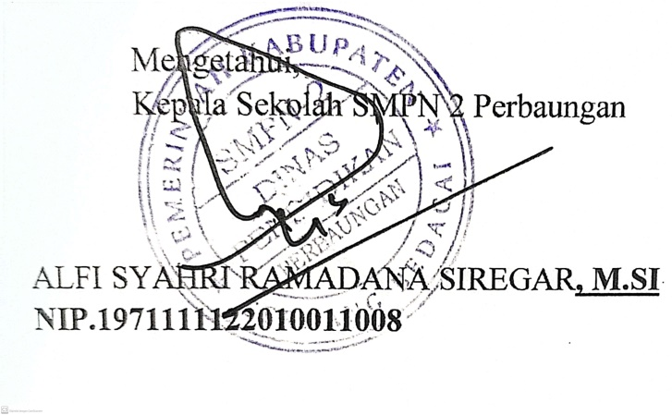 | Perbaungan, 20 Juli 2024
 | Guru Mata Pelajaran Bahas Inggris
 | Sry Rahayu Ningsih.
 | Nip.19780727200212200

