CHAPTER IV
FINDING AND DISSCUSSION
4. Finding
4.1 Developing advertisement Material
The development of teaching materials, as a follow-up to the design that has been carried out. The learning tools developed in this research are based teaching materials. Teaching materials developed at this stage will be evaluated by expert lecturers. The structure or framework chosen in the development of teaching materials should be simple and appropriate to the needs. After everything is finished, to get a valid and good teaching material, the researcher gives teaching materials to experts so that they are validated. The purpose of the development stage is to produce a product that has been revised based on input from the validator.
Figure 3.The old material advertisment
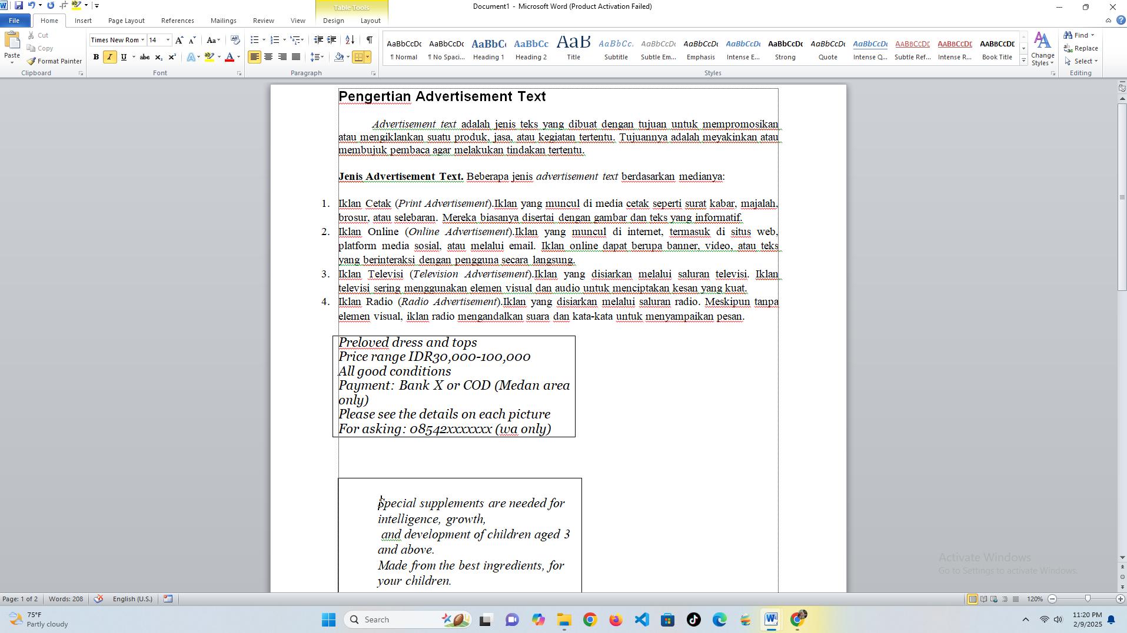

Figure 4.The material advertisement Test
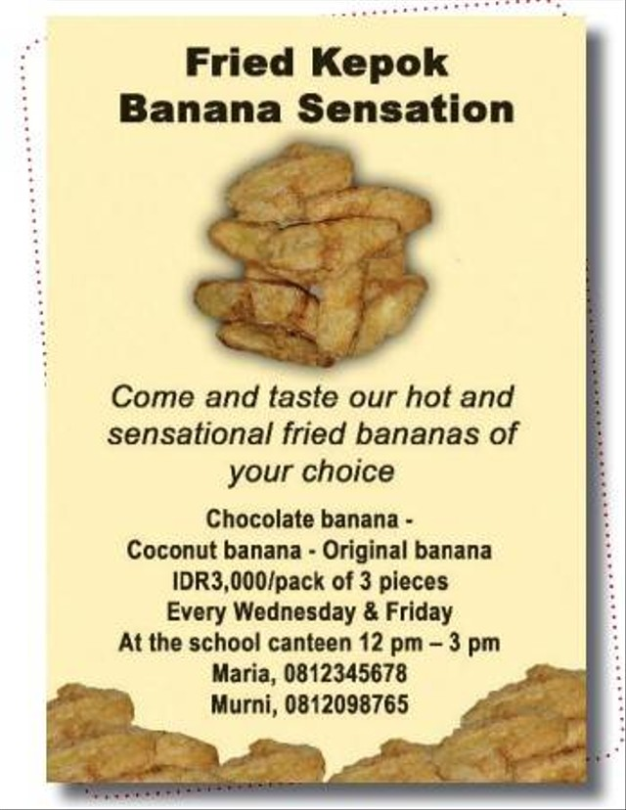
1. What is the purpose of the text?
a. To persuade the readers to buy fried kapok banana.
b. To inform the readers about banana.
c. To announce the readers about Maria and Murni.
d. To inform the readers to buy fried kepok.
The old advertisment material always about reading text and answer based of the the text. Many teachers teach advertisment material by reading skill and it almost never to teach with writing
Figure 5.Developing advertisment Material by You tobe
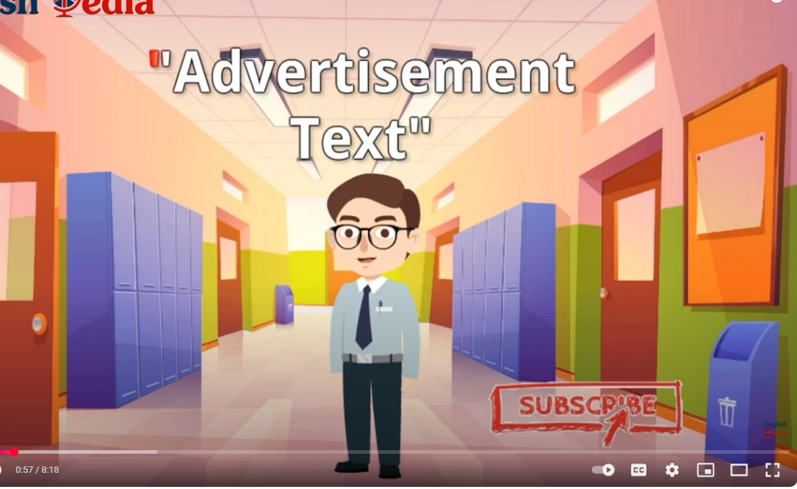
Figure 6.The Developing of material advertisment
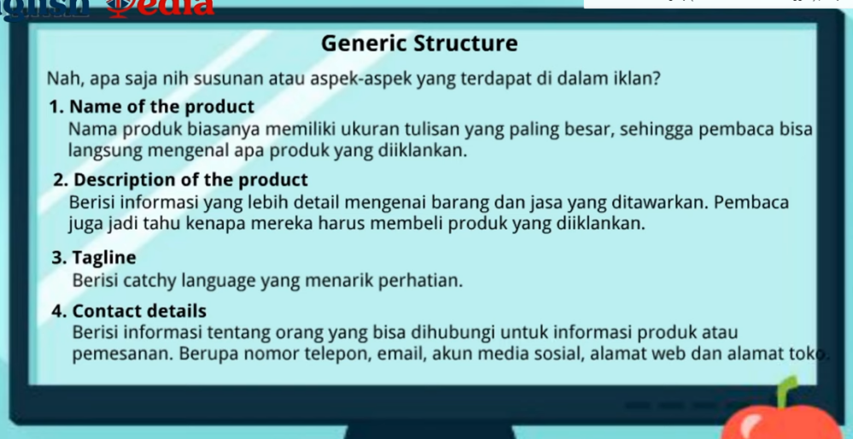
The explanation generic struture of advertising material is collaborated with Indonesian so that It can be understood by students clearly.
Figure 7.The Developing of material advertisement from Generic Structure
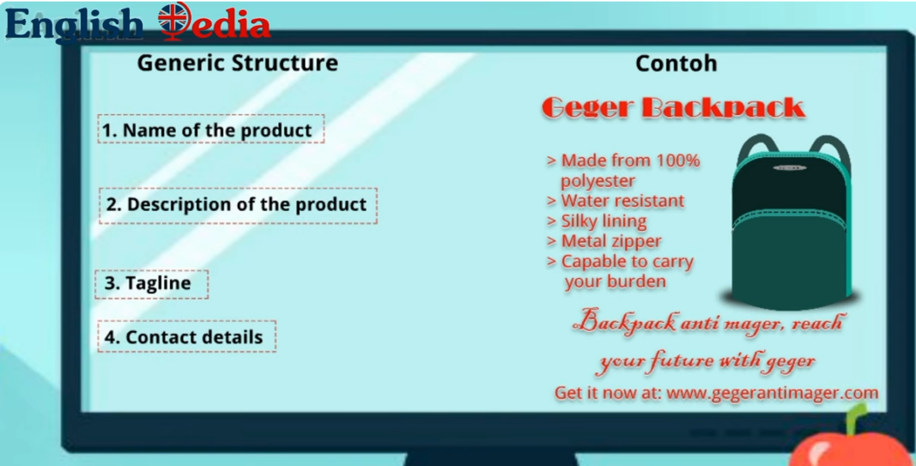
Explanation Generic Structure and example a product by picture
Figure 8.The Developing of material advertisement

A tagline is a short phrase used to convey the identity, values, or purpose of a brand, product, or company in a concise and compelling manner.
Figure 9. the Developing of material advertisement from Generic Structure
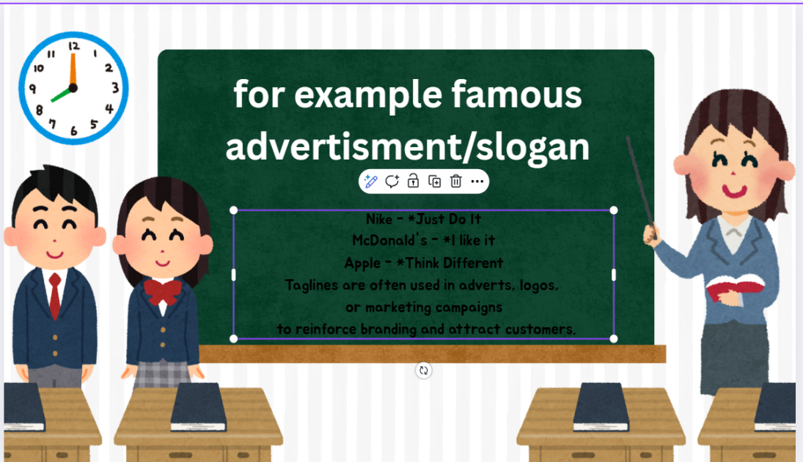
The words or sentences are used in advertisement by Power point Canva
Figure 10. The Developing of material advertisement from Generic Structure
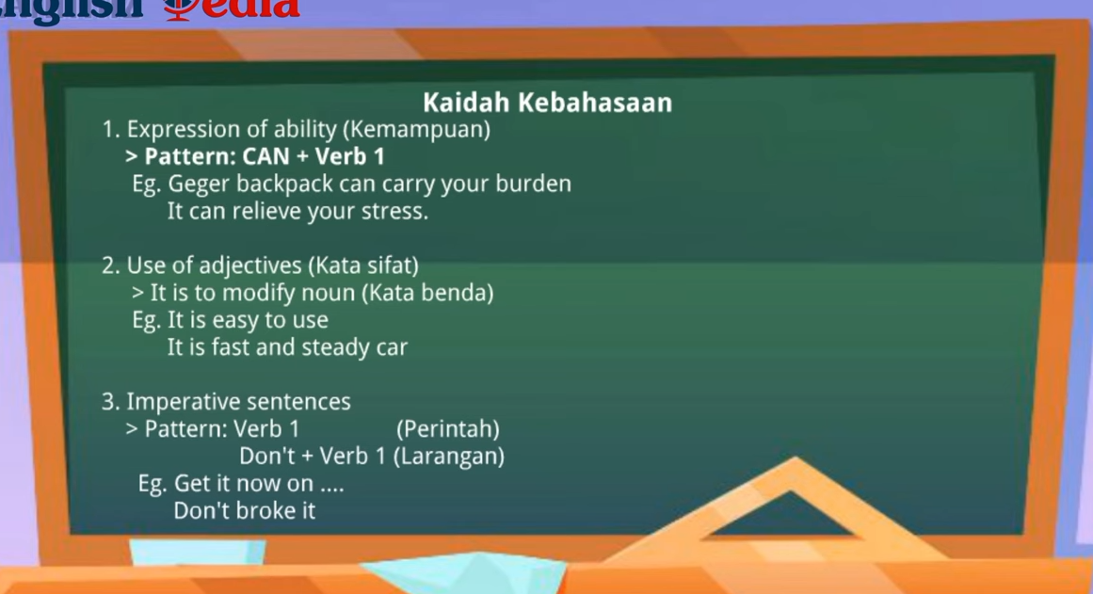
The learners also need to understand the linguistic rules in writing advertisements.
Figure 11.The Developing of material advertisement from Generic Structure
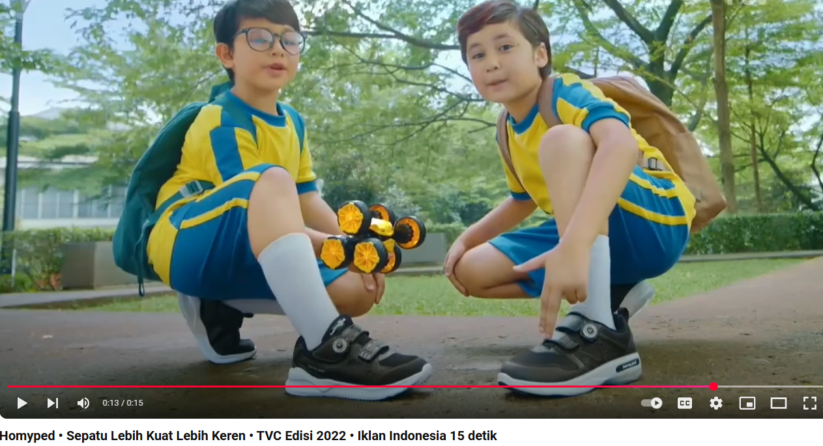
Developing advertising material based need of students and things are interesting and favoured by children in class IX. Giving many Example advertisiments
Simple Advertisment
Figure 12.The Developing of material advertisemen
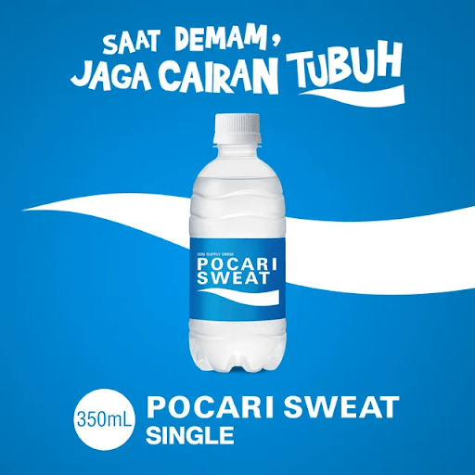
Interisting adverisment
Figure 13.The Developing of material advertisement
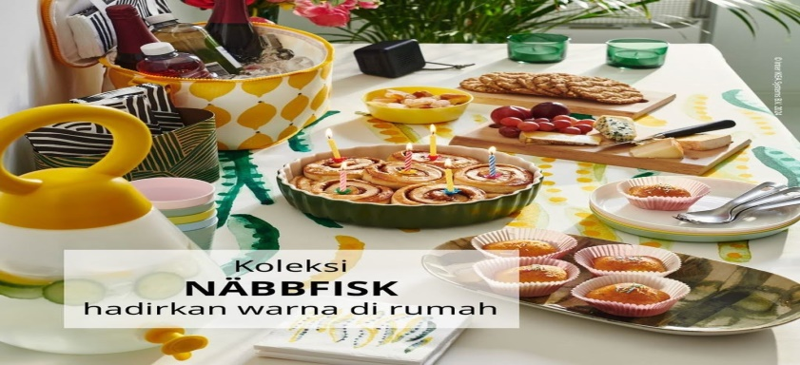

Public Service Advertisement

Figure 14.The Developing of material advertisement
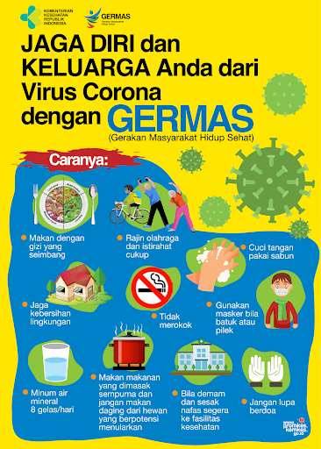

The Example of Column Advertisment

Figure 15.The Developing of material advertisement

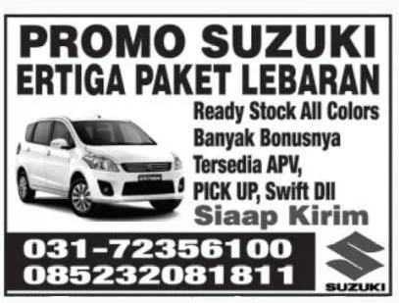

Provide many examples of advertising to students can open students' minds to be more imaginative in making a reminiscent advertisement that they like.

Figure 16.The Developing of material advertisement

Example of Display Advertising
4.1.1 Media Expert
The assessment by media design experts aims to determine the feasibility of based English teaching materials in terms of media design. Media design experts give an assessment according to the media design expert grid. In the preparation of teaching materials, it is necessary for authors to master design skills, so that the physical appearance of teaching English materials will be able to arouse students' motivation in writing and studying them.

Figure 17.The Developing of material advertisement from Generic Structure Using Vidio of a Product by Power point Canva
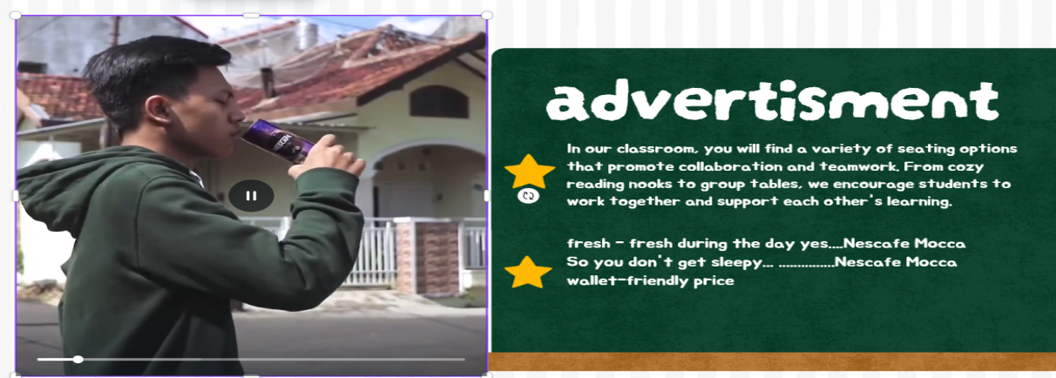

Figure 18.The Developing of materia


Example of a Print Media Advertisement
4.1.2. Material Substance
The validation of the English advertisement material in this teaching material is intended to be able to see the feasibility of the material in the developed teaching material. The material substance expert assessment includes three aspects, namely, content feasibility aspects, presentation feasibility aspects and linguistic aspects.
- Conten feasibility aspect is Assess whether the content of the advert is fit for purpose, accurate, relevant, and does not scatter the audience. This includes clarity of message, truthfulness of information, and alignment with prevailing values and norms.
- Presentation feasibility aspects are Presentation feasibility aspects include: Layout and Visual Design by looking at the composition of advertising elements (text, images, colours, and graphics) must be balanced, harmonious and the use of illustrations or photos must be relevant to the message to be conveyed. for Visuals must be of high quality and not blurry or broken. Advertising materials must have uniqueness so as not to be boring and Presentation of messages can use storytelling or interesting surprise elements.
- The linguistic aspect of being able to use correct grammar according to the rules of English by using a familiar or persuasive language style according to the context of the advert. Effectiveness in Communication Sentences should be short, concise, and clear to be easily digested in a short time,Use words that have an emotional impact according to the purpose of the advert.
Figure 19. Example of Non Commercial advertisement
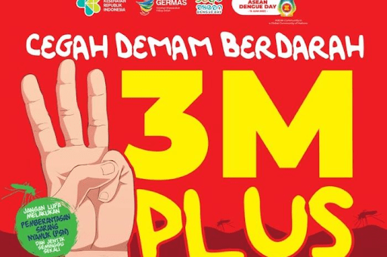

Figure 20.Example of a Commercial Advertisement
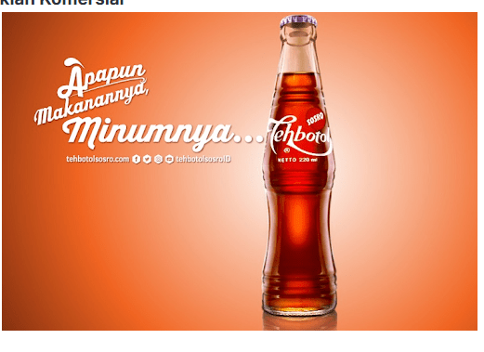
4.1.3 Implementation Stage.
The first step for the Canva power point application in making or creating simple adverts according to the learners' wishes.

Figure 21. The First Step to Writing Advertisement by Canva
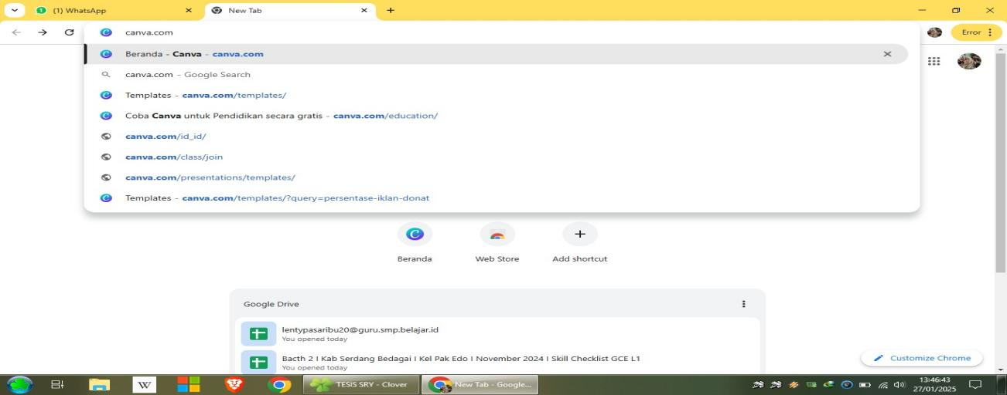
Figure 22.The Second Step, The students can be choice a picture in Canva
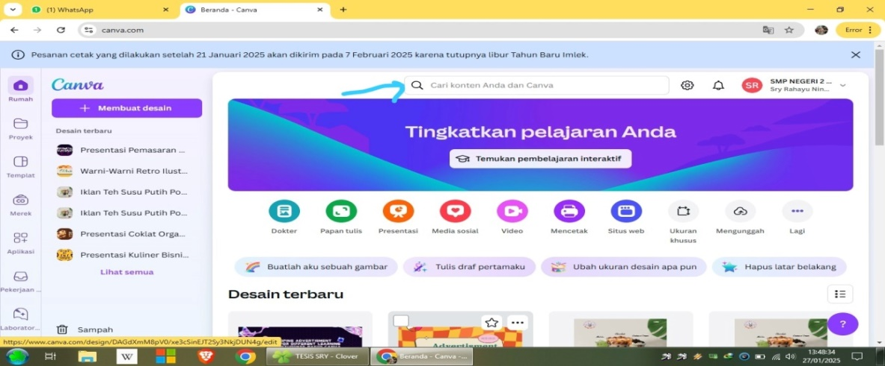
Figure 23.The Third step, after choice a picture and write a sentence with Text
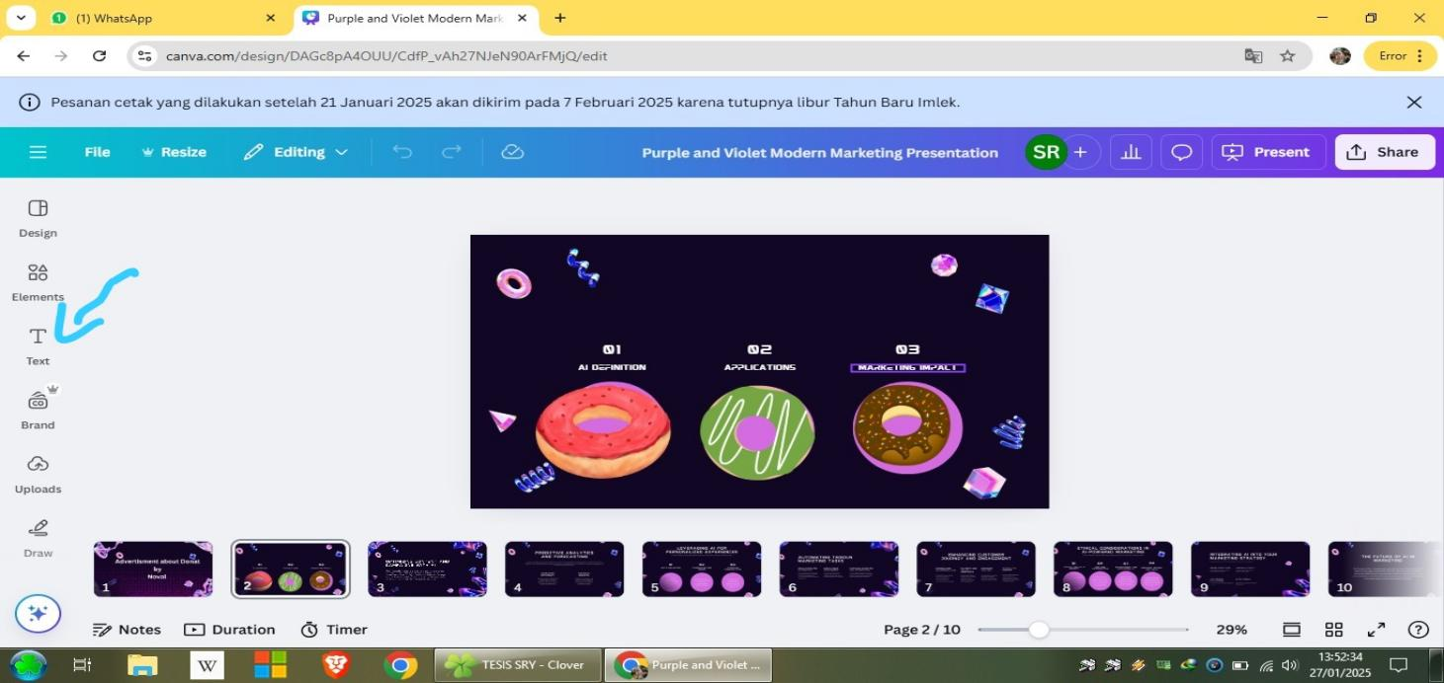
Figure 24.The Third step, after choice a picture and write a sentence with Text
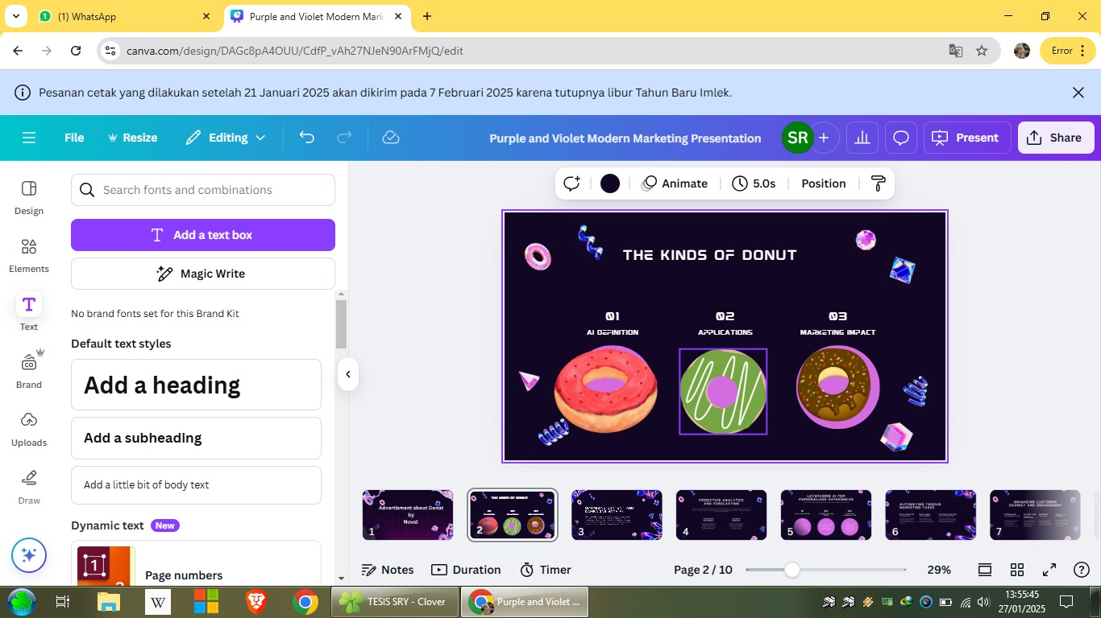
Figure 25. The fourth step, The students write a product and elements
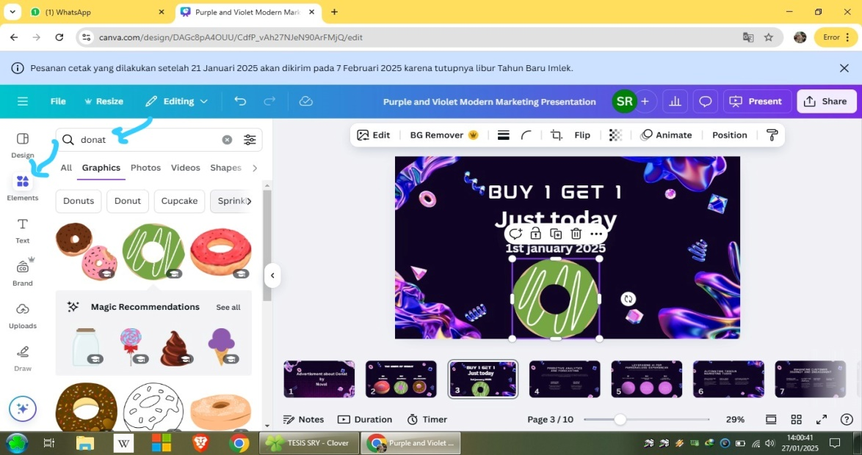
Figure 26.The result of Canva Power point cab be download and share to wa group to presentation.
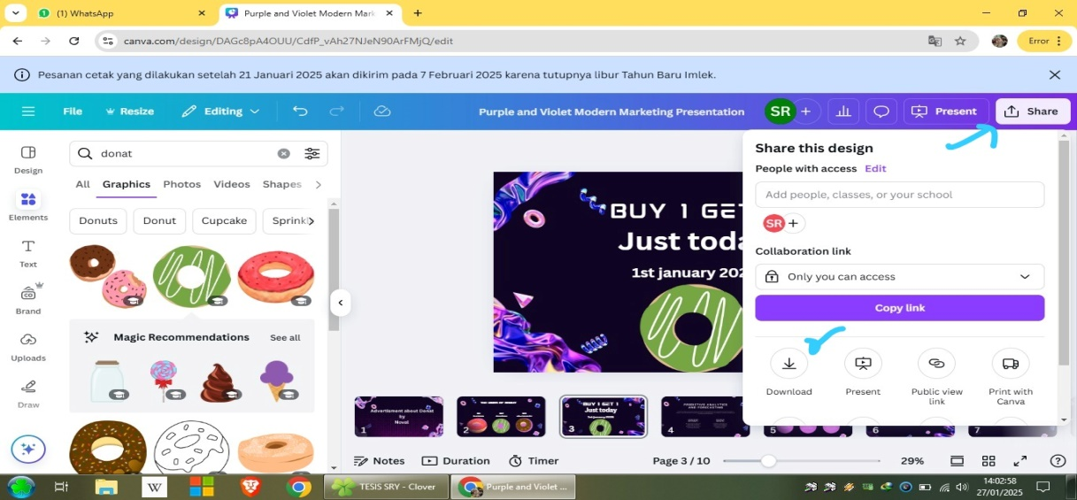
Figure 27.The way to download it is to press the top corner, there is a share text, then press download you can choose the file type according to your worksheet
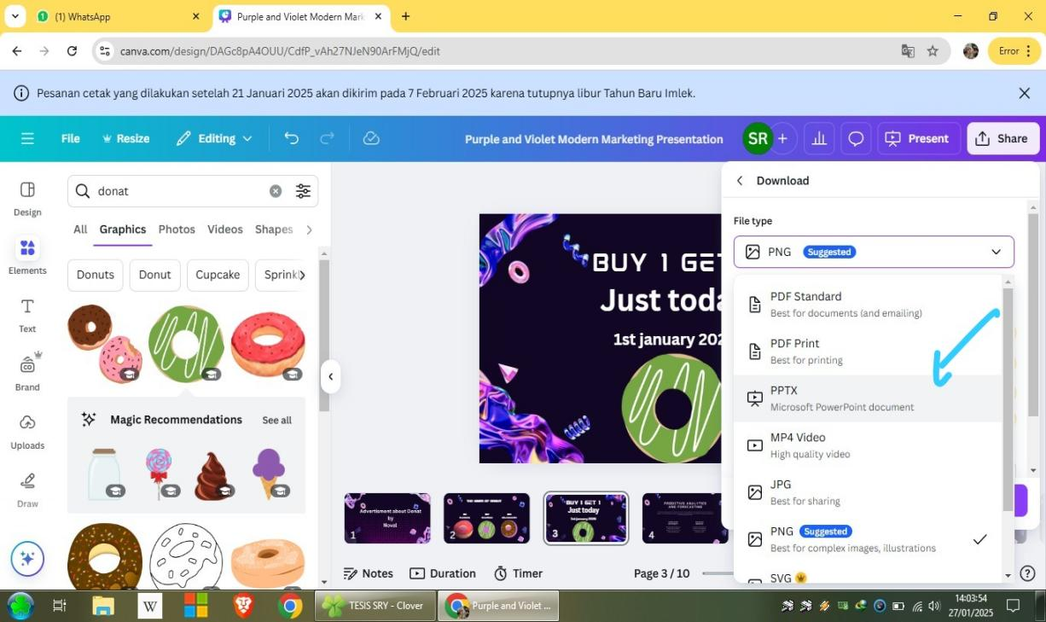

Figure 28.The after choice a picture and write a sentence with Text
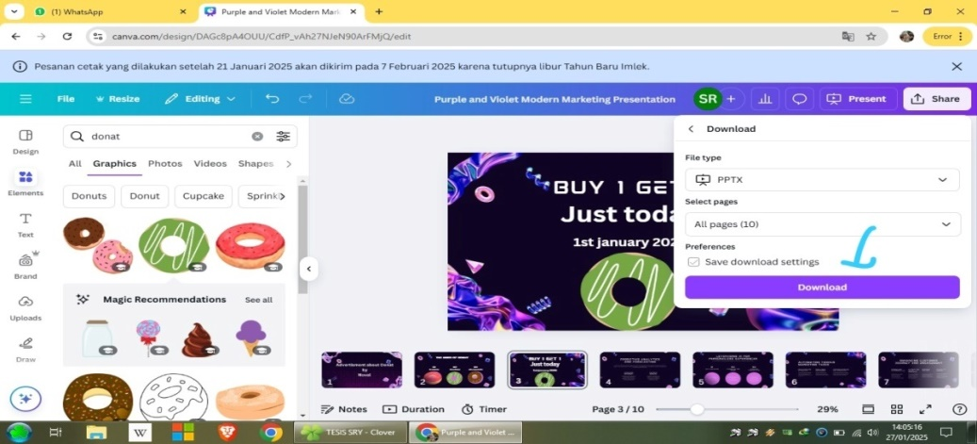
Finally just press download
4.2. Expert Validation Results
After validating the English Advertisment Material, the process is carried out tests on students Ninth Grade at SMP Negeri 2 Perbaungan. The researcher gave test to know the practicalities of English Advertisment Writing materials. While, in developing English Advertisment Writing materials the researcher used ADDIE model. Researcher was consisted of five phases that include analysis, design, development, implementation, and evaluation.
4.2.1. Analysis
Analysis In analysis step, the researcher analyzed students' needs and students' interest. Students' needs was analyzed through syllabus that is managed by Freedom Curriculum (Kurikulum merdeka ). Besides, the researcher also analyzed the Worksheet that students used in learning English. While, students' interest was analyzed by identifying the students' interest by giving the questionnares.
The needs analysis included the syllabus and students' needs. Firstly, the analysis of the syllabus of junior high school grade IX students should learn to write about the type of advertisement they choose. In the competency standards and basic competencies, students are expected to be able to write simple and interesting Advertising sentences with the display of using Canva Power point as a student presentation where student achievement is measured by indicators. Secondly, students‘ needs are analysed by identifying students’ needs, interests and performance. In terms of performance context, there are two meetings in a week, it takes 80 minutes for each meeting.
The standard competence and basic competences for The Ninth grade students can be seen in appendix.
1). The result of qoustionaire for the Nineth grade students the questionnaire consisted of 15 questions with four answers.
A). goal
Table 4.1 The Questions Number 9 and 10
NO | QUESTION | ITEM | N | PERCENTAGE
9 | In your opinion, how is the learning process of English Advertising especially writing skills in the classroom. | a. very interesting | 14 | 46.7%
9 |  | b. Less intersting | 2 | 3%
9 |  | c. Not interesting | 16 | 50%
9 |  | d. Very not intersting | 0 | 0%
10 | How important do you think it is to be able to write advertising in English? | a. Very important | 19 | 60%
10 |  | b. Quiet important | 4 | 10%
10 |  | c. Less important | 9 | 30%
10 |  | d. Not important | 0 | 0%

Questions 9 and 10 aimed to seek information about students' opinions and interest in classroom learning activities, especially writing in advertising English. Based on the results of the questionnaire on question number 9 (50%) of students thought that writing activities in class were less interesting to them. This is because in the teaching and learning process, they only use English reading materials and explanations from teachers that are less interesting to them. In question number 10, most students said that learning to write advertising is very important in English. This means that students need writing activities to improve their English material in advertising material in an interesting activity with different learning styles of students based on Canva Power Point.

B). Necessities
Table 4.2. The question Number 4,8, and 12
NO | QUESTION | ITEM | N | PERCENTAGE
4 | In your opinion , in addition to teaching materials / learning resources that are currently used in learning English , especially English Advertisment , is there still needed additional material to support English Advertisment Writing | a. very Needed | 24 | 80%
4 |  | b. Less Needed | 1 | 0,3%
4 |  | c. Not Needed | 5 | 16,7%
4 |  | d. Very not Needed | 0 | 0%
8 | Is understanding of the kind advertisement very necessary before understand in writing with student choice | a. Very necessary | 10 | 27%
8 |  | b. Necessary | 6 | 20%
8 |  | c. Less Necessary | 15 | 50%
8 |  | d. Unnecessary | 1 | 0,3%
12 | Do you think it is necessary to provide understanding and example images of writing interesting short advertisement sentences using canva Power point? | a. Verry necessary | 12 | 40%
12 |  | b. Necessary | 9 | 30%
12 |  | c. Less necessary | 9 | 30 %
12 |  | d.unnecessary | 0 | 0%

Questions 4, 8 and 12 aimed to find out students' needs for materials. In question number 4 (86.7%) students said that they need additional materials in learning English about advertisements. While in question number 8 and 12 most of the students said that types of advertising, providing examples of advertising images along with short sentences of canva Power point-based advertisements are important in learning English. This shows that they need more canva in making advertisements with Power point for their presentation as an understanding of the material. And English advertisement teaching materials are in written form so students are lazy to write short advertisements, they think the materials they use now are not interesting to them.
C). Wants
Table 4.3. The question Number 5,6,7 and 15
NO | QUESTION | ITEM | N | PERCENTAGE
5 | What kind advertisement writing materials do you want in learning English ? | a. picture | 12 | 40%
5 |  | b. short story / functional text | 7 | 16 %
5 |  | c. advertisement vidios | 13 | 44 %
5 |  | d. games | 0 | 0%
6 | What kind of advertisement task do you want in learning writing ? | a. multiple choices | 18 | 60%
6 |  | b. essay | 6 | 20%
6 |  | c. fill in the blank text | 0 | 0%
6 |  | d. answer based on picture | 6 | 20%
7 | What capacity building do you expect from learning English, especially in advertising? | a. To be able to add new vocabulary in advertising texts | 12 | 36,7%
7 |  | b. To be able to write short and interesting advertisement sentences well | 7 | 23,33%
7 |  | c. To be able to write short and interesting advertisement sentences well | 1 | 0,3 %
7 |  | d.To be able to comprehend the text and anwer questions correctly | 12 | 36,7%
15 | What kind of learning do you like | a. Individually | 3 | 10%
15 | What kind of learning do you like | b. In pair | 23 | 70%
15 | What kind of learning do you like | c. In group | 6 | 10%
15 | What kind of learning do you like | d. Whole class | 3 | 10%

The purpose of this questionnaire was to find out the students' desire to learn English especially in writing advertisements. In questions 5, 6, 7, and 15, there were no significantly different answers in each question. In questions 5, and 6, it was clear that the students liked English materials combined with lots of pictures, advertising videos, listening to dialogues. They also preferred to do multiple-choice tasks, although there was no significant difference between the 4 options. However, the researcher made the tasks in the English writing materials not only focused on multiple choice so that the tasks designed by the researcher still had varied exercises although most of them were in multiple choice form.
Based on the answers to questions number 7 and 15, there was no significant difference between the 4 answer choices, but most of the students hoped that they would like to be able to create short advertisements in the form of written text, images, videos, and podcasts using Canva powerpoints according to the type of text they want by linking project learning which is to produce products and market them in the school and residential environment with friends, teachers, neighbours, or the general public in traditional and modern ways such as social media. they prefer to work in pairs, and groups.
D). Topic
Table 4.4. The question Number 11
NO | QUESTION | ITEM | N | PERCENTAGE
11 | In your opinion , what topics of do you like in learning English advertisement , especially writing | a. Daily Life  ( family, school life , and community, etc) | 25 | 76,7%
11 |  | b. Health | 1 | 13,33%
11 |  | c. Nature | 6 | 6,7%
11 |  | d. Economics And socioculture | 0 | 0%

The purpose of this question was to find the information about the students' preference for the topic of advertisement materials. Based on xl the table above, there is 60% students' choose daily life topic. It was present in the English advertisment writing material, because the material was designed by the researcher related to daily life.

E). Material
Table 4.5. The question Number 1,2.3 and 14
NO | QUESTION | ITEM | N | PERCENTAGE
1 | Are teaching advertisement materials / learning resources used in writing in the classroom interesting ? | a. very  interesting | 12 | 40%
1 |  | b. Less  interesting | 4 | 13,33%
1 |  | c. Not interesting | 16 | 46,7%
1 |  | d. Very not improving reading ability | 0 | 0%
2 | Have the teaching advertisement materials / learning resources currently used in Writing in the classroom improving your Writing ability | a. Very improving reading ability | 19 | 63%
2 |  | b. Quite improving reading ability | 11 | 36,7%
2 |  | c. Not impoving eading ability yet | 0 | 0%
2 |  | d. Not improving reading ability | 0 | 0%
3 | What capacity building do you expect form learning English especially in advertisement writing to different learning style students | a. To be able to improve vocabulary | 2 | 6,7%
3 |  | b. To be able to read well and correctly | 8 | 26,7%
3 |  | c. To be able to use the language used in text in daily activity | 22 | 66,7%
3 |  | d. To be able to comprehend the text and answer questions correctly | 0 | 0%
14. | Is the teaching materials / learning resources that are how used in English ressons especially sufficient your advertisment writing needs ? | a. Very sufficient | 25 | 76,7%
14. |  | b. sufficient | 1 | 3%
14. |  | c. Less sufficient | 6 | 20%
14. |  | d. Not sufficient | 0 | 0%

The purpose of these questions were to find out the appropriateness of the material especially in reading. To make the students' interested and easier to understand the material, the researcher combined the material in English reading materials with many pictures. It can seen that most of the students (60%) assumed that picture is important in learning reading, it can make students motivated and interested in learning. Beside, these questions were to measure wheter the worksheet currently used interesting or not. Based on question number 1, the worksheet currently used was less interesting. However, in questions number 2 and 3, it can be seen that the worksheet was still unable to improve their reading ability yet and sufficient the students' reading need. It can be conclude that the worksheet which used was less interesting, so it was not improving the students' reading ability yet.
F). lack
Table 4.6. The question Number 13
NO | QUESTION | ITEM | N | PERCENTAGE
13 | What are the difficulties factors in learning advertisement writing ? | a. Comperhend of the advertisement material | 17 | 56,7%
13 |  | b. Comperhend the kind of text advertisement | 7 | 23%
13 |  | c. Comprehend the vocabulary of advertisement text | 6 | 20%
13 |  | d. Comprehend the functions of the advertisement material | 0 | 0%

The purpose of this question was to know the students' difficulties in learning writing. Based on the table above, there were different answers from 4 options. It can be seen that most of the students (86,7%) feel difficult advertisement material.
4.2.2. Design Stage
After doing the analysis, the next step is to design. This design stage includes two parts, namely compiling research instruments, making questions and teaching materials. (for Further see attachment A.2) student-made print advertising or short video adverts and podcasts.
4.2.3 Media Expert Validation
The assessment by media design experts aims to determine the feasibility of based English teaching materials in terms of media design. Media design experts give an assessment according to the media design expert grid. In the preparation of teaching materials, it is necessary for authors to master design skills, so that the physical appearance of teaching English materials will be able to arouse students' motivation in writing and studying them. The assessment was carried out by two lecturers, Sutikno, S.Pd., M.Pd., Ph.D (Graduate Director at Al-Washliyah Nusantara Muslim University Medan), and H. Asnawi, S.Pd., M. Hum (head of study program in English at Al-Washliyah Nusantara Muslim University Medan).
Table 4.7. Data on the Results of Assessment of English Teaching Media Design Experts
No | Statement | Evaluator |  | Maximum score
No | Statement | (1) | (2) | Maximum score
(1) | (2) | (3) | (4) | (5)
 | 1 | 3 | 4 | 4
2 | Picture on English advertisment writing material has illustrated the material outlined | 3 | 4 | 4
3. | The font size used in the English advertisement maerials module in writing is appropriate. | 3 | 4 | 4
4. | The clear variation of letters/fonts for the display of writing on the English advertismnet writing materials module is interesting. | 3 | 4 | 4
5. | The use of colour combinations between background text and images on this English advertisement writing materials module is appropriate. | 3 | 3 | 4
6. | The layout of the images used in this English advertisement Writing materials module is appropriate. | 3 | 4 | 4
7. | The images used in this English advertisement writing materials module are overall attractive. | 4 | 4 | 4
8. | The overall appearance of the English advertisement writing materials module is attractive | 4 | 4 | 4
9. | This English advertisement writing materials module is suitable for use by students. | 3 | 4 | 4
 | SMP
 | $$\sum{SCORE}$$ | 29 | 35 | 36
 | Percentage | 80,5% | 97,2% | 100%
 | criteria | Very high

Based on the questionnaire that has been filled by expert, there were some parts that need revision, there are following comments and suggestions from design expert. Design expert stated that the design of the product is very good and appropriate for the student-s, but it needs perfection of the product.
4.2.4 Material Substance Expert Assessment
The validation of the English advertisement material in this teaching material is intended to be able to see the feasibility of the material in the developed teaching material. The material substance expert assessment includes three aspects, namely, content feasibility aspects, presentation feasibility aspects and linguistic aspects.
The assessment was carried out by two lecturers, Sutikno, S.Pd., M.Pd., Ph.D (Graduate Director at Al-Washliyah Nusantara Muslim University Medan), and H. Asnawi, S.Pd., M. Hum (head of study program in English at Al-Washliyah Nusantara Muslim University Medan).
Table 4.8 data on the result of assessment of English Teaching materials design experts
NO | Statement aspect | Assessment criteria | Evaluator |  | Maximum score
NO | Statement aspect | Assessment criteria | (I) | (II) | Maximum score
(1) | (2) | (3) | (3) | (4) | (5)
A | content feasibility | 1 | 3 | 4 | 4
A | content feasibility | 2 | 3 | 4 | 4
A | content feasibility | 4 | 3 | 4 | 4
A | content feasibility | 5 | 4 | 4 | 4
A | content feasibility | 6 | 3 | 4 | 4
A | content feasibility | 7 | 3 | 4 | 4
 |  | 8 | 3 | 4 | 4
 |  | 9 | 3 | 4 | 4
 |  | 10 | 3 | 4 | 4
 |  | 11 | 3 | 4 | 4
 |  | 12 | 3 | 4 | 4
B | Komponen  kebahasaan | 1 | 3 | 4 | 4
B | Komponen  kebahasaan | 2 | 4 | 4 | 4
B | Komponen  kebahasaan | 3 | 3 | 4 | 4
Score |  |  | 45 | 60 | 60
Precentage |  |  | 75% | 100% | 100%
Criteria |  |  | Very high

Based on the questionnaires that have been filled out by experts, there are several parts that need to be revised. The design expert stated that the product design was very good and suitable for students, but there was a need for product improvement.
4.2.5 Implementation Stage
The implementation stage is the stage of applying the learning tools that have been developed in the design and development stages. At this stage, learning to write advertising texts is carried out in accordance with the teaching modules that have been compiled. The learning activities begin with preliminary activities, which include greeting the students, checking attendance, and conveying the learning objectives. The teacher also conducts an apperception by relating the learning material to the students' experiences with advertisements that are often encountered in everyday life.
In the core activity, the teacher presents examples of advertising texts in various media forms, such as posters and advertising videos. Next, the teacher explains the meaning, purpose, and characteristics of advertising texts. Students are divided into several groups to analyse the elements of advertising through the worksheets provided. Based on the results of the analysis, students write advertising texts according to the specified products. During the learning process, the teacher acts as a facilitator by providing guidance and feedback to students.
The learning activity ends with a closing activity that includes learning reflection, reinforcement of the material that has been learned, and delivery of learning conclusions. The teacher also conveys the follow-up to the learning in the next meeting.There were thirty two students of IX -3 class of SMP NEGRI 2 PERBAUNGAN. Before the students used the product, the researcher show the product to the students in order to explain the process of using the product.
Table 4.9. Student Response Questionnaire Result Data
No | Respon  dent | Evaluation
No | Respon  dent | 1 | 2 | 3 | 4 | 5 | 6 | 7 | 8 | 9 | 10 | 11 | 12 | 13 | 14 | 15 | 16 | 17
1 | AK | 3 | 3 | 3 | 3 | 3 | 3 | 3 | 3 | 3 | 3 | 3 | 3 | 3 | 3 | 3 | 3 | 3
2 | ACPA | 4 | 3 | 2 | 3 | 3 | 2 | 3 | 2 | 3 | 3 | 4 | 3 | 3 | 4 | 3 | 3 | 4
3 | AAP | 4 | 3 | 3 | 3 | 3 | 3 | 3 | 3 | 4 | 3 | 4 | 4 | 4 | 3 | 4 | 3 | 3
4 | ASG | 1 | 1 | 1 | 3 | 4 | 4 | 1 | 1 | 4 | 1 | 4 | 3 | 1 | 1 | 3 | 1 | 4
5 | APB | 4 | 4 | 4 | 3 | 3 | 4 | 4 | 4 | 3 | 3 | 4 | 3 | 3 | 4 | 4 | 3 | 3
6 | ALOS | 3 | 3 | 3 | 3 | 3 | 3 | 3 | 3 | 3 | 3 | 2 | 2 | 2 | 2 | 3 | 2 | 1
7 | AS | 3 | 3 | 3 | 3 | 3 | 3 | 3 | 3 | 4 | 3 | 3 | 3 | 3 | 3 | 3 | 3 | 3
8 | AP | 3 | 3 | 4 | 3 | 4 | 4 | 3 | 3 | 3 | 3 | 3 | 3 | 3 | 3 | 4 | 3 | 3
9 | BN | 3 | 3 | 3 | 3 | 3 | 3 | 2 | 1 | 3 | 3 | 3 | 3 | 3 | 3 | 3 | 3 | 3
10 | DHI | 3 | 2 | 4 | 2 | 4 | 3 | 1 | 2 | 3 | 2 | 2 | 1 | 4 | 3 | 3 | 2 | 4
11 | FA | 4 | 3 | 4 | 4 | 3 | 3 | 3 | 4 | 3 | 4 | 4 | 3 | 4 | 4 | 3 | 3 | 4
12 | KBH | 3 | 3 | 4 | 3 | 3 | 3 | 3 | 3 | 3 | 3 | 2 | 3 | 2 | 3 | 3 | 3 | 3
13 | MPAD | 3 | 4 | 3 | 3 | 3 | 4 | 3 | 2 | 3 | 3 | 3 | 3 | 2 | 4 | 3 | 4 | 3
14 | MAR | 4 | 3 | 3 | 3 | 3 | 4 | 4 | 4 | 4 | 3 | 4 | 4 | 3 | 3 | 3 | 4 | 3
15 | MAB | 4 | 1 | 3 | 2 | 4 | 2 | 3 | 2 | 4 | 4 | 4 | 3 | 2 | 4 | 1 | 4 | 4
16 | MR | 4 | 3 | 4 | 2 | 3 | 3 | 3 | 2 | 3 | 3 | 4 | 3 | 3 | 4 | 3 | 3 | 4
17 | MHM | 3 | 3 | 3 | 4 | 3 | 3 | 3 | 2 | 2 | 3 | 4 | 3 | 3 | 3 | 3 | 2 | 2
18 | MR | 3 | 3 | 3 | 3 | 3 | 3 | 3 | 3 | 3 | 3 | 3 | 3 | 3 | 3 | 3 | 3 | 3
19 | MRRS | 3 | 2 | 4 | 4 | 3 | 3 | 4 | 3 | 4 | 3 | 4 | 3 | 4 | 3 | 3 | 4 | 3
20 | MZH | 3 | 3 | 3 | 4 | 2 | 3 | 3 | 4 | 3 | 3 | 3 | 3 | 3 | 3 | 3 | 3 | 3
21 | MA | 3 | 2 | 3 | 3 | 3 | 2 | 3 | 2 | 3 | 3 | 3 | 2 | 3 | 3 | 3 | 3 | 3
22 | NACD | 3 | 3 | 3 | 2 | 3 | 2 | 3 | 3 | 3 | 3 | 2 | 3 | 3 | 3 | 3 | 3 | 3
23 | PFLG | 3 | 3 | 3 | 2 | 3 | 2 | 3 | 3 | 3 | 2 | 3 | 3 | 2 | 3 | 3 | 3 | 3
24 | PMS | 3 | 3 | 3 | 3 | 3 | 2 | 4 | 2 | 3 | 3 | 3 | 3 | 3 | 3 | 3 | 3 | 3
25 | NS | 3 | 3 | 4 | 3 | 3 | 3 | 4 | 4 | 4 | 4 | 4 | 4 | 4 | 4 | 4 | 4 | 3
26 | RS | 3 | 3 | 3 | 3 | 3 | 3 | 3 | 3 | 3 | 3 | 3 | 3 | 3 | 3 | 3 | 3 | 3
27 | RDA | 3 | 3 | 2 | 3 | 3 | 3 | 2 | 3 | 3 | 3 | 3 | 3 | 3 | 3 | 3 | 3 | 3
28 | RW | 3 | 2 | 3 | 4 | 3 | 4 | 4 | 4 | 3 | 4 | 4 | 3 | 4 | 3 | 4 | 4 | 3
29 | SM | 2 | 3 | 3 | 2 | 3 | 3 | 2 | 2 | 3 | 2 | 3 | 3 | 3 | 3 | 3 | 2 | 2
30 | WMY | 2 | 3 | 3 | 2 | 3 | 3 | 3 | 2 | 3 | 2 | 3 | 3 | 4 | 2 | 3 | 3 | 3
31 | WA | 2 | 3 | 3 | 3 | 3 | 3 | 3 | 3 | 3 | 3 | 3 | 3 | 3 | 3 | 3 | 3 | 3
32 | YA | 2 | 3 | 4 | 4 | 3 | 3 | 4 | 3 | 4 | 3 | 4 | 3 | 4 | 3 | 3 | 4 | 3
Total score |  | 97 | 89 | 94 | 88 | 93 | 90 | 89 | 82 | 96 | 87 | 99 | 89 | 89 | 93 | 93 | 90 | 94
percentage |  | 76.07 %
category |  | Very high

Based on the table above, it shows that the average number of students' responses received an average of 76,07% which was included in the very High category.
4.2.6 Evaluation stage
The last stage in ADDIE is the evaluation stage. The researcher assessed this ability by following the results of the assessment test which was distributed to the students getting a good assessment with the overall average of the students' tests showing the categories.
The following is the assessment of all students in grade IX.
Table 4.10. score assessment students last
NO | The initials of the student | Total
1 | AK | 80
2 | ACP | 80
3 | AAP | 80
4 | ASG | 80
5 | AFB | 80
6 | ALON | 80
7 | AS | 80
8 | AP | 80
9 | B | 80
10 | DHI | 80
11 | FA | 80
12 | KBH | 80
13 | MPAD | 80
14 | MAR | 80
15 | MA | 80
16 | MR | 80
17 | MHM | 80
18 | MR | 80
19 | MRRN | 80
20 | MZH | 80
21 | MA | 80
22 | NACD | 95
23 | PFBLG | 80
24 | PMS | 80
25 | RS | 80
26 | RS | 100
27 | RDA | 80
28 | RW | 80
29 | SM | 80
30 | WMY | 80
31 | WA | 80
32 | YA | 80
Total score
Percentage Amount
Category

Based on the table above shows that the average value of students obtained an average number of 81,18%.

6. The Date of Pre test and Post Test Result
After validation the English advertisement material, the process is carried out pre test and post test result student ninth grade at SMP Negeri 2 Perbaungan. The researcher gave test to know the practicalities of English advertisement writing material.
Table 4.11. Date of Pre Test Advertisment Writing
No | Nama Peserta Didik | Assessment Criteria |  |  |  | Maximum score
 | IX-3 | Creativity  Unique and Fresh ideas in advertisment writing | Appropriate  Content is to the learning style and context of the product. | Language  Interesting, persuasive, and easy-to-understand language | Structure  Clear, logical, and effective sentence structure | Creativity= 30 %  Appropriate=30%  Language  =20 %  Structure =20 %
1 | Aldi Khoirullansyah | 20 | 20 | 15 | 15 | 70%
2 | Alicia Cristiani P. | 25 | 20 | 15 | 15 | 75%
3 | Almira Anindya Prayogi. | 20 | 25 | 15 | 15 | 75%
4 | Angel Syafudin Br G | 20 | 20 | 15 | 20 | 75%
5 | Angelina Florensia B. | 15 | 15 | 15 | 15 | 60%
6 | Arina Letisa Oktapia Nst. | 20 | 15 | 15 | 15 | 65%
7 | Aynun Syahfitri | 20 | 25 | 15 | 15 | 75%
8 | Azril Pratama | 20 | 15 | 15 | 15 | 60%
9 | Badaruddin | 20 | 15 | 15 | 15 | 60%
10 | Daffa Hafiz Ibni | 20 | 20 | 15 | 15 | 70%
11 | Fatimah Azzahra | 20 | 20 | 15 | 20 | 75%
12 | Kesi Br Hombing | 15 | 15 | 20 | 20 | 70%
13 | MHD. Prabu aditya Dharma | 15 | 20 | 15 | 20 | 70%
14 | MHD. Alfata Riza | 20 | 15 | 15 | 15 | 65%
15 | Minorinis Amelia Baene. | 20 | 25 | 15 | 19 | 79%
16 | M. Haqqi Mullafatih | 20 | 20 | 15 | 15 | 70%
17 | M. Rehan | 20 | 15 | 20 | 15 | 70%
18 | M. Risky Ramadhan Nst. | 20 | 20 | 15 | 15 | 70%
19 | M. Zildan Habib | 20 | 20 | 20 | 15 | 75%
20 | Mutiara Anjari | 20 | 15 | 15 | 15 | 65%
21 | Natasya Abel Charistiany | 20 | 20 | 20 | 15 | 75%
22 | Pricilia Vanesa Br LG | 25 | 25 | 15 | 20 | 85%
23 | Prinsah Melati Surbakti. | 20 | 15 | 15 | 15 | 65%
24 | Rama Singgih | 15 | 15 | 15 | 20 | 65%
25 | Renaldi Syah Putra | 15 | 15 | 15 | 20 | 65%
26 | Reza dwi ananda | 15 | 15 | 20 | 15 | 65%
27 | Risky Wardana | 20 | 20 | 15 | 15 | 70%
28 | Syakila Mutaza | 20 | 20 | 15 | 20 | 75%
29 | Wesley Monang Youwe | 20 | 20 | 15 | 20 | 75%
30 | Wildan Afiya | 20 | 15 | 15 | 20 | 70%
31 | Winar | 20 | 20 | 15 | 20 | 75%
32 | Yuda Apriansyah | 15 | 15 | 15 | 15 | 60%

Based on the table above shows that the average value of students obtained an average number of 67,63 %
Table .4.12. Date Of Pre Test Advertisment of Presentation Assessment
No | Nama Peserta Didik | Assessment Criteria |  |  |  | Maximum score
 | IX-3 | Creativity  Unique and Fresh ideas in advertisment writing | Appropriate  Content is to the learning style and context of the product. | Language  Interesting, persuasive, and easy-to-understand language | Structure  Clear, logical, and effective sentence structure | Creativity= 30 %  Appropriate=30%  Language  =20 %  Structure =20 %
1 | Aldi Khoirullansyah | 20 | 20 | 15 | 15 | 70%
2 | Alicia Cristiani P. | 25 | 20 | 15 | 15 | 75%
3 | Almira Anindya Prayogi. | 20 | 25 | 15 | 15 | 75%
4 | Angel Syafudin Br G | 20 | 20 | 15 | 20 | 75%
5 | Angelina Florensia B. | 15 | 15 | 15 | 15 | 60%
6 | Arina Letisa Oktapia Nst. | 20 | 15 | 15 | 15 | 65%
7 | Aynun Syahfitri | 20 | 25 | 15 | 15 | 75%
8 | Azril Pratama | 20 | 15 | 15 | 15 | 60%
9 | Badaruddin | 20 | 15 | 15 | 15 | 60%
10 | Daffa Hafiz Ibni | 20 | 20 | 15 | 15 | 70%
11 | Fatimah Azzahra | 20 | 20 | 15 | 20 | 75%
12 | Kesi Br Hombing | 15 | 15 | 20 | 20 | 70%
13 | MHD. Prabu aditya D | 15 | 20 | 15 | 20 | 70%
14 | MHD. Alfata Riza | 20 | 15 | 15 | 15 | 65%
15 | Minorinis Amelia Baene. | 20 | 25 | 15 | 19 | 79%
16 | M. Haqqi Mullafatih | 20 | 20 | 15 | 15 | 70%
17 | M. Rehan | 20 | 15 | 20 | 15 | 70%
18 | M. Risky Ramadhan Nst. | 20 | 20 | 15 | 15 | 70%
19 | M. Zildan Habib | 20 | 20 | 20 | 15 | 75%
20 | Mutiara Anjari | 20 | 15 | 15 | 15 | 65%
21 | Natasya Abel Charistiany | 20 | 20 | 20 | 15 | 75%
22 | Pricilia Vanesa Br LG | 25 | 25 | 15 | 20 | 85%
23 | Prinsah Melati Surbakti. | 20 | 15 | 15 | 15 | 65%
24 | Rama Singgih | 15 | 15 | 15 | 20 | 65%
25 | Renaldi Syah Putra | 15 | 15 | 15 | 20 | 65%
26 | Reza dwi ananda | 15 | 15 | 20 | 15 | 65%
27 | Risky Wardana | 20 | 20 | 15 | 15 | 70%
28 | Syakila Mutaza | 20 | 20 | 15 | 20 | 75%
29 | Wesley Monang Youwe | 20 | 20 | 15 | 20 | 75%
30 | Wildan Afiya | 20 | 15 | 15 | 20 | 70%
31 | Winar | 20 | 20 | 15 | 20 | 75%
32 | Yuda Apriansyah | 15 | 15 | 15 | 15 | 60%

Rating Scale : 1 = Deficient 2 = Fair 3 = Good 4 = Very Good
To make it easier to understand, We can calculate the percentage of students in each grade range based on the total number of students: Range 1: 5 Student does not understand the material about 15,62 %.
Range 2:10 Students understand the material but need improvement about 31,25 %
Range 3: 12 Students understand the material well about 37,5 %
Range 4: 5 Students have demonstrated excellent understanding about 15,62 %.
Table 4.13. The Date of Post Test Advertisment Writing
No | Nama Peserta didik | Assessment Criteria
 |  | Creativity  ( 25 % ) | Content Alignment( 20 % ) | Language and Grammar( 20 % ) | Writing Structure  ( 15 % ) | Media Utilisation  ( 20 % ) | Maximum score
1 | Aldi Khoirullansyah | 15 | 20 | 20 | 12 | 15 | 82%
2 | Alicia Cristiani P. | 20 | 20 | 15 | 15 | 20 | 90%
3 | Almira Anindya Prayogi. | 20 | 15 | 20 | 25 | 20 | 90%
4 | Angel Syafudin Br Ginting | 22 | 15 | 20 | 15 | 20 | 92%
5 | Angelina Florensia B. | 15 | 15 | 20 | 15 | 13 | 78%
6 | Arina Letisa Oktapia Nst. | 15 | 16 | 20 | 15 | 13 | 79%
7 | Aynun Syahfitri | 15 | 20 | 20 | 15 | 20 | 90%
8 | Azril Pratama | 20 | 20 | 15 | 12 | 15 | 82%
9 | Badaruddin | 16 | 15 | 20 | 15 | 13 | 79%
10 | Daffa Hafiz Ibni | 20 | 16 | 15 | 15 | 13 | 79%
11 | Fatimah Azzahra | 17 | 20 | 15 | 15 | 17 | 84%
12 | Kesi Br Hombing | 16 | 20 | 15 | 15 | 17 | 83%
13 | MHD. Prabu aditya D | 16 | 19 | 15 | 15 | 17 | 82%
14 | MHD. Alfata Riza | 18 | 19 | 15 | 15 | 19 | 86%
15 | Minorinis Amelia Baene | 20 | 20 | 15 | 15 | 20 | 90%
16 | M. Haqqi Mullafatih | 15 | 19 | 18 | 15 | 19 | 86%
17 | M. Rehan | 20 | 17 | 15 | 15 | 17 | 84%
18 | M. Risky Ramadhan Nst | 20 | 17 | 15 | 15 | 20 | 88%
19 | M. Zildan Habib | 15 | 20 | 17 | 15 | 17 | 84%
20 | Mutiara Anjari | 20 | 17 | 15 | 15 | 16 | 85%
21 | Natasya Abel Charistiany. | 19 | 15 | 18 | 15 | 19 | 86%
22 | Pricilia Vanesa Br Lg | 23 | 20 | 15 | 15 | 20 | 93%
23 | Prinsah Melati Surbakti. | 17 | 14 | 20 | 15 | 13 | 79%
24 | Rama singgih | 17 | 20 | 15 | 15 | 16 | 85%
25 | Renaldi Syah Putra | 15 | 20 | 16 | 15 | 16 | 84%
26 | Reza dwi ananda | 15 | 19 | 19 | 14 | 19 | 86%
27 | Risky Wardana | 21 | 20 | 15 | 12 | 13 | 83%
28 | Syakila Mutaza | 15 | 20 | 20 | 13 | 13 | 83%
29 | Wesley Monang Youwe | 15 | 20 | 20 | 13 | 14 | 84%
30 | Wildan Afiya | 20 | 20 | 15 | 13 | 14 | 84%
31 | Winar | 20 | 20 | 15 | 15 | 20 | 90%
32 | Yuda Apriansyah | 17 | 14 | 20 | 15 | 13 | 79%

Based on the table above shows that the average value of students obtained an average number of 8,5 % .
Table 4.14. The Data of Post Test Advertisment Writing of Presentation
No | Nama Siswa | Assessment Criteria
 | IX-3 | Presentation Content | . Material Delivery | Use of Media | Audience Engagement | Appearance and Attitude | Assessment score  (1-4)
1 | Aldi Khoirullansyah | 4 | 2 | 3 | 3 | 3 | 3
2 | Alicia Cristiani P | 4 | 4 | 4 | 4 | 4 | 4
3 | Almira Anindya Prayogi. | 4 | 4 | 4 | 4 | 4 | 4
4 | Angel Syafudin | 4 | 4 | 4 | 4 | 4 | 4
5 | Angelina Florensia B. | 2 | 2 | 2 | 2 | 2 | 2
6 | Arina Letisa Oktapia Br Nst. | 2 | 3 | 2 | 4 | 4 | 3
7 | Aynun Syahfitri | 4 | 4 | 4 | 4 | 4 | 4
8 | Azril Pratama | 4 | 2 | 3 | 3 | 4 | 3
9 | Badaruddin | 2 | 2 | 2 | 2 | 2 | 2
10 | Daffa Hafiz Ibni | 4 | 4 | 4 | 3 | 4 | 4
11 | Fatimah Azzahra | 3 | 3 | 3 | 3 | 3 | 3
12 | Kesi Br Hombing | 3 | 3 | 3 | 3 | 3 | 3
13 | MHD. Prabu aditya.D | 3 | 3 | 3 | 3 | 3 | 3
14 | MHD. Alfata Riza | 3 | 3 | 3 | 3 | 3 | 3
15 | Minorinis Amelia .B | 4 | 4 | 4 | 4 | 4 | 4
16 | M. Haqqi Mullafatih | 3 | 3 | 3 | 3 | 3 | 3
17 | M. Rehan | 3 | 3 | 3 | 3 | 3 | 3
18 | M. Risky Ramadhan Nst | 3 | 3 | 3 | 3 | 3 | 3
19 | M. Zildan Habib | 4 | 4 | 3 | 4 | 4 | 4
20 | Mutiara Anjari | 3 | 3 | 3 | 3 | 3 | 3
21 | Natasya Abel Charistiany.. | 3 | 3 | 3 | 3 | 3 | 3
22 | Pricilia Vanesa Br LB | 4 | 4 | 4 | 4 | 4 | 4
23 | Prinsah Melati Surbakti | 2 | 2 | 2 | 2 | 2 | 2
24 | Rama singgih | 3 | 3 | 3 | 3 | 3 | 3
25 | Renaldi Syah Putra | 3 | 3 | 3 | 3 | 3 | 3
26 | Reza dwi ananda | 3 | 3 | 3 | 3 | 3 | 3
27 | Risky Wardana | 3 | 3 | 3 | 3 | 3 | 3
28 | Syakila Mutaza | 3 | 3 | 3 | 3 | 3 | 3
29 | Wesley Monang Youwe | 3 | 3 | 3 | 3 | 3 | 3
30 | Wildan Afiya | 3 | 3 | 3 | 3 | 3 | 3
31 | Winar | 4 | 4 | 4 | 4 | 4 | 4
32 | Yuda Apriansyah | 2 | 3 | 1 | 2 | 2 | 2

The percentage of students in each grade range based on the total number of students:
Range 1: No Student does not understand the Advertidment material about 0 % ,
Range 2: Students understand the material but need improvement about 6,25 %.
Range 3:17 Students understand the material well about 53,12 %,
Range 4: 13 Students have demonstrated excellent understanding about 40,63 %
Rating Scale
- 1 = Deficient
- 2 = Fair
- 3 = Good
- 4 = Very Good
The following is a table of pre-test, post-test advertisment Writing of Different Learning Style Based Power point Canva at the Ninth Grade Three and the difference in scores for each students.
Diketahui : dˉ(is the average difference) =
n is the number of pair data (students) = 32
𝑑i(Calculate the score difference) = 470

dˉ=∑ 𝑑𝑖
n
dˉ = 470
32
dˉ = 14,69 %
- The following is a table of pre-test, post-test Presentation advertisment Writing of Different Learning Style Based Power point Canva at the Ninth Grade Three and the difference in scores for each students
Table 4.15.The Data of Different Score Pre Test and Post Test Advertisment Writing of Presentation
Nama Peserta Didik Pre Post D
Aldi Khoirullansyah 70 82 5740
Alicia Cristiani P. 75 90 67125
Almira Anindya Prayogi 75 90 67125
Angel Syafudin Br G 75 92 68925
Angelina Florensia B. 60 78 46620
Arina Letisa Oktapia Nst. 65 79 51270
Aynun Syahfitri 75 90 67125
Azril Pratama 60 82 48900
Badaruddin 60 79 47040
Daffa Hafiz Ibni 70 79 54960
Fatimah Azzahra 75 84 62925
Kesi Br Hombing 70 83 57820
MHD. Prabu aditya Dharma 70 82 56790
MHD. Alfata Riza 65 86 55805
Minorinis Amelia Baene. 79 90 71051
M. Haqqi Mullafatih 70 86 60050
M. Rehan 70 84 58130
M. Risky Ramadhan Nst. 70 88 61570
M. Zildan Habib 75 84 62925
Mutiara Anjari 65 85 54910
Natasya Abel Charistiany 75 86 64425
Pricilia Vanesa Br LG 85 93 78920
Prinsah Melati Surbakti 65 79 51270
Rama Singgih 65 85 54910
Renaldi Syah Putra 65 84 54275
Reza dwi ananda 65 86 55555
Risky Wardana 70 83 57820
Syakila Mutaza 75 83 61725
Wesley Monang Youwe 75 84 62925
Wildan Afiya 70 84 58130
Winar 75 90 67125
Yuda Apriansyah 60 79 47040

D=(X1​×X2​)−X1​
- X1X_1X1​ = nilai Pre Test
- X2X_2X2​ = nilai Post Test
For calculation Example :
- Aldi Khoirullansyah → Pre Test = 70, Post Test = 82
D=(70×82)−70=5740D = (70 \times 82) - 70 = 5740D=(70×82)−70=5740
So the result is much bigger because we multiply first and then subtract.
I'll explain step by step so it's clear how to get the value D with the formula::
D=(X1×X2)−X1D = (X_1 \times X_2) - X_1
Where :
- X1X_1 = nilai Pre Test
- X2X_2 = nilai Post Test

The First Example: Aldi Khoirullansyah
- Pre Test (X1X_1) = 70
- Post Test (X2X_2) = 82
D=(70×82)−70D = (70 \times 82) - 70 D=5740−70=5670D = 5740 - 70 = 5670 . I wrote 5740 directly before, but it turns out that after calculating in detail, it has to be reduced by 70 again → the final result is 5670

The second Example :Pricilia Vanesa Br LG
- Pre Test (X1X_1) = 85
- Post Test (X2X_2) = 93
D=(85×93)−85D = (85 \times 93) - 85 D=7905−85=7820D = 7905 - 85 = 7820

The Third Example :Azril Pratama
- Pre Test (X1X_1) = 60
- Post Test (X2X_2) = 82
D=(60×82)−60D = (60 \times 82) - 60 D=4920−60=4860D = 4920 - 60 = 4860
So, the process is to first multiply the pre-value by the post-value, then subtract the pre-value from the result. That is why the result D is large, because it is the multiplication of two percentages.
using the latest reduction results so that everything is accurate
Diketahui : dˉ(is the average difference) =
n is the number of pair data (students) = 32
𝑑i(Calculate the score difference) = 23
dˉ=∑ 𝑑𝑖
n
dˉ = 23
32
dˉ = 0,7
Table 4.16. The Data of Different Score Pre Test and Post Test Advertisment Writing test
No | Nama Peserta Didik | Pre Test | Post Test | Difference
1 | Aldi Khoirullansyah | 70 | 82 | 12
2 | Alicia Cristiani P. | 75 | 90 | 15
3 | Almira Anindya Prayogi | 75 | 90 | 15
4 | Angel Syafudin Br G | 75 | 92 | 17
5 | Angelina Florensia B. | 60 | 78 | 18
6 | Arina Letisa Oktapia Nst. | 65 | 79 | 14
7 | Aynun Syahfitri | 75 | 90 | 15
8 | Azril Pratama | 60 | 82 | 22
9 | Badaruddin | 60 | 79 | 19
10 | Daffa Hafiz Ibni | 70 | 79 | 9
11 | Fatimah Azzahra | 75 | 84 | 9
12 | Kesi Br Hombing | 70 | 83 | 13
13 | MHD. Prabu A. Dharma | 70 | 82 | 12
14 | MHD. Alfata Riza | 65 | 86 | 21
15 | Minorinis Amelia Baene | 79 | 90 | 11
16 | M. Haqqi Mullafatih | 70 | 86 | 16
17 | M. Rehan | 70 | 84 | 14
18 | M. Risky Ramadhan Nst. | 70 | 88 | 18
19 | M. Zildan Habib | 75 | 84 | 9
20 | Mutiara Anjari | 65 | 85 | 20
21 | Natasya Abel Charistiany | 75 | 86 | 11
22 | Pricilia Vanesa Br LG | 85 | 93 | 8
23 | Prinsah Melati Surbakti | 65 | 79 | 14
24 | Rama Singgih | 65 | 85 | 20
25 | Renaldi Syah Putra | 65 | 84 | 19
26 | Reza Dwi Ananda | 65 | 86 | 21
27 | Risky Wardana | 70 | 83 | 13
28 | Syakila Mutaza | 75 | 83 | 8
29 | Wesley Monang Youwe | 75 | 84 | 9
30 | Wildan Afiya | 70 | 84 | 14
31 | Winar | 75 | 90 | 15
32 | Yuda Apriansyah | 60 | 79 | 19

I calculated the data using a very simple formula, namely: Difference = Post-Test Score − Pre-Test Score\text{Difference} = \text{Post-Test Score} - \text{Pre-Test Score}

So:
• Pre-Test → initial score before treatment/learning.
• Post-test → score after treatment/learning.
• Difference → the result of subtracting the pre-test score from the post-test score to see how much each student has improved.
Contoh:
- Aldi Khoirullansyah → Pre Test = 70, Post Test = 82 Selisih=82−70=12\text{Selisih} = 82 - 70 = 12
4.2.7 The Effectiveness of Using advertisement material in writing for different learning style of Students based of Canva Power point.
From the previous advertising material, there needs to be an addition to complete the material.material is more perfect because advertising material is a functional text material is a short functional text that requires a development of material through learning media by using Canva Power point. We know Canva has dynamic features which of course have many fun learning innovations for learners who have different learning styles.
For learners who have different learning styles such as kinesthetic, visual and auditory learning styles.Kinesthetic, Visual and auditory learning styles. As explained in the previous chapters chapters that Visual learners, namely Canva Power point, are inherently suitable for teaching and learning activities in class IX SMP Negeri 2 Perbaungan,offering well-designed layouts, infographics, and sample adverts that visually explain abstract concepts.Auditory Learners: Additional voice-overs, embedded audio clips, or video adverts enhance the comprehension of students who learn through Kinesthetic Learners:
Interactive activities such as designing a mock advert in Canva or drag-and-drop exercises can reinforce learning through listening. drag-and-drop exercises can reinforce learning through hands-on experience.
Writing lesson with advertising material through Power point canva where text-based slides whose sentences invite viewers, readers in the world of social media with the design of taking pictures, sounds or videos.Social media world with the design of taking pictures, sound or video on features in the Canva application can be make sure that students who prefer to write short adverts to promote the results of their work on P5 learning ( Project strengthening of Pancasila Student Profile through Canva Power point can be directly presented on social media.
They directly present in front of the class while explaining them in front of the class while explaining the purpose and purpose of the advertisement they made in the form of their work or products.in the form of the results of his work or products - products that are of interest to students such as Smart Phones, Sport Shoes, Snacks, School Equipment and other products. The world of adolescence is full of puberty - full of love stories with disclosure through chat What's App is always the subject of conversation. both in the school environment and the place of residence, viral things, Trending teenagers and symbols.
The Learning Outcomes that the authors aim to achieve are Increased Retention, learners by Combining visual, auditory, and interactive elements to increase retention of advertising principles by catering for a wide range of audiences. Interactive elements to improve retention of advertising principles by catering for multiple senses. multiple senses. On Practical applications, The Canva design tool allows students to apply theoretical knowledge, encouraging deeper learning and skill development in writing and designing adverts.
In writing and designing adverts. In Inclusiveness, the results of the needs of students about advertising writing materials have been carried out for several months, namely from February 2024 to April 2024. From the findings, researchers combine existing materials / old advertising materials by looking at the advantages and disadvantages of these materials.With the refinement of the development of new advertising materials, the results of the theoretical Model. Ideal principles of writing advertising material with Canva Power point media or different learning strengths tend to be more engaged and perform better when the materials match their individual needs better if the material suits their individual needs.
After completing the needs analysis between the development of advertisement material for writing skills with Canva Power point, we will get a new model, namely the development of short functional text material about advertising with writing skills based on Canva Power point is very useful, innovative, creative and fun because students become eager to write a short advertisement by connecting images in the Canva application, making videos equipped with sounds that match the writing of advertising sentences that they expect according to the wishes of their students or groups. Furthermore, testing the model from May, July to November 2024 and the results show that the Pre test results are still low, doing the assignment takes a long time about 3 x meetings and the results can be seen in the table above, for the Post Test writing - presenting students in class IX-3 is more effective, enthusiastic and takes less time only 1 x meeting which is 80 minutes and gets good grades seen from the table above in the 2024 to 2025 academic year of SMP Negeri 2 Perbaungan with a population of 32 students.
4.3 Discussion
The data was analyzed by using descriptive quantitative analysis. The quantitative analysis was used to describe data of close-ended questionnaire from media expert, material expert, students validation, and test. The following is discussion of English Writig materials validity. The validation result in term of material is good, but it still need revision to perfection the product. The expert suggested to add the basic of competence. Based on the data, scores obtained is 88,9 %, it was high category. Where is the maximum score is 72, then the percentage is Based the data. The product is in the high category. But it still needs to be revised reach to perfection the product. Thus, the English reading.
Materials has been acquired after some revision and a was proper to be implemented. The validation result in term of English advertisement material is very good and appropriate to the students. Based on the data, scores obtained is 87,5%, it was very high category Where is the maximum score is 120, then the percentage is, the product is in the very high category. After the material and media expert said that the product can be used for the students, then the product is given to the teacher as one to one trial.
He gave comment about the English Advertisment Material are interesting, good product and appropriate in learning as writing learning media. The validation result in term of material is very good and appropriate to the students. Based on the data, scores obtained are 76,07%, it was high category. Where is the maximum score is 2040, then the percentage is 76,07%, the product is in the high category. He recommended to continued for the implementation to the students.. There were 32 students as the users. Data from test was collected by using test. Based on the data, scores obtained is 2435, it was very high category. Whereas the maximum score is 3000, then the percentage is 81,18%, the product is in the very high category.
To conclude, a good learning media should have an impact to the students to attract their interest to learn such as a English advertisement materials writing should has good material based on the curriculum and syllabus, good performance of English reading materials design which is suitable with the students'need.
The use of Canva PowerPoint as a learning medium for advertising writing has proven to facilitate teachers and students in the process of designing and presenting advertising material. Canva PowerPoint provides various templates, visual elements, and design features that support the delivery of advertising message For teachers, the use of Canva PowerPoint helps in compiling advertising learning materials more efficiently and creatively, as well as facilitating the presentation of advertising examples that are relevant to students' lives. This medium also supports teachers in developing innovative learning that is in line with the characteristics and learning styles of students.
For students, Canva PowerPoint facilitates the process of writing and developing advertising texts through attractive and easy-to-use visual displays. Students become more active, motivated, and assisted in expressing their creative ideas in the form of structured advertisements. In addition, the use of this media encourages students to collaborate, think creatively, and improve their digital literacy skills.s in an attractive, systematic, and communicative manner.
A research canva of expert that The results of the study indicate that the use of Canva PowerPoint in advertising writing instruction has a positive impact on students' comprehension, creativity, and motivation to learn. These findings are consistent with the views of learning experts who emphasise the importance of visual media in supporting the learning process. According to Mayer (2009) in his Multimedia Learning theory, learning will be more effective if information is presented through a combination of text and visuals, as this can help students construct more meaningful understanding. Canva, as a visual and text-based medium, supports this principle in advertising learning.
In the context of language learning, particularly advertising writing, Harmer (2007) states that writing skills will develop optimally if students are given the opportunity to express their ideas creatively through contextual and meaningful tasks. The use of Canva allows students to express their advertising ideas not only in text form but also through visual design, making the writing process more interesting and less monotonous. This reinforces research findings that show an increase in student engagement during the learning process.
Furthermore, Arsyad (2017) emphasises that learning media serves as a tool to clarify learning messages and increase student attention. Canva PowerPoint plays a role in clarifying advertising concepts through structured templates, colours, images, and layouts. Thus, students find it easier to understand the elements of advertising. Smaldino et al. (2015) state that the integration of technology in learning can increase teaching effectiveness when used appropriately and in line with learning objectives. Canva PowerPoint makes it easier for teachers to design advertising materials that are in line with the curriculum and syllabus, while helping students develop 21st-century skills, such as creativity, collaboration, and digital literacy.
Although the use of Canva provides many benefits, experts also emphasise the importance of readiness of facilities and infrastructure. Sanjaya (2016) states that the effectiveness of learning media is greatly influenced by the availability of facilities and the ability of teachers to manage learning. Therefore, the use of Canva needs to be supported by careful planning and alternative learning strategies to anticipate technological limitations.
Based on the discussion of these experts' opinions, it can be concluded that the use of Canva PowerPoint in advertising learning has a strong theoretical basis. Canva not only functions as a visual medium but also as a tool that supports active, creative, and meaningful learning. The findings of this study reinforce previous theories and research results that the use of digital media such as Canva can improve the quality of advertising writing learning.

