DAFTAR PUSTAKA
Afifah, H., & Nurwaini, S. (2018). Antifungal Activity of Aloe Vera Carbopol 934 Based Gel against Candida albicans dan Trichophyton mentagrophytes. InJurnal Farmasi Indonesia (Vol.15, Issue2). http://journals.ums.ac.id/index.php/pharmacon
Afiska, I., Royani, I., Khalid, N. F., & Khalid, A. (2024). Laporan Kasus: Penatalaksanaan Tinea Capitis Tipe Graypatch Pada Anak Usia 10 Tahun Dan Pandangan Islam Terhadap Penyakit. Prepotif: Jurnal Kesehatan Masyarakat, 8(1), 722-728.
Agung, A. I., Sari, N., Erwati, M., Putra, G., & Pertiwi, N. R. (2022).. Upaya Peningkatan Derajat Kesehatan Masyarakat Terhadap Penyakit Kulit (Kurap) Di Rsud Bangli, Bali.
Ahmed, S., Ikram, S., & Chitosan, A. (2021). Chitosan based scaffolds and their applications in wound healing: A review. International Journal of Biological Macromolecules, 170, 308322. https://doi.org/10.1016/j.ijbiomac.2020.12.089
Ali, F., Khan, I., Chen, J., Akhtar, K., Bakhsh, E. M., & Khan, S. B. (2022). Emerging fabrication strategies of hydrogels and its applications. Gels, 8(4), Article 205. https://doi.org/10.3390/gels8040205
Ali, M., Hussain, A., & Ahmad, M. (2021). Formulation and stability testing of hydrogel-based topical delivery systems. Journal of Drug Delivery Science and Technology, 61, 102134.
Al Shaqsi, N. H. K., Al Hoqani, H. A. S., Hossain, M. A., & Al Sibani, M. A. (2020). Optimization of the demineralization process for the extraction of chitin from Omani Portunidae segnis. Biochemistry and Biophysics Reports, 23, 100779. https://doi.org/10.1016/j.bbrep.2020.100779
Ansel. 1989. Pengantar Bentuk Sediaan Farmasi (Edisi Keem). UI Press
Ayu, TZM (2023). Formulasi Dan Evaluasi Sediaan Gel N-Hexane Dan Ekstrak Etanol Daun Matoa (Pometia pinnata JR & G. Forst) Terhadap Pertumbuhan Jamur Trichophyton mentagrophytes ATCC 9533. Warta Bhakti Husada Mulia: Jurnal Kesehatan ,10 (1).
Chasanah, U., Apriliyanto, A. B., Anggara, D., Kusumawardani, A., & Ermawati, D. (2019). Characterization and Antibacterial Activity of Dayak Onion (Eleutherine palmifolia) Hydrogel in Vitro.
Chik, C. E. N. C. E., Kamaruzzan, A. S., Rahim, A. I. A., Lananan, F., Endut, A., Aslamyah, S., & Kasan, N. A. (2023). Extraction and Characterization of Litopenaeus vannamei's Shell as Potential Sources of Chitosan Biopolymers. Journal of Renewable Materials, 11(3).
Cosmetic Ingredient Review (CIR). (2020). Final Report on the Safety Assessment of Methylparaben.
Dahliana, D., Warsidah, W., Helena, S., Safitri, I., & Minsas, S. Kelimpahan Kerang Bambu (Solen sp.) di Pantai Mutiara Kecamatan Sukadana Kabupaten Kayong Utara. Oseanologia, 2(3), 89-96.
Depkes RI, 2014, Farmakope Indonesia Edisi Departemen Keseliatan RI: Jakarta.
Depkes, R. I. (1995). Farmakope indonesia edisi IV. Jakarta: Departemen Kesehatan Republik Indonesia, 45.
Dewi, N. P., Pratiwi, P. D., Deniyati, D., Sibadu, M. S. A., Hadiq, S., Kusumawati, D. E., & Mahardika, M. P. (2024). Farmasi Industri.
Elieh-Ali-Komi, D., Hamblin, M. R., & Daniel, E.-A.-K. (2016). Chitin and Chitosan: Production and Application of Versatile Biomedical Nanomaterials HHS Public Access. In Int J Adv Res (Indore) (Vol. 4, Issue 3).
Elsabee, M. Z., & Abdou, E. S. (2024). Chitosan as an antimicrobial agent: mechanisms and applications. Polymer Bulletin.
Fahlevi, R. I., Ramadhan, A. M., & Aryati, F. (n.d.) (2021). Journal homepage. https://doi.org/10.25026/mpc.v13i1.460
Fitriani, N., Lestari, D., & Wulandari, S. (2023). Epidemiologi Infeksi Jamur Superfisial di Negara Berkembang. Jurnal Biomedik dan Kesehatan Komunitas, 9(2), 115–122.
Fitriana, R., Sari, D. K., & Rahayu, R. (2020). Evaluasi aktivitas antimikroba tanaman herbal menggunakan metode difusi. Jurnal Farmasi Indonesia, 17(2), 88–95.
Fitriani, D., Susilawati, R., & Yuliasih, Y. (2023). Pengaruh variasi konsentrasi karbopol 940 terhadap sifat fisik dan stabilitas sediaan hidrogel ekstrak daun sirih. Jurnal Farmasetika, 8(1), 4552. https://jurnal.unpad.ac.id/farmasetika/article/view/35705
Hanifa, S. M., Afdhala, R. R., & Sari, S. (2022, October). Keanekaragaman Jamur Mikroskopis Di Kawasan Ekowisata Sarah Kabupaten Aceh Besar. In Prosiding Seminar Nasional Biologi, Teknologi dan Kependidikan (Vol. 10, No. 2, pp. 152-175).
Hasliani. (2019). Sistem Integumen. CV. Tohar Media. ( fungsi kulit).
Hay, R. J. (2017). Fungal infections. In Rook’s Textbook of Dermatology (9th ed.). Wiley-Blackwell.
Hoffer, L., Shvarts, S., & Segal-Engelchin, D. (2020). Hair loss due to scalp ringworm irradiation in childhood: health and psychosocial risks for women.Israel Journal of Health Policy Research,9(1).https://doi.org/10.1186/s13584-020-00393-2
Imtihani, H. N., Wahyuono, R. A., & Permatasari, S. N. (2020). Biopolimer Kitosan Dan Penggunaannya Dalam Formulasi Obat. Penerbit Graniti.
Ismiarti, R. E., & Trisna Praja, T. ko(n.d.) (2018). Perbandingan Kitosan Dari Limbah Udang Windu Dan Kitosan Murni Terhadap Penurunan Kadar Besi (Fe) Pada Air Sumur Gali. In Telp/Fax (Vol. 2, Issue 2).
Jamilatun, M., Azzahra, N., & Aminah, A. (2020). Perbandingan Pertumbuhan Aspergillus fumigatus pada Media Instan Modifikasi Carrot Sucrose Agar dan Potato Dextrose Agar. Jurnal Mikologi Indonesia, 4(1). https://doi.org/10.46638/jmi.v4i1.69
Januarti, R. F., Nugroho, R. A., & Anwar, E. (2019). Uji aktivitas antibakteri menggunakan metode dilusi dan difusi. Jurnal Sains dan Kesehatan, 2(1), 45–52.
Kadarul, N. N., Isrul, M., & Halid, N. H. A. (2023). Formulasi dan Uji Stabilitas Fisik Sediaan Hydrogel Eye Mask Ekstrak Etanol Kayu Secang (Caesalpinia sappan L). Jurnal Pharmacia Mandala Waluya, 2(6), 334-348.
Kalangi Bagaian, S. J. R., Fakultas, A.-H., Universitas, K., & Manado, S. R. (n.d.) (2013). Histofisiologi Kulit.
Kaur, L., Dangi, M., & Yadav, G. (2021). Hydrogels as Topical Drug Delivery Systems: A Review. Journal of Drug Delivery and Therapeutics, 11(5), 206–212. https://doi.org/10.22270/jddt.v11i5.4982
Kombongkila, O., & Taunaumang, H. (2024). Analisis Struktur Film Tipis Disperse Orange-3 Hasil FTIR (Vol. 5, Issue 1).
Kong, M. et al. (2024). Antifungal activity and mechanisms of chitosan. International Journal of Biological Macromolecules.
Karyadini, H. W., Rahayu, R., & Masfiyah, M. (2018). Profil mikroorganisme penyebab dermatofitosis di Rumah Sakit Islam Sultan Agung Semarang. Media Farmasi Indonesia, 13(2), 1393-1399.
Kumar, R., Singh, A., & Yadav, H. (2021). Recent advances in stability testing of pharmaceutical hydrogels. International Journal of Pharmaceutical Sciences and Research, 12(3), 1450–1458.
Lachman, L., Lieberman, H.A., & Kanig, J.L. (2020). The Theory and Practice of Industrial Pharmacy. 4th Edition. Philadelphia: Lea & Febiger.
Latha, R., Sasikala, R., & Muruganandam, N. (2019). Prevalence of non-dermatophyte mold and yeast in clinical dermatophytosis. International Journal of Health Sciences and Research, 9(4), 32-37.
Lee, J. H., & Kim, S. Y. (2024). Optimization of depigmentation process in chitosan extraction from shrimp shells using sodium hypochlorite. International Journal of Biological Macromolecules, 233, 123456. https://doi.org/10.1016/j.ijbiomac.2023.12.345
Lekjinda, K., Sunintaboon, P., Watthanaphanit, A., Tangboriboonrat, P., & Ubol, S. (2024). Ag/Au-incorporated trimethyl chitosan-shell hybrid particles as reinforcing and antioxidant fillers for trimethyl chitosan hydrogel. Carbohydrate Polymers, 337. https://doi.org/10.1016/j.carbpol.2024.122132
Lestari, G. D., 2015. Tanaman Hias Landskap Edisi Revisi. Jakarta:Swadaya.
Lifiani, R., Tampubolon, M. I., & Oktaviana, L. (2021). Formulasi krim anti-aging ekstrak etanol daun jelatang (Urtica dioica L.) dengan penambahan sari lidah buaya (Aloe vera). Jurnal teknologi kesehatan dan ilmu sosial (tekesnos), 3(2), 361-371.
Lidia Putama Mursal, I., Selistiawati, A., Sheyka Meli, D., Chaerani, N., Muyasyar, N., Latipah, T., & Vidia, V. (2022). Uji Kualitas Kitosan Dari Limbah Tulang Sotong Dengan Variasi Suhu Deasetilasi. In Jurnal Ilmiah Farmasi (Vol. 2, Issue 2).
Liu, Y., Luo, J., Dong, H., Secundo, F., Mao, X., & Huang, W.-C. (2025). Chitin extraction at room temperature using a novel temperature-responsive switchable deep eutectic system with enhanced recyclability. Food and Bioprocess Technology. https://doi.org/10.1007/s11947-025-03746-4
Mahatmanti, F. W., Kusumastuti, E., Jumaeri, J., Sulistyani, M., Susiyanti, A., Haryati, U., & Dirgantari, P. S. (2022). Pembuatan Kitin Dan Kitosan Dari Limbah Cangkang Udang Sebagai Upaya Memanfaatkan Limbah Menjadi Material Maju. Inovasi Kimia, 1, 1–38. https://doi.org/10.15294/ik.v1i1.60
Maulani, D., Nofianti, K. A., Sugijanto, N. E., & Kartosentono, S. (2021). An eco-friendly absorption method of Cu2+, Cd2+, and Pb2+ using the shells and chitosan derived from Solen vagina. Journal of Ecological Engineering, 22(7).
Mirzayev, M. (2025). Anatomy of the skin: structure and functions of the epidermis and dermis.
Mulyati, M., Zuraida, Z., Winita, R., & Novita, N. A. (2023). Deteksi Jamur Dermatophyta pada Helm Driver Ojek Online di Kecamatan Ciracas. Anakes: Jurnal Ilmiah Analis Kesehatan, 9(1), 55-64.
Nafisi, S., Bagheri, F., Moghimi, H., & Khodayari, S. (2020). Applications of natural polymers in topical drug delivery. International Journal of Biological Macromolecules, 163, 20692080. https://doi.org/10.1016/j.ijbiomac.2020.08.042
Natalia, D. A., Dharmayanti, N., & Dewi, F. R. (2021). Produksi kitosan dari cangkang rajungan (Portunus sp.) pada suhu ruang. Jurnal Pengolahan Hasil Perikanan Indonesia, 24(3), 301-309.
Nawaliya, A., Triana, D. & Sinuhaji, B., 2021. Kejadian Infeksi Trichophyton mentagrophytes Terkait Personal Hygiene Antara Nelayan Dengan Pengolah Ikan Rumahan Di Wilayah Pesisir Kota Bengkulu. Jurnal Kesehatan Kusuma Husada, Pp. 74-81.
Nurhayati, T., Wulandari, L. A., & Prasetyo, D. (2020). Perbandingan metode lubang dan cakram dalam uji antimikroba. Jurnal Ilmu Kesehatan, 9(1), 25–30.
Nurhayati, N., Ridwanto, R., Daulay, A.S., Syahputra, R.A. dan Rani, Z. (2022). Utilization of chitosan as a natural preservative against catfish. International Journal of Science, Technology & Management, 3(5), hal. 1396–1399.
Nurjanah., Jacoeb, Agoes M., Gita, Rianda F. 2013. Komposisi Kimia Kerang Pisau (Solen spp.) dari Pantai Kejawanan, Cirebon, Jawa Barat. Jurnal Pengolahan Hasil Perikanan Indonesia. 16 (1): 22-32.
Nur, N., Windari, R., Fauziah, S. I., Juniar, A. E., & Purnomo, T. (n.d.) (2019). Biobakterisida Kitosan Cangkang Kerang Darah sebagai Anti Bakteri Ralstonia solanacearum Biobactericide Chitosan Blood Shell as an Anti Bacterial Ralstonia solanacearum (Vol. 16, Issue 1).
Parhi, R. (2017). Cross-linked hydrogel for pharmaceutical applications. Advanced Pharmaceutical Bulletin (Vol. 7, Issue 4, pp. 515–530). Tabriz University of Medical Sciences. https://doi.org/10.15171/apb.2017.064
Patel, D., Shah, P., & Desai, T. (2022). Evaluation of long-term and accelerated stability of topical hydrogels. Asian Journal of Pharmaceutics, 16(1), 12–19.
Pelu, A. D., Lihi, M., & Wokas, M. N. I. (2022). Uji Aktivitas Antifungi Ekstrak Anggur Laut (Caulerpa sp.) Asal Pulau Geser Kabupaten Seram Bagian Timur Terhadap Fungi Candida albicans. Jurnal Ilmu Kedokteran dan Kesehatan Indonesia, 2(2), 153-163.
Prayoga, A., Bastian, B., & Aristoteles, A. (2023). Perbedaan Jumlah Koloni Jamur Candida Albicans Pada Media Sabouraud Dextrose Agar (SDA) DAN Media Modifikasi Biji Nangka (Artocarpus heterophyllus lamk). Journal of Indonesian Medical Laboratory and Science (JoIMedLabS), 4(1), 78–86.
Poznanski, P., Hameed, A., & Orczyk, W. (2023). Chitosan and Chitosan Nanoparticles: Parameters Enhancing Antifungal Activity. In Molecules (Vol. 28, Issue 7). MDPI. https://doi.org/10.3390/molecules28072996
Putri, S. D., Hartono, D., & Pratama, Y. (2024). Eco-friendly approach in chitosan production: Optimization of NaOH concentration for deacetylation. Journal of Environmental Chemical Engineering, 12(2), 110567. https://doi.org/10.1016/j.jece.2023.110567
Putri, A.S., Nurhidayat, N., & Widiyarti, G. (2022). Studi Stabilitas Fisik dan Kimia Gel Ekstrak Daun Binahong (Anredera cordifolia) Menggunakan Climatic Chamber. Jurnal Ilmu Kefarmasian Indonesia, 20(2), 141148. https://doi.org/10.35814/jifi.v20i2.3213
Rabea, E. I. et al. (2023). Chitosan and its derivatives as antifungal agents. Biomacromolecules.
Rahman, M., Akhtar, J., & Beg, S. (2023). Advanced techniques in rheological evaluation and physical stability testing of gels. Current Pharmaceutical Design, 29(4), 352–360.
Ramadhani, F., Pasaribu, S. P., Sentosa Panggabean Jurusan Kimia FMIPA, A., Mulawarman, U., Jalan Barong Tongkok No, S., Gunung Kelua Samarinda, K., & Timur, K. (n.d.). Prosiding Seminar Nasional Kimia2023 eISSN 2987-9922 Jurusan Kimia FMIPA UNMUL.
Rani, Z., Ridwanto, R., Nasution, H.M., Kaban, V.E., Nasri, N. dan Nurhayati, B.K. (2023). Antibacterial activity of freshwater lobster (Cherax quadricarinatus) shell chitosan gel preparation against Escherichia coli and Staphylococcus aureus. Journal of Applied Pharmaceutical Science, 13(2), hal. 146–153. https://doi.org/10.7324/JAPS.2023.130216
Riani Kusmiati, A. (n.d.) (2020). Pemanfaatan Kitosan Dari Cangkang Udang sebagai Adsorben Logam Berat Pb pada Limbah Praktikum Kimia Farmasi. In Journal Of Laboratory ISSN (Vol. 3, Issue 1).
Ridwanto, R., Rosa, V.D., Rani, Z. dan Fauzi, Z.P.A. (2024). Utilization of chitosan from fresh water lobster (Cherax quadricarinatus) shells in anti-acne gel preparations. Trends in Sciences, 21(2), hal. 19. https://doi.org/10.48048/tis.2024.7243
Ristiari, N. P. N., Julyasih, K. S. M., & Suryanti, I. A. P. (2019). Isolasi dan identifikasi jamur mikroskopis pada rizosfer tanaman jeruk siam (Citrus nobilis Lour.) di Kecamatan Kintamani, Bali. Jurnal Pendidikan Biologi Undiksha, 6(1), 10-19.
Rizki, D., & Rani, Z. (2023). Isolasi Dan Identifikasi Kitosan Dari Cangkang Kerang Bulu (Anadara antiquata). Media Farmasi, 19(2), 74-80.
Rodrı́guez-Tudela, J. L., Cuenca-Estrella, M., Dı́az-Guerra, T. M., & Mellado, E. (2021). Standardization of antifungal susceptibility variables for a semiautomated methodology. Journal of clinical microbiology, 39(7), 2513-2517.
Rowe, R.C., Sheskey, P.J., & Quinn, M.E. (2021). Handbook of Pharmaceutical Excipients. Pharmaceutical Press.
Sapiun, Z., Sophian, A., Abinawanto, M., Kamba, V., Damiti, S. A., & Luawo, H. (2020). Optimization of Mcfarland Turbidity standards value in determining template DNA as reference in Salmonella Typhimurium ATCC 14028 test using Real-Time PCR (QPCR). PalArch’s Journal of Archaeology of Egypt/Egyptology, 17(6), 10916-10922.
Sari, L. P., & Nugroho, A. (2023). Effect of stirring and temperature on deacetylation efficiency in chitosan synthesis. International Journal of Biological Macromolecules, 234, 123589. https://doi.org/10.1016/j.ijbiomac.2023.123589
Sari, P. P., Alamsyah, Y., & Kornialia, K. (2024). Daya hambat ekstrak daun mangga (Mangifera indica L.) terhadap pertumbuhan Candida albicans: Studi deskriptif. Padjadjaran Journal of Dental Researchers and Students, 8(1), 128-135.
Setyawan, D., Sari, D.P., & Putri, R.K. (2021). Sintesis dan Karakterisasi Kitosan dari Limbah Cangkang Udang. Jurnal Ilmu Kefarmasian Indonesia, 19(3), 192–198. https://doi.org/10.35814/jifi.v19i3.2512
Sharma, A., Kaur, J., & Goyal, A. (2021). Carbopol 940 Vs Carbol 904: A better Polymer for Hydrogel Formulation. Research Journal of Pharmacy and Technology, 14(3), 1561-1564.
Sheskey, Paul J., Cook, Walter G., & Cable, Colin G. (2017). Handbook Of PharmaceuticalExcipients.Edisikedelapan. London: Pharmaceutical Press.
Sikorski, D., Gzyra-Jagieła, K., & Draczyński, Z. (2021). The kinetics of chitosan degradation in organic acid solutions. Marine Drugs, 19(5), 236.
Sinko, P. J. (2011). Martin’s Physical Pharmacy and Pharmaceutical Sciences (6th ed.). Lippincott
Singh, R., Patel, A., & Kumar, P. (2023). Effect of sodium hypochlorite concentration on depigmentation and quality of chitosan extracted from crustacean shells. Journal of Polymers and the Environment, 31(2), 789-798. https://doi.org/10.1007/s10924-022-02456-x
Sudjarwo, G. W., & Rosalia, M. S. (2019). Uji Aktivitas Anti Jamur Nanopartikel Kitosan Terhadap Jamur Candida albicans secara In Vitro. Prosiding Seminakel, 50-57.
Sulviana, D., Basarang, M., & Fatmawati, A. (2020). Identifikasi Trichophyton mentagrophytesPada Pedagang Ikan Penderita Tinea Pedis Di Pasar Daya Kota Makassar. Jurnal Medika, 5(1), 19-24.
Syafira, A., Puspitasari, D., & Pramesthi, Y. (2021). Evaluasi stabilitas fisik dan pH sediaan gel antibakteri. Jurnal Ilmu Kefarmasian Indonesia, 19(2), 120–128. https://jurnal.unpad.ac.id/farmasetika/article/view/50293
Thapliyal, P. C., & Singh, K. (2014). Aerogels as promising thermal insulating materials: An overview. Journal of materials, 2014(1), 127049.
Teng, Y., Li, S., Tang, H., Tao, X., Fan, Y., & Huang, Y. (2023). Medical Applications of Hydrogels in Skin Infections: A Review. InInfection and Drug Resistance (Vol. 16, pp. 391–401). Dove Medical Press Ltd. https://doi.org/10.2147/IDR.S396990
Thomas, N. A., Tungadi, R., Hiola, F., & S. Latif, M. (2023). Pengaruh Konsentrasi Carbopol 940 Sebagai Gelling Agent Terhadap Stabilitas Fisik Sediaan Gel Lidah Buaya (Aloe Vera). Indonesian Journal of Pharmaceutical Education, 3(2). https://doi.org/10.37311/ijpe.v3i2.18050
Trisyani, N. (n.d.) (2022). The Role of Mineral Content in Bamboo Shell Meat (Shell Meal) and Calm Flour (Meat Meal) and Formation Process on the Health of Living-Being in Indonesia (Vol. 24, Issue 1).
Tyas, A. A., 2021. Pemanfaatan Bekatul Padi (Oryza Sativa L.) Varietas Situ Bagendit Sebagai Media Alternatif Pertumbuhan Jamur Trichophyton mentagrophytes. Doctoral Dissertation, Poltekkes Kemenkes Yogyakarta.
Utami, R. T., Ismail, I. U., Dinata, A. S., Delfira, A., Rinarto, N. D., Safitri, M.,Afrianti, N., Sari, D. M., Hazmi, A. A., Fitriani, I., & others. (2023). ANFISMAN : Anatomi \& Fisiologi Manusia. PT. Sonpedia Publishing Indonesia.https://books.google.co.id/books?id=fbLQEAAAQBAJ
Wahyuni, E. A., Qomaria, N., & Lisdiana, L. (2023). Anatomical respiratory organ of Solen sp. In BIO Web of Conferences (Vol. 74, p. 03007). EDP Sciences.
Wang, X., Chen, Y., & Zhao, L. (2023). Role of washing and drying methods on the purity and characteristics of chitosan obtained from seafood waste. Journal of Cleaner Production, 390, 136474. https://doi.org/10.1016/j.jclepro.2023.136474
Wei, X., Chen, S., Rong, J., Sui, Z., Wang, S., Lin, Y., Xiao, J., & Huang, D. (2021). Improving the Ca(II) adsorption of chitosan via physical and chemical modifications and charactering the structures of the calcified complexes. Polymer Testing, 98. https://doi.org/10.1016/j.polymertesting.2021.107192
Wulan Sari, N., & Fajri, M. (2018). Analisis Fitokimia Dan Gugus Fungsi Dari Ekstrak Etanol Pisang Goroho Merah (Musa Acuminate (L)) (Vol. 2, Issue 1).
Xing, K. et al. (2023). Reactive oxygen species generation by chitosan in fungal inhibition. Journal of Applied Microbiology.
Yamlean, Paulina V.Y. (2020).Farmasetika.Klaten:Penerbit Lakeisha.
Younes, I., & Rinaudo, M. (2023). Chitosan antimicrobial properties and applications. Carbohydrate Polymers, 312, 120746.
Zhang, J., Xu, W.-R., & Zhang, Y.-C. (2022). Facile production of chitin from shrimp shells using a deep eutectic solvent and acetic acid. RSC Advances, 12(34), 22017–22025. https://doi.org/10.1039/D2RA03417D

LAMPIRAN
Lampiran 1.Surat Permohonan Izin Penelitian
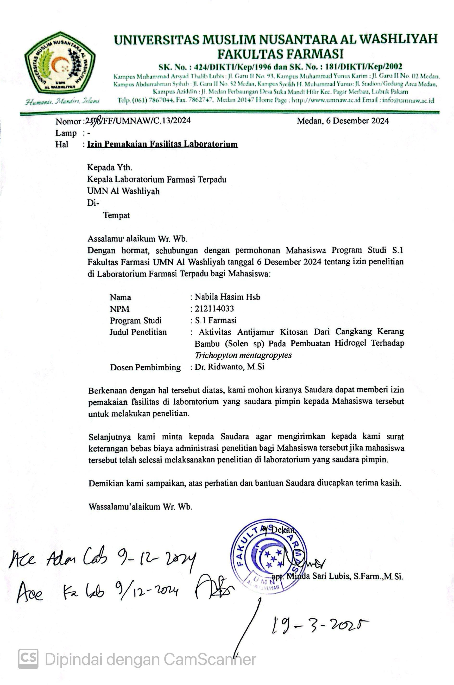

Lampiran 2. Surat Permohonan Etchical Clearance
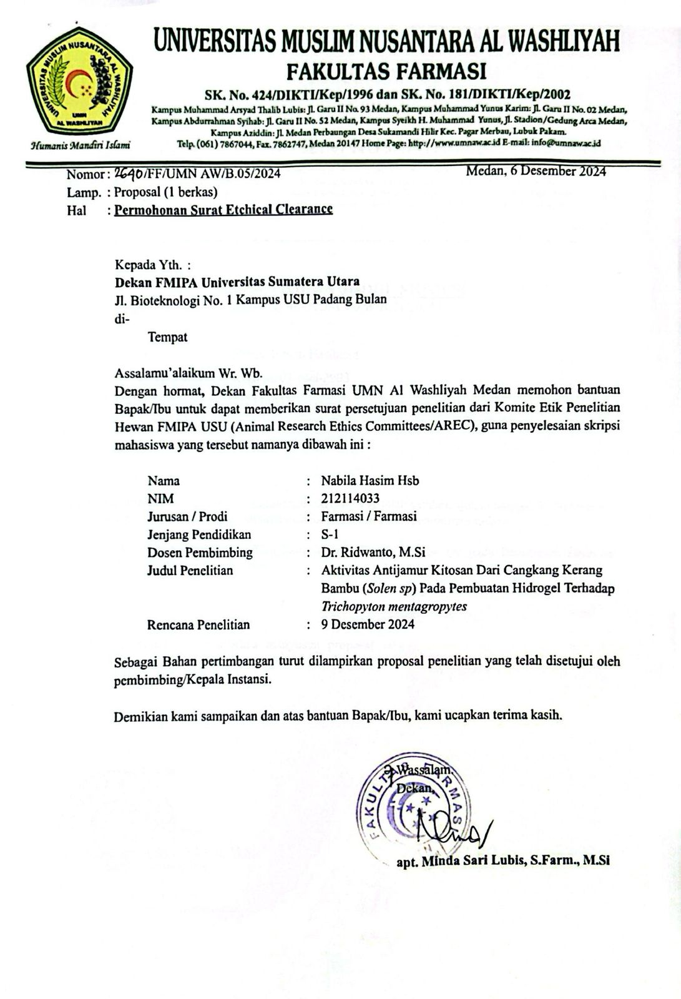

Lampiran 3. Hasil Determinasi
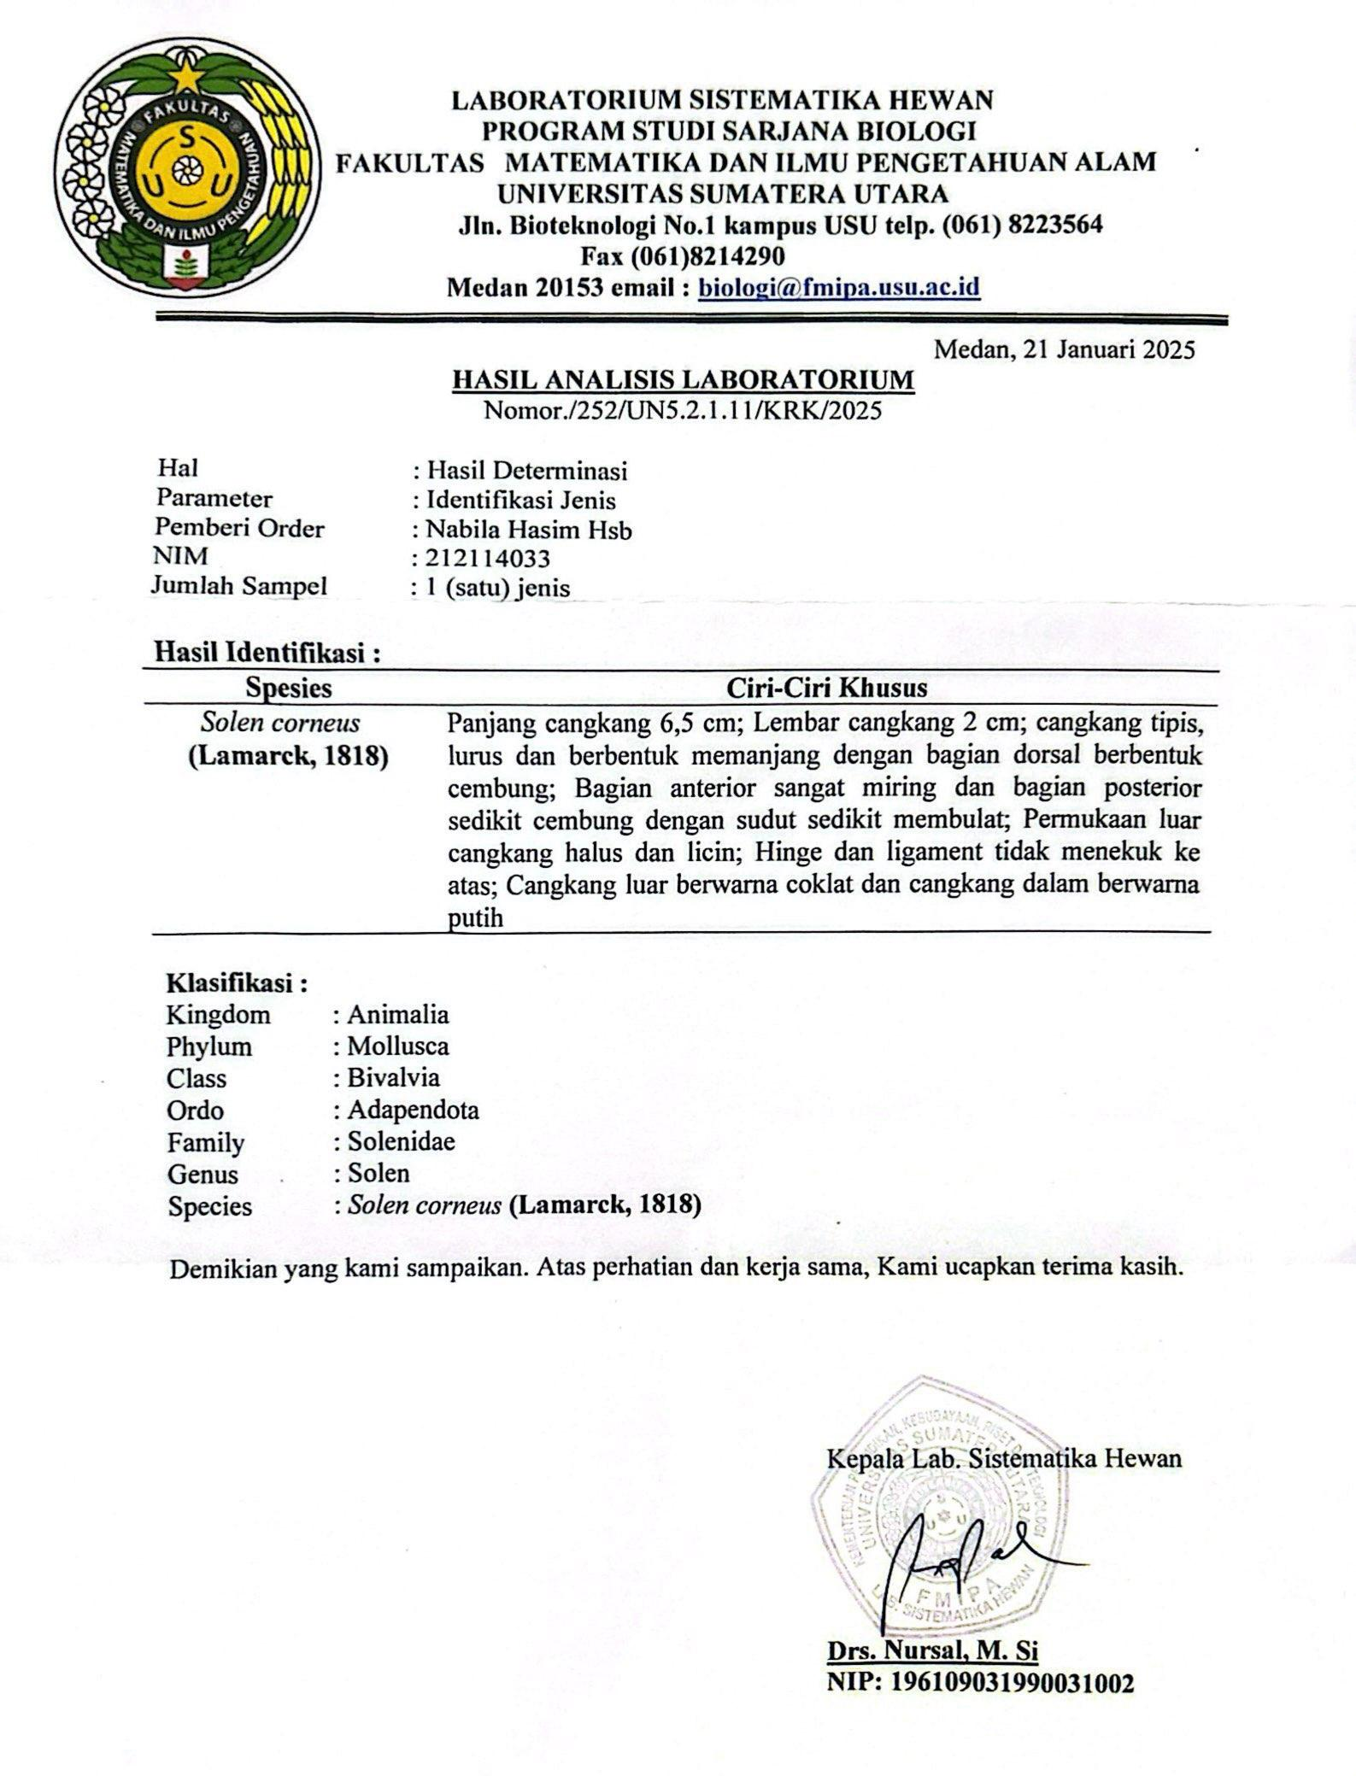

Lampiran 4. Hasil Etchical Clearance Uji Iritasi Manusia
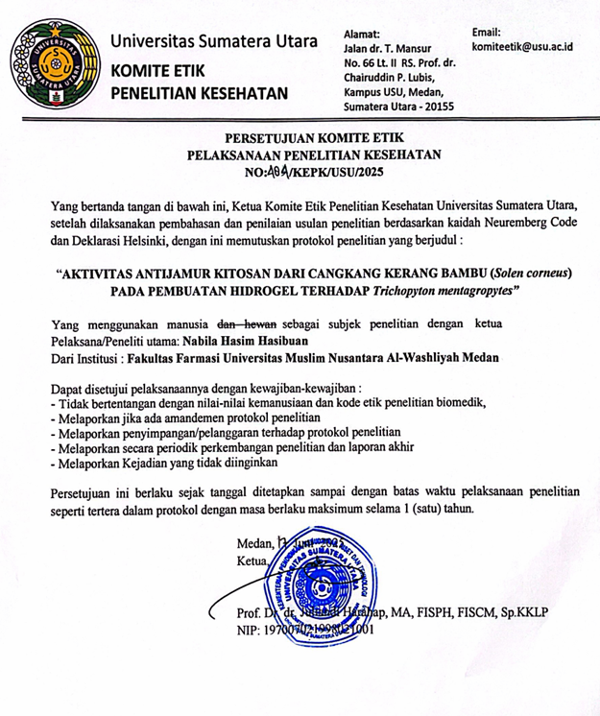

Lampiran 5. Bagan alir Penelitian
Berat basah cangkang kerang bambu 2 kg
Dikeringkan dibawah sinar matahari selama 5 hari
Disortasi basah
Dicuci dengan air mengalir
Dikeringkan dengan cara diangin- anginkan
Ditimbang
Disortasi Kering
Ditimbang kembali
Berat kering cangkang bambu 1,4 kg
Dihaluskan menggunakan blender
Cangkang kerang bambu
Disimpan dalam wadah tertutup
Serbuk cangkang bambu 1.1800 kg
Pengubahan kitin menjadi kitosan

Lampiran 5 lanjutan 1
Bagan alir pengubahan kitin menjadi kitosan
a. Tahap Deproteinasi
Serbuk cangkang kerang bambu
Ditimbang 100g serbuk cangkang bambu
Ditambahkan NaOH 4 % sebanyak 1L (1:10)
Dipanaskan pada suhu 100°C dan diaduk hingga kecepatan 100 rpm selama 1 jam
Filtrat
Endapan
Dibilas dengan Aquadest hingga Ph netral 7 sebanyak 1,7 L hingga
Dikeringkan dalam oven pada suhu 60ºC selama 4 jam
Serbuk cangkang kerang bambu bebas protein sebanyak 97,75 g

Lampiran 5.(Lanjutan )
b. Tahap Demineralisasi
Serbuk cangkang bambu bebas protein
Ditimbang serbuk cangkang bambu bebas protein
Ditambahkan HCL 2 N sebanyak 488,750 ml (1:5)
Dipanaskan pada suhu 100°C dan diaduk hingga kecepatan 100 rpm selama 1 jam
Filtrat
Endapan
Dibilas dengan Aquadest hingga Ph netral 7 sebanyak 1,7 L
Dikeringkan dalam oven pada suhu 60ºC selama 4 jam
Serbuk cangkang kerang bambu bebas mineral sebanyak 50,95 g

Lampiran 5.(Lanjutan )
c. Tahap Depigmentasi
Ditimbang serbuk cangkang bambu bebas mineral
Ditambahkan NaOCl 4% sebanyak 509,500 ml (1:10)
Diaduk hingga kecepatan 100 rpm selama 1 jam pada suhu ruang
Filtrat
Endapan
Dibilas dengan Aquadest hingga Ph netral 7 sebanyak 1,2 L
Dikeringkan dalam oven pada suhu 60ºC selama 4 jam
Serbuk cangkang kerang bambu setelah depigemntasi menghasilkan sebanyak 48,75g
Serbuk cangkang bambu bebas mineral

Lampiran 5.(Lanjutan )
d. Tahap Deasetilasi
Ditimbang serbuk cangkang bambu yang diperoleh
Ditambahkan NaOH 50 % sebanyak 9,800 ml (1:20)
Diaduk hingga kecepatan 300 rpm selama 1 jam pada suhu 100 ºC
Filtrat
Endapan
Dibilas dengan Aquadest hingga Ph netral 7 sebanyak 22,4 L
Dikeringkan dalam oven pada suhu 100ºC selama 80 menit
Kitosan murni
Serbuk cangkang bambu setelah depigmentasi
Analisis FTIR
Karakterisasi

Lampiran 5.(Lanjutan )
Bagan alir formulasi sediaan hidrogel
a. Pembuatan konsentrasi kitosan
Kitosan sebanyak 2 g ; 4 g ; 6 g
Kitosan dalam berbagai konsentrasi
Dilarutkan dengan 100 ml asam asetat 2%

b. Pembuatan sediaan hidrogel kitosan
Karbopol
Dikembangkan dalam aquadest
Ditutup dan didiamkan selama 24 jam
Gel transparan
Dimasukan metil paraben yang telah di larutkan dengan propilen glikol, diaduk ad hohomogen
Ditambahkan gliserin,diaduk homogen , tetesin TEA sampai pH netral
Dasar hidrogel
Ditambahkan kitosan sesuai konsentrasi
Digerus ad homogen
Hidrogel Kitosan
Evaluasi sediaan hidrogel
Uji antijamur terhadap jamur
Trichophytonmentagrophytes

Lampiran 6.Penyiapan sampel
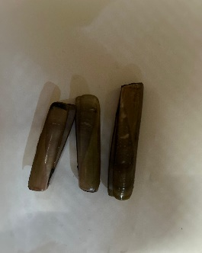 | 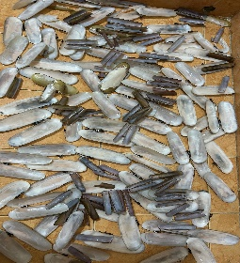
Sampel kerang bambu | Propses pengeringan cangkang kerang bambu yang telah dibersihkan sebelumnya
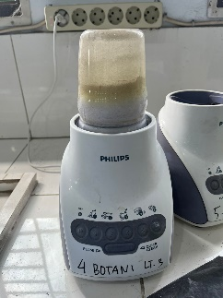 | 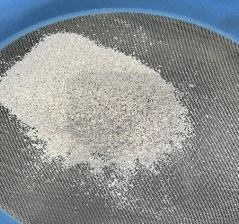
Proses penggilingan cangkang kerang bambu yang telah di keringkan sebelumnya | Proses pengayakan cangkang kerang bambu setelah digiling menggunakan mesh 40

Lampiran 7.Peroses Pembuatan Kitosan
1. ProsesDeproteinasi
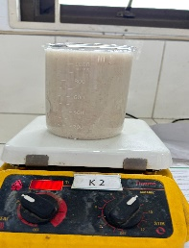 | 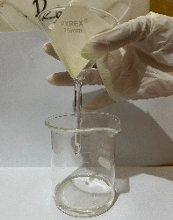
Prosespengadukanserbukcangkang bambu selama 1 jam | Prosespenyaringanserbukcangkang bambusetelah pengadukan
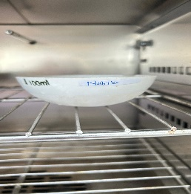 | 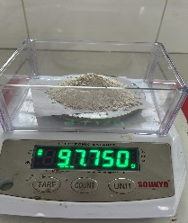
Proses pengeringan dalam oven pada suhu 60°C selama 4 jam | Hasilakhir deproteinasi setelah di oven selama 4 jam

Lampiran 7. ( Lanjutan )
2. ProsesDemineralisasi

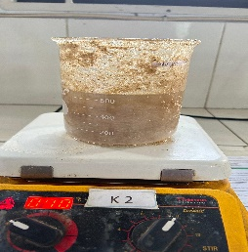 | 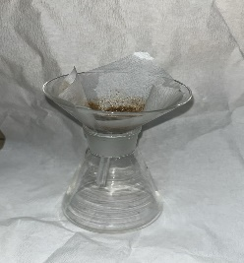
Hasil deproteinasi diaduk lagi selama 1 jam menggunakan larutan HCL 2N | Prosespenyaringansetelah pengadukan selama 1 jam
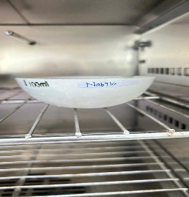 | 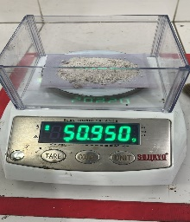
Proses pengeringan dalam oven pada suhu 60°C selama 4 jam | Hasilakhir demineralisasi setelah di oven selama 4 jam

Lampiran 7. ( Lanjutan )
3. ProsesDepigmentasi

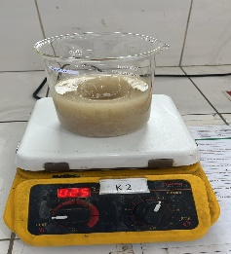 | 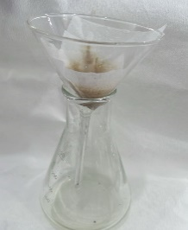
Hasil demineralisasi diaduk lagi selama 1 jam menggunakan larutan NaOCl 4% suhu ruang | Prosespenyaringansetelah pengadukan selama 1 jam
 | 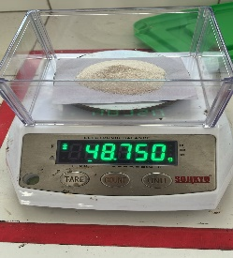
Proses pengeringan dalam oven pada suhu 60°C selama 4 jam | Hasilakhir depigemntasi setelah di oven selama 4 jam

Lampiran 7. ( Lanjutan )
4. ProsesDeasitilasi
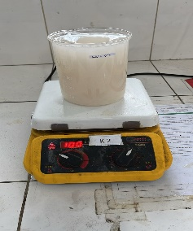 | 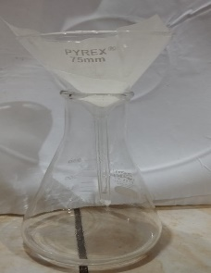
Hasil depigementasi diaduk lagi selama 1 jam menggunakan larutan NaOH 50 % | Prosespenyaringansetelah pengadukan selama 1 jam
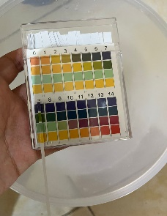
Hasil uji menggunakan pH | Hasilakhir deasitilasi setelah di oven selama 80 menit

Lampiran 8. Hasil FTIR Kitosan Cangkang Kerang Bambu
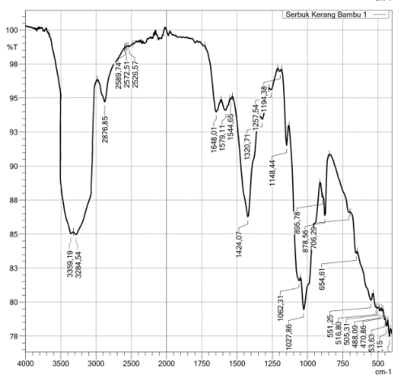

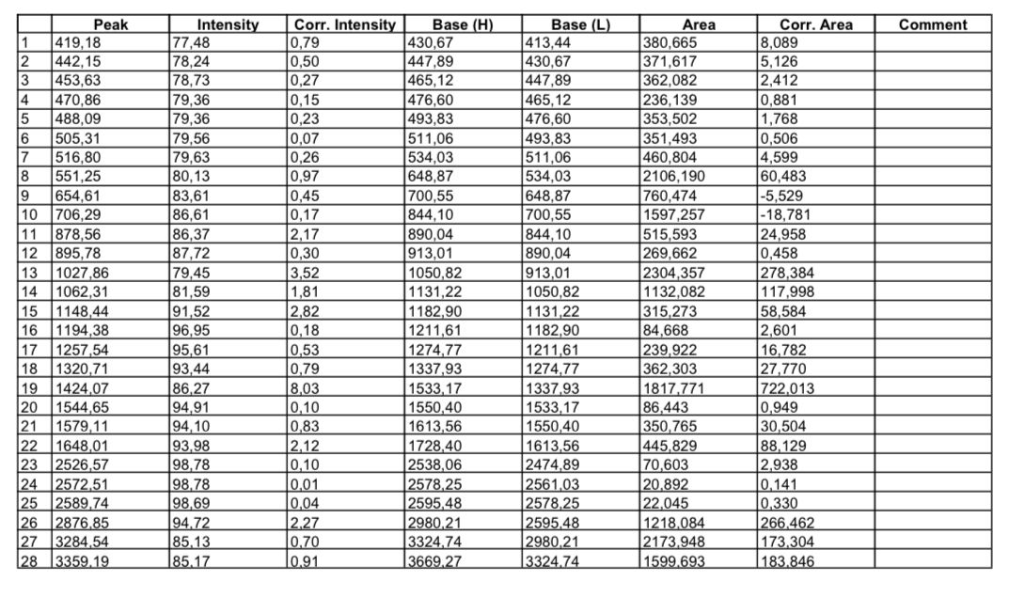

Lampiran 9. Rendemen
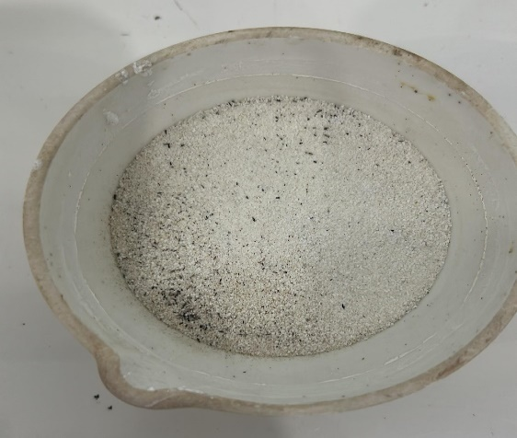 | 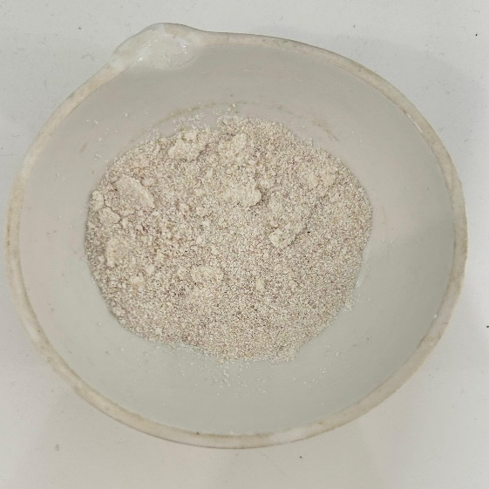
Kitin | Kitosan

Lampiran10. Kadar Air
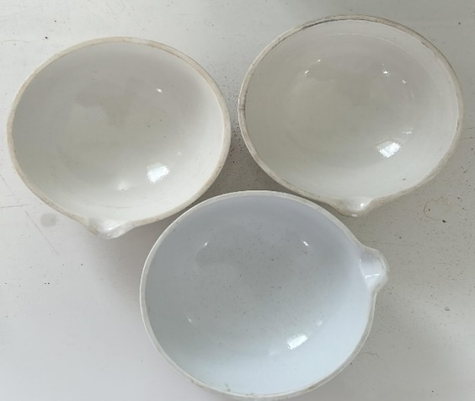 | 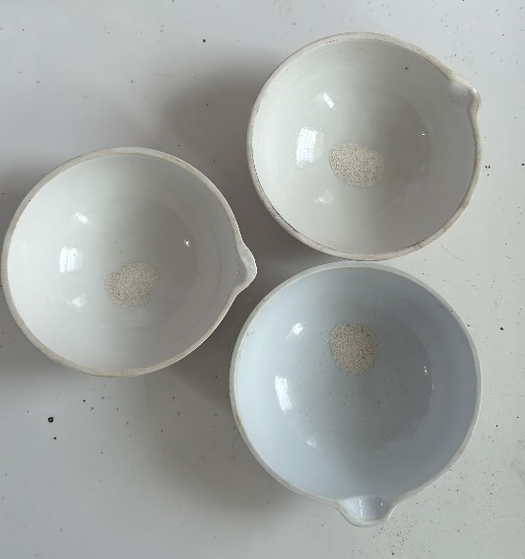
Cawan kosong | Cawan isi
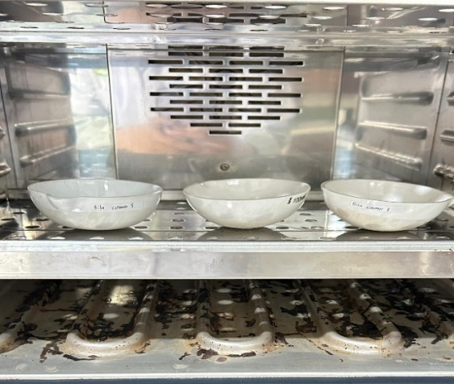 | 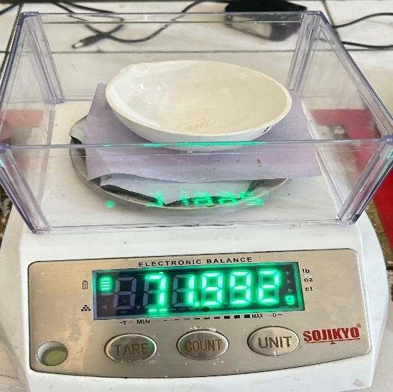
Cawan isi dimasukan oven suhu 105℃ selama 1-2 jam | Hasil setelah dioven dimasukan ke desikator selama 30 menit dan ditimbang

Lampiran 11. Kadar Abu
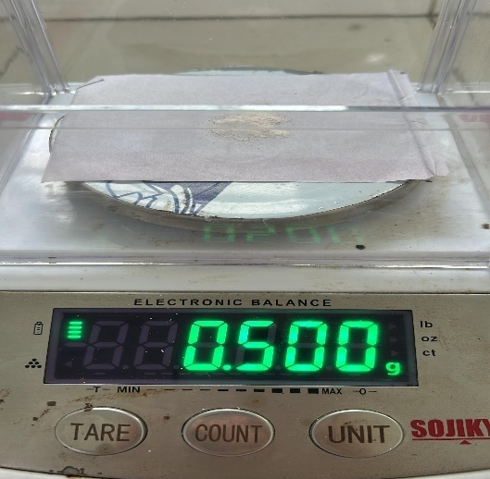 | 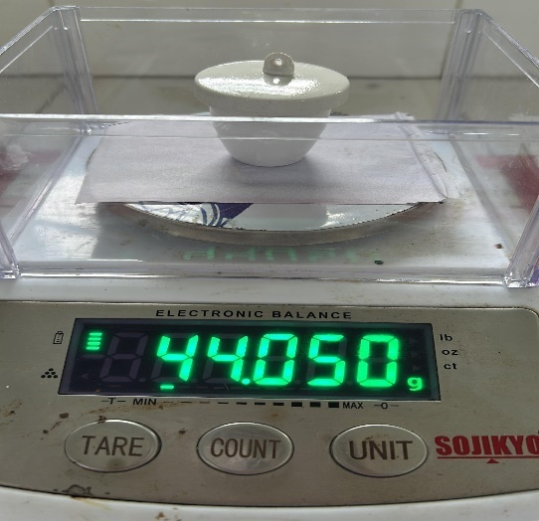
Berat kitosan ditimbang sebanyak 0,5 g | Cawan porselin isi dan cawan porselin kosong ditimbang
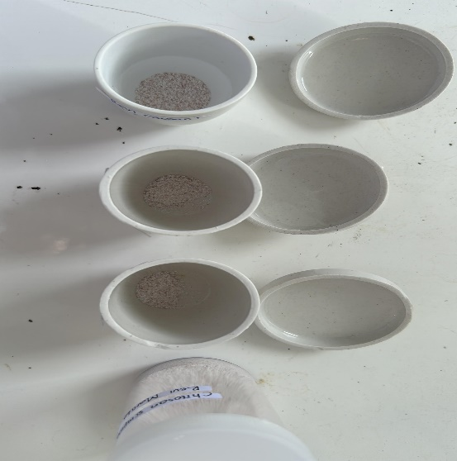 | 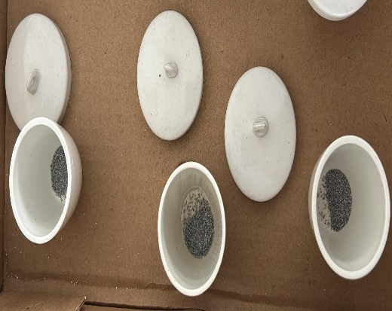
Cawan porselin isi sebelum dimasukan tanur suhu 600℃ | Hasil kadar abu setelah ditanur

Lampiran 12. Sediaan Hidrogel
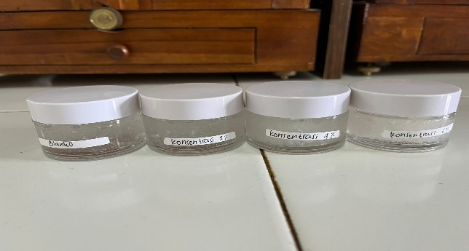

A B C D

Keterangan:
A : Blanko
B : Konsentrasi 2 %
C : Konsentrasi 4 %
D : Konsentrasi 6 %

Lampiran 13. Hasil Uji Homogenitas Sediaan Hidrogel
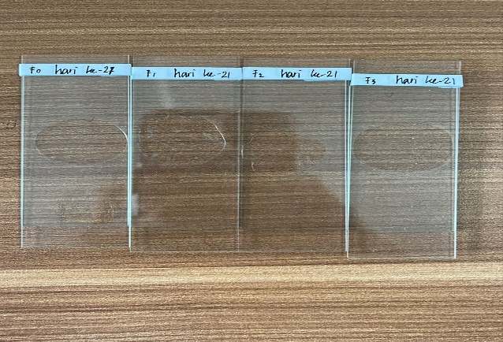

A B C D

Keterangan:
A : Blanko
B : Konsentrasi 2 %
C : Konsentrasi 4 %
D : Konsentrasi 6 %

Lampiran14.Hasil Uji pH Sediaan Hidrogel
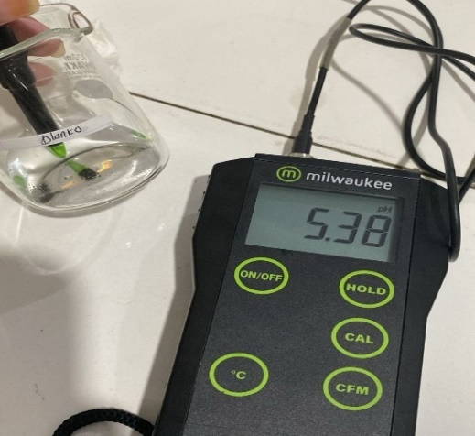 | 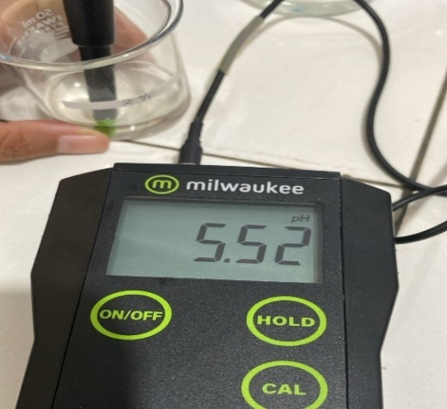
Blanko | Konsenterasi 2 %
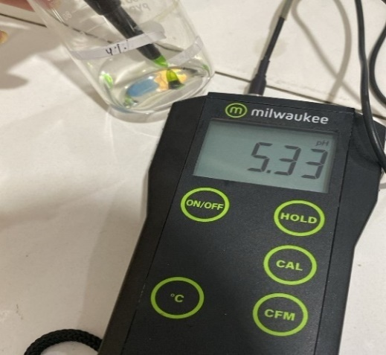 | 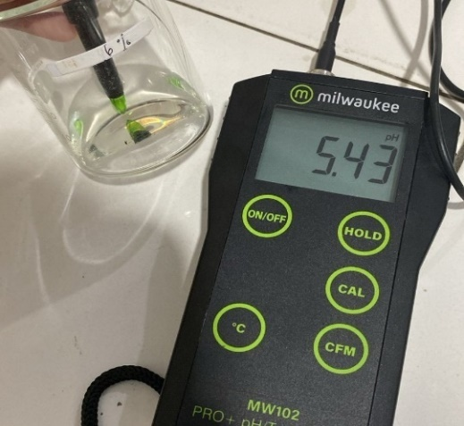
Konsenterasi 4 % | Konsenterasi 6 %

Lampiran15. Hasil Uji Daya Lekat Sediaan Hidrogel
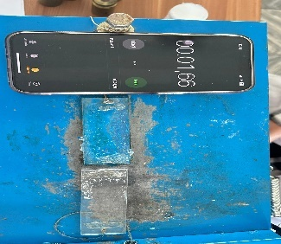 | 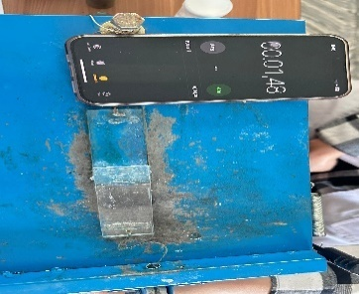
Blanko | F1
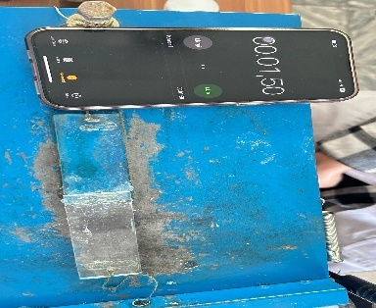 | 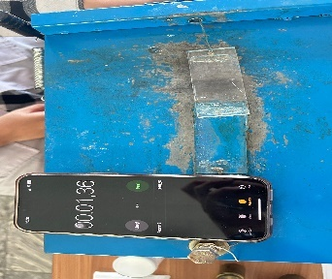
F2 | F3

Lampiran 16. Hasil Uji Daya Sebar Sediaan Hidrogel
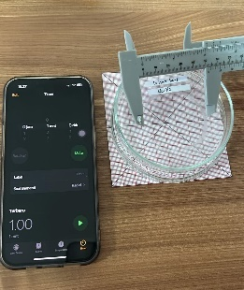 | 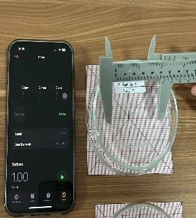
Blanko | F1
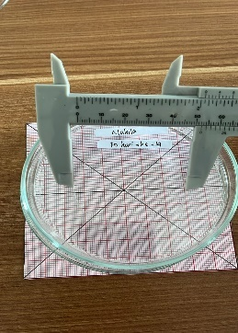 | 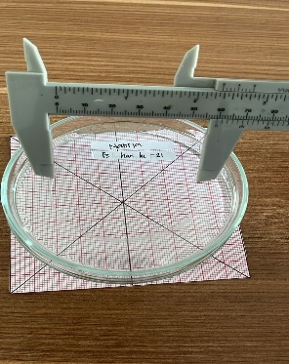
F2 | F3

Lampiran17. Hasil Uji Viskositas Sediaan Hidrogel
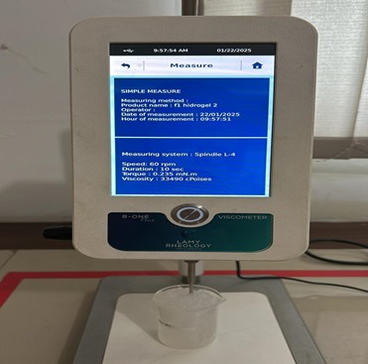 | 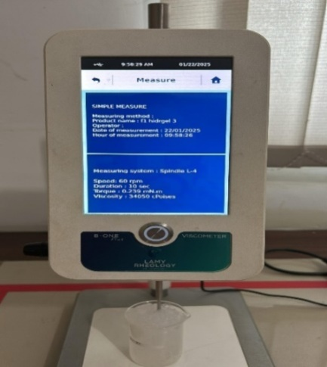
Blanko | F1
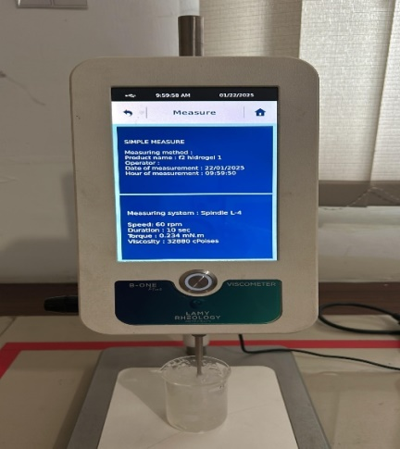 | 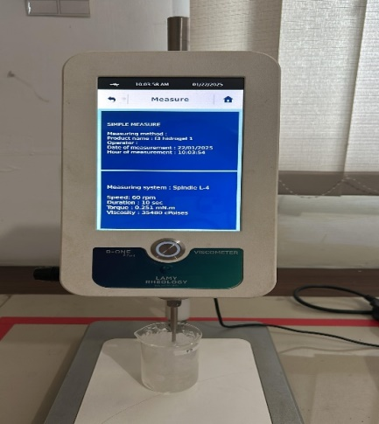
F2 | F3

Lampiran 18. Hasil Uji Iritasi
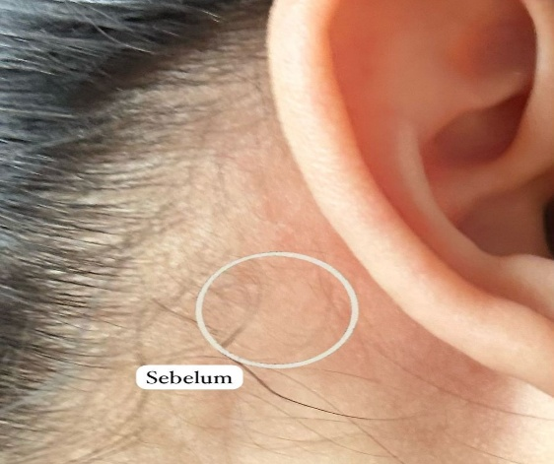 | 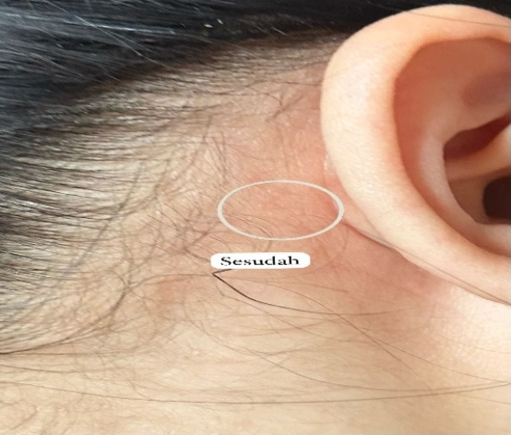
Sebelum | Sesudah

Lampiran 19. Identifikasi JamurTrichophyton mentagrophytes

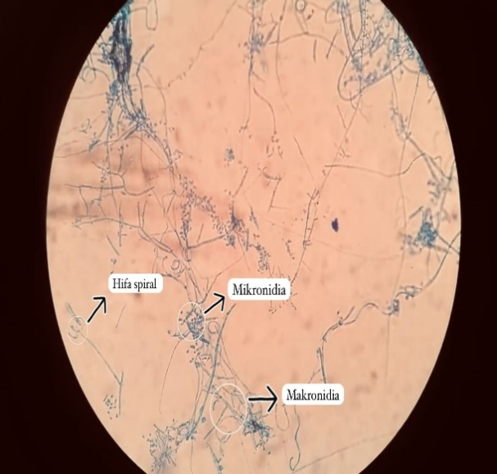

Lampiran 20. Hasil Uji Aktivitas Antijamur
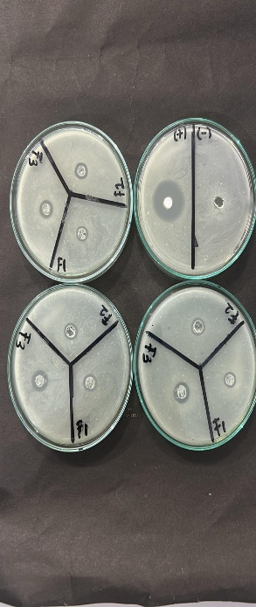
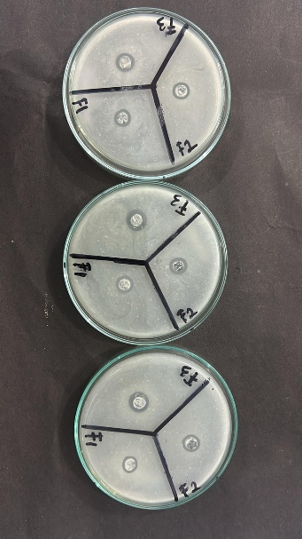

P1 P2 P3
Keterangan:
P1 : Pengulangan 1
P2 : Pengulangan 2
P3 : Pengulangan 3

Lampiran 21.Perhitungan Kadar Air
Pengulangan | Beratawal(g) | Beratakhir(g)
1 | 72,000 | 71,992
2 | 69,750 | 69,742
3 | 75,350 | 75,344

%kadarair = $\frac{a-b}{c}$ × 100%
Keterangan:
a: Beratcawandansampelawal(g)
b: Beratcawandansampelsetelahkering(g)
c:Beratsampelawal (g)

Perhitungan :
- %kadarair = $\frac{a-b}{c}$ × 100%
$=\frac{72,000-71,992}{0,5} ×100 \%$ = 1,6 %

- %kadarair = $\frac{a-b}{c}$ × 100%
$=\frac{69, 750 - 69,742}{0,5} ×100 \%$ = 1,6 %

- %kadarair = $\frac{a-b}{c}$ × 100%
$=\frac{75,350 -75,344}{0,5} ×100 \%$ = 1,2 %

Rata-rata%kadarair= $\frac{1,6+1,6+1,2 }{3} ×100\%$= 1,46 %

Lampiran 22.Perhitungan Kadar Abu
Pengulangan | Beratsampel | Beratcawan kosong | Berat cawan berisi
1 | 0,5gram | 43, 448 gram | 43, 450 gram
2 | 0,5 gram | 45, 449gram | 45,450gram
3 | 0,5 gram | 40, 698gram | 40,700gram

%kadarabu $=\frac{Berat cawan isi-Berat cawan kosong}{Berat Simplisia }$ x 100 %

Perhitungan :
- %kadarabu $=\frac{Berat cawan isi-Berat cawan kosong}{Berat Simplisia }$ x 100 %
$=\frac{43, 450 - 43, 448}{0,5}$ × 100 % = 0,4 %

- %kadarabu $=\frac{Berat cawan isi-Berat cawan kosong}{Berat Simplisia }$ x 100 %
$=\frac{45, 450 - 45, 449}{0,5}$ × 100 % = 0,2 %

- %kadarabu $=\frac{Berat cawan isi-Berat cawan kosong}{Berat Simplisia }$ x 100 %
$=\frac{40, 700 - 40, 698}{0,5}$ × 100 % = 0,4 %

Rata- rata%kadarabu= $\frac{0,4+0,2+0,4 }{3}$ × 100% = 0, 33 %

Lampiran 23.Perhitungan Rendemen Kitosan
Beratserbukcangkangkerang bambu | 100gram
Beratsampelsetelahdeproteinasi | 97, 75 gram
Beratsampelsetelahdemineralisasi | 52,12gram
Berat sampel setelah dipigmentasi | 95,68 gram
Kitosanyangdidapatkan | 50, 35 gram
% Rendemen | 52, 62 %

Perhitungan :
% Rendemen $=\frac{Berat kitosan yang dihasilkan (g)}{Berat awal \left( kitin\right) (g)}$ × 100 %
$=\frac{50,35 gram}{95, 68 gram}$ × 100 %
= 52,62 %

Lampiran24. Hasil Analisa Derajat Deasetilasi FTIR Kitosan Cangkang Kerang Bambu
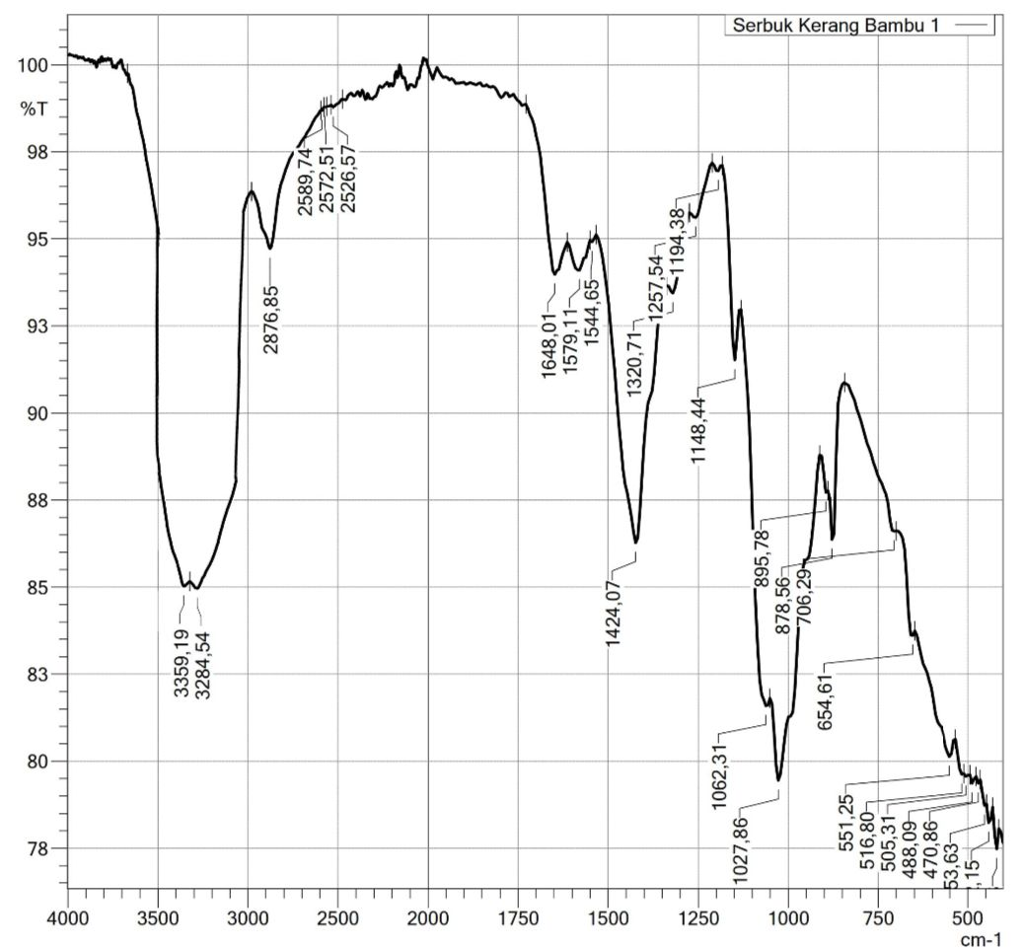

Diketahui: AB= 85
AC= 101
DE= 94
DF = 99

Penyelesaian :
A1648=log $\frac{DF}{DE}$ = log $\frac{99}{94}$ = 0,0224
A3359=log $\frac{AC}{AB}$ = log $\frac{101}{85}$ = 0,0748
% DD = 1− ( $\frac{A 1648}{A 3359}$ x $\frac{1}{1,33}$ )
% DD = 1− ( $\frac{0,0224}{0,0748}$ x $\frac{1}{1,33}$ )
% DD = 1 – ( 0,2994 × 0,7518 )
% DD = 1− ( 0,2250) = 0,775
DD = 77,5 %

Lampiran 25. Surat Pernyataan Sukarelawan

SURATPERNYATAAN

Sayayang bertandatangandibawah ini:

Nama : Yuda Danda Pertama
Umur : 21 tahun
Alamat : Gg. Tanjung , Jl. Garu II A

Menyatakan bersedia menjadi sukarelawan untuk uji iritasi kulit yang dilakukan dalam penelitian Nabila Hasim Hasibuan dengan judul penelitian “Aktivitas Antijamur Kitosan Dari Cangkang Kerang Bambu (Solen corneus)Pada Pembuatan Hidrogel Terhadap Trichopyton mentagropytes”dan memenuhi kriteria sebagai sukarelawan uji sebagai berikut:
- Wanita/ Laki-lakiberbadansehat
- Usiaantara 20-30tahun
- Tidakadariwayat penyakityangberhubungandenganalergi,dan
- Bersediamenjadirelawan
Apabilaterjadihal-halyangtidakdiinginkanselamaujiiritasi,sukarelawan tidak akan menuntut kepada peneliti.
Demikian surat pernyataan ini dibuat, atas partisipasinya peneliti mengucapkan terima kasih.

Medan, 25Februari2025
Sukarelawan Peneliti

(Yuda Danda Pertama ) (Nabila Hasim Hsb)

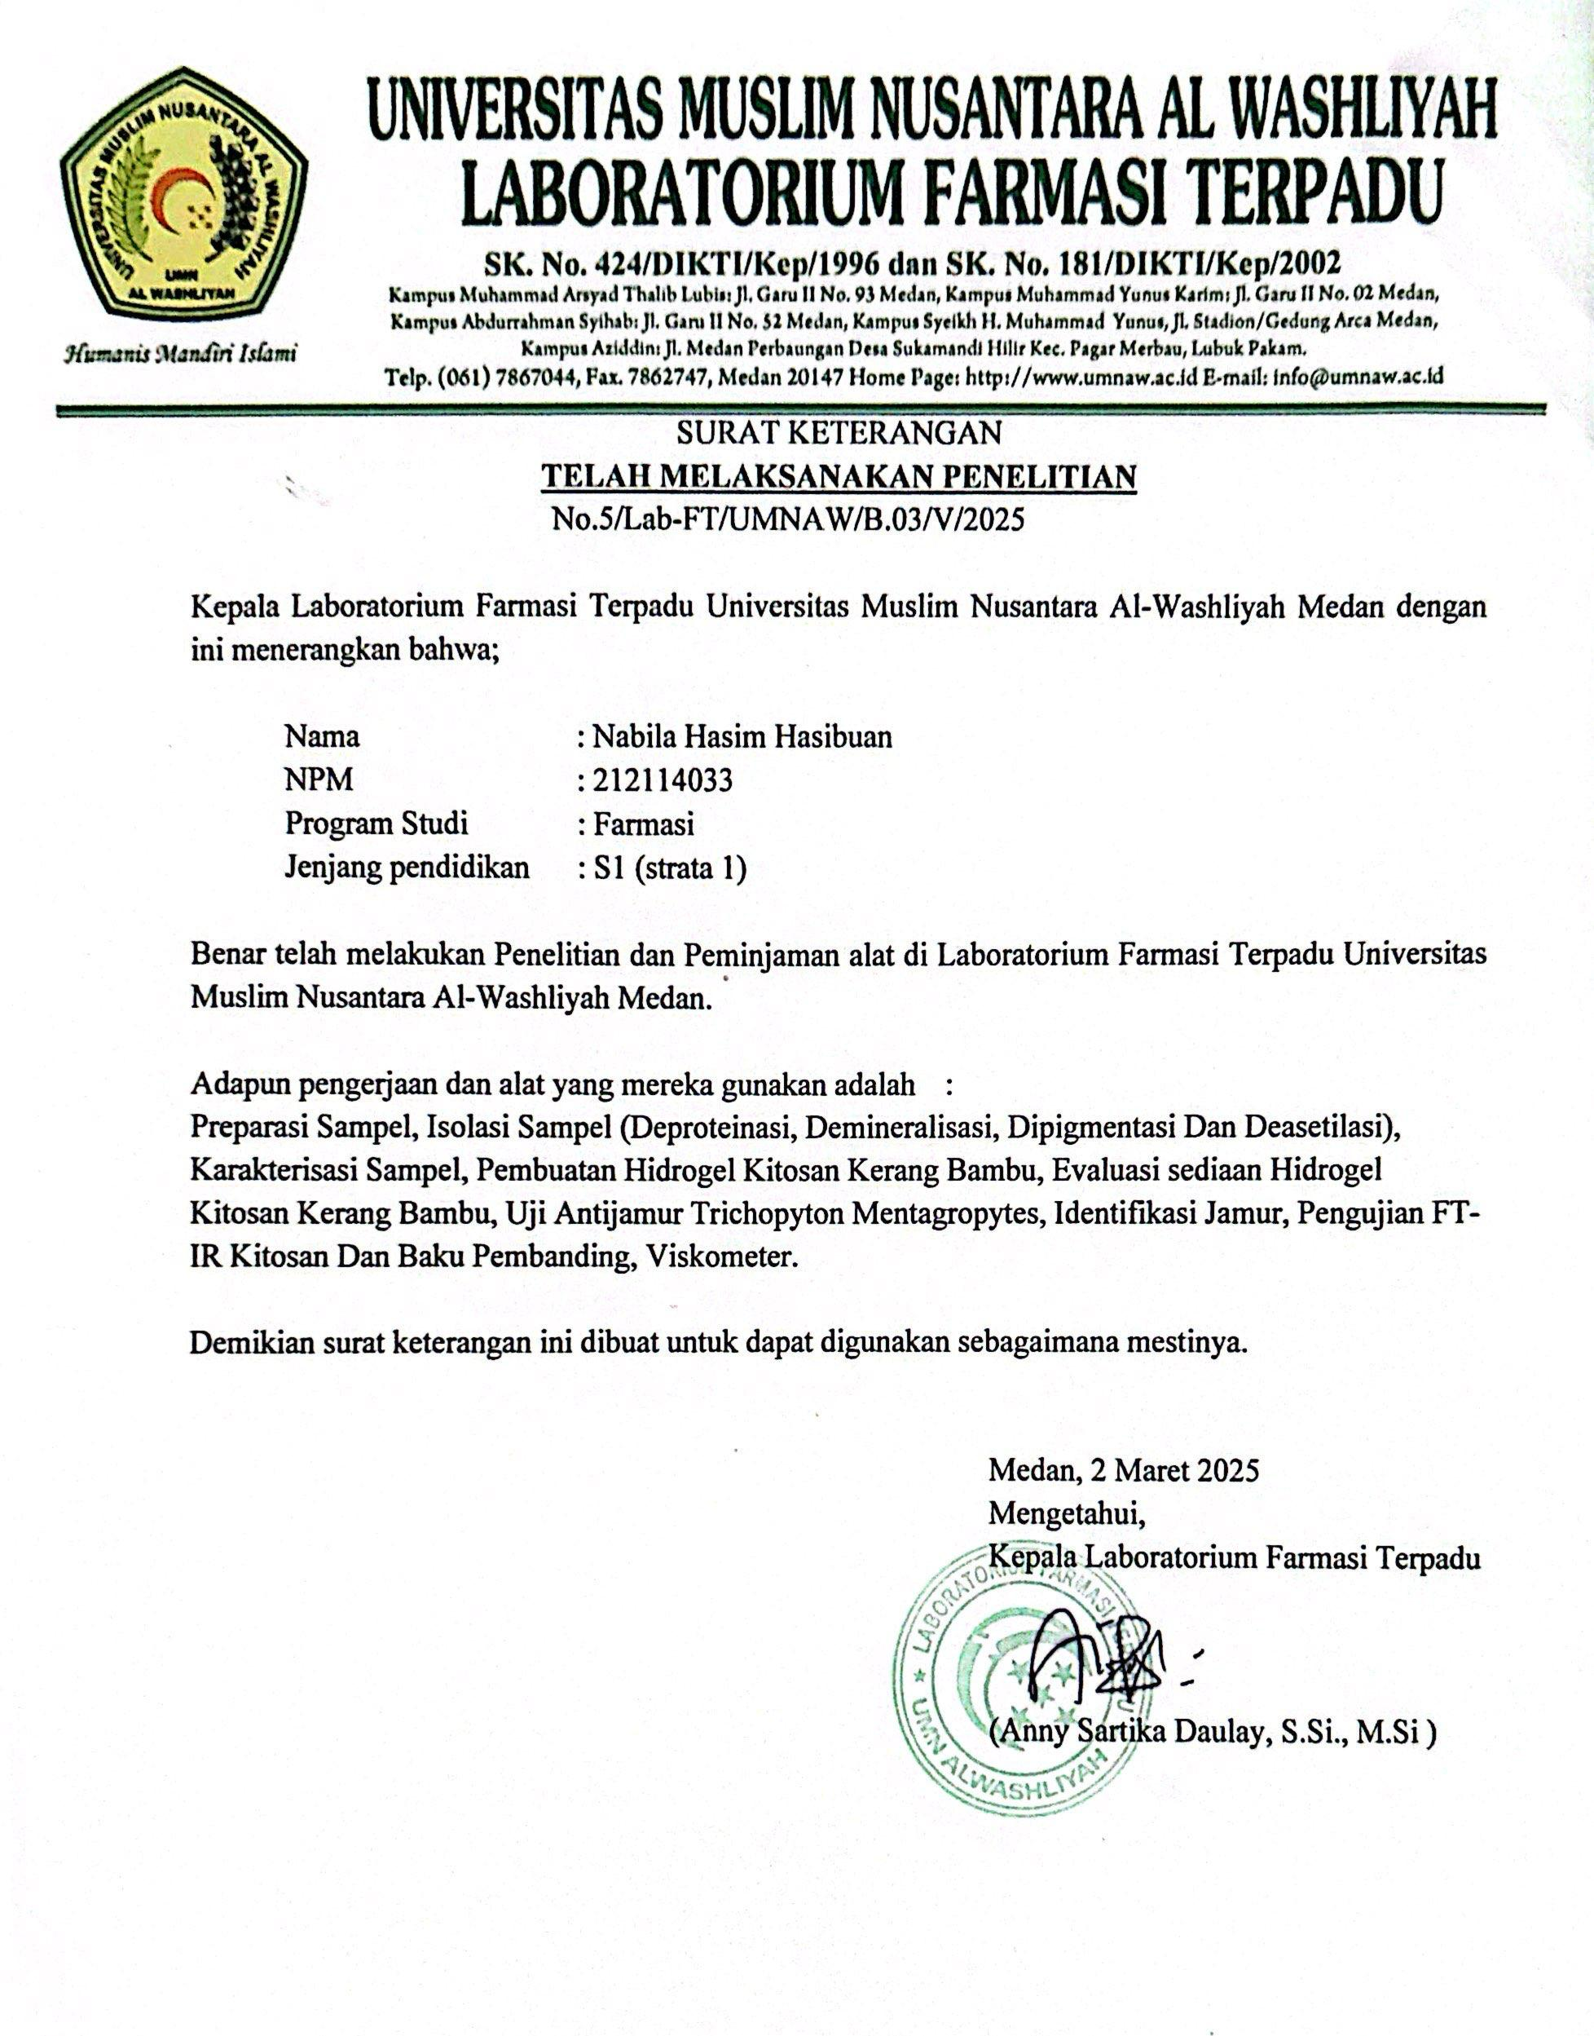
Lampiran 26. Surat Selesai Peneliti

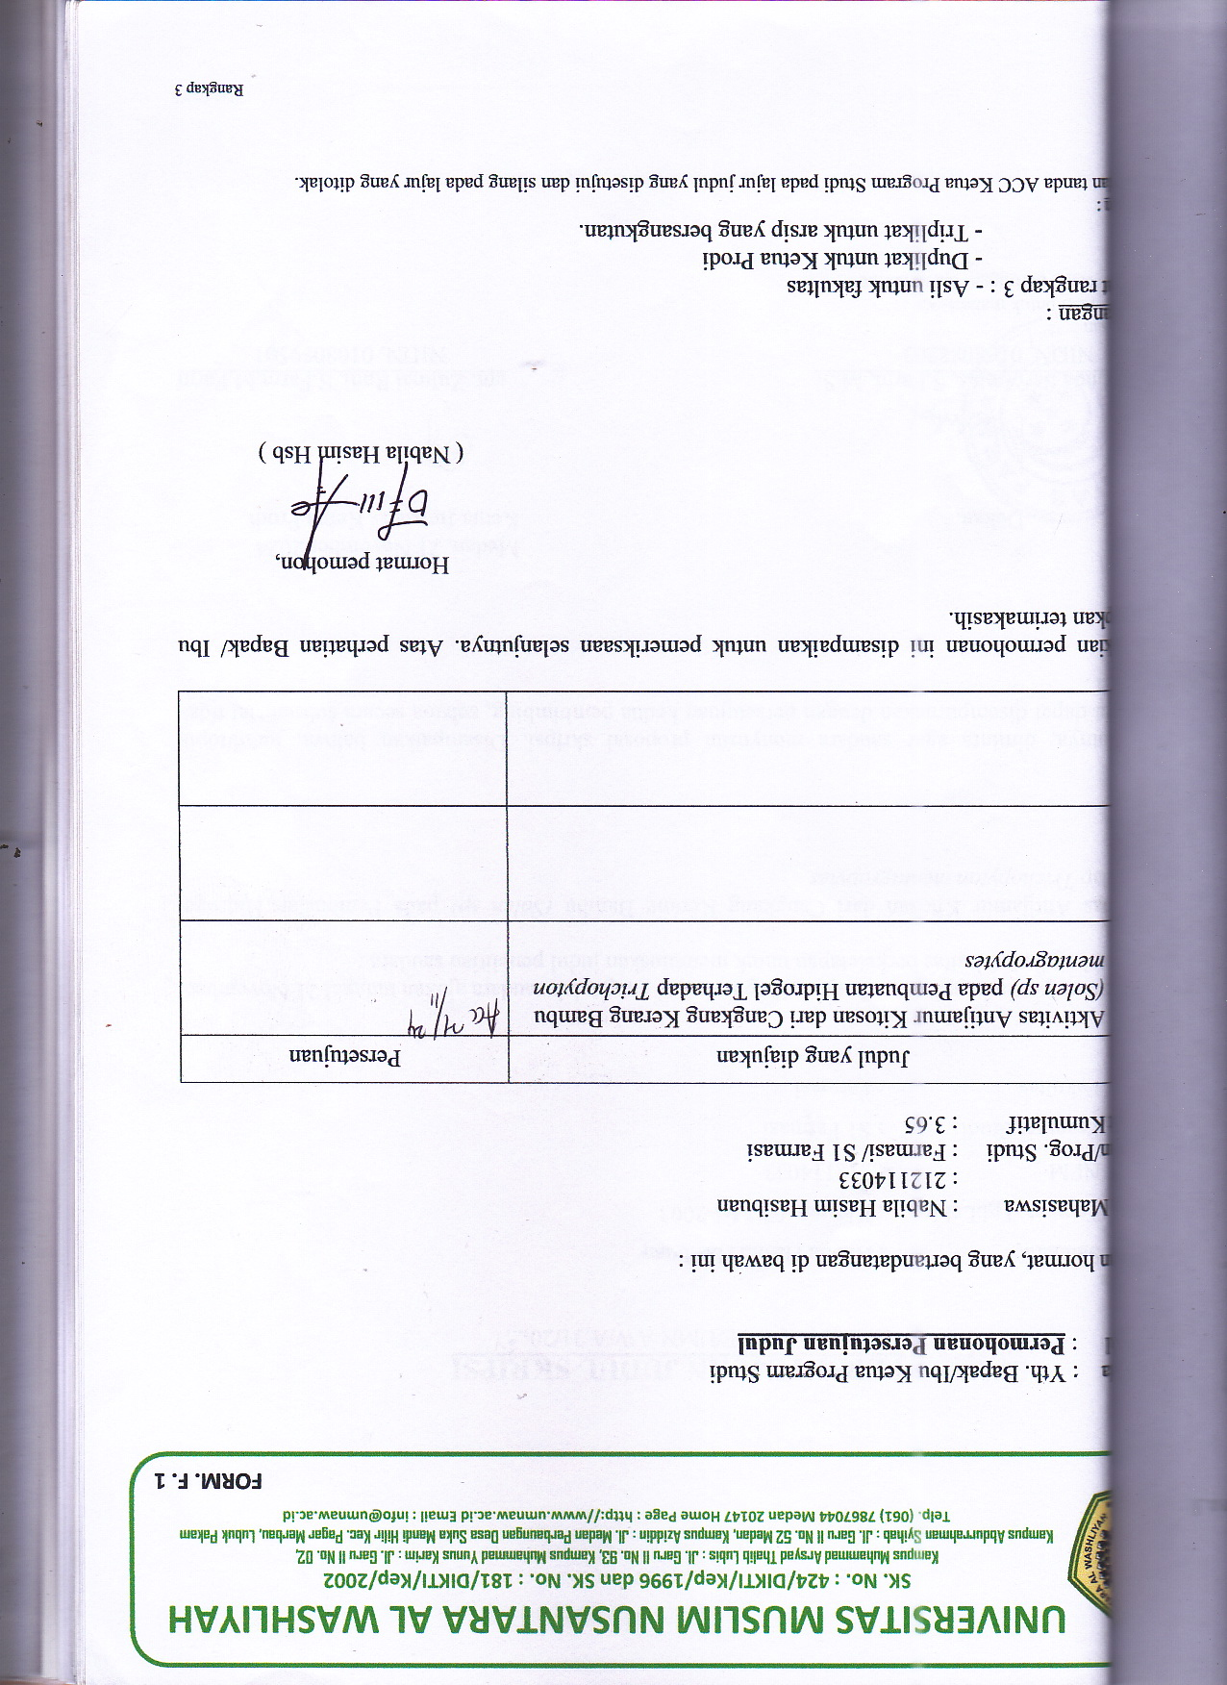
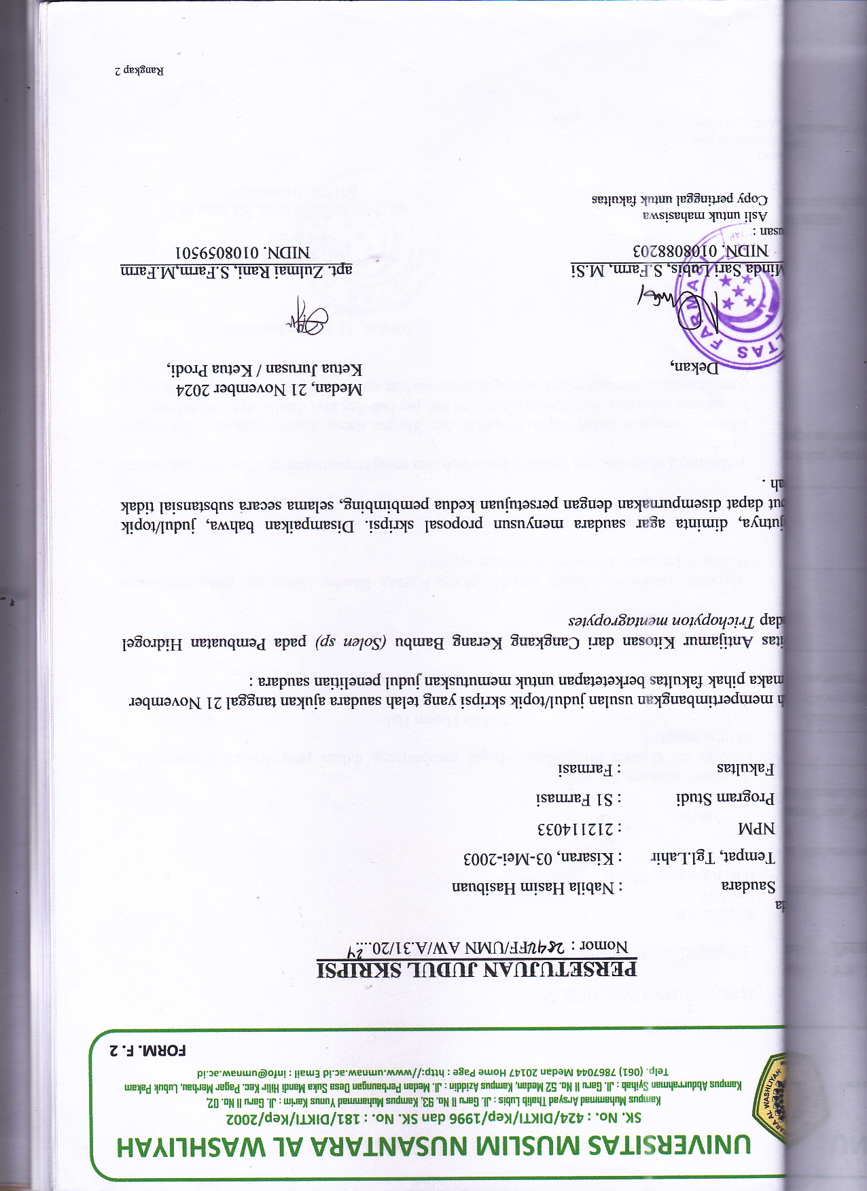
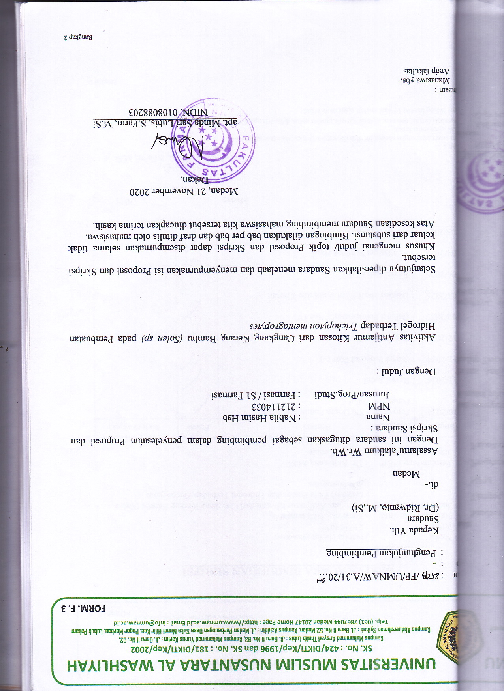
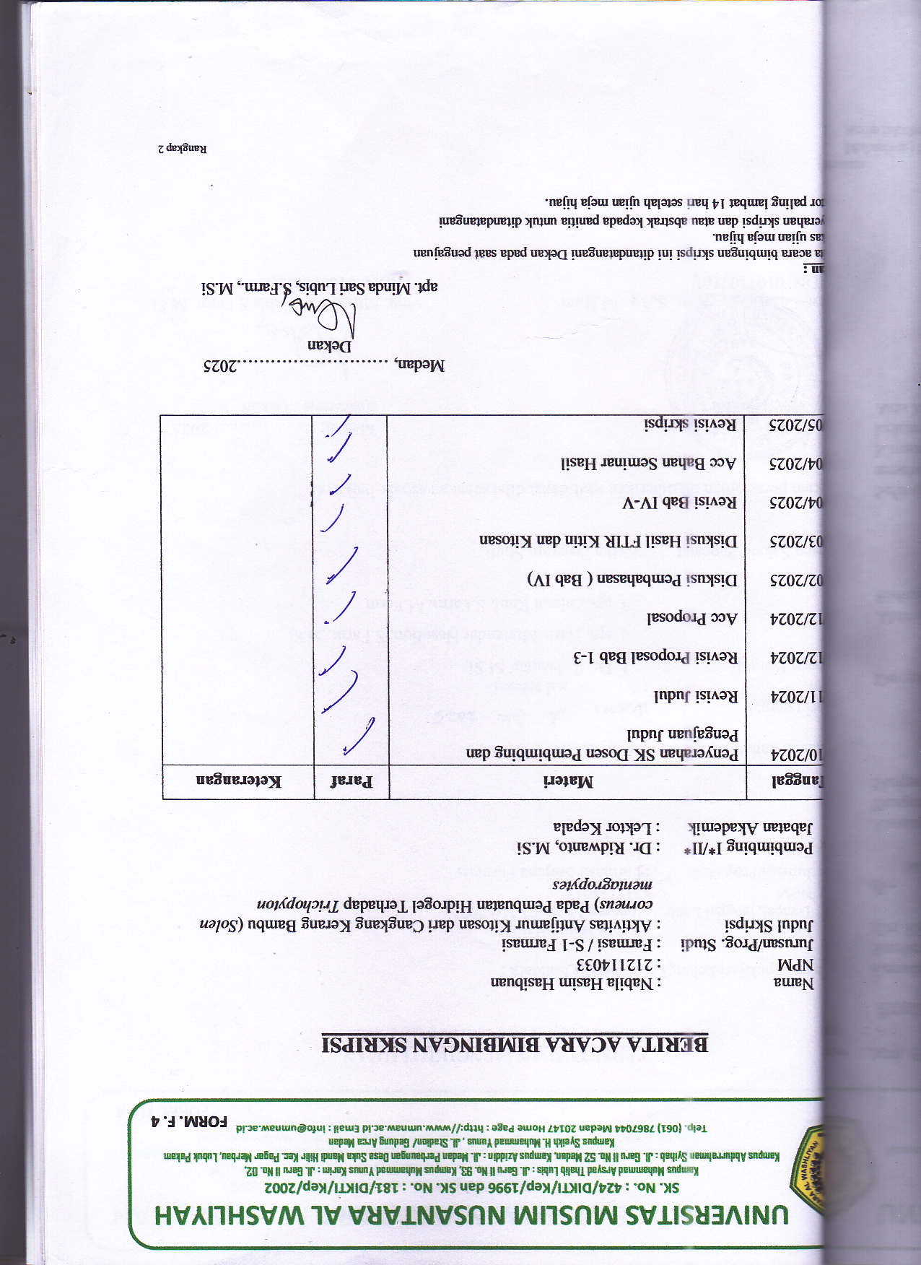
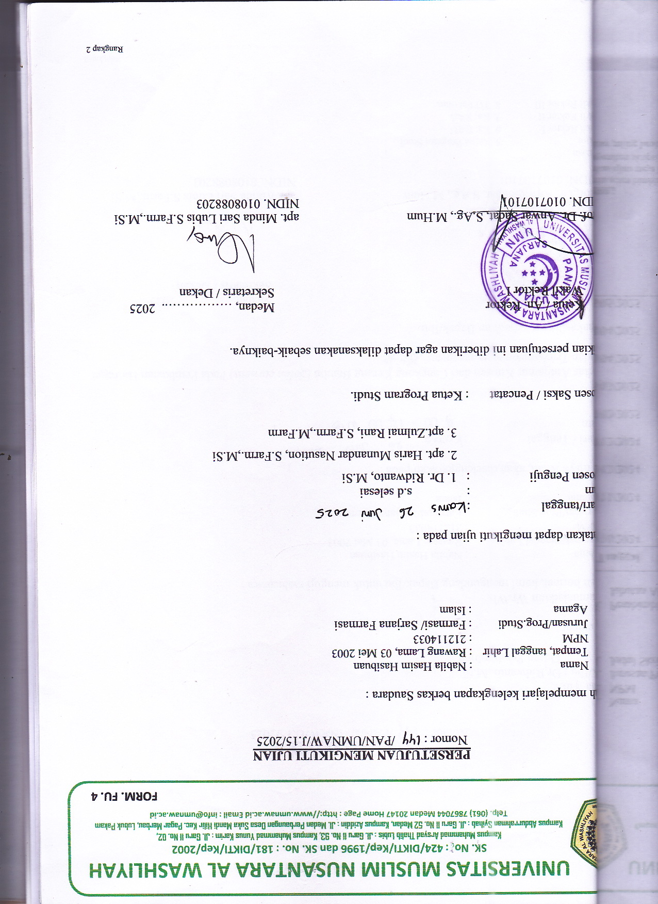
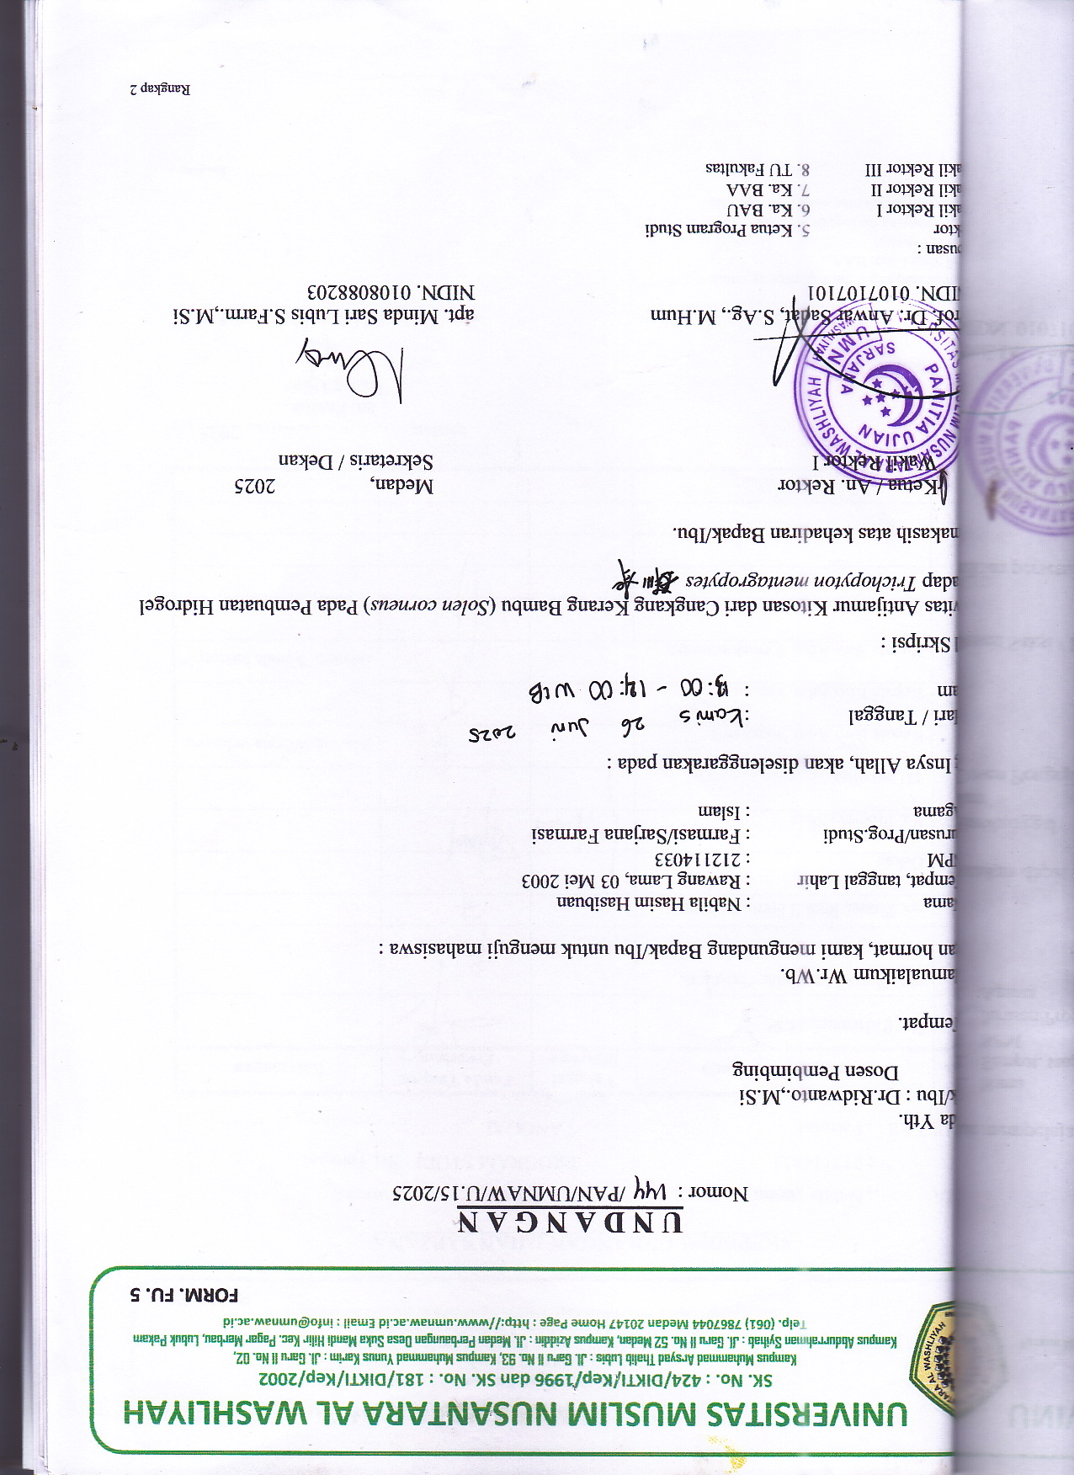
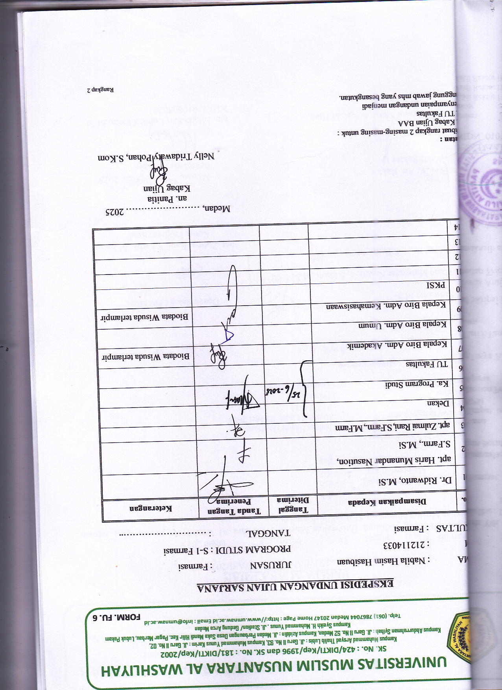
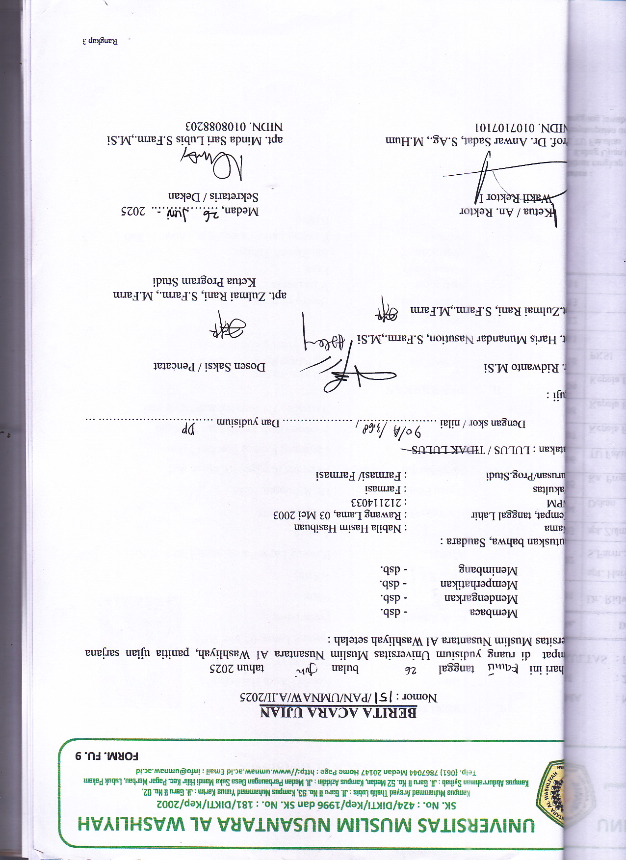
BIODATA MAHASISWA

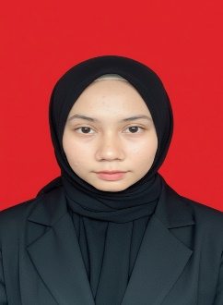
- IDENTITAS DIRI
Nama : Nabila Hasim Hasibuan
NPM : 212114033
Tempat/Tgl Lahir :Rawang Lama, 03 Mei 2003
Jenis Kelamin : Perempuan
Agama : Islam
Anak Ke : 1(Satu)
Alamat : Rawang Lama Panca Arga, Dusun II Kab.
Asahan
No. Telp/Hp : 081269221378
Dosen Pembimbing : Dr. Ridwanto, M.Si
Judul Skripsi : Aktivitas Antijamur Kitosan dari
Cangkang Kerang Bambu (Solen
corneus) Pada Pembuatan Hidrogel
Terhadap Trichopyton mentagropytes

- PENDIDIKAN
SD : SD Min Meranti
SLTP/SMP : SMP Mas Pp Nurul Hakim
SLTA/SMA : SMA Mas Pp Nurul Hakim

- ORANG TUA
Nama ( Ayah) : Hasim Hasibuan
Pekerjaan : Wiraswasta
Nama ( Ibu) : Erna
Pekerjaan : Ibu Rumah Tangga
Alamat : Rawang Lama Panca Arga, Dusun II Kab.
Asahan

