DAFTARPUSTAKA
Abdullah, R., & Hasni. (2020). Pengaruh Corporate Social Responsibility TerhadapKinerja Perusahaan Pada Pt. Pln Up3 Baubau. Komuniti: Jurnal Komunikasi Dan Teknologi Informasi, 12(2), 62–81. Https://Doi.Org/10.62668/Jiem.V1i01.149

Almunawwaroh, M., Deswanto, V., & Karlina, E. (2022). Green Accounting: Akuntansi Dan Lingkungan.

Angelina, M., & Nursasi, E. (2022). Pengaruh Penerapan Green Accounting dan Kinerja Lingkungan Terhadap Kinerja Keuangan Perusahaan. Akuntansi 45, 3(2), 208–217. Https://Doi.Org/10.30640/Akuntansi45.V3i2.873

Anikmah Musfirati, Lorensius Ginting, M. L. N. H. (2021). Pengaruh Pengungkapan Corporate Social Responsibility Terhadap Profitabilitas Perusahaan (Studi Empiris Pada Perusahaan Sektor Industri Rokok Yang Terdaftar Di Bursa Efek Indonesia Tahun 2016-2019). Journal Of Information System, Applied, Management,Accounting And Research., 5(2). Https://Doi.Org/10.52362/Jisamar.V5i2
Ass, S. B. (2020). Analisis Rasio Profitabilitas Dan Solvabilitas Pada Pt. Mayora Indah Tbk. Brand Jurnal Ilmiah Manajemen Pemasaran, 2(2), 195–206. Https://Ejournals.Umma.Ac.Id/Index.Php/Brand

Aziz, Z. R., & Kholmi, M. (2024). Pengaruh Corporate Social Responsibility Terhadap Profitabilitas. Jurnal Ekonomi Akuntansi Manajemen,23(246), 54–63.

Budiono, S., & Dura, J. (2021). The Effect Of Green Accounting Implementation On Profitability In Companies Compass Index 100. International Journal Of Educational Research & Social Sciences, 2(6), 1526–1534.
Carolyn, H., Fauzi, A., & Utaminingtyas, T. H. (2023). Research And Literature TheEffect Of Corporate Social Responsibility And Ownership Structure On Profitability. InternationalJournalOfMultidisciplinaryResearchAndLiteratureIjomral,2(1),1–
120. Https://Doi.Org/10.53067/Ijomral.V2i1

Desi Raihan Ramdiani, & Nurleli. (2023). Pengaruh Kineja Lingkungan Dan PengungkapanCorporateSocialResponsibilityTerhadapTingkatProfitabilitas.Jurnal Riset Akuntansi, 57–64. Https://Doi.Org/10.29313/Jra.V3i1.1786

Elvadri, A. B., Karimah, A. U., Midaria, I. U., Shela, J. D., Deden, M., Adhani, M., & Susanti, N. M. (2023). Penerapan CSR (Corporate Social Responsibility) Pada Pt. Pertamina Dalam Meningkatkan Tanggung Jawab Lingkungan Perusahaan. Jurnal Manajemen Dan Akuntansi, 1(2), 223–231. Https://Doi.Org/Xx..Xxxxx/Wanargi

Erlangga, C. M., Fauzi, A., & Sumiati, A. (2021). Penerapan Green Accounting Dan CorporateSocialResponsibilityDisclosureTerhadapNilaiPerusahaanMelaluiProfitabilitas. Akuntabilitas, 14(1), 61–78. Https://Doi.Org/10.15408/Akt.V14i1.20749

Ghozali, I. (2018). Aplikasi Analisis Multivariat Dan Ekonometrika. Universitas Diponegoro.

Gustinya, Se., M.Ak., D. (2022). Pengaruh Penerapan Green Accounting Terhadap Nilai Perusahaan Manufaktur Peserta Proper Yang Listing Di Bursa Efek Indonesia Tahun 2017 - 2019. Jurnal Akuntansi Dan Bisnis Krisnadwipayana, 9(2), 759. Https://Doi.Org/10.35137/Jabk.V9i2.688

Hamidi. (2019). Analisis Penerapan Green Accounting Terhadap Kinerja Keuangan Perusahaan. 6(2).Https://Doi.Org/10.4324/9781315561103-15

Hergianti, A. N., & Retnani, E. R. (2020). Pengaruh Pertumbuhan Perusahaan, Profitabilitas Dan Leverage Terhadap Nilai Perusahaan. Jurnal Ilmu Dan Riset Akuntansi, 9(2), 1–20.
I Dewa Made Endian, N. N. A. S. (2020). Perspektif Akuntansi Manajemen Lingkungan Dan Pengungkapannya Pada Nilai Perusahaan. Kaos Gl Dergisi, 8(75), 147–154. Https://Doi.Org/10.1016/J.Jnc.2020.125798%0a
Indrawati, L., Suci, M., & Andiani, N. D. (2020). Pengaruh Kepemilikan Institusional Dan Corporate Social Responsibility Terhadap Profitabilitas Pada Perusahaan Pertambangan. Prospek: Jurnal Manajemen Dan Bisnis, 2(1), 40. Https://Doi.Org/10.23887/Pjmb.V2i1.26188

Kholmi, M., & Nafiza, S. A. (2022). Pengaruh Penerapan Green Accounting Terhadap Profitabilitas(StudiPadaPerusahaanManufaktur YangTerdaftarDiBeiTahun2018- 2019 ). Reviu Akuntansi Dan Bisnis Indonesia, 6(1), 143–155. Https://Doi.Org/10.18196/Rabin.V6i1.12998

Kumala, A., Sullicyanna Luna Bianca, Novia Mega Putri, & Maria Yovita R. Pandin. (2023). Peranan Green Accounting Terhadap Green Campus Pada Universitas 17 Agustus 1945 Surabaya. Cemerlang: Jurnal Manajemen Dan Ekonomi Bisnis, 3(3), 222–240.Https://Doi.Org/10.55606/Cemerlang.V3i3.1365

Kusuma, A., Desy, D., & Anggraini, I. (2023). Pengaruh Penerapan Green Accounting Terhadap Profitabilitas Pada Perusahaan Manufaktur. Bisnis, Dan Sosial), 1(1), 161– 171.

Lako,A.(2018).AkuntansiHijau:Isu, Teori&Aplikasi.

Meiyana, A., & Aisyah, M. N. (2019). Pengaruh Kinerja Lingkungan, Biaya Lingkungan, Dan Ukuran Perusahaan Terhadap Kinerja Keuangan Dengan Corporate Social Responsibility Sebagai Variabel Intervening. Nominal: Barometer Riset Akuntansi Dan Manajemen, 8(1), 1–18. Https://Doi.Org/10.21831/Nominal.V8i1.24495

Niandari, N., & Handayani, H. (2023). Green Accounting, Kinerja Lingkungan, Dan Profitabilitas. Jurnal Akuntansi Bisnis, 16(1), 83–96. Https://Doi.Org/10.30813/Jab.V16i1.3875

Nuridah, S., Merliyana, M., Sagitarius, E., & Surachman, S. N. (2023). Pengaruh Good Corporate Governance terhadap Profitabilitas. Jurnal Ekonomi, Bisnis dan Manajemen, 2(2), 1–10. https://journal.unimar- amni.ac.id/index.php/EBISMEN/article/view/773/656

Oktiara, K., & Effriyanti, E. (2024). Pengaruh Green Accounting, Corporate Social Responsibility (CSR), Dan Struktur Modal Terhadap Nilai Perusahaan (Studi Empiris Pada Perusahaan Sektor Energi Di Bursa Efek Indonesia Tahun 2018 – 2022). Mantap: Journal Of Management Accounting, Tax And Production, 2(2), 1125–1136. Https://Doi.Org/10.57235/Mantap.V2i2.3609

Panigoro, N. (2020). Struktur modal dan pengaruhnya terhadap profitabilitas perusahaan. Jambura Accounting Review, 2(1), 65–76. https://jar.fe.ung.ac.id/index.php/jar/article/view/15/9
Pratiwi, A., Nurulrahmatia, N., & Muniarty, P. (2020). Pengaruh Corporate Social Responsibility (CSR) Terhadap Profitabilitas Pada Perusahaan Perbankan Yang TerdaftarDiBei.Owner,4(1),95.Https://Doi.Org/10.33395/Owner.V4i1.201

Rahman, Z. A., Lilik, H., & Kartikasari, N. (2023). Pengaruh Penerapan Green Accounting Terhadap Profitabilitas “The Effect Of Implementation Green Accounting On Profitability.” Jurnal Monex - Jurnal Of Accounting Research, 12(2), 251–263. Https://Repository.Uinjkt.Ac.Id/Dspace/Handle/123456789/56729%0awww.Idx.Co.Id

Reza, Muhammad. (2024). Kualitas Pengungkapan SDGs Dan Green Accounting: Implikasi Kinerja Keuangan. Jurnal Riset Terapan Akuntansi, 9(1).

Riyadh, H. A., Al-Shmam, M. A., Huang, H. H., Gunawan, B., & Alfaiza, S. A. (2020). The Analysis Of Green Accounting Cost Impact On Corporations Financial Performance.InternationalJournalOfEnergyEconomicsAndPolicy,10(6),421–
426. Https://Doi.Org/10.32479/Ijeep.9238

Rosaline, V. D., Wuryani, E., Ekonomi, F., Surabaya, U. N., & Surabaya, K. (2020). Pengaruh Penerapan Green Accounting Dan Environmental Performance Terhadap Economic Performance. Jurnal Riset Akuntansi Dan Keuangan, 8(3), 569–578. Https://Doi.Org/10.17509/Jrak.V8i3.26158

Rusmana, O., & Purnaman, S. M. N. (2020). Pengaruh Pengungkapan Emisi Karbon Dan Kinerja Lingkungan Terhadap Nilai Perusahaan.Jurnal Ekonomi,BisnisDanAkuntansi (Jeba),22.Https://Doi.Org/10.59141/Comserva.V2i6.364

Sa,A.,Martini,T.,Kudus,I.,&Kudus,I.(2024).AnalisisProfitabilitas:DitinjauDari

Green Accounting,UkuranPerusahaan,DanTotalAssetTurnover.2(2),219–232.
Sanjana, S., & Rizky, M. F. (2020). Analisis Profitabilitas Dalam Menilai Kinerja Keuangan. E-Journal Universitas Islam Negeri Sumatera Utara, 274–282.

Santika, Y., Wicaksono, B., & Iqbal, A. (2023). Pengaruh Penerapan Green Accounting Terhadap Kinerja Perusahaan. Jae (Jurnal Akuntansi Dan Ekonomi), 8(3), 146–158. Https://Doi.Org/10.29407/Jae.V8i3.21323

Sapulette, S. G., & Limba, F. B. (2021). Pengaruh Penerapan Green Accounting Dan Kinerja Lingkungan Terhadap Nilai Perusahaan Manufaktur Yang Terdaftar Di BEI Tahun 2018-2020. Kupna Akuntansi: Kumpulan Artikel Akuntansi, 2(1), 31–43. Https://Doi.Org/10.30598/Kupna.V2.I1.P31-43

Sari, E. P., & Putri, R. F. (2022). Ukuran Perusahaan, Good Corporate Governance, Pengungkapan Corporate Social Responsibility Dan Nilai Perusahaan Di Indonesia. Ekonomi, Keuangan, Investasi Dan Syariah (Ekuitas), 4(1), 81–92. Https://Doi.Org/10.47065/Ekuitas.V4i1.1734
Sari, N. R., & Wahyuningtyas, E. T. (2020). Studi Penerapan Green Accountig Dan Pengungkapan Sustainability Report Terhadap Profitabilitas. Raya Jemursari, 2005, 1–6. Www.Idx.Co.Id

Selvia, S. M., & Virna Sulfitri. (2023). Pengaruh Green Accounting, Corporate Social Responsibility Dan Financial Distress Terhadap Nilai Perusahaan Pada Perusahaan Manufaktur Sektor Consumer Goods Yang Terdaftar Di Bei 2019-2021. Jurnal Ekonomi Trisakti, 3(2), 3035–3048. Https://Doi.Org/10.25105/Jet.V3i2.17999

Sidarta, A. L., Sukoharsono, E. G., & Laily, A. N. R. (2023). The Influence Of Green Accounting On The Company Profitability. Revista De Gestão E Secretariado (Management And Administrative Professional Review), 14(6), 9829–9841. Https://Doi.Org/10.7769/Gesec.V14i6.2343

Sugiyono,P.D.(2019).MetodePenelitianKuantitatif,KualitatifDanR&D.

Wairisal, P. L. (2024). Implikasi Return On Equity (ROE) Dalam Membangun Kinerja Perusahaan Yang Berkelanjutan. COSMOS: Jurnal Ilmu Pendidikan, Ekonomi Dan Teknologi, 1(4), 238–249.

Wati, L. N., Syahdam, G. R., & Prambudi, B. (2019). Peran Pengungkapan CSR Dan Mekanisme GCG Pada Kinerja Keuangan Terhadap Nilai Perusahaan. Jurnal Ecodemica: Jurnal Ekonomi, Manajemen, dan Bisnis, 3(2), 98-110. doi:10.31311/jeco.v3i2.5635

Wulandari, D. (2021). Pengaruh perputaran modal kerja, ukuran perusahaan, pertumbuhan penjualan,likuiditas,danstrukturmodalterhadapprofitabilitas.JurnalEkonomi,

Keuangan dan Manajemen Asri (JEKMA), 3(1), 46–55. https://jurnalekonomi.unisla.ac.id/index.php/JEKMA/article/view/661/495

LAMPIRAN

Lampiran1:DaftarSampel Perusahaan

NO | KODE PERUSAHAAN | NAMAPERUSAHAAN
1 | ADRO | AlamtriResources IndonesiaTbk
2 | AKRA | AKRCorporindoTbk
3 | BSSR | BaramultiSuksessaranaTbk
4 | GEMS | GoldenEnergyMinesTbk
5 | HRUM | HarumEnergyTbk
6 | ITMG | IndoTambangrayaMegahTbk
7 | MBAP | MitrabaraAdiperdanaTbk
8 | MEDC | MedcoEnergiInternasionalTbk
9 | PTBA | BukitAsamTbk
10 | PTRO | PetroseaTbk
11 | SMMT | GoldenEagleEnergyTbk
12 | TOBA | TBSEnergiUtamaTbk
13 | MCOL | PrimaAndalanMandiriTbk
Sumber:Datasekunderdiolah,2025

Lampiran2:ProfitabilitasPerusahaan(ROE)

NO | KODE | TAHUN | LABA BERSIH | EKUITAS | ROE
1 | ADRO | 2021 | 1,107,105 | 4,458,315 | 0.2483236
1 | ADRO | 2022 | 2,922,928 | 6,527,338 | 0.4477979
1 | ADRO | 2023 | 1,876,857 | 7,408,750 | 0.2533298
2 | AKRA | 2021 | 1,157,728,068 | 11,298,965,113 | 0.1024632
2 | AKRA | 2022 | 2,576,003,196 | 13,154,810,775 | 0.1958221
2 | AKRA | 2023 | 3,048,325,748 | 14,042,957,513 | 0.2170715
3 | BSSR | 2021 | 205,236,884 | 252,612,693 | 0.8124567
3 | BSSR | 2022 | 190,093,511 | 220,477,774 | 0.8621890
3 | BSSR | 2023 | 162,005,984 | 242,483,460 | 0.6681115
4 | GEMS | 2021 | 280,988,117 | 316,324,043 | 0.8882920
4 | GEMS | 2022 | 535,483,888 | 558,244,639 | 0.9592280
4 | GEMS | 2023 | 528,190,589 | 663,112,087 | 0.7965329
5 | HRUM | 2021 | 98,866,975 | 651,472,183 | 0.1517593
5 | HRUM | 2022 | 379,293,023 | 992,272,505 | 0.3822468
5 | HRUM | 2023 | 196,147,082 | 1,174,720,450 | 0.1669734

NO | KODE | TAHUN | LABA BERSIH | EKUITAS | ROE
6 | ITMG | 2021 | 461,730 | 1,201,559 | 0.3842758
6 | ITMG | 2022 | 1,219,926 | 1,950,280 | 0.6255133
6 | ITMG | 2023 | 505,717 | 1,788,540 | 0.2827541
7 | MBAP | 2021 | 100,700,577 | 199,983,661 | 0.5035440
7 | MBAP | 2022 | 179,170,638 | 250,265,760 | 0.7159215
7 | MBAP | 2023 | 21,554,505 | 172,787,797 | 0.1247455
8 | MEDC | 2021 | 84,814,968 | 1,229,336,461 | 0.0689925
8 | MEDC | 2022 | 588,546,441 | 1,747,519,325 | 0.3367897
8 | MEDC | 2023 | 346,831,018 | 2,027,595,992 | 0.1710553
9 | PTBA | 2021 | 7,575,939 | 24,253,724 | 0.3123619
9 | PTBA | 2022 | 12,766,366 | 28,916,046 | 0.4414976
9 | PTBA | 2023 | 5,483,717 | 21,563,196 | 0.2543091
10 | PTRO | 2021 | 36,958 | 260,223 | 0.1420243
10 | PTRO | 2022 | 37,959 | 297,991 | 0.1273830
10 | PTRO | 2023 | 13,814 | 235,630 | 0.0586258
11 | SMMT | 2021 | 253,414,751,914 | 817,847,583,715 | 0.3098557
11 | SMMT | 2022 | 435,439,344,418 | 1,016,896,178,133 | 0.4282043
11 | SMMT | 2023 | 247,180,101,814 | 799,523,779,947 | 0.3091592
12 | TOBA | 2021 | 70,115,079 | 354,225,327 | 0.1979392
12 | TOBA | 2022 | 88,139,879 | 423,710,293 | 0.2080192
12 | TOBA | 2023 | 12,485,407 | 423,687,645 | 0.0294684
13 | MCOL | 2021 | 274,151,345 | 402,617,027 | 0.6809234
13 | MCOL | 2022 | 358,239,199 | 566,691,463 | 0.6321592
13 | MCOL | 2023 | 234,960,757 | 585,662,403 | 0.4011880
Sumber:Datasekunderdiolah, 2025

Lampiran3:GreenAccountingPerusahaan

NO | KODE | TAHUN | TINGKAT | POIN
1 | ADRO | 2021 | HIJAU | 4
1 | ADRO | 2022 | EMAS | 5
1 | ADRO | 2023 | EMAS | 5
2 | AKRA | 2021 | BIRU | 3
2 | AKRA | 2022 | HIJAU | 4
2 | AKRA | 2023 | HIJAU | 4
3 | BSSR | 2021 | BIRU | 3

NO | KODE | TAHUN | TINGKAT | POIN
 |  | 2022 | HIJAU | 4
 |  | 2023 | BIRU | 3
4 | GEMS | 2021 | HIJAU | 4
4 | GEMS | 2022 | EMAS | 5
4 | GEMS | 2023 | HIJAU | 4
5 | HRUM | 2021 | BIRU | 3
5 | HRUM | 2022 | BIRU | 3
5 | HRUM | 2023 | BIRU | 3
6 | ITMG | 2021 | HIJAU | 4
6 | ITMG | 2022 | HIJAU | 4
6 | ITMG | 2023 | BIRU | 3
7 | MBAP | 2021 | HIJAU | 4
7 | MBAP | 2022 | HIJAU | 4
7 | MBAP | 2023 | BIRU | 3
8 | MEDC | 2021 | EMAS | 5
8 | MEDC | 2022 | HIJAU | 4
8 | MEDC | 2023 | BIRU | 3
9 | PTBA | 2021 | BIRU | 3
9 | PTBA | 2022 | HIJAU | 4
9 | PTBA | 2023 | BIRU | 3
10 | PTRO | 2021 | BIRU | 3
10 | PTRO | 2022 | HIJAU | 4
10 | PTRO | 2023 | BIRU | 3
11 | SMMT | 2021 | BIRU | 3
11 | SMMT | 2022 | HIJAU | 4
11 | SMMT | 2023 | BIRU | 3
12 | TOBA | 2021 | BIRU | 3
12 | TOBA | 2022 | HIJAU | 4
12 | TOBA | 2023 | BIRU | 3
13 | MCOL | 2021 | HIJAU | 4
13 | MCOL | 2022 | BIRU | 3
13 | MCOL | 2023 | BIRU | 3
Sumber:Datasekunderdiolah,2025

Lampiran4:CorporateSocialResponsibility Perusahaan

NO | KODE | TAHUN | ∑Xij | Nij | CSR
1 | ADRO | 2021 | 42 | 91 | 0.461538
1 | ADRO | 2022 | 52 | 91 | 0.571429
1 | ADRO | 2023 | 46 | 91 | 0.505495
2 | AKRA | 2021 | 33 | 91 | 0.362637
2 | AKRA | 2022 | 41 | 91 | 0.450549
2 | AKRA | 2023 | 43 | 91 | 0.472527
3 | BSSR | 2021 | 33 | 91 | 0.362637
3 | BSSR | 2022 | 42 | 91 | 0.461538
3 | BSSR | 2023 | 37 | 91 | 0.406593
4 | GEMS | 2021 | 45 | 91 | 0.494505
4 | GEMS | 2022 | 50 | 91 | 0.549451
4 | GEMS | 2023 | 43 | 91 | 0.472527
5 | HRUM | 2021 | 39 | 91 | 0.428571
5 | HRUM | 2022 | 45 | 91 | 0.494505
5 | HRUM | 2023 | 35 | 91 | 0.384615
6 | ITMG | 2021 | 45 | 91 | 0.494505
6 | ITMG | 2022 | 50 | 91 | 0.549451
6 | ITMG | 2023 | 47 | 91 | 0.516484
7 | MBAP | 2021 | 43 | 91 | 0.472527
7 | MBAP | 2022 | 49 | 91 | 0.538462
7 | MBAP | 2023 | 46 | 91 | 0.505495
8 | MEDC | 2021 | 38 | 91 | 0.417582
8 | MEDC | 2022 | 49 | 91 | 0.538462
8 | MEDC | 2023 | 43 | 91 | 0.472527
9 | PTBA | 2021 | 40 | 91 | 0.439560
9 | PTBA | 2022 | 45 | 91 | 0.494505
9 | PTBA | 2023 | 43 | 91 | 0.472527
10 | PTRO | 2021 | 38 | 91 | 0.417582
10 | PTRO | 2022 | 44 | 91 | 0.483516
10 | PTRO | 2023 | 41 | 91 | 0.450549
11 | SMMT | 2021 | 35 | 91 | 0.384615
11 | SMMT | 2022 | 44 | 91 | 0.483516
11 | SMMT | 2023 | 46 | 91 | 0.505495
12 | TOBA | 2021 | 42 | 91 | 0.461538
12 | TOBA | 2022 | 47 | 91 | 0.516484

NO | KODE | TAHUN | ∑Xij | Nij | CSR
 |  | 2023 | 41 | 91 | 0.450549
13 | MCOL | 2021 | 40 | 91 | 0.439560
13 | MCOL | 2022 | 46 | 91 | 0.505495
13 | MCOL | 2023 | 43 | 91 | 0.472527
Sumber:Datasekunderdiolah,2025

Lampiran5:VariabelIndependendanVariabelDependen

NO | KODE | TAHUN | GA | CSR | ROE
1 | ADRO | 2021 | 4 | 0.461538 | 0.248324
1 | ADRO | 2022 | 5 | 0.571428 | 0.447798
1 | ADRO | 2023 | 5 | 0.505494 | 0.253330
2 | AKRA | 2021 | 3 | 0.362637 | 0.102463
2 | AKRA | 2022 | 4 | 0.450549 | 0.195822
2 | AKRA | 2023 | 4 | 0.472527 | 0.217071
3 | BSSR | 2021 | 3 | 0.362637 | 0.812457
3 | BSSR | 2022 | 4 | 0.461538 | 0.862189
3 | BSSR | 2023 | 3 | 0.406593 | 0.668111
4 | GEMS | 2021 | 4 | 0.494505 | 0.888292
4 | GEMS | 2022 | 5 | 0.549450 | 0.959228
4 | GEMS | 2023 | 4 | 0.472527 | 0.796533
5 | HRUM | 2021 | 3 | 0.428571 | 0.151759
5 | HRUM | 2022 | 3 | 0.494505 | 0.382247
5 | HRUM | 2023 | 3 | 0.384615 | 0.166973
6 | ITMG | 2021 | 4 | 0.494505 | 0.384276
6 | ITMG | 2022 | 4 | 0.549450 | 0.625513
6 | ITMG | 2023 | 3 | 0.516483 | 0.282754
7 | MBAP | 2021 | 4 | 0.472527 | 0.503544
7 | MBAP | 2022 | 4 | 0.538461 | 0.715921
7 | MBAP | 2023 | 3 | 0.505494 | 0.124746
8 | MEDC | 2021 | 5 | 0.417582 | 0.068992
8 | MEDC | 2022 | 4 | 0.538461 | 0.336790
8 | MEDC | 2023 | 3 | 0.472527 | 0.171055
9 | PTBA | 2021 | 3 | 0.439560 | 0.312362
9 | PTBA | 2022 | 4 | 0.494505 | 0.441498
9 | PTBA | 2023 | 3 | 0.472527 | 0.254309

NO | KODE | TAHUN | GA | CSR | ROE
10 | PTRO | 2021 | 3 | 0.417582 | 0.142024
10 | PTRO | 2022 | 4 | 0.483516 | 0.127383
10 | PTRO | 2023 | 3 | 0.450549 | 0.058626
11 | SMMT | 2021 | 3 | 0.384615 | 0.309856
11 | SMMT | 2022 | 4 | 0.483516 | 0.428204
11 | SMMT | 2023 | 3 | 0.505494 | 0.309159
12 | TOBA | 2021 | 3 | 0.461538 | 0.197939
12 | TOBA | 2022 | 4 | 0.516483 | 0.208019
12 | TOBA | 2023 | 3 | 0.450549 | 0.029468
13 | MCOL | 2021 | 4 | 0.439560 | 0.680923
13 | MCOL | 2022 | 3 | 0.505494 | 0.632159
13 | MCOL | 2023 | 3 | 0.472527 | 0.401188
Sumber:Datasekunderdiolah,2025

Lampiran6:HasilPengolahanDataOutputEViews12(2025) Analisis Statistik Deskriptif

Date:06/19/25Time:23:02 Sample: 2021 2023

 | GA | CSR | ROE
Mean | 3.615385 | 0.470836 | 0.382033
Median | 4.000000 | 0.472527 | 0.309856
Maximum | 5.000000 | 0.571428 | 0.959228
Minimum | 3.000000 | 0.362637 | 0.029468
Std.Dev. | 0.673380 | 0.050392 | 0.258960
Skewness | 0.619969 | -0.317680 | 0.711077
Kurtosis | 2.335140 | 2.763392 | 2.368988
Jarque-Bera | 3.216661 | 0.746955 | 3.933632
Probability | 0.200222 | 0.688336 | 0.139902
Sum | 141.0000 | 18.36262 | 14.89930
SumSq.Dev. | 17.23077 | 0.096495 | 2.548286
Observations | 39 | 39 | 39
Sumber:hasiloutputEViews12,datadiolah2025

RegresiLinearBergandaDataPanel

CommonEffect Model
Dependent Variable: ROE Method: Panel Least Squares Date: 06/19/25Time: 23:07 Sample: 2021 2023
Periodsincluded:3
Cross-sectionsincluded:13
Totalpanel(balanced)observations:39

Variable | Coefficient | Std.Error | t-Statistic | Prob.
C | -0.259064 | 0.387132 | -0.669188 | 0.5076
GA | 0.089127 | 0.069079 | 1.290207 | 0.2052
CSR | 0.677242 | 0.923098 | 0.733662 | 0.4679
R-squared | 0.100072 | Meandependentvar |  | 0.382033
AdjustedR-squared | 0.050076 | S.D.dependentvar |  | 0.258960
S.E.ofregression | 0.252393 | Akaikeinfocriterion |  | 0.158141
Sumsquaredresid | 2.293273 | Schwarzcriterion |  | 0.286108
Loglikelihood | -0.083758 | Hannan-Quinncriter. |  | 0.204055
F-statistic | 2.001610 | Durbin-Watsonstat |  | 0.393032
Prob(F-statistic) | 0.149877
Sumber:hasiloutputEViews12,datadiolah2025

FixedEffect Model
Dependent Variable: ROE Method:Panel LeastSquares Date: 06/19/25Time: 23:04 Sample: 2021 2023
Periodsincluded:3
Cross-sectionsincluded:13
Totalpanel(balanced)observations:39

Variable | Coefficient | Std.Error | t-Statistic | Prob.
C | -0.425940 | 0.233430 | -1.824700 | 0.0805
GA | 0.082143 | 0.039257 | 2.092453 | 0.0472
CSR | 1.085293 | 0.512585 | 2.117292 | 0.0448
EffectsSpecification
Cross-sectionfixed(dummy variables)

R-squared | 0.881471 | Meandependentvar | 0.382033
AdjustedR-squared | 0.812329 | S.D.dependentvar | 0.258960
S.E.of regression | 0.112184 | Akaikeinfocriterion | -1.253631
Sumsquaredresid | 0.302046 | Schwarzcriterion | -0.613800
Loglikelihood | 39.44581 | Hannan-Quinncriter. | -1.024065
F-statistic | 12.74873 | Durbin-Watsonstat | 2.692768
Prob(F-statistic) | 0.000000
Sumber:hasiloutputEViews12,datadiolah2025

RandomEffect Model
DependentVariable:ROE
Method:Panel EGLS (Cross-section random effects) Date: 06/20/25Time: 02:19
Sample:20212023
Periodsincluded:3
Cross-sectionsincluded:13
Totalpanel(balanced)observations:39
SwamyandAroraestimatorofcomponentvariances

Variable | Coefficient | Std.Error | t-Statistic | Prob.
C | -0.407939 | 0.237392 | -1.718416 | 0.0943
GA | 0.082437 | 0.038447 | 2.144179 | 0.0388
CSR | 1.044802 | 0.503286 | 2.075960 | 0.0451
EffectsSpecification
S.D. Rho
Cross-sectionrandom 0.247863 0.8300
Idiosyncratic random 0.112184 0.1700
WeightedStatistics

R-squared | 0.291583 | Meandependentvar | 0.096586
AdjustedR-squared | 0.252226 | S.D.dependentvar | 0.126399
S.E.ofregression | 0.109302 | Sumsquaredresid | 0.430092
F-statistic | 7.408747 | Durbin-Watsonstat | 1.906418
Prob(F-statistic) | 0.002019
 | UnweightedStatistics
R-squared | 0.095835 Meandependentvar |  | 0.382033
Sumsquaredresid | 2.304071 Durbin-Watsonstat |  | 0.355864
Sumber:hasiloutputEViews12,datadiolah2025

PemilihanModelRegresiLinearBergandaData Panel
- UjiChow

Redundant Fixed Effects Tests Equation:MODEL_FEM
Testcross-sectionfixedeffects
EffectsTest | Statistic | d.f. | Prob.
Cross-sectionF | 13.184943 | (12,24) | 0.0000
Cross-sectionChi-square | 79.059129 | 12 | 0.0000

Cross-section fixed effects test equation: Dependent Variable: ROE
Method: Panel Least Squares Date: 06/19/25Time: 23:05 Sample: 2021 2023
Periodsincluded:3
Cross-sectionsincluded:13
Totalpanel(balanced)observations:39

Variable | Coefficient | Std.Error | t-Statistic | Prob.
C | -0.259064 | 0.387132 | -0.669188 | 0.5076
GA | 0.089127 | 0.069079 | 1.290207 | 0.2052
CSR | 0.677242 | 0.923098 | 0.733662 | 0.4679
R-squared | 0.100072 | Meandependentvar |  | 0.382033
AdjustedR-squared | 0.050076 | S.D.dependentvar |  | 0.258960
S.E.ofregression | 0.252393 | Akaikeinfocriterion |  | 0.158141
Sumsquaredresid | 2.293273 | Schwarzcriterion |  | 0.286108
Loglikelihood | -0.083758 | Hannan-Quinncriter. |  | 0.204055
F-statistic | 2.001610 | Durbin-Watsonstat |  | 0.393032
Prob(F-statistic) | 0.149877
Sumber:hasiloutputEViews12,datadiolah2025

- UjiHausman

Correlated Random Effects - Hausman Test Equation:MODEL_REM
Testcross-sectionrandomeffects

TestSummary | Chi-Sq.Statistic | Chi-Sq.d.f. | Prob.
Cross-sectionrandom | 0.174346 | 2 | 0.9165

Cross-sectionrandomeffectstest comparisons:

Variable Fixed Random Var(Diff.) Prob.

GA | 0.082143 | 0.082437 | 0.000063 | 0.9704
CSR | 1.085293 | 1.044802 | 0.009447 | 0.6770

Cross-section random effects test equation: Dependent Variable: ROE
Method: Panel Least Squares Date: 06/19/25Time: 23:06 Sample: 2021 2023
Periodsincluded:3
Cross-sectionsincluded:13
Totalpanel(balanced)observations:39

Variable | Coefficient | Std.Error | t-Statistic | Prob.
C | -0.425940 | 0.233430 | -1.824700 | 0.0805
GA | 0.082143 | 0.039257 | 2.092453 | 0.0472
CSR | 1.085293 | 0.512585 | 2.117292 | 0.0448
EffectsSpecification
Cross-sectionfixed(dummyvariables)

R-squared | 0.881471 | Meandependentvar | 0.382033
AdjustedR-squared | 0.812329 | S.D.dependentvar | 0.258960
S.E.ofregression | 0.112184 | Akaikeinfocriterion | -1.253631
Sumsquaredresid | 0.302046 | Schwarzcriterion | -0.613800
Loglikelihood | 39.44581 | Hannan-Quinncriter. | -1.024065
F-statistic | 12.74873 | Durbin-Watsonstat | 2.692768
Prob(F-statistic) | 0.000000
Sumber:hasiloutputEViews12,datadiolah2025

UjiLagrangeMultiplier
LagrangeMultiplierTests forRandom Effects Null hypotheses: No effects
Alternative hypotheses:Two-sided (Breusch-Pagan) and one-sided (all others) alternatives
 | Cross-section | TestHypothesis Time | Both
Breusch-Pagan | 24.78050 | 0.400284 | 25.18079
 | (0.0000) | (0.5269) | (0.0000)
Honda | 4.978002 | -0.632680 | 3.072607
 | (0.0000) | (0.7365) | (0.0011)
King-Wu | 4.978002 | -0.632680 | 1.295760
 | (0.0000) | (0.7365) | (0.0975)
StandardizedHonda | 5.381354 | -0.056811 | 0.674606
 | (0.0000) | (0.5227) | (0.2500)
StandardizedKing-Wu | 5.381354 | -0.056811 | -0.638309
 | (0.0000) | (0.5227) | (0.7384)
Gourieroux,etal. | -- | -- | 24.78050
 |  |  | (0.0000)
Sumber:hasiloutputEViews12,datadiolah2025

UjiAsumsiKlasik
- Uji Normalitas

12
Series: Standardized ResidualsSample2021 2023
Observations39

10

8
Mean | -1.14e-17
Median | -0.074246
Maximum | 0.594201
Minimum | -0.371545
Std.Dev. | 0.246239
Skewness | 0.760076
Kurtosis | 2.587725
Jarque-Bera | 4.031354
Probabili ty | 0.133230

6

4

2

0
-0.4 -0.3 -0.2 -0.1 0.0 0.1 0.2 0.3 0.4 0.5 0.6
Sumber:hasiloutputEViews12,datadiolah2025

Uji Multikolinearitas
Variance Inflation Factors Date:06/19/25Time:23:12 Sample: 1 39
Includedobservations:39

Variable | Coefficient Variance | Uncentered VIF | Centered VIF
C | 0.149871 | 91.75485 | NA
GA | 0.004772 | 39.47788 | 1.290767
CSR | 0.852111 | 116.9413 | 1.290767
Sumber:hasiloutputEViews12,datadiolah 2025

Uji Heterokedastisitas
HeteroskedasticityTest: Breusch-Pagan-GodfreyNull hypothesis: Homoskedasticity
F-statistic | 2.026037 | Prob.F(2,36) | 0.1466
Obs*R-squared | 3.945636 | Prob.Chi-Square(2) | 0.1391
ScaledexplainedSS | 4.013315 | Prob.Chi-Square(2) | 0.1344
Sumber:hasiloutputEViews12,datadiolah2025

Uji Autokorelasi

WeightedStatistics

R-squared | 0.291583 | Meandependentvar | 0.096586
AdjustedR-squared | 0.252226 | S.D.dependentvar | 0.126399
S.E.ofregression | 0.109302 | Sumsquaredresid | 0.430092
F-statistic | 7.408747 | Durbin-Watsonstat | 1.906418
Prob(F-statistic) | 0.002019
Sumber:hasiloutputEViews12,datadiolah2025

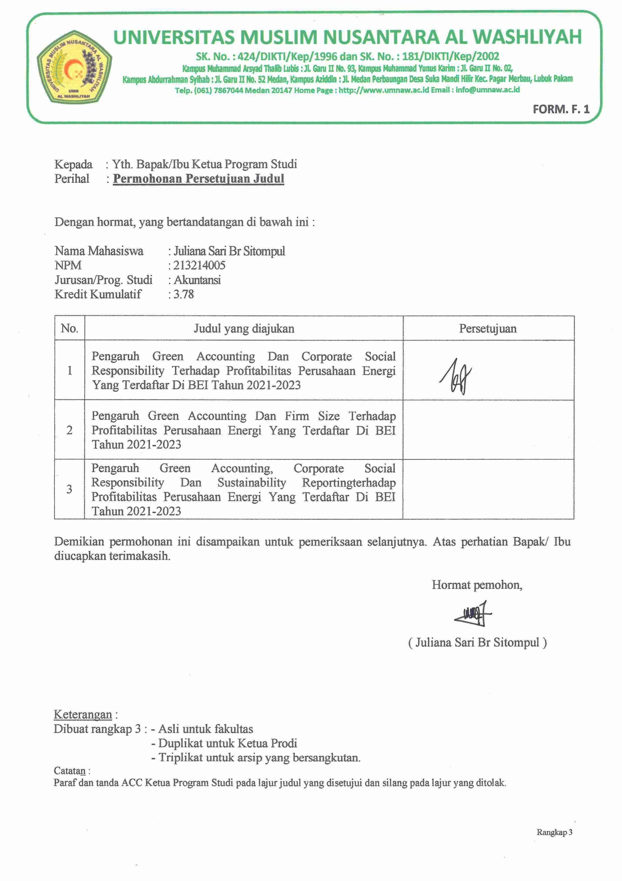

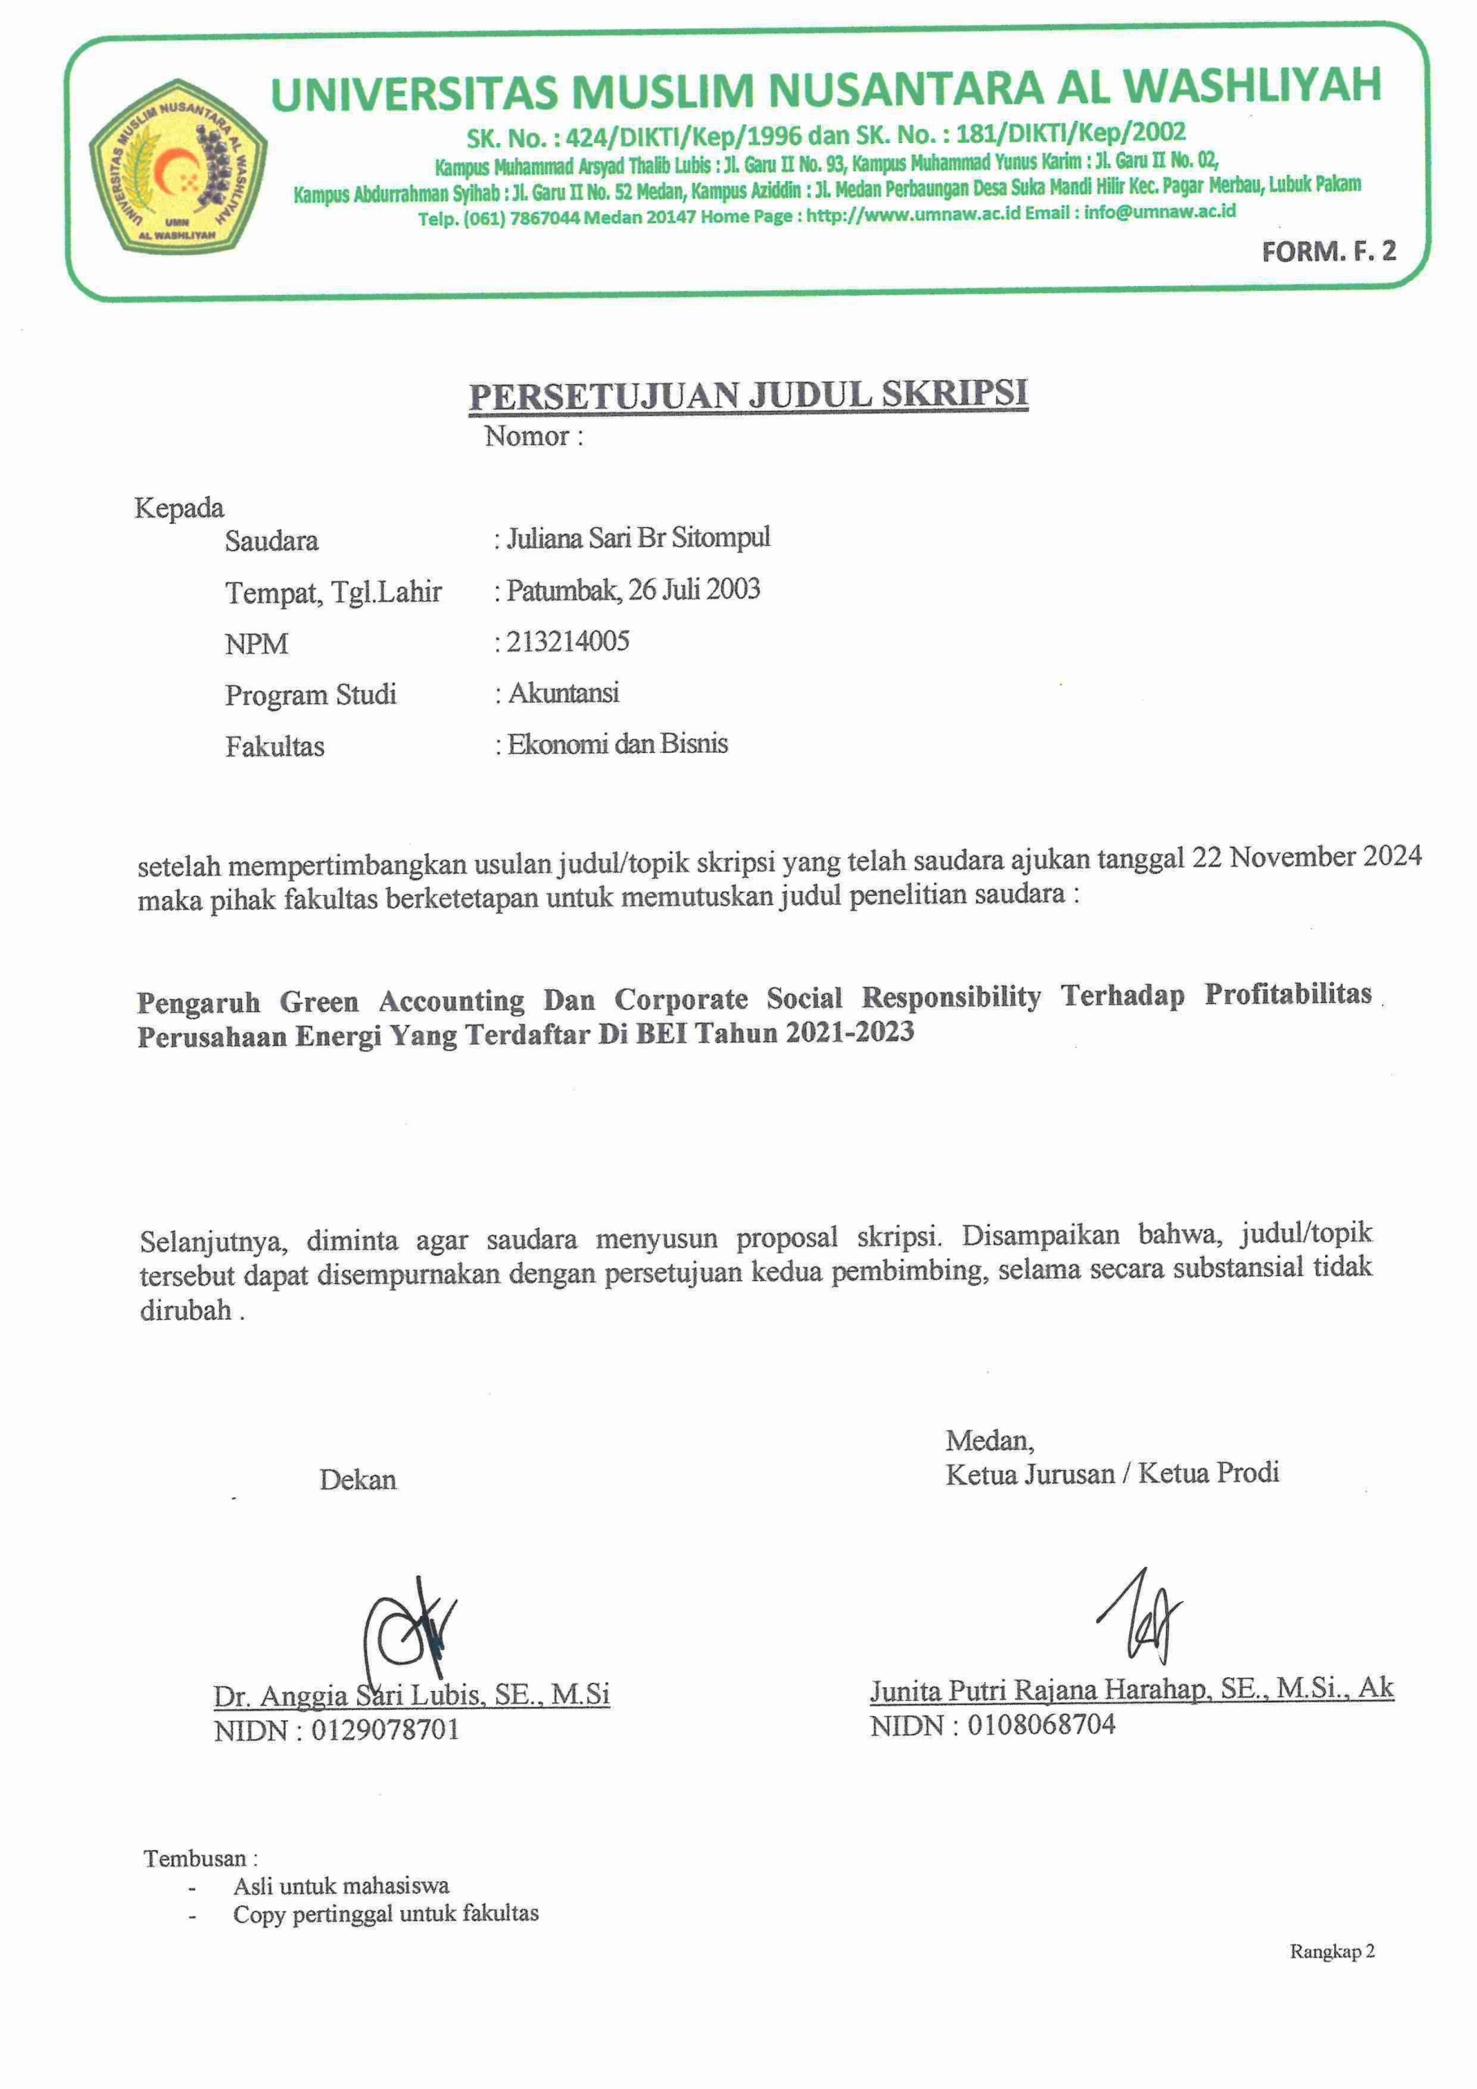

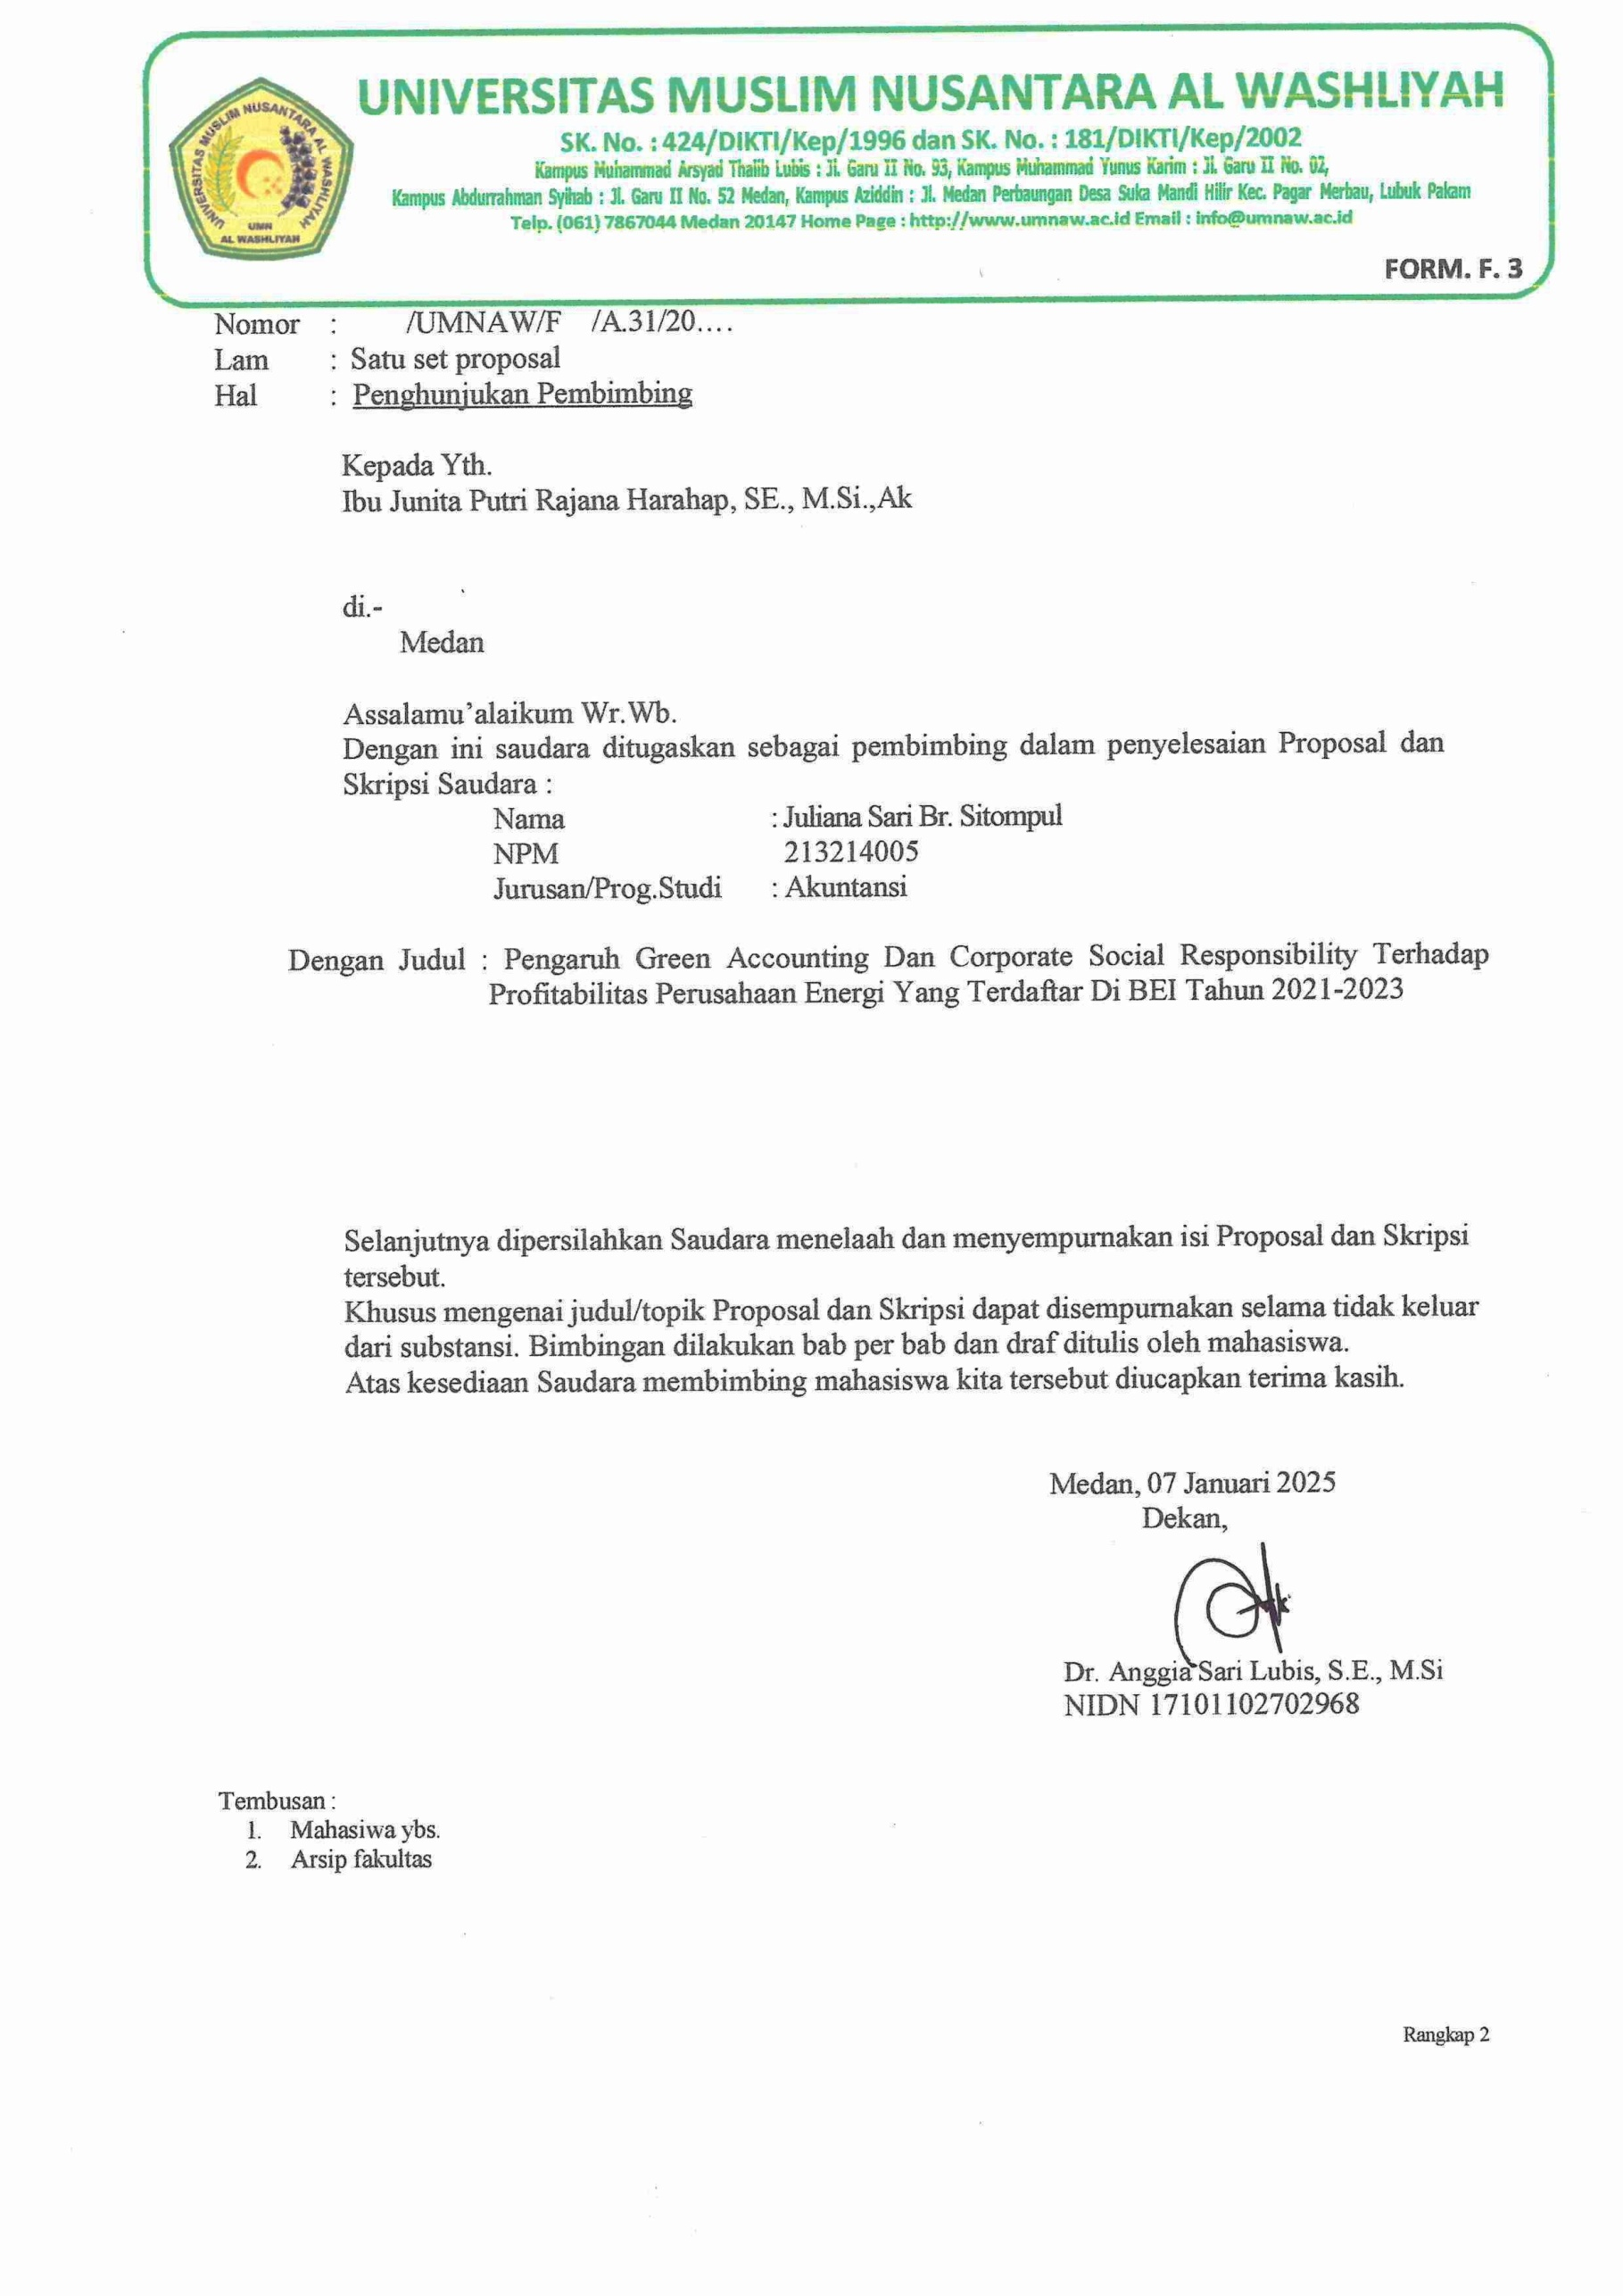

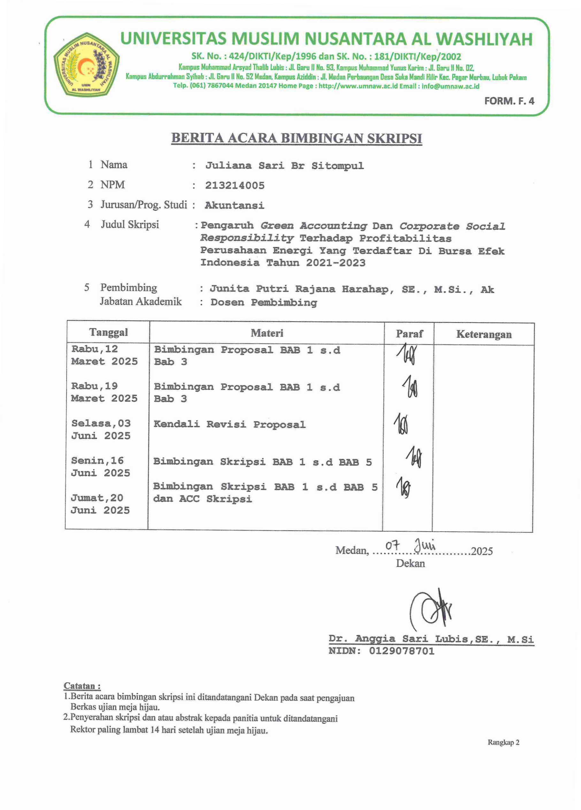

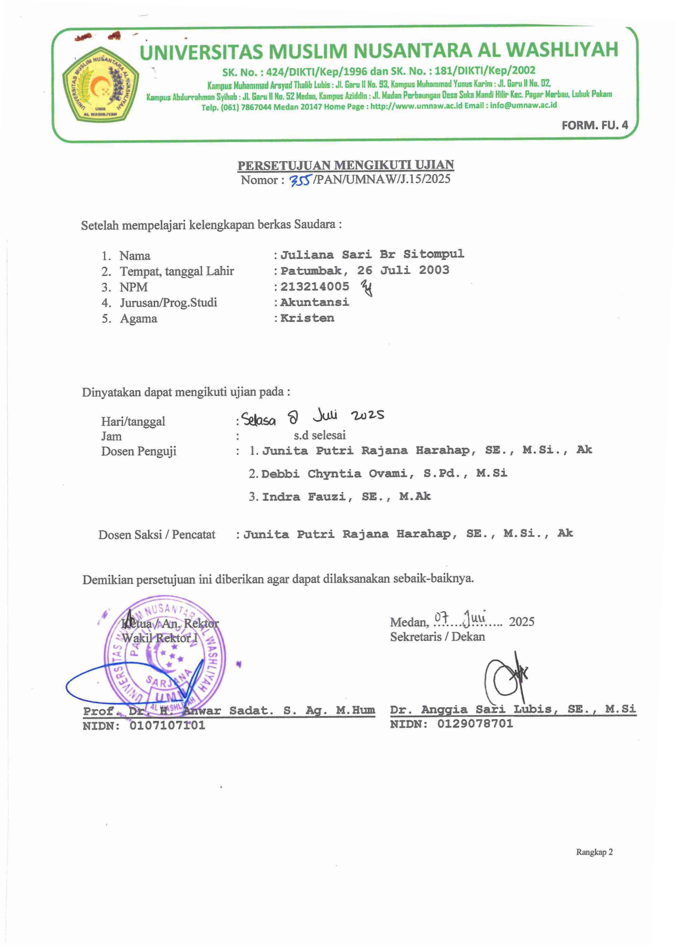

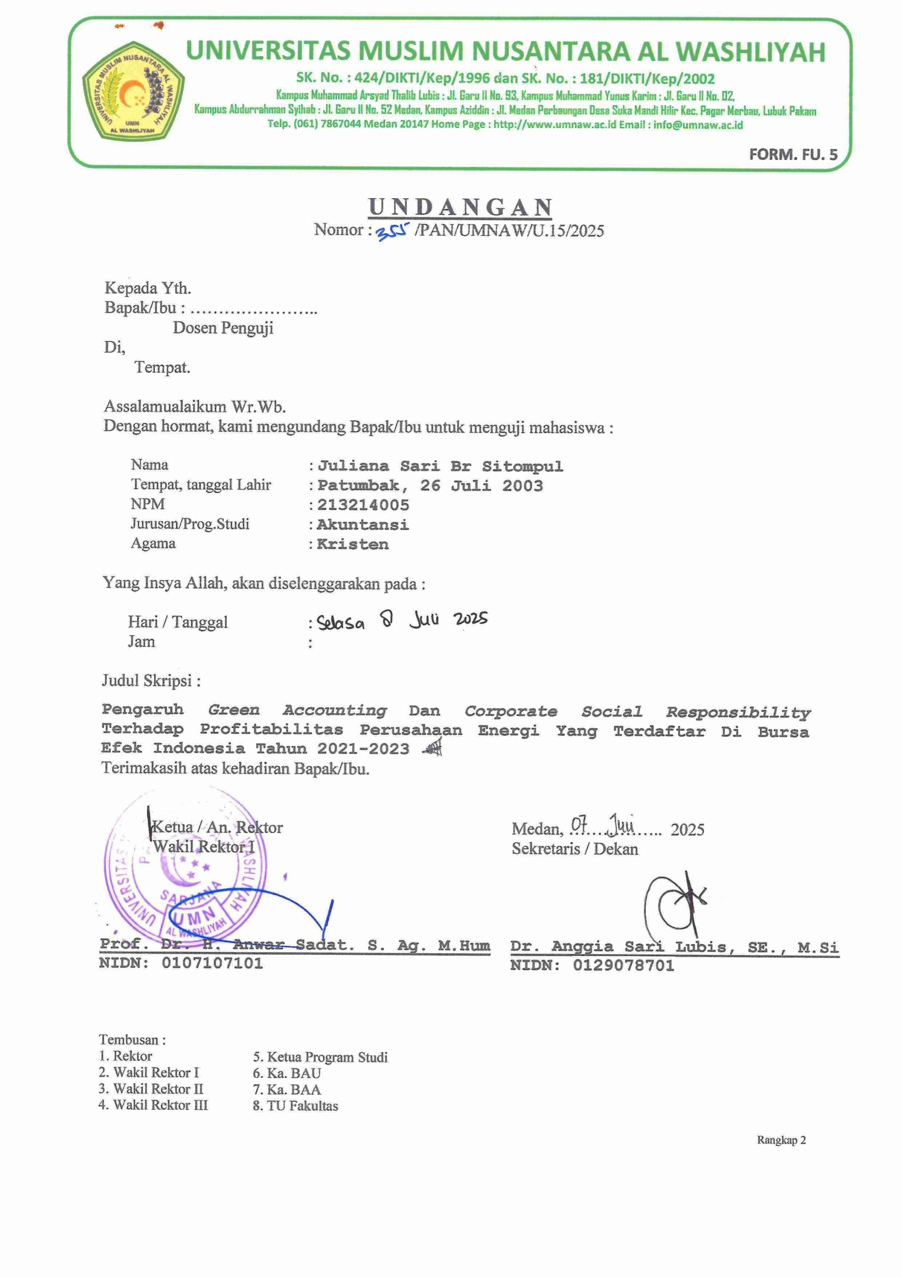

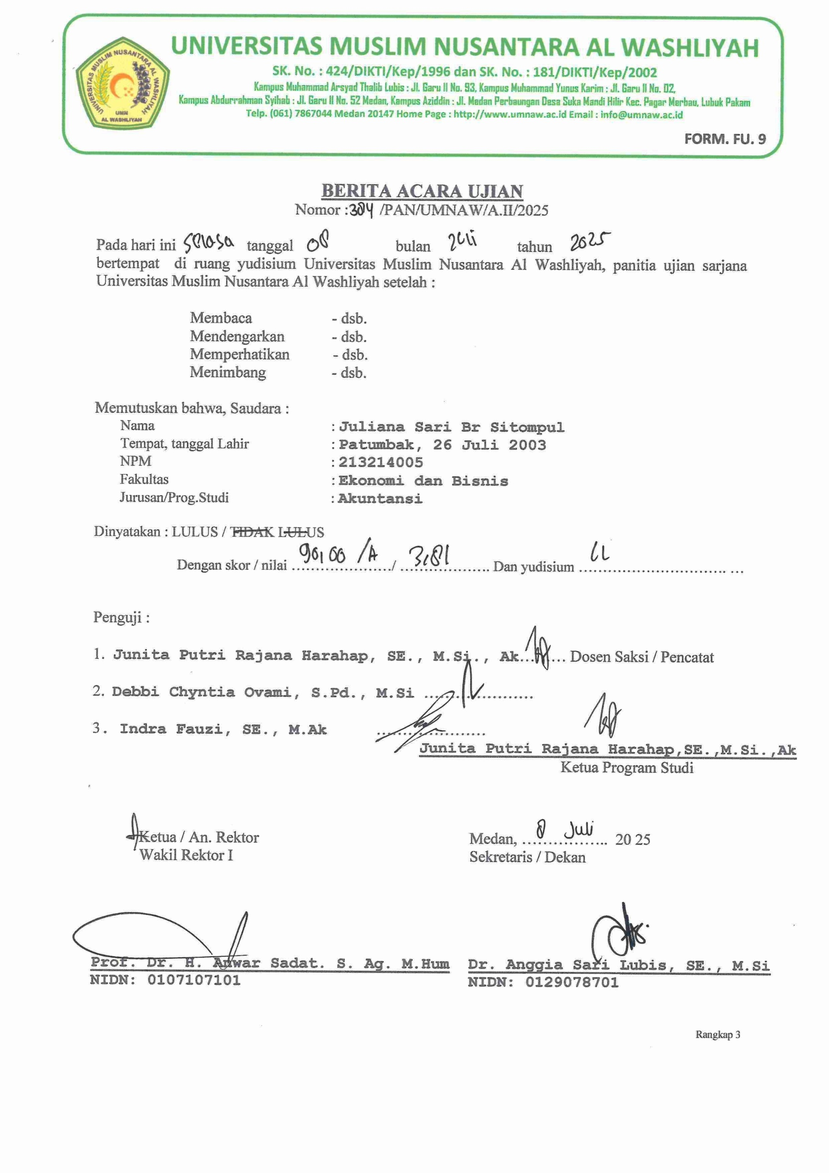

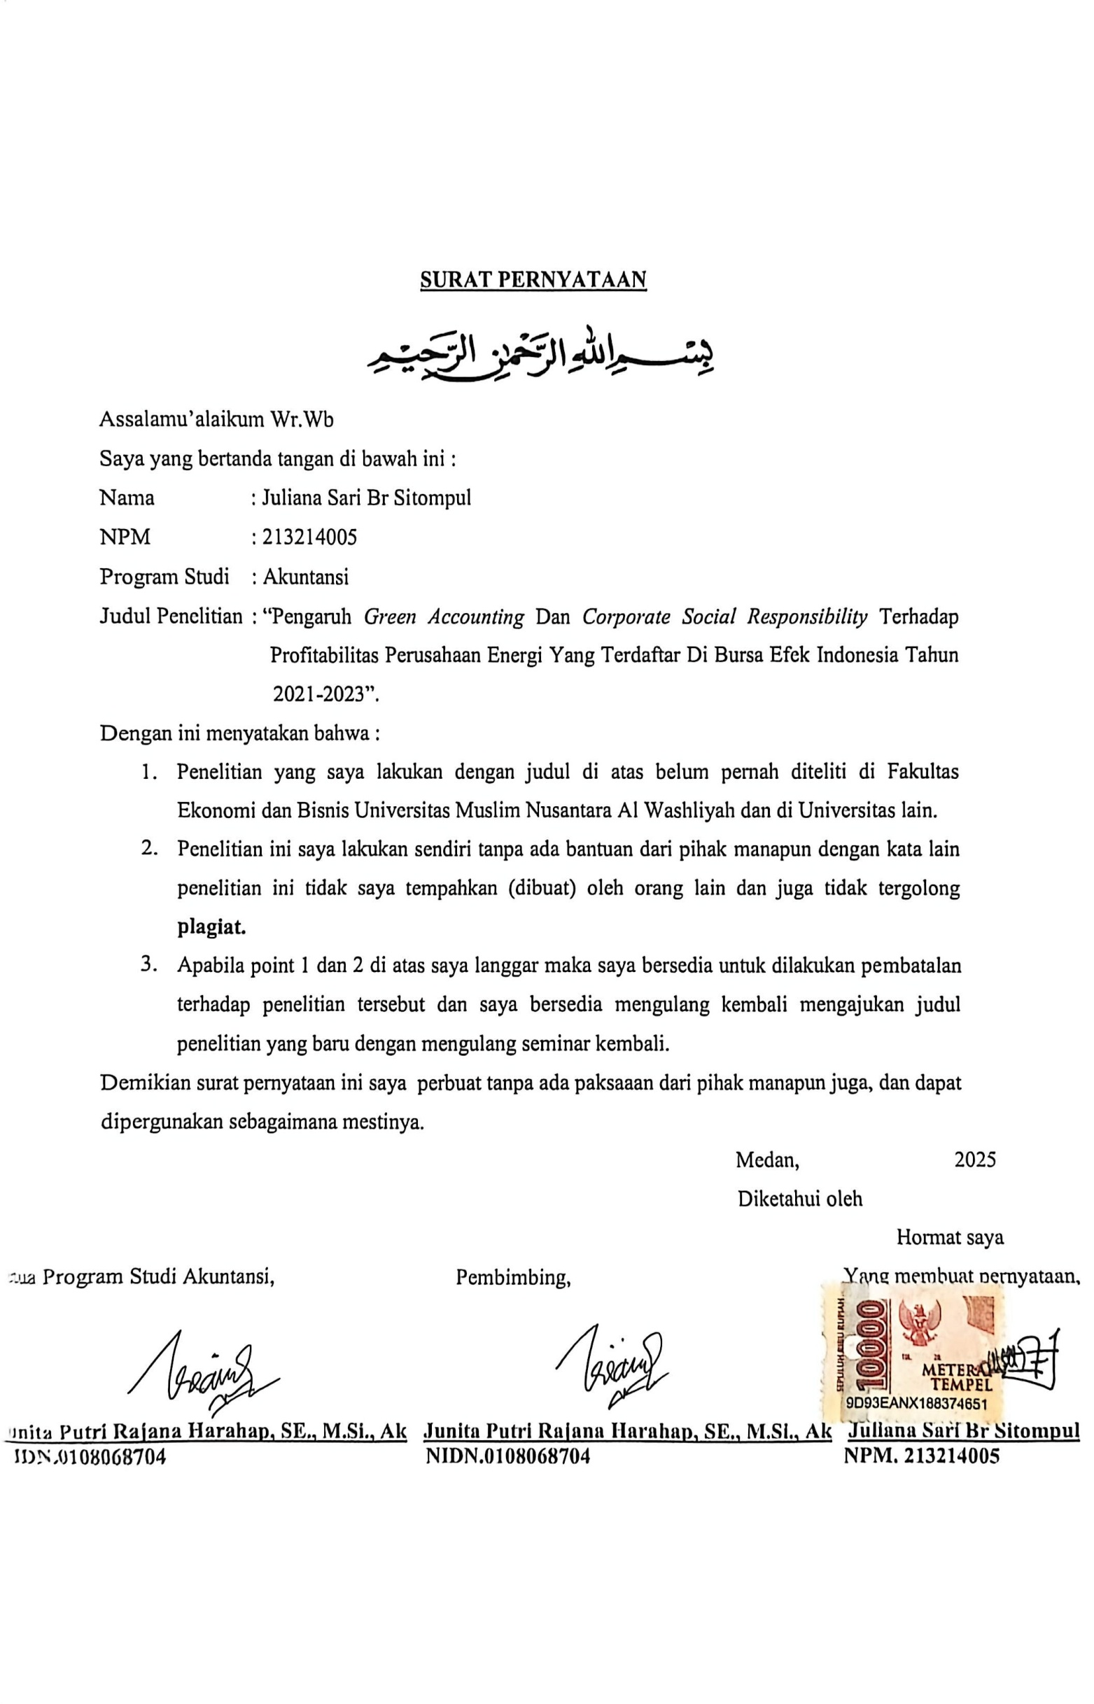

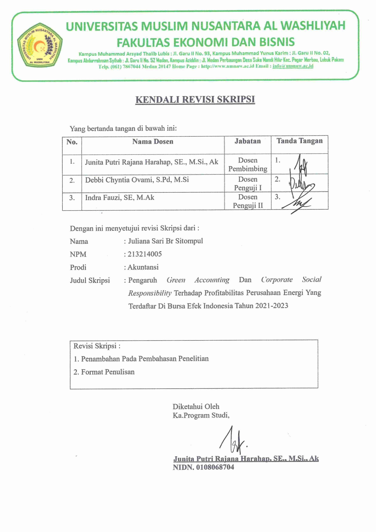

BIODATAMAHASISWA


  - IDENTITASDIRI
Nama : JulianaSari Br Sitompul
NPM 213214005
Tempat/Tanggal Lahir :Patumbak,26Juli2003 Jenis Kelamin : Perempuan
Agama : Kristen Protestan
Status :Belum Menikah
Pekerjaan : Mahasiswa
AnakKe :4 Dari5 Bersaudara
Alamat :Dusun VPatumbak II
No. Telp/HP 081375494464
Dosen Pembimbing :JunitaPutriRajanaHarahap,SE.,M.Si., Ak
Judul Skripsi :PengaruhGreenAccountingDanCorporateSocial Responsibility Terhadap ProfitabilitasPerusahaan Energi Yang Terdaftar Di Bursa Efek Indonesia Tahun 2021-2023
IndeksKumulatif :3.81

PENDIDIKAN
SD :SDNegeri101793 Patumbak
SMP :SMPNegeri1 Patumbak
SMK :SMKNegeri1Patumbak

ORANGTUA
Nama Ayah :PasiharSitompul
Pekerjaan : Petani
NamaIbu : RamsideBr Tamba
Pekerjaan :IbuRumahTangga
Alamat :Dusun VPatumbak II

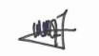
Medan,21Juli 2025
JulianaSari Br Sitompul

