DESIGNING AUDIOLINGUAL LEARNING MODEL USING
THE SELF-RECORD METHOD AS A MEDIUM AND ITS
IMPACT TO STUDENTS’ LISTENING AND SPEAKING
ABILITY AT SMP NEGERI 4 TANJUNG MORAWA IN ACADEMIC YEAR 2023/2024

THESIS

By:

CYNTHIA WULANDARI
Registration Number: 227215019



ENGLISH EDUCATION DEPARTMENT
POSTGRADUATION PROGRAM
UNIVERSITAS MUSLIM NUSANTARA AL-WASHLIYAH
MEDAN
2024
DESIGNING AUDIOLINGUAL LEARNING MODEL USING
THE SELF-RECORD METHOD AS A MEDIUM AND ITS
IMPACT TO STUDENTS’ LISTENING AND SPEAKING
ABILITY AT SMP NEGERI 4 TANJUNG MORAWA IN ACADEMIC YEAR 2023/2024

THESIS

To Obtain a Master Degree in English Education (M.Pd) in the Postgraduate Master Program in English Language education (S2)
Universitas Muslim Nusantara Al-Washliyah

By:

CYNTHIA WULANDARI
Registration Number: 227215019

ENGLISH EDUCATION DEPARTMENT
POSTGRADUATION PROGRAM
UNIVERSITAS MUSLIM NUSANTARA AL-WASHLIYAH
MEDAN
2024
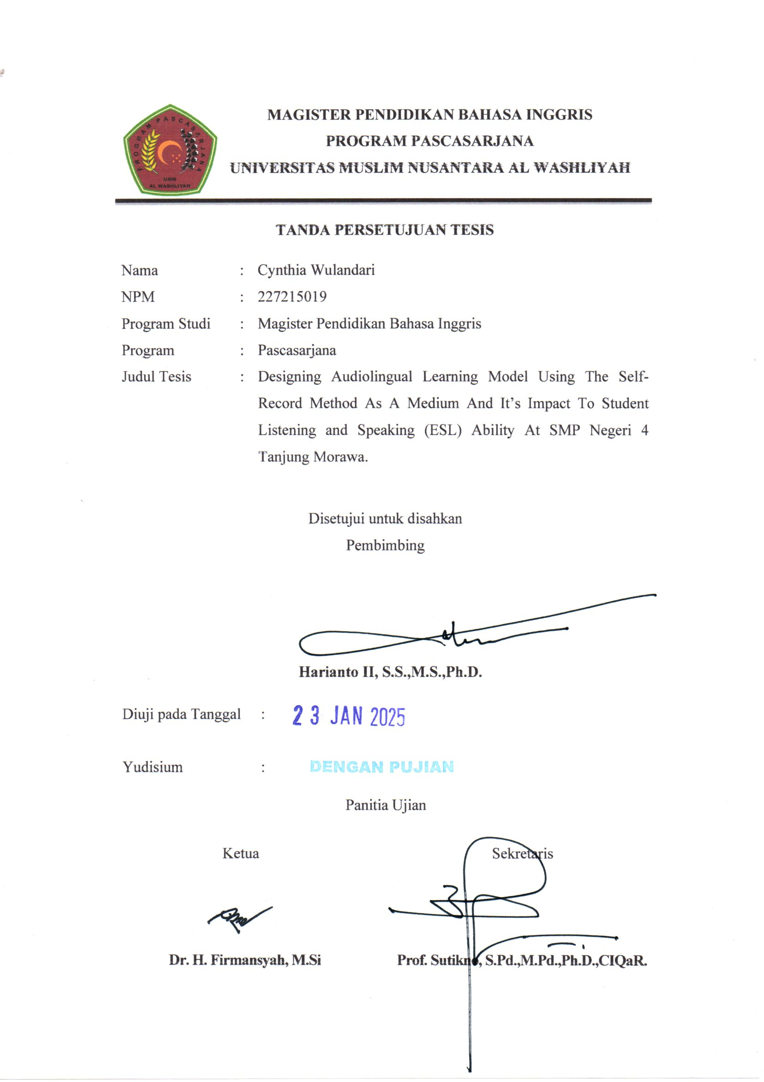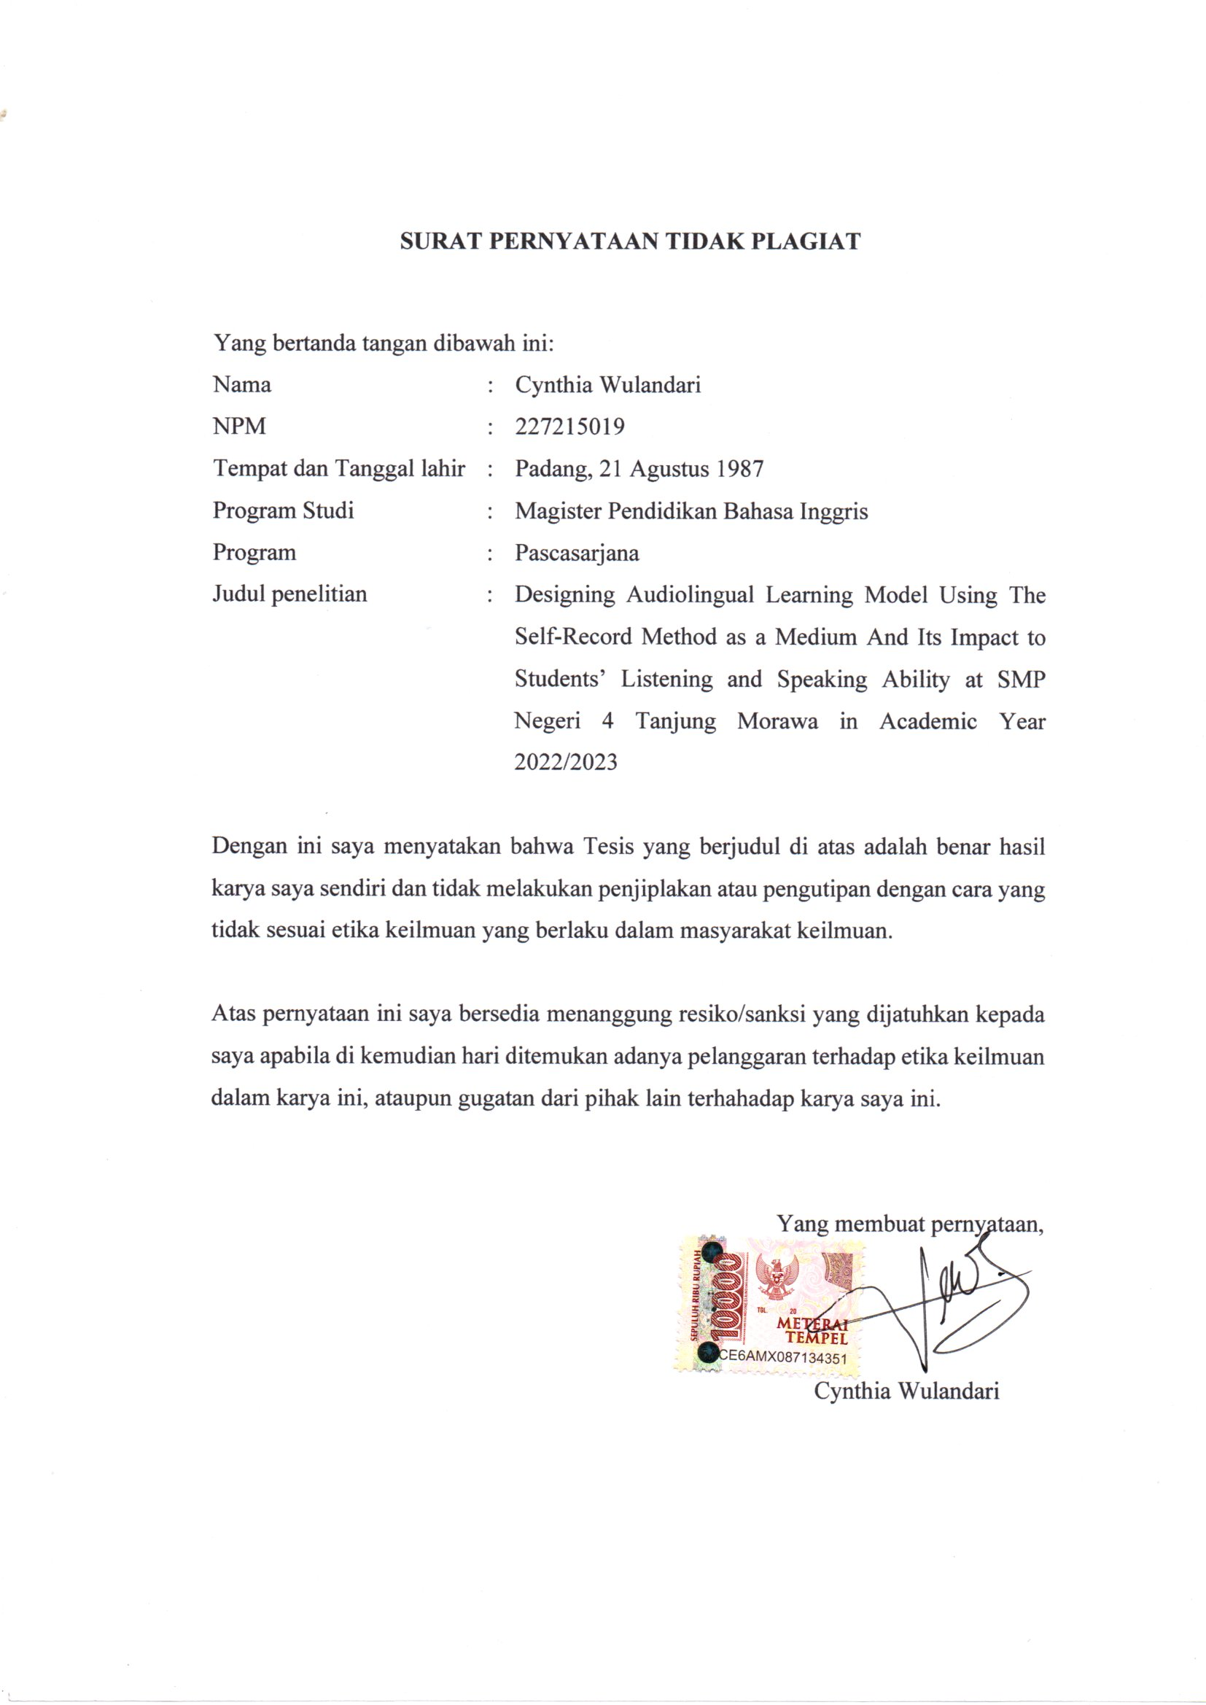
ABSTRACT
DESIGNINGAUDIOLINGUALLEARNINGMODELUSINGTHESELF-RECORDMETHODASAMEDIUMANDITSIMPACTTOSTUDENTS'LISTENINGANDSPEAKINGABILITIESATSMPNEGERI4TANJUNGMORAWAINACADEMICYEAR2023/2024

By:

CYNTHIA WULANDARI
NPM : 227215019
In the concept of language mastery, the stages to be passed are: (1) listening, (2) understanding the meaning of speech, (3) practicing/repeating speech, (4) reading, (5) writing. To achieve fluency in English, students must master all four of these abilities. One solution is for students to listen to their own conversations, which will make it easier for them to gain experience in listening to English conversations. Self-recording video is a practice where students or study participants use technological devices like smartphones, phones, or laptops to record themselves speaking in the target language, usually English, either inside or outside the classroom. This Research was aimed to made a design of Self-Recording Video as a method to improve student’s listening and speaking abilities. The sample of this research was students in class 9A and 9B. The study collected data by applying the following techniques: study literacy, interview, observation, test, and documentation.In developing of learning material by using SRV method several process criteria were used R&D cycle of Borg and Gill. The result of this research was showed that Implementing Self-record is significant to increase Student English language listening and speaking abilities at SMP NEGERI 4 TANJUNG MORAWA by increase the students listening skill by 23.22 points and the T-test score was 0,03, and the speaking skill by 22,61 point, and the T-test score was 0,01. The learning design of Self-record learning models is in the good levels to implementing at SMP NEGERI 4 TANJUNG MORAWA, by the design evaluated score was 3.51, indicating that the research design developed by the researcher was considered to be of "good" quality.

Keywords: R&D, Listening and Speaking Abilities

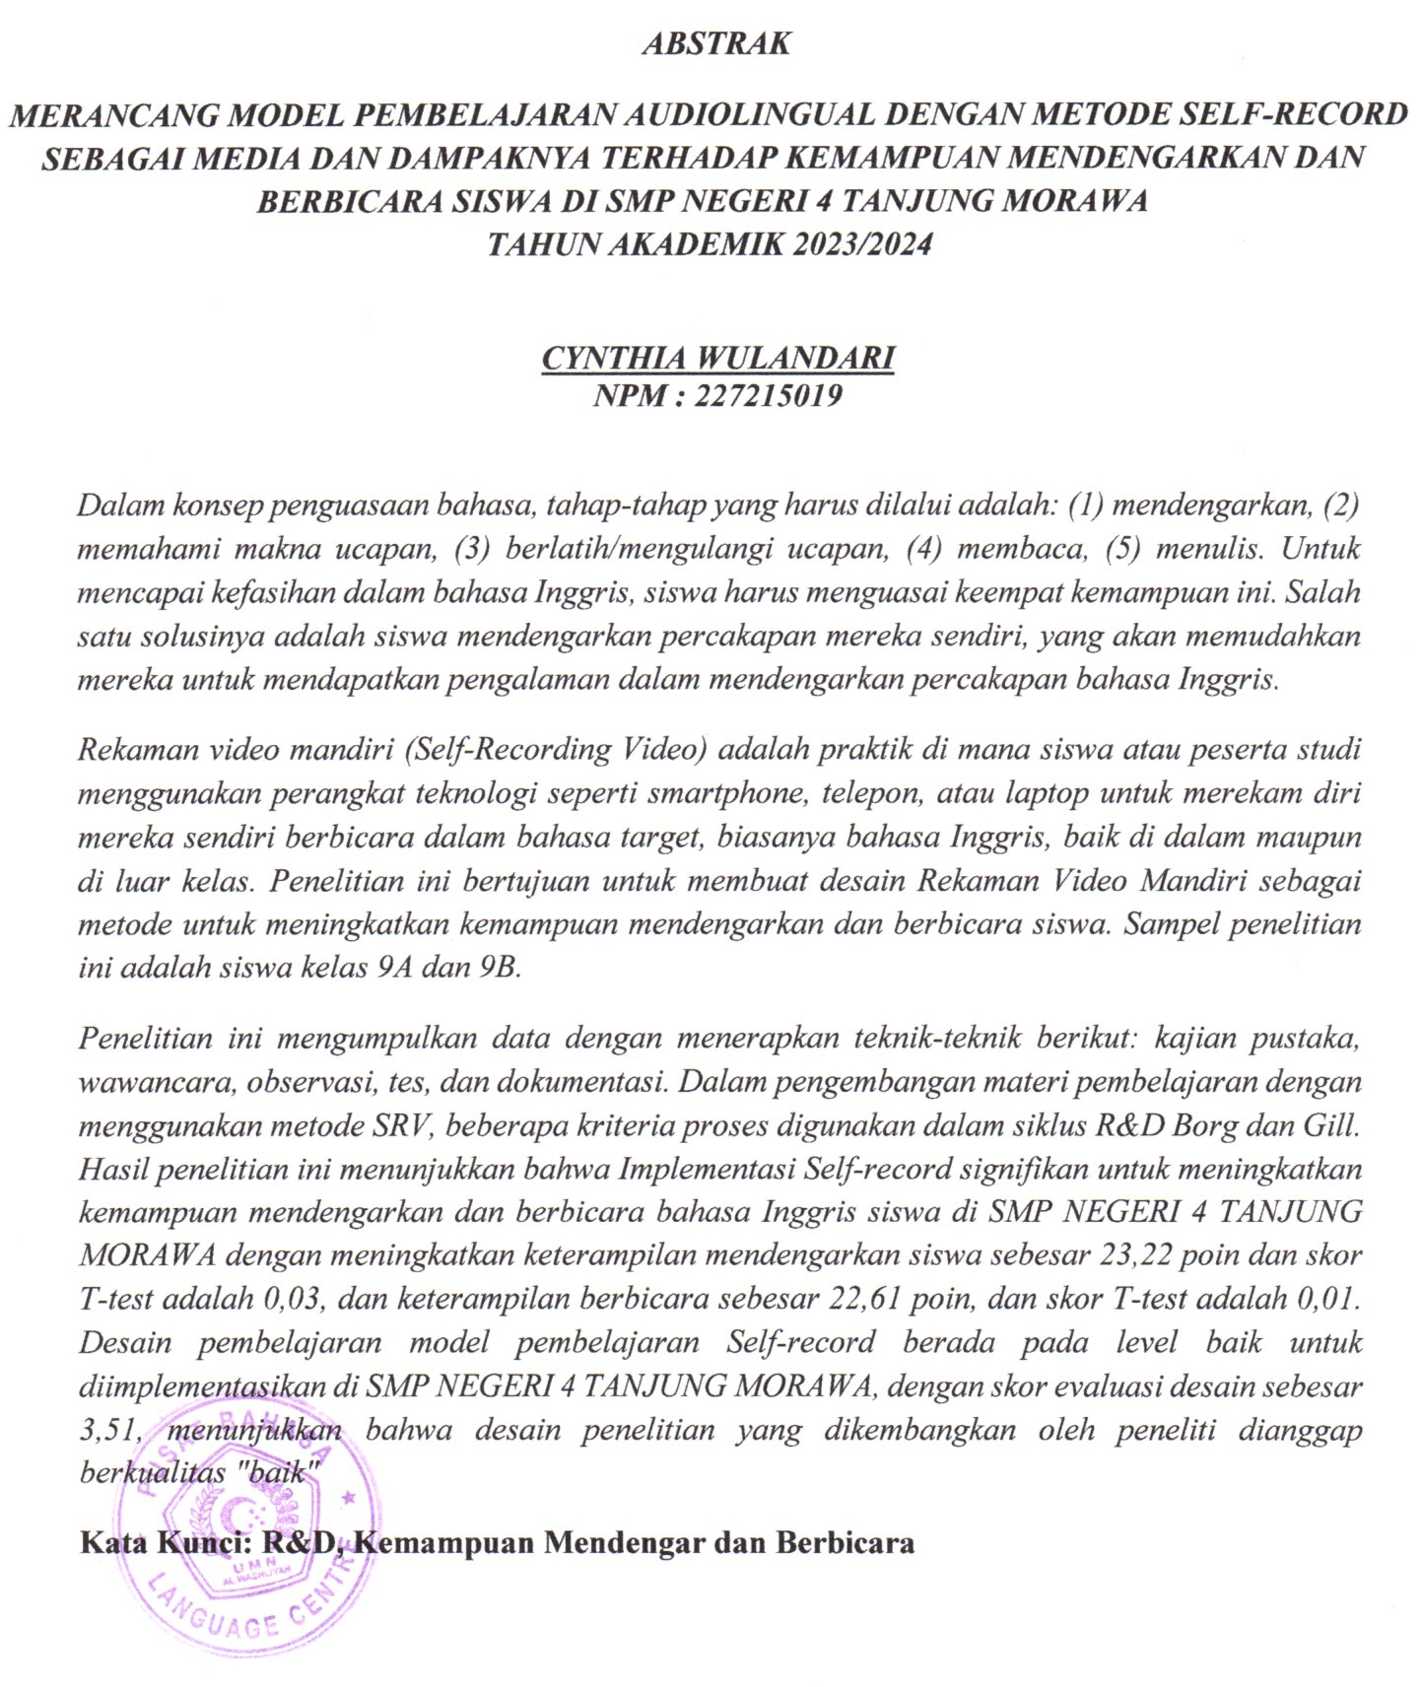
ACKNOWLEDEGMENTS

Assalamu’alaikum Wr.Wb
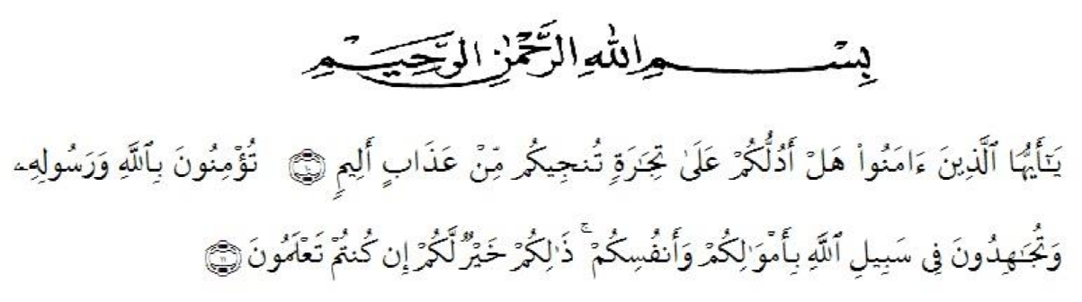
Artinya:
“O believers! Shall I guide you to an exchange that will save you from a painful punishment?¹⁰. It is to have faith in Allah and His Messenger, and strive in the cause of Allah with your wealth and your lives. That is best for you, if only you knew.¹¹.QS (As-Shaff 10 : 11)
First and foremost, she would praise and thanks to Almighty God, because of His blessings she can complete this research. She got suggestions, criticism and guidance from many people. Therefore, she would like to extend her sincere and special thanks to
- Dr. H. Firmansyah, M.Si, the Rector of UMN Al-Washliyah Medan,
- Sutikno, S.Pd.,M.Pd.,Ph.D.,CIQaR, the Postgraduate Director of UMN
Al-Washliyah Medan,
- Asnawi, S.Pd., M.Hum, the leader of English Department of UMN Al-
Washliyah Medan,
- Harianto II, S.S., M.S., Ph.D the first consultant, who has given correction, suggestion, comments, criticism for completing her research,
- The lectures of the English Department of FKIP UMN Al Washliyah Medan who have taught him,
- She’s beloved parents, husband and my beloved children, Fico Hadyan Arifin and Nikeysha Jihannifah who always support me by Morallity and for their love and praying to finishing her study in the postgraduate program.

Finally, the researcher realized that this thesis was far from being perfect. Therefore, constructive suggestion was needed for the resercher to continue the research.

Medan, 6 May 2024
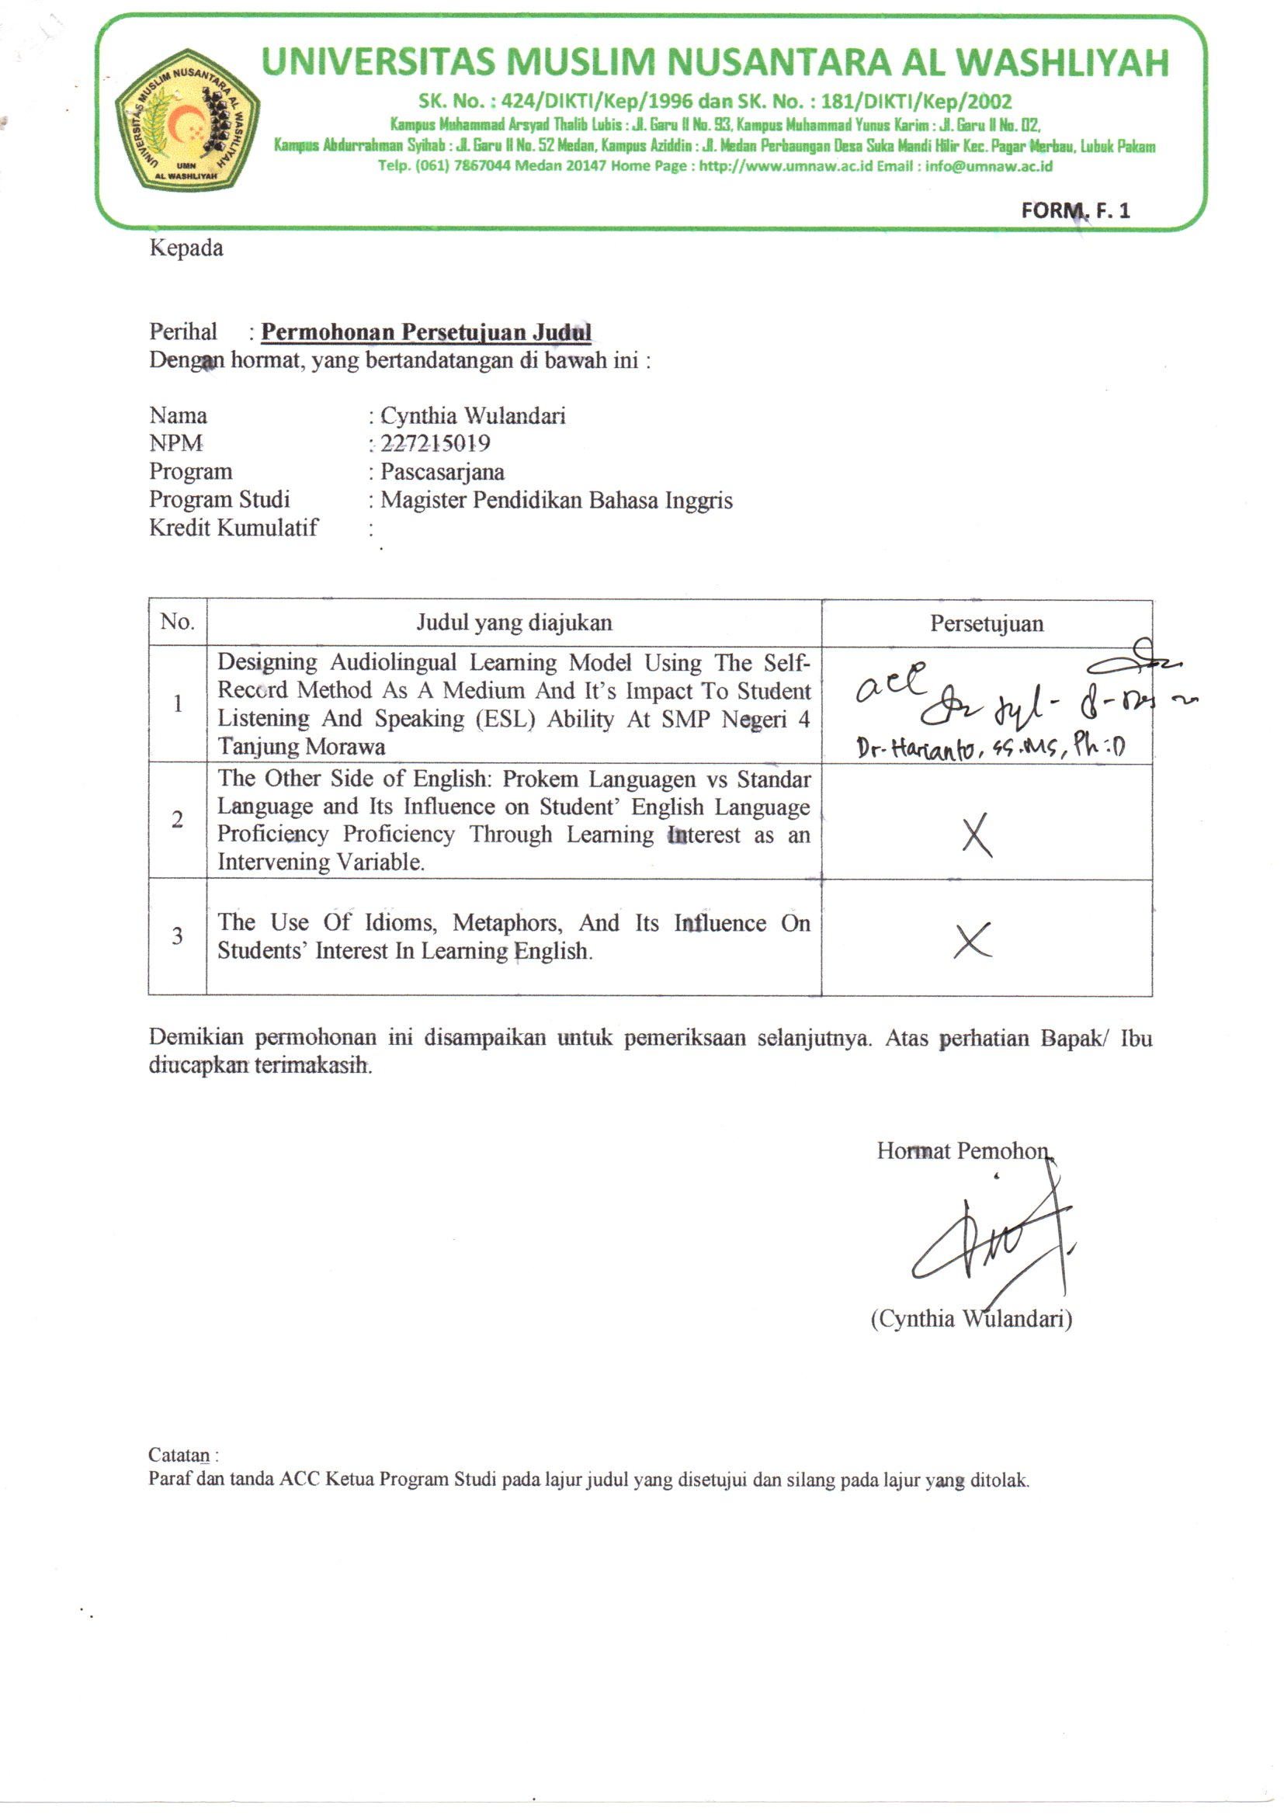
The researcher,

CYNTHIA WULANDARI

TABLE OF CONTENTS

LETTER OF APPROVAL
ABSTRACT ....................................................................................................... iii
ABSTRAK .......................................................................................................... iv
ACKNOWLEDGEMENTS................................................................................. v
TABLE of CONTENTS ................................................................................... vii
LIST of TABLE .................................................................................................. ix
LIST of FIGURE ................................................................................................ xi
LIST of APPENDIX ......................................................................................... xii

CHAPTER I INTRODUCTION ....................................................................... 2
1.1Background of the Study .............................................................................. 2
1.2Problem Identification ................................................................................... 7
1.3Problem Limitations ..................................................................................... 7
1.4Problem Formulation ................................................................................... 8
1.5Objective of Research .................................................................................... 8
1.6 Benefit of the Research ............................................................................... 9
CHAPTER II LITERATURE REVIEW ........................................................ 10
2.1Theoritical Framework .............................................................................. 10 2.1.1Self Record Method .................................................................................. 10 2.1.2Speaking Skill .....................................................................................…... 11
2.2Previous Research ................................................................................….. 20
2.3Framework of Thinking ............................................................................. 21
2.4Hypothesis .................................................................................................... 25

CHAPTER III RESEARCH METHODOLOGY .......................................... 26
3.1Research Model ..................................................................................…...... 26
3.2Research Location and Time ...................................................................... 27
3.3Population and Sample ................................................................................ 28
3.4Research Design ........................................................................................... 28
3.5Definition Operational Variable ................................................................. 29

3.6Research Instrument Development ............................................................ 32
3.7 Data Collection Techniques ................................................…….................33 3.8Data Analysis Techniques ........................................................................... 34
CHAPTER IV RESULT AND DISCUSSION ............................................... 38
4.1.Result of Research ...................................................................................... 38
4.1.1Data analyses ............................................................................................. 38
4.1.2Hypothesis Test ......................................................................................... 59
- H1 ................................................................................................................... 59
- H2 ................................................................................................................... 60
- H3 ................................................................................................................... 62
4.2.Discussion .................................................................................................... 63
CHAPTER V CONCLUSION AND SUGGESTION ..................................... 66
  - Conclusion .................................................................................................... 66
  - Suggestion .................................................................................................... 66
REFERENCES ................................................................................................... 68
APPENDIX ...................................................................................................... 72

LIST OF TABLE

Table 1 : Student’s Listening Skill Indicator | 4
Table 2 : Student’s Speaking Skill Indicator | 4
Table 3 : Random Pre-test Student Observation | 5
Table 4: Research Schedule | 27
Table 5: Pre-Test IX-A | 38
Table 6: Pre-Test IX-B | 39
Table 7: Validity of Listening Ability Test (Control Class) | 41
Table 8: Validity of Listening Ability Test (Treatment Class) | 41
Table 9: Validity of Speaking Ability Test (Control Class) | 41
Table 10: Validity of Speaking Ability Test (Treatment Class) | 41
Table 11: Phase-1 (Control Class) | 43
Table 12: Phase-1 (Treatment) | 44
Table 13: Test of Normality | 46
Table 14: Test of Homogeneity of Variance | 46
Table 15: Listening Abilities T-Test (Phase-1) | 47
Table 16: Speaking Abilities T-Test (Phase-1) | 47
Table 17: Method Assessment | 49
Table 18: Validity of Listening Ability Test (Control Class) | 50
Table 19: Validity of Listening Ability Test (Treatment Class) | 50
Table 20: Validity of Speaking Ability Test (Control Class) | 50
Table 21: Validity of Speaking Ability Test (Treatment Class) | 50
Table 22: Phase-2 (Control Class) | 52
Table 23: Phase-2 (Treatment) | 53
Table 24: Test of Normality | 55
Table 25: Test of Homogeneity of Variance | 55
Table 26: Listening Abilities T-Test (Phase-1) | 56
Table 27: Speaking Abilities T-Test (Phase-1) | 57
Table 28: Method Assessment | 58

:

LIST OF FIGURE

Figure 1: Flowchart of The Learning Activities With Self-Recording Method | 24
Figure 2:Borg & Gill R&D Step | 28
Figure 3: Reliability of Listening ability test (Control Class) | 42
Figure 4: Reliability of Listening ability test (Treatment Class) | 42
Figure 5: Reliability of Speaking ability test (Control Class) | 42
Figure 6: Reliability of Speaking ability test (Treatment Class) | 42
Figure 7: Reliability of Listening ability test Phase-2 (Control Class) | 51
Figure 8: Reliability of Listening ability test Phase-2 (Treatment Class) | 51
Figure 9: Reliability of Speaking ability test Phase-2 (Control Class) | 51
Figure 10: Reliability of Speaking ability test Phase-2 (Treatment Class) | 51
Figure 11: Student’s Listening Abilities Improvement | 60
Figure 12: Student’s Speaking Abilities Improvement | 62

LIST Of APPENDIX

Appendix 1: Pre-test Student Observation (Student listening abilities) | 72
Appendix 2: Pre-test Student Observation (Student Speaking abilities) | 72
Appendix 3: Random Pre-test Student Observation | 73
Appendix 4: Self-Record Treatment Role | 74
Appendix 5: Post-test observation (Teacher observation/ Control Class) | 74
Appendix 6: Student Rubric Assessment (Speaking) | 74
Appendix 7: Listening Test (Pre-test) | 78
Appendix 8: Listening Test (Phase-1) | 81
Appendix 9: Listening Test (Phase-2) | 84
Appendix 10: Material Quality Assessment | 88
Appendix 11: Language Quality Assessment | 91
Appendix 12: Method Quality Assessment | 93
Appendix 13: Method Assessment | 96
Appendix 14: Student Test and Observation Result Treatment Class (Pre-test) 97
Appendix 15: Student Test and Observation Result Control Class (Pre-test) 99
Appendix 16: Learning Modul of Self-Record Method 101

CHAPTER I
INTRODUCTION

1.1Background of the Study
Basically, language is a means of oral and written communication. People use language to express their ideas and desires to others such as when they ask for help from others. Knowledge of English language becomes very important to develop oneself in global community since English is a common language used in global communication. Indonesia has experienced curriculum changes to meet the demands of global community, and industrial revolution.
The English language proficiency of Indonesian students is still poor, based on data from the Education First institution involving 112 countries. Indonesia shows English language proficiency that falls into the low category with a score of 486 points. According to Prihatin (2019:25) state that “The latest EPI data shows that Indonesia ranked 51st out of 88 countries in the world, and 13th out of 21 countries in Asia. With an average score of 51.58, Indonesia falls under the ‘low proficiency category”. We knows that Indonesia at low proficiency category in English language. The low English language proficiency is due to several factors, one of which is the unfamiliarity of Indonesian society with hearing conversations in English.
In the concept of language mastery, the stages to be passed are: (1) listening,
(2) understanding the meaning of speech, (3) practicing/repeating speech, (4) reading, (5) writing. To mastery English language, everybody need to mastery this aspect first.
This is in line with what was conveyed by Haris, as mentioned by Isjoni, state that In language learning, there are four essential abilities to acquire, which can be categorized into encoding and decoding processes. Speaking and writing fall under the encoding processes, where we convey our ideas, thoughts, or feelings using language forms. On the other hand, listening and reading are considered decoding processes, as they involve receiving spoken or written messages. To achieve fluency in English, students must master all four of these abilities (Isjoni, 2009:22).
The more frequently one hears pronunciation or conversations in English, the more vocabulary one will understand. Schools, as environments where children learn, should encourage them to gain this experience (hearing conversations in English). The challenge is when a child hears English conversations spoken by others (especially native speakers), they still encounter difficulties due to the speed of pronunciation. Hence, a suitable learning medium is required to solve this problem.
The next stage in mastering a language after listening to it is understanding, then imitating, and repeating the knowledge of that language. Learning related to a language essentially lies not in its theory but in the practice and implementation in everyday life.
Speaking ability is a skill or power to express ideas, opinions, or messages orally with correct sentences grammatically. Speaking is the ability to produce words in language practice. Speaking ability is one of the most important abilities to be developed and improved as a means of effective communication. Speaking ability is considered as one of the most difficult aspect in language learning. According to
According to expert stated above, researcher felt so excited to observes SMP
Negeri 4 Tanjung Morawa Student’s English proficiency by testing their listening and speaking abilities. SMP Negeri 4 Tanjung Morawa the result showed below.
There are several indicator that researcher made to follow this assessment.
Tabel 1. Student listening Skill Indicator
No | Listening Abilities | Details
1 | Evaluating Information | according to decoding processes and meaning-building processes, which listeners draw upon to arrive at a full understanding of texts (Nhat, 2021:48)
2 | Interpreting Messages | Students can interpret messages or ideas conveyed by speakers in a foreign language(Rost,M, 2011:11).
3 | Content Comprehension | learners need to employ to understand listening input comprehensively (Nhat, 2021:48)
4 | Capturing Nuances | Students can capture nuances, implied meanings, or emotions conveyed in a foreign language (Mendelsohn, D.J:1999)
5 | Detail Understanding | Students can identify specific details and information in foreign language texts or conversations (Rost,M, 2011:11).

Tabel 2. Student Speaking Skill Indicator
No | Aspect of Speaking | Theories
1 | Grammar | Academic grammar must be efficient because academic writing and Speaking must be clear, focus briefly, and be written in a good structure (Perdana, et al, 2021:125)
2 | Pronunciation | Pronouns represent a heterogeneous and contradictory part of speech in morphological-paradigmatic, functionalsemantic and syntactic relations (Muryasov, 2021:152)
3 | Vocabulary | P ercentage of students’ vocabulary as indicator of speaking ability 72% (Putri and Refnaldi, 2020:52)
4 | Fluency | The findings support the multidimensionality of speech fluency and the need to include both macro and micro fluency features in the scoring, scale development, and validation of second Language speaking assessment (Yan et al, 2020:1).
5 | Comprehension | The students with high verbal-linguistic intellect were found to speak English more fluently. As a consequence, verbal-linguistic intelligence will increase students' speaking abilities (Syam, 2023:51)

Table 3: Random Pre-test Student Observation
Name of Student |  | Assessment Indicator
Name of Student |  | Student Speaking Skill |  |  |  | Student listening Skill
Name of Student | In 1 | In 2 | In 3 | In 4 | In 5 | In 1 | In 2 | In 3 | In 4 | In 5
Akbar Sahara Tanjung | 3 | 2 | 2 | 2 | 2 | 2 | 1 | 3 | 2 | 2
Anisa Putri Harahap | 2 | 2 | 2 | 2 | 2 | 2 | 2 | 2 | 1 | 2
Amelia Putri | 3 | 2 | 2 | 2 | 2 | 2 | 2 | 3 | 1 | 2
Benny Shalva Budi | 3 | 3 | 2 | 2 | 3 | 2 | 2 | 2 | 2 | 2
Boy Simatupang | 3 | 3 | 3 | 4 | 3 | 2 | 2 | 2 | 2 | 2
Chairul Wiguna Tri | 3 | 3 | 2 | 2 | 2 | 3 | 2 | 3 | 2 | 2
Frans Eben Gultom | 3 | 3 | 3 | 3 | 3 | 3 | 3 | 3 | 2 | 2
Glory Chantika | 4 | 3 | 3 | 4 | 4 | 4 | 4 | 3 | 1 | 3
Javier Haristson S | 3 | 2 | 2 | 2 | 2 | 2 | 2 | 2 | 2 | 2
Mutiara Clevia | 3 | 3 | 3 | 2 | 3 | 3 | 3 | 3 | 2 | 3

According to the pre-test data above, researcher know that, SMP Negeri 4 Tanjung Morawa Student’s English proficiency by testing their listening and speaking abilities are showed at poor level. This data indicate that majority of students couldn’t follow the learning process in right way even though the teachers have been trying to implement effective methods to enhance the students' foreign language proficiency.
As teachers, we have a responsibility to solve this issue. One solution is for students to listen to their own conversations, which will make it easier for them to gain experience in listening to English conversations. This is in line with what was conveyed by Burn Anne (2019:10)”The main aim of speaking tasks is to help students develop the fluency of expert speakers where meaning is communicated with few hesitations and in a manner that is appropriate for the social purpose of the message. This is achieved through the use of accurate language and discourse routines, appropriate speech enabling abilities, and effective communication strategies”.
One of method that could solve both of this problem is by self-record learning, this method mean, student must be record their learning process and after that they must be repeat the lesson at their home’s.
In line with Burn Anne, Maulana, et al (2023:883) Said that Self-Recording Video increases students' confidence in speaking and provides opportunities to improve abilities. Despite challenges, such as mispronunciations, this approach helps students feel supported and motivated. By using this video, students can practice speaking more confidently and effectively in learning English.
Encalada (2019:64) claimed also that “SRVs have helped me to develop my speaking abilities," we find out that the majority of students, 48, 1% of them, very agreed and that 43, 2% of them agreed”.
In line with Encalada, Qureshi, et al (2019:26) said that “One aspect of speech class assessment that may be required is digital video recording. This made it easier for students to complete the self-reflection sheets and give peer comments with more accuracy and effectiveness”. Aprianto and Muhlisin (2022:252) also said that “The finding of to what extent the use of SRV as an English language learning method in developing English learning performance statistically depicted that it has affected the students’ English learning. From nine items used as the instrument to assess the students’ perception of how the SRV is used in students’ English learning performance, SRV shows very positive in which the average score of the use of SRV is 84.76 %. As a result, the Self-Recordinng Videos method can effectively facilitate the students’ English learning performance
According to all of the expert above, researcher feel interested to using Selfrecord method to improve SMP Negeri 4 Tanjung Morawa Student’s English proficiency specially on their listening and speaking abilities. Therefore, the researcher has decided to conduct a study with the title “Designing Audiolingual
Learning Model Using The Self-Recor Method As A Medium And It’s Impact To
Student Listening And Speaking Ability At SMP Negeri 4 Tanjung Morawa (20232024).
1.2Problem Identification
- SMP Negeri 4 Tanjung MorawaStudent’s Speaking skill showed at poor level.
- SMP Negeri 4 Tanjung Morawa Student’s Listening skill showed at poor level.
- Is need to improve a new learning method to increase student’s speaking and listening skill at SMP Negeri 4 Tanjung Morawa.

1.3Problem Limitations
- This research are focus on Self-recording method
- This research are focus at 9 grade student’s of SMP Negeri 4 Tanjung Morawa
- This research are focus to improve SMP Negeri 4 Tanjung Morawa student’s listening and speaking skill.

1.4Problem Formulation
Based on the limitations mentioned above, the research questions for this study can be formulated “
- How is the impact of Self-record learning models to SMP Negeri 4 Tanjung
Morawa student’s listening skill?
- How is the impact of Self-record learning model to SMP Negeri 4 Tanjung
Morawa student’s speaking skill?
- How is the designing of audiolingual learning model using the self-record method as a medium to student listening and speaking ability at SMP Negeri 4
Tanjung Morawa?

1.5Objective of The Research
    - General Objective
The general objective of this research is to design an audiolingual learning model utilizeing the self-record method as a medium, and to investigateits impact on student’s listening and speaking abilities at SMP Negeri 4
Tanjung Morawa (2023-2024)
    - Specific Objective
To create a thorough audiolingual learning model that uses the self-record approach as its main teaching instrument.
To evaluate how well the audiolingual learning approach at SMP Negeri 4
Tanjung Morawa has improved students' listening and speaking abilities.

1.6 Benefit of the Research
This research is expected to be beneficial to the author, teachers, and students in the following ways:
- For the Auhor: it hoped that the research will be valuable as one of the requirements of graduating from the Master program at UMN Graduate School and as a valuable teaching experience.
- For teacher: this research is expected to offer an alternative method for enchancing student’s English language proficiency
- For Students: It is anticipated that the implementation of this method in their learning process will help improve their English language listening abilities.

CHAPTER II
LITERATURE REVIEW

2.1Theoretical Framework
2.1.1Self-record Method
These days, a lot of people use English as a global language for business, technology, research, information, and even diplomacy. 25% of the world's population uses it for international communications. English has been taught to all generations, and being able to communicate in English is one of the most important goals in learning a language. Learning English essentially requires developing language abilities such as speaking, listening, reading, and writing.
Self-recording video is a practice where students or study participants use technological devices like smartphones, phones, or laptops to record themselves speaking in the target language, usually English, either inside or outside the classroom. The main goal of self-recording video is to improve language proficiency, particularly speaking in academic language. Through this activity, students or study participants (Padmadewi, 2019).
Lamasigi and Ika (2023:33) they claim that SRV (Self-Recording Video) based from the research that has been done that students majoring in law, management, or public administration have favorable opinions regarding the usage of selfrecording videos in English classes.
Maulana, et al (2023:883) Said that Self-Recording Video increases students' confidence in speaking and provides opportunities to improve abilities. Despite challenges, such as mispronunciations, this approach helps students feel supported and motivated. By using this video, students can practice speaking more confidently and effectively in learning English.
Encalada (2019:64) claimed also that “SRVs have helped me to develop my
speaking abilities," we find out that the majority of students, 48, 1% of them, very agreed and that 43, 2% of them agreed.
Aprianto and Muhlisin (2022:252) also said that “The finding of to what extent the use of SRV as an English language learning method in developing English learning performance statistically depicted that it has affected the students’ English learning. From nine items used as the instrument to assess the students’ perception of how the SRV is used in students’ English learning performance, SRV shows very positive in which the average score of the use of SRV is 84.76 %. As a result, the
SelfRecordinng Videos method can effectively facilitate the students’ English learning performance.
Some studies suggest that the Self-Recording method is not very significant, despite the fact that many studies support its positive effects on the prospects of
English language learning, particularly when speaking and listening. Gokturk (2019:88) said that “Although the integration of digital video recordings into speaking classes did not significantly improve learners' oral fluency abilities, it did improve their overall speaking proficiency, according to the results of the analysis of the scores given to the learners by two raters using an analytic scale. However, the examination of the qualitative data revealed that using digital video recordings could inspire learners to take chances with the target language in addition to boosting their self-confidence. The findings have consequences for speaking course design in EFL environments as well as speaking skill assessments”.
2.1.2Speaking Skill
Even though speaking is one of the most challenging components of learning a language, it is an essential component of every language curriculum. Speaking is an important ability that requires learners to acquire a variety of difficult components, such as vocabulary, grammar, pronunciation, fluency, and interactive communication, in order to succeed in life, the workplace, and their studies in this more globalized society (Anh et al, 2022:63).
It's true that learning and utilizing English as a second language is difficult. Furthermore, speaking seems to be the hardest of the four fundamental English language abilities for learners—listening, speaking, reading, and writing—for both objective and subjective reasons.
To help learners exhibit their proficiency in using a foreign language, this is a crucial skill that needs to be practiced often. Students who are proficient in spoken English have numerous advantages in life, in the classroom, and in the workplace. But the truth is that because most students don't actually engage in learning activities, the learning environment in English-speaking classrooms is frequently dull and passive. Fear keeps the majority of pupils from daring to voice their ideas.

2.1 The Definition of Speaking Ability
Speaking ability is a skill or power to express ideas, opinions, or messages orally with correct sentences grammatically. Speaking is the ability to produce words in language practice. Speaking ability is one of the most important abilities to be developed and improved as a means of effective communication. Speaking ability is considered as one of the most difficult aspect in language learning.
According to Anh, et al (2022:64), Speaking skill considered in this study is the communication skill that students acquire to communicate, express opinions, convey information to others, and understand communication content. Speaking is one of the most important language abilities to acquire, and the integration of other language abilities shows how important speaking is. By assisting pupils in expanding their vocabulary and grammar, it improves the reinforcement of other abilities. Students can communicate their thoughts and feelings, tell tales, make requests, engage in dialogue, and exhibit a variety of linguistic abilities through speaking exercises.
Speaking is a useful skill that allows students to convey, defend, and explain their ideas. Additionally, speaking proficiency is defined as the ability to produce words, phrases, and sentences while conveying ideas for various audiences while adhering to proper grammar and vocabulary norms and combining ease and confidence (Trang and Nguyen, 2021:97)

2.2 The Aim of Speaking
According to Richards (2010: 201) stated that speaking is used for many different purpose. When we use casual conversation our purposes may be to make social contact with people, to establish rapport, to engage in the harmless chitchat that occupies much of the time we spend with friends. When we engage in discussion with someone, on the other hand, the purpose may be to seek or express opinions, to persuade someone about something, or to clarify information. The main purpose of speaking is to communicate. Speaking is a important tool to communicate or to deliver mind things about what the speaker will be said with their society. That is why, speaking is very important. Basically, there are three important aims of speaking (Tarigan, 2008: 30-36) Namely :
- To inform
To inform means that the speaker wants to inform and share ideas, information, process feeling or opinion to the hearer and give knowledge as well in particular purpose (Tarigan, 2008:30). In this case, the speaker just want to inform about a fact.
- To entertain
To entertain means that the speaker wants to make the hearer feels happier with the materials which are selected primarilly based on their entertainment value (Tarigan, 2008:32). For example when the teacher told about story to the students, the parents told the funny to their children. By doing it, speaking will be more interesting to be heard by the listeners.

- To discuss
To discuss means that the speaker wants to discuss something because the purpose of speaking is to make some decisions and planning (Tarigan, 2008:36). Discussion activity is believed to get more attention from the students because they have to solve a problem from the task which is given by the teacher.
From the statements before, it can be concluded that through speaking, somebody can inform their feeling and knows somebody’s feeling from ask him in their communication and make some decisions.

2.3 The Components of Speaking
Speaking score ranged from zero (minimum mark, if they cannot speak) to 20 (maximum mark). According to Speaking Scoring Criteria by Phillips (2007). It examined five components of English language. Philip described each criterion concretely and practically. The speaking test was supposed to score for pronunciation, grammar, vocabulary, fluency, and organization.
- Pronounciation
Pronouns represent a heterogeneous and contradictory part of speech in morphological-paradigmatic, functionalsemantic and syntactic relations
(Muryasov, 2021:152)
- Grammar
Academic grammar must be efficient because academic writing and Speaking must be clear, focus briefly, and be written in a good structure
(Perdana, et al, 2021:125).
- Vocabulary
Percentage of students’ vocabulary as indicator of speaking ability 72%
(Putri and Refnaldi, 2020:52)
- Fluency
The findings support the multidimensionality of speech fluency and the need to include both macro and micro fluency features in the scoring, scale development, and validation of second Language speaking assessment (Yan et al, 2020:1).
- Organization
The students with high verbal-linguistic intellect were found to speak English more fluently. As a consequence, verbal-linguistic intelligence will increase students' speaking abilities (Syam, 2023:51)

2.1.3Listening Abilities
One of the initial steps in learning a language is to get accustomed to listening to that language and understanding the meaning and intent of the spoken words. The next step is to follow along, practice, and apply it in everyday life. Listening is a crucial skill for English learners since effective verbal communication hinges on comprehending the speaker's expressions. Furthermore, there is a universal desire to grasp what English speakers convey at a natural pace, including comprehending English in films, TV shows, music, and announcements. In essence, the objective of English learning is real-world communication. Nevertheless, mastering the art of listening poses a formidable challenge for learners (Wah, N.N, 2019:883).
For a long time, listening comprehension has received little attention in language studies and is typically thought of as a skill that can be learned on its own. According to some academics, listening comprehension is a skill that people are born with, hence learning it is not necessary. According to some, hearing and listening are the same thing. Many studies, however, have disputed this viewpoint and emphasized that hearing and listening are two distinct abilities. While listening is an interpretive process, hearing is only a physiological one. That is to say, hearing is an innate talent whereas listening necessitates focus in order to understand the context. While listening is a complex process in which listeners first amass sounds, recognize "small sound sequences as words, and then transform bigger word sequences into meaning, hearing involves physiological processes related to sound (Chen, and I-Chun, 2019:3).
Haris, as mentioned by Isjoni, states that in language learning, there are four essential abilities to acquire, which can be categorized into encoding and decoding processes. Speaking and writing fall under the encoding processes, where we convey our ideas, thoughts, or feelings using language forms. On the other hand, listening and reading are considered decoding processes, as they involve receiving spoken or written messages. To achieve fluency in English, students must master all four of these abilities (Isjoni, 2009:22)..
Hamad et al in their research state that, “The development of aural and oral abilities, along with a quicker response in interaction, was observed in the experimental group when compared to the results of the control group. This highlights the success of the Youtube and Audio track Imitation (YATI) approach as an effective tool that curriculum designers can develop and utilize to enhance the aural and oral proficiency of EFL learners in accordance with their desired learning outcomes” (Hamadmona M, dkk., 2019:196).
Listening and reading are considered receptive abilities since they involve understanding language without the need to produce it. These abilities entail accepting and comprehending language input. Among the four aspects mentioned above, listening tends to be particularly challenging for young learners, especially students. Many students face difficulties in comprehending spoken English words or sentences. Typically, the listening instruction methods in schools remain relatively inflexible, primarily focusing on exercises such as those found in TOEFL conversations (Mailawati Anisa., and Anita anita, 2022:62).
In summary, the journey to language fluency involves not only speaking and writing but also proficient listening and reading abilities. Effective listening is a vital component for comprehending spoken English and achieving real-world communication. As such, it deserves focused attention and innovative approaches in language learning programs.
2.1.4Definition of Listening Abilities
Listening Skill is defined as the ability to receive, interpret, and understand spoken language and various auditory inputs, encompassing not only the recognition of individual words and phrases but also the comprehension of context, tone, nuance, and the speaker's intent. .
Field J (2008) state, that “Listening Skill can be understood as "the competence to actively receive, process, and make sense of spoken language, integrating both linguistic and paralinguistic cues, such as intonation, rhythm, and stress, to comprehend the message being conveyed. And according to Anderson N J, In educational contexts, Listening Skill is often defined as "the ability to attentively and accurately perceive oral instructions, lectures, or conversations, and to demonstrate comprehension through paraphrasing, summarizing, or responding appropriately (Anderson, N. J,1999:153).
In conclusion, Listening Skill encompasses the ability to receive, interpret, and comprehend spoken language and auditory stimuli. It goes beyond the mere recognition of words and phrases, extending to the understanding of context, tone, nuances, and the speaker's intentions. Proficiency in listening requires active engagement, focused attention, and the capacity to extract meaning effectively from oral communication.
According to various experts above, Listening Skill is further characterized by the accurate perception and understanding of spoken language, including nuances, idiomatic expressions, and different speech registers, with the aim of engaging in effective oral communication. It also involves actively receiving, processing, and making sense of spoken language by integrating both linguistic and paralinguistic cues, such as intonation, rhythm, and stress, to comprehend the intended message.
In educational contexts, Listening Skill is pivotal for attentively and precisely perceiving oral instructions, lectures, or conversations. It entails demonstrating comprehension through paraphrasing, summarizing, or responding appropriately. Overall, the multifaceted nature of Listening Skill underscores its significance in effective communication and learning processes.
2.1.5Indicator of Listening Abilities
Indicators of Listening Abilities are specific criteria or behaviors that experts use to assess a learner's ability to understand and interpret spoken language effectively. These indicators can vary depending on the context and goals of assessment. Here are some common indicators of listening abilities according to experts with references.
- Comprehension of Main Ideas: One key indicator is the ability to identify and understand the main ideas and key points in spoken discourse. Experts like Rost (2011) emphasize the importance of assessing learners' comprehension of central themes.
- Inference and Interpretation: This indicator evaluates,.how students can interpret messages or ideas conveyed by speakers in a foreign language
(Rost,M, 2011:11)
- Listening for Inference: This indicator evaluates the learner's skill in making inferences and drawing conclusions based on the information presented in spoken discourse
- Listening for Paraphrasing: Assessing whether the learners can paraphrase or restate what they have heard in their own words, demonstrating comprehension and the ability to convey the meaning accurately
- Listening for Global Understanding: This indicator assesses the learner's ability to understand the overall message, main ideas, and general themes in spoken discourse.
2.2Previous Research
Research utilizing the Self-record method is not a new concept in the field of education, particularly in Indonesia. Below are several studies that have employed the self-recording method as a teaching approach:
- Title: "The Effect of Self-recording on the classroom behavior of two eightgrade Student’s"
    - Authors: Broden Marcia, R Vance Hall, and Brenda Mitts
    - Publication Year: 1971
    - Summary: This study showed that Self-record could increase student’s talks out ability.
- Title: "The Implementation Of Self-recording Video in Speaking Practice "
    - Authors: Maulana Atika, Elmiati, and M. Khairi Ikhsan
    - Publication Year: 2023
    - Summary: This study aims to see the application of Self-Recording Video in students' speaking practice. This type of research uses descriptive research through a qualitative approach. This study reveals that Self-Recording Video increases students' confidence in speaking and provides opportunities to improve abilities. Despite challenges, such as mispronunciations, this approach helps students feel supported and motivated. By using this video, students can practice speaking more confidently and effectively in learning English.
- Title: "Perceptions about Self-recording Videos to Develop EFL Speaking
Abilities in Two Ecuadorian Universities "
    - Authors: Encalada Maria Asuncion Rojas
    - Publication Year: 2019
    - Summary: Although the research reached its objectives in trying to find out the participants` perceptions, some limitations and shortcomings have to be explained. One of them is about the instrumentation. Since the survey was online, the lack of a trained interviewer to clarify questions could have possibly led to less reliable information.
2.3Framework of Thinking
The English language proficiency of Indonesian students is still poor, based on data from the Education First institution involving 112 countries. Indonesia shows English language proficiency that falls into the low category with a score of 486 points. According to Prihatin (2019:25) state that “The latest EPI data shows that Indonesia ranked 51st out of 88 countries in the world, and 13th out of 21 countries in Asia. With an average score of 51.58, Indonesia falls under the ‘low proficiency category”. We knows that Indonesia at low proficiency category in English language. The low English language proficiency is due to several factors, one of which is the unfamiliarity of Indonesian society with hearing conversations in English.
In the concept of language mastery, the stages to be passed are: (1) listening, (2) understanding the meaning of speech, (3) practicing/repeating speech, (4) reading, (5) writing. To mastery English language, everybody need to mastery
this aspect first.
SMP Negeri 4 Tanjung Morawa is one of the schools that understands the importance of enhancing students' foreign language abilities, and thus, to date, various teaching methods have been implemented to improve students' foreign language abilities, especially in English. However, up to this point, a suitable method for enhancing students' foreign language abilities has not yet been found.
Based on the researcher observation data, indicates that students' foreign language listening and speaking abilities at SMP Negeri 4 Tanjung Morawa are still relatively low. the researcher attempts to investigate what factors causing the low foreign language listening and speaking abilities of students at SMP
Negeri 4 Tanjung Morawa, even though the teachers have been trying to implement effective methods to enhance the students' foreign language proficiency.
According to the pre-test data above, researcher know that, SMP Negeri 4
Tanjung Morawa Student’s English proficiency by testing their listening and speaking abilities are showed at poor level. This data indicate that majority of students couldn’t follow the learning process in right way even though the teachers have been trying to implement effective methods to enhance the students' foreign language proficiency.
As teachers, we have a responsibility to solve this issue. One solution is for students to listen to their own conversations, which will make it easier for them to gain experience in listening to English conversations. Takarroucht et al, in their research stated that study applied team games-based language learning had good effect on speaking and listening abilities in the experimental group (Takarroucht, K., dkk, (2022:53).
Broden et all (1971: 191) said that “ Self-recording could increase student study result, and when this program was discontinued, student study result was descrease. The descrease result shoed at student talks out score. In line with broden, Maulana, et al (2023:883) Said that Self-Recording Video increases students' confidence in speaking and provides opportunities to improve abilities. Despite challenges, such as mispronunciations, this approach helps students feel supported and motivated. By using this video, students can practice speaking more confidently and effectively in learning English.
Encalada (2019:64) claimed also that “SRVs have helped me to develop my speaking abilities," we find out that the majority of students, 48, 1% of them, very agreed and that 43, 2% of them agreed.



Variabel X

Self
-
record Method

Variabel Y2

SMP Negeri 4
Speaking skill’s

Variabel Y1

SMP Negeri 4
Listening skill’s

Figure 1:
Flowchart of The Learning Activities With Self-Recording Method

2.4Hypotheses
According to explanation above, The hypothesis of this research is:
H1 : Implementing Self-record is significant to increase Student English language listening abilities at SMP NEGERI 4 TANJUNG MORAWA
H2 : Implementing Self-record is significant to increase Student English language speaking abilities at SMP NEGERI 4 TANJUNG MORAWA
H3 : The learning design of Self-record learning models is in the good levels to
implementing at SMP NEGERI 4 TANJUNG MORAWA
CHAPTER III
RESEARCH METHODOLOGY

3.1Research Models
In this study, development research is used as a research design. The procedure entails a cycle of research and development, R&D that includes field testing, reviewing, and refining research findings. Inadequacies discovered during the field test phase are fixed using this procedure.
R&D cycle from Borg&Gall (2019:24), the process of developing takes more the presentation of this process. The process doesn‘t end to the developing steps. Furthermore, it will be continued to the validating and revising steps.
The steps of the R&D cycle, as outlined by Borg & Gall (2019:24), are as follows: planning, research and information gathering, significant product revision, initial field trials, initial product development, dissemination, and implementation. To put it briefly, there are three primary phases to the R&D cycle: information research and testing, initial product development, and evaluation. Interviews, observation, and needs analysis are all part of research and information collection.

3.2 Research Location and Time
This research was conducted at SMP Negeri 4 Tanjung Morawa, Medan that located at Jalan Sultan Serdang, Pasar V, Kec. Tanjung Morawa, Kabupaten Deli
Serdang, Sumatera Utara 20362. The research took place from January to March 2024 during the odd semester of the 2023/2024 academic year. The schedule of research could see at table 1 below:

Tabel 4: Research Schedule
No | Activity | Time
No | Activity | Agustus 2023 |  |  |  | November 2023 |  |  |  | Desember 2023 |  |  |  | August-Sept 2024 |  |  |  | October-Nov 2024
No | Activity | I | II | III | IV | I | II | III | IV | I | II | III | IV | I | II | III | IV | I | II | III | IV
1 | Find title of research
2 | Proposal mentoring
3 | Proposal Seminar
4 | Research preparation, Study plan , and data collection
5 | Research analysis data
5 | Research mentoring
6 | Result Seminar

3.3 Population and Sample
- Population of this research is 9th grade Students of SMP Negeri 4 Tanjung Morawa that stay in class 9A and 9B.
- Sample of this research is the class between 9A and 9B that have lower listening and speaking score after pre-test
3.4Research Design
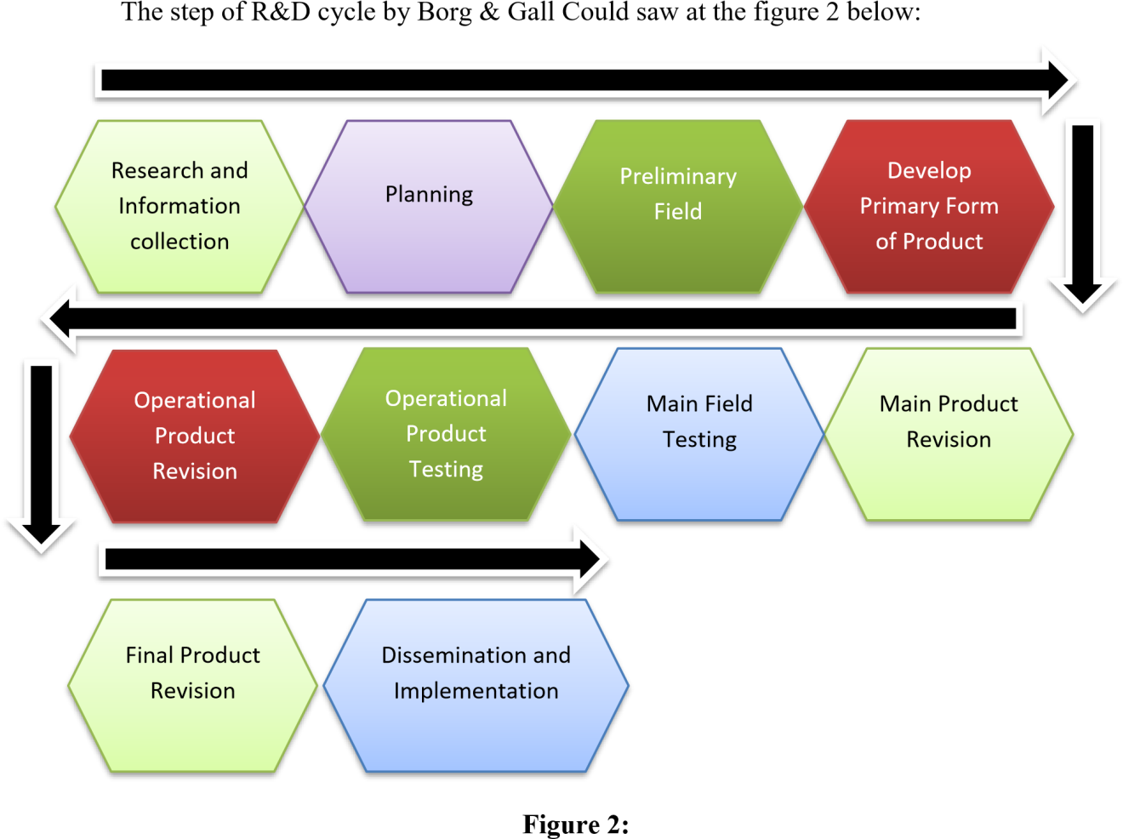
Borg & Gill R&D Step

3.5 Definition Operational Variable
This research is focus at the implementation of Self-record method to Improve student Vocabulary.
    - Self-recording Conceptual Definition
Self-recording video is a practice where students or study participants use technological device.s like smartphones, phones, or laptops to record themselves speaking in the target language, usually English, either inside or outside the classroom. The main goal of self-recording video is to improve language proficiency, particularly speaking in academic language. Through this activity, students or study participants (Nyoman Padmadewi, 2019).
This approach will facilitate comprehension and elucidation of the SelfRecord Video installation at SMPN 4 Tanjung Morawa. Based on the postpositivist philosophy, the qualitative research method is used to study natural object conditions (as opposed to experiments) and uses the researcher as the primary instrument. Triangulation (combined) data collection techniques are used, inductive/qualitative data analysis is used, and meaning is prioritized in qualitative research results rather than generalization (Sugiyono, 2019). This study included an English instructor as one of its participants.
    - Self-record operational definition
- Indicator
Indicator of self-record is the step of this game implementation.
  - Teacher Explain about self-record method aim to the whole student
  - Teacher make a dialog text that sudent use 3)Teacher make a group by student at treatment class
4)Teacher start the games.
- Assesment
In this game there are two assessments conducted, that are student assessment and teacher assessment. The sheet of assessment could see at appendix of this proposal.
3.5.3Listening Conceptual Definition
Listening Skill is defined as the ability to receive, interpret, and understand spoken language and various auditory inputs, encompassing not only the recognition of individual words and phrases but also the comprehension of context, tone, nuance, and the speaker's intent. Proficient listening involves active engagement, focused attention, and the capacity to extract meaning from oral communication effectively (Richards, J. C., & Schmidt, R: 2010).
- Indicator
Student could: , 1. Evaluating Information, 2. Interpreting Messages, 3. Content
Comprehension, 4. Capturing Nuances, 5. Detail Understanding
- Listening assessment
Listening assessment do by test that researcher apply to “treatment student” by answered multiple choice as many as the student can do.
Note: Assessment pattern are following:
Maximum score are 25
Very good | : If Score >22
Good | : If score 18-21
Enough | : If Score 14-17
Poor | : If Score 10-13
Very poor | : If Score < 10

3.5.4Speaking Conceptual Definition
According to Harmer (2007: 284) speaking ability is the ability to speak fluently which presupposes not only knowledge of language characteristics, but also the ability to process information and language 'on the spot'. This requires the ability to work together in managing speaking turns. It takes place in a real situation and has little time for detailed planning. Therefore, fluency is required to achieve the goal of conversation. Speaking ability is an important part of the curriculum in language teaching, and most teachers consider it the most difficult skill to teach because it is an interactive process that requires the ability to cooperate in rotation management.
3.5.5Speaking Oprasional Definition
- Indicator
Speaking score ranged from zero (minimum mark, if they cannot speak) to 20 (maximum mark). According to Speaking Scoring Criteria by Phillips (2007). It examined five components of English language. Philip described each criterion concretely and practically. The speaking test was supposed to score for pronunciation, grammar, vocabulary, fluency, and organization.
- Speaking assessment
Because the test is an oral test, the researcher divides the score into five criteria. In scoring the test, the researcher applies the theory of Brown (2004:171) for assessment speaking. There are five indicators to be assessed in this research which are grammar, vocabulary, comprehension, fluency, pronunciation and each of them has different assessment to do.
Note: Assessment pattern are following:
Maximum score are 25
1.Very good | : If Score >22
2.Good | : If score 18-21
3.Enough | : If Score 14-17
4.Poor | : If Score 10-13
5.Very poor | : If Score < 10

3.6Research Instrument Development The instrument of this research are:
- Observation sheet of students speaking ability
This paper was made to know how much the student mastery English speaking
- Sheet of Test
This paper was made to evaluate students listening abilities
- Pre-test and Post-test Rubric Assessment
This paper is made to know the grade of student speaking abilities
- Students rubric assessment guideline (speaking)
This paper is made to valuated the student speaking abilities
- Teacher assessment guideline
This paper is made to valuated the teacher during the learning process
- Reflection sheet of learning activity (Professional Judgement)
This sheet was consist the valuated of the learning process and suggestion to improve learning process next.
- Learning modul 8.Students Self-phone
.
3.7Data Collection Techniques
The data collection techniques in this research are as follows:
- Observation This activity is conducted by the researcher to assess whether students' English listening and speaking are categorized as good or not. It also aims to evaluate whether the self-record method applied at SMPN 4 Tanjung Morawa was appropriate or not. (Observation sheets can be found in the appendix).
- The Interview Method: involves posing questions to teachers, such as inquiring about the efforts they have made so far to enhance students' English listening and speaking skill, whether they have been using the other method.
- Test (Pre-test and Post-test): This sheet contains assessments of students' English listening and speaking abilities. The assessment criteria on this rubric can be found in the appendix.
  - Data Analysis Techniques
There are three types of analyses that will be conducted by the researcher in this study, namely:
3.8.1Analysis of Instrument
1.Analysis of Validity
According to Arikunto (2013:211) stated validity is a measurement that indicates the level of validity instrument. In this reseach, the researcher used content validity. To test the content validity, the researcher used Pearson Moment Products with the formula adopted from Arikunto (2013) as followed:
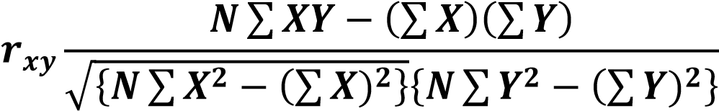
Note: rxy = The product of the total amount variable X and Y N = The number of data pairs X and Y
ΣX = The total of variable Y
ΣY = The total of variable X
ΣX² = The squared total amount of variable X
ΣY² = The squared total amount of variable Y

2.Analysis of Reliability
Reliability refers to extend to which the test is consistent in its score and gives us an indication of how accurate the test score are (Hatch and Farhady, 1982: 244). The concept of reliability comes from the ideas that no measurements is perfect even if we use the same scale, there will always be differences.
Inter-rater reliability was applied in this study in order to ensure the reliability of the score and to avoid the subjectively of the researcher. To achieve the reliability in assessing the students’ speaking performance, the researcher uses a speaking criteria based on Harris (1974), where the focus of speaking abilities assessed are; pronunciation, grammar, vocabulary, fluency, and comprehension. The second rater is the English teacher who has experience in assessing students’ speaking, with the aim of getting a consistent and fair assessment.
After finding the inter-rater coeficient, the researcher will then analyze the coeficient of reliability with the standard of reliability according to Slameto (1998: 147) in Hayanti (2010: 38) as follow:
A very low reliability (range from 0.00 – 0.19), A low reliability (range from 0.20 – 0.39), An average reliability (range from 0.40 – 0.59), A high reliability (range from 0.60 – 0.79), A very high reliability (range from 0.80 –0.100).
3.8.2Analysis of Hypothesis
1.H1 & H2
The researcher used Statistical Package for the Social Science (SPSS) for analyzing the data. Alan Bryan and Duncan Cramer (2005:21) stated SPSS is a manipulating, analyzing, and presenting data program which used in the social and behavior science. After the data was collected from the pre-test and posttest, the researcher analyzed the data with the T-test formulation. The analysis of the data using the Ttest formulation is in the following:
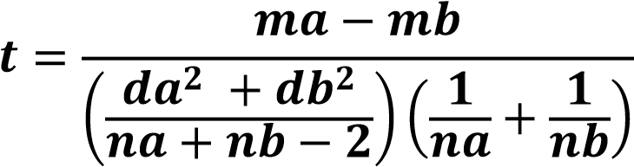
Note:
t = Total
Ma = The mean of experiment group Mb = The mean of control group da = The standart deviation of experiment group db = The standart deviation of control group Na = The total number sample of experiment group Nb = The total number sample of control group.

2.H3
To prove the hypotheses 3 (H3) of this research, researcher use expert judgment to valuating the design of audiolingual learning by using self-record as medium that researcher did. There are three aspect that valuating by the expert, Media using, language using, and method using. Leveling of the method, could find by take the average value of the three aspect of assessment. The assessment was did by the principle of SMP Negeri 4 Tanjung Morawa The assessment of learning process could saw at the appendix of this thesis.

CHAPTER IV
RESULT AND DISCUSSION
4.1Result of Research
4.1.1Data Analyses
Following the research steps proposed by Borg & Gill, the first step in this study was to “seek and gather information” regarding the listening and speaking abilities of Junior High School 4 Tanjung Morawa students, as well as the learning methods that had been implemented by the school. Based on the results of observations and tests conducted by the researcher, the results were as shown in Table 5 below:
Table 5: Pre-test IX-A
No | Name Of Student |  | Score
No | Name Of Student | Listening Abilities | Condition | Speaking Abilities | Condition
1 | ADELLA CARRISSA ZENOBIA TAMBUNAN | 44 | unpass | 40 | unpass
2 | AHMAD ZEUS SARAGIH | 36 | unpass | 60 | unpass
3 | ALLYSYHA PUTRI | 52 | unpass | 52 | unpass
4 | ANGELICA NAMIRA ULI ARRAZZAQU BR SILITONGA | 56 | unpass | 64 | unpass
5 | AUREL PRICILIA BR. NABABAN | 60 | unpass | 80 | Pass
6 | AYU PRICILLA BR SILABAN | 68 | Unpass | 68 | unpass
7 | BAYKAL ARSYAHVIN | 72 | Pass | 64 | unpass
8 | CIKA ANGELINA BR SIAGIAN | 48 | unpass | 56 | unpass
9 | DEA ANDRI RASYA | 52 | unpass | 44 | unpass
10 | DIMAS PRAYUDHA | 52 | unpass | 56 | unpass
11 | FADHIL IHSAN MUDA TARIGAN | 64 | unpass | 36 | unpass
12 | HAFIZ MAULANA YUSUF | 52 | unpass | 60 | unpass
13 | HAMZAH AR-RASYID | 48 | unpass | 56 | unpass
14 | HAWILA LINDO EVITA BR PASARIBU | 56 | unpass | 60 | unpass
15 | JOSUA ISRAEL PANGGABEAN | 56 | unpass | 68 | unpass
16 | LETIZHA NAMIRA AZRA | 44 | unpass | 32 | unpass
17 | MESSI ALBERT SARAGIH | 52 | unpass | 68 | unpass
18 | MUHAMMAD RASYID | 92 | Pass | 96 | Pass
19 | NACHITA KANAIYA | 88 | Pass | 84 | Pass
20 | NATANAEL HAYES WIJAYA BUTARBUTAR | 32 | unpass | 36 | unpass
21 | NAYLA VORI | 64 | unpass | 72 | Pass
22 | NIKITA REFISIS BR SIAGIAN | 60 | unpass | 56 | unpass
23 | RASTI NUR HIDAYAH | 64 | unpass | 48 | unpass
24 | RIFKY RAMADHANU | 92 | Pass | 84 | Pass
25 | RIZKI AULIA ZAHRA | 40 | unpass | 28 | unpass
26 | SATRIA SITUMORANG | 32 | unpass | 32 | unpass
27 | SYIFA AMELIA RHISHANTY | 48 | unpass | 52 | unpass
28 | WILLYAMS ORLANDO MANURUNG | 32 | unpass | 32 | unpass
29 | WULAN DESTRIANI SIMAMORA | 52 | unass | 48 | unpass
30 | YOLA CRISTIN SITUMORANG | 80 | Pass | 72 | Pass
31 | ZAHARA AUNY BALQIS | 84 | Pass | 88 | Pass
 | Average | 57,16129032 |  | 57,80645161

According to table 5 above, it was evident that in the class IX-A out of 33 students, only 6 students passed the listening material, with an average score of 57,16, and 7 students passed the speaking material with an average score of 57,80.
Tabel 6: Pre-test IX B
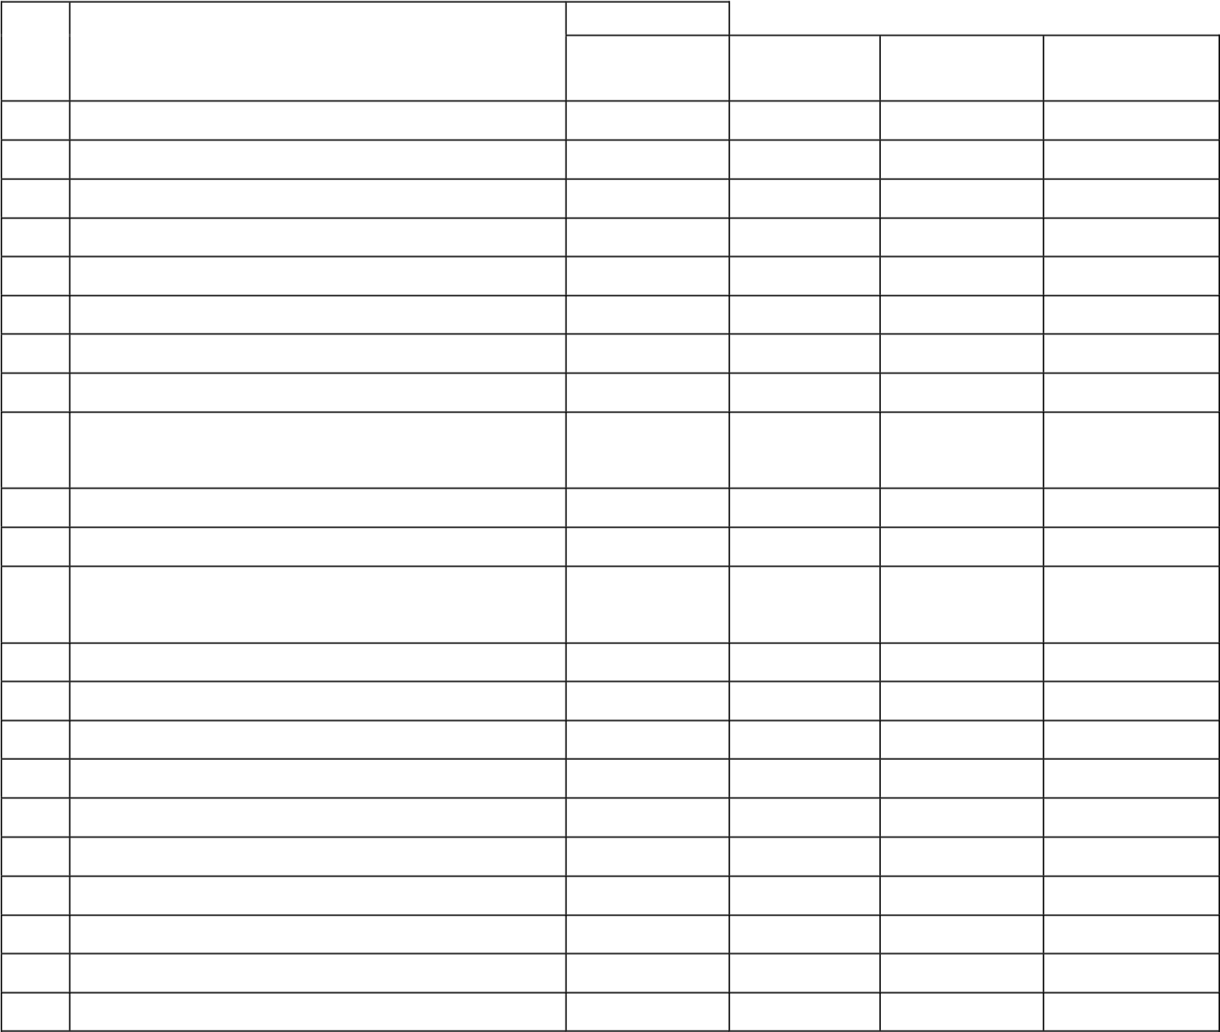
Score
No Name Of Student Listening Speaking
Condition Condition
Abilities Abilities
- ADAM GHIFAHRY 44 unpass 40 unpass
- AFIQA SAFITRI 28 unpass 64 unpass
- AGRIVA SITUMORANG 64 unpass 60 unpass
- ALFARENSA G.D TUMEWU 72 Pass 84 Pass
- ALHAFIZ LIANZA 60 unpass 80 Pass
- ANA STEVANI SIMBOLON 80 Pass 76 Pass
- ANDIKA MANULLANG 72 Pass 84 Pass
- AZAHRA NAILA ARDIANSYAH 48 unpass 56 unpass
- BOSTON BLESING LOOTOHUDANA 48 unpass 40 unpass
GIAWA
- BRIAN FRANKLIN LAOLI 68 unpass 80 Pass
- DAVID PERDAMAIAN GEA 64 unpass 36 unpass
- DEBORA MARTHA ULINA BR 52 unpass 80 Pass
SURBAKTI
- DESPITA BR SIBURIAN 68 unpass 80 Pass
- FAHRI ARDIANSYAH 88 Pass 80 Pass
- FEDRICK SEBASTIAN HUTABARAT 68 unpass 76 Pass
- FIVI JULIA RAHMAT 48 unpass 48 unpass
- IKHSAN ALFIAN 52 unpass 68 unpass
- JEREMY HILTON SIPAHUTAR 80 Pass 88 Pass
- KEZIA TOGI R BR SIMORANGKIR 64 unpass 76 Pass
- MARKUS SILABAN 52 unpass 68 unpass
- MAWAR DELIMA BR SIANIPAR 52 unpass 60 unpass
- MAYLITA TARIGAN 52 unpass 52 unpass
23 | MUHAMMAD ADRIAN MAULANA  SEMBIRING | 64 | unpass | 48 | unpass
24 | MUHAMMAD RIZA | 88 | Pass | 76 | Pass
25 | NANDA PRATIWI | 68 | unpass | 40 | unpass
26 | PUPUT LESTARI BR TAMBA | 48 | unpass | 32 | unpass
27 | RIDO KURNIAWAN | 68 | unpass | 64 | unpass
28 | RISMA ARTAULI PAKPAHAN | 36 | unpass | 28 | unpass
29 | RIZKY RAMADAN SIDABUTAR | 60 | unass | 52 | unass
30 | SAFITRI DWI AYUNING TYAS | 88 | Pass | 72 | Pass
31 | STEVEN PETRUS SIBURIAN | 68 | unpass | 40 | pass
32 | SYAIDHINA SUHAILA | 56 | unpass | 40 | unpass
33 | TRI MULYANI BANCIN | 36 | unpass | 44 | unpass
 | Average | 60,72727273 |  | 60,96969697

Based on Table 6 above, it is known that in class IX-B, out of 33 students, only 7 students passed the listening material, with an average score of 60.72, and 13 students passed the speaking material with an average score of 60.96.
Referring to Tables 5 and 6 above, it is evident that class IX-B has a better average ability compared to class IX-A. Therefore, in this study, the researcher will designate class IX-A as the experimental group and class IX-B as the control group.
After gaining an overview of students' listening and speaking abilities, the researcher conducted “planning and development of the initial design” of the learning materials, adjusting them to suit the students' proficiency levels, particularly in listening and speaking. The learning design created by the researcher can be seen in the appendix of this thesis.
Once the development of the learning design was completed, the next step was “the initial testing”. In this phase, the researcher designated class IX-A as the main subject of the research and class IX-B as the control group. Before testing was did, researcher did the instrument test by used validity anb reliability test. The result of the validity and reliability test could saw at the table below:
- Validity Test
  - Listening Ability
Table 7: Validity of Listening Ability test (Control Class)
Quisioner | r count | r tabel | Status
Item point y1.1 | 0,86961888 | 0,344 | Valid
Item point y1.2 | 0,870192635 | 0,344 | Valid
Item point y1.3 | 0,78266 | 0,344 | Valid
Item point y1.4 | 0,846603334 | 0,344 | Valid
Item point y1.5 | 0,883906625 | 0,344 | Valid

Table 8: Validity of Listening Ability test (Treatment Class)
Quisioner | r count | r tabel | Status
Item point y3.1 | 0,886805027 | 0,355 | Valid
Item point y3.2 | 0,860422863 | 0,355 | Valid
Item point y3.3 | 0,866463846 | 0,355 | Valid
Item point y3.4 | 0,716082088 | 0,355 | Valid
Item point y3.5 | 0,841116589 | 0,355 | Valid

  - Speaking Ability
Table 9:Vallidity of Speaking Ability test (Control Class)
Quisioner | r count | r tabel | Status
Item point y2.1 | 0,864414337 | 0,344 | Valid
Item point y2.2 | 0,796074978 | 0,344 | Valid
Item point y2.3 | 0,820428243 | 0,344 | Valid
Item point y2.4 | 0,887467344 | 0,344 | Valid
Item point y2.5 | 0,870247889 | 0,344 | Valid

Table 10: Validity of Speaking Anility test (Treatment Class)
Quisioner | r count | r tabel | Status
Item point y4.1 | 0,863723802 | 0,355 | Valid
Item point y4.2 | 0,880346882 | 0,355 | Valid
Item point y4.3 | 0,892652605 | 0,355 | Valid
Item point y4.4 | 0,895972889 | 0,355 | Valid
Item point y4.5 | 0,87001359 | 0,355 | Valid

Based on the validity table above, it is evident that the materials used to test the students' listening and speaking abilities, both in the control and treatment groups, were found to be valid. This is evidenced by the r-count values being greater than the r-table values.
- Reliability Test
  - Listening Ability
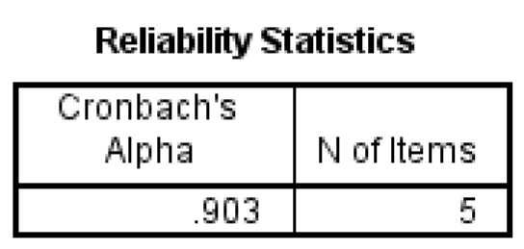
Figure 3:
Reliability of Listening ability test (Control Class)

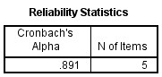
Figure 4:
Reliability of Listening ability test (Treatment Class)

  - Speaking Ability
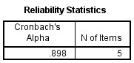

Figure 5:
Reliability of Speaking ability test (Control Class)

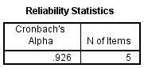
Figure 6:
Reliability of Speaking ability test (Treatment Class)

Based on the reliability test conducted on each class and each learning material, it was found that the Cronbach's alpha value was greater than 0.60, which indicates that the test materials administered to the students were reliable and in the very high reliability level.

After the testing instrument was determined to be valid and reliable, the next step was to assess the students' abilities using this instrument. The results of this initial testing can be seen in Tables 11 and 12below:
Tabel 11:Phase-1 (Control Class)
No | Name Of Student | Score
No | Name Of Student | Listening Abilities | Condition | Speaking Abilities | Condition
1 | ADAM GHIFAHRY | 56 | unpass | 60 | unpass
2 | AFIQA SAFITRI | 40 | unpass | 68 | Unpass
3 | AGRIVA SITUMORANG | 72 | Pass | 64 | Unpass
4 | ALFARENSA G.D TUMEWU | 84 | Pass | 88 | Pass
5 | ALHAFIZ LIANZA | 72 | unpass | 88 | Pass
6 | ANA STEVANI SIMBOLON | 84 | Pass | 80 | Pass
7 | ANDIKA MANULLANG | 80 | Pass | 84 | Pass
8 | AZAHRA NAILA ARDIANSYAH | 64 | unpass | 60 | unpass
9 | BOSTON BLESING LOOTOHUDANA GIAWA | 76 | unpass | 52 | unpass
10 | BRIAN FRANKLIN LAOLI | 84 | Pass | 80 | Pass
11 | DAVID PERDAMAIAN GEA | 80 | Pass | 44 | unpass
12 | DEBORA MARTHA ULINA BR SURBAKTI | 76 | unpass | 80 | Pass
13 | DESPITA BR SIBURIAN | 84 | Pass | 80 | Pass
14 | FAHRI ARDIANSYAH | 88 | Pass | 80 | Pass
15 | FEDRICK SEBASTIAN HUTABARAT | 84 | Pass | 76 | Pass
16 | FIVI JULIA RAHMAT | 52 | unpass | 52 | unpass
17 | IKHSAN ALFIAN | 68 | unpass | 68 | unpass
18 | JEREMY HILTON SIPAHUTAR | 84 | Pass | 88 | Pass
19 | KEZIA TOGI R BR SIMORANGKIR | 68 | unpass | 76 | Pass
20 | MARKUS SILABAN | 64 | unpass | 68 | unpass
21 | MAWAR DELIMA BR SIANIPAR | 56 | unpass | 60 | unpass
22 | MAYLITA TARIGAN | 56 | unpass | 52 | unpass
23 | MUHAMMAD ADRIAN MAULANA  SEMBIRING | 72 | Pass | 56 | unpass
24 | MUHAMMAD RIZA | 92 | Pass | 76 | Pass
25 | NANDA PRATIWI | 72 | Pass | 48 | unpass
26 | PUPUT LESTARI BR TAMBA | 56 | unpass | 40 | unpass
27 | RIDO KURNIAWAN | 72 | Pass | 64 | unpass
28 | RISMA ARTAULI PAKPAHAN | 52 | unpass | 44 | unpass
29 | RIZKY RAMADAN SIDABUTAR | 68 | unass | 52 | unass
30 | SAFITRI DWI AYUNING TYAS | 92 | Pass | 72 | Pass
31 | STEVEN PETRUS SIBURIAN | 72 | Pass | 40 | unpass
32 | SYAIDHINA SUHAILA | 60 | unpass | 48 | unpass
33 | TRI MULYANI BANCIN | 48 | unpass | 48 | Unpass
 | Average | 70,54545455 |  | 64,72727273

Table 12: Phase-1 (Treatment Class)
No | Name Of Student |  | Score
No | Name Of Student | Listening Abilities | Condition | Speaking Abilities | Condition
1 | ADELLA CARRISSA ZENOBIA TAMBUNAN | 64 | unpass | 60 | unpass
2 | AHMAD ZEUS SARAGIH | 52 | unpass | 80 | Pass
3 | ALLYSYHA PUTRI | 68 | unpass | 68 | Unpass
4 | ANGELICA NAMIRA ULI  ARRAZZAQU BR SILITONGA | 72 | Pass | 80 | Pass
5 | AUREL PRICILIA BR. NABABAN | 72 | Pass | 88 | Pass
6 | AYU PRICILLA BR SILABAN | 68 | Unpass | 84 | Pass
7 | BAYKAL ARSYAHVIN | 88 | Pass | 76 | Pass
8 | CIKA ANGELINA BR SIAGIAN | 64 | unpass | 72 | Pass
9 | DEA ANDRI RASYA | 64 | unpass | 60 | unpass
10 | DIMAS PRAYUDHA | 68 | unpass | 72 | Pass
11 | FADHIL IHSAN MUDA TARIGAN | 80 | Pass | 52 | Unpass
12 | HAFIZ MAULANA YUSUF | 72 | Pass | 60 | unpass
13 | HAMZAH AR-RASYID | 64 | unpass | 64 | unpass
14 | HAWILA LINDO EVITA BR PASARIBU | 76 | Pass | 72 | Pass
15 | JOSUA ISRAEL PANGGABEAN | 76 | Pass | 68 | unpass
16 | LETIZHA NAMIRA AZRA | 64 | unpass | 48 | unpass
17 | MESSI ALBERT SARAGIH | 72 | Pass | 76 | Pass
18 | MUHAMMAD RASYID | 96 | Pass | 96 | Pass
19 | NACHITA KANAIYA | 96 | Pass | 96 | Pass
20 | NATANAEL HAYES WIJAYA BUTAR-BUTAR | 56 | unpass | 56 | unpass
21 | NAYLA VORI | 84 | Pass | 84 | Pass
22 | NIKITA REFISIS BR SIAGIAN | 80 | Pass | 64 | unpass
23 | RASTI NUR HIDAYAH | 80 | Pass | 72 | pass
24 | RIFKY RAMADHANU | 96 | Pass | 96 | Pass
25 | RIZKI AULIA ZAHRA | 60 | unpass | 48 | unpass
26 | SATRIA SITUMORANG | 44 | unpass | 52 | unpass
27 | SYIFA AMELIA RHISHANTY | 56 | unpass | 64 | unpass
28 | WILLYAMS ORLANDO MANURUNG | 52 | unpass | 52 | unpass
29 | WULAN DESTRIANI SIMAMORA | 68 | unass | 60 | unpass
30 | YOLA CRISTIN SITUMORANG | 92 | Pass | 88 | Pass
31 | ZAHARA AUNY BALQIS | 84 | Pass | 100 | Pass
 | Average | 71,87096774 |  | 71,22580645

Based on Table 11 above, it is evident that in the control class, regarding the listening ability of 33 students, it was found that 11 students were categorized as passing, with an average score of 70.54. Meanwhile, regarding speaking ability, out of 33 students, 13 students were categorized as passing. Table 12 shows that the students' abilities in the treatment class, in terms of listening, had an average score of 71.87, with 16 out of 31 students categorized as passing. Regarding speaking ability, students in the treatment class had an average score of 71.22, with 16 students passing.
To determine whether the teaching method developed by the researcher successfully influenced the students' listening and speaking abilities, a statistical test is necessary.

- Normality and Homogeneity Test (Phase-1)
Prior to conducting the T-test, the data underwent normality and homogeneity tests. These tests were performed to determine whether the obtained data distribution was normal and homogeneous.

Table 13: Tests of Normality
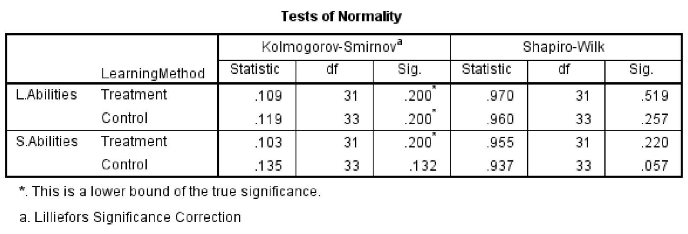
Based on Table 13, the significance values in the Kolmogorov-Smirnov column were greater than the alpha level of 0.05. This indicates that the data did not deviate significantly from a normal distribution, suggesting that the normality assumption was met.

Table 14: Test of Homogeneity of Variance
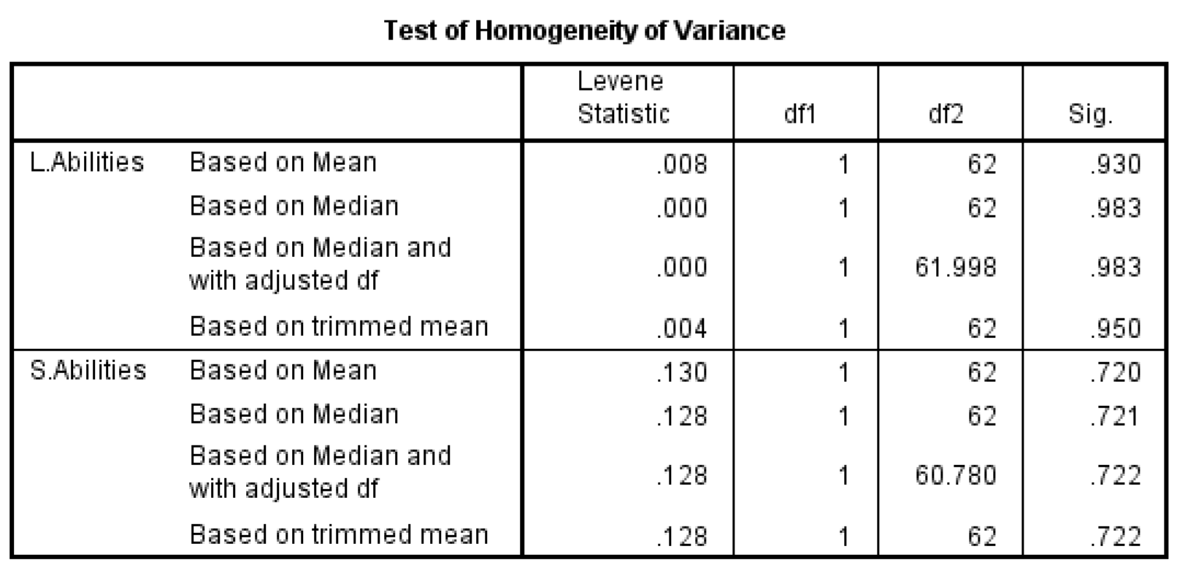
Based on Table 14, the significance levels for the listening abilities test (p =
0.930) and the speaking abilities test (p = 0.720) were both non-significant (p >
0.05). These results suggest that the data collected for both listening and speaking abilities were drawn from a homogeneous population.
- T-Test (Phase-1)
After the data was confirmed to be normally distributed and homogeneous, the next step was to conduct a t-test. This test was performed to determine the significance of the effect caused by the implementation of a learning design using the self-record learning method. The results of the test can be seen in the following table:
Table 15: Listening Abilities T-Test (Phase-1)
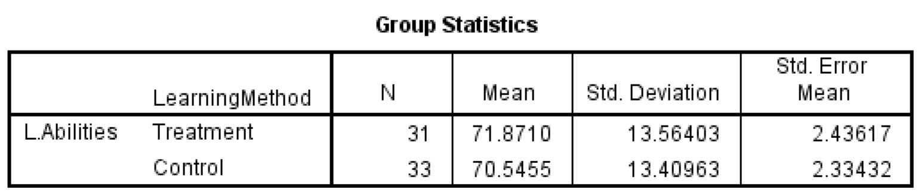
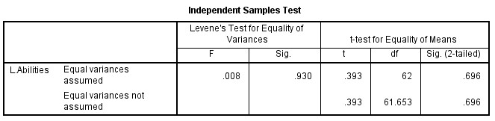
Referring to Table 15 above, it is known that the average score of students in the treatment class was higher compared to the control class. However, the significance value was 0.696, which is greater than the alpha value (0.05). This indicates that the learning method designed by the researcher was not able to provide a significant impact on the listening ability of students at SMP Negeri 4 Tanjung Morawa. Therefore, further evaluation of the research design created by the researcher is needed.
Table:16: Speaking Abilities T-Test (Phase-1)
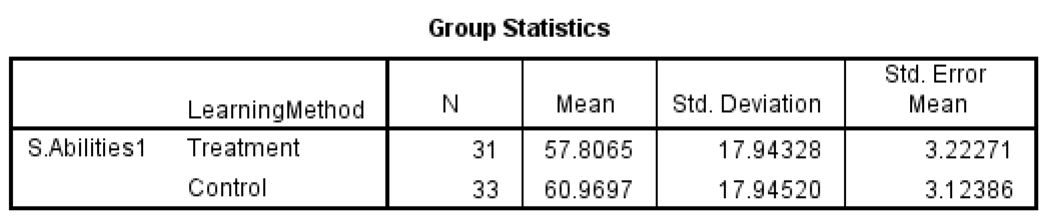
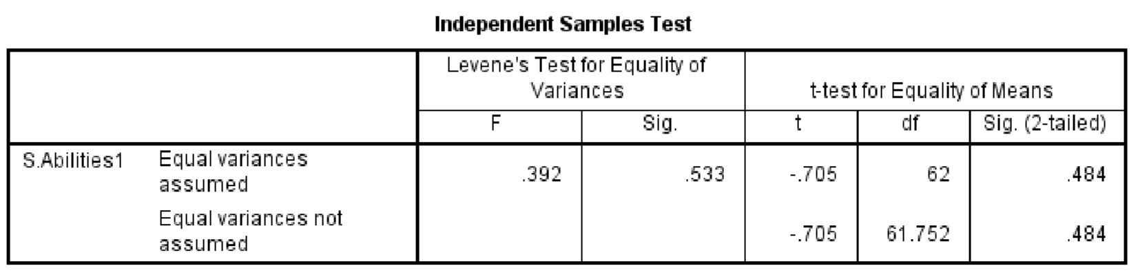
Referring to Table 16 above, it is known that the average score of students in the treatment class was higher compared to the control class. However, the significance value was 0.484, which is greater than the alpha value (0.05). This indicates that the speaking method designed by the researcher was not able to provide a significant impact on the speaking ability of students at SMP Negeri 4 Tanjung Morawa. Therefore, further evaluation of the research design created by the researcher is needed.
Referring to Borg & Gill's research and development method, the next step after the initial design implementation was to revise the designed product. At this stage, the researcher requested feedback and input on the developed method from the principal of SMP Negeri 4 Tanjung Morawa. The principal's assessment can be seen in Table 17 below:
Table 17: Method Assessment (Phase-1)
No | Method Aspect | Sub-Aspect | Assessment Indicator | Point/Score
1 | Material | Content  Suitability | Relevance of Content | 4
1 | Material | Content  Suitability | Richness of Content | 3
1 | Material | Content  Suitability | Organization | 3
1 | Material | Content  Suitability | Engagement | 3
1 | Material | Content  Suitability | Consistency | 4
1 | Material | Content  Suitability | Readability | 3
1 | Material | Presentation | Interactivity | 4
1 | Material | Presentation | Creativity | 4
1 | Material | Presentation | Accessibility | 4
1 | Material | Presentation | Support | 3
1 | Material | Language | Language Accuracy | 3
1 | Material | Language | Completeness of Translations | 3
2 | Language | Language Useage | Grammar | 3
2 | Language | Language Useage | Language Richness | 3
2 | Language | Language Useage | Fluency | 3
2 | Language | Language Useage | Language economy | 3
2 | Language | Language Useage | Language Creativity | 3
2 | Language | Language Useage | Contextual Suitability | 4
2 | Language | Language Useage | Audience Suitability | 3
3 | Method/Media | Presentation | Structure Coherence | 3
3 | Method/Media | Presentation | Use of Method/Media | 2
3 | Method/Media | Presentation | Student Engagment | 2
3 | Method/Media | Presentation | Creativity | 3
3 | Method/Media | Presentation | Accessibility | 3
3 | Method/Media | Effectiveness | Learning Objctives | 3
3 | Method/Media | Effectiveness | Active Teaching | 3
3 | Method/Media | Effectiveness | Student Engagment | 2
3 | Method/Media | Effectiveness | Evaluation | 3
3 | Method/Media | Effectiveness | Use of Technology | 2
3 | Method/Media | Effectiveness | Usability | 3
3 | Method/Media | Effectiveness | Measureability | 4
 | Total |  |  | 92
 | Average |  |  | 2,967741935

According to table 17 above, could saw that the average value of method assessment was at 2,96 that’s means the method that researcher develop was at enough level doesn’t reach good level. There were several point had lower score, that point to be the focus of researcher evaluating. The evaluating point could saw at the appendix of this thesis.
After evaluating the main product, the next steps was main field testing. The result of the main filed testing could saw at the table below:
- Validity Test (Phase-2)
  - Listening Ability
Table 18: Validity of Listening Ability test (Control Class)
Quisioner | r count | r tabel | Status
Item point y1.1 | 0,828125 | 0,344 | Valid
Item point y1.2 | 0,883760081 | 0,344 | Valid
Item point y1.3 | 0,794101388 | 0,344 | Valid
Item point y1.4 | 0,830621963 | 0,344 | Valid
Item point y1.5 | 0,870444298 | 0,344 | Valid

Table 19: Validity of Listening Ability test (Treatment Class)
Quisioner | r count | r tabel | Status
Item point y3.1 | 0,753288131 | 0,355 | Valid
Item point y3.2 | 0,873120875 | 0,355 | Valid
Item point y3.3 | 0,881610577 | 0,355 | Valid
Item point y3.4 | 0,811014068 | 0,355 | Valid
Item point y3.5 | 0,786391504 | 0,355 | Valid

  - Speaking Ability
Table 20:Vallidity of Speaking Ability test (Control Class)
Quisioner | r count | r tabel | Status
Item point y2.1 | 0,83684161 | 0,344 | Valid
Item point y2.2 | 0,798810842 | 0,344 | Valid
Item point y2.3 | 0,819400848 | 0,344 | Valid
Item point y2.4 | 0,880064432 | 0,344 | Valid
Item point y2.5 | 0,86939954 | 0,344 | Valid

Table 21: Validity of Speaking Anility test (Treatment Class)
Quisioner | r count | r tabel | Status
Item point y4.1 | 0,791868681 | 0,355 | Valid
Item point y4.2 | 0,830746329 | 0,355 | Valid
Item point y4.3 | 0,858473883 | 0,355 | Valid
Item point y4.4 | 0,884647826 | 0,355 | Valid
Item point y4.5 | 0,702224973 | 0,355 | Valid
Based on the validity table above, it is evident that the materials used to test the students' listening and speaking abilities, both in the control and treatment groups, were found to be valid. This is evidenced by the r-count values being greater than the r-table values.
- Reliability Test (Phase-2)
  - Listening Ability
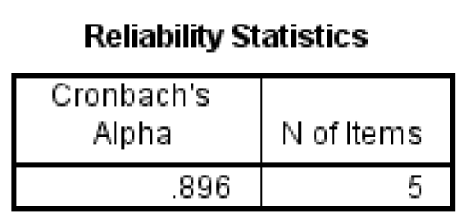
Figure 7:
Reliability of Listening ability test Phase-2 (Control Class)

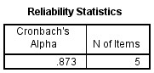
Figure 8:
Reliability of Listening ability test Phase-2 (Treatment Class)

  - Speaking Ability
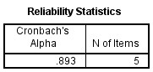
Figure 9:
Reliability of Speaking ability test Phase-2 (Control Class)

Figure 10:
Reliability of Speaking ability test Phase-2 (Treatment Class)

Based on the reliability test conducted on each class and each learning material, it was found that the Cronbach's alpha value was greater than 0.60, which indicates that the test materials administered to the students were reliable and in the very high reliability level.

After the testing instrument was determined to be valid and reliable, the next step was to assess the students' abilities using this instrument. The results of this main field testing can be seen in Tables 22 and 23 below:
Tabel 22:Phase-2 (Control Class)
No | Name Of Student | Score
No | Name Of Student | Listening Abilities | Condition | Speaking Abilities | Condition
1 | ADAM GHIFAHRY | 56 | unpass | 60 | unpass
2 | AFIQA SAFITRI | 44 | unpass | 68 | Unpass
3 | AGRIVA SITUMORANG | 72 | Pass | 64 | Unpass
4 | ALFARENSA G.D TUMEWU | 84 | Pass | 88 | Pass
5 | ALHAFIZ LIANZA | 76 | Pass | 88 | Pass
6 | ANA STEVANI SIMBOLON | 84 | Pass | 80 | Pass
7 | ANDIKA MANULLANG | 80 | Pass | 84 | Pass
8 | AZAHRA NAILA ARDIANSYAH | 64 | unpass | 60 | unpass
9 | BOSTON BLESING  LOOTOHUDANA GIAWA | 76 | Pass | 52 | unpass
10 | BRIAN FRANKLIN LAOLI | 84 | Pass | 80 | Pass
11 | DAVID PERDAMAIAN GEA | 84 | Pass | 44 | unpass
12 | DEBORA MARTHA ULINA BR SURBAKTI | 76 | Pass | 80 | Pass
13 | DESPITA BR SIBURIAN | 84 | Pass | 80 | Pass
14 | FAHRI ARDIANSYAH | 88 | Pass | 80 | Pass
15 | FEDRICK SEBASTIAN HUTABARAT | 84 | Pass | 76 | Pass
16 | FIVI JULIA RAHMAT | 52 | Unpass | 52 | unpass
17 | IKHSAN ALFIAN | 68 | Unpass | 72 | Pass
18 | JEREMY HILTON SIPAHUTAR | 84 | Pass | 88 | Pass
19 | KEZIA TOGI R BR SIMORANGKIR | 68 | Unpass | 76 | Pass
20 | MARKUS SILABAN | 68 | Unpass | 68 | unpass
21 | MAWAR DELIMA BR SIANIPAR | 56 | Unpass | 64 | unpass
22 | MAYLITA TARIGAN | 56 | Unpass | 52 | unpass
23 | MUHAMMAD ADRIAN MAULANA SEMBIRING | 72 | Pass | 56 | unpass
24 | MUHAMMAD RIZA | 92 | Pass | 76 | Pass
25 | NANDA PRATIWI | 72 | Pass | 48 | unpass
26 | PUPUT LESTARI BR TAMBA | 56 | Unpass | 40 | unpass
27 | RIDO KURNIAWAN | 72 | Pass | 64 | unpass
28 | RISMA ARTAULI PAKPAHAN | 52 | Unpass | 44 | unpass
29 | RIZKY RAMADAN SIDABUTAR | 68 | Unass | 52 | unass
30 | SAFITRI DWI AYUNING TYAS | 92 | Pass | 72 | Pass
31 | STEVEN PETRUS SIBURIAN | 72 | Pass | 40 | unpass
32 | SYAIDHINA SUHAILA | 60 | Unpass | 48 | unpass
33 | TRI MULYANI BANCIN | 48 | Unpass | 48 | Unpass
 | Average | 71,03030303 |  | 64,96969697

Table 23: Phase-2 (Treatment Class)
No | Name Of Student |  | Score
No | Name Of Student | Listening Abilities | Condition | Speaking Abilities | Condition
1 | ADELLA CARRISSA ZENOBIA TAMBUNAN | 80 | Pass | 68 | unpass
2 | AHMAD ZEUS SARAGIH | 84 | Pass | 80 | Pass
3 | ALLYSYHA PUTRI | 76 | Pass | 68 | Unpass
4 | ANGELICA NAMIRA ULI  ARRAZZAQU BR SILITONGA | 72 | Pass | 80 | Pass
5 | AUREL PRICILIA BR.  NABABAN | 80 | Pass | 88 | Pass
6 | AYU PRICILLA BR SILABAN | 76 | Pass | 88 | Pass
7 | BAYKAL ARSYAHVIN | 96 | Pass | 84 | Pass
8 | CIKA ANGELINA BR SIAGIAN | 72 | Pass | 84 | Pass
9 | DEA ANDRI RASYA | 76 | Pass | 60 | unpass
10 | DIMAS PRAYUDHA | 84 | Pass | 72 | Pass
11 | FADHIL IHSAN MUDA TARIGAN | 84 | Pass | 52 | Unpass
12 | HAFIZ MAULANA YUSUF | 80 | Pass | 60 | unpass
13 | HAMZAH AR-RASYID | 64 | unpass | 72 | Pass
14 | HAWILA LINDO EVITA BR PASARIBU | 76 | Pass | 72 | Pass
15 | JOSUA ISRAEL PANGGABEAN | 88 | Pass | 76 | Pass
16 | LETIZHA NAMIRA AZRA | 72 | Pass | 72 | Pass
17 | MESSI ALBERT SARAGIH | 80 | Pass | 76 | Pass
18 | MUHAMMAD RASYID | 96 | Pass | 100 | Pass
19 | NACHITA KANAIYA | 96 | Pass | 100 | Pass
20 | NATANAEL HAYES WIJAYA BUTAR-BUTAR | 64 | unpass | 56 | unpass
21 | NAYLA VORI | 88 | Pass | 88 | Pass
22 | NIKITA REFISIS BR SIAGIAN | 88 | Pass | 72 | Pass
23 | RASTI NUR HIDAYAH | 88 | Pass | 92 | Pass
24 | RIFKY RAMADHANU | 100 | Pass | 96 | Pass
25 | RIZKI AULIA ZAHRA | 72 | Pass | 72 | Pass
26 | SATRIA SITUMORANG | 60 | unpass | 72 | Pass
27 | SYIFA AMELIA RHISHANTY | 72 | Pass | 76 | Pass
28 | WILLYAMS ORLANDO MANURUNG | 64 | unpass | 64 | unpass
29 | WULAN DESTRIANI SIMAMORA | 76 | Pass | 72 | Pass
30 | YOLA CRISTIN SITUMORANG | 96 | Pass | 88 | Pass
31 | ZAHARA AUNY BALQIS | 92 | Pass | 100 | Pass
 | Average | 80,38709677 |  | 77,41935484

Based on Table 22 above, it is evident that in the control class, regarding the listening ability of 33 students, it was found that 21 students were categorized as passing, with an average score of 70.54. Meanwhile, regarding speaking ability, out of 33 students, 14 students were categorized as passing. Table 23 shows that the students' abilities in the treatment class, in terms of listening, had an average score of 80,38, with 27 out of 31 students categorized as passing. Regarding speaking ability, students in the treatment class had an average score of 77.41, with 24 students passing.
To determine whether the teaching method developed by the researcher successfully influenced the students' listening and speaking abilities, a statistical test is necessary.
- Normality and Homogeneity Test (Phase-2)
Prior to conducting the T-test, the data underwent normality and homogeneity tests. These tests were performed to determine whether the obtained data distribution was normal and homogeneous.
Table 24: Tests of Normality
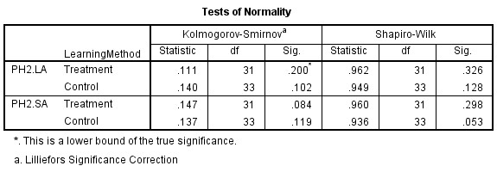
Based on Table 24, the significance values in the Kolmogorov-Smirnov column were greater than the alpha level of 0.05. This indicates that the data did not deviate significantly from a normal distribution, suggesting that the normality assumption was met.

Table 25: Test of Homogeneity of Variance
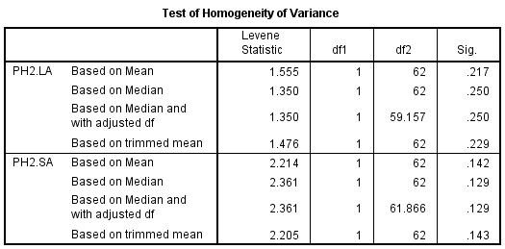
Based on Table 25, the significance levels for the listening abilities test (p =
0.217) and the speaking abilities test (p = 0.142) were both non-significant (p >
0.05). These results suggest that the data collected for both listening and speaking abilities were drawn from a homogeneous population.
- T-Test (Phase-2)
After the data was confirmed to be normally distributed and homogeneous, the next step was to conduct a t-test. This test was performed to determine the significance of the effect caused by the implementation of a learning design using the self-record learning method. The results of the test can be seen in the following table:
Table 26: Listening Abilities T-Test
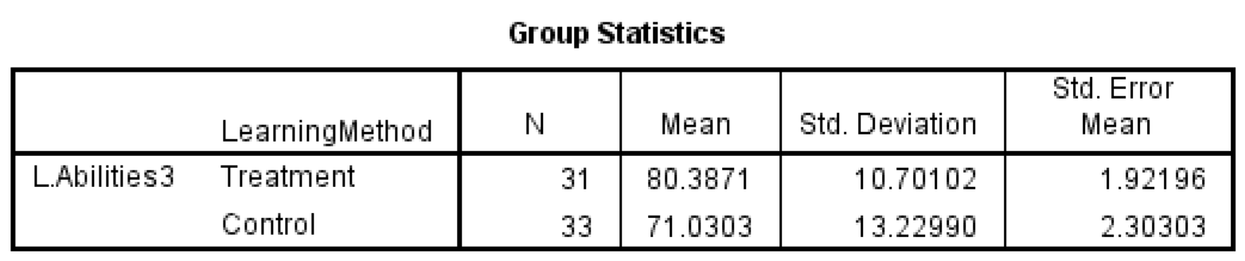
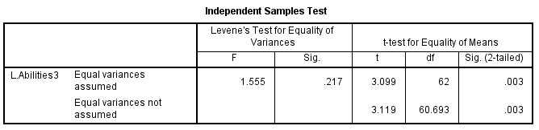
Referring to Table 26 above, it is known that the average score of students in the treatment class was higher compared to the control class. The significance value was 0.03, which is lower than the alpha value (0.05). This indicates that the learning method designed by the researcher was able to provide a significant impact on the listening ability of students at SMP Negeri 4 Tanjung Morawa. Therefore, further evaluation of the research design created by the researcher is needed.
Table 27:Speaking Abilities T-Test
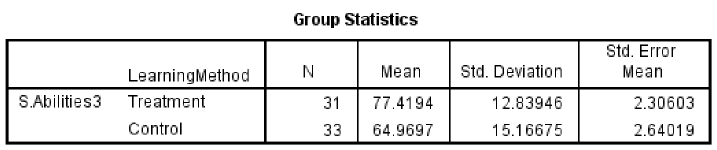
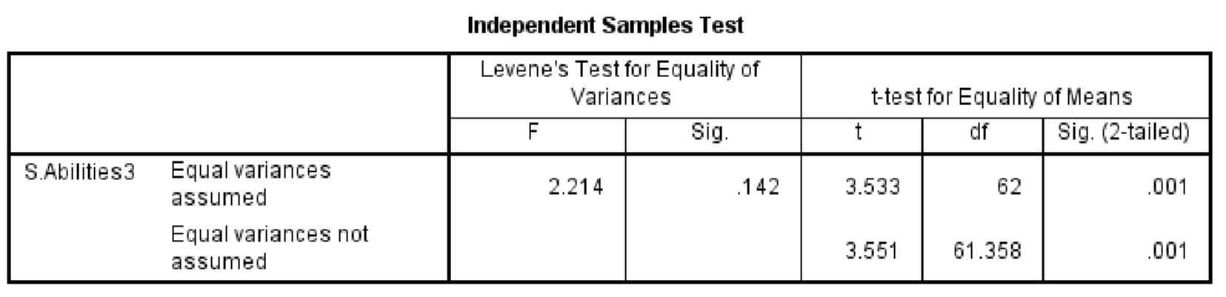
Referring to Table 27 above, it is known that the average score of students in the treatment class was higher compared to the control class. The significance value was 0.01, which is lower than the alpha value (0.05). This indicates that the learning method designed by the researcher was able to provide a significant impact on the speaking ability of students at SMP Negeri 4 Tanjung Morawa. Therefore, further evaluation of the research design created by the researcher is needed
Referring to Borg & Gill's research and development method, the next step after the initial design implementation was to revise the designed product. At this stage, the researcher requested feedback and input on the developed method from the principal of SMP Negeri 4 Tanjung Morawa. The principal's assessment can be seen in Table 28 below:
Table 28: Method Assessment (Phase-2)
No | Method Aspect | Sub-Aspect | Assessment Indicator | Point/Score
1 | Material | Content  Suitability | Relevance of Content | 4
1 | Material | Content  Suitability | Richness of Content | 4
1 | Material | Content  Suitability | Organization | 4
1 | Material | Content  Suitability | Engagement | 3
1 | Material | Content  Suitability | Consistency | 4
1 | Material | Content  Suitability | Readability | 3
1 | Material | Presentation | Interactivity | 3
1 | Material | Presentation | Creativity | 4
1 | Material | Presentation | Accessibility | 4
1 | Material | Presentation | Support | 4
1 | Material | Language | Language Accuracy | 4
1 | Material | Language | Completeness of Translations | 3
2 | Language | Language Useage | Grammar | 4
2 | Language | Language Useage | Language Richness | 3
2 | Language | Language Useage | Fluency | 3
2 | Language | Language Useage | Language economy | 3
2 | Language | Language Useage | Language Creativity | 4
2 | Language | Language Useage | Contextual Suitability | 4
2 | Language | Language Useage | Audience Suitability | 4
3 | Method/Media | Presentation | Structure Coherence | 4
3 | Method/Media | Presentation | Use of Method/Media | 4
3 | Method/Media | Presentation | Student Engagment | 3
3 | Method/Media | Presentation | Creativity | 3
3 | Method/Media | Presentation | Accessibility | 3
3 | Method/Media | Effectiveness | Learning Objctives | 3
3 | Method/Media | Effectiveness | Active Teaching | 3
3 | Method/Media | Effectiveness | Student Engagment | 3
3 | Method/Media | Effectiveness | Evaluation | 3
3 | Method/Media | Effectiveness | Use of Technology | 4
3 | Method/Media | Effectiveness | Usability | 3
3 | Method/Media | Effectiveness | Measureability | 4
 | Total |  |  | 109
 | Average |  |  | 3,516129032

According to table 28 above, could saw that the average value of method assessment was at 3,51 that’s means the method that researcher develop was reach
good level.
Referencing the results obtained in Phase 2, the sixth stage of the listening and speaking instructional design development at SMP Negeri 4 Tanjung Morawa has demonstrated highly favorable outcomes. Thus, based on Borg and Gill's development theory, the development process can be terminated and proceed to the final phase: Dissemination and Implementation.
4.1.2Hypothesis test
1.H1
Referring to the first hypothesis of this study, "Implementing Self-record is significant to increase Student English language listening abilities at SMP NEGRI 4 TANJUNG MORAWA," it was found in Phase 2 that the results were as presented in Table 26. This table shows that there was a difference in the mean scores between the control and treatment groups. The control group had a mean score of 71.03, while the treatment group had a mean score of 80.38.
Given the passing standard of 75 (where 72 points are for academic performance and 3 points are for diligence), the control group, on average, did not meet the passing criteria. According to Table 22, only 21 out of 33 students in the control group passed the listening material. When converted into a percentage, this means that the passing rate for the control group was only 63.63%.
In contrast, a different scenario was observed in the treatment group. Out of 31 students, 27 met the passing standard. When converted into a percentage, this means that a substantial 87.1% of students in the treatment group successfully passed the listening material. Given this significant difference of approximately 23.46% in passing rates between the control and treatment groups, it is reasonable that Table 26's statistical analysis indicates that the instructional design employing the selfrecord method yielded significant results, with a significance value of 0.03, which is lower than the alpha value of 0.05. To visualize the progress of students' abilities in each class, please refer to the figure below.

60.72727273
57.16129032
71.03030303
80.38709677
0
10
20
30
40
50
60
70
80
90
Control
Treatment
Listening abilities
Average Student's Test Score
Control Vs Treatment
Pre-test
Post-test
Figure 11:
Student’s Listening Abilities Improvement
As shown in Figure 11, the increase in students' listening abilities from the pretest to the post-test was 10.31 points in the control group, while in the treatment group, the increase was 23.22 points. Based on these results, it can be inferred that the improvement in students' listening abilities using the self-recording method was significantly higher compared to the previous method. Based on these findings, the researcher concludes that H01 is rejected and H1 is accepted.
2.H2
Referring to the second hypothesis of this study, "Implementing Self-record is significant to increase Student English language speaking abilities at SMP NEGERI 4 TANJUNG MORAWA " it was found in Phase 2 that the results were as presented in Table 27. This table shows that there was a difference in the mean scores between the control and treatment groups. The control group had a mean score of 64,96, while the treatment group had a mean score of 77,41.
Given the passing standard of 75 (where 72 points are for academic performance and 3 points are for diligence), the control group, on average, did not meet the passing criteria. According to Table 22, only 14 out of 33 students in the control group passed the speaking material. When converted into a percentage, this means that the passing rate for the control group was only 42,42%.
In contrast, a different scenario was observed in the treatment group. Out of 31 students, 24 met the passing standard. When converted into a percentage, this means that a substantial 77,41% of students in the treatment group successfully passed the speaking material. Given this significant difference of approximately 34,99% in passing rates between the control and treatment groups, it is reasonable that Table 26's statistical analysis indicates that the instructional design employing the selfrecord method yielded significant results, with a significance value of 0.01, which is lower than the alpha value of 0.05. To visualize the progress of students' abilities in each class, please refer to the figure below.

60.96969697
57.80645161
64.96969697
77.41935484
0
10
20
30
40
50
60
70
80
90
Control
Treatment
Speaking abilities
Average Student's Test Score
Control Vs Treatment
Pre-test
Post-test
Figure 12:
Student’s Speaking Abilities Improvement
As shown in Figure 12, the increase in students' speaking abilities from the pretest to the post-test was 4 points in the control group, while in the treatment group, the increase was 22,61 points. Based on these results, it can be inferred that the improvement in students' speaking abilities using the self-recording method was significantly higher compared to the previous method. Based on these findings, the researcher concludes that H02 is rejected and H2 is accepted.
3.H3
Referring to the third hypothesis of this study, "The learning design of Selfrecord learning models is in the good levels to implementing at SMP NEGERI 4 TANJUNG MORAWA" The research design was evaluated and received a score of 3.51, indicating that the research design developed by the researcher was considered to be of "good" quality.
This evaluation was conducted based on the method assessment sheet completed by the principal of SMP Negeri 4 Tanjung Morawa. The assessment focused on aspects of the teaching method, including the material, language use, and media usage. The results of this assessment can be found in Table 28 of this thesis. Therefore, the researcher concludes that H03 in this study is rejected and H3 is accepted.
4.2Discussion
As revealed in the data analysis presented above, the instructional design incorporating the self-recording method was successfully developed through two rounds of revision and evaluation. This success is evidenced by the improvement in students' listening and speaking abilities, as well as the positive evaluation of the method, which was rated as "good" levels.
In the initial planning phase, the researcher attempted to align the instructional materials with the students' abilities. This alignment was determined based on the results of the researcher's previous observations. The suitability of the materials for the students' abilities was considered a fundamental standard in selecting instructional content. Sabarudin (2018:17) said that;
“Materi pembelajaran yang di dalamnya ada proses penentuan urutan, pemilihannya yang harus mengacu pada standar kompetensi, proses identifikasi aspek dan jenis untuk mendapatkan materi yang relevan dengan SK dan KD, membutuhkan proses cukup panjang dan rumit. Begitu juga ketika materi pembelajaran hendak disampaikan, disaat itulah dibutuhkan media yang benar-benar tepat untuk tersampaikannya materi untuk mencapai tujuan pembelajaran”

In English translation:
“The process of developing instructional materials, which involves determining the sequence and selection of content based on competency standards, as well as identifying the aspects and types of content relevant to the Standards of Competence (SK) and Basic Competencies (KD), is quite lengthy and complex. Similarly, when delivering instructional materials, the selection of an appropriate medium is crucial to ensure that the learning objectives are achieved”.

In the line with Ahyadi, et al (2021:115) did, researcher must be attempted to analyze students’ needs, consisting of personality, competence, weakness, and pleasantness in learning English. Based on the analyze result, the next step was Constructing instructional materials and strategies.
According to the result of the observation, researcher did the design of the listening and speaking learning strategies by used self-record method. Maulana, et al (2023:883) Said that Self-Recording Video increases students' confidence in speaking and provides opportunities to improve abilities. Despite challenges, such as mispronunciations, this approach helps students feel supported and motivated. By using this video, students can practice speaking more confidently and effectively in learning English.
This is in line with what was conveyed by Burn Anne (2019:10)”The main aim of speaking tasks is to help students develop the fluency of expert speakers where meaning is communicated with few hesitations and in a manner that is appropriate for the social purpose of the message. This is achieved through the use of accurate language and discourse routines, appropriate speech enabling abilities, and effective communication strategies”.
In the preliminary test result showed that the preliminary design wasn’t impact the students listening and speaking abilities. This could be happened because, according to the method assessment that did by the principle, the learning material and the language used that researcher did was less compatible to the student’s abilities.
According to this suggestion, researcher was redesign the learning methods by used the common material and language. Researcher did the material by used the simple folklore that students knew well. As the result, the achievement of students listening and speaking abilities was increased significantly.
This result was in line with the statement of Aprianto and Muhlisin (2022:252) that “The finding of to what extent the use of SRV as an English language learning method in developing English learning performance statistically depicted that it has affected the students’ English learning.
Same energy with the Encalada (2019:64) claimed that “SRVs have helped me to develop my speaking abilities," we find out that the majority of students, 48, 1% of them, very agreed and that 43, 2% of them agreed.

CHAPTER V
CONCLUSION AND SUGGESTION

5.1CONCLUSION
Based on the results research, the researcher concluded:
- Implementing Self-record is significant to increase Student English language listening abilities at SMP NEGERI 4 TANJUNG MORAWA by increase the students listening skill by 23.22 points and the T-test score was 0,03 which is lower than the alpha value of 0.05.
- Implementing Self-record is significant to increase Student English language speaking abilities at SMP NEGERI 4 TANJUNG MORAWA by increase the student’s speaking skill by 22,61 point, and the T-test score was 0,01 which
lower than the alpha value 0,05.
- The learning design of Self-record learning models is in the good levels to
implementing at SMP NEGERI 4 TANJUNG MORAWA, by the design
evaluated score was 3.51, indicating that the research design developed by the researcher was considered to be of "good" quality.

5.2SUGGESTION
This study is limited only to students' Listening and Speaking abilities From the researcher's perspective, there are still many aspects of language mastery, especially in English, that can be improved through this method, such as reading skills, understanding syllables, and writing. Therefore, the researcher suggests that
66

future researchers to explore this topic further regarding the benefits of implementing this method in efforts to improve students' language abilities

REFERENCES
Agung, Iskandar. (2012). Panduan Penelitian Tindakan Kelas Bagi Guru. Jakarta:
PT. Bestari Buana Murni.

Ahyadi, Baso Jabu, Rafi’ah Nur, Developing Instructional Material And Strategies For Buginese Learners In The Crash Course Program At Neroa School,
(Journal of Language Teaching and Pedagogy, 2021), Vol. 3. No. 2. Pp.115.
ISSN: 2654-8267.

Anderson, N. J. (1999). Exploring Second Language Reading: Issues and
Strategies. Heinle & Heinle)

Anh Dang Thi Ngoc, Nguyen Van Thinh, and Pham Thi Nga, Utilizing Video
Recording to Develop EFL Student’s Speaking Abilities,(International Journal of Linguistics, Literature and Translation, 2022) Vol 5, No 5. Pp. 63-71. ISSN: 2617-0299
Aprianto Dedi, dan Muhlisin, The Use of Self-Recording Videos as ESL Learning Method in Increasing English Learning Performance, (Empiricism Journal, 2022), Vol 3, No 2. Pp.246-253. ISSN2745-7613.
Arikunto, S. (2013). Prosedur Penelitian Suatu Pendekatan Praktis. Jakarta:
Rineka Cipta.
Borg and Gall. (2019). Educational Research: An Introduction, 8th Edition.
Pearson.
Bryman, A., & Cramer, D. (2005). Quantitative data analysis with SPSS 12 and 13:
A guide for social scientists. Psychology Press.
Burns Anne. Concepts for Teaching Speaking in the English Language Classroom.
(LEARN Journal, 2019). Vol 12. No1

Chen Chih-Ming, and I-Chun Chen, The Effects of Video-Annotated Listening Review Mechanism on Promoting EFL Listening Comprehension,
(Interactive Learning Environments. SSCI, 2019)

Encalada Maria Asuncion Rojas. Perceptions about Self-recording Videos to Develop EFL Speaking Abilities in Two Ecuadorian Universities. (Journal of Language Teaching and Research, 2019). Vol 10. No 1. ISSN: 1798-4769.
P60-67.

Field, J. (2008). Listening in the Language Classroom. Cambridge University Press)

Gokturk Nazhnur, Examining The Effectiveness Of Digital Video Recordings On Oral Performance Of Efl Learners.(Teaching English With Thecnology, 2019), Vol 16, No 2. Pp71-96.

Hamad mona M., Amal Abdelsattar Metwally., & Sabina Yasmin Alfaruque, The Impact of Using YouTubes and Audio Tracks Imitation YATI on Improving Speaking Abilities of EFL Learners, (English Language Teaching, 2019) Vol 12. 1916-4742.

Isjoni, Cooperative Learning Efektivitas Pembelajaran Kelompok, (Bandung :
Alfabeta, Cet. 4, 2010)

Mailawati Anisa., and Anita anita, The Impact of English Songs To Improve On English Listening Abilities. (Journal of Research on Language Education
(JoRLE), 2022))Vol.3: 2809-4271, Pp-62

Maulana Atika, Elmiati, and M.Khairi Ikhsan. The Implementation Of Selfrecording Video in Speaking Practice. (Jurnal Pendidikan Mandala, 2023) Vol 8. No 3. ISSN: 2656-6745. P.883-887.

Mendelsohn, D. J, Applying Learning Strategies in Intensive Language Instruction,
1999. ERIC Digest

Muryasov Rakhim Zakievich, Pronouns in the System of Parts of Speech, (IJLL: International Journal of Language and Linguistics, 2021) Vol 9, No 4.
Pp.145- 154. ISSN: 2330-0205.

Nhat, Nguyen Thi Hong, Developing Bottom-up Listening Abilities in a Google Classroom-based EFL module,(ACOJ, 2021) Vol12, No 3. Pp.45-57.
ISSN:1936-9859

Padmadewi Nyoman Ni. Students’Perception on Self-Recording Video. (Innovative Education Journal, 2019), Vol . No 1. P. 1–8.

Peerdana Indra, Sardjana Orba Manullang, dan Fina Amalia Masri, Effectiveness of Online Grammarly Application in Improving Academic Writing: Review of Experts Experience, (IJSS: International Journal of Social Sciences, 2021)
Vol 4, No 1. Pp.122-130. ISSN: 2632-9409

Phillips, L. D. (2007). Decision conferencing. In W. Edwards, R. Miles, & von Winterfeldt (Eds.). Advances in decision analysis: From foundations to applications Cambridge: Cambridge University Press [(p. 375)

Prihatin Yoga. The Practice Of English Language Teaching In Indonesia. (Proceeding: 1st National Seminar of PBI (English Language Education), 2019)). ISBN: 978-602-6779-26-7. P-25.

Putri Aulia and Refnaldi, The Correlation Between Students’ Vocabulary Mastery And Speaking Ability At Grade 8 Of Junior High School, (JELT: Journal of English Language Teaching, 2020) Vol9, No 1. Pp.44-55. ISSN: 2302-3198

Qureshi Bilal, John Roseberry, and Zeeshan Qureshi. Boosting Intersubjectivity By Digital Video Recording Project In Efl Classes, (SCOPE: Journal of English Language Teaching, 2019), Vol 4, No 1, ISSN 2541-0326.

Richards, J. C., & Schmidt, R. Longman Dictionary of Language Teaching and
Applied Linguistics. 2010. Pearson Education

Rost, M. Teaching and Researching Listening (2nd ed.), 2011, Routledge.)P-11

Sabarudin, Materi Pembelajaran Dalam Kurikulum 2013. Jurnal An-Nur, 2018. Vol. 4. No.1 P.17.

Slameto. (1998) Belajar dan Faktor-Faktor yang Mempengaruhinya. Jakarta: Bina
Aksara

Sugiyono. (2015). Metode Penelitian Pendidikan Kuantitatif Kualitatif dan R & D.
Bandung: Alfabeta.

Syam Iin Nurul Magfira, The Correlation Between Students’ Verballinguistics Intelligence And Their Speaking Abilities, (Skripsi: University Syarif
Hidayatullah Jakarta, 2023)

Takarroucht Kenza, Kufakunesu Zano, Alex Zamorano, Team Games-Language Learning Model in Improving Students’ Speaking and Listening Abilities Viewed from Creativity. (JOLLS: Journal of Language and Literature
Studies, 2022) Vol. 2.P-53

Tarigan, H. G. (2008). Menulis sebagai suatu keterampilan berbahasa. Bandung:
Angkasa.

Trang Tran Thi Thien, and Nguyen Thi Phuong Hong, A mobile Video Recording Task-based Approach to Teaching EFL Learners’ Speaking Skill. (IJSM:
International Journal of Science Management Studies, 2021) Vol 4, No 2.
Pp.96-116. ISSN:2581-5946

Wah nu nu, Teaching Listening Abilities to English as a Foreign Language Students through Effective Strategies, (International Journal of Trend in Scientific
Research and Development (IJTSRD), 2019)), Vol 3: 2456 – 6470

Yan Xun, Ha Ram Kim, and Ji Young Kim, Dimensionality Of Speech Fluency: Examining The Relationships Among Complexity, Accuracy, And Fluency (Caf) Features Of Speaking Performances On The Aptis Test. (Article: Language Testing, 2020).

APPENDICES

Apendices 1. Pre-test Student Observation (Student listening abilities)
No | Listening Abilities | Details
1 | Evaluating Information | according to decoding processes and meaning-building processes, which listeners draw upon to arrive at a full understanding of texts (Nhat, 2021:48)
2 | Interpreting Messages | Students can interpret messages or ideas conveyed by speakers in a foreign language(Rost,M, 2011:11).
3 | Content Comprehension | learners need to employ to understand listening input comprehensively (Nhat, 2021:48)
4 | Capturing Nuances | Students can capture nuances, implied meanings, or emotions conveyed in a foreign language (Mendelsohn, D.J:1999)
5 | Detail Understanding | Students can identify specific details and information in foreign language texts or conversations (Rost,M, 2011:11).

Apendices 2. Pre-test Student Observation (Student Speaking abilities)
No | Aspect of Speaking | Theories
1 | Grammar | Academic grammar must be efficient because academic writing and Speaking must be clear, focus briefly, and be written in a good structure (Perdana, et al, 2021:125)
2 | Pronunciation | Pronouns represent a heterogeneous and contradictory part of speech in morphological-paradigmatic, functionalsemantic and syntactic relations (Muryasov, 2021:152)
3 | Vocabulary | P ercentage of students’ vocabulary as indicator of speaking ability 72% (Putri and Refnaldi, 2020:52)
4 | Fluency | The findings support the multidimensionality of speech fluency and the need to include both macro and micro fluency features in the scoring, scale development, and validation of second Language speaking assessment (Yan et al, 2020:1).
5 | Comprehension | The students with high verbal-linguistic intellect were found to speak English more fluently. As a consequence, verbal-linguistic intelligence will increase students' speaking abilities (Syam, 2023:51)

Appendices 3: Random Pre-test Student Observation

Name of Student |  | Assessment Indicator
Name of Student |  | Student Speaking Skill |  |  |  |  | Student listening Skill
Name of Student | In 1 | In 2 | In 3 | In 4 | In 5 | Total | In 1 | In 2 | In 3 | In 4 | In 5 | Total
Akbar Sahara Tanjung | 3 | 2 | 2 | 2 | 2 | 11 | 2 | 1 | 3 | 2 | 2 | 10
Anisa Putri Harahap | 2 | 2 | 2 | 2 | 2 | 10 | 2 | 2 | 2 | 1 | 2 | 9
Amelia Putri | 3 | 2 | 2 | 2 | 2 | 11 | 2 | 2 | 3 | 1 | 2 | 10
Benny Shalva Budi | 3 | 3 | 2 | 2 | 3 | 13 | 2 | 2 | 2 | 2 | 2 | 10
Boy  Simatupang | 3 | 3 | 3 | 4 | 3 | 16 | 2 | 2 | 2 | 2 | 2 | 10
Chairul  Wiguna Tri | 3 | 3 | 2 | 2 | 2 | 12 | 3 | 2 | 3 | 2 | 2 | 12
Frans Eben  Gultom | 3 | 3 | 3 | 3 | 3 | 15 | 3 | 3 | 3 | 2 | 2 | 13
Glory  Chantika | 4 | 3 | 3 | 4 | 4 | 18 | 4 | 4 | 3 | 1 | 3 | 15
Javier  Haristson S | 3 | 2 | 2 | 2 | 2 | 11 | 2 | 2 | 2 | 2 | 2 | 10
Mutiara Clevia | 3 | 3 | 3 | 2 | 3 | 14 | 3 | 3 | 3 | 2 | 3 | 14

Maksimum score are 25 (For each subject)
1.Very good | : If Score >22
2.Good | : If score 18-21
3.Enough | : If Score 14-17
4.Poor | : If Score 10-13
5.Very poor | : If Score < 10

Appendices 4: Self-Record Treatment Role

Procedure of Self-Recording Implementation

- Teacher was prepared the dialog text that student use while the learning process begin.
- Teacher explains what the aim of Self-record method.
- Teacher divides the students into several couple.
- Teacher asking to the couple student to read the text infront of the class, with pretend gesture like the text situation.
- Student record the dialog situation.
- When the dialog done Teacher, ask student to learning the text according to the record result and in the next meeting, student must reply the dialog without text. Be along with the collaborating teacher, researcher assesses the students.

Appendix 5: Post-test observation (Teacher observation/ Control Class)
No | Observation Activity | Indicator |  | Accessment
No | Observation Activity |  |  | Poor | Fair | Good | Exelent
1 | Preparation | Planning Activity:  - Prepare the tools and materials required to implement the Time token Method activity.  - Organize introductory, core, and closing activities.  - Time management.  - Use appropriate teaching techniques/methods.  - Prepare assessment tools
2 | Main Activity | - Lesson Introduction:  - Distribution of dialog text
 |  | • | Speaking Based on the dialog text
 |  | • | Repeat Process
3 | End of Activity | • | Evaluating Learning Outcomes:
 |  | • | Presenting conclusions from the learning.
 |  | • | Communicating the benefits of the learning
 |  | • | Announcing the next learning theme

Appendix 6: Student Rubric Assessment (Speaking only)
Aspect | Leveling of  Student  Speaking  Abilities | Condition | Score
Grammar | Very Good | The student demonstrates a near-native level of grammatical accuracy and fluency. They consistently apply complex grammatical structures correctly and naturally in spoken English | 5
Grammar | Good | The student has a strong command of grammar and makes only minor errors that do not significantly impact communication. They can use a variety of grammatical structures accurately and appropriately | 4
Grammar | Enough | The student has a basic understanding of grammar and can communicate effectively, although they may make frequent errors. They may struggle with more complex grammatical structures, but their meaning is generally clear | 3
Grammar | Poor | The student has a limited understanding of grammar and makes frequent errors that significantly impact communication. They may have difficulty forming correct sentences and using appropriate verb tenses | 2
Grammar | Very Poor | The student has a very limited understanding of grammar and struggles to communicate basic ideas. They make numerous errors that make their speech difficult to understand | 1
Pronunciation | Very Good | The student's pronunciation is highly accurate and natural. They produce sounds clearly and consistently, with correct stress, intonation, and rhythm. Their speech is easily understood by native speakers | 5
Pronunciation | Good | The student's pronunciation is generally accurate, but there may be occasional minor errors that do not significantly impact intelligibility. They can produce most sounds correctly and use appropriate stress and intonation | 4
Pronunciation | Enough | The student's pronunciation is adequate for basic communication. They may have difficulty with certain | 3
 |  | sounds or patterns, but their speech is generally understandable. They may need to slow down or repeat themselves at times
 | Poor | The student's pronunciation is significantly impaired, and their speech is often difficult to understand. They may have problems with a range of sounds, stress, intonation, and rhythm. Their errors can hinder effective communication | 2
 | Very Poor | The student's pronunciation is severely limited, and their speech is often unintelligible. They may have difficulty producing most sounds accurately and struggle with basic intonation and rhythm. Their pronunciation significantly hinders communication | 1

Sustain of Appendix 6 #part-1

Aspect | Leveling of Student  Speaking  Abilities | Condition | Score
Vocabulary | Very Good | The student possesses a wide-ranging vocabulary and can use words precisely and appropriately in various contexts. They have a strong command of idioms, phrasal verbs, and collocations | 5
Vocabulary | Good | The student has a solid vocabulary and can express themselves clearly and accurately. They may occasionally struggle with more complex or specialized vocabulary, but they can generally communicate effectively | 4
Vocabulary | Enough | The student has a basic vocabulary and can understand and use common words and phrases. They may have difficulty with more advanced vocabulary, but they can convey their meaning in simple terms | 3
Vocabulary | Poor | The student has a limited vocabulary and struggles to express themselves clearly. They may rely on simple words and phrases, and their speech and writing can be repetitive and monotonous | 2
Vocabulary | Very Poor | The student has a very limited vocabulary and struggles to understand and use even basic words and phrases. Their communication is often unclear and imprecise. | 1
Fluency | Very Good | The student speaks fluently and smoothly, with few hesitations or pauses. Their speech is natural and rhythmic, and they can easily express themselves in complex sentences and paragraphs | 5
Fluency | Good | The student speaks fluently, with occasional hesitations or pauses. They can express themselves clearly and coherently, although their speech may lack some of the natural flow of native speakers | 4
Fluency | Enough | The student speaks with moderate fluency, often pausing to think or search for words. Their speech may be somewhat halting, but they can generally convey their meaning | 3
Fluency | Poor | The student speaks slowly and haltingly, with frequent pauses and hesitations. Their speech lacks fluency and can be difficult to follow. They may rely heavily on simple sentence structures and basic vocabulary | 2
 | Very Poor | The student speaks very slowly and hesitantly, with long pauses between words and phrases. Their speech is often fragmented and disjointed, making it difficult to understand. They may struggle to form complete  sentences or express complex ideas | 1

Sustain of Appendix 6 #part-2
Aspect | Leveling of Student  Speaking  Abilities | Condition | Score
Comprehension | Very Good | They can identify main ideas, supporting details, and implicit meanings with ease | 5
Comprehension | Good | The student has a strong comprehension of a variety of texts. They can understand the main ideas and supporting details, but may occasionally struggle with more complex or nuanced information | 4
Comprehension | Enough | The student has a basic understanding of simple texts. They can identify the main ideas, but may have difficulty  with more complex language or subtle meanings | 3
Comprehension | Poor | The student has limited comprehension of texts. They may struggle to understand the main ideas and supporting details, even in simple texts. They often rely on context clues or visual aids to help them understand. | 2
Comprehension | Very Poor | The student has very limited comprehension of texts. They struggle to understand even basic information and may require significant support to comprehend any meaningful content | 1

Appendix 7: Listening Test (Pre-test)

CINDERELLA
Evaluating Information
- What is the primary obstacle preventing Cinderella from attending the ball?
  - A. A lack of interest o B. A physical disability o C. A lack of social abilities o D. A cruel stepmother and stepsisters
- What is the most significant role of the Fairy Godmother in the story?
  - A. Providing moral guidance o B. Granting magical wishes o C. Offering emotional support o D. Teaching life lessons
- What is the most likely consequence of losing the glass slipper?
  - A. A lifetime of loneliness o B. A curse from a powerful witch o C. A tragic accident o D. The Prince's despair
- Which of the following is the most compelling reason for the Prince's attraction to Cinderella?
  - A. Her physical beauty o B. Her kind and gentle nature o C. Her royal lineage o D. Her magical powers
- What is the most effective solution to Cinderella's predicament?
  - A. A heroic act of bravery o B. A stroke of luck o C. A magical transformation o D. A clever disguise
Interpreting Meanings
- When the Fairy Godmother says, "The spell will last until midnight," what does she imply?
  - A. A warning about the limitations of magic o B. A hint at a future challenge o C. A reminder of the fleeting nature of time o D. A symbol of hope and renewal
- What is the symbolic meaning of the glass slipper? o A. A symbol of wealth and power o B. A representation of purity and innocence o C. A token of love and affection
D. A magical artifact with special powers
- What is the implied message of the Prince's search for the owner of the glass slipper?
  - A. The importance of perseverance o B. The power of true love o C. The value of patience o D. The need for a perfect match
- When Cinderella loses her slipper at the ball, what does it symbolize?
  - A. A missed opportunity o B. A broken promise o C. A moment of carelessness o D. A test of fate
- What is the underlying message of the story's happy ending?
  - A. The power of love to overcome adversity o B. The importance of wealth and status o C. The need for a strong support system o D. The value of hard work and determination
Content Comprehension
- What is the main setting of the story?
  - A. A bustling city o B. A magical forest o C. A royal palace o D. A humble cottage
- Who is the main antagonist of the story?
  - A. The Fairy Godmother o B. The Prince o C. The Stepmother o D. The King
- What is the main conflict in the story? o A. A battle between good and evil o B. A struggle for power o C. A quest for love o D. A search for identity
- What is the ultimate goal of Cinderella? o To attend the royal ball o To escape her cruel stepmother o To marry the Prince o To become a princess
- What is the resolution of the story?
  - Cinderella marries the Prince and lives happily ever after o The Stepmother and Stepsisters are punished o The Fairy Godmother becomes a queen o Cinderella opens her own business

Capturing Nuance
- How does Cinderella's body language convey her longing to attend the ball?
  - A. A confident stride and a determined expression o B. A sad sigh and a wistful gaze o C. An angry outburst and a rebellious attitude o D. A playful smile and a carefree demeanor
- What is the emotional impact of the Fairy Godmother's transformation?
  - A. A sense of awe and wonder o B. A feeling of envy and jealousy o C. A moment of fear and uncertainty o D. A surge of excitement and anticipation
- How does the author's tone contribute to the reader's understanding of the Stepmother's character? o A. Sympathetic and understanding o B. Critical and judgmental o C. Humorous and lighthearted o D. Ominous and foreboding
- What is the underlying emotion conveyed by the Prince's search for the owner of the glass slipper? o A. Love and devotion o B. Frustration and impatience o C. Hope and determination o D. Regret and remorse
- How does the author's choice of words emphasize the contrast between Cinderella and her stepsisters?
  - A. By using vivid imagery and descriptive language o B. By employing irony and sarcasm o C. By contrasting adjectives and adverbs o D. By using personification and metaphor
Detail Understanding
- What specific action does the Fairy Godmother take to transform Cinderella?
  - A. She waves a magic wand.
  - B. She recites a powerful incantation. o C. She uses a special potion.
  - D. She places a magical crown on Cinderella's head.
- How do the Stepsisters try to fit into the glass slipper?
  - A. They cut off their toes. o B. They use magic spells. o C. They ask for the Fairy Godmother's help.
  - D. They simply try to force their feet into the slipper.
- What is the significance of the clock striking midnight? A. It marks the beginning of a new day.
    - It signals the end of the magical spell.

    - It is a reminder of the passage of time.
  - D. It is a symbol of hope and renewal.
- How does the Prince recognize Cinderella as the owner of the glass slipper?
  - A. He remembers her face. o B. He recognizes her voice. o C. He feels a special connection.
  - D. He sees a birthmark on her foot.
- What is the ultimate fate of the Stepmother and Stepsisters?
  - A. They are banished from the kingdom. o B. They are forced to work as servants. o C. They are transformed into animals. o D. They are left to live in poverty and misery

Appendix 8: Listening Test (Phase-1)
TURTOISE AND THE HARE
Evaluating information
- Which of the following is the most likely cause of the Hare's defeat?
  - A. Underestimation of the Tortoise o B. Physical injury o C. A sudden change in weather o D. A wrong turn on the course
- What is the most significant lesson to be learned from the story?
  - A. Always be the fastest.
  - B. Confidence is key to success.
  - C. Perseverance is more important than speed.
  - D. Luck plays a major role in life.
- Which of the following is the most credible explanation for the Tortoise's victory?
  - A. The Tortoise had a secret advantage. o B. The Hare was unfairly disadvantaged. o C. The Tortoise consistently maintained a steady pace.
  - D. The race was rigged in the Tortoise's favor.
- What is the most likely implication of the Hare's behavior?
  - A. It highlights the importance of humility. o B. It emphasizes the need for strategic planning. o C. It demonstrates the power of positive thinking. o D. It shows the danger of underestimating opponents.
- Which of the following is the most accurate assessment of the Hare's character?
    - Diligent and patient
    - Arrogant and careless
    - Kind and compassionate
    - Intelligent and strategic
Interpreting Meanings
- When the Hare says, "I'll just take a little nap," what does he imply?
  - A. He is feeling physically exhausted. o B. He is confident in his ability to win. o C. He is planning a strategic move.
  - D. He is feeling anxious about the race.
- What is the symbolic meaning of the Tortoise's steady pace? o A. The importance of taking breaks.
  - B. The value of perseverance and consistency. o C. The power of luck and chance.
  - D. The need for speed and agility.
- What is the implied message of the Hare's overconfidence?
  - A. It can lead to complacency. o B. It can motivate others to strive harder. o C. It is a necessary trait for success.
  - D. It can be a source of strength.
- When the Tortoise says, "Slow and steady wins the race," what is the underlying message?
  - A. Speed is not always the most important factor. o B. Hard work is the key to success. o C. Luck plays a significant role in life.
  - D. It is important to know your limits.
- What is the figurative meaning of the Hare's nap?
  - A. A strategic pause.
  - B. A moment of weakness. o C. A sign of arrogance. o D. A symbol of relaxation.
Content Comprehension
- What is the main setting of the story?
  - A. A dense forest o B. A bustling city o C. A vast desert o D. A countryside road
- Who is the main protagonist of the story?
  - A. The Hare o B. The Tortoise o C. The Fox o D. The Owl
- What is the primary conflict in the story?
  - A. A struggle for power
    - A battle between good and evil
    - A race between two different creatures
    - A disagreement over resources
- What is the main lesson to be learned from the story?
  - A. The importance of speed o B. The value of perseverance o C. The power of luck o D. The need for shortcuts
- What is the ultimate goal of the race?
  - A. To determine the fastest animal o B. To prove a point about perseverance o C. To win a prize o D. To simply have fun
Capturing Nuance
- How does the Hare's body language convey his overconfidence?
  - A. Slouching posture and slow movements o B. Arrogant smirk and dismissive gestures o C. Nervous fidgeting and anxious glances o D. Calm demeanor and focused expression
- What does the Tortoise's steady pace symbolize about his character?
  - A. Impatience and recklessness o B. Patience and perseverance o C. Laziness and lack of motivation o D. Intelligence and cunning
- How does the author's tone contribute to the reader's understanding of the Hare's character?
  - A. Sympathetic and understanding o B. Critical and judgmental o C. Humorous and lighthearted o D. Somber and serious
- What is the underlying emotion conveyed by the Hare's realization of his defeat?
  - A. Relief and satisfaction o B. Anger and frustration o C. Shame and embarrassment o D. Acceptance and understanding
- How does the author's choice of words emphasize the contrast between the Hare and the Tortoise? o A. By using vivid imagery and descriptive language o B. By employing irony and sarcasm o C. By contrasting adjectives and adverbs o D. By using personification and metaphor
Detail Understanding
- What specific action does the Hare take that ultimately leads to his defeat? A. He stops to eat grass.
    - He takes a nap.

    - He gets lost.
    - He injures his leg.
- How does the Tortoise maintain his steady pace throughout the race?
  - A. He uses a secret technique. o B. He has a strong support team. o C. He simply keeps moving forward.
  - D. He cheats by taking a shortcut.
- What is the initial reaction of the other animals to the Tortoise's confidence?
  - A. Surprise o B. Laughter o C. Encouragement o D. Disbelief
- What is the significance of the racecourse in the story?
  - A. It is a neutral setting. o B. It favors the Tortoise. o C. It favors the Hare.
  - D. It is irrelevant to the outcome.
- What is the role of the narrator in conveying the story's message?
  - A. To provide a biased perspective o B. To remain neutral and objective
  - C. To encourage the reader to sympathize with the Hare o D. To criticize the Hare's behavior
Appendix 9: Listening Test (Phase-2)

RAPUNZEL
Evaluating Information
- What is the primary cause of Snow White's predicament?
  - A. A jealous stepmother o B. A curse from a wicked witch o C. A tragic accident o D. A royal decree
- Which of the following is the most significant factor in Snow White's survival?
  - A. Her beauty o B. The kindness of the dwarfs o C. The magic of the prince o D. Her own intelligence
- What is the most likely consequence of the Queen's evil actions?
  - A. Eternal happiness o B. Divine reward o C. A tragic downfall o D. A peaceful resolution
- Which of the following is the most compelling reason for the Prince's attraction to Snow White?
    - Her physical beauty
    - Her kind and gentle nature o C. Her royal lineage o D. Her magical powers
- What is the most effective solution to the Queen's wickedness?
  - A. Forgiveness and understanding o B. A magical spell o C. A heroic battle o D. A tragic demise
Interpreting Meanings
- When the Queen asks the Magic Mirror, "Who is the fairest of them all?", what does she truly mean?
  - A. A genuine question about beauty o B. A veiled threat to anyone who challenges her o C. A desire for validation and admiration o D. A longing for eternal youth
- What is the symbolic meaning of the poisoned apple?
  - A. A symbol of temptation and deceit o B. A representation of death and rebirth o C. A token of love and affection o D. A magical artifact with healing powers
- What is the implied message of the dwarfs' kindness and protection?
  - A. The importance of family o B. The power of friendship o C. The value of simplicity o D. The need for vigilance
- When the Prince kisses Snow White, what does it symbolize?
  - A. True love's kiss o A magical enchantment o A symbol of dominance o A gesture of pity
- What is the underlying message of the Queen's eventual downfall?
  - A. The consequences of evil deeds o B. The power of karma o C. The importance of forgiveness o D. The inevitability of death
Content Comprehension
- What is the main setting of the story?
  - A. A bustling city o B. A magical forest o C. A royal castle o D. A distant land
- Who is the main antagonist of the story?
  - A. The Huntsman o B. The Queen
    - The Wicked Witch
    - The Evil Sorcerer
- What is the main conflict in the story?
  - A. A battle between good and evil o B. A struggle for power o C. A quest for love o D. A search for identity
- What is the ultimate goal of the Queen?
  - To be the fairest in the land o To rule the kingdom o To marry the Prince o To destroy Snow White
- What is the resolution of the story?
  - Snow White marries the Prince and lives happily ever after o The Queen reforms and becomes a good person o The dwarfs take over the kingdom o Snow White becomes a powerful sorceress
Capturing Nuance
- How does the Queen's body language convey her jealousy and malice?
  - A. A warm smile and gentle demeanor o B. A cold stare and a sinister grin o C. A nervous twitch and a worried frown o D. A joyful expression and a playful tone
- What is the emotional impact of Snow White's isolation in the forest?
  - A. A sense of peace and tranquility o B. A feeling of loneliness and despair o C. A spirit of adventure and excitement o D. A desire for revenge
- How does the author's tone contribute to the reader's understanding of the Queen's character?
  - A. Sympathetic and understanding o B. Critical and judgmental o C. Humorous and lighthearted o D. Ominous and foreboding
- What is the underlying emotion conveyed by the Prince's kiss?
  - A. Love and compassion o B. Pity and sympathy o C. Desire and lust o D. Curiosity and wonder
- How does the author's choice of words emphasize the contrast between Snow White and the Queen?
  - A. By using vivid imagery and descriptive language o B. By employing irony and sarcasm o C. By contrasting adjectives and adverbs o D. By using personification and metaphor

Detail Understanding
- What specific action does the Queen take to eliminate Snow White?
  - A. She poisons her food. o B. She casts a powerful spell. o C. She sends her away to a distant land. o D. She orders a huntsman to kill her.
- How do the dwarfs care for Snow White while she is asleep?
  - A. They build her a coffin. o B. They sing her lullabies. o C. They nurse her back to health. o D. They protect her from the Queen.
- What is the significance of the glass coffin?
  - A. It is a symbol of eternal sleep.
  - B. It is a magical artifact. o C. It is a gift from the Prince.
  - D. It is a tool of the Queen's evil plan.
- How does the Prince discover Snow White? oA. He follows a trail of breadcrumbs. oB. He is guided by a magical map. oC. He stumbles upon her by chance.
  - D. He is led by a wise old owl.
- What is the ultimate fate of the Queen? oA. She is banished from the kingdom. oB. She is imprisoned for her crimes. oC. She is transformed into a frog. oD. She meets a tragic end.

Appendix 10: Material Quality Assessment
No | Assessment Aspect | Condition | Score
1 | Relevance of Content | The material is highly relevant and aligned with the learning objectives | 5
1 | Relevance of Content | The material is quite relevant, though there are some irrelevant elements | 4
1 | Relevance of Content | The material contains some relevant elements but also some irrelevant ones | 3
1 | Relevance of Content | The material has limited relevance to the learning objectives. | 2
1 | Relevance of Content | The material is entirely irrelevant to the learning objectives | 1
2 | Richness of Content | The material is very rich, with plenty of sources, illustrations, and examples | 5
2 | Richness of Content | The material is moderately rich, with some relevant sources and illustrations | 4
2 | Richness of Content | The material has some sources and illustrations but lacks richness | 3
2 | Richness of Content | The material has few relevant sources and illustrations | 2
2 | Richness of Content | The material is very poor, lacking any relevant sources or illustrations | 1
3 | Organization | Information is delivered in a highly structured and easily understandable manner. | 5
3 | Organization | Information is reasonably structured, with occasional clarity issues. | 4
3 | Organization | Information lacks some structure and can be challenging to follow. | 3
3 | Organization | Information is unstructured and difficult to comprehend. | 2
3 | Organization | Information is extremely unstructured and highly confusing. | 1
4 | Engagement | The delivery system highly encourages student participation and interaction. | 5
4 | Engagement | The delivery system moderately encourages student participation and interaction. | 4
4 | Engagement | The delivery system has some attempts at student engagement. | 3
4 | Engagement | The delivery system lacks encouragement for student participation and interaction. | 2
4 | Engagement | The delivery system is entirely passive and noninteractive | 1

Sustain: Appendix 10
No | Assessment Aspect | Condition | Score
5 | Consistency | The delivery system is consistent in style, language, and format. | 5
5 | Consistency | The delivery system is generally consistent, with some minor inconsistencies. | 4
5 | Consistency | The delivery system has noticeable inconsistencies. | 3
5 | Consistency | The delivery system is highly inconsistent and confusing. | 2
5 | Consistency | The delivery system is extremely inconsistent and hard to understand | 1
6 | Readability | Information is presented in very clear and easily understandable language. | 5
6 | Readability | Information is presented in fairly clear language, with some complex sentences. | 4
6 | Readability | Information includes some difficult-tounderstand sentences. | 3
6 | Readability | Information is presented in highly complex and confusing language. | 2
6 | Readability | Information is extremely difficult to understand and unclear | 1
7 | Interactivity | The presentation is highly interactive and actively involves students. | 5
7 | Interactivity | The presentation is moderately interactive and allows for student participation. | 4
7 | Interactivity | The presentation has some interactive elements. | 3
7 | Interactivity | The presentation is not very interactive and does not encourage student participation. | 2
7 | Interactivity | The presentation is entirely passive and noninteractive. | 1
8 | Creativity | The presentation is highly creative and captures student attention. | 5
8 | Creativity | The presentation is fairly creative and engaging. | 4
8 | Creativity | The presentation includes some creative elements. | 3
8 | Creativity | The presentation lacks creativity and is unengaging. | 2
8 | Creativity | The presentation is extremely uncreative and boring | 1
9 | Accessibility | The material is very accessible to all students. | 5
9 | Accessibility | The material is reasonably accessible, with some minor barriers. | 4
9 | Accessibility | The material has some accessibility barriers. | 3
9 | Accessibility | The material is difficult to access for most students. | 2
9 | Accessibility | The material is very difficult to access for nearly all students. | 1

Sustain: Appendix 10
No | Assessment Aspect | Condition | Score
10 | Support | The presentation is accompanied by excellent additional support resources, such as tutorials or teacher assistance. | 5
10 | Support | The presentation is accompanied by fairly good additional support resources. | 4
10 | Support | The presentation includes some additional support resources. | 3
10 | Support | The presentation has limited or no additional support resources. | 2
10 | Support | The presentation lacks any additional support resources. | 1
11 | Language Accuracy | The language used is highly accurate, free from grammar and spelling errors. | 5
11 | Language Accuracy | The language used is reasonably accurate, with occasional grammar or spelling errors. | 4
11 | Language Accuracy | The language used has some grammar or spelling errors. | 3
11 | Language Accuracy | The language used has many grammar or spelling errors. | 2
11 | Language Accuracy | The language used is highly inaccurate, with numerous grammar and spelling errors. | 1
12 | Completeness of Translations | Complete translations are provided for foreign terms or languages used. | 5
12 | Completeness of Translations | Fairly complete translations are provided for foreign terms or languages used. | 4
12 | Completeness of Translations | Incomplete translations are provided for foreign terms or languages used. | 3
12 | Completeness of Translations | Very incomplete translations are provided for foreign terms or languages used. | 2
12 | Completeness of Translations | No translations are provided for foreign terms or languages used. | 1

Appendix 11: Language Quality Assessment
No | Assessment Aspect | Condition | Score
1 | Grammar | The language used is highly accurate, free from grammar, spelling, and syntax errors. | 5
1 | Grammar | The language used is fairly accurate, with occasional grammar, spelling, or syntax errors. | 4
1 | Grammar | The language used has some grammar, spelling, or syntax errors. | 3
1 | Grammar | The language used has many grammar, spelling, or syntax errors that affect comprehension. | 2
1 | Grammar | The language used is highly inaccurate, with numerous significant grammar, spelling, or syntax errors | 1
2 | Language Richness | The language used is very rich, with diverse and creative word usage. | 5
2 | Language Richness | The language used is moderately rich, though there may be some word or phrase repetitions. | 4
2 | Language Richness | The language used has some word or phrase repetitions, but they do not significantly impact understanding. | 3
2 | Language Richness | The language used is not very rich and includes
 |  | significant word or phrase repetitions that affect comprehension. | 2
 |  | The language used is extremely poor, with excessive
 |  | word or phrase repetitions that severely hinder understanding | 1
3 | Fluency | The language used flows very smoothly and is easily understood by the reader. | 5
3 | Fluency | The language used is fairly fluent, with minor disruptions in the flow. | 4
3 | Fluency | The language used has some disruptions in the flow but remains understandable. | 3
3 | Fluency | The language used lacks fluency and contains significant disruptions that hinder understanding. | 2
3 | Fluency | The language used is highly unstructured, with severe disruptions that make it very difficult to understand | 1
4 | Language Economy | The language used is highly efficient and avoids unnecessary repetition. | 5
4 | Language Economy | The language used is reasonably efficient, though there may be some word or information repetition. | 4
4 | Language Economy | The language used includes some word or information repetition but is not excessive. | 3
4 | Language Economy | The language used is inefficient and contains
 |  | significant word or information repetition that affects comprehension. | 2
 |  | The language used is extremely inefficient, with
 |  | excessive word or information repetition that severely hinders understanding. | 1

Sustain: Appendix 11
No | Assessment Aspect | Condition | Score
5 | Language  Creativity | The language used is highly creative, with unique expressions and figurative language. | 5
5 | Language  Creativity | The language used is moderately creative, with some interesting expressions and figurative language. | 4
5 | Language  Creativity | The language used makes some creative attempts but lacks consistency. | 3
5 | Language  Creativity | The language used is not very creative and lacks creative elements. | 2
5 | Language  Creativity | The language used is extremely uncreative, with no creative elements | 1
6 | Contextual Suitability | The language used is highly suitable for the context and communication objectives. | 5
6 | Contextual Suitability | The language used is fairly suitable for the context and communication objectives, with minor inconsistencies. | 4
6 | Contextual Suitability | The language used has some inconsistencies with the context but does not significantly hinder understanding. | 3
6 | Contextual Suitability | The language used is not very suitable for the context and often disrupts understanding. | 2
6 | Contextual Suitability | The language used is highly unsuitable for the context, making it difficult to understand | 1
7 | Audience  Suitability | The language used is highly suitable for the intended audience, taking into account their knowledge levels and needs. | 5
7 | Audience  Suitability | The language used is fairly suitable for the intended audience, though there may be some inconsistencies. | 4
7 | Audience  Suitability | The language used has some inconsistencies with the intended audience but does not significantly hinder understanding. | 3
7 | Audience  Suitability | The language used is not very suitable for the
 |  | intended audience and frequently disrupts understanding. | 2
 |  | The language used is highly unsuitable for the
 |  | intended audience, making it difficult to understand. | 1

Appendix 12: Method Quality Assessment
No | Assessment Aspect | Condition | Score
1 | Structural Coherence | The method presentation design has a highly structured and logically organized sequence. | 5
1 | Structural Coherence | The method presentation design has a good structure, with minor areas for improvement. | 4
1 | Structural Coherence | The method presentation design is reasonably structured, but there are some unclear sequences. | 3
1 | Structural Coherence | The method presentation design lacks clear structure and can be confusing. | 2
1 | Structural Coherence | The method presentation design is highly unstructured and lacks a coherent sequence | 1
2 | Use of Media | The use of media in the method presentation design is highly effective and enhances understanding. | 5
2 | Use of Media | The use of media in the method presentation design is moderately effective, with some areas for improvement. | 4
2 | Use of Media | The use of media in the method presentation design has some effective elements. | 3
2 | Use of Media | The use of media in the method presentation
 |  | design is not very effective and does not consistently support understanding. | 2
 |  | The use of media in the method presentation
 |  | design is highly ineffective and does not contribute | 1
3 | Student Engagement | The method presentation design actively encourages students to participate and interact. | 5
3 | Student Engagement | The method presentation design moderately encourages students to participate and interact. | 4
3 | Student Engagement | The method presentation design includes some attempts to engage students. | 3
3 | Student Engagement | The method presentation design lacks active student participation and interaction. | 2
3 | Student Engagement | The method presentation design does not engage students at all | 1
4 | Creativity | The method presentation design is highly creative and captures students' attention. | 5
4 | Creativity | The method presentation design is moderately creative and engaging. | 4
4 | Creativity | The method presentation design includes some creative elements. | 3
4 | Creativity | The method presentation design is not very creative | 2
4 | Creativity | The method presentation design is extremely uncreative and boring | 1

Sustain: Appendix 12
No | Assessment Aspect | Condition | Score
5 | Accessibility | Materials in the method presentation design are very easily accessible to all students. | 5
5 | Accessibility | Materials in the method presentation design are reasonably accessible, with some minor barriers. | 4
5 | Accessibility | Materials in the method presentation design have some accessibility barriers but are generally accessible. | 3
5 | Accessibility | Materials in the method presentation design are difficult to access for most students. | 2
5 | Accessibility | Materials in the method presentation design are very difficult to access for nearly all students | 1
6 | Learning Objectives | The learning objectives in the method design are very clear, measurable, and relevant to the content. | 5
6 | Learning Objectives | The learning objectives in the method design are fairly clear, measurable, and relevant to the content, with some minor areas of ambiguity. | 4
6 | Learning Objectives | The learning objectives in the method design have some ambiguity or lack clarity in measurement. | 3
6 | Learning Objectives | The learning objectives in the method design are unclear, not measurable, or not relevant to the content. | 2
6 | Learning Objectives | The learning objectives in the method design are highly unclear, not measurable, or irrelevant. | 1
7 | Active Teaching | The method design supports active teaching that involves students in discussions, experiments, or other active learning activities. | 5
7 | Active Teaching | The method design moderately supports active teaching, with some areas for improvement. | 4
7 | Active Teaching | The method design includes some elements of active teaching but lacks consistency. | 3
7 | Active Teaching | The method design lacks support for active teaching, and students are more passive in their learning. | 2
7 | Active Teaching | The method design does not support active teaching, and students are passive receivers of information | 1
8 | Student Engagement | The method design actively encourages students to participate actively and interact in the learning process. | 5
8 | Student Engagement | The method design moderately encourages students to participate actively and interact, with some areas for improvement. | 4
8 | Student Engagement | The method design includes some elements that encourage students to participate actively. | 3
8 | Student Engagement | The method design does not actively encourage
 |  | students to participate actively and interact in the learning process. | 2
 |  | The method design does not encourage active student participation, and students are passive in their learning | 1

Sustain: Appendix 12
No | Assessment Aspect | Condition | Score
9 | Evaluation | The method design includes highly effective and relevant evaluations to measure student understanding. | 5
9 | Evaluation | The method design includes fairly effective evaluations, with some areas for improvement. | 4
9 | Evaluation | The method design includes some evaluation elements but may lack relevance or effectiveness. | 3
9 | Evaluation | The method design includes ineffective evaluations that are not always relevant to the content. | 2
9 | Evaluation | The method design lacks evaluations or includes highly ineffective and irrelevant evaluations | 1
10 | Use of Technology | The use of technology in the method design is highly effective and enhances learning. | 5
10 | Use of Technology | The use of technology in the method design is moderately effective, with some areas for improvement. | 4
10 | Use of Technology | The use of technology in the method design has some benefits but lacks consistency in enhancing learning. | 3
10 | Use of Technology | The use of technology in the method design | 2
10 | Use of Technology | The use of technology in the method design is highly effective and enhances learning. | 1
11 | Usability | The method design is very user-friendly for teachers or instructors. | 5
11 | Usability | The method design is fairly user-friendly for teachers or instructors, with some minor challenges. | 4
11 | Usability | The method design has some usability challenges for teachers or instructors, but they are not significant. | 3
11 | Usability | The method design is not very user-friendly for teachers or instructors and requires additional effort. | 2
11 | Usability | The method design is highly user-unfriendly for teachers or instructors and requires significant effort. | 1
12 | Measurability | The effectiveness of the method design is highly measurable, with clear metrics and accurate measurements. | 5
12 | Measurability | The effectiveness of the method design is reasonably measurable, with some areas of measurement ambiguity. | 4
12 | Measurability | The effectiveness of the method design has some
 |  | measurement ambiguity but does not significantly hinder evaluation. | 3
 |  | The effectiveness of the method design is poorly measurable, with unclear or inaccurate metrics. | 2
 |  | The effectiveness of the method design is highly unmeasurable, with significant ambiguity in metrics | 1

Appendix 13: Method Assessment

No | Method Aspect | Sub-Aspect | Assessment Indicator | Point/Score
1 | Material | Content  Suitability | Relevance of Content
1 | Material | Content  Suitability | Richness of Content
1 | Material | Content  Suitability | Organization
1 | Material | Content  Suitability | Engagement
1 | Material | Content  Suitability | Consistency
1 | Material | Content  Suitability | Readability
1 | Material | Presentation | Interactivity
1 | Material | Presentation | Creativity
1 | Material | Presentation | Accessibility
1 | Material | Presentation | Support
1 | Material | Language | Language Accuracy
1 | Material | Language | Completeness of Translations
2 | Language | Language Useage | Grammar
2 | Language | Language Useage | Language Richness
2 | Language | Language Useage | Fluency
2 | Language | Language Useage | Language economy
2 | Language | Language Useage | Language Creativity
2 | Language | Language Useage | Contextual Suitability
2 | Language | Language Useage | Audience Suitability
3 | Method/Media | Presentation | Structure Coherence
3 | Method/Media | Presentation | Use of Method/Media
3 | Method/Media | Presentation | Student Engagment
3 | Method/Media | Presentation | Creativity
3 | Method/Media | Presentation | Accessibility
3 | Method/Media | Effectiveness | Learning Objctives
3 | Method/Media | Effectiveness | Active Teaching
3 | Method/Media | Effectiveness | Student Engagment
3 | Method/Media | Effectiveness | Evaluation
3 | Method/Media | Effectiveness | Use of Technology
3 | Method/Media | Effectiveness | Usability
3 | Method/Media | Effectiveness | Measureability
 |  | Total |  | 155
 |  | Average

Very good | : If Score ≥4
Good | : If score 3-3,99
Enough | : If Score 2-2,99
Poor | : If Score 1-1,99
Very poor | : If Score < 1

Appendix 14: Student Test and Observation Result Treatment Class (Pre-test)

No | Nama | Listening Skil Indicator |  |  |  |  | Sum | Score | Speaking Skill Indicator |  |  |  |  | Sum | Score
No | Nama | in1 | in2 | in3 | in4 | in5 | Sum | Score | in1 | in2 | in3 | in4 | in5 | Sum | Score
1 | ADELLA CARRISSA ZENOBIA TAMBUNAN | 2 | 2 | 2 | 3 | 2 | 11 | 44 | 2 | 3 | 2 | 1 | 2 | 10 | 40
2 | AHMAD ZEUS SARAGIH | 2 | 2 | 1 | 2 | 2 | 9 | 36 | 3 | 2 | 3 | 4 | 3 | 15 | 60
3 | ALLYSYHA PUTRI | 3 | 2 | 3 | 2 | 3 | 13 | 52 | 2 | 3 | 2 | 3 | 3 | 13 | 52
4 | Angelica Namira Uli Arrazzaqu Br Silitonga | 3 | 3 | 3 | 2 | 3 | 14 | 56 | 3 | 3 | 3 | 4 | 3 | 16 | 64
5 | Aurel Pricilia Br. Nababan | 3 | 3 | 3 | 3 | 3 | 15 | 60 | 4 | 4 | 4 | 4 | 4 | 20 | 80
6 | AYU PRICILLA BR SILABAN | 4 | 3 | 3 | 3 | 4 | 17 | 68 | 4 | 3 | 3 | 4 | 3 | 17 | 68
7 | BAYKAL ARSYAHVIN | 4 | 3 | 4 | 4 | 3 | 18 | 72 | 3 | 3 | 3 | 3 | 4 | 16 | 64
8 | CIKA ANGELINA BR SIAGIAN | 2 | 2 | 2 | 3 | 3 | 12 | 48 | 3 | 3 | 3 | 2 | 3 | 14 | 56
9 | Dea Andri Rasya | 2 | 3 | 2 | 3 | 3 | 13 | 52 | 3 | 2 | 2 | 2 | 2 | 11 | 44
10 | DIMAS PRAYUDHA | 3 | 3 | 3 | 2 | 2 | 13 | 52 | 3 | 3 | 3 | 3 | 2 | 14 | 56
11 | Fadhil Ihsan Muda Tarigan | 3 | 3 | 3 | 4 | 3 | 16 | 64 | 2 | 2 | 2 | 1 | 2 | 9 | 36
12 | HAFIZ MAULANA YUSUF | 2 | 2 | 3 | 3 | 3 | 13 | 52 | 3 | 3 | 2 | 3 | 4 | 15 | 60
13 | HAMZAH AR-RASYID | 2 | 2 | 2 | 3 | 3 | 12 | 48 | 3 | 3 | 3 | 2 | 3 | 14 | 56
14 | HAWILA LINDO EVITA BR PASARIBU | 3 | 2 | 3 | 3 | 3 | 14 | 56 | 3 | 3 | 3 | 3 | 3 | 15 | 60
15 | JOSUA ISRAEL PANGGABEAN | 3 | 3 | 3 | 2 | 3 | 14 | 56 | 3 | 3 | 4 | 3 | 4 | 17 | 68
16 | LETIZHA NAMIRA AZRA | 3 | 1 | 2 | 2 | 3 | 11 | 44 | 2 | 1 | 1 | 1 | 3 | 8 | 32
17 | MESSI ALBERT SARAGIH | 2 | 2 | 3 | 3 | 3 | 13 | 52 | 4 | 4 | 3 | 2 | 4 | 17 | 68
18 | MUHAMMAD RASYID | 5 | 4 | 5 | 4 | 5 | 23 | 92 | 5 | 5 | 5 | 4 | 5 | 24 | 96
19 | NACHITA KANAIYA | 4 | 5 | 5 | 4 | 4 | 22 | 88 | 4 | 5 | 4 | 4 | 4 | 21 | 84
20 | Natanael Hayes Wijaya Butar-Butar | 2 | 1 | 1 | 2 | 2 | 8 | 32 | 2 | 2 | 2 | 1 | 2 | 9 | 36
97

98

21 | NAYLA VORI | 4 | 3 | 3 | 2 | 4 | 16 | 64 | 3 | 4 | 4 | 3 | 4 | 18 | 72
22 | NIKITA REFISIS BR SIAGIAN | 3 | 3 | 3 | 3 | 3 | 15 | 60 | 3 | 3 | 3 | 2 | 3 | 14 | 56
23 | RASTI NUR HIDAYAH | 3 | 3 | 3 | 3 | 4 | 16 | 64 | 3 | 3 | 1 | 2 | 3 | 12 | 48
24 | Rifky Ramadhanu | 5 | 5 | 4 | 4 | 5 | 23 | 92 | 4 | 5 | 5 | 3 | 4 | 21 | 84
25 | RIZKI AULIA ZAHRA | 2 | 2 | 2 | 2 | 2 | 10 | 40 | 2 | 1 | 1 | 1 | 2 | 7 | 28
26 | SATRIA SITUMORANG | 2 | 1 | 2 | 1 | 2 | 8 | 32 | 2 | 2 | 1 | 1 | 2 | 8 | 32
27 | SYIFA AMELIA RHISHANTY | 2 | 2 | 2 | 3 | 3 | 12 | 48 | 3 | 2 | 3 | 2 | 3 | 13 | 52
28 | WILLYAMS ORLANDO MANURUNG | 2 | 2 | 1 | 1 | 2 | 8 | 32 | 2 | 2 | 1 | 1 | 2 | 8 | 32
29 | WULAN DESTRIANI SIMAMORA | 3 | 2 | 3 | 2 | 3 | 13 | 52 | 3 | 2 | 2 | 2 | 3 | 12 | 48
30 | YOLA CRISTIN SITUMORANG | 5 | 4 | 3 | 3 | 5 | 20 | 80 | 4 | 3 | 4 | 3 | 4 | 18 | 72
31 | Zahara Auny Balqis | 5 | 4 | 4 | 3 | 5 | 21 | 84 | 5 | 4 | 4 | 4 | 5 | 22 | 88
 | Average |  |  |  |  |  |  | 57,161  29032 |  |  | Average |  |  |  | 57,80645161

Appendix 15: Student Test and Observation Result Control Class (Pre-test)

No | Nama | Listening Skil Indicator |  |  |  |  | Sum | Score |  | Speaking Skill Indicator |  |  |  | Sum | Score
No | Nama | in1 | in2 | in3 | in4 | in5 | Sum | Score | in1 | in2 | in3 | in4 | in5 | Sum | Score
1 | ADAM GHIFAHRY | 2 | 2 | 2 | 3 | 2 | 11 | 44 | 2 | 3 | 2 | 1 | 2 | 10 | 40
2 | AFIQA SAFITRI | 1 | 1 | 1 | 2 | 2 | 7 | 28 | 3 | 3 | 3 | 4 | 3 | 16 | 64
3 | Agriva Situmorang | 3 | 3 | 3 | 3 | 4 | 16 | 64 | 3 | 3 | 3 | 3 | 3 | 15 | 60
4 | ALFARENSA G.D TUMEWU | 4 | 3 | 3 | 5 | 3 | 18 | 72 | 4 | 4 | 4 | 4 | 5 | 21 | 84
5 | ALHAFIZ LIANZA | 3 | 3 | 3 | 3 | 3 | 15 | 60 | 4 | 4 | 4 | 4 | 4 | 20 | 80
6 | ANA STEVANI SIMBOLON | 4 | 4 | 4 | 4 | 4 | 20 | 80 | 4 | 4 | 4 | 4 | 3 | 19 | 76
7 | ANDIKA MANULLANG | 4 | 3 | 4 | 4 | 3 | 18 | 72 | 4 | 4 | 4 | 4 | 5 | 21 | 84
8 | AZAHRA NAILA ARDIANSYAH | 2 | 2 | 2 | 3 | 3 | 12 | 48 | 3 | 3 | 3 | 2 | 3 | 14 | 56
9 | BOSTON BLESING LOOTOHUDANA GIAWA | 2 | 2 | 2 | 3 | 3 | 12 | 48 | 3 | 2 | 2 | 1 | 2 | 10 | 40
10 | BRIAN FRANKLIN LAOLI | 3 | 3 | 3 | 4 | 4 | 17 | 68 | 4 | 4 | 3 | 4 | 5 | 20 | 80
11 | DAVID PERDAMAIAN GEA | 3 | 3 | 3 | 4 | 3 | 16 | 64 | 2 | 2 | 2 | 1 | 2 | 9 | 36
12 | Debora Martha Ulina Br Surbakti | 2 | 2 | 3 | 3 | 3 | 13 | 52 | 4 | 4 | 3 | 4 | 5 | 20 | 80
13 | Despita Br Siburian | 3 | 3 | 3 | 4 | 4 | 17 | 68 | 4 | 4 | 3 | 4 | 5 | 20 | 80
14 | Fahri Ardiansyah | 4 | 4 | 4 | 5 | 5 | 22 | 88 | 4 | 4 | 3 | 4 | 5 | 20 | 80
15 | Fedrick Sebastian Hutabarat | 4 | 3 | 3 | 4 | 3 | 17 | 68 | 4 | 3 | 4 | 4 | 4 | 19 | 76
16 | Fivi Julia Rahmat | 2 | 2 | 2 | 3 | 3 | 12 | 48 | 3 | 3 | 1 | 2 | 3 | 12 | 48
17 | IKHSAN ALFIAN | 2 | 2 | 3 | 3 | 3 | 13 | 52 | 4 | 4 | 3 | 2 | 4 | 17 | 68
18 | JEREMY HILTON SIPAHUTAR | 3 | 4 | 4 | 4 | 5 | 20 | 80 | 5 | 4 | 4 | 4 | 5 | 22 | 88
19 | KEZIA TOGI R BR SIMORANGKIR | 3 | 3 | 3 | 4 | 3 | 16 | 64 | 4 | 3 | 4 | 4 | 4 | 19 | 76
20 | Markus Silaban | 2 | 2 | 3 | 3 | 3 | 13 | 52 | 4 | 4 | 3 | 3 | 3 | 17 | 68
21 | Mawar Delima Br Sianipar | 3 | 2 | 2 | 3 | 3 | 13 | 52 | 3 | 3 | 3 | 3 | 3 | 15 | 60
22 | Maylita Tarigan | 3 | 2 | 2 | 3 | 3 | 13 | 52 | 3 | 3 | 2 | 2 | 3 | 13 | 52
23 | Muhammad Adrian Maulana Sembiring | 3 | 3 | 3 | 3 | 4 | 16 | 64 | 3 | 3 | 1 | 2 | 3 | 12 | 48
24 | MUHAMMAD RIZA | 4 | 4 | 4 | 5 | 5 | 22 | 88 | 4 | 4 | 4 | 3 | 4 | 19 | 76

99
25 | Nanda Pratiwi | 3 | 3 | 3 | 4 | 4 | 17 | 68 | 3 | 2 | 2 | 1 | 2 | 10 | 40
26 | Puput Lestari Br Tamba | 2 | 2 | 2 | 3 | 3 | 12 | 48 | 2 | 2 | 1 | 1 | 2 | 8 | 32
27 | Rido Kurniawan | 3 | 3 | 3 | 4 | 4 | 17 | 68 | 3 | 3 | 3 | 3 | 4 | 16 | 64
28 | RISMA ARTAULI PAKPAHAN | 2 | 2 | 1 | 2 | 2 | 9 | 36 | 2 | 1 | 1 | 1 | 2 | 7 | 28
29 | Rizky Ramadan Sidabutar | 3 | 3 | 3 | 3 | 3 | 15 | 60 | 3 | 3 | 2 | 2 | 3 | 13 | 52
30 | SAFITRI DWI AYUNING TYAS | 4 | 4 | 4 | 5 | 5 | 22 | 88 | 4 | 3 | 4 | 3 | 4 | 18 | 72
31 | STEVEN PETRUS SIBURIAN | 3 | 3 | 3 | 4 | 4 | 17 | 68 | 3 | 2 | 2 | 1 | 2 | 10 | 40
32 | SYAIDHINA SUHAILA | 2 | 3 | 3 | 3 | 3 | 14 | 56 | 2 | 2 | 2 | 2 | 2 | 10 | 40
33 | TRI MULYANI BANCIN | 2 | 2 | 1 | 2 | 2 | 9 | 36 | 2 | 2 | 2 | 3 | 2 | 11 | 44
 | Average |  |  |  |  |  |  | 60,72727273 |  |  | Average |  |  |  | 60,96969697

Appendix 16: Learning Modul of Self-Recording Method



Nama Sekolah
Nama

penyusun
NIP

Mata

pelajaran

:
SMPN 4 Tanjung Morawa

:
CYNTHIA WULANDARI

: 198708212010012013

:
Bahasa

Inggris

MODUL AJAR
KURIKULUMMERDEKA

MODUL AJAR KURIKULUM MERDEKA CHAPTER 0 THE BEGINNING

 | INFORMASI UMUM
A. IDENTITAS MODUL
Penyusun | : CYTHIA WULANDARI
Tahun Penyusunan | : 2024
Jenjang Sekolah | : SMP/MTs
Mata Pelajaran | : Bahasa Inggris
Fase / Kelas / Semester (Ganjil) | : D / IX / I
Alokasi Waktu | : 1 Pertemuan atau setara 3 JP (3 x 40 menit)
B. KOMPETENSI AWAL

Capaian Pembelajaran
Pada akhir Fase D, peserta didik menggunakan teks lisan, tulisan dan visual dalam bahasa Inggris untuk berinteraksi dan berkomunikasi dalam konteks yang lebih beragam dan dalam situasi formal dan informal. Peserta didik dapat menggunakan berbagai jenis teks seperti narasi, deskripsi, prosedur, teks khusus (pesan singkat, iklan) dan teks otentik menjadi rujukan utama dalam mempelajari bahasa Inggris di fase ini. Peserta didik menggunakan bahasa Inggris untuk berdiskusi dan menyampaikan keinginan/perasaan. Pemahaman mereka terhadap teks tulisan semakin berkembang dan keterampilan inferensi mulai tampak ketika memahami informasi tersirat. Mereka memproduksi teks tulisan dan visual dalam bahasa Inggris yang terstruktur dengan kosakata yang lebih beragam. Mereka memahami tujuan dan pemirsa ketika memproduksi teks tulisan dan visual dalam bahasa Inggris.
Elemen Menyimak – Berbicara
- Pada akhir Fase D, peserta didik menggunakan bahasa Inggris untuk berinteraksi dan saling bertukar ide, pengalaman, minat, pendapat dan pandangan dengan guru, teman sebaya dan orang lain dalam berbagai macam konteks familiar yang formal dan informal. Dengan pengulangan dan penggantian kosakata, peserta didik memahami ide utama dan detil yang relevan dari diskusi atau presentasi mengenai berbagai macam topik yang telah familiar dan dalam konteks kehidupan di sekolah dan di rumah. Mereka terlibat dalam diskusi, misalnya memberikan pendapat, membuat perbandingan dan menyampaikan preferensi. Mereka menjelaskan dan memperjelas jawaban mereka menggunakan struktur kalimat dan kata kerja sederhana.
Elemen Membaca - Memirsa
- Pada akhir fase D, peserta didik membaca dan merespon teks familiar dan tidak familiar yang mengandung struktur yang telah dipelajari dan kosakata yang familiar secara mandiri. Mereka mencari dan mengevaluasi ide utama dan informasi spesifik dalam berbagai jenis teks. Teks ini dapat berbentuk cetak atau digital, termasuk diantaranya teks visual, multimodal atau interaktif. Mereka mengidentifikasi tujuan teks dan mulai melakukan inferensi untuk memahami informasi tersirat dalam sebuah teks.
Elemen Menulis - Mempresentasikan
- Pada akhir Fase D, peserta didik mengomunikasikan ide dan pengalaman mereka melalui paragraf sederhana dan terstruktur, menunjukkan perkembangan dalam penggunaan kosakata spesifik dan struktur kalimat sederhana. Menggunakan contoh, mereka membuat perencanaan, menulis, dan menyajikan teks informasi, imajinasi dan persuasi dengan menggunakan kalimat sederhana dan majemuk untuk menyusun argumen dan menjelaskan atau mempertahankan suatu pendapat.
Mereka juga menyertakan informasi dasar dan detail, dan memvariasikan

konstruksi kalimat mereka dalam tulisan mereka. Peserta didik mengungkapkan ide-ide dalam bentuk sekarang, masa depan, dan masa lalu. Mereka menggunakan penanda waktu, kata keterangan frekuensi dan konjungsi umum untuk menghubungkan ide. Upaya mereka untuk mengeja kata-kata baru didasarkan pada hubungan bunyi-huruf Bahasa Inggris yang diketahui dan mereka menggunakan tanda baca dan kapitalisasi dengan konsisten.
C. PROFIL PELAJAR PANCASILA
- Beriman, bertakwa kepada Tuhan Yang Maha Esa, dan Berakhlak Mulia,
- berkebinekaan global,
- bergotong royong,
- kreatif,
- bernalar kritis, dan
- mandiri.
D. SARANA DAN PRASARANA
Gawai, laptop/komputer, akses internet, buku teks, papan tulis/white board, lembar kerja, handout materi, infokus/proyektor/pointer dan referensi yang mendukung..
E. TARGET PESERTA DIDIK
Peserta didik reguler/tipikal: umum, tidak ada kesulitan dalam mencerna dan memahami materi ajar.
F. MODEL PEMBELAJARAN
Model pembelajaran tatap muka
KOMPONEN INTI
A. TUJUAN KEGIATAN PEMBELAJARAN
Bab ini dirancang untuk menunjang proses belajar peserta didik.
Materi yang disajikan dalam bab ini meliputi: classroom language, complimentary, certainty & uncertainty, like & dislike, intonation, grammar, dan sentences. Penyajian materi disertai dengan pranala sumber belajar bagi peserta didik yang memiliki akses Internet. Bila tidak tersedia akses internet, contoh pelafalan dapat ditanyakan pada guru Bahasa Inggris di sekolah.
- Peserta didik memahami Exclamation merupakan ungkapan yang digunakan untuk mengungkapkan perasaan secara spontan.
- Peserta didik mengerti satuan ukuran yang digunakan untuk menyatakan pengukuran
- Peserta didik memahami ungkapan-ungkapan yang digunakan untuk menunjukkan rasa kaget atau tidak percaya.
- Peserta didik memahami ungkapan-ungkapan yang digunakan untukmengungkapkan kesetujuan
- Peserta didik dapat melakukan ungkapan dengan bentuk pertanyaan pendek (question tag), •Peserta didik dapat melakukan ungkapan menyatakan pengharapan (wish & hope).
- Peserta didik memahami adjectives atau kata sifat yang berakhiran –ish.
- Peserta didik dapat melakukan ungkapan simpati kita gunakan untuk menunjukkan kepedulian pada teman atau keluarga yang sedang bersedih atau mengalami masamasa sulit.
- Peserta didik memahami Intensifier yang digunakan untuk memberikan keterangan tentang intensitas•Peserta didik memahami dan mengerti penggunaan Transition signals. Comparative, Superlative serta Phrasal verbs .

•Peserta didik dapat melakukan beberapa ungkapan dalam Bahasa Inggris dapat digunakan untuk menunjukkan kekecewaan.
B. PEMAHAMAN BERMAKNA
Chapter ini melampirkan materi yang meliputi:
Classroom language, exclamation, measurement, expressing surprise and disbelief, agreement, question tag, expression of wish, adjective, sympathy, degree verb, transition signals, disappointment, comparative, superlative, phrasal verb, dan
attracting someone’s attention. Chapter ini dirancang untuk menunjang proses belajar peserta didik, dengan materi yang akan dipelajari pada chapter-chapter berikutnya.
C. PERTANYAAN PEMANTIK
▪ Terdiri dari enam chapter apa saja?
D. KEGIATAN PEMBELAJARAN
Kegiatan Pendahuluan
- Guru dapat memperkenalkan diri terlebih dahulu kepada peserta didik.
Guru dapat menggunakan bahasa Inggris atau bahasa Indonesia. Guru menjelaskan tujuan pembelajaran pada Chapter.
Bahasa guru
“Good morning, everyone.”
“My name is [Teacher’s full name]. You can call me [Teacher’s name].” “I’m from
[Teacher’s origin].”
- Guru menjelaskan tujuan Chapter 0. Bila memungkinkan, bahasa Inggris dapat digunakan secara penuh atau sebagian besar. Bila belum memungkinkan guru dapat menggunakan bahasa Indonesia. Penggunaan bahasa Inggris dan Bahasa Indonesia dapat disesuaikan dengan tingkat kemampuan bahasa Inggris Peserta didik pada bagian-bagian selanjutnya pada Chapter ini. ▪Bahasa Guru:
materi yang meliputi:
Classroom language, exclamation, measurement, expressing surprise and disbelief, agreement, question tag, expression of wish, adjective, sympathy, degree verb, transition signals, disappointment, comparative, superlative, phrasal verb, dan attracting someone’s attention.

Kegiatan Inti


- Mari belajar cara menyampaikan berbagai ungkapan yang diperlukan di dalam kelas. Kalian mungkin pernah mendengar atau menggunakan ungkapan tersebut. Dalam beberapa kesempatan, guru di kelas akan menggunakan ungkapan-ungkapan berikut ini:

Teacher Talk
We will learn how... | Kita akan belajar mengenai...
Would you pronounce the word | Dapatkah kamu melafalkan kata
How do you spell that | Bagaimana kamu mengeja itu
How do you say/ in indonesian | Bagaimana kamu mengatakan/ dalam b.indonesia
Any question? | Ada pertanyaan?
Do you get it? | Apakah kamu mengerti?
Listen up, please | Tolong dengarkan
May i have your attention? | Perhatian semua
Let’s start the game | Mari kita mulai permainannya
Have you all finished? | Apakah kalian semua sudah selesai?
Pick your team mate | Pilih teman tim kalian!
Just a moment, please | Tunggu sebentar!
Once upon the time | Dahulu kala
You are going to work in pairs | Kalaian akan bekerja secara berpasangan
Preparte your gadget | Siapkan hp kalian
Please tell us about... | Tolong beritahu kami tentang...
Goodjob | Kerja bagus
Keep in touch | Perhankan
Nice improve | Improvisasi yang baik
Well done | Kerja bagus
We all waiting to you | Kami semua menunggu mu
▪Sebagai peserta didik, berikut ini adalah ungkapan -ungkapan yang dapat kalian gunakan di kelas:
Stufde nt’s Talk
Could you repeat it? | Bisakah diulangi?
May i ask you a question? | Dapatkah saya mengajukan pertanyaan?
How should i pronounce | Bagaimana saya mengatakannya
Would you spell the word for me, please | Bisakah anda mengejakannya untukku?
Could you explain it a little bit? In part... | Dapatkah kau ulangi sedikit saja, pada bagian...
Could you speak slowly? | Bisa diulangi lebih pelan?
Can you help me please? | Dapatkah kamu membantu saya?
I didn’t get it | Saya belum paham

▪Exclamation merupakan ungkapan yang digunakan untuk mengungkapkan perasaan secara spontan.
Exclamation
How brave | Berani sekali
Awsome | Luar biasa
You are very kind | Kamu sangat baik
Good job | Kerja bagus
Keep in touch | Pertahankan
Nice work | Kerja bagus
What a funny game | Lucunya permainan ini
C. Measurement
Characters:
- A: Seorang ibu
- B: Anaknya yang sedang belajar memasak
A: Honey, can you help me measure the flour for the cake? Ibu, bisa bantu Ibu mengukur tepung untuk kue?
B: Sure, Mom. How much do we need? *Tentu, Bu. Kita butuh berapa banyak?
A: We need two cups of flour. Can you find the measuring cups? *Kita butuh dua cangkir tepung. Kamu bisa cari cangkir takar?
B: Okay, here they are. So, I should fill this up twice, right? *Oke, ini dia. Jadi, aku isi ini dua kali, ya?
A: Exactly. And don't forget to level off the top with a knife. *Tepat sekali. Dan jangan lupa ratakan bagian atasnya dengan pisau.
B: Got it. Anything else I can help with? *Paham. Ada lagi yang bisa aku bantu?
A: Yes, please get the scale. We need to weigh the sugar. *Iya, tolong ambilkan timbangan. Kita perlu menimbang gula.
B: Okay, the sugar weighs exactly one pound. Is that correct? *Oke, gula ini beratnya tepat satu pon. Sudah benar?
A: Perfect! You're a great helper. *Sempurna! Kamu membantu sekali.

Istilah terkait pengukuran yang bisa digunakan:
- Measure: mengukur
- Cup: cangkir (satuan takar)
- Weigh: menimbang
- Scale: timbangan
- Gram: gram
- Kilogram: kilogram
- Pound: pon
- Ounce: ons
- Meter: meter
- Centimeter: centimeter
- Inch: inci
D. Expression of Surprise
Setting: Di sebuah kafe
Characters:
- Andi: Seorang siswa
- Budi: Teman Andi
Andi: Guess what? I won the science competition! *Tebak apa? Aku menang lomba sains!
Budi: Wow, really? That's amazing! I had no idea you were so good at science. *Wow, benar? Itu luar biasa! Aku tidak tahu kalau kamu sangat bagus dalam sains.
Andi: Yeah, I know, right? I was surprised too. *Iya, tahu, kan? Aku juga terkejut.
Budi: So, what's the prize? *Jadi, hadiahnya apa?
Andi: A new laptop! Can you believe it? *Laptop baru! Kamu percaya?
Budi: No way! That's awesome! You deserve it. *Tidak mungkin! Keren banget! Kamu memang pantas mendapatkannya.
Andi: Thanks, man. I'm still in shock. *Terima kasih, Bro. Aku masih syok.
Budi: I'm so happy for you. Let's celebrate tonight! *Aku sangat senang untukmu. Mari kita rayakan malam ini!
Beberapa ekspresi terkejut lain yang bisa digunakan:
- That's incredible! (Itu luar biasa!)
- I can't believe it! (Aku tidak percaya!)
- You're kidding me! (Kamu bercanda!)
- No way! (Tidak mungkin!)
- Are you serious? (Apa kamu serius?)
- Wow, I'm speechless! (Wow, aku tidak bisa berkata-kata!)
E. EXPRESSION OF AGREEMENT
Tentu, mari kita buat percakapan bahasa Inggris dengan tema ekspresi persetujuan. Berikut adalah contoh percakapannya:
Setting: Di sebuah kafe
Characters:
- Andi: Seorang mahasiswa
- Budi: Teman sekamar Andi
Andi: I think the new coffee shop downtown is really good. *Aku pikir kedai kopi baru di pusat kota itu benar-benar enak.
Budi: I agree. The latte there is the best I've ever had. *Aku setuju. Latte di sana adalah yang terbaik yang pernah kurasakan.
Andi: Yeah, and the atmosphere is so cozy. It's a great place to study. *Iya, dan suasananya sangat nyaman. Tempat yang bagus untuk belajar.
Budi: Absolutely! I've been going there every day since it opened. *Tentu saja! Aku sudah pergi ke sana setiap hari sejak dibuka.
Andi: I know, right? I think we should go there again tomorrow. *Iya, tahu, kan? Kurasa kita harus pergi ke sana lagi besok.
Budi: That's a great idea! Maybe we can try their new pastries too. *Ide bagus! Mungkin kita bisa coba pastry baru mereka juga.
Beberapa ekspresi persetujuan lain yang bisa digunakan:
• I agree with you. (Aku setuju denganmu.)

- That's right. (Itu benar.)
- Exactly. (Persis.)
- You're absolutely right. (Kamu benar sekali.)
- I couldn't agree more. (Aku tidak bisa lebih setuju.)
- I'm with you on that. (Aku sepakat denganmu.) • Definitely. (Pasti.)



▪

Dengan

question

tag
,

kita

dapat

memastikan

atau

mengkonirmasi

suatu

ungkapan

dengan bentuk
pertanyaan pendek sebagaimana contoh
-
contoh berikut:

Di sebuah kafe

•

Pekerja:

What would you like to order? *Mau pesan apa?

•

Pelanggan:

I'll have a cappuccino, please. *Saya mau cappuccino.

•

Pekerja:

Would you like anything else? A pastry, perhaps? *Mau tambah lagi? Mungkin pastry?

•

Pelanggan:

No, thank you. Just the cappuccino. *Tida
k, terima kasih. Hanya cappuccino saja.

Di sebuah taman

•

Teman A:

Do you want to play frisbee? *Mau main frisbee?

•

Teman B:

Sure, that sounds fun. Can I borrow your frisbee? *Tentu, kedengarannya
menyenangkan. Boleh pinjam frisbeemu?

•

Teman A:

Of course. Here you go. *Tentu saja. Nih.

Saat menelepon teman

•

Kamu:

Hey, are you free this weekend? *Hei, kamu sibuk akhir pekan ini?

•

Teman:

Yeah, why? *Iya, kenapa?

•

Kamu:

Want to go see a movie? *Mau nonton film?

Beberapa pertanyaan sederhana lainnya
yang bisa kamu gunakan:

•

How are you?

•

What's your name?

•

Where are you from?

•

Do you like coffee?

•

What are you doing?

•

Can you help me?

G. EXPRESSION OF WISH AND HOPE

Berharap untuk masa depan

•

Andi:

I wish I could travel around the world. *Aku berharap bisa ke
liling dunia.

•

Budi:

That would be amazing! I hope you can save up enough money to do it someday. *Itu akan
sangat luar biasa! Aku harap kamu bisa menabung cukup uang untuk melakukannya suatu hari
nanti.

Mengucapkan selamat

•

Ani:

I heard you got a promotion. Congratulations! *Aku dengar kamu dapat promosi. Selamat!

- Budi: Thank you. I hope I can do well in my new position. *Terima kasih. Aku berharap bisa berbuat baik di posisi baruku.
Mengucapkan selamat tinggal
- Andi: I have to go now. *Aku harus pergi sekarang.
- Budi: Okay, bye. Have a nice day! *Oke, sampai jumpa. Semoga harimu menyenangkan!
- Andi: Thanks. I hope to see you soon. *Terima kasih. Aku harap bisa bertemu denganmu segera.
Mengucapkan ulang tahun
- Andi: Happy birthday! I wish you all the best. *Selamat ulang tahun! Aku berharap yang terbaik untukmu.
- Budi: Thank you. I wish for good health and happiness. *Terima kasih. Aku berharap sehat dan bahagia

- Wish dan hope memiliki arti yang hampir sama, yaitu untuk menyatakan pengharapan. Yang membedakan adalah, wish biasanya digunakan untuk menyatakan pengharapan yang tidak mudah atau tidak mungkin untuk diwujudkan. Sedangkan hope biasanya digunakan untuk menyatakan pengharapan yang bisa atau sangat mungkin terjadi.

H. ADJECTIVE ENDING IN-ISH
Setting: Dua teman sedang mengobrol di sebuah kafe.
Karakter:
- Andi: Seorang mahasiswa yang suka mengamati orang. • Budi: Seorang teman yang santai dan mudah bergaul.
Percakapan:
Andi: Hey Budi, did you see that guy over there? His hair is kind of reddish.
- Hei Budi, kamu lihat orang itu di sana? Rambutnya agak kemerahan.
Budi: Yeah, I noticed him too. He looks a bit childish for his age, don’t you think?
- Iya, aku juga perhatikan. Dia terlihat agak kekanak-kanakan untuk usianya, menurutmu?
Andi: I agree. And his clothes are a bit old-fashioned. He's wearing those really baggy jeans.
- Aku setuju. Dan pakaiannya agak kuno. Dia pakai celana jeans yang sangat lebar itu.
Budi: Yeah, and his shoes are quite dirty. Maybe he's a bit of a slob?
- Iya, dan sepatunya cukup kotor. Mungkin dia agak jorok?
Andi: Maybe, but he seems pretty friendly. He was smiling at everyone.
- Mungkin, tapi dia terlihat cukup ramah. Dia tersenyum pada semua orang.
Budi: That's true. He’s a bit odd, but in a nice way.
- Itu benar. Dia agak aneh, tapi dengan cara yang baik.
Andi: Exactly. I think he's just a bit quirky.
- Persis. Aku pikir dia hanya sedikit unik.
Beberapa kata sifat berakhiran -ish yang bisa digunakan dalam percakapan:
- Childish: Kekanak-kanakan
- Old-fashioned: Kuno
- Slobish: Jorok
- Quirky: Unik
- Foolish: Bodoh
- Stylish: Bergaya
- Selfish: Egois
- Nervous: Gugup
- Punctual: Tepat waktu (ish menunjukkan sedikit kurang tepat waktu) • Politish: Bersifat politik (ish menunjukkan sedikit sentuhan politik)
Contoh kalimat lain:
- Her English is a bit childish. (Bahasa Inggrisnya agak kekanak-kanakan.)
- The weather today is kind of foolish. It's sunny and rainy at the same time. (Cuaca hari ini agak aneh. Cerah dan hujan bersamaan.)
- He's a bit selfish, but he's a good friend. (Dia agak egois, tapi dia teman yang baik.)

- REFLEKSI

Peserta didik menunjukkan hasil perjalanan/pengalaman belajar. Peserta didik mengidentiikasi yang telah dipelajari dengan memberi penilaian pada hasil belajar diri sendiri dengan menggunakan rekaman yang diambil pada setiap pertemuan..
- ASESMEN / PENILAIAN
Progress Check
Progress Check ditampilkan setelah menyelesaikan materi pada Chapters 1-2 dan Chapters 3-5.
Peserta didik bisa melakukan asesmen secara mandiri terkait dengan materi-materi pokok pada bab-bab yang terdapat pada buku. Serta dilakukan berdasarkan pengujian terkait dengan kemampuan mendegtar dan berbicara siswa yang telah disiapkan dan dapat dilihat pada lampiran.
- KEGIATAN PENGAYAAN DAN REMEDIAL
Pengayaan
  - Pengayaan diberikan untuk menambah wawasan peserta didik mengenai materi pembelajaran yang dapat diberikan kepada peserta didik yang telah tuntas mencapai Capaian Pembelajaran (CP)
  - Pengayaan dapat ditagihkan atau tidak ditagihkan, sesuai kesepakatan dengan peserta didik.
  - Berdasarkan hasil analisis penilaian, peserta didik yang sudah mencapai ketuntasan belajar diberi kegiatan pembelajaran pengayaan untuk perluasan atau pendalaman materi.

Remedial
  - Apabila ada peserta didik yang belum mencapai kompetensi yang ditargetkan, maka peserta didik dapat mengulang latihan atau kegiatan di bagian yang masih belum dikuasiasi dengan baik. Oleh karena itu, kegiatan remedial dapat disesuaikan dengan kebutuhan dan kondisi peserta didik di masing-masing sekolah.
LAMPIRAN
- LEMBAR KERJA PESERTA DIDIK
  - Peserta didik bisa melakukan Lembar Kerja Peserta Didik (LKPD) secara mandiri terkait dengan materi-materi pokok pada bab-bab yang terdapat pada buku.
- BAHAN BACAAN GURU & PESERTA DIDIK
  - Buku Panduan Guru dan Siswa English for Nusantara untuk SMP/MTs Kelas IX : Penerbit, Kementerian Pendidikan, Kebudayaan, Riset, dan Teknologi Tahun 2022
  - Guru dan peserta didik mencari berbagai informasi tentang chapter 0 the beginning media atau website resmi dibawa nauangan kementerian pendidikan, kebudayaan, riset dan teknologi.

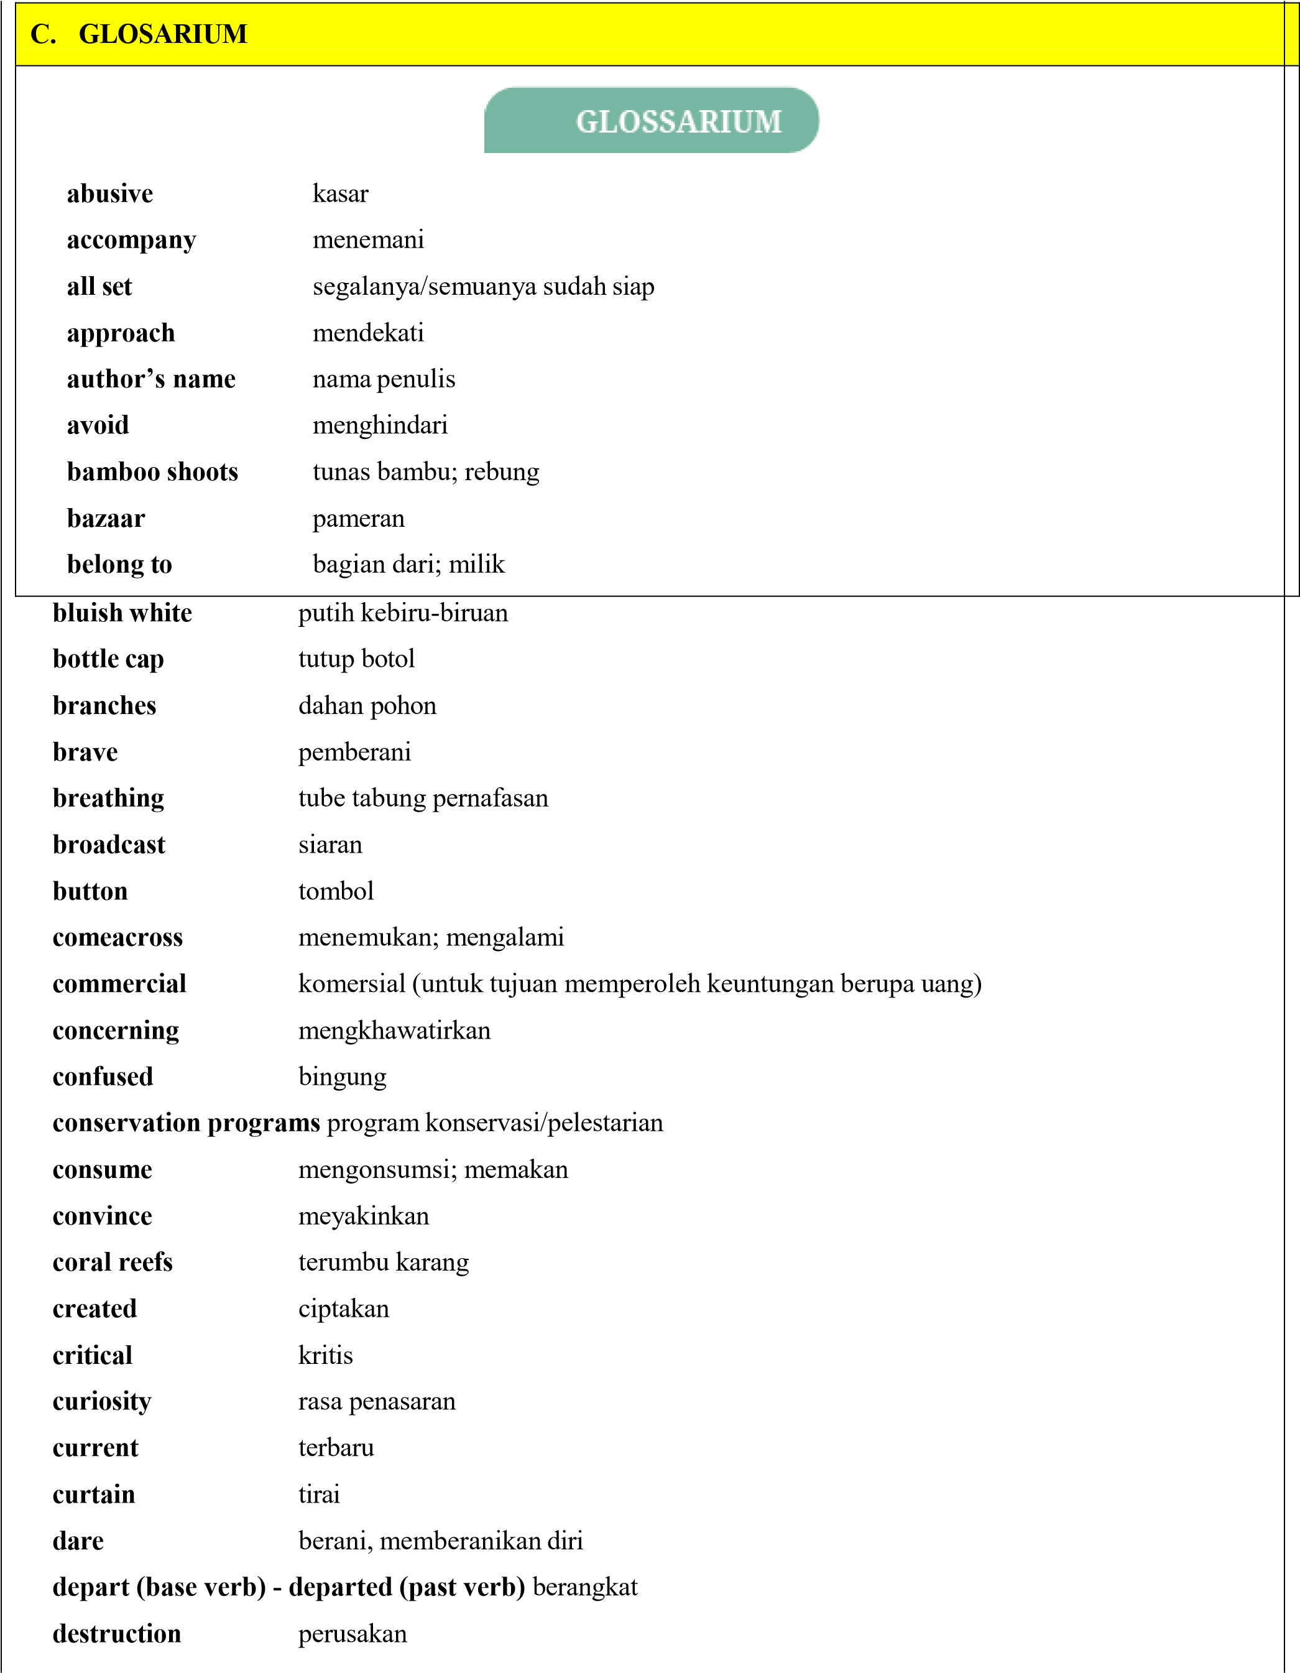
dig deeper menggali (misalnya menggali informasi) digital devices perangkat digital disabled students siswa penyandang disabilitas
disappear | menghilang; punah; hancur
disrespectful | tidak sopan
dizzy | pusing
educational | pendidikan
electrical engineering teknik elektro
embed | melekatkan
endangered | terancam punah
excited | ersemangat, senang, gembira
excited | bersemangat / senang
excitement | kegembiraan
excursion karya wisata
experts | ahli
fake | palsu
famous | terkenal
fastened | mengencangkan
feather | bulu
featherless patch area kulit tak berbulu featherless patch kulit tak berbulu
 | figs | buah ara
 | fill out | mengisi
 | founder | pendiri
 | future | masa depan
 | gear | perlengkapan
 | give out | memberikan/membagikan
 | glue | lem
 | go down | turun
 | goods | barang
 | government | pemerintah graying
 | black | hitam keabu-abuan
 | green sea turtle | penyu laut hijau
 | guarantee | menjamin
 | habitat loss | kerusakan habitat
 | hang | menggelantung;bergelantung(an)
harbor |  |  | pelabuhan
head towards/to |  |  | menuju (ke)
height |  |  | tinggi badan
holes |  |  | lubang
hollow reeds |  |  | tumbuhan buluh berongga
house reef |  |  | rumah karang atau terumbu karang terdekat dari resor menyelam/snorkeling, dapat diakses dari bibir pantai dengan hanya berenang.
hover |  |  | mengarahkan kursor tetikus
illegal hunting |  |  | perburuan liar
important |  |  | penting
imposter |  |  | penipu
in general |  |  | pada umumnya
institutions |  |  | lembaga
intelligence |  |  | kecerdasan
interesting menarik
in the field |  | pada bidangnya
invent |  | menciptakan
it takes longer |  | memerlukan waktu yang lebih lama
jewelry |  | perhiasan
knight outfit |  | pakaian ksatria
lantern |  | lentera
lecturer |  | dosen
limbs tangan |  | dan kaki
log off |  | mengakhiri akses (internet)
lose track (of) |  | tak dapat mengingat atau menghitung
lychee |  | leci
mammal |  | hewan beranak, mamalia
mangosteen |  | manggis
mangrove |  | hutan mangruf
medication |  | obat-obatan
membrane |  | selaput
motorboat |  | perahu motor
mouse |  | tetikus
mute |  | membisukan
nasty |  | menjijikan; menyakitkan
native (to) |  | berasal/khas (dari)
 | neck |  | leher
 | north |  | utara
 | observe |  | melihat, mengamati
 | observed |  | mengamati
 | offensive |  | menyinggung
 | offer |  | menawarkan
 | ordinary person |  | orang biasa
pack (base verb) – packed (past verb) mengemas, berkemas
pardon | maaf (mohon diulangi)
passionate | bersemangat, tertarik
pioneer | pelopor
predator | pemangsa
pressed | menekan
primate | hewan primata
publication date | tanggal terbit
purpose | tujuan
put on | memakai
rainforest | hutan hujan tropis
reasonable | price harga yang wajar
recipient | penerima
recycling | daur ulang
reddish-brown | (berwarna) coklat kemerahan
reliability | dapat diandalkan
retrieve | mengambil
revved | menyala
reward | hadiah, penghargaan
scam | penipuan
scary | menakutkan
scientific | name nama ilmiah
screenshot | tangkapan layar
search engine | mesin pencari
self-blame | (sikap) menyalahkan diri sendiri
services | jasa
social network | jaringan/pertemanan sosial
sophisticated | mutakhir
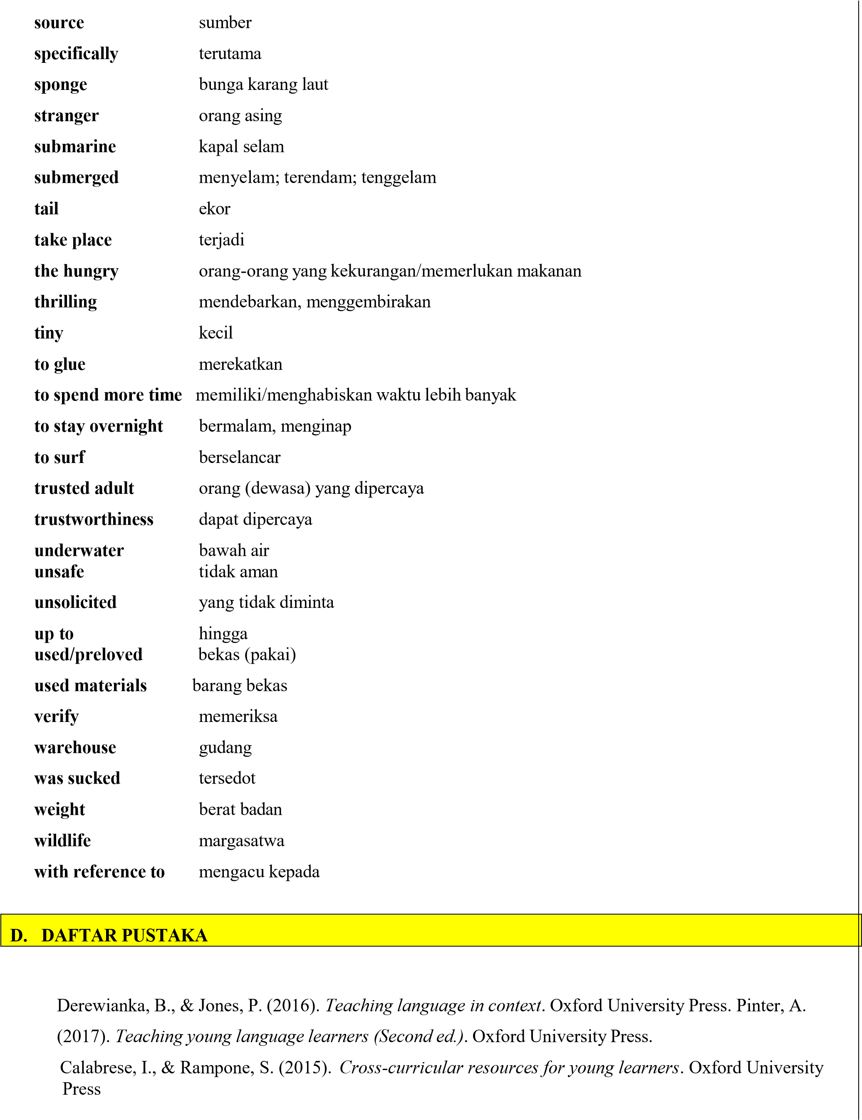
https://www.nationalgeographic.com/animals/mammals/facts/proboscis-monkey#:~:text=Proboscis%20monkeys%20have%20an%20unusual,cross%20rivers%20to%20find%20food.
https://www.rekoforest.org/field-stories/5-main-differences-betweenapes-vs-monkeys/)https://www.nationalgeographic.com/animals/birds/facts/birds-ofparadise?msclkid=26256016d06b11eca2f6547d404146b0https://westpapuastory.com/cenderawasih-birdparadise/https://worldbirds.com/what-is-birding/https://www.silentforest.eu/projects/bali-myna/https://www.worldwildlife.org/species/orangutanhttps://www.mongabay.co.id/2017/09/04/konservasi-orangutan-masih-hadapi-kendala-apa-saja/https://www.worldwildlife.org/species/gorilla?pc=AVB014005&ds_rl=1262308&gclsrc=3p.dshttps://www.oxfordlearnersdictionaries.com/https://learnenglishteens.britishcouncil.org/grammar/b1b2-grammar/passive-formshttps://literacyideas.com/how-to-write-a-
descriptivetext/#:~:text=Paragraph%205%3A%20The%20purpose%20of,their%20descriptive%20text%20before%20writing.
https://www.teach-this.com/functional-activities-worksheets/describing-thingshttps://www.twinkl.co.id/resource/teacher-evaluation-sheet-za-kps-1646300132
